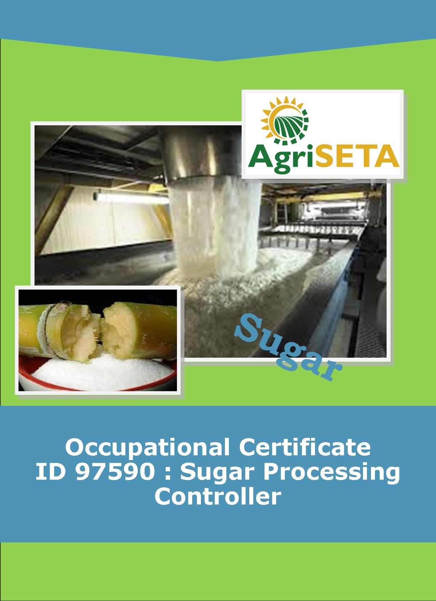
KNOWLEDGE COMPONENT:
KNOWLEDGE COMPONENT: LEARNER WORKBOOK 1: SUGAR PROCESSING LABORATORY WORK
Occupational Certificate: Sugar Processing Controller

KNOWLEDGE COMPONENT:

LEARNER WORKBOOK 1: SUGAR PROCESSING LABORATORY WORK
LEARNER WORKBOOK 1:
SUGAR PROCESSING LABORATORY WORK
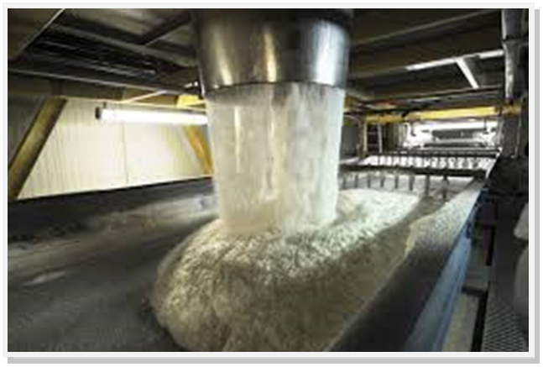
OCCUPATIONAL CERTIFICATE: ID 97590: SUGAR PROCESSING CONTROLLER

©Copyright AgriSETA
Telephone: +27 12 301 5600
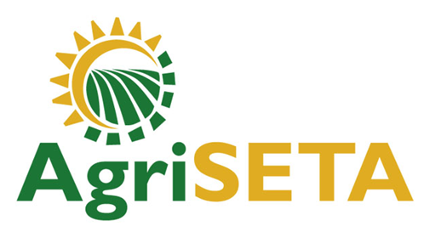

AgriSETA holds the copyright to its publications and Web pages. Proper citation is requested.

TABLE OF CONTENTS

1. AN INTRODUCTION TO THIS LEARNER WORKBOOK 6
2. LEARNER DETAILS 7
3. FORMATIVE ASSESSMENT INSTRUCTIONS 8
4. KNOWLEDGE MODULE 1: INTRODUCTION TO SUGAR PROCESSING LABORATORY WORK 9
4.1 Knowledge Topic 1: Laboratory Apparatus and Equipment and their uses (10%) 10
4.2 Knowledge Topic 2: Specific laboratory techniques (5%) 25
4.3 Knowledge Topic 3: Arithmetical calculations (10%) 32
4.4 Knowledge Topic 4: Draw and interpret graphs (10%) 55
4.5 Knowledge Topic 5: Units of measurement (10%) 63
4.6 Knowledge Topic 6: Use a balance (5%) 66
4.7 Knowledge Topic 7: Use flasks, measuring cylinders and pipettes (5%) 70
4.8 Knowledge Topic 8: Burettes and titration (5%) 74
4.9 Knowledge Topic 9: Filtration techniques (10%) 77
4.10 Knowledge Topic 10: Drying (10%) 83
4.11 Knowledge Topic 11: Preparation of solutions and concentration calculations (10%) 86
4.11 Knowledge Topic 12: Sampling (10%) 115
5. CONCLUSION OF KNOWLEDGE MODULE 1: INTRODUCTION TO SUGAR PROCESSING LABORATORY WORK 117

AN INTRODUCTION TO THIS LEARNER WORKBOOK
This Knowledge Component Learner Workbook 1: Sugar Processing Laboratory Work Resource: Book 1: Sugar Processing Laboratory Work is intended to be used with the Knowledge Component Learning Resource: Book 1 (Textbook): Sugar Processing Laboratory Work of the Occupational Qualification: Sugar Processing Controller NQF 5.
Guidance on the use of this Work Book is provided in the Learning Guide.

LEARNER DETAILS
First name
Surname
ID number
Mobile phone contact number
E-mail address
Postal address
Date on which you started this Knowledge Module
Date on which you completed this Knowledge Module
Declaration: | I hereby confirm that:  - I received the assessment plan and schedule.  - I understand my rights in terms of special needs, re-assessment, feedback and appeals against assessment decisions.  - I completed this formative assessment independently without assistance from anyone else.
Total Marks for Knowledge Module 1 | 1091 marks
Marks attained
Date:
Place:
Signature of Learner:
Signature of Assessor:

FORMATIVE ASSESSMENT INSTRUCTIONS
Instructions
- Work individually to present the results of each Learning Activity in this Learner Workbook.
- Complete all the sections.
- Use a black pen and ensure that you complete the questions in your own handwriting.
- A recommended time to complete each activity is shown.
- The marks you will attain for each learning activity are shown in brackets.
- The total marks obtained for each Knowledge Module must be transferred from the back of each Learner Workbook to the Learner Qualification Summative Assessment Tool.

KNOWLEDGE MODULE 1: INTRODUCTION TO SUGAR PROCESSING LABORATORY WORK
NQF LEVEL: 4
CREDITS: 8
PURPOSE OF THE KNOWLEDGE MODULE: The main focus of the learning in this knowledge module is to build an understanding of sugar processing science.
The learning will enable learners to demonstrate an understanding of:
- KM-01-KT01: Laboratory apparatus and equipment and their uses (10%)
- KM-01-KT02: Specific laboratory techniques (5%)
- KM-01-KT03: Arithmetical calculations (10%)
- KM-01-KT04: Draw and interpret graphs (10%)
- KM-01-KT05: Units of measurement (10%)
- KM-01-KT06: Use of a balance (5%)
- KM-01-KT07: Use flasks, measuring cylinders and pipettes (5%)
- KM-01-KT08: Burettes and titration (5%)
- KM-01-KT09: Filtration techniques (10%)
- KM-01-KT010: Drying (10%)
- KM-01-KT11: Preparation of solutions and concentration calculations (10%)
- KM-01-KT12: Sampling (10%)
- 4.1 Knowledge Topic 1: Laboratory Apparatus and Equipment and their uses (10%)
Topic elements to be covered include:
- KT0101 Apparatus
- KT0102 Equipment
Internal Assessment Criteria and Weight
- IAC0101: Equipment and apparatus can be identified and their uses explained
- Weight: 10%

Learning activity 1.1: Individual Learning activity: 30 minutes (30 marks)

Learning Objective: Correctly identify and describe the use of laboratory apparatus.
Task: Thirty (30) pieces of apparatus are illustrated in the first column of the table below. Provide the name of, and describe the use of, each piece of apparatus by completing the second and third columns of the table.
IMAGE OF APPARATUS | Name of Apparatus | Use of Apparatus
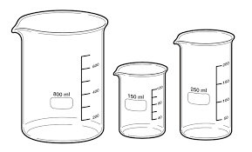
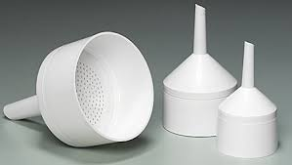
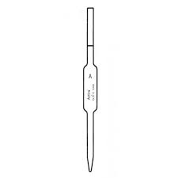
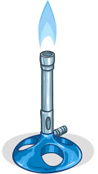
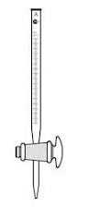
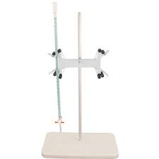
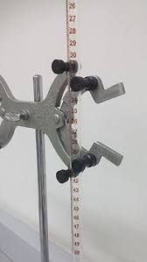
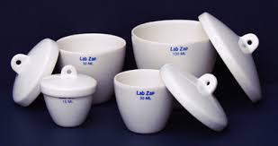
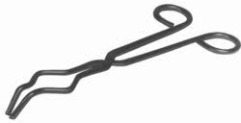
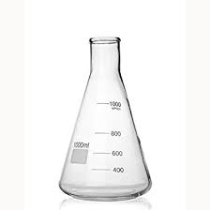
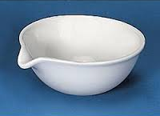
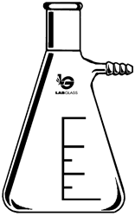
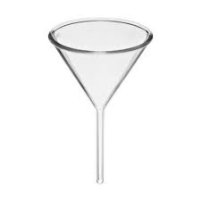
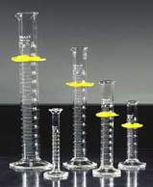
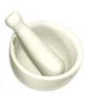
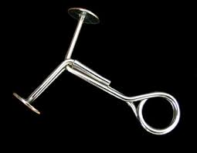
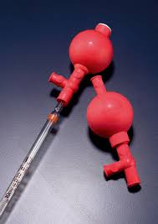
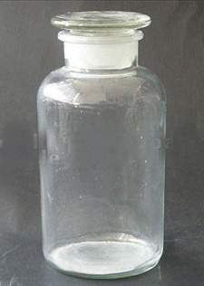
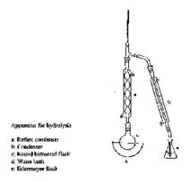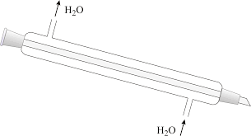
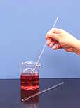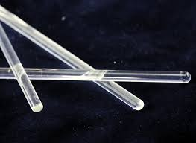
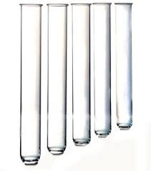
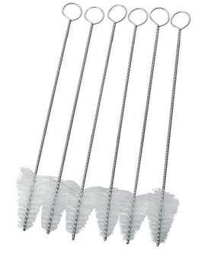
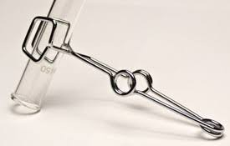
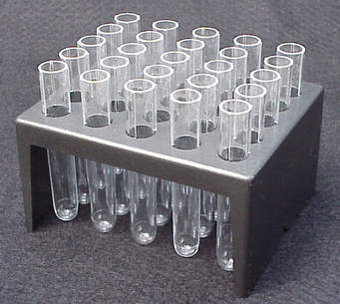
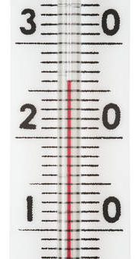
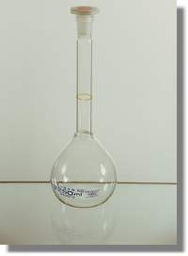
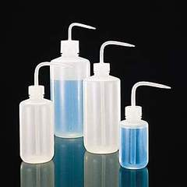
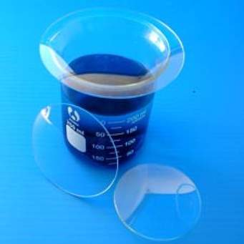
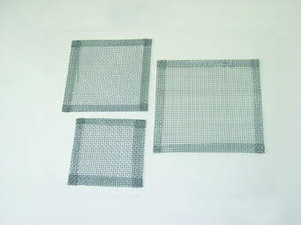
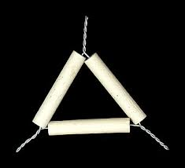

Learning activity 1.2: Individual Learning activity: 30 minutes (30 marks)
Learning Objective: Correctly identify and describe the use of laboratory equipment.
Task: Fourteen (14) pieces of laboratory equipment are illustrated in the first column of the table below. Provide the name of, and describe the use of, each piece of laboratory equipment by completing the second and third columns of the table.
IMAGE OF LABORATORY EQUIPMENT | NAME OF LABORATORY EQUIPMENT | USE OF LABORATORY EQUIPMENT
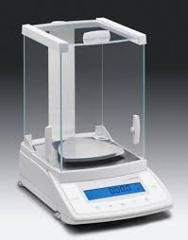
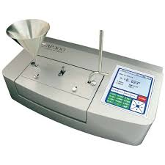
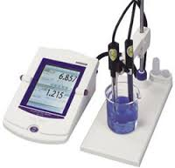
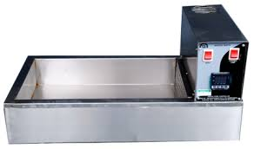
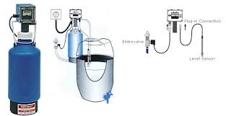
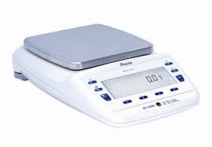
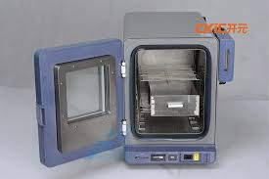
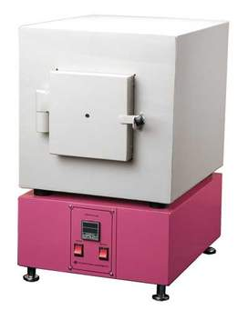
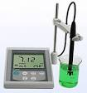
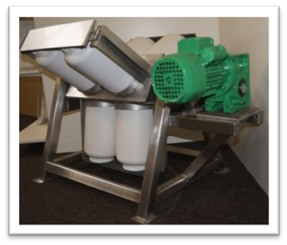
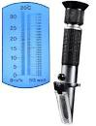
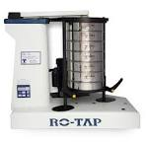
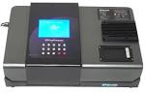
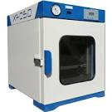

- 4.2 Knowledge Topic 2: Specific laboratory techniques (5%)
Topic elements to be covered include:
- KT0201 Sampling
- KT0202 Cleanliness
- KT0203 Chemicals
- KT0204 Gasses
- KT0205 Standard Methods
- KT0206 Liquid Levels
- KT0207 Temperature
- KT0208 Safety
Internal Assessment Criteria and Weight
- IAC0201 Laboratory techniques for specific analytical procedures can be explained
- Weight 5%

Learning activity 2: Individual Learning activity: 60 minutes (80 marks)
Learning Objective: Explain the laboratory techniques for a specific set of analytical procedures routinely used in a Sugar Laboratory.
Task: Read the following questions carefully and write your answers in the spaces provided.
- Name the 4 main purposes of the laboratory. (4)

- Explain the terms “representative sample” and “biased sample”. (2)

- Name 6 characteristics of a good laboratory worker. (6)
- Explain how you check that a glass container is clean. (3)

- State 12 precautions that must be taken when working with glassware. (12)

- (a) What is dermatitis? (1)

- How can it be prevented? (2)

- State 3 safety precautions to be taken when dealing with chemicals. (5)

- List the effects of good housekeeping in the laboratory. (5)

- (a) List the 3 precautions to be taken when reading a liquid level in a measuring cylinder or burette. (3)

(b) List the 3 precautions to be taken when making to the mark in a volumetric container. (3)

- Explain why a volumetric flask must be held by its neck. (3)

- (a) Why are watch glasses used? (2)

(b) How is a watch glass placed
- on a beaker (1)

- on a filter funnel (1)

- State 9 precautions that must be kept in mind when dispensing from a reagent bottle. (12)

- Explain how a thermometer is used. (1)

- State 3 precautions to be taken when using wash bottles. (3)

- (a) What is the purpose of a desiccator? (1)

(b) State 3 precautions to be taken when working with a desiccator. (3)

- State the 7 statements that must be included in a laboratory report. (7)

- 4.3 Knowledge Topic 3: Arithmetical calculations (10%)
Topic elements to be covered include:
- KT0301 Terminology
- KT0302 Calculation rules
- KT0303 Fractions and decimals
- KT0304 Cubes and squares
- KT0305 Percentages and ratios
Internal Assessment Criteria and Weight
- IAC0301 Calculation are correctly performed
- Weight 10%

Learning activity 3: Individual Learning activity: 4 hours (400 marks)
Learning Objective: Perform the mathematical calculations correctly
Task: Read the following questions carefully and write your answers in the spaces provided.
- Add (13)
- 3 + 9
- 2 + 9
- 8 + 3
- 5 + 6
- 9 + 3
- 9 + 4
- 5 + 7
- 4 + 9
- 8 + 5
- 7 + 7
- 8 + 6
- 8 + 7
- 7 + 9

- Add (8)
- 7 + 27
- 23 + 49
- 29 + 71
- 34 + 22
- 36 + 18
- 56 + 43
- 79 + 36
- 62 + 35

- Add (9)
- 5 865 + 1 977
- 349 + 224 + 113
- 25 362 + 16 549 + 28 437
- 238 + 653 + 275 + 586 + 21
- 408 + 207 + 265
- 2 348 + 1 886 + 2 675
- 53 856 + 29 567 + 14 385
- 125 + 908 + 576 + 56 + 102
- 5 396 785 + 255 137 + 2 856 325 + 8 753

- Subtract (13)
- 12 – 4
- 18 – 9
- 14 – 8
- 17 – 8
- 13 – 8
- 13 – 4
- 11 – 9
- 12 – 5
- 13 - 6
- 13 - 7
- 15 - 9
- 14 - 5
- 13 - 5

- Write down the missing numbers (10)
- ____ - 5 = 6
- ____ - 6 = 5
- ____ - 8 = 3
- ____ - 8 = 5
- ____ - 9 = 4
- ____ - 5 = 7
- ____ - 6 = 7
- ____ - 8 = 9
- ____ - 8 = 6
- ____ - 7 = 9

- Subtract (13)
- 13 - 2
- 19 - 14
- 19 - 18
- 24 - 20
- 49 - 45
- 37 - 22
- 43 - 30
- 38 - 35
- 88 - 81
- 57 - 44
- 11 - 6
- 10 - 7
- 12 - 8

- Write the answers (26)
- (1) + (-1)
- (-2) + (-3)
- (3) + (-5)
- (-5) + (2)
- (-6) + (-7)
- (-2) + (-3) + (-1)
- (-1) + (-2) + (2)
- (-3) + (-2) + (6)
- (-2) + (-3) + (5)
- (-4) + (-1) + (2)
- (-1) + (-1) + (-1) + (7)
- (-3) + (0) + (-3)
- (2) + (2) + (2) + (-6)
- (-4) + (4) + (-1)
- (1) + (0) + (-4) + (-1)
- (-2) + (-1) + (1)
- (-2) + (2) + (-2)+ (2)
- (-1) + (0) + (1)
- (-3) - (-2)
- (-3) - (2)
- (3) - (-2)
- (-17) - (-15)
- (-20) - (-20)
- (8) + (-12)
- (-1) + (-5) - (4)
- (-2) - (-5) + (-3)

- Calculate the products (6)
- 29 × 6
- 37 × 5
- 43 × 4
- 57 × 6
- 63 × 8
- 69 × 5

- Calculate the products (6)
- 173 × 25
- 73 × 58
- 45 × 2575
- 318 × 36
- 78 × 75
- 432 × 25

- Calculate the products (18)
- 251 × 346
- 444 × 333
- 504 × 360
- 555 × 444
- 650 × 205
- 321 × 319
- 385 × 250
- 465 × 158
- 436 × 306
- 25 ÷ 5
- 32 ÷ 8
- 30 ÷ 5
- 35 ÷ 7
- 36 ÷ 4
- 63 ÷ 7
- 16 ÷ 8
- 27 ÷ 9
- 36 ÷ 6

- Tabulate the factors (or divisor) of the following numbers (5)
- 12
- 15
- 18
- 27
- 30

- Write down the missing numbers (10)
- ____ ÷ 7 = 4 r 3
- ____ ÷ 6 = 9 r 2
- ____ ÷ 5 = 8 r 2
- ____ ÷ 7 = 6 r 1
- ____ ÷ 8 = 7 r 5
- ____ / 8 = 3 r 6
- ____ / 7 = 7 r 3
- ____ / 9 = 7 r 3
- ____ /58 = 7 r 2
- ____ /55 = 9 r 1

- Complete the following number sentences (13)
- 35 ÷ 7
- 24 ÷ 8
- 45 ÷ 9
- 20 ÷ 10
- 63 ÷ 9
- 350 ÷ 7
- 240 ÷ 8
- 450 ÷ 9
- 200 ÷ 10
- 630 ÷ 9
- 3 500 ÷ 7
- 2 400 ÷ 8
- 4 500 ÷ 9

ORDER OF OPERATIONS:
- Simplify (26)
- 2 + (3 × 2)
- (2 + 3) × 2
- 10 - 4 - 2
- 10 - (4 - 2)
- (2 × 3) - 1
- 2 × (3 - 1)
- 8 + (8 ÷ 2)
- (8 + 8) ÷ 2
- 8 + (8 ÷ 2)
- (7 - 2) + (3 - 1)
- 7 - 2 + 3 - 1
- 18 - 2 ÷ 2 + 2
- (18 - 2) ÷ (2 + 2)
- (3) × (6)
- (4) (3)
- (3) × (-2)
- (3) × (-10)
- (-2) × (3)
- (15)(-2)
- (-3)(3)
- (-12)(-3)
- (-2)(-5) + 4
- (-3)(3) + (2) (-3) + (1) (-5)
- ((-2) × (5)) - (-2)
- (-3)(-2)(3)(-5)
- (-4)4(-2)

FRACTIONS:
- Convert to decimal fractions (10)
- 22/50
- 8/125
- 1/2
- 17/50
- 9/20
- 18/25
- 13/4
- 3/4
- 1/25
- 5/8

- Convert to common fractions in lowest terms (10)
- 0,5
- 0,375
- 0,625
- 0,75
- 0,68
- 0,875
- 0,4
- 0,08
- 0,85
- 0,1 123

- Write down in the form of decimal fractions (24)
- 11/10
- 725/100
- 375/100
- 78/10
- 25/100
- 81/1000
- 9/100
- 25/100
- 11/100
- 115/100
- 13/1 000
- 15/1000
- 17/10
- 75/1000
- 40/100
- 23/24
- 545/72
- 71/75
- 42/50
- 87/95
- 12/15
- 1/25
- 33/66
- 44/88

- Write down the correct relationship sign; = or > or < (8)
- 0,4 |  | 0,5
- 15/1000 |  | 0,15
- 11/10 |  | 1,2
- 5/100 |  | 55/1000
- 0,18 |  | 0,19
- 0,25 |  | 255/1000
- 11/10 |  | 1,1
- 0,08 |  | 0,081

- Add (14)
- 2,3 + 1,5
- 1,25 + 3,38
- 0,125 + 5,628
- 3,08 + 4,75
- 6,025 + 3,105
- 15,085 + 39,807
- 3,25 + 5,128
- 17,08 + 3,007
- 13 + 15,5
- 7,75 + 75
- 98,354 + 3,8 + 36,085 +116,389
- 113,073 + 45,75 + 308,9 + 7,857
- 67,008 + 1 328,25 + 327,25 + 85
- 0,007 + 45 + 147,5 + 27,057

- Write the value of the digits which have been underlined in the following (5)
1 097.085 | 1 097.085 | 1 097.085 | 1 097.085 | 1 097.085

- Subtract (9)
- 0,9 - 0,5
- 0,65-0,53
- 2,075-0,705
- 7,537-2,458
- 3,123-1,347
- 25,000-18,364
- 7,50-3,25
- 6,85-3,127
- 0,39-0,389

- Write down the answers (13)
- 0,7 × 10
- 1,25 × 10
- 6,85 × 100
- 0,625 × 100
- 0,035 × 1000
- 0,005 × 1000
- 3,7 ÷ 10
- 0.02 ÷ 10
- 3,81 ÷ 100
- 13,05 ÷ 10
- 175,5 ÷ 1000
- 180,5 ÷ 1000
- 245,0 ÷ 10,0

- Calculate the squares of (5)
- 4
- 16
- 50
- 62
- 14

- Calculate the cubes of (5)
- 2
- 8
- 36
- 100
- 24

- Calculate the following quotients (5)
- 43.42 ÷ 13
- 131.95 ÷ 65
- 60.45 ÷ 31
- 811.3 ÷
- 1903.5 ÷ 81

- Calculate the quotient of 9 348 ÷ 38 and then write down the answers (10)
- 93.48 ÷ 38
- 934.8 ÷ 38
- 9.348 ÷ 3.8
- 93.48 ÷ 0.38
- 9.348 ÷ 38
- 934.8 ÷ 0.38
- 9.348 ÷ 0.38
- 934.8 ÷380
- 93.48 ÷ 3.8
- 93.48 ÷ 380

- Calculate the square roots of the following (5)
- 144
- 49
- 25
- 529
- 225

- Calculate the cube roots of the following (5)
- 1 728
- 343
- 512
- 1,0
- 125

- Correct the following to 2 decimal places (6)
- 12.574
- 157.375 324 1
- 12.575
- 103 456.823 934 8
- 0.023
- 2.151

- Correct the following to 3 decimal places (6)
- 475.899 273 753
- 0.038 473 9
- 13.345
- 56.475 95
- 0.001 199 999 99
- 54.354 83

PERCENTAGES
- Express the following as fractions (10)
- 35%
- 160%
- 90%
- 12.5%
- 5%
- 0.375%
- 27.5%
- 75%
- 30%
- 33%

- Express the following as percentages (5)
- 1/5
- 1/25
- 0,4
- 3/10
- 13/50

- Write down the answers (5)
- 1% of 300
- 5% of 30
- 75% of 40
- 80% of 20
- 20% of 60

- Express the following as percentages (5)
- 5 of 200
- 25 of 300
- 54 of 200
- 40 of 160
- 15 of 75

- Of 150 pupils in a class, 100 passed their exams. What % passed? (1)

- If VAT IS 13% what do you pay for the items marked below (5)
- 50c
- R1,70
- R15,50
- R12,34
- R9,10

- Find 7% of 1 million people (1)

- You buy a bicycle on H.P. over two years. If the interest rate is 20% p.a. What do you pay altogether if the cost price is R 425? (1)

- Calculate the % increase of the following (4)
- milk from 60c to 65c a litre
- bread from 83c to 89c a loaf
- pencils from 20c to 25c each
- meat from R3,99 to R4,16 a kg
- Calculate the price if the following discounts are given (5)
- 10% on R 110
- 33.3% on R 1289,89
- 25% on R 45 000
- 2.5% on R12,50
- 15% on R 47,95

- What is the % profit or loss if a dealer buys an article for 20c and sells it for (5)
- 22c
- 28c
- 30c
- 18c
- R1,20

- At what price must the following be sold to make a profit of 15%? (5)
- potatoes at R 2,45 a pocket
- clocks at R9,45 each
- a bicycle at R 143
- a car at R450
- shoes at R12,56 a pair

RATIOS
- 4 l of water is mixed with 30 l of alcohol. What is the ratio of water to alcohol? (1)

- In a town there are 10 000 dogs, 5 000 cats and 25 000 people (3)
- How many dogs are there for every cat?
- How many people for every cat?
- How many people for every dog?

- Divide R 450 in the ratio 3 : 5 (2)

RATE
- A man is paid R2 160 for 360 hours work. What is his hourly rate and how long must he work to earn R1? (2)

- How long will it take a man on horseback to ride around his farm of which the lengths of the sides are 3,075 km, 2,704 km, 1,600 km and 3,356 km, if he rides at the rate of 9.5 km in 1 hour? (2)

- A bricklayer lays 300 bricks in 1 hour 20 minutes. How many bricks will he lay in 3 hours 40 minutes? (2)

GENERAL
- Soccer players are making a fence for their soccer field. What is the total length of timber required for the poles if each pole is 1.117 m long and they require 100 poles? (2)

- If the mass of the truck and its load of cement is 5.110 t and that of the truck alone is 1.682 t. what is the mass of 1 pocket of cement if there are 80 pockets on the truck? (2)

- In a bus bringing people to work there were 32 people who paid 90c each, 18 who paid 60c each and 2 who paid 50c each and 16 who paid 40c each. How much did the bus driver take altogether and what was his name? (2)
- Find the cost of fitting a rail to the walls of a room 6.7 m long by 6.1 m wide, if the rails costs 90.9c a metre. (2)

- John’s home is on a rectangular piece of ground which is 291.8 m long and 218.4 m wide. There is a path around the ground which is 7.25 m longer than the perimeter of the ground. How far does John cycle if he cycles on the path round the ground 10 times? (2)

- Show eight thousand four hundred and sixty four as a number. (1)

- Show 19/10 as a decimal. (1)

- Show 23.75 as a fraction. (1)

- Add three thousand eight hundred and fifty six to two thousand seven hundred and seventy six. (1)

- Add 184 and 3 287. (1)

- Subtract (3)
- 754 from 1 393
- 14,5 from 27,85
- 81/2 from 12.75

- Subtract ten thousand and thirty four from one million five hundred and eighty one thousand, three hundred and twenty nine. (2)

- 4.4 Knowledge Topic 4: Draw and interpret graphs (10%)
Topic elements to be covered include:
  - KT0401 Axis
  - KT0402 Scale
  - KT0403 Concentration Standard
  - KT0404 Rules
  - KT0405 Data
Internal Assessment Criteria and Weight
- IAC0401 Graphs are drawn accurately
- Weight 10%

Learning activity 4: Individual Learning activity: 4 hours (70 marks)
Learning Objective: Draw graphs accurately and demonstrate an ability to interpret graphs.
Task: Read the following questions carefully and draw the graphs instructed.
Draw the following graphs:
- Rainfall for 1987
Month | Rainfall (mm) | Month | Rainfall (mm)
January | 180 | July | 2
February | 20 | August | 5
March | 140 | September | 4
April | 65 | October | 1
May | 35 | November | 120
June | 5 | December | 110

- Phosphate standard graph
Optical density | mg phosphate in solution per 100 ml
0.20 | 5
0.38 | 10
0.62 | 15
0.81 | 20
1.02 | 25
1.16 | 30
1.39 | 35
1.53 | 40
1.76 | 45
2.00 | 50

- Sucrose % cane – 1987
Month | Sucrose % of cane
April | 11.34
May | 12.05
June | 12.51
July | 13.17
August | 13.62
September | 13.71
October | 13.48
November | 12.66
December | 12.29

- Extraction – 1987
Month | Extraction (%)
April | 96.49
May | 96.89
June | 96.89
July | 96.97
August | 97.02
September | 97.24
October | 97.25
November | 97.08
December | 97.02

- Boiling house recovery – 1987
Month | Boiling house recovery (%)
April | 87.23
May | 87.80
June | 89.00
July | 89.07
August | 88.62
September | 87.64
October | 87.67
November | 86.97
December | 86.36

- Overall recovery – 1987
Month | Overall recovery (%)
April | 84.17
May | 85.07
June | 86.23
July | 86.38
August | 85.99
September | 85.22
October | 85.26
November | 84.43
December | 83.78

- Plot extraction B.H.R and O.R on to one graph using the information from question 4, 5 and 6.

- 4.5 Knowledge Topic 5: Units of measurement (10%)
Topic elements to be covered include:
- KT0501 Measurement of Quantity
- KT0502 Derived Units
- KT0503 Length
- KT0504 Area
- KT0505 Volume
Internal Assessment Criteria and Weight
- IAC0501 An understanding of measurement units can be demonstrated
- Weight 10%

Learning activity 5: Individual Learning activity: 40 minutes (32 marks)
Learning Objective: Demonstrate an understanding of the units of measurement.
Task: Read the following questions carefully and write your answers in the spaces provided.
- (a) How many basic units are used internationally? (1)

(b) Name 3 basic units. (3)

- Name the prefixes used to designate the different multiples and sub-multiples of the basic unit. (5)

- State how to convert from: (7)
- km to m: | X 1000
- km to cm:
- km to mm:
- mm to cm:
- cm to m:
- m to km:
- mm to m:
- cm to km:

- State how to convert from: (8)
- km² to m²:
- km² to cm²:
- km² to mm²:
- mm² to cm²:
- cm² to m²:
- m² to km²:
- mm² to m²:
- cm² to km²:

- State how to convert from: (8)
- mm³ to cm³
- cm³ to dm³
- dm³ to mm³
- cm³ to m³
- dm³ to m³
- m³ to km³
- km³ to m³
- m³ to dm³

- 4.6 Knowledge Topic 6: Use a balance (5%)
Topic elements to be covered include:
- KT0601 Mechanical Balances
- KT0602 Electronic Balances
- KT0603 Massing
Internal Assessment Criteria and Weight
- IAC0601 An understanding of the use of balances can be demonstrated
- Weight 5%

Learning activity 6: Individual Learning activity: 5 hours (42 marks)
Learning Objective: Demonstrate an understanding of the use of balances.
Task: Read the following questions carefully, implement the instructions and write your answers in the spaces provided or request the instructor to sign that you have performed the task satisfactorily.
Instructions
- Students to work in pairs. Each group collects the 10 items listed below and masses the items on the different balances available in the laboratory. (20)
 |  | Top Pan Balance |  |  |  | Analytical Balance
 | Item | Balance 1 |  | Balance 2 |  | Balance 3 |  | Balance 4
 | Item | 1 | 2` | 3 | 4` | 5 | 6 | 7 | 8
1 | 50 ml beaker
2 | rubber stopper
3 | filling funnel
4 | nickel basin
5 | watch glass
6 | 10 glass beads
7 | test tube
8 | moisture dish
9 | stirring rod
10 | crucible

- Working in your group, mass out each of the following items. Demonstrate your results to the instructor who will sign next to the item below. (8)
- 30.0g refined sugar into a 100 ml beaker
- 50g of raw sugar into a 250 ml beaker
- 100.5g of silica gel into a 250 ml beaker
- 25.14g of sand into a moisture dish
- 1.234g of salt into a 50 ml beaker
- 3g ±1mg of celite into a nickel massing basin
- 5g ±0.5mg of pumice powder into a small beaker. Note: 0.5mg = 0.005g. Therefore 4 decimal places must be recorded.
- 1 spoonful of raw sugar on a watch glass and accurately find the mass.

- List 14 precautions that must be taken when using a balance. (14)

- 4.7 Knowledge Topic 7: Use flasks, measuring cylinders and pipettes (5%)
Topic elements to be covered include:
- KT0701 Specific Flasks
- KT0702 Measuring Cylinders
- KT0703 Use a Pipette
Internal Assessment Criteria and Weight
- IAC0701 An understanding of the use of flasks, measuring cylinders and pipettes can be demonstrated
- Weight 5%

Learning activity 7: Individual Learning activity: 2 hours (40 marks)
Learning Objective: Demonstrate an understanding of the use of volumetric flasks, measuring cylinders and pippettes.
Task: Read the following questions carefully, implement the instructions and write your answers in the spaces provided or request the instructor to sign that you have performed the task satisfactorily.
Instructions
- Clean and dry a 50 ml volumetric flask and accurately find its mass to 4 decimal places using an analytical balance. Then accurately pipette 10 ml of water into the volumetric flask, mass the flask and repeat the exercise 4 times. (10)
Accurate pipetting technique would result in:
- The mass of the volumetric flask increasing by the same amount with each aliquot pipetted.
Signature of instructor:

- The level of water in the volumetric flask being at the mark after pipetting 5 aliquots of 10 ml is the water if at 200C.
Signature of instructor:

- Practice by pipetting 50 x 1 ml aliquots of water into a 50 ml volumetric flask using a large graduated pipette. (10)
After 50 aliquots assess your accuracy by checking to see how far off the mark the water level is in the volumetric flask.
Signature of instructor:

- State the 20 steps that must be followed when using a pipette. (20)

- 4.8 Knowledge Topic 8: Burettes and titration (5%)
Topic elements to be covered include:
- KT0801 Purpose
- KT0802 Definition
- KT0803 Method
Internal Assessment Criteria and Weight
- IAC0801 An understanding of the use of burettes to perform a titration can be demonstrated.
- Weight 5%
Learning activity 8: Individual Learning activity: 2 hours (45 marks)
Learning Objective: Demonstrate an understanding of the use of a burette to perform a titration.
Task: Read the following questions carefully, implement the instructions and write your answers in the spaces provided or request the instructor to sign that you have performed the task satisfactorily.
Instructions
- Describe a burette (3)

- Explain what a “titration” is. (3)

- State the 14 steps to be followed when using a burette. (14)

- Examine a burette closely. Dismantle the top and ensure that the tap and tube is clean. Reassemble the tap and tighten it so that it is not loose, but not so tight as to prevent you from turning it easily. If the tap is too loose, it will leak and if too tight you run the risk of breaking the burette. (5)
Signature of instructor:

- Dispense about 120 ml each of 0.1 M sodium hydroxide (NaOH) solution and 0.1 M hydrochloric acid (HCl) solution. Pipette 25 ml of NaOH solution into an Erlenmeyer flask and titrate with HCl solution using phenolphthalein as an indicator. The end point is when the phenolphthalein changes from red to pale pink. Repeat the titration until 3 identical readings (titres) are obtained. (20)
Signature of instructor:

- 4.9 Knowledge Topic 9: Filtration techniques (10%)
Topic elements to be covered include:
- KT0901 Filter Paper
- KT0902 Clarification Agent
- KT0903 Gravity Filtration
- KT0904 Vacuum Filtration
- KT0905 Pressure Filtration
Internal Assessment Criteria and Weight
- IAC0901 An understanding of the use of filtration techniques can be demonstrated.
- Weight 10%

Learning activity 9: Individual Learning activity: 4 hours (65 marks)
Learning Objective: Demonstrate an understanding of the use of different filtration techniques.
Task: Read the following questions carefully, implement the instructions and write your answers in the spaces provided or request the instructor to sign that you have performed the task satisfactorily.
Instructions
- List the different types of filters used in sugar analysis and state their uses. (12)

- (a) Explain what a “filter aid” is.(3)

(b) Name 2 filter aids used in a mill laboratory. (2)

- (a) Explain what a clarification agent is. (2)

(b) When is a clarification agent used? (1)

- State the 5 steps to be followed when performing a gravity filtration.(5)

- State the 10 steps to be followed during a vacuum filtration if you wish to recover the residue.(10)

- Exercise 1: Gravity Filtration: Collect ± 100 ml of refined sugar solution that has been prepared by your Training Officer, add a spatula of pumice powder and stir the mixture.
(Pumice powder is made by grinding the crusty surface that forms when lava cools and sets.)
Filter the mixture via gravity filtration. The aim is to recover the filtrate.
If the first runnings are compared with the beaker containing the rest of the filtrate, it will be evident that the first runnings are cloudy due to the presence of fine pumice particles. It takes a short while for the pumice to coat the filter paper. (10)
Signature of instructor:

- EXERCISE 2: Vacuum Filtration without pre-coating the filter paper
Collect ± 100 ml of concentrated raw sugar solution that has been prepared by your Training Officer, add a spatula of pumice powder and stir the mixture.
Filter the mixture using vacuum filtration. The aim is to recover the filtrate.
You will notice that filtration is relatively slow due to the presence of impurities in suspension that tend to blind the pores of the filter paper.
These impurities are colloidal i.e. neither dissolved nor completely soluble. We use Celite 577 as a filter aid because the colloidal matter is retained in the mat of filtrate aid. (10)
Signature of instructor:

- EXERCISE 3: Vacuum Filter using pre-coating of the filter paper.
Assemble the apparatus for a vacuum filtration. Collect a raw sugar solution containing some talcum powder in suspension and also collect a beaker with some pumice powder.
Precoat the filter paper with pumice under low vacuum and then filter the sugar solution. The aim is to recover the residue.
You will notice that filtration is faster than in Exercise 2. (10)
Signature of instructor:

- 4.10 Knowledge Topic 10: Drying (10%)
Topic elements to be covered include:
- KT1001 Equipment
- KT1002 Method
- KT1003 Calculations
Internal Assessment Criteria and Weight
- IAC1001 The purpose of drying can be explained.
- Weight 10%

Learning activity 10: Individual Learning activity: 3 hours (40 marks)
Learning Objective: Understand and use drying techniques.
Task: Read the following questions carefully, implement the instructions and write your answers in the spaces provided or request the instructor to sign that you have performed the task satisfactorily.
Instructions
- Name 5 instances where the moisture % of a substance is used. (5)

- Describe the working of a Spencer oven. (5)
- Describe the procedure to be followed when using a moisture oven. (10)

- EXERCISE 1: Determine the moisture % of a 10g sample of silica gel by drying in an oven at 105˚C for 1 hour. Use an electronic top pan balance to determine the mass to two decimal places. (10)
Write your answer here:
Signature of instructor:

- EXERCISE 2: Determine the moisture % of a 2g sample of Celite by drying in an oven at 105˚C for 1 hour. Use an analytical balance to determine the mass to 4 decimal places. (10)
Write your answer here:
Signature of instructor:
- 4.11 Knowledge Topic 11: Preparation of solutions and concentration calculations (10%)
Topic elements to be covered include:
- KT1101 Standard Solutions
- KT1102 Reagent Solutions
- KT1103 Preparation
- KT1104 Concentration and Dilution
- KT1105 Storage
Internal Assessment Criteria and Weight
- IAC1101 An understanding of the use of standard solutions can be demonstrated.
- Weight 10%

Learning activity 11: Individual Learning activity: 8 hours (207 marks)
Learning Objective: Accurately prepare standard solutions and perform calculations relevant to standard solutions.
Task: Read the following questions carefully, implement the instructions and write your answers in the spaces provided or request the instructor to sign that you have performed the task satisfactorily.
Instructions
- EXERCISE 1: Collect a 50 ml beaker with some sugar. Transfer this sugar quantitatively to a second 250 ml beaker and make to the 250ml mark with water. Concentrate on all the steps necessary to ensure that all of the sugar is transferred to the beaker.
Some important points to remember are:
- The top 50 ml beaker must remain in contact with the bottom 250 ml beaker.
- Ensure that all the wash water runs into the 250 ml beaker.
- Also wash the outside of the spout of the top 50 ml beaker.
- If a glass rod is used to stir and dissolve the sugar in the 250 ml beaker, the glass rod must also be washed off into the beaker before the level is made up to the 250 ml mark.
Repeat this exercise twice. (10)
Signature of instructor:

- EXERCISE 2: Collect 1 50 ml beaker containing sugar solution from your instructor. Using a pipette quantitatively transfer 25 ml of sugar solution into a 250 ml volumetric flask and make to the mark. (10)
Signature of instructor:

- EXERCISE 3: Your instructor will prepare a solution of methylene blue. Collect ±40 ml of the blue solution in a 50 ml beaker. Quantitatively transfer a 10 ml aliquot of blue solution into a 100 ml volumetric flask and make to the mark.
To compare your accuracy with the other students, read the absorbance of the solution prepared in the volumetric flask in a spectrophotometer at 570 mm and record the reading.
Method of using the spectrophotometer:
- Select the required wavelength using the relevant knob.
- With the sample tube filled with water adjust the absorbance to zero.
- Rinse the sample tube three times with some solution.
- Fill the sample tube with solution, dry the outside and read the absorbance.
Write your answer here:
- The absorbencies of all of the students should be the same. Variations are due to errors during preparation of the solution. Repeat this exercise. (10)
Signature of instructor:

- EXERCISE 4: Your instructor will prepare a 1 M sodium hydroxide solution by dissolving 40g of NaOH in 1000 ml water (Solution A). Your instructor will also prepare a 0.1 M hydrochloric acid solution by dissolving 8.9 ml concentrated HCI in 1000 ml of water (Solution B). (10)
- Pipette 25 ml of Solution A into a 250 ml volumetric flask and make to the mark. Label this solution C.
- Fill a burette with solution B.
- Take a 10 ml aliquot of solution C and titrate with solution B using phenolphthalein as indicator. The end point is pale pink.
- Take 10 ml aliquot of solution C and titrate with solution B using methyl orange as indicator. The end point is peach pink.
- Repeat the exercise until solutions C and B have been exhausted.
Signature of instructor:

- Find the percentage composition of the following sucrose solutions. (10)
- 7 g sucrose placed in 93 g water
- 20 g sucrose placed in 80 g water
- 25 g sucrose placed in 125 g water
- 43 g sucrose placed in 152 g water
- 57 g sucrose placed in 193 g water
- 62 g sucrose contained in 158 g sucrose solution
- 95 g sucrose contained in 175 g sucrose solution
- 225 g sucrose contained in 330 g sucrose solution
- 310 g sucrose contained in 390 g sucrose solution
- 450 g sucrose contained in 770 g sucrose solution

- Find the mass of sucrose in the following sucrose solutions: (10)
- 50 g of a 20% sucrose solution
- 75 g of a 15% sucrose solution
- 100 g of a 35% sucrose solution
- 225 g of a 25% sucrose solution
- 300 g of a 50% sucrose solution
- 88 g of a 22% sucrose solution
- 170 g of a 30% sucrose solution
- 150 g of a 80% sucrose solution
- 200 g of a 38% sucrose solution
- 350 g of a 70% sucrose solution

- Find the mass of the following solutions: (10)
- 5% sucrose solution containing 10 g sucrose
- 10% sucrose solution containing 40 g sucrose
- 17% sucrose solution containing 85 g sucrose
- 25% sucrose solution containing 15 g sucrose
- 33% sucrose solution containing 11 g sucrose
- 45% sucrose solution containing 30 g sucrose
- 65% sucrose solution containing 130 g sucrose
- 77% sucrose solution containing 38,5 g sucrose
- 87% sucrose solution containing 29 g sucrose
- 93% sucrose solution containing 40 g sucrose
- Calculate the following concentrations: (10)
- Calculate the concentration in g/l of a solution containing 12 g solute in 2 l of solution
- Calculate the concentration in g/l of a solution containing 72 g solute in 120 cm3 of solution
- Calculate the concentration in g/l of a solution containing 35 g solute in 250 cm3 of solution
- Calculate the concentration in g/l of a solution containing 125 g solute in 50 ml of solution
- Calculate the concentration in g/l of a solution containing 225 g solute in 400 ml of solution
- Calculate the concentration in g/l of a solution containing 47 g solute in 85 ml of solution
- Calculate the concentration in g/l of a solution containing 163 g solute in 50 ml of solution
- Calculate the concentration in mg/ml of a solution containing 85 mg solute in 20 ml of solution
- Calculate the concentration in mg/ml of a solution containing 222 g solute in 11 ml of solution
- Calculate the concentration in g/l of a solution containing 0,02 g solute in 100 ml of solution

- Calculate the following volumes: (11)
- Calculate the volume of the solution required to give a concentration of 175 g/l using 25 g of solute.
- Calculate the volume of the solution required to give a concentration of 80 g/l using 60 g of solute.
- Calculate the volume of the solution required to give a concentration of 45 g/l using 125 g of solute.
- Calculate the volume of the solution required to give a concentration of 10 g/l using 2,5 g of solute.
- Calculate the volume of the solution required to give a concentration of 100 g/l using 20 g of solute.
- Calculate the volume of the solution required to give a concentration of 35 g/l using 140 g of solute
- Calculate the volume of the solution required to give a concentration of 12 g/l using 48 g of solute.
- Calculate the volume of the solution required to give a concentration of 36 g/l using 9 g of solute.
- Calculate the volume of the solution required to give a concentration of 56 g/l using 7 g of solute.
- Calculate the volume of the solution required to give a concentration of 330 g/l using 15 g of solute.
- Calculate the volume of the solution required to give a concentration of 136 g/l using 12 g of solute.

- Calculate the following quantities: (10)
- Calculate the quantity of sugar that must be placed in a 200 ml volumetric flask to give a concentration of 5 g/l (grams per litre).
- Calculate the quantity of sugar that must be placed in a 100 ml volumetric flask to give a concentration of 15 g/l (grams per litre).
- Calculate the quantity of sugar that must be placed in a 100 ml volumetric flask to give a concentration of 30 g/l (gram per litre).
- Calculate the quantity of sugar that must be placed in a 200 ml volumetric flask to give a concentration of 150 g/l (grams per litre)
- Calculate the quantity of sugar that must be placed in a 200 ml volumetric flask to give a concentration of 50 g/l (grams per litre).
- Calculate the quantity of sugar that must be placed in a 250 ml volumetric flask to give a concentration of 75 g/l (grams per litre)
- Calculate the quantity of sugar that must be placed in a 100 ml volumetric flask to give a concentration of 250 mg/ml.
- Calculate the quantity of sugar that must be placed in a 200 ml volumetric flask to give a concentration of 350 mg/ml.
- Calculate the quantity of sugar that must be placed in a 250 ml volumetric flask to give a concentration of 20 g/l (grams per litre).
- Calculate the quantity of sugar that must be placed in a 500 ml volumetric flask to give a concentration of 100 mg/ml.

- Express the following solutions as parts of solute per million parts of solution (ppm): (10)
- 30 mg of sugar in 300 g of water.
- 0.07 g of sugar in 72 g of water.
- 25 mg of sugar in 500 g of water.
- 0.008 g sugar in 250 g of water.
- 18 mg of sugar in 0.2 kg of water.
- 0.375 g of sugar in 125 000 mg of water.
- 2.7 g of sugar in 9 kg of water.
- 160 mg of sugar in 80 ml of water.
- 45 g of sugar in 900 l of water.
- 77.7 g of sugar in 100 from 100 l of water.

- Calculate the following volumes: (10)
- Calculate the volume (aliquot) that must be taken from 250 g/l standard solution and made up to 100 ml to give a new solution of concentration 150 g/l.
- Calculate the volume (aliquot) that must be taken from a 50 g/l standard solution and made up to 100 ml to give a new solution of concentration 10 g/l.
- Calculate the volume (aliquot) that must be taken from a 100 g/l standard solution and made up to 250 ml to give a new solution of concentration 15 g/l.
- Calculate the volume (aliquot) that must be taken from a 150 g/l standard solution and made up to 300 ml to give a new solution of concentration 40 g/l.
- Calculate the volume (aliquot) that must be taken from a 75 g/l standard solution and made up to 150 ml to give a new solution of concentration 50 g/l.
- Calculate the volume (aliquot) that must be taken from 1 20 g/l standard solution and made up to a 50 ml to give a new solution of concentration 5 g/l.
- Calculate the volume (aliquot) that must be taken from a 200 g/l standard solution and made up to 150 ml to give a new solution of concentration 75 g/l.
- Calculate the volume (aliquot) that must be taken from a 300 g/l standard solution and made up to 150 ml to give a new solution of concentration 80 g/l.
- Calculate the volume (aliquot) that must be taken from a 350 g/l standard solution and made up to 200 ml to give a new solution of concentration 100 g/l.
- Calculate the volume (aliquot) that must be taken from a 400 g/l standard solution and made up to 500 ml to give a new solution of concentration 35 g/l.

- Calculate the following masses: (7)
- 15 g of sugar is dissolved in 50 ml of water in a volumetric flask. 20 ml of the solution is pipetted out into a 50 ml volumetric flask and made to the mark. 10 ml of this solution is pipetted into an evaporating dish and evaporated to dryness. What mass of dry sugar will be obtained?
- 50 g of sugar is dissolved in 100 ml of water in a volumetric flask. 20 ml of the solution is pipetted out into a 100 ml volumetric flask and made to the mark. 25 ml of this solution is pipetted into an evaporating dish and evaporated to dryness. What mass of dry sugar will be obtained?
- 50 g of sugar is dissolved in 200 ml of water in a volumetric flask. 25 ml of the solution is pipetted out into a 250 ml volumetric flask and made to the mark. 50 ml of this solution is pipetted into an evaporating dish and evaporated to dryness. What mass of dry sugar will be obtained?
- 80 g of sugar is dissolved in 250 ml of water in a volumetric flask. 25 ml of the solution is pipetted out into a 200 ml volumetric flask and made to the mark. 50 ml of this solution is pipetted into an evaporating dish and evaporated to dryness. What mass of dry sugar will be obtained?
- 160 g of sugar is dissolved in 500 ml of water in volumetric flask. 25 ml of the solution is pipetted out into a 100 ml volumetric flask and made to the mark. 25 ml of this solution is pipetted into an evaporating dish and evaporated to dryness. What mass of dry sugar will be obtained?
- 220 g sugar is dissolved in 500 ml of water in a volumetric flask. 25 ml of the solution is pipetted out into a 250 ml volumetric flask and made to the mark. 50 ml of this solution is pipetted into an evaporating dish and evaporated to dryness. What mass of dry sugar will be obtained?
- 400 g of sugar is dissolved in 700 ml of water in a volumetric flask. 25 ml of the solution is pipetted out into a 250 ml volumetric flask and made to the mark. 50 ml of this solution is pipetted into an evaporating dish and evaporated to dryness. What mass of dry sugar will be obtained?
- Calculate the following masses: (7)
- A quantity of sugar is dissolved in 100 ml of water in volumetric flask. 10 ml of the solution is pipetted out into a 100 ml volumetric flask and made to the mark. 20 ml of this solution is pipetted into an evaporating dish and evaporated to dryness giving 0,6 grams of sugar. What mass of sugar was initially placed into the 100 ml volumetric flask?
- A quantity of sugar is dissolved in 100 ml of water in a volumetric flask. 20 ml of the solution is pipetted out into 200 ml volumetric flask and made to the mark. 20 ml of this solution is pipetted into an evaporating dish and evaporated to dryness giving 1,4 grams of sugar. What mass of sugar was initially placed into the 100 ml volumetric flask?
- A quantity of sugar is dissolved in 200 ml of water in a volumetric flask. 25 ml of the solution is pipetted out into a 100 ml volumetric flask and made to the mark. 20 ml of this solution is pipetted into an evaporating dish and evaporated to dryness giving 1.5 grams of sugar. What mass of sugar was initially placed into the 200 ml volumetric flask?
- A quantity of sugar is dissolved in 200 ml of water in a volumetric flask. 25 ml of the solution is pipetted out into a 200 ml volumetric flask and made to the mark. 20 ml of this solution is pipetted into an evaporating dish and evaporated to dryness giving 0,375 grams of sugar. What mass of sugar was initially placed into the 200 ml volumetric flask?
- A quantity of sugar is dissolved in 250 ml of water in a volumetric flask. 20 ml of the solution is pipetted out into 100 ml volumetric flask and made to the mark. 25 ml of this solution is pipetted into an evaporating dish and evaporated to dryness giving 0,5 grams of sugar. What mass of sugar was initially placed into the 250 ml volumetric flask?
- A quantity of sugar is dissolved in 250 ml of water in a volumetric flask. 10 ml of the solution is pipetted out into a 200 ml volumetric flask and made to the mark. 25 ml of this solution is pipetted into an evaporating dish and evaporated to dryness giving 0,375 grams of sugar. What mass of sugar was initially placed into the 250 ml volumetric flask?
- A quantity of sugar is dissolved in 500 ml of water in a volumetric flask. 50 ml of the solution is pipetted out into a 100 ml volumetric flask and made to the mark. 25 ml of this solution is pipetted into an evaporating dish and evaporated to dryness giving 4 grams of sugar. What mass of sugar was initially placed into the 500 ml volumetric flask?

- Calculate the following quantities: (10)
- For a particular analysis a solution of 5 ml of concentrated HCl in a 250 ml volumetric flask is required. However you wish to prepare 100 ml of solution. What quantity of concentrated HCl would you place in the 100 ml flask?
- For a particular analysis a solution of 10 ml of concentrated HCl in a 500 ml volumetric flask is required. However you wish to prepare 200 ml of solution. What quantity of concentrated HCl would you place in the 200 ml flask?
- For a particular analysis a solution of 5 ml of concentrated HCl in a 200 ml volumetric flask is required. However you wish to prepare 250 ml of solution. What quantity of concentrated HCl would you place in the 250 ml flask?
- For a particular analysis a solution of 20 ml of concentrated HCl in a 100 ml volumetric flask is required. However you wish to prepare 250 ml of solution. What quantity of concentrated HCl would you place in the 250 ml flask?
- For a particular analysis a solution of 7 ml of concentrated HCl in a 250 ml volumetric flask is required. However you wish to prepare 100 ml of solution. What quantity of concentrated HCl would you place in the 100 ml flask?
- For a particular analysis a solution of 1,5 g of NaOH in a 100 ml volumetric flask is required. However you wish to prepare 250 ml of solution. What quantity of NaOH would you place in the 250 ml flask?
- For a particular analysis a solution of 17 g of NaOH in a 250 ml volumetric flask is required. However you wish to prepare 100 ml of solution. What quantity of NaOH would you place in the 100 100 ml flask?
- For a particular analysis a solution of 9 g of NaOH in a 500 ml volumetric flask is required. However you wish to prepare 200 ml of solution. What quantity of NaOH would you place in the 200 ml flask?
- For a particular analysis a solution of 25 g of NaOH in a 250 ml volumetric flask is required. However you wish to prepare 1000 ml of solution. What quantity of NaOH would you place in the 1000 ml flask?
- For a particular analysis a solution of 50 g of NaOH in a 1 000 ml volumetric flask is required. However you wish to prepare 200 ml of solution. What quantity of NaOH would you place in the 200 ml flask?

- Calculate the following: (26)
- An 800 ml sample of mixed juice must be divided into 3 portions in the ratio 2:3:5 for analysis purposes. What volume will each portion be?

- A 750 g sample of molasses must be divided into 3 portions in the ratio 3:5:7 for analysis purposes. What mass will each portion be?

- A 300 g sample of VHP sugar must be divided in the ration 3:7. What mass will each portion be?

- A quantity of sugar is dissolved in 250 ml of water in a volumetric flask. 20 ml of this solution is pipetted into a 200 ml volumetric flask and made to the mark. 50 ml of this solution is pipetted into an evaporating basin and evaporated to dryness, yielding 0.25 g of sugar.
- What mass of sugar was transferred in the 50 ml pipette?

- What mass of sugar was in the 200 ml volumetric flask?

- What mass of sugar was transferred in the 20 ml pipette?

- What mass of sugar was in the 250 ml of water?
- A 55 g of sugar is dissolved with water and made up to 200 ml in volumetric flask. 25 ml of the solution is pipetted into a 100 ml volumetric flask and made to the mark. 20 ml of this solution is pipetted into an evaporating basin and evaporated to dryness.
- What amount of sugar should be obtained?

However only 1.2 g of sugar is recovered.
- Explain the possible reasons why the recovery is not 100 %.

- For a particular analysis a solution of 12 g of NaOH in a 500 ml volumetric flask is required. However, you wish to prepare 200 ml of solution. What quantity of NaOH would you place in the 100 ml flask?

- For a particular analysis the method stipulates that 70 g of sugar must be dissolved in 300 ml of water. However only 30 g of a sugar sample is available. In what quantity of water would you dissolve the 30 g of sugar to give the required concentration?

- In a titration 14 ml of HCl solution neutralised 20 ml of NaOH solution. What volume of HCl would be required to neutralise 50 ml of NaOH solution?

- Express the following concentrations in parts per million (ppm)
- 12 g of sugar in 5 kg of water
- 475 mg of sugar in 750 g of water
- 0.0026 g of sugar in 130 g of water
- 0.00015 kg of sugar in 900 000 mg

- What quantity of sugar must be placed in 250 ml volumetric flask to give a concentration of 45 g/l?

- What quantity of sugar must be placed in a 200 ml volumetric flask to give a concentration of 17 mg/ml?

- How would you prepare a 120 ppm sugar solution?

- Express a concentration of 90 ppm in
- g/l
- mg/ml

- 20 g of sugar is dissolved in a 250 ml volumetric flask.
- What is the concentration of the solution in g/ml?

- What volume of water must be added to the solution to change its concentration to 0.02 g/ml?

- Calculate the mass of sugar needed to prepare the following: (10)
- 1 ml of a solution with a density of 1.30 g/ml
- 25 ml of a solution with a density of 1.15 g/ml
- 30 ml of a solution with a density of 1.22 g/ml
- 55 ml of a solution with a density of 1.25 g/ml
- 72 ml of a solution with a density of 1.37 g/ml
- 91 ml of a solution with a density of 1.11 g/ml
- 117 ml of a solution with a density of 1.4 g/ml
- 230 ml of a solution with a density of 1.2 g/ml
- 800 ml of a solution with a density of 1.37 g/ml
- 1500 ml of a solution with a density of 1.33 g/ml

- Calculate the volume of a sugar solution if it …. : (10)
- Contains 17 g of sugar and has a density of 1.34 g/ml
- Contains 34 g of sugar and has a density of 1.15 g/ml
- Contains 55 g of sugar and has a density of 1.28 g/ml
- Contains 71 g of sugar and has a density of 1.4 g/ml
- Contains 29 g of sugar and has a density of 1.33 g/ml
- Contains 93 g of sugar and has a density of 1.34 g/ml
- Contains 114 g of sugar and has a density of 1.21 g/ml
- Contains 209 g of sugar and has a density of 1.17 g/ml
- Contains 300 g of sugar and has a density of 1.09 g/ml
- Contains 162 g of sugar and has a density of 1.22 g/ml

- Convert the following % dissolved substances to concentrations in grams/litre of solution (Use the table in the Appendix of your Learning Resource) (8)
- 5%
- 12%
- 17%
- 28%
- 37%
- 43%
- 62%
- 73%
- 88%
- 92%

- Convert the following concentration in g/l to a % sucrose (Use the table in the Appendix of your Learning Resource) (8)
- 20.12 g/l
- 35.42 g/l
- 109.22 g/l
- 129.97 g/l
- 229.12 g/l
- 264.96 g/l
- 358.55 g/l
- 506.90 g/l
- 629.89 g/l
- 833.35 g/l

- 4.11 Knowledge Topic 12: Sampling (10%)
Topic elements to be covered include:
- KT1201 Composite sampling
- KT1202 Continuous sampling
- KT1203 Catch sampling
- KT1204 Sampling containers
- KT1205 Procedures
Internal Assessment Criteria and Weight
- IAC1201 An understanding of the sampling techniques can be demonstrated.
- IAC1202 The purpose of sampling and importance of accurate sampling can be explained.
- Weight 10%

Learning activity 12: Individual Learning activity: 30 minutes (10 marks)
Learning Objective: Demonstrate an understanding of the importance and purpose of sampling and the correct sampling technique.
Task: Read the following questions carefully and write your answers in the spaces provided.
- Explain the term “continuous sampling” and state when it is used. (3)

- Explain the term “catch sampling” and state when it is used. (3)

- Name 4 important precautions to be taken regarding sampling. (4)

CONCLUSION OF KNOWLEDGE MODULE 1: INTRODUCTION TO SUGAR PROCESSING LABORATORY WORK
Throughout this knowledge module you have been provided opportunities to complete formative learning activities. You have captured your results in this Learner Workbook.
The total marks for this Knowledge Module are as follows:
Knowledge Module | Total Marks | Marks attained
KM-01-KT01: Laboratory apparatus and equipment and their uses (10%) | 60 marks
KM-01-KT02: Specific laboratory techniques (5%) | 80 marks
KM-01-KT03: Arithmetical calculations (10%) | 400 marks
KM-01-KT04: Draw and interpret graphs (10%) | 70 marks
KM-01-KT05: Units of measurement (10%) | 32 marks
KM-01-KT06: Use of a balance (5%) | 42 marks
KM-01-KT07: Use flasks, measuring cylinders and pipettes (5%) | 40 marks
KM-01-KT08: Burettes and titration (5%) | 45 marks
KM-01-KT09: Filtration techniques (10%) | 65 marks
KM-01-KT010: Drying (10%) | 40 marks
KM-01-KT11: Preparation of solutions and concentration calculations (10%) | 207 marks
KM-01-KT12: Sampling (10%) | 10 marks
Total Marks | 1091 marks



