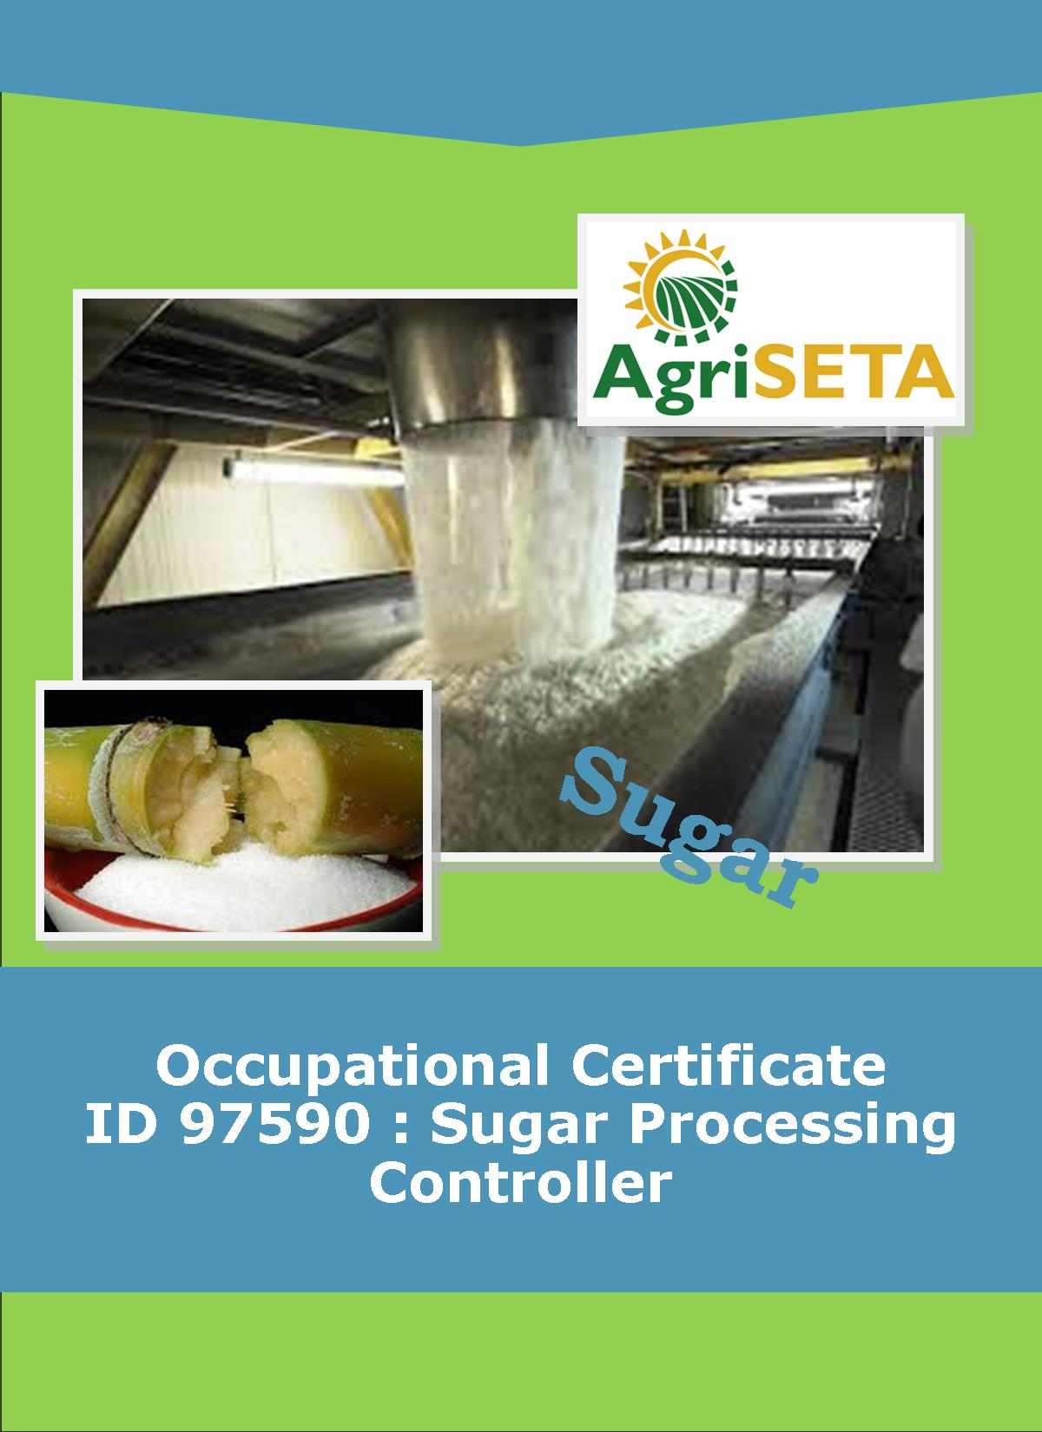
KNOWLEDGE COMPONENT: LEARNING RESOURCE
BOOK 1: SUGAR PROCESSING LABORATORY WORK
OCCUPATIONAL QUALIFICATION: SUGAR PROCESSING CONTROLLER

KNOWLEDGE COMPONENT:
LEARNING RESOURCE

BOOK 1: SUGAR PROCESSING LABORATORY WORK
KNOWLEDGE COMPONENT:
LEARNING RESOURCE
BOOK 1: SUGAR PROCESSING LABORATORY WORK
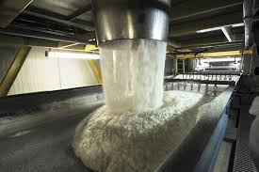
OCCUPATIONAL QUALIFICATION:
SUGAR PROCESSING CONTROLLER

©Copyright AgriSETA
Telephone: +27 12 301 5600


AgriSETA holds the copyright to its publications and Web pages. Proper citation is requested.

TABLE OF CONTENTS
KNOWLEDGE MODULE 1 10
SUGAR PROCESSING LABORATORY WORK 10

1.1 Knowledge Topic 1: Laboratory Apparatus and Equipment 12
1.1.1 INTRODUCTION 12
1.1.2 APPARATUS 12
1.1.3 EQUIPMENT 37

1.2 Knowledge Topic 2: Specific Laboratory Techniques 51
1.2.1 INTRODUCTION 51
1.2.2 SAMPLING 51
1.2.3 CLEANLINESS 53
1.2.4 DERMATITIS 56
1.2.5 CHEMICALS 56
1.2.6 GASES 57
1.2.7 ACCIDENTS WITH CHEMICALS 58
1.2.8 HOUSEKEEPING 58
1.2.9 READING LIQUID LEVELS AND MAKING TO MARK 59
1.2.10 TEMPERATURE 61
1.2.11 WATCH GLASSES 62
1.2.12 REAGENT BOTTLES 62
1.2.13 THERMOMETERS 64
1.2.14 WASH BOTTLES 64
1.2.15 DESICCATORS 64
1.2.16 STIRRING RODS 65
1.2.17 REPORT OF WORK DONE 66
1.2.18 STANDARD METHODS 67
1.2.19 SAFETY AND FIRE HAZARD 67
1.2.20 Fire 67
1.2.21 Accidents 69

1.3 Knowledge Topic 3: Arithmetical Calculations 70
1.3.1 INTRODUCTION 70
1.3.2 TERMINOLOGY 70
1.3.3 THE NUMBER CONCEPT 70
1.3.4 WRITING DOWN NUMBERS 70
1.3.5 CALCULATIONS RULES 71
1.3.6 ADDITION 72
1.3.7 SUBTRACTION 74
1.3.8 INTEGERS 74
1.3.9 Adding positive and negative numbers 75
1.3.10 Subtracting positive and negative numbers 75
1.3.11 MULTIPLICATION 75
1.3.12 Multiplication terminology 76
1.3.13 Important rules 76
1.3.14 DIVISION 80
1.3.15 Division terminology 80
1.3.16 Important points 80
1.3.17 FRACTIONS 83
1.3.18 DECIMALS 87
1.3.19 Decimal fractions 87
1.3.20 Place values 87
1.3.21 Calculating with decimal fractions 88
1.3.22 Addition and subtraction 88
1.3.23 Multiplication 89
1.3.24 Division 89
1.3.25 SQUARES AND CUBES 90
1.3.26 SQUARE ROOTS AND CUBE ROOTS: 90
1.3.27 MATHEMATICAL SIGNS: 90
1.3.28 ROUNDING OFF (CORRECTING) 91
1.3.29 PERCENTAGES 91
1.3.30 RATIO 93
1.3.31 DIVISION OF A QUANTITY IN A CERTAIN RATIO 95

1.4 Knowledge Topic 4: Graphs 97
1.4.1 INTRODUCTION 97
1.4.2 AXIS 97
1.4.3 INFORMATION 97
1.4.4 STANDARD GRAPHS 97
1.4.5 RULES FOR DRAWING GRAPHS 98
1.4.6 Introduction 98
1.4.7 For each Data Set 98
1.4.8 TO LOCATE A POINT EXACTLY 100
1.4.9 GENERAL – HOW TO DRAW A GRAPH 101

1.5 Knowledge Topic 5: Measurement of Quantities 104
1.5.1 THE S.I. (SYSTEM INTERNATIONALE D’UNITES) 104
1.5.2 DERIVED UNITS 104
1.5.3 LENGTH 105
1.5.4 AREA 106
1.5.5 VOLUME 107

1.6 Knowledge Topic 6: Use a Balance 109
1.6.1 INTRODUCTION 109
1.6.2 PRECAUTIONS TO BE OBSERVED WHEN USING A BALANCE 111
1.6.3 BALANCE CAPACITY 112
1.6.4 MASSING AN OBJECT 112
1.6.5 MASSING OUT A SPECIFIC AMOUNT OF SAMPLE 113

1.7 Knowledge Topic 7: Flasks, Cylinders and Pipettes 115
1.7.1 VOLUMETRIC FLASKS 115
1.7.2 ERLENMEYER FLASKS 115
1.7.3 KOHLRAUSCH FLASKS 115
1.7.4 SUGAR FLASKS 116
1.7.5 MEASURING CYLINDERS 116
1.7.6 PIPETTES 116

1.8 Knowledge Topic 8: Burettes and Titrations 120
1.8.1 INTRODUCTION 120
1.8.2 USE OF A BURETTE 121

1.9 Knowledge Topic 9: Filtration 124
1.9.1 INTRODUCTION 124
1.9.2 FILTER PAPER 125
1.9.3 FILTER AID 126
1.9.4 CLARIFICATION AGENT 127
1.9.5 GRAVITY FILTRATION (BRIX & POL) 127
1.9.6 VACUUM FILTRATION 128
1.9.7 PRESSURE FILTRATION (NUTSCH) 130

1.10 Knowledge Topic 10: Drying 131
1.10.1 INTRODUCTION 131
1.10.2 EQUIPMENT 132
1.10.3 SPENCER TYPE OVEN 132
1.10.4 MOISTURE OVEN 133

1.11 Knowledge Topic 11: Preparation of Solutions and Concentration Calculations 135
1.11.1 INTRODUCTION 135
1.11.2 STANDARD SOLUTIONS 135
1.11.3 REAGENT SOLUTIONS 135
1.11.4 PREPARATION OF SOLUTIONS 136
1.11.5 STORAGE OF SOLUTIONS 139
1.11.6 AMOUNT OF DISSOLVED SUBSTANCE(S) 140
1.11.7 EXPRESSING CONCENTRATION 141
1.11.8 REDUCING THE CONCENTRATION 142
1.11.9 CALCULATIONS INVOLVING QUANTITATIVE TRANSFERS 145
1.11.10 DENSITY OF SOLUTIONS 148
1.11.11 SPECIFIC GRAVITY 151
1.11.12 CONVERTING % DISSOLVED SUBSTANCE TO CONCENTRATION IN g/l 151
1.11.13 CONVERTING CONCENTRATION IN g/l TO % DISSOLVED SUBSTANCE 152

1.12 Knowledge Topic 12: Sampling 154
1.12.1 INTRODUCTION 154
1.12.2 CONTINUOUS SAMPLING 154
1.12.3 CATCH SAMPLING 154
1.12.4 SAMPLE CONTAINERS AND PRESERVATION OF SAMPLES 155
1.12.5 SPECIFIC SAMPLING PROCEDURES AT A MILL 155

APPENDIX A: BRIX, APPARENT DENSITY AND GRAMS OF SUCROSE PER 100 CM³ OF SUGAR SOLUTIONS 173
APPENDIX B: SUGAR CANE FACTORY – GLOSSARY OF TERMS 184

-o0o-

AN INTRODUCTION TO THIS LEARNING RESOURCE
This Knowledge Component Learning Resource: Book 1: Sugar Processing Laboratory Work is intended to be used with the Knowledge Component Learner Workbook 1 (Formative Assessment Guide): Sugar Processing Laboratory Work of the Occupational Qualification: Sugar Processing Controller NQF 5. It can also be used as a stand-alone information resource (text book).
This Learning Resource provides detailed information on the following topics:
- KM-01-KT01: Laboratory apparatus and equipment and their uses
- KM-01-KT02: Specific laboratory techniques
- KM-01-KT03: Arithmetical calculations
- KM-01-KT04: Draw and interpret graphs
- KM-01-KT05: Units of measurement
- KM-01-KT06: Use a balance
- KM-01-KT07: Use flasks, measuring cylinders and pipettes
- KM-01-KT08: Burettes and titration
- KM-01-KT09: Filtration techniques
- KM-01-KT10: Drying
- KM-01-KT11: Preparation of solutions and concentration calculations
- KM-01-KT12: Sampling
(Note: KM = Knowledge Module, KT = Knowledge Topic)

KNOWLEDGE MODULE 1

SUGAR PROCESSING LABORATORY WORK
Module number: 313908000-KM01: NQF Level 4: Credits 8
BACKGROUND
In the organisational structure of every sugar mill (sugar processing plant) there is a specific department or division dedicated to quality control. This is usually connected to a laboratory, whose main purposes are:
- Quality control of raw materials (often for the purpose of producer payments);
- Monitoring of production processes (especially to evaluate and quantify industrial losses) and
- Quality control of final products.
To monitor the quality from raw material delivery through manufacturing to a final product, it is imperative to depend on good laboratory physical infrastructure, accurate and reliable equipment, competent and well-trained technical staff and an efficient analysis plan.
Measurements required from the on-site sugar laboratory include:
- pol (sucrose) per cent in juice,
- brix (total soluble solids) per cent in juice,
- pol (sucrose) per cent in cane,
- brix per cent in cane,
- fibre per cent,
- commercial cane sugar (CCS),
- purity, and
- dissolved solids value.
It should be the goal of every sugar laboratory worker to accomplish the work needed with the greatest speed and the smallest chance of error providing results of the highest reliability and repeatability.
Several people depend on these laboratory results:
- Cane growers rely on the laboratory results for:
  - their cane payments
  - guidance on how to improve their production practices
  - guidance on how to improve their harvesting practices
  - guidance on how to improve their transportation practices
- Cane processors rely on these laboratory results:
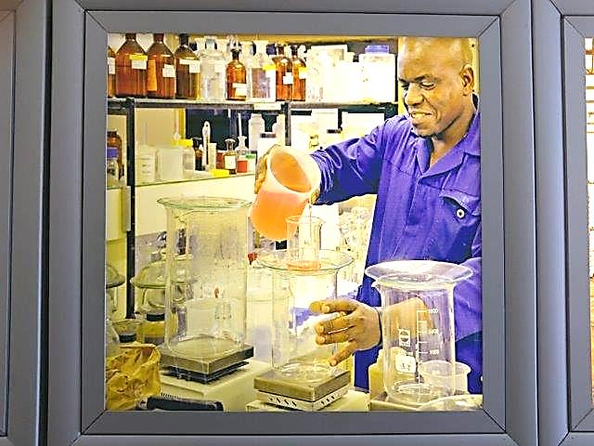
  - To determine whether the sugar can move onto the next stage of processing in the processing chain
  - To determine whether the equipment is functioning efficiently
  - To determine whether the final product is of the desired quality
With so much at stake, laboratory workers must be neat, diligent and precise - providing quick and accurate results to the various stakeholders as required.

Knowledge Topic 1: Laboratory Apparatus and Equipment

INTRODUCTION
The analytical results from the laboratory are essential for the efficient operation of the sugar extraction and recovery processes. It is therefore critical that the laboratory results are accurate. The laboratory worker/ analyst thus has a very important and responsible task.
It is important that the laboratory worker knows the names and the uses of all the equipment at his disposal. This gives him a better understanding of his work and ensures that he uses his equipment correctly. Correct use of equipment plays an important role in achieving accurate analytical results.

APPARATUS
DESCRIPTION OF APPARATUS | IMAGE OF APPARATUS
Beakers:  These are cylindrical in shape and have a spout to enable liquid to be poured without spilling. Beakers are used for mixing, boiling, supporting a funnel and numerous other uses.  The volume of a beaker can be expressed to millilitres (ml) or cubic centimetres (cm³or cc) with 1 millilitre being equal to 1 cubic centimetre. We will use beakers of volume 50ml, 250ml and 600ml.  Note: The volume graduations on beakers may only be used to collect or disperse approximate volumes. | 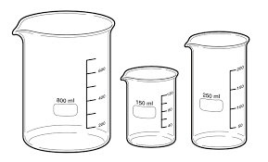  Figure 1: Beaker
Beaker Tongs:  Used to handle hot beakers safely. | 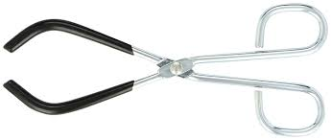  Figure 2: Beaker Tongs
Buchner Funnel:  Used to hold the filter paper when filtering under vacuum. Their sizes are indicated by their inner diameter i.e. 70mm, 85mm etc. | 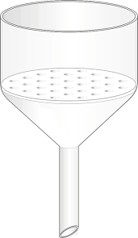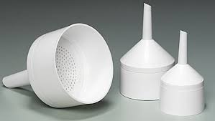  Figure 3: Buchner Funnel
Bulb Pipette:  These are a type of “volumetric” glassware. Volumetric glassware refers to glassware that is accurately marked to hold or deliver exact volumes under specified conditions.  A pipette is a volumetric vessel used to deliver a constant volume of liquid according to the size of the pipette. We will use bulb pipettes of volumes 100 cm³; 50 cm³; 25 cm³; 20 cm³; 10 cm³; 5 cm³; 2 cm³; 1 cm³.  Note: A pipette will only be accurate when both the pipette and the liquid inside the pipette are at the temperature marked on the pipette. | 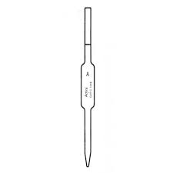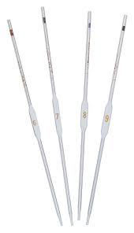  Figure 4: Bulb Pipette
Bunsen Burner:  A Bunsen burner uses propane and butane gas (LPG) to produce an intense flame. Glassware is usually not heated directly by the Bunsen but the glassware is placed on a wire gauze. However, during ashing the crucible is heated directly by the Bunsen burner. | 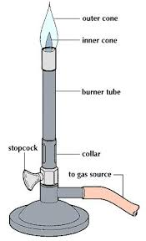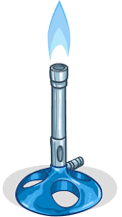  Figure 5: Bunsen Burner
Burette:  A long volumetric cylinder used in titrations for accurately dispensing quantities of liquid between 0 and 50 cm³. When not in use a burette must be clamped upside down with the tap open and the bottom end of the burette clear from the stand. | 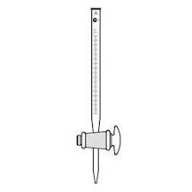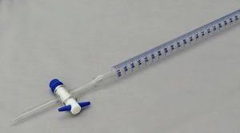  Figure 6: Burette
Burette Brush:  A long thin brush used for cleaning burettes. | 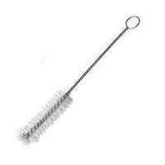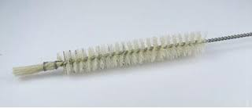  Figure 7: Burette brush
Burette Stand:  This stand is used to hold a burette in an upright position. It can also be used to clamp other apparatus and is sometimes called a retort stand. | 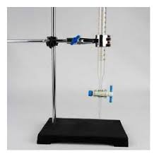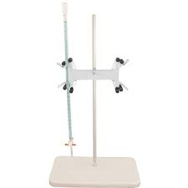  Figure 8: Burette or retort stand
Burette Clamp:  A clamp used to hold the burette upright on a retort stand. | 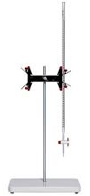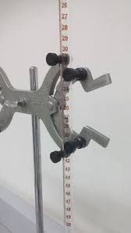  Figure 9: Burette clamp
Burette Filling Funnel:  A small funnel used when filling a burette with liquid. | 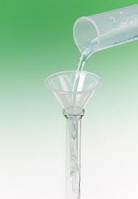  Figure 10: Burette filling funnel
Bosshead:  Used to attach a clamp to a stand. A bosshead must be attached to the retort stand in such a way that it supports the clamp even if the clamp is not firmly held by the screw of the bosshead. | 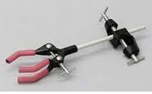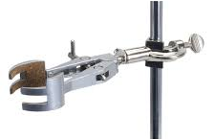  Figure 11: Bosshead
Clamp:  Used to clamp (hold) glassware to a stand. | 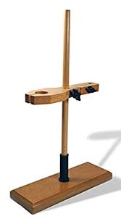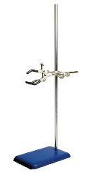  Figure 12: Clamps (Wooden and metal with rubber versions) on retort stands
Cookie Jar:  A plastic container used when tumbling cane for preparation index determination. They can also be used to store samples. | 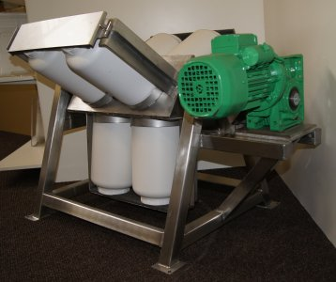  Figure 13: Cookie jars (In preparation index tumbler)
Cork Borer:  These come in different sizes (diameters) and are used to make holes in corks or rubber bungs for fitting glass tubing. | 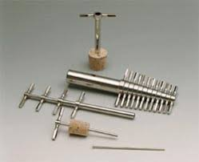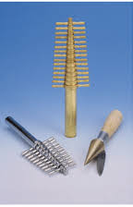  Figure 14: Cork borer
Crucible:  A vessel used when heating a sample to a high temperature during “ashing”. Crucibles are usually made from porcelain which will withstand high temperatures. | 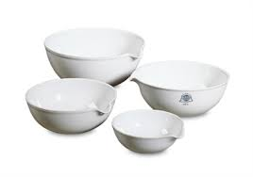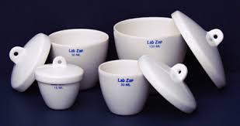  Figure 15: Crucible
Crucible Tongs:  Used to remove crucibles from the Bunsen or muffle furnace. | 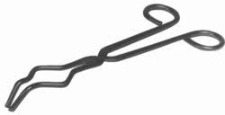  Figure 16: Crucible tongs
Decanting Stand:  Used to hold a sieve steady when pouring samples of juices and extracts through it. | 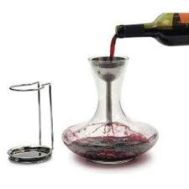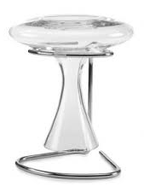  Figure 17: Decanting stand
Desiccator:  Used to cool objects in a dry atmosphere. | 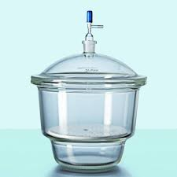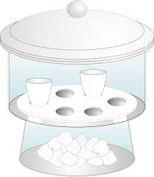  Figure 18: Desiccator
Digestor Bowl:  The bowl that fits onto the cold digestor and which contains water and the sample of prepared cane that is to be disintegrated. | 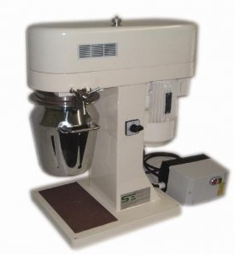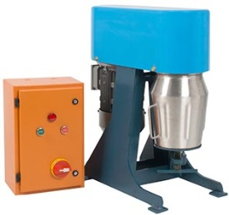  Figure 19: Cold Digestors with Bowls
Dripping Bottle:  Used for adding indicator solutions dropwise. | 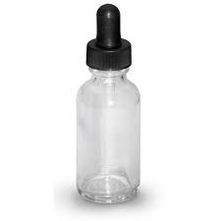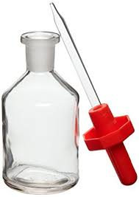  Figure 20: Dripping bottles
Erlenmeyer Flask / Conical Flask  A general purpose flask that can be heated and is used extensively during titrations. These flasks have graduations to give a rough indication of the volume of liquid contained. | 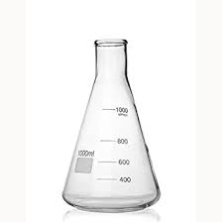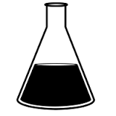  Figure 21: Erlenmeyer Flask / Conical Flask
Evaporating Basin:  Used on the steam bath (water bath) to evaporate solutions to dryness. | 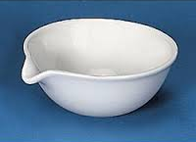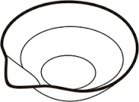  Figure 22: Evaporating Basin
Filter Paper:  Used to separate solids from liquids. The liquid travels through the paper leaving the solids behind.  The liquid (or solution) that goes through is called the filtrate, while the solids left behind on the paper is known as the residue. | 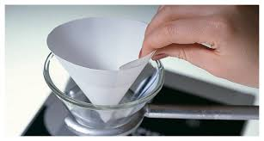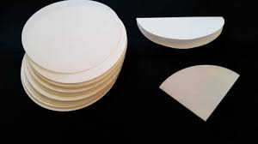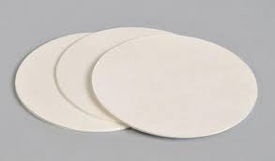  Figure 23: Filter Paper
Filter Flask / Buchner Flask:  Used to support the Buchner funnel and to catch the filtrate when doing vacuum filtrations. In order to withstand pressure variations these filter flasks are made from thicker glass than ordinary Erlenmeyer flasks. We will use 250cm³ and 500cm³ filter flasks. | 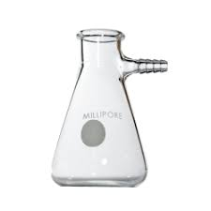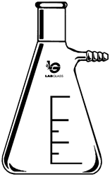  Figure 24: Filter Flask / Buchner Flask
Flask Tongs:  Used to handle hot flasks safely. | 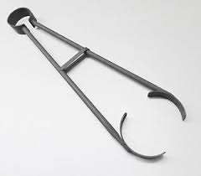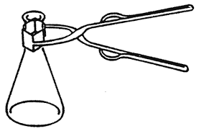  Figure 25: Flask tongs
Funnel:  Used to support filter paper during filtration or for pouring liquids into narrow-mouthed containers. | 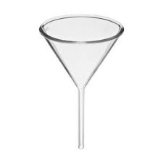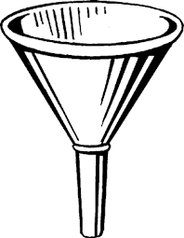  Figure 26: Funnels
Furnace Tongs:  Used when removing hot items from the muffle furnace. | 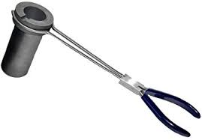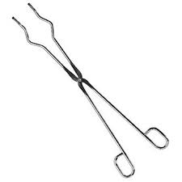  Figure 27: Furnace tongs
Glass Beads:  Some glass beads placed into a boiling liquid will promote even boiling and prevent “bumping”. | 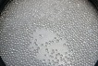  Figure 28: Glass beads
Glass Bottles / Sample bottles:  Used for mixing and storing samples. | 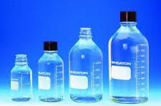  Figure 29: Glass bottles
Graduated Pipette:  A volumetric vessel used to deliver liquid according to the graduation on the pipette. We will use graduated pipettes of maximum volume 25 cm³, 10 cm³ and 5 cm³. | 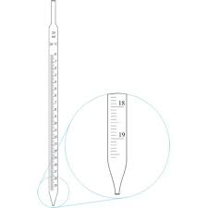  Figure 30: Graduated pipette
Kohlrausch Flask:  A wide-mouthed volumetric flask used for the preparation of solutions of filter cake and sugar pol. It is useful for applications where it is difficult to get solids into the narrow neck of an ordinary volumetric flask.  Kohlrausch flasks are rarely used for pol determinations. “Sugar flasks” are preferred. These are similar to Kohlrausch flasks, but the neck is not as wide. We use 100 ml sugar flasks for sugar pol determinations. | 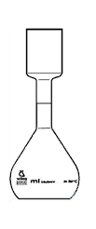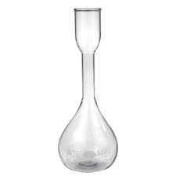  Figure 31: Kohlrausch Flasks
Large Massing Basin:  Used when massing (weighing) bagasse or cane samples. | 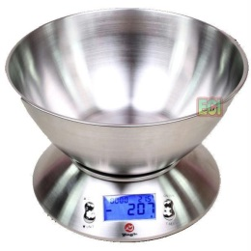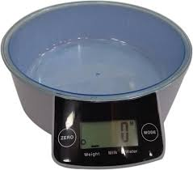  Figure 32: Large Massing Basins
Magnetic Follower:  Used with a magnetic stirrer hot plate to mix the contents of a beaker or flask. It consists of a small metal bar covered in plastic. Sometimes magnetic stirrers are also fitted to hot plates. | 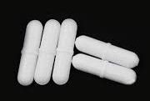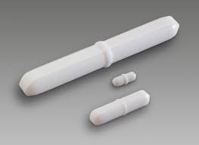  Figure 33: Magnetic Follower
Magnetic Follower Retriever:  Used to take the magnetic follower out of a beaker or flask. | 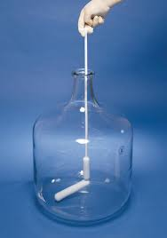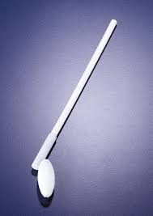  Figure 34: Magnetic Follower Retrievers
Measuring Cylinder:  Used for measuring out liquids or solutions. Measuring cylinders are more accurate than beakers but not as accurate as pipettes or burettes (i.e. volumetric glassware). | 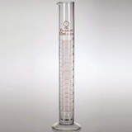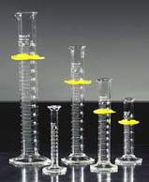  Figure 35: Measuring Cylinders
Moisture Dish:  Used to hold sugar when drying sugar in an oven for moisture determination. It consists of a stainless steel dish with a cover / lid. | 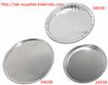  Figure 36: Moisture Dish
Mortar and Pestle:  Used to grind samples or chemicals to smaller pieces or into a powder form. | 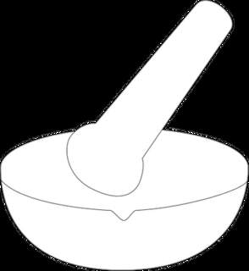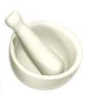  Figure 37: Mortar and Pestle
Nickel Massing Basin:  Used for general massing (weighing) of small quantities. It has a wide top with a spout to facilitate transferring its contents into another container. | 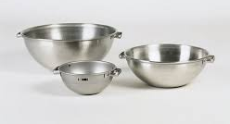  Figure 38: Nickel Massing Basins
Pinch Clips:  Used to clamp rubber tubing to act as a valve / seal. | 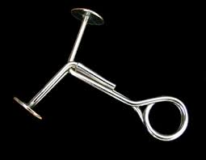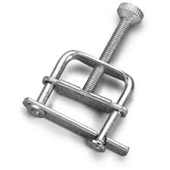  Figure 39: Pinch Clips
Pipette Filler:  Used when filling a pipette with dangerous / toxic liquids. When in any doubt as to the nature of a liquid or solution, consider it as dangerous and use a pipette filler. | 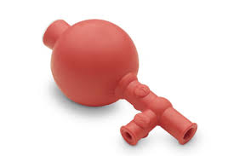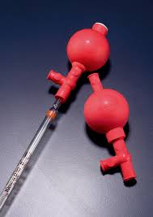  Figure 40: Pipette Filler
Pipette Stand:  Used for storage of pipettes. | 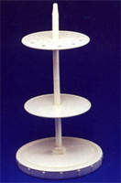  Figure 41: Pipette Stand
Plastic Jug:  Used when massing (weighing) water or measuring out approximate quantities of water. | 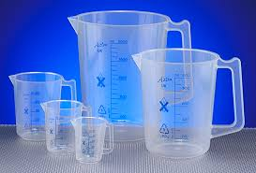  Figure 42: Plastic Jug
Policeman:  A plastic or rubber sleeve that fits over a glass stirring rod and prevents chipping and other damage. | 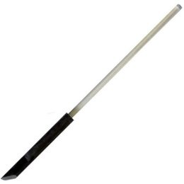  Figure 43: Policeman
Protective Mask:  To be used to protect the face and eyes against flying glass should there be the risk of explosion or implosion of glass. | 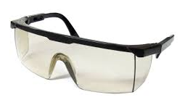  Figure 44: Protective Mask
Quick fit Erlenmeyer Flask:  An Erlenmeyer flask which has a ground glass mouth into which special ground adaptors fit to form a sealed joint. | 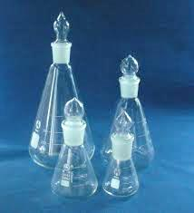  Figure 45: Quick fit Erlenmeyer Flasks
Reagent Bottle:  Used to store chemicals and solutions. They must have tight fitting tops – either plastic or glass. Screw tops are not acceptable. | 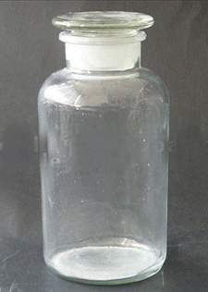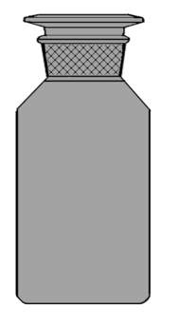  Figure 46: Reagent Bottles
Reflux Condenser / Liebig Condenser:  This apparatus fits snugly onto a quick-fit flask and is used to condense the vapour being released by the boiling solution in the flask. Its operation is very simple. Vapour moves up the central glass tube of the condenser, which is surrounded by cooling water drawn from a tap. The water enters at the bottom, swirls around the outer glass tube and exits at the top. Sometimes the cooling water flows through a coil in the centre of the condenser and the vapour is outside. | 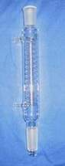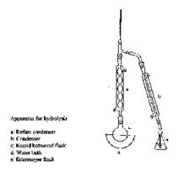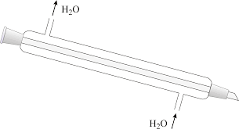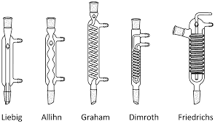  Figure 47: Reflux Condenser / Liebig Condenser
Rubber Cone:  Used when connecting a filter flask and Buchner funnel to provide a vacuum seal. The rubber cone fits into the neck of the Buchner flask. | 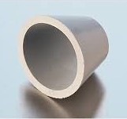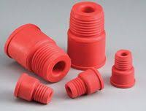  Figure 48: Rubber Cones
Rubber Stopper:  Used to close and seal the openings of flasks and bottles. | 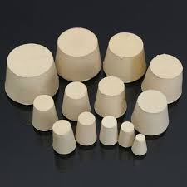  Figure 49: Rubber Stoppers
Sample Can:  Used when collecting samples from the factory. | 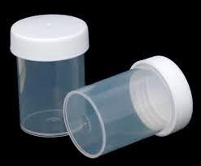  Figure 50: Sample Cans
Sample Divider / Riffle:  Used to divide a sample into two representative portions. | 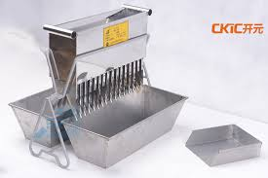  Figure 51: Sample Divider / Riffle
Sieve:  Used in sets for sieving sugar, bagacillo and for separating solid matter from juice. | 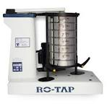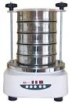  Figure 52: Sieve
Stirring Rod:  A glass rod used for mixing and stirring solutions. | 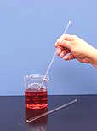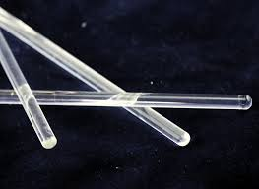  Figure 53: Stirring Rod
Spatula:  A spoon like object used for dispensing chemicals. Under no circumstances must a spatula be used to stir solutions. | 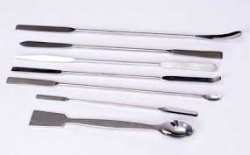  Figure 54: Spatula
Stop Clock or Interval Timer:  Used for timing a reaction or procedure. | 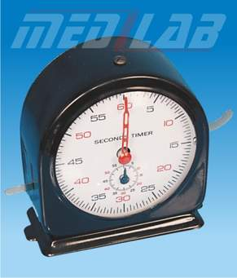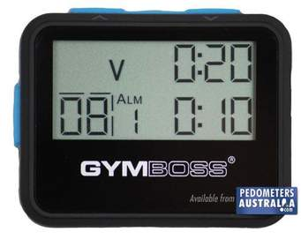  Figure 55: Stop Clock or Interval Timer
Strainer Stopper:  A rubber stopper with a sieve on it. It is used to drain off the solution after a raw sugar has been washed with alcohol prior to grain size analysis.  A strainer stopper consists of a simple rubber stopper with a hole through its centre and a piece of centrifugal screen covering one end and held in place by a rubber sleeve. When assembled the smooth part of the screen must be on the outside. | 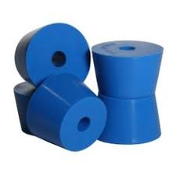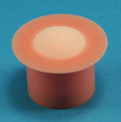  Figure 56: Strainer Stopper
Test Tube:  Used when mixing or boiling small quantities of liquids or solutions. | 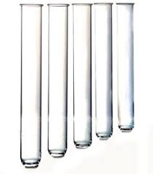  Figure 57: Test Tubes
Test Tube Brush:  Used for cleaning test tubes. | 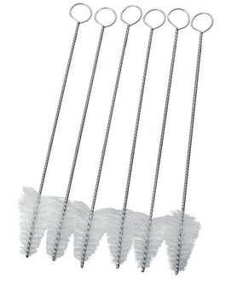  Figure 58: Test Tube Brushes
Test Tube Holder:  Used to hold hot test tubes. | 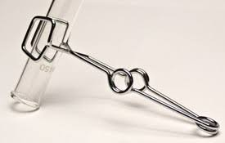  Figure 59: Test Tube Holder
Test Tube Rack:  Used to hold a number of test tubes in an upright position. | 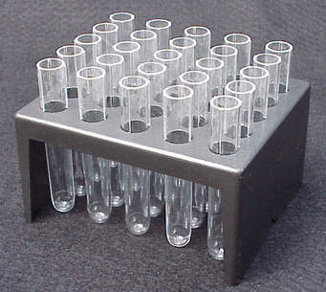  Figure 60: Test Tube Rack
Test Tube Stopper:  Used to seal a test tube. | 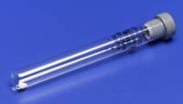  Figure 61: Test Tube Stopper
Thermometer:  Used to measure temperature. | 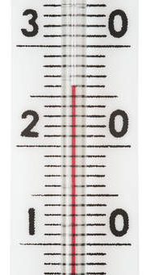  Figure 62: Thermometer
Transfer funnel:  Used to transfer cane or bagasse from the massing basin to the digestor bowl. | 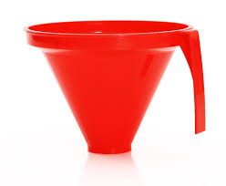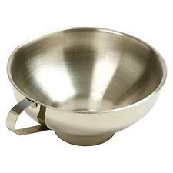  Figure 63: Transfer Funnel
Tripod:  Used to support equipment being heated by a Bunsen burner. | 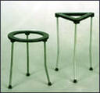  Figure 64: Tripod
Tubing:  Rubber or plastic tubing is used to connect air, vacuum or water supplies to apparatus as required. | 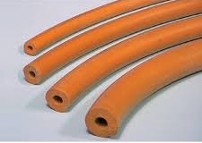  Figure 65: Tubing
Volumetric Flask:  A volumetric vessel which, when made to the mark, will contain an exact volume of the liquid / solution. We will use volumetric flasks of volume 1000 ml, 500 ml, 250 ml, 200 ml, 100 ml and 50 ml.  Note: A volumetric flask must have a stopper that fits it properly. | 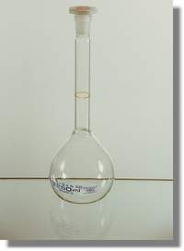  Figure 66: Volumetric Flask
Wash Bottle:  Used to deliver water in small quantities when making to the mark or when washing and rinsing glassware, we generally need to wash either with water or alcohol and hence our wash bottles must be clearly labelled accordingly. | 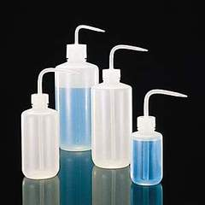  Figure 67: Wash Bottles
Watch Glass:  A glass dish used to cover beakers and funnels to minimise evaporation. These are also used to hold stoppers removed from reagent bottles to prevent them from becoming contaminated. | 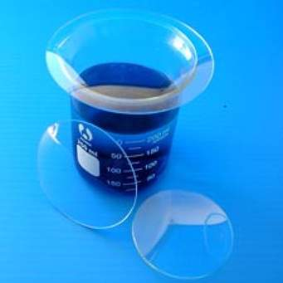  Figure 68: Watch Glass
Wire Gauze:  Used to spread the heating effect of a Bunsen flame. | 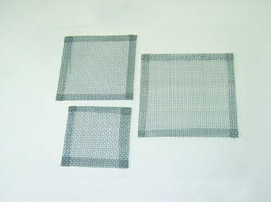  Figure 69: Wire Gauze
Wire Triangle (Clay Pipe Triangle):  Used to support a crucible on a tripod stand. | 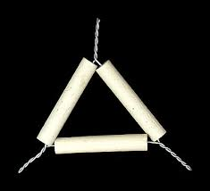  Figure 70: Wire Triangle / Clay Pipe Triangle

EQUIPMENT
DESCRIPTION OF LABORATORY EQUIPMENT | IMAGE OF LABORATORY EQUIPMENT
Analytical Balance:  Used for accurate massing (weighing) to an accuracy of 4 decimal places. The balance is enclosed so as not to be affected by draughts and must be placed on a special table. | 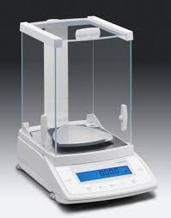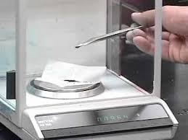  Figure 71: Analytical Balance
Automatic Polarimeter or Saccharimeter:  Measures the angle of rotation of the plane of polarised light as it passes through a sugar solution (pol). The angle of rotation is proportional to the concentration of sugar in the solution. | 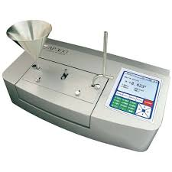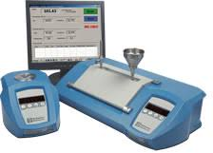  Figure 72: Automatic Polarimeter
Cane Drying Oven:  Used for drying cane and bagasse when determining their moisture content. The principle of operation is simple. The sample of prepared cane or bagasse is placed on a sieve and warm air blows from above through the sample. | 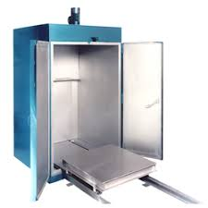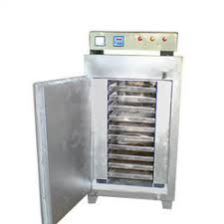  Figure 73: Cane Drying Oven
Cold Digestor:  Used to disintegrate cane and bagasse before conducting pol and brix analyses. | 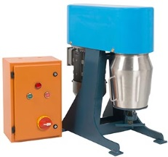  Figure 74: Cold Digestor
Conductivity Meter:  Used to measure the specific conductance of a solution. Using a calculation the conductivity of a solution can be used to determine the amount of inorganic material dissolved in the solution (conductivity ash). | 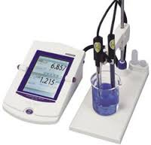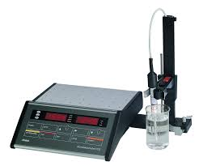Figure 75: Conductivity Meter
Constant Temperature Water Bath:  A water bath that keeps water at a constant temperature. | 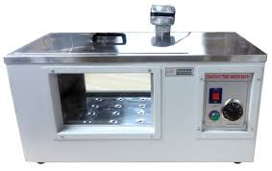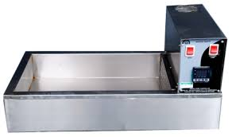  Figure 76: Constant Temperature Water Bath
De-ionizer:  Used for producing de-ionised water which is used for making up solutions and rinsing. It contains a resin that removes impurities (salts) from the water. | 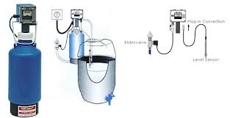  Figure 77: De-ionizer
Desiccators  These are large glass vessels containing silica gel which absorbs moisture from the air inside the desiccator. Desiccators are designed to keep the samples dry by preventing them from absorbing moisture from the atmosphere. If the gel is blue it is dry and can be used, but when pink, the gel needs to be dried in a moisture oven. | Figure 78: Desiccators
Distiller (Still):  Used for making distilled water which is used for making up solutions and rinsing. The still works on the principle of the Liebig Condenser. | 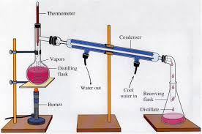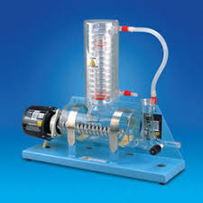  Figure 79: Distiller
Drying Rack:  A rack that allows the water to drain off apparatus that has been washed. | 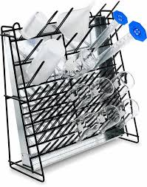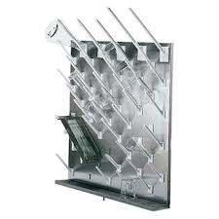  Figure 80: Drying Rack
Electronic Calculator:  Used for doing calculations. | 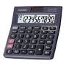  Figure 81: Electronic Calculator
Electronic Top Pan Balance:  A heavy duty balance which has the pan at the top and usually has a digital readout. It is used for massing (weighing) to 1 or 2 decimal places. | 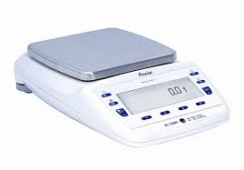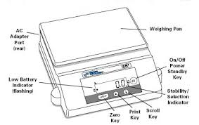  Figure 82: Top Pan Balance
Flask Shaker:  Used to shake flasks or bottles and mix the contents. It is also called a rotary motion shaker. | 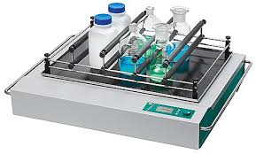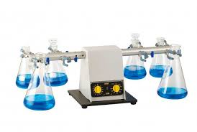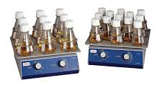  Figure 83: Flask Shaker
Fume Cupboard:  Used to extract smoke, unpleasant odours and vapours when doing various analyses. The glass door also provides eye protection when working with possibly explosive reagents. | 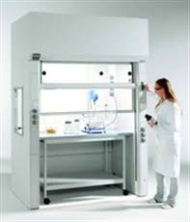  Figure 84: Fume Cupboard
Glass Drying Oven:  Used to dry glassware like beakers, watch glasses, test tubes, Erlenmeyer flasks etc. Volumetric glassware (pipettes, burettes and volumetric flasks) must never be placed in a glass drying oven. | 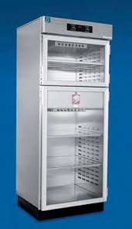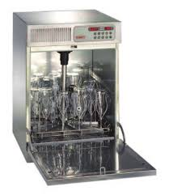  Figure 85: Glass Drying Ovens
Hot Plate:  Used for heating and boiling purposes. | 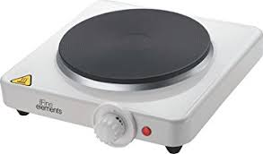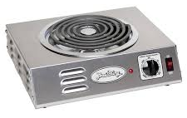  Figure 86: Hot Plates
Magnetic Stirrer hotplate:  Used for heating and stirring at the same time. | 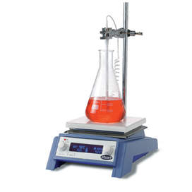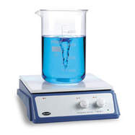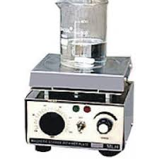  Figure 87: Magnetic Stirrer Hotplates
Moisture Oven:  Used to dry samples of sugar and filter cake so that the moisture content can be determined. Air is circulated in the oven using a fan. | 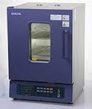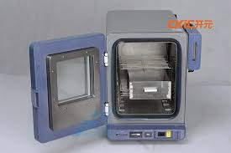  Figure 88: Moisture Oven
Monochromatic light source:  A light source that gives off light of one wavelength. A yellow sodium lamp is used to illuminate the prisms of a refractometer. | 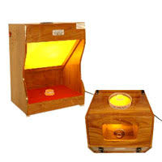  Figure 89: Monochromatic light source
Muffle Furnace:  Used to burn sugar, molasses cane, bagasse and coal completely so that the ash content can be determined. The vapours emitted are toxic hence the muffle furnace is placed in a fume cupboard. | 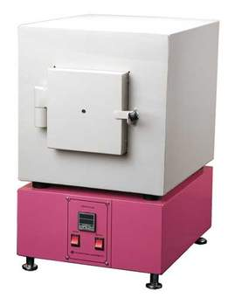  Figure 90: Muffle Furnace
Periodic Table:  A table that contains the elements according to their properties. | 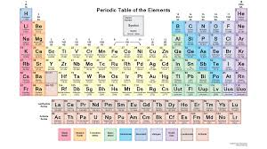  Figure 91: Periodic Table
pH Meter:  Measures the degree of acidity of alkalinity of a solution. | 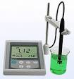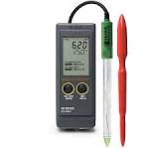  Figure 92: pH Meters
PI Tumbler or Grenfell Tumbler:  Used to tumble the cookie jar when determining the preparation index (PI) on shredded cane. The PI is a measure of what percentage of the cane cells have been broken to allow for juice extraction. | 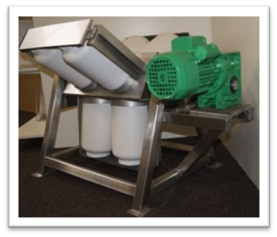  Figure 93: PI Tumbler
Refractometer / Precision Refractometer:  Measures the angle of refraction (bending) of light passing through a sucrose solution. We use the Zeiss precision refractometer. The angle of refraction is proportional to the concentration of dissolved substances in the solution (Brix). | 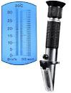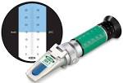  Figure 94: Refractometers
Refrigerator:  Used for keeping samples and solutions cool to prevent deterioration. | 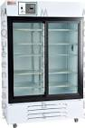  Figure 95: Refrigerator
Refrigerator Water Bath:  A bath fitted with a refrigerated cooler. | 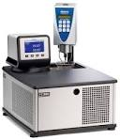  Figure 96: Refrigerator Water Bath
Sample Buckets:  For collecting cane, bagasse etc. from the factory. | 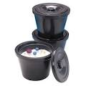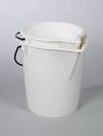  Figure 97: Sample buckets
Sieve Shakers:  Used for shaking sets of sieve to separate a sample into its different particle sizes. | 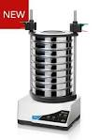  Figure 98: Sieve Shakers
Spectrophotometer:  Measures the light absorbed by a solution. The spectrophotometer contains a prism that splits white light into its spectrum. By selecting a certain wavelength e.g. 460 mm you select a light colour which is then passed through the sample and the absorbance measured.  For example:  During determination of the phosphate content of a sample, chemicals are added that cause the solution to be coloured blue according to the phosphate content, the greater the phosphate content, the more blue the solution and hence the greater the amount of light absorbed by the solution. The spectrophotometer is also used for the determination of colour, starch and sugar traces. | 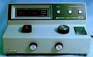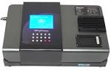  Figure 99: Spectrophotometers
Steam bath / Water bath  A Steam bath / water bath is used to evaporate samples in an evaporating basin to dryness.  Note: When placing an evaporating basin in the water bath, just enough rings should be removed so that the basin sits snugly. | 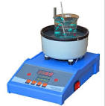  Figure 100: Steam Bath
Vacuum oven:  Used to dry samples at temperatures lower than 1000C (Also known as a freeze dryer). | 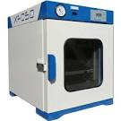  Figure 101: Vacuum Oven

Knowledge Topic 2: Specific Laboratory Techniques

INTRODUCTION
Quality control in manufacturing processes is conducted by analysis. Many large firms have their own testing laboratories in the same way as the sugar industry.
The main purposes of the laboratory are:
  - To control the process
  - To detect and indicate the extent of the losses
  - To supply management with information for financial and administrative purposes
  - To enable comparisons with other mills

SAMPLING
All stages of laboratory work from sampling to analysis are vitally important. Samples must be representative of the material being sampled.
Definition: A small part or quantity intended to show what the whole is like.
A sample is a portion of bulk material that can be conveniently analysed e.g. cane.
A representative sample is a true reflection of the bulk material. A biased sample is a sample that is not representative. It is pointless to analyse perfectly a sample that is not representative or to sample and analyse perfectly and then make errors in the calculation of results.
Some things to remember when sampling
- When taking a sample of product (say juice) ensure that you have not included some stagnant (“old”) product that may have been trapped in the sampling pipe.
- Beware of using containers and lids that are contaminated i.e. dirty or wet.
- Do not leave samples to stand as they will deteriorate due to chemical and bacterial degradation.
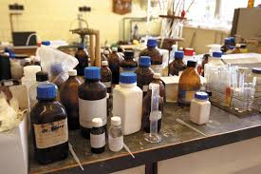
- Keep samples covered so that they do not lose moisture to the atmosphere or become contaminated with dirt and other substances (Use an up-side down watch glass for this purpose – if the vesicle is small enough - or keep the sampling container lid closed until analysis).
- Before sub-sampling a product for analysis, mix it thoroughly first since many products contain substances that settle to the bottom. Taking a quantity from the top would then yield a biased sample. Examples are: juice, massecuite, molasses, sugar etc.
An untidy laboratory
The operation of a laboratory revolves around sound technique, and for the laboratory to be successful, the laboratory worker must pay attention to detail and correctness of technique. The laboratory does not depend on the size of the building or the extent of instrumentation but on correctness of technique. Correct analytical methods and techniques have been designed to give the best possible result. An analyst cannot change or modify the technique in any way as this will introduce possible errors.
The laboratory worker must develop good habits. An interested and enthusiastic worker will develop neatness and orderliness of thought as well as action. He / she will always use the correct techniques and will develop patience, self-confidence and integrity.
A good laboratory worker produces both precise and accurate results.
Let us illustrate the differences using a dartboard as an analogy. The bull’s eye is the desired target.
Accuracy involves getting the right / correct result.
Precision is a measure of how close to each other your different results are. If you are consistent in your methodology and your sampling is representative then your results will be close to each other.
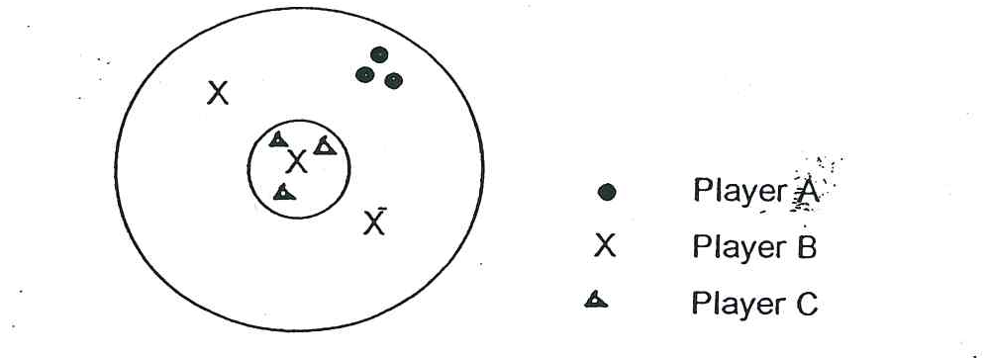
Player A is precise but not accurate.
Player B is not precise but he is accurate, since the average of his 3 throws is in the bull.
Player C is precise and accurate.

CLEANLINESS
A large number of instruments and pieces of apparatus are at the disposal of the laboratory worker and if these are not used correctly the results produced will be meaningless. All apparatus must be clean before use. Dirty apparatus will contaminate the new sample being analysed thus wasting both time and effort. Glassware is best cleaned with Teepol, Extran or other detergents.
To test for cleanliness of a glass vessel the following procedure should be adopted.
- Place only enough distilled water into the vessel so that, when it is swirled, the entire inner surface is wetted.
- Swirl the vessel.
- Empty the water from the vessel.
- If the water remains as an unbroken film on the glass, the vessel is clean. If the water collects in drops, the vessel is dirty.
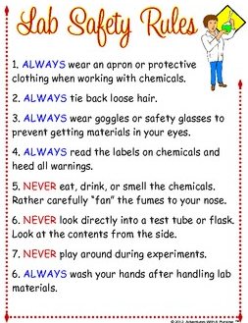
Each laboratory worker must have a clean glass cloth, ordinary towel and a swipe. The glass cloth is used to dry apparatus, while the towel is used to dry one’s hands. When working it may be convenient to keep the glass cloth handy by draping it over your shoulder. This is quite acceptable but the glass cloth must never be placed so that it rubs against your neck. This will cause it to become greasy. The swipe is used exclusively to clean spillages and to wipe the bench.
Instruments must be treated with care and handled gently as they are delicate. They must be used in accordance with the instructions supplied by the manufacturer. Liquids and powders spilt on instruments (or anywhere else) must be cleaned up immediately. Dirt accumulated on instruments reduces their lifespan. Repairing and overhauling laboratory equipment is very costly. Looking after the equipment and the apparatus at your disposal will lead to consistent and reliable results.
Precautions when using glassware:
- Do not overheat or cool suddenly.
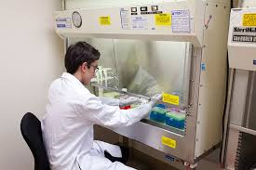
- Do not apply excessive pressure as the glass could shatter.
Adhere to Lab Safety Rules
- Do not force glassware.
- Do not apply vacuum unless the glassware is designed to be used under vacuum.
- Use a protective screen where there is possibility of explosion or implosion, for example when vacuum is applied to an ordinary Erlenmeyer flask.
Work behind glass to protect eyes
- Protect your hands when cutting or breaking glass tubing.
- When fitting glass tubing into a rubber, polish the ends (round end in flame), lubricate with glycerine or vaseline and hold the glass with a cloth in order to protect your hands in case of accidental breakage.
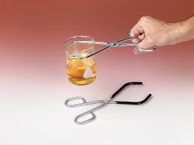
- If glass is broken, it must not be picked up with your hands, but with a brush and pan. For very fine splinters, a wet tissue may be used. Broken glassware must not be thrown into a bin where other people could get cut handling the glass. It must be wrapped in paper first. A specially designated bin must be set aside for broken glassware.
- Do not use cracked or broken glassware.
- Do not use dirty glassware.
- Handle hot items with tongs.
- Never leave vessels unattended when evaporation work is in progress. If the heat source is not adjusted correctly the vessel may crack or explode as dryness is approached. The temperature should be lowered gradually as the liquid level drops.
Handle hot items with tongs
- Caution should be exercised when removing glassware from a heat source and it must never be placed onto a cold or damp surface. Sudden temperature changes may cause the vessel to break.
- Heat must never be applied to a badly scratched or etched vessel as the thermal strength will have been greatly reduced.
- A point source of heating (Bunsen flame) must never be applied directly to a vessel as this will greatly increase the chance of breakage. A wire gauze needs to be used to distribute the heat across a greater area.
- When very hot items have been removed from the muffle furnace, the heat should always be reduced by placing on a metal gauze or asbestos mat before placing them into a desiccator.
- Heat vessels by slow movement of the vessel across to the heat source to ensure even heating.
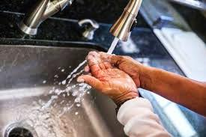
- Anti-bumping devices, such as powdered pumice or glass beads, should be used in the vessel, when rapid heating is required. Material with sharp edges such as broken porcelain must NOT be used as an anti-bumping device. This will cause internal abrasion and reduce the mechanical and thermal strength of the vessel.
Wash hands regularly
Wire guaze distributes heat
- Glassware must be dry before being placed on a hot plate.

DERMATITIS
This is one of the most common occupational diseases. It is an inflammation of the skin, caused by dust, liquid or other external agents. Some people’s skins are more sensitive than others and may be temporarily or permanently sensitive to one or more substances at work. The best preventative measure against dermatitis is cleanliness. By keeping one’s hands clean and dry the possibility of dermatitis will be reduced.

CHEMICALS
Dangerous Substances | Examples
Concentrated acids and alkalis | Sulphuric acid, chromic acid, sodium hydroxide
Poisons  i.e. substances containing lead, mercury, barium, phenol, bromine and cyanide | Basic lead acetate, mercury chloride.
Strong oxidants | Calcium hypochloride.

Always treat unknown chemicals as dangerous. If a spillage or accidental contact takes place consult the safety chart for emergency precautions. When chemicals come in contact with the skin, it must be washed off immediately.
Remember:
Never drink from a beaker. A beaker left in a laboratory for drinking is a potential danger.
Always add acid or alkali to water never the other way around.
Never put your fingers into chemicals.
Always wash your hands after working and before eating, drinking or smoking.
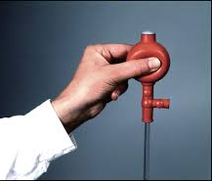
Use protective clothing when necessary, but the wearing of protective clothing does not mean that the other safety rules and practices can be disregarded, for example, when pipetting dangerous liquids, a pipette filler must always be used.
Use a pipette filler
Drops on the outside of bottles should be considered dangerous, particularly with strong acids. The outside of the bottle must be washed with lots of water. Do not put stoppers on the bench top where someone else may come into contact with the acid residue (use a watch glass). Always pour from the side away from the label so that the writing on the side does not become illegible.
Special care is necessary when dealing with mercury. Even a small amount can poison the atmosphere of a room. All mercury containers should be well stoppered and labelled. When working with very toxic substances always use a protective mask or respirator and where possible carry out work in a fume cupboard.

GASES
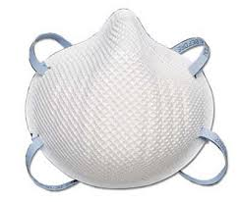
Poisonous gases like chlorine and ammonia and inflammable vapours of ether, chloroform, acetone and alcohol must be treated extremely carefully. A fume cupboard must be used to prevent the gas entering the laboratory. Flammable vapours and gases should only be used in a room with no naked lights or hot plates - an explosion could easily occur. No smoking is allowed in the laboratory for this reason.
Wear a mask when working with fumes

ACCIDENTS WITH CHEMICALS
In the sugar analytical laboratory several potentially harmful chemicals and acids are used. Should an accident occur, the following measures should be followed:
- Acids: If the acids have been in contact with the eyes, mouth or skin, wash with large amounts of water. Blisters and burns must receive medical attention.
- Lead acetate: If swallowed, wash out the mouth thoroughly with water. Have plenty of water to drink, followed by two tablespoons of Epson salts in water. Obtain medical attention.
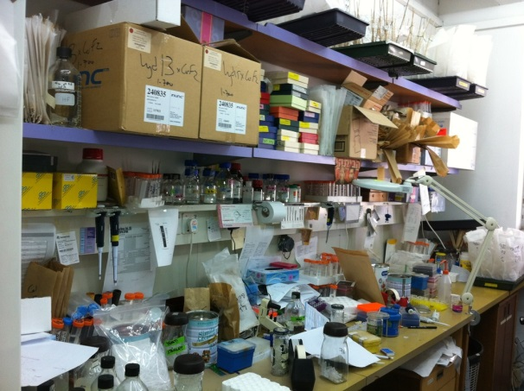
- Juice preservative (mercuric chloride): If eye is contaminated rinse thoroughly with water. Where splashing or direct contact has occurred, obtain medical attention. If the skin is contaminated, drench the skin with water. Then wash thoroughly with soap and water. Remove clothing that has been contaminated and wash before re-use. If swallowed, wash out the mouth thoroughly and have a large quantity of milk to drink.

HOUSEKEEPING
Housekeeping means having a place for everything and keeping everything in its place at all times.
Good housekeeping:
If the laboratory is kept clean and neat:
- Time will be saved.
Another untidy laboratory
- More space will be provided.
- Injuries will be reduced /avoided.
- Fire risk will be reduced.
- Damage to equipment will be reduced.
- Analytical results will improve.
The laboratory will be a far better place to work in and results will improve if you ALWAYS.
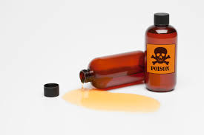
- Keep your work area clean.
- Clear spillages promptly.
- Keep your apparatus and equipment clean.
Poor housekeeping:
Clean spills immediately
Poor housekeeping results in:
- People tripping over loose objects on floors.
- People slipping on greasy, wet or dirty floors.
- People walking into projecting, poorly stacked or badly placed articles.
- Hands or other parts of the body cut on projecting nails, splinters, wire, etc.
- Apparatus being damaged and broken due to work areas being cluttered.

READING LIQUID LEVELS AND MAKING TO MARK
A meniscus is the shape that a liquid assumes on its surface. It is most easily seen in narrow tubes.
When reading a liquid level, the eye must be level with the bottom of the meniscus. If this is not done, the error of parallax occurs.
The precautions to be taken when reading a liquid level are:
- The vessel must be held vertically (i.e. straight up).
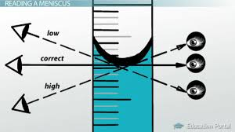
- The eye must be level with the bottom of the meniscus.
- The position of the bottom of the meniscus must be determined relative to the closest scale marking.
The eye must be level with the bottom of the meniscus
Water forms a hollow (concave) surface while syrup or mercury forms a heaped (convex) surface.
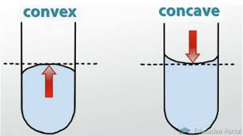
If you look at the liquid surface from the side it appears to be a thick band due to the fact that the liquid “curls up” against the glass.
The curved surface (meniscus) of a liquid is more pronounced the narrower the container.
The precautions to be taken when making to mark are:
Convex versus concave

- The vessel must be held vertically.
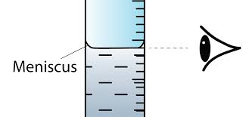
- The eye must be level with the graduation mark. When the eye is at the correct position a circular graduation mark will appear as a single line.
- The bottom of the meniscus must be brought to coincide with the graduation mark. The circular graduation mark becomes the straight line tangent to the curve at the surface of the liquid. Identifying the bottom of the meniscus accurately is of prime importance. It is a skill that may initially require some practice since the meniscus appears to consist of several layers, the bottom being absolutely clear. To assist accurate readings the meniscus can be highlighted using a strip of darkly coloured paper about 6 cm long to 2 cm wide.
Correct reading of the mark
Method
Hold the coloured paper behind the flask on the far side of the meniscus and about 1 mm below what you judge to be the bottom of the meniscus. The paper used will colour the bottom of the meniscus so that it appears as a coloured line. After a bit of practice the coloured paper will no longer be necessary.
When making to the mark a wash bottle may only be used to bring the meniscus close to the graduation mark. To bring the meniscus up to the mark a pipette or medicine dropper must be used. A pipette can be used to produce drops of widely varying size.

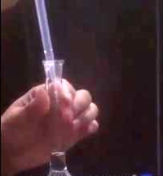
TEMPERATURE
Temperature is of great importance when working with volumetric glassware. Most glassware is graduated at 20˚C (etched on the vessel) and the vessel will contain or deliver that volume of liquid only at 20˚C. This is because glass expands and contracts with differences in temperature, thus its volume will be correct only at the temperature at which it is calibrated (normally 20˚C).
To prevent your hands heating the volumetric flask and hence affecting its accuracy always hold the flask by the neck using the tips of the thumb, first and second fingers.
Holding a volumetric flask
Exercise:
- Take two volumetric flasks of different volume, make each to the mark with water and stopper.
- Show your instructor to receive confirmation that you have made to the mark accurately.
- Place your volumetric flask in the refrigerator for an hour and then inspect the meniscus. You will notice that the meniscus is now below the graduation mark. Allow the volumetric flask to attain room temperature.
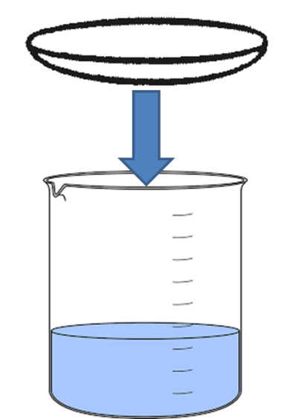
- Heat the volumetric flasks in warm water. Notice that the meniscus will now be above the graduation mark.

WATCH GLASSES
When gravity filtrations are done or solutions are left standing, a watch glass must be used at all times.
- When covering beakers containing samples / solutions, the watch glass must be placed concave side up as shown in the diagram to the right. Vapour emitted will then condense on the watch glass and form droplets that will run down and drop back into the solution.
Covering a beaker with a watch glass
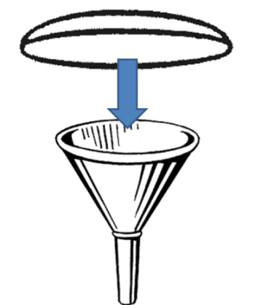
During gravity filtration (e.g. pol and brix) the top of the filtering funnel must be covered with a watch glass with the convex side up as shown to the left. This is done so that the watch glass is not partly immersed in the solution / residue on the filter paper.
- When removing a watch glass from a gravity filtration, place it on the desk with the concave side up as follows:
Covering a funnel with a watch glass
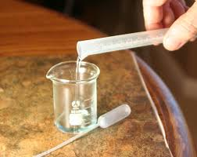

Placing a watch glass on a work bench

REAGENT BOTTLES
The following points must be borne in mind when dispensing from a reagent bottle:
- Estimate how much reagent will be needed before the reagent bottle is opened. Have a suitable beaker and watch glass or piece of paper ready on which to place the lid or stopper.
First dispense into smaller vessels
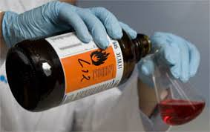
- When pouring out of the bottle the label must face the palm or to the side. This is done so that any liquid remaining on the lip of the bottle will not drain onto the label and damage it.
Pour away from the reagent label
- The bottle must not be left opened for longer than is absolutely necessary.
- No unused portion of a reagent may be returned to the bottle. This will avoid contamination of the good reagent in the bottle.
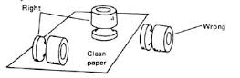
- The stopper of a reagent bottle must NEVER be placed on the shelf or on the work bench. It must be placed on a clean watch glass or clean piece of paper or held between the thumb and fingers of one hand. The watch glass must be washed afterwards.
Don't place stoppers directly on workbench
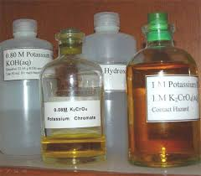
- Never insert a pipette into the reagent bottle. Always pour from the bottle into a beaker, and pipette from the beaker.
- Stopper the bottle immediately after the reagent has been dispensed.
- Keep the reagent bottle absolutely clean, especially round the neck and mouth of the bottle.
Label all reagent bottles clearly
- All bottles must be labelled.

THERMOMETERS
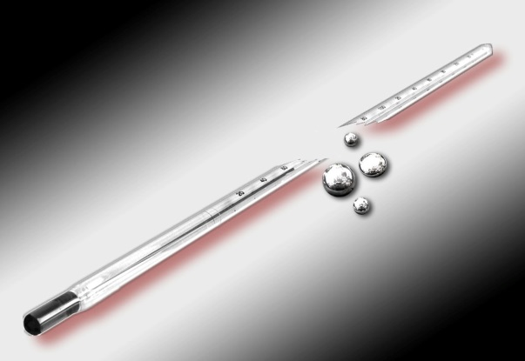
Thermometers are delicate instruments and must be handled with great care. The following must be kept in mind when using a thermometer:
Thermometers break when used for stirring: DON’T!
- When measuring temperature hold the thermometer at the uppermost end so that heat transfer from the hand will not affect the reading.
- Never use a thermometer as a stirring rod.

WASH BOTTLES
All wash bottles must be clearly labelled e.g. distilled water or de-ionised water, and reserved for that wash liquid only. Never interchange the contents or labels of bottles. The purpose of the fine jet is to deliver a fine stream of water. Under no circumstances must the fine jet be removed. Hot liquids must never be used in a polythene wash bottle.

DESICCATORS
When substances have been dried by heating (e.g. moisture determination of sugar in a drying oven or ash determination of final molasses in a muffle furnace) they should not be left exposed to the atmosphere, as they will absorb moisture and give incorrect results. For this reason, these substances are stored in a desiccator which is a covered glass container specially designed for storing substances in a dry atmosphere.
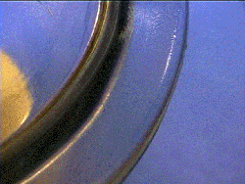
The desiccator is usually charged with some drying agent such as anhydrous calcium chloride, silica gel, activated alumina or anhydrous calcium sulphate. Silica gel has self-indicating colour (blue when dry and pink when wet). The colour changes from blue to pink when the desiccant is exhausted. The exhausted material can be regenerated by heating in an electric oven at 150˚C – 180˚c and reused.
Place vaseline on lid edge for an airtight seal
The ground edge of the desiccator should be lightly coated with white vaseline or a special grease to make it air tight. Do not use too much grease, as this can cause the lid to slide off. When opening the desiccator, slide off the lid very slowly. If opened too quickly, the sudden in-rush of air may blow out part of the sample from the desiccator.
The desiccator must always be kept spotlessly clean. The lid of the desiccator may never be placed on the work bench or shelf where the ground glass joint could become contaminated with dirt. Some desiccators are fitted with a vacuum breaker valve in the lid. Special care is needed when handling the lid, otherwise the stopper remains in your hand while the lid itself falls.
When a heated sample is initially placed into a desiccator the lid or the vacuum valve on the lid must be left slightly open for a few minutes so that hot air can escape. When the lid is closed and the air cools, the air will contract and cause a slight vacuum that will seal the lid.
Some desiccators are fitted with a pressure release valve. This consists of a stopper fitting into a hole in the lid. The stopper has a hole in one side that connects to a hole in the centre of the stopper which is exposed to the atmosphere. The lid has a groove halfway along the side of the hole.
When turned to a specific position air can move from the inside of the desiccator, up the groove in the lid, into the hole in the stopper and up through the stopper into the atmosphere.
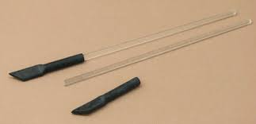
When the stopper is turned 90˚, the smooth side of the desiccator blocks and seals the hole. If this special glass stopper is lost or broken, the desiccator can be sealed with a rubber stopper or a rubber stopper fitted with a glass tap.

STIRRING RODS
If they are made in the laboratory, both ends of the glass rod should be rounded off in a Bunsen flame. If bought ready-made they come with their ends rounded off. If not rounded off, the sharp edges can break off and contaminate a sample, lead to injury or scratch the beaker. It is best to use a policeman at all times.
Use policemen on stirring rods to avoid breakage
To break a glass rod, mark the rod at the place that you want it to break using a file, hold the rod (in a cloth) at equal distances from the mark and break.

REPORT OF WORK DONE
A report is a written statement of the work that you have produced. It is a reflection of the analyst’s capabilities; a neat and clean report is thus a good reflection on the analyst and the work that he / she has produced. The work that is carried out in a laboratory is vital to the efficient running of the sugar factory.
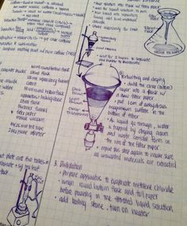
If a report is lost the results are either lost forever or the work has to be redone. This represents a waste of time and money. If the report is incomplete the work may have to be repeated – also a waste of time and money. The report produced must be everlasting (in a book or recognised work sheet), not on scraps of filter paper or scrap pads which can be lost or have their pages torn out. The record must contain all relevant information set out in such a way that it is easily read and understood. It must be neat and it must be a true reflection of the work that has been done. The report must include the following:
- Details of sample
- Date
- Name of analyst
- Objective of work
An artistic touch is not necessary although delightful
- Record of all masses, volumes or any other measurement
- Standard method reference
- Signature
A portion of the page must be ruled off for rough work. Neatness is important. A neat report shows a neat character. A messy report shows a messy character. When an error is made on the report it must NOT be rubbed out. A single line must be drawn through it and the correction written above or below. Never over-write to make corrections. Laboratory equipment is linked to the laboratory computer network, hence making the use of a notebook obsolete in many cases. However, a notebook must still be kept handy.

STANDARD METHODS
A standard method is a written analytical procedure. Different methods of analysis will result in slightly different results. The difference might not be great, but there will be a difference. In our sugar industry with its 16 factories, where it is desirable to compare results, this would not be possible if each factory did their analysis in a different way.
The sugar industry compiled a Laboratory Manual that contains all the standard methods as approved by the Chemical Control Committee. If each factory runs its laboratory as recommended their results will be comparable to each other. It follows that standard methods must be adhered to.

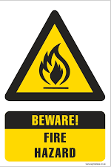
SAFETY AND FIRE HAZARD
Laboratories are fire hazard areas

Fire
For a fire to burn, three conditions must be met
- A fuel must be present
- Heat must be present
- Oxygen must be present
Fuels can occur in a variety of forms.
- Solid fuels: coal, wood, paper, bagasse, sugar
It is very important to note that water may only be used to douse Class A fires.

Using water on Class B, C or D fires will be disastrous as it will aggravate the situation.
- Liquid fuels: paraffin, spirits, oil, petrol, alcohol, acetone etc.
- Gaseous fuels: acetylene, “cadac”, methane, hydrogen etc.
Sources of heat include:
- Open flame; Bunsen burner, matches, lighter
- Heating element: hot plates
- Spontaneous ignition: phosphorus exposed to air
- Explosions: sugar dust
Types of fires:
- Class A: Caused by solids like wood, paper, coal, grass etc.
  - To extinguish: Water or chemical extinguishers (contains powder) may be used
- Class B: Caused by liquids like petrol, oil, paraffin, paint etc.
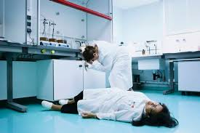
  - To extinguish: A dry chemical extinguisher must be used
- Class C: Electrical fires.
  - To extinguish: A dry chemical extinguisher or carbon dioxide may be used.
- Class D: Caused by reactive metals like sodium, aluminium etc.
Accidents can happen in a laboratory
  - To extinguish: A dry chemical extinguisher or carbon dioxide may be used.
Precautions that need to be taken to prevent fires:

- Be alert
- Rubbish bins should be clearly designated for different substances i.e. paper, glass, rags.
- Keep the work area clean.
- Limit dust.

Accidents
Report all accidents immediately
An accident is an unplanned and uncontrolled incident caused by an unsafe act or unsafe conditions.
NOSA inspects industrial installations and assigns a star rating from 1 to 5 stars based on the factory’s safety record. It is very important to always be aware of the importance of maintaining safe working conditions and practices. Unsafe or dangerous practices / conditions must be reported immediately so that they can be rectified.
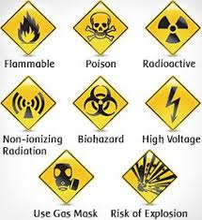
The many dangers in a laboratory
Knowledge Topic 3: Arithmetical Calculations

INTRODUCTION
Elementary arithmetic deals with:
  - Numbers
  - Calculation rules
  - Structure of mathematics
  - Solving Problems

TERMINOLOGY
5 is a DIGIT.
+, -, × and ÷ are OPERATION SIGNS
=, >, <, ≡ are RELATIONSHIP SIGNS

THE NUMBER CONCEPT
A DIGIT is a SYMBOL, which is used to represent a number.
There are 10 symbols altogether. They are:
0,1,2,3,4,5,6,7,8,9,
To write down the number 27 the digits 2 and 7 are used.
The representation of a number by digits is called a NUMERAL.
27 is a NUMERAL, 2 and 7 are DIGITS
NUMBER is a CONCEPT (an idea, notion, invention).

WRITING DOWN NUMBERS
The value of a digit is determined by its position.
e.g. units - U
tens - T
hundreds - H
thousands - TH
ten thousands - TTH and so on
Example:
In the number 2341
- 2 represents thousands
- 3 represents hundreds
- 4 represents tens
- 1 represents a unit

CALCULATIONS RULES
Calculations must always be done according to the priority of the operation sign. The order of priority is as follows:
- Brackets
- Of (means multiply)
- Division - working from the left
- Multiplication – working from the left
- Addition – working from the left
- Subtraction – working from the left
Example:
26 – ((6 ÷ 3) + 2)
= 26 – (2 + 2)
= 26 – 4
= 22
Without the second brackets this equation would be:
26 – (6 ÷ 3) + 2
= 26 – 2 + 2
= 26 – 0
= 26

ADDITION
The meaning of addition is the bringing together of objects of the same kind or calculating the sum.
Take the situation where there are 3 boys and 4 girls on bicycles. How many bicycles are there?
3 bicycles + 4 bicycles = 7 bicycles
But: 3 boys + 4 girls = 3 boys + 4 girls
Remember:
Only quantities of the same kind can be added or subtracted from each other. In our example above the 3 bicycles and 4 bicycles were added to give 7 bicycles. But the 3 boys and 4 girls will still give us 3 boys and 4 girls.
The order in which addition is done is as follows:
first add the units
then add the tens
then add the hundreds
and so on
Example:
Calculate the addition of 2 379 and 1 234
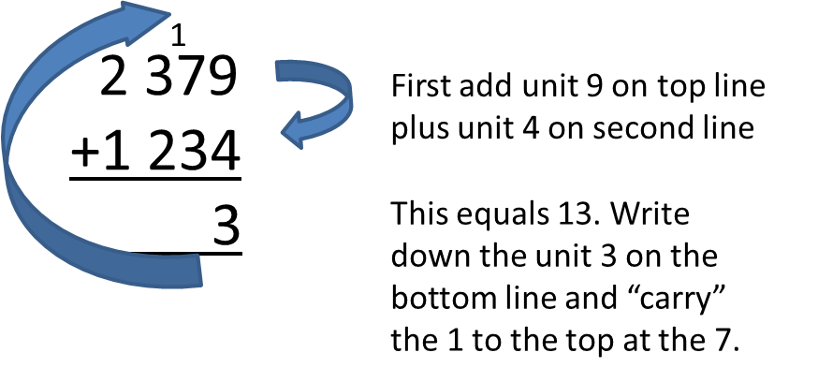
Then,
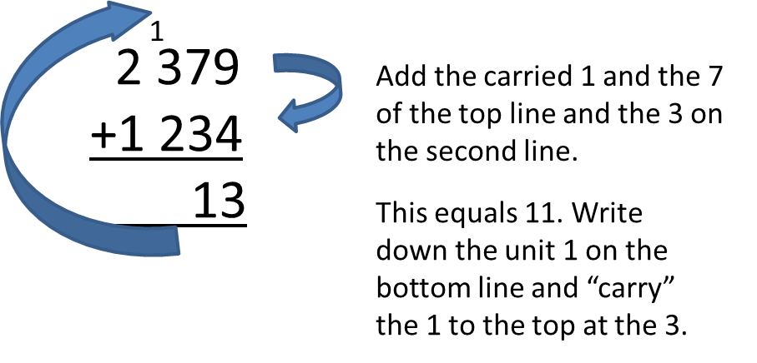
Then,
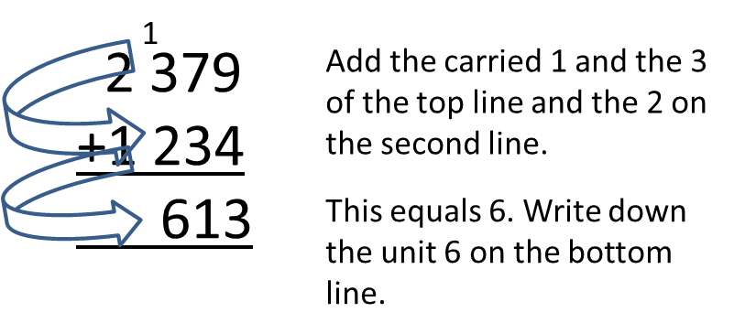
Finally,
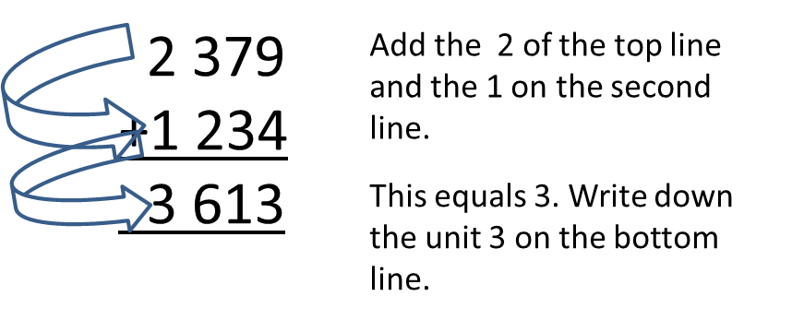

SUBTRACTION
Subtraction means “take away” or “separate” or “calculate the difference”.
Subtraction is the INVERSE OPERATION of addition.
11 – 3 = 8 (That means: 8 + 3 = 11)
Note that in subtraction only quantities of the same kind can be subtracted from each other as is the case with addition.
11 apples – 3 apples = 8 apples
11 apples – 3 pears = 11 apples – 3 pears

INTEGERS
An integer is any number that is not a fraction or that is not a decimal number. In other words an integer is any whole number. There are numbers less than zero (i.e. -1, -2, -3….) known as negative numbers. These numbers can be represented as follows on a number line:
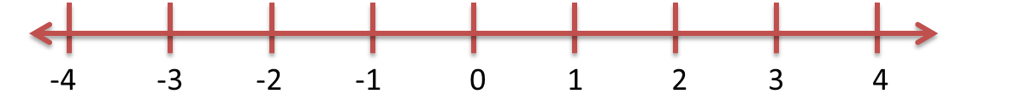
Note: When we write a positive number like +4 we usually omit the + sign and write just 4.
Think of positive and negative numbers as follows:
If you have a bank account and you have diligently saved R 500 you now have R 500 and this is indicated on your bank statement as +500 or just 500.
If you have no money in the bank, your balance on the statement is R 0.
If you borrow R 500 from the bank on your chequebook overdraft to go on a train trip, you will OWE the bank R 500 and this is indicated on your statement as –R 500.
You will then have to give the bank R 500 to get your account to zero.

Adding positive and negative numbers
Addition can be represented on the number line as follows:
Example:
(+5) + (-7)
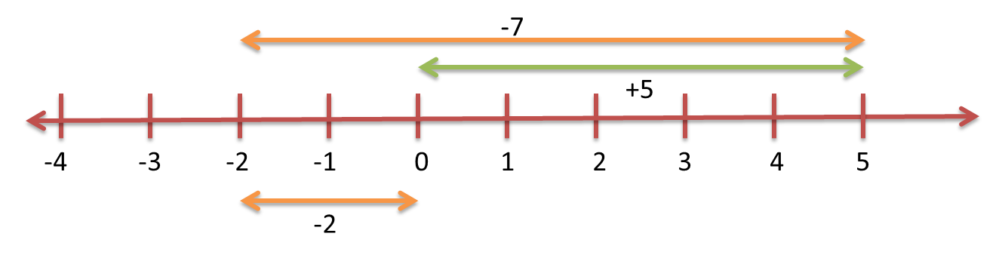
Thus,
(+5) + (-7) = -2
Or simply say: I have 5, I owe 7, so I still owe -2.

Subtracting positive and negative numbers
When we subtract a negative number, we change the sign of the number and then add that number:
For example:
5 – (+3) is the same as 5 + (-3) = +2
-5 – (-3) is the same as -5 + (+3) = -2
-5 – (+3) is the same as -5 + (-3) = -8

MULTIPLICATION
Multiplication is the repeated addition of the same number.

Multiplication terminology
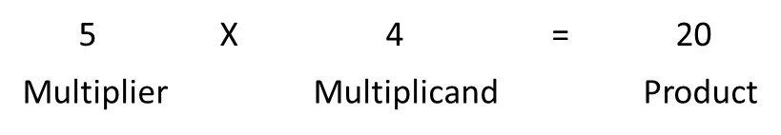
Thus, the product of 5 and 4 is 20.

Important rules
- 0 multiplied by a number is ALWAYS i.e. 345 x 0 = 0
- 1 times a number is always that same number i.e. 2 345 x 1 = 2 345
- If 2 × 3 = 6 then 3 × 2 = 6
- A positive number (+) × a positive number (+) = a positive number (+) i.e. 4 x 3 = 12
- A positive number (+) × a negative number (-) = a negative number (-) i.e. 4 x -3 = -12
- A negative number (-) × a negative number (-) = a positive number (+) i.e. -4 x -3 = 12
Multiplication is important in our everyday work. Working in conjunction with division, we work out percentages (%).
Multiplication examples:
237 multiplied by 5 is calculated as follows:
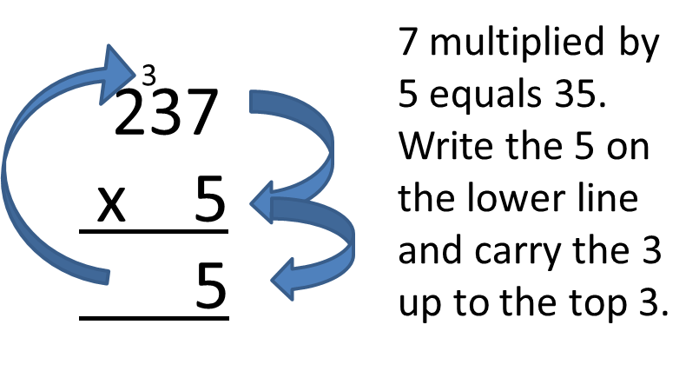
Then,
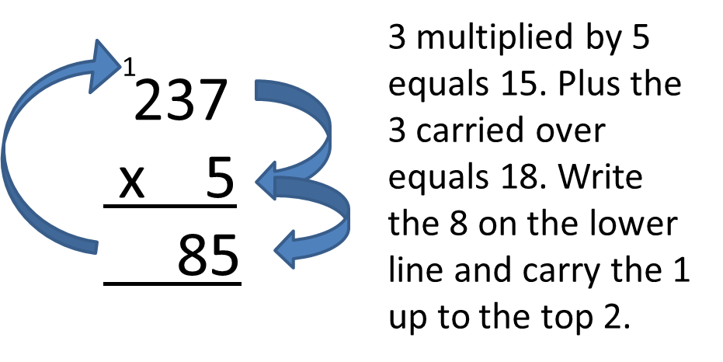
Finally,
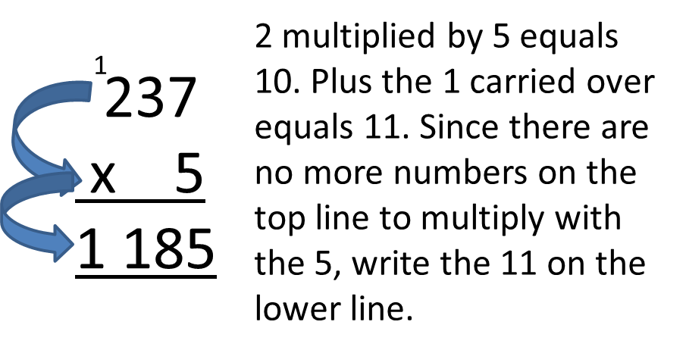
Similarly, 237 multiplied by 35 is calculated as follows:
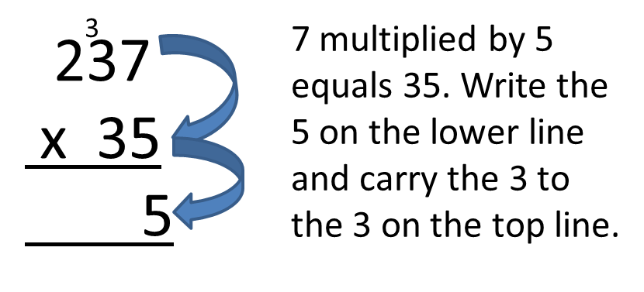
Then,
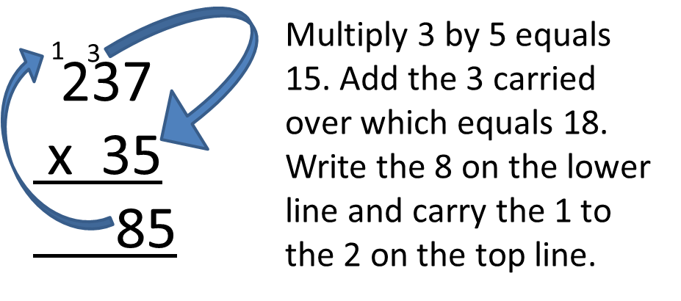
And,
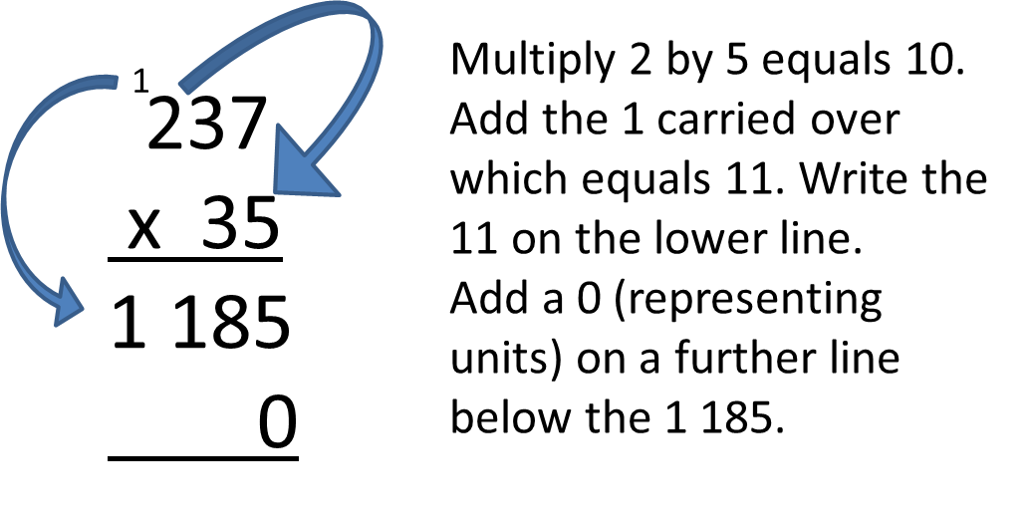
Then,
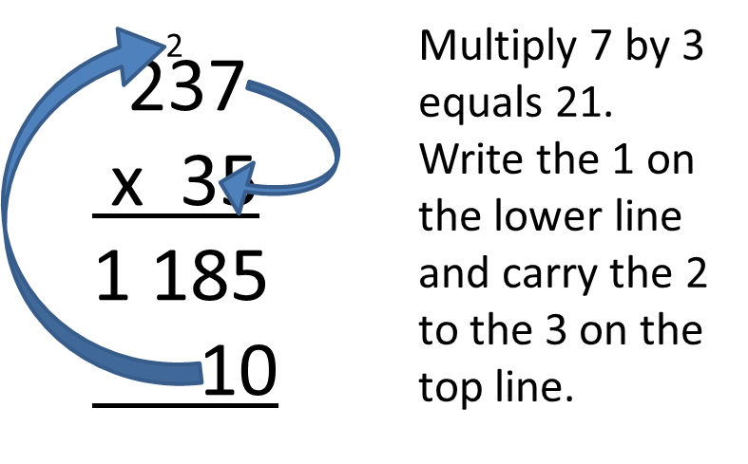
And,
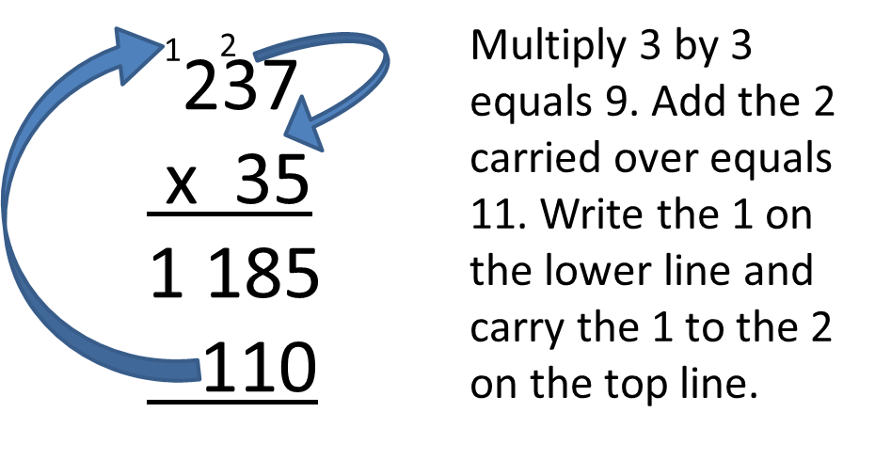
Then,
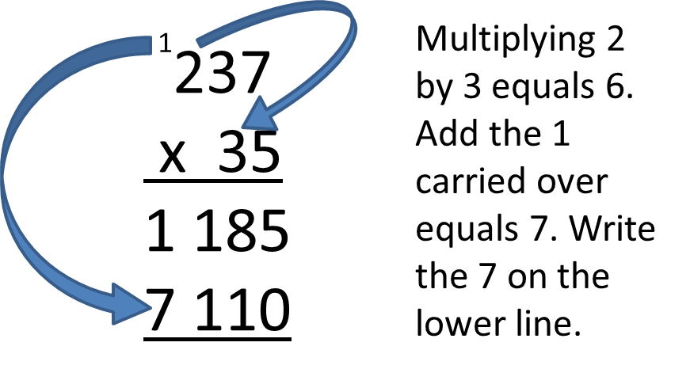
Now,
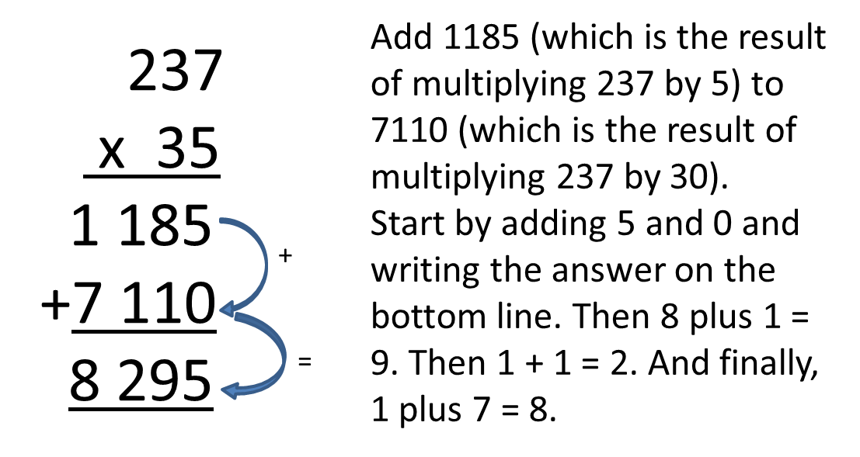 .Thus: 237 x 35 = 8 295

DIVISION
Division can be seen as a process whereby a number of objects are divided into equal parts or as repeated subtraction of the same number:
For example:
How many sweets will each child get if 8 sweets are divided equally among 4 children?
We have: 8 ÷ 4 = 2 or 8/4 = 2 or 4 can be subtracted from 8 twice
Each child therefore receives 2 sweets.

Division terminology
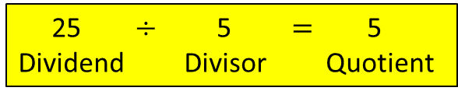

Important points
- Any number divided by 1 gives that same number i.e. 495 $÷$ 1 = 495
- Division by 0 cannot be done. No number can ever be divided by 0.
- All division can be placed into two groups.
- If the divisor divides exactly – the divisor is a factor
- If the dividend is not exactly divisible by the divisor – there is a remainder
Example:
Is 5 a factor of 11?
11 ÷ 5 = 2 remainder 1 This means that 5 is not a factor of 11.
- Division is the INVERSE OF MULTIPLICATION.
e.g. 4 × 2 = 8
Thus: 8 ÷ 4 = 2
And: 8 ÷ 2 = 4
This is important because:
- A division operation can be viewed in terms of a multiplication operation.
e.g. How many times does 7 go into 56?
56 ÷ 7 = 8
Let us now change the question and ask by what number must 7 be multiplied to get 56?
7 × 8 = 56
- To check the answer of a division operation, multiply the divisor by the quotient.
Division Examples:
2 947 $÷$ 7 is calculated as follows:
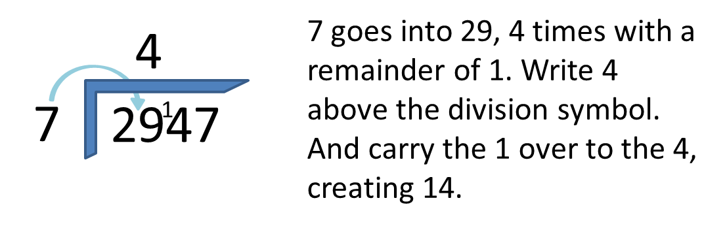
Then,
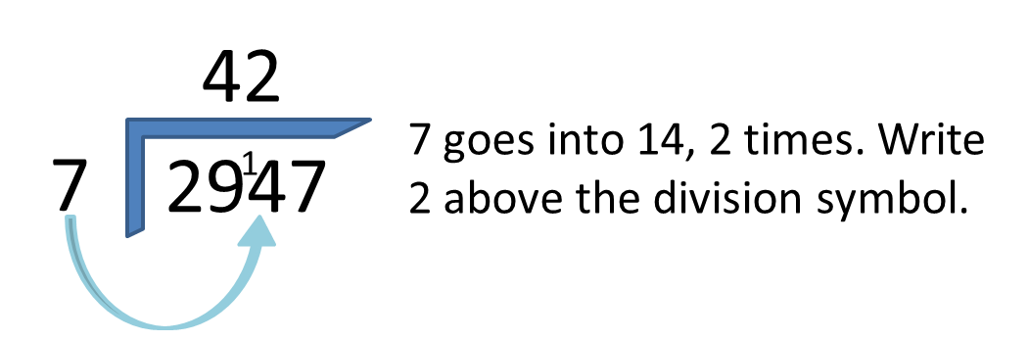
And finally,
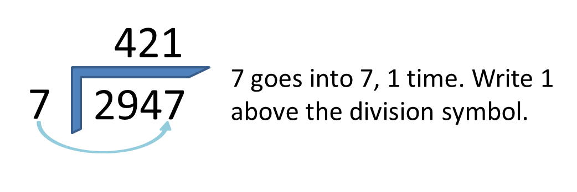
Similarly,
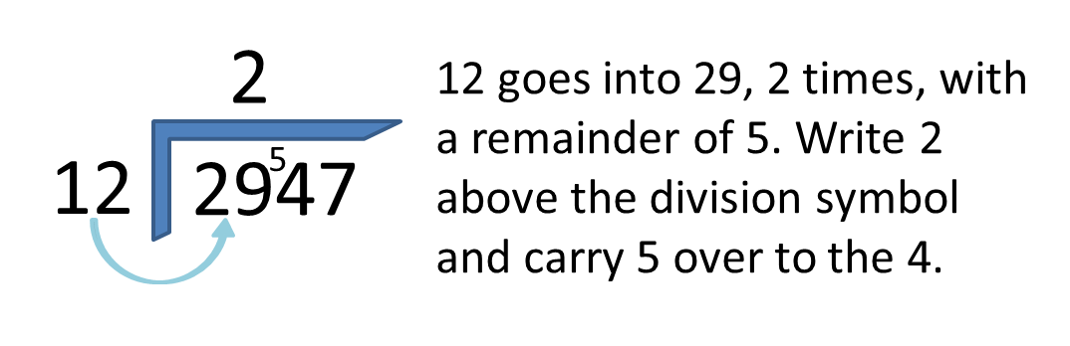
Then,
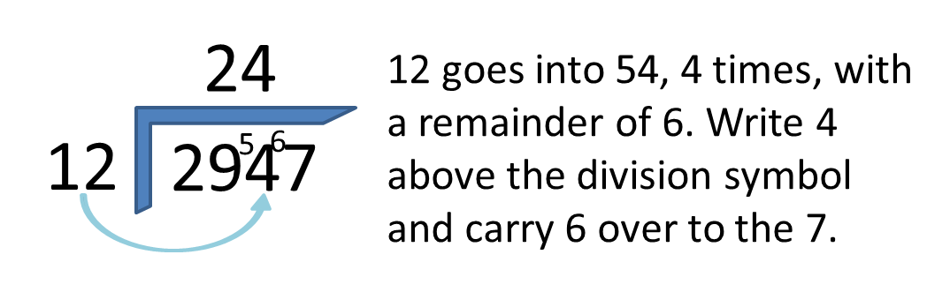
And,
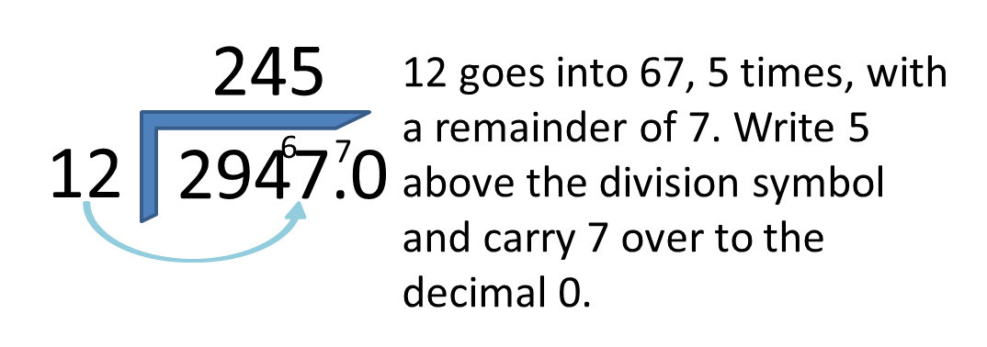
Finally,
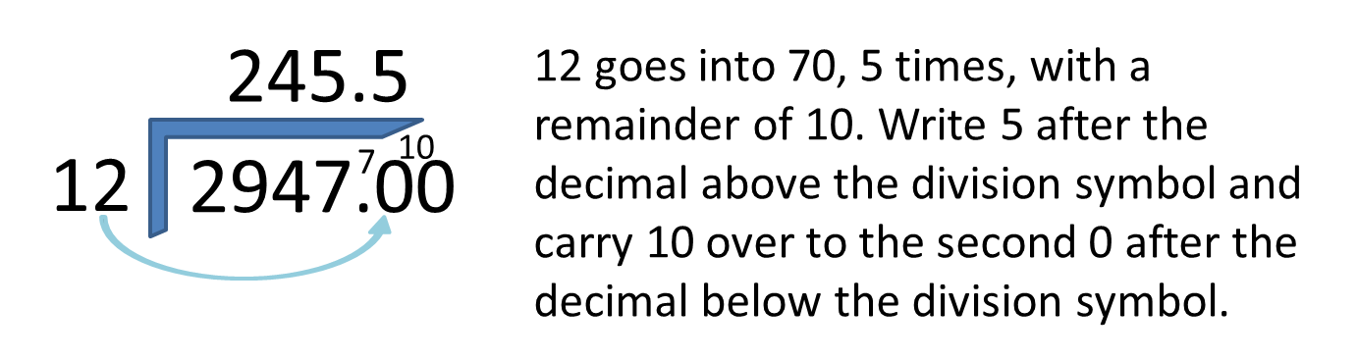
Thus, 2947 divided by 12 is equal to 245.5 (You can decide to which decimal place you would like to complete the equation. You can continue to 2, 3 or 4 or more decimal places depending on the accuracy required).

FRACTIONS
If you have a cake and you cut it into 3 pieces and you eat 1 piece, you have eaten one out of 3 pieces i.e. a third. If the cake has 4 pieces and you eat one piece, then you have eaten a quarter. Likewise if the cake is cut into 8 pieces, each piece is one eighth.
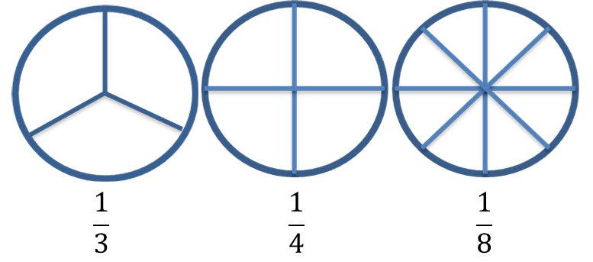
Note:
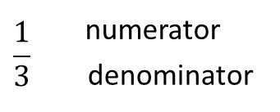
Converting fractions from one denominator to another:
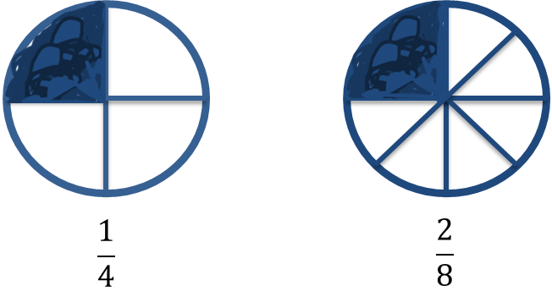
Note:
To convert quarters to eighths, you follow the following method:
First, find the common denominator.
In this case….4 is a multiple of 8, or conversely, 8 is exactly divisible by 4
Thus, for the denominator, 4 x 2 = 8, then do the same with the numerator, i.e. 1 x 2 = 2.
Therefore: 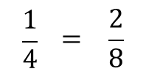
Similarly:
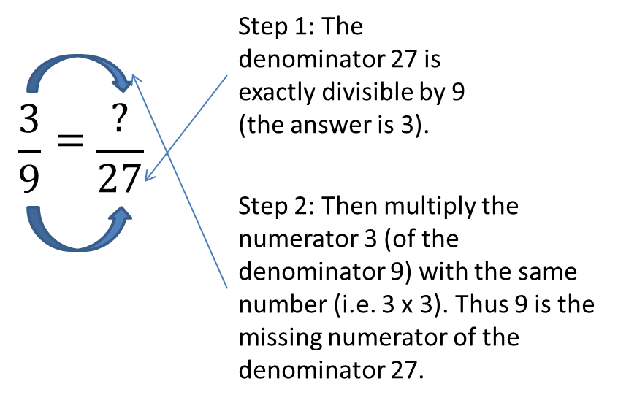
And,
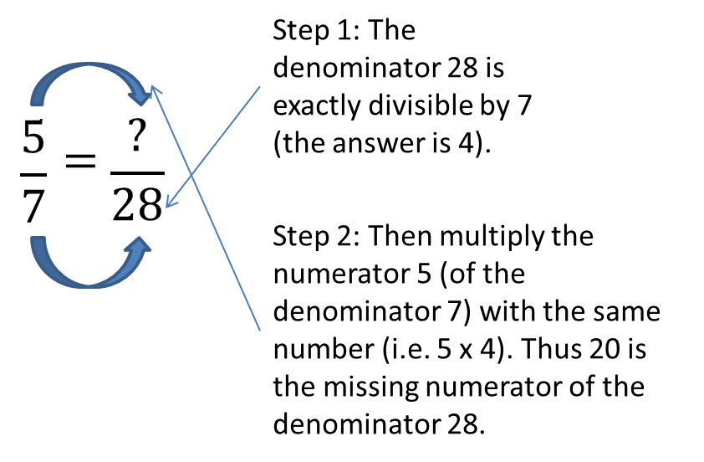
Proper and Improper fractions:
Proper fraction: denominator is greater than the numerator
Example: $\frac{2}{3}$ ; $\frac{1}{2}$ ; $\frac{3}{5}$
Improper fraction: numerator is greater than the denominator
Example: $\frac{3}{2}$ = $1\frac{1}{2}$ ; $\frac{5}{4}$ = $1\frac{1}{4}$ ; $\frac{8}{3}$ = $2\frac{2}{3}$
Simplifying Fractions:
A fraction is simplified by ‘using’ the largest number that can divide into both the numerator and the denominator without a remainder.
Examples:
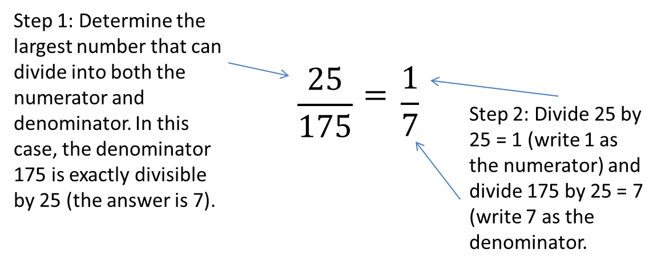
And
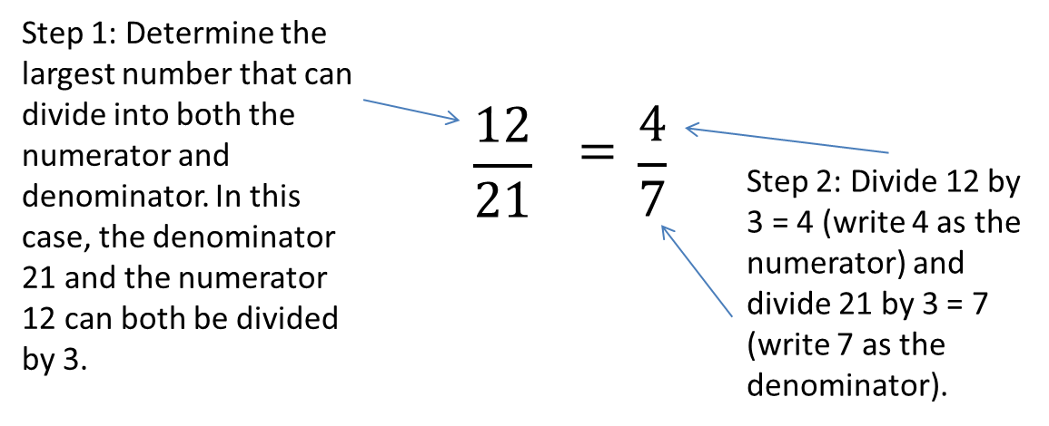
And
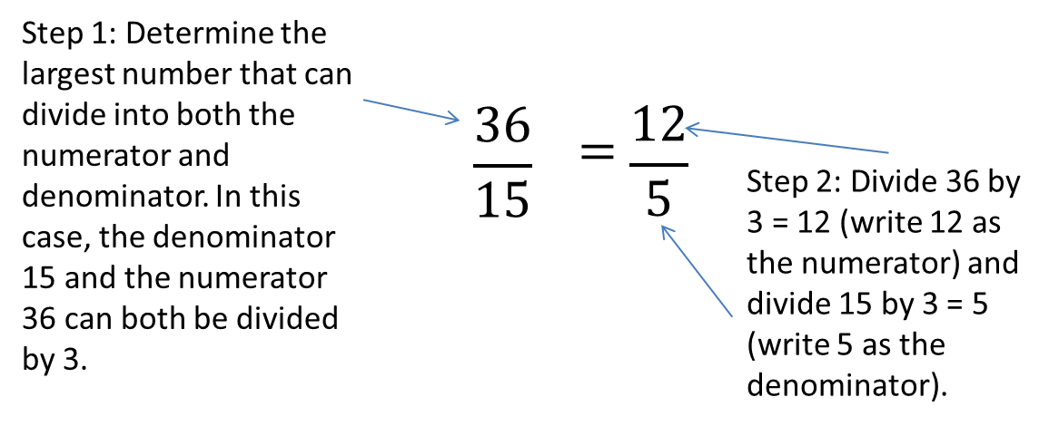
To simplify the fraction further, divide 12 by 5 = 2 remainder 2, thus $2\frac{2}{5}$

DECIMALS

Decimal fractions
The denominators of decimal fractions are the power of ten:
10 100 1000 etc.

Place values
The value of the digit is determined by its position
e.g. 2⁄10 tenths – t 0.2
2⁄100 hundredths – h 0.02
2⁄1000 thousandths – th 0.002
2⁄10000 and so on 0.0002
To convert $\frac{3}{8}$ to a decimal fraction
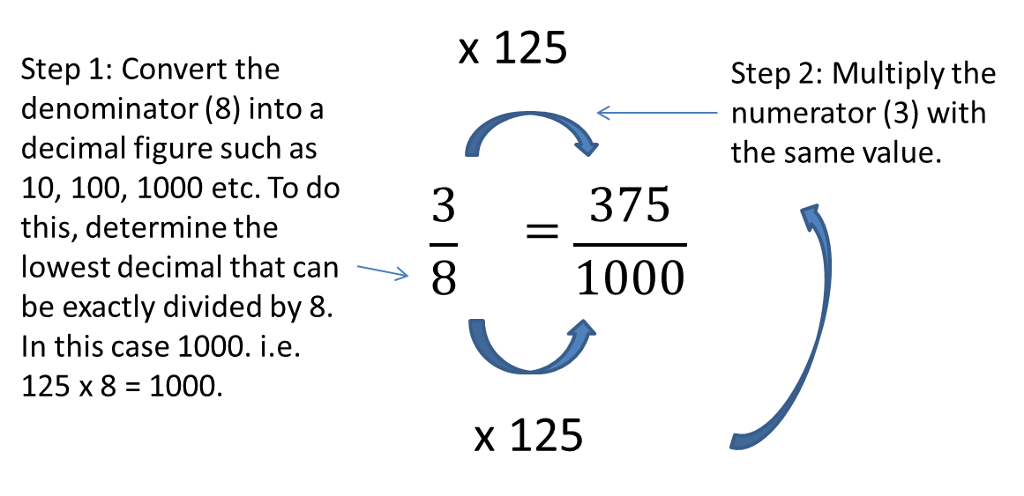 = 0.375
Or
Divide 3 by 8, as follows:
or 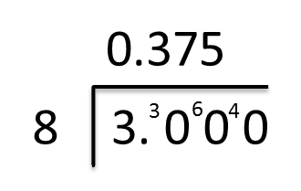
0.375
8 3.000
0
30
24
60
56
40
40

Convert $23/5$ to a decimal fraction:
First convert 3/5 into a decimal number, by dividing 3 by 5 as follows:
or 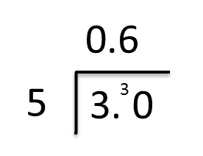
0,6

5 3,0
0
30
30

Thus, 3/5 = 0.6
Add the 2
$23/5$ = $26/{10}$ = 2.6

Calculating with decimal fractions
The same rules apply as with whole numbers.

Addition and subtraction
Write the numbers down so that the decimal commas are aligned and proceed as for whole numbers:
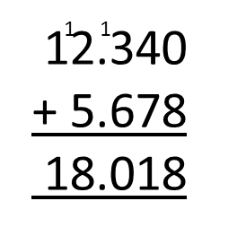 and 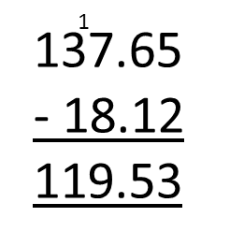

Multiplication
Ignore the decimal comma(s) and multiply as for integers. The product is then given the same number of decimal places as there are in the two numbers that have been multiplied.
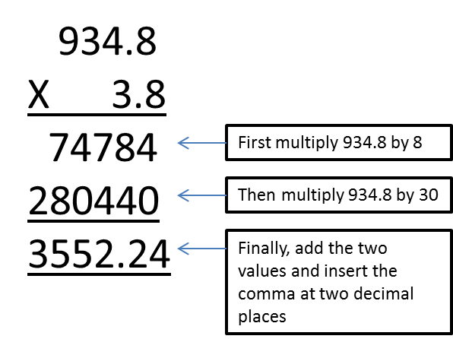
Note: When multiplying by 10, 100 or 1000, the decimal comma moves 1, 2 or 3 places to the right respectively.

Division
Make the divisor a whole number by multiplying by 10 or 100 or 1000 and then multiply the dividend by the same number.
Example: 93.48 ÷ 3.8
= 934.8 ÷ 38
The answer (quotient) then has the same number of decimal places as the dividend.
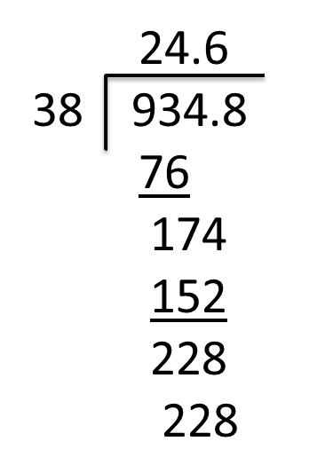
When dividing by 10, 100, or 1000 the decimal comma moves 1, 2 or 3 places to the left respectively.

SQUARES AND CUBES
When a number is multiplied by itself the answer obtained is known as the square of the original number.
Example:
- 4 × 4 = 16 (4² = 16)
- 7 × 7 = 49 (7² = 49)
If a number is multiplied by itself and again by itself, then the product is called the cube of that number.
Example:
The cube of 5 is 5 × 5 × 5 = 125 (5³ = 125)

SQUARE ROOTS AND CUBE ROOTS:
√16 = 4 (4 × 4 = 16) ∛125 = 5 (5 × 5 × 5 = 125)
√49 = 7 (7 × 7 = 49) ∛27 = 3 (3 × 3 × 3 = 27)
√25 = 5 (5 × 5 = 25) ∛216 = 6 (6 × 6 × 6 = 216)

MATHEMATICAL SIGNS:
> greater than Example: 8 > 2
< smaller than Example: 3 < 100
= equals Example: 2 = 2

ROUNDING OFF (CORRECTING)
Rounding off involves reducing the accuracy / precision of a number so as to reduce its complexity and make it easier to manipulate or record.
Wherever a decimal place to be discarded is represented by a number less than five, the preceding digit (that is the last to be recorded) shall remain as is stands but where the number to be discarded is greater than five, one shall be added to the preceding digit.
Where the number to be discarded is exactly five, the preceding digit shall be unaltered if it is an even number, but if it is an odd number one shall be added to it.
Examples:
- 12.733 rounded off to the 2nd decimal place is 12.73
- 12.735 rounded off to the 2nd decimal place is 12.74
- 12.725 rounded off to the 2nd decimal place is 12.72
- 12.726 rounded off to the 2nd decimal place is 12.73
- 12 733 rounded off to the nearest hundred is 12 700
- 12 753 rounded to the nearest hundred is 12 800

PERCENTAGES
A percentage is a fraction with a denominator of 100.
Percentage means per 100 or out of 100.
e.g. ${20}/{100}$ = 20%
In a percentage 100 is always the basis of comparison.
Example 1:
30 km of the total distance of a 50 km journey is completed.
What % is completed?
$\frac{30 km}{50 km}$ = $\frac{3}{5}$is completed
Notice how the zeroes and km cancelled out.
To convert this fraction to a percentage
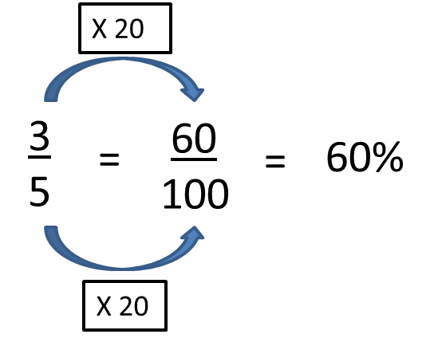
or we multiply the fraction by 100: 3/5 × 100 = 60%
In 60% the basis of comparison is 100.
The comparison must always be based on measurements that are of the same kind. The numerator and the denominator must have the same units.
Example 2:
You invest R 1 000 at an interest rate of 15% per year. How much money do you have in the bank after one year?
Interest = 15% of R 1 000
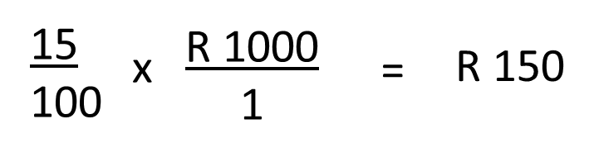
But you also have your original R 1 000 in the bank.
The total in your bank account is thus R 1 000 + R 150 = R 1 150
Example 3:
What is the % profit or loss if a dealer buys an article for 20c and sells it for 25c.
% Profit
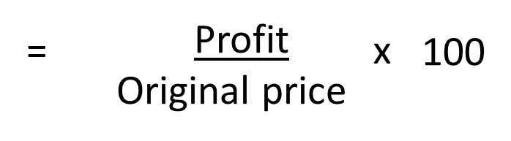
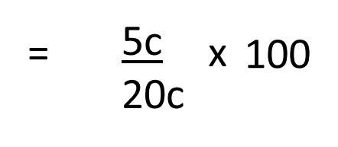
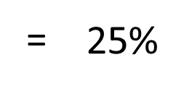

RATIO
Example 1
In a school a certain class has 36 pupils. There are 24 boys and 12 girls.
There are 2 ways in which the number of boys can be compared to the number of girls.
By subtraction
There are 24 – 12 = 12 more boys than girls.
By division
For every 24 boys there are 12 girls. There are twice as many boys as girls, or the ratio of boys to girls is 2 to 1, or there are 2 boys per girl.
We write this ratio as 2:1 or $\frac{2}{1}$
We can also say: There are 2 boys per girl.
“Per” therefore means “for every”.
The ratio of girls to boys is 1:2 or $\frac{1}{2}$
Example 2:
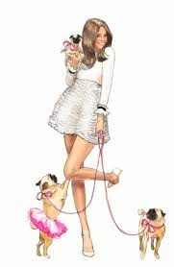
There are 4 girls with 3 dogs each.
In total there are 4 girls and 12 dogs.
We also say: there are 3 dogs per girl (3:1) or for every girl there are 3 dogs.
What is the ratio of girls to dogs?
There are several answers, for example:
- 4 to 12 or 4 :12 or 4/12
- 1 to 3 or 1:3 or 1/3
- 2 to 6 or 2:6 or 2/6
- 3 to 9 or 3:9 or 3/9
Which answer is correct: $\frac{4}{12}$ ; $\frac{1}{3}$ ; $\frac{2}{6}$ or $\frac{3}{9}$ ?
Since they are equivalent fractions:
$\frac{4}{12}$ = $\frac{1}{3}$ = $\frac{2}{6}$ = $\frac{3}{9}$ and therefore all are correct!
A ratio is usually given as the simplest fraction i.e. 1:3.

DIVISION OF A QUANTITY IN A CERTAIN RATIO
Example 1:
Divide 63 sweets between Andre and Albert in the ratio 3:4

This means that Andre gets 3 and Albert 4 out of every 7 sweets.
So Andre gets $\frac{3}{7}$ and Albert $\frac{4}{7}$ of the sweets. So Andre gets $\frac{3}{7}$ × 63 sweets = 27 sweets and Albert gets $\frac{4}{7}$ × 63 sweets = 36 sweets.
Check: Andre + Albert = 63 sweets
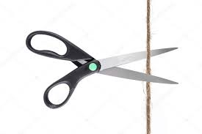
27 + 36 = 63 sweets
27 : 36
3 : 4
Example 2:
Divide a 36 m long rope in the ratio 3:4:5.
The total of the sections is 3 + 4 + 5 = 12
The ratio will therefore be: $\frac{3}{12}$ : $\frac{4}{12}$ : $\frac{5}{12}$
The sections will be:
$\frac{3}{12}$ of 36 m $\frac{4}{12}$ of 36 m $\frac{5}{12}$ of 36 m
= $\frac{3}{12}$ × 36 m = $\frac{4}{12}$× 36 m = $\frac{5}{12}$ × 36 m
= 9 m = 12 m = 15 m
Check:
9 m + 12 m + 15 m = 36 m
$\frac{9}{36}$ : $\frac{12}{36}$ : $\frac{15}{36}$
= $\frac{3}{12}$ : $\frac{4}{12}$ : $\frac{5}{12}$
Rate:
The rate at which something takes place tells you how fast / slow it is happening.
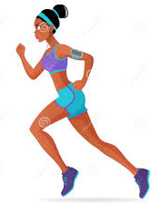
Examples:
- If you earn R 15 an hour at work, you are being paid the rate of R 15 per hour or R15/h
- If you run 100 m in 20 seconds you are running at an average rate (speed) of $\frac{100 m}{20s}$ = 5 m per second or 5 m/s (5m.s⁻¹)

Knowledge Topic 4: Graphs

INTRODUCTION
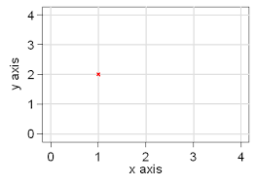
A graph is a pictorial representation of two sets of conditions. These could vary from cigarettes smoked over a week or month or year to weekly Boiling House or Recoveries over a mill’s crushing season.

AXIS
A graph has two axes. A horizontal axis and a vertical axis. Each axis is used for a particular set of conditions. Each axis must be labelled and the values for each particular set of conditions must be stated.

INFORMATION
When drawing a graph the following information must be put onto the graph paper.
- Heading of the graph e.g. Standard Phosphate graph.
- Date the graph was drawn – this is important as some chemicals deteriorate over a period of time and a new graph has to be drawn with freshly prepared chemicals.
- Name of the person who drew up the graph – not everybody in a mill laboratory draws up a graph but a lot of people read a graph - if needed the person who drew up the graph can be consulted.
- Any additional information may be written down on the back of the graph paper.

STANDARD GRAPHS
A standard graph is a reference graph of known concentration of a particular compound.
A series of standard solutions of the compound are prepared and analysed. The results obtained are plotted on a graph and this graph is now used as the reference for further analysis of unknown samples.
By using the standard graph we can determine the level of concentration in an unknown sample.
Remember: A standard graph is a reference graph – so extreme care must be taken when drawing up this graph. If a standard graph is incorrect, then all analyses that are done will give an incorrect result.

RULES FOR DRAWING GRAPHS

Introduction
- Have both data sets.
- Decide which axis should carry which data set. Generally, the more complex data set with the greater range will go on the longer axis.

For each Data Set
- Find the lowest and highest value (the range)
- Spread this range over the “whole” axis working with convenient figures that cover this range.
- Calculate the scale by:
20 mm : 0.050 mg (for example)
2 mm : x mg
20 × x = 2 × 0,050
X = $\frac{2 ×0,050 mg}{20}$
SCALE: 2 mm = 0,005 mg
Write down this scale near the axis.
- Do not use scales with recurring decimals e.g. 2 mm = 0,0333…..

Example: Phosphate Standard Graph
mg Phosphate per 100 ml of solution | Optical density
0.07 | 0.05
0.12 | 0.10
0.18 | 0.15
0.24 | 0.20
0.3 | 0.25
0.35 | 0.30

If an unknown sample is read in the spectrophotometer and the optical density is 0.125, what is the concentration of phosphate per 100 ml of this sample?

Answer: 0.15 mg phosphate per 100 ml of solution (Read off the Phosphate Standard Graph by finding the point at which the arrow at 0.125 from the Y-axis intercepts with the graph line. Then read down to find the relevant value on the X-axis i.e. 0.15 mg Phosphate.

TO LOCATE A POINT EXACTLY
To locate 0.134 mg exactly, proceed as follows:
- the 0.130 mg line is easily found.
- To this value 0.004 mg must be added (0.134 - 0.130 = 1.004)
- 0.004 mg is: $\frac{0.004}{0.01}$ = 0.4 Divisions
- Locate this as follows:
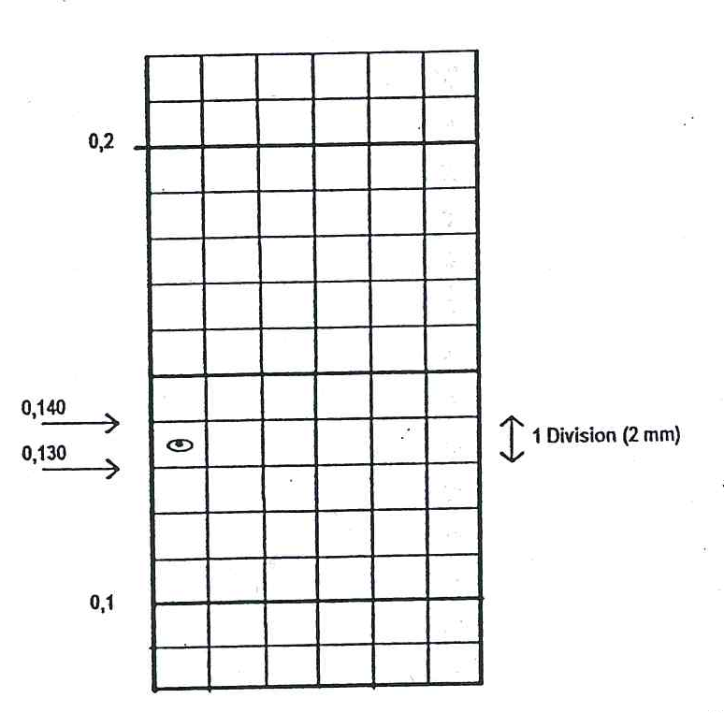
represents the value of 0,134

GENERAL – HOW TO DRAW A GRAPH

By hand
- Use a sharp pencil and a good ruler.
- Mark each point with a clear bold dot that is not too large and circle the dot boldly. Work neatly.
- For straight line graphs (like the phosphate standard graph) draw an “average” straight line that:
- goes through as many points as possible, and
- has an equal number of points above it as below it.

Using Excel
If you have access to a computer you can also draw your standard curves on the Excel programme of Microsoft.
- Type the data into the spreadsheet (The X-axis values in the first column and the Y-axis values in the second column. Put the titles of the X-axis and the Y-axis in the first row of each column.
- Select the cells that contain the data that you want to use for the chart. Tip: If you select only one cell, Excel automatically plots all cells that contain data that is adjacent to that cell into a chart. If the cells that you want to plot in a chart are not in a continuous range, you can select nonadjacent cells or ranges as long as the selection forms a rectangle. You can also hide the rows or columns that you do not want to plot in the chart.
- On the Insert tab, in the Charts group, do one of the following:
  - Click the chart type, and then click a chart subtype that you want to use.
  - To see all available chart types, click to launch the Insert Chart dialog box, and then click the arrows to scroll through the chart types.
  - Tip: A ScreenTip displays the chart type name when you rest the mouse pointer over any chart type or chart subtype.
- Click on Insert Chart – Scatter Plot and further refine your graph by choosing Chart Layouts with a background grid.
- Click the chart element for which you want to change the layout, or do the following to select it from a list of chart elements.
  - Click anywhere in the chart to display the Chart Tools.
  - On the Format tab, in the Current Selection group, click the arrow in the Chart Elements box, and then click the chart element that you want.
  - On the Layout tab, in the Labels, Axes, or Background group, click the chart element button that corresponds with the chart element that you selected, and then click the layout option that you want.

Knowledge Topic 5: Measurement of Quantities

THE S.I. (SYSTEM INTERNATIONALE D’UNITES)
Seven basic units have been accepted internationally, and all other units are derived from these. We will only be concerned with three basic units. They are:
Length – metre (m)
Mass – kilogram (kg)
Time – second (s)
Units of area and volume (capacity) are based on the unit of length, the metre.

DERIVED UNITS
Apart from time, all the derived S.I. units are decimal multiples of the basic unit and are named by the addition of prefixes.
Multiples and sub-multiples of a unit:
Prefix | kilo- | Basic Unit |  | deci- |  | centi- |  | milli-
To convert to Basic Unit (u) | x 1000 | x 1 |  | ÷10 |  | ÷100 |  | ÷1000
Factor to convert to the Basic Unit | × 1000 u | × 1 u |  | ÷ 0,1 u |  | ÷ 0,01 u |  | × 0,001 u
OR | × 10³u | × 10⁰u |  | × 10⁻¹u |  | × 10⁻²u |  | × 10⁻³u
To convert between multiples | × 1000  ÷1000 |  | ×10  ÷10 |  | ×10  ÷10 |  | ×10  ÷10

Examples: | Km | M | dm | cm | Mm
Examples: | kg | g |  |  | mg

LENGTH
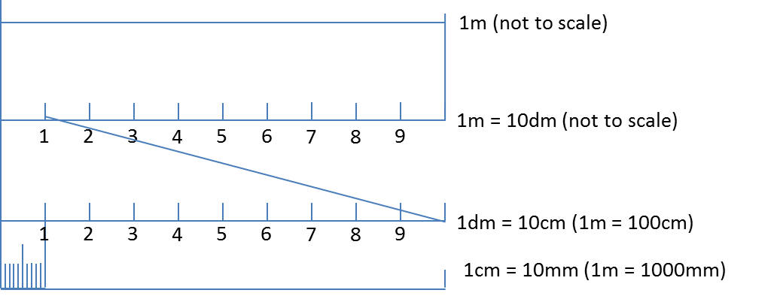

Prefix | Kilo- | Basic Unit |  | deci- |  | centi- |  | milli-
To convert to Basic Unit (u) | x 1000 | x 1 |  | ÷10 |  | ÷100 |  | ÷1000
Factor to convert to the Basic Unit | × 1000 m | × 1 m |  | ÷ 0,1 m |  | ÷ 0,01 m |  | × 0,001 m
OR | × 10³m | × 10⁰m |  | × 10⁻¹m |  | × 10⁻²m |  | × 10⁻³m
To convert between multiples | × 1000  ÷1000 |  | ×10  ÷10 |  | ×10  ÷10 |  | ×10  ÷10

Examples: | 23.2 km  = 23.2 × 1000  = 23 200 m | 397 m | 47.8 dm  = 47.8 × 0.1  = 4.78 m | 9 103 cm  = 9103 ×0.01  = 91.03m | 119 217 mm  = 119 217 × 0.001  = 119.217m

AREA
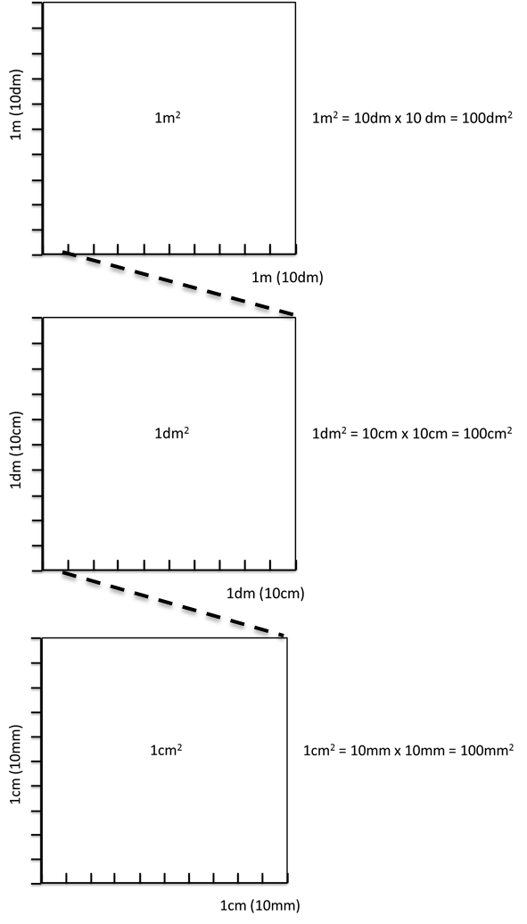
Prefix | km² | m² |  | dm² |  | cm² |  | mm²
To convert to Basic Unit (u) | x 1000 000 | x 1 |  | ÷100 |  | ÷10 000 |  | ÷1 000 000
Factor to convert to the Basic Unit | × 1 000 000 m | × 1 m |  | × 0.01 m |  | ÷ 0.0001 m |  | × 0.000 001m
OR | × 10⁶m² | × 10⁰m² |  | × 10⁻²m² |  | × 10⁻⁴m² |  | × 10⁻⁶m²
Example | 4.37 km²  =4.37 × 1 000 000  =4 370 000 m² | 1,92 m² |  | 2.34 dm²  =2.34 ÷ 100  =0.0234 m² |  | 40 372 cm²  =40 372 ÷ 10 000  =4.0372 m² |  | 729 342  =729 342 ÷ 1 000 000  =0.729342 m²
To convert between multiples | × 100 0000  ×1000 000 |  | ×100  ÷100 |  | ×100  ÷100 |  | ×100  ÷100

VOLUME
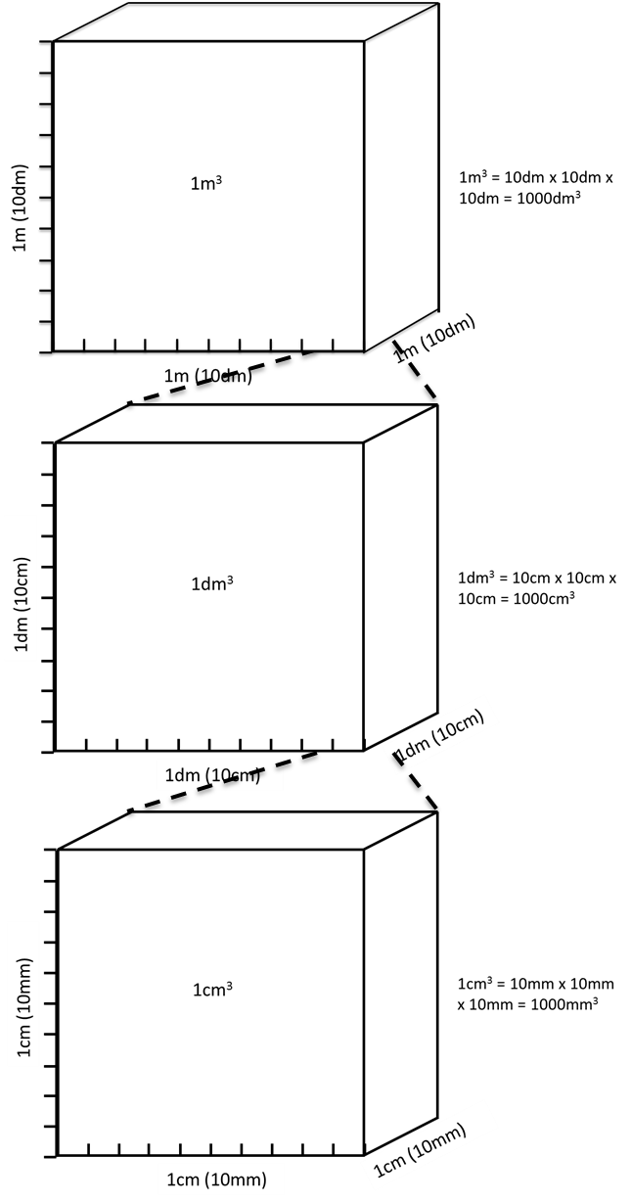

Prefix | km³ | m³ |  | dm³ |  | cm³ |  | Mm³
To convert to Basic Unit (u) | x 1 000 000 000 | x 1 |  | ÷1000 |  | ÷1 000 000 |  | ÷1 000 000 000
Factor to convert to the Basic Unit | × 1 000 000 000m | × 1 m³ |  | × 0.001 m³ |  | ÷ 0.000 001 m³ |  | × 0.000 000 001 m³
OR | × 10⁹m³ | × 10⁰m³ |  | × 10⁻³m³ |  | × 10⁻⁶m³ |  | × 10⁻⁹m³
Example | 0.25 km³  =0.25 × 1000 000 000  =250 000 000 m³ | 413 m³ |  | 22.4 dm³  =22.4 ÷ 0.001  =0.0224 m³ |  | 117 219 cm³  =117 219 × 0.000 001  =0.117219 m³ |  | 972 139144 mm3  =972 139 144 × 0.000 000 001  =0.972 139 144 m³
To convert between multiples | × 1000 000 000  ×1000 000 000 |  | ×1000  ÷1000 |  | ×1000  ÷1000 |  | ×1000  ÷1000

Note:
1 cm³ = 1 ml
1 dm³= 1l
Summary:
1 km³ = 1 000 000 000 m³
1 m³ = 1 000 dm³
1 dm³ = 1000 cm³
1 cm³ = 1000 mm³

Knowledge Topic 6: Use a Balance

INTRODUCTION
The standard unit of mass is the kilogram, this unit is however, too big for use in the laboratory and we thus use the gram as the unit of mass.
1 kilogram = 1 000 grams (1 000 g = 1 kg)
1 gram = 1 000 milligrams (1 000 mg = 1 g)
Weight and mass are not the same.
Weight is the force exerted on an object by the earth (measured in Newtons).
The mass of an object is a measure of the quantity of matter in the object.
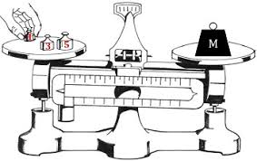
Mass is measured by comparison with known standard masses.
In the laboratory mass is measured on a balance where the unknown mass is balanced against a known mass. This can be done with varying degrees of accuracy depending on the type of balance being used.
The principle of a balance is a rigid beam which is supported and pivoted at the centre on a knife edge. Suspended from each end is a pan. One pan is used to hold the object being massed and the other holds the known standard mass. When the standards equal the unknown mass the beam is in equilibrium and the unknown mass can now be compared (equalled) to the standard mass.
The principle of a balance illustrated

With modern balances the design is different but the principle remains the same.

Modern Mechanical Balances
Externally these balances appear to have only one pan. However, the second “pan” is actually a set of masses inside the machine.
Below are photos of two examples of Mettler Analytical balances (Model H54AR)
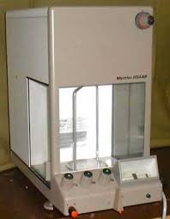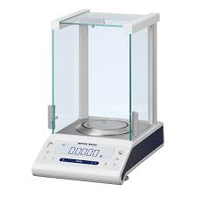
Mettler Analytical Balance Mettler Classic Analytical Balance
(Model H54AR) (Model ML104T/00)

Modern Electronic Balances
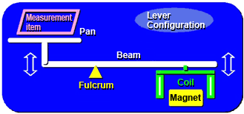
Here the pan is connected to a bar placed in a solenoid (coil). The sample placed on the pan pushes the bar into the solenoid. The electronic controls of the balance then apply an electric current to the solenoid just enough to cause the bar to move back to its original position. The greater the mass of the sample, the greater the current required. The instrument is then calibrated so that this current is converted and displayed as a mass in grams.

Principle of how an electronic balance works

PRECAUTIONS TO BE OBSERVED WHEN USING A BALANCE
- The balance must be positioned in a permanent place on a firm foundation as free as possible from vibration. Specially constructed tables are usually used.
- The balance must be shielded from draughts and from heat.
- The balance must be level.
- If the balance must be moved it must be done by a competent person.
- The balance must be clean. All spillages must be cleaned up immediately. Powder spillages must be swept immediately. Liquor spillages must be wiped up at once. A damp cloth must be used to wipe the spill and then the balance must be dried well.
- The maximum load of the balance (capacity) must be checked. This is stated on the balance and must not be exceeded under any circumstances.
- Check that the accuracy required by the analysis is available from the balance being used.
- Check the zero position of the balance and if necessary reset.
N.B. The levelling and resetting are the only adjustments that a laboratory worker may make to the balance. If anything else is found to be wrong, it must be reported to the supervisor.
- The balance must always be used according to the manufacturer’s instructions.
- All movement of dials and the addition and removal of objects must be done gently.
- The object to be massed must be at the same temperature as the balance. Warm objects in the balance cause air currents which render the massing inaccurate. Unequal expansion of the beam will introduce errors.
- Powders and liquids must be massed in suitable containers.
- Desiccants must not be placed in the balance as the air inside and outside the case should be in equilibrium.
- After massing the balance must be reset. All the dials must be set to zero. All traces of spillages and all vessels must be removed from the balance.
- The doors of the balance must be closed after use (if applicable).

BALANCE CAPACITY
A balance may mass to the nearest gram, to one, two, three or four decimal places.

MASSING AN OBJECT

Modern Mechanical Analytical Balance (Sauter analytical balance)
- Zero the display using the adjustment knobs.
- Move the right hand side control level to the “Full massing position” and check that the scale reads zero.
If the scale does not read exactly zero, reset it using the adjustment screw situated at the back right hand side of the balance.
- Move the right hand control lever to the “full arrest” position.
- Open the door, place the object on the pan and close the door.
- Move the right hand control lever to the “approximate massing position”
- Read the mass (say 7g).
- Move the right hand control lever to the “full arrest position”.
- Dial in 7g using the display knobs.
- Move the right hand side control lever to the “full massing position”.
- Adjust using the fine adjustment knob until the correct reading is obtained (i.e. the scale is lined up with the special mark).
- Adjust the right hand control lever to the “full arrest position”, remove the object / sample and return all display settings to zero.
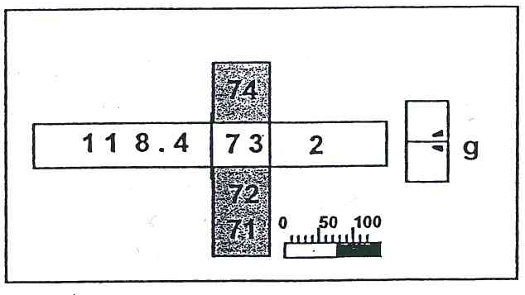
Mechanical balances have generally been replaced by electronic analytical balances

Modern Electronic Analytical Balance
- Zero the scale by pressing the reset button / bar.
- Place the object on the pan, close the doors and wait for a steady reading.
- Take the reading.
- Remove the object and zero the instrument.
- Close the doors.

MASSING OUT A SPECIFIC AMOUNT OF SAMPLE

Modern Mechanical Analytical Balance
Part A: Massing the nickel basin
The procedure is as described in section 1.6.4.1.
Let us assume that the mass of the nickel massing basin was found to be 34.5573 g.
Part B: Massing out a specific amount of sample (say 26.000g to 0.002g of sugar)
- With the right hand control lever in the “full arrest position” dial in 60, _ _73 (34,5573g + 26,0000g = 60,5573g) on the display.
- Switch to the “Approximate Massing” position and add almost 26g of sugar i.e. until the scale reads 60g.
- Switch to “full arrest” position. Close the doors of the balance.
- Move the lever into the “full massing position” and read the actual mass.
Add or remove sample until the desired mass is obtained. Do not add or remove sample in the “full massing position”.
When adding / removing sugar first switch to the “approximate massing” position. Then switch back to the full massing position to check if the correct amount of sugar has been added.
Note: Since the mass of the sugar only needs to be within 0,002g, one can stop adding sugar when the scale reads 60,5555g since this is within 0,002g of 60,5573g.
When the scale reading is very close to 60,5573g the right hand adjustment can be used to line up the mark (balance the scale) and hence find the exact mass.

Modern Electronic Analytical Balance
- Place the nickel massing basin on the pan and wait for a steady reading.
- Tare the scale by pressing the reset button / bar. This will zero the scale. The scale stores the mass of the massing basin and displays it as zero.
- Add sugar until the scale reads 26,0000g.
- Remove the nickel massing basin and zero the instrument.
Note: When doing moisture analyses this tare facility cannot be utilised, since the following information is required.
- Mass of empty dish
- Mass of dish and sample
- Mass of dish and dried sample.

Knowledge Topic 7: Flasks, Cylinders and Pipettes

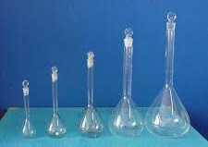
VOLUMETRIC FLASKS
Volumetric flasks come in a range of volumes
A volumetric flask is a flat-bottomed, pear-shaped vessel with a long narrow neck. The neck is made narrow so that a small change in volume will have a large effect upon the height of the meniscus. Any error in adjustment of the meniscus is therefore small.
A thin line etched around the neck indicates the volume that it holds at a specific temperature (usually 20˚C). The capacity and temperature are clearly marked on the flask. A volumetric flask contains a specified volume (it is important to note that it will not deliver that volume because if the contents of a volumetric flask are poured out, some of the solution remains behind on the inside surface of the volumetric flask). The graduation mark extends completely around the neck in order to avoid the error due to parallax. The concave surface of the meniscus should be in line with the mark and both the back and front of the mark should be seen as a single line if the error of parallax is to be avoided. Volumetric flasks are used extensively when making up solutions.

ERLENMEYER FLASKS
These come in capacities ranging from 50cm³ to 500cm³ and are most commonly used for titrations. Graduation marks found on Erlenmeyer flasks are approximate volumes and should not be used for measuring purposes. Certain titrations with Erlenmeyer flasks require the application of heat. Make sure that there are no cracks or moisture present on the outside of the flask. When placed on the hot plate, moisture between the hot plate and the flask can cause the flask to crack or break.
Erlenmeyer flasks measure only approximate volumes

KOHLRAUSCH FLASKS
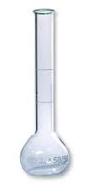
The most commonly used in mill laboratories are the 100cm³ and 200cm³ Kohlrausch flasks. They have wide mouths so that pre-massed solid materials can be transferred into them. When dissolving solids in a Kohlrausch flask, use a clean, dry, rubber stopper which has a tight fit to close the mouth of the flask.

SUGAR FLASKS
Kohlrausch flask
Sugar flasks are very similar to Kohlrausch flasks, the difference being the neck of the flask. Sugar flasks have narrower necks than Kohlrausch flasks to ensure greater accuracy.
Sugar flask

MEASURING CYLINDERS
A measuring cylinder (graduated cylinder) is a graduated vessel available in capacities ranging from 2 to 2 000cm³. Since the surface area of the liquor is much greater than in a volumetric flask the accuracy is not very high. Measuring cylinders cannot therefore be used for work demanding a high degree of accuracy. They are useful when rough measurements are required.

PIPETTES
A pipette is a volumetric glass cylinder with a jet at one end and a mouthpiece at the other. A bulk pipette has one calibration mark and the cylinder expands into a bulb about halfway along its length. A graduated pipette has a number of calibration marks depending on its size. General purpose bulb pipettes are used for delivering or transferring a definite volume of liquid under certain specified conditions of temperature and method of use. Pipettes are normally calibrated at 20˚C and will not deliver the same volume of liquid at any other temperature. The exact volume of solution delivered by a pipette is called an aliquot of solution.
Measuring cyclinders come in a range of volumes

Use of a pipette
- Select a pipette of the required volume.
- Make sure that it is clean, both inside and outside and dry on the outside.
- Use a pipette filler when working with dangerous liquids.
- When sucking ensure that the tip of the pipette is well below the liquid surface.
- Rinse the pipette twice with distilled water.
- Draw the water up to the bottom of the bulb. Any more is wasteful.
- Rotate the pipette horizontally to wash the entire inner surface of the pipette to above the graduation mark. Steady the pipette by supporting it with the fingertips of the left hand just above the jet.
A pipette measures volumes accurately
- Discard the waste into a waste beaker through the jet – not through the mouthpiece.
- Rinse with solution a total of three times.
- Hold the pipette in a vertical position with the tip well below the surface of the solution to prevent sucking in air.
- Do not touch the bulb because of the effect of temperature expansion. Hold the pipette by the stem.
- Draw up the solution until the level is about 2cm above the graduation mark.
- Close the top of the pipette with your index finger (A slightly moist finger forms a better seal).
- Check that there are no air bubbles, especially in the jet.
- Wipe the outside of the pipette with a clean tissue.
- Hold the pipette vertically. By manipulating the index finger, allow the liquid level to drop until the concave base of the meniscus coincides with the graduation mark. Remember to avoid the error of parallax. Use the waste beaker to collect this excess solution.
- Any liquid adhering to the jet must be removed. DO NOT use a tissue. Hold the pipette vertically and bring the side of the waste beaker into contact with the jet by tilting the vessel.
- Place the receiving vessel beneath the pipette and allow the liquid to drain by removing the index finger. Hold the pipette vertically and tilt the vessel so that the side is in contact with the jet. Do not allow any splashing to occur. Steady the bottom of the pipette by resting it between the index and the middle fingers, while holding the receiving vessel with the thumb, third and fourth fingers (This technique is worth learning).
- As the level drops, keep your eye on the meniscus. When the meniscus stops falling, start counting. Keep the jet in contact with the side of the vessel for 15 seconds. DO NOT BLOW.
The pipette has been calibrated to take account of the last bit of solution remaining in the jet of the pipette.
- Clean the pipette with distilled water, dry the outside and place in proper storage i.e. use a pipette stand. In order to protect the tip of the pipette it must always be stored in the pipette stand with the tip facing upward. This also prevents particles of dust etc. from entering the pipette and clogging the jet.

Use of a pipette filler (pumpette)
- Fit the pipette filler onto the pipette.
- Immerse the tip / jet of the pipette into the relevant solution.
- Press valve A (atmosphere) which opens the pipette filler to the atmosphere and squeeze the bulb of the pipette filler to force air out. Release valve A.
Pipette fillers are used for toxic fluids
- Press valve S (suck) which connects the pipette to the vacuum inside the bulb of the pipette filler. This allows solution to be sucked into the pipette to above the graduation mark.
- Gently press valve E (eject) while holding the pipette above the waste beaker to release the solution until the bottom of the meniscus is on the graduation mark.
- Place the receiving vessel beneath the pipette and press valve E to release the solution. Valve E allows air from the atmosphere to move into the bulb of the pipette filler.

Knowledge Topic 8: Burettes and Titrations

INTRODUCTION
A burette is a graduated cylindrical tube of uniform bore. It has a stopcock at the bottom to control the flow through a narrow jet. Burettes are used in the laboratory to deliver measured volumes of liquids and are available in various capacities. They are graduated according to their size and intended use and are usually subdivided into 0,1 cm³.
A burette is used for titrations. A titration is the controlled addition of a solution (in a burette) to a known volume of another solution (in an Erlenmeyer flask) until a definite endpoint is reached, showing that two chemicals have reacted completely. Calculations can be performed using the results obtained from a titration. The flask must be continuously swirled as solution is added.
A titre is the volume of solution delivered by a burette to reach the end-point (It is often the difference between two burette readings).
The accuracy with which any burette can deliver a measured volume is dependent on the accuracy of the graduation, the temperature of the solution in the burette and the method by which the burette is used. Burettes are usually calibrated at a temperature of 20˚C.
A burette
Most modern burettes have a stopcock made of PTFE or Teflon. This material does not need lubrication when not in use. During storage the burette should be clamped in a stand with the stopcock uppermost to allow it to drain. If it is to be stored for a long time, the stopcock nut should be loosened and the stopcock should be “popped” out of its barrel to prevent deformation due to pressure.

USE OF A BURETTE
- The burette must first be cleaned and rinsed with distilled water.
- Rinse the burette three times with a portion of the solution to be used. Drain through the stopcock and jet. Make sure when rinsing that the entire surface of the burette is reached by the solution. Using more solution than is necessary is wasteful.
- Using a burette filling funnel, fill the burette to well above the zero mark. Tap the burette sharply to allow air bubbles to rise to the top. The air bubbles in the jet must be removed by allowing the solution to run out of the jet. Remove this bubble first, top up if necessary, and then remove the funnel. If the bubbles persists, the burette must be emptied, cleaned and the process repeated. NB. The filling funnel must be placed on a watch glass or in a small clean beaker.
- When zeroing the burette, it must be clamped vertically in a burette stand using a burette clamp.
- Wipe the entire outside of the burette with clean tissue to remove all traces of solution.
- Run the solution into a waste beaker until the concave bottom of the meniscus coincides with the zero mark. Remember to keep your eye level with the mark.
- Remove the drop adhering to the jet by bringing the inside of the waste beaker into contact with the tip of the jet. To accomplish this, the waste beaker should be held at an angle to the axis of the jet.
- Check the zero setting again before starting titration.
- The burette stopcock is operated with the left hand using the thumb, index and middle fingers. The thumb is placed on the front of the stopcock and the two fingers at the back of the stopcock. The nut faces the palm. By moving the two fingers it is possible to operate the stopcock, allowing 1 drop at a time to pass through the jet. The right hand is then used to swirl the flask, the little finger being used to stabilise the Erlenmeyer flask as it is swirled. It is also possible to set the tap quite loosely so that it can be “flicked” through 180° resulting to small droplets being dispensed.
- When the solution in the flask is about to change colour it may be desirable to dispense a “small” drop by opening the tap slightly, allowing a diminutive droplet to form at the tip of the jet and then transferring it to the Erlenmeyer flask by touching it with the side of the flask.
- When titrating add about 2 – 5 drops of indicator to the solution in the Erlenmeyer flask. Titrate until the colour starts to change, then add the solution dropwise until the end-point is almost reached.
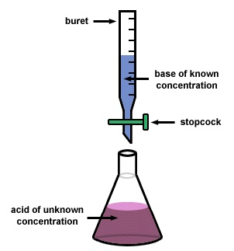
- Wash down the sides of the Erlenmeyer flask using a wash bottle.
It is vital that the flask be swirled, with direction changes throughout the titration, to ensure thorough mixing.
- Remove the solution adhering to the burette jet by touching the flask to the jet. Swirl the flask to mix in this portion. This should change the colour, giving the end point. If not, carefully continue the titration.
- Read the final volume immediately and write it down on your report. Use the same precautions as when reading the zero. The analysis should be repeated until duplicate titres are within 0,1 cm³ of each other.
A titration setup
- After use the burette must be thoroughly cleaned before being stored. The burette must be allowed to dry naturally while clamped upside down.
Note:
- When reading the liquid level in a burette, estimate the second decimal place. For example 29.45 ml means that the level is half way between 29.4 and 29.5 ml scale divisions.
- When handling the burette, every effort must be made to minimise touching the graduation area as this will cause the burette to warm up and hence affect its accuracy.
- When repeating titration in order to get volumes within 0.1 cm³ of each other, you already have a very good idea of the end point, say 24.1 cm³. About 23 cm³ can then be rapidly run into the Erlenmeyer by simply opening the burette fully. However, allow about 15 – 20 seconds before completing the titration to allow solution adhering on the sides of the burette to run down.
- All beakers containing reagents must be covered with watch glasses.

Knowledge Topic 9: Filtration

INTRODUCTION
Filtration is a process whereby the solid material is separated from the liquid part of a mixture.
The liquid that passes through the filter paper is called the filtrate. The solids that remain on the filter paper is called the residue. Filtration can be carried out in a number of ways. In a normal sugar mill laboratory it is done by gravity, by vacuum or by using pressure.
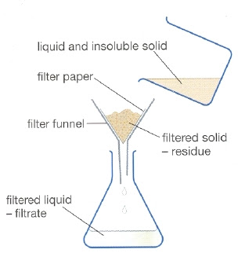
Effective filtration is dependent on the sizes of the holes / pores in the filter paper (filtering medium). Obviously the holes in the filter paper must be smaller than the particles that we wish to remove.
Consider a mixture of insoluble substances of different particle sizes, for example a mixture of marbles, sand and Talcum powder. By filtering with filters of different porosity (pore size), it is possible to separate the different substances. In this example we would require different sieves. It is important to note that filtration only removes those substances that do not dissolve i.e. insoluble substances. For example, if some sand and sugar are added to a beaker containing water, the sugar will dissolve and the sand will settle to the bottom. Filtering this mixture removes only the sand.
Insoluble particles can be removed by filtration
The analytical procedure during filtration differs depending on whether we require the filtrate or residue for analysis. If the filtrate is required, the residue on the filter paper is NOT washed with water or other solvents, since this would dilute the filtrate. Example: pol, brix and colour.
However, if the residue is required, the residue remaining on the filter paper must be washed. Example: suspended solid analysis and starch analyses.

FILTER PAPER
Six different grades or filter media are used in the laboratory. They are:
- Whatman No. 1 filter paper – insoluble matter in juice
- Whatman No. 5 filter paper – starch
- Whatman No. 6 filter paper – brix and turbidity
- Whatman No. 91 filter paper – pol and starch
- Whatman G.F.A (glass fibre) – insoluble matter in effluent.
- 0,45µm cellulose membrane - colour
You will notice that each of the above filter papers look and feel different because the sizes of their holes / pores are different. Papers must never be used for the wrong application as errors will result due to cloudy filtrates, slow or too rapid filtration.
When a filter paper is folded, the creases must not be sharp. If they are sharp the paper is weakened and poor filtration can result.
Procedure to be followed when folding filter paper:
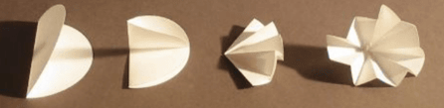
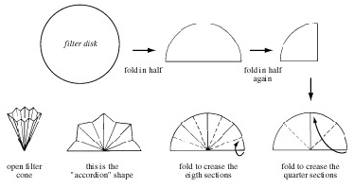
- First fold the paper in half, crease lightly and then fold in half again.
- Open the paper to the half folded position and fold the ends to the middle.
- Again open the paper to the half folded position.
- Proceed to “concertina fold” the filter paper as follows:
  - Open the filter paper and press into a filter funnel.
  - The uneven (crepe) surface of Whatman No. 91 paper with its ridges and grooves promotes filtration by facilitating drainage.

FILTER AID
Filter aid is primarily used not only to improve the filtration rate, but it also increases the clarity of the filtrate. It is inert i.e. it does not change the composition of the sample but acts like an extra piece of filter paper provided it is used correctly. Usually a mixture to be filtered contains substances of varying particle sizes. If one of the constituents consists of particles that are about the size of pores in the filter paper, they will cause these pores to block / blind thus preventing the rest of the solution from passing through the filter. To prevent this, a filter aid, like Celite, is used. The filter aid forms a mat called a “depth filter” which retains the smaller particles but also maintains drainage due to the spaces between the particles of the filter aid.
Two types of filter aid are used in the laboratory namely acid washed Kieselguhr and Celite 577. Note that Celite 577 may be used only for brix and suspended matter. When doing gravity filtration the filter aid must be well mixed with the sample and poured into the folded filter paper immediately. This ensures that the entire surface of the filter paper is coated with the filter aid and the filtration will be improved. When doing a vacuum filtration the filter pad is first prepared with the filter aid and then the sample can be poured slowly onto the mat of filter aid.

CLARIFICATION AGENT
Basic lead sub-acetate is a clarification agent and it is used to clarify solutions of pol determinations. The dry lead acts chemically on the sample forming a floc which, when removed by the filter, leaves a clear filtrate. The quantity of lead used is important. Too little or too much lead will lead to poor filtration and/or incorrect readings.
Definition of floc:
…..“a loosely clumped mass of fine particles”…..

GRAVITY FILTRATION (BRIX & POL)
Gravity filtration is done in the following manner:
- Pour approximately 100cm³ of juice (for brix) or 200cm³ of juice (for pol), into a clean, dry glass bottle, fitted with a stopper.
- Add the required amount of lead (for pol analysis) or 1g of filter aid (for brix analysis).
Fit the stopper and shake well.
- Place a filter funnel containing the required filter paper into a beaker.
- If it is brix filtration the juice must be poured into the folded filter paper immediately before the filter aid can settle out. It is important to push the folded filter paper down into the filter funnel and to hold it down while the solution is poured with the other hand. This will allow the watch glass to be supported by the rim of the filter funnel, thus forming a better seal.
During pol filtration, allow the solution to stand to allow the floc to form. The time it takes will depend on the product being analysed. Once the floc has formed, pour the sample into the folded filter paper.
- The funnel must now be covered with a watch glass to minimise evaporation.
- The first 10 – 25cm³ of filtrate (first runnings) must be discarded and the funnel transferred to a clean and dry breaker. This is very important because the first runnings are more concentrated than the rest of the solution due to water being withdrawn during the wetting of the filter paper. The first runnings may also be cloudy due to some small particles of filter aid or precipitate / residue being initially washed through the filter paper.

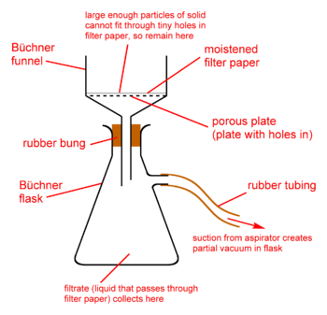
VACUUM FILTRATION
The vacuum filtration is done in two stages: precoating followed by filtration.
The precoating is done to form a mat of filter aid on the filter paper to improve the filtration.
Vacuum filtration with Buchner flask and funnel
- Fit a Buchner funnel and rubber cone into a filter flask.
- Connect the flask to a source of vacuum (a pump or water jet).
Vacuum filtration with Buchner flask and funnel
- Place the filter in the funnel the right way around and, under low vacuum, wet the paper with water. It is important to ensure that the paper fits neatly and is flat.
- The precoating can now take place. Depending on the analysis 2 – 5g of Kieselguhr is massed into a beaker. Add water, or alcohol if starch is being determined, and make a slurry.
- Pour the slurry down a glass rod onto the paper. Rinse the beaker and rod with a wash bottle to remove all the filter aid. Low vacuum is used to form the filter pad.
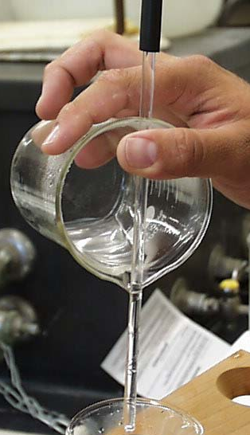
- The filtration can now be carried out. Assume that the residue is required.
The juice is poured slowly down a glass rod onto the precoated filter paper. When analysing for suspended solids the juice must be poured at a rate slower than the drainage rate of the paper. This is important since a layer of liquid must NOT form over the mat.
- While filtering, stir the beaker contents. Note: This applies to suspended solids determinations but not to starch whose washing by decantation is preferable.
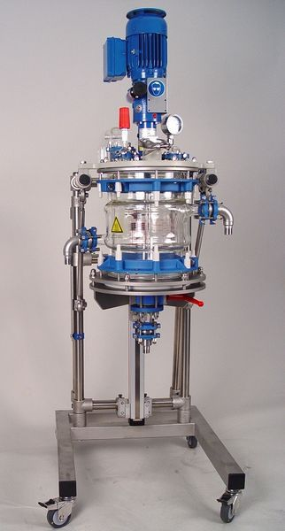
- Since the residue is required wash the glass rod off into the beaker, wash the side of the beaker, pour the solution into the Buchner and rinse the beaker several times into the Buchner using the wash bottle. Keep the spout of the beaker over the funnel until this has been done then wash the inside and outside of the spout. Touch the spout to the inside surface of the funnel to remove the last drop. This practice will ensure that none of the solution runs down the outside of the beaker.
How to pour a liquid along a glass rod
- Increase the vacuum and wash the filter with distilled water or alcohol (depending on the analysis). Allow the filter to drain between washings.
- Allow the filter to drain for 5 minutes under vacuum. Release the vacuum. The filter paper and contents can now be removed.
A laboratory scale Nutsch filter
When performing suspended solids analysis the filter paper supplied has a greater diameter than the Buchner funnel used. Use an object (e.g. a beaker) that just fits into the Buchner funnel and press the paper in, then flatten the folds so that they form pleats around the sides.
In cases where the filtrate is required, the vacuum flask is changed for a dry clean one after the first runnings have been collected. At the end of the filtration, do not rinse the beaker as this will dilute the filtrate.

PRESSURE FILTRATION (NUTSCH)
The basic principle involves placing a sample of massecuite over a sieve and applying air pressure to force the mother liquor through the sieve while the sugar crystals remain behind. The mother liquor is called a NUTSCH sample and is analysed for pol and brix. Depending on where the sample has been taken, the purity of the mother liquor can be used to assess the work done in the crystallisers, reheaters and the centrifugals.
Massecuite definition:
…“a dense mass of sugar crystals mixed with mother liquor obtained by evaporation”….

Knowledge Topic 10: Drying

INTRODUCTION
Drying is the process whereby moisture is removed from a substance by heating. This is done so that the moisture % of a substance can be determined. The moisture % is used for various purposes.
Definition of DAC:
“Direct Analysis of Cane” system – used for cane payments to cane growers
- Moisture % cane is used in the DAC calculations for cane payment.
- Moisture % bagasse is used to measure the efficiency of the dewatering process i.e. how well the mills are working.
- Moisture % filter cake is used as a guide to the efficiency of the rotary vacuum filters.
- Moisture % sugar is used as a measure of the efficiency of the sugar dryer.
- Dry solids % molasses is an alternative method of measuring the total soluble solids content of molasses and is more accurate than the refractometer brix determination.
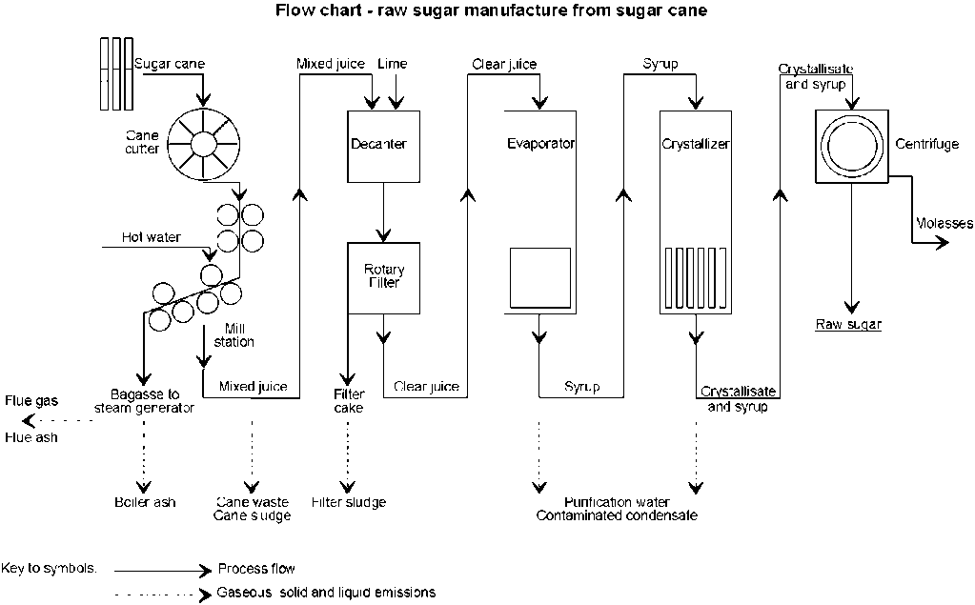
The flow chart below shows the sugar production process where some of these measurements are needed:
Flow chart of sugar manufacture

EQUIPMENT
To measure moisture % we need to use an oven. There are three types of ovens in use in a mill laboratory. They are:
- The Spencer type oven (Labotec or Dietert)
- Moisture oven with circulating fan
- Vacuum oven

SPENCER TYPE OVEN
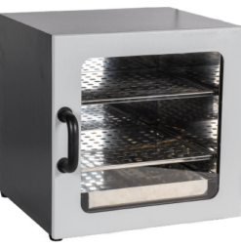
In a Spencer type oven a fan blows hot air from the top through the sample which is placed in a tray. The tray has a screen at the bottom which allows the hot moist air to pass through. The Spencer oven is used for prepared cane or bagasse.
Procedure for analysing moisture
The moisture tray must be thoroughly cleaned with a brush and preheated in the oven for five minutes. The tray must be preheated because after the sample is dried it must be massed hot to prevent reabsorption of moisture. It is massed hot because the tray is too big to fit in a desiccator to cool. The tray is massed empty, the sample is added and the mass of the tray with sample is recorded.
The tray is then placed in the oven for 60 minutes at 105˚C. At the end of the time period the tray must be removed and massed hot. This must be done immediately, not 5 or 10 minutes later or the sample will have reabsorbed moisture. Care must be taken that the fan is not running while the tray is removed or small particles might blow away, giving an incorrect result.
Calculation
Mass of empty tray = A grams
Mass of tray and wet sample = B grams
Mass of tray and dry sample = C grams
Moisture % = $\frac{B -C}{B -A}$× 100 or = $\frac{Mass of moisture}{Mass of wet sample}$× 100
Record the answer correct to two decimal places.

MOISTURE OVEN
The moisture oven is used for sugar and filter cake moisture. The oven has a circulating fan to ensure that the temperature inside the oven is uniform and that there are no hot spots. The moisture % sugar analysis is critical and the mass and timing must be done accurately.
Procedure for using the moisture oven
Dry a clean moisture dish for 1 hr at 105˚C in the moisture oven. Cool in a desiccator.
- Weigh the clean and dry moisture dish and lid to the accuracy required by the particular analysis.
- Add the amount of sample required.
- Replace the lid immediately and reweigh the moisture dish containing the sample.
- Place the dish in the oven. Remove the lid, invert the lid and place the moisture dish inside the lid.
- Dry for 3 hours as required at 105˚C (sugar) or 4 hours at 130˚C (filter cake)
- Using tongs replace the lid on the dish and remove from the oven.
- Place in a desiccator and allow to cool to ambient temperature for 1 hour.
- Weigh the dish, lid and dry sample to the precision required.
Moisture % = $\frac{Mass of moisture}{Mass of sample}$ × 100
Note:
When placing samples into a moisture oven, start placing the samples on the top shelf and work down towards the bottom shelf. When removing samples from a moisture oven start at the bottom shelf and work upwards towards the top shelf. This reduces the risk of one sample spill contaminating several other samples.
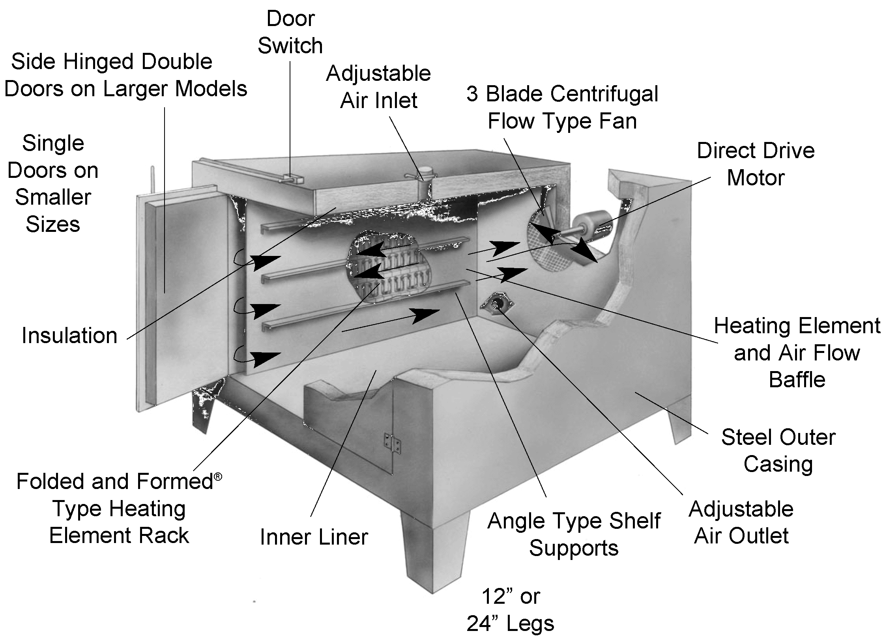
A cross-section through a typical drying oven

Knowledge Topic 11: Preparation of Solutions and Concentration Calculations

INTRODUCTION
If a solute (e.g. sugar) is mixed with a solvent (e.g. water) the result is called a solution. A solution is therefore a homogeneous mixture of two (or more) components. Homogeneous means uniform i.e. the components cannot be told apart e.g. we cannot see the sugar dissolved in a sugar solution. A heterogeneous mixture is a mixture of two or more components where it is possible to tell the components apart e.g. a mixture of sugar and sand.
A standard solution is a solution with a known concentration of chemicals.
A standard solution is necessary when doing most analyses so that the unknown can be compared with the known. The accuracy of the final result of the analysis will thus depend on whether the solution was made correctly or not.
Definition of distilled water:
Distilled water is water that has had many of its impurities removed through distillation. Distillation involves boiling the water and then condensing the steam into a clean container (See process diagram below)

STANDARD SOLUTIONS
There are two ways of making up standard solutions:
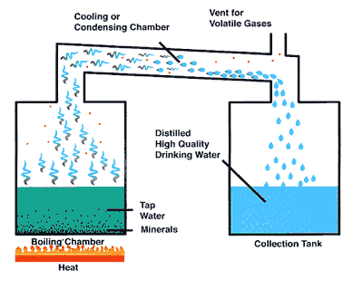
- By massing / pipetting a known quantity and making to mark in a volumetric flask.
- By using an aliquot of concentrated standard solution and making to the mark.
In both cases distilled or de-ionised water must be used. NOT TAP WATER!

REAGENT SOLUTIONS
A reagent solution is a solution which is used to react with another substance e.g. an indicator solution.
How to make distilled water

PREPARATION OF SOLUTIONS
The procedure described here refers to the preparation of any standard solution.
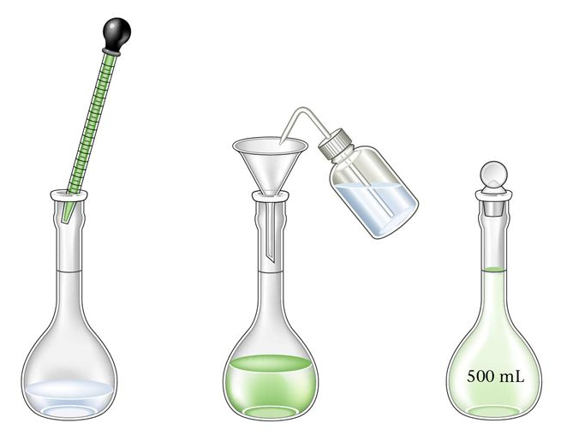
The first step involves massing and quantitatively transferring the solute to the flask. (Note that kohlrausch and sugar flasks are also volumetric flasks.)
The second step involves making the contents of the volumetric flask up to the graduation mark.
The step-by-step technique involved in each of these tasks is listed below:
Step 1: Transferring the solute to the flask
- Read the procedure and obtain all the items required.
Process of making standard solution from liquids
- Make sure that all the equipment is clean.
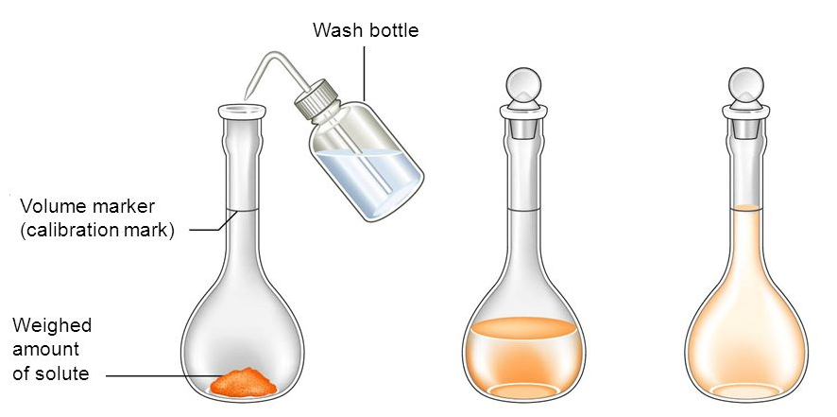
- Mass out the required quantity of chemical(s) into a nickel massing basin or beaker.
- If heat is required to dissolve the solute, do this in a beaker first, then transfer the cooled solution to the flask.
How to make a standard solution from a solute
- Using the jet from a wash bottle, wash the final portion of the solute from the massing basin into the flask.
Note: To prevent the funnel from choking, wet the solute and swirl the massing basin to form a slurry. Also wash the outside of the spout into the flask.
- If a funnel is used, wash that too into the flask.
NOTE: At this point all the chemicals must be in the flask, with none lost by adhering to the beaker, the massing basin or the funnel. This is referred to as a quantitative transfer.
Step 2: Making to the mark accurately
The aim of this lengthy and precise procedure is that, at the end of the 23 steps, the analyst must be able to say, with complete certainty, that all the chemical measured out is contained in a certain volume of solution, with nothing having been lost anywhere. Note that loss could be in the form of a solid chemical (after massing and before dissolving), or in the form of solution.
- Rinse the inside and outside of the funnel into the flask using the washing bottle.
If the pipette was used to transfer an aliquot of solution and the pipette touched the side of the volumetric flask, this must be rinsed down.
- Make up to the bottom of the neck and stopper the flask (This allows space for mixing)
- Mix well by swirling the flask until there are no striations in the solution.
- Wash the stopper into the flask (Do not lose chemical in drops adhering to the stopper). If the stopper is rinsed using a funnel, the funnel must be rinsed (both inside and outside) before it is removed.
- Make up to 2cm below the mark.
- Stopper and swirl again. This is the last mixing until No. 22 below.
When the flask is finally made up to the mark in step 20, the neck above the mark must be absolutely dry. Any drops in this area would increase the volume during the last mixing in step 22.
- Rinse the stopper into the funnel again and rinse the funnel.
- Rinse the neck of the flask (The level should be 0.5 cm below the mark).
- Dry the stopper.
- Dry the neck down to the mark with a roll of tissue / filter paper.
- Do not dip the tissue into the solution (This will lose solution).
- Replace the stopper.
- Note the water bath temperature and ask the laboratory supervisor to adjust it if necessary.
- Place a wash bottle and the flask into the water bath (time).
- Remove the wash bottle and flask from the water bath (time).
- Minutes in water bath: Minimum 30 minutes.
- Do not allow the flask to float. Contamination of the neck above the graduation mark could occur.
- Dry the wash bottle.
- Dry the flask.
- By bringing the tip of a pipette or fine dropper close to the meniscus, carefully make to mark (No splashing or wetting of the neck above the mark).
HINT: Hold the flask above the mark with the index finger placed over the mouth about half way. Keep the pipette against this finger to control it in the centre of the neck so as not to let it touch the side.
- Replace the stopper (It should still be dry).
- Mix well by inverting 20 times.
- Store in a reagent bottle and label the bottle accurately.
Dealing with a bubble:
If there are bubbles at the surface of the meniscus these must be removed either by tapping the flask or by using 1-2 drops of ether. The ether breaks the surface tension and allows the bubbles to escape.
Importance of using a water bath:
When a solute dissolves it changes the temperature of the solution either by absorbing or releasing heat. When sugar, for example, dissolves it causes the solution to cool since the dissolution process absorbs energy. On the other hand, concentrated sulphuric acid releases heat when it dissolves. If the solution is not brought back to 20˚C using a constant temperature water bath, inaccuracies would result when the solution is made to the mark in the volumetric flask.

STORAGE OF SOLUTIONS
It is usual to store solutions in reagent bottles with ground glass or polythene stoppers. When storing alkaline solutions a polythene or rubber stopper must be used as a glass stopper will seize in the bottle.
The bottle must be clean and dry to prevent contamination, be rinsed with a small portion of the solution before the solution is transferred to the bottle. The bottle must be labelled and have a tight fitting stopper. The label must contain the following information:
- name of the solution
- concentration of the solution
- name of the person who prepared the solution
- date when prepared
Label solutions clearly as required by your laboratory
- expiry date (if applicable)
- special instructions (e.g. “store in fridge”) if applicable.
In order to protect the label and the information on it, it is a good idea to cover the label with clear cellotape or other self-adhesive plastic.
Remember always to dispense liquid from the side opposite the label so as to not obliterate the information on it.
Pour away from the label to avoid spoiling it

AMOUNT OF DISSOLVED SUBSTANCE(S)

Percentage dissolved Substance(s)
It is often very convenient to express the amount of dissolved substance (solute) in a solution as a percentage by mass.
Formula:
% Dissolved substance(s) = $\frac{Massof Dissolved substance(s)}{Mass of solution}$ × 100
Example 1:
- 15 g sugar in 85 g water
% Dissolved substance = $\frac{15 g}{100 g}$ × 100 = 15 % sugar
- 85 g sugar in 125 g water
% Dissolved substance = $\frac{85 g}{210 g}$ × 100 = 40.5% sugar

Mass of Dissolved Substance:
Formula:
Mass of Dissolved substance(s) = $\frac{Percentage dissolved substance(s)}{100}$ × Mass of solution
Example 2:
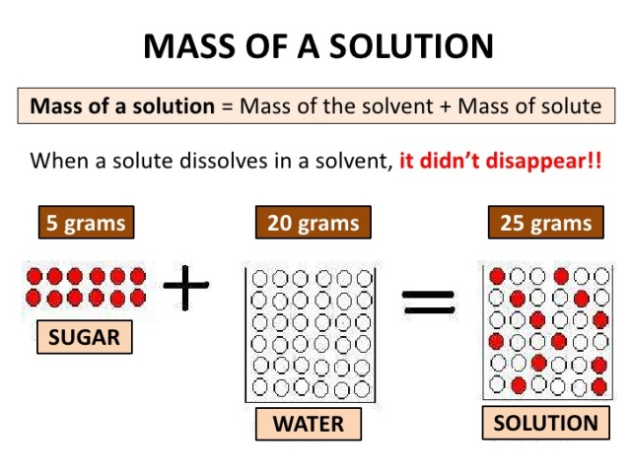
Find the mass of sucrose in 150 g of a 35% sucrose solution.
Mass of sucrose = $\frac{35}{100}$ × 150g = 52.5 g

Mass of solution
Formula:
Mass of solution = $\frac{Mass of Dissolved substance(s)}{\% Dissolved substance(s)}$ × 100
Example 3:
Find the mass of a 40% sucrose solution if the solution contains 75g of sucrose.
Mass of solution = $\frac{75 g}{40\%}$ × 100 = 187.5g

EXPRESSING CONCENTRATION
The concentration of a substance in water can be expressed as a mass per certain volume of solution.
The concentration is usually expressed as the mass of solute per litre of solution.
Example 4:
1 g per litre ; 7g per litre ; 11.3g per litre; 1 g per 1000 cm³
It is important that the above is remembered as it simplifies the working out of different concentrations and volumes.
Remember 1 litre is always the basis of the calculation i.e. 1 l or 1000 cm³ is the denominator in all cases.

Calculating of volume
Given mass and concentration the volume can be obtained.
Example 4:
Mass = 500 g
Concentration = 250 g/l
using ratio:
Volume = $\frac{Mass}{Concentration}$ 250g solute in 1 l (given)
= $\frac{ 500 g}{250 g ̸l}$ ∴(2 × 250g) solute in (2 × 1 l)
= 2l ∴500 g solute in 2000 cm3
∴500 g solute in 2 l
Example 5:
Mass = 270 g
Concentration = 72 g/l
using ratio:
Volume = $\frac{Mass }{Concentration}$ 72 g solute in 1 l (concentration)
= $\frac{270 g}{72 g ̸ l}$ ∴(3.75 × 72 g) solute in (3.75 × 1 l)
= 3.75 l ∴ 270 g solute in 3.75 l

Calculation of Mass
Given volume and concentration the mass can be obtained.
Examples 6:
Volume = 300 cm³ (0.3 l)
Concentration = 100 g/l
using ratio:
Mass = Concentration × volume 100 g solute in 1 litre (concentration)
=$\frac{100 g}{11}$ × $\frac{0,3l}{1}$ ∴(0.3 × 100g) solute in (0.3 × 1 l)
= 30g ∴30 g solute in 0.3 l

REDUCING THE CONCENTRATION
When you wish to make a series of solutions of different concentrations from your original standard solution the following procedure is used.
Aliquot = $\frac{New Concentration ×New Volume}{Old Concentration}$
The aliquot is the volume of the original solution that must be taken and diluted.
Why does this formula work?
Consider a volume V₁ of a solution of concentration A g/l and you want to change it into a new solution of concentration B g/l by adding water to get a new volume V₂.
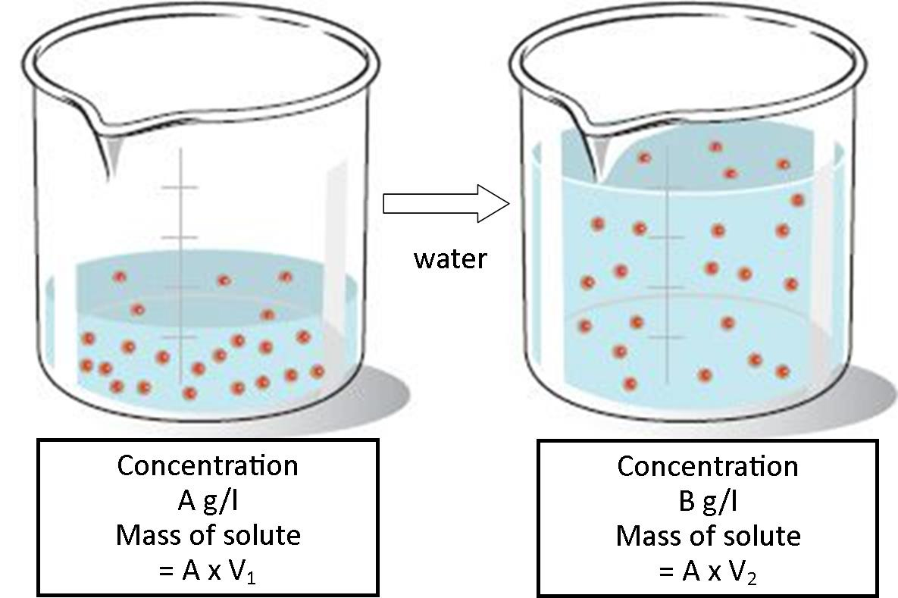
But the mass of solute in the first solution is equal to the mass of solute in the second, since only water has been added.
A × V₁ = B × V₁
V₁ = $\frac{B ×V₂}{A}$
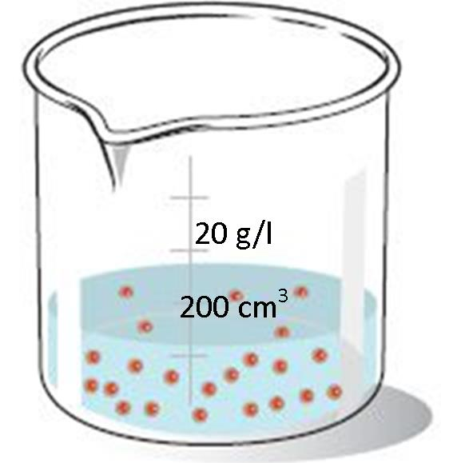
Example:
From a 500 g/l standard solution make up 200 cm³ with a concentration of 20 g/l.
Method 1: Using step by step reasoning:
- You want to make 200 cm3 of solution with a concentration of 20 g/l.
- The mass of solute present in the 200 cm³ (0.2l) must thus be:
Mass = Concentration × Volume
= $\frac{20 g}{1l}$ × $\frac{0.2l}{1}$
= 4 g solute present in the 200 cm³
- Thus 4 g of solute must come from your original standard solution.
- What volume of the standard solution will contain 4 g of solute?.
Volume = $\frac{Mass}{Concentration }$
= $\frac{4 g}{500 g ̸ l}$
= 0.008 l
= 8 cm³ of the original solution contains 4 g of solute
- Pipette out a 8 cm³ aliquot of the original solution and make it up to 200 cm³ (0.2 l). This will give you a concentration of 20 g/l.
Concentration = $\frac{Mass }{Volume}$
= $\frac{4 g}{0,2 l}$
Definition of aliquot:
A portion of a larger whole, especially a sample taken for chemical analysis or other treatment.
= 20 g/l
Method 2: Using the formula
Aliquot = $\frac{New concentration ×New volume}{Old concentration }$
= $\frac{20 g ̸l ×0.2 l}{500 g ̸ l}$
= 0.008 l
= 8 ml
Method 3: Using a mass balance
Mass of solute in standard solution = Mass of solute in new solution
“Old” Concentration × “Old” Volume = New Concentration × New Volume
500 g/l × “Old” Volume = 20 g/l × 0.2 l
“Old” Volume = $\frac{20 g̸l ×0,2 l}{500 g ̸ l}$
“Old” Volume = 0.008 l = 8 ml
Thus 8 cm³ of your old solution is necessary.
Therefore 8 cm³ of the old solution (500 g/l) is diluted up to 200 cm³ and this will give a new solution of concentration 20 g/l.

CALCULATIONS INVOLVING QUANTITATIVE TRANSFERS

Simple Dilutions
Example 1:
18 g of sugar is dissolved in 250 ml of water in a volumetric flask. 50 ml of the solution is pipetted out into a 100 ml volumetric flask and made to the mark. 25 ml of this solution is pipetted into an evaporating dish and evaporated to dryness. What mass of dry sugar will be obtained?
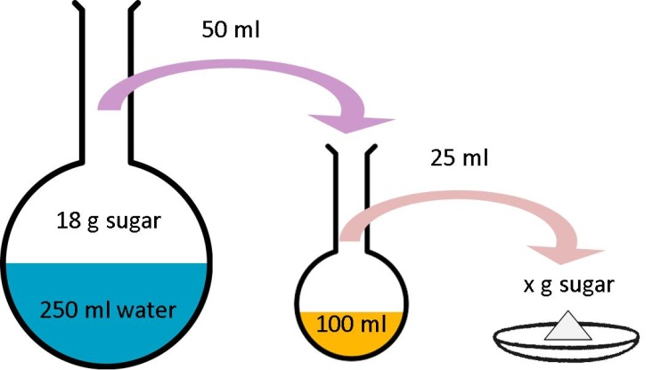
We can represent this information as follows:
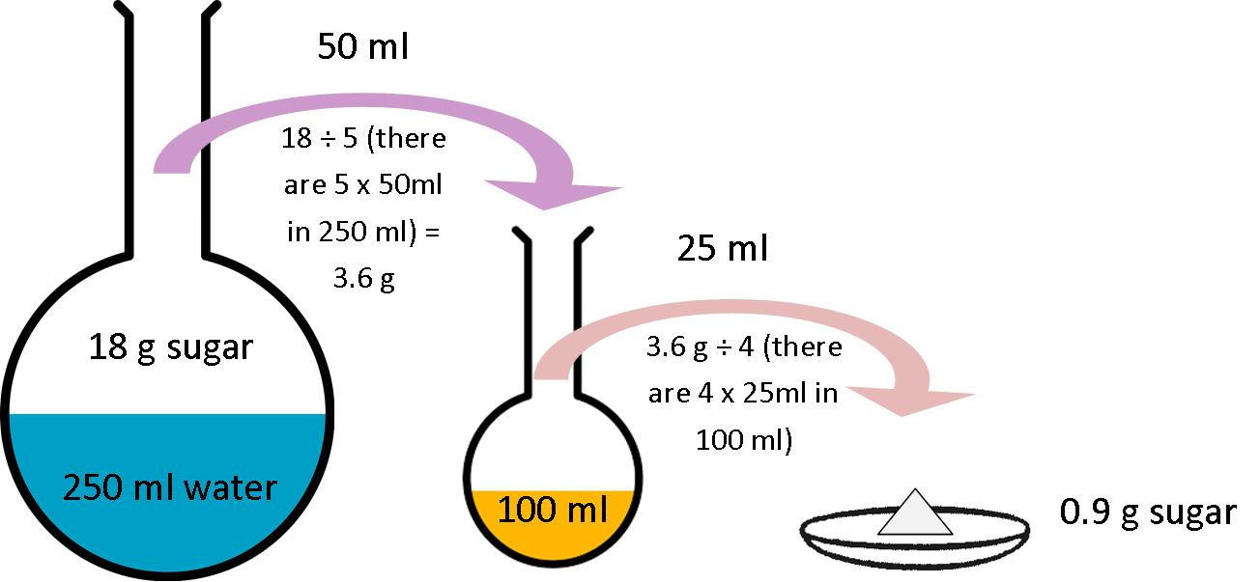
Steps in our reasoning:
- The 50 ml aliquot contains only 3.6 g sugar $\left(\frac{18 g}{5}\right)$ i.e. $\frac{18}{250}$ × 50
- Therefore the 100 ml volumetric flask contains 3.6 g sugar.
- The 25 ml aliquot contains only 0.9 g of sugar $\left(\frac{3.6}{4}\right)$i.e. $\frac{3.6}{100}$× 25
- Therefore 0.9 g dry sugar will be obtained.
Example 2:
A quantity of sugar is dissolved in 500 ml of water in a volumetric flask. 20 ml of the solution is pipetted out into a 100 ml volumetric flask and made to the mark. 25 ml of the solution is pipetted out into an evaporating dish and evaporated to dryness giving 1.5 grams of sugar.
What mass of sugar was initially placed into the 500 ml volumetric flask?
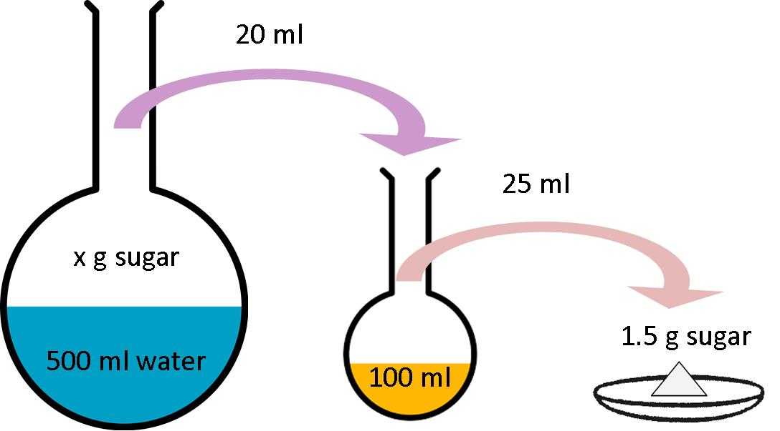
We represent this information shown below and we then calculate backwards.
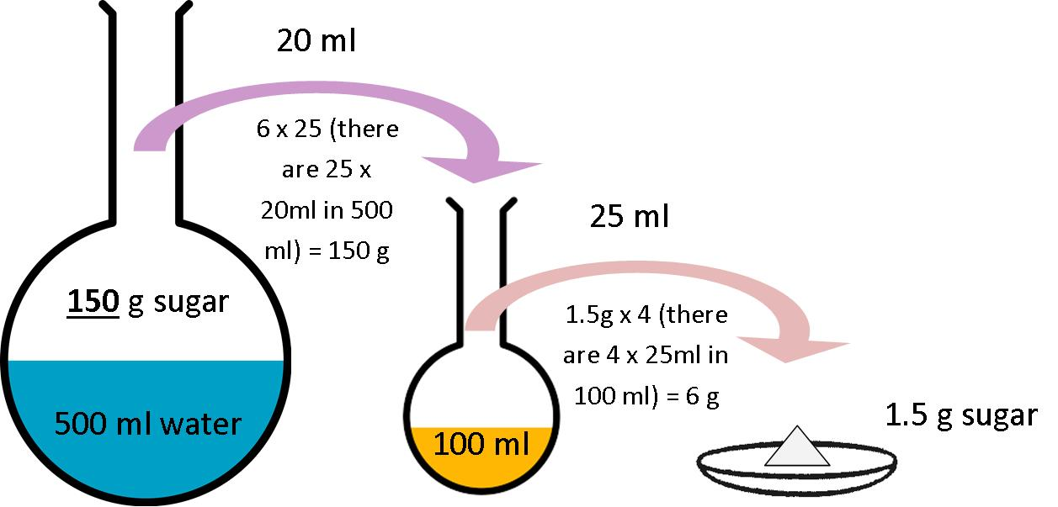
Steps in our reasoning:
- 1.5 g sugar was left, thus there must be 1.5 g of sugar in the 25 ml aliquot.
- Since there is 1.5 g of sugar in the 25 ml aliquot there must be 6 g (4 × 1.5 g) of sugar in the 100 ml volumetric flask.
- Since there is 6 g of sugar in the 100 ml volumetric flask, there must be 6 g of sugar in the 20 ml aliquot that was placed into the 100 ml volumetric flask.
- Since there is 6 g sugar in the 20 ml aliquot there must be 150 (25 × 6 g) of sugar in the 500 ml volumetric flask.

Ratio and Proportion
Example:
For a particular analysis a solution of 25 g NaOH in a 300 ml volumetric flask is required.
However, you wish to prepare only 200 ml of solution. What quantity of NaOH would you place in the 200 ml volumetric flask?
25 g NaOH in 300 ml of solution
Thus: $\frac{25 g }{1.5}$ NaOH in $\frac{300 ml }{1.5}$ of solution
Thus 16.67 g NaOH in 200 ml of solution
OR
$\frac{25}{×}$ = $\frac{300}{200}$
300 × = 25 x 200
300 × = 5 000
× = 16.67g NaOH

DENSITY OF SOLUTIONS

Density
The density of a solution is the mass of solution per unit volume of solution.
Formula:
Density = $\frac{Mass of solution (in grams)}{Volume of solution (in ml)}$ - $\left[D= \frac{M}{V}\right]$
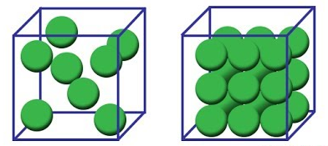
Unit: g/ml solution
The density of water is 0.99717 g/ml at 20˚C. This means that every 1 ml of water has a mass of 0.99717 g. (usually it is accurate enough to take the density of water as 1 g/ml).
Example 1:
Density describes how closely particles are packed in a volume
If 50 g of pure sucrose is dissolved in 100 ml (100g) of water the result is a solution of mass 150 g and a volume of 131.36 ml.
Density = $\frac{Mass of solution (in grams)}{Volume of solution (in ml)}$ % Sucrose = $\frac{Mass of sucrose}{Mass of solution}$ × 100
= $\frac{150 g}{131.36 ml }$ = $\frac{50 g}{150 g}$ × 100
= 1.14 g/ml of solution = 33.33 %
Example 2:
If 100 g of pure sucrose is dissolved in a 100 ml (100g) of water the result is a solution of mass 200 g and a volume of 162.79 ml.
Density = $\frac{Mass of solution (in grams)}{Volume of solution (in ml)}$ % Sucrose = $\frac{Mass of sucrose}{Mass of solution}$ × 100
= $\frac{200 g}{162.79 ml}$ = $\frac{100 g}{200 g}$× 100
= 1.23 g/ml of solution = 50%
Using sugar solutions as examples we showed that as the percentage of the dissolved substance (sugar) in the solution increases, the density of the solution increases.
Appendix A contains a table that relates the % dissolved substances (Brix) to the density of solution in g/ml. This table was compiled using pure sucrose solution.

Other useful formulae:
- Mass
Mass = Density × Volume (M = D × V)
Example 1:
Find the mass of 100 ml of solution of density 1.15 g/ml.
M = D × V
= 1.15 g/ml × 100 ml
= 115 g
Example 2:
Find the mass of 250 ml of a solution of solution of density 1.2 g/ml.
M = D × V
= 1.2 g/ml × 250 ml
= 300 g
- Volume
Volume = $\frac{Mass}{Density}$ $\left(V= \frac{M}{D}\right)$
Example:
Find the volume of a sugar solution that has a density of 1.11 g/ml if it has a mass of 111 g.
V = $\frac{M}{D}$
= $\frac{111 g}{1.11 g ̸ ml}$
= 100 ml
Example 2:
Find the volume of sugar solution that has a density of 1.17 g/ml if it has a mass of 39 g.
V = $\frac{M}{D}$
= $\frac{39 g}{1.17 g ̸ ml}$
= 33.33 ml
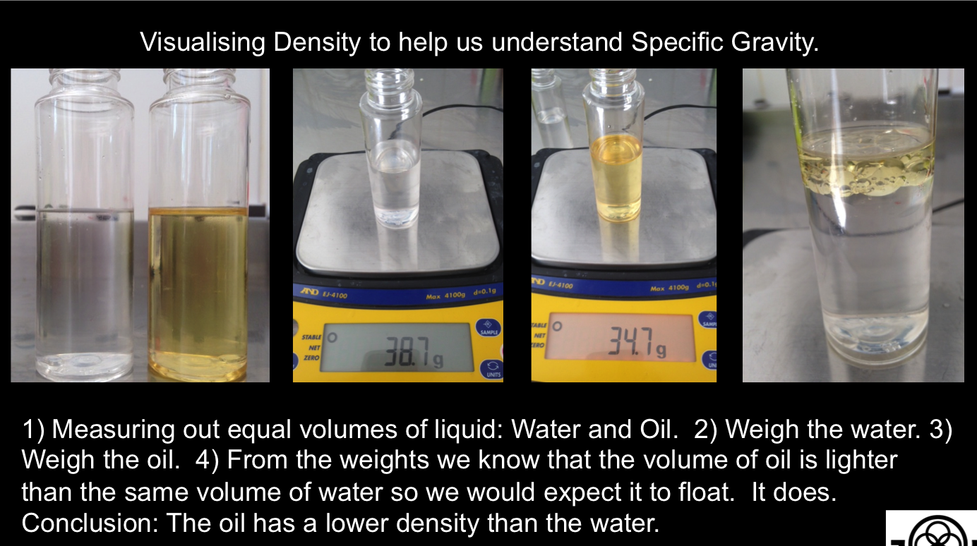
Example 3:
Find the volume of a sugar solution that has a density of 1.17 g/ml if it has a mass of 58.5 g.
V = $\frac{M}{D}$
= $\frac{58.5 g}{1.17 g ̸ ml}$
= 50 ml

SPECIFIC GRAVITY
The specific gravity of a substance / solution is defined as the ratio of the density of that substance / solution at 20˚C to the density of water at 20˚C.
Specific Gravity = $\frac{Density of solution}{Density of water}$
Sp. Gr. = $\frac{DSOL}{Dw}$
D_{SOL} = D_{W} × Sp. Gr.

CONVERTING % DISSOLVED SUBSTANCE TO CONCENTRATION IN g/l
Example:
Find the concentration of a 15% pure sucrose solution.
15% sucrose solution = 15 g sucrose / 100 g solution
We need to find the volume of 100 g solution. To do this we consult the table in Appendix A and we find that a 15% solution has a density of 1.05811 g/ml.
Therefore the volume of 100 g of 15% sucrose solution is:
V = $\frac{M}{D}$
= $\frac{100 g}{1.05811 g ̸ ml}$
= 94.508 ml
Now 15% sucrose solution
= 15 g sucrose / 100 g solution
= $\frac{15 g sucrose }{100 g solution}$
= $\frac{15 g sucrose}{94.508 ml of solution}$
= 0.15872 g/ml
= 15.872 g/ 100 ml solution
= 158.72 g / 1000 ml solution
= 158.72 g/l
Note: that we calculated the concentration of the 15% sucrose solution as 0.15872 g/ml which is equal to 15.872 g/100 ml solution. This agrees quite clearly with the grams of sucrose (mass in grams) per 100 cm³ in vacuo given in the table in Appendix A which is 15.887 g/ml solution.
Definition of “in vacuo”:
“in a vacuum”
We could therefore use the table in Appendix A to directly convert 15% sucrose solution to 15.887 g/ml solution (i.e. without the above calculation).

CONVERTING CONCENTRATION IN g/l TO % DISSOLVED SUBSTANCE
Example:
Find the % sucrose in a solution of concentration 225.58 g/l solution.
Concentration = 225.58 g of sucrose / 1000 ml of solution
= $\frac{225.58 g sucrose}{1000 ml of solution }$
= $\frac{22.558 g of sucrose }{100 ml of solution }$
We need to find the mass of 100 ml of solution.
Consulting the table in Appendix A we find that 100 ml of solution that contains 22.558 g sucrose has a density of 1.08347 g / ml.
Therefore the mass of 100 ml of the solution containing 22.558 g/100 ml is:
M = D × V
= 1.08347 g/ml × 100 ml
= 108.347 g
Now:
% Dissolved Substance = $\frac{Mass of substance }{Mass of solution}$ × 100
= $\frac{Mass of sucrose in 100 ml solution}{Mass of 100 ml of solution}$ × 100
= $\frac{22.558 g}{108.347}$× 100
= 20.82 %
Therefore a 225.58 g/ 1000 ml sucrose solution is 20.82% sucrose solution.
Alternatively:
We can use the Table in Appendix A to directly convert a 22.558 g/ 100 ml sucrose to a percentage composition of 20.8%.

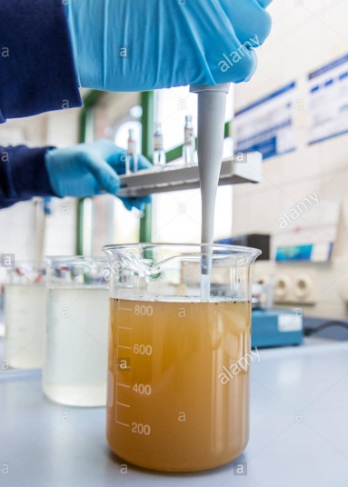
Knowledge Topic 12: Sampling

INTRODUCTION
Correct sampling techniques are of vital importance if meaningful results are to be obtained to effect proper factory control. An analysis can be no better than the representivity of the sample being analysed. It becomes meaningless and pointless to obtain and publish analytical results of samples that are not representative. The following factors should be borne in mind when an analysis is done on a sample that is not representative.
Samples should be well mixed before an aliquot is taken for analysis
- Waste of time – another analysis could have been done
- Waste of money – chemicals, filter paper.
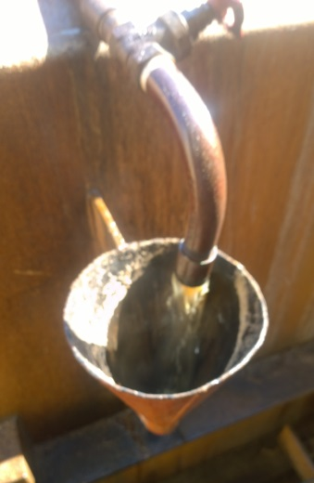
Sub-sampling of samples sent to the laboratory must also be representative to ensure accuracy. The importance of mixing the primary sample before sub-sampling cannot be over-stressed. Sub-sampling is a procedure whereby a sample is divided up into smaller portions – each portion being representative of the original sample. The person taking the sample (sample carrier) should not be interfered with while doing his job. Operators have a tendency to tell the sample carrier when to take a sample (when the conditions are right). This means that the sample taken is then biased and no longer representative.
Samples are taken at many stages of the sugar milling process. Here at the diffusion stage….

CONTINUOUS SAMPLING
Continuous sampling is necessary where great accuracy is required e.g. cane (DAC), mixed juice, sugar and final molasses. The sample should be in proportion to the quantity produced during a specific period.

CATCH SAMPLING
Where great accuracy is not required, catch samples taken at fairly large time intervals or as required are adequate. These are the samples required for routine quality control i.e. brix, pol and pH. Catch sampling is also practiced when there is the possibility that a continuous sample will deteriorate during the sampling period.

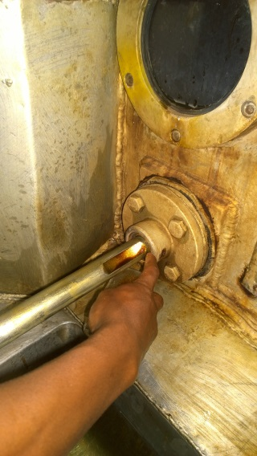
SAMPLE CONTAINERS AND PRESERVATION OF SAMPLES
Measuring sugar crystal formation
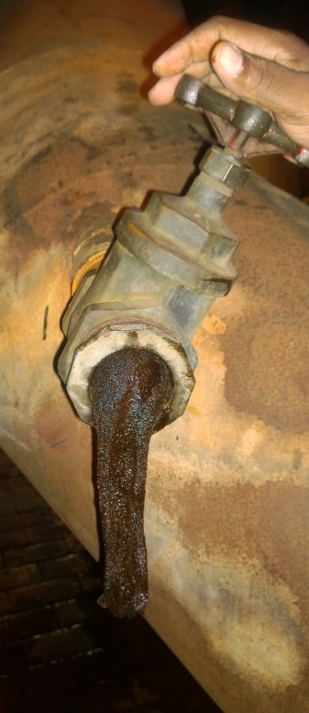
In order to obtain accurate results, cleanliness of sample receptacles is absolutely essential. It is imperative that sample containers are cleaned and sterilised at regular intervals to prevent contamination of subsequent samples. In the case of continuous samples, juice preservative (mercuric chloride) should be added to prevent possible deterioration. It is general practice in laboratories to preserve composite samples of juice (mixed juice and clear juice) with mercuric chloride. It is not necessary to preserve samples of high concentration (syrup, molasses, massecuites) although syrup samples must be placed in a fridge or deep freeze if they are to be stored for some time.
Duplicate sampling devices and containers are necessary. Sample cans should be made of stainless steel or copper, be seamless and have covers to minimise evaporation losses and to prevent contamination and deterioration. They should not have sharp corners.
High concentration massecuite sampling point

SPECIFIC SAMPLING PROCEDURES AT A MILL

Cane
- PREPARED CANE FOR DIRECT ANALYSIS
For cane payment purposes, individual cane consignments are sampled. When the first mm is by-passed for mechanical reasons, cane sampling must continue and the miller shall provide the equipment and labour necessary for transferring the excess cane sample back to process.
Apparatus: Electronic cane tracker, Cane sub-sampler, Sample table, Sample shredder, Enamel billycan with lid (seamless construction and 6 litre capacity)
PROCEDURE FOR PERSONNEL OPERATING THE ELECTRONIC CANE TRACKER
- Visually follow the progress of the consignment on the carrier system up to the point where the electronic cane tracker is designed to take over.
- Make allowance as dictated by local conditions for intermixed cane so as to ensure that this will not be sampled. Apart from this the sampling period should correspond with the passage of the maximum percentage of a consignment. Special circumstances, e.g. group testing, may dictate that one sample will be taken to represent the cane from more than one supplier, but this will be done only on specific instructions from the SICB Senior Technologist.
- Once all intermixed cane has passed the cane tracker starting point, cause the electronic cane tracker to follow the progress of the consignment.
- Complete the weighbridge ticket with details required, viz. cane tracker number and, if applicable, bundle numbers, and consign the ticket to the laboratory. Alternatively if Autolab is in operation enter the relevant details via the keyboard.
- As the end of a consignment passes the cane tracking initiation point, depress the stop button.
- After every new consignment check that the tracker output counter number plus the number of consignments in transit equal the tracker input counter number. If these figures do not agree, immediately investigate the reason and take the necessary measures.
- If for any reason mixing of cane from different suppliers occurs after the head of a consignment has passed the cane tracking initiation point, tracking must be interrupted so as to avoid sampling the intermixed portion. When this occurs, one consignment will be shown as two on the display and the sampling staff must be advised immediately what action to take. Such incidents must always be recorded.
- Check frequently that the tracker output counter corresponds with the sample point counter.
PROCEDURE FOR PERSONNEL OPERATING AT SAMPLE POINT
- On receiving the cane tracker signal (the green signalizing light and bell)
- Note the size of the consignment as shown on the cane tracker display and adjust the cane sub-sampler secondary stage reject interval timer so as to obtain the optimum size sample (10 kg) in the sample receptacle.
- Fill in a sample ticket showing the sample point counter number and the receptacle number.
- After a factory maintenance stop reject the cane from the first two cane sampler openings as a precaution against the possible presence of water in the sampling equipment.
- At the end of the sample run which is indicated by the red signaling light and bell, tip the contents of the sample receptacle onto the table provided. Note: All subsequent cane sampling operations must be done as thoroughly and quickly as possible to avoid selective sampling and loss of moisture.
- Mix the cane and then spread into a layer 50 – 70 mm thick. By randomly taking handfuls of cane collect one sub-sample of about 2kg. Care must be taken not to shake the cane held in the hand as this will result in particle size selection.
- Discard the excess sample on the mixing table.
- Transfer the sub-sample to the sample shredder distributing the sample evenly in the shredder compartment.
- After shredding transfer the sample from the shredder sample receiver to the enamel billycan, taking the precaution of first wiping out the billycan with a portion of the cane sample and rejecting this cane portion.
At some installations a pneumatic sample conveyor system has been installed. In these instances transfer the sample from the shredder sample receiver to the plastic bag provided. Close the bag by tying a knot at the open end and prick the plastic a few times to release trapped air. Fit the plastic bag into the canvas carrier bag which is attached to a pneumatic sample conveyor shuttle.
- Immediately convey the sample in the closed billycan with relevant sample ticket to the laboratory, or alternatively, where pneumatic sample conveyors are in operation, place the shuttle with carrier bag attached in the air tube system.
- The work area as well as all equipment must be maintained in a clean state at all times.
The analysis of the sample (being representative of the mm preparation) is compared with the analysis of the DAC sample and must be taken at the same time as the latter. The sample for leaching analysis must not undergo any preparation beyond that already given by the mill knives and mill shredder. Since there is no preparation of the cane from the hatch to the sample box used for collecting the sample for direct analysis of cane, the sample for leaching analysis may conveniently be withdrawn from the same portion of cane collected for the direct analysis.
Therefore the sampling procedure is the same as that for the DAC sample except that the leaching analysis sample is not shredded in the sample shredder.
- WHOLE STICK CANE
DETERMINATION OF TOPS AND TRASH
General
Representative sampling of whole stick cane is notoriously difficult. A grab sample may be used as described below:
Apparatus: Mechanical grab sampler, Stretcher
Procedure
- Position the grab sampler next to the cane carrier and before the first cane knives in a place which permits sampling of all delivered cane.
- The frequency of sampling will depend on local conditions and requirements.
- Ensure that a full grab load is taken.
- Deposit the whole sample in the stretcher taking care to return any spillage to the stretcher.

Bagasse
Because of the difficulties of continuous sampling of bagasse, catch samples are taken at regular intervals. Different types and configurations of bagasse conveyors at mills have given rise to various methods for obtaining a sample representative of the full depth and width of the final bagasse blanket. Ideally sampling should be through a hatch situated in the base plate of the bagasse elevator just after the last mill. Such a hatch must span the full width of the elevator and open sufficiently to allow the fall-out of a complete slat load of bagasse. Opening and closing of the hatch must be with a snap action to avoid bias.
However, the increasing trend in the South African industry towards the uses of belt conveyors precludes the use of a sample hatch and at mills where this already exists, use of the “swing” sampler is recommended.
Apparatus: Hatch sampler or, if not applicable, swing sampler, Sample receptacle enamel billycan with lid, seamless construction (6 litre capacity), Mixing table (stainless steel top)
PROCEDURE
- Regardless of chokes or other irregularities of crushing, a sample of bagasse should be taken at a predetermined time every hour. If the mill is not crushing at the sampling time, no sample shall be taken for that hour.
- If the hatch sampler is used, the hatch is opened so as to allow a full slat load of bagasse to fall through. Reject this sample and collect a second sample for analysis.
- If the swing sampler is used the sampling procedure is as follows:
- Remove the locking pin and swing the handle down until it rests on the guide wheel.
- Push the sample box into the bagasse stream ensuring that the leading edge moves beyond the rear of the falling bagasse stream and then reverse the stroke.
- The hatch sample is mixed on the sample table while that obtained with the swing sampler is mixed in the sampler box.
- In either case random handfuls which are placed in the sample receptacle, are taken to provide a sub-sample of ca. 1kg. In sub-sampling by hand, care must be taken not to shake the bagasse held in the hand as this will result in a biased sample.
- Immediately convey the bagasse sample in the closed sample receptacle to the laboratory.

First Expressed Juice
Apparatus: Copper container attached to a long handle (1000 cm³), Enamel seamless billycan with lid (3 litres)
PROCEDURE
- A catch sample is taken using the long handled copper container.
- The sample must be taken from the front and across the whole length of the front roller, the sample receptacle being moved steadily across the length of the roller. If the sample receptacle fills up before the end of the sweep, it must be withdrawn, the contents emptied into the clean, dry billycan and sampling continued from the point at which it was interrupted.
- Transfer all the catch samples to the billycan, cover with the lid and take it to the laboratory.

Mixed Juice
POL, BRIX AND SUCROSE
Apparatus: Mixed juice sampler (with chiller for hot juice), Sample receptacle – seamless stainless steel bucket with lid (15 litre) (with immersion cooler for hot juice), Juice mixer, Bottle – wide mouth, with lid (450 cm³), Measuring cylinder (50 cm³), Polythene tubing (100 micron wall thickness; the tubing is flattened at manufacture to give a width of 75 mm), Heat sealer, Alcohol bath, Deep freezer (- 40°C),
Reagent: Juice preservative
PROCEDURE
- The sample must be collected continuously over the hour.
- At the commencement of the hour, add juice preservative to the clean dry sample receptacle (0.2 cm³ preservative per litre of juice to be collected) and position the receptacle with lid at the sampler outlet.
- At the end of the hour remove the sample receptacle at the same time as the scale reading is taken and replace with a second receptacle, previously cleaned and dried and to which the requisite quantity of juice preservative has subsequently been added.
- The receptacle containing the juice is kept covered with the lid and immediately conveyed to the laboratory.
- In the laboratory thoroughly mix the juice in the receptacle using the juice mixer.
- Transfer a portion of the juice into a 450 cm³ bottle taking the precaution of first rinsing the bottle with a portion of the juice discarding the rinsings.
- The samples for pol, brix and sucrose analyses are drawn from the 450 cm³ bottle. For sucrose analysis, however, hourly samples are not analysed individually, but analysis is conducted instead on a weekly composite sample prepared as described in steps (h) to (n) below.
- Cut a 125 mm length of the plastic tubing and double seal one end using the strip heat sealer.
- Rinse the measuring cylinder with a portion of the mixed juice (discard the rinsing) and then measure out an aliquot of approximately 20 cm³ but proportional to the tonnage of mixed juice recorded for the hour.
- Pour the juice from the measuring cylinder into the plastic sachet.
- Double seal the sachet approximately 40 mm from the open end, taking care to expel as much of the air as possible before sealing.
- Label and seal the remaining 40 mm portion of the sachet in accordance with the requirements of the SICB central laboratory.
- Place the sachet in the alcohol bath stored in the deep freezer so as to ensure rapid freezing.
- After 10 minutes in the alcohol bath transfer the sachet with frozen mixed juice sample to the storage container in the deep freezer.
- Repeat steps (h) and (n) throughout the week for each hourly mixed juice sample.
- At the end of the week the frozen sachets are dispatched to the SICB central laboratory in the insulated containers provided for this purpose.
PROCEDURE FOR THAWING FROZEN MIXED JUICE SAMPLES
The operation is carried out at the SICB central laboratory.
- Remove the frozen sachets from the container and hang them on the special racks provided.
- Immerse the rack of frozen samples in the ambient temperature running water bath for 10 minutes.
- Remove the rack from the water bath, allow the excess water to drain and immerse the rack with samples in the alcohol bath for a few seconds.
- Remove the rack with samples from the alcohol bath and stand for 20 minutes in the air chamber (ambient temperature) so that the sachets are dried by a forced draught of air.
- Remove the sachets from the rack and place on a clean sheet of paper toweling. Cover with a second sheet of paper toweling and gently press so as to absorb any remaining moisture/alcohol.
- Inspect for any evidence of juice leaks and discard any sachets found to be leaking.
- Cut open the sachets and expel the contents into a clean dry 6 litre billycan.
- Once all the juice has been transferred from the sachets to the billycan, thoroughly stir the composite sample and place the lid on the billycan.
INSOLUBLE SOLIDS DETERMINATION
General
Representative sampling of mixed juice for insoluble solids requires proper sampler design and positioning in view of the propensity for heavy insoluble solids to segregate and not be dispersed uniformity through the juice flow.
Apparatus: Cutter sampler, Seamless stainless steel bucket with lid (12 litre), Reagent juice preservative
PROCEDURE
- Sampling is conducted over the shift such that each hour two cuts (forward and back) are taken across the full cross section of the juice flow.
- The sampler delivers approximately 5 litres of juice over the shift at the cut frequency specified in (a) above.
- Just before the beginning of the shift take the clean dry sample bucket and add 1 cm³ of juice preservative (0,2 cm³ per litre of sample).
- At the beginning of the shift, place the sample bucket with lid beneath the sampler outlet. The outflow from the sampler is led through the lid opening and into the receptacle by means of a length of polythene tubing.
- Depress the control valve which activates the sampler to move fully across and then back again through the juice stream.
- Repeat step (e) each hour throughout the shift.
- At the end of the shift remove the sample receptacle with the sample for analysis and replace with a clean, dry receptacle to which 1 cm³ of juice preservative has subsequently been added.
- All the sample in the sample receptacle must be taken to the laboratory for sub-sampling, do not discard any if the sample is larger than usual.
Note: if for some reason the sample receptacle is found to have filled to overflowing the whole sample must be rejected as it will be biased.
- In the laboratory the sample is cooled if necessary prior to sub-sampling and analysis.

REDUCING SUGARS AND pH
Apparatus: Mixed Juice sampler, Sample receptacle – seamless stainless steel bucket with lid (15 litre), Juice mixer, Bottle – wide mouth with lid (450 cm³)
PROCEDURE
Samples for the above analyses are taken from the samples collected for the pol and brix determination described above. For reducing sugars analysis 100 cm³ of the hourly sample is placed in a bottle used to collect a four hour composite sample. The latter is stored in the refrigerator.

CLARIFIED JUICE
GENERAL
Because of the danger of evaporation inherent in the sampling of a hot liquid, catch sampling is preferable to continuous sampling unless suitable and adequate techniques can be employed to prevent evaporation.
Apparatus: Container with handle (200 cm³), Enamel or stainless steel billycan with lid (1 litre), Juice mixer, Bottle with lid (1 litre), Refrigerator
PROCEDURE
- Sampling is conducted every hour using the sampling container.
- After flushing the sample line take a 500 cm³ catch sample from a suitable point in the clear juice line representing the total clarified juice flow.
- Cover the sample receptacle with the lid and convey the sample to the laboratory.
- In the laboratory cool the sample to ambient temperature by standing the billycan in a water trough.
- Once ambient temperature is attained remove the can from the trough and wipe down the exterior to remove adhering water.
- From the well stirred sample, transfer ca. 100 cm³ to a clean dry beaker for the pH determination and a further ca. 100 cm³ to the clean dry compositing bottle to which was added 0,2 cm³ preservative prior in the addition of the first aliquot of juice.
- Place the lid on the compositing bottle and store in the refrigerator.
- Steps (b) to (g) are repeated hourly.
- At the end of 4 hours the 4 hourly composite is brought to room temperature by placing the bottle in the tap water trough for 10 – 15 minutes.

FILTER FEED (MUD)
pH
Apparatus: Container with handle (500 cm³), Enamel or stainless steel seamless billycan with lid (1 litre)
PROCEDURE
- A catch sample is taken every hour from each mud pump.
- Transfer the individual catch samples to clean dry billycans and cover with lids.
- In the laboratory each sample is cooled to ambient temperature by standing the billycan in a water trough.
- When a sample has attained ambient temperature, remove the can from the trough and dry the exterior.
- From the well stirred sample transfer sufficient into a 50 cm³ beaker for a pH determination.
BRIX, BAGACILLO AND SUSPENDED SOLIDS % FEED (FOR THE DETERMINATION OF BAGACILLO RATIO AND FILTER RETENTION)
GENERAL
When determining filter retention it is necessary to synchronize the sampling of filter feed and filtrate.
Apparatus: Copper container with handle (500 cm³), Enamel or stainless steel seamless billycan with lid (5 litre)
PROCEDURE
- A series of catch samples of the mud feed to the filters is taken for the duration of a test at a point after the addition of the bagacillo used as filter aid.
- At the end of the sampling period take the billycan to the laboratory.
- In the laboratory cool the sample to ambient temperature by standing the billycan in a water trough for approximately 30 minutes.
- When the sample has attained ambient temperature, remove the can from the trough and dry the exterior.
POL AND INSOLUBLE SOLIDS (PRESS WATER CLARIFIER MUD ONLY)
GENERAL
When press water clarifier mud is not returned to the mixed juice but instead is weighed and then sent to the filters, it is necessary for cane payment and factory control purposes to determine the pol and insoluble solids content of the mud.
Apparatus: Sample receptacle – enameled seamless billycan with lid (3 litre), Bottle – wide mouth with glass stopper (2 litre), Beaker (250 cm³, graduated)
PROCEDURE
- Take a catch sample once an hour using the clean dry billycan.
- Take the sample from across the mud flow as it discharges from the weigh tank of the scale.
- Put the lid on the billycan and convey the sample to the laboratory.
- In the laboratory cool the sample to ambient by standing in a water trough at room temperature for approximately 30 minutes
- When the sample has attained ambient temperature remove the can from the trough and dry the exterior.
- Add 0.3 cm³ juice preservative to the clean dry bottle.
- Rapidly stir the sample in the billycan and using the beaker transfer 150 cm³ of the agitated sample to the bottle.
- Repeat steps (a) to (g) each hour until the end of the 8 hour shift.

FILTER CAKE
POL AND MOISTURE
Apparatus: Enamel or stainless steel seamless billycan with lid (3 litre)
PROCEDURE
- A catch sample is taken every hour from the full width of each filter.
- Hold the clean dry billycan at one end of the scraper plate at a level just below the discharge and move the can along the length of the scraper plate at a rate sufficient to collect a sample from the full width of the filter.
- Place the lid on the billycan and convey the sample to the laboratory.
- Cool sample in the water bath until ambient temperature is attained.

FILTRATE
BRIX AND POL DETERMINATION
Apparatus: Copper container with handle (500 cm³), Enamel or stainless steel seamless billycan with lid (1 litre)
PROCEDURE
- A catch sample is taken every 4 hours using the copper container.
- Rinse the copper container well with the filtrate and take a catch sample.
- Transfer the sample to the clean dry billycan.
- Place the lid on the billycan and take it to the laboratory.
- In the laboratory cool the sample to ambient temperature by standing the billycan in a water trough for approximately 30 minutes.
- When ambient temperature has been attained, remove the can from the trough and dry the exterior.
BRIX AND MUD SOLIDS % FILTRATE (FOR THE DETERMINATION OF FILTER RETENTION)
GENERAL
When determining filter retention it is necessary to synchronize the sampling of filter feed and filtrate. A series of catch samples is taken for the duration of a test.

SYRUP
Apparatus: Sample receptacle, seamless stainless steel or Enamel billycan with lid (1 litre), Juice mixer, Bottle with lid (1 litre), Refrigerator
PROCEDURE
- A catch sample is taken hourly from the take-off pipe situated on the delivery side of the pump.
- Before collecting the sample the take-off pipe valve must be opened and the pipe flushed with syrup.
- Once the pipe has been flushed clean, collect ca. 500 cm³ in the clean dry sample receptacle.
- Put the lid on the receptacle and take it to the laboratory.
- In the laboratory place the receptacle in a water trough to cool.
- When the sample has attained ambient temperature, (after ca. 30 minutes) remove the receptacle from the water trough and dry the exterior.
- From the well agitated sample draw sufficient to fill a small beaker (50 cm³) for the hourly pH determination, first taking the precaution of rinsing the beaker with syrup and discarding the rinsing.
- Draw a further fixed volume (50 cm³) or fixed mass (50 g) of syrup and pour this into the clean dry bottle.
- Put the lid on the bottle and store in the refrigerator.
- Successive hourly aliquots are poured into the same bottle.
- At the end of the 8 hour shift, take the bottle from the refrigerator and bring in room temperature by placing the bottle in a water trough at room temperature for 10 - 15 minutes.

REMELT
Apparatus: Sample receptacle, seamless stainless steel or Enamel billycan with lid (1 litre), Bottle with lid (1 litre), Refrigerator
PROCEDURE
- A catch sample is taken hourly from a short take off pipe with stopcock, after the brix controller.
- Before taking the sample, the take-off pipe valve must be opened fully and the sample pipe flushed with remelt so as to clear any sugar crystals and remelt from the sample pipe.
- Once the pipe has been flushed clean, collect ca. 500 cm³ of remelt in the clean dry sample receptacle.
- Put the lid on the receptacle and convey the sample to the laboratory.
- In the laboratory stand the sample receptacle in a water trough and allow to cool.
- When the sample has attained ambient temperature, (after ca. 30 minutes) remove the receptacle from the trough and dry the exterior.
- From the well agitated sample, transfer a fixed volume (100 cm³) into the clean dry bottle.
- Put the lid on the bottle and store in the refrigerator.
- Successive hourly aliquots are poured into the same bottle.
- At the end of the 8 hour shift the sample is brought to room temperature to standing it in a water trough at room temperature for 10 – 15 minutes.

A-, B- and C- Massecuite
Apparatus: Brass container (1 litre), Enamel billycans with lids (1 litre, 5 litre), Heavy duty balance
PROCEDURE
Imperfect circulation and therefore several catch samples should be taken at regular intervals while the massecuite is discharging.
- Using the brass container take catch samples at regular intervals from the gutter, neglecting the first fraction of the strike before commencing sampling.
- Each catch sample is transferred to the 5 litre billycan.
- Put the lid on the billycan and convey the sample to the laboratory.
Note: Samples of C-massecuite may also be taken before and after reheating.

MAGMA
Catch samples are taken as required.

A- and B- Molasses
Catch samples are taken from “blow up” tanks as required.

FINAL MOLASSES
Apparatus: Continuous sampler, Stainless steel bucket, seamless with lid (15 litre), Stout rod for mixing the sample, Light duty balance, Enamel billycan with lid (5 litre)
PROCEDURE
- The sample is collected continuously over 2 hours.
- At the beginning of the 2 hour period place the clean dry stainless steel bucket at the sampler outlet so that the molasses flows directly through the lid opening into the bucket.
- At the end of the 2 hour period remove the sample container and replace with a clean dry one.
- Take the sample bucket with sample to the laboratory, keeping the bucket covered with its lid.
- In the laboratory mix the sample thoroughly with the stout rod.
- Weigh into the billycan a mass of molasses proportional to the tons of molasses recorded for the 2 hour period (ca. 4 g / ton molasses).
- Place the lid on the billycan and store in a safe place.
- The remainder of the 2 hourly sample is used for brix and pol determination.
- Steps (b) to (h) are repeated every 2 hours until the end of the week.
- At the end of the week, heat the composite sample in a water bath to 50°C and mix thoroughly with the stout rod.

B-, C1- and C2- Sugars
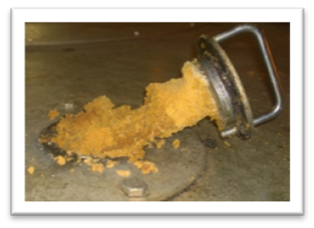
GENERAL
These sugars are sampled from the continuous centrifugals, but it is difficult to obtain representative samples from these machines and the problem has not yet been fully resolved even with the sampler described below:
Apparatus: Sampling scoop, Enamel billycan with lid (5 litre)
Sampling at the centrifuging stage
PROCEDURE
- Remove the sampling scoop from the slot provided in the top of the centrifugal casing and scrape off all adhering sugar.
- Replace with the concave side facing against the direction of rotation of the centrifugal basket.
- Leave for about 2 minutes and then scrape off the sugar which has collected into the billycan.
- Take the samples regularly on consecutive machines over a period of 2 hours.
- At the end of the 2 hour period take the combined samples to the laboratory for analysis.

A-SUGAR
GENERAL
Samples are best taken automatically with a semi-continuous sampler and care must be exercised at all stages to avoid loss or absorption of moisture.
Apparatus: Sugar sampler and receptacle
PROCEDURE
- At the beginning of the hour brush off all sugar adhering to the sampler.
- Place the clean dry sample receptacle in a position such that the sugar sample falls directly into the funnel opening.
- At the end of the hour remove the receptacle and replace the funnel top with a closed lid.
- Take the sealed container to the laboratory for sub-sampling and analysis.
These specific sampling procedures for each of the various components can be found on Pages 211 to 227 of the Laboratory Manual.

APPENDIX A: BRIX, APPARENT DENSITY AND GRAMS OF SUCROSE PER 100 CM³ OF SUGAR SOLUTIONS
NOTES: Column 1 gives brix or percentage of sucrose in the solution.
Column 2 gives apparent density, i.e. the mass in air with brass weights of 1 cm³ of solution at 20°C
Column 3 gives the grams sucrose (weighed in vacuo) per 100 cm³ of solution.

Percentage of sucrose by mass (Brix) (1) | Apparent density at 20°C (2) | Grams of sucrose per 100 cm³ (mass in vacuo) (3) | Percentage of sucrose by mass (Brix) (1) | Apparent density at 20°C (2) | Grams of sucrose per 100 cm³ (mass in vacuo) (3)
0.0 | 0.99717 | 0.000 | 5.0 | 1.01680 | 5.089
0.1 | 0.99756 | 0.100 | 5.1 | 1.01719 | 5.193
0.2 | 0.99795 | 0.200 | 5.2 | 1.01759 | 5.297
0.3 | 0.99834 | 0.300 | 5.3 | 1.01799 | 5.401
0.4 | 0.99872 | 0.400 | 5.4 | 1.01839 | 5.506
0.5 | 0.99911 | 0.500 | 5.5 | 1.01879 | 5.609
0.6 | 0.99950 | 0.600 | 5.6 | 1.01919 | 5.713
0.7 | 0.99989 | 0.701 | 5.7 | 1.01959 | 5.818
0.8 | 1.00028 | 0.801 | 5.8 | 1.01999 | 5.922
0.9 | 1.00067 | 0.902 | 5.9 | 1.02040 | 6.027
1.0 | 1.00106 | 1.002 | 6.0 | 1.02080 | 6.131
1.1 | 1.00145 | 1.103 | 6.1 | 1.02120 | 6.236
1.2 | 1.00184 | 1.203 | 6.2 | 1.02160 | 6.340
1.3 | 1.00223 | 1.304 | 6.3 | 1.02200 | 6.445
1.4 | 1.00261 | 1.405 | 6.4 | 1.02241 | 6.550
1.5 | 1.00300 | 1.506 | 6.5 | 1.02281 | 6.655
1.6 | 1.00339 | 1.607 | 6.6 | 1.02321 | 6.760
1.7 | 1.00378 | 1.708 | 6.7 | 1.02362 | 6.865
1.8 | 1.00417 | 1.809 | 6.8 | 1.02402 | 6.971
1.9 | 1.00456 | 1.911 | 6.9 | 1.02442 | 7.076
2.0 | 1.00495 | 2.012 | 7.0 | 1.02483 | 7.181
2.1 | 1.00534 | 2.113 | 7.1 | 1.02523 | 7.287
2.2 | 1.00574 | 2.215 | 7.2 | 1.02564 | 7.392
2.3 | 1.00613 | 2.317 | 7.3 | 1.02604 | 7.498
2.4 | 1.00652 | 2.418 | 7.4 | 1.02645 | 7.604
2.5 | 1.00691 | 2.520 | 7.5 | 1.02685 | 7.709
2.6 | 1.00730 | 2.622 | 7.6 | 1.02726 | 7.815
2.7 | 1.00769 | 2.724 | 7.7 | 1.02766 | 7.921
2.8 | 1.00809 | 2.826 | 7.8 | 1.02807 | 8.027
2.9 | 1.00848 | 2.928 | 7.9 | 1.02848 | 8.133
3.0 | 1.00887 | 3.030 | 8.0 | 1.02888 | 8.240
3.1 | 1.00927 | 3.132 | 8.1 | 1.02929 | 8.346
3.2 | 1.00966 | 3.234 | 8.2 | 1.02970 | 8.452
3.3 | 1.01006 | 3.337 | 8.3 | 1.03011 | 8.559
3.4 | 1.01045 | 3.439 | 8.4 | 1.03052 | 8.665
3.5 | 1.01084 | 3.542 | 8.5 | 1.03093 | 8.772
3.6 | 1.01124 | 3.644 | 8.6 | 1.03133 | 8.879
3.7 | 1.01163 | 3.747 | 8.7 | 1.03174 | 8.985
3.8 | 1.01203 | 3.850 | 8.8 | 1.03215 | 9.192
3.9 | 1.01243 | 3.953 | 8.9 | 1.03256 | 9.199
4.0 | 1.01282 | 4.056 | 9.0 | 1.03297 | 9.306
4.1 | 1.01322 | 4.159 | 9.1 | 1.03338 | 9.413
4.2 | 1.01361 | 4.262 | 9.2 | 1.03379 | 9.521
4.3 | 1.01401 | 4.365 | 9.3 | 1.03420 | 9.628
4.4 | 1.01441 | 4.468 | 9.4 | 1.03461 | 9.735
4.5 | 1.01480 | 4.571 | 9.5 | 1.03503 | 9.843
4.6 | 1.01520 | 4.675 | 9.6 | 1.03544 | 9.950
4.7 | 1.01560 | 4.778 | 9.7 | 1.03585 | 10.058
4.8 | 1.01600 | 4.882 | 9.8 | 1.03626 | 10.166
4.9 | 1.01640 | 4.986 | 9.9 | 1.03667 | 10.274
10.0 | 1.03709 | 10.381 | 15.0 | 1.05811 | 15.887
10.1 | 1.03750 | 10.489 | 15.1 | 1.05854 | 16.000
10.2 | 1.03791 | 10.597 | 15.2 | 1.05897 | 16.112
10.3 | 1.03833 | 10.706 | 15.3 | 1.05940 | 16.225
10.4 | 1.03874 | 10.814 | 15.4 | 1.05983 | 16.338
10.5 | 1.03916 | 10.922 | 15.5 | 1.06026 | 16.450
10.6 | 1.03957 | 11.031 | 15.6 | 1.06069 | 16.563
10.7 | 1.03999 | 11.139 | 15.7 | 1.06112 | 16.676
10.8 | 1.04040 | 11.248 | 15.8 | 1.06155 | 16.789
10.9 | 1.04082 | 11.356 | 15.9 | 1.06198 | 16.902
11.0 | 1.04123 | 11.465 | 16.0 | 1.06241 | 17.015
11.1 | 1.04165 | 11.574 | 16.1 | 1.06284 | 17.129
11.2 | 1.04207 | 11.683 | 16.2 | 1.06327 | 17.242
11.3 | 1.04248 | 11.792 | 16.3 | 1.06370 | 17.356
11.4 | 1.04290 | 11.901 | 16.4 | 1.06414 | 17.469
11.5 | 1.04332 | 12.010 | 16.5 | 1.06457 | 17.583
11.6 | 1.04373 | 12.120 | 16.6 | 1.06500 | 17.697
11.7 | 1.04415 | 12.229 | 16.7 | 1.06544 | 17.810
11.8 | 1.04457 | 12.338 | 16.8 | 1.06587 | 17.924
11.9 | 1.04499 | 12.448 | 16.9 | 1.06630 | 18.038
12.0 | 1.04541 | 12.558 | 17.0 | 1.06674 | 18.152
12.1 | 1.04583 | 12.667 | 17.1 | 1.06717 | 18.267
12.2 | 1.04625 | 12.777 | 17.2 | 1.06761 | 18.381
12.3 | 1.04667 | 12.887 | 17.3 | 1.06804 | 18.495
12.4 | 1.04709 | 12.997 | 17.4 | 1.06848 | 18.610
12.5 | 1.04750 | 13.107 | 17.5 | 1.06891 | 18.724
12.6 | 1.04793 | 13.217 | 17.6 | 1.06935 | 18.839
12.7 | 1.04835 | 13.327 | 17.7 | 1.06978 | 18.954
12.8 | 1.04877 | 13.438 | 17.8 | 1.07022 | 19.069
12.9 | 1.04919 | 13.548 | 17.9 | 1.07066 | 19.184
13.0 | 1.04961 | 13.659 | 18.0 | 1.07110 | 19.299
13.1 | 1.05003 | 13.769 | 18.1 | 1.07153 | 19.414
13.2 | 1.05046 | 13.880 | 18.2 | 1.07197 | 19.529
13.3 | 1.05088 | 13.991 | 18.3 | 1.07241 | 19.644
13.4 | 1.05130 | 14.102 | 18.4 | 1.07285 | 19.760
13.5 | 1.05172 | 14.213 | 18.5 | 1.07329 | 19.875
13.6 | 1.05215 | 14.324 | 18.6 | 1.07373 | 19.991
13.7 | 1.05257 | 14.435 | 18.7 | 1.07417 | 20.107
13.8 | 1.05300 | 14.546 | 18.8 | 1.07461 | 20.222
13.9 | 1.05342 | 14.657 | 18.9 | 1.07505 | 20.338
14.0 | 1.05385 | 14.769 | 19.0 | 1.07549 | 20.454
14.1 | 1.05427 | 14.880 | 19.1 | 1.07593 | 20.570
14.2 | 1.05470 | 14.992 | 19.2 | 1.07637 | 20.686
14.3 | 1.05512 | 15.103 | 19.3 | 1.07681 | 20.803
14.4 | 1.05555 | 15.215 | 19.4 | 1.07725 | 20.919
14.5 | 1.05598 | 15.327 | 19.5 | 1.07769 | 21.036
14.6 | 1.05640 | 15.439 | 19.6 | 1.07814 | 21.152
14.7 | 1.05683 | 15.551 | 19.7 | 1.07858 | 21.269
14.8 | 1.05726 | 15.663 | 19.8 | 1.07902 | 21.385
14.9 | 1.05768 | 15.775 | 19.9 | 1.07947 | 21.502
20.0 | 1.07991 | 21.619 | 25.0 | 1.10251 | 27.589
20.1 | 1.08035 | 21.736 | 25.1 | 1.10297 | 27.710
20.2 | 1.08080 | 21.853 | 25.2 | 1.10343 | 27.833
20.3 | 1.08124 | 21.971 | 25.3 | 1.10389 | 27.955
20.4 | 1.08169 | 22.088 | 25.4 | 1.10435 | 28.077
20.5 | 1.08213 | 22.205 | 25.5 | 1.10482 | 28.199
20.6 | 1.08258 | 22.323 | 25.6 | 1.10528 | 28.322
20.7 | 1.08302 | 22.440 | 25.7 | 1.10574 | 28.444
20.8 | 1.08347 | 22.558 | 25.8 | 1.10620 | 28.567
20.9 | 1.08392 | 22.676 | 25.9 | 1.10667 | 28.690
21.0 | 1.08436 | 22.794 | 26.0 | 1.10713 | 28.813
21.1 | 1.08481 | 22.912 | 26.1 | 1.10759 | 28.935
21.2 | 1.08526 | 23.030 | 26.2 | 1.10806 | 29.059
21.3 | 1.08571 | 23.148 | 26.3 | 1.10852 | 29.182
21.4 | 1.08616 | 23.266 | 26.4 | 1.10899 | 29.305
21.5 | 1.08660 | 23.385 | 26.5 | 1.10945 | 29.428
21.6 | 1.08705 | 23.503 | 26.6 | 1.10992 | 29.552
21.7 | 1.08750 | 23.622 | 26.7 | 1.11038 | 29.675
21.8 | 1.08795 | 23.740 | 26.8 | 1.11085 | 29.799
21.9 | 1.08840 | 23.859 | 26.9 | 1.11131 | 29.923
22.0 | 1.08885 | 23.978 | 27.0 | 1.11178 | 30.046
22.1 | 1.08930 | 24.097 | 27.1 | 1.11225 | 30.170
22.2 | 1.08975 | 24.216 | 27.2 | 1.11272 | 30.294
22.3 | 1.09020 | 24.335 | 27.3 | 1.11318 | 30.418
22.4 | 1.09066 | 24.454 | 27.4 | 1.11365 | 30.543
22.5 | 1.09111 | 24.573 | 27.5 | 1.11412 | 30.667
22.6 | 1.09156 | 24.693 | 27.6 | 1.11459 | 30.792
22.7 | 1.09201 | 24.812 | 27.7 | 1.11506 | 30.916
22.8 | 1.09247 | 24.932 | 27.8 | 1.11553 | 31.041
22.9 | 1.09292 | 25.052 | 27.9 | 1.11600 | 31.165
23.0 | 1.09337 | 25.172 | 28.0 | 1.11647 | 31.290
23.1 | 1.09383 | 25.292 | 28.1 | 1.11694 | 31.415
23.2 | 1.09428 | 25.412 | 28.2 | 1.11741 | 31.540
23.3 | 1.09473 | 25.532 | 28.3 | 1.11788 | 31.666
23.4 | 1.09519 | 25.652 | 28.4 | 1.11835 | 31.791
23.5 | 1.09564 | 25.772 | 28.5 | 1.11882 | 31.916
23.6 | 1.09610 | 25.893 | 28.6 | 1.11929 | 32.042
23.7 | 1.09656 | 26.013 | 28.7 | 1.11977 | 32.167
23.8 | 1.09701 | 25.134 | 28.8 | 1.12024 | 32.293
23.9 | 1.09747 | 26.255 | 28.9 | 1.12071 | 32.419
24.0 | 1.09792 | 26.375 | 29.0 | 1.12119 | 32.545
24.1 | 1.09838 | 26.496 | 29.1 | 1.12166 | 32.671
24.2 | 1.09884 | 26.617 | 29.2 | 1.12214 | 32.797
24.3 | 1.09930 | 26.738 | 29.3 | 1.12261 | 32.923
24.4 | 1.09976 | 26.860 | 29.4 | 1.12308 | 33.049
24.5 | 1.10021 | 26.981 | 29.5 | 1.12356 | 33.176
24.6 | 1.10067 | 27.102 | 29.6 | 1.12404 | 33.302
24.7 | 1.10113 | 27.224 | 29.7 | 1.12451 | 33.429
24.8 | 1.10159 | 27.345 | 29.8 | 1.12499 | 33.556
24.9 | 1.10205 | 27.467 | 29.9 | 1.12546 | 33.683
30.0 | 1.12594 | 33.810 | 35.0 | 1.15024 | 40.295
30.1 | 1.12642 | 33.937 | 35.1 | 1.15073 | 40.427
30.2 | 1.12690 | 34.064 | 35.2 | 1.15123 | 40.560
30.3 | 1.12737 | 34.191 | 35.3 | 1.15172 | 40.692
30.4 | 1.12785 | 34.318 | 35.4 | 1.52222 | 40.825
30.5 | 1.12833 | 34.446 | 35.5 | 1.15271 | 40.958
30.6 | 1.12881 | 34.574 | 35.6 | 1.15321 | 41.091
30.7 | 1.12929 | 34.701 | 35.7 | 1.15371 | 41.224
30.8 | 1.12977 | 34.829 | 35.8 | 1.15420 | 41.358
30.9 | 1.13025 | 34.957 | 35.9 | 1.15470 | 41.491
31.0 | 1.13073 | 35.085 | 36.0 | 1.15520 | 41.625
31.1 | 1.13121 | 35.213 | 36.1 | 1.15570 | 41.758
31.2 | 1.13169 | 35.341 | 36.2 | 1.15620 | 41.892
31.3 | 1.13217 | 35.470 | 36.3 | 1.15669 | 42.026
31.4 | 1.13266 | 35.598 | 36.4 | 1.15719 | 42.160
31.5 | 1.13314 | 35.727 | 36.5 | 1.15769 | 42.294
31.6 | 1.13362 | 35.855 | 36.6 | 1.15819 | 42.428
31.7 | 1.13410 | 35.984 | 36.7 | 1.15869 | 42.562
31.8 | 1.13459 | 36.113 | 36.8 | 1.15919 | 42.697
31.9 | 1.13507 | 36.242 | 36.9 | 1.15970 | 42.831
32.0 | 1.13555 | 36.371 | 37.0 | 1.16020 | 42.966
32.1 | 1.13604 | 36.500 | 37.1 | 1.16070 | 43.100
32.2 | 1.13652 | 36.630 | 37.2 | 1.16120 | 43.235
32.3 | 1.13701 | 36.759 | 37.3 | 1.16170 | 43.370
32.4 | 1.13749 | 36.889 | 37.4 | 1.16221 | 43.505
32.5 | 1.13798 | 37.018 | 37.5 | 1.16271 | 43.641
32.6 | 1.13846 | 37.148 | 37.6 | 1.16321 | 43.776
32.7 | 1.13895 | 37.278 | 37.7 | 1.16372 | 43.911
32.8 | 1.13944 | 37.408 | 37.8 | 1.16422 | 44.047
32.9 | 1.13992 | 37.538 | 37.9 | 1.16473 | 44.182
33.0 | 1.14041 | 37.668 | 38.0 | 1.16523 | 44.318
33.1 | 1.14090 | 37.798 | 38.1 | 1.16574 | 44.454
33.2 | 1.14139 | 37.929 | 38.2 | 1.16624 | 44.590
33.3 | 1.14188 | 38.059 | 38.3 | 1.16675 | 44.726
33.4 | 1.14236 | 38.190 | 38.4 | 1.16726 | 44.862
33.5 | 1.14285 | 38.320 | 38.5 | 1.16776 | 44.999
33.6 | 1.14334 | 38.451 | 38.6 | 1.16827 | 45.135
33.7 | 1.14383 | 38.582 | 38.7 | 1.16878 | 45.272
33.8 | 1.14432 | 38.713 | 38.8 | 1.16929 | 45.408
33.9 | 1.14481 | 38.844 | 38.9 | 1.16979 | 45.545
34.0 | 1.14530 | 38.976 | 39.0 | 1.17030 | 45.682
34.1 | 1.14580 | 39.107 | 39.1 | 1.17081 | 45.819
34.2 | 1.14629 | 39.239 | 39.2 | 1.17132 | 45.956
34.3 | 1.14678 | 39.370 | 39.3 | 1.17183 | 46.094
34.4 | 1.14727 | 39.502 | 39.4 | 1.17234 | 46.231
34.5 | 1.14776 | 39.634 | 39.5 | 1.17285 | 46.369
34.6 | 1.14826 | 39.767 | 39.6 | 1.17336 | 46.506
34.7 | 1.14875 | 39.898 | 39.7 | 1.17387 | 46.644
34.8 | 1.14925 | 40.030 | 39.8 | 1.17439 | 46.782
34.9 | 1.14974 | 40.162 | 39.9 | 1.17490 | 46.920
40.0 | 1.17541 | 47.058 | 45.0 | 1.20151 | 54.114
40.1 | 1.17593 | 47.196 | 45.1 | 1.20204 | 54.259
40.3 | 1.17695 | 47.473 | 45.3 | 1.20311 | 54.547
40.4 | 1.17747 | 47.611 | 45.4 | 1.20364 | 54.692
40.5 | 1.17798 | 47.750 | 45.5 | 1.20417 | 54.837
40.6 | 1.17849 | 47.889 | 45.6 | 1.20470 | 54.981
40.7 | 1.17901 | 48.028 | 45.7 | 1.20524 | 55.126
40.8 | 1.17953 | 48.167 | 45.8 | 1.20577 | 55.272
40.9 | 1.18004 | 48.306 | 45.9 | 1.20630 | 55.417
41.0 | 1.18056 | 48.855 | 46.0 | 1.20684 | 55.562
41.1 | 1.18107 | 48.585 | 46.1 | 1.20737 | 55.708
41.2 | 1.18159 | 48.724 | 46.2 | 1.20791 | 55.853
41.3 | 1.18211 | 48.864 | 46.3 | 1.20845 | 55.999
41.4 | 1.18263 | 49.004 | 46.4 | 1.20898 | 56.145
41.5 | 1.18314 | 49.143 | 46.5 | 1.20952 | 56.291
41.6 | 1.18356 | 49.283 | 46.6 | 1.21006 | 56.437
41.7 | 1.18418 | 49.424 | 46.7 | 1.21059 | 56.583
41.8 | 1.18470 | 49.564 | 46.8 | 1.21113 | 56.729
41.9 | 1.18522 | 49.704 | 46.9 | 1.21167 | 56.876
42.0 | 1.18574 | 49.845 | 47.0 | 1.21221 | 57.022
42.1 | 1.18626 | 49.985 | 47.1 | 1.21275 | 57.169
42.2 | 1.18678 | 50.126 | 47.2 | 1.21329 | 57.316
42.3 | 1.18730 | 50.267 | 47.3 | 1.21383 | 57.463
42.4 | 1.18782 | 50.408 | 47.4 | 1.21437 | 57.610
42.5 | 1.18835 | 50.549 | 47.5 | 1.21491 | 57.757
42.6 | 1.18887 | 50.690 | 47.6 | 1.21545 | 57.904
42.7 | 1.18939 | 50.831 | 47.7 | 1.21599 | 58.052
42.8 | 1.18991 | 50.973 | 47.8 | 1.21653 | 58.199
42.9 | 1.19044 | 51.114 | 47.9 | 1.21707 | 58.347
43.0 | 1.19096 | 51.256 | 48.0 | 1.21761 | 58.495
43.1 | 1.19148 | 51.398 | 48.1 | 1.21816 | 58.643
43.2 | 1.19201 | 51.539 | 48.2 | 1.21870 | 58.791
43.3 | 1.19253 | 51.681 | 48.3 | 1.21924 | 58.939
43.4 | 1.19306 | 51.824 | 48.4 | 1.21979 | 59.087
43.5 | 1.19358 | 51.966 | 48.5 | 1.22033 | 59.236
43.6 | 1.19411 | 52.108 | 48.6 | 1.22088 | 59.385
43.7 | 1.19483 | 52.251 | 48.7 | 1.22142 | 59.533
43.8 | 1.19516 | 52.393 | 48.8 | 1.22197 | 59.682
43.9 | 1.19569 | 52.536 | 48.9 | 1.22251 | 59.831
44.0 | 1.19622 | 52.679 | 49.0 | 1.22306 | 59.980
44.1 | 1.19674 | 52.822 | 49.1 | 1.22360 | 60.129
44.2 | 1.19727 | 52.965 | 49.2 | 1.22415 | 60.279
44.3 | 1.19780 | 53.108 | 49.3 | 1.22470 | 60.428
44.4 | 1.19833 | 53.252 | 49.4 | 1.22525 | 60.578
44.5 | 1.19886 | 53.395 | 49.5 | 1.22580 | 60.728
44.6 | 1.19939 | 53.539 | 49.6 | 1.22634 | 60.878
44.7 | 1.19992 | 53.683 | 49.7 | 1.22689 | 61.028
44.8 | 1.20045 | 53.826 | 49.8 | 1.22744 | 61.178
44.9 | 1.20098 | 53.970 | 49.9 | 1.22799 | 61.328
50.0 | 1.22854 | 61.478 | 55.0 | 1.25651 | 69.164
50.1 | 1.22909 | 61.629 | 55.1 | 1.25708 | 69.322
50.2 | 1.22964 | 61.780 | 55.2 | 1.25765 | 69.479
50.3 | 1.23019 | 61.930 | 55.3 | 1.25822 | 69.636
50.4 | 1.23074 | 62.081 | 55.4 | 1.25879 | 69.794
50.5 | 1.23130 | 62.232 | 55.5 | 1.25936 | 69.951
50.6 | 1.23185 | 62.383 | 55.6 | 1.25993 | 70.109
50.7 | 1.23240 | 62.535 | 55.7 | 1.26050 | 70.267
50.8 | 1.23295 | 62.686 | 55.8 | 1.26108 | 70.425
50.9 | 1.23351 | 62.838 | 55.9 | 1.26165 | 70.583
51.0 | 1.23406 | 62.989 | 56.0 | 1.26222 | 70.742
51.1 | 1.23461 | 63.141 | 56.1 | 1.26279 | 70.900
51.2 | 1.23517 | 63.293 | 56.2 | 1.26337 | 71.059
51.3 | 1.23572 | 63.445 | 56.3 | 1.26394 | 71.217
51.4 | 1.23628 | 63.597 | 56.4 | 1.26452 | 71.376
51.5 | 1.23683 | 63.750 | 56.5 | 1.26509 | 71.535
51.6 | 1.23739 | 63.902 | 56.6 | 1.26566 | 71.694
51.7 | 1.23794 | 64.055 | 56.7 | 1.26624 | 71.854
51.8 | 1.23850 | 64.208 | 56.8 | 1.26682 | 72.013
51.9 | 1.23906 | 64.360 | 56.9 | 1.26739 | 72.173
52.0 | 1.23962 | 64.513 | 57.0 | 1.26797 | 72.332
52.1 | 1.24017 | 64.666 | 57.1 | 1.26854 | 72.492
52.2 | 1.24073 | 64.820 | 57.2 | 1.26912 | 72.652
52.3 | 1.24129 | 64.973 | 57.3 | 1.26970 | 72.812
52.4 | 1.24185 | 65.127 | 57.4 | 1.27028 | 72.973
52.5 | 1.24241 | 65.280 | 57.5 | 1.27086 | 73.133
52.6 | 1.24297 | 65.433 | 57.6 | 1.27143 | 73.293
52.7 | 1.24353 | 65.588 | 57.7 | 1.27201 | 73.454
52.8 | 1.24409 | 65.742 | 57.8 | 1.27259 | 73.615
52.9 | 1.24465 | 65.896 | 57.9 | 1.27317 | 73.776
53.0 | 1.24521 | 66.050 | 58.0 | 1.27375 | 73.937
53.1 | 1.24577 | 66.205 | 58.1 | 1.27433 | 74.098
53.2 | 1.24633 | 66.359 | 58.2 | 1.27492 | 74.260
53.3 | 1.24690 | 66.514 | 58.3 | 1.27550 | 74.421
53.4 | 1.24746 | 66.669 | 58.4 | 1.27608 | 74.583
53.5 | 1.24802 | 66.824 | 58.5 | 1.27664 | 74.744
53.6 | 1.24858 | 66.979 | 58.6 | 1.27724 | 74.906
53.7 | 1.24915 | 67.134 | 58.7 | 1.27782 | 75.068
53.8 | 1.24971 | 67.290 | 58.8 | 1.27841 | 75.230
53.9 | 1.25028 | 67.445 | 58.9 | 1.27899 | 75.393
54.0 | 1.25084 | 67.601 | 59.0 | 1.27958 | 75.555
54.1 | 1.25141 | 67.757 | 59.1 | 1.28017 | 75.718
54.2 | 1.25197 | 67.912 | 59.2 | 1.28075 | 75.880
54.3 | 1.25254 | 68.069 | 59.3 | 1.28134 | 76.043
54.4 | 1.25311 | 68.225 | 59.4 | 1.28193 | 76.207
54.5 | 1.25367 | 68.381 | 59.4 | 1.28251 | 76.369
54.6 | 1.25424 | 68.537 | 59.6 | 1.28309 | 76.533
54.7 | 1.25481 | 68.694 | 59.7 | 1.28367 | 76.696
54.8 | 1.25538 | 68.851 | 59.8 | 1.28426 | 76.860
54.9 | 1.25594 | 69.008 | 59.9 | 1.28485 | 77.024
60.0 | 128544 | 77.188 | 65.0 | 1.31533 | 85.561
60.1 | 1.28602 | 77.351 | 65.1 | 1.31594 | 85.733
60.2 | 1.28661 | 77.515 | 65.2 | 1.31655 | 85.904
60.3 | 1.28720 | 77.680 | 65.3 | 1.31716 | 86.076
60.4 | 1.28779 | 77.844 | 65.4 | 1.31777 | 86.248
60.5 | 1.28838 | 78.009 | 65.5 | 1.31837 | 86.419
60.6 | 1.28897 | 78.173 | 65.6 | 1.31898 | 86.591
60.7 | 1.28956 | 78.338 | 65.7 | 1.31959 | 86.763
60.8 | 1.29015 | 78.503 | 65.8 | 1.32019 | 86.935
60.9 | 1.29074 | 78.668 | 65.9 | 1.32081 | 87.107
61.0 | 1.29133 | 78.833 | 66.0 | 1.32142 | 87.280
61.1 | 1.29193 | 78.999 | 66.1 | 1.32203 | 87.453
61.2 | 1.29252 | 79.165 | 66.2 | 1.32264 | 87.626
61.3 | 1.29311 | 79.330 | 66.3 | 1.32325 | 87.798
61.4 | 1.29370 | 79.496 | 66.4 | 1.32385 | 87.971
61.5 | 1.29430 | 79.662 | 66.5 | 1.32446 | 88.142
61.6 | 1.29489 | 79.828 | 66.6 | 1.32509 | 88.318
61.7 | 1.29548 | 79.995 | 66.7 | 1.32570 | 88.492
61.8 | 1.29608 | 80.161 | 66.8 | 1.32632 | 88.666
61.9 | 1.29667 | 80.328 | 66.9 | 1.32693 | 88.839
62.0 | 1.29726 | 80.494 | 67.0 | 1.32754 | 89.012
62.1 | 1.29786 | 80.661 | 67.1 | 1.32816 | 89.187
62.2 | 1.29845 | 80.828 | 67.2 | 1.32878 | 89.361
62.3 | 1.29905 | 80.995 | 67.3 | 1.32939 | 89.536
62.4 | 1.29966 | 81.162 | 67.4 | 1.33001 | 89.711
62.5 | 1.30025 | 81.329 | 67.5 | 1.33062 | 89.885
62.6 | 1.30085 | 81.497 | 67.6 | 1.33124 | 90.060
62.7 | 1.30145 | 81.665 | 67.7 | 1.33186 | 90.235
62.8 | 1.30205 | 81.833 | 67.8 | 1.33248 | 90.411
62.9 | 1.30265 | 82.001 | 67.9 | 1.33309 | 90.585
63.0 | 1.30325 | 82.169 | 68.0 | 1.33371 | 90.761
63.1 | 1.30385 | 82.337 | 68.1 | 1.33433 | 90.937
63.2 | 1.30446 | 82.506 | 68.2 | 1.33495 | 91.112
63.3 | 1.30506 | 82.674 | 68.3 | 1.33557 | 91.288
63.4 | 1.30566 | 82.843 | 68.4 | 1.33619 | 91.464
63.5 | 1.30626 | 83.012 | 68.5 | 1.33681 | 91.641
63.6 | 1.30686 | 83.180 | 68.6 | 1.33743 | 91.817
63.7 | 1.30747 | 83.350 | 68.7 | 1.33805 | 91.993
63.8 | 1.30807 | 83.519 | 68.8 | 1.33867 | 92.169
63.9 | 1.30867 | 83.688 | 68.9 | 1.33930 | 92.347
64.0 | 1.30927 | 83.858 | 69.0 | 1.33992 | 92.524
64.1 | 1.30988 | 84.028 | 69.1 | 1.34054 | 92.524
64.2 | 1.31048 | 84.198 | 69.2 | 1.34116 | 92.878
64.3 | 1.31108 | 84.367 | 69.3 | 1.34179 | 93.056
64.4 | 1.31169 | 84.538 | 69.4 | 1.34241 | 93.233
64.5 | 1.31229 | 84.708 | 69.5 | 1.34304 | 93.411
64.6 | 1.31290 | 84.879 | 69.6 | 1.34366 | 93.589
64.7 | 1.31350 | 85.049 | 69.7 | 1.34429 | 93.767
64.8 | 1.31412 | 85.220 | 69.8 | 1.34491 | 93.945
64.9 | 1.31473 | 85.391 | 69.9 | 1.34554 | 94.123
70.0 | 1.34616 | 94.302 | 75.0 | 1.37797 | 103.423
70.1 | 1.34679 | 94.481 | 75.1 | 1.37862 | 103.609
70.2 | 1.34742 | 94.660 | 75.2 | 1.37926 | 103.796
70.3 | 1.34805 | 94.839 | 75.3 | 1.37991 | 103.983
70.4 | 1.34867 | 95.017 | 75.4 | 1.38055 | 104.170
70.5 | 1.34930 | 95.197 | 75.5 | 1.38119 | 104.356
70.6 | 1.34993 | 95.376 | 75.6 | 1.38184 | 104.356
70.7 | 1.35056 | 95.556 | 75.7 | 1.38249 | 104.731
70.8 | 1.35119 | 95.736 | 75.8 | 1.38314 | 104.919
70.9 | 1.35182 | 95.916 | 75.9 | 1.38379 | 105.106
71.0 | 1.35245 | 96.096 | 76.0 | 1.38444 | 105.294
71.1 | 1.35308 | 96.276 | 76.1 | 1.38510 | 105.482
71.2 | 1.35371 | 96.456 | 76.2 | 1.38575 | 105.670
71.3 | 1.35434 | 96.636 | 76.3 | 1.38640 | 105.859
71.4 | 1.35498 | 96.817 | 76.4 | 1.38705 | 106.047
71.5 | 1.35561 | 96.998 | 76.5 | 1.38770 | 106.236
71.6 | 1.35625 | 97.179 | 76.6 | 1.38835 | 106.424
71.7 | 1.35688 | 97.360 | 76.7 | 1.38900 | 106.613
71.8 | 1.35751 | 97.541 | 76.8 | 1.38965 | 106.802
71.9 | 1.35814 | 97.722 | 76.9 | 1.39030 | 106.991
72.0 | 1.35877 | 97.904 | 77.0 | 1.39096 | 107.181
72.1 | 1.35940 | 98.085 | 77.1 | 1.39161 | 107.370
72.2 | 1.36004 | 98.268 | 77.2 | 1.39225 | 107.560
72.3 | 1.36067 | 98.449 | 77.3 | 1.39291 | 107.750
72.4 | 1.36131 | 98.632 | 77.4 | 1.39356 | 107.940
72.5 | 1.36194 | 98.814 | 77.5 | 1.39422 | 108.130
72.6 | 1.36358 | 98.997 | 77.6 | 1.39488 | 108.320
72.7 | 1.36322 | 99.179 | 77.7 | 1.39554 | 108.511
72.8 | 1.36385 | 99.362 | 77.8 | 1.39619 | 108.701
72.9 | 1.36450 | 99.545 | 77.9 | 1.39685 | 108.892
73.0 | 1.36514 | 99.728 | 78.0 | 1.39751 | 109.084
73.1 | 1.36578 | 99.912 | 78.1 | 1.39816 | 109.274
73.2 | 1.36642 | 100.095 | 78.2 | 1.39882 | 109.466
73.3 | 1.36705 | 100.278 | 78.3 | 1.39948 | 109.657
73.4 | 1.36769 | 100.462 | 78.4 | 1.40013 | 109.848
73.5 | 1.36833 | 100.646 | 78.5 | 1.40079 | 110.041
73.6 | 1.36896 | 100.827 | 78.6 | 1.40145 | 110.232
73.7 | 1.36960 | 101.014 | 78.7 | 1.40277 | 110.425
73.8 | 1.37024 | 101.198 | 78.8 | 1.40277 | 110.617
73.9 | 1.37088 | 101.383 | 78.9 | 1.40343 | 110.809
74.0 | 1.37153 | 101.568 | 79.0 | 1.40409 | 111.002
74.1 | 1.37217 | 101.753 | 79.1 | 1.40475 | 111.195
74.2 | 1.37281 | 101.937 | 79.2 | 1.40541 | 111.388
74.3 | 1.37345 | 102.122 | 79.3 | 1.40607 | 111.581
74.4 | 1.37410 | 102.308 | 79.4 | 1.40674 | 111.775
74.5 | 1.37475 | 102.493 | 79.5 | 1.40740 | 111.968
74.6 | 1.37539 | 102.679 | 79.6 | 1.40806 | 112.161
74.7 | 1.37604 | 102.865 | 79.7 | 1.40875 | 112.354
74.8 | 1.37668 | 103.050 | 79.8 | 1.40939 | 112.549
74.9 | 1.37733 | 103.237 | 79.9 | 1.41005 | 112.743
80.0 | 1.41072 | 112.938 | 85.0 | 1.44439 | 122.858
80.1 | 1.41138 | 113.131 | 85.1 | 1.44507 | 123.061
80.2 | 1.41204 | 113.326 | 85.2 | 1.44576 | 123.263
80.3 | 1.41271 | 113.521 | 85.3 | 1.44644 | 123.466
80.4 | 1.41337 | 113.715 | 85.4 | 1.44712 | 123.670
80.5 | 1.41404 | 113.911 | 85.5 | 1.44781 | 123.873
80.6 | 1.41472 | 114.106 | 85.6 | 1.44849 | 124.076
80.7 | 1.42537 | 114.301 | 85.7 | 1.44918 | 124.28
80.8 | 1.41604 | 114.497 | 85.8 | 1.44986 | 124.484
80.9 | 1.41671 | 114.692 | 85.9 | 1.45055 | 124.688
81.0 | 1.41727 | 117.888 | 86.0 | 1.45124 | 124.892
81.1 | 1.41804 | 115.084 | 86.1 | 1.45192 | 125.096
81.2 | 1.41871 | 115.280 | 86.2 | 1.45261 | 125.301
81.3 | 1.41938 | 115.477 | 86.3 | 1.45330 | 125.505
81.4 | 1.42005 | 115.673 | 86.4 | 1.45398 | 125.710
81.5 | 1.42072 | 115.870 | 86.5 | 1.45467 | 125.915
81.6 | 1.42139 | 116.067 | 86.6 | 1.45536 | 125.121
81.7 | 1.42206 | 116.264 | 86.7 | 1.45605 | 126.326
81.8 | 1.42273 | 116.461 | 86.8 | 1.45674 | 126.531
81.9 | 1.42340 | 116.658 | 86.9 | 1.45743 | 126.737
82.0 | 1.42407 | 116.856 | 87.0 | 1.45812 | 126.943
82.1 | 1.42475 | 117.053 | 87.1 | 1.45881 | 127.149
82.2 | 1.42543 | 117.252 | 87.2 | 1.45950 | 127.355
82.3 | 1.42610 | 117.449 | 87.3 | 1.46019 | 127.562
82.4 | 1.42677 | 117.647 | 87.4 | 1.46088 | 127.768
82.5 | 1.42744 | 117.845 | 87.5 | 1.46157 | 127.975
82.6 | 1.42811 | 118.044 | 87.6 | 1.46227 | 128.182
82.7 | 1.42878 | 118.243 | 87.7 | 1.46296 | 128.389
82.8 | 1.42946 | 118.442 | 87.8 | 1.46365 | 128.596
82.9 | 1.43013 | 118.641 | 87.9 | 1.46434 | 128.803
83.0 | 1.43081 | 118.840 | 88.0 | 1.46504 | 129.011
83.1 | 1.43148 | 119.039 | 88.1 | 1.46573 | 129.219
83.2 | 1.43216 | 119.239 | 88.2 | 1.46643 | 129.426
83.3 | 1.43283 | 119.438 | 88.3 | 1.46712 | 129.635
83.4 | 1.43351 | 119.638 | 88.4 | 1.46782 | 129.843
83.5 | 1.43419 | 119.838 | 88.5 | 1.46851 | 130.051
83.6 | 1.43488 | 120.039 | 88.6 | 1.46921 | 130.260
83.7 | 1.43555 | 120.238 | 88.7 | 1.46990 | 130.468
83.8 | 1.43623 | 120.439 | 88.8 | 1.47060 | 130.677
83.9 | 1.43691 | 120.640 | 88.9 | 1.47130 | 130.886
84.0 | 1.43758 | 120.841 | 89.0 | 1.47199 | 131.096
84.1 | 1.43826 | 121.042 | 89.1 | 1.47269 | 131.305
84.2 | 1.43894 | 121.243 | 89.2 | 1.47339 | 131.515
84.3 | 1.43962 | 121.444 | 89.3 | 1.47409 | 131.725
84.4 | 1.44030 | 121.646 | 89.4 | 1.47479 | 131.935
84.5 | 1.44098 | 121.847 | 89.5 | 1.47548 | 132.145
84.6 | 1.44166 | 122.049 | 89.6 | 1.47618 | 132.355
84.7 | 1.44234 | 122.251 | 89.7 | 1.47688 | 132.565
84.8 | 1.44303 | 122.453 | 89.8 | 1.47758 | 132.776
84.9 | 1.44371 | 122.655 | 89.9 | 1.47828 | 132.987
90.0 | 1.47898 | 133.198 | 93.0 | 1.50017 | 139.608
90.1 | 1.47968 | 133.409 | 93.1 | 1.50088 | 139.824
90.2 | 1.48039 | 133.620 | 93.2 | 1.50159 | 140.041
90.3 | 1.48109 | 133.832 | 93.3 | 1.50230 | 140.257
90.4 | 1.48179 | 134.043 | 93.4 | 1.50302 | 140.474
90.5 | 1.48249 | 134.255 | 93.5 | 1.50373 | 140.691
90.6 | 1.48320 | 134.467 | 93.6 | 1.50444 | 140.908
90.7 | 1.48390 | 134.680 | 93.7 | 1.50516 | 141.126
90.8 | 1.48460 | 134.892 | 93.8 | 1.50587 | 141.343
90.9 | 1.48531 | 135.104 | 93.9 | 1.50659 | 141.561
91.0 | 1.48601 | 135.317 | 94.0 | 1.50730 | 141.779
91.1 | 1.48672 | 135.530 | 94.1 | 1.50802 | 141.997
91.2 | 1.48742 | 135.743 | 94.2 | 1.50873 | 142.216
91.3 | 1.48813 | 135.956 | 94.3 | 1.50945 | 142.434
91.4 | 1.48883 | 136.170 | 94.4 | 1.15102 | 142.653
91.5 | 1.48954 | 136.383 | 94.5 | 1.51088 | 142.872
91.6 | 1.49024 | 136.597 | 94.6 | 1.51160 | 143.091
91.7 | 1.49095 | 136.811 | 94.7 | 1.51231 | 143.31
91.8 | 1.49166 | 137.025 | 94.8 | 1.51303 | 143.529
91.9 | 1.49236 | 137.239 | 94.9 | 1.51375 | 143.749
92.0 | 1.49307 | 137.454 | 95.0 | 1.51447 | 143.968
92.1 | 1.49378 | 137.668
92.2 | 1.49449 | 137.883
92.3 | 1.49520 | 138.098
92.4 | 1.49591 | 138.313
92.5 | 1.49662 | 138.529
92.6 | 1.49733 | 138.744
92.7 | 1.49804 | 138.960
92.8 | 1.49875 | 139.176
92.9 | 1.49946 | 139.392

APPENDIX B: SUGAR CANE FACTORY – GLOSSARY OF TERMS
Affination: Treatment of raw sugar crystals to remove the film of adhering molasses. This is achieved by mixing sugar with a concentrated syrup and then centrifuging the magma with or without water washing.
Affinated sugar: Sugar purified by affination.
Agglomeration: Sticking together of two or more crystals during the centrifuging and drying operations.
Ash content: Solid residue determined gravimetrically after incineration in the presence of oxygen. In analysis of sugar products, sulfuric acid is added to the sample, and this residue as sulfated ash heated to 525 °C is taken to be a measure of the inorganic constituents. Sometimes determined indirectly by measurement of electrical conductivity of the product in solution (see Conductivity ash).
Bagacillo: Fine fraction of bagasse obtained by screening or pneumatic separation, generally used as a filter aid in filtration.
Bagasse: Cane residue leaving mills after extraction of juice.
Boiling house: That part of the sugar mill in which the processes of production of sugar from raw juice are carried out. It is also referred to as the back-end or raw house.
Boiling point elevation: Difference between the temperature of a boiling sugar solution and the temperature of boiling pure water, both measured at the same pressure.
Brix: Measure of dissolved solids in sugar juice, liquor or syrup using a refractometer, otherwise referred to as refractometric dry solids. For solutions containing only sugar and water, Brix = % sugar by mass. Spindle Brix is determined using a hydrometer, but is now seldom used.
Brix-free water: Water forming part of the cellulosic structure of the cane, and hence not part of the juice expressed in milling. It cannot be separated from natural fiber by mechanical means but is driven off at elevated temperatures.
Calandria: Tubular or plate heating element in a vacuum pan or evaporator vessel.
Carbonatation: Process involving introduction of carbon dioxide gas into limed juice or syrup to remove color and nonsugar solids.
Carbonatation gas: Gas rich in carbon dioxide for use in carbonatation.
Centrifugal: Centrifuge used to separate sugar from mother liquor.
Clarifier: Apparatus for the separation by sedimentation of suspended solids from a turbid sugar solution.
Clarified juice: Juice from clarifiers, also referred to as clear juice.
Colour: Attenuation index, determined by absorption of light under defined conditions. Generally measured using the ICUMSA method at 420 nm, and referred to as ICUMSA units or IU.
Conductivity ash: Estimate of ash content by measurement of the conductivity of the solution.
Conglomerate: Two or more crystals grown together during pan boiling.
Cooling crystallization: Crystallization by cooling of the massecuite.
Crystal content: Proportion by mass of crystals in massecuite, often expressed as a percentage, and referred to total massecuite mass or to massecuite dry substance (Brix).
Crystallization: Nucleation and growth of crystals.
Crystallization scheme: Defines the number and arrangement of crystallization stages involved in producing sugar.
Cush cush: The stream of wet bagasse or bagacillo separated from raw juice by the juice screens.
Cut a pan: Discharge a portion of the massecuite from a pan, retaining a footing upon which to feed more syrup or molasses for crystallization.
Dissolved solids: All solute material which is in solution, including sucrose, monosaccharides, ash and other organic impurities.
Drop a pan: Discharge all of the massecuite from a pan. Also referred to as striking a pan.
Dry substance: A measure of total solids obtained from evaporating a solution or massecuite under vacuum to dryness. Also referred to as total solids by drying or dry solids.
Entrainment separator: Apparatus for removing juice, syrup or massecuite entrained in the vapor.
Evaporator effect: One of a system of evaporators operating in series as a multiple effect system (e.g., first effect, second effect). Condensates and vapors are labeled correspondingly (e.g., first condensate and vapor one condensate and vapor from the first effect respectively).
Exhaustion: Applied to a massecuite, it represents the g of sucrose present in crystalline form per 100g of sucrose.
Extraction: Proportion of sugar extracted from cane in the extraction plant; equals mass of sugar in raw juice as a percentage of mass of sugar in cane.
Extraneous matter: All cane leaves and tops, mud, soil, roots, rocks, stones and tramp iron delivered with the cane.
False grain: Undesirable small crystals, formed spontaneously by secondary nucleation when the supersaturation during crystallization is too high.
Fiber: The dry fibrous insoluble structure of the cane plant. Generally taken to mean all insoluble material in the cane delivered to a mill, and therefore includes soil or other extraneous insoluble matter in cane.
Filter cake: Material retained on the filter screens and discharged from the filters after filtering clarifier muds.
Filtrate: Liquid passed through the screens of the filters.
Flocculant: Polyelectrolyte in solution added to juice to assist clarification.
Footing: A charge of massecuite retained in or transferred to a pan as the start of a massecuite boiling.
Imbibition: The process of adding imbibition water to the extraction plant to increase extraction. Sometimes incorrectly referred to as maceration (steeping cane in juice). Water added is called imbibition water.
Invert sugar: Mixture of approximately equal parts of glucose and fructose (monosaccharides) resulting from the hydrolysis of sucrose (inversion).
Liming: Process step in juice purification in which lime is introduced into the sugar juice in the form of milk of lime or lime saccharate solution.
Liquid sugar: Refined sugar products in liquid form (e.g. liquid sucrose, liquid invert).
Liquor: A sugar syrup, a term generally used in sugar refining.
Magma: Mixture of crystals and liquid (water, clarified juice, syrup or molasses) produced by mingling.
Magma mixer: Mingler, where crystal sugar and liquid are mixed together.
Massecuite: The mixture of crystals and mother liquor resulting from the crystallization process. Massecuites are classified according to purity as A, B, or C massecuites.
Massecuite mixer: Apparatus from which massecuite is distributed to the centrifugals.
Melter: Equipment in which dissolving of sugar takes place.
Melting: Another term for dissolving of sugar crystals.
Molasses: The mother liquor separated from the crystals by centrifuging. A, B or C molasses is derived from the corresponding massecuites. C molasses is also referred to as final molasses.
Mother liquor: Liquid phase in the massecuite during crystallization; refers to syrup or liquor in which the crystals are growing.
Nonsucrose: Dissolved solids contained in any process stream other than sucrose.
Nonsugar: Common overall term for dissolved solids other than sugar contained in any process stream.
Nucleation: Generation and development of small crystals capable of growth.
Pan or vacuum pan: Vacuum evaporative crystallizer used in the sugar industry to crystallize sugar from liquor, syrup or molasses
Phosphatation: Clarification using phosphoric acid and lime, in which certain nonsugar components are removed by flotation.
Polarization (or pol): The apparent sucrose content expressed as a mass percent measured by the optical rotation of polarized light passing through a sugar solution. This is accurate only for pure sucrose solutions
Press water: Juice expressed from dewatering mills after a diffuser.
Purity: The true purity is the sucrose content as a percent of the dry substance or dissolved solids content. The solids consist of sugar plus nonsucrose components such as invert, ash, and colorants. Apparent purity is expressed as polarization divided by refractometer Brix, multiplied by 100.
Raw juice: Juice obtained from the cane extraction process. Also referred to as mixed juice (from mills) or draft juice (from diffusers).
Raw sugar: Brown sugar produced in a raw sugar mill generally destined for further processing to white sugar in a refinery.
Reducing sugars: Generally referred to and/or interpreted as invert sugar, determined by measuring reducing substance content by laboratory analysis.
Refining: Purification of sugar through chemical and physical methods, generally including some or all of clarification, filtration, decolorization and recrystallization.
Refractometric dry solids (RDS): Measurement of total dissolved solids in a sugar liquor or syrup using a refractometer. For solutions containing only sugar and water, % RDS = Brix = % sugar by mass.
Remelt: A syrup made from centrifuged low-grade sugar which is dissolved or remelted and returned to the high grade boilings.
Runoff: General term for syrups or molasses produced on centrifuging a massecuite.
Safety factor: Number to indicate keeping quality of raw sugar, calculated from pol and moisture content (= moisture (g/100 g sugar) / (100 – pol)).
Saturation: A sugar solution at saturation will not dissolve any more crystals at the temperature of the solution.
Seeding
(a) Introducing crystal fragments to induce nucleation, as a means of initiating the crystallization process;
(b) Introduction of fine crystals in the form of a slurry (similar to full seeding) to start crystallization. Sometimes referred to as graining.
Seed: Suspension of fine crystals in saturated solution of alcohol, or the initial grain resulting from seeding in a vacuum pan.
Solubility coefficient: Ratio of concentration of sucrose in impure saturated solution to the concentration in a pure sucrose solution saturated at the same temperature (with concentration expressed as sucrose/water ratio). Referred to as saturation coefficient in the beet sugar industry.
Strike: Massecuite as a completed boiling, all of which is discharged from the pan.
Sucrose: Pure chemical compound C12H22O11 known as white sugar, generally measured by polarization in pure solution or by GC or HPLC in impure solution. The chemical term is β-D-fructofuranosyl @alpha;-D-glucopyranoside.
Sugar: Term for the disaccharide sucrose and products of the sugar industry, essentially composed of sucrose.
Sulfitation: Introduction of sulfur dioxide into juice or liquor.
Supersaturation: The degree to which the sucrose content in solution is greater than the sucrose content in a saturated solution.
Supersaturation coefficient: Calculated as the quotient formed by dividing the sugar/water ratio of the supersaturated solution by the sugar/water ratio of a saturated solution under the same conditions (temperature and purity or nonsucrose/water ratio). It shows whether the solution is unsaturated (<1), saturated (=1) or supersaturated (>1).
Supersaturation, critical: Supersaturation at which nucleation begins spontaneously.
Suspended solids: Insoluble solids in juice or other liquid, removable by mechanical means.
Sweet water: Wash water or water containing a small amount of sugar.
Syrup: The concentrated juice from the evaporators.
Trash: Cane tops, leaves, dead stalks of cane and any other vegetable matter delivered with the cane.

