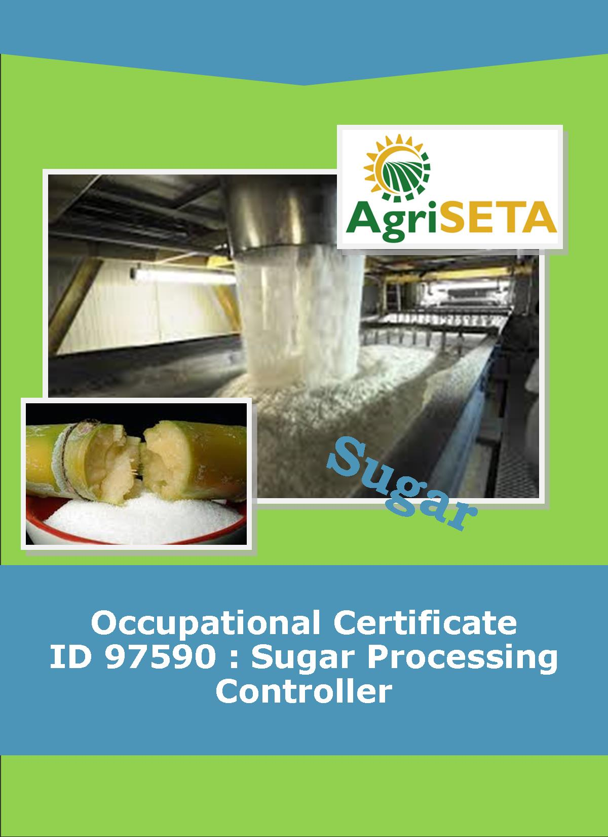**KNOWLEDGE COMPONENT:**

**KNOWLEDGE COMPONENT: LEARNER WORKBOOK 2: THE SUGAR MANUFACTURING PROCESS**

**Occupational Certificate: Sugar Processing Controller**

**KNOWLEDGE COMPONENT: LEARNER WORKBOOK 2: THE SUGAR MANUFACTURING PROCESS**

**LEARNER WORKBOOK 2:**

**THE SUGAR MANUFACTURING PROCESS**

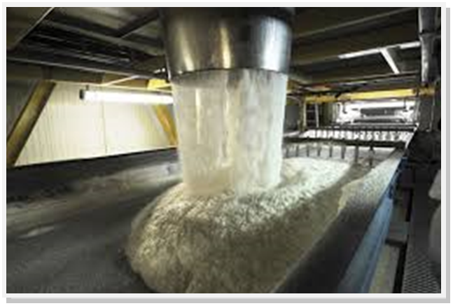

**OCCUPATIONAL CERTIFICATE: SUGAR PROCESSING CONTROLLER**

**©Copyright AgriSETA**

**Telephone: +27 12 301 5600**



AgriSETA holds the copyright to its publications and Web pages. Proper citation is requested.

**TABLE OF CONTENTS**

1. AN INTRODUCTION TO THIS LEARNER WORKBOOK 6

2. LEARNER DETAILS 7

3. FORMATIVE ASSESSMENT INSTRUCTIONS 8

4. KNOWLEDGE MODULE 2: THE SUGAR MANUFACTURING PROCESS 9

4.1 Knowledge Topic 1: The sugar manufacturing process (55%) 10

4.2 Knowledge Topic 2: Rework and recycling (15%) 18

4.3 Knowledge Topic 3: Sugar and By-Products Analysis (30%) 22

5. CONCLUSION OF KNOWLEDGE MODULE 2: THE SUGAR MANUFACTURING PROCESS 66

1. AN INTRODUCTION TO THIS LEARNER WORKBOOK

This Knowledge Component Learner Workbook 2: Sugar Manufacturing Process is intended to be used with the Knowledge Component Learning Resource: Book 2 (Textbook): Sugar Manufacturing Process of the Occupational Qualification: Sugar Processing Controller NQF 5.

Guidance on the use of this Work Book is provided in the Learning Guide.

1. LEARNER DETAILS

|  |  |
| --- | --- |
| First name |  |
| Surname |  |
| ID number |  |
| Mobile phone contact number |  |
| E-mail address |  |
| Postal address |  |
| Date on which you started this Knowledge Module |  |
| Date on which you completed this Knowledge Module |  |
| Declaration: | I hereby confirm that:   * I received the assessment plan and schedule. * I understand my rights in terms of special needs, re-assessment, feedback and appeals against assessment decisions. * I completed this formative assessment independently without assistance from anyone else. |
| Total Marks for Knowledge Module 2 | ________ marks |
| Marks attained |  |
| Date: |  |
| Place: |  |
| Signature of Learner: |  |
| Signature of Assessor: |  |

1. FORMATIVE ASSESSMENT INSTRUCTIONS

**Instructions**

* Work individually to present the results of each Learning Activity in this Learner Workbook.
* Complete all the sections.
* Use a black pen and ensure that you complete the questions in your own handwriting.
* A recommended time to complete each activity is shown.
* The marks you will attain for each learning activity are shown in brackets.
* The total marks obtained for each Knowledge Module must be transferred from the back of each Learner Workbook to the Learner Qualification Summative Assessment Tool.

1. KNOWLEDGE MODULE 2: THE SUGAR MANUFACTURING PROCESS

**NQF LEVEL: 5**

**CREDITS: 12**

**PURPOSE OF THE KNOWLEDGE MODULE: The main focus of the learning in this knowledge module is to build an understanding of the sugar manufacturing process.**

The learning will enable learners to demonstrate an understanding of:

* KM-02-KT01: The sugar manufacturing process (55%)
* KM-02-KT02: Rework and recycling (15%)
* KM-02-KT03: Sugar and By-Products Analysis (30%)

4.1 Knowledge Topic 1: The sugar manufacturing process (55%)

Topic elements to be covered include:

* KT0101 Process flow diagram
* KT0102 Instrumentation and process flow (DSC, SCADA)

Internal Assessment Criteria and Weight

* IAC0101 The process steps of cane to crystal can be identified on a flow diagram and explained
* IAC0102 An understanding of control systems used to control specific production areas can be demonstrated
* IAC0103 An understanding of the relationship between instrument and product flow and quality can be demonstrated
* (Weight 55%)

**Learning activity 1.1: Individual Learning activity: 1 hour (25 marks)**



**Learning Objective:** Correctly identify and explain the process steps of cane to crystal on a flow diagram.

**Task:** Provide labels for the flow diagram of sugar manufacturing below.

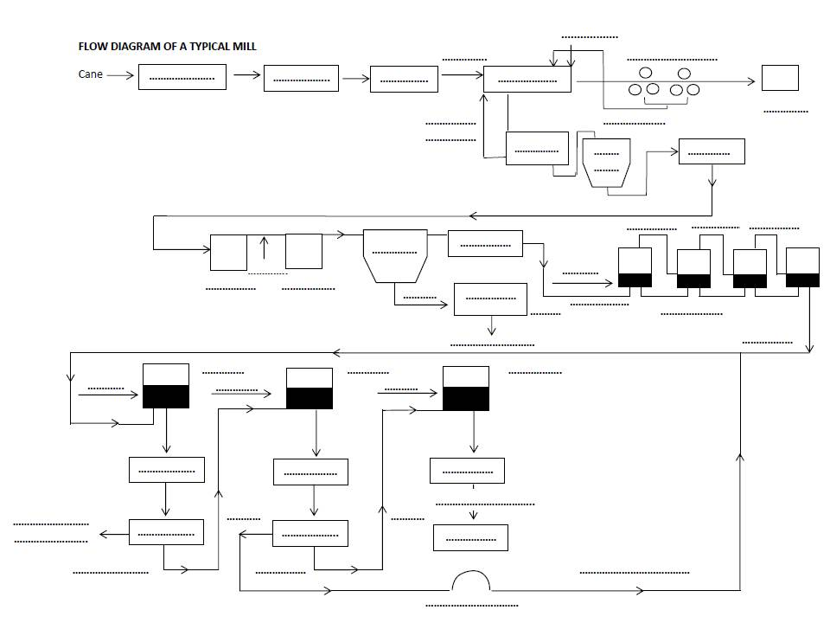

**Learning activity 1.2: Individual Learning activity: 15 minutes (26 marks)**



**Learning Objective:** Demonstrate an understanding of control systems used to control specific production areas.

**Task:** Read the following questions carefully and write your answers in the space provided.

1. Name the six (6) goals of instrumentation and control. (6)

|  |
| --- |
|  |
|  |
|  |
|  |
|  |
|  |

1. List eight (8) process variables that need to be checked constantly. (8)

|  |
| --- |
|  |
|  |
|  |
|  |
|  |
|  |
|  |
|  |

1. List and describe four (4) challenges to solid level measurement. (8)

|  |
| --- |
|  |
|  |
|  |
|  |
|  |
|  |
|  |
|  |

1. Name four (4) types of solid level measuring sensors. (4)

|  |
| --- |
|  |
|  |
|  |
|  |

**Learning activity 1.3: Individual Learning activity: 30 minutes (33 marks)**



**Learning Objective:** Demonstrate an understanding of the relationship between instrument and product flow and quality.

**Task:** Read the following questions carefully and write your answers in the space provided.

1. List the measurements that are taken at the cane preparation stage. (4)

|  |
| --- |
|  |
|  |
|  |
|  |

1. List the measurements and control measures taken at the milling train where juice extraction takes place. (6)

|  |
| --- |
|  |
|  |
|  |
|  |
|  |
|  |
|  |

1. What needs to be removed from the juice clarification tank? (4)

|  |
| --- |
|  |
|  |
|  |
|  |

1. What is the pH of cane juice and what pH does it need to be adjusted to with the addition of milk of lime? (2)

|  |
| --- |
|  |
|  |

1. What variables need to be controlled during juice clarification? (2)

|  |
| --- |
|  |
|  |

1. What samples are taken at the juice clarification stage for analysis? (2)

|  |
| --- |
|  |
|  |

1. Name 6 variables that need to be controlled in the evaporator. (6)

|  |
| --- |
|  |
|  |
|  |
|  |
|  |
|  |

1. Name four (4) variables that are controlled at the crystallisation and centrifuging stage. (4)

|  |
| --- |
|  |
|  |
|  |
|  |

1. Name three (3) variables that are controlled at the drying stage. (3)

|  |
| --- |
|  |
|  |
|  |

4.2 Knowledge Topic 2: Rework and recycling (15%)

Topic elements to be covered include:

* KT0201 Effects and potential losses from over flows and leaks
* KT0202 Effects and potential losses from carry-overs
* KT0203 Effects and potential losses from recirculation of processed product
* KT0204 Effects and potential losses from rework of substandard products

Internal Assessment Criteria and Weight

* IAC0201 The effects of rework and recycling of specific production flows and targets can be explained
* (Weight 15%)

**Learning activity 2.1: Individual Learning activity: 1 hour (34 marks)**



**Learning Objective:** Explain the effects of rework and recycling of specific production flows and targets.

**Task:** Read the following questions carefully and write your answers in the space provided.

1. Name the two types of losses that occur in a sugar mill. (2)

|  |
| --- |
|  |
|  |

1. Undetermined losses can be categorized into 3 parts. Name them. (3)

|  |
| --- |
|  |
|  |
|  |

1. Chemical losses, such as high POL and sucrose losses, could be measured because of these 5 factors….(10)

|  |
| --- |
|  |
|  |
|  |
|  |
|  |

1. Chemical losses could be picked up in the calculations due to laboratory errors. Name some causes of these laboratory errors. (4)

|  |
| --- |
|  |
|  |
|  |
|  |

1. Mechanical losses are often due to leaks in the system. Name four (4) places where mechanical losses could occur. (4)

|  |
| --- |
|  |
|  |
|  |
|  |

1. Define entrainment. (2)

|  |
| --- |
|  |
|  |

1. What could cause administrative losses? (5)

|  |
| --- |
|  |
|  |
|  |
|  |
|  |

1. What reduces chemical losses, a faster or slower milling speed? Justify your answer. (4)

|  |
| --- |
|  |
|  |
|  |
|  |
|  |

4.3 Knowledge Topic 3: Sugar and By-Products Analysis (30%)

Topic elements to be covered include:

* KT0301 Sucrose Molecule
* KT0302 Chemical Reactions
* KT0303 Constituents of Sugarcane
* KT0304 Brix
* KT0305 Apparent Sucrose (pol)
* KT0306 Moisture
* KT0307 pH
* KT0308 Ash
* KT0309 Phosphate
* KT0310 Colour & Turbidity
* KT0311 Starch
* KT0312 Grain Size
* KT0313 Reducing Sugars
* KT0314 Sugar Trace

Internal Assessment Criteria and Weight

* IAC0301 An understanding of mechanical and chemical breakdown of sucrose can be demonstrated in terms of factory efficiencies
* IAC0302 Calculations are accurately performed
* (Weight 30%)

**Learning activity 3.1: Individual Learning activity: 10 minutes (6 marks)**



**Learning Objective:** Demonstrate an understanding of mechanical and chemical breakdown of sucrose in terms of factory efficiencies.

**DESCRIPTION: THE SUCROSE MOLECULE**

**Task:** Read each question carefully and write your answer in the space provided.

1. Why is sugar known as a “dissacharide”? (2)

|  |
| --- |
|  |
|  |
|  |
|  |
|  |

1. Give the formulae for the following molecules (3)
2. Glucose

|  |
| --- |
|  |

1. Fructose

|  |
| --- |
|  |

1. Sucrose

|  |
| --- |
|  |

1. What is the function of sucrose in the cane plant? (1)

|  |
| --- |
|  |
|  |
|  |
|  |
|  |

**Learning activity 3.2: Individual Learning activity: 10 minutes (11 marks)**



**Learning Objective:** Demonstrate an understanding of mechanical and chemical breakdown of sucrose in terms of factory efficiencies.

**DESCRIPTION: CHEMICAL REACTIONS**

**Task:** Read each question carefully and write your answer in the space provided.

1. (a) Explain the term inversion. (2)

|  |
| --- |
|  |
|  |
|  |
|  |
|  |

(b) What conditions increases the amount of inversion? (3)

|  |
| --- |
|  |
|  |
|  |
|  |
|  |
|  |

(c) Why is inversion highly undesirable in the sugar mill? (2)

|  |
| --- |
|  |
|  |
|  |

1. (a) Explain the term “alkaline degradation”. (2)

|  |
| --- |
|  |
|  |
|  |

(b) Why is this reaction(s) undesirable? (2)

|  |
| --- |
|  |
|  |
|  |

**Learning activity 3.3: Individual Learning activity: 10 minutes (16 marks)**



**Learning Objective:** Demonstrate an understanding of mechanical and chemical breakdown of sucrose in terms of factory efficiencies.

**DESCRIPTION: CONSTITUENTS OF SUGAR CANE**

**Task:** Read each question carefully and write your answer in the space provided.

1. (a) Give the percentage composition of cane. (3)

Dissolved substances (%)

|  |
| --- |
|  |

Insoluble fibre (%)

|  |
| --- |
|  |

Water (%)

|  |
| --- |
|  |

(b) Give the percentage composition of the dissolved substances in cane. (3)

Sucrose (%)

|  |
| --- |
|  |

Other substances (%)

|  |
| --- |
|  |

(c) What compounds constitute the “other substances” found dissolved in cane juice. (10)

|  |
| --- |
|  |
|  |
|  |
|  |
|  |
|  |
|  |
|  |
|  |
|  |

**Learning activity 3.4: Individual Learning activity: 30 minutes (35 marks)**



**Learning Objective:** Demonstrate an understanding of mechanical and chemical breakdown of sucrose in terms of factory efficiencies.

**DESCRIPTION: PERCENTAGE DISSOLVED SUBSTANCES (BRIX)**

**Task:** Read each question carefully and write your answer in the space provided.

1. Give the formula for percentage dissolved substances (BRIX). (2)

|  |
| --- |
|  |
|  |

1. 25 g of pure sucrose is dissolved in 50 g water. Calculate the percentage dissolved substances. (3)

|  |
| --- |
|  |
|  |
|  |
|  |
|  |
|  |

1. State 2 ways in which the percentage dissolved substances can be measured. (2)

|  |
| --- |
|  |
|  |
|  |
|  |

1. Complete the following sentences.
2. A refractometer uses the ________________ of light as it enters a solution as a measure of the _______________________ of that solution. (2)
3. The percentage dissolved substances in a solution is measured by refractometer is known as the _______________________ of the solution. (1)
4. The unit of percentage dissolved substances as measured by refractometer is __________________________________ (1)
5. A refractometer is calibrated using pure _______________________ solutions of known __________________________ (2)
6. Brix can be used as an important indicator by factory staff. State the areas where knowledge of the brix is particularly important/useful. (5)

|  |
| --- |
|  |
|  |
|  |
|  |
|  |

1. (a) Why is filtration important before the brix of a sample can be read? (2)

|  |
| --- |
|  |
|  |
|  |
|  |

(b) Explain the filtering procedure. (5)

|  |
| --- |
|  |
|  |
|  |
|  |
|  |

(c) Give the dilutions for:

Syrup ____________________________

Molasses __________________________ (2)

1. Write the procedure for determining the brix of a juice sample. (6)

|  |
| --- |
|  |
|  |
|  |
|  |
|  |
|  |
|  |
|  |

1. Explain the procedure to be followed if a reading is taken and the refractometer is not at 20°C. (2)

|  |
| --- |
|  |
|  |
|  |
|  |

**Learning activity 3.5: Individual Learning activity: 2 hours (80 marks)**



**Learning Objective:** Demonstrate an understanding of mechanical and chemical breakdown of sucrose in terms of factory efficiencies.

**DESCRIPTION: PERCENTAGE APPARENT SUCROSE (POL)**

**Task:** Read each question carefully and write your answer in the space provided.

1. Give the formula for the sucrose % solution. (2)

|  |
| --- |
|  |
|  |
|  |
|  |

1. A solution is prepared by dissolving 8 g sucrose, 12 g salt and 30 g water in a flask.
2. Calculate the brix of the solution. (2)

|  |
| --- |
|  |
|  |
|  |

1. Calculate the sucrose % of the solution. (2)

|  |
| --- |
|  |
|  |
|  |
|  |

3(a) The amount of sucrose in a sample is found by projecting a beam of _________________ light through the solution and measuring the ____________________ of the light. A greater sucrose content will result in ________________. (4)

(b) What instrument is used to perform the analysis described in (a) above. (1)

|  |
| --- |
|  |
|  |

1. The result from the analysis is called the apparent sucrose % (or pol %). Why is the answer not the true sucrose %? (3)

|  |
| --- |
|  |
|  |
|  |

4. Explain why the difference between pol % and sucrose % is small for juice but quite large for molasses. (4)

|  |
| --- |
|  |
|  |
|  |
|  |

5. State where the pol % is used in the sugar mill to facilitate control of the process. (5)

|  |
| --- |
|  |
|  |
|  |

6. Explain the procedure for using a saccharimeter (non flow-through tube). (5)

|  |
| --- |
|  |
|  |
|  |
|  |
|  |

1. Give the dilutions necessary for the following products.
2. Syrup __________________________________________ (1)
3. Massecuite _____________________________________________ (1)
4. Final molasses __________________________________________ (2)

8. Complete the following:

1. All saccharimeters are calibrated in sugar degrees (°Z) which are established so that….(3)

|  |
| --- |
|  |
|  |
|  |
|  |

1. The saccharimeter thus reads the percentage of …….(1)

|  |
| --- |
|  |
|  |

9. Give the formula used to calculate Pol %. (2)

|  |
| --- |
|  |
|  |
|  |

10. Complete the following (19):

|  |  |  |  |  |  |
| --- | --- | --- | --- | --- | --- |
| Number | 1 | 2 | 3 | 4 | 5 |
| Refractometer reading | 80,8 | 81,2 | 79,5 | 80,5 | 79,3 |
| Temperature | 22 | 15 | 20 | 26 | 20 |
| Brix@ refractometer temp. Temperature correction  Brix @ 200C |  |  |  |  |  |
| Saccharimeter reading Temperature | 45,0  25 | 46,0  21 | 44,5  23 | 44,2  29 | 29,5  23 |
| Brix adjustment  Brix @ sacch temp. |  |  |  |  |  |
| Pol from Schmidtz’s table |  |  |  |  |  |
| Dilution ratio | 5 | 5 | 5 | 5 | 5 |
| Corrected pol  Corrected brix  Purity |  |  |  |  |  |

|  |  |  |  |  |  |
| --- | --- | --- | --- | --- | --- |
| Number | 6 | 7 | 8 | 9 | 10 |
| Refractometer reading | 80,3 | 81,3 | 90,9 | 91,1 | 91,2 |
| Temperature | 23 | 16 | 20 | 14 | 27 |
| Brix@ refractometer temp. Temperature correction  Brix @ 200C |  |  |  |  |  |
| Saccharimeter reading Temperature | 28,4  27 | 31,0  19 | 65,8  23 | 65,4  18 | 67,2  30 |
| Brix adjustment  Brix @ sacch temp. |  |  |  |  |  |
| Pol from Schmidtz’s table |  |  |  |  |  |
| Dilution ratio | 3 | 1 | 5 | 3 | 1 |
| Corrected pol  Corrected brix  Purity |  |  |  |  |  |

|  |  |  |  |  |
| --- | --- | --- | --- | --- |
| Number | 11 | 12 | 13 | 14 |
| Refractometer reading | 92,0 | 91,9 | 92,0 | 92,6 |
| Temperature | 18 | 21 | 21 | 27 |
| Brix@ refractometer temp. Temperature correction  Brix @ 200C |  |  |  |  |
| Saccharimeter reading Temperature | 54,0  21 | 53,4  23 | 53,6  25 | 55,0  30 |
| Brix adjustment  Brix @ sacch temp. |  |  |  |  |
| Pol from Schmidtz’s table |  |  |  |  |
| Dilution ratio | 5 | 5 | 3 | 1 |
| Corrected pol  Corrected brix  Purity |  |  |  |  |

11. Explain the procedure for the analysis of a raw sugar for pol %. (15)

|  |
| --- |
|  |
|  |
|  |
|  |
|  |
|  |
|  |
|  |
|  |
|  |
|  |
|  |

12. Explain the procedure for the analysis of juice for pol %. (8)

|  |
| --- |
|  |
|  |
|  |
|  |
|  |
|  |
|  |
|  |

**Learning activity 3.6: Individual Learning activity: 30 minutes (15 marks)**



**Learning Objective:** Demonstrate an understanding of mechanical and chemical breakdown of sucrose in terms of factory efficiencies.

**DESCRIPTION: MOISTURE ANALYSIS**

**Task:** Read each question carefully and write your answer in the space provided.

1. Why is the moisture % of raw sugar important? (2)

|  |
| --- |
|  |
|  |
|  |
|  |

1. (a) Explain in detail the procedure for analysing a raw sugar for its moisture content. (9)

|  |
| --- |
|  |
|  |
|  |
|  |

(b) The following results were obtained.

Mass of empty dish + lid 67,3371 g

Mass of sugar, dish and lid before drying 75,8936 g

Mass of sugar, dish and lid after drying 75,8792 g

Calculate the moisture % sugar. (4)

**Learning activity 3.7: Individual Learning activity: 1 hour (38 marks)**



**Learning Objective:** Demonstrate an understanding of mechanical and chemical breakdown of sucrose in terms of factory efficiencies.

**DESCRIPTION: pH MEASUREMENT**

**Task:** Read each question carefully and write your answer in the space provided. Complete the practical exercise in the laboratory thereafter.

1. Explain the following terms.
2. Atoms (2)

|  |
| --- |
|  |
|  |
|  |

1. Compounds (2)

|  |
| --- |
|  |
|  |
|  |
|  |

1. Ions (2)

|  |
| --- |
|  |
|  |
|  |
|  |

1. (a) Define the pH of a solution (2)

|  |
| --- |
|  |
|  |
|  |
|  |

1. What term do we use when the pH is
2. Less than 7: _______________________________________________
3. Greater than seven: _________________________________________
4. Seven exactly: ______________________________________________ (6)
5. Explain how an indicator works. (3)

|  |
| --- |
|  |
|  |
|  |
|  |

1. Explain the basic principle ion which the operation of a pH meter is based. (3)

|  |
| --- |
|  |
|  |
|  |
|  |
|  |

1. Why can pH measurements only be compared if measured at room temperature? (1)

|  |
| --- |
|  |
|  |
|  |
|  |

1. (a) What is a buffer solution? (3)

|  |
| --- |
|  |
|  |
|  |
|  |

1. Which buffer solution do we use to standardise our pH meters. (2)

|  |
| --- |
|  |
|  |
|  |
|  |

1. Give the procedure to be followed when standardising a pH meter. (4)

|  |
| --- |
|  |
|  |
|  |
|  |

1. Complete the following practical exercise in the laboratory (8)

Cut 4 strips of filter paper. Dip two strips into phenolphthalein solution, remove the strip and allow to dry. Dip the other two strips into Cresol Red indicator and allow to dry.

Dip each filter paper into either hydrochloric acid or sodium hydroxide solution as indicated in the table below. Record your results by completing the table.

|  |  |  |
| --- | --- | --- |
|  | **Colour in Acid** | **Colour in Base (Alkali)** |
| Phenolphthalein paper strip 1 |  |  |
| Phenolphthalein paper strip 2 |  |  |
| Cresol red paper strip 1 |  |  |
| Cresol red paper strip 2 |  |  |

**Learning activity 3.8: Individual Learning activity: 2 hours (48 marks)**



**Learning Objective:** Demonstrate an understanding of mechanical and chemical breakdown of sucrose in terms of factory efficiencies.

**DESCRIPTION: ASH DETERMINATIONS**

**Task:** Read each question carefully and write your answer in the space provided. Complete the practical exercise in the laboratory thereafter.

1. Explain what is meant by the term ash. (3)

|  |
| --- |
|  |
|  |
|  |
|  |

1. Give the most common
2. Cations in sugar cane (4)

|  |
| --- |
|  |
|  |
|  |
|  |
|  |

1. Anions in sugar cane (3)
2. State the procedure that must be followed to determine the ash % of a sample of raw

(12)

|  |
| --- |
|  |
|  |
|  |
|  |

1. After conducting a sulphated ash analysis on a raw sugar sample, the following results were found.

Mass of crucible and sugar sample 75,6871 g

Mass of crucible 65,6871 g

Mass of crucible and ash 65,7133 g

Determine the ash % sugar. (3)

|  |
| --- |
|  |
|  |
|  |
|  |
|  |

1. Complete the following sentence:

The greater the number of ions in solution the lower the ___________________________ of the solution and the greater the __________________________ (2)

1. State the procedure to determine the conductivity ash % of a sample of raw sugar. (6)

|  |
| --- |
|  |
|  |
|  |
|  |
|  |

1. A raw sugar sample is analysed for its conductivity ash % and the following results were found.

CWATER at 23°C = 1.15 µ

CSOLUTION at 23°C = 138.73 µS

Cell constant = 0,818 cm-1

Calculate the conductivity ash % (7)

|  |
| --- |
|  |
|  |
|  |
|  |
|  |

1. Complete the following practical exercise in the laboratory (8)

Your Training Officer will supply you with a sample of raw sugar (±20 g)

Analyse portion of the sugar for its sulphated ash and another portion for its conductivity ash.

Show all your calculations and workings.

|  |
| --- |
|  |
|  |
|  |
|  |
|  |
|  |
|  |
|  |
|  |
|  |
|  |
|  |
|  |
|  |
|  |
|  |
|  |
|  |

**Learning activity 3.9: Individual Learning activity: 1 hour (22 marks)**



**Learning Objective:** Demonstrate an understanding of mechanical and chemical breakdown of sucrose in terms of factory efficiencies.

**DESCRIPTION: PHOSPHATE DETERMINATIONS**

**Task:** Read each question carefully and write your answer in the space provided.

1. Why is it important that the phosphate content of mixed juice be determined? (2)

|  |
| --- |
|  |
|  |
|  |

1. What is the critical phosphate level below which phosphate is added to mixed juice? (1)

|  |
| --- |
|  |
|  |
|  |
|  |

1. Describe the steps in preparing a standard phosphate graph. (6)

|  |
| --- |
|  |
|  |
|  |
|  |
|  |
|  |

1. Describe the steps in measuring the phosphate content of a mixed juice sample. (9)

|  |
| --- |
|  |
|  |
|  |
|  |
|  |
|  |
|  |
|  |

1. During a phosphate determination conducted on mixed juice the following results were obtained.

mg P2O5 in solution = 0,379

mg P2O5 in blank solution = 0,034

Calculate the ppm P2O5 in the mixed juice. (4)

|  |
| --- |
|  |
|  |
|  |
|  |
|  |

**Learning activity 3.10: Individual Learning activity: 1 hour (25 marks)**



**Learning Objective:** Demonstrate an understanding of mechanical and chemical breakdown of sucrose in terms of factory efficiencies.

**DESCRIPTION: COLOUR AND TURBIDITY MEASUREMENTS**

**Task:** Read each question carefully and write your answer in the space provided.

1. What does a spectrophotometer measure? (merely stating “colour” is not the correct answer) (2)

|  |
| --- |
|  |
|  |
|  |
|  |

1. State the factors that affect the colour of a sugar solution (4)

|  |
| --- |
|  |
|  |
|  |
|  |

1. Describe how to use a spectrophotometer. (6)

|  |
| --- |
|  |
|  |
|  |
|  |

1. Describe the procedure to determine the colour and turbidity of clear juice. (10)

|  |
| --- |
|  |
|  |
|  |
|  |
|  |
|  |
|  |
|  |
|  |
|  |
|  |
|  |
|  |
|  |
|  |
|  |
|  |
|  |

1. A colour determination is performed in a raw sugar sample and the results obtained are as follows:

Brix reading at 200C = 51,30

Optical density at 420 nm = 0,650

Determine the ICUMSA 420 colour (3)

|  |
| --- |
|  |
|  |
|  |
|  |
|  |
|  |
|  |

**Learning activity 3.11: Individual Learning activity: 1 hour (30 marks)**



**Learning Objective:** Demonstrate an understanding of mechanical and chemical breakdown of sucrose in terms of factory efficiencies.

**DESCRIPTION: STARCH MEASUREMENT**

**Task:** Read each question carefully and write your answer in the space provided.

1. What is “starch”? (2)

|  |
| --- |
|  |
|  |
|  |
|  |
|  |

1. Why do we need to ascertain the starch content of raw sugar? (2)

|  |
| --- |
|  |
|  |
|  |
|  |

1. Describe the procedure for creating a standard starch graph (20)

|  |
| --- |
|  |
|  |
|  |
|  |
|  |
|  |

1. A sample of raw sugar is analysed for its starch content.

The results were as follows:

OD solution 0,188

OD blank 0,021

Calcium chloride factor: 0,295

(i.e. optical density of 1 mg / 50 ml solution)

Determine the starch content of the sugar in ppm. (6)

|  |
| --- |
|  |
|  |
|  |
|  |
|  |
|  |

**Learning activity 3.12: Individual Learning activity: 1 hour (50 marks)**



**Learning Objective:** Demonstrate an understanding of mechanical and chemical breakdown of sucrose in terms of factory efficiencies.

**DESCRIPTION: GRAIN SIZE DETERMINATIONS**

**Task:** Read the question carefully and write your answers in the space provided.

A raw sugar was analysed for grain and the information listed in the table below was noted:

Complete the table and find /calculate

1. The specific grain size (SGS)
2. The mean aperture (Ma)
3. The co-efficient of variation (CV)

|  |  |  |  |  |  |  |  |
| --- | --- | --- | --- | --- | --- | --- | --- |
| Mass of sugar samples = 100,47 g | | | | | | | |
| Sieve size (mm) | 1,7 | 1,18 | 1,00 | 0,6 | 0,355 | Pan | Total |
| Sieve + sugar (g) | 462,23 | 458,81 | 517,74 | 468,52 | 387,23 | 370,44 | - |
| Sieve (g) | 461,99 | 455,72 | 508,87 | 396,69 | 376,48 | 634,36 | - |
| Mass of sugar (g) |  |  |  |  |  |  |  |
| % total mass of sugar |  |  |  |  |  |  |  |
| Factor |  |  |  |  |  |  |  |
| Product |  |  |  |  |  |  |  |
| Cumulative % values |  |  |  |  |  |  |  |

**Learning activity 3.13: Individual Learning activity: 1 hour (47 marks)**



**Learning Objective:** Demonstrate an understanding of mechanical and chemical breakdown of sucrose in terms of factory efficiencies.

**DESCRIPTION: REDUCING SUGAR ANALYSIS**

**Task:** Read the questions carefully and write your answers in the spaces provided.

1. When we refer to “reducing sugars”, which sugars do we mean? (2)

|  |
| --- |
|  |
|  |
|  |
|  |
|  |

1. The basic reaction employed in analysing for reducing sugars is reacting the reducing sugars with _________________________ ions to produce _____________________________ ions which exists as _____________________________. (3)
2. A raw sugar sample was analysed for its reducing sugar % sugar and the following information was noted:

Titre of blank =

Titre of solution =

Difference, V =

Calculate the reducing sugar % sugar. (5)

|  |
| --- |
|  |
|  |
|  |
|  |

1. A sample of mixed juice was analysed by the Lane and Eynon method to determine its reducing sugar %

The 50 g sample of juice used had a pol % of 13% and the titre required to reach the end point was 28.5 cm3

1. What column in Table 7 in the Laboratory Manual must be consulted?(2)

|  |
| --- |
|  |
|  |

1. Calculate the reducing sugars % mixed juice (14)

|  |
| --- |
|  |
|  |
|  |
|  |

1. A sample of syrup was analysed to determine its reducing sugar %.

It was found that:

The syrup had a pol % of 60% and the titre required to reach the end point was 36.5 cm3.

1. What column in Table 7 in the Laboratory Manual must be consulted? (2)

|  |
| --- |
|  |
|  |

1. Calculate the reducing sugar % stock solution. (3)

|  |
| --- |
|  |
|  |
|  |
|  |

1. A 4.25 g sample of molasses was analysed to determine its reducing sugar %.

The 4.25 g sample was dissolved in water, quantitatively transferred to a 250 cm3 flask and made to the mark. 100 cm3 was pipetted and diluted to 200 cm3. This solution was used in the burette.

It was found that:

The molasses had a pol % of 30% and the titre required to reach the end-point was 35.80 cm3.

1. What column in Table 7 in the Laboratory Manual must be consulted? (2)

|  |
| --- |
|  |
|  |

1. Calculate the reducing sugars % molasses. (3)

|  |
| --- |
|  |
|  |
|  |
|  |

1. A 7.9982 g sample of syrup was analysed for its reducing sugar % and for its total invert %.

The results obtained were as follows:

Titre obtained for reducing sugars = 41.79 cm3

Titre obtained for total invert = 19.72 cm3

1. What column in Table 7 in the Laboratory Manual must be consulted? (2)

|  |
| --- |
|  |
|  |

1. Calculate the reducing sugars % syrup. (3)

|  |
| --- |
|  |
|  |
|  |
|  |

1. Calculate the total invert % syrup. (3)

|  |
| --- |
|  |
|  |
|  |
|  |

1. Calculate the sucrose % syrup. (3)

|  |
| --- |
|  |
|  |
|  |
|  |

**Learning activity 3.14: Individual Learning activity: 30 minutes (25 marks)**



**Learning Objective:** Demonstrate an understanding of mechanical and chemical breakdown of sucrose in terms of factory efficiencies.

**DESCRIPTION: SUGAR TRACE ANALYSIS**

**Task:** Read the questions carefully and write your answers in the spaces provided.

1. Explain why it is important to check for the presence of trace amounts of sugar in water? (3)

|  |
| --- |
|  |
|  |
|  |
|  |
|  |

1. If given a sample of boiler feedwater, explain how you would:
2. Quickly test to ascertain if it contains sugar-traces or not. (5)

|  |
| --- |
|  |
|  |
|  |
|  |

1. Use the Resorcinol method to determine the exact concentration of sugar in ppm.(7)

|  |
| --- |
|  |
|  |
|  |
|  |
|  |

1. Explain how one would use the phenol sulphuric acid method to determine the amount of sugar in vapour 2 condensate. (10)

|  |
| --- |
|  |
|  |
|  |
|  |
|  |

1. CONCLUSION OF KNOWLEDGE MODULE 2: THE SUGAR MANUFACTURING PROCESS

Throughout this knowledge module you have been provided opportunities to complete formative learning activities. You have captured your results in this Learner Workbook.

The total marks for this Knowledge Module are as follows:

|  |  |  |
| --- | --- | --- |
| **Knowledge Module** | **Total Marks** | **Marks attained** |
| KM-02-KT01: The sugar manufacturing process (55%) | 84 |  |
| KM-02-KT02: Rework and recycling (15%) | 34 |  |
| KM-02-KT03: Sugar and By-Products Analysis (30%) |  |  |
| * KT0301 Sucrose molecule | 6 |  |
| * KT0302 Chemical Reactions | 11 |  |
| * KT0303 Constituents of Sugarcane | 16 |  |
| * KT0304 Brix | 35 |  |
| * KT0305 Apparent Sucrose (pol) | 80 |  |
| * KT0306 Moisture | 15 |  |
| * KT0307 pH | 38 |  |
| * KT0308 Ash | 48 |  |
| * KT0309 Phosphate | 22 |  |
| * KT0310 Colour and turbidity | 25 |  |
| * KT0311 Starch | 30 |  |
| * KT0312 Grain size | 50 |  |
| * KT0313 Reducing sugars | 47 |  |
| * KT0314 Sugar trace | 30 |  |
| **Total Marks** | **571 marks** |  |

