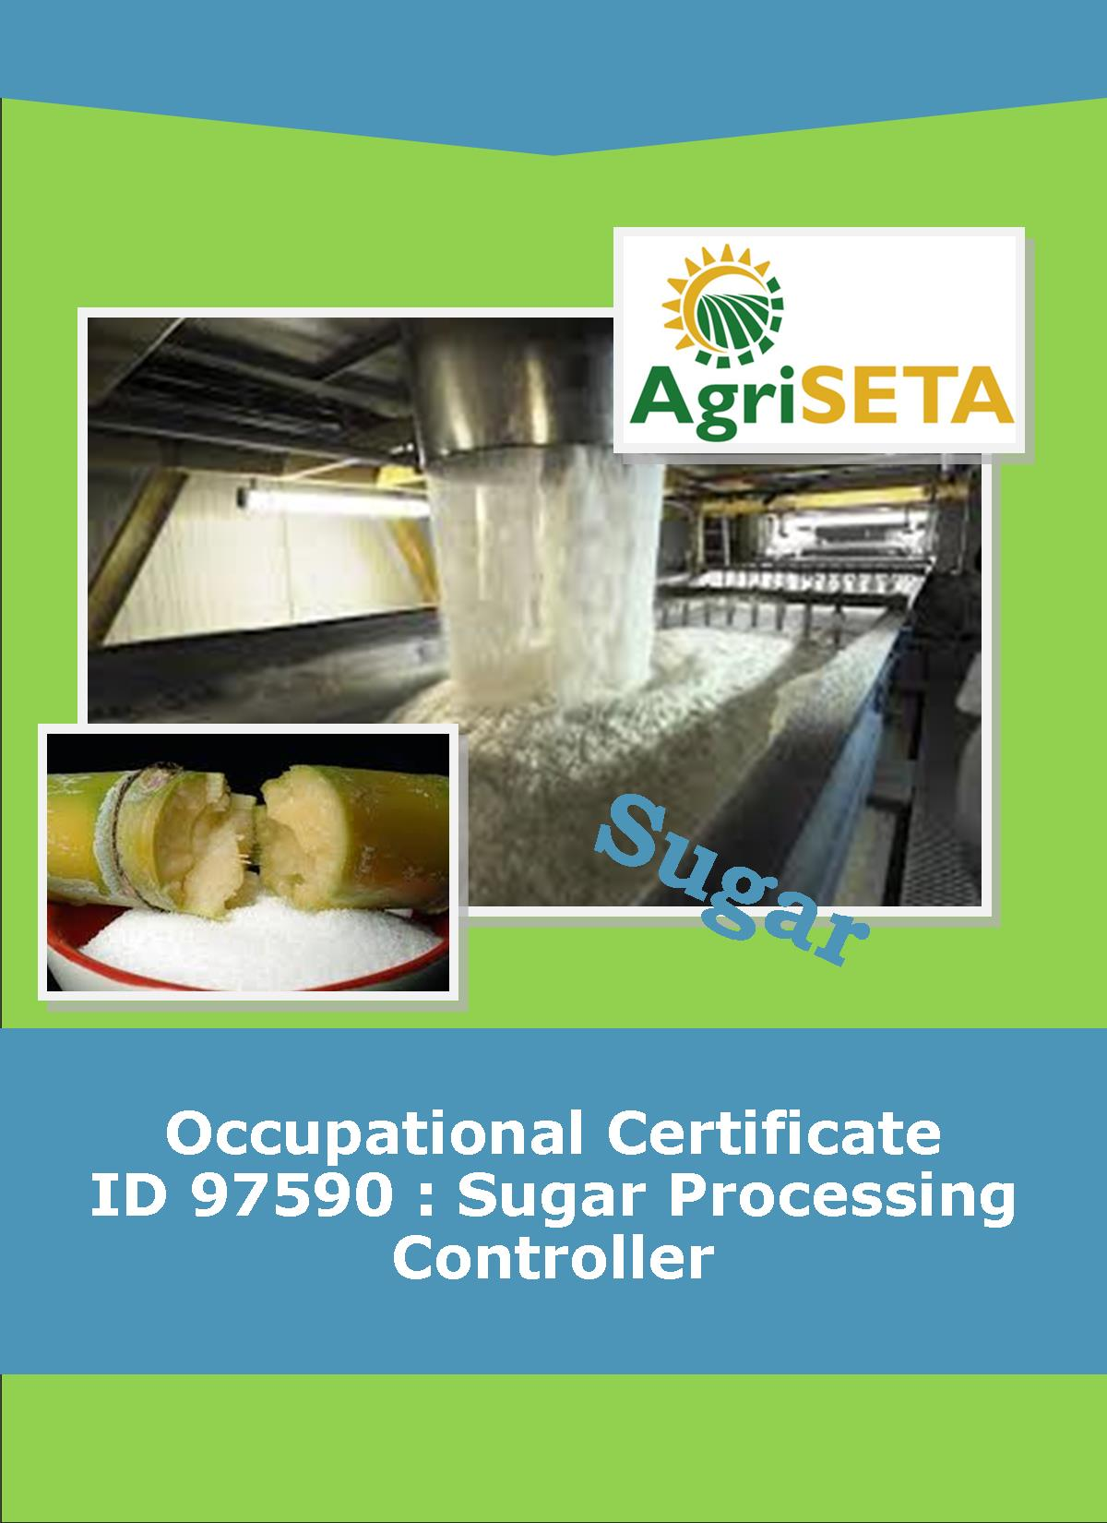**LEARNER SUMMATIVE ASSESSMENT TOOL KNOWLEDGE MODULE 3:**

**KNOWLEDGE COMPONENT: LEARNER SUMMATIVE ASSESSMENT TOOL KNOWLEDGE MODULE 3: SUGAR PROCESSING FACTORY CONTROL CALCULATIONS**

**Occupational Certificate: Sugar Processing Controller**

**LEARNER SUMMATIVE ASSESSMENT TOOL**

**KNOWLEDGE MODULE 3: SUGAR PROCESSING FACTORY CONTROL CALCULATIONS**

**SUGAR PROCESSING FACTORY**

**CONTROL CALCULATIONS**

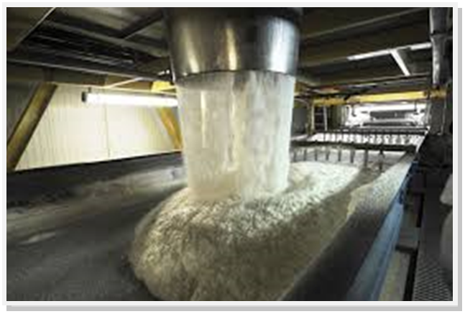

**OCCUPATIONAL CERTIFICATE: ID 97590: SUGAR PROCESSING CONTROLLER**

**©Copyright AgriSETA**

**Telephone: +27 12 301 5600**



AgriSETA holds the copyright to its publications and Web pages. Proper citation is requested.

**TABLE OF CONTENTS**

1. STAKEHOLDER INFORMATION 6

2. COMPETENCY SUMMARY OF ASSESSMENT 8

3. ASSESSMENT ALIGNMENT MATRIX (INTERGRATED OUTCOMES) 9

4. ASSESSMENT DECISION & EVIDENCE EVALUATION RECORD 11

5. OVERALL ASSESSMENT DECISION 12

6. EVIDENCE OF FEEDBACK 13

7. OVERALL RESULTS 14

8. ASSESSMENT REVIEW 15

9. FINAL DECISION 17

10. LEARNER FEEDBACK FORM 18

11. SUMMATIVE ASSESSMENT INSTRUCTIONS 19

12. WRITTEN ASSESSMENT 20

13. FINAL MARKS 27

1. STAKEHOLDER INFORMATION

|  |  |
| --- | --- |
| **LEARNER INFORMATION** | |
| **Name** |  |
| **Surname** |  |
| **ID number** |  |
| **Mobile phone contact number** |  |
| **E-mail address** |  |
| **Physical address** |  |
| **Postal address** |  |
| **Employer Name** |  |
| **Employer Contact Details** |  |

|  |  |
| --- | --- |
| **ASSESSOR DETAILS** | |
| **Name** |  |
| **Surname** |  |
| **Assessor ID** |  |
| **Project Name** | Occupational Certificate ID 97590:Sugar Processing Controller |
| **Module No.** | **Module 3: Sugar Processing Factory Control Calculations** |
| **Date of Assessment** |  |
| **Portfolio submission Date** |  |
| **Assessor Signature** |  |
| **Total Marks for Knowledge Module 3** | 90 marks |
| **Marks attained** |  |
| **Place:** |  |

|  |  |
| --- | --- |
| **MODERATOR DETAILS** | |
| **Moderator Name** |  |
| **Moderator ID** |  |
| **Moderator Signature** |  |
| **Date of Moderation** |  |

1. COMPETENCY SUMMARY OF ASSESSMENT

|  |  |  |  |
| --- | --- | --- | --- |
|  | | | |
| **Module 3** | **KM-03-KT01:** Introduction to factory control concepts | **C** | **NYC** |
| **1** | 1.1. Understanding the meaning of factory performance indicators can be demonstrated |  |  |
| **2** | **KM-03-KT02:** Materials balance | **C** | **NYC** |
|  | 2.1. Source of material to be balanced can be explained |  |  |
|  | 2.2. Calculations are correctly performed |  |  |
| **3** | **KM-03-KT03:** Stock taking | **C** | **NYC** |
|  | 3.1. Knowledge of accurate stocking as a component of materials balance can be demonstrated |  |  |
| **4.** | **KM-03-KT04:** Calculations | **C** | **NYC** |
|  | 4.1. Knowledge of formulas and accurate application can be demonstrated. |  |  |

1. ASSESSMENT ALIGNMENT MATRIX (INTERGRATED OUTCOMES)

|  |  |  |  |  |  |  |  |
| --- | --- | --- | --- | --- | --- | --- | --- |
| **Module No: 3** | **How it is assessed (Assessment methodology)** | **Where is it covered (learning material)** | **Where it is assessed** | | **First Submission** | | |
| **Summative** | **Formative** |
| **SAQA ID Number:** 97590 | Two methods of assessment are followed which are:  1. Summative assessment: written tests, knowledge questions using fundamental and reflexive questions.  2. Formative assessment: assignments, tasks, portfolio of evidence submitted and presentations. |  |  |  | **Clearly meets all the criteria** | **Meets some but not all criteria** | **Clearly does not meet any of the criteria** |
| **Title:** Sugar processing factory control calculations |  |  |  |
| **NQF level and credits:**  NQF Level 5: 12 Credits |  |  |  |
| **Topic: 1** Introduction to factory control concepts | Page 14 & 21 | Question 3.1—3.3 page 20 | Learning Activity 1.1 page 11-14 |  |  |  |
| Question 3.8-3.9 page 21 |
| **Assessment criteria**: Understanding the meaning of factory performance indicators can be demonstrated | Question 3.10 page 22 |  |  |  |  |
| Question 3.11-3.14 page 13-20 |
| Question 3.17, 3.19&3.20 page 24-25 |
| **Topic 2.** Materials balance |  | Page 22-44 |  | Learning Activity 2.1 page 16-21 |  |  |  |
| **Assessment criteria:**  Source of material to be balanced can be explained |  |  |  |
| **Assessment criteria:** Calculations are correctly performed |  |  |  |  |
| **Topic 3.** Stock taking |  | Page 45-46 | Question 3.4-3.7 page 21-22 | Learning Activity 3.1 page 23-28 |  |  |  |
| **Assessment criteria:**  Knowledge of accurate stocking as a component of materials balance can be demonstrated | Question 3.15-3.16 page 24 |  |  |  |  |
| **Topic 4.** Calculations |  | Page 52-73 |  | Learning Activity 4.1 page 30-41 |  |  |  |
| **Assessment Criteria:** Knowledge of formulas and accurate application can be demonstrated. |  |  |  |  |  |  |  |
|  |  |  |

1. ASSESSMENT DECISION & EVIDENCE EVALUATION RECORD

|  |  |  |  |  |
| --- | --- | --- | --- | --- |
| Candidate's Name: - | | | | |
| Assessor's Name: - | | | | |
| **Practical assessment**  I declare that this assessment is my own demonstration.  Marks: The learner is either “Met requirements” or “did not meet requirements”. If the learner did not meet requirements in an area, then he or she must be reassessed.  **Learner achieved: Met requirements /Did not meet requirements** | | | | |
| **KNOWLEDGE MODULE 3: SUGAR PROCESSING FACTORY CONTROL CALCULATIONS** | | | | |
| **Overall outcome:** | | | | |
| **Specific Outcome** | | **Met requirements** | **Did not meet requirements** | **Comments** |
| 1 |  |  |  |  |
| **Specific Outcome** | | **Met requirements** | **Did not meet requirements** | **Comments** |
| 2 |  |  |  |  |
|  | **Specific outcome** | **Met requirements** | **Did not meet requirements** | **Comments** |
| 3 |  |  |  |  |
|  | **Specific outcome** | **Met requirements** | **Did not meet requirements** | **Comments** |
| 4 |  |  |  |  |

1. OVERALL ASSESSMENT DECISION

|  |
| --- |
|  |
| **Assessors Comments:** |
| Signature of Assessor: |
| Date: |

1. EVIDENCE OF FEEDBACK

|  |  |  |
| --- | --- | --- |
| **Module No : 3**  **Level : 5**  **Assessor :**……………………………………………………………………………  **Candidate :**…………………………………………………………………………..  **Date of final assessment:**……………………………………………………………. | | |
| **Evidence criteria** | **Achieved** | **Not** |
| 1. Constructive |  |  |
| 2. Timeous (according to Plan) |  |  |
| 3. Correct mode / medium |  |  |
| 4. Participative |  |  |
| 5. Developmental |  |  |
| 6. Accurate |  |  |
| 7. Specific |  |  |
| 8. Documented |  |  |
| 9. Directed to correct parties |  |  |
| **Signing off date:** …………………………………………….  ..........……………. ………………………………….  **Assessor Candidate** | | |

1. OVERALL RESULTS

|  |  |  |  |  |
| --- | --- | --- | --- | --- |
| **OVERALL RESULT** | **Competent** | |  | |
| **Not Yet Competent** | |  | |
| Declaration by Candidate | | | | |
| I, …………………………………………………………………….declare that I am satisfied that the feedback given to me by the Assessor was relevant, sufficient and done in a constructive manner. I accept the assessment decisions and do realise that have no further questions relating to this particular assessment process. I do realise that after this assessment decision, the moderator will either uphold or reverse this assessment decision taken by the assessor. | | | | |
| **Candidate : _____________**  **_______________________**  **Date: __________________**  **Signature: ______________** | | **Assessor : _____________**  **_______________________**  **Date: __________________**  **Signature: ______________** | | **Moderator : _____________**  **_______________________**  **Date: __________________**  **Signature: ______________** |

1. ASSESSMENT REVIEW

|  |  |  |  |  |  |  |  |  |  |  |  |  |  |  |  |  |
| --- | --- | --- | --- | --- | --- | --- | --- | --- | --- | --- | --- | --- | --- | --- | --- | --- |
| **Assessor’s Name** | |  | | | | | | | **ID Number** | | | | |  | | |
| **Contact Details of Assessor** | | **Email** | |  | | | | | | | | | | | | |
| **Phone** | |  | | | | | | | | | | | | |
| **Fax** | |  | | | | | | | | | | | | |
| **PART 1** | | | | | | | | | | | | | | | | |
|  | **Review Criteria** | | **Valid** | | **Authentic** | **Current** | | **Consistent** | | | **Reliable** | | **Sufficient** | | | **Comments** |
| ***Please conduct an honest review of the Assessment Instruments used in this assessment:*** | | | | | | | | | | | | | | | | |
| 1 | Evidence Topic 1 | |  | |  |  | |  | | |  | |  | | |  |
|  | Knowledge Assignment | |  | |  |  | |  | | |  | |  | | |  |
| Practical Assignment | |
| Natural Occurring Evidence | |
| Reflection | |
| 2 | Evidence Topic 2 | |  | |  |  | |  | | |  | |  | | |  |
|  | Knowledge Assignment | |  | |  |  | |  | | |  | |  | | |  |
| Practical Assignment | |
| Natural Occurring Evidence | |
| Reflection | |
| 3 | Evidence Topic 3 | |  | |  |  | |  | | |  | |  | | |  |
|  | Knowledge Assignment | |  | |  |  | |  | | |  | |  | | |  |
| Practical Assignment | |
| Natural Occurring Evidence | |
| Reflection | |
| 4 | Evidence Topic 4 | |  | |  |  | |  | | |  | |  | | |  |
|  | Knowledge Assignment | |  | |  |  | |  | | |  | |  | | |  |
|  | Practical Assignment | |
|  | Natural Occurring Evidence | |
|  | Reflection | |
| **PART 2** | | | | | | | | | | | | | | | | |
| **No** | **Review Criteria** | | | | | | | | | **Yes** | | **No** | | | **Remarks** | |
| 1 | Do you feel the candidate was appropriately selected and prepared for the RPL assessment? | | | | | | | | |  | |  | | |  | |
| 2 | Did the candidate interpret the evidence requirements appropriately? | | | | | | | | |  | |  | | |  | |
| 3 | Was the assessment free of potential assessment barriers such as language, literacy, access to resources? | | | | | | | | |  | |  | | |  | |
| 4 | Was the assessment evidence presented by the candidate valid, authentic, current and sufficient? | | | | | | | | |  | |  | | |  | |
| 5 | Was the candidate’s workplace access to evidence sufficiently supportive of the assessment strategy? | | | | | | | | |  | |  | | |  | |
| 6 | Do you feel you could make a fair, valid and reliable assessment decision? | | | | | | | | |  | |  | | |  | |
| **Recommendations** | | | | | | | | | | | | | | | | |
| ***(Feedback on Validity, authenticity, currency and sufficiency of candidate evidence.)*** | | | | | | | | | | | | | | | | |
|  | | | | | | | | | | | | | | | | |
|  | | | | | | | | | | | | | | | | |
|  | | | | | | | | | | | | | | | | |
|  | | | | | | | | | | | | | | | | |
|  | | | | | | | | | | | | | | | | |
|  | | | | | | | | | | | | | | | | |
|  | | | | | | | | | | | | | | | | |
|  | | | | | | | | | | | | | | | | |
|  | | | | | | |  | | | | | | | | | |
| **Assessor Signature** | | | | | | | **Date Review Completed** | | | | | | | | | |

1. FINAL DECISION

|  |
| --- |
| **I………………………………………………………. hereby declare Ms/Mr**  **………………………………………… Competent Not Yet Competent** |
| **FEEDBACK TO LEARNER:**  **……………………..………………………..………………………..……………………**  **……………………..………………………..………………………..………………………**  **……………………..………………………..………………………..………………………**  **……………………..………………………..………………………..………………………**  **SIGN: …………………………………… DATE: ……………………..........................** |
| **LEARNER FEEDBACK:**  **……………………..………………………..………………………..………………………**  **……………………..………………………..………………………..………………………**  **……………………..………………………..………………………..………………………**  **……………………..………………………..………………………..………………………**  **SIGN: ……………………………………… DATE: …………………….......................** |
| **MODERATOR FEEDBACK:**  **………………………..………………………..………………………..……………………**  **………………………..………………………..………………………..……………………**  **……………………..………………………..………………………..………………………**  **……………………..………………………..………………………..………………………**  **SIGN: …………………………………… DATE: ……………………........................** |

1. LEARNER FEEDBACK FORM

|  |  |  |  |
| --- | --- | --- | --- |
| **CRITERIA** | **EVIDENCE** | **CRITERIA** | **EVIDENCE** |
| How did your assessor encourage you and put you at ease during the assessment process? |  | Were you given clear and constructive feedback? |  |
| Were your assessor’s questions clear and pitched at the right level of language usage? |  | Did your assessor assess all the evidence provided by you? |  |
| Do you believe that all the assessment criteria and knowledge requirements of the standard you were being measured against were considered in your assessment? |  | Were you aware of any discrimination practice carried out by your assessor towards you? |  |

**LEARNER SIGNATURE:………………………………………………**

**DATE:.…………………………..**

1. SUMMATIVE ASSESSMENT INSTRUCTIONS

**Instructions**

* Work individually and answer all questions.
* Use a black pen and ensure that you complete the questions in your own handwriting.
* Time to spend on this assessment is **1.5 hours.**
* The marks you will attain for each question are shown in brackets.

1. WRITTEN ASSESSMENT

**Candidate instruction:** Complete the following multiple-choice questionnaire by marking the most appropriate response with an x in the space provided.

|  |  |  |  |  |  |
| --- | --- | --- | --- | --- | --- |
| **Scope of Assessment** | | | **Exit Level Outcome/s** | | **Module/s** |
|  | | | 1. :**Factory Control Calculations** | | **3** |
| **Alignment – Learning Outcome 1,2,3&4: Factory concepts, Material balance, Stock taking and Calculations**  **Award four marks for selection of valid “x”. One mark = Competent** | | | | | |
|  | **3.1. What is the formula to calculate tons brix bagasse?** | | | **Mark Allocation** | |
| **a.** | 🞎 | × Tons bagasse | |  | |
| **b.** | 🞎 | × Tons bagasse | |  | |
| **c.** | 🞎 | × Tons bagasse | |  | |
| **d.** | 🞎 | × Tons mixed juice | |  | |
| **e.** | 🞎 | × Tons bagasse | | 4 | |

|  |  |  |  |  |
| --- | --- | --- | --- | --- |
| **3.2** | **What is the formula to calculate suspended solids in mixed juice?** | | **Mark Allocation** | |
| **a.** | 🞎 | × Tons mixed juice |  |
| **b.** | 🞎 | × Tons mixed juice |  |
| **c.** | 🞎 | – [ × Tons mixed juice × $\frac{insoluble solids \%}{100}$] |  |
| **d.** | 🞎 | × Tons bagasse |  |
| **e.** | 🞎 | × Tons mixed juice | 4 |

|  |  |  |  |
| --- | --- | --- | --- |
| **3.3** | **What is the corrected extraction used for?** | | **Mark Allocation** |
| **a.** | 🞎 | To correct the influence of pol and fibre on extraction |  |
| **b.** | 🞎 | To calculate the amount of bagasse produced |  |
| **c.** | 🞎 | To determine the brix, pol and fibre of cane from the analysis of mixed juice and final bagasse. |  |
| **d.** | 🞎 | To calculate the mill balance |  |
| **e.** | 🞎 | To monitor the performance of the extraction plant (front-end). | 4 |

|  |  |  |  |
| --- | --- | --- | --- |
| **3.4** | **Why is there a need for factory data?** | | **Mark Allocation** |
| **a.** | 🞎 | To calculate tonnage |  |
| **b.** | 🞎 | For proper factory control |  |
| **c.** | 🞎 | For cane payments |  |
| **d.** | 🞎 | To get total of crushed cane |  |
| **e.** | 🞎 | To able comparisons with other mills | 4 |

|  |  |  |  |
| --- | --- | --- | --- |
| **3.5** | **Quantitative measurements of the products are required for?** | | **Mark Allocation** |
| **a.** | 🞎 | To determine tons uncorrected. pol in mixed juice |  |
| **b.** | 🞎 | To monitor the performance of the extraction plant (front-end). |  |
| **c.** | 🞎 | The purpose of factory control and cane payments |  |
| **d.** | 🞎 | To determine the fibre that enters the extraction plant |  |
| **e.** | 🞎 | Calculating the imbibition % fibre | 4 |

|  |  |  |  |
| --- | --- | --- | --- |
| **3.6** | **Where are the individual vessels calibrated?** | | **Mark Allocation** |
| **a.** | 🞎 | In evaporators |  |
| **b.** | 🞎 | In cubic metres and tables |  |
| **c.** | 🞎 | In heaters |  |
| **d.** | 🞎 | In piping |  |
| **e.** | 🞎 | Tanks | 4 |

|  |  |  |  |
| --- | --- | --- | --- |
| **3.7** | **What causes errors?** | | **Mark Allocation** |
| **a.** | 🞎 | Mud |  |
| **b.** | 🞎 | Clear juice |  |
| **c.** | 🞎 | Molasses |  |
| **d.** | 🞎 | A Gas in massecuite in the mass per m3 |  |
| **e.** | 🞎 | Syrup | 4 |

|  |  |  |  |
| --- | --- | --- | --- |
| **3.8** | **If the Brix of mixed juice is 15.85% and the sucrose is 12.33 % what would the purity of mixed juice be?** | | **Mark Allocation** |
| **a.** | 🞎 | 75.25 |  |
| **b.** | 🞎 | 77.97 |  |
| **c.** | 🞎 | 76.89 |  |
| **d.** | 🞎 | 77.79 |  |
| **e.** | 🞎 | 77.00 | 4 |

|  |  |  |  |
| --- | --- | --- | --- |
| **3.9** | **The correct definition of Pol is:** | | **Mark Allocation** |
| **a.** | 🞎 | Rotation of light. |  |
| **b.** | 🞎 | Apparent sucrose. |  |
| **c.** | 🞎 | Saccharimeter reading. |  |
| **d.** | 🞎 | Percent dissolved solids in a factory stream |  |
| **e.** | 🞎 | Polarised light. | 4 |

|  |  |  |  |
| --- | --- | --- | --- |
| **3.10** | **What is the formula to calculate Fibre % bagasse?** | | **Mark Allocation** |
| **a.** | 🞎 | 100 |  |
| **b.** | 🞎 | 100 – moisture bagasse – brix % bagasse |  |
| **c.** | 🞎 |  |  |
| **d.** | 🞎 | × 100 |  |
| **e.** | 🞎 | 100 | 4 |

**TRUE OR FALSE QUESTIONS**

**Award one mark for selection of valid “T/F”. One mark = Competent**

|  |  |  |  |
| --- | --- | --- | --- |
| **3.11** | **A bagasse consists of the following components** | | **Mark Allocation** |
| **a.** | 🞎 | fibre (insoluble substances – including sand) |  |
| **b.** | 🞎 | Brix factor |  |
| **c.** | 🞎 | moisture (water) |  |
| **d.** | 🞎 | Pol Factor |  |
| **e.** | 🞎 | brix (dissolved substances) | 5 |

|  |  |  |  |
| --- | --- | --- | --- |
| **3.12** | **The following formula are used to calculate tonnages** | | **Mark Allocation** |
| **a.** | 🞎 | × Tons bagasse |  |
| **b.** | 🞎 | Tons cane + Tons water = Tons bagasse + tons mixed |  |
| **c.** | 🞎 | Fibre % bagasse = 100 – moisture bagasse – brix % bagasse |  |
| **d.** | 🞎 | tons bagasse + tons mixed juice – Tons cane |  |
| **e.** | 🞎 | × Tons bagasse | 5 |

|  |  |  |  |
| --- | --- | --- | --- |
| **3.13** | **The following are percentage formulas** | | **Mark Allocation** |
| **a.** | 🞎 | 100 |  |
| **b.** | 🞎 | [ × Tons insoluble solids] |  |
| **c.** | 🞎 | 100 |  |
| **d.** | 🞎 | 100 |  |
| **e.** | 🞎 | [ × Tons mixed juice × $\frac{insoluble solids \%}{100}$] | 5 |

|  |  |  |  |
| --- | --- | --- | --- |
| **3.14** | **True or False the following parameters need to be recorded for factory performance calculations** | | **Mark Allocation** |
| **a.** | 🞎 | pol % sugar |  |
| **b.** | 🞎 | moisture % sugar |  |
| **c.** | 🞎 | purity sugar |  |
| **d.** | 🞎 | pol % final molasses |  |
| **e.** | 🞎 | brix % final molasses | 5 |

|  |  |  |  |
| --- | --- | --- | --- |
| **3.15** | **True or False reports and material balances are prepared** | | **Mark Allocation** |
| **a.** | 🞎 | Weekly |  |
| **b.** | 🞎 | Daily |  |
| **c.** | 🞎 | Monthly |  |
| **d.** | 🞎 | Quarterly |  |
| **e.** | 🞎 | Seasonally | 5 |

|  |  |  |  |
| --- | --- | --- | --- |
| **3.16** | **True or False the stock in process is worked out by** | | **Mark Allocation** |
| **a.** | 🞎 | The total volume of product is the sum of each individual vessel containing that product. |  |
| **b.** | 🞎 | The product of tons brix per m3 and the volume of the product give the tons brix of the product. |  |
| **c.** | 🞎 | 100 |  |
| **d.** | 🞎 | The product of the ton brix and the purity divided by 100 will give the tons pol of the product. |  |
| **e.** | 🞎 | 100 | 5 |

|  |  |  |  |
| --- | --- | --- | --- |
| **3.17** | **True or False the purpose of the sugar factory mill is to?** | | **Mark Allocation** |
| **a.** | 🞎 | To count bagasse purity |  |
| **b.** | 🞎 | To control the process |  |
| **c.** | 🞎 | To detect and indicate the extent of the losses |  |
| **d.** | 🞎 | To supply management with information for financial and administrative purposes |  |
| **e.** | 🞎 | To enable comparisons with other mills | 5 |

|  |  |  |  |
| --- | --- | --- | --- |
| **3.18** | **True or False: The Brix of factory products is obtained by:** | | **Mark Allocation** |
| **a.** | 🞎 | Mixed juice can be filtered and read directly. |  |
| **b.** | 🞎 | Syrup and Remelt require a dilution of 1:5 before being read. |  |
| **c.** | 🞎 | Massecuites and molasses require a 1:4 dilution before being read. |  |
| **d.** | 🞎 | Syrup and Remelt require a dilution of 1:4 before being read. |  |
| **e.** | 🞎 | Massecuites and molasses require a 1:5 dilution before being read. | 5 |

|  |  |  |  |
| --- | --- | --- | --- |
| **3.19** | **True or False, the following stages are involved in factory control** | | **Mark Allocation** |
| **a.** | 🞎 | Analysis of the product |  |
| **b.** | 🞎 | Daily averaging of analytical results |  |
| **c.** | 🞎 | Daily report using the daily average figures and tonnages |  |
| **d.** | 🞎 | Weekly report using the week’s daily figures, stock in process and the previous week’s figures. To date figures are calculated at the same time. |  |
| **e.** | 🞎 | Monthly figures using the previous month’s to date figures and the current month’s to date figures. | 5 |

|  |  |  |  |
| --- | --- | --- | --- |
| **3.20** | **True or False: Daily averaging is calculated by** | | **Mark Allocation** |
| **a.** | 🞎 | Daily averaging of analytical results |  |
| **b.** | 🞎 | pol % final molasses |  |
| **c.** | 🞎 | The analytical results divided by the number of analyses. |  |
| **d.** | 🞎 | Direct analysis of individual cane consignments for brix, pol and fibre. |  |
| **e.** | 🞎 | The quantity of material associated with the analysis. | 5 |

1. FINAL MARKS

**TOTAL MARKS: 90**

**PASS MARK: 72**

|  |  |
| --- | --- |
| **LEARNER MARKS** |  |
| **PERCENTAGE** |  |
| **ASSESSOR SIGNATURE:** | |