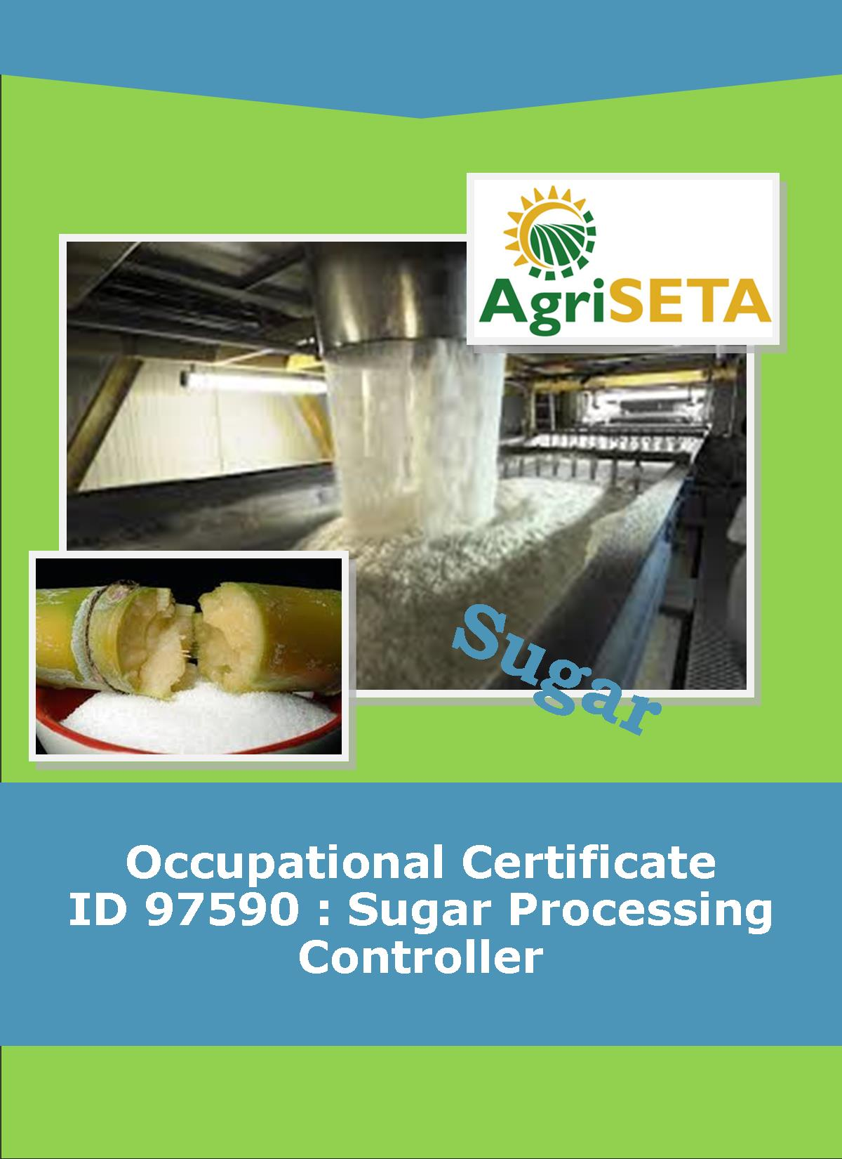**KNOWLEDGE COMPONENT:**

**KNOWLEDGE COMPONENT: LEARNER WORKBOOK 4:**

**SUGAR JUICE EXTRACTION**

**Occupational Certificate: Sugar Processing Controller**

**KNOWLEDGE COMPONENT: LEARNER WORKBOOK 4:**

**SUGAR JUICE EXTRACTION**

**LEARNER WORKBOOK 4:**

**SUGAR JUICE EXTRACTION**

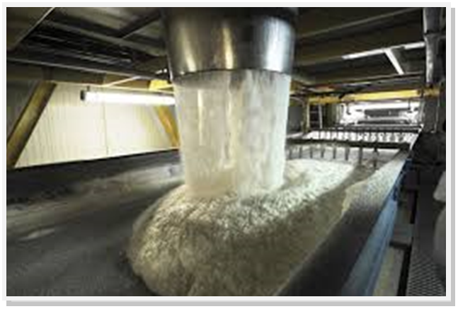

**OCCUPATIONAL CERTIFICATE: SUGAR PROCESSING CONTROLLER**

**©Copyright AgriSETA**

**Telephone: +27 12 301 5600**

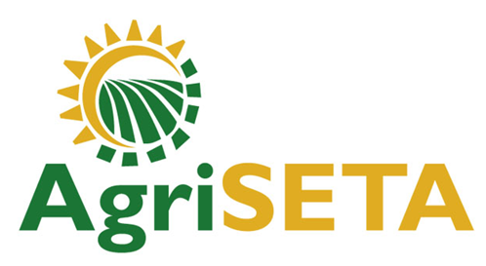

AgriSETA holds the copyright to its publications and Web pages. Proper citation is requested.

**TABLE OF CONTENTS**

1. AN INTRODUCTION TO THIS LEARNER WORKBOOK 6

2. LEARNER DETAILS 7

3. FORMATIVE ASSESSMENT INSTRUCTIONS 8

4. KNOWLEDGE MODULE 4: SUGAR JUICE EXTRACTION 9

4.1 Knowledge Topic 1: Raw product handling and processing (80%) 9

4.2 Knowledge Topic 2: Raw Product Handling and Processing Problem Solving (20%) 42

5. CONCLUSION OF KNOWLEDGE MODULE 4: SUGAR JUICE EXTRACTION 43

1. AN INTRODUCTION TO THIS LEARNER WORKBOOK

This Knowledge Component Learner Workbook 4: Sugar Juice Extraction is intended to be used with the Knowledge Component Learning Resource: Book 4 (Textbook): Sugar Juice Extraction of the Occupational Qualification: Sugar Processing Controller NQF 5.

Guidance on the use of this Work Book is provided in the Learning Guide.

1. LEARNER DETAILS

|  |  |
| --- | --- |
| First name |  |
| Surname |  |
| ID number |  |
| Mobile phone contact number |  |
| E-mail address |  |
| Postal address |  |
| Date on which you started this Knowledge Module |  |
| Date on which you completed this Knowledge Module |  |
| Declaration: | I hereby confirm that:   * I received the assessment plan and schedule. * I understand my rights in terms of special needs, re-assessment, feedback and appeals against assessment decisions. * I completed this formative assessment independently without assistance from anyone else. |
| Total Marks for Knowledge Module 4 | **375** |
| Marks attained |  |
| Date: |  |
| Place: |  |
| Signature of Learner: |  |
| Signature of Assessor: |  |

1. FORMATIVE ASSESSMENT INSTRUCTIONS

**Instructions**

* Work individually to present the results of each Learning Activity in this Learner Workbook.
* Complete all the sections.
* Use a black pen and ensure that you complete the questions in your own handwriting.
* A recommended time to complete each activity is shown.
* The marks you will attain for each learning activity are shown in brackets.
* The total marks obtained for each Knowledge Module must be transferred from the back of each Learner Workbook to the Learner Qualification Summative Assessment Tool.

1. KNOWLEDGE MODULE 4: SUGAR JUICE EXTRACTION

**NQF LEVEL: 4**

**CREDITS: 4**

**PURPOSE OF THE KNOWLEDGE MODULE: The main focus of the learning in this knowledge module is for the learner to build a fundamental understanding of front end juice extraction processes.**

The learning will enable learners to demonstrate an understanding of:

* KM-04-KT01: Raw product handling and processing (80%)
* KM-04-KT02: Raw product handling and processing problem solving (20%)

4.1 Knowledge Topic 1: Raw product handling and processing (80%)

Topic elements to be covered include:

* KT0101 Definitions and composition
* KT0102 Cane receiving, handling and conveying
* KT0103 Cane preparation
* KT0104 Milling
* KT0105 Diffusion
* KT0106 Juice Screening
* KT0107 Juice Massing
* KT0108 Bagasse Handling

Internal Assessment Criteria and Weight

* IAC0101 An understanding of process steps and use of equipment related to raw product handling can be demonstrated
* (Weight 80%)

**Learning activity 1.1: Individual Learning activity: 10 minutes (15 marks)**



**Learning Objective:** An understanding of the various terms used to describe the sugar extraction process can be demonstrated.

**Task:** Read each question carefully and write your answer in the space provided.

1. Explain the difference between sucrose % and pol % (6)

|  |
| --- |
|  |
|  |
|  |
|  |
|  |
|  |

2(a) Define Pol. (3)

|  |
| --- |
|  |
|  |
|  |

(b) Define brix. (3)

|  |
| --- |
|  |
|  |

(c) What is the effect of a higher pol on the purity for the same brix? (3)

|  |
| --- |
|  |
|  |
|  |
|  |

**Learning activity 1.2: Individual Learning activity: 10 minutes (15 marks)**



**Learning Objective:** An understanding of the composition of cane can be demonstrated.

**Task:** Read each question carefully and write your answer in the space provided.

1. What is the difference between fibre and pith? (4)

|  |
| --- |
|  |
|  |
|  |

1. Explain why first expressed juice is always of a higher purity than any other juice. (3)

|  |
| --- |
|  |
|  |
|  |

1. List eight important substances found in cane juice. (8)

|  |
| --- |
|  |
|  |
|  |
|  |
|  |
|  |

**Learning activity 1.3: Individual Learning activity: 30 minutes (27 marks)**



**Learning Objective:** An understanding of the procedures in cane transport and delivery can be demonstrated.

**Task:** Read each question carefully and write your answer in the space provided.

1. List the stages involved from the field to factory. (15)

|  |
| --- |
|  |
|  |
|  |
|  |
|  |
|  |
|  |
|  |
|  |
|  |
|  |
|  |
|  |
|  |

2. Why is a long delay in processing of harvested cane highly undesirable? (1)

|  |
| --- |
|  |
|  |

3. Why is cane consignments massed? (1)

|  |
| --- |
|  |
|  |

4. Describe the function of the cane yard and give the different means of operating a cane yard. (10)

|  |
| --- |
|  |
|  |
|  |
|  |
|  |
|  |
|  |
|  |
|  |
|  |
|  |
|  |
|  |
|  |

**Learning activity 1.4: Individual Learning activity: 1 hour (32 marks)**



**Learning Objective:** An understanding of the procedures in cane handling and preparation after delivery can be demonstrated.

**Task:** Read each question carefully and write your answer in the space provided.

1. Describe what happens to a load of cane from the time it arrives at the factory to being loaded onto the carrier. (6)

|  |
| --- |
|  |
|  |
|  |

2. Briefly describe the types of cane unloading systems in use. (10)

|  |
| --- |
|  |
|  |
|  |
|  |
|  |
|  |
|  |
|  |
|  |
|  |

1. Describe the types of feed table. (4)

|  |
| --- |
|  |
|  |
|  |
|  |

1. Describe the construction of a main carrier with reference to size, method of drive and power requirements.(10)

|  |
| --- |
|  |
|  |
|  |
|  |
|  |
|  |
|  |
|  |
|  |
|  |
|  |
|  |
|  |
|  |
|  |

1. Describe how the shredder can be protected from tramp iron.(2)

|  |
| --- |
|  |
|  |
|  |

**Learning activity 1.5: Individual Learning activity: 1 hour (40 marks)**



**Learning Objective:** An understanding of the process involved in cane preparation can be demonstrated.

**Task:** Read each question carefully and write your answer in the space provided.

1. Name 3 benefits of cane preparation. (6)

|  |
| --- |
|  |
|  |
|  |
|  |
|  |

1. (a) What is meant by “PI”? (1)

|  |
| --- |
|  |

(b) What is a normal/typical PI value? (1)

|  |
| --- |
|  |

(c) List the possible causes of a low PI result and how to remedy the situation. (2)

|  |
| --- |
|  |
|  |
|  |
|  |

1. Sketch a cane knife installation showing: pitch, clearance and method of attachment (5)

|  |
| --- |
|  |

1. What factors influence the power requirements of a cane knife set? (9)

|  |
| --- |
|  |
|  |
|  |
|  |
|  |
|  |
|  |
|  |
|  |
|  |

1. With the aid of a sketch explain the construction and operation of a shredder. (10)

|  |
| --- |
|  |
|  |
|  |
|  |
|  |
|  |

1. What factors influence the power requirements of a shredder? (3)

|  |
| --- |
|  |
|  |
|  |
|  |

1. What causes a shredder to choke with cane? How can this be prevented? (3)

|  |
| --- |
|  |
|  |
|  |
|  |
|  |
|  |

**Learning activity 1.6: Individual Learning activity: 2 hours (136 marks)**



**Learning Objective:** An understanding of the process involved in cane milling can be demonstrated.

**Task:** Read each question carefully and write your answer in the space provided.

1. With the aid of the labelled sketch explain the construction of a 3 roller mill. (8)

|  |
| --- |
|  |
|  |
|  |
|  |
|  |

2. Why are rollers grooved? (3)

|  |
| --- |
|  |
|  |
|  |

3. Explain with the aid of sketched the function of circumferential, chevron and Messchaert grooves. (24)

|  |
| --- |
|  |
|  |
|  |
|  |
|  |
|  |
|  |
|  |
|  |
|  |

4. What effect has the pitch of roller grooving on extraction? (2)

|  |
| --- |
|  |
|  |

5. What is the function of a trash plate? How can it be adjusted? (4)

|  |
| --- |
|  |
|  |
|  |
|  |

6. Make a sketch of a Donnelly chute and describe its purpose. (8)

|  |
| --- |
|  |
|  |
|  |
|  |

7. Make simple sketches of :-(

1. A mill with underfeed roller.(5)

|  |
| --- |
|  |

1. A mill with pressure feeder.(5)

|  |
| --- |
|  |

8. What functions do the above equipment serve? (4)

|  |
| --- |
| **Underfeed roller:** |
|  |
| **Pressure feeder:** T |
|  |

9. Make a simple labelled sketch of a mill hydraulic system. (5)

|  |
| --- |
|  |

10. Why is hydraulic pressure regulation important? (1)

|  |
| --- |
|  |
|  |
|  |

11. Make a sketch of an Edwards Accumulator and describe its operation. (8)

|  |
| --- |
|  |
|  |
|  |

12. What factors influence the load on a mill? (3)

|  |
| --- |
|  |
|  |
|  |

13. Describe the construction of mill bearings. (3)

|  |
| --- |
|  |
|  |
|  |

14. What is meant by setting a mill? (2)

|  |
| --- |
|  |
|  |

15. List the advantages of a turbine over other types of prime movers. (4)

|  |
| --- |
|  |
|  |
|  |
|  |
|  |
|  |

16. List the advantages and disadvantages of electric motors as prime movers. (5)

|  |
| --- |
|  |
|  |
|  |
|  |
|  |

17. What lubrication systems are used for the mill gearing? (2)

|  |
| --- |
|  |
|  |

18. Describe the different types of mill reduction gears with their advantages and disadvantages. (4)

|  |
| --- |
|  |
|  |
|  |
|  |

19. List the factors which influence the power required to crush the cane and extract the juice. (6)

|  |
| --- |
|  |
|  |
|  |
|  |
|  |
|  |

20. Describe the factors that influence the capacity of a milling tandem. (22)

|  |
| --- |
|  |
|  |
|  |
|  |
|  |
|  |
|  |
|  |
|  |
|  |
|  |
|  |
|  |
|  |
|  |
|  |
|  |
|  |
|  |
|  |
|  |

21. (a) What is imbibition (2)

|  |
| --- |
|  |
|  |
|  |

1. The clear juice tank is filling up and the syrup brix is low. How would you solve this problem? (2)

|  |
| --- |
|  |
|  |
|  |

22. The bacteria Leoconostoc mesenteroides destroy sucrose under certain conditions. Name these conditions. What system of juice liming has been adopted to control this bacteria? (4)

|  |
| --- |
|  |
|  |
|  |
|  |

**Learning activity 1.7: Individual Learning activity: 1 hour (47 marks)**



**Learning Objective:** An understanding of the process involved in cane diffusion can be demonstrated.

**Task:** Read each question carefully and write your answer in the space provided.

1. (a) What are the 3 transfer reactions that takes place in a diffuser?(3)

|  |
| --- |
|  |
|  |
|  |

1. What is the name given to these reactions?(1)

|  |
| --- |
|  |
|  |

2. Name the 2 main types of cane diffusers and explain the main difference between them. (4)

|  |
| --- |
|  |
|  |
|  |
|  |

3. Explain the difference between a cane diffuser and a bagasse diffuser with reference to size and retention time. (4)

|  |
| --- |
|  |
|  |
|  |
|  |

1. List the 6 factors which influence diffusion and explain the influence of each factor.(12)

|  |
| --- |
|  |
|  |
|  |
|  |
|  |
|  |
|  |
|  |
|  |
|  |
|  |
|  |

1. Explain the operating parameters in a diffuser with regard to temperature, pH, imbibition rate, bacterial control and retention time.(10)

|  |
| --- |
|  |
|  |
|  |
|  |
|  |
|  |
|  |
|  |
|  |
|  |
|  |

1. Describe the construction and function of a light dewatering device.(4)

|  |
| --- |
|  |
|  |
|  |
|  |
|  |
|  |

1. What is press water and how is it handled?(4)

|  |
| --- |
|  |
|  |
|  |
|  |
|  |

1. Draw a horizontal bed diffuser showing all ancillary equipment and juice and bagasse flows.(5)

|  |
| --- |
|  |

**Learning activity 1.8: Individual Learning activity: 15 minutes (13 marks)**



**Learning Objective:** An understanding of the process involved in juice screening can be demonstrated.

**Task:** Read each question carefully and write your answer in the space provided.

1. With the aid of a sketch explain the principle of operation of a DSM screen. (8)

|  |
| --- |
|  |
|  |
|  |
|  |
|  |
|  |

2. Explain how and why a DSM screen is reversed. (3)

|  |
| --- |
|  |
|  |
|  |
|  |

3. Describe the operation of a contra-shear screen. (2)

|  |
| --- |
|  |
|  |
|  |

4.2 Knowledge Topic 2: Raw product handling and processing problem solving (20%)

Topic elements to be covered include:

* KT0201 Cane receiving, handling and conveying problems and corrective measures
* KT0202 Cane preparation problems and corrective measures
* KT0203 Milling problems and corrective measures
* KT0204 Diffusion problems and corrective measures
* KT0205 Juice screening problems and corrective measures
* KT0206 Juice massing problems and corrective measures
* KT0207 Bagasse handling problems and corrective measures

Internal Assessment Criteria and Weight

* IAC0201 an understanding of trouble shooting and standard responses related to raw product handling and processing can be demonstrated.
* (Weight 20%)

**Learning activity 2.1: Individual Learning activity: 1hours (50 marks)**



**Learning Objective: Task:** Problem solving and corrective measures for raw product handling and processing can be demonstrated.

1. Given that the length of a roller is 1830 mm. calculate the roller diameter, journal diameter and journal length. (5)

|  |
| --- |
|  |
|  |
|  |
|  |
|  |
|  |

2. Calculate the bearing load area of the journals in equation 3. (5)

|  |
| --- |
|  |
|  |
|  |
|  |
|  |

3. Give a total mass balance diagram of the Extraction Plant, basing it on 100 t cane. (5)

|  |
| --- |
|  |
|  |
|  |
|  |
|  |
|  |

4. If 100 tons of pol in cane enter the Extraction Plant, what does an extraction of 96, 7 % mean? What is the percentage loss in bagasse? (5)

|  |
| --- |
|  |
|  |
|  |
|  |
|  |
|  |

5. Tons pol in cane = 35970, 675

Tons pol in mixed juice = 34934, 720

Calculate the extraction.

What does the figure tell us? (5)

|  |
| --- |
|  |
|  |
|  |
|  |
|  |
|  |

6. A mill turbine runs at 6 000 r.p.m. Calculate the mill speed if the following reduction sets are used.

1st – 12:1

2nd – 12:1

3rd – 5: 1

4th – 3: 1 (4)

|  |
| --- |
|  |
|  |
|  |
|  |
|  |
|  |

7. A 2134 mm x 965 mm mill is driven by a turbine running at 4 500 r.p.m. Calculate the peripheral speed of the rollers if the following reduction sets are used.

1st – 18:1

2nd – 12:1

3rd – 8:1 (4)

|  |
| --- |
|  |
|  |
|  |
|  |
|  |
|  |

8. If the peripheral speed of the mill in question 7 is reduced to 6m.min-1. What must the turbine speed be reduced to? (2)

|  |
| --- |
|  |
|  |
|  |

1. Calculate the relevant setting for the first mill in a tandem given:

Crushing rate = 275 t.c.h

Fibre % cane = 17, 6

Av. Diam. of rollers = 945 mm

Speed of rollers = 3, 4 r.p.m.

Length of rollers = 1830 mm

Average roller lift = 6 mm

Mill ratio = 2

Fibre % bagasse in discharge nip = 30%

Bagasse density = 1855Kg/m3. (5)

|  |
| --- |
|  |
|  |
|  |
|  |
|  |
|  |

1. Calculate the relevant settings for the following mill.

Crushing rate = 380 t.c.h.

Fibre % Cane = 15

Av. Diam. of rollers = 945 mm

Speed of rollers = 3, 8 r.p.m.

Length of rollers = 1830 mm

Average roller lift = 6 mm

Mill ratio = 2

Fibre % bagasse in discharge nip = 50%

Bagasse density = 1855Kg/m3 (5)

|  |
| --- |
|  |
|  |
|  |
|  |
|  |
|  |

1. Give the following data, calculate the extraction.

Tons pol in cane = 36 578, 649

Tons mixed juice = 279 432, 190

Pol % mixed juice = 12, 75 (5)

|  |
| --- |
|  |
|  |
|  |
|  |
|  |

1. CONCLUSION OF KNOWLEDGE MODULE 4: SUGAR JUICE EXTRACTION

Throughout this knowledge module you have been provided opportunities to complete formative learning activities. You have captured your results in this Learner Workbook.

The total marks for this Knowledge Module are as follows:

|  |  |  |
| --- | --- | --- |
| **Knowledge Module** | **Total Marks** | **Marks attained** |
| KM-04-KT01: Raw product handling and processing (80%) | 325 |  |
| KM-04-KT02: Raw product handling and processing problem solving (20%) | 50 |  |
| **Total Marks** | **375 marks** |  |

