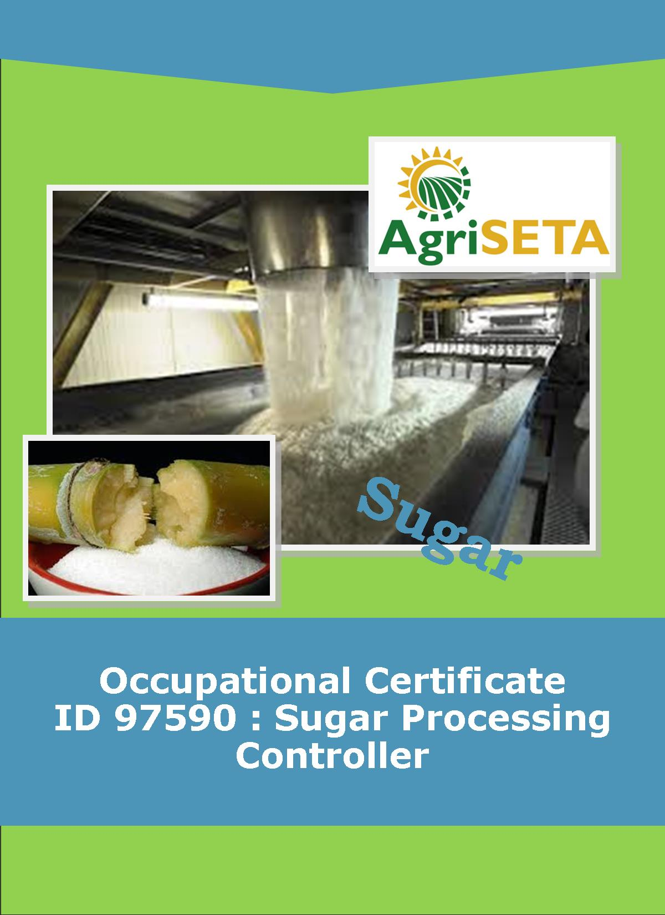
KNOWLEDGE COMPONENT: FACILITATOR ASSESSMENT TOOLS AND MODEL ANSWERS: BOOK 5: SUGAR JUICE HANDLING AND CLARIFICATION
KNOWLEDGE COMPONENT: FACILITATOR FORMATIVE AND SUMMATIVE ASSESSMENT TOOLS AND MODEL ANSWERS : KNOWLEDGE MODULE 5: SUGAR JUICE HANDLING AND CLARIFICATION
Occupational Certificate: Sugar Processing Controller

KNOWLEDGE COMPONENT: FACILITATOR ASSESSMENT TOOLS AND MODEL ANSWERS

BOOK 5: SUGAR JUICE HANDLING AND CLARIFICATION
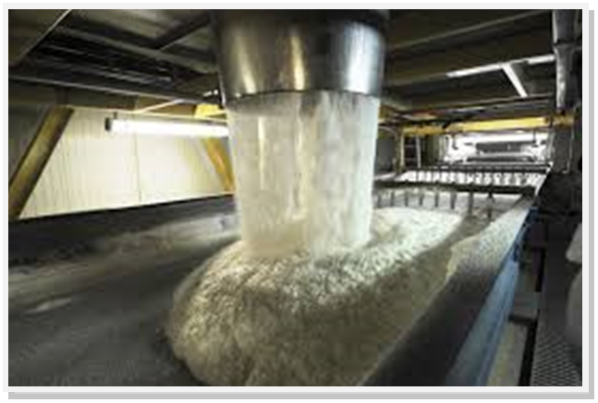
OCCUPATIONAL CERTIFICATE: SUGAR PROCESSING CONTROLLER

©Copyright AgriSETA
Telephone: +27 12 301 5600


AgriSETA holds the copyright to its publications and Web pages. Proper citation is requested.

TABLE OF CONTENTS
1. INTRODUCTION TO THE FACILITATOR ASSESSMENT TOOLKIT OF THE OCCUPATIONAL CERTIFICATE: SUGAR PROCESSING CONTROLLER 6
2. KNOWLEDGE MODULE 5: SUGAR JUICE HANDLING AND CLARIFICATION 7
2.1 Knowledge Topic 1: Juice Heating (40%) 8
2.2 Knowledge Topic 2: Clarification (40%) 14
3. CONCLUSION OF KNOWLEDGE MODULE 5: SUGAR JUICE HANDLING AND CLARIFICATION 28
4. SUMMATIVE ASSESSMENT ACTIVITIES AND MODEL ANSWERS 29
5. WRITTEN ASSESSMENT 30
6. FINAL MARKS 42

INTRODUCTION TO THE FACILITATOR ASSESSMENT TOOLKIT OF THE OCCUPATIONAL CERTIFICATE: SUGAR PROCESSING CONTROLLER
Dear Facilitator
This Toolkit has been created to assist you to assess the Formative Learning Activities of learners undertaking the NQF 5 Occupational Certificate: Sugar Processing Controller Qualification.
During the programme, Learners must be directed to their Learning and Activities Guide to complete Learning Activities associated with each module of the Knowledge Component.
The time allocated to the Learning Activities is provided in the Facilitator’s Implementation Guide, this Facilitator Assessment Toolkit and Model Answers and the Learning and Activities Guide.
The marks allocated to each Learning Activity is provided in this Facilitator Assessment Toolkit and Model Answers and the Learning and Activities Guide.
Instructions to be given to Learners
- They must work individually to present the results of each Learning Activity in each of the Learning and Activities Guides (Workbooks).
- They must complete all the sections.
- They must use a black pen and ensure that they complete the questions in their own handwriting.
- The time provided to complete each activity is shown.
- The marks they will attain for each learning activity are shown in brackets.

KNOWLEDGE MODULE 5: SUGAR JUICE HANDLING AND CLARIFICATION
NQF LEVEL: 5
CREDITS: 4
PURPOSE OF THE KNOWLEDGE MODULE: The main focus of the learning in this knowledge module is for the learner to gain a fundamental understanding of the theory and science of juice handling and clarification.
The learning will enable learners to demonstrate an understanding of:
- KM-05-KT01: Juice Heating (40%)
- KM-05-KT02: Clarification (40%)
- KM-05-KT03: Problem solving (20%)

  - Knowledge Topic 1: Juice Heating (40%)
Topic elements to be covered include:
- KT0101 Properties of mixed juice
- KT0102 Purpose of Heating
- KT0103 Heat Exchange
- KT0104 Equipment
Internal Assessment Criteria and Weight
- IAC0101 An understanding of process steps and use of equipment related to juice heating can be demonstrated
- IAC0102 Key control points related to juice heating can be listed and controls explained
- (Weight 40%)

Learning activity 1.1: Individual Learning activity: 2 hours (30 marks)

Learning Objective: An understanding of the components of mixed juice and thus the need for heating and clarification can be demonstrated.
Task: Read each question carefully and write your answer in the space provided.
- Name and describe 13 substances/components found in mixed juice. (13)
Sucrose: it is the disaccharide formed when a molecule of glucose is combined with a molecule of fructose.

Reducing sugars: are monosaccharide’s (simple sugars) like glucose and fructose.

Inorganic salts (ash): consisting of combinations of positive and negative ions.

Organic Acids: The most frequently found are glycollic, suxine, malic, oxalic, tonic, citric, acetic, and aconitic acids.

Colour bodies: are chlorophyll, anthocyanins and flavanols (polyphenols). Also included is saccaretin, a black pigment associated with sugar cane processing.
Iron compounds: These are organic molecules that contain the Fe²⁺ and Fe³⁺ ions.

Tannin: Amorphic substances consisting of complexes of esters and ethers of various carbohydrates.

Pectins: Pectins are gelatinous carbohydrates which have a pronounced property of increasing the viscosity of solutions. Pectins are found mainly in the cell wall material.

Gums: are colloidal polysaccharides consisting principally of pentosans units which upon hydrolysis give pentose sugars.

Protein: Proteins are very large molecules serving a variety of functions within a living organism.

Wax: Cane wax originates in the nodes and in the rind of the cane plant. Between 60-80% of the wax is retained in the bagasse.
Starch (Amylose): Starch is composed of glucose units strung together. Starch is one of the most undesirable impurities in cane juice as its inclusion in the sugar crystal will cause difficulties in refinery filtration.

Air: Air will interfere in any clarification process involving settling. It must therefore be removed before settling can take place.

- (a) Define inversion (6)
Inversion involves the decomposition of sucrose into glucose and fructose. Glucose and fructose are called invert sugars or reducing sugars. This reaction is highly undesirable since glucose and fructose cannot be converted back into sucrose by man-made processes. The glucose and fructose is lost in molasses. The rate (speed) of inversion increases with:
- Increase in acidity (pH>7)
- Increase in temperature
- Increase in the time of the exposure to the above mentioned conditions

- Explain the effect of both a low and high pH on juice.(6)
Since cane juice is naturally acidic it is imperative that lime be added to keep the pH close to 7 (neutral).
It has been found that the rate of inversion at pH 5,4 and 100°C is 1% inversion per hour.

Learning activity 1.2: Individual Learning activity: 2 hours (50 marks)
Learning Objective: An understanding of process steps and use of equipment related to juice heating can be demonstrated.
Task: Read each question carefully and write your answer in the space provided.
- (a) What type of heat does steam (vapour) release in a juice heater? (2)
Condensed vapour

(b) What happens to the steam when it releases this heat? (2)
When vapour with a pressure close to atmosphere pressure is used for heating the incondensible gases are withdrawn to the sub-atmospheric pressures of the last vessels of the evaporator station.

2. How is heat transmitted? (6)
- Conduction
Here the heat energy moves from a region of higher temperature to a region of lower temperature with the heat energy being transferred from particle to particle.
Example: When one end of a metal rod is heated the heat energy is transferred atom-to-atom towards the cooler end and the cooler end will start to heat up i.e. the atoms will start to vibrate.
- Convection
Here the heat energy is transferred by higher energy particles moving to regions of lower energy.
Example: when a beaker of water is heated, currents are formed when molecules with high kinetic energy move to areas where the molecules have lower kinetic energy
- Radiation
Here the heat energy travels through space in the form of waves.
Example: Heat energy moves from the surface of the sun to earth through the vacuum of space.
Heating and boiling in the factory is done using conduction which is the transfer of heat through a solid media (tube wall) from particle to particle without any particle migration (movement).

3. Write down the equation for:
(a) The heat transferred through a tube wall (5)
Q $∝$ A x $∆$T
Q = k x A x $∆$T
Where k is a constant called the heat transfer co-efficient.
Q = Rate of heat transfer (kJ.s⁻¹)
K = Heat transfer co-efficient (kJ.m⁻²°C^{­1}s⁻¹)
A = Heating surface (m²)
T = Temperature difference between steam and juice (°C)

(b) The heat absorbed by the juice (5)
- The greater the mass of juice the more heat is transferred and absorbed by the juice. The heat transferred is said to be proportional to the mass of juice
Q $∝$M
- The greater the temperature difference/change between the start and end of heat transfer, the greater the amount of heat transferred. The heat transferred is thus proportional to the temperature change.
Q $∝$ $∆t$

4. (a) Define specific heat capacity (4)
The specific heat capacity of a substance is the quantity of heat energy necessary to raise the temperature of 1kg of the substance by 1°C.The specific heat capacity of juice is thus the kJ of heat energy required per 1kg 1°C rise in temperature (kJ.kg⁻¹°C⁻¹).The greater the specific heat capacity of the juice, the more heat is transferred and absorbed by the juice for a given temperature change/difference.

(b) Give the equation to calculate the specific heat capacity of a sugar solution. (4)
C= (1 - 0.006 x B) x 4.187
Where:
B = Brix of sugar solution
C = Specific heat in kJ.kg⁻¹.°C⁻¹

5. With the aid of a sketch describe the construction of a juice heater and indicate how the passes are affected. (18)
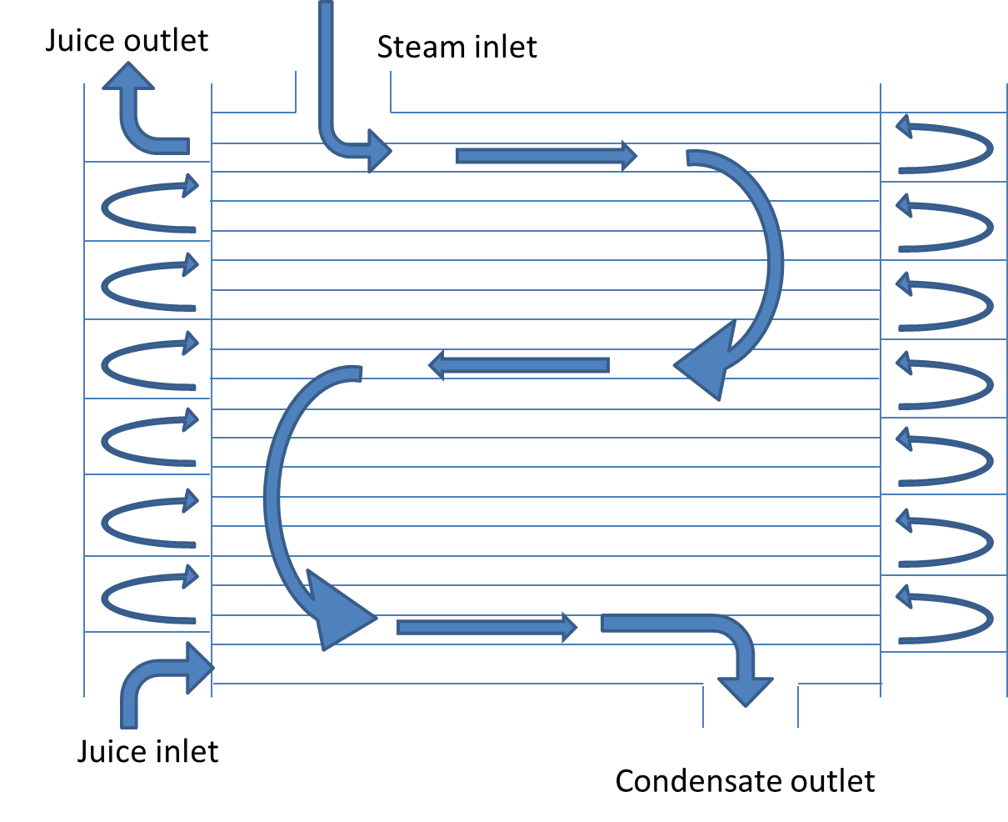
At each end of the heater baffles are arranged so that the juice will pass through a fixed number of tubes in succession. Juice is pumped through the tubes while vapour is fed around the tubes. Condensed vapour is removed via a condensate pipe and a gas vent allows incondensible gases to escape to atmosphere.

6. (a) What effect has juice velocity on heat transfer? (2)
The velocity of the juice through the tubes affects the overall heat transfer co-efficient. The juice velocity should lie between 1.5 to 1.8ms⁻¹ so as to get good turbulence and heat transfer.

(b) What effect has juice velocity on pressure drop across a heater? (2)
The pressure drop across a heater or heaters in series should be limited to 520kPa.The calculation of pressure drop is a function of the juice velocity, the tube diameter, the number of passes and the tube length.
Increasing the juice velocity increases the pressure drop which may be detrimental to the pump. Two heaters in series would double the pressure drop.

  - Knowledge Topic 2: Clarification (40%)
Topic elements to be covered include:
- KT0201 Purpose
- KT0202 Principles
- KT0203 Liming
- KT0204 Operation of Clarifiers
- KT0205 Filtration
- KT0206 Mud recycling
Internal Assessment Criteria and Weight
- IAC0201 An understanding of process steps and use of equipment related to clarification can be demonstrated
- IAC0202 Key control points related to clarification can be listed and controls explained
- (Weight 40%)

Learning activity 2.1: Individual Learning activity: 10 hours (150 marks)
Learning Objective: Demonstrate an understanding of process steps and use of equipment related to clarification.
Task: Read each question carefully and write your answer in the space provided.
- What is the purpose of clarification? (2)
The purpose of clarification is to produce a clear juice, that is of the correct pH value, free of suspended or colloidal matter and to do this with minimal loss of sucrose or destruction of reducing sugars.

- What is the target pH value for limed juice and why is this target chosen? (3)
7.0 to 7.2 pH. ,this is about the best pH for the crystallization process as it will give easy boiling massecuites, develop less colour and there will be little loss of sucrose by inversion or the breakdown of reducing sugars. If the pH is too high the massecuites will be dark and viscous and there will be breakdown of reducing sugars. Low pH’s will cause sucrose inversion

- Explain with the aid of formulae the formation of the milk of lime slurry. (4)
The process of lime slaking generates a great deal of heat. Since calcium hydroxide is only very slightly soluble in water i.e. 0.12% at 25°C, the milk of lime is therefore a fine suspension of small particles of CaO in water.

- Define precipitation. (2)
The two-stage precipitation first causes small particles to form, which grow and rearrange into a very intricate floc that traps and absorbs all suspended solids. Included are the other non-sugars that are precipitated by the reaction change, by the heat, by the calcium and by the increase in pH.

- Explain why purity cannot be used to judge the efficiency of clarification. (4)
Clarification removes the insoluble matter in the juice. Most of the soluble impurities (non-sugars) are NOT removed during clarification. As these impurities remain in solution the brix change from mixed juice to clear juice is negligible and is due to the addition of dilute filtrate from the filter station to the mixed juice. This is the reason why clarification does not drastically affect the purity of the juice. Clarification is thus judged by turbidity/ clarity.

- What component of juice is very important for efficient/effective clarification? (2)
The phosphate content of the juice.

- How does the change in pH from limed juice to clear juice come about? (2)
Through defecation process where lime is added to mixed juice to raise the pH and form a precipitate.

- Explain with the aid of sketches the differences between hot liming and saccharate liming with regard to juice quality and equipment required. (10)
- Hot liming
The system used throughout South Africa is the hot liming process (i.e. heating followed by liming). In the process juice is heated to 103-105°C and then limed to a constant pH of 7.0 -7.2. Heating the juice in an acid medium precipitates out the silica and proteins (mainly albumen) and eliminates the risk of dextran formation since leuconostoc mesenteroids is inactivated above 70°C. The risk of inversion is also minimal as the retention time at 103°C is very short.
- Saccharate liming
The use of lime saccharate is confined to a few factories.
Lime is approximately 17 times more soluble in a sugar solution than in water. The reaction between milk of lime and a sucrose solution gives rise to the possibility of mono-, di- and tricalcium saccharates being formed, depending on the chemical and physical conditions under which the reaction takes place.
In order to ensure that the highly soluble mono-calcium saccharate is formed, it is important to maintain two conditions during preparation.
- An excess of sucrose
- A temperature of below 58°C

- Explain the chemical changes that take place during clarification. (5)

- Explain the meaning of the term flocculation. (2)
Flocculation provides a mechanism whereby insoluble suspended impurities are aggregated into flocs which are suitable for separation by sedimentation.

- (a) How are colloidal particles held in suspension? (4)
These particles are in suspension (in a stable state) because the particles all carry a negative electrical charge and therefore tend to repel each other.
The particles are also all covered with a layer of material which is saturated with water molecules. This cushion prevents close contact of the particles.

- Explain 3 methods of bringing about flocculation. (6)
- Neutralization of the negative charge: This can be done by reducing the pH.
- Reduction of the degree of hydration: This occurs when the juice is heated and some proteins are precipitated e.g. albumen.
- Introduction of a bridging mechanism: This is the basis of the current flocculation process used in the industry and involves the formation of an inorganic precipitate.
- The addition of an additional bridging mechanism i.e. “secondary” flocculation is the use of very high molecular mass polymers which are capable of attachment to adjacent impurity particles. The polymer must have a molecule mass in excess of 1 000 000 (106) and carry some negative charges down its length for the attachment of impurity particles.

- Explain the difference between primary and secondary flocculants. (6)
Primary flocculation: thus involves the aggregation of single particles in free suspension in the juice into clusters of 10 to 10⁴ particles. The resulting primary flocs are small, slow-settling and leave behind a very turbid juice.
Secondary flocculation: is the use of very high molecular mass polymers which are capable of attachment to adjacent impurity particles. The polymer must have a molecule mass in excess of 1 000 000 (106) and carry some negative charges down its length for the attachment of impurity particles.

- What is a flocculant? (2)
A substance which promotes the clumping of particles, especially one used in treating waste water

- What precautions should be taken when dealing with flocculants? (4)

- What are the normal stock solution strengths of talosep and separan? (2)

- Consider the following:
Diameter of preparation tank = 1.2m
Depth when filled = 0.8m
Calculate the amount of dry talosep and separan that must be added to the tank to make up the recommended strength stock solutions. (6)

- Explain the manner of use of the following:
  - an air sparge (3)
The size should be compatible with the space available and also with the size of the preparation tank.
It should be of similar construction, i.e. mild steel epoxy-resin lined, and fitted with an air sparge.
Connection to the dosing pump should be by 25mm internal diameter lines.

  - an educator (3)
This assembly comprises a dry powder supply funnel, vibrating feed through and mixing bowl.
The rate of dry powder addition is controlled by a free standing regulator
This assembly enables perfect flocculant solutions to be prepared without the normal problem of undissolved lumps associated with other make-up systems.

- Describe two methods of lime addition and mixing. (6)

Perry tank: The perry tank is a common mixing device used in a number and factories. It consists of a stirred tank through which the juice flows. The lime is added to the tank which has a juice retention time of about 5 minutes

In-line mixer: A few factories are now using in-line mixers for mixing lime and juice. As the whole system is under pressure the lime has to be injected into the pipe before the mixer.Flashing can be done after mixing. Cleaning of the internals should be done regularly in order to avoid an excessive pressure drop in the line.

- Explain how pH control is achieved. (4)
The first factor for effective pH control is to limit fluctuation in juice flow and in milk of lime (or saccharate) concentrations To achieve this, sufficient buffer capacity should be provided in the juice stream and in the lime preparation stage, before the lime addition point.
The lime addition should be controlled according to the pH of the juice clarifier.
Detect the pH as close as possible to the point of lime addition, allowing enough time for the precipitation reaction to take place, before the limed juice reaches the pH electrode.
There must be at least 4 minutes between addition of lime and the clear juice entering the clarifier.

- List 4 important points affecting the accuracy of pH control. (4)
- Changes in flow
- Changes in acidity of the raw juice
- The reaction time of juice and lime
- The lags in the control loop

- What is the purpose of juice flashing prior to clarification? (4)

- (a) Draw a simple sketch of a Rapi-dorr clarifier. (5)
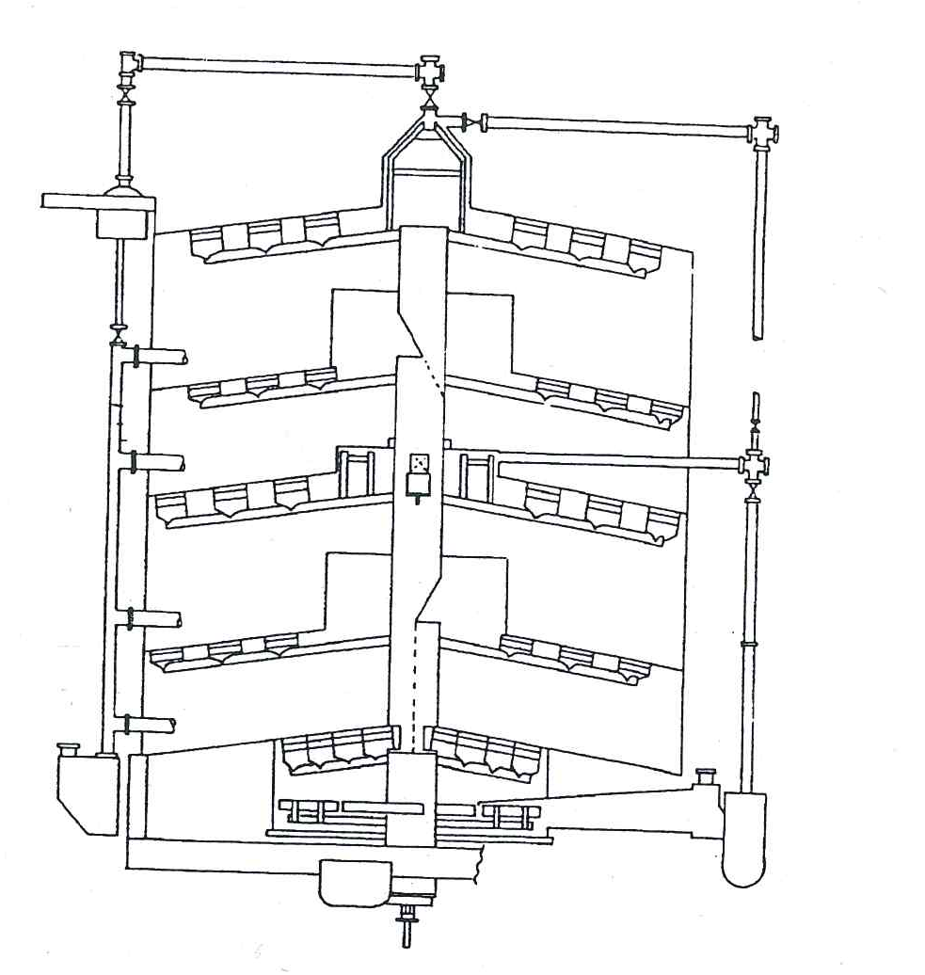

- List the possible causes and remedies if all compartments of a Dorr clarifier are overflowing with cloudy juice. (6)
- The mud might be too tight - pump mud out faster.
- The feed rate may be above the capacity of the clarifier - cut down the feed rate.
- The settling properties of the floc might have changed due to pH, juice quality, temperature (flashing) - check these conditions.
- Temperature convection may be interfering with the proper operation of the clarifier - check on temperatures.

- What action could you take if the mud from the clarifier was too thin? (4)
- Removal of mud is too fast. Slow down the pumping rate.
- The clarifier may be overloaded and the mud does not have enough time to thicken. Slow down the feed rate or you will have to continue to pump thin mud.

- (a) Draw a simple sketch of a SRI clarifier. (5)
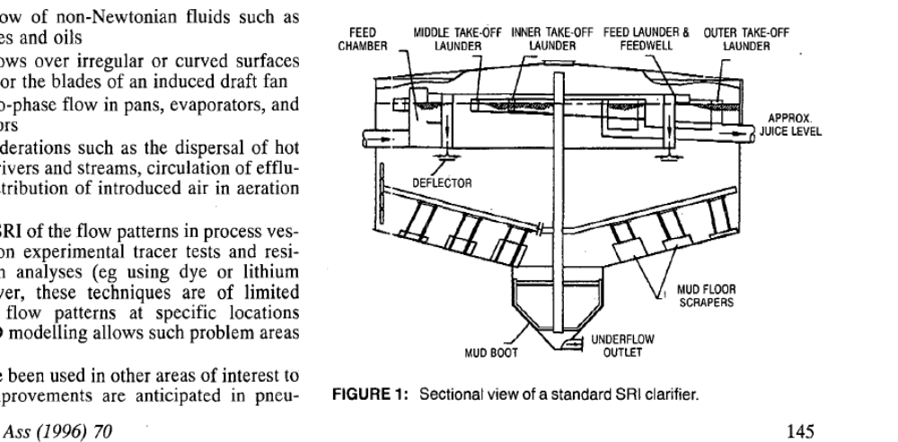

- What is a “launder”? (2)
A Filter in which a juice is feed into.

- Describe the principals of operation of an SRI clarifier. (6)
- Flocculant dosing rates: Periodic settling tests should be done to ensure correct dosage rate.
- Flocculant must be distributed evenly to the distribution points.
Check the following:
- Adjustment of flowmeters
- Strength of flocculant
- Pump operation
- Flocculant tank has flocculant in it
- Lumps in flocculant
- Right pH. Check the pH control system and dosing device.

- List 4 important operating conditions with regard to a SRI clarifier. (4)

- What are the advantages of a SRI clarifier? (9)
A smaller, simpler and cleaner unit
Short retention time and minimization of losses
Higher throughputs
The opportunity to liquidate at week-end shutdowns which will further reduce losses.
Inversion if minimized
Higher density muds
Reduced cake losses
Lower rates of flocculent and lime addition
Lower unit costs
Low internal turbulence at high throughputs – thus low turbidity and minimal bagacillio carryover in the clarified juice
Simple maintenance
Saving in space of up to 70%
The simpler, less cluttered design is best suited to plug flow.

- List the 3 factors that affect purity drop in a clarifier over stop periods and explain their effect. (6)

Effect of pH: The purity drop increases as the pH of the juice falls below 7.2 at a temperature of 88°C over a 40-hour storage period. If the pH is maintained at above 7.2 the purity drop will decrease. If a longer storage period is expected the pH must be increased.

Effect of Temperature: A minimum purity drop occurs between 71 and 74°C. Below this temperature microbial activity increases and causes a purity drop. Above this temperature chemical decomposition increases and inversion increases.
Effect of time period: At 88°C over a period of 40 hours the clear juice purity will drop by 5.4 units from 85 purity to 79.6 purity. Such losses have very serious financial implications. Suppose a clarifier contains 300t of juice at 12°Bx and a purity 88%. After a 20 hour stop the purity drops to 85%.

- How is deterioration in a clarifier minimised (two ways)? (4)
Cold storage: Maintain a juice temperature below 71°C and treat the juice with a bactericide like formalin. Formalin should be added to the juice at a constant rate between the flash tank and clarifier. The final concentration should be 200mg.1⁻¹ and addition should start at a time before shutdown which corresponds to the retention time of the clarifier
Hot storage: Maintain a high juice temperature above 75°C to prevent microbial activity and increase the pH by adding more lime. A clear juice pH at the end of the storage period of 7.2 – 7.5 should be aimed for.
Mud levels: Mud levels must be kept as low as possible during the shut-down period. In most cases however, sucrose losses will occur, particularly in the mud. During weekend or emergency shut-down, the clarifier should be liquidated if possible.

Learning activity 2.2: Individual Learning activity: 5 hours (50 marks)
Learning Objective: Demonstrate an understanding of process steps and use of equipment related to filtration.
Task: Read each question carefully and write your answer in the space provided.
- Why must clarifier underflow/mud be filtered? (2)
To separate as efficiently as possible the mud solids from the clear juice.

- Draw a simple sketch of a rotary vacuum filter and use it to explain its operation. (15)
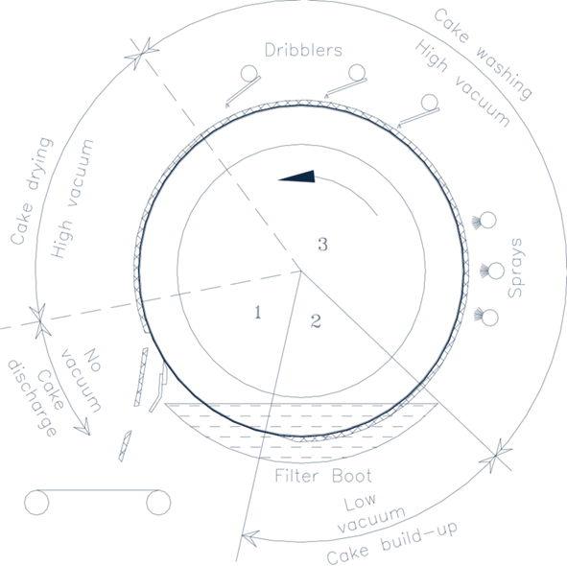
The rotary vacuum filter consists of a double walled drum rotating in a trough containing the mud to be filtered. The mud-bagacillo mixture in the trough is gently agitated to keep the mud and bagacillo in suspension. The outer wall of the drum is made of round-hole screens in 24 sections running the length of the drum. The inner solid wall of each section is connected by a pipe to a manifold at the end of the drum. Attached to the manifold is a distributing valve that is connected via receivers to a source of vacuum.
A low vacuum draws the juice fraction through the perforated plate to form a mat (1cm thick) of fibre and mud over the screen. As the drum turns, a higher vacuum is applied to force filtrate and wash water through the mat that had been formed. The second filtrate is clearer than the first. This first filtrate is called “cloudy filtrate” and goes to the cloudy filtrate receiver to be returned to the juice before the clarifier. The filter screen serves mainly to support the mat which is the main filtering medium. When the drum emerges from the trough, water sprays and drips are directed onto the filter cake to displace the juice. During this washing process, high vacuum is maintained. The water dilutes the filtrates. Filtrate brix is controlled at about 2-4 points lower than mixed juice brix. The cake is then dried by maintaining high vacuum with no water sprays.
Vacuum is broken at the cake discharge point and a scraper deflects the cake onto the disposal carrier. The filtrate is conveyed through metal pipes to the head of the filter and then to filtrate receiving tanks. The purpose of “washing” the cake is to achieve maximum sucrose recovery. Hot condensate is used as wash water. This keeps temperatures high in the filter station which minimizes bacterial activity.

- List 3 factors that affect the performance of a rotary vacuum filter. (6)
- Mud solids concentration (mud solids % feed) which is the dry insoluble begacillo free material separated from the clarifier underflow.
Mud solids concentration = (Dry mud solids/ Clarifier underflow (mud)) x 100
The Mud Solids Concentration must be 3 - 4% for effective filter operation. The 4% level should be viewed as being the maximum.
- Retention which is the percentage of total mud solids treated by the filter which is retained in the filter cake.
Retention = (Mud solids in filter cake / Mud solids in filter feed) x 100
- Bagacillo ratio which is the mass of dry bagacillo in filter feed expressed as a percentage of dry mud solids.
Bagacillo Rato = (Dry bagacillo / Dry mud solids)
The Bagacillo rate should be 1 for good filter operation. Note: Total Solids % filter feed = Bagacillo % filter feed + Mud solids% Filter feed

- List 5 factors that affect filter retention. (10)
- Bagacillo quality: Bagacillo must be fine (mostly pith) and free of long fibre. More than 90% of the bagacillo should pass through a 0.8mm screen and 70% through a 0.5mm screen.
- Bagacillo quantity: The quantity of bagacillo used is given in terms of dry bagacillo % feed. This should be about 3%. Above this figure mixing and pumping is difficult and wash water causes channeling with resultant poor washing.
- Mud solids concentration (MSC): With a low MSC (thin mud) a lot of filtrate passes through the filter screen before the filtering mat is formed, causing poor retention. With a MSC of 3% or less it is not possible to achieve good retention even with large bagacillo ratios. With a MSC of 3%-4% higher retentions are possible provided the bagacillo ratio is correct. More bagacillo is required as the concentration of mud solids increase.
- Pickup vacuum: A low pickup vacuum allows the cake to build up gradually and form a porous cake that allows for effective washing. The pickup vacuum should not exceed - 20 kPa. A high pickup vacuum results in cloudy filtrate due to the solids being sucked through the screen.
- Filter speed: The speed of the filter drum influences the formation of the cake. The maximum speed of the drum should be 1 revolution in 6 minutes. Filter speeds in excess of this will reduce the retention. The aim is to run the filter at an optimal speed to give the wash water sufficient time to displace the juice.

- (a) Why must the cake be washed? (3)
To recover as much sucrose as possible from the clarifier mud such as
- Sucrose % filter cake
- Filter cake % cane
- Purity drop between clear juice and filtrate,
And remove residual juice by displacement.

- List 7 factors that affect the washing performance. (14)
- Wash water temperature: A low wash water temperature (below 70°C) reduces efficiency because of the solidification of waxes. These waxes solidify behind the screen and the screen and the wash water has difficulty in draining away. A too high water temperature can cause flashing at the filtrate pump.
- Pick–up vacuum: A low pick-up vacuum results in a porous cake with good washing properties. The pick-up vacuum must be less than -20 kPa gauge.
- Dry bagacillo % feed: If the dry bagacillo % feed exceeds 4% channeling of the cake will result which will reduce the washing efficiency.
- Filter speed: Low/slow filter speeds give the cake more exposure to the wash water which will improve the washing efficiency.
- High vacuum: A good vacuum (at least -60 kPa gauge) will draw water through the cake with a greater force - thus improving efficiency. If the vacuum is too high (about -80 kPa gauge) there will be a possibility of flashing at the filtrate pump.
- Bagacillo quality: Fine bagacillo gives a cake through which the wash water will be easily drawn. The water will not run off but go through the cake and improve the removal of pol.
- Spray nozzles: Blocked nozzles stop the flow of water with no washing of the cake. Partially blocked nozzles cause the wash water to squirt out with considerable force. This results in channeling, excessive washing of part of the cake and dilution of filtrate. Nozzles should be checked regularly and cleaned whenever necessary.

CONCLUSION OF KNOWLEDGE MODULE 5: SUGAR JUICE HANDLING AND CLARIFICATION
Throughout this knowledge module the learner has been provided opportunities to complete formative learning activities. They have captured their results in their Learner Workbooks.
The total marks for this Knowledge Module are as follows:
Knowledge Module | Total Marks | Marks attained
KM-05-KT01: Juice heating (40%) | 75
KM-05-KT02: Clarification (40%) | 191
KM-05-KT03: Problem solving (20%) (Included above)
Total Marks | 266 marks

SUMMATIVE ASSESSMENT ACTIVITIES AND MODEL ANSWERS
The learner is now required to complete the Summative Assessment (Multiple choice).
Facilitator instructions:
Once the facilitation of this Knowledge Module is completed:
- Allow the learners time to complete their Learner Workbooks (8 hours). There should be no blank activities and all activities should be completed in pen.
- The Summative Assessment Guide is then handed to each learner and the Summative Assessment is done (2 hours)
- It should take approximately 16 hours to mark each Learner Workbook.
- Insert the marks obtained for each Knowledge Module into the Summative Assessment Guide of each learner in the space provided.
- Tally the total marks and complete the Summative Assessment Guide of each learner.
- Hand out each Summative Assessment Guide for final learner feedback and signing.
- Prepare certificates for the programme as required.

WRITTEN ASSESSMENT
Scope of Assessment | Exit Level Outcome/s
 | - : Sugar juice handling and clarification
Alignment – Learning Outcome 1: Juice heating, Clarification and Filtration

Award one mark for selection of valid “x”. One mark = Competent

5.1 | The purpose of clarification is; |  | Mark Allocation
a. |  | To remove the dissolved solids from the mixed juice.
b. |  | To heat the mixed juice.
c. |  | To increase the pH of the clarified juice.
d. |  | To remove colloidal matter and solids from the mixed juice.
e. |  | To increase the Brix of the mixed juice. | (2)

5.2 | The unit for the measurement of heat is; |  | Mark Allocation
a. |  | Pascal.
b. |  | Meter.
c. |  | Celsius.
d. |  | Joule.
e. |  | Gram. | (2)

5.3 | Heat is a form of; |  | Mark Allocation
a. |  | Energy.
b. |  | Temperature.
c. |  | Pressure.
d. |  | Mass.
e. |  | Sound. | (2)
5.4 | Heat transfer happens from particle to particle contact through; |  | Mark Allocation
a. |  | Convection.
b. |  | Energisation.
c. |  | Conduction.
d. |  | Differentiation.
e. |  | Radiation. | (2)

5.5 | Higher energy particles moving to regions of lower energy particles is called; |  | Mark Allocation
a. |  | Convection.
b. |  | Energisation.
c. |  | Conduction.
d. |  | Differentiation.
e. |  | Radiation. | (2)

5.6 | Heat energy travelling through a space in the form of waves is known as; |  | Mark Allocation
a. |  | Convection.
b. |  | Energisation.
c. |  | Conduction.
d. |  | Differentiation.
e. |  | Radiation. | (2)

5.7 | The rate of transfer between steam and juice will increase in the following circumstance. |  | Mark Allocation
a. |  | Steam temperature is low and juice temperature is high.
b. |  | The heat transfer co-efficient is low.
c. |  | The steam temperature increases.
d. |  | The difference between the steam temperature and the juice temperature is high.
e. |  | The flow of juice is fast. | (2)

5.8 | When a heat transfer surface becomes scaled up the following happens; |  | Mark Allocation
a. |  | The heat transfer is reduced.
b. |  | The juice starts to boil.
c. |  | The steam flow is reduced.
d. |  | The steam starts to condense.
e. |  | The heat transfer is increased. | (2)

5.9 | The specific heat capacity of a substance is; |  | Mark Allocation
a. |  | The quantity of juice required to increase its temperature by 1ºC if it comes into contact with 1kg of steam.
b. |  | The quantity of heat required to increase the temperature of 1kg of juice by 1ºC.
c. |  | The ratio of the ability of the juice to absorb heat.
d. |  | Proportional to the temperature difference of steam and juice.
e. |  | Ability to withstand the application of heat. | (2)

5.10 | A shell and tube heater that is typically used in the sugar industry is known as a; |  | Mark Allocation
a. |  | Co-current flow heater.
b. |  | Cross flow heater.
c. |  | Reverse flow heater.
d. |  | Counter current flow heater.
e. |  | Bi-lateral flow heater. | (2)

5.11 | As the juice increases in temperature in the juice heater; |  | Mark Allocation
a. |  | The pH of the juice decreases.
b. |  | The Brix increases.
c. |  | The steam condensed.
d. |  | The juice purity rises.
e. |  | The solids dissolve. | (2)

5.12 | The juice velocity through the heater; |  | Mark Allocation
a. |  | Makes no difference to the heat transfer.
b. |  | Impacts on heat transfer and should be between 1.5 and 1.8 meters per second.
c. |  | Impacts on the heat transfer and should be lower than 1.5 meters per second.
d. |  | Impacts on the heat transfer and should be above 1.8 meters per second.
e. |  | Impacts on heat transfer, but the impact is low and as long as there is some juice flow the heat transfer will continue. | (2)

5.13 | Is there is a pressure drop across a heater or a bank of heaters? |  | Mark Allocation
a. |  | No.
b. |  | Yes and it should be kept to a minimum.
c. |  | Yes and it should be limited to 520kPa.
d. |  | Yes and it should be limited to 1520kPa.
e. |  | Yes and it should be limited to 320kPa. | (2)

5.14 | The heating surface of a juice heater is; |  | Mark Allocation
a. |  | The total area of the circumference of the vessel multiplied by its length.
b. |  | The sum of the internal area of each tube.
c. |  | The ratio between the final temperature of the juice and the final temperature of the steam.
d. |  | The number of tubes times the length of the heater.
e. |  | 4.187 times the heat transfer co-efficient. | (2)

5.15 | A flash tank is; |  | Mark Allocation
a. |  | A sealed vessel.
b. |  | Open to the atmosphere.
c. |  | Either type of vessel.
d. |  | Flashing takes place in the clarifier.
e. |  | None of the above. | (2)
5.16 | The juice entering the flash tank is; |  | Mark Allocation
a. |  | Under a vacuum and below 100ºC.
b. |  | Under pressure and above 110ºC.
c. |  | Under pressure and at 105ºC.
d. |  | Under a vacuum and at 105ºC.
e. |  | At atmospheric pressure and at 105ºC | (2)

5.17 | Organic acids are not removed by clarification and are responsible for downstream; |  | Mark Allocation
a. |  | Colour in sugar.
b. |  | Purity of sugar
c. |  | Forming hard scale in the evaporators.
d. |  | Reducing the ability to cure sugar.
e. |  | Sugar moisture. | (2)

5.18 | The clarification process results in a clear juice for downstream evaporation. What is the most accurate statement when comparing clear juice to mixed juice? |  | Mark Allocation
a. |  | The purity of mixed juice is higher than clear juice.
b. |  | The purity of clear juice is higher than mixed juice.
c. |  | There is little change between the purity of mixed juice and clear juice.
d. |  | Mixed juice has less suspended solids than clear juice.
e. |  | The purity of mixed juice is lower than the purity of clear juice. | (2)

5.19 | If not removed during from the juice during clarification, the colloidal substances may; |  | Mark Allocation
a. |  | Increase the viscosity of the syrup and molasses.
b. |  | Improve the crystallisation of the sucrose.
c. |  | Reduce the clear juice purity.
d. |  | Cause scaling in the evaporator.
e. |  | Result in carry-over. | (2)
5.20 | Excessive cut to crush delay or sever frost on sugarcane will; |  | Mark Allocation
a. |  | Not have an impact on the back-end.
b. |  | Increase the amount of gums.
c. |  | Increase the mixed juice purity.
d. |  | Assist with the capacity of the clarifiers.
e. |  | Increase the heat transfer capacity of the mixed juice. | (2)

5.21 | The simple clarification process is known as; |  | Mark Allocation
a. |  | Boiling.
b. |  | Liming.
c. |  | Heating.
d. |  | Crystallisation.
e. |  | Defecation. | (2)

5.22 | What is the best operating pH for clarification? |  | Mark Allocation
a. |  | Between 5.5 and 6.5
b. |  | Anything lower than 7.
c. |  | Anything greater than 7.
d. |  | Between 7.5 and 7.8.
e. |  | Between 7.0 and 7.2. | (2)

5.23 | Which statement best describes the effect of heating the juice? |  | Mark Allocation
a. |  | Heating causes microbiological activity and sucrose is broken down into glucose and fructose.
b. |  | Heating changes the pH of the juice and neutralises free organic acids.
c. |  | Heating causes coagulation of some of the organic constituents.
d. |  | Heating allows the glucose and fructose molecules to join together again to form sucrose.
e. |  | Heating generates calcium oxide to produce a clarification agent. | (2)

5.24 | The chemical name for lime is? |  | Mark Allocation
a. |  | Calcium hydroxide Ca(OH)₂
b. |  | Potassium Chloride (KCL)
c. |  | Calcium Chloride (CaCl)
d. |  | Calcium Oxide (CaO)
e. |  | Mono Calcium Phosphate (CaHPO₄) | (2)

5.25 | The phosphate content of the juice entering the clarifier should be at least 300 parts per million. If this is found to be below 300 ppm; |  | Mark Allocation
a. |  | Additional phosphate cannot be added.
b. |  | If the phosphate is low, the crush rate needs to be increased.
c. |  | Additional lime can be added to increase the phosphate level.
d. |  | Phosphoric acid or paste can be added to increase the concentration.
e. |  | Syrup needs to be added to increase the phosphoric acid concentration. | (2)

5.26 | Saccharate liming is defined best as follows; |  | Mark Allocation
a. |  | Preparation of the normal concentration milk of lime solution with the addition of some evaporator Brix syrup.
b. |  | Preparation of a 15 Baume solution of milk of lime, adding evaporator Brix of 68 in equal parts to create a solution of 11.0 to 11.15 pH for addition to the clear juice.
c. |  | The milk of lime mixed with the clear juice before the flash tank is known as saccharate liming.
d. |  | None of the above.
e. |  | All of the above. | (2)

5.27 | There is a pH drop during clarification and this is due to; |  | Mark Allocation
a. |  | The introduction of phosphoric acid in the mixed juice.
b. |  | Over liming of the mixed juice.
c. |  | Basic calcium phosphates are trapped in the mud, leaving the clear juice more acidic.
d. |  | If saccharate liming is used the clear juice is more at risk of acid formation.
e. |  | There is a change in acidity of the raw juice. | (2)

5.28 | The definition of a flocculent is; |  | Mark Allocation
a. |  | A number of synthetic water-soluble polymers that are in solution.
b. |  | The formation of an inorganic precipitate.
c. |  | The neutralization of the negative charge of the hydrogen ions.
d. |  | The introduction of a bridging mechanism.
e. |  | A long polymer molecule with negative sites along the chain. | (2)

5.29 | Settling theory is a measure of; |  | Mark Allocation
a. |  | pH.
b. |  | Viscosity of the juice.
c. |  | Rate of settling in millimetres per second.
d. |  | Temperature and viscosity of the juice.
e. |  | Amount of flocculent required to achieve a very clear juice. | (2)

5.30 | Why should the filling and emptying of the Rapi-Dorr clarifier be done slowly? |  | Mark Allocation
a. |  | To prevent the breaking up of the flocculent.
b. |  | So as not to add air into the mixed juice.
c. |  | To prevent damage to the internal baffles (trays) of the clarifier.
d. |  | To ensure that the mud already settled is not disturbed into the clear juice.
e. |  | All of the above. | (2)

5.31 | When should the mud pumps be started? |  | Mark Allocation
a. |  | After the mud has settled.
b. |  | Before filling the clarifier.
c. |  | Soon after juice starts flowing into the clarifier.
d. |  | After the clarifier has filled up.
e. |  | The pumps are never switched off. | (2)
5.32 | The arrival of flocculants on the market enabled the development of the SRI clarifier which has the advantage of; |  | Mark Allocation
a. |  | A shorter retention time.
b. |  | Lower unit costs.
c. |  | Smaller and cleaner unit.
d. |  | Higher density muds.
e. |  | All of the above. | (2)

5.33 | Juice can deteriorate in the clarifier. What three components are responsible for juice deterioration, resulting in purity drop? |  | Mark Allocation
a. |  | Flocculation, pH and suspended solids.
b. |  | Suspended solids, temperature and pH.
c. |  | Flocculation, time and pH.
d. |  | pH, temperature and time.
e. |  | Temperature, pH and Flocculation. | (2)

5.34 | Clarifier mud is conditioned in order to improve the ability to extract the liquid component. This conditioning done by using; |  | Mark Allocation
a. |  | Trash from the sugarcane
b. |  | Bagcillo.
c. |  | Lime.
d. |  | Commercial filter aids.
e. |  | Water. | (2)

5.35 | A rotary vacuum filter will result in a separation percentage of; |  | Mark Allocation
a. |  | Between 80 and 90 % of the clear juice and mud solids.
b. |  | Between 90 and 100 % of the clear juice and mud solids.
c. |  | Between 30 and 40 % of the clear juice and mud solids.
d. |  | Between 50 and 70 % of the clear juice and mud solids.
e. |  | Over 100 % of the clear juice and mud solids. | (2)

5.36 | TRUE OR FALSE QUESTIONS  Award one mark for selection of valid “x”. One mark = Competent  TRUE or FALSE: The following constituents are found in SOLUTION in mixed juice. |  | Mark Allocation
a. | ⓣ | Sucrose
b. | ⓕ | Proteins
c. | ⓣ | Colour bodies
d. | ⓕ | Pectins
e. | ⓕ | Air | (5)

5.37 | TRUE or FALSE: The following constituents are COLLOIDAL MATTER in mixed juice. |  | Mark Allocation
a. | ⓕ | Air
b. | ⓕ | Bagasse
c. | ⓣ | Gums
d. | ⓕ | Reducing sugars
e. | ⓣ | Proteins | (5)

5.38 | TRUE or FALSE: The following constituents are found in SUSPENSION in mixed juice. |  | Mark Allocation
a. | ⓣ | Bagasse
b. | ⓣ | Sand
c. | ⓕ | Organic salts
d. | ⓕ | Tannins
e. | ⓣ | Wax | (5)

5.39 | TRUE or FALSE: The following constituents are REMOVED during clarification. |  | Mark Allocation
a. | ⓕ | Inorganic salts
b. | ⓣ | Pectins
c. | ⓣ | Proteins
d. | ⓕ | Flavanols
e. | ⓣ | Some starch | (5)
5.40 | TRUE or FALSE: State which of these statements are true or false. |  | Mark Allocation
a. | ⓣ | Suspended matter impacts on clear juice clarity.
b. | ⓕ | Colour normally decreases in the clarification process.
c. | ⓣ | Flavanols that are present in mixed juice tend to increase colour in an alkaline solution.
d. | ⓕ | Inversion of sucrose into glucose and fructose produces colour.
e. | ⓕ | An increase in temperature will convert the fructose and glucose molecules back to sucrose. | (5)

5.41 | TRUE or FALSE: Indicate if the following statements are true or false. |  | Mark Allocation
a. | ⓕ | The heating of mixed juice does not reduce microbiological losses.
b. | ⓣ | If juice is heated to above 105ºC, Melted waxes are emulsified into the solution.
c. | ⓕ | Mixed juice is heated to improve the purity of clear juice.
d. | ⓣ | Mixed juice is heated to remove air through flashing.
e. | ⓕ | Heating mixed juice will increase the pH to 6.3. | (5)

5.42 | TRUE or FALSE: Answer the following statements with True or False. |  | Mark Allocation
a. | ⓕ | V1 steam is used for the final heating in the juice heaters.
b. | ⓕ | The addition of lime to clear juice is done in the juice heaters.
c. | ⓣ | The pH control is measured just before the flash tank.
d. | ⓕ | The temperature of mixed juice arriving at the clarifier is above 105ºC.
e. | ⓕ | V2 steam is used in the clear juice heaters, before the evaporators. | (5)

5.43 | TRUE or FALSE: Answer the following statements with True or False. |  | Mark Allocation
a. | ⓣ | Adding lime to the heated mixed juice changes the pH and allows fine colloidal matter to coagulate.
b. | ⓣ | Adding lime increases the pH to a desirable level and prevents loss of sucrose from inversion.
c. | ⓕ | The intention of adding lime is to prevent evaporator tubes from scaling up.
d. | ⓕ | The concentration of lime is measured in degrees Brix.
e. | ⓣ | Consistent and uniform juice flow is important, otherwise the clear juice will be contaminated by floc and precipitate. | (5)
5.44 | TRUE or FALSE: Answer the following statements with True or False. |  | Mark Allocation
a. | ⓣ | Lime can be added as milk of lime or lime saccharate liming.
b. | ⓣ | Lime (CaO) plus water forms calcium hydroxide Ca(OH)₂ and heat.
c. | ⓣ | Calcium hydroxide completely dissolves in a sucrose solution.
d. | ⓕ | Milk of lime is applied to the juice at about 19 Baume.
e. | ⓕ | Good and consistent juice flow is not important. | (5)

5.45 | TRUE or FALSE: Answer the following statements with True or False. |  | Mark Allocation
a. | ⓣ | All polymer flocculants are of high molecular weight.
b. | ⓕ | A Polyacrylamide must be dissolved in dirty water.
c. | ⓕ | It is not necessary to epoxy-line the storage tank for flocculent preparation.
d. | ⓣ | Connections to the dosing pump of a flocculent preparation system should be at least 25mm.
e. | ⓕ | A good flocculent does not improve the settling rate. | (5)

5.46 | TRUE or FALSE: Clarification produces clear juice and mud. |  | Mark Allocation
a. | ⓕ | Mud is treated and pumped onto the nearby sugarcane fields as fertilizer.
b. | ⓣ | Mud directly from the clarifier can be returned to a diffuser.
c. | ⓕ | This mud returned to the diffuser is recycled in the mixed juice.
d. | ⓣ | It is not common practice to return clarifier mud to a milling tandem.
e. | ⓕ | The liquid portion of the mud has no value and is discarded. | (5)

FINAL MARKS
TOTAL MARKS: 125
PASS MARK: 100
LEARNER MARKS
PERCENTAGE
ASSESSOR SIGNATURE:

