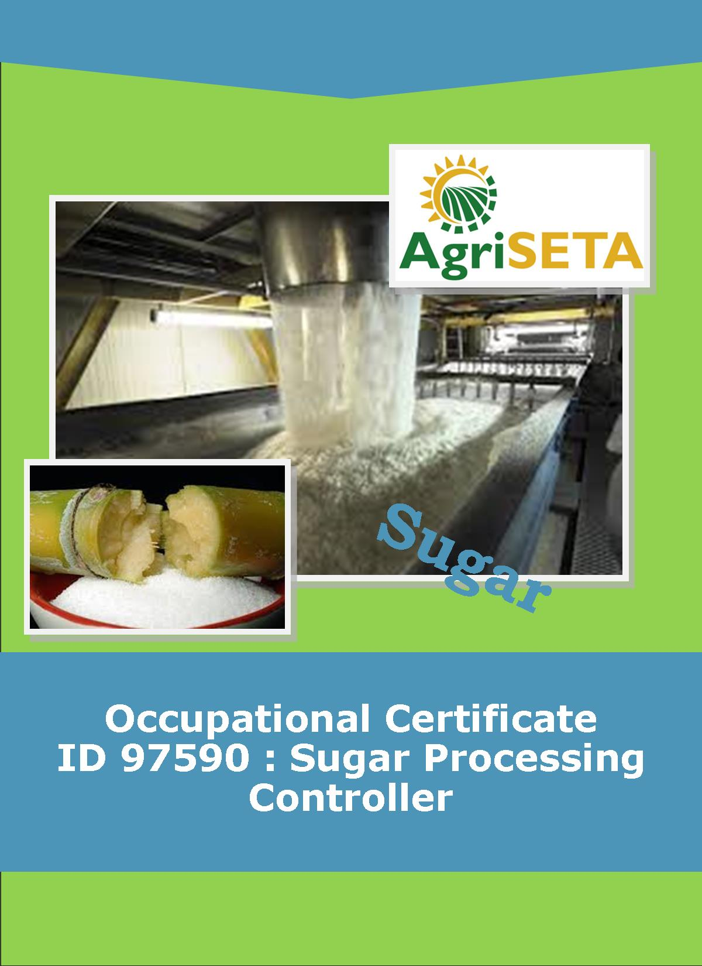
KNOWLEDGE COMPONENT: FACILITATOR IMPLEMENTATION GUIDE: KNOWLEDGE MODULE 5: SUGAR JUICE HANDLING AND CLARIFICATION
KNOWLEDGE COMPONENT: FACILITATOR IMPLEMENTATION GUIDE: KNOWLEDGE MODULE 5: SUGAR JUICE HANDLING AND CLARIFICATION
OCCUPATIONAL QUALIFICATION: SUGAR PROCESSING CONTROLLER

KNOWLEDGE COMPONENT: FACILITATOR IMPLEMENTATION GUIDE

BOOK 5: SUGAR JUICE HANDLING AND CLARIFICATION
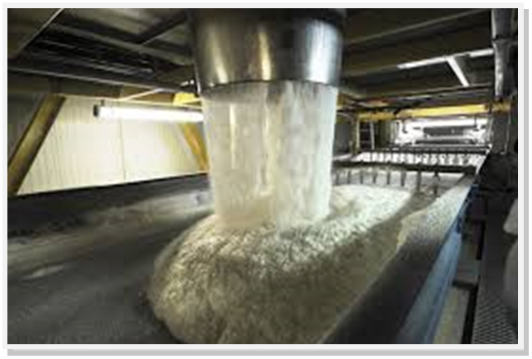
OCCUPATIONAL CERTIFICATE: SUGAR PROCESSING CONTROLLER

©Copyright AgriSETA
Telephone: +27 12 301 5600
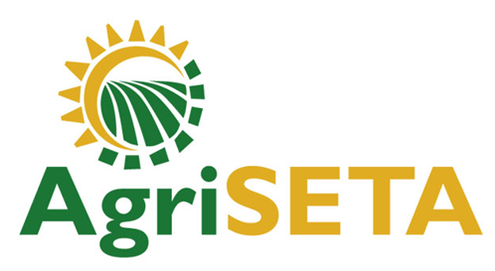

AgriSETA holds the copyright to its publications and Web pages. Proper citation is requested.

TABLE OF CONTENTS
1. INTRODUCTION TO THE FACILITATOR IMPLEMENTATION GUIDE OF THE OCCUPATIONAL CERTIFICATE: SUGAR PROCESSING CONTROLLER: KNOWLEDGE MODULE 5: SUGAR JUICE HANDLING AND CLARIFICATION 6
2. PROGRAMME ADMINISTRATION AND PLANNING 8
2.1 PROGRAMME PLANNING 8
2.2 LEARNER RECRUITMENT 8
2.3 IMPLEMENTING THE PROGRAMME 9
2.4 IMPLEMENTATION DOCUMENTATION 10
3. KNOWLEDGE TOPIC 1: SUGAR JUICE HANDLING AND CLARIFICATION: BACKGROUND 12
4. KNOWLEDGE TOPIC 1: JUICE HEATING (40%) 15
5. KNOWLEDGE TOPIC 2: CLARIFICATION (40%) 21
6. KNOWLEDGE TOPIC 3: PROBLEM SOLVING (20%) 27

INTRODUCTION TO THE FACILITATOR IMPLEMENTATION GUIDE OF THE OCCUPATIONAL CERTIFICATE: SUGAR PROCESSING CONTROLLER: KNOWLEDGE MODULE 5: SUGAR JUICE HANDLING AND CLARIFICATION
Dear Facilitator
This Guide has been created to assist you to facilitate the NQF 5 Occupational Certificate: Sugar Processing Controller Qualification: Knowledge Module 5: Sugar Juice Handling and Clarification.
The following materials form part of this programme:
Name of Document | Numbers required | When to use
Qualification Guide | 1 per learner + 1 for facilitator | At start of programme
Knowledge Component
Learning Resources (Textbooks) | 13 per learner + 13 for facilitator | Hand out at start of each module
Learning and Activities Guides (Workbooks) | 13 per learner + 13 for facilitator | Hand out at start of each module
Learner Summative Assessment Tool (Assessment documents) | 13 per learner + 13 for facilitator/assessor | Assessment to be conducted at end of each module
Facilitator Implementation Guide (This Guide) | 13 for facilitator | Retained by facilitator
Facilitator Assessment Tools and Model Answers | 13 for facilitator | Retained by facilitator
Practical Skills Component
Learner Log Book | 1 for learner + 1 for facilitator | Hand out at start of Practical Skills Component
Mill Supervisor Guide | 1 for facilitator and 1 for Mill Supervisor | Retained by facilitator and Mill Supervisor
Workplace Experience Component
Learner Statement of Work Experience and Summative Guide | 1 per learner | Hand out at start of Workplace Component

This implementation guide will provide the facilitator with guidance regarding the implementation of the programme. This guidance will include:
- Instructions to the facilitator
- The format of the facilitation
- Slides to use during facilitation
- Guidance on directing learners to their assignments
- Recommended reading and further resources to be used during facilitation
Let’s get started!

PROGRAMME ADMINISTRATION AND PLANNING

There are several administrative activities that must be completed before, during and after the training. These include:
- Programme planning,
- Learner recruitment; and
- Implementing the programme

2.1 PROGRAMME PLANNING

The project team and training division meet to:
- Plan all the activities that must take place in order for the Occupational Certificate: Sugar Processing Controller to take place.
- Assign people who will be responsible for facilitating the training (facilitators for theoretical component and instructors for the practical component), for assessment (Both formative and summative) and moderation.
- Decide on the resources that must be purchased and made available during training.
- Assign people responsible for gathering all the required resources.
- Decide on the duration of this Occupational Certificate.
- Ensure that all candidates have venues for the Work Experience Component (before the programme starts)

2.2 LEARNER RECRUITMENT
- Provide learner information forms to all learners for completion.
- Collect all learners’ qualifications, CVs and I.D. copies.
- Evaluate the applications for eligibility for enrolment to the Occupational Certificate.
- Inform learners who have been successfully selected to the Occupational Certificate by way of a welcome letter.
- Inform learners who have been successfully selected to the Occupational Certificate of the first day of the programme.
- Upload of learners to the AgriSETA database
- Receive the proof of uploads from the AgriSETA

2.3 IMPLEMENTING THE PROGRAMME
- Compile a detailed implementation plan and programme schedule.
- Edit, print and prepare the appropriate learning material.
- Purchase and prepare stationery packs for learners (if applicable)
- Purchase stationery for facilitator.
- Book training venues for theoretical and practical components as required by the programme schedule.
- As the programme proceeds hand-out learning materials.
- Train according to the implementation guidelines provided in this manual. Remember to be well prepared before each training session. Find additional learning resources such as examples, samples, photos, posters, videos, pamphlets and additional textbooks etc. which can add value to the learning experience.
- Build site visits and field trips into the programme as often as possible. Invite guest speakers from the industry and specifically from sugar mills to share their experience with the learners.
- Guide the learners through their individual and group exercises and assignments in the Formative Assessment Guide and provide inputs where required.
- Request the assessor to assess the modules as the training proceeds (Formative and summative).
- Obtain feedback from the learners on, at least, a weekly basis regarding their satisfaction with the programme (Venue, Facilitation, Logistics, Amenities). Evaluate the feedback and address issues raised as quickly as possible providing feedback to the learners as to how these issues were addressed.
- Ensure that learners understand the Training Provider appeals procedures and the Code of Conduct of the Training Provider.
- As Competency Results become available ensure that these are sent to the relevant functionary for data capture and, if relevant, upload to the AgriSETA database.
- Ensure that learners are eligible to proceed to the practical component of the Occupational Certificate before signing off on the Knowledge Component.
- Ensure that learners are eligible to proceed to the Work Experience Component of the Occupational Certificate before signing off on the Practical Component.
- Ensure that Mentors for the Work Experience Component are adequately briefed on their role and responsibilities before placing the learner for the Work Experience Component.
- Plan for and schedule the Integrated Summative Assessment event (recruiting panel, providing the learner with the relevant case study materials, allowing enough time and resources for the learner to prepare for the assessment, scheduling the Summative Assessment date, time and venue, sending invitations to the panel and the learner).
- Once competency is declared ensure that results are uploaded to AgriSETA and request the relevant department to print the award certificates (as relevant).
- Issue certificates to the successful candidates.

2.4 IMPLEMENTATION DOCUMENTATION
The Training Provider will provide templates of the following documents to the facilitator as requested:
- Learner recruitment form
- Training schedule
- Welcome letter
- Attendance registers
- Daily evaluation form
- Learner upload forms
- Individual learner progress report forms

KNOWLEDGE TOPIC 1: SUGAR JUICE HANDLING AND CLARIFICATION: BACKGROUND
INSTRUCTIONS TO FACILITATOR
Purpose: To introduce the candidates to Knowledge Module 5: Sugar Juice Handling and Clarification
Objectives: By the end of the session the candidates will:
- Have received their Sugar Processing Controller Knowledge Component Learner Guide – Book 5 (Textbook)
- Have received their Sugar Processing Controller Knowledge Component Formative Assessment Guide – Workbook 5,
- Be aware of the topics that will be dealt with within this module.
Procedure: Hand out the participant materials and conduct a presentation. Allow time for learning activity.
Participant Materials: Hand-out the following participant materials
- The Learner Guide Book 5 (Textbook)
- The Learner Formative Assessment Guide – Workbook 5
Presentation: Do a presentation explaining the Sugar Juice Handling and Clarification process in general covering the following aspects:
- Background to Sugar Juice Handling and Clarification
Slides: Use the following slides for your presentation and refer frequently to the Learning Resource for further information.
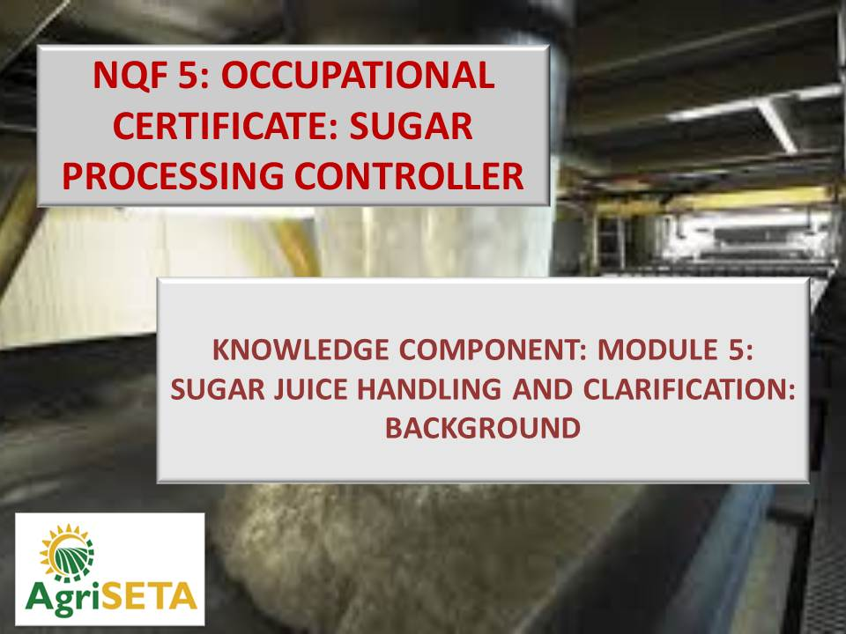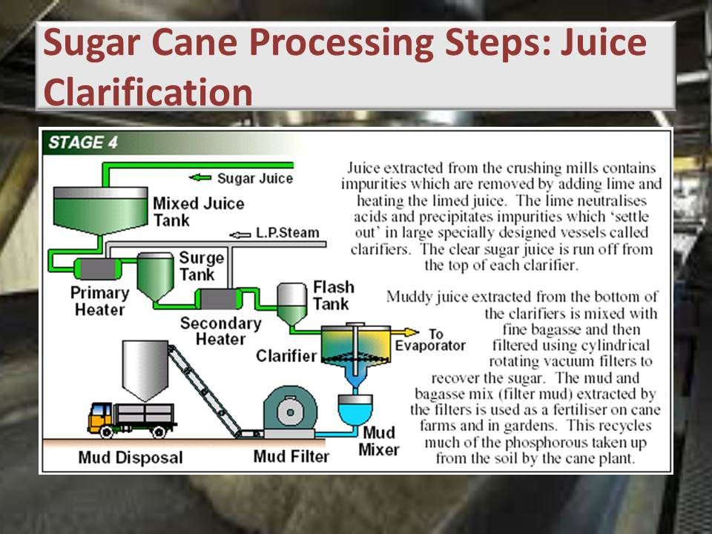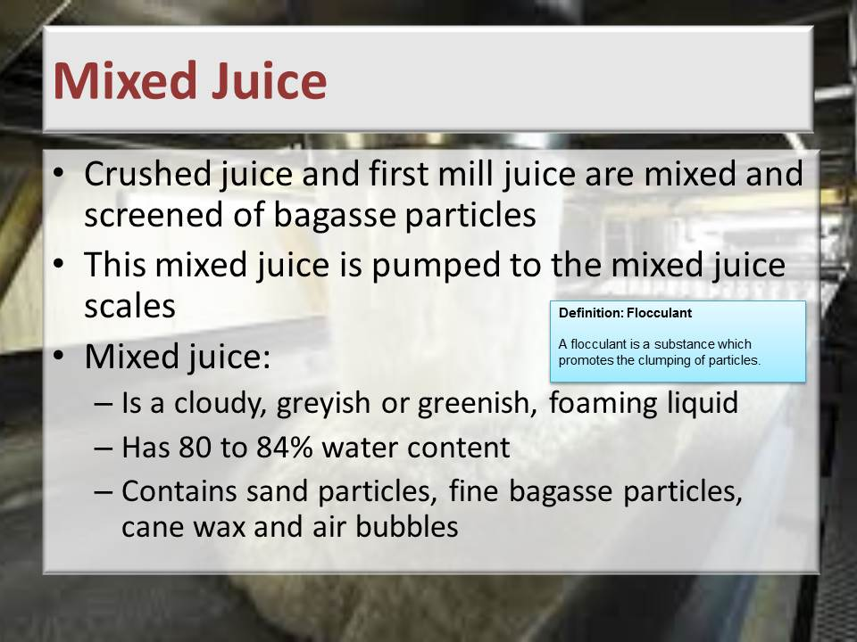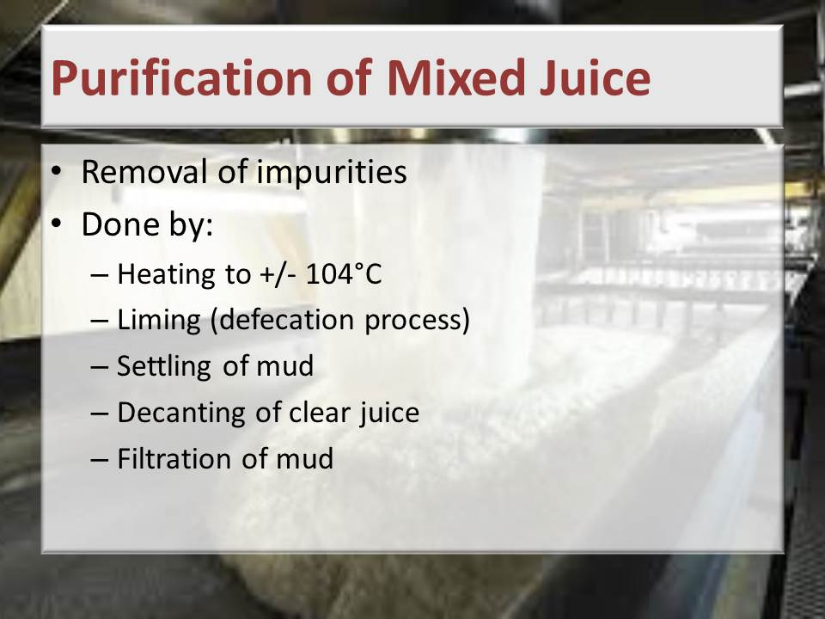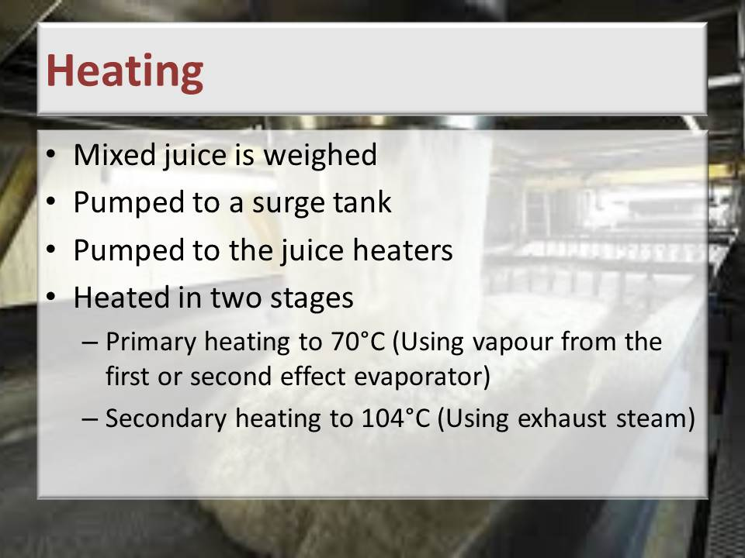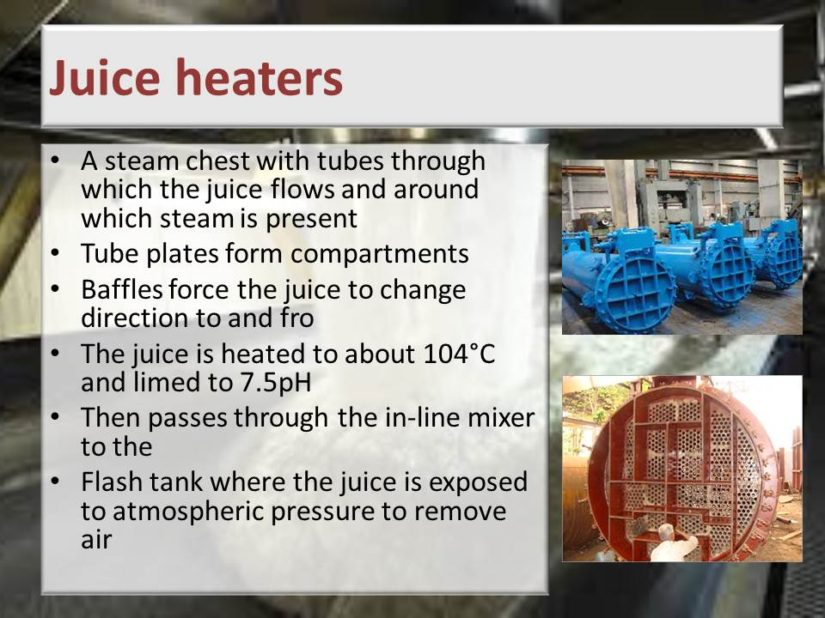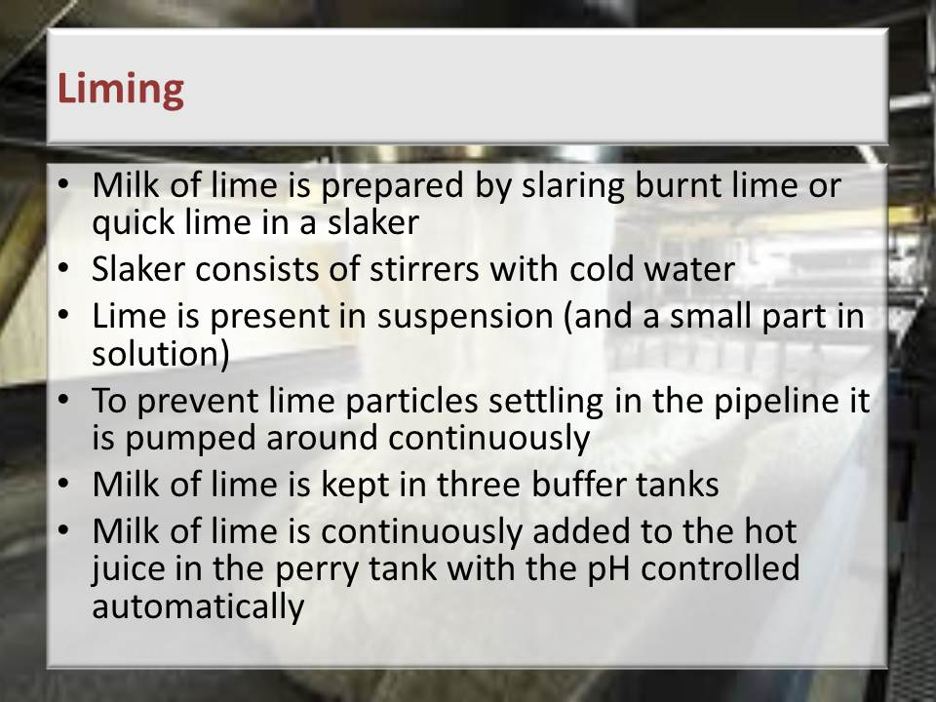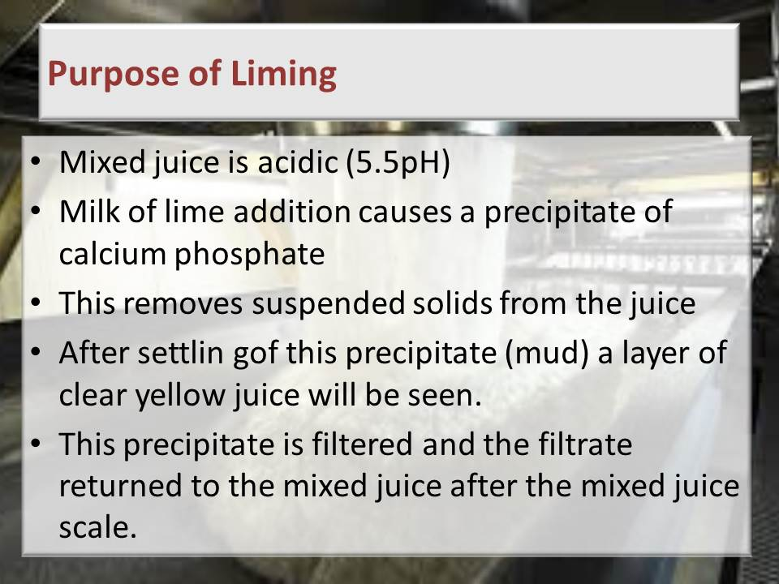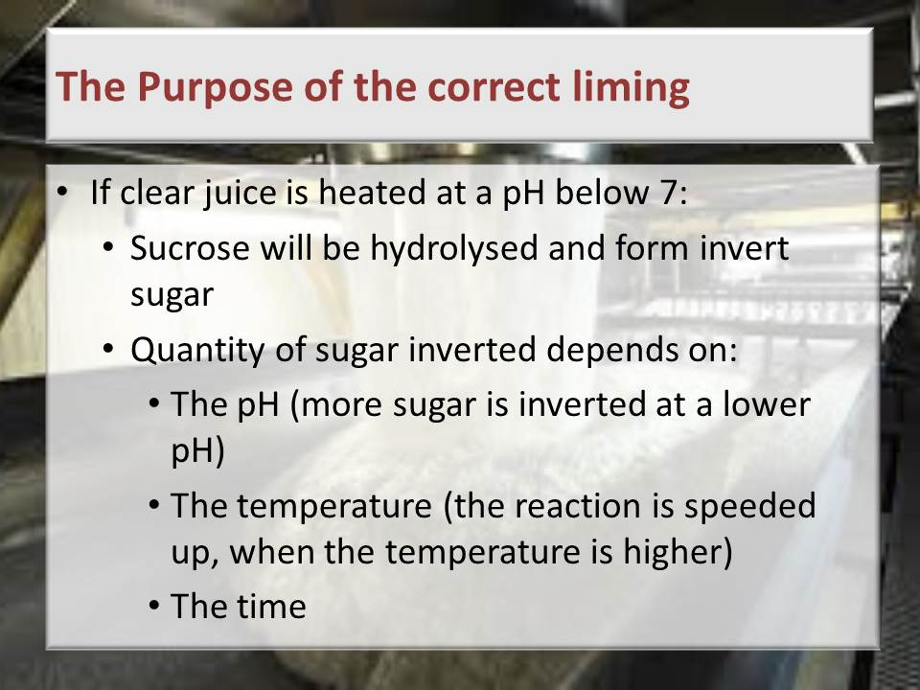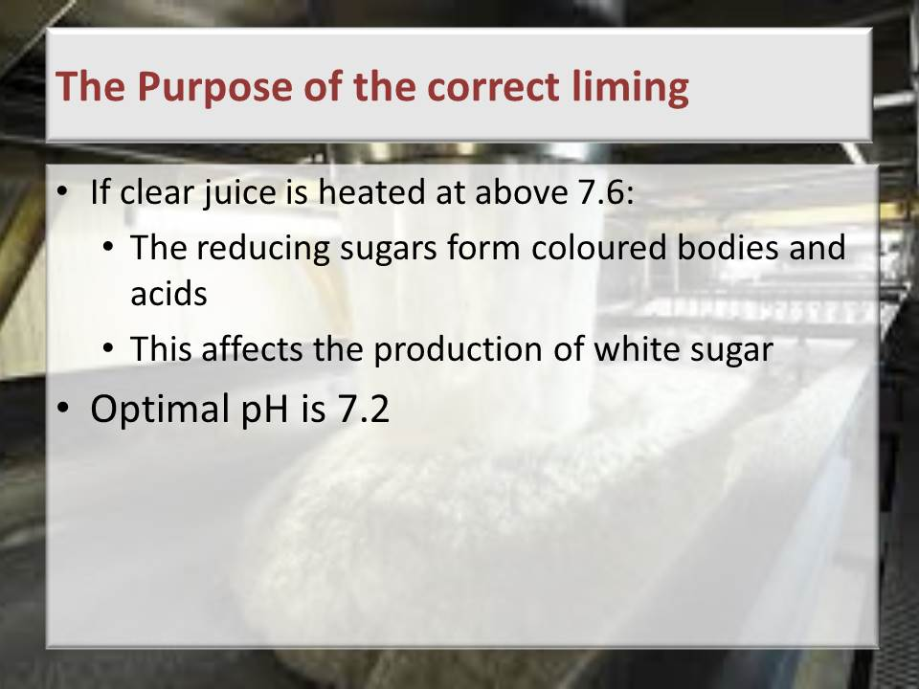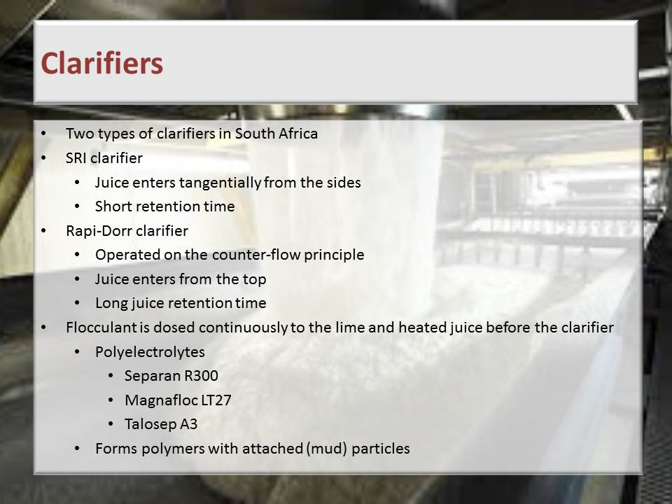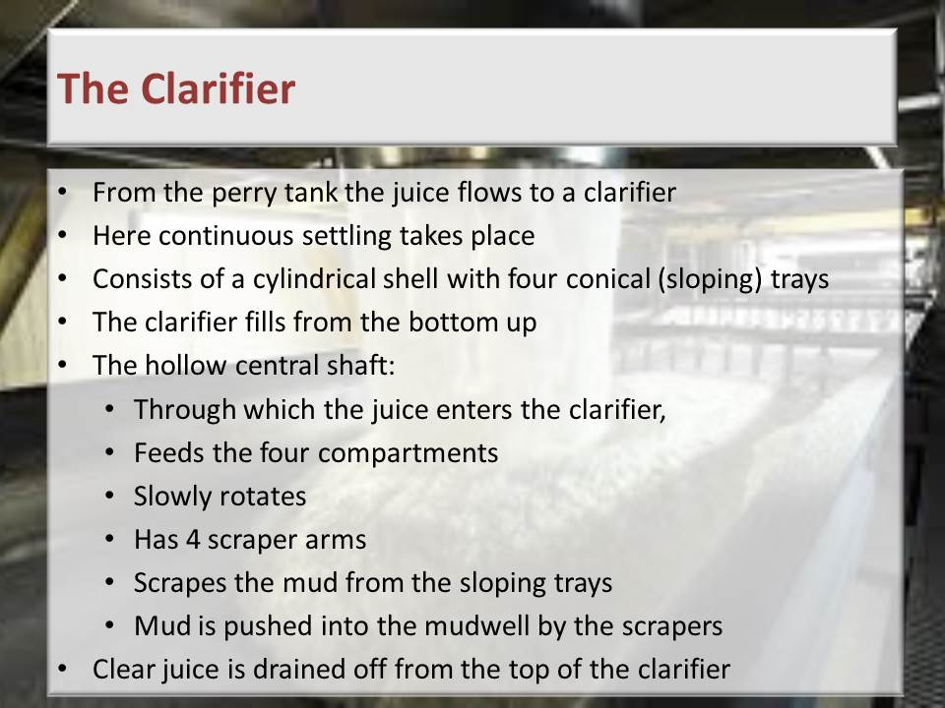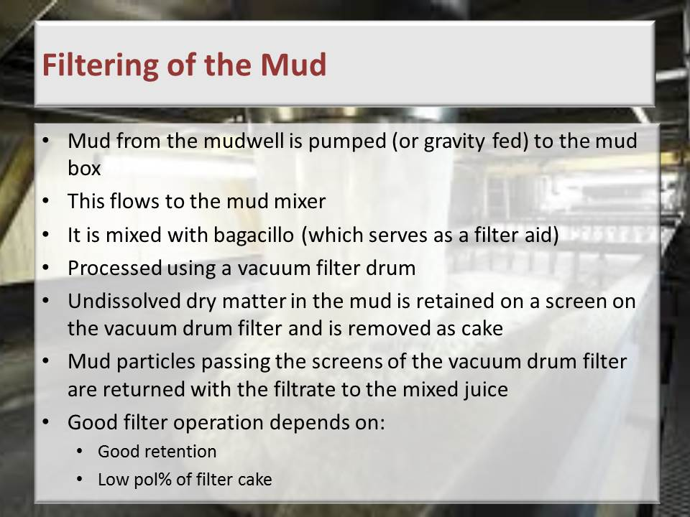
Practical activity: Organise a visit to a Sugar Mill for a guided tour of the Juice Heaters, Clarifiers and Filters of a Sugar Mill factory. Spend some time looking at the equipment – It would be advantageous if some of these components can be viewed in a workshop or as non-installed components so that the learners can view the working parts of the equipment and the insides of these chambers. Learners are instructed to take notes and photos during their field trip and compile a report from the visit. (6 hours). A follow-up field trip will be done again at the end of this Knowledge Component to view the equipment in operation with some practical demonstration of troubleshooting and operation.
Total time taken: Presentation: 2 hours
Practical activity 6 hours
Close: Move on to the next Knowledge Topic

KNOWLEDGE TOPIC 1: JUICE HEATING (40%)
INSTRUCTIONS TO FACILITATOR
Purpose: To introduce the candidates to Knowledge Topic 1: Juice Heating
Objectives: By the end of the session the candidates will:
- Understand the components of Mixed Juice and why clarification is necessary
- Be able to demonstrate an understanding of the process steps and use of equipment related to juice heating
- Be able to list the key control points related to juice heating and explain the controls
Procedure: Conduct a presentation and allow time for the learning activity.
Participant Materials: The learner will use the following materials:
- The Learner Guide Book 5 (Textbook)
- The Learner Formative Assessment Guide – Workbook 5
Presentation: Do a presentation describing the properties of mixed juice and the juice heating process and principles.
Slides: Use the following slides for your presentation.
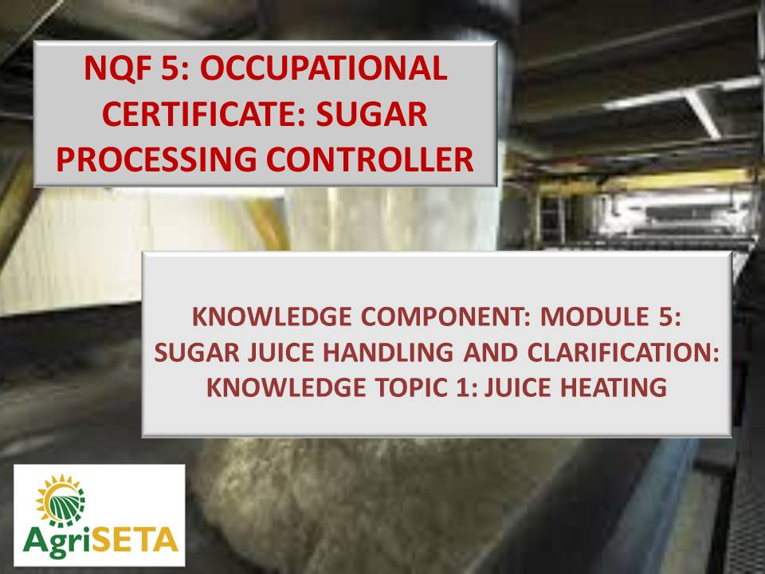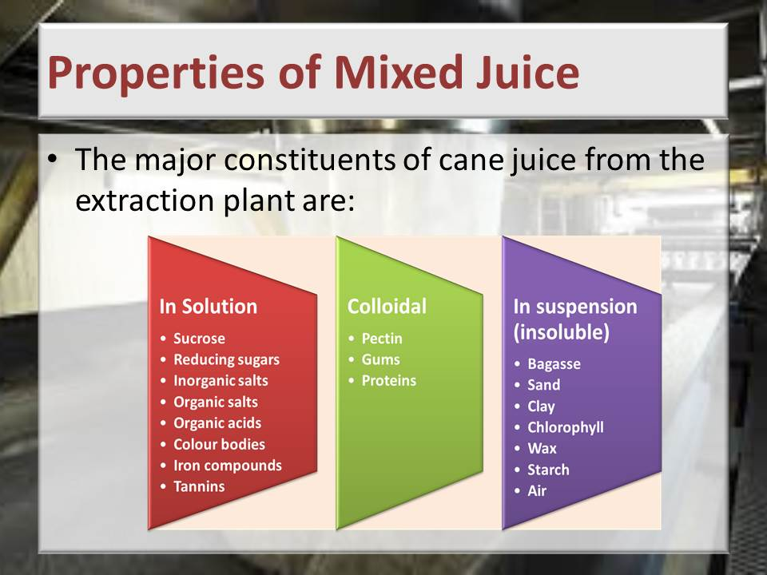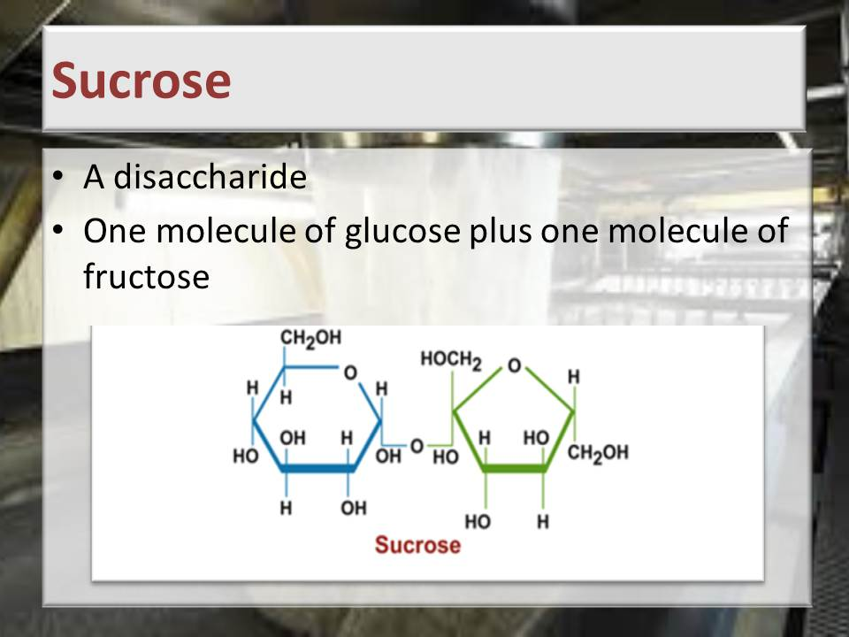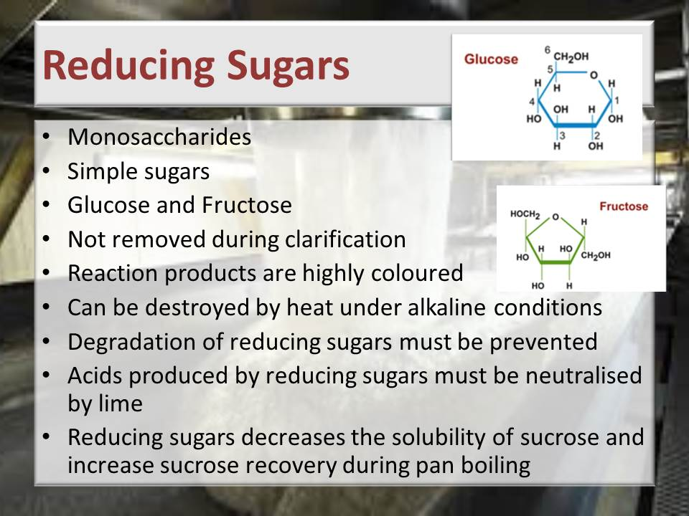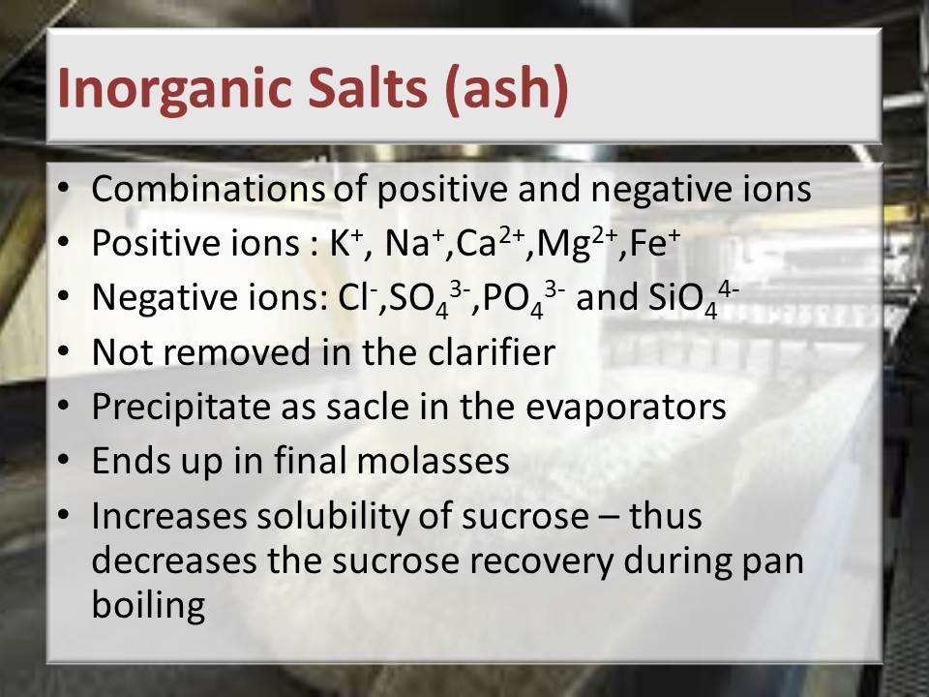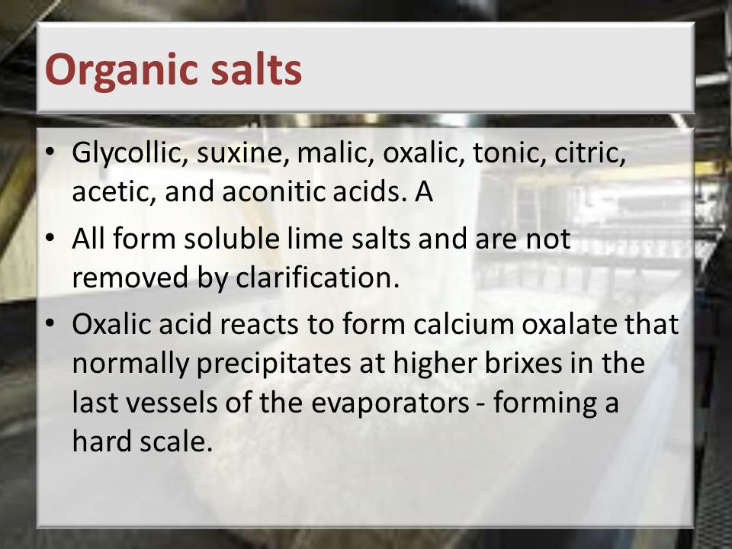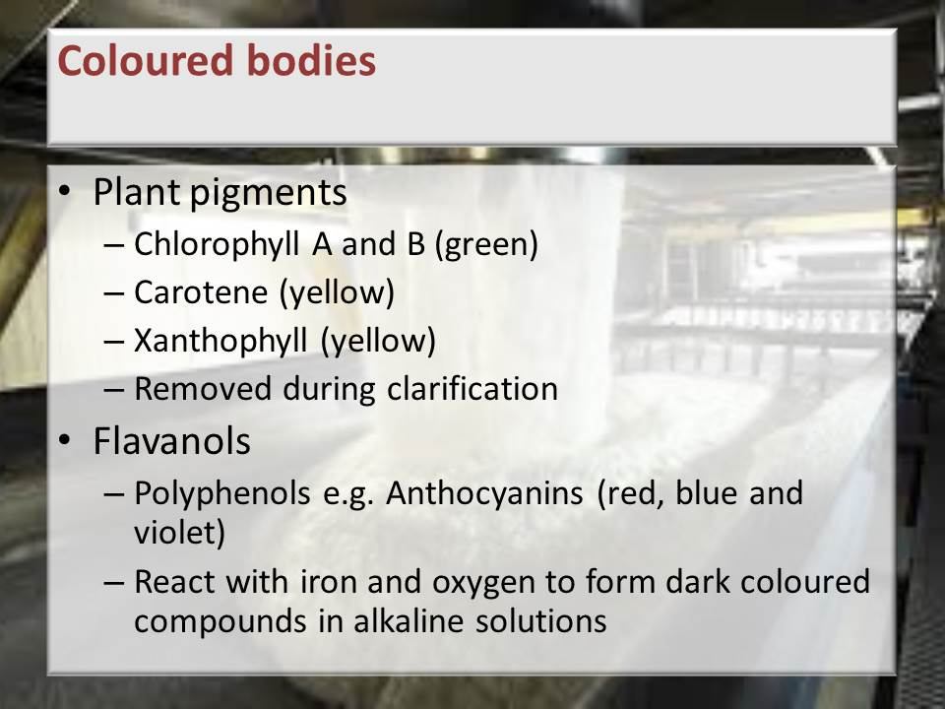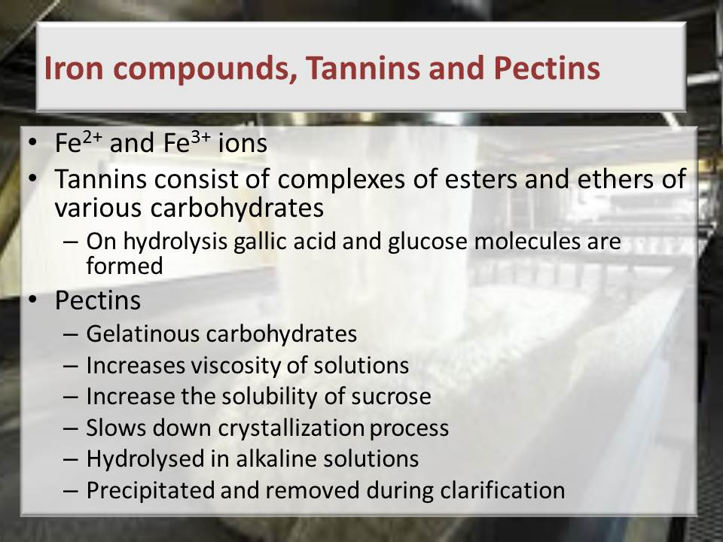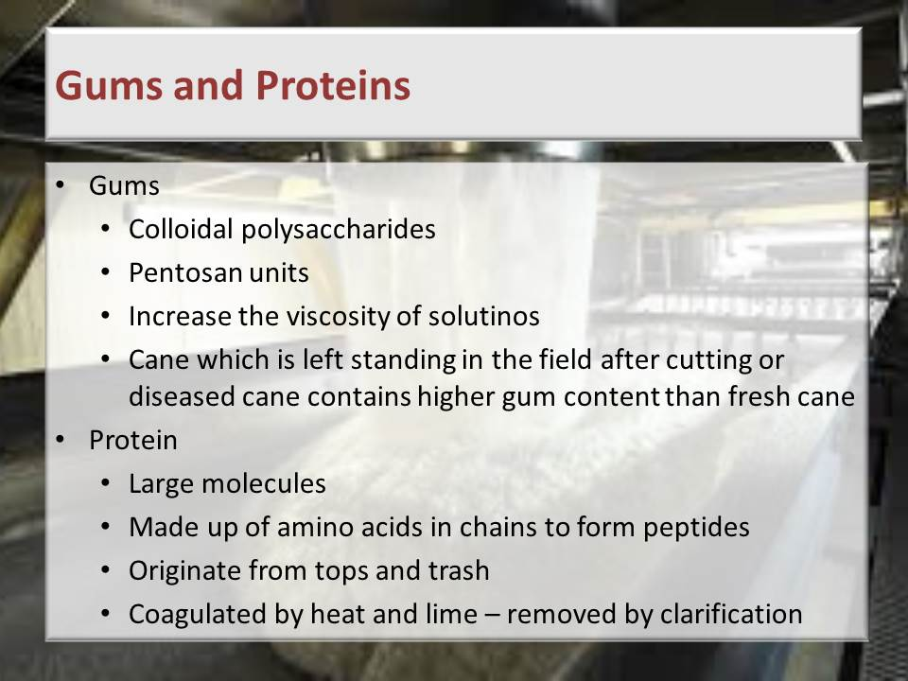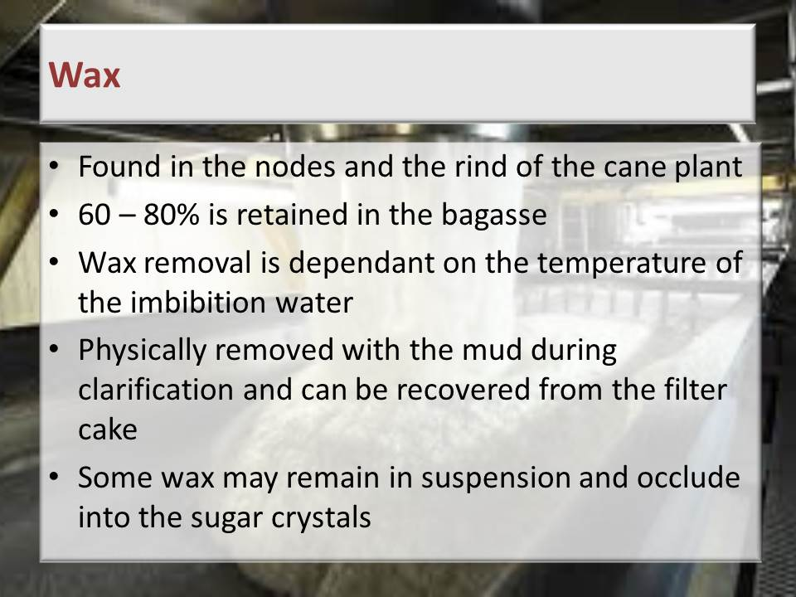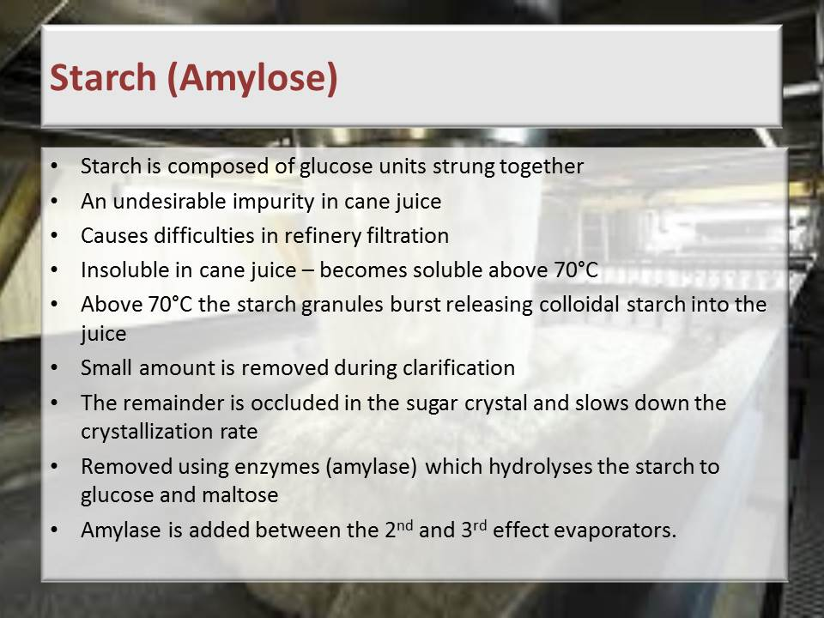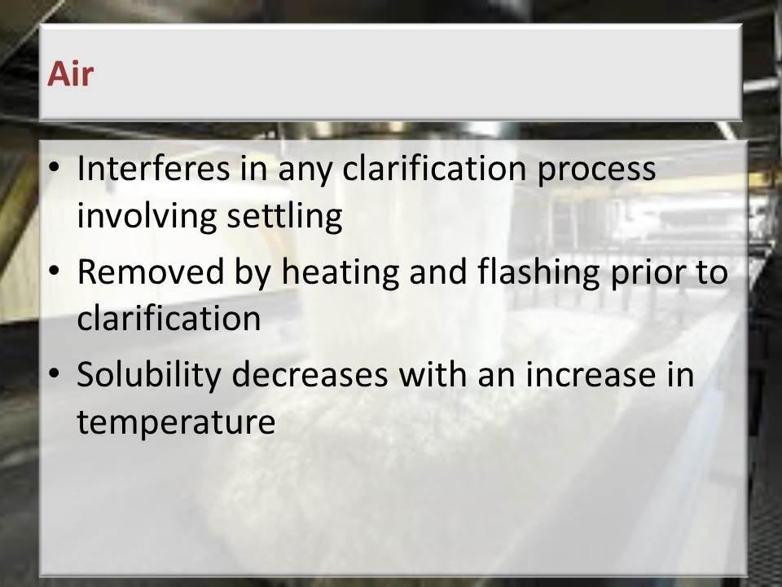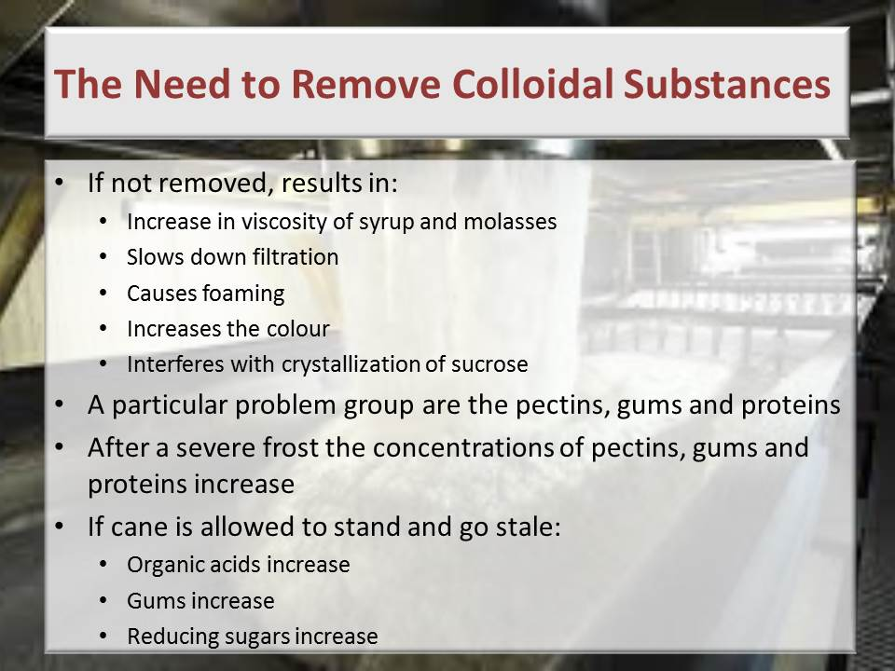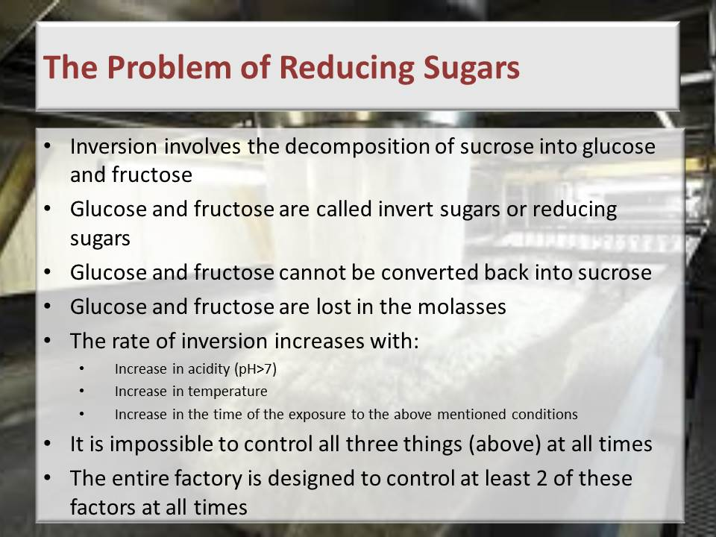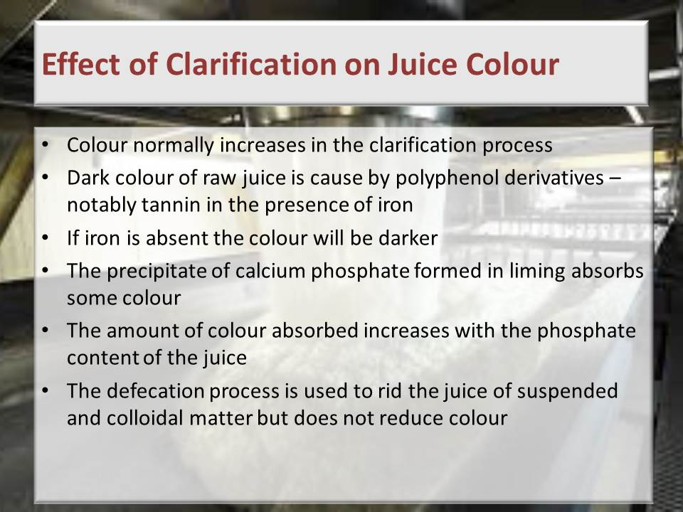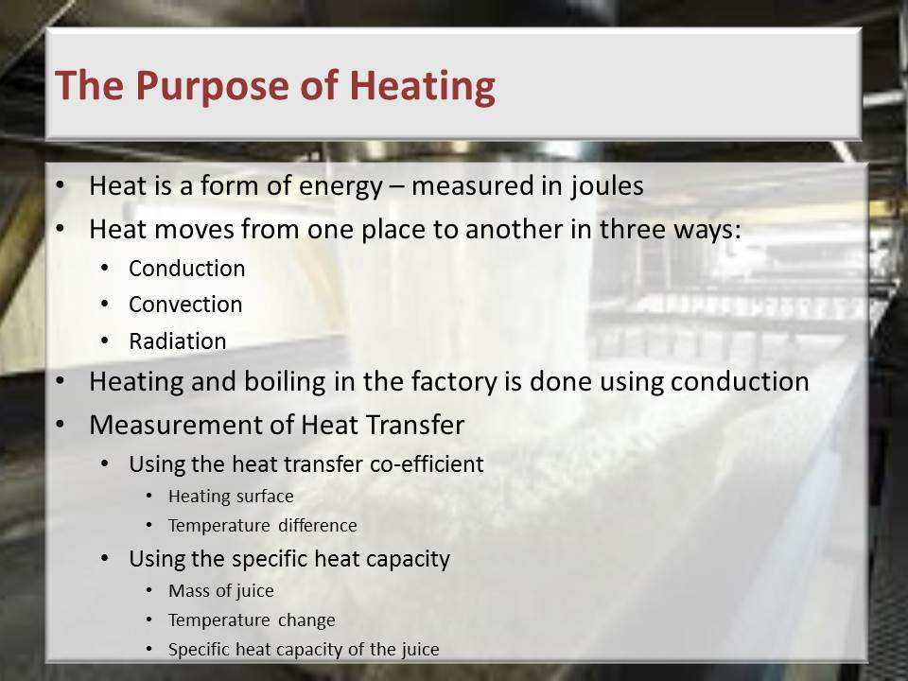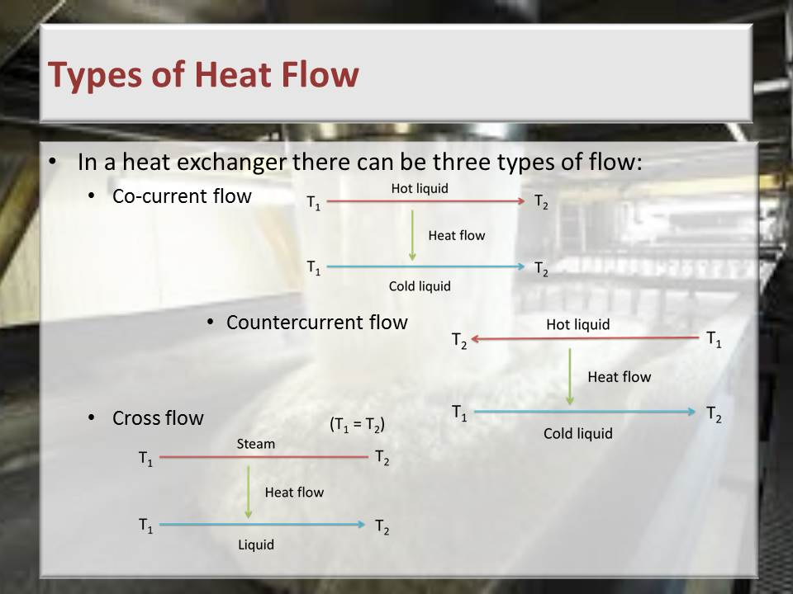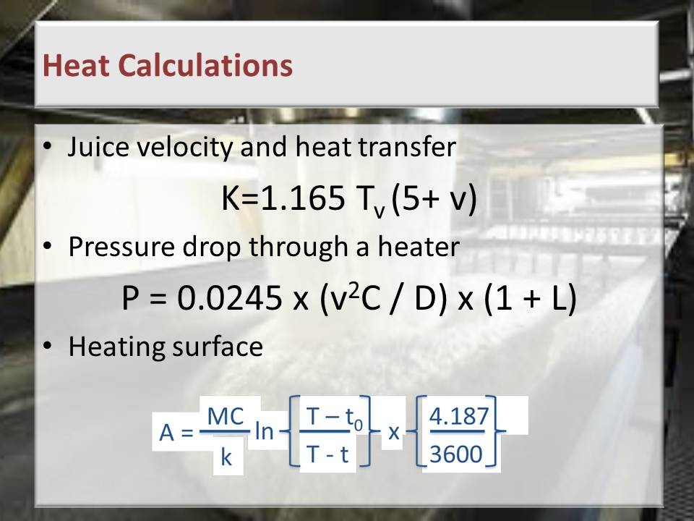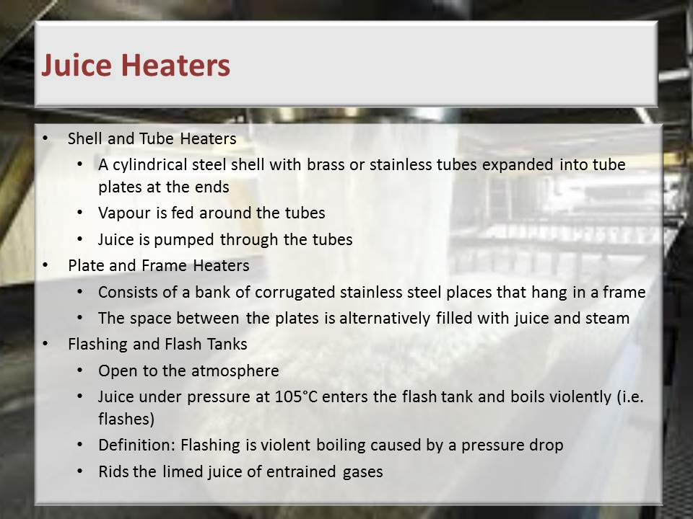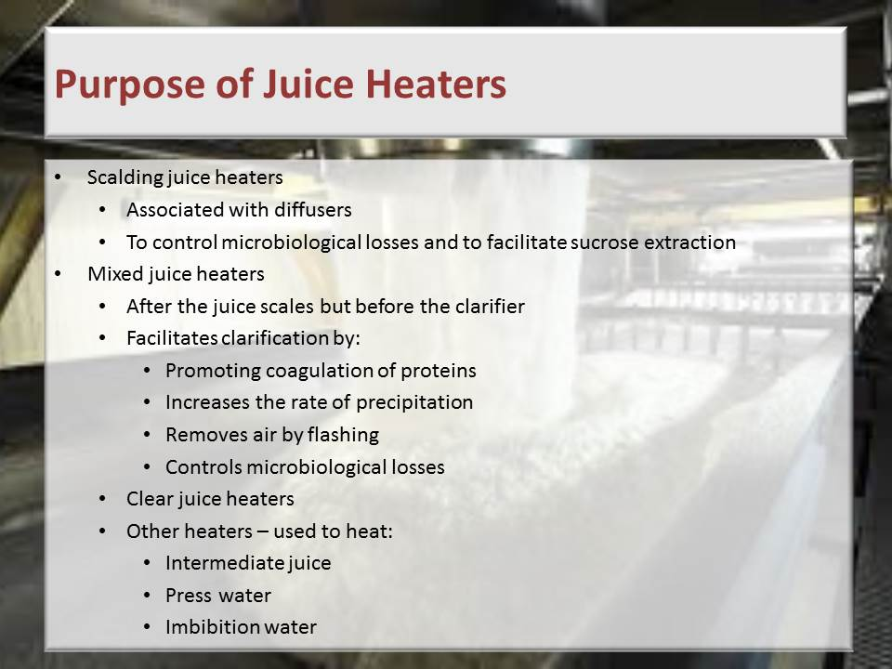
Learning activity: Guide learners to Page 11 of the Learner Workbook 5. Learners are instructed to complete Learning activity 1.1. (2 hours).
Guide learners to Page 13 of the Learner Workbook 5. Learners are instructed to complete Learning activity 1.2. (2 hours)
Total time taken: Presentation: 4 hours
Learning activity 1.1: 2 hours
Learning activity 1.2: 2 hours
Close: Move on to the next Knowledge Topic.

KNOWLEDGE TOPIC 2: CLARIFICATION (40%)
INSTRUCTIONS TO FACILITATOR
Purpose: To introduce the candidates to Knowledge Topic 2: Clarification (40%)
Objectives: By the end of the session the candidates will:
- Be able to demonstrate an understanding of the process steps and use of equipment related to clarification.
- Be able to list the key control points in juice clarification and explain the controls.
Procedure: Conduct a presentation and allow time for learning activities.
Participant Materials: The learner will use the following materials:
- The Learner Guide Book 5 (Textbook)
- The Learner Formative Assessment Guide – Workbook 5
Presentation: Do a presentation covering the following topics:
- Sugar Juice Clarification
Slides: Use the following slides for your presentation referring frequently to the Learning Resource for more detail.
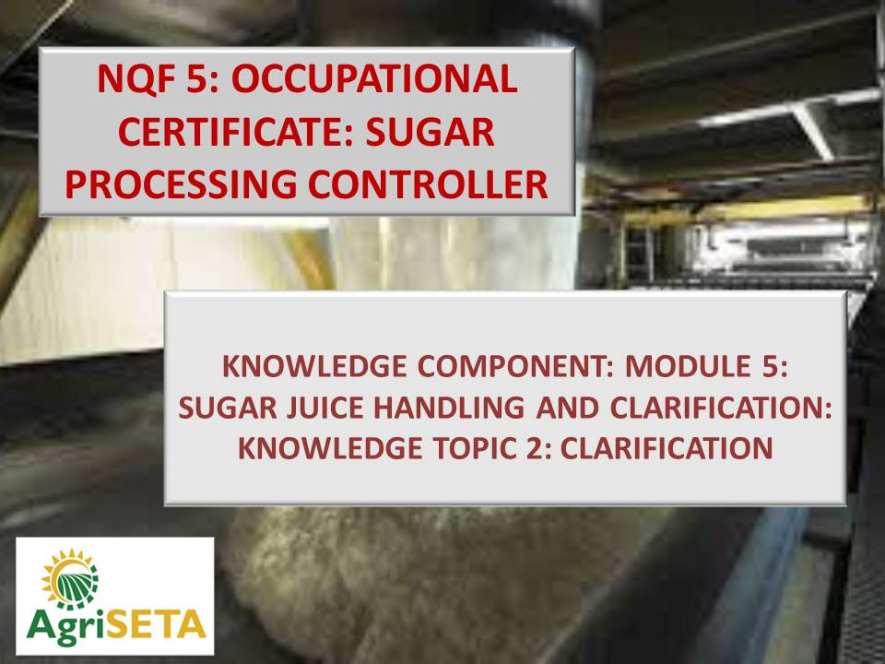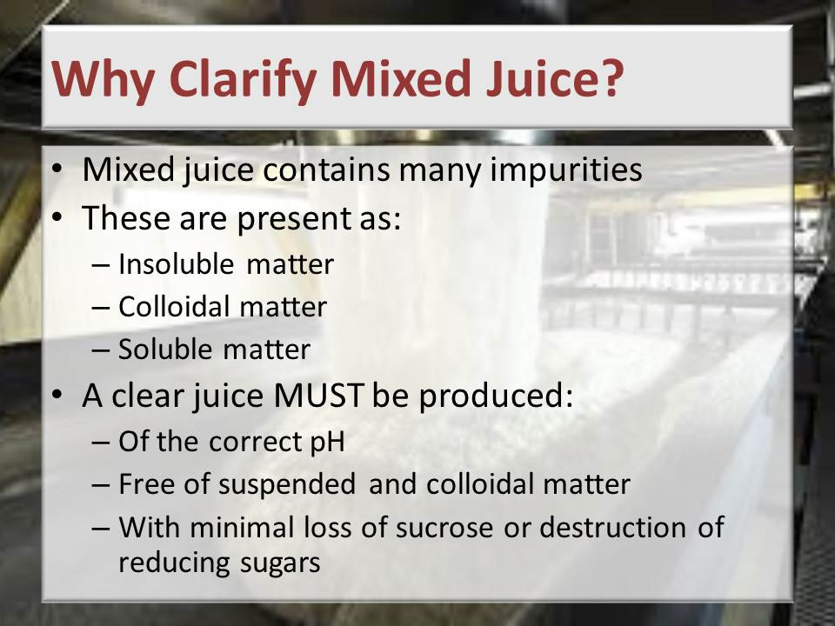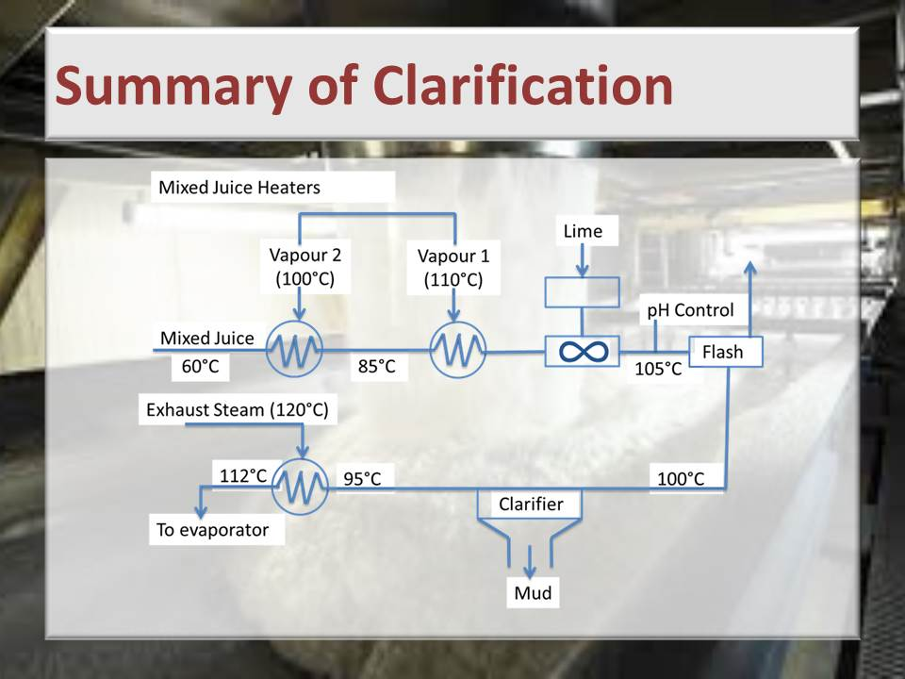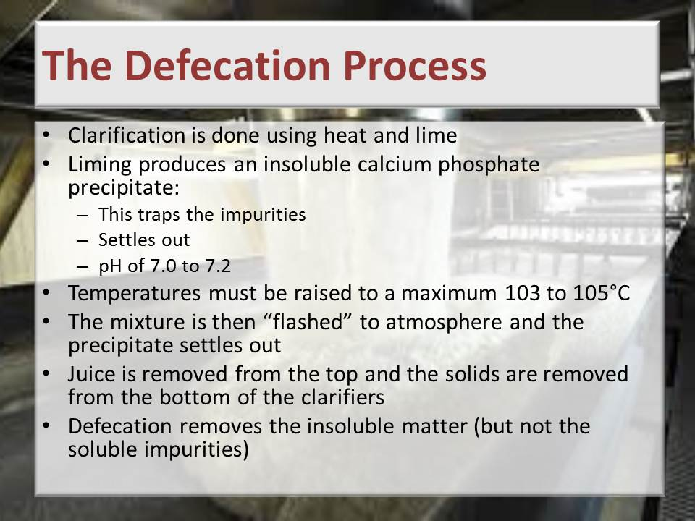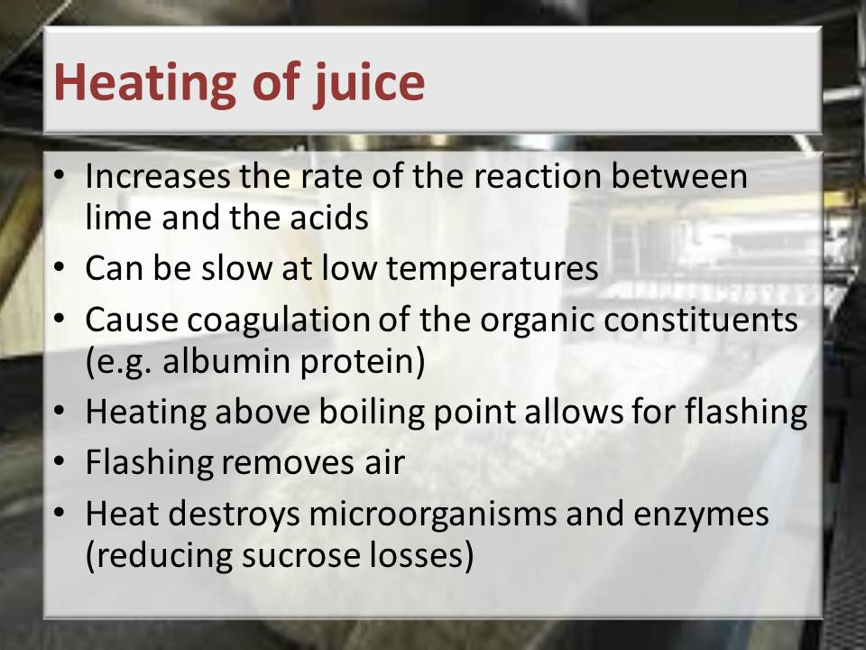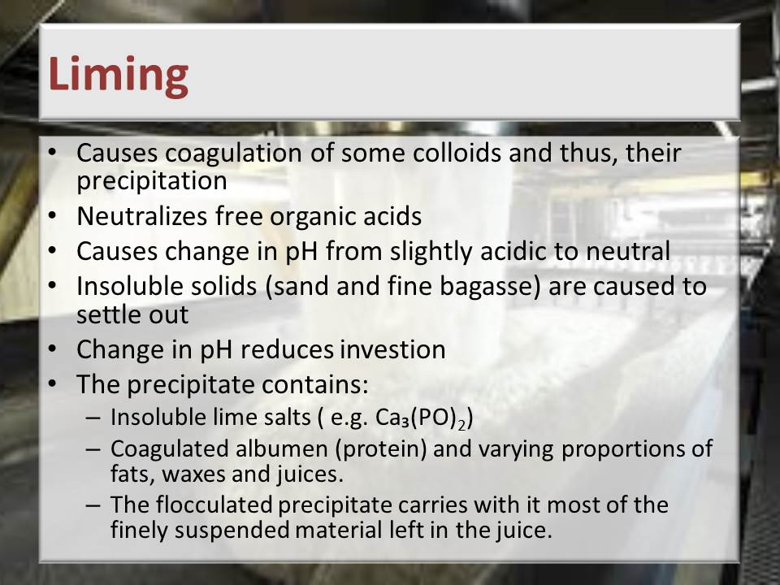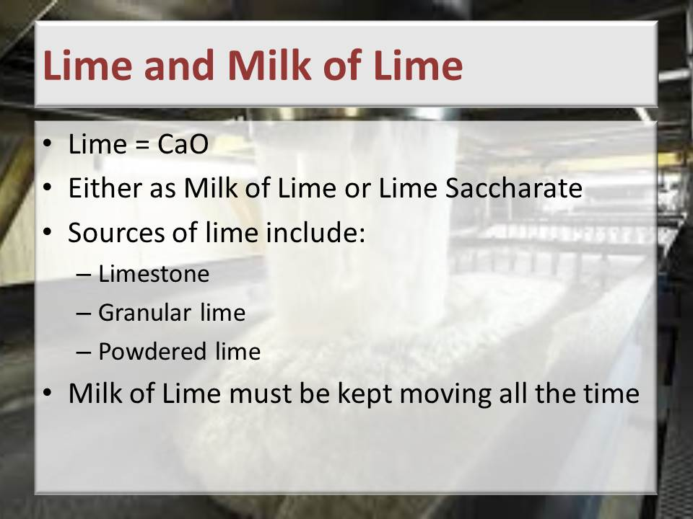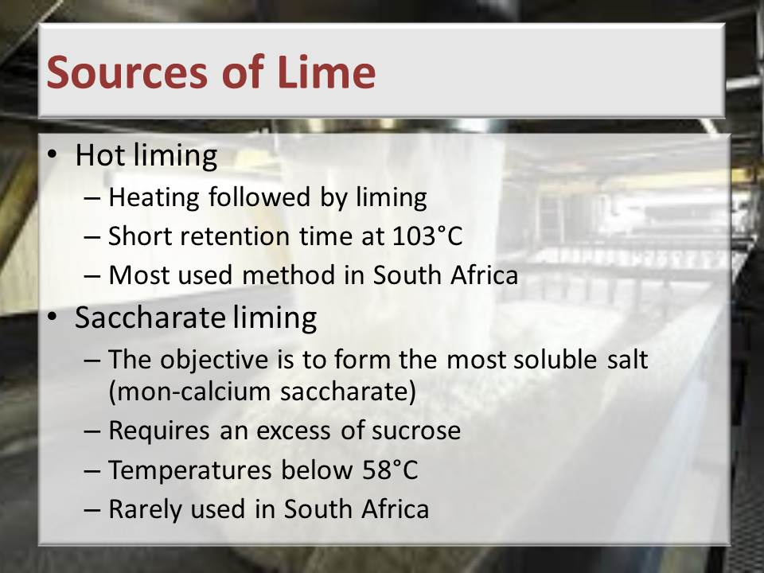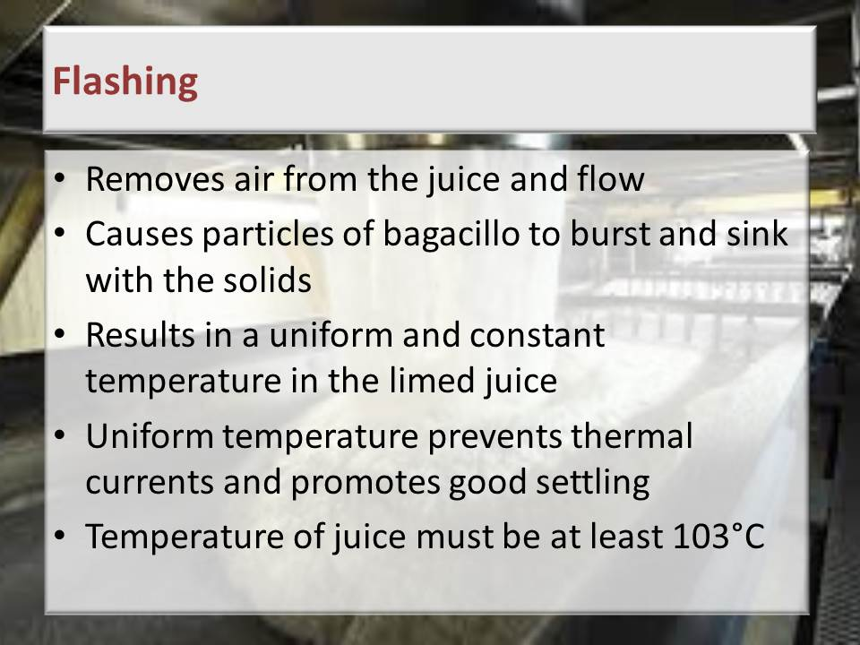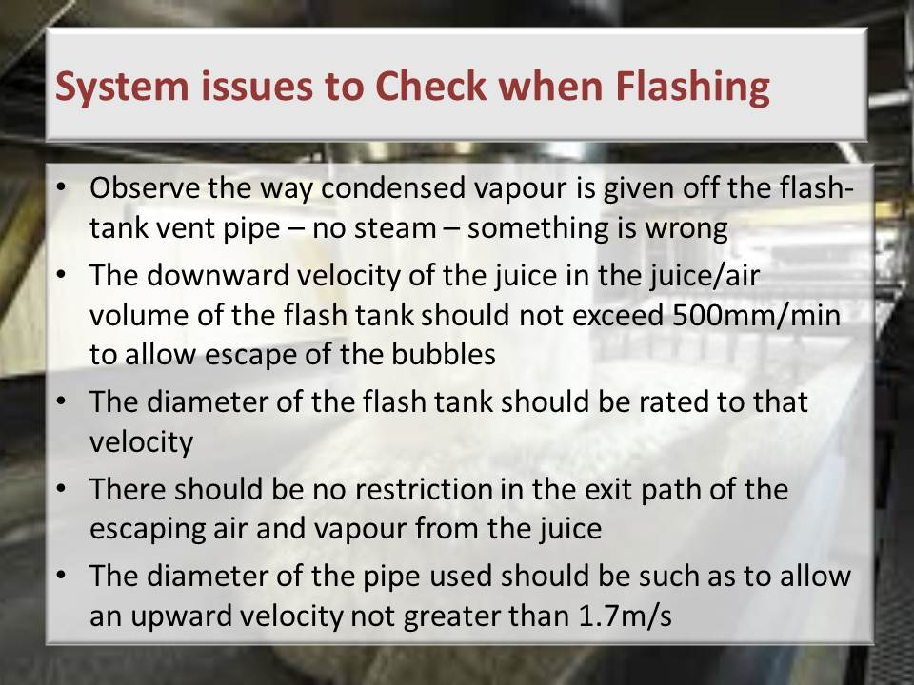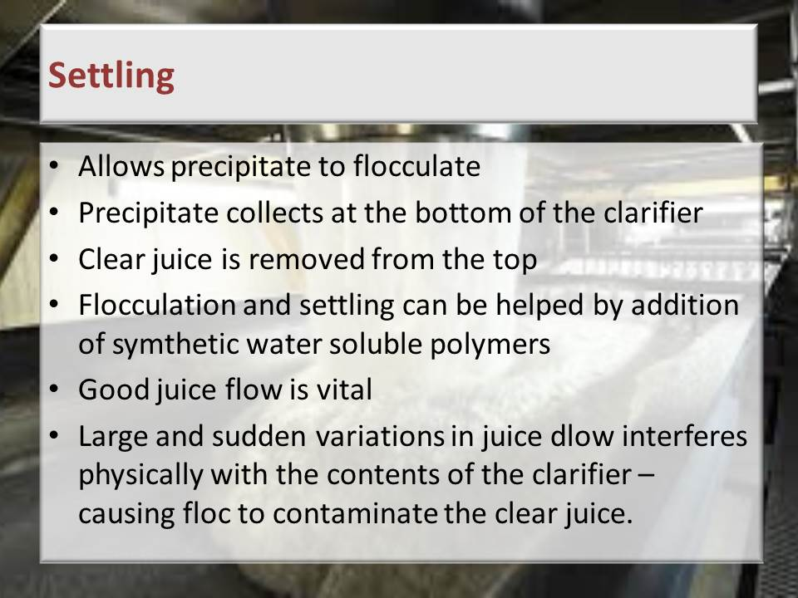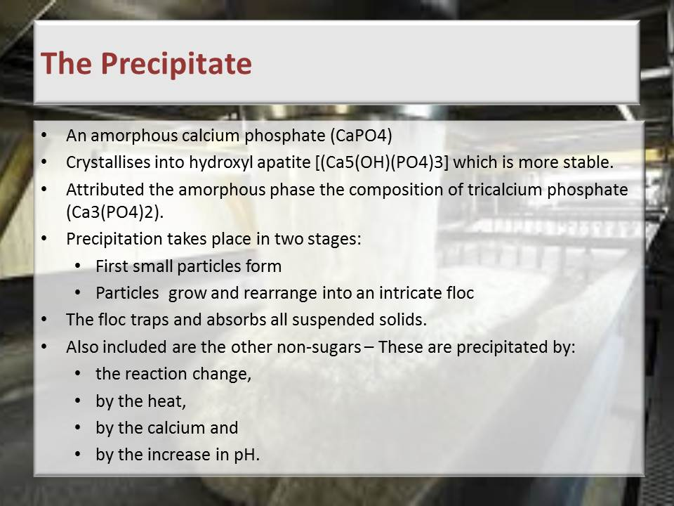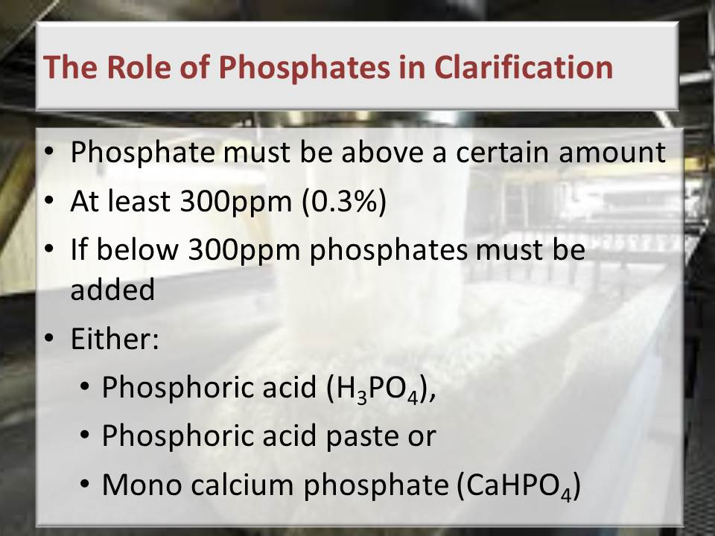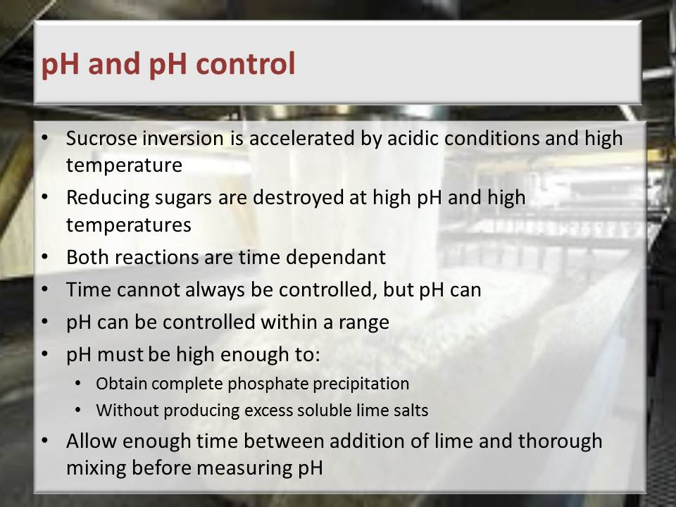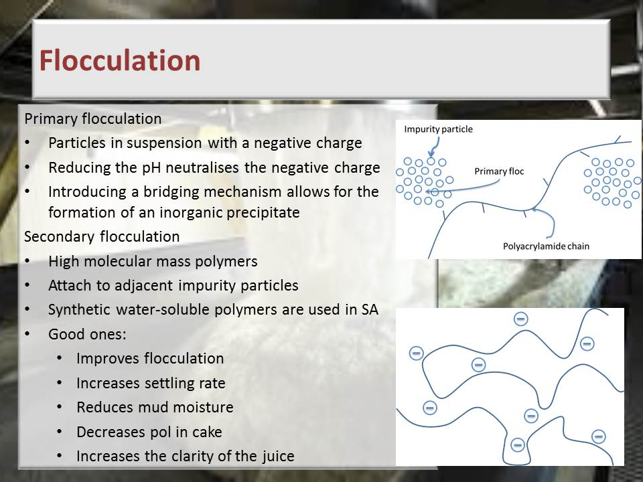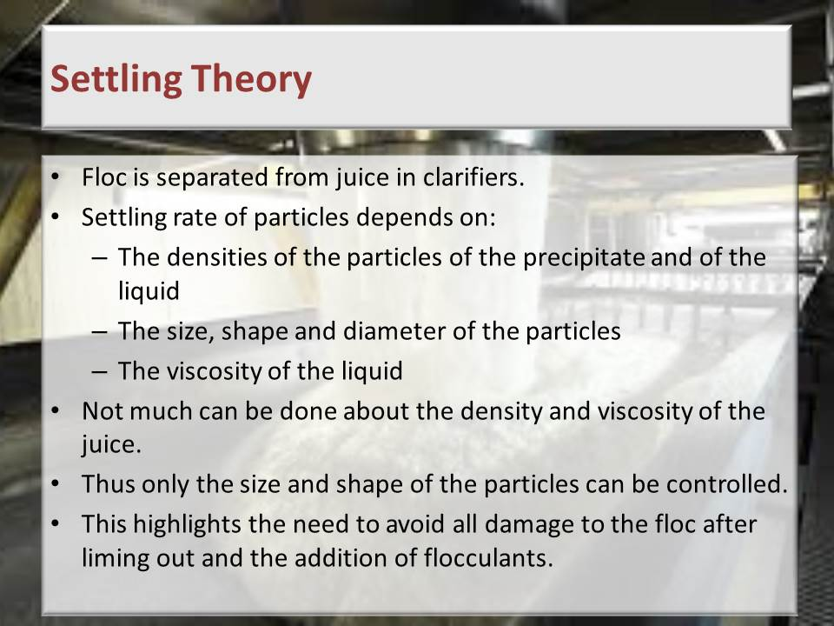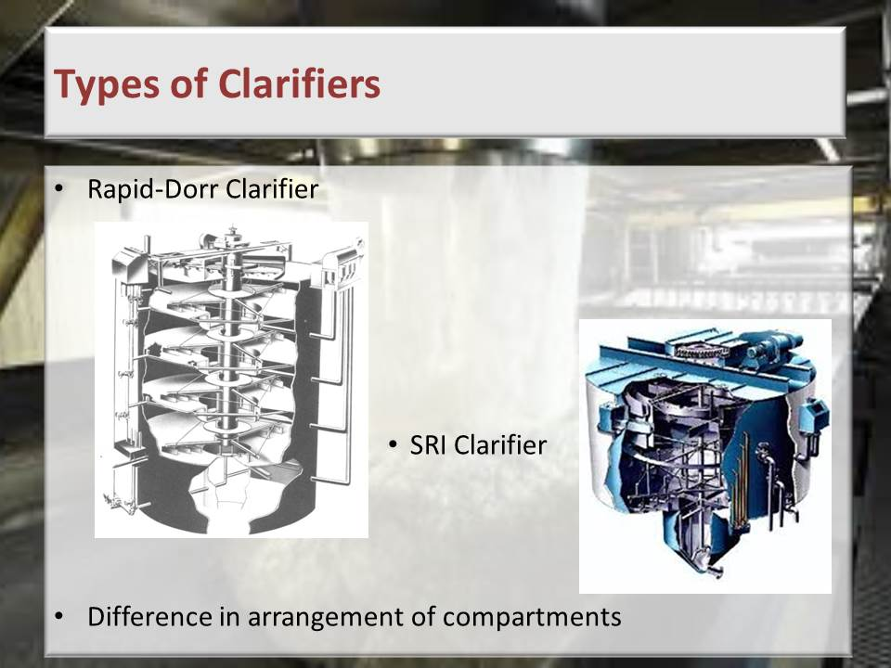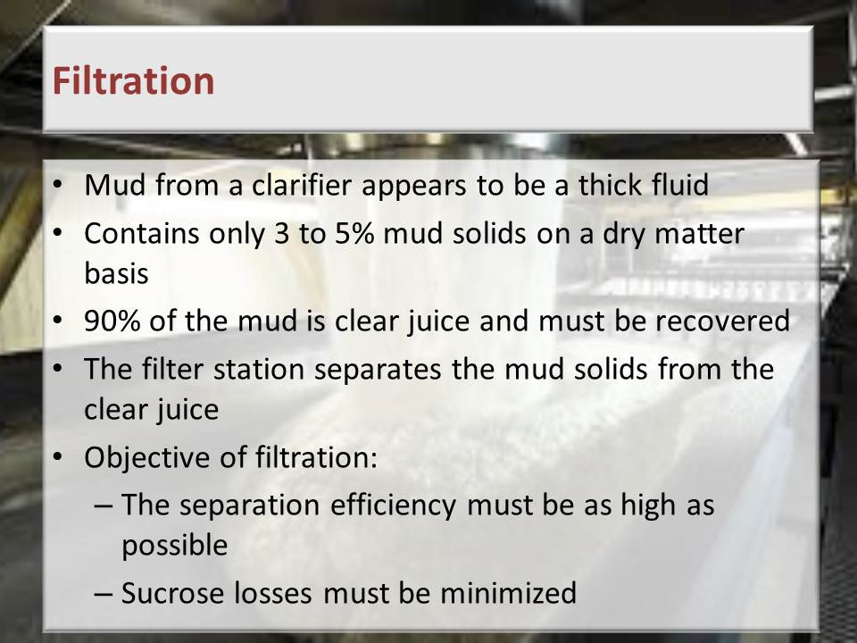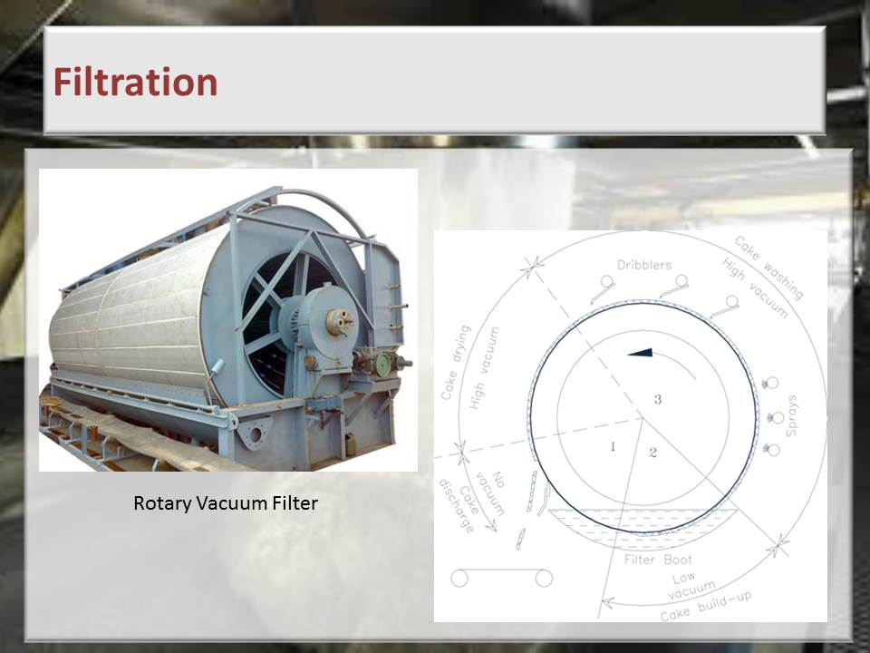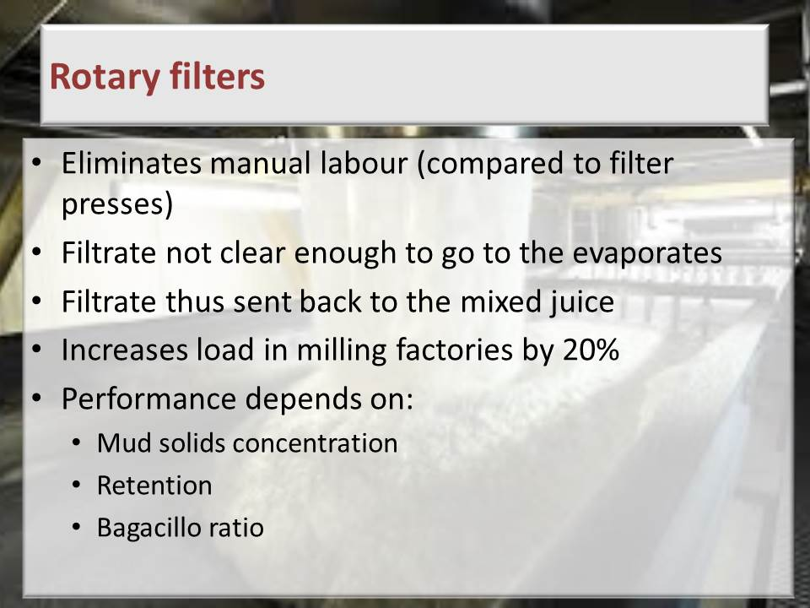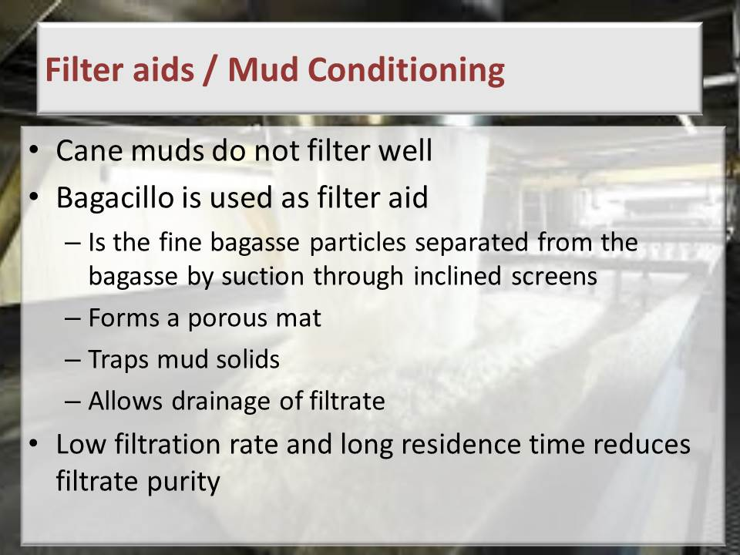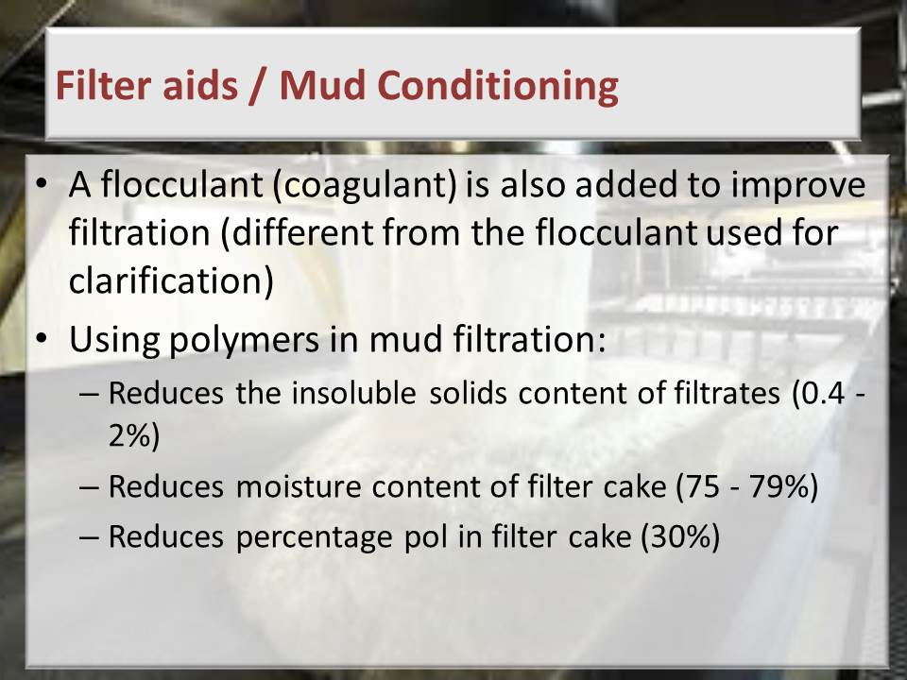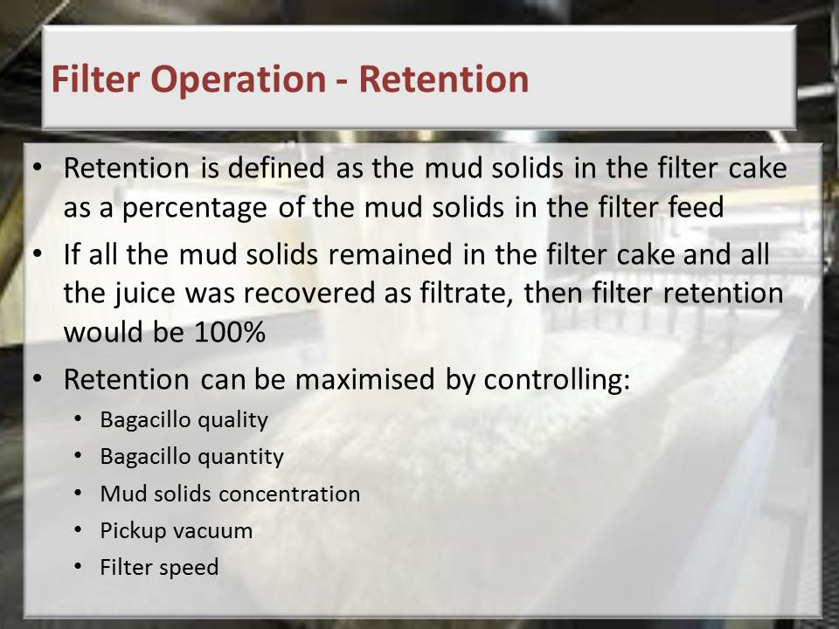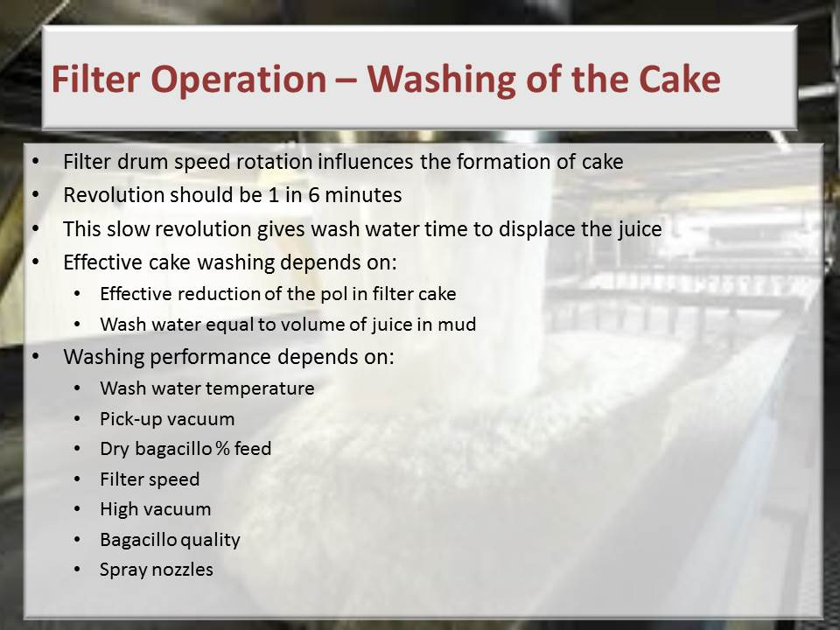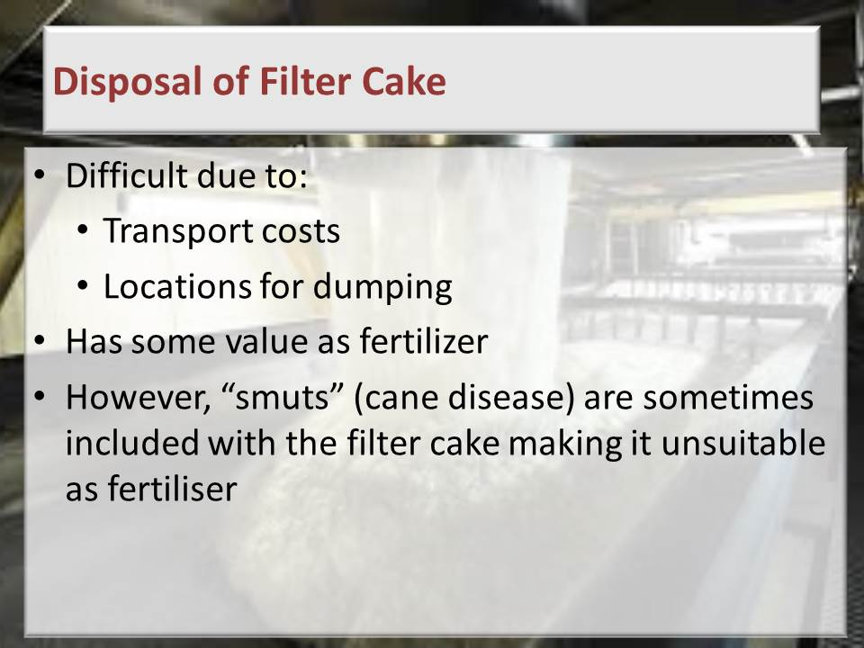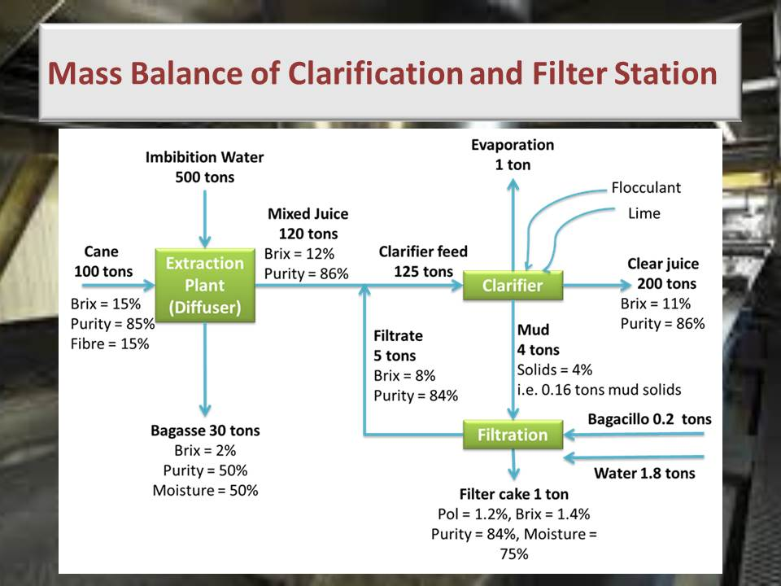
Learning activity: Guide learners to Page 19 of the Learner Workbook 5. Learners are instructed to complete Learning activity 2.1 (10 hours)
Guide learners to Page 33 of the Learner Workbook 5. Learners are instructed to complete Learning activity 2.2 (5 hours)
Total time taken: Presentation: 6 hours
Learning activity 2.1: 10 hours
Learning activity 2.2: 5 hours
Close: Move on to the next Knowledge Topic

KNOWLEDGE TOPIC 3: PROBLEM SOLVING (20%)
INSTRUCTIONS TO FACILITATOR
Purpose: To review sections of Knowledge Topic 1 and 2 as they relate to problem solving in sugar juice handling and clarification (20%)
Objectives: By the end of the session the candidates will:
- Be able to demonstrate an understanding of trouble shooting and standard responses related to juice handling and clarification.
Procedure: Conduct a presentation.
Participant Materials: The learner will use the following materials:
- The Learner Guide Book 5 (Textbook)
Presentation: Do a presentation covering the following topics:
- Heat Exchange problems and corrective measures
- Liming problems and corrective measures
- Clarification problems and corrective measures
- Filtration problems and corrective measures
- Mud recycling problems and corrective measures
Slides: Use the following slides for your presentation referring frequently to the Learning Resource for more detail.
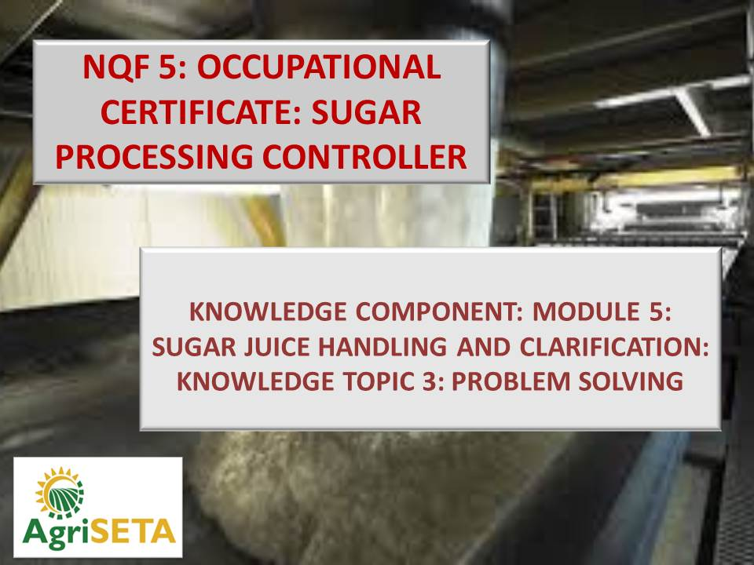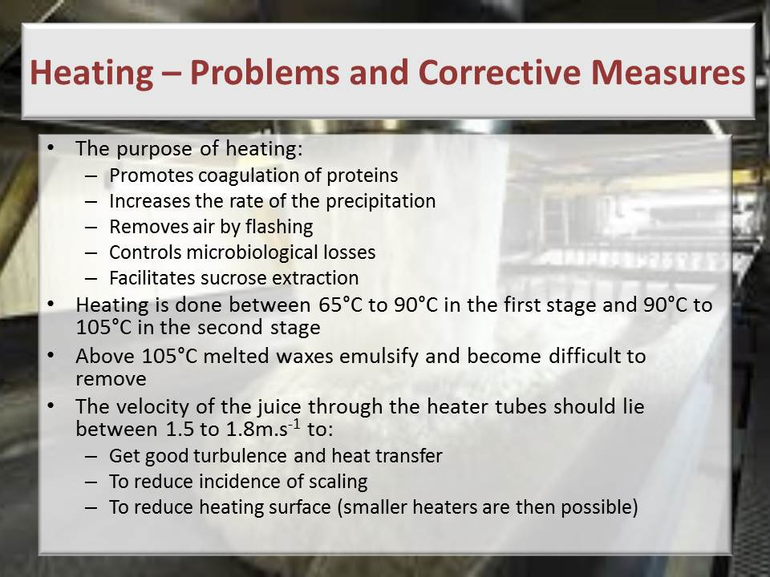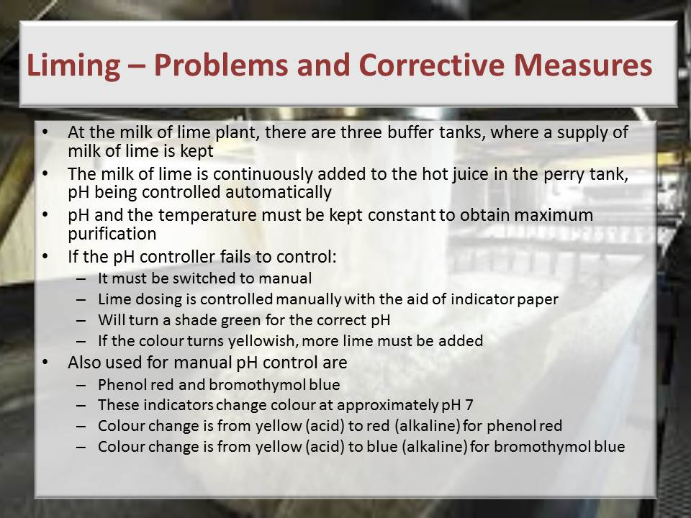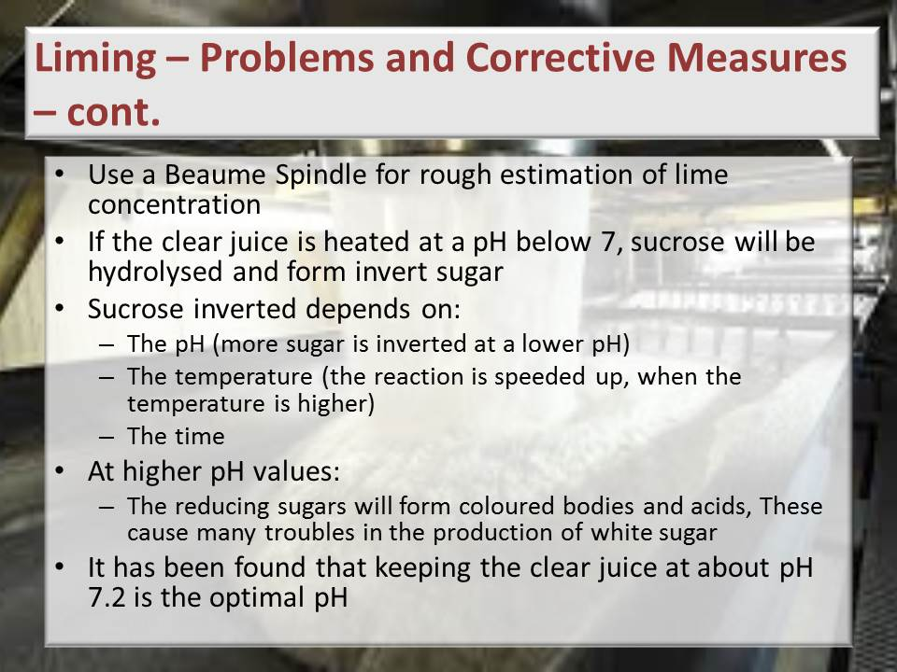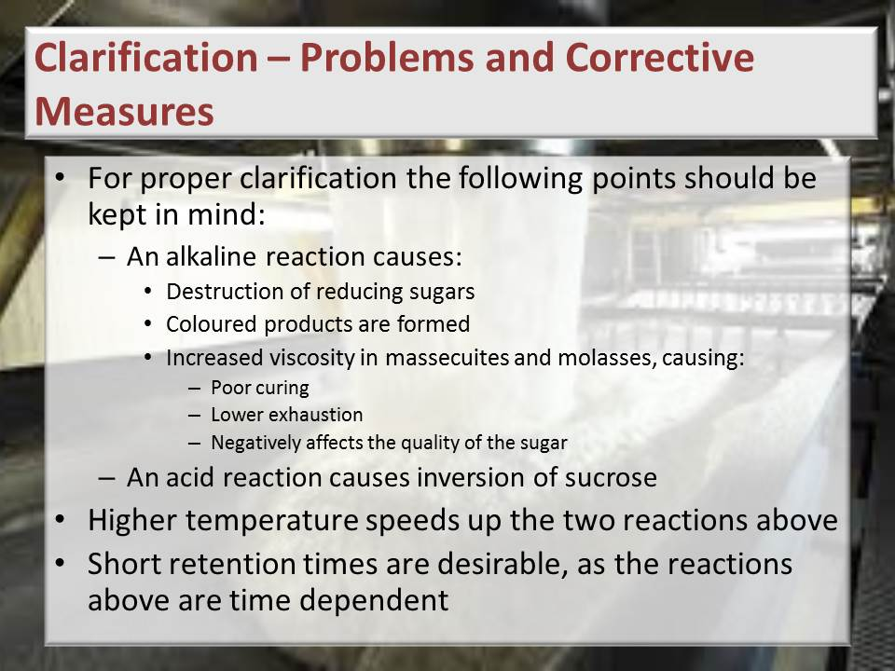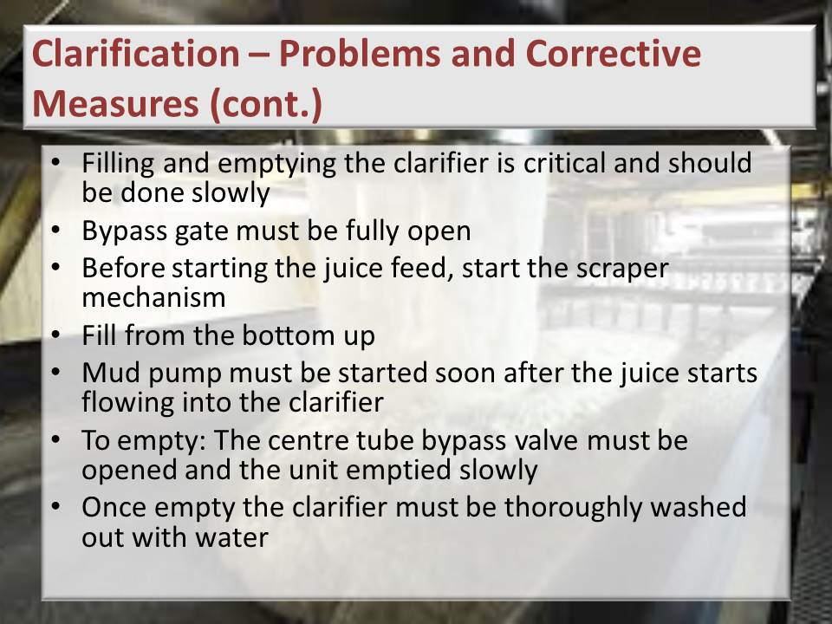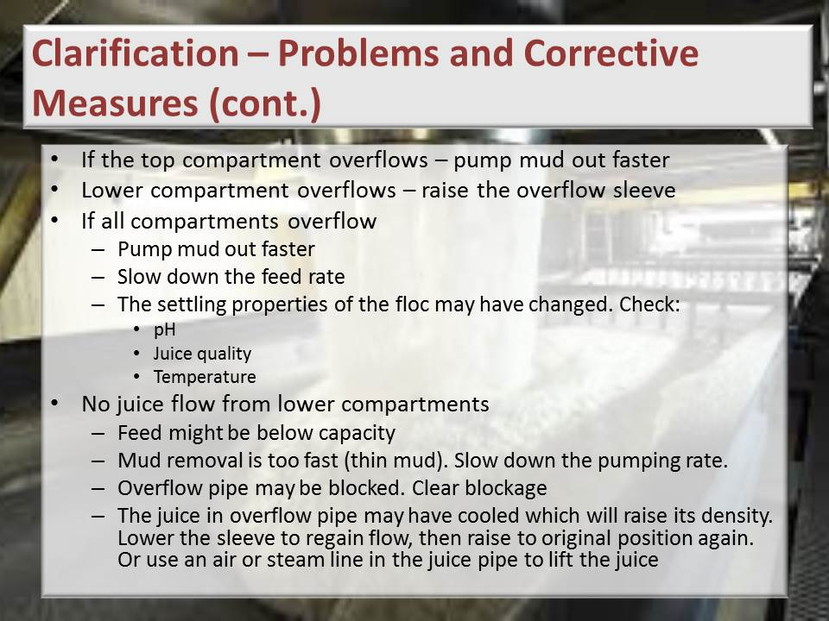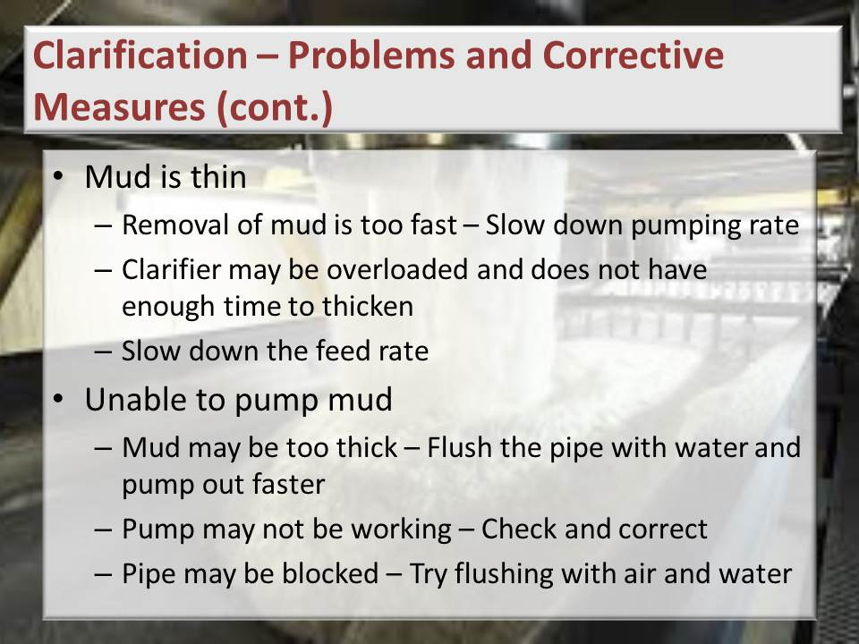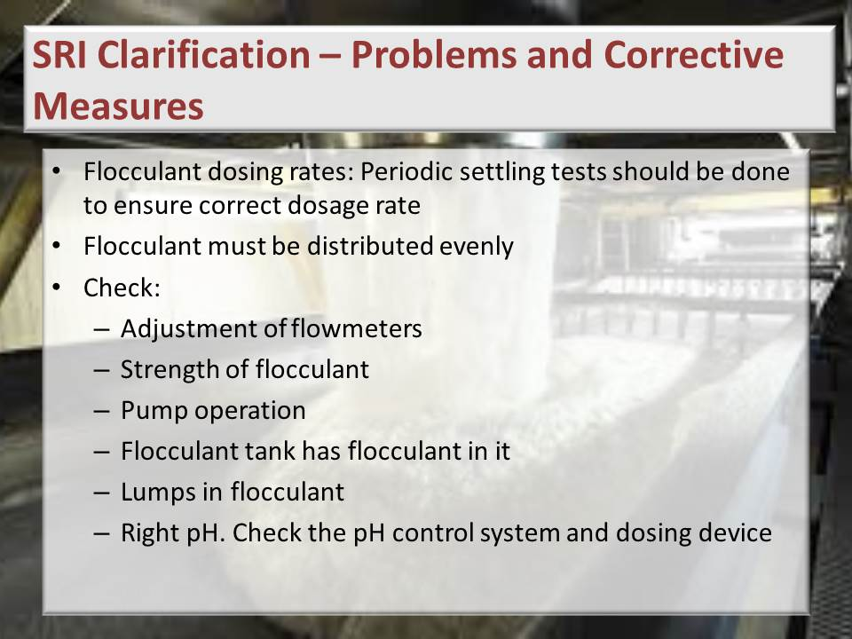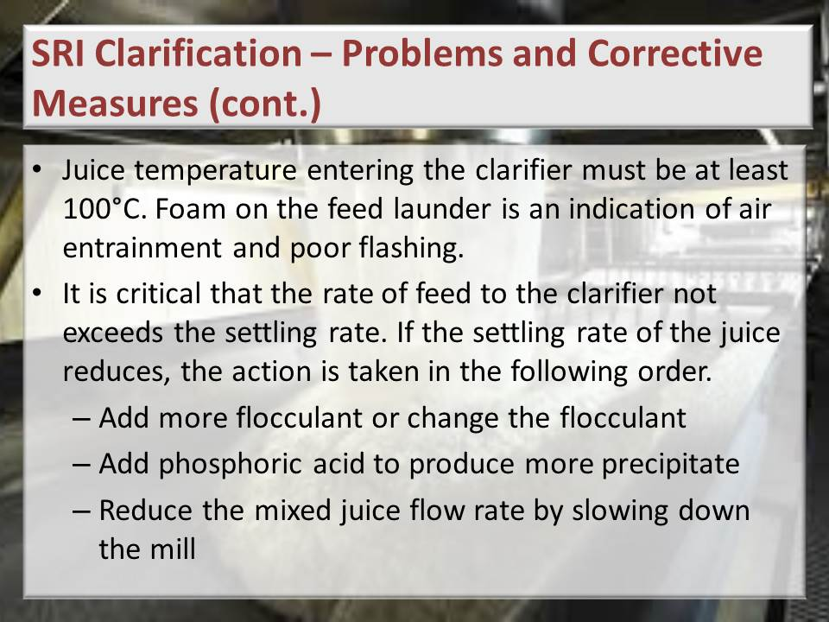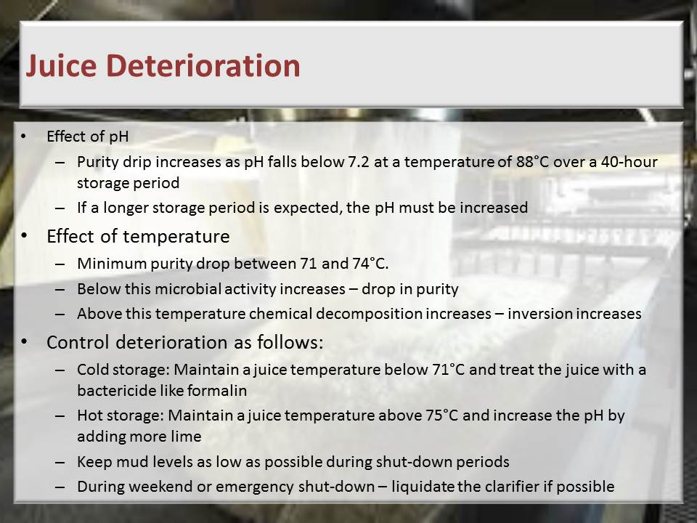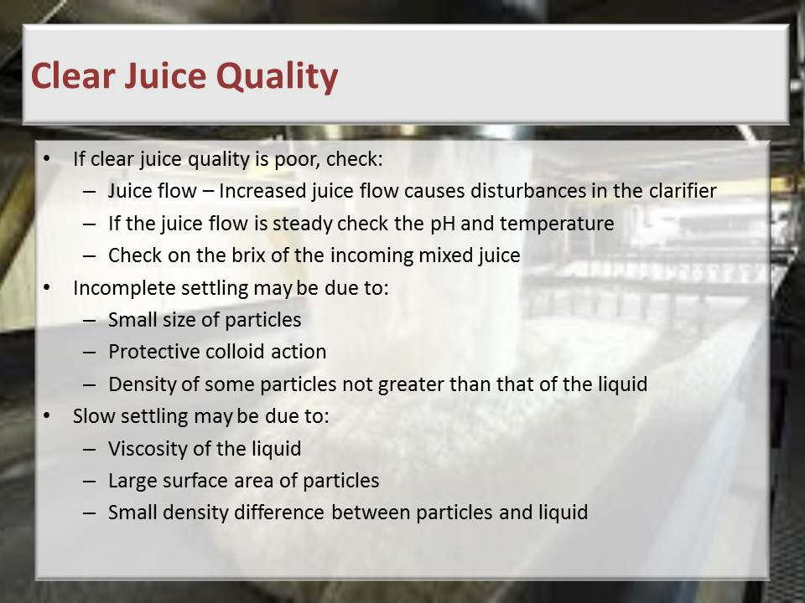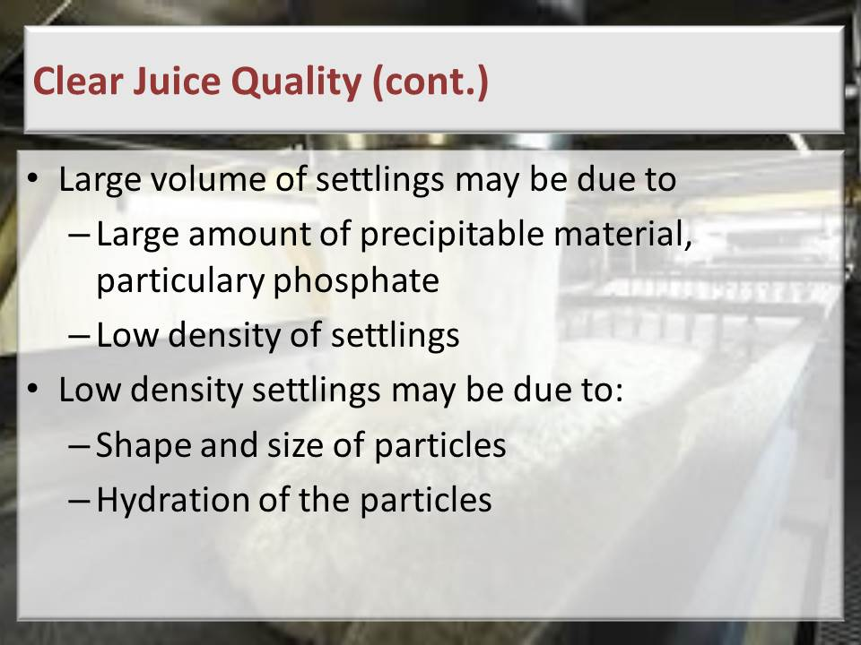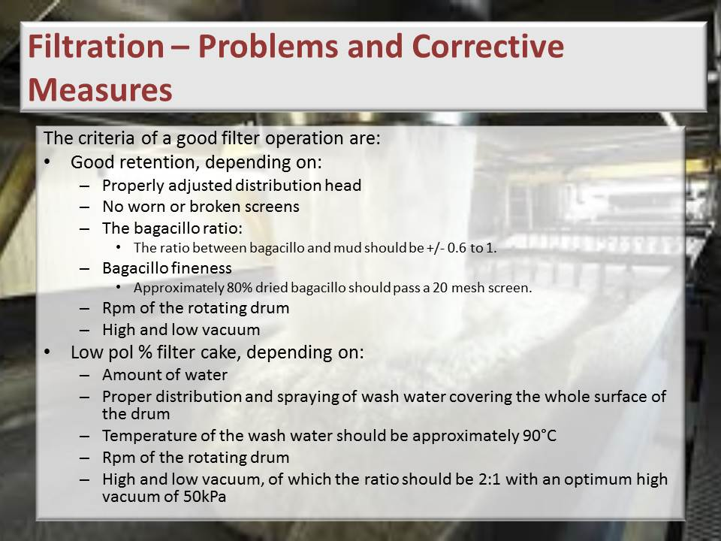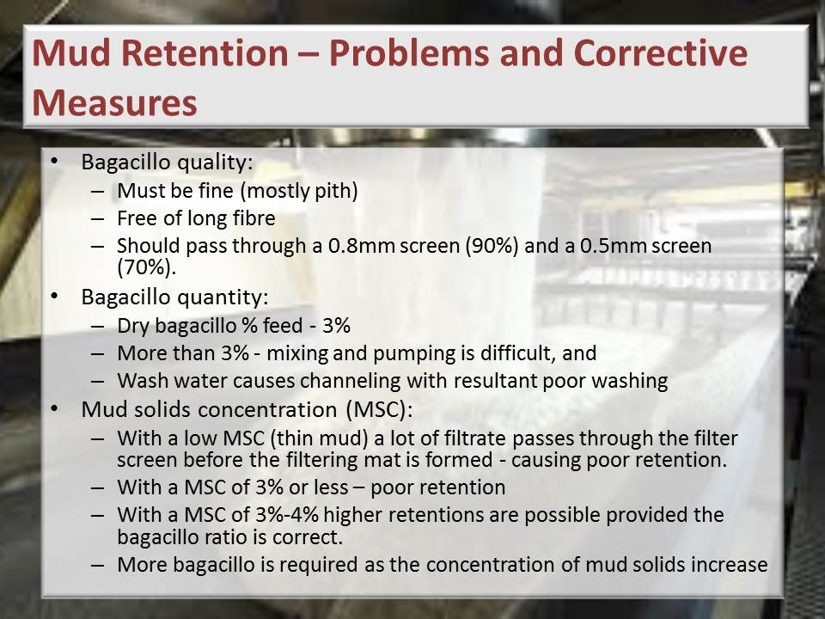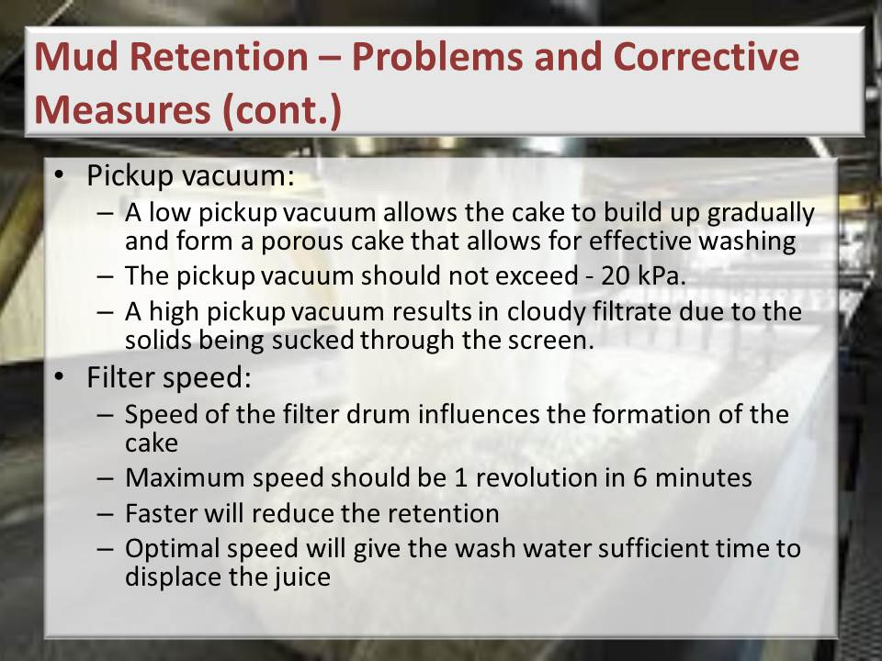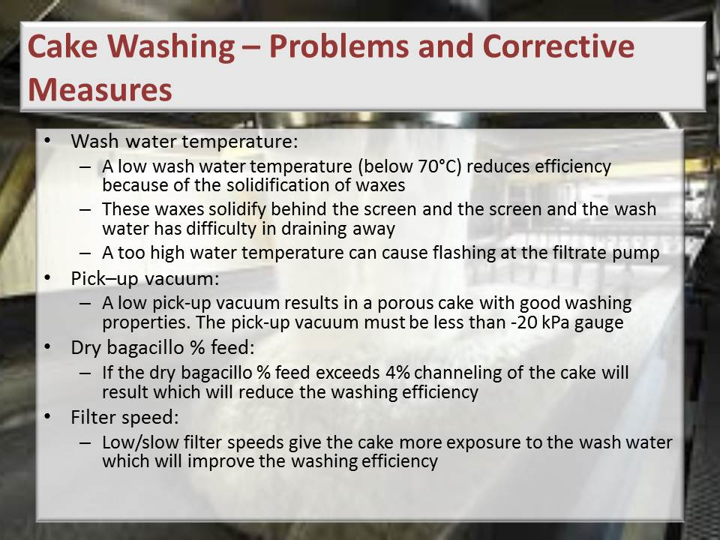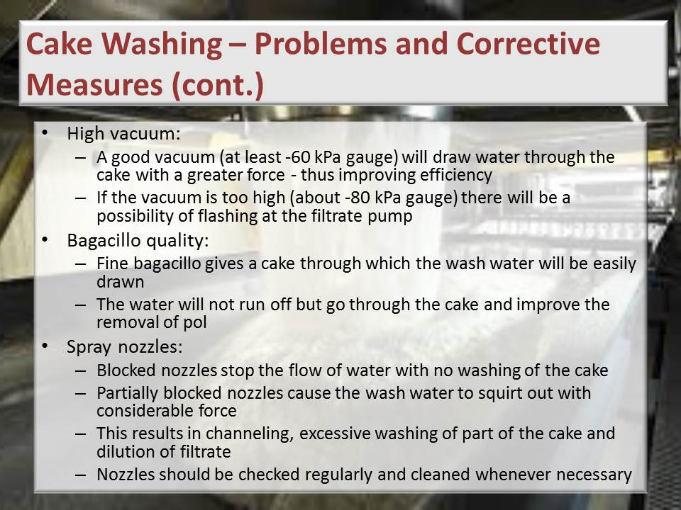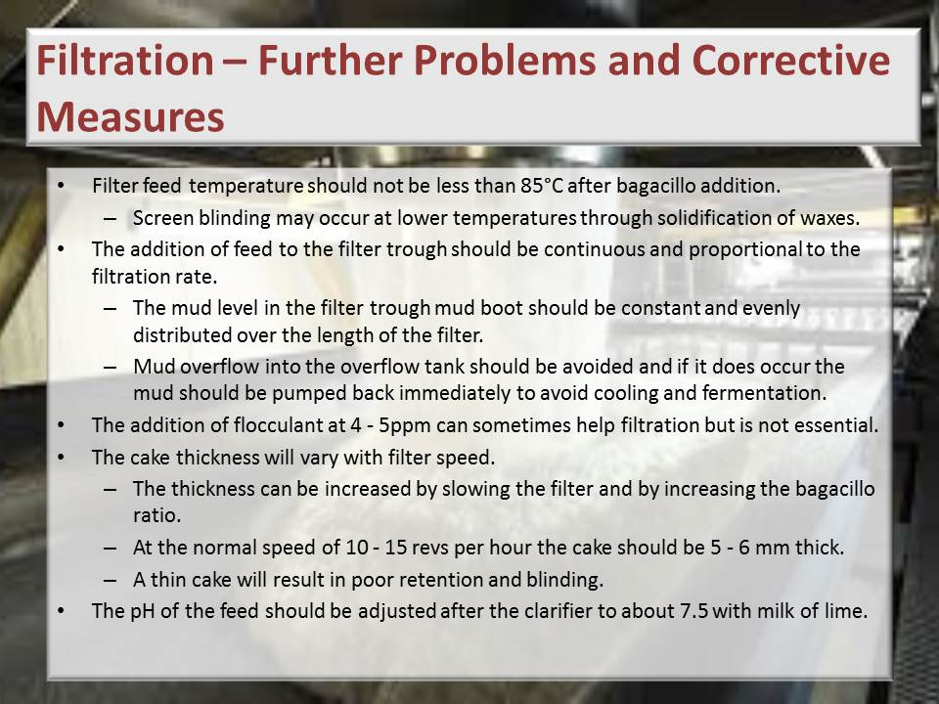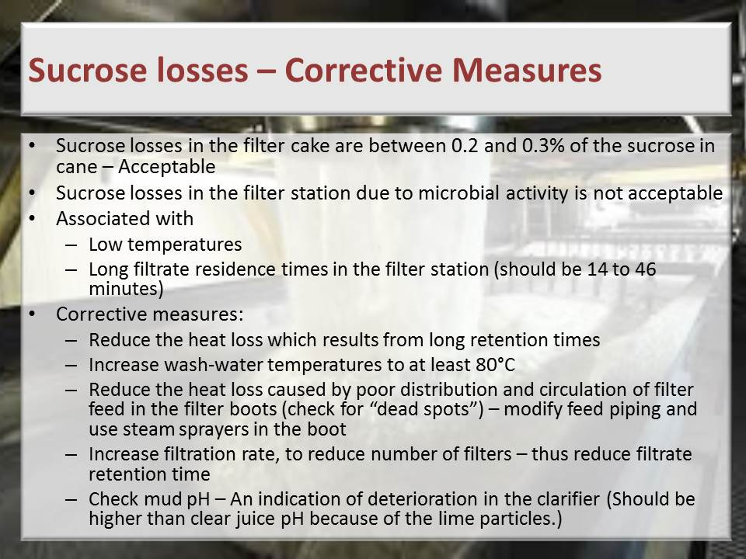
Practical activity: Organise a further visit to a Sugar Mill for a guided tour of the Juice Heaters, Clarifiers and Filters of a Sugar Mill factory. During this visit view the equipment in operation with some practical demonstration of troubleshooting and operation. Learners are instructed to take notes and photos and to compile a report regarding the operation of juice heating and clarification equipment as well as provide several trouble shooting instructions that have been demonstrated or discussed with them during the field trip.
Total time taken: Presentation: 5 hours
Practical activity: 6 hours
Close: Move on to the next Knowledge Module.



