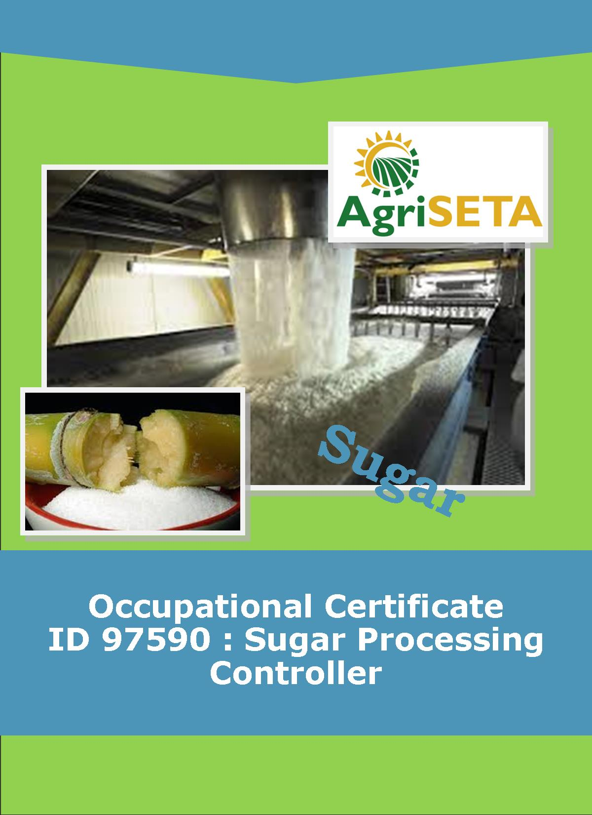
KNOWLEDGE COMPONENT:
KNOWLEDGE COMPONENT: LEARNER WORKBOOK 5: SUGAR JUICE HANDLING AND CLARIFICATION
Occupational Certificate: Sugar Processing Controller

KNOWLEDGE COMPONENT: LEARNER WORKBOOK 5:

BOOK 5: SUGAR JUICE HANDLING AND CLARIFICATION
LEARNER WORKBOOK 5:
SUGAR JUICE HANDLING AND CLARIFICATION
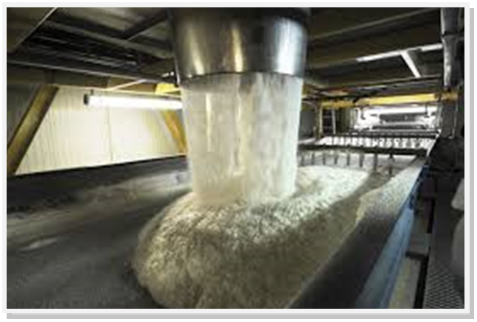
OCCUPATIONAL CERTIFICATE: SUGAR PROCESSING CONTROLLER

©Copyright AgriSETA
Telephone: +27 12 301 5600
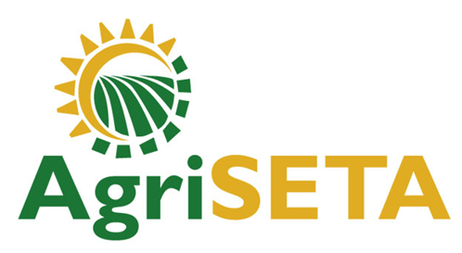

AgriSETA holds the copyright to its publications and Web pages. Proper citation is requested.

TABLE OF CONTENTS
1. AN INTRODUCTION TO THIS LEARNER WORKBOOK 6
2. LEARNER DETAILS 7
3. FORMATIVE ASSESSMENT INSTRUCTIONS 8
4. KNOWLEDGE MODULE 5: SUGAR JUICE HANDLING AND CLARIFICATION 9
4.1 Knowledge Topic 1: Juice Heating (40%) 10
4.2 Knowledge Topic 2: Clarification (40%) 18
5. CONCLUSION OF KNOWLEDGE MODULE 5: SUGAR JUICE HANDLING AND CLARIFICATION 37

AN INTRODUCTION TO THIS LEARNER WORKBOOK
This Knowledge Component Learner Workbook 5: Sugar Juice Handling and Clarification is intended to be used with the Knowledge Component Learning Resource: Book 5 (Textbook): Sugar Juice Handling and Clarification of the Occupational Qualification: Sugar Processing Controller NQF 5.
Guidance on the use of this Work Book is provided in the Learning Guide.

LEARNER DETAILS
First name
Surname
ID number
Mobile phone contact number
E-mail address
Postal address
Date on which you started this Knowledge Module
Date on which you completed this Knowledge Module
Declaration: | I hereby confirm that:  - I received the assessment plan and schedule.  - I understand my rights in terms of special needs, re-assessment, feedback and appeals against assessment decisions.  - I completed this formative assessment independently without assistance from anyone else.
Total Marks for Knowledge Module 5 | 266 marks
Marks attained
Date:
Place:
Signature of Learner:
Signature of Assessor:

FORMATIVE ASSESSMENT INSTRUCTIONS
Instructions
- Work individually to present the results of each Learning Activity in this Learner Workbook.
- Complete all the sections.
- Use a black pen and ensure that you complete the questions in your own handwriting.
- A recommended time to complete each activity is shown.
- The marks you will attain for each learning activity are shown in brackets.
- The total marks obtained for each Knowledge Module must be transferred from the back of each Learner Workbook to the Learner Qualification Summative Assessment Tool.

KNOWLEDGE MODULE 5: SUGAR JUICE HANDLING AND CLARIFICATION
NQF LEVEL: 5
CREDITS: 4
PURPOSE OF THE KNOWLEDGE MODULE: The main focus of the learning in this knowledge module is for the learner to gain a fundamental understanding of the theory and science of juice handling and clarification.
The learning will enable learners to demonstrate an understanding of:
- KM-05-KT01: Juice Heating (40%)
- KM-05-KT02: Clarification (40%)
- KM-05-KT03: Problem solving (20%)

4.1 Knowledge Topic 1: Juice Heating (40%)
Topic elements to be covered include:
- KT0101 Properties of mixed juice
- KT0102 Purpose of Heating
- KT0103 Heat Exchange
- KT0104 Equipment
Internal Assessment Criteria and Weight
- IAC0101 An understanding of process steps and use of equipment related to juice heating can be demonstrated
- IAC0102 Key control points related to juice heating can be listed and controls explained
- (Weight 40%)

Learning activity 1.1: Individual Learning activity: 2 hours (30 marks)

Learning Objective: An understanding of the components of mixed juice and thus the need for heating and clarification can be demonstrated.
Task: Read each question carefully and write your answer in the space provided.
- Name and describe 18 substances/components found in mixed juice. (18)
1.
2.
3.
4.
5.
6.
7.
8.
9.
10.
11.
12.
13.
14.
15.
16.
17.
18.

- (a) Define inversion (6)

- Explain the effect of both a low and high pH on juice.(6)

Learning activity 1.2: Individual Learning activity: 2 hours (50 marks)
Learning Objective: An understanding of process steps and use of equipment related to juice heating can be demonstrated.
Task: Read each question carefully and write your answer in the space provided.
- (a) What type of heat does steam (vapour) release in a juice heater? (2)

(b) What happens to the steam when it releases this heat? (2)

2. How is heat transmitted? (6)

3. Write down the equation for:
(a) The heat transferred through a tube wall (5)

(b) The heat absorbed by the juice (5)

4. (a) Define specific heat capacity (4)

(b) Give the equation to calculate the specific heat capacity of a sugar solution. (4)

5. With the aid of a sketch describe the construction of a juice heater and indicate how the passes are affected. (18)
6. (a) What effect has juice velocity on heat transfer? (2)

(b) What effect has juice velocity on pressure drop across a heater? (2)

4.2 Knowledge Topic 2: Clarification (40%)
Topic elements to be covered include:
- KT0201 Purpose
- KT0202 Principles
- KT0203 Liming
- KT0204 Operation of Clarifiers
- KT0205 Filtration
- KT0206 Mud recycling
Internal Assessment Criteria and Weight
- IAC0201 An understanding of process steps and use of equipment related to clarification can be demonstrated
- IAC0202 Key control points related to clarification can be listed and controls explained
- (Weight 40%)

Learning activity 2.1: Individual Learning activity: 10 hours (150 marks)
Learning Objective: Demonstrate an understanding of process steps and use of equipment related to clarification.
Task: Read each question carefully and write your answer in the space provided.
- What is the purpose of clarification? (2)

- What is the target pH value for limed juice and why is this target chosen? (3)

- Explain with the aid of formulae the formation of the milk of lime slurry. (4)

- Define precipitation. (2)

- Explain why purity cannot be used to judge the efficiency of clarification. (4)

- What component of juice is very important for efficient/effective clarification? (2)

- How does the change in pH from limed juice to clear juice come about? (4)

- Explain with the aid of sketches the differences between hot liming and saccharate liming with regard to juice quality and equipment required. (10)

- Explain the chemical changes that take place during clarification. (5)

- Explain the meaning of the term flocculation. (3)

- (a) How are colloidal particles held in suspension? (4)

- Explain 3 methods of bringing about flocculation. (6)
.
- Explain the difference between primary and secondary flocculants. (6)

- What is a flocculant? (4)
- What precautions should be taken when dealing with flocculants? (4)

- What are the normal stock solution strengths of talosep and separan? (2)

- Consider the following:

Diameter of preparation tank = 1.2m
Depth when filled = 0.8m

Calculate the amount of dry talosep and separan that must be added to the tank to make up the recommended strength stock solutions. (6)

- Explain the manner of use of the following:
  - an air sparge (3)

  - an educator (3)

- Describe two methods of lime addition and mixing. (6)
- Explain how pH control is achieved. (4)

- List 4 important points affecting the accuracy of pH control. (8)

- What is the purpose of juice flashing prior to clarification? (4)
- (a) Draw a simple sketch of a Rapi-dorr clarifier. (5)

- List the possible causes and remedies if all compartments of a Dorr clarifier are overflowing with cloudy juice. (6)
- What action could you take if the mud from the clarifier was too thin? (4)

- (a) Draw a simple sketch of a SRI clarifier. (5)
- What is a “launder”? (2)

- Describe the principals of operation of an SRI clarifier. (6)

- List 4 important operating conditions with regard to a SRI clarifier. (8)

- What are the advantages of a SRI clarifier? (5)

- List the 3 factors that affect purity drop in a clarifier over stop periods and explain their effect. (6)

- How is deterioration in a clarifier minimised (two ways)? (4)

Learning activity 2.2: Individual Learning activity: 5 hours (50 marks)
Learning Objective: Demonstrate an understanding of process steps and use of equipment related to filtration.
Task: Read each question carefully and write your answer in the space provided.
- Why must clarifier underflow/mud be filtered? (2)

- Draw a simple sketch of a rotary vacuum filter and use it to explain its operation. (15)
- List 3 factors that affect the performance of a rotary vacuum filter. (6)

- List 5 factors that affect filter retention. (10)

- (a) Why must the cake be washed? (3)

- List 7 factors that affect the washing performance. (14)

CONCLUSION OF KNOWLEDGE MODULE 5: SUGAR JUICE HANDLING AND CLARIFICATION
Throughout this knowledge module you have been provided opportunities to complete formative learning activities. You have captured your results in this Learner Workbook.
The total marks for this Knowledge Module are as follows:
Knowledge Module | Total Marks | Marks attained
KM-05-KT01: Juice heating (40%) | 75
KM-05-KT02: Clarification (40%) | 191
KM-05-KT03: Problem solving (20%) (Included above)
Total Marks | 266 marks



