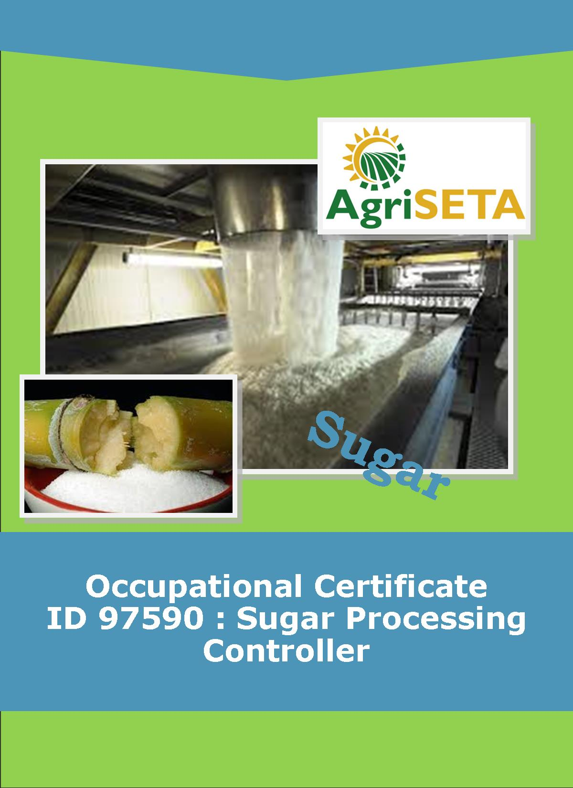
LEARNER SUMMATIVE ASSESSMENT TOOL KNOWLEDGE MODULE 5:
KNOWLEDGE COMPONENT: LEARNER SUMMATIVE ASSESSMENT TOOL KNOWLEDGE MODULE 5:
SUGAR JUICE HANDLING AND CLARIFICATION
Occupational Certificate: Sugar Processing Controller

LEARNER SUMMATIVE ASSESSMENT TOOL KNOWLEDGE MODULE 5:
SUGAR JUICE HANDLING AND CLARIFICATION
SUGAR JUICE HANDLING AND CLARIFICATION
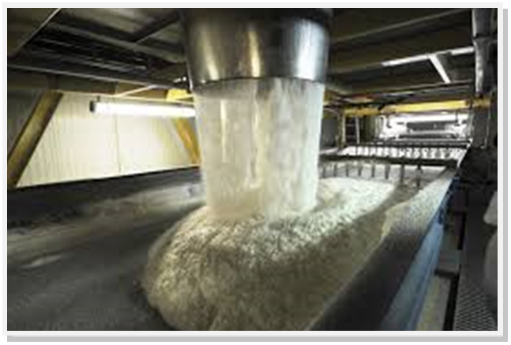
OCCUPATIONAL CERTIFICATE: ID 97590: SUGAR PROCESSING CONTROLLER

©Copyright AgriSETA
Telephone: +27 12 301 5600


AgriSETA holds the copyright to its publications and Web pages. Proper citation is requested.

TABLE OF CONTENTS

1. STAKEHOLDER INFORMATION 6
2. COMPETENCY SUMMARY OF ASSESSMENT 8
3. ASSESSMENT ALIGNMENT MATRIX (INTERGRATED OUTCOMES) 9
4. ASSESSMENT DECISION & EVIDENCE EVALUATION RECORD 11
5. OVERALL ASSESSMENT DECISION 12
6. EVIDENCE OF FEEDBACK 13
7. OVERALL RESULTS 14
8. ASSESSMENT REVIEW 15
9. FINAL DECISION 17
10. LEARNER FEEDBACK FORM 18
11. SUMMATIVE ASSESSMENT INSTRUCTIONS 19
12. WRITTEN ASSESSMENT 20
13. FINAL MARKS 34

STAKEHOLDER INFORMATION
LEARNER INFORMATION
Name
Surname
ID number
Mobile phone contact number
E-mail address
Physical address
Postal address
Employer Name
Employer Contact Details

ASSESSOR DETAILS
Name
Surname
Assessor ID
Project Name | Occupational Certificate ID 97590:Sugar Processing Controller
Module No. | Module 5:Sugar Juice Handling and Clarification
Date of Assessment
Portfolio submission Date
Assessor Signature
Total Marks for Knowledge Module 5 | 125 marks
Marks attained
Place:

MODERATOR DETAILS
Moderator Name
Moderator ID
Moderator Signature
Date of Moderation

COMPETENCY SUMMARY OF ASSESSMENT
Module 5 | KM-05-KT01: Juice Heating | C | NYC
1 | 1.1. An understanding of process steps and use of equipment related to juice heating can be demonstrated
 | 1.2. Key control points related to juice heating can be listed and controls explained
2 | KM-05-KT02: Clarification | C | NYC
 | 2.1. An understanding of process steps and use of equipment related to clarification can be demonstrated
 | 2.2. Key control points related to clarification can be listed and controls explained
3 | KM-05-KT03: Problem solving | C | NYC
 | 3.1.
 | 3.2.

ASSESSMENT ALIGNMENT MATRIX (INTERGRATED OUTCOMES)
Module No: 5 | How it is assessed (Assessment methodology) | Where is it covered in learning resource | Where it is assessed |  | First Submission
Module No: 5 | How it is assessed (Assessment methodology) | Where is it covered in learning resource | Summative | Formative
SAQA ID Number: 97590 | Two methods of assessment are followed which are:  1. Summative assessment: written tests, knowledge questions using fundamental and reflexive questions.  2. Formative assessment: assignments, tasks, portfolio of evidence submitted and presentations. |  |  |  | Clearly meets all the criteria | Meets some but not all criteria | Clearly does not meet any of the criteria
Title: Sugar Juice Handling and Clarification
NQF level and credits:
NQF Level 5: 4 Credits
Topic: 1 Juice Heating |  | Page 10-45 | Question 5.1-5.16 page 19-23 | Learning Activity 1.1-1.2 page 11-19
Assessment criteria: An understanding of process steps and use of equipment related to juice heating can be demonstrated |  |  | Question 5.36-5.40 page 29-30
Assessment criteria: Key control points related to juice heating can be listed and controls explained
Topic 2. Clarification |  | Page 46-94 | Question 5.17-5.35 page 23-28 | Learning Activity 2.1-2.2 page 19-36
Assessment criteria: An understanding of process steps and use of equipment related to clarification can be demonstrated |  |  | Question 5.41-5.46 page 30-32
Assessment criteria: Key control points related to clarification can be listed and controls explained
Topic 3: Problem solving
Assessment criteria: An understanding of trouble shooting and standard responses related to juice handling and clarification can be demonstrated

ASSESSMENT DECISION & EVIDENCE EVALUATION RECORD
Candidate's Name: -

Assessor's Name: -

Practical assessment
I declare that this assessment is my own demonstration.
Marks: The learner is either “Met requirements” or “did not meet requirements”. If the learner did not meet requirements in an area, then he or she must be reassessed.
Learner achieved: Met requirements /Did not meet requirements
KNOWLEDGE MODULE 1:SUGAR JUICE HANDLING AND CLARIFICATION
Overall outcome:

Specific Outcome |  | Met requirements | Did not meet requirements | Comments
1
Specific Outcome |  | Met requirements | Did not meet requirements | Comments
2
 | Specific outcome | Met requirements | Did not meet requirements | Comments
3
 | Specific outcome | Met requirements | Did not meet requirements | Comments
4
5 | Specific outcome | Met requirements | Did not meet requirements | Comments

OVERALL ASSESSMENT DECISION
Assessors Comments:

Signature of Assessor:

Date:

EVIDENCE OF FEEDBACK
Module No : 5
Level : 5
Assessor :……………………………………………………………………………
Candidate :…………………………………………………………………………..
Date of final assessment:…………………………………………………………….
Evidence criteria | Achieved | Not
1. Constructive
2. Timeous (according to Plan)
3. Correct mode / medium
4. Participative
5. Developmental
6. Accurate
7. Specific
8. Documented
9. Directed to correct parties
Signing off date: …………………………………………….

..........……………. ………………………………….
Assessor Candidate

OVERALL RESULTS
OVERALL RESULT | Competent
OVERALL RESULT | Not Yet Competent
Declaration by Candidate
I, …………………………………………………………………….declare that I am satisfied that the feedback given to me by the Assessor was relevant, sufficient and done in a constructive manner. I accept the assessment decisions and do realise that have no further questions relating to this particular assessment process. I do realise that after this assessment decision, the moderator will either uphold or reverse this assessment decision taken by the assessor.
Candidate : _____________  _______________________  Date: __________________  Signature: ______________ |  | Assessor : _____________  _______________________  Date: __________________  Signature: ______________ |  | Moderator : _____________  _______________________  Date: __________________  Signature: ______________

ASSESSMENT REVIEW
Assessor’s Name |  |  |  |  |  |  |  |  | ID Number
Contact Details of Assessor |  | Email
 |  | Phone
 |  | Fax
PART 1
 | Review Criteria |  | Valid |  | Authentic | Current |  | Consistent |  |  | Reliable |  | Sufficient |  |  | Comments
Please conduct an honest review of the Assessment Instruments used in this assessment:
1 | Evidence Topic 1
 | Knowledge Assignment
 | Practical Assignment
 | Natural Occurring Evidence
 | Reflection
2 | Evidence Topic 2
 | Knowledge Assignment
 | Practical Assignment
 | Natural Occurring Evidence
 | Reflection
3 | Evidence Topic 3
 | Knowledge Assignment
 | Practical Assignment
 | Natural Occurring Evidence
 | Reflection
 | Historical Evidence Location Grid
 | CCFO Location Grid
PART 2
No | Review Criteria |  |  |  |  |  |  |  |  | Yes |  | No |  |  | Remarks
1 | Do you feel the candidate was appropriately selected and prepared for the RPL assessment?
2 | Did the candidate interpret the evidence requirements appropriately?
3 | Was the assessment free of potential assessment barriers such as language, literacy, access to resources?
4 | Was the assessment evidence presented by the candidate valid, authentic, current and sufficient?
5 | Was the candidate’s workplace access to evidence sufficiently supportive of the assessment strategy?
6 | Do you feel you could make a fair, valid and reliable assessment decision?
Recommendations
(Feedback on Validity, authenticity, currency and sufficiency of candidate evidence.)
Assessor Signature |  |  |  |  |  |  | Date Review Completed

FINAL DECISION
I………………………………………………………. hereby declare Ms/Mr

………………………………………… Competent Not Yet Competent

FEEDBACK TO LEARNER:

……………………..………………………..………………………..……………………

……………………..………………………..………………………..………………………

……………………..………………………..………………………..………………………

……………………..………………………..………………………..………………………

SIGN: …………………………………… DATE: ……………………..........................

LEARNER FEEDBACK:

……………………..………………………..………………………..………………………

……………………..………………………..………………………..………………………

……………………..………………………..………………………..………………………

……………………..………………………..………………………..………………………

SIGN: ……………………………………… DATE: …………………….......................

MODERATOR FEEDBACK:

………………………..………………………..………………………..……………………

………………………..………………………..………………………..……………………

……………………..………………………..………………………..………………………

……………………..………………………..………………………..………………………

SIGN: …………………………………… DATE: ……………………........................

LEARNER FEEDBACK FORM
CRITERIA | EVIDENCE | CRITERIA | EVIDENCE
How did your assessor encourage you and put you at ease during the assessment process? |  | Were you given clear and constructive feedback?
Were your assessor’s questions clear and pitched at the right level of language usage? |  | Did your assessor assess all the evidence provided by you?
Do you believe that all the assessment criteria and knowledge requirements of the standard you were being measured against were considered in your assessment? |  | Were you aware of any discrimination practice carried out by your assessor towards you?

LEARNER SIGNATURE:………………………………………………

DATE:.…………………………..

SUMMATIVE ASSESSMENT INSTRUCTIONS
Instructions
- Work individually and answer all questions.
- Use a black pen and ensure that you complete the questions in your own handwriting.
- Time to spend on this assessment is 2 hours.
- The marks you will attain for each question are shown in brackets.

WRITTEN ASSESSMENT
Candidate instruction: Complete the following multiple-choice questionnaire by marking the most appropriate response with an x in the space provided.
5.1 | The purpose of clarification is; |  | Mark Allocation
a. |  | To remove the dissolved solids from the mixed juice.
b. |  | To heat the mixed juice.
c. |  | To increase the pH of the clarified juice.
d. |  | To remove colloidal matter and solids from the mixed juice.
e. |  | To increase the Brix of the mixed juice. | 2

5.2 | The unit for the measurement of heat is; |  | Mark Allocation
a. |  | Pascal.
b. |  | Meter.
c. |  | Celsius.
d. |  | Joule.
e. |  | Gram. | 2

5.3 | Heat is a form of; |  | Mark Allocation
a. |  | Energy.
b. |  | Temperature.
c. |  | Pressure.
d. |  | Mass.
e. |  | Sound. | 2

5.4 | Heat transfer happens from particle to particle contact through; |  | Mark Allocation
a. |  | Convection.
b. |  | Energisation.
c. |  | Conduction.
d. |  | Differentiation.
e. |  | Radiation. | 2

5.5 | Higher energy particles moving to regions of lower energy particles is called; |  | Mark Allocation
a. |  | Convection.
b. |  | Energisation.
c. |  | Conduction.
d. |  | Differentiation.
e. |  | Radiation. | 2

5.6 | Heat energy travelling through a space in the form of waves is known as; |  | Mark Allocation
a. |  | Convection.
b. |  | Energisation.
c. |  | Conduction.
d. |  | Differentiation.
e. |  | Radiation. | 2

5.7 | The rate of transfer between steam and juice will increase in the following circumstance. |  | Mark Allocation
a. |  | Steam temperature is low and juice temperature is high.
b. |  | The heat transfer co-efficient is low.
c. |  | The steam temperature increases.
d. |  | The difference between the steam temperature and the juice temperature is high.
e. |  | The flow of juice is fast. | 2
5.8 | When a heat transfer surface becomes scaled up the following happens; |  | Mark Allocation
a. |  | The heat transfer is reduced.
b. |  | The juice starts to boil.
c. |  | The steam flow is reduced.
d. |  | The steam starts to condense.
e. |  | The heat transfer is increased. | 2

5.9 | The specific heat capacity of a substance is; |  | Mark Allocation
a. |  | The quantity of juice required to increase its temperature by 1ºC if it comes into contact with 1kg of steam.
b. |  | The quantity of heat required to increase the temperature of 1kg of juice by 1ºC.
c. |  | The ratio of the ability of the juice to absorb heat.
d. |  | Proportional to the temperature difference of steam and juice.
e. |  | Ability to withstand the application of heat. | 2

5.10 | A shell and tube heater that is typically used in the sugar industry is known as a; |  | Mark Allocation
a. |  | Co-current flow heater.
b. |  | Cross flow heater.
c. |  | Reverse flow heater.
d. |  | Counter current flow heater.
e. |  | Bi-lateral flow heater. | 2

5.11 | As the juice increases in temperature in the juice heater; |  | Mark Allocation
a. |  | The pH of the juice decreases.
b. |  | The Brix increases.
c. |  | The steam condensed.
d. |  | The juice purity rises.
e. |  | The solids dissolve. | 2
5.12 | The juice velocity through the heater; |  | Mark Allocation
a. |  | Makes no difference to the heat transfer.
b. |  | Impacts on heat transfer and should be between 1.5 and 1.8 meters per second.
c. |  | Impacts on the heat transfer and should be lower than 1.5 meters per second.
d. |  | Impacts on the heat transfer and should be above 1.8 meters per second.
e. |  | Impacts on heat transfer, but the impact is low and as long as there is some juice flow the heat transfer will continue. | 2

5.13 | Is there is a pressure drop across a heater or a bank of heaters? |  | Mark Allocation
a. |  | No.
b. |  | Yes and it should be kept to a minimum.
c. |  | Yes and it should be limited to 520kPa.
d. |  | Yes and it should be limited to 1520kPa.
e. |  | Yes and it should be limited to 320kPa. | 2

5.14 | The heating surface of a juice heater is; |  | Mark Allocation
a. |  | The total area of the circumference of the vessel multiplied by its length.
b. |  | The sum of the internal area of each tube.
c. |  | The ratio between the final temperature of the juice and the final temperature of the steam.
d. |  | The number of tubes times the length of the heater.
e. |  | 4.187 times the heat transfer co-efficient. | 2

5.15 | A flash tank is; |  | Mark Allocation
a. |  | A sealed vessel.
b. |  | Open to the atmosphere.
c. |  | Either type of vessel.
d. |  | Flashing takes place in the clarifier.
e. |  | None of the above. | 2

5.16 | The juice entering the flash tank is; |  | Mark Allocation
a. |  | Under a vacuum and below 100ºC.
b. |  | Under pressure and above 110ºC.
c. |  | Under pressure and at 105ºC.
d. |  | Under a vacuum and at 105ºC.
e. |  | At atmospheric pressure and at 105ºC | 2

5.17 | Organic acids are not removed by clarification and are responsible for downstream; |  | Mark Allocation
a. |  | Colour in sugar.
b. |  | Purity of sugar
c. |  | Forming hard scale in the evaporators.
d. |  | Reducing the ability to cure sugar.
e. |  | Sugar moisture. | 2

5.18 | The clarification process results in a clear juice for downstream evaporation. What is the most accurate statement when comparing clear juice to mixed juice? |  | Mark Allocation
a. |  | The purity of mixed juice is higher than clear juice.
b. |  | The purity of clear juice is higher than mixed juice.
c. |  | There is little change between the purity of mixed juice and clear juice.
d. |  | Mixed juice has less suspended solids than clear juice.
e. |  | The purity of mixed juice is lower than the purity of clear juice. | 2
5.19 | If not removed during from the juice during clarification, the colloidal substances may; |  | Mark Allocation
a. |  | Increase the viscosity of the syrup and molasses.
b. |  | Improve the crystallisation of the sucrose.
c. |  | Reduce the clear juice purity.
d. |  | Cause scaling in the evaporator.
e. |  | Result in carry-over. | 2

5.20 | Excessive cut to crush delay or sever frost on sugarcane will; |  | Mark Allocation
a. |  | Not have an impact on the back-end.
b. |  | Increase the amount of gums.
c. |  | Increase the mixed juice purity.
d. |  | Assist with the capacity of the clarifiers.
e. |  | Increase the heat transfer capacity of the mixed juice. | 2

5.21 | The simple clarification process is known as; |  | Mark Allocation
a. |  | Boiling.
b. |  | Liming.
c. |  | Heating.
d. |  | Crystallisation.
e. |  | Defecation. | 2

5.22 | What is the best operating pH for clarification? |  | Mark Allocation
a. |  | Between 5.5 and 6.5
b. |  | Anything lower than 7.
c. |  | Anything greater than 7.
d. |  | Between 7.5 and 7.8.
e. |  | Between 7.0 and 7.2. | 2
5.23 | Which statement best describes the effect of heating the juice? |  | Mark Allocation
a. |  | Heating causes microbiological activity and sucrose is broken down into glucose and fructose.
b. |  | Heating changes the pH of the juice and neutralises free organic acids.
c. |  | Heating causes coagulation of some of the organic constituents.
d. |  | Heating allows the glucose and fructose molecules to join together again to form sucrose.
e. |  | Heating generates calcium oxide to produce a clarification agent. | 2

5.24 | The chemical name for lime is? |  | Mark Allocation
a. |  | Calcium hydroxide Ca(OH)₂
b. |  | Potassium Chloride (KCL)
c. |  | Calcium Chloride (CaCl)
d. |  | Calcium Oxide (CaO)
e. |  | Mono Calcium Phosphate (CaHPO₄) | 2

5.25 | The phosphate content of the juice entering the clarifier should be at least 300 parts per million. If this is found to be below 300 ppm; |  | Mark Allocation
a. |  | Additional phosphate cannot be added.
b. |  | If the phosphate is low, the crush rate needs to be increased.
c. |  | Additional lime can be added to increase the phosphate level.
d. |  | Phosphoric acid or paste can be added to increase the concentration.
e. |  | Syrup needs to be added to increase the phosphoric acid concentration. | 2

5.26 | Saccharate liming is defined best as follows; |  | Mark Allocation
a. |  | Preparation of the normal concentration milk of lime solution with the addition of some evaporator Brix syrup.
b. |  | Preparation of a 15 Baume solution of milk of lime, adding evaporator Brix of 68 in equal parts to create a solution of 11.0 to 11.15 pH for addition to the clear juice.
c. |  | The milk of lime mixed with the clear juice before the flash tank is known as saccharate liming.
d. |  | None of the above.
e. |  | All of the above. | 2

5.27 | There is a pH drop during clarification and this is due to; |  | Mark Allocation
a. |  | The introduction of phosphoric acid in the mixed juice.
b. |  | Over liming of the mixed juice.
c. |  | Basic calcium phosphates are trapped in the mud, leaving the clear juice more acidic.
d. |  | If saccharate liming is used the clear juice is more at risk of acid formation.
e. |  | There is a change in acidity of the raw juice. | 2

5.28 | The definition of a flocculent is; |  | Mark Allocation
a. |  | A number of synthetic water-soluble polymers that are in solution.
b. |  | The formation of an inorganic precipitate.
c. |  | The neutralization of the negative charge of the hydrogen ions.
d. |  | The introduction of a bridging mechanism.
e. |  | A long polymer molecule with negative sites along the chain. | 2

5.29 | Settling theory is a measure of; |  | Mark Allocation
a. |  | pH.
b. |  | Viscosity of the juice.
c. |  | Rate of settling in millimetres per second.
d. |  | Temperature and viscosity of the juice.
e. |  | Amount of flocculent required to achieve a very clear juice. | 2

5.30 | Why should the filling and emptying of the Rapi-Dorr clarifier be done slowly? |  | Mark Allocation
a. |  | To prevent the breaking up of the flocculent.
b. |  | So as not to add air into the mixed juice.
c. |  | To prevent damage to the internal baffles (trays) of the clarifier.
d. |  | To ensure that the mud already settled is not disturbed into the clear juice.
e. |  | All of the above. | 2

5.31 | When should the mud pumps be started? |  | Mark Allocation
a. |  | After the mud has settled.
b. |  | Before filling the clarifier.
c. |  | Soon after juice starts flowing into the clarifier.
d. |  | After the clarifier has filled up.
e. |  | The pumps are never switched off. | 2

5.32 | The arrival of flocculants on the market enabled the development of the SRI clarifier which has the advantage of; |  | Mark Allocation
a. |  | A shorter retention time.
b. |  | Lower unit costs.
c. |  | Smaller and cleaner unit.
d. |  | Higher density muds.
e. |  | All of the above. | 2
5.33 | Juice can deteriorate in the clarifier. What three components are responsible for juice deterioration, resulting in purity drop? |  | Mark Allocation
a. |  | Flocculation, pH and suspended solids.
b. |  | Suspended solids, temperature and pH.
c. |  | Flocculation, time and pH.
d. |  | pH, temperature and time.
e. |  | Temperature, pH and Flocculation. | 2

5.34 | Clarifier mud is conditioned in order to improve the ability to extract the liquid component. This conditioning done by using; |  | Mark Allocation
a. |  | Trash from the sugarcane
b. |  | Bagcillo.
c. |  | Lime.
d. |  | Commercial filter aids.
e. |  | Water. | 2

5.35 | A rotary vacuum filter will result in a separation percentage of; |  | Mark Allocation
a. |  | Between 80 and 90 % of the clear juice and mud solids.
b. |  | Between 90 and 100 % of the clear juice and mud solids.
c. |  | Between 30 and 40 % of the clear juice and mud solids.
d. |  | Between 50 and 70 % of the clear juice and mud solids.
e. |  | Over 100 % of the clear juice and mud solids. | 2

5.36 | TRUE OR FALSE QUESTIONS  Award one mark for selection of valid “x”. One mark = Competent  TRUE or FALSE: The following constituents are found in SOLUTION in mixed juice. |  | Mark Allocation
a. |  | Sucrose
b. |  | Proteins
c. |  | Colour bodies
d. |  | Pectins
e. |  | Air | 1

5.37 | TRUE or FALSE: The following constituents are COLLOIDAL MATTER in mixed juice. |  | Mark Allocation
a. |  | Air
b. |  | Bagasse
c. |  | Gums
d. |  | Reducing sugars
e. |  | Proteins | 5

5.38 | TRUE or FALSE: The following constituents are found in SUSPENSION in mixed juice. |  | Mark Allocation
a. |  | Bagasse
b. |  | Sand
c. |  | Organic salts
d. |  | Tannins
e. |  | Wax | 5

5.39 | TRUE or FALSE: The following constituents are REMOVED during clarification. |  | Mark Allocation
a. |  | Inorganic salts
b. |  | Pectins
c. |  | Proteins
d. |  | Flavanols
e. |  | Some starch | 5
5.40 | TRUE or FALSE: State which of these statements are true or false. |  | Mark Allocation
a. |  | Suspended matter impacts on clear juice clarity.
b. |  | Colour normally decreases in the clarification process.
c. |  | Flavanols that are present in mixed juice tend to increase colour in an alkaline solution.
d. |  | Inversion of sucrose into glucose and fructose produces colour.
e. |  | An increase in temperature will convert the fructose and glucose molecules back to sucrose. | 5

5.41 | TRUE or FALSE: Indicate if the following statements are true or false. |  | Mark Allocation
a. |  | The heating of mixed juice does not reduce microbiological losses.
b. |  | If juice is heated to above 105ºC, Melted waxes are emulsified into the solution.
c. |  | Mixed juice is heated to improve the purity of clear juice.
d. |  | Mixed juice is heated to remove air through flashing.
e. |  | Heating mixed juice will increase the pH to 6.3. | 5

5.42 | TRUE or FALSE: Answer the following statements with True or False. |  | Mark Allocation
a. |  | V1 steam is used for the final heating in the juice heaters.
b. |  | The addition of lime to clear juice is done in the juice heaters.
c. |  | The pH control is measured just before the flash tank.
d. |  | The temperature of mixed juice arriving at the clarifier is above 105ºC.
e. |  | V2 steam is used in the clear juice heaters, before the evaporators. | 5

5.43 | TRUE or FALSE: Answer the following statements with True or False. |  | Mark Allocation
a. |  | Adding lime to the heated mixed juice changes the pH and allows fine colloidal matter to coagulate.
b. |  | Adding lime increases the pH to a desirable level and prevents loss of sucrose from inversion.
c. |  | The intention of adding lime is to prevent evaporator tubes from scaling up.
d. |  | The concentration of lime is measured in degrees Brix.
e. |  | Consistent and uniform juice flow is important, otherwise the clear juice will be contaminated by floc and precipitate. | 5

5.44 | TRUE or FALSE: Answer the following statements with True or False. |  | Mark Allocation
a. |  | Lime can be added as milk of lime or lime saccharate liming.
b. |  | Lime (CaO) plus water forms calcium hydroxide Ca(OH)₂ and heat.
c. |  | Calcium hydroxide completely dissolves in a sucrose solution.
d. |  | Milk of lime is applied to the juice at about 19 Baume.
e. |  | Good and consistent juice flow is not important. | 5

5.45 | TRUE or FALSE: Answer the following statements with True or False. |  | Mark Allocation
a. |  | All polymer flocculants are of high molecular weight.
b. |  | A Polyacrylamide must be dissolved in dirty water.
c. |  | It is not necessary to epoxy-line the storage tank for flocculent preparation.
d. |  | Connections to the dosing pump of a flocculent preparation system should be at least 25mm.
e. |  | A good flocculent does not improve the settling rate. | 5

5.46 | TRUE or FALSE: Clarification produces clear juice and mud. |  | Mark Allocation
a. |  | Mud is treated and pumped onto the nearby sugarcane fields as fertilizer.
b. |  | Mud directly from the clarifier can be returned to a diffuser.
c. |  | This mud returned to the diffuser is recycled in the mixed juice.
d. |  | It is not common practice to return clarifier mud to a milling tandem.
e. |  | The liquid portion of the mud has no value and is discarded. | 5

FINAL MARKS
TOTAL MARKS: 125
PASS MARK: 100
LEARNER MARKS
PERCENTAGE
ASSESSOR SIGNATURE:

