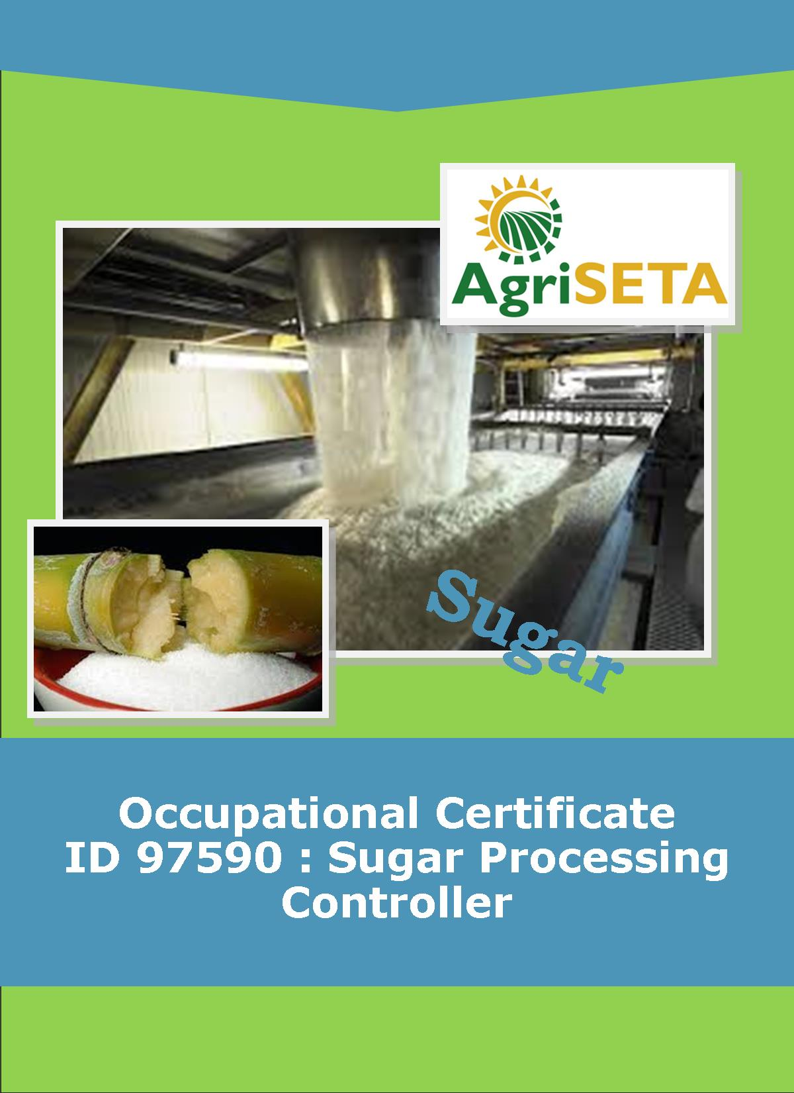
KNOWLEDGE COMPONENT: LEARNING RESOURCE:
BOOK 5: SUGAR JUICE HANDLING AND CLARIFICATION
OCCUPATIONAL QUALIFICATION: SUGAR PROCESSING CONTROLLER

KNOWLEDGE COMPONENT:
LEARNING RESOURCE

BOOK 5: SUGAR JUICE HANDLING AND CLARIFICATION
KNOWLEDGE COMPONENT:
LEARNING RESOURCE
BOOK 5: SUGAR JUICE HANDLING AND CLARIFICATION
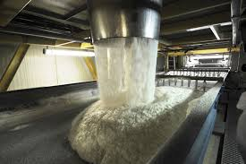
OCCUPATIONAL QUALIFICATION:
SUGAR PROCESSING CONTROLLER

©Copyright AgriSETA
Telephone: +27 12 301 5600


AgriSETA holds the copyright to its publications and Web pages. Proper citation is requested.

TABLE OF CONTENTS
AN INTRODUCTION TO THIS LEARNING RESOURCE 9
KNOWLEDGE MODULE 5 10

SUGAR JUICE HANDLING AND CLARIFICATION 10

1.1 Knowledge Topic 1: Juice Heating 19
1.1.1 PROPERTIES OF MIXED JUICE 19
1.1.1.1 Components of mixed juice 19
(1) Sucrose 19
(2) Reducing sugars 20
(3) Inorganic salts (ash) 20
(4) Organic Acids 20
(5) Colour bodies 21
(6) Iron compounds 22
(7) Tannin 22
(8) Pectins 22
(9) Gums 23
(10) Protein 23
(11) Wax 25
(12) Starch (Amylose) 25
(13) Air 26
(14) Summary 26
1.1.1.2 Need for removal of colloidal substances 26
1.1.1.3 Effect of clarification on juice colour 27

1.1.2 THE PURPOSE OF HEATING 28
1.1.2.1 The need for juice heating prior to clarification 28
1.1.2.2 What is heat? 28
1.1.2.3 Heat transfer 28
(1) Conduction 28
(2) Convection 28
(3) Radiation 28
1.1.2.4 Measurement of heat transfer 29
(1) Heating surface (symbol A) 29
(2) Temperature difference ($∆$T) 29
(1) Mass of juice (symbol M) 32
(2) Temperature change (symbol $∆t)$ 32
(3) Specific heat capacity of the juice (symbol C) 32
1.1.2.5 Types of heat flow: 34
(1) Co-current flow 34
(2) Countercurrent flow 35
(3) Cross flow 36

1.1.3 HEATER CALCULATIONS 37
(1) Juice velocity and heat transfer 37
(2) Pressure drop through a heater 39
(3) Heating surface 40

1.1.4 JUICE HEATERS 41
1.1.4.1 Shell and tube heaters 41
1.1.4.2 Plate and frame heaters 44
1.1.4.3 Flashing and flash tanks 44
1.1.4.4 Purpose of juice heaters 44

1.2 Knowledge Topic 2: Clarification 46
1.2.1 INTRODUCTION: WHY DO WE NEED TO CLARIFY MIXED JUICE? 46

1.2.2 THE PRINCIPLES OF CLARIFICATION 46
1.2.2.1 The Defecation Process 46
1.2.2.2 Heating 47

1.2.3 LIMING 48
1.2.3.1 Lime and milk of lime 49
(1) Limestone 49
(4) Granular lime 49
(5) Powdered lime 50
1.2.3.2 The Baumé scale 50
1.2.3.3 Flashing 50
1.2.3.4 Settling 51
1.2.3.5 The precipitate 51
(1) Nature of the precipitate 51
(2) Nature of the absorbed material around impurity particles 52
1.2.3.6 The role of phosphates in clarification 52
1.2.3.7 Addition of phosphate 53
1.2.3.8 Defecation methods 53
(1) Hot liming 53
(2) Saccharate liming 53
1.2.3.9 Lime addition 55
(1) Perry tank 56
(2) In-line mixer 56
1.2.3.10 pH and pH Control 56
(1) pH control 56
(2) pH drop during clarification 57
(3) Disadvantages of over-liming 58
1.2.3.11 Mechanism of calcium-phosphate precipitation primary flocculation 58
1.2.3.12 Flocculants 59
(1) Flocculation 59
(2) Secondary Flocculation 60
(3) Binding of flocculant with Mud particles 61
(4) Flocculant structure 61
(5) The effect of eletroctrolytes (ions in solution) on polymers 62
1.2.3.13 Flocculant preparation and make up equipment 63
(1) Preparation tank 63
(2) Dosing pump supply tank 64
(3) Eductor assembly 64
1.2.3.14 Settling theory 65

1.2.4 CLARIFIERS 67
1.2.4.1 The Rapid-Dorr Clarifier 67
(1) General operation 68
(2) Starting up and shut down 69
(a) Filling 69
(b) Emptying 69
(c) Operational problems 69
1.2.4.2 SRI Clarifier 71
(1) Description 71
(2) Trouble shooting 74
(3) Retention time 75
1.2.4.3 Juice deterioration 76
(1) Effect of pH 76
(2) Effect of Temperature 77
(3) Control of deterioration 79
1.2.4.4 Assessing the efficiency of clarification 79
1.2.4.5 Comparing mixed juice and clear juice 81
(1) Brix 81
(2) Purity 81
1.2.4.6 Tracer Tests 81

1.2.5 FILTRATION 83
1.2.5.1 Introduction 83
1.2.5.2 Objective of Filtration 83
(1) The separation efficiency must be as high as possible. 83
(2) Sucrose losses must be minimized 84
1.2.5.3 Rotary vacuum filters: Description 84
1.2.5.4 Filter Aids/Mud Conditioning 86
1.2.5.5 Advantages and Disadvantages of Rotary Filters 86
1.2.5.6 Filter station Arrangement 86
1.2.5.7 Performance factors 88
1.2.5.8 Filter Operation 89
(1) Retention 89
(2) Washing of the cake 90
(3) Other performance factors 92
1.2.5.9 Sucrose Losses 92
1.2.5.10 Disposal of Filter Cake 94
1.2.5.11 Clarification and filter station Mass Balance 94

AN INTRODUCTION TO THIS LEARNING RESOURCE
This Knowledge Component Learning Resource: Book 5: Sugar Juice Handling and Clarification is intended to be used with the Knowledge Component Learner Workbook 5 (Formative Assessment Guide): Sugar Juice Handling and Clarification: Sugar Processing Controller NQF 5. It can also be used as a stand-alone information resource (text book).
This Learning Resource provides detailed information on the following topics:
- KM-05-KT01: Juice Heating (40%)
- KM-05-KT02: Clarification (40%)
- KM-05-KT03: Problem solving (20%)
(Note: KM = Knowledge Module, KT = Knowledge Topic)

KNOWLEDGE MODULE 5

SUGAR JUICE HANDLING AND CLARIFICATION
Module number: 313908000-KM05: NQF Level 5: Credits 4
BACKGROUND
In Knowledge Module 2, the various steps in the processing of sugar cane were briefly explained. Juice clarification (or purification) was explained as follows:
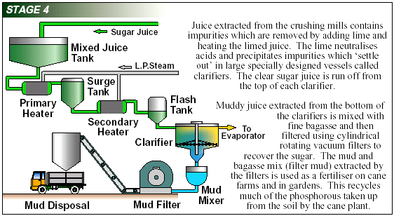
Crushed juice and first mill juice are mixed and screened of bagasse particles and this mixed juice is pumped to the mixed juice scales. This mixed juice is a cloudy, greyish or greenish foaming liquid with a water content of 80 to 84%. In suspension one finds sand particles, fine bagasse particles, cane wax and air bubbles.
Definition: Flocculant

A flocculant is a substance which promotes the clumping of particles.
To produce raw sugar, the mixed juice has to be purified, it is necessary to remove as much of the impurities as possible. This is done in the following steps:
- Heating to +/- 104°C
- Liming of mixed juice (defecation process)
- Settling of mud
- Decanting of the clear juice
- Filtration of the mud
The mixed juice is weighed. This is necessary to get a firm base for making a balance sheet of the sugar entering and leaving the factory. The weighed juice is discharged into a surge tank, from where it is pumped to the juice heaters. The mixed juice is heated in two stages. The process is as follows:
- Primary heating to 70°C.
- Secondary heating to approximately 104°C.
Primary heating is normally done with vapour from the first effect or second effect evaporator. Secondary heating is done with exhaust steam.
A juice heater consists in principle of a steam chest with tubes through which the juice flows and around which steam is present. The tubes are fitted in tube-plates. The cylindrical shell is extended beyond the tube plates at each end, thus forming compartments which are closed by heavy cast iron doors.
In these compartments baffles are fitted which force the juice to change direction to and fro (normally 12 times). The juice is heated to about 104°C, limed to +/- 7.5pH and then passes through the in-line mixer before entering the flash tank. In the flash tank, juice is exposed to atmospheric pressure in order to remove air before clarification takes place.
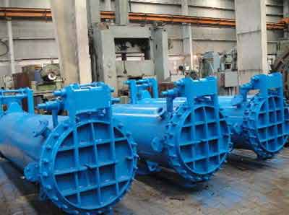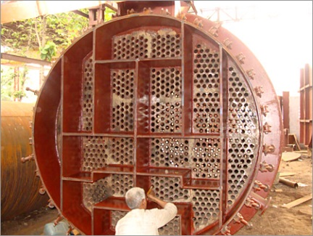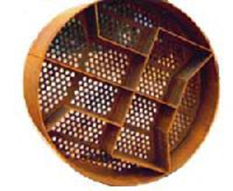
Examples of juice heaters with different configurations of tube-plates.

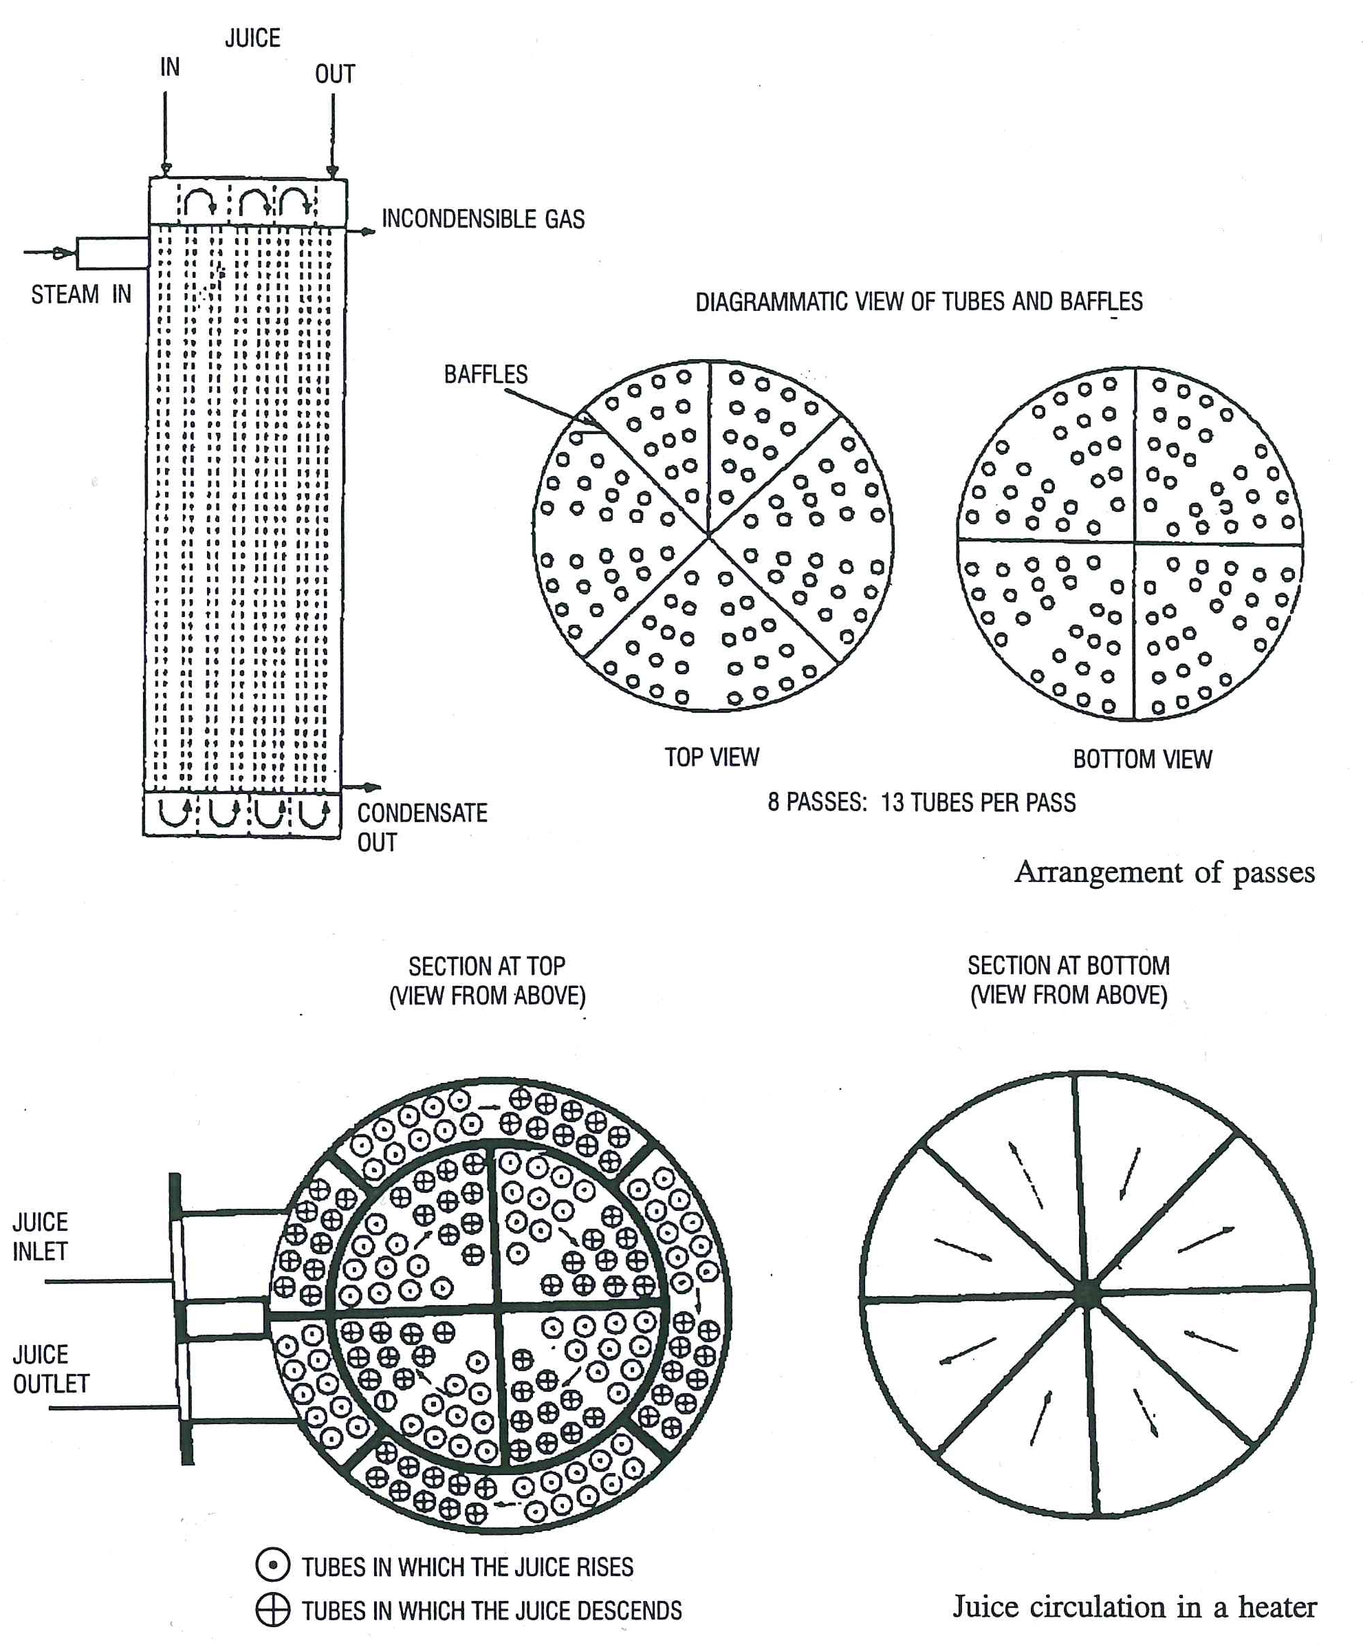
Milk of lime is prepared by slaking burnt lime or quick lime in a slaker consisting of stirrers with cold water. In milk of lime, by far the largest part of the lime is present in suspension and only a small part is in solution. To prevent the lime particles from settling in the pipeline, the milk of lime is pumped around continuously.
At the milk of lime plant, there are three buffer tanks, where a supply of milk of lime is kept. The milk of lime is continuously added to the hot juice in the perry tank, pH being controlled automatically. If the pH controller fails to control, it must be switched to manual and the lime dosing controlled manually with the aid of indicator paper which, when dipped into a sample of the juice, will turn a shade green for the correct pH. If the colour turns yellowish, more lime must be added. It is essential to keep the pH and the temperature very constant to obtain maximum purification. Also used for manual pH control are phenol red and bromothymol blue. These indicators change colour at approximately pH 7. Colour change is from yellow (acid) to red (alkaline) for phenol red and yellow (acid) to blue (alkaline) for bromothymol blue.
A Beaume scale hydrometer or "spindle" provides scientific measurements for the density of liquids.
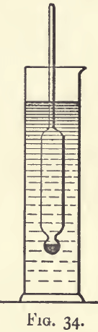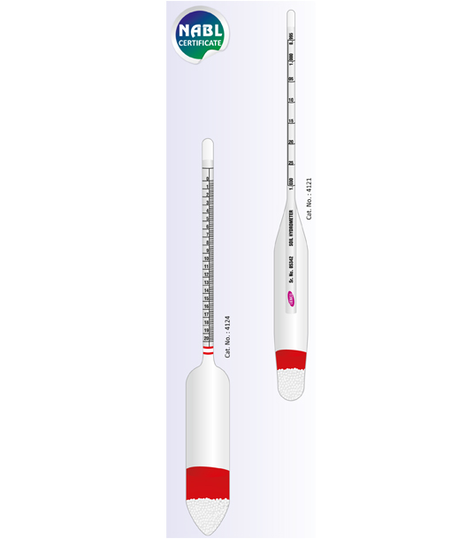
For rough estimation of the concentration of the milk of lime, a so-called Beaume Spindle is used, which shows an accurate reading below 10° Be. One determines the density (concentration) of the milk of lime by plunging the spindle in a cylinder filled with milk of lime.
The disadvantages of using milk of lime with a high concentration are:
- Part of lime does not dissolve.
- These undissolved lime particles cause a high alkaline reaction in the clarifier, resulting in destruction of reducing sugars.
It is very important during the purification process that sucrose and the reducing sugars are not destroyed. The most common purification process in South Africa is the defecation process.
Mixed juice is always acidic, its pH is about 5.5. When milk of lime is added to the heated juice in the clarifier tank, a precipitate (fine insoluble particles) of calcium phosphate is formed that settles out i.e. it removes the suspended solids from the juice. After settling of this precipitate (mud) a layer of clear yellow juice will be seen. The settled precipitate is filtered and the filtrate is returned to the mixed juice after the mixed juice scale.
If this clear juice is heated at a pH below 7, sucrose will be hydrolysed and form invert sugar. The quantity of sucrose which will be inverted depends on:
- The pH (more sugar is inverted at a lower pH)
- The temperature (the reaction is speeded up, when the temperature is higher)
- The time
Lime is produced from limestone CaCo₃, which is heated and decomposed to CaO and CO₂. The burnt lime or quick-lime is slaked with water:
CaO + H₂O = Ca(OH₂)
In the sugar factory a suspension is used, which is known as milk of lime.
When the pH is kept above 7.6 hardly any sucrose is inverted, but at higher pH values, another unpleasant reaction takes place, the reducing sugars will form coloured bodies and acids, which cause many troubles in the production of white sugar.
It has been found that keeping the clear juice at about pH 7.2 is the optimal pH.
From the perry tank, the juice flows to a clarifier – an apparatus for continuous settling. The clarifier consists of a cylindrical shell, with four conical trays built in.
When starting up, the juice enters a feeding chamber and flows through a hollow shaft to the bottom compartments, as the valve in the hollow shaft is open. No juice enters the top compartments, as the valve in the following shaft is open. No juice enters the top compartments until the bottom compartment is entirely full. As now the sloping tray of the top compartment is supported by juice, the danger from sagging no longer exists.
The valve in the hollow shaft should always be open when filling or liquidating a clarifier.
The valve can be closed when the clarifier is completely full. The slowly rotating shaft (5 r.p.h.) has two functions:
- Feeding the four compartments
- Scraping the mud from the sloping trays (4 scraper arms with scrapers are fitted to the shaft, one set for each of the four trays).
After the limed juice has entered the compartments through the hollow shaft, the mud particles settle on the trays and are scraped off by a set of scrapers attached to the shaft. An ordinary chain is fixed in the scraper arm for the same purpose. The scrapers push the mud from the tray into the mudwell. From here it flows through a stand pipe on top of which is a diaphragm-type mud pump, two for each mudwell. In principle the mud discharge could equally take place by gravity, with the advantage of less disturbance (turbulence) in the clarifier. The mud is collected in the mud box from where it flows to the mud mixer where it is mixed with bagacillo as a filter aid. A Weir Box at the end of the mud mixer distributes the mud to the different filters.
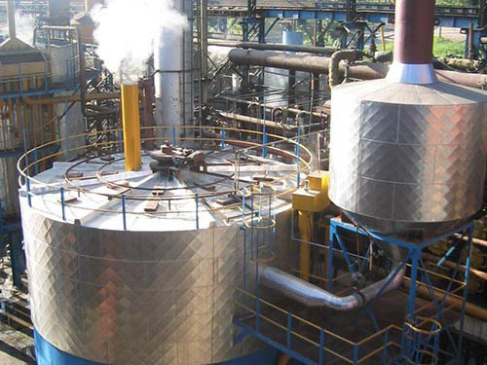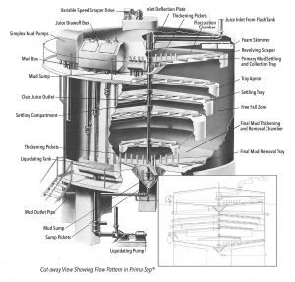
External and internal view of a juice clarifier.
Six cocks are fitted to the mud compartments of the clarifier to check the mud levels. The de-aeration cocks are fitted at the highest point of each compartment. They should always be kept open. At least once a shift these valves and pipes should be thoroughly rinsed with water. Failing to do this can cause a serious accident. If one or more of the de-aeration cocks or pipes are choked, a pocket of air and vapour is formed in that particular compartment. The pressure increases to such a point that it will find the way out through one of the clarified juice overflow lines. The force by which this happens will hurt (burn) anyone in the area.
For proper clarification the following points should be kept in mind:
- An alkaline reaction causes destruction of reducing sugars, coloured products are formed and it will increase viscosity in massecuites and molasses, causing poor curing, lower exhaustion and affecting the quality of the sugar.
- An acid reaction causes inversion of sucrose (the pH of clarified juice should always be kept at +/- 7.0)
- Higher temperature speeds up the two reactions above.
- Short retention times are desirable, as the reactions above are time dependent.
The clear juice is drained off from the highest point in each compartment close to the sidewall of the clarifier. The drainpipes terminate in two juice boxes, built on top of the clarifier. For each group of four drains or overflow pipes the output can be regulated at the end of the pipe by means of a sliding tube (telescopic pipe). The clear juice in the overflow pipe is in equilibrium with the juice inside the Dorr and the quantity of limed juice entering the clarifier from the defecation tank. The clarifiers found in South African factories today are generally of the Rapi-Dorr type and the trayless clarifiers are known as the S.R.I. Clarifiers.
The SRI Clarifier is made up of a cylindrical tank in which circumferential launders are fitted. The juice is fed into the feed launder tangentially at one or more points. The feed launder encircles the feed-well and by means of slots made on its inner edge, juice is distributed evenly. The feed-well extends downwards for a little more than one metre. Beneath the feed-well there is a deflector plate that directs the descending juice toward the centre and the periphery. A cone of separation is soon established in which the clear juice travels up to the outlet launders and the solids to the bottom where they are withdrawn. There are two or three juice outlet launders, one on each side of the feed launder. They are provided with slots on their inside and outside, to allow juice to be withdrawn from the entire surface area. The main advantage of the SRI Clarifier is its short retention time.
The Rapi-Dorr Clarifier is operated on the counter-flow principle. The juice is admitted at the top centre and moves out towards the periphery where it is extracted at the point of lowest velocity. The separated mud is collected on the trays and is pushed by means of scrapers until it falls to a thickening chamber where it is compacted before being withdrawn. The main disadvantage of this clarifier is its long juice retention time which enhances sucrose losses.
Although most of the non-sugars are removed during this clarification process, some inorganic substances remain. To improve settling of juice in the clarifier and also to assist filtration, polyelectrolytes are used as flocculants. The best known of these is Separan R300, Magnafloc LT27 and Talosep A3. When the charges of these flocculants are neutralised by particles of opposite charge from the juice, the polymers with attached (mud) particles will agglomerate and large sized floc will be formed rapidly.
The flocculent is dosed continuously to the limed and heated juice, preferably just before entering the clarifier. The amount required is between 0.1 and 5 ppm (parts per million) on mixed juice.
Mud from the clarifier is mixed with bagacillo in a mud mixer. The mixture is then processed using a vacuum filter. This filter consists of a horizontal drum, the surface of which is divided by longitudinal ribs into shallow chambers extending the full length of the drum. The outer surface of these chambers is covered by stainless steel screens with small apertures (0.5mm). Each chamber is connected individually to a vacuum system by a small metal and rubber pipe which runs through the hollow axis and terminates in a distribution head at both ends of the drum.
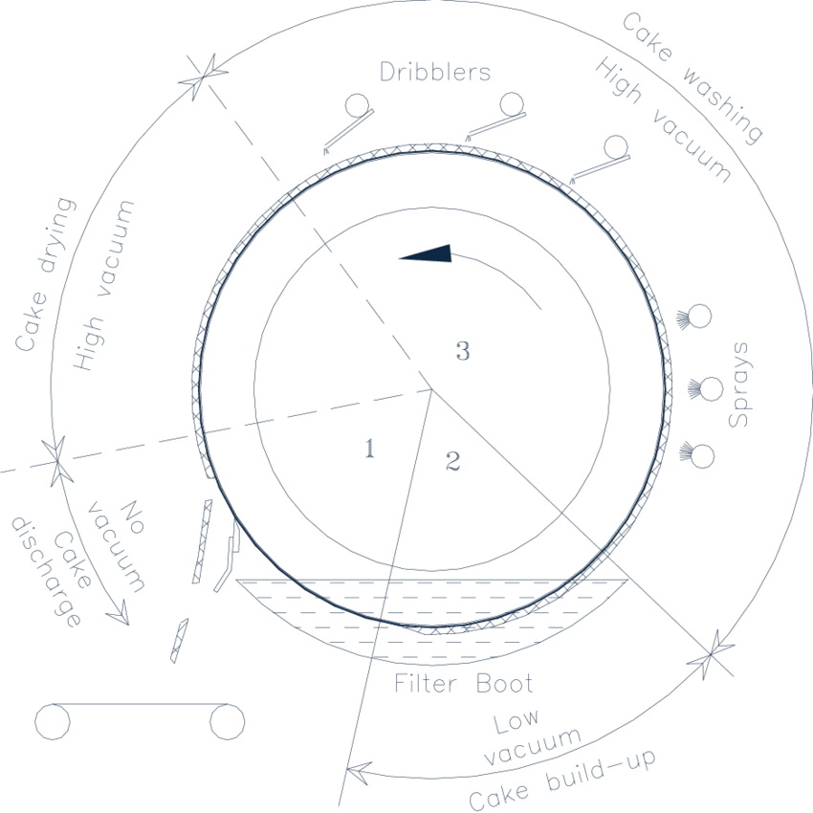
When the drum rotates, this distribution head connects each of the chambers in turn to low vacuum, high vacuum and no vacuum (atmospheric pressure). The rotating drum dips into a tray containing the mixture of mud and bagacillo. An agitator prevents settling of mud in the tray. As the drum rotates, its surface will be submerged in the mud. Low vacuum is applied to the different chambers up to point 2 (see diagram below), forming a thin cake on the filtering surface. Before this thin cake is formed, quite a considerable part of the suspended particles will pass through the screen.
The percentage of the undissolved dry matter in the muddy juice is retained on the screen and removed as cake. This is called retention. A good retention of 80% or higher is very important as the mud particles passing the screen are returned with the filtrate to the mixed juice, and back into the clarification process. Recirculation should always be avoided, not only here but everywhere in the process.
Low vacuum is applied first and then high vacuum, otherwise retention would drop considerably.
After passing point 2 the vacuum is switched from low to high and the cake builds up further until the drum emerges from the mud tray. The cake so formed passes under washing sprays, is dried by suction and scraped onto a conveyor belt from where it will go back to the cane fields as fertiliser.
The criteria of a good filter operation are:
- Good retention, depending on:
- Properly adjusted distribution head
- No worn or broken screens
- The bagacillo ratio – The ratio between bagacillo and mud should be +/- 0.6 to 1.
- Bagacillo fineness – Approximately 80% dried bagacillo should pass a 20 mesh screen.
- Rpm of the rotating drum
- High and low vacuum.
- Low pol % filter cake, depending on:
- Amount of water
- Proper distribution and spraying of wash water covering the whole surface of the drum
- Temperature of the wash water should be approximately 90°C
- Rpm of the rotating drum
- High and low vacuum, of which the ratio should be 2:1 with an optimum high vacuum of 50kPa
Vacuum in the filter is maintained by means of a condenser and a vacuum pump. The filtrate is divided by the distribution head into cloudy filtrate from the low vacuum section and clear (less cloudy) filtrate from the high vacuum section.
Each of these filtrates go to a separate tank, the so-called high and low filtrate tanks. These two tanks are connected with each other by a pipe in which a reducing valve has been fitted. This valve allows a vacuum to be built up in the low filtrate tank but at a lower level.
In this Knowledge Module we will delve into these processes in more detail.

  - Knowledge Topic 1: Juice Heating

PROPERTIES OF MIXED JUICE

Components of mixed juice
Some of the major constituents of cane juice from the extraction plant are:
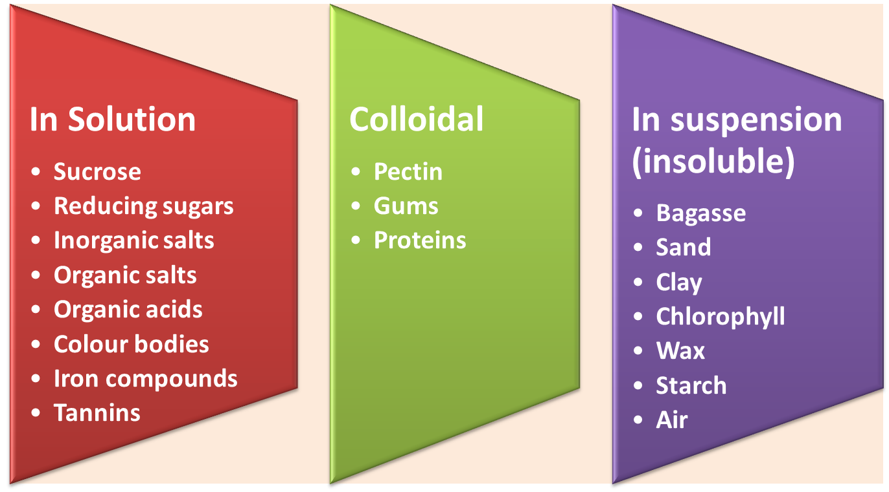

Sucrose
Sucrose is the name given to the disaccharide formed when a molecule of glucose is combined with a molecule of fructose.
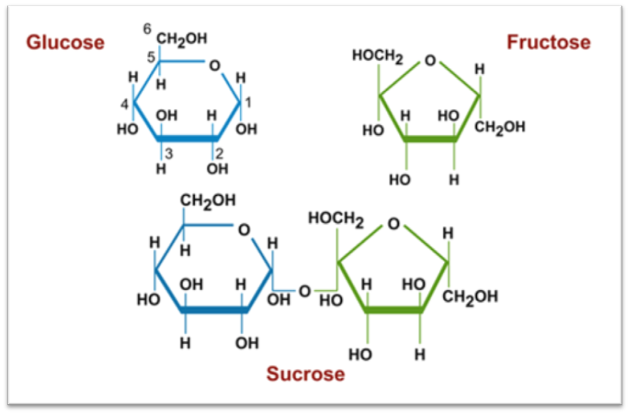

Reducing sugars
Reducing sugars are monosaccharides (simple sugars) like glucose and fructose.
Reducing sugars are not removed during clarification and are carried through into the final molasses.
Reducing sugars can be destroyed by the action of heat, under alkaline conditions. The reaction products can be highly coloured and this degradation of reducing sugars must be prevented. The composition of reducing sugars also produce acids that must be neutralized by lime and thus increase the calcium content of the juice. Another reason why we do not wish to destroy reducing sugars is that the reducing sugars decrease the solubility of sucrose and thus increases the sucrose recovery during pan boiling .

Inorganic salts (ash)
Inorganic salts consisting of combinations of positive and negative ions.
Positive ions : K⁺, Na⁺,Ca²⁺,Mg²⁺,Fe⁺
Negative ions: Cl⁻,SO₄³⁻,PO₄³⁻ and SiO₄⁴⁻
Inorganic salts are not removed in the clarifier, but some precipitate as scale in the evaporators while the rest is carried through into final molasses. Inorganic salts increases the solubility of sucrose and thus decreases the sucrose recovery during pan boiling.

Organic Acids
The most frequently found are glycollic, suxine, malic, oxalic, tonic, citric, acetic, and aconitic acids. All form soluble lime salts and are not removed by clarification. Oxalic acid reacts to form calcium oxalate that normally precipitates at higher brixes in the last vessels of the evaporators, forming a hard scale.

Colour bodies
Colour bodies are chlorophyll, anthocyanins and flavanols (polyphenols). Also included is saccaretin, a black pigment associated with sugar cane processing. Saccaretin is not a single compound, but a mixture formed during processing.
- Plant pigments
Chlorophyll A and B are the green pigments in plant leaves. Other pigments are carotene (yellow) and xanthophyll (yellow). These pigments are all removed or destroyed during clarification and are not usual constituents of raw sugar.
- Flavanols
Flavanols are polyphenols present in sugar cane and are of interest because they react particularly with iron and oxygen to form dark coloured compounds especially in alkaline solutions.
Polyphenols are located principally in the nodes of the cane stalks and in the leaves.
Example:
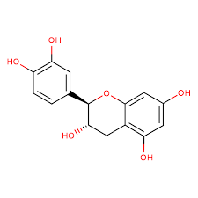
d-catechin (5-7-3-4-tetrahydroxy-flavanol-3)
Anthocyanins is a general term for the group of red, blue and violet colouring materials found in plants. Anthocyanins are soluble in water and enters the mixed juice. When lime is added it changes to a dark green but is not precipitated (except when strongly alkaline). Anthocyanins are polyphenols and are turned dark by iron salts.

Iron compounds
These are organic molecules that contain the Fe²⁺ and Fe³⁺ ions.

Tannin
Amorphic substances consisting of complexes of esters and ethers of various carbohydrates. On hydrolysis gallic acid and glucose molecules are among the products. Its removal during clarification is not clear.
Example:
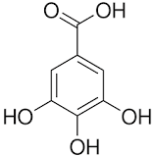
Gallic Acid

Pectins
Pectins are gelatinous carbohydrates which have a pronounced property of increasing the viscosity of solutions. The structural unit of the methylated polygalacturamide polymer chain of pectin is as follows:
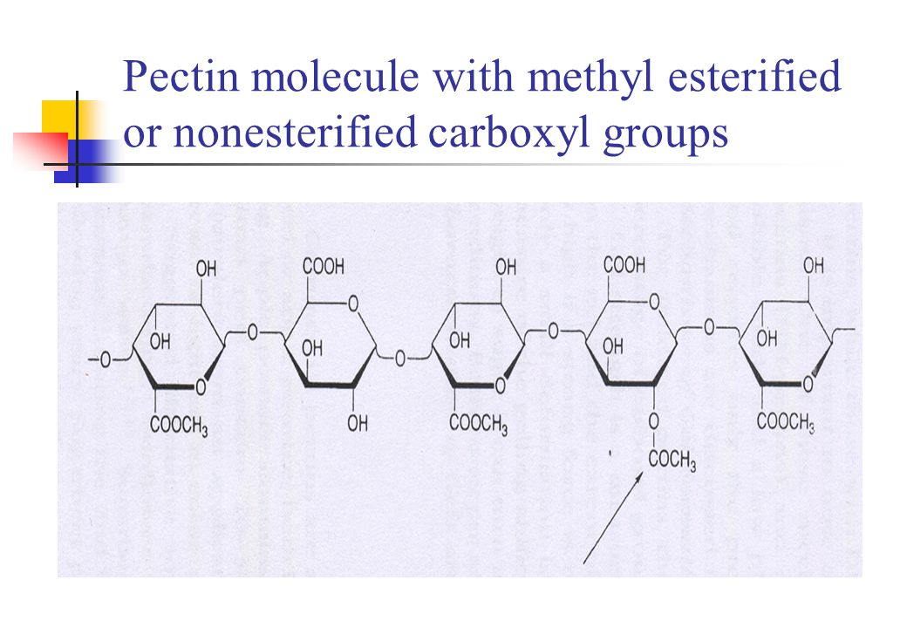
Pectins are found mainly in the cell wall material. The quantity that is expressed in cane juice depends to a large extent on the extraction process. Pectins may be released into solution by heating juice which contains bagasse particles. The juice that is expressed from the last mills will contain more pectins than the juice that is extracted from the first mills. Pectins increase the solubility of sucrose. They will thus slow down the crystallization process. Pectins are easily hydrolysed in alkaline solutions to pectic acid so that in liming juice calcium pectate is formed. This is highly insoluble but usually results in the formation of a gel. Pectins are therefore precipitated and removed during clarification.

Gums
Gums are colloidal polysaccharides consisting principally of pentosans units which upon hydrolysis give pentose sugars. The pentosans are hydrophilic substances which markedly increase the viscosity of solutions. Their removal during clarification is not clear.
The amount of gums in the cane juice will depend upon cane variety, conditions of growth and climatic conditions. Cane which is left standing in the field after cutting or diseased cane will contain higher gum content than fresh cane

Protein
Proteins are very large molecules serving a variety of functions within a living organism. Despite their wide range of functions, all proteins have something in common with one another. They are polymeters made up by linking together, in various combinations, a number of different simple monomeric units called α-amino acids
An amino acid is a bifunctional organic molecule that contains both a carboxyl group (-COOH) as well as an amino group (-NH₂). In an α-amino acid the amino group is located on the carbon atom adjacent to the carboxyl group. This gives the following general structure.
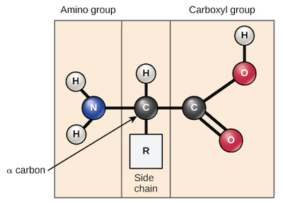
Example:
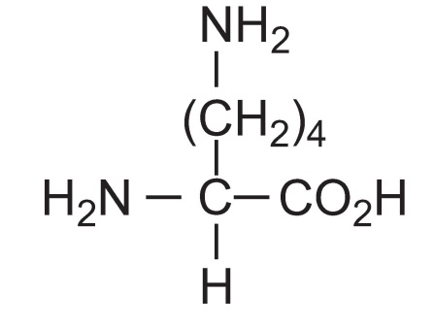
Lysine
In a protein molecule amino acids are linked together to form a long chain. This can be viewed as the result of the elimination of a water molecule from between the-NH₂ group of one amino acid molecule and the-COOH group of another. The molecule is called a peptide.
Proteins in mixed juice originate from tops and trash. They are removed by clarification, since they are coagulated by heat and lime. The main protein found in cane juice is albumin.
The following is the structural formula for a tannin called corilagin:
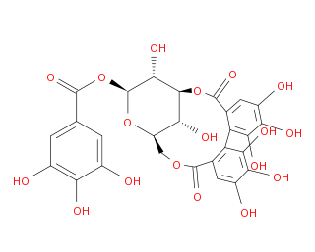
Corilagin

Wax
Cane wax originates in the nodes and in the rind of the cane plant. Between 60-80% of the wax is retained in the bagasse. The amount of wax retained in the bagasse will depend on the temperature of the imbibition water used. Wax in the juice is physically removed with the mud during clarification and it can be recovered from the filter cake. Some wax may remain in suspension and be occluded into the sugar crystals.

Starch (Amylose)
Starch is composed of glucose units strung together.
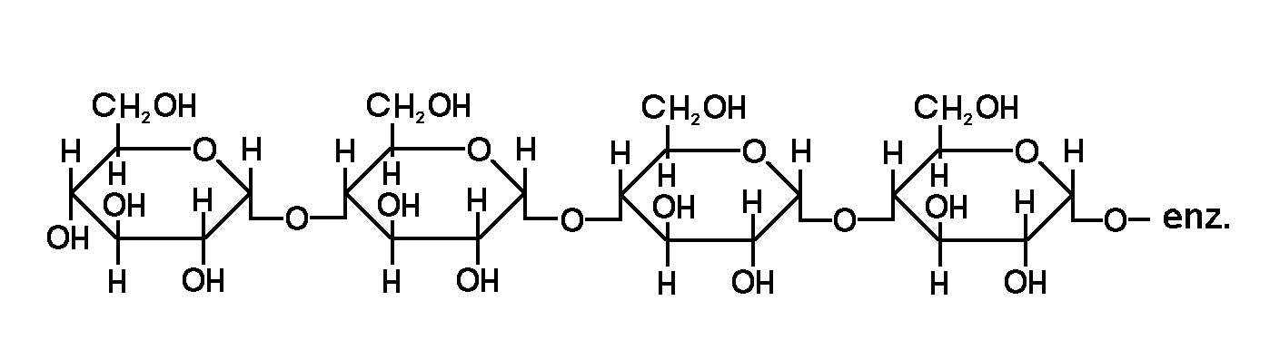
Glucopyranoside structure of starch
Starch is one of the most undesirable impurities in cane juice as its inclusion in the sugar crystal will cause difficulties in refinery filtration. Starch occurs in the cane plant and serves as a reserve food for the plant. Granular starch is insoluble in cane juice but becomes soluble above 70°C. At this temperature the starch granules burst releasing colloidal starch into the juice. A small amount of starch is removed during clarification; however the rest will be occluded in the sugar crystal and slow down the crystallization rate. It can be removed by using enzymes (α amylase) which hydrolyses the starch to glucose and maltose. The enzyme is usually added between the 2nd and 3rd effect evaporators.

Air
Air will interfere in any clarification process involving settling. It must therefore be removed before settling can take place. This is one of the reasons why the juice is heated and flashed prior to clarification. The solubility of air decreases with an increase in temperature.

Summary
It is clear that soluble impurities (non-sugars) are not removed during clarification. As these impurities remain in solution the brix change from mixed juice to clear juice is negligible. This is why clarification doesn’t drastically affect purity. Clarification is thus judged by turbidity (clarity). As the suspended matter affects turbidity this is the impurity that must be removed.

Need for removal of colloidal substances
If not removed from the juice, colloidal substances may increase the viscosity of syrup and molasses, slow down filtration, cause foaming, increase the colour and finally interfere with the crystallization of sucrose. Although percentage wise, the quantity of colloids eliminated is not large, the removal of substances in this range is an important result of clarification.
A group of compounds that can cause particular problems during processing are the pectins, gums and proteins. Their effect is kept under control as long as the quantities are relatively small. However, after a severe frost, for example, their concentration increases dramatically resulting in severe processing problems. These compounds increase the viscosity and cause crystal growth irregularities.
If cane is allowed to stand and go stale the following occur:
- Organic acids increase ( mainly lactic acid)
- Gums increase
- Reducing sugars increase
Inversion involves the decomposition of sucrose into glucose and fructose. Glucose and fructose are called invert sugars or reducing sugars. This reaction is highly undesirable since glucose and fructose cannot be converted back into sucrose by man-made processes. The glucose and fructose is lost in molasses.
The rate (speed) of inversion increases with:
- Increase in acidity (pH>7)
- Increase in temperature
- Increase in the time of the exposure to the above mentioned conditions
It is impossible to control all three factors at all times during the sugar manufacturing process. To minimize inversion it is important that at least 2 factors are controlled at all times. The whole factory is designed with this in mind. Since cane juice is naturally acidic it is imperative that lime be added to keep the pH close to 7 (neutral).
It has been found that the rate of inversion at pH 5,4 and 100°C is 1% inversion per hour.

Effect of clarification on juice colour
Colour normally increases in the clarification process. The dark colour of raw juice is caused principally by various polyphenol derivatives, chief among which is tannin. In the presence of iron (which may be dissolved from mill rolls) the colour is two to three times darker than in the absence of iron. This is attributable to the combined interaction of the polyphenols, the oxidative enzyme lactose, and iron salts. The ferrous salts from the mill are oxidized to ferric ions by enzymatic action and these give the dark coloured compounds with polyphenols.
The phenolic colouring substances which are primarily in the colloidal state are not effectively removed by clarification. The actual quantity present is normally less than 0.01 per cent, but this is sufficient to give highly coloured juices.
The precipitate of calcium phosphate formed in liming does absorb some colour. The amount absorbed increases with the phosphate content of the juice. However, the removal in simple clarification is generally not sufficient to counteract the colour produced in the process.
This highlights the fact that the simple defecation process is used to rid the juice of suspended and colloidal matter. It has very little effect on reducing colour (if any) and in fact can lead to colour increase.

THE PURPOSE OF HEATING

The need for juice heating prior to clarification
Heating the mixed juice before clarification has several important benefits and greatly assists the clarification process. This will be discussed in more detail later.

What is heat?
Heat is a form of energy. The temperature of an object/material is an indication of the amount of heat energy that it contains i.e. the average kinetic energy of the vibrating/moving particles. Heat energy is measured in joules.

Heat transfer
Heat energy moves from one place to another in three ways:

Conduction
Here the heat energy moves from a region of higher temperature to a region of lower temperature with the heat energy being transferred from particle to particle.
Example: When one end of a metal rod is heated the heat energy is transferred atom-to-atom towards the cooler end and the cooler end will start to heat up i.e. the atoms will start to vibrate.

Convection
Here the heat energy is transferred by higher energy particles moving to regions of lower energy.
Example: when a beaker of water is heated, currents are formed when molecules with high kinetic energy move to areas where the molecules have lower kinetic energy

Radiation
Here the heat energy travels through space in the form of waves.
Example: Heat energy moves from the surface of the sun to earth through the vacuum of space.
Heating and boiling in the factory is done using conduction which is the transfer of heat through a solid media (tube wall) from particle to particle without any particle migration (movement).

Measurement of heat transfer
Method 1: Using the heat transfer co–efficient
The quantity of heat (Symbol Q) transferred and absorbed by a body (i.e. the juice)
Depends on the following factors:

Heating surface (symbol A)
The greater the surface area of hot medium (vapour/steam) in contact with cooler medium (juice) the greater will be the rate of heat transfer from the hot medium to the cooler medium. Mathematically we say that the rate of heat transfer is proportional to the heating surface.
Q $∝$ A
The rate of heat transfer is measured in kilojoules per second (kJ.s⁻¹) and the area is measured in square metres (m²)

Temperature difference ($∆$T)
The greater the temperature difference between the heating medium (vapour/steam) and the juice the greater is the rate of heat transfer. The rate of heat transfer is said to be proportional to the temperature difference.
Q $∝$ $∆$T
The temperature difference is measured in C°.
The effect of heating surface and temperature difference on the rate of heat transfer can be represented as follows in equation form.
Q $∝$ A x $∆$T
Q = k x A x $∆$T
Where k is a constant called the heat transfer co-efficient.
Q = Rate of heat transfer (kJ.s⁻¹)
K = Heat transfer co-efficient (kJ.m⁻²°C^{­1}s⁻¹)
A = Heating surface (m²)
T = Temperature difference between steam and juice (°C)
The coefficient (k) takes into account resistances to heat flow and is influenced by velocity of flow and the condition of the heating surface. A high heat transfer co-efficient (H.T.C. value) is thus desirable. As the heat transfer surface becomes progressively more scaled, the opposition resistance to heat transfer increases and the HTC value drops. We can rearrange the equation for heat transfer to obtain an expression for the H.TC.
K = Q/ A.$∆$T
Example: Consider a clear juice heater
Heating surface= 150cm³
Temperature of steam fed to the heater=120°C (P_{STEAM}= 200kPa)
Mass (average) of the juice in the heater=110°C
Rate of condensate formation= 3.2 tons/hour
Calculate the heat transfer co-efficient.
Solution
Each kilogram of steam that condenses at 200kPa releases 2200 Kj of latent heat (from steam tables).
This latent heat heats the juice.
Latent energy released by 3200 kg of steam per hour =3200kg/hour × 2200 kJ/kg
= 7 040 000 kJ/hour
Latent energy released by 3200kg of steam per second = 7 040 000 kJ/hour / 3600 s
=1956 kJ/s
Temperature difference ($∆T$) = Temperature of steam – Mean temperature of juice
= 120°C - 110°C
= 10°C
K = Q / A.$∆$T
K = 1956 kJ/s / 150m².10°C
K = 1.3 kJ/m².C.s
PURPOSE OF EVAPORATION (STEAM TABLE)
ABSOLUTE  PRESSURE  kPa | TEMPERATURE  °C | LATENT  HEAT  kJ.kg⁻¹
5.0 | 32.88 | 2423.7
10.0 | 45.81 | 2392.8
15.0 | 53.97 | 2373.1
20.0 | 60.06 | 2358.3
25.0 | 64.97 | 2346.3
30.0 | 69.10 | 2336.1
35.0 | 72.70 | 2327.2
40.0 | 75.87 | 2319.2
45.0 | 78.70 | 2312.0
50.0 | 81.33 | 2305.4
55.0 | 83.72 | 2299.3
60.0 | 85.94 | 2293.6
65.0 | 88.01 | 2288.3
70.0 | 89.95 | 2283.3
75.0 | 91.78 | 2278.6
80.0 | 93.50 | 2274.1
85.0 | 95.14 | 2269.8
90.0 | 96.71 | 2265.7
95.0 | 98.20 | 2261.8
100.0 | 99.63 | 2258.0
101.3 | 100.00 | 2257.0
106.3 | 101.40 | 2253.3
111.3 | 102.66 | 2250.2
116.3 | 103.87 | 2246.7
121.3 | 105.10 | 2243.4
126.3 | 106.26 | 2240.70
131.3 | 107.39 | 2237.2
136.3 | 108.50 | 2234.1
141.3 | 109.55 | 2231.3
146.3 | 110.58 | 2228.4
151.3 | 111.61 | 2225.6
156.3 | 112.60 | 2223.1
161.3 | 113.56 | 2220.4
166.3 | 114.51 | 2217.9
171.3 | 115.40 | 2215.4
176.3 | 116.28 | 2213.0
181.3 | 117.14 | 2210.5
186.3 | 117.96 | 2208.3
191.3 | 118.80 | 2205.6
196.3 | 119.63 | 2203.5
200.0 | 120.23 | 2201.9
201.3 | 120.42 | 2201.1
206.3 | 121.21 | 2199.1
211.3 | 121.96 | 2197.0

Method 2: Using the specific heat capacity.
The quantity of heat (symbol Q) transferred and absorbed by a body (i.e. the juice) also depends on the following factors:

Mass of juice (symbol M)
The greater the mass of juice the more heat is transferred and absorbed by the juice. The heat transferred is said to be proportional to the mass of juice
Q $∝$M
The mass of juice is measured in kg.

Temperature change (symbol $∆t)$
The greater the temperature difference/change between the start and end of heat transfer, the greater the amount of heat transferred. The heat transferred is thus proportional to the temperature change.
Q $∝$ $∆t$
Temperature change/difference is measured in °C.

Specific heat capacity of the juice (symbol C)
The specific heat capacity of a substance is the quantity of heat energy necessary to raise the temperature of 1kg of the substance by 1°C.
The specific heat capacity of juice is thus the kJ of heat energy required per 1kg 1°C rise in temperature (kJ.kg⁻¹°C⁻¹).
The greater the specific heat capacity of the juice, the more heat is transferred and absorbed by the juice for a given temperature change/difference.
Q $∝$ C
The specific heat capacity of sugar solutions can be calculated from the following equation:
C= (1 - 0.006 x B) x 4.187
Where:
B = Brix of sugar solution
C = Specific heat in kJ.kg⁻¹.°C⁻¹
The quantity of heat absorbed by a body is expressed as:
Q=M x C x $∆$t
Where:
Q = Quantity of heat transferred (kJ)
M = Mass of substance (kg)
C = Specific heat of substance (kJ.kg⁻¹.°C⁻¹
$∆$t = Temperature change between start and end of heat transfer (°C)
Example:
What is the heat required per hour to heat juice of 15°Brix flowing through a heater at the rate of 1800kg.min⁻¹ if the inlet temperature is 21°C and the outlet temperature is 71°C.
Calculation:
C = (1 - 0.006 B) 4.187
= (1 - 0.006 x 15) 4.187
= 0.91 x 4.187
= 3.82 kJ.kg⁻¹°C⁻¹
Q = M x C x $∆$t
For one minute:
Q = 1800kg x 3.82 kJ.kg⁻¹.°C⁻¹ x(71 - 21)°C
= 343 800 kJ
For one hour:
Q = 343 800 kJ x 60 = 20 628 000 Kj
For one second:
Q = 343 800kJ / 60 s
Q = 5730 kJ.s⁻¹
Q = 5730 kJ.s⁻¹
Q = 5730 kW

Types of heat flow:
In a heat exchanger there can be three types of heat flow

Co-current flow
Here the hot liquid and cold liquid flow parallel in the same direction. The result is that the temperature of the hot liquid decreases and the temperature of the cold liquid increases until the same temperature is eventually reached.

Pictorial representation
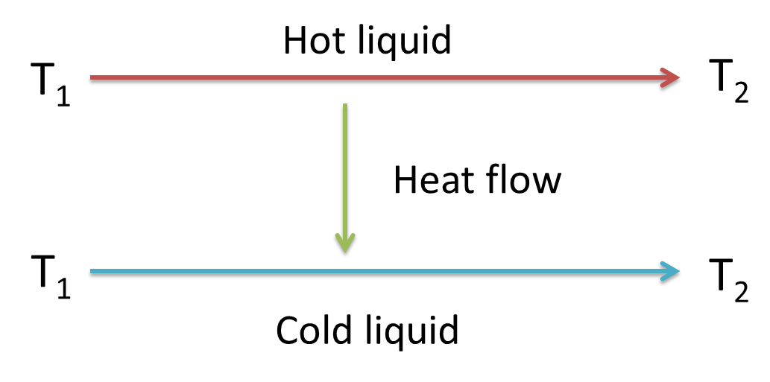
Graphical representation:
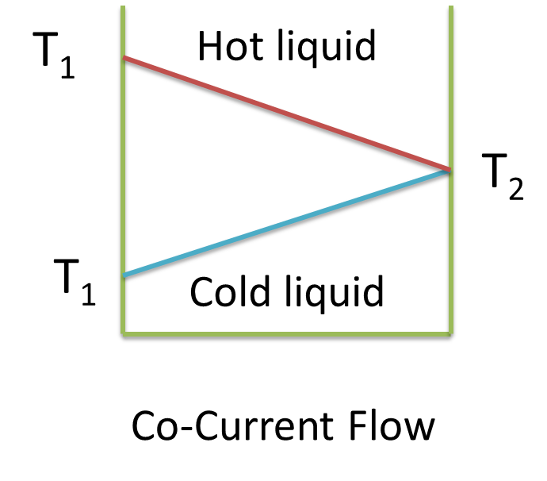

Countercurrent flow
Here the hot liquid and cold liquids flow parallel in opposite directions. The temperature of the hot liquid decreases and the temperature of the cold liquid increases until the same final temperature is reached.
Pictorial representation:
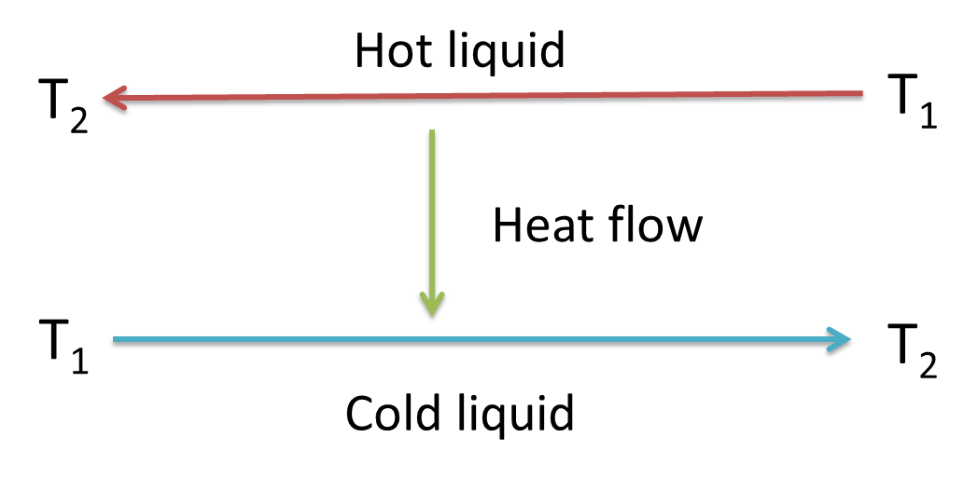
Graphical representation
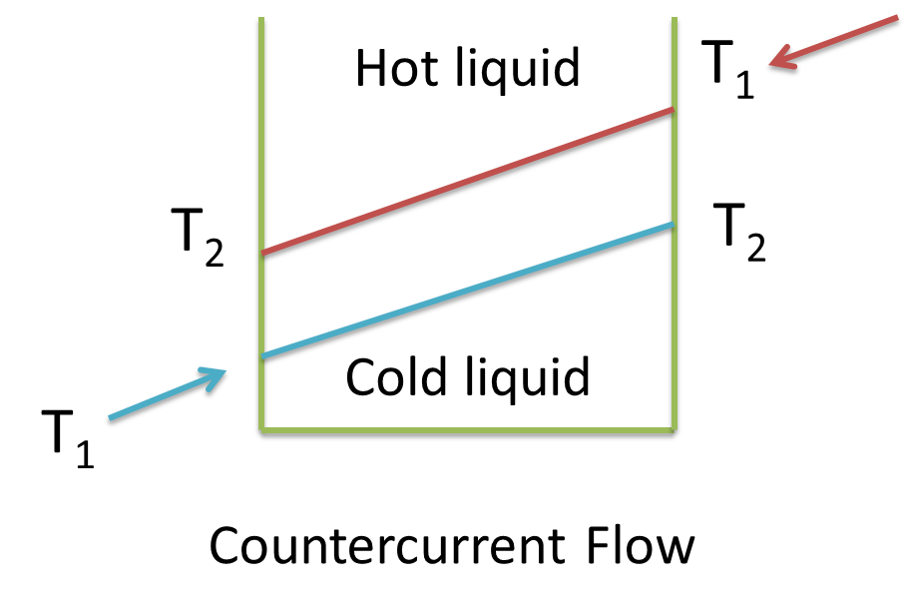

Cross flow
Here the hot heating medium is saturated steam. The result is that as the steam loses heat, it condenses and is replaced by new steam thus maintaining a constant temperature. The liquid on the other hand increases its temperature.
Pictorial representation:
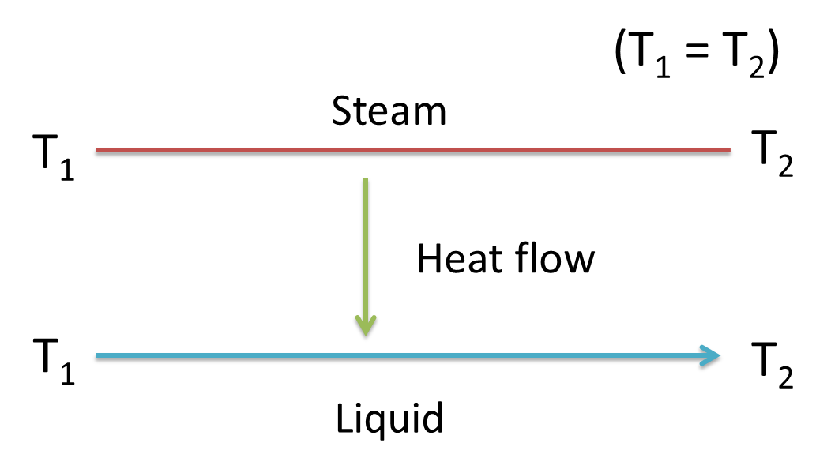
Graphical representation:
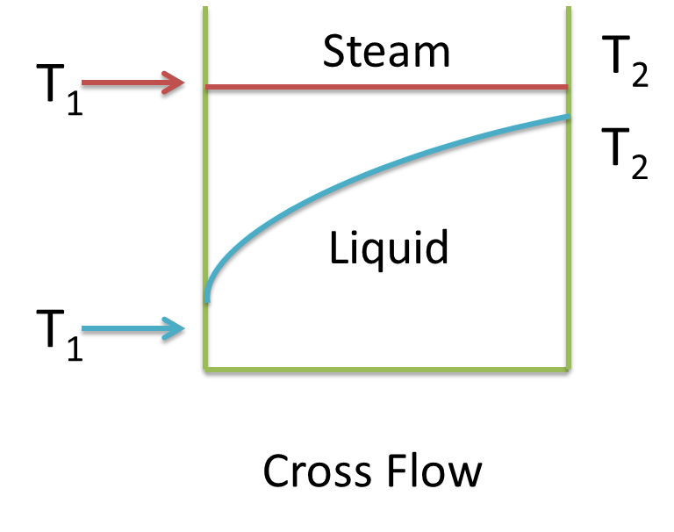

HEATER CALCULATIONS

Juice velocity and heat transfer
The velocity of the juice through the tubes affects the overall heat transfer co-efficient. The juice velocity should lie between 1.5 to 1.8ms⁻¹ so as to get good turbulence and heat transfer.
Below 1.5ms⁻¹ the heat transfer coefficient drops with decreasing velocity necessitating a greater heating surface.
The decrease in velocity also increases the rate of scaling which will also affect the heat transfer co-efficient. Above 1.8ms⁻¹ the increase in the pressure drop between inlet and outlet becomes prohibitive.
The relationship between the velocity and heat transfer is a function of the heat transfer coefficient, the juice velocity and vapour temperature:
K=1.165 T_{v} (5+ v)
Where: K= Heat transfer coefficient (W.m⁻².°C⁻¹.s⁻¹ or J.m⁻².°C⁻¹.s⁻¹)
v =Juice velocity (m.s⁻¹)
T_{v} = Vapour Temperature
Examples:
- Juice velocity = 1.5 m.s⁻¹
Vapour temperature = 111°C
K = 1.165 x (5+1.5)
= 840 W.m⁻².°C⁻¹
- Juice velocity = 1.8m.s⁻¹
Vapour temperature = 111°C
K = 1.165 T_{v} (5 + V)
= 1.165 x 111 (5 + 1.8)
= 879 W.m⁻². °C⁻¹

Pressure drop through a heater
The pressure drop across a heater or heaters in series should be limited to 520kPa.The calculation of pressure drop is a function of the juice velocity, the tube diameter, the number of passes and the tube length.
Increasing the juice velocity increases the pressure drop which may be detrimental to the pump. Two heaters in series would double the pressure drop.
Formula: P = 0.0245 x (v²C / D) x (1 + L)
Where: P = Pressure drop (kPa)
v = Juice velocity (m.s⁻¹)
D =Tube diameter (m)
C = Number of passes
L = Tube length (m)
Example 1:
Juice velocity = 1.5 m.s⁻¹
Tube diameter = 50mm
Number of passes = 20
Tube length = 4.6m
P = 0.0245 x (v²C/D) x (1+L)
= 0.0245 x (1.5 x 1.5 x 20) / 0.050) x (1 + 4.6)
= 123 kPa
Example 2:
Juice velocity = 1.8 m.s⁻¹
Tube diameter = 50 mm
Number of passes = 20
Tube length = 4.6m
P = 0.0245 x (v²C/D) x (1+L)
= 0.0245 x (1.8 x 1.8 x 20) / 0.050) x (1 + 4.6)
= 178 kPa

Heating surface
The heating surface of the heater is the surface calculated using the internal diameter of the tubes. To obtain the same juice outlet temperature an increase in velocity would require more heating surface.
The heating surface required can be calculated from the following formula:
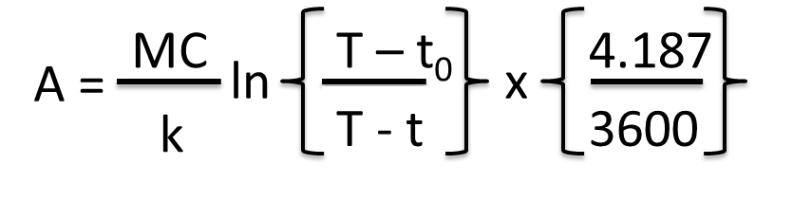
Where:
A = Area of heating surface (m²)
M = mass of the juice to be heated (kg)
C = specific heat of the sugar solution
T = temperature of the heating vapour (°C)
T = final temperature of the hot juice (°C)
t₀ = initial temperature of the cold juice (°C)
K = heat transfer co-efficient (J.m⁻².°C⁻¹.s⁻¹ or W.m⁻².°C⁻¹)

JUICE HEATERS

Shell and tube heaters
A traditional juice heater consists of a cylindrical steel shell with brass or stainless tubes expanded into tube plates at the ends of heater.
At each end of the heater baffles are arranged so that the juice will pass through a fixed number of tubes in succession. Juice is pumped through the tubes while vapour is fed around the tubes. Condensed vapour is removed via a condensate pipe and a gas vent allows incondensible gases to escape to atmosphere.
When vapour with a pressure close to atmosphere pressure is used for heating the incondensible gases are withdrawn to the sub-atmospheric pressures of the last vessels of the evaporator station.
Heaters may be mounted vertically or horizontally depending on whether floor space or vertical height is the main consideration. The following diagram is a side view of a horizontal juice heater. Each pass in the diagram represents 21 tubes.
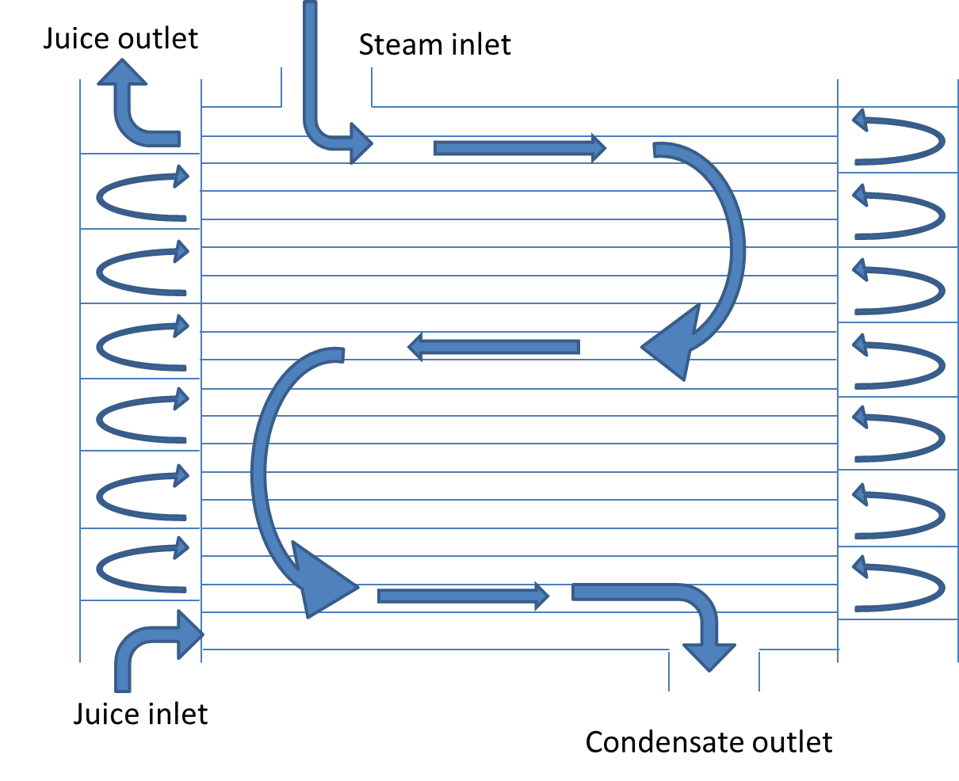
The diagram below shows the top and bottom of a 16 pass vertical juice heater.
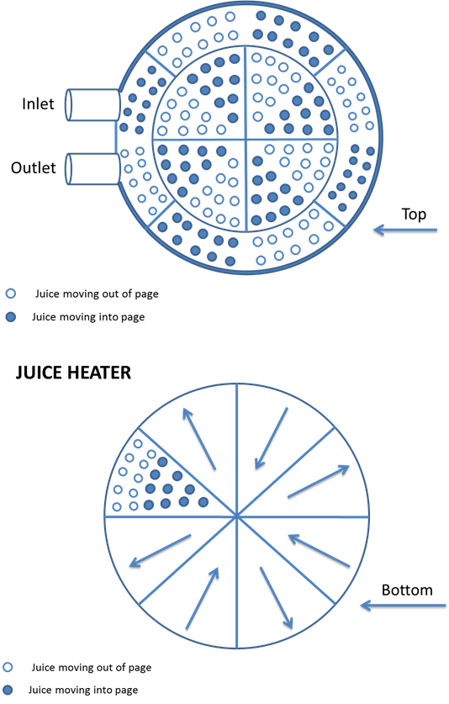
External details of a typical shell and tube juice heater:
(Fives Lllle-Cail)
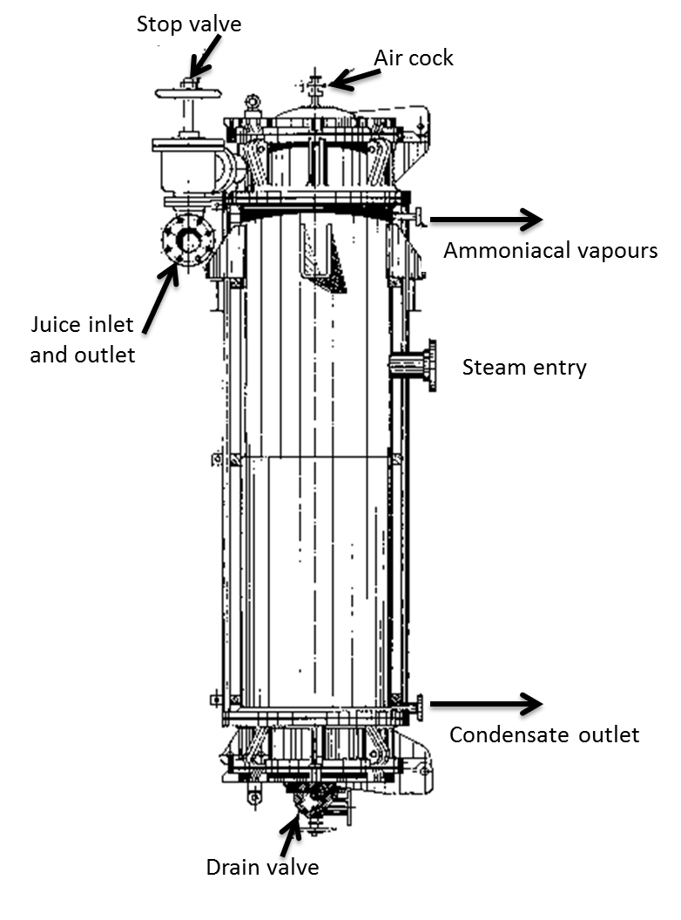

Plate and frame heaters
The plate and frame exchanger consists of a bank of corrugated stainless steel plates. The plates hang in a frame, are rubber sealed and are clamped together by 4 bolts. The space between the plates is alternately filled with juice and steam. The corrugation creates a juice flow pattern which is conducive to good heat transfer. The capacity of a plate heat exchanger can easily be changed by the removal or addition of plates.
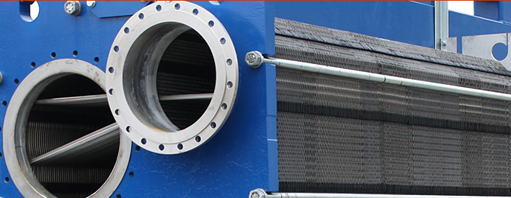

Flashing and flash tanks
A flash tank is a vessel that is open to the atmosphere. Juice under pressure at 105°C enters the flash tank and boils violently i.e. flashes. In the process the temperature of the liquid decreases to 100°C and the heat energy due to the 5°C temperature difference is released as vapour. Flashing can thus be defined as violent boiling caused by a pressure drop.
Flashing also rids the limed juice of entrained gases that would hinder settling of the calcium precipitate.
The effectiveness of the flashing operation is a function of the surface area of the juice in the tank rather than the volume of the tank.

Purpose of juice heaters
There are various juice heaters in a sugar factory each with its own purpose:
- Scalding juice heaters are associated with diffusers. At the feed end of the diffuser, juice is recycled through heaters at a rate of about 300% on cane. In these heaters the temperature is raised from about 65°C to 90°C using V2 steam. The purpose of this heating is to control microbiological losses and to facilitate sucrose extraction.
- Mixed juice heaters are placed after the juice scales but before the clarifier. Heating is usually done in two stages. In the first stage the juice is heated to about 90°C using V2 steam. In the second stage the juice is heated from 90°C to 105°C using V1 steam. At a temperature above 105°C melted waxes emulsify and become difficult to remove. The purpose of this heating is to facilitate clarification in various ways:
- Promotes coagulation of proteins
- Increases the rate of the precipitation
- Removes air by flashing
- Controls microbiological losses
- With the clarifier open to atmosphere the juice leaving the clarifier is about 100°C. In the first effect evaporator however boiling takes place well above 100°C and the juice needs to be heated before evaporation begins. In South Africa this heating is always done separately in clear juice heaters, using exhaust steam, to about 115°C. If this temperature is above the first effect boiling point juice flashing will occur which can cause feed distribution problems due to localized dry-out of areas.
- Other heaters are sometimes used to heat intermediate juice, press water and imbibition water in various ways. A special heater is one using vapor from the last effect. This steam is free and reduces the load on the condenser. Since the temperature of this steam is low at about 55$℃$ it can only be used on cold juice and requires large heating surfaces. This type of heater condenser is used in South Africa.

  - Knowledge Topic 2: Clarification

INTRODUCTION: WHY DO WE NEED TO CLARIFY MIXED JUICE?
Mixed juice, extracted from cane by milling or by diffusion, contains many impurities. These are present as insoluble matter, as colloidal matter and as soluble species.
The purpose of clarification is to produce a clear juice, that is of the correct pH value, free of suspended or colloidal matter and to do this with minimal loss of sucrose or destruction of reducing sugars.
The efficiency of clarification will have an important bearing on the quality of the sugar produced. Clarification involves the liming of juice to produce an insoluble calcium phosphate precipitate that settles, trapping and removing impurities.

THE PRINCIPLES OF CLARIFICATION

The Defecation Process
Clarification by heat and lime, known as the simple defecation process, is the oldest and, in many ways, the most effective means of purifying the juice.
Mixed juice is generally dark and slightly acid and in order to obtain a clear coloured juice the South African practice is to add milk of lime to the juice after heating it to its boiling point.
The neutralizing reaction between lime and juice is controlled to produce a clear juice of pH 7.0 to 7.2. This is about the best pH for the crystallization process as it will give easy boiling massecuites, develop less colour and there will be little loss of sucrose by inversion or the breakdown of reducing sugars. If the pH is too high the massecuites will be dark and viscous and there will be breakdown of reducing sugars. Low pH’s will cause sucrose inversion.
The juice temperature is raised to a maximum of 103-105°C but never allowed to drop below boiling point. It is then “flashed” to atmosphere and the “limed-juice” is sent to decant in large vessels called clarifiers where the clear juice separates from the precipitated solids. The juice is removed from the top (overflow) while the solids are removed from the bottom (underflow).
Clarification removes the insoluble matter in the juice. Most of the soluble impurities (non-sugars) are NOT removed during clarification. As these impurities remain in solution the brix change from mixed juice to clear juice is negligible and is due to the addition of dilute filtrate from the filter station to the mixed juice. This is the reason why clarification does not drastically affect the purity of the juice. Clarification is thus judged by turbidity/ clarity. As the suspended matter causes turbidity, this is the impurity that must be removed. During clarification some colour is removed from the juice, but the lime also reacts and produces colour. The net effect is that colour does not change significantly. However, it is normal for a small colour increase to occur during clarification.
The clarification process can be summarized as follows:
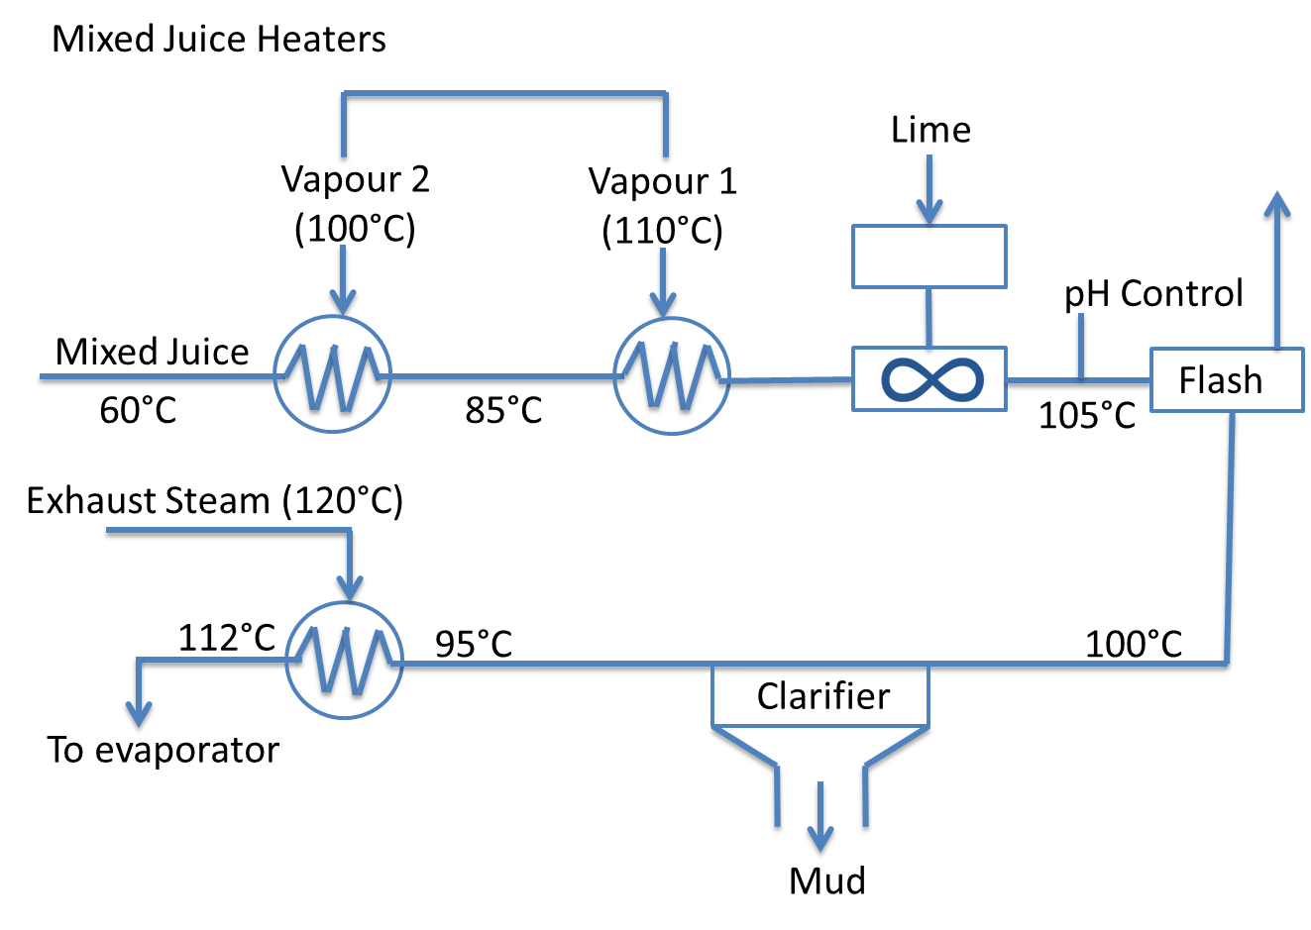

Heating
Heating the juice has the following effects:
- It increases the rate of the reaction between the lime and the acids. This can be very slow at low temperatures.
- Heat causes coagulation of some of the organic constituents. The albumin protein found in cane juice coagulates and is removed.
- Heating above the boiling point allows flashing to occur that removes air
- Heat destroys microorganisms and enzymes, thus preventing sucrose losses due to microbiological activity.

LIMING
Liming has the following effects:
- Causes coagulation of some colloids: The addition of lime to the mixed juice neutralizes free organic acids which change the hydrogen ion concentration of the juice. This change in pH neutralizes the electrical charge on the colloids causing them to coagulate and precipitate. This enables insoluble solids (sand and fine bagasse) which were held in suspension by the colloidal matter to settle out.
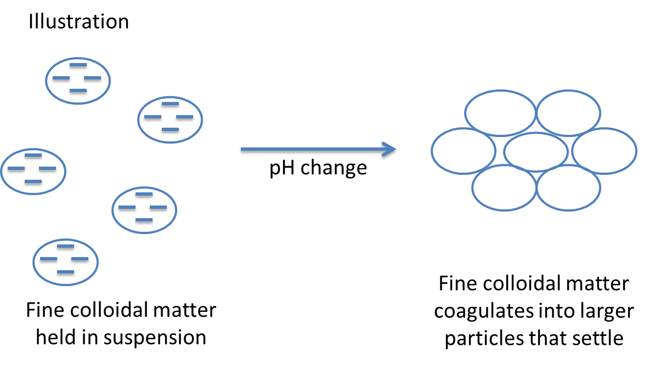
- Changes the pH of the juice from slightly acidic to neutral/slightly alkaline. This reduces inversion and the alkaline degradation of reducing sugars.
- Forms a heavy precipitate of complex composition which contains :
- Insoluble lime salts ( e.g. Ca₃(PO)₂)
- Coagulated albumen (protein) and varying proportions of fats, waxes and juices. The flocculated precipitate carries with it most of the finely suspended material left in the juice.

Lime and milk of lime
The addition of lime (CaO) is done either in the form of milk of lime or as lime saccharate. Whatever the clarification process used, lime is the main clarification agent.
Sources of lime

Limestone
Lime is produced in kilns by burning a mixture of limestone and coke (a form of carbon). The heat for the reaction is produced by the reaction between coke and oxygen.
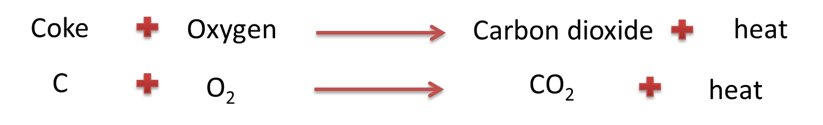
The heat produced decomposes the limestone (CaCO₃) into lime (CaO).
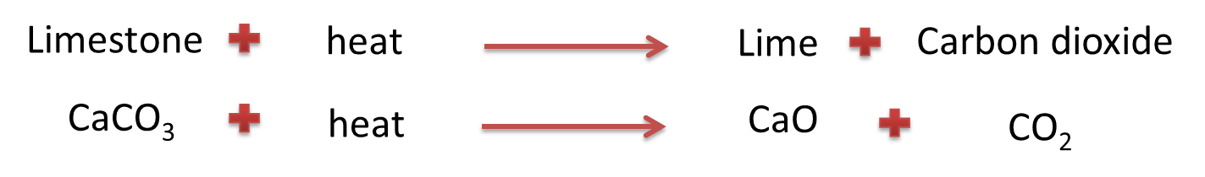
The calcium oxide is known as unslaked lime. It is extremely hygroscopic (i.e. absorbs water readily) and care should be taken with its storage.
The unslaked lime (CaO) is then mixed with water in a slaker to form a slurry (or suspension) called milk of lime.
The process of lime slaking generates a great deal of heat.
Since calcium hydroxide is only very slightly soluble in water i.e. 0.12% at 25°C, the milk of lime is therefore a fine suspension of small particles of CaO in water.

Granular lime
Lime is also obtained from suppliers as lumps and is used in this form at most mills. Since the calcium oxide has a strong affinity for moisture and CO₂ from the atmosphere, the stock should therefore be kept low and in a protected environment.

Powdered lime

The Baumé scale
The Baumé scale is an alternative to measure the total dissolved solids (Brix). However, the Baumé scale has no convenient relationship with the percentage composition of sugar solutions, and for this reason has largely disappeared in sugar work. The relationship between Brix and Baumé at 20°C is shown in tables.
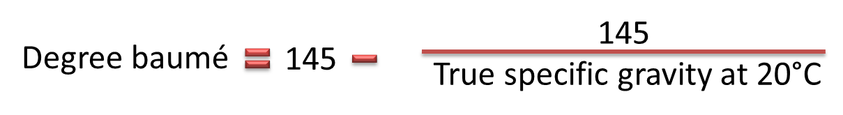
For example: 15°Bx sucrose solution= Specific gravity of 1.06104 = 8.34 degree baumé
However, concentrations of lime solutions are still expressed in degrees Baumé.
8 degrees Baumé lime solution = Specific gravity 1.060
= 75g CaO/litre
= 7.08% CaO (by mass)
Milk of lime is applied to the juice at about 8 Baumé.
The quality of the lime used in clarification is of prime importance. The most important criterion for the quality of lime is the percentage of available CaO. This percentage should be about 85% and must be checked regularly.

Flashing
This removes air from the juice and floc, thus allowing settling to proceed. Flashing also results in a uniform and constant temperature in the limed juice. This prevents thermal currents in the clarifier and promotes good settling.
Juice must be heated up to at least 103°C before flashing is allowed. When lime is added before the flash tank, one has to ensure that the temperature of the juice leaving the final heating stage is controlled at about 105°C.
The purpose of flashing is therefore to:
- Force out the air present in the juice
- Cause particles of bagacillo to burst and sink with the solids
- Ensure constant temperature
It is therefore essential to have adequate capacity for the flashing of the juice at atmospheric pressure. A good point to remember is to observe the way condensed vapour is given off the flash-tank vent pipe. If there is very little or no steam coming out, something is wrong.
The following is important
- The downward velocity of the juice in the juice/air separation volume of the flash tank should not exceed 500 mm.min-1 to allow satisfactory escape of the vapour bubbles. Therefore the diameter of the flash tank should be rated to that velocity.
- There should be no restriction in the exit path of the escaping air and vapour from the juice. The diameter of the pipe used should be such as to allow an upward velocity not greater than 1.7m.s-1.

Settling
Settling in clarifiers allows the precipitate to flocculate and to collect at the bottom of the vessel, where some of the precipitation also takes place. The clear juice can then be removed from the top of the vessel. Flocculation and settling, particularly in short retention type clarifiers are helped by the addition of synthetic water soluble polymers.
In addition, good juice flow control is vital to proper clarifier operation. Large and sudden variations in juice flow interfere not only with heating and liming, but also physically disrupt the contents of clarifiers, causing the floc to contaminate the clear juice.

The precipitate

Nature of the precipitate
The precipitate that forms in cane juice with the combined action of lime and heat is in fact an amorphous calcium phosphate (CaPO₄) which, within a few minutes, begins to crystallise into hydroxyl apatite [(Ca₅(OH)(PO₄)₃] which is more stable.
Recently, certain studies attributed the amorphous phase to the composition of tricalcium phosphate (Ca₃(PO₄)₂).
The two-stage precipitation first causes small particles to form, which grow and rearrange into a very intricate floc that traps and absorbs all suspended solids. Included are the other non-sugars that are precipitated by the reaction change, by the heat, by the calcium and by the increase in pH.

Nature of the absorbed material around impurity particles
There is no doubt that the absorbed material is proteinaceous and a large proportion of it is mucoid in which protein is conjugated with a polysaccharide. The general term for these compounds is arabino galactans.

The role of phosphates in clarification
The phosphate content of the juice is the most important factor in efficient clarification. The phosphate content must be above a certain amount.
There are two theories in this regard:
- The phosphate content should be at least 300 ppm
In sugar cane, the phosphates are organic as well as inorganic. If the inorganic phosphate level in the juice is less than 300ppm, the juice cannot be clarified properly and addition of phosphates may be required. This can be in the form of phosphoric acid (H₃PO₄), phosphoric acid paste or mono calcium phosphate (CaHPO₄).
Note that the phosphate in juices are usually measured as P₂O₅, since:
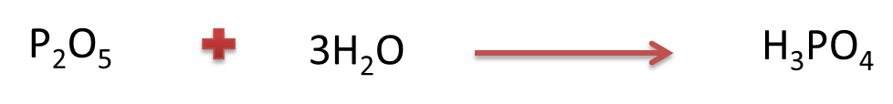
- The clarification depends on the ratio between the phosphate content and certain non-sugars:
The ratio:
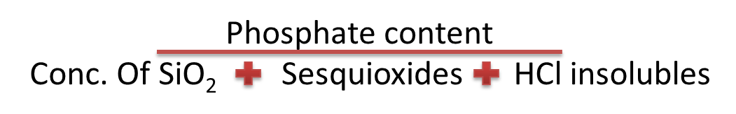
If the ratio is less than 0.15 clarification will be poor and mud volumes high. Between 0.15 and 0.25 clarification will be fair. Above 0.25 clarification will be good.

Addition of phosphate
It is possible to add phosphate to the juice to improve clarification. Of the numerous types of phosphate available, the two used most often are mono-calcium phosphate and phosphoric acid. Of the two, phosphoric acid is preferred as it easier to handle and dose. The phosphoric acid is made up to a standard diluted solution and then dosed using a metering pump.

Defecation methods
Defecation is the term applied to the process where lime is added to mixed juice to raise the pH and form a precipitate. Over the years a number of methods of defecation have been used.

Hot liming
The system used throughout South Africa is the hot liming process (i.e. heating followed by liming). In the process juice is heated to 103-105°C and then limed to a constant pH of 7.0 -7.2. Heating the juice in an acid medium precipitates out the silica and proteins (mainly albumen) and eliminates the risk of dextran formation since leuconostoc mesenteroids is inactivated above 70°C. The risk of inversion is also minimal as the retention time at 103°C is very short.

Saccharate liming
The use of lime saccharate is confined to a few factories.
Lime is approximately 17 times more soluble in a sugar solution than in water. The reaction between milk of lime and a sucrose solution gives rise to the possibility of mono-, di- and tricalcium saccharates being formed, depending on the chemical and physical conditions under which the reaction takes place.
The objective is the formation of the most soluble salt, namely mono-calcium saccharate, according to the reaction:
In order to ensure that that the highly soluble mono-calcium saccharate is formed, it is important to maintain two conditions during preparation.
- An excess of sucrose
- A temperature of below 58°C
In practice the required ratio of sucrose to CaO of 7:1 is obtained by using evaporator syrup (68$°$Bx) on 15$°$ Baumé milk of lime. The pH of the resulting saccharate solution is 11.0 – 11.15. By controlling the saccharate formation pH at 11.00, excess sucrose is present and the formation of mono-calcium saccharate is assured.
The syrup and milk of lime is mixed in a mixing tank from which the saccharate lime then overflows to a storage tank. From this tank the saccharate lime is pumped through a circulating ring main. Dosing of the mixed juice after primary heating is done before the intermediate juice pump.
Saccharate liming has the advantage of making the Ca²⁺ ions more available for the reaction with PO₄³⁻ thus increasing the reaction rate.
Comparison between Milk of Lime and Saccharate Application
- Saccharate being soluble does not settle in pipes and tanks while milk of lime has to be stirred and circulated to prevent settling of the suspension. The milk of lime velocity in pipes should not be less than 1m.s⁻¹
- Saccharate can be left standing during week-end shutdowns and is immediately available at start-up.
- Saccharate produces clear juices of much lower turbidity than those from milk of lime. However, it has been shown that the benefits do not extend beyond clear juice. Syrup turbidity and sugar quality does not improve.
- Saccharate liming tends to cause lighter, more voluminous muds.
- When the syrup is limed to produce lime saccharate, the syrup must be overlimed. This causes degradation of reducing sugars and the solution assumes a dark colour.
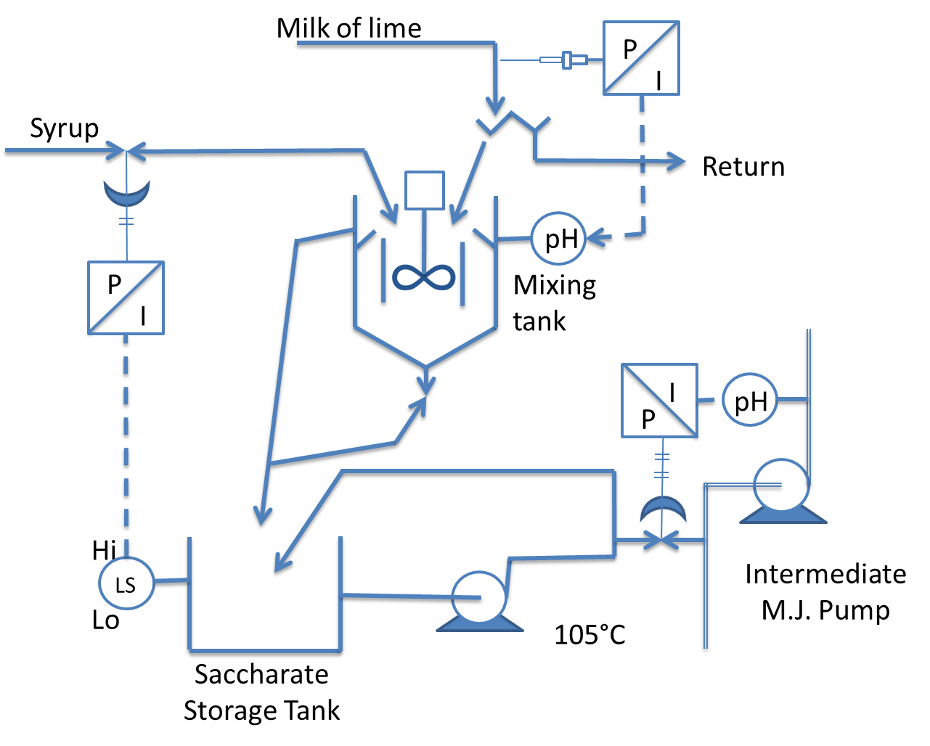

Lime addition
As milk of lime is a suspension that must be kept moving all the time, it is not possible to regulate the flow by means of a valve.
A device must therefore be used to divide the flow, a proportion being dosed into the juice, the rest being returned to the supply tank.
This can be done by using a splitter box, or a variable speed pump.
Lime and juice mixing
The mixing of the lime and juice is extremely important. Poor mixing will not produce a uniform floc.

Perry tank
The perry tank is a common mixing device used in a number and factories. It consists of a stirred tank through which the juice flows. The lime is added to the tank which has a juice retention time of about 5 minutes

In-line mixer
A few factories are now using in-line mixers for mixing lime and juice. As the whole system is under pressure the lime has to be injected into the pipe before the mixer.
Flashing can be done after mixing. Cleaning of the internals should be done regularly in order to avoid an excessive pressure drop in the line.

pH and pH Control

pH control
The rate of sucrose inversion is accelerated by acidic pH values and high temperatures while reducing sugars are destroyed at high pH values and high temperatures. In both cases the extent of the inversion or of degradation depends on the time.
Since the temperature is relatively high and retention time cannot always be controlled it is essential to have effective pH control.
Lime addition to the juice is controlled so as to give a steady pH of the juice leaving the clarifier. This means that one pH value will not be suitable for all types of juice. The pH will have to be controlled within a certain range.
The pH must be high enough to obtain complete phosphate precipitation without producing excess soluble lime salts. Bad pH control is likely to cause secondary precipitation in the clear juice.
The first factor for effective pH control is to limit fluctuation in juice flow and in milk of lime (or saccharate) concentrations. To achieve this, sufficient buffer capacity should be provided in the juice stream and in the lime preparation stage, before the lime addition point.
Theoretically, to obtain a constant clear juice pH the lime addition should be controlled according to the pH of the juice clarifier. The difference in time makes control by this method extremely difficult (15 minutes for the SRI clarifier and 45 minutes for the rapidorr clarifier).
The normal method of control is to detect the pH as close as possible to the point of lime addition, allowing enough time for the precipitation reaction to take place, before the limed juice reaches the pH electrode.
There must be at least 4 minutes between addition of lime and the clear juice entering the clarifier. During this period the lime reacts with the juice and the pH increases gradually from 5.5 to 7.2.
The limed juice off-take to the pH electrode should be about 8m down-stream from the point of lime addition in the case of an in-line mixer. Control must take into account the drop in pH that will occur from limed to clear juice. The accuracy of control depends on:
- Changes in flow
- Changes in acidity of the raw juice
- The reaction time of juice and lime
- The lags in the control loop

pH drop during clarification
It is important to note that the juice must be limed to a higher pH than is desired in the clarified overflow because a drop in pH always occurs during settling.
This change is a function of the amount of phosphate in the juice. The higher the phosphate content, the more marked the difference in pH.
Reasons for the pH drop
- Lime reacts with the phosphate to form several basic calcium phosphates e.g. hydroxyl apatite [Ca₅(OH) PO₄)₃]. Basic calcium phosphates are more insoluble and precipitate in the mud, leaving the solution more acidic.
In addition the following reaction also occurs that results in the formation of H⁺ ions
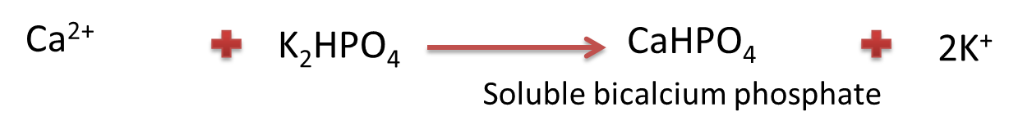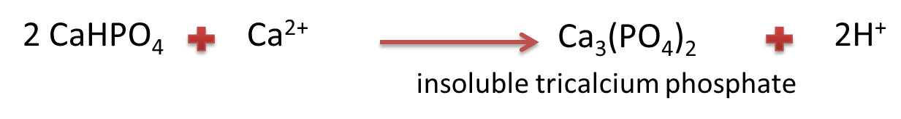
- A pH drop results from the acid formation due to heat degradation of reducing sugars

Disadvantages of over-liming
High liming above pH 8.5 causes an increased drop in pH because of the formation of acids by the action of excess lime on the reducing sugars.

Mechanism of calcium-phosphate precipitation primary flocculation
Impurities in the mixed juice are in suspension and each is surrounded by an absorbed proteinaceous layer that gives the impurity particles a negative outer layer. The reason for this is that the proteinaceous molecules surround the impurity particle in such a way that the negative areas of the proteinaceous molecules are facing the outside of the particles. As a result of the negative charge around impurity particles, Ca²⁺ ions surround and become “bound” to the impurity particles. The calcium phosphate precipitate acts as “bridges” between impurity particles entrapping them as part of the floc. This process is known as primary flocculation. Primary flocculation thus involves the aggregation of single particles in free suspension in the juice into clusters of 10 to 10⁴ particles. The resulting primary flocs are small, slow-settling and leave behind a very turbid juice.
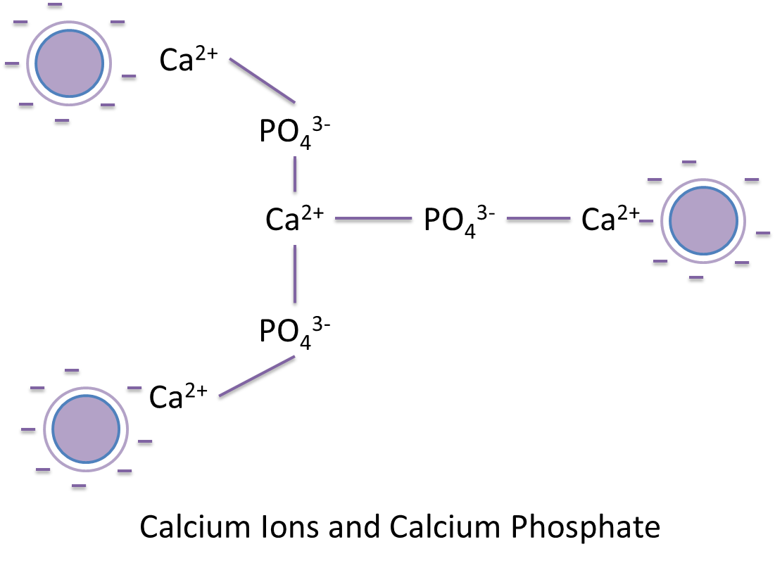

Flocculants

Flocculation
Flocculation provides a mechanism whereby insoluble suspended impurities are aggregated into flocs which are suitable for separation by sedimentation.
The range of impurities removed by flocculation can be broken up into different particles sizes: Those visible to the naked eye and very large molecules - the colloids (polysaccharides, proteins and complex silicates).
These particles are in suspension (in a stable state) because the particles all carry a negative electrical charge and therefore tend to repel each other.
The particles are also all covered with a layer of material which is saturated with water molecules. This cushion prevents close contact of the particles.
Destabilization and flocculation can be brought about by:
- Neutralization of the negative charge: This can be done by reducing the pH.
- Reduction of the degree of hydration: This occurs when the juice is heated and some proteins are precipitated e.g. albumen.
- Introduction of a bridging mechanism: This is the basis of the current flocculation process used in the industry and involves the formation of an inorganic precipitate.
- The addition of an additional bridging mechanism i.e. “secondary” flocculation is the use of very high molecular mass polymers which are capable of attachment to adjacent impurity particles. The polymer must have a molecule mass in excess of 1 000 000 (106) and carry some negative charges down its length for the attachment of impurity particles.

Secondary Flocculation
A number of synthetic water-soluble polymers, bearing various trade names have come into general factory use.
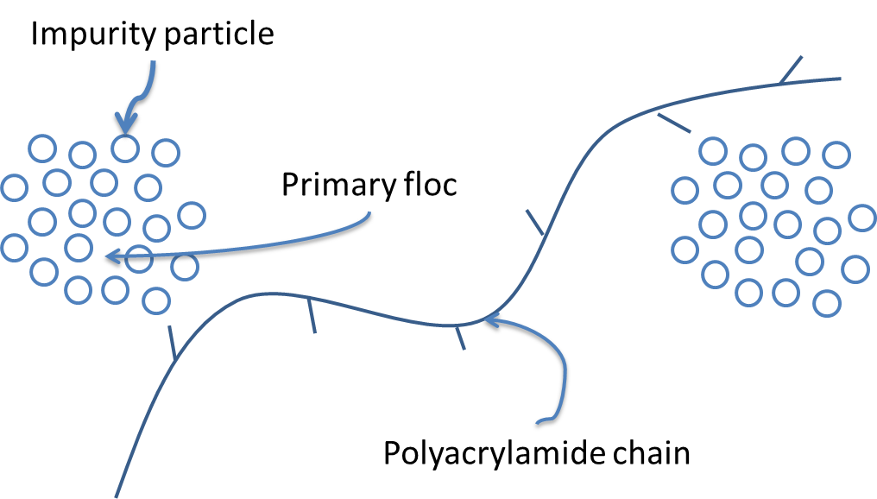
At the same time, by collecting together the smaller primary flocs, it produces a far clearer juice.
Studies done in Australia have also suggested that mud particles (and other precipitated particles) attach themselves to the active sites of the long chain polymer and form a floc structure.
The polymers adopted so far by the sugar industry are mainly anionic (negative) which carry the same charge as the particles of the suspension in the juice.
All polymer flocculants are of high molecular weight. The settling rate increases with molecular weight. Molecular weights below 10⁶ act only as stabilizers and are not large enough for bridging. Molecular weights should be in the order of 10⁷ (10 million) for good clarification.
The action of these polyelectrolytes is to produce the secondary flocculation, which involves the chain molecules forming interparticle bridges by adsorbing and binding together the particles formed by the primary flocculation. Bigger units are thus formed that settle faster. When these larger particles settle they entrap and remove impurities. Secondary flocculation increases the floc size to 10⁵ – 10⁷ particles.

Binding of flocculant with Mud particles
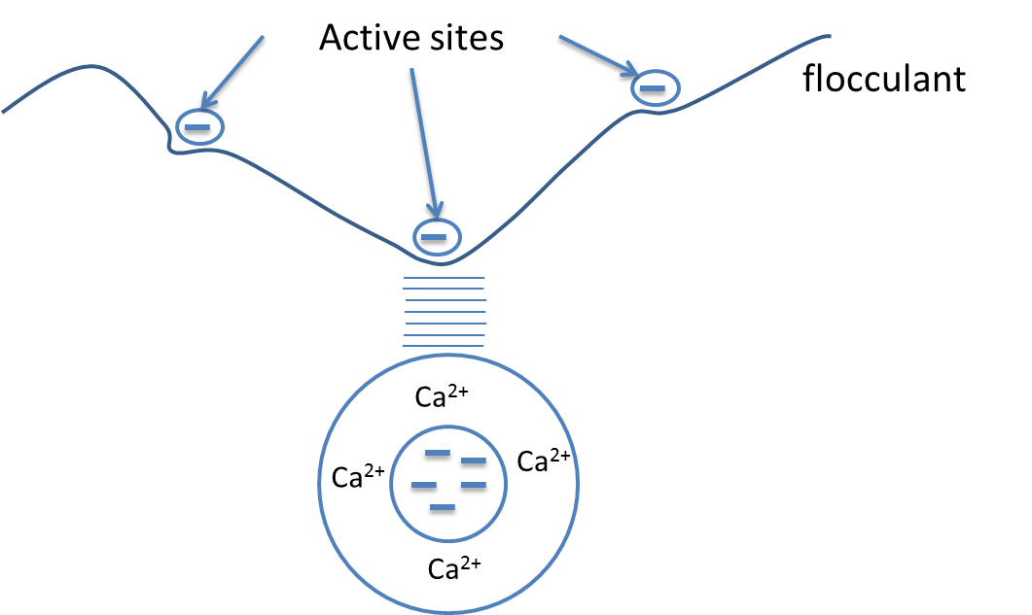

Flocculant structure
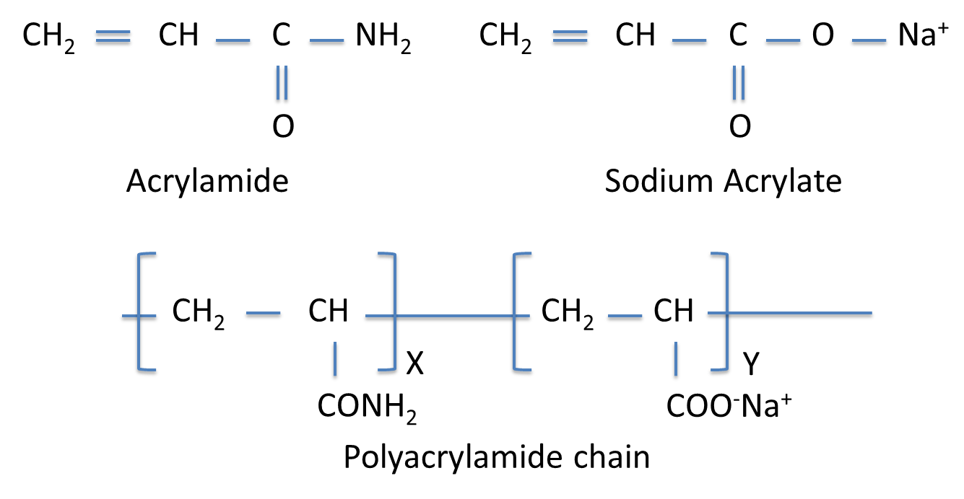
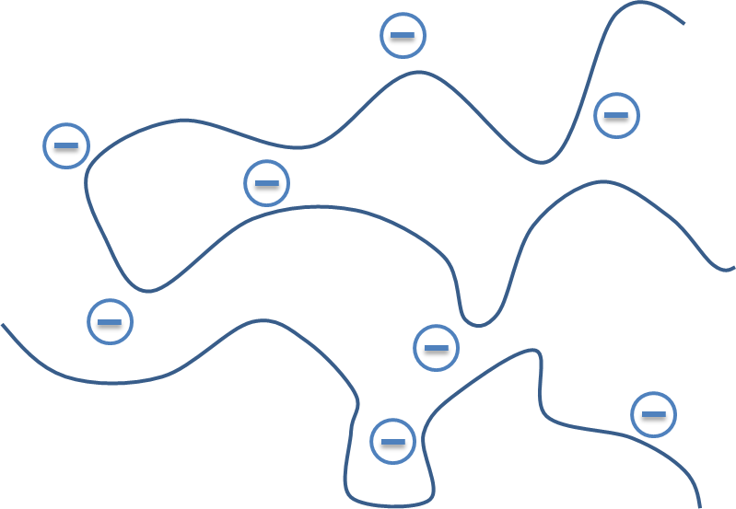
Generally a good flocculant improves flocculation, increases settling rate, reduces mud moisture, decreases pol in cake and most importantly, increases the clarity of the clarified juice.
Factors that affect the performance of polymers in juice clarification are
- Time of agitation of the stock solution
- Polymer solution concentration
- pH of solution
- Influence of phosphate precipitate
- Concentration of calcium in the juice

The effect of eletroctrolytes (ions in solution) on polymers
The molecular configuration of a flocculant depends on the ionic strength and ash content of the water used for dissolving the flocculant.
When a polyacrylamide is dissolved in pure water the only inorganic ions present will be sodium ions.
The chain will thus be fully extended and will be able to function efficiently.
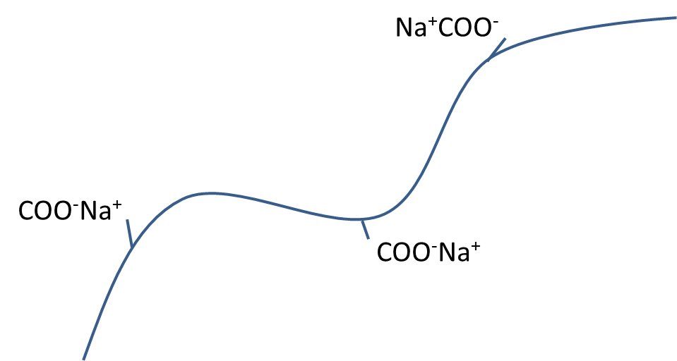
When a polyacrylamide is dissolved in impure water the ions of the impurity insulates the chain and make it fold up reducing its efficiency. The water used for making up the solution must be condensate or de-ionised water to achieve maximum efficiency of the polyacrylamide.

Flocculant preparation and make up equipment
Tate and Lyle the manufacturers of “Talosep” recommend the following procedure:
Essentially two vessels are required, one for dissolving and ageing, the other for supplying the dosing pump. All pipework carrying flocculant solutions must be of smooth bore and be fitted with large radius bends (at least 25mm diameter).

Preparation tank
The size chosen depends upon the space available but should be of sufficient capacity to cover the requirement of at least one shift.
The material of construction should be mild steel with an epoxy-resin lining. Galvanised surfaces must not be used.
A make-up supply of pure water (condensate or de-ionized water), a vibrator dry powder feeder and air sparge should be fitted. An in-line filter should also be fitted in the make-up water supply line.
The preparation tank should be sited close to the storage tank, and above it if possible, to allow the flocculation to flow into it by gravity.

Dosing pump supply tank
The size should be compatible with the space available and also with the size of the preparation tank. It should be of similar construction, i.e. mild steel epoxy-resin lined, and fitted with an air sparge. Connection to the dosing pump should be by 25mm internal diameter lines.

Eductor assembly
This assembly comprises a dry powder supply funnel, vibrating feed through and mixing bowl. The rate of dry powder addition is controlled by a free standing regulator. This assembly enables perfect flocculant solutions to be prepared without the normal problem of undissolved lumps associated with other make-up systems.

A typical flocculant preparation and dosing system
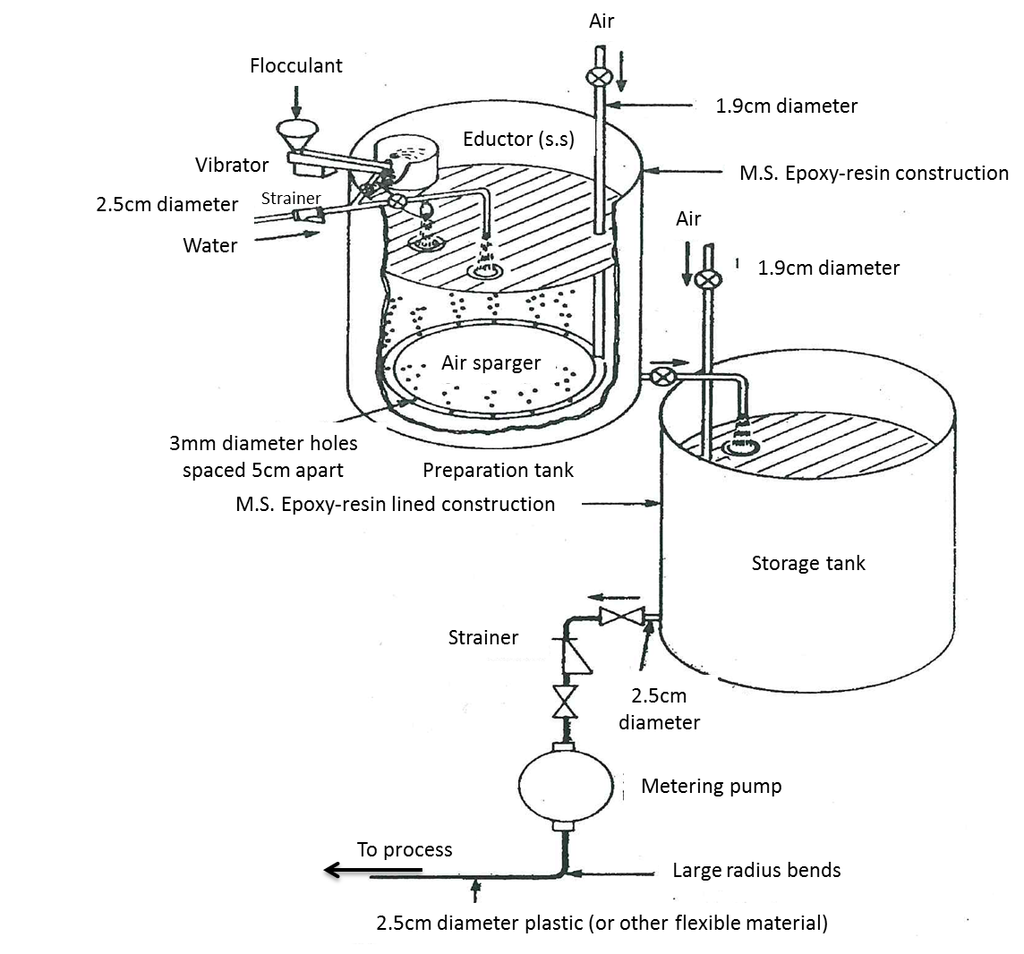

Settling theory
The floc is separated from the juice in special vessels called clarifiers. Settling theory indicates that the settling rate of particles depends mostly on three factors:
- The densities of the particles of the precipitate and of the liquid
- The size, shape and diameter of the particles
- The viscosity of the liquid
Not much can be done about the density and viscosity of the juice. Thus only the size and shape of the particles can be controlled. This highlights the need to avoid all damage to the floc after liming out and the addition of flocculants. Settling tests can be done on different juices to determine their rate of settling on m.s⁻¹. The procedure is as follows: Boil the juice to remove air, lime. Place enough flocculant solution in a 200mm long glass tube so that when filled the flocculant concentration will be 5-8ppm (mg/l juice). Pour the juice gently down the side of the tube so it does not trap air. An interface (border) will form between the upper clear juice and the lower turbid (murky juice). This interface (border) will form between the upper clear juice and the lower turbid (murky juice). This interface will move down and it is possible to note how many millimetres it has moved after certain time intervals.
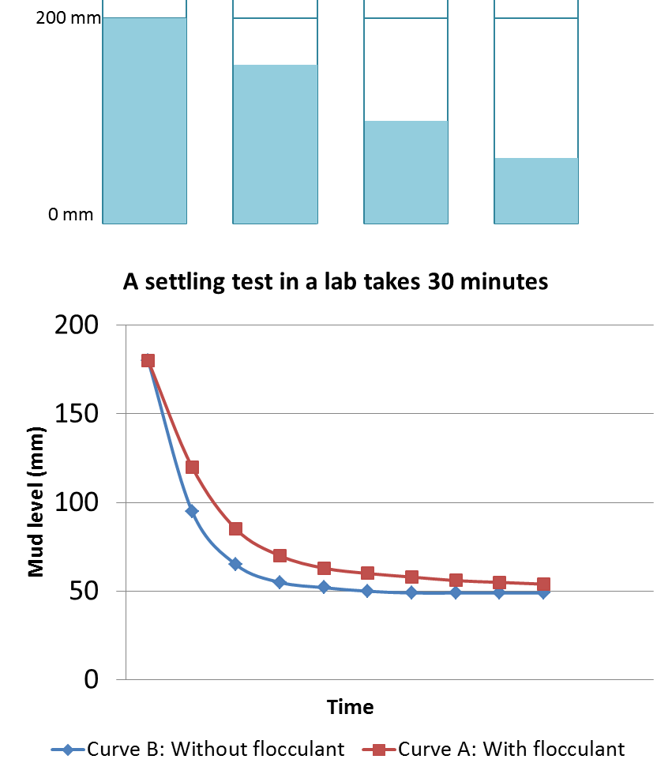

CLARIFIERS

The Rapid-Dorr Clarifier
Two types of clarifier are found in the industry. The Rapidorr and SRI clarifiers. The difference between the two is in the arrangement of the compartments. The Rapi-Dorr has four compartments with the clarifier divided into 2 separate clarifiers and the juice is fed to the two top compartments of each section through the centre tube. The four compartments of the Rapi-Dorr 444 are each isolated from each other and the juice is fed equally to the four compartments.
The Rapi-Dorr clarifiers are operated on the counter-flow principle. The juice is admitted at the top centre and moves towards the periphery where it is extracted at the point of lowest velocity. The separated mud is collected on the trays and is pushed by means of scrapers until it is full to a thickening chamber where it is compacted before being withdrawn.
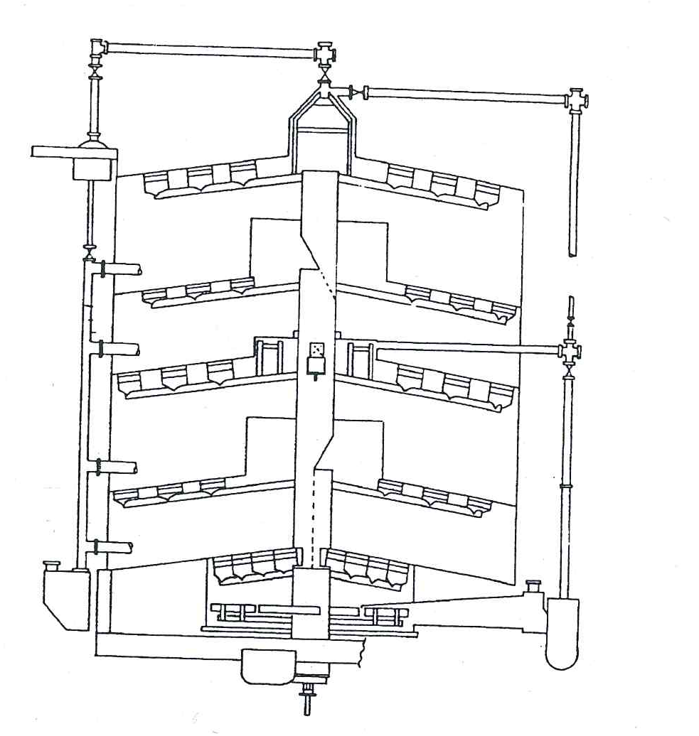
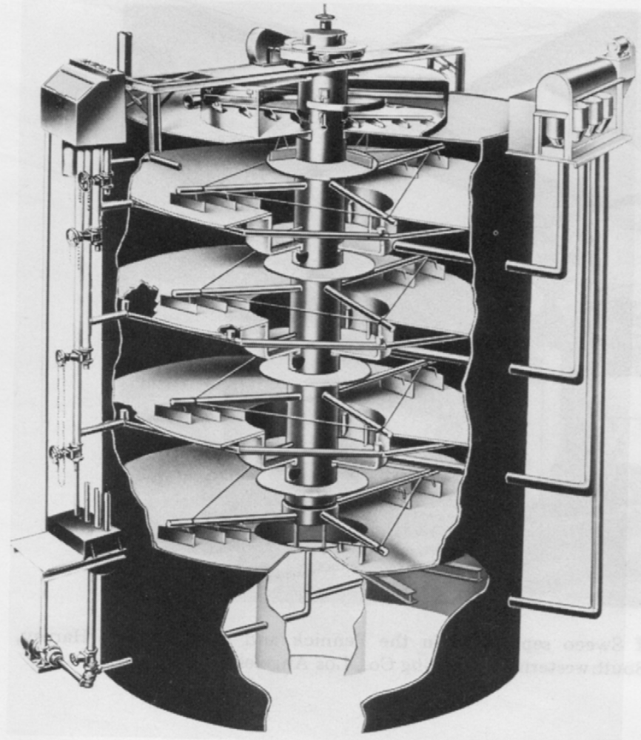

General operation
Clarified juice is collected from each compartment and flows to an overflow box on the outside of the clarifier. The overflow box has adjustable sleeves for regulating the rate of flow from each compartment.
Thickened mud is withdrawn by diaphragm mud pumps from each mud boot. Each compartment has a mud raking mechanism which consists of two long and two short arms equipped with scraper blades. The rake arms are attached to the centre tube which is driven by a worm-gear drive head. Juice enters the unit through the feed compartment which dissipates the velocity of the feed. Foam and some suspended solids rise to the surface of the juice and are removed by the skimmer mechanism through the foam canal.
The defoamed juice enters the compartments through equal sized openings. Suspended solids settle on the surface of the trays and are raked to the centre boots by the raking mechanism.

Starting up and shut down
Filling and emptying the clarifier is the only critical operation and should be done slowly.

Filling
The by-pass gate must be fully open (handwheel spindle up). This provides an opening in centre tube to equalize the pressure and prevent tray collapse or upward buckling.
Before starting the juice feed, start the scraper mechanism. As the trays are designed for normal operation only, with part of their support coming from the solution in the lower compartment, the rate of feed must be slow enough to allow the juice to flow through the by-pass openings into the bottom compartment.
The clarifier must be filled from the bottom up. The mud pump must be started soon after the juice starts flowing into the clarifier. If this is not done there is a chance that the mud will compact and block the pipes. As the solid settle and are moved to the clarifier centre the running of the pumps must be regulated to remove the mud as fast as it becomes thick enough. Do not try and get the mud thick quickly.

Emptying
The centre tube “by-pass” valve must be opened and the unit emptied slowly. By opening the by-pass the pressure on either side of the trays is equalized. This prevents an overload or an uplift on the trays with possible damage. When the clarifier is empty it must be thoroughly washed out with water.

Operational problems
- Top compartment overflows, cloudy juice: The mud might be too light. Pump mud out faster.
- Lower compartment overflows cloudy juice: The overflow sleeve may be set too low. Gradually raise the sleeve until the juice runs clear
- All compartments overflow with cloudy juice:
  - The mud might be too tight - pump mud out faster.
  - The feed rate may be above the capacity of the clarifier - cut down the feed rate.
  - The settling properties of the floc might have changed due to pH, juice quality, temperature (flashing) - check these conditions.
  - Temperature convection may be interfering with the proper operation of the clarifier - check on temperatures.
- No juice flow from the lower compartments:
  - Feed might be below capacity. This condition is normal if the flow from the top compartment is clear.
  - The mud removal might be too fast (thin mud). Slow down the pumping rate.
  - The overflow pipe might be blocked. Clear the blockage.
  - The juice in the overflow pipe might have cooled. This will raise its density. Lower the sleeve to regain flow, then raise to the original position again. If this doesn’t work an air or steam line in the juice pipe may be used to lift the juice.
- Mud is thin
  - Removal of mud is too fast. Slow down the pumping rate.
  - The clarifier may be overloaded and the mud does not have enough time to thicken. Slow down the feed rate or you will have to continue to pump thin mud.
- Unable to pump mud
  - The mud may be too thick. Flush out the pipes with water and then pump out faster.
  - The pump may not be working. Check and correct.
  - The pipe may be blocked with a foreign object. Try flushing with water or air. If the pipe clears be aware that the object may return and block the pipe.

SRI Clarifier
The SRI (Sugar Research Institute, Australia) high throughput clarifier offers the following advantages:
- A smaller, simpler and cleaner unit
- Short retention time and minimization of losses
- Higher throughputs
- The opportunity to liquidate at week-end shutdowns which will further reduce losses.
- Inversion if minimised
- Higher density muds
- Reduced cake losses
- Lower rates of flocculent and lime addition
- Lower unit costs
- Low internal turbulence at high throughputs – thus low turbidity and minimal bagacillio carryover in the clarified juice
- Simple maintenance
- Saving in space of up to 70%
- The simpler, less cluttered design is best suited to plug flow.
The short retention time SRI clarifier was made possible by the arrival of flocculants.
It was designed on the basis of minimization of cross-flow and to approach a vertical upward and downward path for juice and mud respectively. The clarifier is made up of a cylindrical tank in which circumferential launders are fitted.

Description
The clarifier consists of a cylindrical tank in which circumferential launders are fitted.
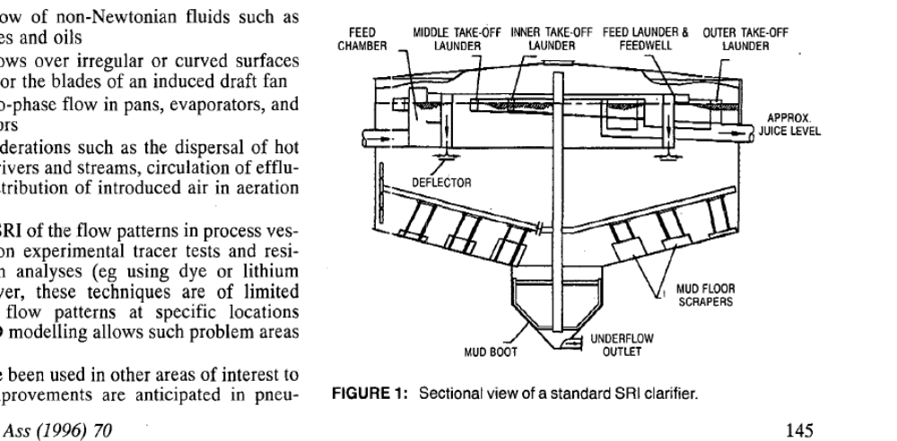
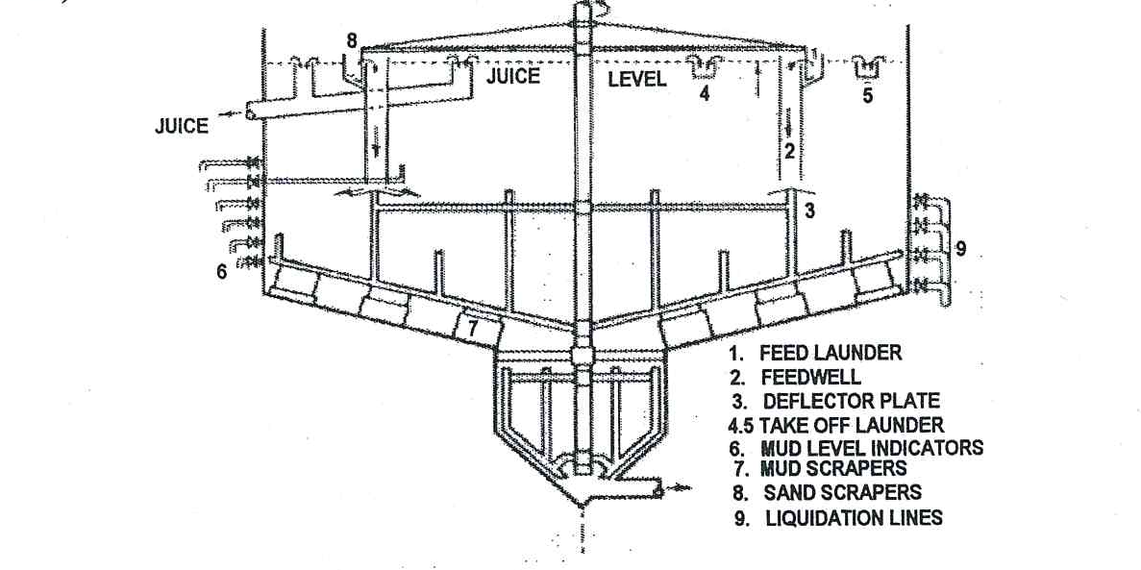

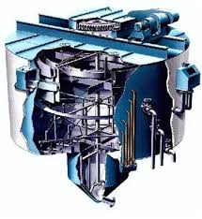
The juice is fed into the launders tangentially (at the periphery) and at diametrically opposite points. The inlet launders encircle the feed well with their outer edges above the liquid level. The inner edge forms the outer circumference of the feed well and this inner side is castellated (having grooves or slots on its upper surface) to permit the even distribution of the incoming juice.
The base of each feed launder is perforated to allow a proportion of the juice to pass through, carrying with it entrained sand and heavier solids which are thus passed into the feed well. Rotating scrapers in the feed launder move the settled solids towards the perforations.
Juice in the feed well is radially deflected into the clarifier by a ring-shaped baffle mounted on the rotating scraper gear. This deflector directs the descending juice towards the centre and periphery. A zone of separation is soon established in which the clear juice travels up to the outlet launders and the solids move to the bottom. The parameter controlling solid-liquid separation is the initial settling rate of the suspension, whilst the upflow rate of the liquid must obviously be less than the settling rate of the suspension.
Factory results confirm with remarkable clarity the correctness of the particular design. Good clarification has been achieved with clarifier (subsider) retention times of less than fifteen minutes. Thus, Fletcher and Stewart are able to size the SRI subsider with an upflow rate of 50% of the initial settling rate. In practice, factories have operated satisfactorily with an upflow rate of 70% of the initial settling rate.
Two concentric take-off launders with castellated edges are fitted and arranged in such a way that the flow into each is proportional to the adjacent surface area. The lower half of the clarifier is formed as a shallow cone with a mud boot. The muds raked from the peripheral areas of the cone by the scrapers are moved towards the mud boot and take-off point.
On the central shaft, inside the mud boot, are also attached a number of vertical arms which cause gentle shearing of the mud. This shearing allows excess juice trapped by the “floc” to escape towards the surface with the clear juice.
The mud particles become compacted and are removed by means of an outlet pipe at the bottom of the cone either by a pump or by gravity. This short residence time clarifier needs good process control for satisfactory operation. Juice flow control and constant juice temperature are essential. These clarifiers are also susceptible to changes in juice brix.

Trouble shooting
Attention to detail is necessary to ensure efficient operation of the SRI clarifier. The following must be remembered:
- Flocculant dosing rates: Periodic settling tests should be done to ensure correct dosage rate.
- Flocculant must be distributed evenly to the distribution points.
Check the following:
- Adjustment of flowmeters
- Strength of flocculant
- Pump operation
- Flocculant tank has flocculant in it
- Lumps in flocculant
- Right pH. Check the pH control system and dosing device.
Juice temperature entering the clarifier must be at least 100°C. Foam on the feed launder is an indication of air entrainment and poor flashing.
It is critical that the rate of feed to the clarifier not exceeds the settling rate. If the settling rate of the juice reduces, the action is taken in the following order.
- Add more flocculant or change the flocculant
- Add phosphoric acid to produce more precipitate
- Reduce the mixed juice flow rate by slowing down the mill

Retention time
The retention time depends on the clarifier capacity and the juice throughput. The retention time in a Rapidorr is far greater than an SRI clarifier (i.e. 45min as opposed to 10 minutes). To design a SRI clarifier, both juice flow rate and the settling rate must be known. A slower settling rate requires a larger clarifier.
Typical capacity and throughput values for SRI clarifiers
DIAMETER (mm) | CAPACITY (1) | THROUGHPUT(tons juice/hour)
6 100 | 84 600 | 125
6 700 | 103 000 | 150
7 300 | 123 500 | 180
7 900 | 145 900 | 210
8 500 | 170 500 | 255
9 100 | 198 100 | 280

Example
The total retention time in a 7.9m SRI clarifier is calculated as follows:
Tons juice (throughput) per hour = 210 =210 000 kg
Density of juice at 13°brix = 1.05 tons/m³
= 1.05 kg/l
Now:
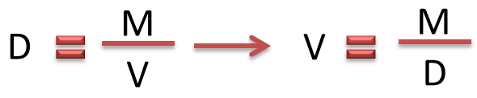
Therefore: Volume of juice per hour (Flow rate) = 210 000kg / 1.05 kg/l
= 200 000 litres
Capacity of clarifier = 145 900 litres
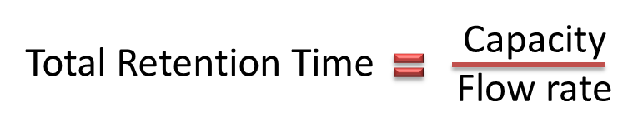
Thus: 145 900 l / 200 000 l/h
= 0.7295 h
= 0.7295 x 60
= 44 min
= 0,7295x 60
= 44 min

Juice deterioration
The decline in purity of clear juice stored over an extended period is a function of pH, temperature and the time period.

Effect of pH
The purity drop increases as the pH of the juice falls below 7.2 at a temperature of 88°C over a 40-hour storage period. If the pH is maintained at above 7.2 the purity drop will decrease. If a longer storage period is expected the pH must be increased.
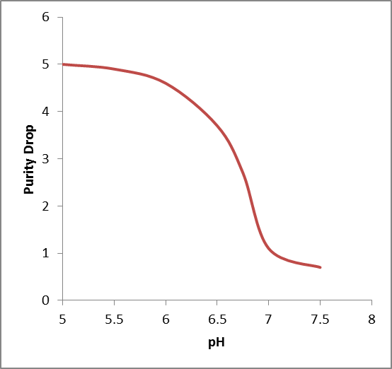

Effect of Temperature
A minimum purity drop occurs between 71 and 74°C. Below this temperature microbial activity increases and causes a purity drop. Above this temperature chemical decomposition increases and inversion increases.
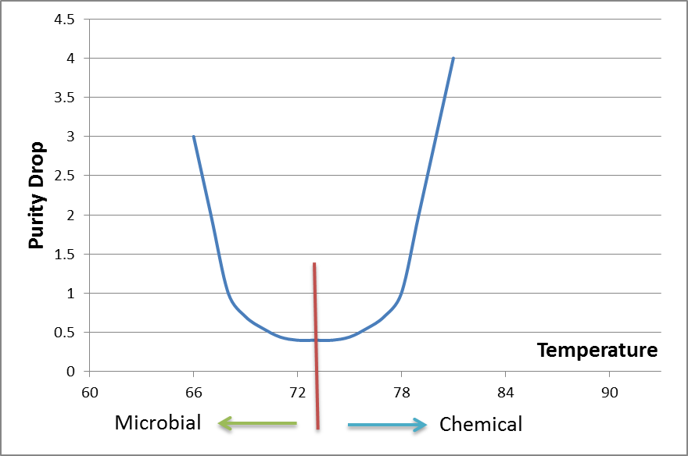
At 88°C over a period of 40 hours the clear juice purity will drop by 5.4 units from 85 purity to 79.6 purity. Such losses have very serious financial implications.
To understand the financial implications of a purity drop in the clarifier during a weekly mill stop, consider the following example.
Suppose a clarifier contains 300t of juice at 12°Bx and a purity 88%. After a 20 hour stop the purity drops to 85%
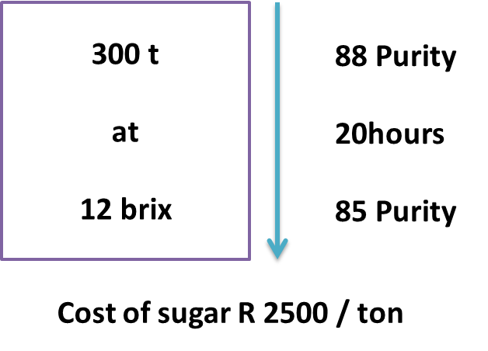
- Calculate the financial loss per week
- Calculate the financial loss per year
Purity = $\frac{\text{Pol} }{\text{Brix}}$ x 100 $⇒$ Pol = $\frac{\text{Brix x Purity}}{\text{100}}$
Pol Drop = $\frac{\text{Brix x Purity Drop}}{\text{100}}$
= $\frac{\text{12 x 3}}{\text{100}}$
= 0.36 units
Tons Pol Lost = $\frac{\text{0.36}}{\text{100}}$ x 300
= 1.08 tons
Loss in Money = 1.08 x 2500
= R 2700
Over a 40 week season = R 2700 x 40 = R 108 000

Control of deterioration
Deterioration can be minimized in the following ways:
- Cold storage
Maintain a juice temperature below 71°C and treat the juice with a bactericide like formalin. Formalin should be added to the juice at a constant rate between the flash tank and clarifier. The final concentration should be 200mg.1⁻¹ and addition should start at a time before shutdown which corresponds to the retention time of the clarifier.
- Hot storage
Maintain a high juice temperature above 75°C to prevent microbial activity and increase the pH by adding more lime. A clear juice pH at the end of the storage period of 7.2 – 7.5 should be aimed for.
- Mud levels
Mud levels must be kept as low as possible during the shut-down period. In most cases however, sucrose losses will occur, particularly in the mud. During weekend or emergency shut-down, the clarifier should be liquidated if possible.

Assessing the efficiency of clarification
Simple lime clarification of juice brings about a precipitation, coagulation and eventual settling of suspended material.
The following results are desirable:
- Precipitation and coagulation as complete as possible
- Rapid rate of settling
- Minimum volume of settlings
- Dense settlings
- Clear juice
Temperature, pH, quantity of lime and the mechanics of the process all determine the character of the resulting solid–liquid system.
When the clear juice quality is poor, check the following:
- Juice flow: Increased juice flow causes disturbances in the clarifier’
- If the juice flow is steady check the pH and temperature control.
- Check on the brix of the incoming mixed juice
Unsatisfactory results in clarification involve some of the following factors:
- Incomplete settling may be due to:
- Small size of particles
- Protective colloid action
- Density of some particles not greater than that of the liquid
- Slow settling may be due to:
- Viscosity of the liquid
- Large surface area of particles
- Small density difference between particles and liquid
- Large volume of settlings may be due to:
- Large amount of precipitable material, particularly phosphate
- Low density of settlings
- Low density settlings may be due to:
- Shape and size of particles
- Hydration of the particles

Comparing mixed juice and clear juice

Brix
The brix of clear juice can be lower than that of mixed juice because of the addition of the more dilute filtrate and the water in the milk of lime and flocculant solution. On the other hand however, there is some evaporation from the flash tank and from the clarifier.

Purity
If filtrate was not returned, a small increase in purity would occur from mixed juice to clear juice mainly because of the removal of some brix (for example protein) during clarification. However, the return of filtrate complicates the issue, since filtrate is usually of lower purity than clear juice.
 | Mixed juice purity | Clear juice purity
If filtrate was not returned | 85% | 85.5%
If filtrate was returned | 85% | 84.5%

Tracer Tests
Tracer tests are used to gain an understanding of the movement of juice through the clarifier.
- Method 1 : Using Conductivity
The tracer used is usually NaCI and this is added to the clarifier outlet. The conductivity of the clear juice outlet and mud outlet is measured to ascertain the amount of NaCI leaving the clarifier at these two points
The conductivity at the clear juice outlet should be as follows:

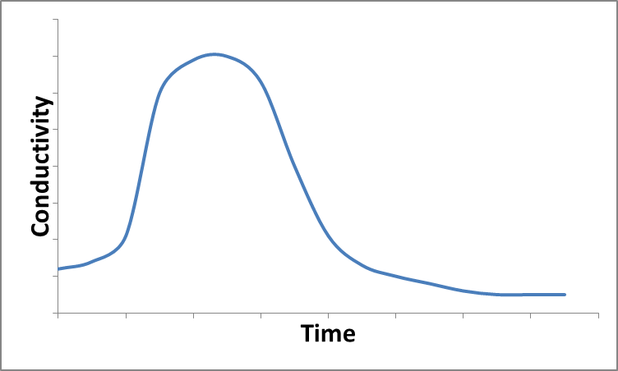
Notice that the clear juice at time zero already has a conductivity before any salt has reached that point .This is called the baseline conductivity and is due to salts and acids occurring naturally in the juice.
This conductivity baseline varies considerably and affects the graph.
- Method 2:
Add LiCI to the juice at the clarifier inlet. Since juice contains no Li+, we can take regular samples at the cleaner juice outlet. These samples are then analysed in the laboratory for their Li+ content. This method has the advantage of having a baseline.
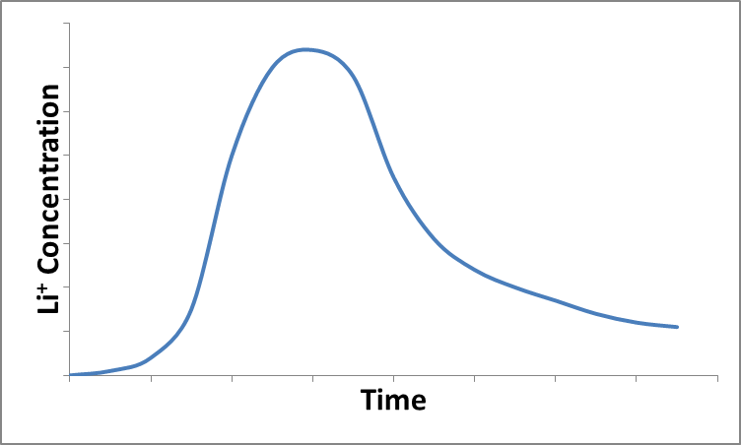
Once the graph has been plotted, the area under the curve is found and this must be equal to the mass of Li added. If this is not the case, then something serious is happening between the point of Li addition and where it is measured. Either you are not measuring all the clear juice outlet streams or some juice holdup is occurring that is giving Li⁺ a very long retention time.
A clarifier tracer test always gives a “tail” where the Li⁺ concentration emerging with the clear juice tapers off slowly. This is done to the Li⁺ entering the mud and being slowly released by the mud when it is replaced by fresh juice.
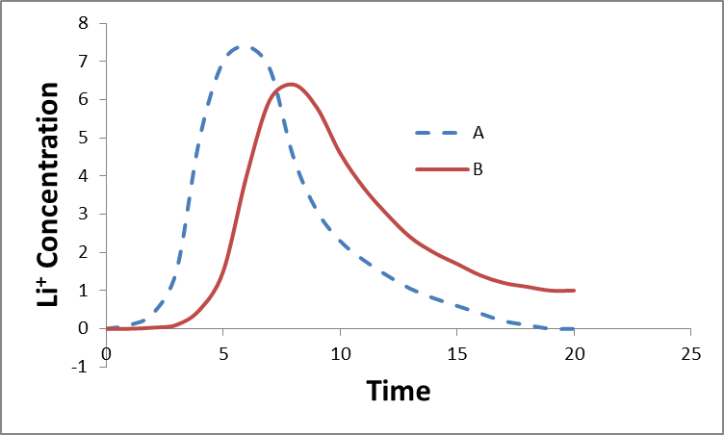
Curve A: indicates a low retention time.
Curve B: indicates a long retention time which is undesirable.

FILTRATION

Introduction
Mud from a clarifier appears to be a thick fluid but in fact contains only 3 to 5% mud solids on a dry basis. Over 90% of the mud is clear juice and this has to be recovered. The purpose of the filter station is to separate, as efficiently as possible, the mud solids from the clear juice.

Objective of Filtration
Two objectives are present:

The separation efficiency must be as high as possible.
This can be gauged by the amount of solid left in the filtrate.

Sucrose losses must be minimized
Losses occur in two cases. Firstly, there is a direct loss in the filter cake and secondly there can be less visible, but possibly more serious losses because of, microbiological activity in the filter station.

Rotary vacuum filters: Description
The rotary vacuum filter used for the filtration of clarifier muds is a segmented drum covered with a perforated stainless steel screen. As the perforations (0.5mm) are too big to retain mud particles bagacillo is used as a filter aid. The bagacillo forms the filter medium.
The filtrate is separated into two portions, clear and cloudy filtrate. In practice there is little to differentiate between the two filtrates as they are both cloudy and both are returned to the mixed juice tank.
Generally a rotary vacuum filter or Oliver filter will give a 50-70% separation of the clear juice and the mud solids in the mud.
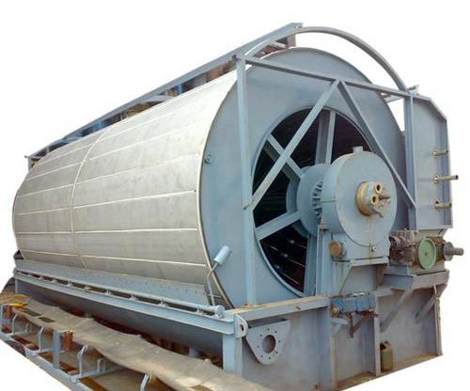
The rotary vacuum filter consists of a double walled drum rotating in a trough containing the mud to be filtered. The mud-bagacillo mixture in the trough is gently agitated to keep the mud and bagacillo in suspension. The outer wall of the drum is made of round-hole screens in 24 sections running the length of the drum. The inner solid wall of each section is connected by a pipe to a manifold at the end of the drum. Attached to the manifold is a distributing valve that is connected via receivers to a source of vacuum.
A low vacuum draws the juice fraction through the perforated plate to form a mat (1cm thick) of fibre and mud over the screen. As the drum turns, a higher vacuum is applied to force filtrate and wash water through the mat that had been formed. The second filtrate is clearer than the first. This first filtrate is called “cloudy filtrate” and goes to the cloudy filtrate receiver to be returned to the juice before the clarifier. The filter screen serves mainly to support the mat which is the main filtering medium. When the drum emerges from the trough, water sprays and drips are directed onto the filter cake to displace the juice. During this washing process, high vacuum is maintained. The water dilutes the filtrates. Filtrate brix is controlled at about 2-4 points lower than mixed juice brix. The cake is then dried by maintaining high vacuum with no water sprays.
Vacuum is broken at the cake discharge point and a scraper deflects the cake onto the disposal carrier. The filtrate is conveyed through metal pipes to the head of the filter and then to filtrate receiving tanks. The purpose of “washing” the cake is to achieve maximum sucrose recovery. Hot condensate is used as wash water. This keeps temperatures high in the filter station which minimizes bacterial activity.
The basic principle of operation is shown below:
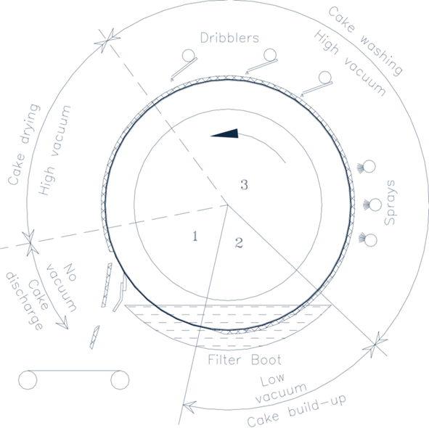

Filter Aids/Mud Conditioning
Cane muds do not filter well and the addition of a filter aid is essential (i.e. the mud must be conditioned). The filter aid used is bagacillo which are fine bagasse particles separated from the bagasse by suction through inclined screens. The bagacillo forms a porous mat that traps the mud solids and allows drainage of filtrate. A low filtration rate and associated long residence time can cause an extensive drop in filtrate purity.
The quantity of bagacillo necessary varies from 3 to 6 kg per ton of cane crushed.
A flocculant (coagulant) is also added to improve filtration. For best performance this flocculant is usually different from that used for clarification.
It has been shown that using polymers in mud filtration has the following effects:
- Insoluble solids content of the filtrate is reduced (from 2.0 to 0.4%)
- the moisture content of filter cake is reduced (79.5 to 75.6%) and
- the percentage pol in filter cake is reduced (about 30%).

Advantages and Disadvantages of Rotary Filters
The main advantage of the rotary filter is the elimination of manual labour, particularly when compared to filter presses.
The greatest disadvantage of rotary filters is that they cannot produce filtrate clear enough to go to the evaporators. In South Africa the filtrate is sent back to the mixed juice. This represents an increased load of about 20% in milling factories or about 10% with diffusion.

Filter station Arrangement
The layout of a typical filter station is shown below
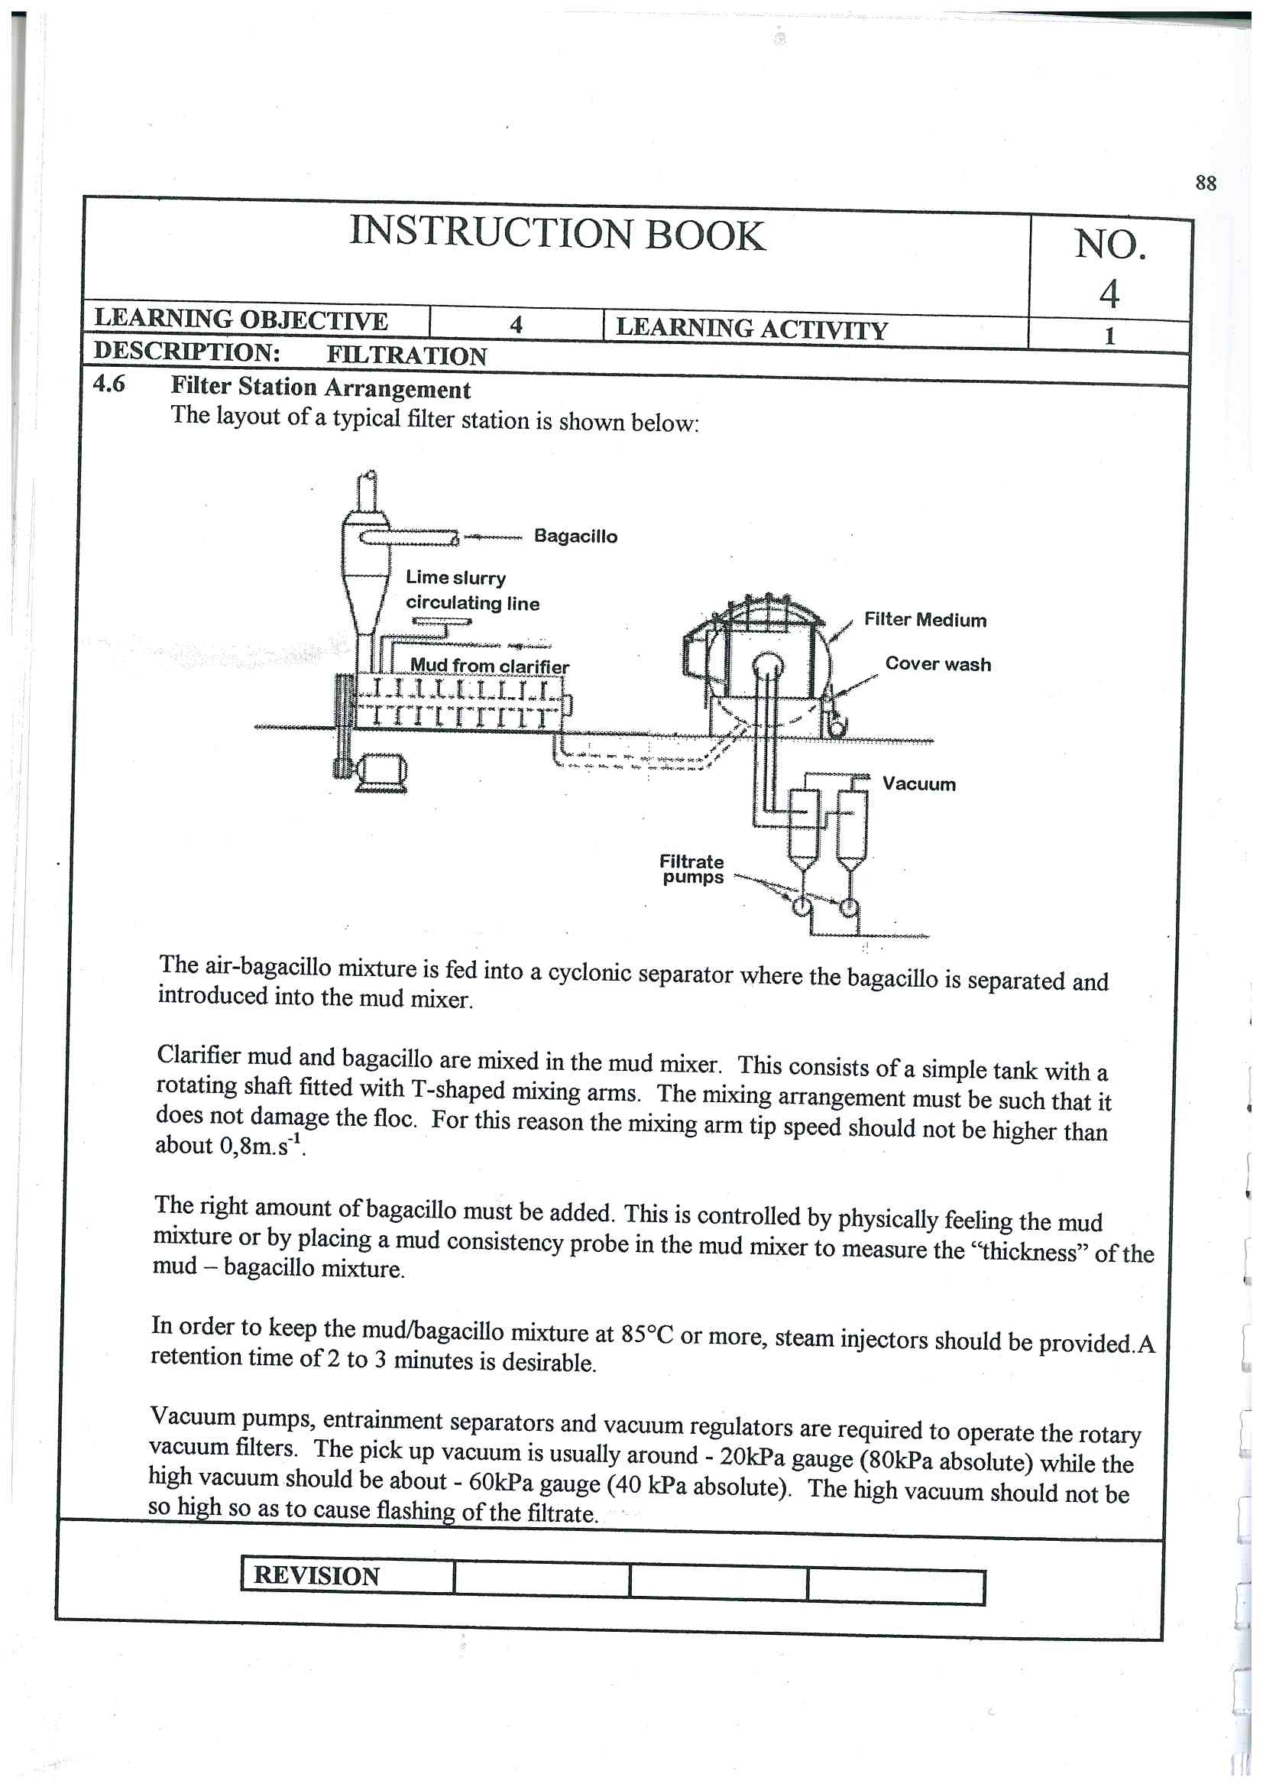
The air-bagacillo mixture is fed into a cyclonic separator where the bagacillo is separated and introduced into the mud mixer.
Clarifier mud and bagacillo are mixed in the mud mixer. This consists of a simple tank with a rotating shaft fitted with T-shaped mixing arms. The mixing arrangement must be such that it does not damage the floc. For this reason the mixing arm tip speed should not be higher than about 0.8m.s⁻¹.
The right amount of bagacillo must be added. This is controlled by physically feeling the mud mixture or by placing a mud consistency probe in the mud mixer to measure the “thickness” of the mud-bagacillo mixture.
In order to keep the mud-bagcillo mixture at 85°C or more, steam injectors should be provided. A retention time of 2 to 3 minutes is desirable.
Vacuum pumps, entrainment separators and vacuum regulators are required to operate the rotary vacuum filters. The pick-up vacuum is usually around -20 kPa gauge (80 kPa absolute) while the high vacuum should be about – 60 kPa gauge (40 kPa absolute). The high vacuum should not be so high as to cause flashing of the filtrate.

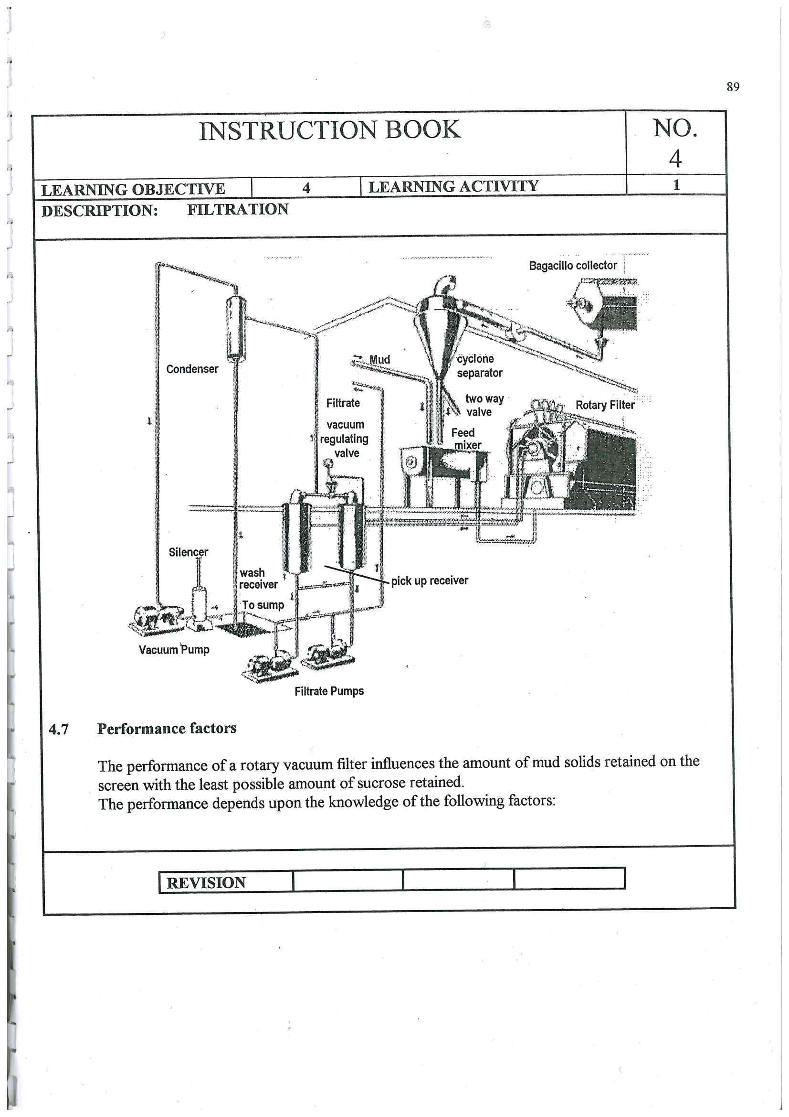

Performance factors
The performance of a rotary vacuum filter influences the amount of mud solids retained on the screen with the least possible amount of sucrose retained. The performance depends upon the knowledge of the following factors.
- Mud solids concentration (mud solids % feed) which is the dry insoluble begacillo free material separated from the clarifier underflow.
Mud solids concentration = (Dry mud solids/ Clarifier underflow (mud)) x 100
The Mud Solids Concentration must be 3 - 4% for effective filter operation. The 4% level should be viewed as being the maximum.
- Retention which is the percentage of total mud solids treated by the filter which is retained in the filter cake.
Retention = (Mud solids in filter cake / Mud solids in filter feed) x 100
- Bagacillo ratio which is the mass of dry bagacillo in filter feed expressed as a percentage of dry mud solids.
Bagacillo Rato = (Dry bagacillo / Dry mud solids)
The Bagacillo rate should be 1 for good filter operation.
Note: Total Solids % filter feed = Bagacillo % filter feed + Mud solids% Filter feed

Filter Operation

Retention
The retention of a filter is defined as the mud solids in the filter cake as a percentage of the mud solids in the filter feed. If all the mud solids remained in the filter cake and all the juice was recovered as filtrate, then the filter retention would be 100%.
The amount of mud solids retained by the filter influences the quantity of mud handled by the clarification station. The recirculation of muds does not only increase the quantity of mud but the recirculated mud particles consist of fine particles which are more difficult to settle (broken floc particles).
Practical achievement of 100% retention is impossible but the retention can be maximized by controlling the following:
- Bagacillo quality
Bagacillo must be fine (mostly pith) and free of long fibre. More than 90% of the bagacillo should pass through a 0.8mm screen and 70% through a 0.5mm screen.
- Bagacillo quantity
The quantity of bagacillo used is given in terms of dry bagacillo % feed. This should be about 3%. Above this figure mixing and pumping is difficult and wash water causes channeling with resultant poor washing.
- Mud solids concentration (MSC)
With a low MSC (thin mud) a lot of filtrate passes through the filter screen before the filtering mat is formed, causing poor retention. With a MSC of 3% or less it is not possible to achieve good retention even with large bagacillo ratios. With a MSC of 3%-4% higher retentions are possible provided the bagacillo ratio is correct. More bagacillo is required as the concentration of mud solids increase.
- Pickup vacuum
A low pickup vacuum allows the cake to build up gradually and form a porous cake that allows for effective washing. The pickup vacuum should not exceed - 20 kPa. A high pickup vacuum results in cloudy filtrate due to the solids being sucked through the screen.
- Filter speed
The speed of the filter drum influences the formation of the cake. The maximum speed of the drum should be 1 revolution in 6 minutes. Filter speeds in excess of this will reduce the retention. The aim is to run the filter at an optimal speed to give the wash water sufficient time to displace the juice.

Washing of the cake
The main purpose of the filter station is to recover as much sucrose as possible from the clarifier mud. The amount of sucrose lost at the station will be a function of:
- Sucrose % filter cake
- Filter cake % cane
- Purity drop between clear juice and filtrate.
Effective cake washing depends on
- The effective reduction of the pol in filter cake. The wash water is assumed to remove residual juice by displacement.
- Under perfect conditions this displacement would require a volume of wash water equal to the volume of juice in the mud so that the brix of the juice in the mud is not diluted as it becomes filtrate. In practice this is not possible and the brix of the filtrate is ±70% of that of the feed. The filtrate brix should only be 2 - 4% points below the brix of the clear juice.
The washing performance depends upon:
- Wash water temperature
A low wash water temperature (below 70°C) reduces efficiency because of the solidification of waxes. These waxes solidify behind the screen and the screen and the wash water has difficulty in draining away. A too high water temperature can cause flashing at the filtrate pump.
- Pick–up vacuum
A low pick-up vacuum results in a porous cake with good washing properties. The pick-up vacuum must be less than -20 kPa gauge.
- Dry bagacillo % feed
If the dry bagacillo % feed exceeds 4% channeling of the cake will result which will reduce the washing efficiency.
- Filter speed
Low/slow filter speeds give the cake more exposure to the wash water which will improve the washing efficiency.
- High vacuum
A good vacuum (at least -60 kPa gauge) will draw water through the cake with a greater force - thus improving efficiency. If the vacuum is too high (about -80 kPa gauge) there will be a possibility of flashing at the filtrate pump.
- Bagacillo quality
Fine bagacillo gives a cake through which the wash water will be easily drawn. The water will not run off but go through the cake and improve the removal of pol.
- Spray nozzles
Blocked nozzles stop the flow of water with no washing of the cake. Partially blocked nozzles cause the wash water to squirt out with considerable force. This results in channeling, excessive washing of part of the cake and dilution of filtrate. Nozzles should be checked regularly and cleaned whenever necessary.

Other performance factors
- Filter feed temperature should not be less than 85°C after bagacillo addition. Screen blinding may occur at lower temperatures through solidification of waxes.
- The addition of feed to the filter trough should be continuous and proportional to the filtration rate. The mud level in the filter trough mud boot should be constant and evenly distributed over the length of the filter. Mud overflow into the overflow tank should be avoided and if it does occur the mud should be pumped back immediately to avoid cooling and fermentation.
- The addition of flocculant at 4 - 5ppm can sometimes help filtration but is not essential.
- The cake thickness will vary with filter speed. The thickness can be increased by slowing the filter and by increasing the bagacillo ratio. At the normal speed of 10 - 15 revs per hour the cake should be 5 - 6 mm thick. A thin cake will result in poor retention and blinding.
- The pH of the feed should be adjusted after the clarifier to about 7.5 with milk of lime.

Sucrose Losses
Sucrose losses in filter cake, in the South African industry, are between 0.2 and 0.3% of the sucrose in cane, and are considered to be acceptable. Losses of sucrose in the filter station itself, because of microbiological activity are less evident but can be much more serious.
Surveys of filter stations can show severe purity drops between clear juice and filtrate accompanied by increases in lactic acid concentrations.
Microbiological Survey
 | Lactic Acid Concentration  Good/Acceptable | In ppm on Brix  Bad/Poor
Mixed Juice | 200 | 200
Limed Juice | 250 | 600
Mud | 300 | 900
Filter feed | 10 | 1000
Filtrate | 350 | 6000
Clear Juice | 205 | 305

Large purity drops and increases in lactic acid are associated with low temperatures and long filtrate residence times in the filter station. Filtrate residence times have been measured and vary from 14 to 46 minutes.
Hyperthermophilic bacteria have been found to be active in clarifier juices and in mud as well as in filtrate. It is known that a temperature of at least 75°C is necessary in order to suppress hyperthermophilic bacteria. High temperatures can be maintained by:
- Reducing the heat loss which results from long retention times.
- Increase the wash–water temperatures to at least 80°C
Sucrose losses by bacteriological activity is not only a direct loss of sucrose but their activity also produces lactic acid and ethanol that reduces the recovery of sucrose during pan boiling. Gums are also produced that increase masscuite viscosity.
Another case of low temperatures has been found to be the poor distribution and circulation of filter feed in the filter boots. Temperatures as low as 50°C were measured in certain dead spots in the filter boot at a number of factories. Modifications to the feed piping and the use of steam sprayers in the boot can solve this problem.
Filtrate retention time is affected primarily by installed plant capacities especially in factories where diffusers have replaced mills, and also by filtration rate. Increasing the filtration rate would reduce the number of filters required which would reduce the filtrate retention time.
Although the filtrate purity is inevitably lower than mixed juice purity it should not be lower by more than one to two units.
Mud pH can give an indication of deterioration in the clarifier. Generally is should be higher than clear juice pH because of lime particles settling in the mud. If it drops below the clear juice pH then there could be deterioration.

Disposal of Filter Cake
This can become a problem - both as regards to transport costs and to locations for dumping.
Filter cake has some value as fertilizer and is taken by farmers, if it can help them. However, the issue is complicated by the fact that a number of mills include smuts with the filter cake.

Clarification and filter station Mass Balance
