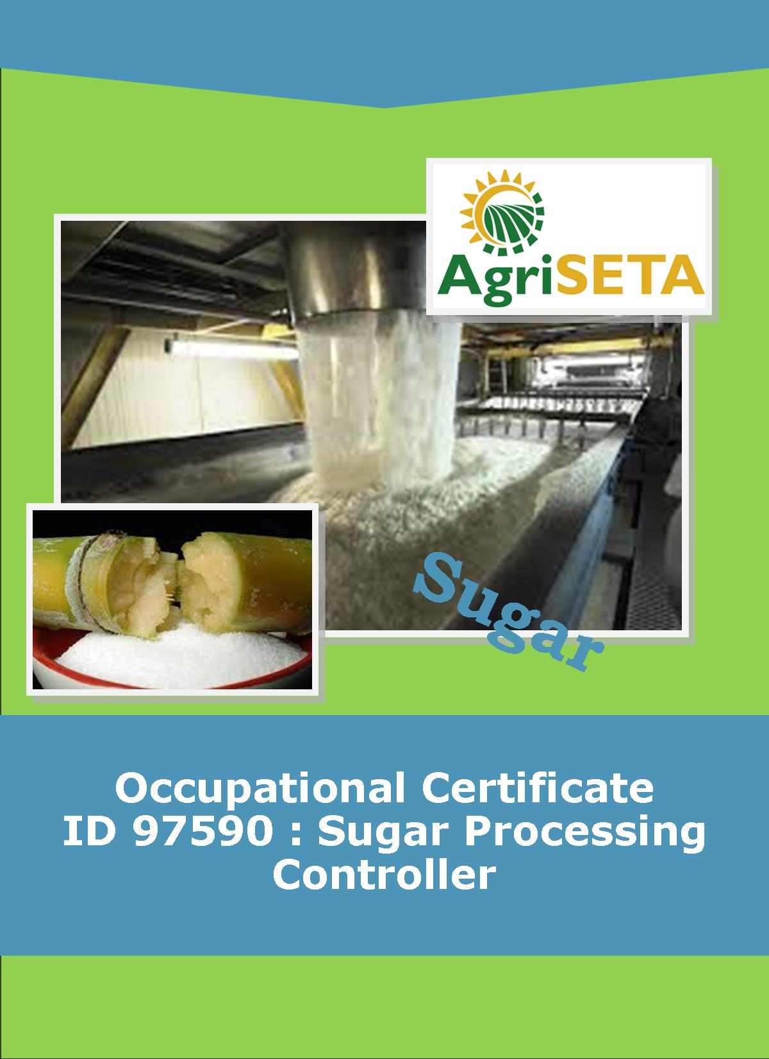
KNOWLEDGE COMPONENT: FACILITATOR FORMATIVE AND SUMMATIVE ASSESSMENT TOOLS AND MODEL ANSWERS : KNOWLEDGE MODULE 6 : EVAPORATION
KNOWLEDGE COMPONENT: FACILITATOR FORMATIVE AND SUMMATIVE ASSESSMENT TOOLS AND MODEL ANSWERS – KNOWLEDGE MODULE 6 : EVAPORATION
Occupational Certificate: Sugar Processing Controller

KNOWLEDGE COMPONENT: FACILITATOR FORMATIVE AND SUMMATIVE ASSESSMENT TOOLS AND MODEL ANSWERS – KNOWLEDGE MODULE 6 : EVAPORATION
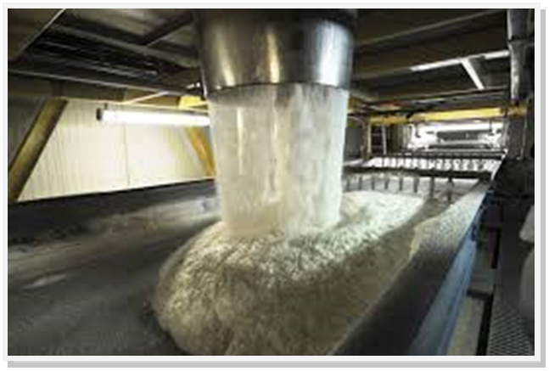
OCCUPATIONAL CERTIFICATE: SUGAR PROCESSING CONTROLLER

©Copyright AgriSETA
Telephone: +27 12 301 5600
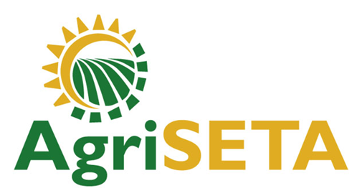

AgriSETA holds the copyright to its publications and Web pages. Proper citation is requested.

TABLE OF CONTENTS
1. INTRODUCTION TO THE FACILITATOR ASSESSMENT TOOLKIT OF THE OCCUPATIONAL CERTIFICATE: SUGAR PROCESSING CONTROLLER 6
2. KNOWLEDGE MODULE 6: EVAPORATION 7
2.1 Knowledge Topic 1: Evaporation principles (35%) 7
2.2 Knowledge Topic 2: Evaporator design / type (15%) 17
2.3 Knowledge topic 3: Pressure and vacuum (35%) 32
3. CONCLUSION OF KNOWLEDGE MODULE 6: SUGAR PROCESSING FACTORY CONTROL CALCULATIONS 36
4. SUMMATIVE ASSESSMENT ACTIVITIES AND MODEL ANSWERS 37
4.1 Written Assessment Model Answers 38
4.2 Written Assessment Total Marks 52

INTRODUCTION TO THE FACILITATOR ASSESSMENT TOOLKIT OF THE OCCUPATIONAL CERTIFICATE: SUGAR PROCESSING CONTROLLER
Dear Facilitator
This Toolkit has been created to assist you to assess the Formative Learning Activities of learners undertaking the NQF 5 Occupational Certificate: Sugar Processing Controller Qualification.
During the programme, Learners must be directed to their Learning and Activities Guide to complete Learning Activities associated with each module of the Knowledge Component.
The time allocated to the Learning Activities is provided in the Facilitator’s Implementation Guide, this Facilitator Assessment Toolkit and Model Answers and the Learning and Activities Guide.
The marks allocated to each Learning Activity is provided in this Facilitator Assessment Toolkit and Model Answers and the Learning and Activities Guide.
Instructions to be given to Learners
- They must work individually to present the results of each Learning Activity in each of the Learning and Activities Guides (Workbooks).
- They must complete all the sections.
- They must use a black pen and ensure that they complete the questions in their own handwriting.
- The time provided to complete each activity is shown.
- The marks they will attain for each learning activity are shown in brackets.

KNOWLEDGE MODULE 6: EVAPORATION
NQF LEVEL: 4
CREDITS: 8
PURPOSE OF THE KNOWLEDGE MODULE: The main focus of the learning in this knowledge module is to build an understanding of for the learner to gain fundamental understanding of the theory and science of evaporation.
The learning will enable learners to demonstrate an understanding of:
- KM-06-KT01: Evaporation principles (35%)
- KM-06-KT02: Evaporator design/type (15%)
- KM-06-KT03: Pressure and vacuum (35%)
- KM-06-KT04: Evaporation problem solving (15%)

2.1 Knowledge Topic 1: Evaporation principles (35%)
Topic elements to be covered include:
- KT0101 Calculations
- KT0102 Pressure and boiling point
- KT0103 Single and multiple effects
Internal Assessment Criteria and Weight
- IAC0101 An understanding of process steps and use of equipment related to evaporation can be demonstrated
- IAC0102 Key control points related to evaporation can be listed and controls explained
- IAC0103 An understanding of evaporation related calculations and formula can be demonstrated
- (Weight 35%)
Learning activity 1.1: Individual Learning activity: 10 minutes (7 marks)

Learning Objective: An understanding of process steps and use of equipment related to evaporation can be demonstrated.
Task: Read each question carefully and write your answer in the space provided.
1. What is the objective of evaporation? (2)
To eliminate the remaining major unwanted component- water in order to recover the sucrose.

2 Calculate the amount of water evaporated per hour
Brix of clear juice = 15
Brix of syrup = 65
Tons of clear juice per hour = 375 (5)
E = J $\left(\text{1-}\frac{\text{BJ}}{\text{BS}}\right)$
375$\left(\text{1-}\frac{\text{15}}{\text{65}}\right)$
=288,46t

Learning activity 1.2: Individual Learning activity: 10 minutes (10 marks)
Learning Objective: Key control points related to evaporation can be listed and controls explained
Task: Read each question carefully and write your answer in the space provided.
- What is single effect of evaporation? (2)
During single effect evaporation, each kg of steam condenses and passes its latent heat to a boiling solution where it evaporates 1kg of water to produce 1kg of vapour. This is called one-to-one evaporation.

- What is a Rillieuxs principle and why is it different under operating conditions? (8)

Rillieuxs first principle
In multiple effect evaporation on n effects, 1kg of steam fed to the first vessel will evaporate n kg of water from the juice.
Under factory conditions this principle is not totally accurate as there are some factors which cause deviations from the principle.
These can be summarized as follows:
- Heat is required to raise the temperature of the juice to boiling point. Hence some vapour is condensed without causing an equivalent amount of evaporation.
- An increases in the latent heat of the vapour as the boiling temperature decreases (i.e. the pressure decreases). The latent heat required to evaporated 1 kg of vapour in the last effect is thus greater than in the first effect.
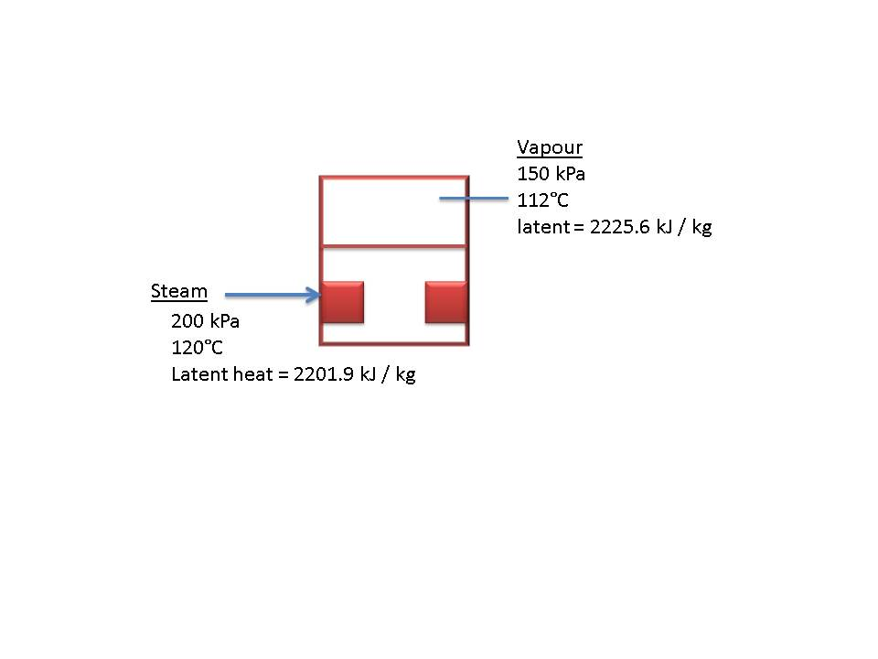
Therefore 1kg of steam condensing does not release enough energy to evaporate 1 kg of water.
- A decrease in the specific heat of the juice as it is concentrated. This means that less energy/heat is required to raise the temperature of more concentrated syrup by 1⁰ C.
- Flashing of the juice as it enters a lower pressure vessel causing some evaporation without vapour needing to be condensed to produce the vapour.
- Flashing of the condensate. This will be discussed later.
- Heat lost by radiation and by removal of incondensable gases.

Rillieuxs second principle
If the vapours are withdrawn from a given effect of a multiple – effect evaporate and used outside the boundary of the evaporator system in place of steam saving will be.
Steam saving = $\frac{\text{Number of the effect bled × Mass of vapour bled}}{\text{Total number of effects }}$
Steam saving = $\frac{\text{m ×} \text{V}}{\text{n}}$
So if the vapour is bled from the 1st effect of a quadruple effect the saving would be 25% of the vapour bled and if the bled from the 2nd effect the saving would be 50% of the vapour bled.
A pre-evaporator is sometimes used to generate vapour purely for juice heaters and pans. The juice then passes on to the conventional multiple effect evaporators.

Learning activity 1.3: Individual Learning activity: 10 minutes (9 marks)
Learning Objective: An understanding of evaporation related calculations and formula can be demonstrated
Task: Read each question carefully and write your answer in the space provided.
- What is vapour bleeding and what are the advantages of vapour bleeding? (4)
In order to use the least amount of exhaust steam, vapour is bled (drawn off) from one or more effect of a multiple effect evaporator and used to heat juice in juice heater and heat syrup in vacuum pans.
Advantages
The economy in steam usage will increase as vapour is bled from vessels further down the set i.e. using V₂ vapour would show a better saving than using V₁ vapour

2. Calculate the quality of exhaust steam saved if 10 tons of vapour is bled from the second effect of a 5t effect evaporator train. (5)
= $\frac{\text{m × V}}{\text{n}}$
= $\frac{\text{2 ×10}}{\text{4}}$
= 5 tons

Learning activity 1.4: Individual Learning activity: 30 minutes (17 marks)
Learning Objective: An understanding of evaporation related calculations and formula can be demonstrated.
Task: Read each question carefully and write your answer in the space provided.
- Explain how the reducing ratio can indicate losses in the evaporator station.(2)
Under normal conditions, a clear juice with a good pH (7.0 – 7.4) will record a small decrease in the reducing sugar ratio of between 4 – 6% from clear juice to syrup. The decrease is greater when the juice has been over limited during the clarification stage. A large decrease in the reducing sugar ratio indicates destruction of reducing sugars.
An increase in the reducing sugar ratio or a reducing sugar ratio that remains constant indicates inversion.

- Why is the turbidity of syrup greater than that of clear juice? (3)
The syrup if diluted has an increase in turbidly over that of clear juice. This is due mainly to the post precipitation of certain non-sugars because of the high temperature in the first evaporator vessel. These non-sugars include silica, and organic compounds.

- What is the mechanism of sucrose inversion and reducing sugar degradation in an evaporator? (6)
Inversion is the thermal and/ or acid decomposition of a sucrose solution to yield a mixture of glucose. When cane juice is heated, its sugar content undergoes decomposition by inversion which is more marked the higher the temperatures, lower pH and longer the time of exposure.
The rate of inversion is affected by pH, temperature and time.
- The amount of sucrose inverted is directly proportional to the time.
- The rate of inversion is proportional to the H⁺ ion concentration (acidity). The rate increases tenfold for every 1 unit decreases in pH. At 100°C and pH of 7.0 the rate is 0.021% inverted per hour. At pH of 6.0 the rate will increase to 0.21% inverted per hour.
- The rate of inversion increases rapidly with increase in temperature. If the inversion at 100°C is 1, 00 then then the rate at 120° is 5.23 times faster.
Alkaline juice and high temperatures in the first and second vessel are conducive to the degradation of glucose and fructose and the formation of organic acids and dark coloured compounds. These products cause viscosity problems later on in the process. A decrease in the reducing sugar ratio results mainly from the destruction of reducing sugars.
Destruction increases with temperature, increases with the time and increases as pH increases. The degradation of reducing sugars is a function of pH, temperature and reaction (retention) time.

- How is colour formed? (3)
Colour formation occurs mainly in the first vessels of the evaporator which correspond to high temperatures and slightly alkaline or neutral conditions. Suitable pH control and short retention times in these effects have brought this under control.
Recent work indicates that under alkaline conditions, reducing sugars break down to form colour compounds, notably melanoidin pigments, but under normal conditions would only make a small contribution.

- Why is there normally a pH drop along the evaporator from clear juice to syrup? (3)
This drop in pH is due to the following factors:
- As evaporation progress, the existing acids become more concentrated, making the solution more acidic.
- Decomposition of reducing sugars to form organic acids.
- Loss of alkaline volatiles such as ammonia.
Thus a combination of high concentration and high temperature will produce conditions of low pH and thus increased inversion.

2.2 Knowledge Topic 2: Evaporator design / type (15%)
Topic elements to be covered include:
- KT0201 Principles of operation
- KT0202 Heat transmission
- KT0203 Scale and cleaning
- KT0204 Control systems and principles
Internal Assessment Criteria and Weight
- IAC0201 Examples of evaporator equipment can be identified.
- (Weight 15%)
Learning activity 2.1: Individual Learning activity: 10 minutes (9marks)
Learning Objective: Task: Examples of evaporator equipment can be identified.
1. Why is evaporation in the evaporators more economical than evaporation in the pans? (2)
This achieves an economy in steam usage as the vapour bled comes from the water in the juice. The economy in steam usage will increase as vapour is bled from vessels further down the set i.e. using V₂ vapour would show a better saving than using V₁ vapour.

2. What factors determine the capacity of an evaporator? (3)
Area of the heating surface
Number of the effects
Location and extent of vapour bleeding

3. What is meant by evaporator system is self-balancing? (2)
The whole system is self-balancing which means that the capacity is determined by the least productive unit.

4. How does clear juice temperature affect evaporator capacity? (2)
If this temperature is low, then the heat has to be used to bring the temperature up to boiling point without generating any vapour. Conversely as the juice flows from vessel to one of a lower pressure and temperature, it flashes (fast evaporation) which improves the steam economy.

Learning activity 2.2: Individual Learning activity: 15 minutes (11marks)
Learning Objective: Examples of evaporator equipment can be identified.
Task: Read each question carefully and write your answer in the space provided.
- What is the aim of evaporator control? (2)
The primary aim of evaporator control is to obtain a uniform syrup brix from the last evaporator and secondly to get adequate V₁ and V₂ vapour bleeding.

2. Sketch an evaporator vessel, labelling all the parts (5)
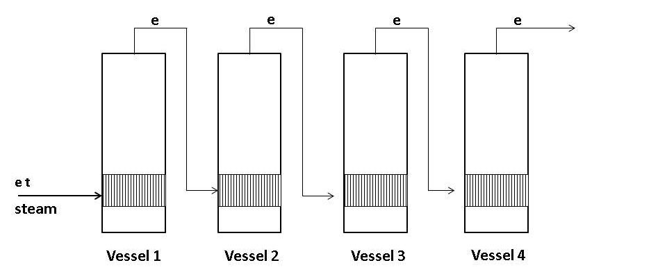

3. Describe the method by which feed is introduced into the vessels. (4)
The feed is taken in below the Calandria of the vessel. The juice is fed into the vessel in such a way that the distribution over all the tubes is as even as possible. Most evaporators are provided with a juice distribution ring inside the vessel below the bottom tube plate, with a number of holes each provided with a baffle. This ring is connected to the juice manifold through the bottom dish of the vessel by two or more branches. The flow of juice from on vessel to another is best regulated by means of a valve.

Learning activity 2.3: Individual Learning activity: 45 minutes (22 marks)
Learning Objective: Examples of evaporator equipment can be identified.
Task: Read each question carefully and write your answer in the space provided.
1. Describe the method by which incondensable gas is removed from the Calandria of evaporator vessels. (2)
Gases from Calandria under the pressure can be vented to the atmosphere, while gases from Calandria under the vacuum can be vented to the vapour space of the same vessel or to the vapour pipe leading to the condenser.

2. With the aid of a diagram describe how a combined condensate removal system works and the advantages and disadvantages of the system (10)
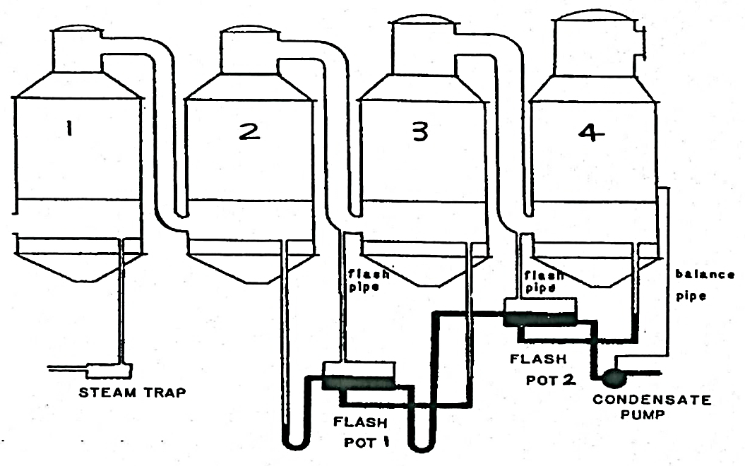
- Evaporator 1 is under pressure hence condensate is drained via a system trap.
- Evaporator 2, 3 and 4 are under the vacuum increasing from evaporator 2 to evaporator 3 and is greatest in evaporator 4. In other words, the pressure decreases from evaporator 2 to evaporator 3 and is the lowest in evaporator 4.
- The condensate from evaporator 2 drains to the flash pot via a U-leg. The difference in liquid levels in the two sides of the U-leg compensates for the pressure difference between the Calandria of the second evaporator and the Calandria of third evaporator. The U-leg act as seal and prevents the higher pressure in the Calandria of evaporator 2 from forcing/blowing all the condensate into flash pot 1 and hence allowing vapour to escape.
- Since flash pot 1 is connected to the Calandria of evaporator 3, it is at a lower pressure than the Calandria of evaporator 2. The condensate from evaporator 2 thus flashes and produces vapour that is piped to the Calandria of evaporator 3.
- Since flash pot 1 and the Calandria of the evaporator 3 are at the same pressure, condensate from evaporator 3 is also allowed to drain into flash pot 1.
- As condensate accumulates in flash pot 1 it is drained to flash pot 2 via a U-leg. The difference in liquid levels in the two sides of the U-leg compensates for the pressure difference between flash pot 1 ( connected to the Calandria of evaporator 3) and flash pot 2 (connected to the Calandria of evaporator 4 )
- Since that pot 2 is connected to the Calandria of evaporator 4, it is at a lower pressure than the Calandria of evaporator 3. The condensate from flash port 1 thus flashes and produces vapour that is piped to the Calandria of evaporator 4.
- Since flash pot 2 and the Calandria of evaporator 4 are at the same pressure, condensate from evaporator 4 is also allowed to drain into flash pot 2.
- As condensate accumulates in flash pot 2 it is pumped away using a pump.
The advantages of the combined removal system are that it is a simple installation.
The disadvantages are that all the condensates are cooled to the temperature of the last vessel condensate and in the event of any vessel entraining; all the condensate will be contaminated.

3. Describe how entrainment is caused and how it can be controlled and the effects minimized. (6)
Entrainment is the carrying over of droplets of juice with the vapour from one effect to the Calandria of the next (or to the condenser). This results in a loss of sugar and contamination of condenser water.
Entrainment is increased by sudden changes in flow, pressure, temperature or vacuum.
Entrainment has been controlled by means of louvre type separators either on their own or in conjunction with stainless mesh screens known as demisters. These demisters should be carefully fitted to avoid any holes which can actually aggravate entrainment due to high velocity velocities.
Efficient separation in the last vessel is essential to minimize entrainment.

4. What are the results of increased and reduced retention times in evaporator vessels? (4)
The reduction of retention time in a vessel will not only minimise scaling, but will also prevent inversion and degradation at a high temperatures. Factory extensions normally require more vapour to be bled from the vessels. This requires more heating surface with an associated longer retention time. This encourages colour formation and inversion. Retention time can be reduced by using a long tube evaporator or Kestner. The Kestner has tubes +/- 7m long and the high juice velocities improve the heater transfer rate and reduce scaling. The retention time is 25 to 33% less than a conventional vessel of the same evaporation capacity. Low fouling results in a good wetting of the heating surfaces.

Learning activity 2.4: Individual Learning activity: 30 minutes (20 marks)
Learning Objective: Examples of evaporator equipment can be identified.
Task: Read each question carefully and write your answer in the space provided.
1. Sketch an evaporator station consisting of 2 kestner vessels in parallel, followed by a quadruple effect set of Roberts vessels. Kestner vapour is used for juice heating and also feeds the first vessel of the quad. Vapour two is used for pan boiling. Show only the juice flow and steam/vapour flow. Use rectangles to represent the vessels. (15)
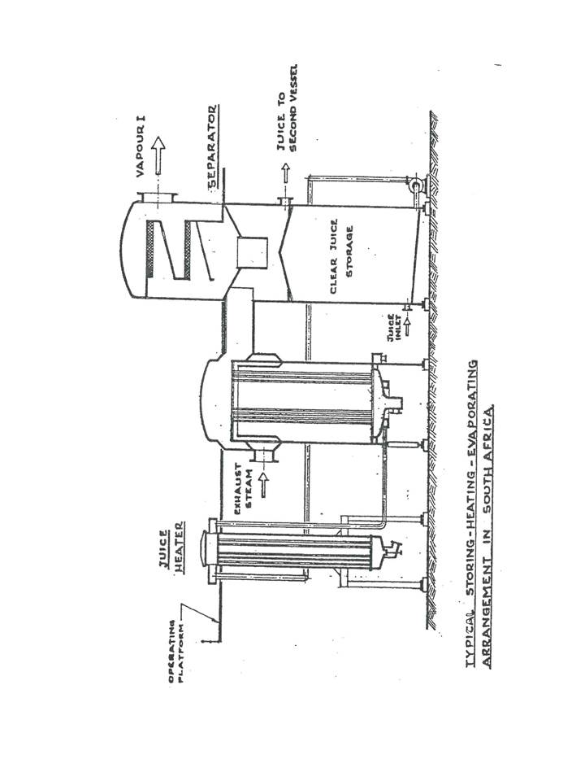
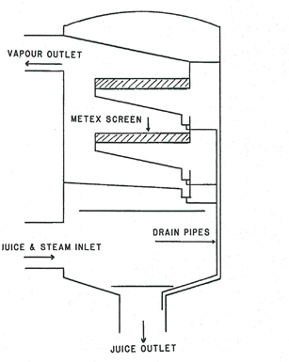
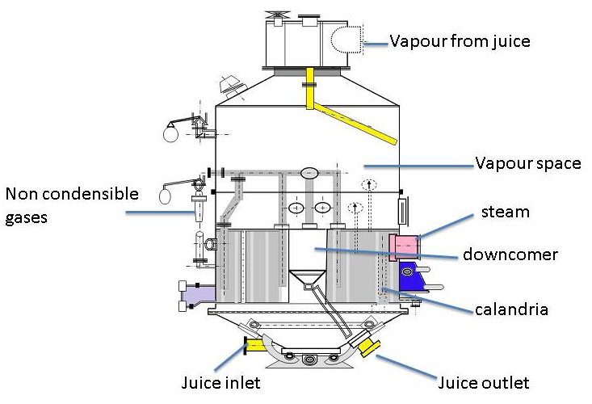
2. (a) on what does the heat transfer depend in an evaporator? (2)
It depends upon the total temperature drop from the exhaust steam in the 1st vessel to the vapour in the last vessel, as well as the heat transmission rates of each heating surface.

(b) Explain how this affects the first and last vessels (3)
The first vessel steam chest/calandria temperature depends on the exhaust steam temperature and is limited by the risk of inversion at high temperatures.
The temperature of the syrup in the last vessel depends on the vacuum created in the condenser. (Temperature of the cooling water). This is usually limited o 55°C as bellow this high viscosity of the syrup causes poor heat transfer.

Learning activity 2.5: Individual Learning activity: 30 minutes (20 marks)
Learning Objective: Examples of evaporator equipment can be identified.
Task: Read each question carefully and write your answer in the space provided.
- Explain the 3 main factors which govern the heat flow in an evaporator. (6)
The heat flow rate is directly proportional to the heating surface area. ($\text{Q }\text{∝}\text{ A)}$ This means that as the heating surface increases, the heat flow rate increases.
The heat flow rate is directly proportional to the temperature drop across the heating surface $\text{(Q }\text{∝}\text{ ∆T)}$
The heat flows rate is inversely proportional to the thickness (d) of the heating surface material $\text{(Q }\text{∝} \frac{\text{1}}{\text{d}}\text{)}$

- Discuss the effect of the film of water on the steam side on heat flow.(4)
A thin film of liquid at relatively high velocity, which is beneficial to good heat transfer, can also be obtained by carefully pouring the liquid into the top of a long tube.
A disadvantage is that the distribution weirs and trays for pouring in the juice have to be dismantled and removed to get access to the tubes from the top. Also it is necessary to recirculate juice to ensure complete wetting of the tubes at all times.

- Discuss the effect of hydrostatic head on heat flow. (4)
The depth of the juice in the Calandria causes the juice at the bottom to experience a significant pressure due to the height of juice above. This increased pressure increases the boiling point of the juice at the bottom. The temperature of the juice at the bottom thus increases but the juice does not boil. Since the bottom of the tubes is at a slightly higher temperature, the temperature difference ($∆T)$ between steam/vapour and juice is reduced which reduces the rates of heat transfer.
The hydrostatic head also slows down/depresses the movement of the juice the bottom of the tubes. This reduced velocity causes stagnant layers of juice to form on the heating surfaces and this also decreases the heat transfer coefficient.

- What effect does viscosity have on heat transfer?(2)
Viscosity greatly effects circulation. The effect of viscosity increases down the evaporator train as the brix of the syrup increases.

- Discuss the effects of scale on heat transfer (4)
Scale causes certain non-sugars to become insoluble and be deposited on the heating surface.
Scale formation results in a resistance to heat transfer. The buildup of scale could be such as that the heat transfer is affected to an extent where the required evaporation cannot be maintained.

Learning activity 2.6: Individual Learning activity: 30 minutes (20marks)
Learning Objective: Examples of evaporator equipment can be identified.
Task: Read each question carefully and write your answer in the space provided.
1. Discuss the formation of scale in different vessels. (6)
Scale is formed as the juice in the evaporator increases in concentration (brix) and causes certain non-sugars to become insoluble and be deposited on the heating surface
Scale formation results in a resistance to heat transfer. The buildup of scale could be such as that the heat transfer is affected to an extent where the required evaporation cannot be maintained. The scale builds up gradually under operating conditions and will be heavier at the bottom of the tubes. The static juice height has to be increased as scale formation builds up.
Scale formation will be reduced by ensuring adequate wetting of the heat transfer surface. Slow crushing and short stops increase the formation of scale due to low juice velocities. Low fouling occurs with a high sustained velocity/ flow rate. The high HTC is the results of low scale formation.

2. What could cause slack syrup produced by the evaporator? (4)
- A low steam pressure in the Calandria of the first vessel. If this pressure is inadequate the total evaporating process throughout the set is down.
- Inadequate vacuum in the last vessel. A poor vacuum in the last effect affects the performance of the preceding vessels.

3. Describe the methods by which scale can be removed from the evaporator tubes. (6)

Mechanical cleaning: Mechanical cleaning is usually carried out with tool heads mounted on flexible shafts driven by electric motors. This type of cleaning is expensive in equipment maintenance and labour costs and with hard scale, tube damage is common.

Chemical cleaning: For chemical cleaning to be effective the reagents and methods used must be suited to the type of scale. The most common method employed is alkali-acid cleaning. The procedure is to boil a caustic soda solution or a caustic soda/soda ash solution, then wash thoroughly with water and then boil or occasionally spray sulphur or phosphoric acid. Due to the different scales found in the vessels one chemical is not normally enough to remove them all. As caustic attacks silicates and silica and acids attack phosphates, oxalates and carbonates, both are used to obtain as complete removal as possible.

4. What different methods can be used to automate an evaporator? (4)
Method 1: cut the flow rate of juice\syrup through the evaporators. This is done by reducing the flow rate from the tail evaporators and working towards the front of the evaporator train. However it is important to maintain the correct syrup levels in the evaporators. This method of control is called feedback control.
Method 2: set the desired flowrate and use the steam pressures to control the brix of final syrup. The final brix is increased by increased by increasing rate in 2 ways.
- Increasing the exhaust steam pressure to the first affected by increased letdown.
- Increasing the vapour pressure to evaporator 3 also by letdown into the V₂ line.

2.3 Knowledge topic 3: Pressure and vacuum (35%)
Topic elements to be covered include:
- KT0301 Objectives
- KT0302 Vacuum pumps
- KT0303 Cooling systems
Internal Assessment Criteria and Weight
- IAC0301 The purpose of vacuum and pressure in evaporation process can be explained.
- (Weight 35%)

Learning activity 3.1: Individual Learning activity: 10 minutes (10 marks)
Learning Objective: Task: The purpose of vacuum and pressure in evaporation process can be explained.
1. Sketch a condenser, labelling all the parts. (5)
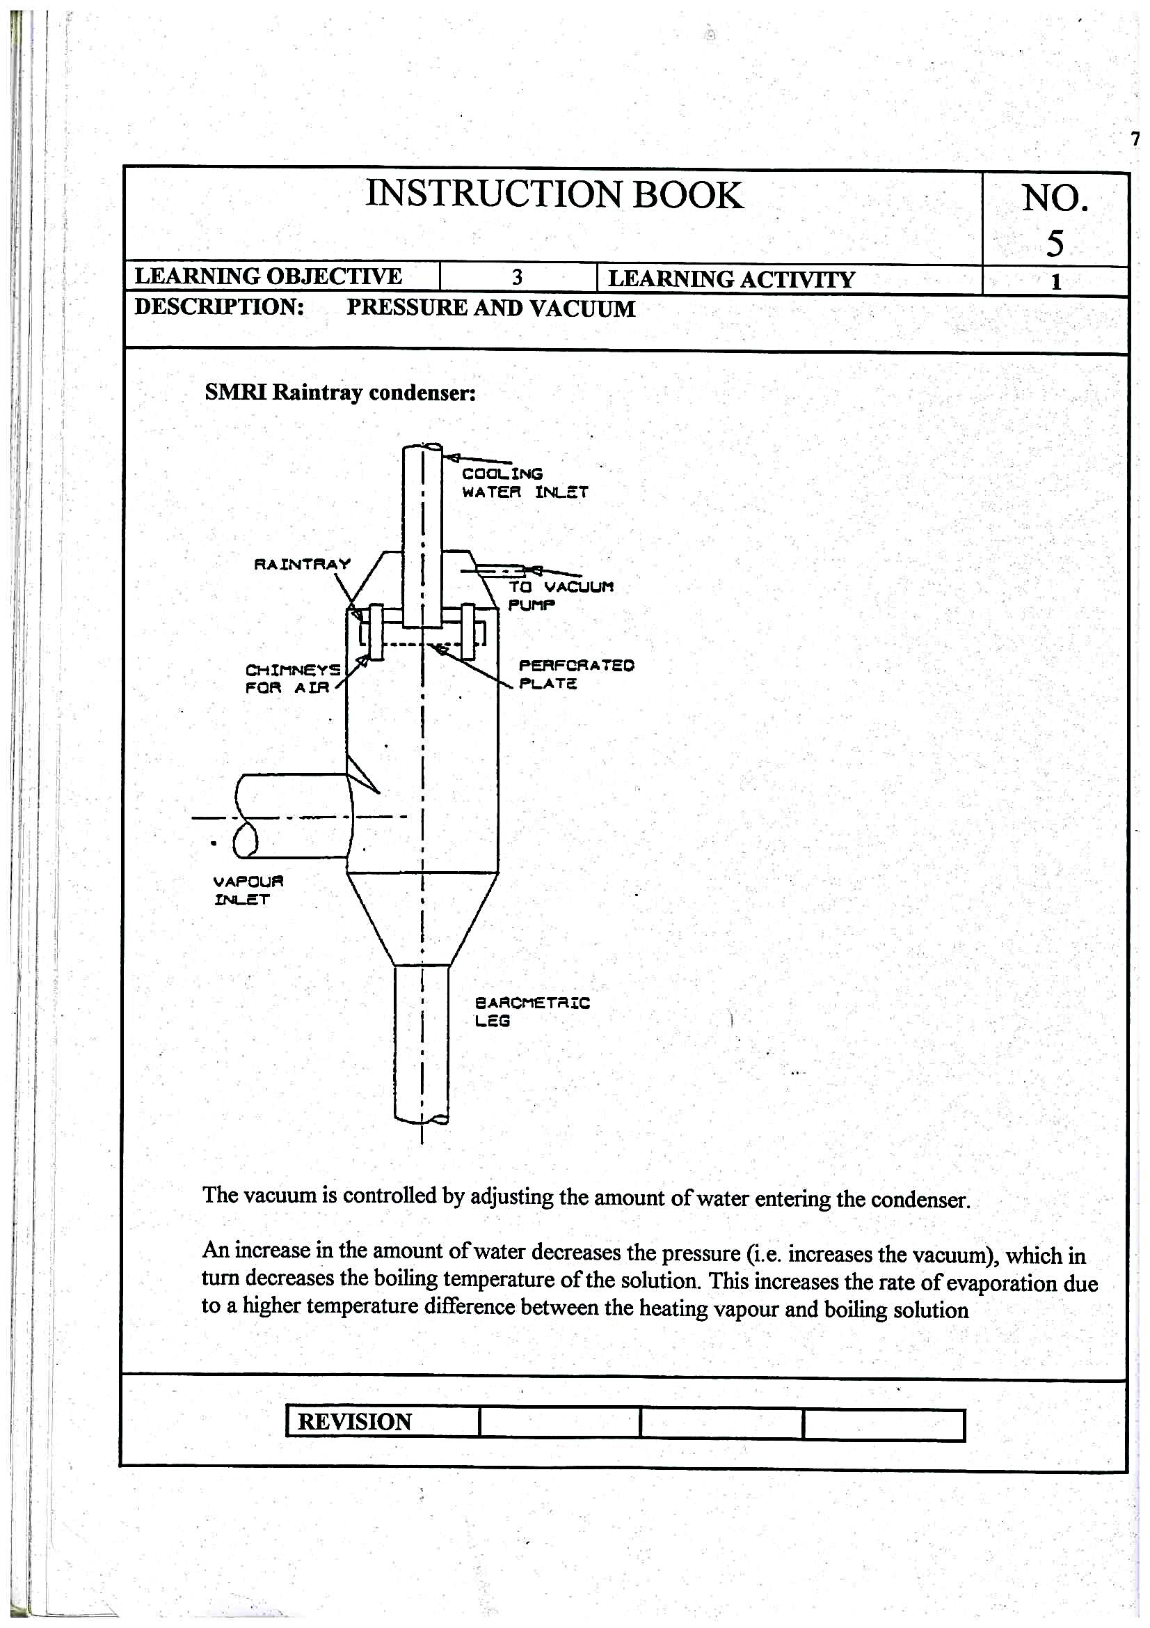
2. What is barometric leg? (2)
A barometric leg is basically a condensate drain. In a vacuum system that is used to condense steam and condensable vapors through heat exchangers or condensers, the condensate is normally dropped into a receiver tank that is often vented to atmosphere or a low-pressure vent system.

3. Explain what is meant by approach temperature and the importance of the approach temperature measurement. (3)
The approach temperature is the difference between the inlet vapour temperature (t_{v}) and the outlet temperature (t_{o}) i.e. (T_{v}-T_{o}). A condenser is said to be working well if the approach temperature is low. The more water is used the lower it becomes. This increases the approach temperature and lowers the condenser efficiency. Strict control of the condenser water will ensure that the condenser is working is working efficiently.

Learning activity 3.2: Individual Learning activity: 10 minutes (8 marks)
Learning Objective: The purpose of vacuum and pressure in evaporation process can be explained.
Task: Read each question carefully and write your answer in the space provided.
1. Why is the vacuum in the last vessel limited? (4)
- Leaks in the evaporator body and related vacuum piping
- Poor functioning of the vacuum pumps ( incondensable gas pumps)
- Insufficient condenser water, which could be due to a shortage of water, or malfunctioning of the condenser water supply pumps.
- High condenser water temperature.

2. What are the benefits of boiling under vacuum? (4)
- Improved heat transfer
As the pressure above the liquid decreases (i.e. increase in vacuum), the boiling point of the liquid decreases. This increases the temperature difference ($∆T$) between the vapour and the boing liquid thus improving the rate of heat transfer.
- Reduction of inversion and destruction of sucrose
A reduced boiling temperature will minimise any sucrose destruction.

CONCLUSION OF KNOWLEDGE MODULE 6: SUGAR PROCESSING FACTORY CONTROL CALCULATIONS
Throughout this knowledge module you have been provided opportunities to complete formative learning activities. You have captured your results in this Learner Workbook.
The total marks for this Knowledge Module are as follows:
Knowledge Module | Total Marks | Marks attained
KM-06-KT01: Evaporation principles (35%) | 43
KM-06-KT02: Evaporator design / type (15%) | 102
KM-06-KT03: Pressure and vacuum (35%) | 18
KM-06-KT04: Evaporation problem solving (15%)
 | 168 marks

SUMMATIVE ASSESSMENT ACTIVITIES AND MODEL ANSWERS
The learner is now required to complete the Summative Assessment (Multiple choice).
Facilitator instructions:
Once the facilitation of this Knowledge Module is completed:
- Allow the learners time to complete their Learner Workbooks (8 hours). There should be no blank activities and all activities should be completed in pen.
- The Summative Assessment Guide is then handed to each learner and the Summative Assessment is done (2 hours)
- It should take approximately 16 hours to mark each Learner Workbook.
- Insert the marks obtained for each Knowledge Module into the Summative Assessment Guide of each learner in the space provided.
- Tally the total marks and complete the Summative Assessment Guide of each learner.
- Hand out each Summative Assessment Guide for final learner feedback and signing.
- Prepare certificates for the programme as required.

4.1 Written Assessment Model Answers
Candidate instruction: Complete the following multiple-choice questionnaire by marking the most appropriate response with an x in the space provided.
Scope of Assessment | Exit Level Outcome/s | Module/s
 | - : Evaporation | 6
Alignment – Learning Outcome 1: Evaporation, Evaporator design and operation, Pressure and Chemical changes.

Award one mark for selection of valid “x”. One mark = Competent

61 | The purpose of evaporation is to; |  |  | Mark Allocation
a. |  | Control the pH of clear juice.
b. |  | Maintain a constant temperature of the clear juice.
c. |  | Remove unwanted water from the clear juice.
d. |  | Remove unwanted suspended solids from the clear juice.
e. |  | Form small crystals for sugar manufacture. |  | (2)
6.2 | Is there a limit to the soluble solids concentration of syrup? |  |  | Mark Allocation
a. |  | No.
b. |  | Yes, it must be no greater than 55 ºBrix.
c. |  | Yes, it must be close to 72 ºBrix.
d. |  | Yes, it must be between 72 and 75 ºBrix.
e. |  | Yes, the best recommendation is that it is between 65 and 68 ºBrix. | (2)
An extraction plant produces 400 tons of clear juice per hour at 12 ºBrix and this must be concentrated to syrup of 70 oBrix.
Assume the following: J = mass of clear juice per hour
S = mass of syrup per hour
BJ = Brix % Clear Juice
BS = Brix % Syrup
E = mass of water evaporated per hour.
%E = Percentage of water evaporated
Using the following formulae;
S = BJ x J
BS
E = J – S
%E = E
J X 10
6.3 | What will be the mass syrup (S) per hour? |  |  |  | Mark Allocation
a. |  |  | 70.59
b. |  |  | 64.32
c. |  |  | 65.87
d. |  |  | 68.57
e. |  |  | 69.38 |  | (2)
6.4 | Using the parameters and formulae from question 3, what would be the mass of water (E) evaporated per hour. |  |  |  | Mark Allocation
a. |  |  | 329.41
b. |  |  | 335.58
c. |  |  | 334.13
d. |  |  | 331.43
e. |  |  | 330.62 |  | (2)
6.5 | Using the parameters and formulae from question 3, what would be the percent of water (%E) evaporated per hour? |  |  |  | Mark Allocation
a. |  |  | 82.65%
b. |  |  | 83.90%
c. |  |  | 83.53%
d. |  |  | 82.86%
e. |  |  | 82.66% |  | (2)
6.6 | What is the temperature range for sensible heat for water? |  |  |  | Mark Allocation
a. |  |  | 99 ºC – 100 ºC
b. |  |  | 20 ºC – 75 ºC
c. |  |  | 0 ºC – 20 ºC
d. |  |  | 0 ºC – 100 ºC
e. |  |  | 20 ºC – 100 ºC |  | (2)
6.7 | Pressure on the surface of water will influence the boiling point of water. Which is the correct statement? |  |  |  | Mark Allocation
a. |  |  | A low pressure will increase the boiling point.
b. |  |  | A high pressure will increase the boiling point.
c. |  |  | The boiling point remains the same under any pressure.
d. |  |  | A higher pressure will lower the boiling point
e. |  |  | A low pressure will not have any impact on the boiling point. |  | (2)
6.8 | Why will 80 tons of steam produce 80 tons of vapour from 100 tons of juice in a single effect evaporator? |  |  |  | Mark Allocation
a. |  |  | Because 1 kg of steam will only evaporate about 1kg of vapour from a solution at its boiling point.
b. |  |  | Because 100 tons of juice will only have 20 tons of vapour to evaporate (100-80).
c. |  |  | There is insufficient sensible heat to evaporate more vapour.
d. |  |  | The single effect evaporator is inefficient.
e. |  |  | Much of the heat that is absorbed by the juice is used to reach the boiling point. |  | (2)
6.9 | Boiling point elevation (B.P.E) is; |  |  |  | Mark Allocation
a. |  |  | A decrease in the boiling point as a result of the increase in Brix.
b. |  |  | The increase in the boiling point as a result of the decrease in pressure.
c. |  |  | An increase of the boiling point as a result of the increase in pressure.
d. |  |  | The increase in pressure as a result of the increase in Brix.
e. |  |  | The increase in boiling point as a result of an increase in Brix. |  | (2)
6.10 |  | Is there a limit to the number of evaporators that can be installed in a sugar factory? |  |  | Mark Allocation
a. |  |  |  | Yes and cannot be more than five.
b. |  |  |  | No, as long as there is sufficient exhaust steam.
c. |  |  |  | Yes, there should be no more than three.
d. |  |  |  | Yes, a normal factory could manage seven.
e. |  |  |  | Yes, there should be no more than four. | (2)
6.11 |  | In order to evaporate 80 tons of water from 100 tons of clear juice in a quadruple (4) effect evaporator station, how many tons of exhaust steam is needed. |  |  | Mark Allocation
a. |  |  |  | 80 tons.
b. |  |  |  | 20 tons.
c. |  |  |  | 60 tons.
d. |  |  |  | 320 tons.
e. |  |  |  | None of the above. | (2)
6.12 |  | What is the best definition for vapour? |  |  | Mark Allocation
a. |  |  |  | The spare steam that is not used by the first or second effect.
b. |  |  |  | The steam that has already been used in the first evaporator.
c. |  |  |  | The primary steam that comes from the boilers.
d. |  |  |  | The steam that is generated by boiling the clear juice.
e. |  |  |  | The secondary steam that comes from the boilers. | (2)
6.13 |  | A quadruple (4) effect evaporator station is supplied with 20 tons of exhaust steam to evaporate 80 tons of water per hour. An additional 10 tons is required to be supplied to the factory, totalling 30 tons of exhaust steam demand per hour.  Calculate the tons of exhaust steam that would be saved, if the 10 tons required for the factory is bled from the first vessel (V1) rather than being taken from the exhaust steam supply.  Assume the following: E = tons of water to be evaporated.  n = the number of vessels in the system.  m = the position of the vessel from where the vapour is bled.  V1 = the tons of steam bled per hour.  e = tons of vapour  Use the following formulae; |  |  | Mark Allocation
  e = | m x V₁  n
a. |  |  |  | No saving.
b. |  |  |  | 5 tons.
c. |  |  |  | 27.5 tons.
d. |  |  |  | 7.5 tons.
e. |  |  |  | 2.5 tons. | (2)
6.14 |  | Vapour bleeding is practiced in evaporator operations in order to: |  |  | Mark Allocation
a. |  |  |  | Save water.
b. |  |  |  | Increase the Brix of syrup.
c. |  |  |  | Control pH
d. |  |  |  | Save steam.
e. |  |  |  | Reduce the number of vessels in the evaporator station. | (2)
6.15 |  | Which statement best defines vapour recompression. |  |  | Mark Allocation
a. |  |  |  | Vapour that is bled to the juice heaters is compressed in the heaters.
b. |  |  |  | Exhaust steam is compressed when entering the calandria of the first effect.
c. |  |  |  | A portion of vapour from an evaporator is bled off and mechanically compressed for use in the evaporator station.
d. |  |  |  | The pressure of the steam in the final effect is compressed due to the multiplying effect.
e. |  |  |  | Vapour that is bled off is mechanically compressed before going to the juice heaters. | (2)
6.16 |  | Which of the following factors improve the capacity of the evaporator station? |  |  | Mark Allocation
a. |  |  |  | Location and extent of vapour bleeding.
b. |  |  |  | Area of the heating surface.
c. |  |  |  | Number of vessels (effects).
d. |  |  |  | Heat of the incoming juice.
e. |  |  |  | All of the above. | (2)
6.17 |  | An evaporator is a large vessel where clear juice is boiled. Where does the heat transfer take place within the vessel? |  |  | Mark Allocation
a. |  |  |  | The calandria.
b. |  |  |  | The save all.
c. |  |  |  | The condenser.
d. |  |  |  | The vapour space.
e. |  |  |  | The downcomer. | (2)
6.18 |  | Condensate is removed from the first effect evaporator and used for; |  |  | Mark Allocation
a. |  |  |  | Imbibition.
b. |  |  |  | Factory washing.
c. |  |  |  | Boiler feed water.
d. |  |  |  | Juice heaters.
e. |  |  |  | None of the above. | (2)
6.19 |  | The definition of Entrainment is best described as follows; |  |  | Mark Allocation
a. |  |  |  | The wet condensate that is removed from the evaporator.
b. |  |  |  | The juice that flows from one evaporator to the next.
c. |  |  |  | The velocity of the vapour leaving the tubes.
d. |  |  |  | The increase in Brix from clear juice to syrup.
e. |  |  |  | The carryover of droplets of juice in the vapour. | (2)
6.20 |  | The design difference between a Roberts evaporator and Kestner evaporator is; |  |  | Mark Allocation
a. |  |  |  | The Kestner occupies more floor space.
b. |  |  |  | The Kestner has a longer residence (retention) time.
c. |  |  |  | There are no differences.
d. |  |  |  | The Kestner has a calandria that is much longer than a Roberts.
e. |  |  |  | The Roberts has an efficient separator positioned alongside the evaporator. | (2)
6.21 |  | The Kestner evaporator in the SA sugar industry uses a specific heat exchange principle. What is the best description of this principle? |  |  | Mark Allocation
a. |  |  |  | Climbing film
b. |  |  |  | Falling film.
c. |  |  |  | Reduce film.
d. |  |  |  | Heat transfer co-efficient.
e. |  |  |  | Boiling point elevation. | (2)
6.22 |  | How is a vacuum produced in the evaporation station? |  |  | Mark Allocation
a. |  |  |  | Vacuum from the pans is used.
b. |  |  |  | A condenser creates a vacuum in the last effect.
c. |  |  |  | The first effect provides vacuum from the vapour.
d. |  |  |  | There are vacuum pumps that generate vacuum.
e. |  |  |  | The heat transfer in the calandria of the final effect creates the vacuum. | (2)
6.23 |  | A U-Leg is best defined as follows: |  |  | Mark Allocation
a. |  |  |  | A support for the evaporator.
b. |  |  |  | A means of storing condensate.
c. |  |  |  | Preventing flash-back from the flash pot.
d. |  |  |  | Compensates for different pressures and acts as a seal.
e. |  |  |  | Provides a means to pump the condensate away. | (2)
6.24 |  | The heat transfer in an evaporator station is mainly by; |  |  | Mark Allocation
a. |  |  |  | Conduction.
b. |  |  |  | Convection.
c. |  |  |  | Radiation.
d. |  |  |  | BPE.
e. |  |  |  | Hydrostatic head. | (2)
6.25 |  | Heat transfer within an evaporator can be improved by; |  |  | Mark Allocation
a. |  |  |  | Incondensable gasses.
b. |  |  |  | Scaling of evaporator tubes.
c. |  |  |  | Higher juice velocity and turbulence.
d. |  |  |  | Viscous syrup.
e. |  |  |  | Entrainment. | (2)
6.26 |  | The effect of evaporation on clear juice; |  |  | Mark Allocation
a. |  |  |  | Significantly decreases the purity of the juice.
b. |  |  |  | Reduces the tons of Brix in syrup.
c. |  |  |  | Develops sugar crystals.
d. |  |  |  | Decreases the viscosity (thickness) of the juice.
e. |  |  |  | Increases the viscosity (thickness) of the juice. | (2)
6.27 |  | The hydrostatic head is the increase in pressure at the bottom of the vessel due to the height of the juice above and has the following effect. |  |  | Mark Allocation
a. |  |  |  | Improves the movement of juice at the bottom of the vessel.
b. |  |  |  | Increases the boiling point of juice at the bottom of the vessel.
c. |  |  |  | Improves the condensation of the steam.
d. |  |  |  | Develops more incondensable gasses.
e. |  |  |  | Provides the easy movement of juice from one vessel to the next. | (2)
6.28 |  | Scale that is found in the evaporator tubes is as a result of; |  |  | Mark Allocation
a. |  |  |  | The condition of the steam used in the first effect.
b. |  |  |  | The hydrostatic head.
c. |  |  |  | Certain non-sugars becoming insoluble and being deposited on the heating surface.
d. |  |  |  | The increase in BPE.
e. |  |  |  | Increased HTC. | (2)
6.29 |  | Which of the following parameters are used to measure the performance of an evaporator. |  |  | Mark Allocation
a. |  |  |  | Brix of the syrup leaving the last evaporator.
b. |  |  |  | V₁ and V₂ steam pressures.
c. |  |  |  | Exhaust steam pressure.
d. |  |  |  | Clear juice flow into the first evaporator.
e. |  |  |  | All of the above. | (2)

6.30 | The best response that is required if the syrup Brix from the last effect is too low is; |  | Mark Allocation
a. |  | Decrease exhaust steam pressure.
b. |  | Increase the flow of clear juice.
c. |  | Reduce the vacuum.
d. |  | Increase the exhaust steam pressure.
e. |  | Increase the retention time in the clarifiers. | (2)
6.31 | The definition for pressure is; |  | Mark Allocation
a. |  | Force of the atmosphere on the outside of a vessel.
b. |  | Atmospheric pressure.
c. |  | The difference between gauge pressure and absolute pressure.
d. |  | Pascal.
e. |  | Force per unit area. | (2)
6.32 | Pressure is measured in; |  | Mark Allocation
a. |  | Joule.
b. |  | Gram.
c. |  | Degree.
d. |  | Pascal.
e. |  | None of the above. | (2)
6.33 | The vacuum produced by the condenser is best controlled as follows; |  | Mark Allocation
a. |  | Increase the vacuum by decreasing the cooling water flow.
b. |  | Decrease the vacuum by increasing the cooling water temperature.
c. |  | Decrease the vacuum by increasing the cooling water flow.
d. |  | Decrease the vacuum by increasing the condensate removal.
e. |  | Increase the vacuum by adjusting the vapour flow from the previous vessel. | (2)
6.34 | The reducing sugar ratio is defined best as follows; |  | Mark Allocation
a. |  | The ratio of reducing sugars to pol.
b. |  | The percent of dissolved solids to pol.
c. |  | The degree of change in purity of syrup.
d. |  | The ratio of the change in rotation of certain sugars.
e. |  | All of the above. | (2)
6.35 | The pH of syrup is lower than the pH of clear juice. Choose the statement that best describes why. |  | Mark Allocation
a. |  | The pH of the clear juice was too low as it entered the evaporation station.
b. |  | The syrup is too viscous (thick) to get an accurate pH reading.
c. |  | The retention time in the evaporators is too long.
d. |  | There are insufficient effects in the evaporator station.
e. |  | Evaporation causes the acids existing in the juice to become more concentrated. | (2)

TRUE OR FALSE QUESTIONS:
Scope of Assessment |  |  | Exit Level Outcome/s |  | Module/s
 |  |  | 2.: Evaporation |  | 6
Alignment – Learning Outcome 2: Evaporation Evaporator design and operation, Pressure and Chemical changes.
Award one mark for selection of valid “T/F”. One mark = Competent
6.36 | TRUE or FALSE: Evaporator capacity is determined by a number of factors. Which of the factors below determine evaporator capacity. |  |  | Mark Allocation
a. | ⓕ | Sucrose content of the clear juice.
b. | ⓣ | Area of the heating surface.
c. | ⓣ | Location and extent of vapour bleeding.
d. | ⓕ | Steam temperature.
e. | ⓣ | Number of effects. |  | (5)
6.37 | TRUE or FALSE: Condensate needs to be removed from the evaporator. This is done by various means. |  |  | Mark Allocation
a. | ⓣ | U-Leg.
b. | ⓕ | Calandria.
c. | ⓣ | Flash vessel connected to the pressure outlet.
d. | ⓣ | Steam trap.
e. | ⓕ | Save all. |  | (5)
6.38 | TRUE or FALSE: Entrainment can result in sucrose losses. What solutions below will minimise this. |  |  | Mark Allocation
a. | ⓣ | Efficient demisters.
b. | ⓕ | Longer retention time.
c. | ⓕ | Condenser water.
d. | ⓕ | Sudden changes in flow.
e. | ⓕ | U-Leg. |  | (5)
6.39 | TRUE or FALSE: Which statements are true and which are false, regarding the handling of condensate from a quadruple (4) effect evaporator station? |  |  | Mark Allocation
a. | ⓣ | Condensate from the first effect is removed by steam trap.
b. | ⓕ | Condensate from the final effect is removed by steam trap.
c. | ⓣ | A U-leg from the second effect enters a flash pot.
d. | ⓣ | The condensate is pumped from the final effect flash pot.
e. | ⓕ | Condensate from 2, 3 and 4 is discharged through manually controlled valves. |  | (5)
6.40 | TRUE or FALSE: Scale is formed in the heating tubes; respond with true or false for the following statements. |  |  | Mark Allocation
a. | ⓕ | Results in an increase in juice flow through the vessel.
b. | ⓣ | Reduces the heat transfer coefficient of the vessel.
c. | ⓣ | Will be reduced by adequate wetting of the tubes.
d. | ⓕ | Results in sucrose inversion.
e. | ⓣ | Will increase from the first effect to the last effect. |  | (5)
6.41 | TRUE or FALSE: Indicate if the following statements are true or false with relation to incondensable gasses. |  |  | Mark Allocation
a. | ⓕ | Have no impact on the capacity of the evaporator.
b. | ⓣ | Can build up pressure in the calandria if not removed.
c. | ⓣ | Are vented to the vapour area of the same vessel.
d. | ⓣ | Are vented to the condenser after the last vessel.
e. | ⓕ | Air, ammonia and carbon dioxide can be condensed. |  | (5)
6.42 | TRUE or FALSE: Heat transfer coefficient (HTC) is the ability for heat to be transferred between steam and juice; expressed as kJ/m2/oC/. State if the following statements are true or false. |  |  | Mark Allocation
a. | ⓣ | Good HTC for a first effect vessel is about 3.5.
b. | ⓕ | The higher the number, the worse the HTC.
c. | ⓕ | Poor HTC in a dirty second effect vessel is about 10.2.
d. | ⓣ | HTC can only be measured if the heating area of the vessel is known.
e. | ⓣ | HTC can be used to calculate the steam requirements of an evaporator station. |  | (5)
6.43 | TRUE or FALSE: In relation to pressure, answer the following statements with True or False. |  |  | Mark Allocation
a. | ⓣ | The air that surrounds us exerts a pressure called atmospheric pressure.
b. | ⓣ | Gauge pressure will be 0 kPa at atmospheric pressure.
c. | ⓣ | The difference between gauge pressure and absolute pressure is 100 kPa.
d. | ⓣ | A vacuum is an absolute pressure below 100 kPa.
e. | ⓣ | A reading of -25 kPa gauge pressure will be a vacuum. |  | (5)
6.44 | TRUE or FALSE: The following statements relate to a condenser in the evaporation station. Decide which are true and which are false. |  |  | Mark Allocation
a. | ⓣ | A condenser reduces vapour to condensate and causes a vacuum.
b. | ⓕ | The condenser will work well if the cooling water temperature is high.
c. | ⓣ | A barometric leg and sealing well are used to ensure that the vacuum enters the evaporator.
d. | ⓕ | The vacuum will increase the absolute pressure in the evaporator.
e. | ⓣ | An increase in the vacuum will decrease the boiling point in the last effect. |  | (5)
6.45 | TRUE or FALSE: Answer the following statements with True or False. |  |  | Mark Allocation
a. | ⓕ | Vacuum pumps generate the vacuum for the last vessel in the evaporator station.
b. | ⓣ | The most common type of vacuum pump in the SA industry is the liquid ring vacuum pump.
c. | ⓣ | The rate of inversion is affected by pH, temperature and time.
d. | ⓣ | Colour is formed due to the concentration of colour bodies brought in with the cane.
e. | ⓣ | Inversion is the thermal and/or acid breaking down of the sucrose molecule into glucose and fructose. |  | (5)
6.46 | TRUE or FALSE: The following statements are actions that should be taken to respond to syrup from the final effect that is too slack. State which are true and which are false. |  |  | Mark Allocation
a. | ⓕ | Clear juice pumping rate must be increased.
b. | ⓣ | The boiling point in the last effect can be reduced by increasing water flow to the condenser.
c. | ⓣ | Condensate needs to be removed to improve heat transfer.
d. | ⓕ | The pH needs to be balanced to between 7 and 7.2.
e. | ⓣ | Exhaust steam pressure can be increased. |  | (5)

4.2 Written Assessment Total Marks
TOTAL MARKS: 125
PASS MARK: 100

LEARNER MARKS
PERCENTAGE
ASSESSOR SIGNATURE:

