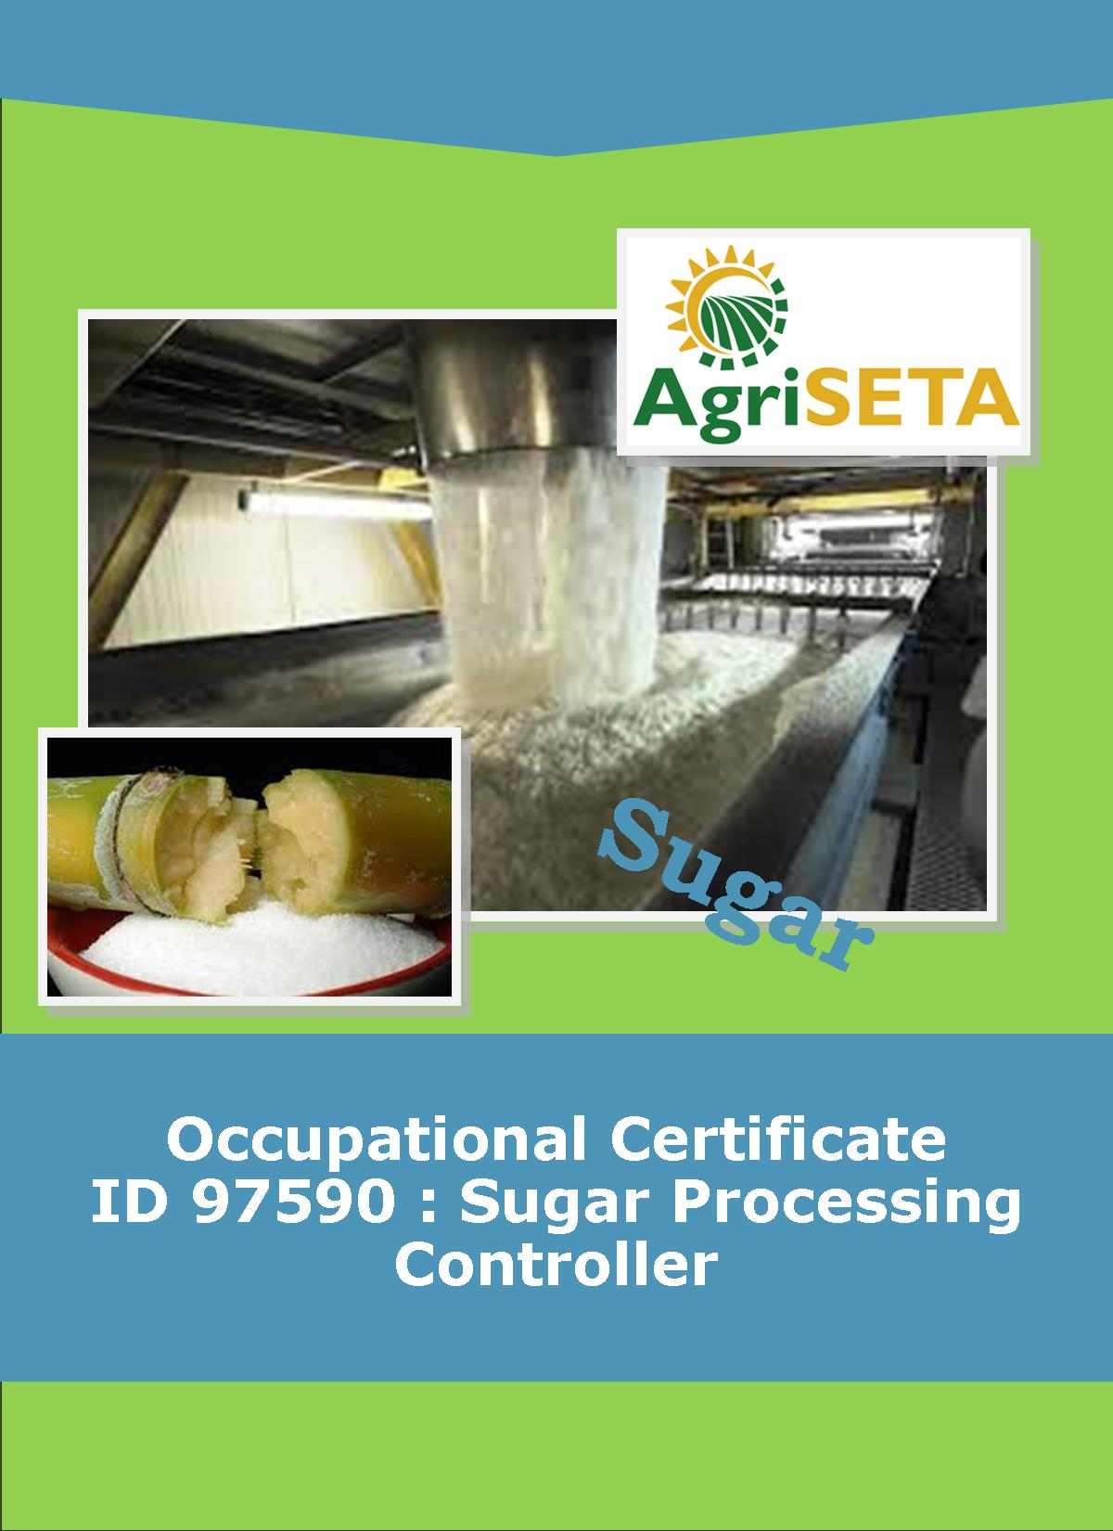
KNOWLEDGE COMPONENT:
KNOWLEDGE COMPONENT : LEARNER WORKBOOK 6 : EVAPORATION
Occupational Certificate: Sugar Processing Controller

KNOWLEDGE COMPONENT: LEARNER WORKBOOK 6:

EVAPORATION
LEARNER WORKBOOK 6 : EVAPORATION
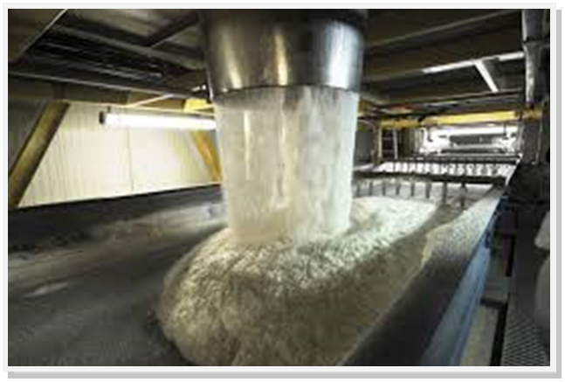
OCCUPATIONAL CERTIFICATE: SUGAR PROCESSING CONTROLLER

©Copyright AgriSETA
Telephone: +27 12 301 5600
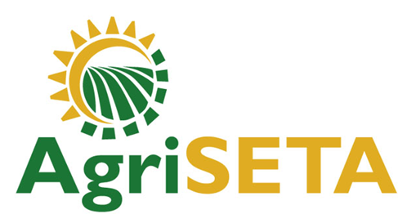

AgriSETA holds the copyright to its publications and Web pages. Proper citation is requested.

TABLE OF CONTENTS
1. AN INTRODUCTION TO THIS LEARNER WORKBOOK 6
2. LEARNER DETAILS 7
3. FORMATIVE ASSESSMENT INSTRUCTIONS 8
4. KNOWLEDGE MODULE 6: EVAPORATION 9
4.1 Knowledge Topic 1: Evaporation principles (35%) 9
4.2 Knowledge Topic 2: Evaporator design / type (15%) 16
4.3 Knowledge topic 3: Pressure and vacuum (35%) 28
5. CONCLUSION OF KNOWLEDGE MODULE 6: EVAPORATION 31

AN INTRODUCTION TO THIS LEARNER WORKBOOK
This Knowledge Component Learner Workbook 6: Evaporation is intended to be used with the Knowledge Component Learning Resource: Book 6 (Textbook): Evaporation of the Occupational Qualification: Sugar Processing Controller NQF 5.
Guidance on the use of this Work Book is provided in the Learning Guide.

LEARNER DETAILS
First name
Surname
ID number
Mobile phone contact number
E-mail address
Postal address
Date on which you started this Knowledge Module
Date on which you completed this Knowledge Module
Declaration: | I hereby confirm that:  - I received the assessment plan and schedule.  - I understand my rights in terms of special needs, re-assessment, feedback and appeals against assessment decisions.  - I completed this formative assessment independently without assistance from anyone else.
Total Marks for Knowledge Module 6 | 163
Marks attained
Date:
Place:
Signature of Learner:
Signature of Assessor:

FORMATIVE ASSESSMENT INSTRUCTIONS
Instructions
- Work individually to present the results of each Learning Activity in this Learner Workbook.
- Complete all the sections.
- Use a black pen and ensure that you complete the questions in your own handwriting.
- A recommended time to complete each activity is shown.
- The marks you will attain for each learning activity are shown in brackets.
- The total marks obtained for each Knowledge Module must be transferred from the back of each Learner Workbook to the Learner Qualification Summative Assessment Tool.

KNOWLEDGE MODULE 6: EVAPORATION
NQF LEVEL: 4
CREDITS: 8
PURPOSE OF THE KNOWLEDGE MODULE: The main focus of the learning in this knowledge module is to build an understanding of for the learner to gain fundamental understanding of the theory and science of evaporation.
The learning will enable learners to demonstrate an understanding of:
- KM-06-KT01: Evaporation principles (35%)
- KM-06-KT02: Evaporator design/type (15%)
- KM-06-KT03: Pressure and vacuum (35%)
- KM-06-KT04: Evaporation problem solving (15%)

4.1 Knowledge Topic 1: Evaporation principles (35%)
Topic elements to be covered include:
- KT0101 Calculations
- KT0102 Pressure and boiling point
- KT0103 Single and multiple effects
- KT0104
Internal Assessment Criteria and Weight
- IAC0101 An understanding of process steps and use of equipment related to evaporation can be demonstrated
- IAC0102 Key control points related to evaporation can be listed and controls explained
- IAC0103 An understanding of evaporation related calculations and formula can be demonstrated
- (Weight 35%)
Learning activity 1.1: Individual Learning activity: 10 minutes (7marks)

Learning Objective: An understanding of process steps and use of equipment related to evaporation can be demonstrated.
Task: Read each question carefully and write your answer in the space provided.
1. What is the objective of evaporation? (2)

2 Calculate the amount of water evaporated per hour
Brix of clear juice = 15
Brix of syrup = 65
Tons of clear juice per hour = 375 (5)

Learning activity 1.2: Individual Learning activity: 10 minutes (10 marks)
Learning Objective: Key control points related to evaporation can be listed and controls explained
Task: Read each question carefully and write your answer in the space provided.
- What is single effect of evaporation? (2)

- What is a Rillieuxs principle and why is it different under operating conditions? (8)
Learning activity 1.3: Individual Learning activity: 10 minutes (9 marks)
Learning Objective: An understanding of evaporation related calculations and formula can be demonstrated
Task: Read each question carefully and write your answer in the space provided.
- What is vapour bleeding and what are the advantages of vapour bleeding? (4)

2. Calculate the quality of exhaust steam saved if 10 tons of vapour is bled from the second effect of a 5 – effect evaporator train. (5)
Learning activity 1.4: Individual Learning activity: 30 minutes (17 marks)
Learning Objective: An understanding of evaporation related calculations and formula can be demonstrated.
Task: Read each question carefully and write your answer in the space provided.
- Explain how the reducing ratio can indicate losses in the evaporator station. (2)

- Why is the turbidity of syrup greater than that of clear juice? (3)

- What is the mechanism of sucrose inversion and reducing sugar degradation in an evaporator? (6)

- How is colour formed? (3)

- Why is there normally a pH drop along the evaporator from clear juice to syrup? (3)

4.2 Knowledge Topic 2: Evaporator design / type (15%)
Topic elements to be covered include:
- KT0201 Principles of operation
- KT0202 Heat transmission
- KT0203 Scale and cleaning
- KT0204 Control systems and principles
Internal Assessment Criteria and Weight
- IAC0201 Examples of evaporator equipment can be identified.
- (Weight 15%)
Learning activity 2.1: Individual Learning activity: 10 minutes (9marks)
Learning Objective: Task: Examples of evaporator equipment can be identified.
1. Why is evaporation in the evaporators more economical than evaporation in the pans? (2)

2. What factors determine the capacity of an evaporator? (3)

3. What is meant by evaporator system is self-balancing? (2)

4. How does clear juice temperature affect evaporator capacity? (2)

Learning activity 2.2: Individual Learning activity: 15 minutes (11 marks)
Learning Objective: Examples of evaporator equipment can be identified.
Task: Read each question carefully and write your answer in the space provided.
- What is the aim of evaporator control? (2)

2. Sketch an evaporator vessel, labelling all the parts (5)
3. Describe the method by which feed is introduced into the vessels. (4)

Learning activity 2.3: Individual Learning activity: 45 minutes (22 marks)
Learning Objective: Examples of evaporator equipment can be identified.
Task: Read each question carefully and write your answer in the space provided.
1. Describe the method by which incondensable gas is removed from the Calandria of evaporator vessels. (2)

2. With the aid of a describe how a combined condensate removal system works and the advantages and disadvantages of the system (10)

3. Describe how entrainment is caused and how it can be controlled and the effects minimized. (6)

4. What are the results of increased and reduced retention times in evaporator vessels? (4)
Learning activity 2.4: Individual Learning activity: 30 minutes (20 marks)
Learning Objective: Examples of evaporator equipment can be identified.
Task: Read each question carefully and write your answer in the space provided.
1. Sketch an evaporator station consisting of 2 kestner vessels in parallel, followed by a quadruple effect set of Roberts vessels. Kestner vapour is used for juice heating and also feeds the first vessel of the quad. Vapour two is used for pan boiling. Show only the juice flow and steam/vapour flow. Use rectangles to represent the vessels. (15)
2. (a) On what does the heat transfer depend in an evaporator? (2)

(b) Explain how this affects the first and last vessels (3)

Learning activity 2.5: Individual Learning activity: 30 minutes (20 marks)
Learning Objective: Examples of evaporator equipment can be identified.
Task: Read each question carefully and write your answer in the space provided.
1. Explain the 3 main factors which govern the heat flow in an evaporator. (6)

- Discuss the effect of the film of water on the steam side on heat flow. (4)

- Discuss the effect of hydrostatic head on heat flow.(4)

- What effect does viscosity have on heat transfer? (2)

- Discuss the effects of scale on heat transfer(4)

Learning activity 2.6: Individual Learning activity: 30 minutes (20marks)
Learning Objective: Examples of evaporator equipment can be identified.
Task: Read each question carefully and write your answer in the space provided.
1. Discuss the formation of scale in different vessels. (6)

2. What could cause slack syrup produced by the evaporator? (4)

3. Describe the methods by which scale can be removed from the evaporator tubes. (6)

4. What different methods can be used to automate an evaporator? (4)

  - Knowledge topic 3: Pressure and vacuum (35%)
Topic elements to be covered include:
- KT0301 Objectives
- KT0302 Vacuum pumps
- KT0303 Cooling systems
Internal Assessment Criteria and Weight
- IAC0301.The purpose of vacuum and pressure in evaporation process can be explained.
- (Weight 35%)
Learning activity 3.1: Individual Learning activity: 10 minutes (10marks)
Learning Objective: Task: The purpose of vacuum and pressure in evaporation process can be explained.
1. Sketch a condenser, labelling all the parts. (5)
2. What is barometric leg? (2)

3. Explain what is meant by approach temperature and the importance of the approach temperature measurement. (3)

Learning activity 3.2: Individual Learning activity: 10 minutes (8marks)
Learning Objective: The purpose of vacuum and pressure in evaporation process can be explained.
Task: Read each question carefully and write your answer in the space provided.
1. Why is the vacuum in the last vessel limited? (4)

3. What are the benefits of boiling under vacuum? (4)

CONCLUSION OF KNOWLEDGE MODULE 6: EVAPORATION
Throughout this knowledge module you have been provided opportunities to complete formative learning activities. You have captured your results in this Learner Workbook.
The total marks for this Knowledge Module are as follows:
Knowledge Module | Total Marks | Marks attained
KM-06-KT01: Evaporation principles (35%) | 43
KM-06-KT02: Evaporator design / type (15%) | 102
KM-06-KT03: Pressure and vacuum (35%) | 18
KM-06-KT04: Evaporation problem solving (15%)
Total Marks | 168 marks



