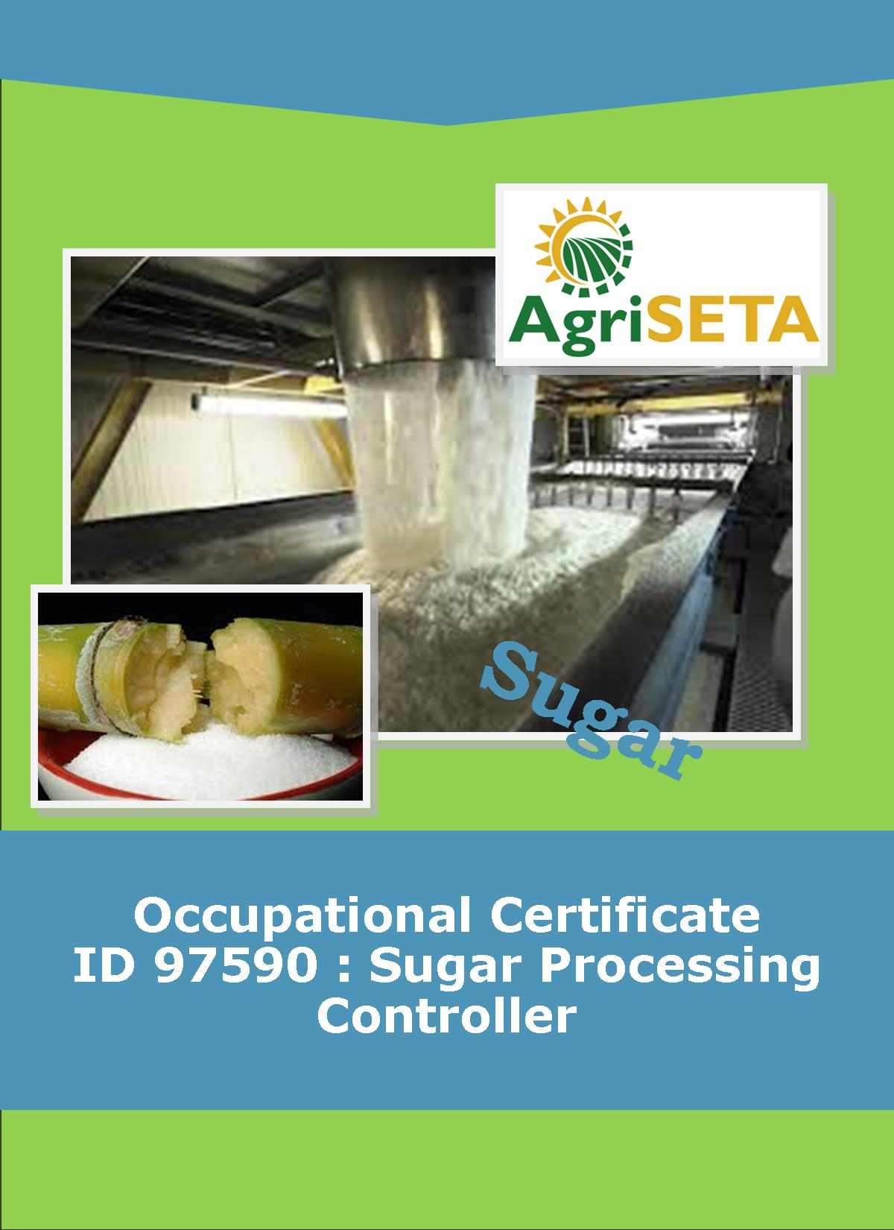
Sugar Juice Handling and Clarification Sugar Juice Handling and Clarification
LEARNER SUMMATIVE ASSESSMENT TOOL : KNOWLEDGE MODULE 6:
KNOWLEDGE COMPONENT: LEARNER SUMMATIVE ASSESSMENT TOOL : KNOWLEDGE MODULE 6 : EVAPORATION
Occupational Certificate: Sugar Processing Controller

LEARNER SUMMATIVE ASSESSMENT TOOL KNOWLEDGE MODULE 6:
EVAPORATION
EVAPORATION
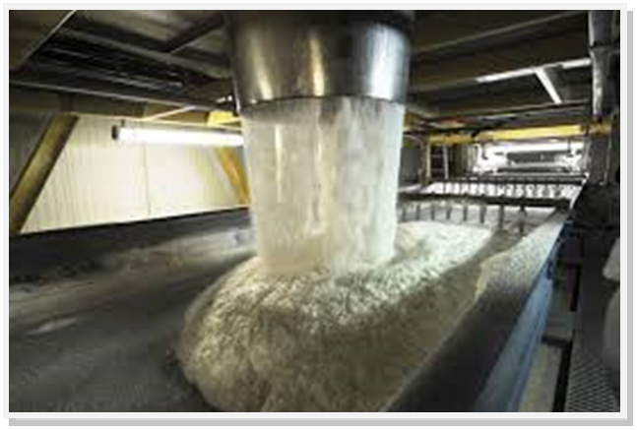
OCCUPATIONAL CERTIFICATE: ID 97590: SUGAR PROCESSING CONTROLLER

©Copyright AgriSETA
Telephone: +27 12 301 5600


AgriSETA holds the copyright to its publications and Web pages. Proper citation is requested.

TABLE OF CONTENTS

1. STAKEHOLDER INFORMATION 6
2. COMPETENCY SUMMARY OF ASSESSMENT 8
3. ASSESSMENT ALIGNMENT MATRIX (INTERGRATED OUTCOMES) 9
4. ASSESSMENT DECISION & EVIDENCE EVALUATION RECORD 11
5. OVERALL ASSESSMENT DECISION 12
6. EVIDENCE OF FEEDBACK 13
7. OVERALL RESULTS 14
8. ASSESSMENT REVIEW 15
9. FINAL DECISION 17
10. LEARNER FEEDBACK FORM 18
11. SUMMATIVE ASSESSMENT INSTRUCTIONS 19
12. WRITTEN ASSESSMENT 20
13. FINAL MARKS 37

STAKEHOLDER INFORMATION
LEARNER INFORMATION
Name
Surname
ID number
Mobile phone contact number
E-mail address
Physical address
Postal address
Employer Name
Employer Contact Details

ASSESSOR DETAILS
Name
Surname
Assessor ID
Project Name | Occupational Certificate ID 97590:Sugar Processing Controller
Module No. | Module 6: Evaporation
Date of Assessment
Portfolio submission Date
Assessor Signature
Total Marks for Knowledge Module 6 | 125 marks
Marks attained
Place:

MODERATOR DETAILS
Moderator Name
Moderator ID
Moderator Signature
Date of Moderation

COMPETENCY SUMMARY OF ASSESSMENT
Module 6 | KM-06-KT01:Evaporation principles | C | NYC
1 | 1.1.An understanding of process steps and use of equipment related to evaporation can be demonstrated
 | 1.2. Key control points related to evaporation can be listed and controls explained
2 | KM-06-KT02: Evaporator design/type | - C | NYC
 | 2.1 Examples of evaporator equipment can be identified.
3 | KM-06-KT03: Pressure and vacuum | C | NYC
 | 3.1. The purpose of vacuum and pressure in evaporation process can be explained.
4. | KM-06-KT04: Evaporation problem solving | C | NYC
 | 4.1. An understanding of trouble shooting and standard responses related to evaporation can be demonstrated

ASSESSMENT ALIGNMENT MATRIX (INTERGRATED OUTCOMES)
Module No: 6 | Where it is covered in learning resource(page/ unit) | Where it is assessed |  | First Submission
Module No: 6 | Where it is covered in learning resource(page/ unit) | Summative | Formative
SAQA ID Number: 97590 |  |  |  | Clearly meets all the criteria | Meets some but not all criteria | Clearly does not meet any of the criteria
Title: Evaporation
NQF level and credits:
NQF Level 4: 8 Credits
Topic: 1  Evaporation principles | Page 8- | Question 6.1 | Learning Activity 1.1 -1.4 page 10-15
Assessment criteria: An understanding of process steps and use of equipment related to evaporation can be demonstrated | Page 9-34 | Question 6.2 -6.14
 | Page 9-34 | Question 6.24-
Assessment criteria: Key control points related to evaporation can be listed and controls explained
Assessment criteria: An understanding of evaporation related calculations and formula can be demonstrated
Topic 2. Evaporator design/type | Page 40-61 | Question 6.15 -6.21 | Learning Activity 2.1-2.6 page 16-27
Assessment criteria: Examples of evaporator equipment can be identified. |  | Question -6.25-6.44 page 28-35
Topic 3. Pressure and vacuum | Page 62-69 | Question 6.22 page 27 | Learning Activity 3.1 page 28-30
Assessment criteria: The purpose of vacuum and pressure in evaporation process can be explained. |  | Question 6.45-46 page 35
Topic 4. Evaporation problem solving
Assessment criteria: An understanding of trouble shooting and standard responses related to evaporation can be demonstrated

ASSESSMENT DECISION & EVIDENCE EVALUATION RECORD
Candidate's Name: -

Assessor's Name: -

Practical assessment
I declare that this assessment is my own demonstration.
Marks: The learner is either “Met requirements” or “did not meet requirements”. If the learner did not meet requirements in an area, then he or she must be reassessed.
Learner achieved: Met requirements /Did not meet requirements
KNOWLEDGE MODULE 6:EVAPORATION
Overall outcome:

Specific Outcome |  | Met requirements | Did not meet requirements | Comments
1
Specific Outcome |  | Met requirements | Did not meet requirements | Comments
2
Specific outcome |  | Met requirements | Did not meet requirements | Comments
3
Specific outcome |  | Met requirements | Did not meet requirements | Comments
4

OVERALL ASSESSMENT DECISION
Assessors Comments:

Signature of Assessor:

Date:

EVIDENCE OF FEEDBACK
Module No :6
Level :4
Assessor :……………………………………………………………………………
Candidate :…………………………………………………………………………..
Date of final assessment:…………………………………………………………….
Evidence criteria | Achieved | Not
1. Constructive
2. Timeous (according to Plan)
3. Correct mode / medium
4. Participative
5. Developmental
6. Accurate
7. Specific
8. Documented
9. Directed to correct parties
Signing off date: …………………………………………….

..........……………. ………………………………….
Assessor Candidate

OVERALL RESULTS
OVERALL RESULT | Competent
OVERALL RESULT | Not Yet Competent
Declaration by Candidate
I, …………………………………………………………………….declare that I am satisfied that the feedback given to me by the Assessor was relevant, sufficient and done in a constructive manner. I accept the assessment decisions and do realise that have no further questions relating to this particular assessment process. I do realise that after this assessment decision, the moderator will either uphold or reverse this assessment decision taken by the assessor.
Candidate : _____________  _______________________  Date: __________________  Signature: ______________ |  | Assessor : _____________  _______________________  Date: __________________  Signature: ______________ |  | Moderator : _____________  _______________________  Date: __________________  Signature: ______________

ASSESSMENT REVIEW
Assessor’s Name |  |  |  |  |  |  |  |  | ID Number
Contact Details of Assessor |  | Email
 |  | Phone
 |  | Fax
PART 1
 | Review Criteria |  | Valid |  | Authentic | Current |  | Consistent |  |  | Reliable |  | Sufficient |  |  | Comments
Please conduct an honest review of the Assessment Instruments used in this assessment:
1 | Evidence Topic 1
 | Knowledge Assignment
 | Practical Assignment
 | Natural Occurring Evidence
 | Reflection
2 | Evidence Topic 2
 | Knowledge Assignment
 | Practical Assignment
 | Natural Occurring Evidence
 | Reflection
3 | Evidence Topic 3
 | Knowledge Assignment
 | Practical Assignment
 | Natural Occurring Evidence
 | Reflection
4 | Evidence Topic 4
 | Knowledge Assignment
 | Practical Assignment
 | Natural Occurring Evidence
 | Reflection
 | Historical Evidence Location Grid
 | CCFO Location Grid
PART 2
No | Review Criteria |  |  |  |  |  |  |  |  | Yes |  | No |  |  | Remarks
1 | Do you feel the candidate was appropriately selected and prepared for the RPL assessment?
2 | Did the candidate interpret the evidence requirements appropriately?
3 | Was the assessment free of potential assessment barriers such as language, literacy, access to resources?
4 | Was the assessment evidence presented by the candidate valid, authentic, current and sufficient?
5 | Was the candidate’s workplace access to evidence sufficiently supportive of the assessment strategy?
6 | Do you feel you could make a fair, valid and reliable assessment decision?
Recommendations
(Feedback on Validity, authenticity, currency and sufficiency of candidate evidence.)
Assessor Signature |  |  |  |  |  |  | Date Review Completed

FINAL DECISION
I………………………………………………………. hereby declare Ms/Mr

………………………………………… Competent Not Yet Competent

FEEDBACK TO LEARNER:

……………………..………………………..………………………..……………………

……………………..………………………..………………………..………………………

……………………..………………………..………………………..………………………

……………………..………………………..………………………..………………………

SIGN: …………………………………… DATE: ……………………..........................

LEARNER FEEDBACK:

……………………..………………………..………………………..………………………

……………………..………………………..………………………..………………………

……………………..………………………..………………………..………………………

……………………..………………………..………………………..………………………

SIGN: ……………………………………… DATE: …………………….......................

MODERATOR FEEDBACK:

………………………..………………………..………………………..……………………

………………………..………………………..………………………..……………………

……………………..………………………..………………………..………………………

……………………..………………………..………………………..………………………

SIGN: …………………………………… DATE: ……………………........................

LEARNER FEEDBACK FORM
CRITERIA | EVIDENCE | CRITERIA | EVIDENCE
How did your assessor encourage you and put you at ease during the assessment process? |  | Were you given clear and constructive feedback?
Were your assessor’s questions clear and pitched at the right level of language usage? |  | Did your assessor assess all the evidence provided by you?
Do you believe that all the assessment criteria and knowledge requirements of the standard you were being measured against were considered in your assessment? |  | Were you aware of any discrimination practice carried out by your assessor towards you?

LEARNER SIGNATURE:………………………………………………

DATE:.…………………………..

SUMMATIVE ASSESSMENT INSTRUCTIONS
Instructions
- Work individually and answer all questions.
- Use a black pen and ensure that you complete the questions in your own handwriting.
- Time to spend on this assessment is 2 hours.
- The marks you will attain for each question are shown in brackets.

WRITTEN ASSESSMENT
Candidate instruction: Complete the following multiple-choice questionnaire by marking the most appropriate response with an x in the space provided.
Scope of Assessment | Exit Level Outcome/s | Module/s
 | - : Evaporation | 6
Alignment – Learning Outcome 1: Evaporation Principles

Award one mark for selection of valid “x”. One mark = Competent

61 | The purpose of evaporation is to; |  | Mark Allocation
a. |  | Control the pH of clear juice.
b. |  | Maintain a constant temperature of the clear juice.
c. |  | Remove unwanted water from the clear juice.
d. |  | Remove unwanted suspended solids from the clear juice.
e. |  | Form small crystals for sugar manufacture. | (2)

6.2 | Is there a limit to the soluble solids concentration of syrup? |  |  | Mark Allocation
a. |  | No.
b. |  | Yes, it must be no greater than 55 ºBrix.
c. |  | Yes, it must be close to 72 ºBrix.
d. |  | Yes, it must be between 72 and 75 ºBrix.
e. |  | Yes, the best recommendation is that it is between 65 and 68 ºBrix. | (2)

An extraction plant produces 400 tons of clear juice per hour at 12 ºBrix and this must be concentrated to syrup of 70 oBrix.
Assume the following: J = mass of clear juice per hour
S = mass of syrup per hour
BJ = Brix % Clear Juice
BS = Brix % Syrup
E = mass of water evaporated per hour.
%E = Percentage of water evaporated
Using the following formulae;
S = BJ x J
BS
E = J – S
%E = E
J X 10

6.3 | What will be the mass syrup (S) per hour? |  | Mark Allocation
a. |  | 70.59
b. |  | 64.32
c. |  | 65.87
d. |  | 68.57
e. |  | 69.38 | (2)

6.4 | Using the parameters and formulae from question 3, what would be the mass of water (E) evaporated per hour. |  | Mark Allocation
a. |  | 329.41
b. |  | 335.58
c. |  | 334.13
d. |  | 331.43
e. |  | 330.62 | (2)

6.5 | Using the parameters and formulae from question 3, what would be the percent of water (%E) evaporated per hour? |  | Mark Allocation
a. |  | 82.65%
b. |  | 83.90%
c. |  | 83.53%
d. |  | 82.86%
e. |  | 82.66% | (2)

6.6 | What is the temperature range for sensible heat for water? |  | Mark Allocation
a. |  | 99 ºC – 100 ºC
b. |  | 20 ºC – 75 ºC
c. |  | 0 ºC – 20 ºC
d. |  | 0 ºC – 100 ºC
e. |  | 20 ºC – 100 ºC | (2)

6.7 | Pressure on the surface of water will influence the boiling point of water. Which is the correct statement? |  | Mark Allocation
a. |  | A low pressure will increase the boiling point.
b. |  | A high pressure will increase the boiling point.
c. |  | The boiling point remains the same under any pressure.
d. |  | A higher pressure will lower the boiling point
e. |  | A low pressure will not have any impact on the boiling point. | (2)

6.8 | Why will 80 tons of steam produce 80 tons of vapour from 100 tons of juice in a single effect evaporator? |  | Mark Allocation
a. |  | Because 1 kg of steam will only evaporate about 1kg of vapour from a solution at its boiling point.
b. |  | Because 100 tons of juice will only have 20 tons of vapour to evaporate (100-80).
c. |  | There is insufficient sensible heat to evaporate more vapour.
d. |  | The single effect evaporator is inefficient.
e. |  | Much of the heat that is absorbed by the juice is used to reach the boiling point. | (2)

6.9 | Boiling point elevation (B.P.E) is; |  | Mark Allocation
a. |  | A decrease in the boiling point as a result of the increase in Brix.
b. |  | The increase in the boiling point as a result of the decrease in pressure.
c. |  | An increase of the boiling point as a result of the increase in pressure.
d. |  | The increase in pressure as a result of the increase in Brix.
e. |  | The increase in boiling point as a result of an increase in Brix. | (2)

6.10 | Is there a limit to the number of evaporators that can be installed in a sugar factory? |  | Mark Allocation
a. |  | Yes and cannot be more than five.
b. |  | No, as long as there is sufficient exhaust steam.
c. |  | Yes, there should be no more than three.
d. |  | Yes, a normal factory could manage seven.
e. |  | Yes, there should be no more than four. | (2)

6.11 | In order to evaporate 80 tons of water from 100 tons of clear juice in a quadruple (4) effect evaporator station, how many tons of exhaust steam is needed. |  | Mark Allocation
a. |  | 80 tons.
b. |  | 20 tons.
c. |  | 60 tons.
d. |  | 320 tons.
e. |  | None of the above. | (2)

6.12 | What is the best definition for vapour? |  | Mark Allocation
a. |  | The spare steam that is not used by the first or second effect.
b. |  | The steam that has already been used in the first evaporator.
c. |  | The primary steam that comes from the boilers.
d. |  | The steam that is generated by boiling the clear juice.
e. |  | The secondary steam that comes from the boilers. | (2)

6.13 | A quadruple (4) effect evaporator station is supplied with 20 tons of exhaust steam to evaporate 80 tons of water per hour. An additional 10 tons is required to be supplied to the factory, totalling 30 tons of exhaust steam demand per hour.  Calculate the tons of exhaust steam that would be saved, if the 10 tons required for the factory is bled from the first vessel (V1) rather than being taken from the exhaust steam supply.  Assume the following: E = tons of water to be evaporated.  n = the number of vessels in the system.  m = the position of the vessel from where the vapour is bled.  V1 = the tons of steam bled per hour.  e = tons of vapour  Use the following formulae; |  | Mark Allocation
  e = | m x V₁  n
a. |  | No saving.
b. |  | 5 tons.
c. |  | 27.5 tons.
d. |  | 7.5 tons.
e. |  | 2.5 tons. | (2)

6.14 | Vapour bleeding is practiced in evaporator operations in order to: |  | Mark Allocation
a. |  | Save water.
b. |  | Increase the Brix of syrup.
c. |  | Control pH
d. |  | Save steam.
e. |  | Reduce the number of vessels in the evaporator station. | (2)

6.15 | Which statement best defines vapour recompression. |  | Mark Allocation
a. |  | Vapour that is bled to the juice heaters is compressed in the heaters.
b. |  | Exhaust steam is compressed when entering the calandria of the first effect.
c. |  | A portion of vapour from an evaporator is bled off and mechanically compressed for use in the evaporator station.
d. |  | The pressure of the steam in the final effect is compressed due to the multiplying effect.
e. |  | Vapour that is bled off is mechanically compressed before going to the juice heaters. | (2)

6.16 | Which of the following factors improve the capacity of the evaporator station? |  | Mark Allocation
a. |  | Location and extent of vapour bleeding.
b. |  | Area of the heating surface.
c. |  | Number of vessels (effects).
d. |  | Heat of the incoming juice.
e. |  | All of the above. | (2)

6.17 | An evaporator is a large vessel where clear juice is boiled. Where does the heat transfer take place within the vessel? |  | Mark Allocation
a. |  | The calandria.
b. |  | The save all.
c. |  | The condenser.
d. |  | The vapour space.
e. |  | The downcomer. | (2)

6.18 | Condensate is removed from the first effect evaporator and used for; |  | Mark Allocation
a. |  | Imbibition.
b. |  | Factory washing.
c. |  | Boiler feed water.
d. |  | Juice heaters.
e. |  | None of the above. | (2)

6.19 | The definition of Entrainment is best described as follows; |  | Mark Allocation
a. |  | The wet condensate that is removed from the evaporator.
b. |  | The juice that flows from one evaporator to the next.
c. |  | The velocity of the vapour leaving the tubes.
d. |  | The increase in Brix from clear juice to syrup.
e. |  | The carryover of droplets of juice in the vapour. | (2)

6.20 | The design difference between a Roberts evaporator and Kestner evaporator is; |  | Mark Allocation
a. |  | The Kestner occupies more floor space.
b. |  | The Kestner has a longer residence (retention) time.
c. |  | There are no differences.
d. |  | The Kestner has a calandria that is much longer than a Roberts.
e. |  | The Roberts has an efficient separator positioned alongside the evaporator. | (2)

6.21 | The Kestner evaporator in the SA sugar industry uses a specific heat exchange principle. What is the best description of this principle? |  | Mark Allocation
a. |  | Climbing film
b. |  | Falling film.
c. |  | Reduce film.
d. |  | Heat transfer co-efficient.
e. |  | Boiling point elevation. | (2)

6.22 | How is a vacuum produced in the evaporation station? |  | Mark Allocation
a. |  | Vacuum from the pans is used.
b. |  | A condenser creates a vacuum in the last effect.
c. |  | The first effect provides vacuum from the vapour.
d. |  | There are vacuum pumps that generate vacuum.
e. |  | The heat transfer in the calandria of the final effect creates the vacuum. | (2)

6.23 | A U-Leg is best defined as follows: |  | Mark Allocation
a. |  | A support for the evaporator.
b. |  | A means of storing condensate.
c. |  | Preventing flash-back from the flash pot.
d. |  | Compensates for different pressures and acts as a seal.
e. |  | Provides a means to pump the condensate away. | (2)

6.24 | The heat transfer in an evaporator station is mainly by; |  | Mark Allocation
a. |  | Conduction.
b. |  | Convection.
c. |  | Radiation.
d. |  | BPE.
e. |  | Hydrostatic head. | (2)

6.25 | Heat transfer within an evaporator can be improved by; |  | Mark Allocation
a. |  | Incondensable gasses.
b. |  | Scaling of evaporator tubes.
c. |  | Higher juice velocity and turbulence.
d. |  | Viscous syrup.
e. |  | Entrainment. | (2)

6.26 | The effect of evaporation on clear juice; |  | Mark Allocation
a. |  | Significantly decreases the purity of the juice.
b. |  | Reduces the tons of Brix in syrup.
c. |  | Develops sugar crystals.
d. |  | Decreases the viscosity (thickness) of the juice.
e. |  | Increases the viscosity (thickness) of the juice. | (2)

6.27 | The hydrostatic head is the increase in pressure at the bottom of the vessel due to the height of the juice above and has the following effect. |  | Mark Allocation
a. |  | Improves the movement of juice at the bottom of the vessel.
b. |  | Increases the boiling point of juice at the bottom of the vessel.
c. |  | Improves the condensation of the steam.
d. |  | Develops more incondensable gasses.
e. |  | Provides the easy movement of juice from one vessel to the next. | (2)

6.28 | Scale that is found in the evaporator tubes is as a result of; |  | Mark Allocation
a. |  | The condition of the steam used in the first effect.
b. |  | The hydrostatic head.
c. |  | Certain non-sugars becoming insoluble and being deposited on the heating surface.
d. |  | The increase in BPE.
e. |  | Increased HTC. | (2)

6.29 | Which of the following parameters are used to measure the performance of an evaporator. |  | Mark Allocation
a. |  | Brix of the syrup leaving the last evaporator.
b. |  | V₁ and V₂ steam pressures.
c. |  | Exhaust steam pressure.
d. |  | Clear juice flow into the first evaporator.
e. |  | All of the above. | (2)

6.30 | The best response that is required if the syrup Brix from the last effect is too low is; |  | Mark Allocation
a. |  | Decrease exhaust steam pressure.
b. |  | Increase the flow of clear juice.
c. |  | Reduce the vacuum.
d. |  | Increase the exhaust steam pressure.
e. |  | Increase the retention time in the clarifiers. | (2)

6.31 | The definition for pressure is; |  | Mark Allocation
a. |  | Force of the atmosphere on the outside of a vessel.
b. |  | Atmospheric pressure.
c. |  | The difference between gauge pressure and absolute pressure.
d. |  | Pascal.
e. |  | Force per unit area. | (2)

6.32 | Pressure is measured in; |  | Mark Allocation
a. |  | Joule.
b. |  | Gram.
c. |  | Degree.
d. |  | Pascal.
e. |  | None of the above. | (2)

6.33 | The vacuum produced by the condenser is best controlled as follows; |  | Mark Allocation
a. |  | Increase the vacuum by decreasing the cooling water flow.
b. |  | Decrease the vacuum by increasing the cooling water temperature.
c. |  | Decrease the vacuum by increasing the cooling water flow.
d. |  | Decrease the vacuum by increasing the condensate removal.
e. |  | Increase the vacuum by adjusting the vapour flow from the previous vessel. | (2)

6.34 | The reducing sugar ratio is defined best as follows; |  | Mark Allocation
a. |  | The ratio of reducing sugars to pol.
b. |  | The percent of dissolved solids to pol.
c. |  | The degree of change in purity of syrup.
d. |  | The ratio of the change in rotation of certain sugars.
e. |  | All of the above. | (2)

6.35 | The pH of syrup is lower than the pH of clear juice. Choose the statement that best describes why. |  | Mark Allocation
a. |  | The pH of the clear juice was too low as it entered the evaporation station.
b. |  | The syrup is too viscous (thick) to get an accurate pH reading.
c. |  | The retention time in the evaporators is too long.
d. |  | There are insufficient effects in the evaporator station.
e. |  | Evaporation causes the acids existing in the juice to become more concentrated. | (2)

TRUE OR FALSE QUESTIONS:
Scope of Assessment | Exit Level Outcome/s | Module/s
 | 2.: Evaporation | 6
Alignment – Learning Outcome 2: Evaporation design/type: Pressure and Vacuum
Award one mark for selection of valid “T/F”. One mark = Competent

6.36 | TRUE or FALSE: Evaporator capacity is determined by a number of factors. Which of the factors below determine evaporator capacity. |  | Mark Allocation
a. |  | Sucrose content of the clear juice.
b. |  | Area of the heating surface.
c. |  | Location and extent of vapour bleeding.
d. |  | Steam temperature.
e. |  | Number of effects. | (5)

6.37 | TRUE or FALSE: Condensate needs to be removed from the evaporator. This is done by various means. |  | Mark Allocation
a. |  | U-Leg.
b. |  | Calandria.
c. |  | Flash vessel connected to the pressure outlet.
d. |  | Steam trap.
e. |  | Save all. | (5)

6.38 | TRUE or FALSE: Entrainment can result in sucrose losses. What solutions below will minimise this. |  | Mark Allocation
a. |  | Efficient demisters.
b. |  | Longer retention time.
c. |  | Condenser water.
d. |  | Sudden changes in flow.
e. |  | U-Leg. | (5)

6.39 | TRUE or FALSE: Which statements are true and which are false, regarding the handling of condensate from a quadruple (4) effect evaporator station? |  | Mark Allocation
a. |  | Condensate from the first effect is removed by steam trap.
b. |  | Condensate from the final effect is removed by steam trap.
c. |  | A U-leg from the second effect enters a flash pot.
d. |  | The condensate is pumped from the final effect flash pot.
e. |  | Condensate from 2, 3 and 4 is discharged through manually controlled valves. | (5)

6.40 | TRUE or FALSE: Scale is formed in the heating tubes; respond with true or false for the following statements. |  | Mark Allocation
a. |  | Results in an increase in juice flow through the vessel.
b. |  | Reduces the heat transfer coefficient of the vessel.
c. |  | Will be reduced by adequate wetting of the tubes.
d. |  | Results in sucrose inversion.
e. |  | Will increase from the first effect to the last effect. | (5)

6.41 | TRUE or FALSE: Indicate if the following statements are true or false with relation to incondensable gasses. |  | Mark Allocation
a. |  | Have no impact on the capacity of the evaporator.
b. |  | Can build up pressure in the calandria if not removed.
c. |  | Are vented to the vapour area of the same vessel.
d. |  | Are vented to the condenser after the last vessel.
e. |  | Air, ammonia and carbon dioxide can be condensed. | (5)

6.42 | TRUE or FALSE: Heat transfer coefficient (HTC) is the ability for heat to be transferred between steam and juice; expressed as kJ/m2/oC/. State if the following statements are true or false. |  | Mark Allocation
a. |  | Good HTC for a first effect vessel is about 3.5.
b. |  | The higher the number, the worse the HTC.
c. |  | Poor HTC in a dirty second effect vessel is about 10.2.
d. |  | HTC can only be measured if the heating area of the vessel is known.
e. |  | HTC can be used to calculate the steam requirements of an evaporator station. | (5)

6.43 | TRUE or FALSE: In relation to pressure, answer the following statements with True or False. |  | Mark Allocation
a. |  | The air that surrounds us exerts a pressure called atmospheric pressure.
b. |  | Gauge pressure will be 0 kPa at atmospheric pressure.
c. |  | The difference between gauge pressure and absolute pressure is 100 kPa.
d. |  | A vacuum is an absolute pressure below 100 kPa.
e. |  | A reading of -25 kPa gauge pressure will be a vacuum. | (5)

6.44 | TRUE or FALSE: The following statements relate to a condenser in the evaporation station. Decide which are true and which are false. |  | Mark Allocation
a. |  | A condenser reduces vapour to condensate and causes a vacuum.
b. |  | The condenser will work well if the cooling water temperature is high.
c. |  | A barometric leg and sealing well are used to ensure that the vacuum enters the evaporator.
d. |  | The vacuum will increase the absolute pressure in the evaporator.
e. |  | An increase in the vacuum will decrease the boiling point in the last effect. | (5)

6.45 | TRUE or FALSE: Answer the following statements with True or False. |  | Mark Allocation
a. |  | Vacuum pumps generate the vacuum for the last vessel in the evaporator station.
b. |  | The most common type of vacuum pump in the SA industry is the liquid ring vacuum pump.
c. |  | The rate of inversion is affected by pH, temperature and time.
d. |  | Colour is formed due to the concentration of colour bodies brought in with the cane.
e. |  | Inversion is the thermal and/or acid breaking down of the sucrose molecule into glucose and fructose. | (5)

6.46 | TRUE or FALSE: The following statements are actions that should be taken to respond to syrup from the final effect that is too slack. State which are true and which are false. |  | Mark Allocation
a. |  | Clear juice pumping rate must be increased.
b. |  | The boiling point in the last effect can be reduced by increasing water flow to the condenser.
c. |  | Condensate needs to be removed to improve heat transfer.
d. |  | The pH needs to be balanced to between 7 and 7.2.
e. |  | Exhaust steam pressure can be increased. | (5)

FINAL MARKS
TOTAL MARKS: 125
PASS MARK: 100

LEARNER MARKS
PERCENTAGE
ASSESSOR SIGNATURE:

