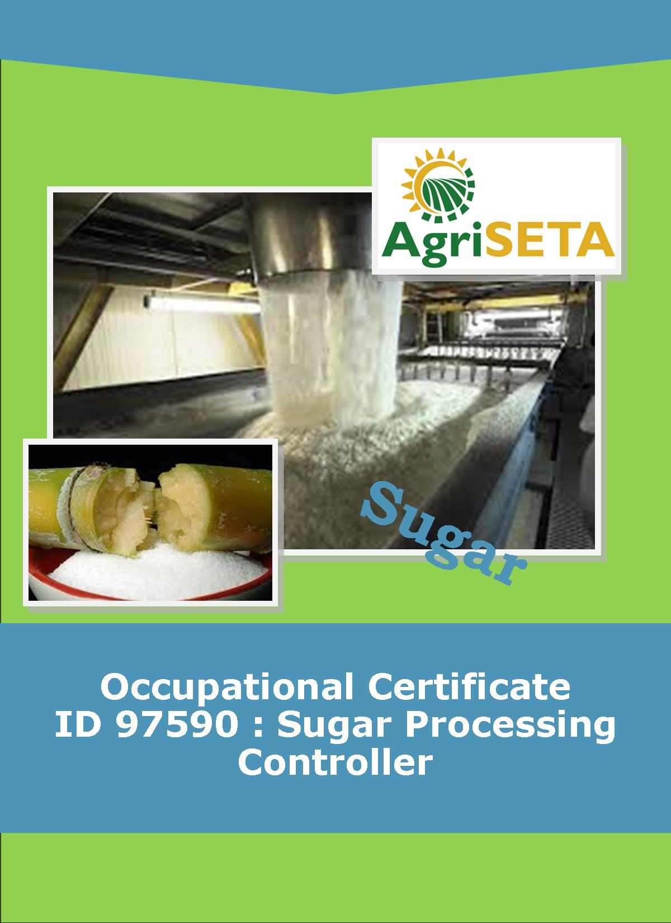
KNOWLEDGE COMPONENT: FACILITATOR FORMATIVE AND SUMMATIVE ASSESSMENT TOOLS AND MODEL ANSWERS : KNOWLEDGE MODULE 7 : PAN BOILING THEORY AND TECHNOLOGY
Occupational Certificate: Sugar Processing Controller

KNOWLEDGE COMPONENT: FACILITATOR FORMATIVE AND SUMMATIVE ASSESSMENT TOOLS AND MODEL ANSWERS – KNOWLEDGE MODULE 7 : PAN BOILING THEORY AND TECHNOLOGY
KNOWLEDGE COMPONENT: FACILITATOR FORMATIVE AND SUMMATIVE ASSESSMENT TOOLS AND MODEL ANSWERS : KNOWLEDGE MODULE 7 : PAN BOILING THEORY AND TECHNOLOGY
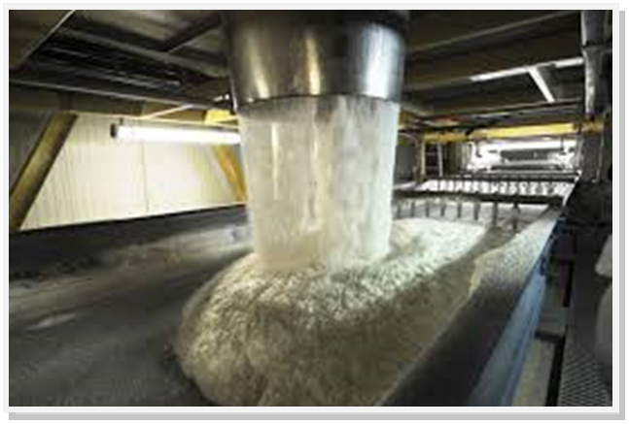
OCCUPATIONAL CERTIFICATE: SUGAR PROCESSING CONTROLLER

©Copyright AgriSETA
Telephone: +27 12 301 5600


AgriSETA holds the copyright to its publications and Web pages. Proper citation is requested.

TABLE OF CONTENTS
1. INTRODUCTION TO THE FACILITATOR ASSESSMENT TOOLKIT OF THE OCCUPATIONAL CERTIFICATE: SUGAR PROCESSING CONTROLLER 6
2. KNOWLEDGE MODULE 7: PAN BOILING THEORY AND TECHNOLOGY 7
2.1 Knowledge Topic 1: Theory of crystallisation (15%) 8
2.2 Knowledge Topic 2: Equipment design and operation (5%) 16
2.3 Knowledge Topic 3: Graining a pan and growing a massecuite (30%) 22
2.4 Knowledge Topic 5: Pan Control and Automation (5%) 25
2.5 Knowledge Topic 6: Problems Experienced during Pan Boiling (15%) 26
2.6 Knowledge Topic 7: Three Massecuite Boling System (5%) 29
2.7 Knowledge Topic 8: Mixture Calculation (5%) 33
2.8 Knowledge Topic 9: Continuous Pan Boiling (5%) 35
2.9 Knowledge Topic 10: Control Formulae (5%) 37
3. CONCLUSION OF KNOWLEDGE MODULE 7: PAN BOILING THEORY AND TECHNOLOGY 39
4. SUMMATIVE ASSESSMENT ACTIVITIES AND MODEL ANSWERS 40
5. WRITTEN ASSESSMENT MODEL ANSWERS 41
6. TOTAL MARKS 56

INTRODUCTION TO THE FACILITATOR ASSESSMENT TOOLKIT OF THE OCCUPATIONAL CERTIFICATE: SUGAR PROCESSING CONTROLLER
Dear Facilitator
This Toolkit has been created to assist you to assess the Formative Learning Activities of learners undertaking the NQF 5 Occupational Certificate: Sugar Processing Controller Qualification.
During the programme, Learners must be directed to their Learning and Activities Guide to complete Learning Activities associated with each module of the Knowledge Component.
The time allocated to the Learning Activities is provided in the Facilitator’s Implementation Guide, this Facilitator Assessment Toolkit and Model Answers and the Learning and Activities Guide.
The marks allocated to each Learning Activity is provided in this Facilitator Assessment Toolkit and Model Answers and the Learning and Activities Guide.
Instructions to be given to Learners
- They must work individually to present the results of each Learning Activity in each of the Learning and Activities Guides (Workbooks).
- They must complete all the sections.
- They must use a black pen and ensure that they complete the questions in their own handwriting.
- The time provided to complete each activity is shown.
- The marks they will attain for each learning activity are shown in brackets.

KNOWLEDGE MODULE 7: PAN BOILING THEORY AND TECHNOLOGY
NQF LEVEL: 5
CREDITS: 8
PURPOSE OF THE KNOWLEDGE MODULE: The main focus of the learning in this knowledge module is to build an understanding of for the learner to gain fundamental understanding of the theory and science of pan boiling.
The learning will enable learners to demonstrate an understanding of:
- KM-07-KT01: Theory of crystallisation (15%)
- KM-07-KT02: Equipment design and operation (5%)
- KM-07-KT03: Graining a pan and growing a massecuite (30%)
- KM-07-KT04: Pan cycle (10%)
- KM-07-KT05: Pan control and automation (5%)
- KM-07-KT06: Problems experienced during pan boiling (15%)
- KM-07-KT07: Three massecuite boiling systems (5%)
- KM-07-KT08: Mixture calculation (5%)
- KM-07-KT09: Continuous pan boiling (5%)
- KM-07-KT10: Control formulae (5%)

  - Knowledge Topic 1: Theory of crystallisation (15%)
Topic elements to be covered include:
- KT0101 Solutions
- KT0102 Purity and saturation
- KT0103 Crystal growth rate
- KT0104 Crystal formation
- KT0105Effect of impurities
- KT0106 Boiling point elevation
- KT0107 Measurement of super saturation
Internal Assessment Criteria and Weight
- IAC0101 Incoming product specification for all stages can be listed
- IAC0102 Theory of crystal formation and growth can be explained
- IAC0103 External influence that impact on crystal formation and growth can be listed and explained
- IAC0104 Define and explain saturation point
- IAC0105 Massecuite flows and pan discharge concepts can be explained
- IAC0106 Sampling and testing practices can be explained
- (Weight 15%)

Learning activity 1.1: Individual Learning activity: 45 minutes (24 marks)

Learning Objective: An understanding of the various terms used to describe crystallisation can be demonstrated.
Task: Read each question carefully and write your answer in the space provided.
1. Define: a saturated solution, a supersaturated solution and the supersaturated coefficient of a sucrose solution. (6)
A saturated solution is one that contains the maximum amount of dissolved substances (solute) at a particular temperature.eg at 60°C
A supersaturated solution contains more solute at a certain temperature than a saturated at this temperature.it is formed when 20g of water is evaporated from a 290g sucrose/100g water saturated sucrose solution at 60°C, a supersaturated solution of 78.4°Bx
The supersaturated coefficient is the “driving force” in sugar boiling.

2. With the aid of a graph explain the different supersaturation zones. (8)
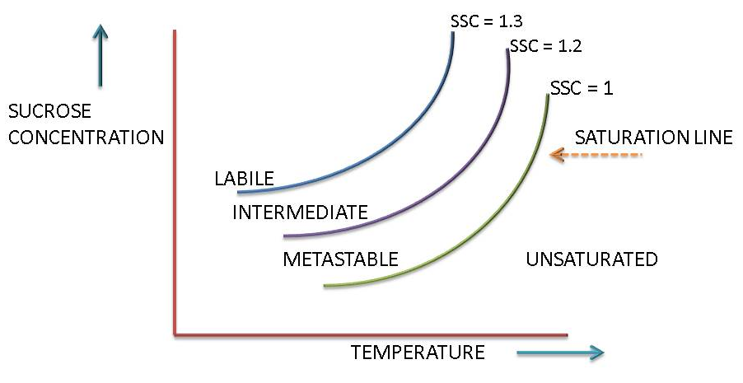
The bold line is called the saturation line and it represents the concentrations of sucrose in a saturated aqueous solution at various temperatures. It is clear that as the temperature increases the concentration of sucrose required to produce a saturated solution increases.
The solubility of sucrose increase from 215g sucrose/100g water at 30°C to 420g sucrose/100g water at 90°C.All points below the saturation line represents unsaturated solutions. When a solution is unsaturated it will dissolve sucrose crystals added to it’ll points above the saturation line represent supersaturated solution and under the right conditions, sucrose will crystallise out of such solutions.

3. State what occurs when a sugar crystal is placed into each of the following zones.
(a) Unsaturated zone (2)
Crystals dissolve and all sucrose is in solution
(b) Saturated solution (2)
The bold line is called the saturation line and it represents the concentrations of sucrose in a saturated aqueous solution at various temperatures.
(c) Metastable zone (2)
At concentrations that fall in the metastable zone any sucrose crystal present will continue to grow until the concentration falls to the level at which the solution is just saturated.
(d) Intermediate zone (2)
At concentration that fall in the intermediate zone crystals will not only grow, but new crystal will form in the presence of other crystals.
(e) Labile zone (2)
At concentration which falls in the table zone, new crystals will from spontaneously. Crystal growth will be rapid.

Learning activity 1.2: Individual Learning activity: 10 minutes (8 marks)
Learning Objective: An understanding of the factors affecting crystal formation can be demonstrated.
Task: Read each question carefully and write your answer in the space provided.
- Define a crystal (2)
A crystal is a regular, uniform and reproducible arrangement of molecules in a solid form.

- Explain the difference between primary and secondary nucleation.(4)
Primary nucleation: Is the formation of crystal nuclei in supersaturated solution by aggregation of molecules
Secondary nucleation: refers to sugar crystals formed in a supersaturated sucrose solution in which sugar crystals are already present.

- Explain the effect of purity and super saturation on primary nucleation.(2)
The occurrence of both primary and secondary nucleation is a function of the supersaturation and purity of the sugar solution. Primary nucleation occurs at a supersaturation above 1.3(labile zone).

Learning activity 1.3: Individual Learning activity: 45 minutes (26 marks)
Learning Objective: An understanding of the factors affecting crystal growth can be demonstrated.
Task: Read each question carefully and write your answer in the space provided.
- Explain the different processes that need to occur for a crystal to grow.(4)
- migration of the sucrose molecules from the solution to the surface of crystal, and
- Orientation of the molecule on the surface of crystal prior to its incorporation into the crystal. The latter is considered to be the rate controlling step.
- What factors influence crystal growth (6
- The rate at which sucrose molecules arrive at thin stationary layer of saturated solution surrounding the crystal. This depends on the relative speed of the movement of crystal through mother liquor i.e. the rate of circulation in the pan;
- The rate of which sucrose molecule will diffuse through the film which surrounds the crystal. This depends mainly on the viscosity of the film and on the degree of super saturation of mother liquor in contact with it;
- The rate at which sucrose molecules are deposited on crystal surface. This is influenced by presence in mother liquor of some impurities like raffinose and other oligosaccharides which interfere with incorporation of sucrose molecules into the crystal lattice.

- What is the driving force of crystallisation and what effect does it have on crystallisation?(10)
- Purity of massecuite: Crystallisation rate decreases as purity decreases. The rate of crystallisation in the raw house is thus slow too very slow compared to crystallisation in a refinery.
- Degree of supersaturation: This is the main driving force of crystallization. An increase in supersaturation has the following effects on crystallisation:
- Increase the rate of attachment of sucrose molecules onto the crystal that increases the rate of crystal growth.
- Increases the viscosity of the solution that reduces the rate of sucrose diffusion.
- Increases the rate of diffusion because of the big difference in concentration between the mother liquor and the film of mother liquor around the crystal.
- Viscosity of massecuite
Viscosity is very important because it affects the mobility of the sucrose molecules. A more viscous massecuite offers more resistance to the movement of sucrose molecules as they migrate towards the crystals. Massecuite viscosity decreases with increase in temperature and increases with decrease in purity. Viscosity also affects the mixing between mother liquor and crystals.
- Temperature
Sucrose crystals grow faster the higher the temperature. However, a higher temperature reduces the supersaturating which is the main driving force of crystallisation. The higher the temperature, the higher concentration required to maintain the same rate of crystallisation.

- Write notes on the effect of impurity on crystal formation.(6)
In general all impurities tend to slow down the rate of crystallisation. Different impurities have different effects and it can therefore be said that the rate of crystallisation is affected by the concentration of impurities and the type of impurity. Starch is a good example of an impurity that slows down the rate of crystallisation. As a crystal grows in the pan there is a competition on growing crystal surface between the sucrose molecules and the impurities. The impurities can be a basic factor in determining the shape of crystal for example, when the growth is carried out high super saturations and there is a high percentage of reducing sugars present there is a tendency for twin crystals to form.
The colour of the sugar boiled is affected by coloured non-sugars which are absorbed by the sucrose crystal. The occlusion (entrapment) of dark coloured impurities in the crystallisation process can be easily seen. This is especially noticeable when a dark seed is used in “A” boilings. A layer of light coloured sucrose can be seen covering the dark seed crystal.

Learning activity 1.4: Individual Learning activity: 45 minutes (26 marks)
Learning Objective: An understanding of the effect of impurities on crystal growth can be demonstrated.
Task: Read each question carefully and write your answer in the space provided.
- What effect does temperature have on crystal growth? (2)
Sucrose crystals grow faster the higher the temperature

- What effects do impurities have on crystal growth? (2)
The impurities can be a basic factor in determining the shape of crystal for example, when the growth is carried out high supersaturations and there is a high percentage of reducing sugars present there is a tendency for twin crystals to form.

- (a) What is viscosity? (2)
Viscosity is the measure of resistance to sheer or angular deformation. The metric unit is the poise (dyne second/cm²), while the SI unit Pascal second (Pa.s =Centipoise x 10-3)

(b) Describe the effects of viscosity on boiling. (4)
A pan boiled at a high temperature and supersaturation will produce better crystallisation velocities.
If the mobility of the sucrose molecule is impeded by high viscosity, and the supersaturation level is high, false grain formation will occur.
Viscosity also affects the mixing between mother liquor and crystals.

- (a) Why do we measure conductivity in a pan? (1)
To obtain supersaturation coefficient of the sugar solution.

(b) Describe how the conductivity of sugar solution is measured and the effects of brix on this measurement. (6)
The conductivity between a pair of electrodes mounted in the wall of a pan is measured in milliamps when a constant low potential (32V AC) is applied to them
As the brix of sucrose solution increases, the density and viscosity of the sucrose solution increases, and the electrical conductance decreases due to the restriction of free ions.
For concentrations up to 30 Brix the conductivity of solution increases due to an increasing concentration of ions. Above 30 Brix the conductivity reaches a maximum before falling due to the effect of viscosity reducing the mobility of the ions.

5. What is boiling point elevation and what two factors cause it? (4)
It is the difference between the boiling point of a sugar solution and the boiling point of pure water and its value changes with the temperature at which the solution is boiling.
Water and Sugar solution

6. Calculate the boiling point of a 50% purity massecuite at 80°Brix and at.25kPa (absolute pressure) (5)
Boiling point of water @ 25kPa=65
BPE due to Brix=13.1
Boiling point of massecuite=65°C + 13.1°C = 78.1°C

  - Knowledge Topic 2: Equipment design and operation (5%)
Topic elements to be covered include:
- KT0201 Batch pans
- KT0202 Operation and ancillary equipment
- KT0203 Pan instrumentation
- KT0204 Feed systems
- KT0205 Strike receiver
- KT0206 Seed receiver
- KT0207 Valves
- KT0208 Starting a batch pan
Internal Assessment Criteria and Weight
- IAC0201 Process flow and instrumentation used can be described
- IAC0202 An understanding of process steps and use of equipment related to juice heating can be demonstrated
- (Weight 5%)

Learning activity 2.1: Individual Learning activity: 30 minutes (19 marks)
Learning Objective: An understanding of the boiling point elevation can be demonstrated.
Task: Read each question carefully and write your answer in the space provided.
- What is boiling point elevation and what two factors cause it? (4)

1. What is a vacuum pan? (2)
A vacuum pan is an evaporative crystalliser or single effect evaporator designed to handle highly viscous material. It is a device for starting and controlling the crystallisation of sugar by the evaporation of water from the concentrated sucrose solution (mother liquor) to maintain the desired concentration

2. What are the two main advantages of boiling under vacuum? (4)
It reduces sucrose decomposition due to high temperature and improves the heat transfer by maintaining sufficient temperature difference between the steam/vapour and the boiling liquid, thereby maintain a good evaporation rate.

3. How is a vacuum in a pan created?(2)
At the correct supersaturation the pan is grained i.e. small crystals are added. These crystals are grown and the mixture of crystals and mother liquor is a called a massecuite

4. (a) What energy is used to heat the massecuite?(1)
Steam

(b) What happens to this form of energy in the calandria? (2)
The steam which suppliers the thermal energy is separated from the boiling massecuite by the metal surfaces of the tubes while the massecuite boils inside the tubes.

7. Draw a detailed labelled diagram of a vacuum pan, explaining the function of each part. (8)
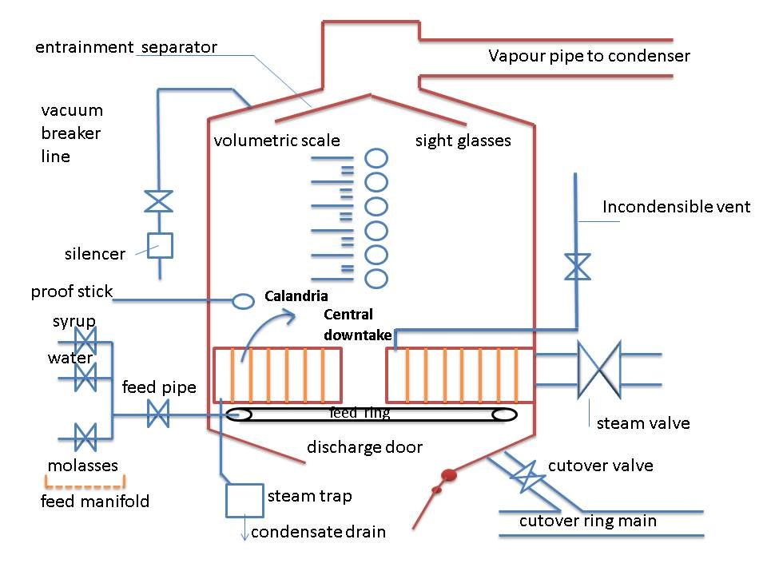
Calandria: is the heating element of the pan and consists of a large number of cylindrical tubes fixed to a top and bottom tube plate.
A condenser: is a vessel used to condense vapour to liquid. Its purpose is not simply to condense vapour but to use this condensation to create a vacuum which can then be controlled by the condenser water

Learning activity 2.2: Individual Learning activity: 15 minutes (12 marks)
Learning Objective: An understanding of pan boiling equipment design and operations is demonstrated.
Task: Read each question carefully and write your answer in the space provided.
1. What is incondensable gas? (2)
Steam, although consisting mainly of gaseous water, also contain some air and other gases that cannot be condensed. These are called incondensable gases

2. Describe the methods by which condensate is removed from a calandria? (10)
The condensate is removed by Steam traps which are Float type traps, Thermostatic traps and Thermodynamics traps with valve disc.
Float Traps: This type of steam trap consists of a small tank with an inlet and outlet and a flat inside. The condensate drain from the calandria is connected to the inlet and the outlet is connected by piping to a condensate tank. While the tank is empty/low the float is in its bottom position and it keeps the control valve in its closed position. When condensate flows into the trap, the float lifts thus opening the control valve and the pressure in the trap forces the condensate out. As the level drops, so does the float, until it closes off the outlet again. The condensate is thus removed but the steam remains behind.
Thermostatic Traps: These traps utilise the temperature difference between steam and condensate. They contain a regulating membrane with a liquid filling. This liquid remains in the liquid phase if in the presence of condensate, but evaporates in the presence of steam.
Thermodynamics traps with valve disc: The condensate discharge is mainly affected as a function of the state of the medium flowing through the traps. Cold condensate can flow freely through the trap and the valve disc is kept fully open by the energy of low. As soon as the condensate approaches boiling temperature, part of the condensate evaporates and produces a considerable increase in velocity of low. This will lead to a pressure drop underneath the valve disc which consequently moves towards the seat. Simultaneously steam will flow into the pressure chamber above the valve disc where the pressure increases until the trap is closed. This is done by condensation (radiation of heat to the environment) and by leak path provided at the valve disc (escape of steam to the outside).
Whether and when the trap will reopen after is independent of the amount of condensate formed, but determined by the temperature of the environment of weather the surroundings air is at rest or agitated .A second point the finish of the sealing surfaces. The rougher the surface the quicker the trap will open, the smoother the surface, the later the opening.

Learning activity 2.3: Individual Learning activity: 10 hours (250 marks)
Learning Objective: Demonstrate an understanding of pan boiling equipment design and operation.
Task: Read each question carefully and write your answer in the space provided.
1. Why is a pan steam out done? (1)
The objective is to give an even, unrealistic flow of feed into the pan

2. Describe how and why molasses is conditioned? (6)
- The molasses is heated so that it has a temperature higher than that of the pan into which it will be introduced. This has the advantage that the molasses will flash when entering the pan, thus promoting circulation.
- The molasses is diluted with steam hot water to have a 70°Bx. The brix is measured by a conductivity meter that operates a valve water/steam.
The conditioning of the molasses feed is essential to remove all traces of small crystals/grain. Conditioning thus prevents odd size crystals forming in the pan.

3. Describe the construction of a seed receiver and its function? (3)
Seed red receivers are usually totally enclosed cylindrical tanks with stirrer. They are connected to the pans, by the cut over line, and are used for the storage of seed. Sight glasses are provided on the ends so that the level inside the receiver can be seen.

4. Describe how circulation is caused in a pan? (3)
Circulation is promoted by the bubbles of vapour formed as the massecuite is heated in the tubes. As the bubbles rise they grow in size and agitate/mix the massecuite as the lift it towards the surface. The massecuite boils and rises in the tubes and then moves down the central downtake to the bottom of the calandria. Circulation is thus due to heating- if the heating is stopped, so does the circulation.

5. What conditions are necessary for good crystallisation? (6)
  - The rate at which sucrose molecules arrive at thin stationary layer of saturated solution surrounding the crystal. This depends on the relative speed of the movement of crystal through mother liquor i.e. the rate of circulation in the pan;
  - The rate of which sucrose molecule will diffuse through the film which surrounds the crystal. This depends mainly on the viscosity of the film and on the degree of supersaturation of mother liquor in contact with it;
  - The rate at which sucrose molecules are deposited on crystal surface. This is influenced by presence in mother liquor of some impurities like raffinose and other oligosaccharides which interfere with incorporation of sucrose molecules into the crystal lattice.

6. How can the effectiveness of circulation be judged? (2)
The circulation can be said to be good if the difference in temperature between the massecuite under the Calandria is 40mm above the calandria and not more than 3 C when the pan is nearly full.

7. How does circulation assist crystallisation? (2)
The mixing effects of circulation are important in bringing new mother liquor into contact with the crystal surface thus assisting crystallisation.

8. Define approach temperature for condenser? (2)
The approach temperature is the difference between the inlet vapour temperature and the outlet water temperature (tv – t₀).

9. How is incondensable gas removed from the condensers?(2)
Incondensible gases are removed by pipes extending to the bottom of the calandria which have holes along their length so that both heavy and light gasses are vented. These vent pipes removing incondensible gases are connected to regulating valves outside the pan.

10. Name 9 types of valves and their most common use? (18)

Diaphragm valve: A rubber diaphragm acts against a ridge in the path of flow thereby regulating the flow.
Gate valve: Gate valves are frequently used to regulate feed to pans and to control the cut-over line.
Butterfly valve: The most common use of butterfly valves on the pan floor is for the automatic control of condenser water.

Slide valve: Slide valves are good for massecuite and magma as the tongue or slide is smooth

Steam valve :They are suitable for high pressure

Ball valve: Ball valves are quick acting valves. The only real use on the pan floor for a ball valve is on the graining funnel.
Float valve: Float valves are used to maintain a fixed level of liquid in a tank.
Non-Return valve: A non-return valve is inserted in a pipe line to prevent liquid flowing back along the pipe.

Safety valve: The safety valve on the calandria is there in case there is a build-up of pressure

  - Knowledge Topic 3: Graining a pan and growing a massecuite (30%)
Topic elements to be covered include:
- KT0301 Grain formation
- KT0302 Slurry
- KT0303 Graining a pan
- KT0304 Control of super saturation
- KT0305 Automatic vacuum control
- KT0306 Boiling a massecuite
- KT0307 Brix of pan feed
- KT0308 Hydrostatic head
- KT0309 Striking a pan
- KT03010 Dealing with highly viscous massecuite
Internal Assessment Criteria and Weight
- IAC0301 Pan boiling process flow and steps can be described
- IAC0302 Quality specification for process stages can be listed
- IAC0303 Potential problem areas can be listed and actions to avoid these explained
- IAC0304 Critical Control Points can be listed
- (Weight 30%)

Learning activity 3.1: Individual Learning activity: 10 hours (250 marks)
Learning Objective: Demonstrate an understanding of pan boiling equipment design and operation.
Task: Read each question carefully and write your answer in the space provided.
1. Describe the following methods of grain formation with relative advantages and disadvantages
- Waiting method
- Shock seeding
- True seeding (10)

The waiting method: In the labile zone primary nucleation takes place. The mother liquor is concentrated into the labile zone and is kept there until sufficient crystal is formed. The boiling solution is then diluted into the metastable zone and kept there until the end of the strike.

Shock seeding: The solution is concentrated into the intermediate zone where secondary nucleation will take place. A small amount of power sugar is added and this induces the formation of further nuclei. To use this method the supersaturation must be higher than normal and is normally done in refineries. Once tiny crystals have formed throughout the solution the pan boiler washed (with water or diluted feed) to get the correct number of crystals. When there are sufficient crystals present the solution is brought into the metastable zone and kept there until the end of the strike.
Shock seeding can be practised in refiners, but not in the solution need to be concentrated more to get the correct supersaturation.

True seeding: True seeding relies on the fact that in the metastable zone existing crystals will grow and no new ones will form. The mother liquor is concentrated to the upper part of the metastable zone (SSC 1.25-1.35) and the required number of seed crystals is added in the form of slurry. It is important to keep the supersaturation constant during this procedure. Boiling is continued in the metastable zone until the end of strike.

2. What is the purpose of slurry and how should it be used?? (8)
Slurry is ideally made by grinding refined sugar in a miniature ball mill with an organic fluid in which sucrose is insoluble The S.M.R.I. recommended method is:
- 800g of refined sugar and 2 litres of methanol are tumbled for 12 hours.
- The ball jar should contain 2500 10mm steel balls and should rotate at 74 r.p.m.
- After 12 hours the ball jar should be diluted to 6 litres with methanol.
If the slurry is made the same way all the time, uniform, uniform size slurry will be made.
It can be calculated how much slurry is needed to produce a certain volume of massecuite of fixed crystal size. If a significant change in the final grain size is desired starting from a normal size of 0,30mm, it is necessary to change the amount of slurry by not less than 20% of the original volume. The amount of slurry used for C boiling is about 1000mm/35m³ of massecuite and about half that for B-boilings. If the correct amount of slurry is used when seeding the crystal size and content of the final massecuite will be uniform.

3. What is meant by bringing the grain together? (2)
The first step in making sugar from liquor is to grain the pan. This means introducing small crystals that are subsequently used as nuclei to grow the main sugar crystals

4. What is the best method of ensuring the best rate of crystal growth and evaporation in a pan? (3)
The rate of evaporation is controlled by varying the amount of water that is available for evaporation. This is done by varying the amount of water fed by varying the amount of syrup/molasses feed supplied to the pan.

5. Compare “bring the grain together” with “growing the grain’’ (4)
Bringing the grain together takes place from E to F. The level of supersaturation is controlled by careful boiling, supplying sufficient water to replace the water being evaporated. Steam supply is also kept constant. This boiling is merely to ensure circulation so that each grain is presented with fresh liquor. Bringing the grain together may take ½ to 1 hour.

  - Knowledge Topic 5: Pan Control and Automation (5%)
Topic elements to be covered include:
- KT0501 Importance of pan control
- KT0502 Using conductivity
- KT0503 Using computer control
Internal Assessment Criteria and Weight
- IAC0501 Instrumentation used in pan boiling can be listed and application explained
- IAC0502 understanding of data readings from instruments can be demonstrated
- (Weight 5%)

Learning activity 5.1: Individual Learning activity: 10 minutes (14 marks)
Learning Objective: Demonstrate an understanding of pan control and automation.
Task: Read each question carefully and write your answer in the space provided.
1. Describe the methods by which the evaporation rate in a pan can be controlled. (10)
The rate of evaporation is controlled by varying the amount of water that is available for evaporation. This is done by varying the amount of water fed by varying the amount of syrup/molasses feed supplied to the pan.
Example 1:
If we wish to reduce the rate of evaporation from the massecuite in the pan, we can take the following action:
- Add water
When this is evaporated, the rate at which is evaporated from the massecuite itself effectively decreases since the total rate of evaporation remains constant.
- Increase the syrup/molasses feed rate
The water present in the feed has the same effect as described above
Example 2
If we wish to increase the rate of evaporation from the massecuite in the pan, we can take the following action:
- Reduce the water added
Since this is now available for evaporation, the rate at which is evaporated from the massecuite itself effectively increases since the total rate of evaporation remains constant.
- Decrease the syrup/molasses feed rate
Reducing the feed reduces the amount of water entering the pan which has the same effect as described above.

2. Why does circulation slow down as the pan fills up and how can circulation be improved? (4)
Circulation is hindered by the resistance of the shape and position of the tubes and by obstructions in the downtake
The pans which make white sugar in a refinery should be fitted with stirrers to improve pan circulation.

  - Knowledge Topic 6: Problems Experienced during Pan Boiling (15%)
Topic elements to be covered include:
- KT0601 False grain
- KT0602 Aconitic acid
- KT0603 Water dilution
- KT0604 Loss of vacuum
- KT0605 Pan not boiling fast enough
- KT0606 Purity of pan feed
- KT0607 Low brix feed
- KT0608 High viscosity massecuite
Internal Assessment Criteria and Weight
- IAC0601 An understanding of trouble shooting and standard responses related to pan boiling can be demonstrated
- (Weight 15%)

Learning activity 6.1: Individual Learning activity: 15 minutes (13 marks)
Learning Objective: Demonstrate an understanding of problems experienced during pan boiling.
Task: Read each question carefully and write your answer in the space provided.
1. (a) What is false grain (2)
False grain is unwanted grain whose size does not compare with desired size formed during the growing process of existing crystals by secondary nucleation False grain is thus a new crop of crystal formed during a boiling and is caused when the supersaturation enters the intermediate zone but can also occur in the upper metastable zone

(b)What conditions cause false grain? (9)
Low crystal content in the boiling massecuite
Evaporation rate in the pan too fast for the crystallization rate
Poor circulation
Grain in the feed
Very large sugar crystals being boiled
Air leaks
High concentration of certain non-sugars
Sharp increase in vacuum or a drop in temperature during boiling
Turbid feed

(c)How is it eliminated? (2)
- Diluting the pan contents with water or
- Heating up the pan by reducing the vacuum (i.e. increasing the absolute pressure)

  - Knowledge Topic 7: Three Massecuite Boling System (5%)
Topic elements to be covered include:
- KT0701 Introduction to massecuite boiling
- KT0702 The three massecuite boiling system
- KT0703 Pan flow data
- KT0704 Crystal size
- KT0705 Types of crystal
- KT0706 Viscosity
- KT0707 Massecuite brix at strike
Internal Assessment Criteria and Weight
- IAC0701 An understanding of process steps and use of equipment related to massecuite boiling can be demonstrated
- IAC0702 An understanding of the impact on factory performance can be demonstrated
- (Weight 5%)

Learning activity 7.1: Individual Learning activity: 45 minutes (33 marks)
Learning Objective: An understanding of three massecuite boiling system is demonstrated.
Task: Read each question carefully and write your answer in the space provided.
1. What is mixed grain? (2)
Mixed grain is a mixture of crystals of different sizes caused by false grain that is not removed but is allowed to grow.

2. What are conglomerates, how are they removed and what is their effect on process? (3)
Conglomerates are three or more crystal stuck together. This happens mostly with high purities. They are caused by a high SSC immediately after seeding. Conglomerates are very problematic as they trap mother liquor and do not dry easily. Furthermore, washing in the centrifugal cannot remove this trapped mother liquor.

3. What is needle grain? (2)
Needle grain is the term given to elongated grain. Elongation DOES NOT occur because the crystal is growing faster along axis, but because the crystal is not growing along the other axes.

4. What are the factors taken into account when a boiling system is selected? (5)
- The keeping quality of the sugar
- The refining quality of the sugar
- The amount of product recirculation (i.e. remelt)
- Flexibility and simplicity as a factory operation
- Steam consumption.

5. Draw a flow diagram of the 3-massecuite boiling system and indicate the purities of the different process streams. (10)
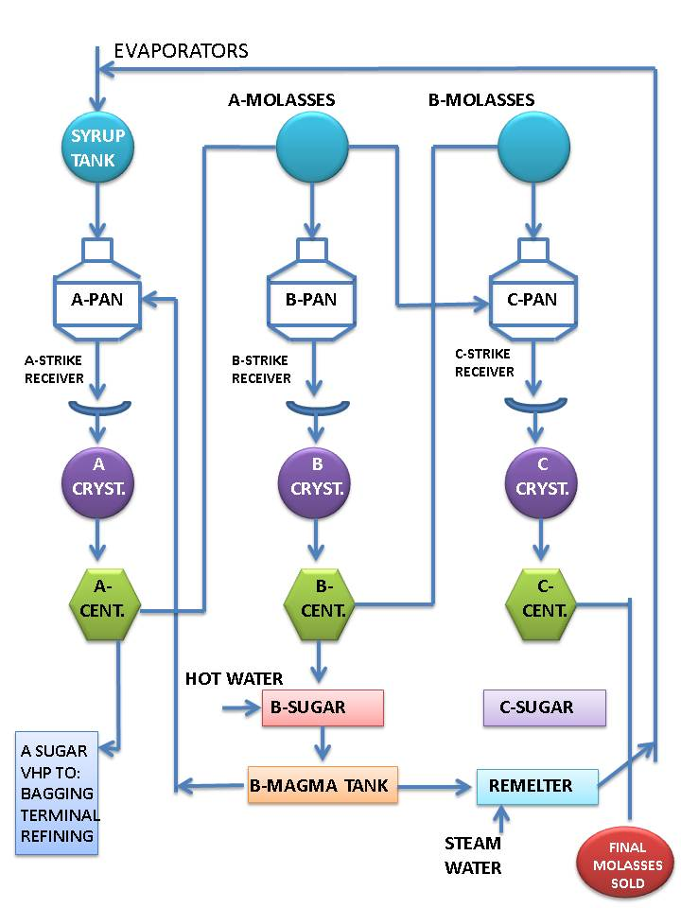
C-massecuite (52% purity) is produced by slurry seeding a mixture (graining charge) of A-molasses and B-molasses and thereafter the pan is fed on B-molasses. This produces C-sugar (81% purity) and final molasses (36%). However, if the C-massecuite purity were to be, say, 45 because the B-molasses purity was very low it would be necessary to feed the C-seed on A-molasses initially and then change over to B-molasses in order to obtain the desired C-massecuite purity. If the C-massecuite purity were too low the crystal content would be too low and exhaustion would be lower than it should be. C-massecuite purity is usually in the range of 52 - 56.
The C-sugar is melted with the excess B magma and the melt (87% purity) is returned to syrup.
B-massecuite (69% purity) is produced by slurry seeding A-molasses to produce B-sugar. Some B-sugar is mixed with water and made into magma (92% purity). B-molasses (47% purity) is produced.
A-massecuite (87% purity) is produced from the B-magma footing and syrup. This A-massecuite produces A-sugar (99% purity) and A-molasses (69% purity).

6. (a) what is the normal crystal size for A, B and C sugars? (3)
V.H.P.Sugar is 0.65-0.77mm
‘B’ sugar is 0.35mm
‘C’ sugar is 0.15mm

(b) What effect has crystal size have on exhaustion, curing (centrifugal and false grain? (4)
Crystal size influences the exhaustion of the mother liquor as well as the curing of the massecuite and the formation of false grain. A big grain (0,65-0,75mm0 cures easily in the centrifugal but false grain forms easily due to the limited crystal surface area. A small grain does not cure very well, but because there is more crystal surface area, false grain doesn’t form easily

7. How does the brix of ‘A’ massecuite at strike affect the quantity of massecuite boiled? (2)
Low massecuite brixes could mean that up to 30% more massecuite would have to be boiled.
8. What effect does brix of feed material have on steam consumption? (2)
High brixes also save time and fuel as less steam is needed in the later stages of boiling where the efficiency is low.

  - Knowledge Topic 8: Mixture Calculation (5%)
Topic elements to be covered include:
- KT0801 Using formulae
Internal Assessment Criteria and Weight
- IAC0801 Formula, calculations and data interpretation is performed correctly
- IAC0802 Balancing product streams to achieve final product specification can be explained
- (Weight 5%)

Learning activity 8.1: Individual Learning activity: 30 minutes (15 marks)
Learning Objective: Mixture calculations are performed.
Task: Read each question carefully and write your answer in the space provided.
1. Given that the molasses of purity 78% and that the B molasses of purity 42%, must be prepared 100 tons of mixture at 72%(5)
TFH =100(72-42)÷78-42
=100(30)÷36
=83.33
=100-83.88=16.67

2. Given: Syrup purity =79
Molasses purity=47
Footing purity=62
Footing Volume=20m³
Calculate the quantities of syrup of syrup and that must be mixed to create the footing. (5)

3. Given: A-molasses purity =70
B-molasses purity =52
Massecuite purity =56
Footing volume =85m³
Calculate the quantities of A- B- molasses required to require creating the footing. (5)

  - Knowledge Topic 9: Continuous Pan Boiling (5%)
Topic elements to be covered include:
- KT0901 Basic operation
- KT0902 Pan control
Internal Assessment Criteria and Weight
- IAC0901 An understanding of process steps and use of equipment related to massecuite boiling can be demonstrated
- IAC0902 An understanding of the impact on factory performance can be demonstrated
- (Weight 5%)

Learning activity 9.1: Individual Learning activity: 10 minutes (10 marks)
Learning Objective: Demonstrate an understanding of continuous pan boiling.
Task: Read each question carefully and write your answer in the space provided.
1. Describe a continuous pan? (2)
Continuous pans are divided into a number of cells/compartments (usually 12) that are separated from each other. The massecuite in each compartment is heated by steam fed to a calandria. The large calandria stretches throughout the pan.

2. How is massecuite discharged from a continuous pan?
The massecuite in each compartment is heated by steam fed to calandria. The large calandria stretches throughout the pan.

3. How is the massecuite boiling controlled in a continuous pan? (6)
- Once a day, samples of the massecuite in the different control compartments are taken and sent to the laboratory for brix analysis. The results are plotted and compared with the target values.
If the brix of a particular cell is too low (i.e. the massecuite is ‘slack’), the conductivity set point of that cell is reduced so that the brix will increase. If the brix of a particular cell is too high (i.e. the massecuite is too ‘tight’), the conductivity set point of that cell is increased so that the brix will reduce.
- Each cell is also regularly checked for its feel (slack/tight) and for the presence of false grain.
If false grain has formed in a cell, the brix of the preceding cell is reduced by increasing its conductivity set point.
- The crystal content of all cells must also be checked periodically. The crystal content must be kept between 30 - 33%.
If the crystal content is low, the rate that seed massecuite is fed to the first compartment must be increased and vice versa.
The seed for a continuous pan is grown in a pan which is a batch pan using graining with slurry. A continuous pan is continuously fed with seed into its first compartment.

  - Knowledge Topic 10: Control Formulae (5%)
Topic elements to be covered include:
- KT1001 Crystal content of massecuite
- KT1002 Exhaustion
- KT1003 SJM formula
Internal Assessment Criteria and Weight
- IAC1001 Formula selection and use, calculations and data interpretation is performed correctly
- (Weight 5%)

Learning activity 10.1: Individual Learning activity: 15 minutes (11 marks)
Learning Objective: An understanding of formula selection, use, calculations and data interpretation is demonstrated.
Task: Read each question carefully and write your answer in the space provided.
1. Define crystal content and give the formula to calculate it. (4)
Crystal content is the mass of crystals as a percentage of the mass of massecuite.
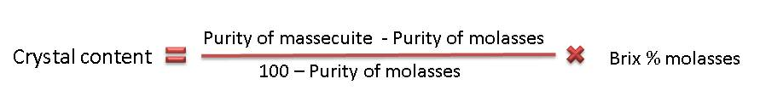

2. What is the maximum crystal content of a fluid massecuite? (3)
A-massecuite 55
B-massecuite 43
C-massecuite 30-35

3. What is exhaustion and how is it calculated. (4)
This gives the amount of crystals of sucrose recovered as a percentage compared to the amount of sucrose available.
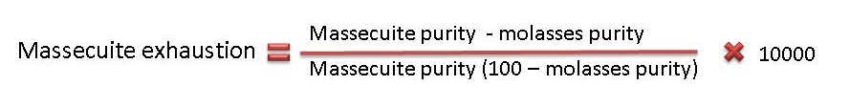

CONCLUSION OF KNOWLEDGE MODULE 7: PAN BOILING THEORY AND TECHNOLOGY
Throughout this knowledge module you have been provided opportunities to complete formative learning activities. You have captured your results in this Learner Workbook.
The total marks for this Knowledge Module are as follows:
Knowledge Module | Total Marks | Marks attained
KM-07-KT01: Theory of crystallisation (15%) | 84
KM-07-KT02: Equipment design and operation (5%) | 76
KM-07-KT03: Graining a pan and growing a massecuite (30%) | 27
KM-07-KT04: Pan cycle (10%)
KM-07-KT05: Pan control and automation (5%) | 14
KM-07-KT06: Problems experienced during pan boiling (15%) | 13
KM-07-KT07: Three massecuite boiling systems (5%) | 33
KM-07-KT08: Mixture calculation (5%) | 15
KM-07-KT09: Continuous pan boiling (5%) | 10
KM-07-KT10: Control formulae (5%) | 21
Total Marks | 283marks

SUMMATIVE ASSESSMENT ACTIVITIES AND MODEL ANSWERS
The learner is now required to complete the Summative Assessment (Multiple choice).
Facilitator instructions:
Once the facilitation of this Knowledge Module is completed:
- Allow the learners time to complete their Learner Workbooks (8 hours). There should be no blank activities and all activities should be completed in pen.
- The Summative Assessment Guide is then handed to each learner and the Summative Assessment is done (1.5 hours)
- It should take approximately 16 hours to mark each Learner Workbook.
- Insert the marks obtained for each Knowledge Module into the Summative Assessment Guide of each learner in the space provided.
- Tally the total marks and complete the Summative Assessment Guide of each learner.
- Hand out each Summative Assessment Guide for final learner feedback and signing.
- Prepare certificates for the programme as required.

WRITTEN ASSESSMENT MODEL ANSWERS

Candidate instruction: Complete the following multiple-choice questionnaire by marking the most appropriate response with an x in the space provided.
Scope of Assessment |  |  | Exit Level Outcome/s |  | Module/s
 |  |  | - : Pan boiling theory and technology |  | 1
Alignment – Learning Outcome 1: Pan boiling theory and technology

Award one mark for selection of valid “x”. One mark = Competent
7.1 | Crystallisation can best be defined as; |  |  | Mark Allocation
a. |  | Increasing the Brix of juice from 15 ºBrix to 65 ºBrix.
b. |  | Removing dissolved sucrose from solution.
c. |  | Remove unwanted water from the clear juice.
d. |  | Remove unwanted suspended solids from the syrup.
e. |  | Boiling syrup under a vacuum. |  | 2

7.2 | A 60°Brix solution at 60°C can dissolve more sugar. This solution is known as; |  | Mark Allocation
a. |  | A saturated solution.
b. |  | A supersaturated solution.
c. |  | A labile solution.
d. |  | A weak solution
e. |  | An unsaturated solution. | 2

7.3 | How can more sugar be dissolved into solution when the solution is saturated. |  | Mark Allocation
a. |  | Increase the temperature of the solution.
b. |  | Cool the solution down.
c. |  | Add the additional sugar very slowly, allowing it to dissolve.
d. |  | Mix the sugar with alcohol.
e. |  | Evaporate some of the water off the solution. | 2

7.4 | What is the best definition for a saturated solution? |  | Mark Allocation
a. |  | A solution that can dissolve more solute at a certain temperature.
b. |  | A solution that will expel sucrose spontaneously.
c. |  | A solution that contains the maximum amount of solute at a certain temperature.
d. |  | When the temperature of the solution increases due to the addition of solute.
e. |  | If the solution is heated and then is able to dissolve more solute. | 2

7.5 | The driving force for crystallisation is; |  | Mark Allocation
a. |  | Operating in the labile zone.
b. |  | The correct supersaturation co-efficient.
c. |  | The amount of vacuum in a pan.
d. |  | Purity of the syrup
e. |  | Brix of the syrup. | 2

7.6 | Low purity feed will have an impact on the zones of supersaturation. Which is the correct statement in this regard. |  | Mark Allocation
a. |  | Decrease the width of the zones.
b. |  | Give a higher crystallisation rate.
c. |  | There will be a wider band between the saturation zones.
d. |  | The BPE will decrease.
e. |  | The SSC will need to be adjusted to match the syrup purity. | 2

7.7 | How can a solution be kept in the metastable zone and what is the impact on crystal growth? |  | Mark Allocation
a. |  | By introducing slugs of water into the solution.
b. |  | By controlling the Brix, thereby managing the degree of supersaturation.
c. |  | By decreasing the vacuum and increasing the boiling point.
d. |  | By cutting back on the steam supply.
e. |  | By releasing the incondensable gasses. | 2

7.8 | Massecuite viscosity (thickness) is important because; |  | Mark Allocation
a. |  | Increasing viscosity will improve the sucrose molecule circulation and speed up crystal formation.
b. |  | The higher the viscosity of the massecuite, the higher the sucrose exhaustion.
c. |  | False grain can come about in situations where the viscosity is too low.
d. |  | Viscosity is only important in the C boilings.
e. |  | Increasing viscosity will slow down the sucrose molecule circulation and slow down crystal formation. | 2

7.9 | Boiling point elevation (B.P.E) is; |  | Mark Allocation
a. |  | A decrease in the boiling point as a result of the increase in Brix.
b. |  | The increase in the boiling point as a result of the decrease in vacuum.
c. |  | An increase of the boiling point as a result of the increase in vacuum.
d. |  | The increase in vacuum as a result of the increase in Brix.
e. |  | The increase in boiling point as a result of an increase in Brix. | 2

7.10 | Conductivity measurement is used to measure; |  | Mark Allocation
a. |  | The vacuum of the pan.
b. |  | The indirect measurement of Brix.
c. |  | Measurement of the circulation in the pan.
d. |  | To indicate the level of the massecuite in the pan.
e. |  | To measure the temperature of the massecuite. | 2

7.11 | What is the purpose of the cut over valve on the pan? |  | Mark Allocation
a. |  | To discharge the massecuite.
b. |  | The separate droplets of juice from the vapour.
c. |  | To transfer product between pans and receivers.
d. |  | To feed the charge into the pan.
e. |  | To remove the condensate from the calandria. | 2

7.12 | Circulation is important for good and effective pan boiling. Which statement best describes the means of circulation in a pan. |  | Mark Allocation
a. |  | The movement of bubbles that result from boiling the massecuite will assist with circulation.
b. |  | The increase of pressure from the incondensable gasses assists with circulation.
c. |  | Increasing the removal of condensate will assist with circulation.
d. |  | The hydrostatic head will circulate the massecuite.
e. |  | The entrainment separator assists with circulation. | 2

7.13 | The vapour from the pan is condensed in the condenser, using injection water, to produce a vacuum. What is the approach temperature of a condenser? |  | Mark Allocation
a. |  | The temperature of the vapour as it approaches the condenser.
b. |  | The difference between the vapour and the condensate temperature.
c. |  | The difference between the vapour and injection water inlet temperature.
d. |  | The difference between the injection water inlet and outlet temperature.
e. |  | The difference between the vapour and injection water outlet temperature. | 2

7.14 | What is the ideal approach temperature for an efficiently operating condenser? |  | Mark Allocation
a. |  | Close to zero.
b. |  | 22.4 ºC
c. |  | 37.5 ºC
d. |  | - 4.2 ºC
e. |  | - 1.1 ºC | 2

7.15 | The molasses blow-up tank is an important feature of pan boiling. Which statement best describes the reason for this. |  | Mark Allocation
a. |  | Molasses or syrup can be stored for indefinite periods as injection steam keeps the temperature up.
b. |  | The tanks are fitted with stirrers so that the feed to the pans is consistent.
c. |  | There is an air supply that can be used to increase the bubbles in the molasses or syrup that will assist in circulation in the pan.
d. |  | False grain can be removed by the introduction of the air.
e. |  | The injection steam and stirrer will dissolve any small crystals that will cause false grain in the pan. | 2

7.16 | If a pan is not steamed out after use, what will be the consequences for the next boiling? |  | Mark Allocation
a. |  | Less massecuite will be drawn into the pan.
b. |  | More steam will be required to boil the massecuite.
c. |  | The pH pf the massecuite will drop.
d. |  | False grain will occur.
e. |  | There will be a lower vacuum in the pan. | 2

7.17 | Which statement best describes false grain. |  | Mark Allocation
a. |  | C Massecuite with a high concentration of fine grain sugar.
b. |  | Unwanted small grain sugar that is formed by secondary nucleation.
c. |  | The fine crystals that have been milled in alcohol.
d. |  | The grain that is found in the B Magma.
e. |  | All of the above. | 2

7.18 | Which of the following will form false grain? |  | Mark Allocation
a. |  | Poor circulation in the pan.
b. |  | A syrup purity above 85%.
c. |  | Boiling the massecuite in the labile zone.
d. |  | Previous pan strike not properly steamed out.
e. |  | All of the above. | 2

7.19 | How best can the degree of supersaturation be measured with instruments in the pan? |  | Mark Allocation
a. |  | By measuring the temperature difference of the massecuite at the top of the pan and the bottom of the pan.
b. |  | By measuring the torque of the proof stick.
c. |  | By the difference in vacuum between the top of the pan and the bottom of the calandria.
d. |  | By measuring the conductivity of the massecuite and plotting a conductivity curve.
e. |  | None of the above. | 2

7.20 | The best definition for seed massecuite would be; |  | Mark Allocation
a. |  | The C sugar that is used as a footing.
b. |  | Partially grown massecuite that contains small crystals, requiring further growth.
c. |  | The slurry that is used as a footing to grow crystals.
d. |  | Crystals that start forming in the massecuite that is in the labile zone.
e. |  | None of the above. | 2

7.21 | In which zone will a pan best operate and grow good sugar crystals. |  | Mark Allocation
a. |  | Labile zone
b. |  | Intermediate zone
c. |  | Unsaturated zone
d. |  | Metastable zone
e. |  | Supersaturated zone | 2

7.22 | Without the means of instrumentation, which is the best way to determine if the massecuite has reached the right saturation for crystal growth. Draw frequent samples from the proof stick and examine under a microscope to look for: |  | Mark Allocation
a. |  | Small crystals in amongst larger crystals after about 20 minutes after adding the slurry.
b. |  | The grain must be close together.
c. |  | When microscopic crystals start forming shortly after adding the slurry.
d. |  | When there is no evidence of crystals.
e. |  | All of the above. | 2

7.23 | Which of the following statements best describe the method of keeping the massecuite boiling in the right zone prior to the addition of slurry or footing. |  | Mark Allocation
a. |  | Adjust the steam pressure to the calandria to ensure that boiling is limited.
b. |  | Continually add A molasses in order to replace the sucrose that is coming out of solution during crystal growth.
c. |  | Leave all valves shut and allow the pan to boil on the residual heat in the calandria.
d. |  | Continually add small amounts of water to compensate for the water that is being evaporated.
e. |  | Manage the vacuum in such a way as to continually decrease the boiling point of the massecuite. | 2

7.24 | What is the best definition of the term “bringing together”. |  | Mark Allocation
a. |  | More crystals will form and the space between crystals in the mother liquor will reduce.
b. |  | Existing crystals will grow and the volume of the massecuite will increase.
c. |  | The crystals formed will move down to the bottom of the pan and the volume of the massecuite will remain the same.
d. |  | Existing crystals will become larger and the volume of the mother liquor will remain the same.
e. |  | The existing crystals will diffuse the sucrose molecule and replace the viscosity with crystal growth. | 2

7.25 | Once bringing together is complete, choose the next step from the following. |  | Mark Allocation
a. |  | The pan is struck.
b. |  | Water is continually added in small amounts to maintain the correct boiling zone.
c. |  | The water is shut off and the pan feed valve is opened to gradually fill the pan to strike level.
d. |  | The vacuum is broken to allow the boiling to stop and the massecuite will rise to the strike level.
e. |  | The water is shut off and the vacuum is increased to increase boiling so that the massecuite can rise to the strike level. | 2

7.26 | If the evaporation rate is too high and the supersaturation will potentially rise to dangerous levels, which is the WRONG solution. |  | Mark Allocation
a. |  | Reduce the steam supply to the calandria.
b. |  | Add liquor into the pan.
c. |  | Add water into the pan.
d. |  | Reduce the vacuum.
e. |  | All of the above. | 2

7.27 | What effect does the hydrostatic head have on a massecuite? |  | Mark Allocation
a. |  | Increases the water quantity in the massecuite.
b. |  | Increases the vacuum required to boil the pan.
c. |  | Will create turbulence in the massecuite.
d. |  | Will increase the boiling point of the massecuite at the bottom of the pan
e. |  | Will result in a higher extraction of incondensable gasses from the massecuite. | 2

7.28 | What is the purpose of utilising the three massecuite boiling system? |  | Mark Allocation
a. |  | Crystal content of more than 66% will make massecuite unmanageable.
b. |  | To recover more crystals from the molasses.
c. |  | Improve the quality of the sugar.
d. |  | Reduce overall steam consumption.
e. |  | All of the above. | 2

7.29 | B-Magma is used as a footing for A sugar. Which is the correct definition for B-Magma? |  | Mark Allocation
a. |  | Syrup is mixed with B molasses.
b. |  | B sugar is mixed with water.
c. |  | A molasses is mixed with C sugar.
d. |  | C sugar is mixed with B molasses
e. |  | C & B sugar is remelted. | 2

7.30 | The purity of syrup feed for the boiling of A sugar is too high and needs to be reduced. This is done by mixing syrup with; |  | Mark Allocation
a. |  | B-Magma.
b. |  | C Molasses.
c. |  | C sugar.
d. |  | Water.
e. |  | Remelt. | 2

7.31 | A high viscosity will impact on crystallisation. Which is the correct statement? |  | Mark Allocation
a. |  | Will impact mostly on C molasses.
b. |  | Reduces the diffusion rate.
c. |  | Reduces the exhaustion of the molasses.
d. |  | Slow down the crystal growth rate.
e. |  | All of the above. | 2

7.32 | The Brix of strikes of A, B and C sugar is important to maximise exhaustion. What is the correct range for B strike massecuite Brix? |  | Mark Allocation
a. |  | 90 – 94 ºBrix
b. |  | 90 – 99 ºBrix
c. |  | 70 – 78 ºBrix
d. |  | 92 – 97 ºBrix
e. |  | 65 – 68 ºBrix | 2

A purity of 72% is ideal for graining a pan. Use the following information to calculate the amount of syrup and the amount of remelt that must be combined to feed the pan.
100 tons of mixture is required to feed a pan.
The syrup purity is 82%
The remelt purity is 68%
How many tons of each must be added to achieve 100 tons of 72% purity?
A = purity of the higher grade feed.
B = purity of the lower grade feed
C = purity desired for the pan feed.
D = relative quantity of higher grade feed.
E = relative quantity of lower grade feed.
Using the formulae, D = C – B
E = A – C
Tons of higher purity (HP) = Tons of feed X D
(D+E)
Tons of lower purity (LP) = Tons of feed X E
(D+E)
7.33 | Choose the correct answer. |  | Mark Allocation
a. |  | HP = 28.6 and LP = 71.4
b. |  | HP = 71.4 and LP = 28.6
c. |  | HP = 40 and LP = 60
d. |  | HP = 21.6 and LP = 78.4
e. |  | HP = 78.4 and LP = 21.6 | 2

7.34 | Control formulae are used to manage the operation of the pan floor. What does “exhaustion” measure? |  | Mark Allocation
a. |  | The amount of crystals recovered in A molasses as a percentage of final molasses.
b. |  | The amount of Brix in final molasses as a percentage of the amount of Brix in syrup.
c. |  | The measure of the purity drop from A massecuite to A molasses.
d. |  | The amount of crystals of sucrose recovered as a percentage compared to the amount of sucrose available.
e. |  | The percentage of the sucrose available in syrup, expressed as a ratio to the percentage of sucrose in final molasses. | 2

7.35 | The SJM formula is also a factory control parameter and is used to calculate; |  | Mark Allocation
a. |  | The percentage recovery of sucrose from a given feed, where sugar and molasses are made.
b. |  | The percentage of the syrup required to ensure that the feed is kept constant where sugar and molasses are made.
c. |  | The tons of sugar made expressed a percentage of the molasses made.
d. |  | The tons of cane required to make one ton of sugar.
e. |  | The percentage of C sugar recovered from B molasses as a percentage where sugar and molasses are made. | 2

TRUE OR FALSE QUESTIONS
Award one mark for selection of valid “x”. One mark = Competent
7.36 | TRUE or FALSE: The following statements relate to the supersaturation co-efficient (SSC). State which statements are true and which are false. |  | Mark Allocation
a. | ⓣ | The SSC is the driving force in sugar boiling.
b. | ⓕ | Area of the heating surface in the pan.
c. | ⓣ | A SSC of 1.1 means that the solution is supersaturated.
d. | ⓣ | A solution containing 1.1 times the sucrose than it would have contained if it were saturated at 60 ºC
e. | ⓕ | A pure sucrose solution in the unsaturated zone. | 5

7.37 | 37. TRUE or FALSE: There are different zones of saturation for a pure sucrose solution. State which are true and which are false. |  | Mark Allocation
a. | ⓣ | The Unsaturated or stable zone has a SSC of <1 and all sucrose is in solution.
b. | ⓕ | The Labile zone has a SSC of < 1.1 and no new crystal growth will occur.
c. | ⓣ | The Metastable zone has a SSC >1 and <1.2. sucrose crystals will continue to grow until the concentration falls to where the solution is just saturated
d. | ⓣ | The Intermediate zone has a SSC of >1.2 but <1.3 and crystals will continue to grow, but new crystals will form.
e. | ⓕ | The Saturation zone has a SSC >1.3 and crystals will grow spontaneously. | 5

7.38 | TRUE or FALSE: Temperature plays an important role in pan boiling and introduces changes to the massecuite. Which of the following statements are true or false in relation to temperature? |  | Mark Allocation
a. | ⓕ | An increase in temperature will increase the SSC because more crystals will be dissolved.
b. | ⓣ | The higher the temperature of the massecuite the lower the viscosity.
c. | ⓣ | The higher the temperature, the higher the degree of supersaturation required to maintain the same rate of crystallisation.
d. | ⓣ | Sucrose crystals will grow faster in a higher temperature.
e. | ⓕ | A low temperature will result in false grain forming, if the solution is saturated. | 5

7.39 | TRUE or FALSE: Vapour from the pan is condensed to provide a vacuum for the pan. Which statements are true or false in relation to this statement? |  | Mark Allocation
a. | ⓕ | A vacuum will increase the boiling point of the massecuite.
b. | ⓕ | An increase in the approach temperature will increase the vacuum.
c. | ⓣ | A barometric leg is used to prevent the atmospheric pressure from entering the pan.
d. | ⓣ | A vacuum is a reading below 100kPa absolute pressure.
e. | ⓕ | It is easier to raise a vacuum in a cold pan than in a hot pan. | 5

7.40 | TRUE or FALSE: before starting a batch pan, certain steps are required. Which of these steps are true and which are false. |  | Mark Allocation
a. | ⓣ | Ensure that the pan is empty.
b. | ⓕ | Ensure that the vacuum pump is on.
c. | ⓕ | Make sure that the calandria steam valve is open and that the condenser water valve is closed.
d. | ⓣ | Close the vacuum breaker valve.
e. | ⓣ | Close the discharge door. | 5

7.41 | TRUE or FALSE: There are three basic methods of grain formation. Which of the statements below are true and which are false. |  | Mark Allocation
a. | ⓣ | The waiting method: The mother liquor is concentrated to the labile zone where crystals will form on their own.
b. | ⓕ | Slurry seeding: Where the solution is concentrated to the labile zone and slurry is introduced.
c. | ⓕ | Graining a pan: Where the massecuite is concentrated into the stable zone and primary nucleation will occur.
d. | ⓣ | True seeding: where the massecuite is in the metastable zone and crystals will continue to grow on seed crystals in the form of slurry, but no new crystals will grow.
e. | ⓣ | Shock seeding: The solution is concentrated into the intermediate zone where secondary nucleation will take place. | 5

7.42 | TRUE or FALSE: Which statements are true or false relating to pan control. |  | Mark Allocation
a. | ⓣ | A steam pressure of about 17 kPa is required for A pan boiling.
b. | ⓕ | The pan vacuum should vary according to the pan feed.
c. | ⓣ | The Brix of the feed should be constant.
d. | ⓣ | Unnecessary addition of hot water will waste steam.
e. | ⓣ | Higher boiling points will lead to faster crystallisation and a possibility of a Maillard Reaction. | 5

7.43 | TRUE or FALSE: Numerous problems can be experienced in pan boiling. Choose which problems and the cause are true or false. |  | Mark Allocation
a. | ⓣ | False grain can be caused by a high concentration of certain non-sugars.
b. | ⓣ | Dilution of the massecuite by water can be caused by a broken tube in the calandria.
c. | ⓣ | Loss of vacuum in the pan can be caused by an interruption in the injection water supply.
d. | ⓣ | A slow boiling pan can be caused by inadequate condensate removal.
e. | ⓣ | False grain can be cause by air leaks. | 5

7.44 | TRUE or FALSE: There are different types of crystal produced. The following statements define the crystal types. Which definitions are true and which are false? |  | Mark Allocation
a. | ⓣ | Conglomerates: This is when three or more crystals are stuck together, caused by high purity feed and high SSC.
b. | ⓕ | Elongated crystal or needle grain: This is when one crystal grows through the centre of another.
c. | ⓣ | Mixed grain: This is a mixture of different sized crystals caused by false grain that has not been dissolved.
d. | ⓕ | Rolled grain: This is elongated grain due to the crystal only growing on one axis due to the reduction rate in crystallisation.
e. | ⓕ | Soft grain: This is crystals that have rounded edges caused by too much water added during the brixing up phase. | 5

7.45 | TRUE or FALSE: Which statements are true and which are false when describing the operation of a continuous pan. |  | Mark Allocation
a. | ⓣ | It is a horizontal vessel that usually has 12 compartments and a calandria that runs the entire length of the vessel.
b. | ⓕ | The compartments each individually grain and boil massecuite using automatic controls.
c. | ⓣ | The conductivity of each compartment is measured and the Brix is adjusted by varying the feed.
d. | ⓣ | The hydrostatic head has a lower impact in a continuous pan versus a batch pan.
e. | ⓣ | An A continuous pan is fed with B magma. | 5

7.46 | TRUE or FALSE: There are some typical values in relation to exhaustion in South African factories. Select the true and false relationships between these values. |  | Mark Allocation
a. | ⓣ | C massecuite exhaustion will be less than A massecuite exhaustion.
b. | ⓣ | A massecuite exhaustion will be more than B massecuite exhaustion.
c. | ⓕ | B massecuite exhaustion will be less than C massecuite exhaustion.
d. | ⓕ | B massecuite exhaustion will be more than A massecuite exhaustion.
e. | ⓣ | C massecuite exhaustion will be less than B massecuite exhaustion. | 5

TOTAL MARKS
TOTAL MARKS: 125
PASS MARK: 100
LEARNER MARKS
PERCENTAGE
ASSESSOR SIGNITURE:

