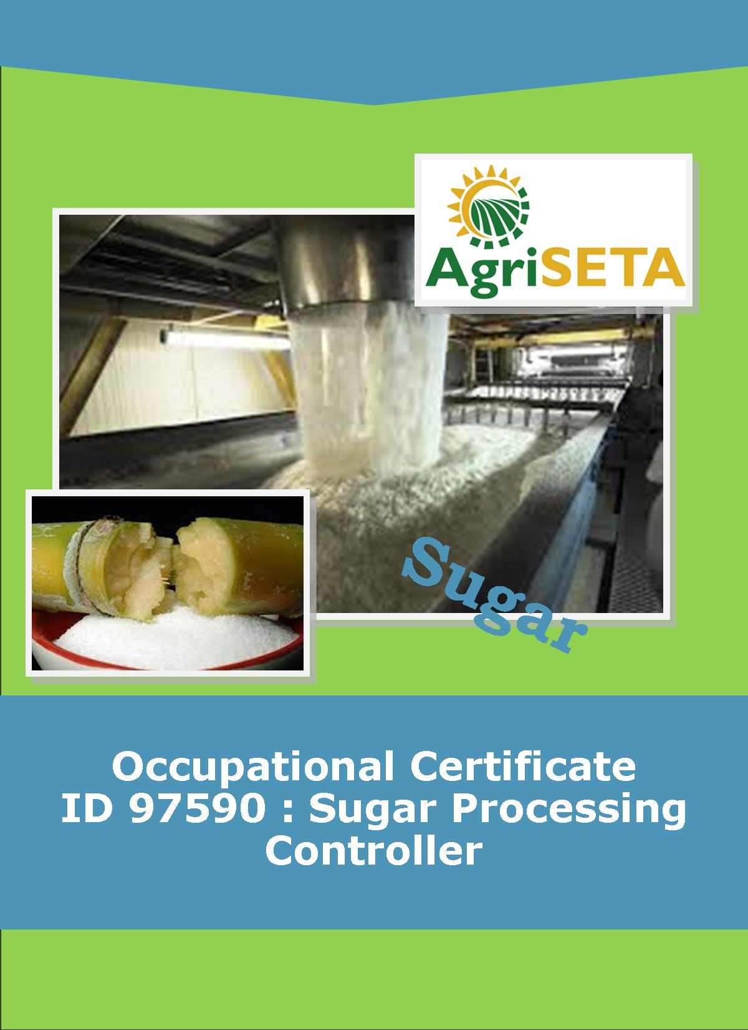
KNOWLEDGE COMPONENT: LEARNER WORKBOOK 7: PAN BOILING THEORY AND TECHNOLOGY
Occupational Certificate: Sugar Processing Controller

KNOWLEDGE COMPONENT: LEARNER WORKBOOK 7: PAN BOILING THEORY AND TECHNOLOGY
KNOWLEDGE COMPONENT: LEARNER WORKBOOK 7: PAN BOILING THEORY AND TECHNOLOGY
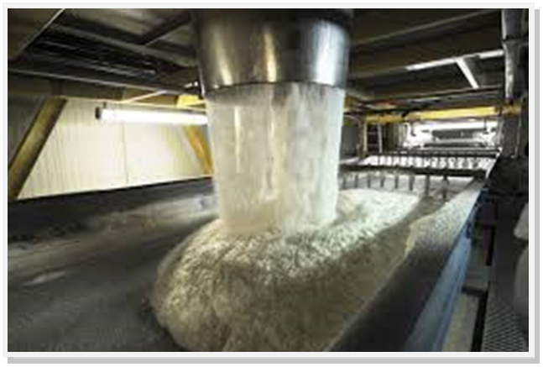
OCCUPATIONAL CERTIFICATE: SUGAR PROCESSING CONTROLLER

©Copyright AgriSETA
Telephone: +27 12 301 5600
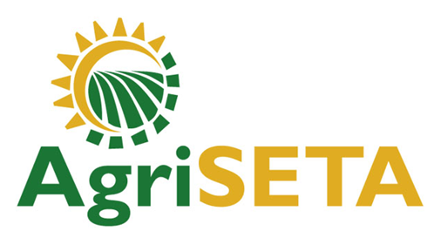

AgriSETA holds the copyright to its publications and Web pages. Proper citation is requested.

TABLE OF CONTENTS
1. INTRODUCTION TO THIS LEARNER WORKBOOK 6
2. LEARNER DETAILS 7
3. FORMATIVE ASSESSMENT INSTRUCTIONS 8
4. KNOWLEDGE MODULE 7: PAN BOILING THEORY AND TECHNOLOGY 9
4.1 Knowledge Topic 1: Theory of crystallisation (15%) 10
4.2 Knowledge Topic 2: Equipment design and operation (5%) 20
4.3 Knowledge Topic 3: Graining a pan and growing a massecuite (30%) 28
4.4 Knowledge Topic 5: Pan Control and Automation (5%) 32
4.5 Knowledge Topic 6: Problems Experienced during Pan Boiling (15%) 34
4.6 Knowledge Topic 7: Three Massecuite Boling System (5%) 37
4.7 Knowledge Topic 8: Mixture Calculation (5%) 42
4.8 Knowledge Topic 9: Continuous Pan Boling (5%) 45
4.9 Knowledge Topic 10: Control Formulae (5%) 48
5. CONCLUSION OF KNOWLEDGE MODULE 7: PAN BOILING THEORY AND TECHNOLOGY 51

INTRODUCTION TO THIS LEARNER WORKBOOK
This Knowledge Component Learner Workbook 7: Pan Boiling and Technology is intended to be used with the Knowledge Component Learning Resource: Book 7 (Textbook): Pan Boiling Technology of the Occupational Qualification: Sugar Processing Controller NQF 5.
Guidance on the use of this Work Book is provided in the Learning Guide.

LEARNER DETAILS
First name
Surname
ID number
Mobile phone contact number
E-mail address
Postal address
Date on which you started this Knowledge Module
Date on which you completed this Knowledge Module
Declaration: | I hereby confirm that:  - I received the assessment plan and schedule.  - I understand my rights in terms of special needs, re-assessment, feedback and appeals against assessment decisions.  - I completed this formative assessment independently without assistance from anyone else.
Total Marks for Knowledge Module 7 | 283
Marks attained
Date:
Place:
Signature of Learner:
Signature of Assessor:

FORMATIVE ASSESSMENT INSTRUCTIONS
Instructions
- Work individually to present the results of each Learning Activity in this Learner Workbook.
- Complete all the sections.
- Use a black pen and ensure that you complete the questions in your own handwriting.
- A recommended time to complete each activity is shown.
- The marks you will attain for each learning activity are shown in brackets.
- The total marks obtained for each Knowledge Module must be transferred from the back of each Learner Workbook to the Learner Qualification Summative Assessment Tool.

KNOWLEDGE MODULE 7: PAN BOILING THEORY AND TECHNOLOGY
NQF LEVEL: 5
CREDITS: 8
PURPOSE OF THE KNOWLEDGE MODULE: The main focus of the learning in this knowledge module is to build an understanding of for the learner to gain fundamental understanding of the theory and science of pan boiling.
The learning will enable learners to demonstrate an understanding of:
- KM-07-KT01: Theory of crystallisation (15%)
- KM-07-KT02: Equipment design and operation (5%)
- KM-07-KT03: Graining a pan and growing a massecuite (30%)
- KM-07-KT04: Pan cycle (10%)
- KM-07-KT05: Pan control and automation (5%)
- KM-07-KT06: Problems experienced during pan boiling (15%)
- KM-07-KT07: Three massecuite boiling systems (5%)
- KM-07-KT08: Mixture calculation (5%)
- KM-07-KT09: Continuous pan boiling (5%)
- KM-07-KT10: Control formulae (5%)

  - Knowledge Topic 1: Theory of crystallisation (15%)
Topic elements to be covered include:
- KT0101 Solutions
- KT0102 Purity and saturation
- KT0103 Crystal growth rate
- KT0104 Crystal formation
- KT0105Effect of impurities
- KT0106 Boiling point elevation
- KT0107 Measurement of super saturation
Internal Assessment Criteria and Weight
- IAC0101 Incoming product specification for all stages can be listed
- IAC0102 Theory of crystal formation and growth can be explained
- IAC0103 External influence that impact on crystal formation and growth can be listed and explained
- IAC0104 Define and explain saturation point
- IAC0105 Massecuite flows and pan discharge concepts can be explained
- IAC0106 Sampling and testing practices can be explained
- (Weight 15%)

Learning activity 1.1: Individual Learning activity: 45 minutes (24 marks)

Learning Objective: An understanding of the various terms used to describe crystallisation can be demonstrated.
Task: Read each question carefully and write your answer in the space provided.
1. Define: a saturated solution, a supersaturated solution and the supersaturation coefficient of a sucrose solution. (6)
2. With the aid of a graph explain the different supersaturation zones. (8)

3. State what occurs when a sugar crystal is placed into each of the following zones.
(a) Unsaturated zone (2)

(b) Saturated solution (2)

(c) Metastable zone (2)

(d) Intermediate zone (2)

(e) Labile zone (2)
Learning activity 1.2: Individual Learning activity: 10 minutes (8 marks)
Learning Objective: An understanding of the factors affecting crystal formation can be demonstrated.
Task: Read each question carefully and write your answer in the space provided.
- Define a crystal (2)

- Explain the difference between primary and secondary nucleation. (4)

- Explain the effect of purity and super saturation on primary nucleation.(2)

Learning activity 1.3: Individual Learning activity: 45 minutes (26 marks)
Learning Objective: An understanding of the factors affecting crystal growth can be demonstrated.
Task: Read each question carefully and write your answer in the space provided.
- Explain the different processes that need to occur for a crystal to grow.(4)

- What factors influence crystal growth?(6)
- What is the driving force of crystallisation and what effect does it have on crystallisation? (10)

- Write notes on the effect of impurity on crystal formation.(6)

Learning activity 1.4: Individual Learning activity: 45 minutes (26 marks)
Learning Objective: An understanding of the effect of impurities on crystal growth can be demonstrated.
Task: Read each question carefully and write your answer in the space provided.
- What effect does temperature have on crystal growth? (2)

- What effects do impurities have on crystal growth?(2)

- (a) What is viscosity? (2)

(b) Describe the effects of viscosity on boiling. (4)

- (a) Why do we measure conductivity in a pan? (1)

(b)Describe how the conductivity of a sugar solution is measure and the effects of brix on this measurement. (6)

5. What is boiling point elevation and what two factors cause it? (4)

6. Calculate the boiling point of a 65 purity massecuite at 75°Brix and at 42.2kPa (absolute pressure) (5)

  - Knowledge Topic 2: Equipment design and operation (5%)
Topic elements to be covered include:
- KT0201 Batch pans
- KT0202 Operation and ancillary equipment
- KT0203 Pan instrumentation
- KT0204 Feed systems
- KT0205 Strike receiver
- KT0206 Seed receiver
- KT0207 Valves
- KT0208 Starting a batch pan
Internal Assessment Criteria and Weight
- IAC0201 Process flow and instrumentation used can be described
- IAC0202 An understanding of process steps and use of equipment related to juice heating can be demonstrated
- (Weight 5%)

Learning activity 2.1: Individual Learning activity: 30 minutes (19 marks)
Learning Objective: An understanding of the boiling point elevation can be demonstrated.
Task: Read each question carefully and write your answer in the space provided.
1. What is a vacuum pan? (2)

2. What are the two main advantages of boiling under vacuum? (4)

3. How is a vacuum in a pan created? (2)

4. (a) What energy is used to heat the massecuite? (1)

(b) What happens to this form of energy in the calandria? (2)

7. Draw a detailed labelled diagram of a vacuum pan, explaining the function of each part. (8)

Learning activity 2.2: Individual Learning activity: 15 minutes (12 marks)
Learning Objective: An understanding of pan boiling equipment design and operations is demonstrated.
Task: Read each question carefully and write your answer in the space provided.
1. What is incondensable gas? (2)

2. Describe the methods by which condensate is removed from a calandria? (10)

Learning activity 2.3: Individual Learning activity: 1 hour (45 marks)
Learning Objective: Demonstrate an understanding of pan boiling equipment design and operation.
Task: Read each question carefully and write your answer in the space provided.
1. Why is a pan steam out done? (1)

2. Describe how and why molasses is conditioned? (6)

3. Describe the construction of a seed receiver and its function? (3)

4. Describe how circulation is caused in a pan? (3)

5. What conditions are necessary for good crystallisation? (6)

6. How can the effectiveness of circulation be judged? (2)

7. How does circulation assist crystallisation? (2)

8. Define approach temperature for condenser? (2)

9. How is incondensable gas removed from the condensers? (2)

10. Name 9 types of valves and their most common use? (18)

  - Knowledge Topic 3: Graining a pan and growing a massecuite (30%)
Topic elements to be covered include:
- KT0301 Grain formation
- KT0302 Slurry
- KT0303 Graining a pan
- KT0304 Control of super saturation
- KT0305 Automatic vacuum control
- KT0306 Boiling a massecuite
- KT0307 Brix of pan feed
- KT0308 Hydrostatic head
- KT0309 Striking a pan
- KT03010 Dealing with highly viscous massecuite
Internal Assessment Criteria and Weight
- IAC0301 Pan boiling process flow and steps can be described
- IAC0302 Quality specification for process stages can be listed
- IAC0303 Potential problem areas can be listed and actions to avoid these explained
- IAC0304 Critical Control Points can be listed
- (Weight 30%)

Learning activity 3.1: Individual Learning activity: 45 minutes (27 marks)
Learning Objective: Demonstrate an understanding of pan boiling equipment design and operation.
Task: Read each question carefully and write your answer in the space provided.
1. Describe the following methods of grain formation with these relative advantages and disadvantages
- Waiting
- Shock seeding
- True seeding (10)

2. What is the purpose of slurry and how should it be used? (8)

3. What is meant by bringing the grain together? (2)

4. What is the best method of ensuring the best rate of crystal growth and evaporation in a pan? (3)

5. Compare “bring the grain together” with “growing the grain’’ (4)

  - Knowledge Topic 5: Pan Control and Automation (5%)
Topic elements to be covered include:
- KT0501 Importance of pan control
- KT0502 Using conductivity
- KT0503 Using computer control
Internal Assessment Criteria and Weight
- IAC0501 Instrumentation used in pan boiling can be listed and application explained
- IAC0502 understanding of data readings from instruments can be demonstrated
- (Weight 5%)

Learning activity 5.1: Individual Learning activity: 10 minutes (14 marks)
Learning Objective: Demonstrate an understanding of pan control and automation.
Task: Read each question carefully and write your answer in the space provided.
1. Describe the methods by which the evaporation rate in a pan can be controlled. (10)

2. Why does circulation slow down as the pan fills up and how can circulation be improved? (4)

  - Knowledge Topic 6: Problems Experienced during Pan Boiling (15%)
Topic elements to be covered include:
- KT0601 False grain
- KT0602 Aconitic acid
- KT0603 Water dilution
- KT0604 Loss of vacuum
- KT0605 Pan not boiling fast enough
- KT0606 Purity of pan feed
- KT0607 Low brix feed
- KT0608 High viscosity massecuite
Internal Assessment Criteria and Weight
- IAC0601 An understanding of trouble shooting and standard responses related to pan boiling can be demonstrated
- (Weight 15%)

Learning activity 6.1: Individual Learning activity: 15 minutes (13 marks)
Learning Objective: Demonstrate an understanding of problems experienced during pan boiling.
Task: Read each question carefully and write your answer in the space provided.
1. (a) What is false grain (2)

(b)What conditions cause false grain? (9)

(c)How is it eliminated? (2)

  - Knowledge Topic 7: Three Massecuite Boling System (5%)
Topic elements to be covered include:
- KT0701 Introduction to massecuite boiling
- KT0702 The three massecuite boiling system
- KT0703 Pan flow data
- KT0704 Crystal size
- KT0705 Types of crystal
- KT0706 Viscosity
- KT0707 Massecuite brix at strike
Internal Assessment Criteria and Weight
- IAC0701 An understanding of process steps and use of equipment related to massecuite boiling can be demonstrated
- IAC0702 An understanding of the impact on factory performance can be demonstrated
- (Weight 5%)

Learning activity 7.1: Individual Learning activity: 45 minutes (33 marks)
Learning Objective: An understanding of three massecuite boiling system is demonstrated.
Task: Read each question carefully and write your answer in the space provided.
1. What is mixed grain? (2)

2. What are conglomerates, how are they removed and what is their effect on process? (3)

3. What is needle grain? (2)

4. What are the factors are taken into account when a boiling system is selected? (5)

5. Draw a flow diagram of the 3-massecuite boiling system and indicate the purities of the different process streams. (10)

6. (a) what is the normal crystal size for A, B and C sugars?(3)

(b) what effect has crystal size on exhaustion, curing (centrifugal and false grain? (4)

7. How does the brix of ‘A’ massecuite at strike affect the quantity of massecuite boiled? (2)

8. What effect does brix of feed material have on steam consumption? (2)

  - Knowledge Topic 8: Mixture Calculation (5%)
Topic elements to be covered include:
- KT0801 Using formulae
Internal Assessment Criteria and Weight
- IAC0801 Formula, calculations and data interpretation is performed correctly
- IAC0802 Balancing product streams to achieve final product specification can be explained
- (Weight 5%)

Learning activity 8.1: Individual Learning activity: 30 minutes (15 marks)
Learning Objective: Mixture calculations are performed.
Task: Read each question carefully and write your answer in the space provided.
1. Given that the desired footing purity is 48 and that the A molasses purity is 53 and B molasses purity is 42, calculate the quantities to boil 85m3 of footing (5)

2. Given: Syrup purity =79
Molasses purity=47
Footing purity=62
Footing Volume=20m³
Calculate the quantities of syrup of syrup and that must be mixed to create the footing. (5)

3. Given: A-molasses purity =70
B-molasses purity =52
Massecuite purity =56
Footing volume =85m³
Calculate the quantities of A- B- molasses required to require creating the footing. (5)

  - Knowledge Topic 9: Continuous Pan Boiling (5%)
Topic elements to be covered include:
- KT0901 Basic operation
- KT0902 Pan control
Internal Assessment Criteria and Weight
- IAC0901 An understanding of process steps and use of equipment related to massecuite boiling can be demonstrated
- IAC0902 An understanding of the impact on factory performance can be demonstrated
- (Weight 5%)

Learning activity 9.1: Individual Learning activity: 10 minutes (10 marks)
Learning Objective: Demonstrate an understanding of continuous pan boiling.
Task: Read each question carefully and write your answer in the space provided.
1. Describe a continuous pan? (2)

2. How is massecuite discharged from a continuous pan? (2)

3. How is the massecuite boiling controlled in a continuous pan? (6)

  - Knowledge Topic 10: Control Formulae (5%)
Topic elements to be covered include:
- KT1001 Crystal content of massecuite
- KT1002 Exhaustion
- KT1003 SJM formula
Internal Assessment Criteria and Weight
- IAC1001 Formula selection and use, calculations and data interpretation is performed correctly
- (Weight 5%)

Learning activity 10.1: Individual Learning activity: 15 minutes (11 marks)
Learning Objective: An understanding of formula selection, use, calculations and data interpretation is demonstrated.
Task: Read each question carefully and write your answer in the space provided.
1. Define crystal content and give the formula to calculate it. (4)

2. What is the maximum crystal content of a fluid massecuite? (3)

3. What is exhaustion and how is it calculated? (4)

CONCLUSION OF KNOWLEDGE MODULE 7: PAN BOILING THEORY AND TECHNOLOGY
Throughout this knowledge module you have been provided opportunities to complete formative learning activities. You have captured your results in this Learner Workbook.
The total marks for this Knowledge Module are as follows:
Knowledge Module | Total Marks | Marks attained
KM-07-KT01: Theory of crystallisation (15%) | 84
KM-07-KT02: Equipment design and operation (5%) | 76
KM-07-KT03: Graining a pan and growing a massecuite (30%) | 27
KM-07-KT04: Pan cycle (10%)
KM-07-KT05: Pan control and automation (5%) | 14
KM-07-KT06: Problems experienced during pan boiling (15%) | 13
KM-07-KT07: Three massecuite boiling system (5%) | 33
KM-07-KT08: Mixture calculation (5%) | 15
KM-07-KT09: Continuous pan boiling (5%) | 10
KM-07-KT10: Control formulae (5%) | 21
Total Marks | 283marks

