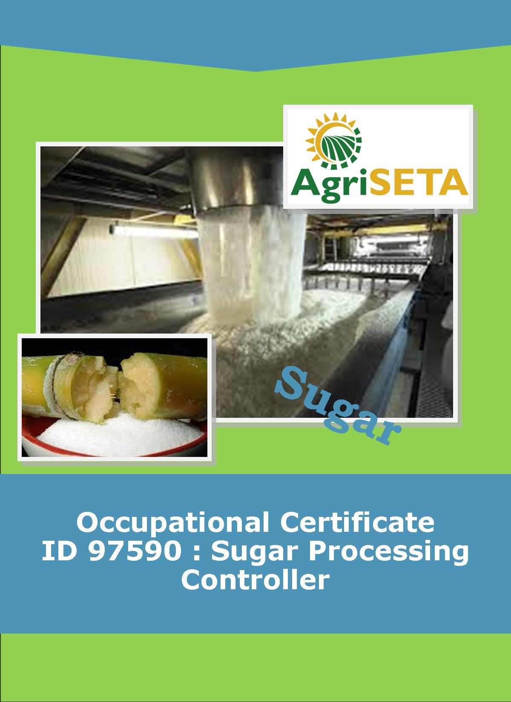
KNOWLEDGE COMPONENT: LEARNING RESOURCE : BOOK 7 : PAN BOILING THEORY AND TECHNOLOGY
OCCUPATIONAL QUALIFICATION: SUGAR PROCESSING CONTROLLER

KNOWLEDGE COMPONENT:
LEARNING RESOURCE

BOOK 7: PAN BOILING THEORY AND TECHNOLOGY
KNOWLEDGE COMPONENT:
LEARNING RESOURCE
BOOK 7 : PAN BOILING THEORY AND TECHNOLOGY
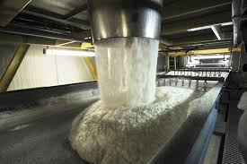
OCCUPATIONAL QUALIFICATION:
SUGAR PROCESSING CONTROLLER

©Copyright AgriSETA
Telephone: +27 12 301 5600


AgriSETA holds the copyright to its publications and Web pages. Proper citation is requested.

TABLE OF CONTENTS
AN INTRODUCTION TO THIS LEARNING RESOURCE 9
KNOWLEDGE MODULE 7 10
PAN BOILING THEORY AND TECHNOLOGY 10

1. Knowledge Topic 1: Theory of Crystallisation 12
1.1 INTRODUCTION 12
1.2 SOLUTIONS 12
1.3 AFFECT OF PURITY ON SATURATION 18
1.4 CRYSTAL GROWTH RATE 20
1.4.1 Factors that affect the rate of crystallisation: 21
(1) Purity of massecuite 21
(2) Degree of supersaturation 21
(3) Viscosity of massecuite 22
(4) Temperature 23
1.5 CRYSTAL FORMATION 23
1.6 EFFECT OF IMPURITIES ON CRYSTAL FORMATION 24
1.7 BOILING POINT ELEVATION 25
1.7.1 Boiling point elevation due to pressure 25
1.7.2 Boiling point elevation due to brix 26
1.8 MEASUREMENT OF SUPER SATURATION 27
1.8.1 Conductivity 27
1.8.2 Boiling point elevation 29
1.8.3 Radio frequency (RF) probe 31
1.8.4 Stirrer torque 31
1.8.5 Crystal scope 32
(1) Crystal size 32
(2) Crystal type (Crystal Habit) 32

2. Knowledge Topic 2: Equipment design and operation 33
2.1 INTRODUCTION 33
2.2 BATCH PANS 33
2.2.1 The Calandria 34
2.2.2 Steam 36
2.2.3 Vacuum system 36
(1) Condensors 36
(2) Barometric leg 37
(3) Approach Temperature 37
2.2.4 Incondensible gas 38
2.2.5 Condensate removal 39
(1) Steam traps 39
(2) U-leg 41
2.2.6 Pan feed system 42
2.2.7 Circulation 43
2.2.8 Entrainment separators: Savealls or catchalls 45
2.2.9 Cut over pipe 45
2.2.10 Sight glasses 46
2.2.11 Breaking vacuum 47
2.2.12 Proof stick 47
2.2.13 Manways 47
2.2.14 Pan discharge door 48
2.2.15 Steaming out 48
2.2.16 Funnel 49
2.2.17 Pan instrumentation 49
2.3 OTHER PAN FLOOR EQUIPMENT 49
2.3.1 “Molasses blow-up tanks” 49
2.3.2 Strike receivers 51
2.3.3 Seed receiver 51
2.4 VALVES 51
2.4.1 Diaphragm valve 52
2.4.2 Gate valve 52
2.4.3 Butterfly valve 53
2.4.4 Slide valve 54
2.4.5 Steam valve 55
2.4.6 Ball valve 56
2.4.7 Float valve 56
2.4.8 Non-Return valve 56
2.4.9 Safety valve 56
2.5 STARTING A BATCH PAN 57

3. Knowledge Topic 3: Graining a pan and growing a massecuite 60
3.1 GRAIN FORMATION 60
3.1.1 The waiting method 60
3.1.2 Shock seeding 60
3.1.3 True seeding 61
3.2 SLURRY 62
3.3 GRAINING A PAN 62
3.4 CONTROL OF SUPER SATURATION 67
3.5 AUTOMATIC VACUUM CONTROL 69
3.6 BOILING OF A MASSECUITE 70
3.7 BRIX OF THE PAN FEED 71
3.8 INFLUENCE OF HYDROSTATIC HEAD IN PAN BOILING 71
3.9 STRIKING A PAN 72
3.10 DEALING WITH HIGHLY VISCOUS MASSECUITE 73

4. Knowledge Topic 5: Pan Control and Automation 75
4.1 IMPORTANCE OF PAN CONTROL 75
4.2 PAN AUTOMATION USING CONDUCTIVITY 76
4.3 USING COMPUTER CONTROL 77
4.3.1 Method 1: Computer control 77
4.3.2 Method 2: Calcor Instruments 79
4.3.3 The advantages of automation 80

5. Knowledge Topic 6: Problems Experienced during Pan Boiling 81
5.1 FALSE GRAIN 81
5.2 ACONITIC ACID 83
5.3 WATER DILUTION OF MASSECUITE IN A PAN 84
5.4 LOSS OF VACUUM 84
5.5 PAN NOT BOILING FAST ENOUGH 85
5.6 PURITY OF PAN FEED 85
5.7 LOW BRIX FEED 85
5.8 HIGH VISCOSITY MASSECUITES 87

6. Knowledge Topic 7: Three Massecuite Boiling System 88
6.1 INTRODUCTION TO MASSECUITE BOILING 88
6.2 THE 3-MASSECUITE BOILING SYSTEM 89
6.3 PAN FLOW DATA 92
6.4 CRYSTAL SIZE 93
6.5 TYPES OF CRYSTAL 94
6.5.1 False grain 94
6.5.2 Mixed grain 94
6.5.3 Conglomerates 94
6.5.4 Rolled grain 95
6.5.5 Elongated crystal: needle grain 95
6.5.6 Soft grain 96
6.6 VISCOSITY 96
6.7 MASSECUITE BRIX AT STRIKE 97
Pan floor brix balance 98
Effect of massecuite brix on quantity of massecuite 99

7. Knowledge Topic 8: Mixture Calculation 100
7.1 INTRODUCTION 100
7.2 USING FORMULAE 100
7.3 USING THE COBENZ DIAGRAM 101

8. Knowledge Topic 9: Continuous Pan Boiling 103
8.1 DESIGN OF A CONTINUOUS PAN AND BASIC OPERATION 103
8.2 PAN CONTROL 106

9. Knowledge Topic 10: Control Formulae 108
9.1 CRYSTAL CONTENT OF THE MASSECUITE 108
9.2 EXHAUSTION 109
9.3 SJM FORMULA 110

AN INTRODUCTION TO THIS LEARNING RESOURCE
This Knowledge Component Learning Resource: Book 7: Pan Boiling Theory and Technology is intended to be used with the Knowledge Component Learner Workbook 7 (Formative Assessment Guide): Pan Boiling Theory and Technology: Sugar Processing Controller NQF 5. It can also be used as a stand-alone information resource (text book).
This Learning Resource provides detailed information on the following topics:
- KM-07-KT01: Theory of crystallisation (15%)
- KM-07-KT02: Equipment design and operation (5%)
- KM-07-KT03: Graining a pan and growing a massecuite (30%)
- KM-07-KT04: Pan cycle (10%)
- KM-07-KT05: Pan control and automation (5%)
- KM-07-KT06: Problems experienced during pan boiling (15%)
- KM-07-KT07: Three massecuite boiling systems (5%)
- KM-07-KT08: Mixture calculation (5%)
- KM-07-KT09: Continuous pan boiling (5%)
- KM-07-KT10: Control formulae (5%)
(Note: KM = Knowledge Module, KT = Knowledge Topic)

KNOWLEDGE MODULE 7

PAN BOILING THEORY AND TECHNOLOGY
Module number: 313908000-KM07: NQF Level 5: Credits 8
BACKGROUND
Physical chemistry assists with sugar purification during the crystallisation process because there is a natural tendency for the sugar crystals to form as pure sucrose, rejecting the non-sugars. Thus, when the sugar crystals are grown in the mother liquor they tend to be pure and the mother liquor becomes more impure. Most remaining non-sugar in the product is contained in the coating of mother liquor left on the crystals.
The mother liquor still contains valuable sugar, of course, so the crystallisation is repeated several times. However, non-sugars inhibit the crystallisation. This is particularly true of other sugars such as glucose and fructose which are the breakdown products of sucrose. Each subsequent step therefore becomes more difficult until one reaches a point where it is no longer viable to continue.
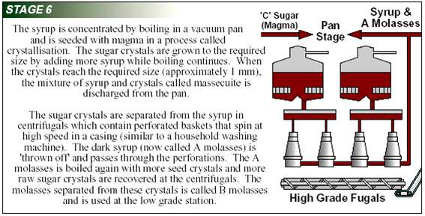
The crystallisation step itself - a "boiling" - takes place in a vacuum pan: a large closed kettle with steam heated pipes. [In practice the heating is done with a low pressure water vapour from the evaporator.] Some modern pans are continuous flow devices but most are batch devices which go through a discrete cycle and are then emptied for a new boiling. A typical cycle might be 4 hours long. The mixture of crystals and mother liquor from a boiling, called the "massecuite", is dropped into a receiving tank called a crystalliser where it is cooled down and the crystals continue to grow. This also releases the pan for a new boiling. From the crystalliser the massecuite is fed to the centrifuges.
In a raw sugar factory it is normal to conduct three boilings. The first or "A" boiling produces the best sugar which is sent to store. The "B" boiling takes longer and the retention time in the crystalliser is also longer if a reasonable crystal size is to be achieved. Some factories re-melt the B sugar to provide part of the A boiling feedstock, others use the crystals as seed for the A boilings and others mix the B sugar with the A sugar for sale. The "C" boiling takes proportionally longer than the B boiling and considerably longer to crystallise. The sugar is usually used as seed for B boilings and the rest is re-melted.

- Knowledge Topic 1: Theory of Crystallisation

1.1 INTRODUCTION
The central technique used to recover sugar in the raw house and the refinery is crystallisation of sucrose from concentrated sucrose solution. The process whereby sugar is recovered via heating and the resulting evaporation of water is called pan boiling. The raw material from which crystalline sugar is obtained is a syrup of about 65°Bx and a purity of 85%.
Crystallisation not only removes dissolved sucrose from solution and recovers it as solid sucrose crystals, but it also a very powerful purification process.

1.2 SOLUTIONS
Sucrose is very soluble in water and dissolves readily.
Example: 150g of sucrose dissolves easily in 100g of water at 60°C to give a solution of 60°Bx.
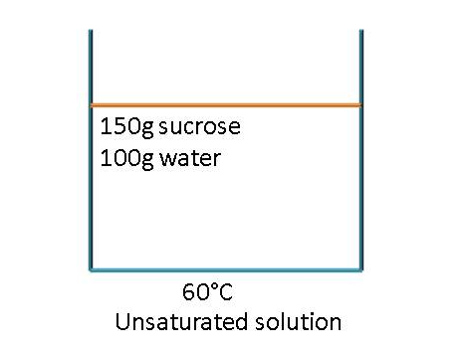
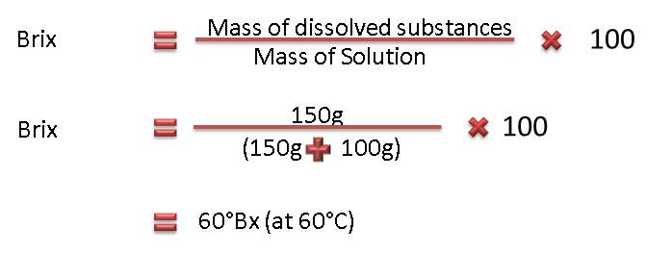
Since the solution is able to dissolve more sucrose at 60°C, the solution is said to be unsaturated.
An unsaturated solution is one that contains less than its maximum amount of dissolved substance (solute) at a particular temperature.
Sucrose can be added to the above 150g sucrose/100g water solution and it will dissolve. However, a point is reached where the solution contains the maximum amount of sucrose possible at 60°C and the solution is then said to be saturated. A saturated solution is one that contains the maximum amount of dissolved substances (solute) at a particular temperature. At 60°C the saturation point is reached at approximately 290g sucrose/100g water. The brix of the saturated solution at 60°C is 74.4°Bx.
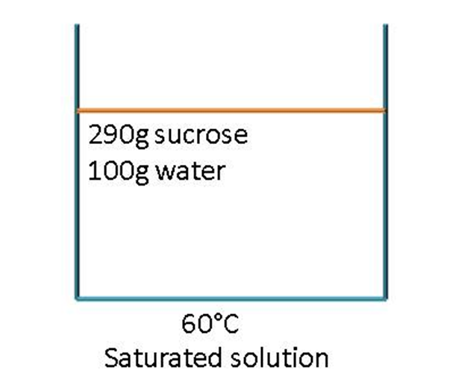
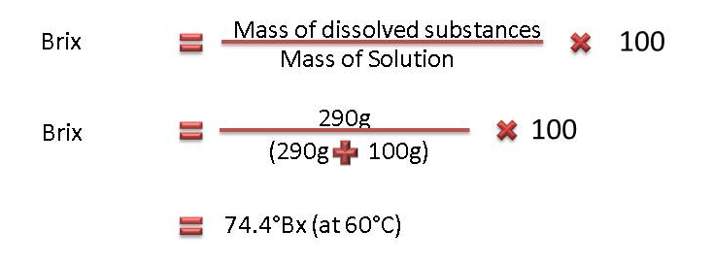
If any additional sugar is added to the saturated solution at 60°C, it will not dissolve but will simply lie at the bottom of the container.
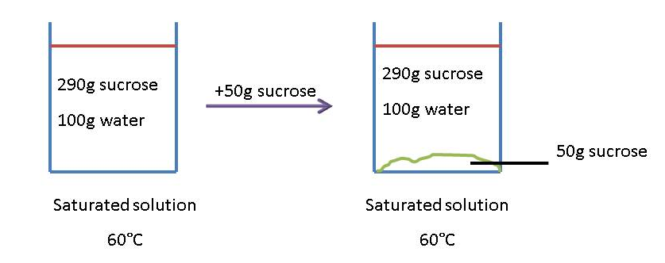
It is possible to prepare a supersaturated solution that contains more solute at a certain temperature than a saturated solution at this temperature. A saturated solution can be prepared by evaporating water from a saturated solution.
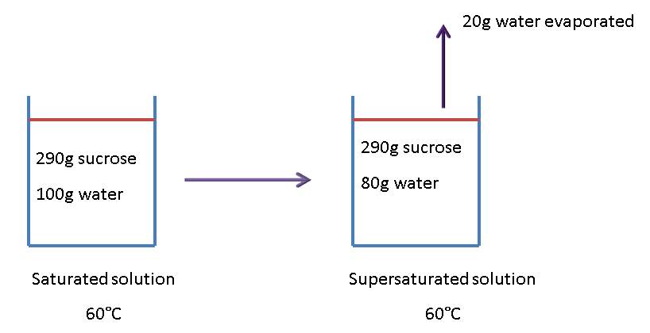
When 20g of water is evaporated from a 290g sucrose/100g water saturated sucrose solution at 60°C, a supersaturated solution of 78.4°Bx is formed. This new supersaturated solution is unstable since it contains more dissolved sucrose than a saturated solution at the same temperature. This solution will seek to return to its saturated state by expelling the “extra” sucrose it contains.
The saturated solution contains 290g sucrose/100g water.
The supersaturated solution contains 290g sucrose/80g water which is equivalent to 363.5g sucrose/100g water.
Reason:
290g sucrose in 80 g
= (290 x 1.25)g sucrose in (80 x 1.25)g water
= 362.5g sucrose in 100g water

The supersaturated sucrose solution (362.5g sucrose/100g water) thus contains 72.5g more sucrose for every 100g of water than the saturated solution (290g sucrose/100g water) at 60°C.If some small sugar crystals are added to the supersaturated solution, it will return to its saturated state by depositing sucrose onto those crystals and in the process the crystals will grow.
However, if the supersaturation is increased too much, then the solution expels sucrose spontaneously as many tiny crystals instead of just growing existing crystal.
It is also possible to prepare a supersaturated solution by cooling a saturated solution.
Example:
At 60°C a saturated sucrose solution contains 290g sucrose/100g water and 70°C a saturated sucrose solution contains 320g sucrose/100g water.
If a saturated sucrose solution at 60°C is heated to 70°C it will be able to dissolve 40g more sucrose per 100g of water before it again becomes saturated at the new temperature of 70°C.
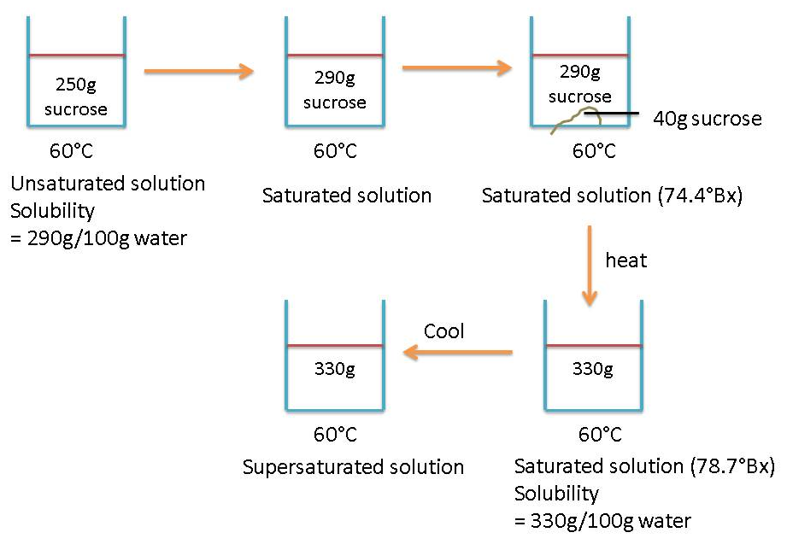
Note that in this the supersaturated sucrose solution holds 330g sucrose/100g water instead of 290g sucrose/100g water.
The degree of supersaturation is defined by the supersaturation co-efficient (SSC).
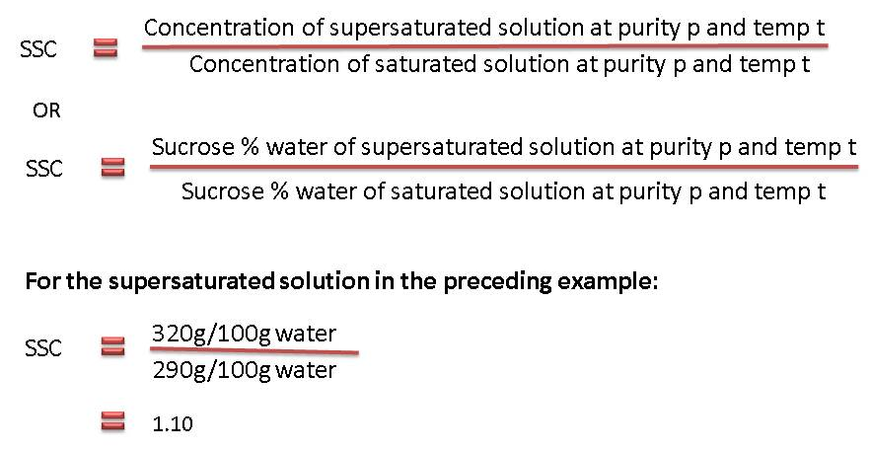
A solution with a SSC of 1.1 at 60°C contains 1.1 times the amount of sucrose that it would have contained had it been saturated at 60°C.
The supersaturated coefficient is the “driving force” in sugar boiling. Supersaturation is a state of tension and the solution strives to return to its saturated state by expelling sucrose - that is - by forming new crystals or by depositing sucrose onto existing crystals.
Different supersaturation zones exist that are determined by the sucrose concentration (i.e. sucrose/100g water) and by the temperature of the solution.
ZONES OF SATURATION
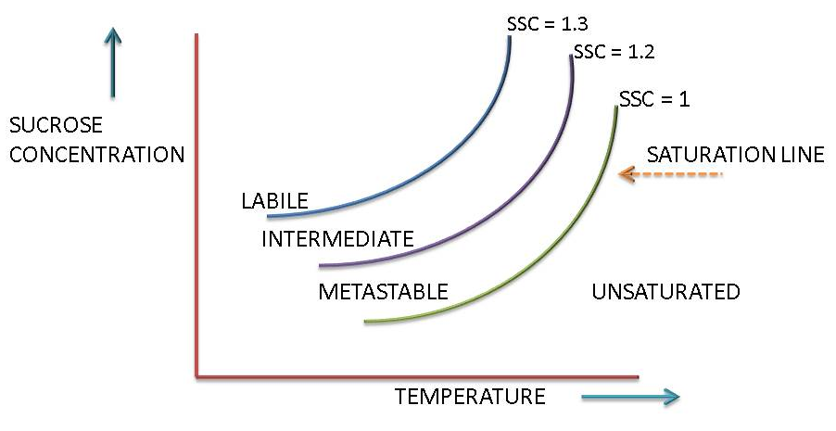
The bold line is called the saturation line and it represents the concentrations of sucrose in a saturated aqueous solution at various temperatures. It is clear that as the temperature increases the concentration of sucrose required to produce a saturated solution increases.
The solubility of sucrose increases from 215g sucrose/100g water at 30°C to 420g sucrose/100g water at 90°C. All points below the saturation line represent unsaturated solutions. When a solution is unsaturated it will dissolve sucrose crystals added to it. All points above the saturation line represent supersaturated solution and under the right conditions, sucrose will crystallise out of such solutions.
Three zones of supersaturation are defined for pure sucrose solution:
- Unsaturated or stable zone (SSC<1.000)
Crystals dissolve and all sucrose is in solution.
- Metastable zone (1.00<SSC<1.20)
At concentrations that fall in the metastable zone any sucrose crystal present will continue to grow until the concentration falls to the level at which the solution is just saturated.
- Intermediate zone (1.20<SSC<1.3)
At concentrations that fall in the intermediate zone crystals will not only grow, but new crystals will form in the presence of other crystals.
- Labile zone (SSC>1.3)
At concentrations which fall in the labile zone, new crystals will from spontaneously. Crystal growth will be rapid.

1.3 AFFECT OF PURITY ON SATURATION
For pure sucrose solutions the approximate widths of the zones of supersaturation are:
Metastable zone 1.00<SSC<1.20
Intermediate zone 1.20<SSC<1.30
Labile zone SSC>1.3
In the case of impure sucrose solutions the band widths are larger. The presence of other compounds in a sucrose solution may increase or decrease the solubility of the sucrose.
In the case of invert sugar, which consists of equal amounts of glucose and fructose, the solubility of sucrose is reduced. This means that less sucrose is able to dissolve before saturation is reached.
Example:
At 50°C the solubility of pure sucrose is 260g sucrose/100g water.
At 50°C the solubility of sucrose in a 50g invert/100g water solution is only 242g sucrose/100g water.
In general, inorganic salts tend to increase the solubility of sucrose in aqueous solution. This means that more sucrose is able to dissolve before saturation is reached. The concentration of sucrose at saturation point is thus greater if inorganic salts are present in solution. Cane sugar solutions are of this type where the impurities present increase the solubility of the sucrose.
Such solutions require a higher sucrose concentration than pure sucrose solutions to reach the same zone of supersaturation. In other words, sucrose solutions containing inorganic salts require a higher sucrose concentration to bring about the same crystallisation phenomena.
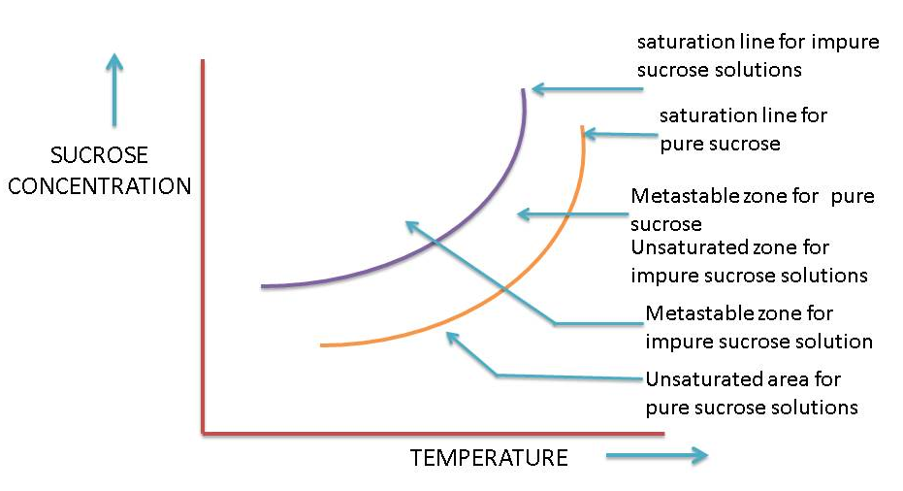
In the above graph the SSC’s of both lines =1.
The actual location of supersaturation zones/curves on the above graph therefore depends on the purity of the sucrose solution. The zones become wider as purity drops. Hence, solutions of lower purity will require a higher supersaturation to reach the same zone of supersaturation.
For pure sucrose solutions the metastable zone lies between a supersaturation of 1.00 and 1.2. For sucrose solutions of purity 70 - 73% the metastable zone lies between a supersaturation of 1.00 and 1.35. However, between 1.00 and 1.3 the rate of crystal growth is too low for practical boiling and hence the practical metastable zone starts above the 1.30 supersaturation. The zone for introducing slurry and growth of seed nuclei is therefore between a supersaturation of 1.30 and 1.35.
With proper control of concentration (Brix) of a supersaturated solution the degree of supersaturation can be controlled and the solution can hence be kept in the metastable zone. Here existing crystals will grow without the new crystals forming.
To boil a pan the following information is important:
- At what temperature will the pan be boiled? This is found from the saturated vapour pressure in the pan.
- The concentration of sucrose (Brix) needed to give the required supersaturation coefficient at the temperature concerned.

1.4 CRYSTAL GROWTH RATE
The rate of crystal growth is called crystallisation velocity.
Crystallisation velocity is measured in milligrams of sugar deposited per minute per square metre of crystal surface (mg/min/m²).
In a massecuite crystal growth is greater the larger the crystal surface are i.e. the smaller the crystals. The reason is that the total surface are of a lot of small crystals is greater than the same mass of big crystals.
The mechanism of growth involves two separate stages viz.
- migration of the sucrose molecules from the solution to the surface of the crystal, and
- orientation of the molecule on the surface of the crystal prior to its incorporation into the crystal. The latter is considered to be the rate controlling step.
Crystallisation velocity is determined therefore by:
  - the rate at which sucrose molecules arrive at the thin stationary layer of saturated solution surrounding the crystal. This depends on the relative speed of the movement of the crystal through mother liquor i.e. the rate of circulation in the pan;
  - the rate at which sucrose molecules will diffuse through the film which surrounds the crystal. This depends mainly on the viscosity of the film and on the degree of supersaturation of mother liquor in contact with it;
  - the rate at which sucrose molecules are deposited on the crystal surface. This is influenced by presence in mother liquor of some impurities like raffinose and other oligosaccharides which interfere with incorporation of sucrose molecules into the crystal lattice.

1.4.1 Factors that affect the rate of crystallisation:

Purity of massecuite

Crystallisation rate decreases as purity decreases. The rate of crystallisation in the raw house is thus slow too very slow compared to crystallisation in a refinery.

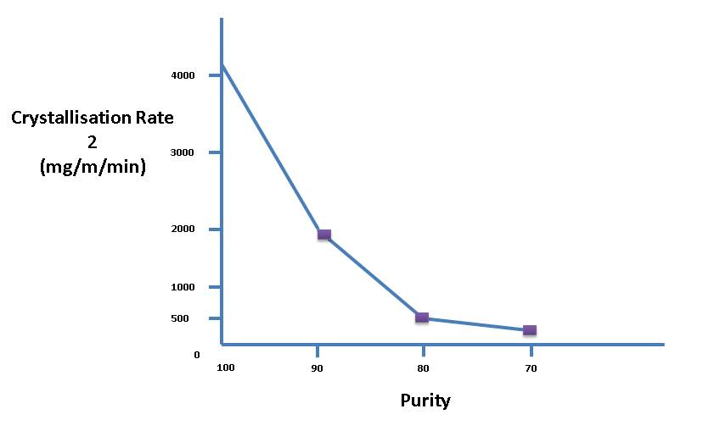

Degree of supersaturation
This is the main driving force for crystallization. An increase in supersaturation has the following effects on crystallisation:
- Increases the rate of attachment of sucrose molecules onto the crystal that increases the rate of crystal growth.
- Increases the viscosity of the solution that reduces the rate of sucrose diffusion.
- Increases the rate of diffusion because of the big difference in concentration between the mother liquor and the film of mother liquor around the crystal.
The rate exhaustion of sucrose from solution by crystallisation is proportional to the square of the supersaturation coefficient. So, in practice, for pure sucrose solutions, a supersaturation coefficient of 1.44 (i.e. 1.20²) should not be exceeded as crystallization becomes uncontrollable and false grain results.

Viscosity of massecuite
Viscosity is very important because it affects the mobility of the sucrose molecules. A more viscous massecuite offers more resistance to the movement of sucrose molecules as they migrate towards the crystals. Massecuite viscosity decreases with increase in temperature and increases with decrease in purity. Viscosity also affects the mixing between mother liquor and crystals.
Viscosity is the measure of resistance to sheer or angular deformation. The metric unit is the poise (dyne second/cm²), while the SI unit is Pascal second (Pa.s = Centipoise x 10⁻³).
Viscosity in centipoise at different temperatures and saturations
 | TEMPERATURE (°C)
SSC | 30 | 40 | 50 | 60 | 70 | 80 | 90
1.00 | 1.66 | 1.28 | 1.08 | 0.96 | 0.92 | 0.91 | 0.89
1.10 | 2.66 | 1.99 | 1.55 | 1.33 | 1.21 | 1.09 | 1.05
1.20 | 4.25 | 3.02 | 2.05 | 1.96 | 1.85 | 1.67 | 1.56
1.30 | 6.75 | 4.70 | 2.92 | 2.92 | 2.65 | 2.34 | 2.06

Because crystallisation velocity to a large extent depends on diffusion velocity, which is governed by supersaturation, viscosity and temperature, a pan boiled at high temperature and supersaturation will produce better crystallisation velocities. The above chart illustrates this. At 90°C (supersaturation 1.30) the viscosity is lower than at 30°C (supersaturation 1.10).
If the mobility of the sucrose molecule is impeded by high viscosity, and the supersaturation level is high, false grain formation will occur.
This can be prevented by increasing the amount of crystal in the pan, thereby increasing the surface area available for the sucrose molecules to crystallise onto.

Temperature
Sucrose crystals grow faster the higher the temperature. However, a higher temperature reduces the supersaturation which is the main driving force of crystallisation. The higher the temperature, the higher the concentration required to maintain the same rate of crystallisation.
Temp °C | Supersaturation co-efficient
65.5 | 1.25
60.0 | 1.30
50.0 | 1.35
40.0 | 1.40

1.5 CRYSTAL FORMATION
Mechanism of crystal formation and growth: A crystal is a regular, uniform and reproducible arrangement of molecules in a solid form.
In supersaturated solutions crystallisation begins with the nucleation mechanism by which a small crystal forms. In homogeneous liquids the process starts with random association of soluble molecules occurring by normal molecular motions. In some cases additional molecules join the cluster which begins to assume a regular spacing of molecules and is called an embryo. The embryo is usually short lived, but in a sufficiently concentrated solution more molecules join the embryo which grows and stabilises to become a crystal nucleus. Thermodynamics of surfaces show that the solubility of crystals decreases as their size increases. Thus, once a crystal nucleus is formed it tends to grow. The formation of crystal nuclei in supersaturated solutions by aggregation of molecules is called primary nucleation.
Only a small portion of crystalline material is formed by primary nucleation as described above. Most of the solid formation is due to precipitation of the solute (sucrose) onto surfaces of existing crystals.
Secondary nucleation refers to sugar crystals formed in a supersaturated sucrose solution in which sugar crystals are already present.
The occurrence of both primary and secondary nucleation is a function of the supersaturation and purity of the sugar solution.
High purity sucrose solutions (Purity above 85%)
Primary nucleation occurs at a supersaturation above 1.3 (labile zone).
Secondary nucleation occurs at a supersaturation between 1.2 and 1.3 (intermediate zone).
Impure sugar solutions (Purity 75%)
Primary nucleation occurs at a supersaturation above 1.6 (labile zone).
Secondary nucleation occurs at a supersaturation between 1.35 and 1.6 (intermediate zone).
It is thus easier to grain (i.e. add very small crystals) at 70 - 72% purity in order to grow crystals than it is to grain on syrup of 85% purity as false grain is easily formed.
The mechanism of crystal growth is as complex a process as nucleation. The most probable theory pictures crystal growth occurring at dislocation found on crystal surfaces. The dislocation is self-perpetuating and crystals grow in a spiral as a result of surface forces. The deposition of sucrose molecules on a solid crystal can only occur if the concentration of the bulk fluid is greater than saturation.
A perfect crystal generally has 12 faces or sides. The crystal does not always have a perfect shape as there are many factors that make some faces grow faster than causing odd shaped crystals. Once the habit or shape of the sucrose crystal has been established it remains more or less the same as the crystal grows. For example, if the crystal formed had a twin or needle or flat shape this shape would stay and the full-grown crystal would have the same shape.
In a commercial process unhindered crystal growth seldom occurs: Crystals agglomerate, impurities are occluded, nucleation occurs both in solutions and at crystal surfaces and crystals are broken by pumps and agitation. The net result of all these factors is spoken of as the habit of crystal growth. The habit may affect the product purity, appearance and behaviour and therefore may seriously influence the product quality.

1.6 EFFECT OF IMPURITIES ON CRYSTAL FORMATION
In general all impurities tend to slow down the rate of crystallisation. Different impurities have different effects and it can therefore be said that the rate of crystallisation is affected by the concentration of impurities and the type of impurity.
Starch is a good example of an impurity that slows down the rate of crystallisation.
As the crystal grows in the pan there is a competition on growing crystal surface between the sucrose molecules and the impurities. The impurities can be a basic factor in determining the shape of the crystal. For example, when the growth is carried out at high supersaturations and there is a high percentage of reducing sugars present there is a tendency for twin crystals to form.
The colour of the sugar boiled is affected by coloured non-sugars which are absorbed by the sucrose crystal.
The occlusion (entrapment) of dark coloured impurities in the crystallisation process can be easily seen. This is especially noticeable when a dark seed sugar is used in “A” boilings. A layer of light coloured sucrose can be seen covering the dark seed crystal.

1.7 BOILING POINT ELEVATION

1.7.1 Boiling point elevation due to pressure
From steam tables one can see that the temperature at which water would boil at different pressures above and below atmospheric pressure varies.
Boiling temperature (°C) |  | Pressure (kPa)
30 |  | 4.2
35 |  | 5.6
40 |  | 7.4
45 |  | 9.6
50 |  | 12.3
55 |  | 15.7
60 |  | 19.9
65 |  | 25.0
70 |  | 31.2
75 |  | 38.5
80 |  | 47.3
85 |  | 57.8
90 |  | 70.1
95 |  | 84.5
100 | Atmospheric Pressure | 101.3
105 |  | 120.8
110 |  | 143.3
115 |  | 169.1
120 |  | 198.5

In a batch pan the hydrostatic head due to the height of massecuite causes the pressure at the bottom of the massecuite to increase as the level in the pan rises. This causes an increase in the boiling point of the massecuite at the bottom. In a batch pan the boiling temperature is thus a function of the height. The hydrostatic head also causes the massecuite at the bottom of the batch pan to be more viscous. This necessitates the use of movement water to ensure circulation. The effect of hydrostatic head limits the height of massecuites in batch pans to 1.35m. The movement water used is at a temperature such that it will flash (boil violently) as it enters the pan, thus causing turbulence and promoting circulation.

1.7.2 Boiling point elevation due to brix
Sugars and salts dissolved in water always raise the boiling point. This boiling point elevation is dependent on the quantity of dissolved material and is independent of pressure. The following boiling point elevation table shows the increase in the boiling point of cane juices at different brixes and purities.
 | PURITY
BRIX | 100 | 90 | 80 | 70 | 60 | 50
40 | 1.0 | 1.0 | 1.3 | 1.5 | 1.7 | 1.9
45 | 1.4 | 1.5 | 1.8 | 2.0 | 2.2 | 2.5
55 | 1.7 | 1.9 | 2.2 | 2.5 | 2.8 | 3.1
60 | 2.3 | 2.5 | 2.8 | 3.1 | 3.5 | 3.9
65 | 2.9 | 3.2 | 3.6 | 4.0 | 4.5 | 4.9
70 | 3.8 | 4.1 | 4.5 | 5.0 | 5.5 | 6.0
75 | 7.0 | 7.5 | 8.0 | 8.6 | 9.4 | 10.1
80 | 9.4 | 10.0 | 10.6 | 11.3 | 12.3 | 13.1
85 | 13.0 | 13.7 | 14.1 | 15.3 | 16.4 | 17.4
90 | 19.7 | 20.5 | 21.2 | 22.4 | 23.7 | 25.3

Using the boiling point vs. pressure table and the boiling point elevation table the boiling point of any sugar solution can be found.
Example:
What is the boiling point of 80°Bx massecuite of 50% purity at 25kPa?
Boiling point of water @ 25kPa = 65°C
BPE due to Brix = 13.1°C
Boiling point of massecuite = 65°C + 13.1°C = 78.1°C

1.8 MEASUREMENT OF SUPER SATURATION
For good crystal growth the supersaturation coefficient (SSC) of the sugar solution must be known. Instruments used to control a boiling measure some property of the solution which is related to Brix and then to SSC i.e. the SSC is measured indirectly.

1.8.1 Conductivity
SSC can be obtained indirectly by measuring the conductivity of solution or massecuite. Sucrose itself does not conduct but some of the impurities present do, especially the salts present.
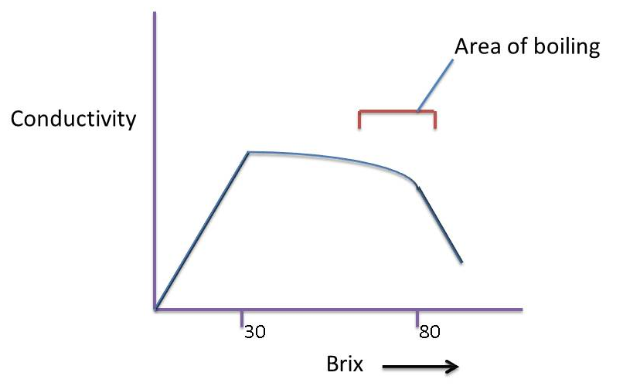
For concentrations up to 30 Brix the conductivity of solution increases due to an increasing concentration of ions. Above 30 Brix the conductivity reaches a maximum before falling due to the effect of viscosity reducing the mobility of the ions. The part of the curve which applies in sugar boilings is indicated. It is clear that increases in supersaturation correspond with decreasing conductivity.
The conductivity between a pair of electrodes mounted in the wall of a pan is measured in milliamps when a constant low potential (32V AC) is applied to them. As the brix of a sucrose solution increases, the density and viscosity of the sucrose solution increases, and the electrical conductance decreases due to the restriction of free ions. This can be used as an indirect method to measure the supersaturation coefficient.
Several trial boilings are done and a conductivity curve is plotted that will maintain the correct supersaturation for good crystal growth. Once the curve is drawn, a massecuite can be boiled according to conductivity. As the Brix increases the conductivity is kept as prescribed by the curve by regulating the feed or – in emergency feeding - with water.
To draw a conductivity curve, conductivity readings must be related to supersaturation coefficient.
The conductivity is noted:
- Where crystals in a massecuite just start to dissolve. This is detected by rounding edges and corners of crystals - this is the conductivity of the saturated solution.
- When false grain (i.e. new crystals) start to form in the presence of other crystals- this is the lower limit of the intermediate zone.
- When a solution without crystals present starts to crystallise spontaneously - this is the upper limit of the intermediate zone and hence the start of the labile zone.
The conductivity probe consists of a cylindrical outer electrode insulated from a second electrode placed inside.
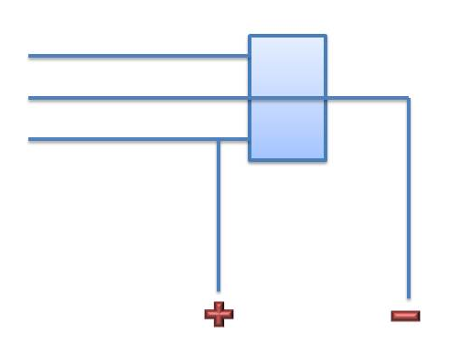
Advantages:
- Useful for massecuite strikes of below 95% purity (i.e. Raw House pans)
- Price of equipment and maintenance is low.
- Variation with temperature is very small for constant supersaturation. On increasing the temperature of a crystal/liquor mixture the tendency towards increase in conductivity is compensated for by an increase in Brix due to solution of part of the crystals. Such a mixture is in a constant state of saturation and shows small fluctuations in conductance with temperature variations.
- Measurement is quick and simple.
Disadvantages:
- Unsuitable for high purity boilings such as refined boilings because of the low ion concentration.
- Scale build-up and metal corrosion due to electrolytic action makes frequent recalibration and cleaning necessary.
- The measurement is sensitive to temperature fluctuation
Boiling house products in cane sugar mills with a purity between 69 and 85%, and temperature 65 to 75°C, show the following relation between conductance and supersaturation:
Milli-amperes | Supersaturation
88 | 1.00
70 | 1.10
54 | 1.20
44 | 1.30

1.8.2 Boiling point elevation
When sugar is dissolved in water the boiling point of the water is higher than that of pure water. The higher the Brix, the higher is its boiling point above the corresponding boiling point of water (at the same pressure).
The difference between the boiling point of a sugar solution and the boiling point of pure water is called the boiling point elevation (BPE) and its value changes with the temperature at which the solution is boiling.
This is illustrated in the following two diagrams showing boiling water and boiling sugar solution:
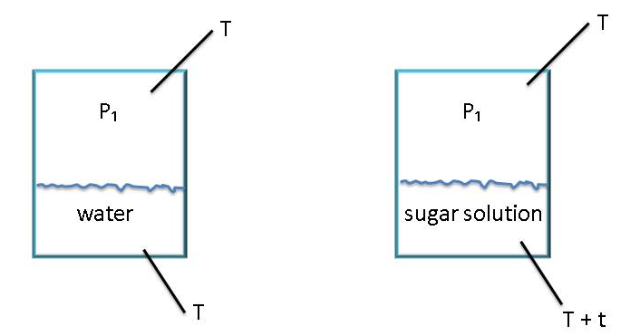
At a pressure P₁ water boils at T°C and the water and vapour temperature is T°C.
At the same pressure P₁, a sugar solution has to be heated to higher temperature before its vapour pressure is to P₁ and it boils. The temperature of the solution is thus (T + t) °C, while the temperature of the vapour above the solution remains T°C.
The BPE of a boiling sugar solution can be correlated with the concentration and hence SSC. Since boiling is carried out at a reduced pressure, it is necessary to compare the elevated boiling point under exactly the same pressure.
The BPE is practically found by inserting one temperature probe in the massecuite and another in the vapour steam above it.
Advantages:
- Can be used on all solutions.
- It is particularly applicable to pure solutions.
Disadvantages:
- Constant vacuum is essential to get a good measurement
- The changing level in the pan complicates the measurements thus requiring compensation.
- With impure substances the BPE only measures the dry substance (Brix), not the sucrose concentration of the mother liquor; therefore supersaturation cannot be defined accurately.

1.8.3 Radio frequency (RF) probe
Conductivity measurements generally work well for raw sugar boilings but not for refined sugar boilings.
The RF probe measures the electrical properties of massecuite i.e. the resistance and capacitance at radio frequencies. Either one of the signals can be related to the SSC and hence used to control the pan.
The RF signal combines the conductivity and capacitance of the massecuite and the magnitude (size) of the RF readings increase with increase in supersaturation coefficient.
The advantage of the RF probe is that it can be used on impure solutions (resistance signal) and pure solutions (capacitance signal). Control of supersaturation in refinery pans is usually done using RF probes, in A-pans by RF probes and in B - and C - by conductivity.
The disadvantage of the RF probe is that encrustation and scaling occurs in raw sugar pans.

1.8.4 Stirrer torque
This method makes use of measuring the stirrer motor power consumption. The Torque required to turn the stirrer in a solution increases with increase in concentration.
Advantages:
- It can be used on all purities.
- It is particularly useful for determining the end point of a boiling.
Disadvantages:
- The measurements are very much dependent on the crystal content.
- When there is little or no crystals as around seeding point, the sensitivity of the signal is low and very temperature dependent.

1.8.5 Crystal scope
This is a good instrument for observing the crystal growth and its uniformity in the pan during sugar boiling process.

Crystal size
False grain, for example, affects the crystal size distribution.

Crystal type (Crystal Habit)
Crystals can be deformed in many ways:
- Conglomerates (multiple crystal joined).Two types are:
    - Twinning
This is the phenomenon whereby two or more crystals share a common face or edge.
    - Aggregate
This refers to a “starry” mass of crystals.
- Elongated crystals formed.
- Impurities are trapped in crystal (occluded impurities).
Crystal elongation is partly due to the presence of dextran, but mainly due to the presence of small polysaccharides i.e. kestoses (Glucose-Glucose-Fructose), Theanderose (Fructose-Fructose-Glucose).
Perfect crystals will only be formed if there is a slow rate of growth at a low supersaturation.
- Knowledge Topic 2: Equipment design and operation

2.1 INTRODUCTION
The boiling of concentrated sucrose solutions to evaporate water and form crystals is done in a vacuum pan. A vacuum pan is an evaporative crystalliser or single effect evaporator designed to handle highly viscous material. It is a device for starting and controlling the crystallisation of sugar by the evaporation of water from the concentrated sucrose solution (mother liquor) to maintain the desired concentration. At the correct supersaturation the pan is “grained” i.e. small crystals are added. These crystals are grown and the mixture of crystals and mother liquor is a called a massecuite. A massecuite containing partially grown crystals is called a “seed” massecuite since it is the starting material from which a massecuite is grown that contains crystal of the required size.
The effect of vacuum is to reduce the boiling point of the solution. This has two main advantages. It reduces sucrose decomposition due to high temperature and improves the heat transfer by maintaining sufficient temperature difference between the steam/vapour and the boiling liquid, thereby maintain a good evaporation rate.
Sugar boiling was traditionally carried out in batch pans, but the modern trend is to use continuous pans.

2.2 BATCH PANS
Modern batch vacuum pans are vertical welded steel cylinders. The walls of the pans are lagged to minimise heat loss.

The basic features of a batch pan are illustrated below:
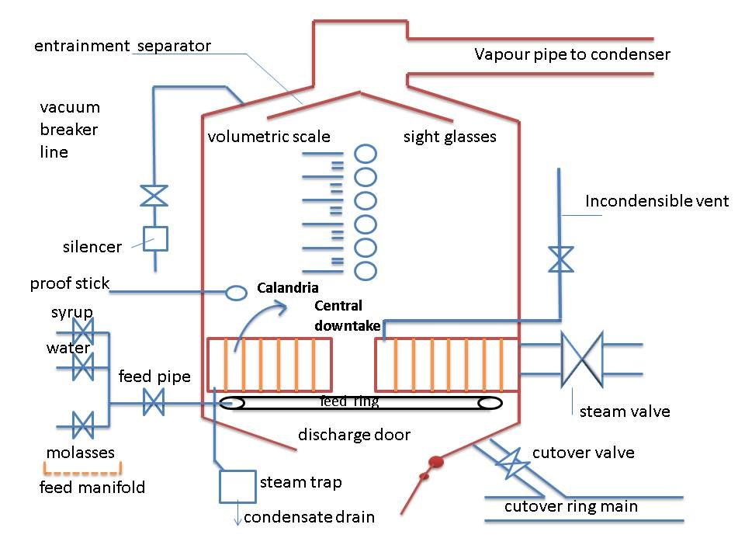

2.2.1 The Calandria
The calandria is the heating element of the pan and consists of a large number of cylindrical tubes fixed to a top and bottom tube plate. The tubes have a diameter of about 100mm with their length being in the order of 1000 - 1500mm. Tubes are usually made of stainless steel.
The steam which supplies the thermal energy is separated from the boiling massecuite by the metal surfaces of the tubes while the massecuite boils inside the tubes. The number and size of the tubes determines the area of the heating surface.
The area of the heating surface governs the rate of evaporation and this area differs according to the duty of the pan. Pans are designed to a heating surface/volume ration which suits the massecuite to be boiled.
High purities require a high heating surface/volume ratio.
Low purities require a low heating surface/volume ratio.
The trend nowadays is to promote circulation, so new low purity pans, and especially the new continuous pans, often have large surface area/volume ratios. Higher ratios in C-Pans also allow the use of lower calandria steam pressures. The C-continuous pan at Darnall, for example, has a heating surface to volume ratio of 9, and normally boils at sub-atmospheric steam pressures.
There are two versions of the tube calandria in use:
The fixed calandria – tube plates attached to the sides of the pan and a central downtake.
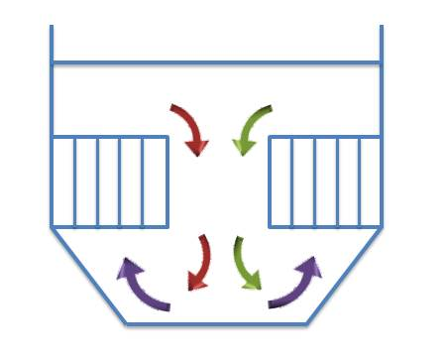
The floating calandria – supported in the middle of the pan with an annular downtake. The bottom tube plate is usually stepped.
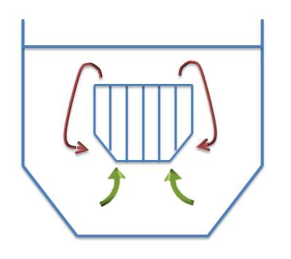

2.2.2 Steam
Steam is the energy that is used to heat the massecuite. The calandria are fed with V1 vapour which is bled from the vapour evaporated from the clear juice in the first effect evaporator. The driving force behind the heating is the temperature difference between the massecuite and the steam. The temperature difference causes the steam to condense (give up its latent hear). The condensate is forced out of the condensate pipe and through the steam trap by the pressure of the steam inside the calandria.
The rate of steam usage and condensate production is dependent on the temperature difference between the massecuite and steam.
When the pan is first charged the temperature difference is greatest and because of this the steam valve must be opened slowly to warm up the calandria and reduce this temperature difference .If this is not done a vast amount of condensate will be produced which could cause the calandria to water log, because it cannot drain away fast enough. The sudden heat change could also damage the calandria.

2.2.3 Vacuum system

Condensors
As the massecuite boils in the pan, a large quantity of water vapour is generated. In order to maintain the vacuum (low pressure) in the pan this water vapour must be continuously removed. This is done using a condenser.
A condenser is a vessel used to condense vapour to liquid. The condenser is either connected to or is enclosed in a vacuum pan. Once the vapour is inside the condenser, cool water (condenser water) is sprayed on it causing the vapour to condense.
The purpose of a condenser is not simply to condense vapour but to use this condensation to create a vacuum which can then be controlled by the condenser water. At -80kPa vacuum (20kPa absolute) 1kg of vapour occupies 6,6m³ of space. This vapour can be condensed by 15 kg of water to 0.001m³ of condensate. The condenser is made up of a series of baffles or perforated plates which causes the water entering at the top of the condenser to form a series of saturating showers or fine rain-like droplets.
This gives efficient condensing of the vapour entering at the bottom. The condenser water enters at the top of the condenser and falls under gravity to the outlet – (the tail pipe or barometric leg). The vapour is sucked into the condenser at the bottom by the vacuum created from the condensation taking place and is drawn up through the falling water and condensed. Some of the vapour cannot be condensed (incondensable gases) and these gases are removed by the air pump (vacuum pump).
The vacuum can be controlled by adjusting the amount of water entering the condenser. An increase in the amount of water increases the vacuum (to a maximum of approximately- 90kPa). A decrease in the amount of water decreases the vacuum (i.e. increases the absolute pressure).
An increase in vacuum (reduced absolute pressure) reduces the massecuite boiling temperature and increases the rate of evaporation. A decrease in vacuum (increase in absolute pressure) increases the massecuite boiling temperature and decreases the rate of evaporation. Taking this information into consideration it is easy to see why it is easy to raise vacuum in a hot pan and extremely difficult to raise vacuum in a cold pan.

Barometric leg
As the pan and condenser is under vacuum and the water in the sealing well is at atmospheric pressure there must be a seal to prevent the water in the sealing well from being sucked into the pan.
This is done by means of a barometric leg or tail pipe. The tail pipe must be at least 10.4 metres long to balance the difference in pressure between – 80kPa (gauge pressure) in the condenser and the atmospheric pressure at the sealing well. If the barometric leg is too short the condenser will fill up with water and possibly flood back into the pan.

Approach Temperature
A condenser is said to be working well if the approach temperature is low.
This approach temperature is the difference between the inlet vapour temperature and the outlet water temperature (tv – t₀).
The more water used the lower t₀ becomes. This increases the approach temperature and the condenser becomes less efficient.
Water control is thus important to ensure that the condenser is working efficiently.

2.2.4 Incondensible gas
Incondensible gasses accumulating in the calandria
Steam, although consisting mainly of gaseous water, also contains some air and other gases that cannot be condensed. These are called incondensible gases. If these gases were not removed they would accumulate in the calandria thus reducing the steam pressure in the calandria, which in turn will lower the temperature of the saturated steam. This will reduce the temperature difference ($∆$T) between steam and boiling liquid and will therefore reduce the heat transfer.
Incondensible gases are removed by pipes extending to the bottom of the calandria which have holes along their length so that both heavy and light gasses are vented. These vent pipes removing incondensible gases are connected to regulating valves outside the pan. The pipe after the valve can lead to one of two places. It can vent to atmosphere or into vapour space of the pan. The gas venting into the dome is a tidy setup, but has the drawback in that it is impossible to know whether incondensible gas and steam is going into the saveall. There is a thus the possibility of the steam wastage. The vent to atmosphere is not tidy, as there is usually water splashed on the floor and the lagging on the pan deteriorates quickly, but it is possible to see if there is steam wastage. If controlled properly the mess can be avoided. It is important to realise that steam is lost to the atmosphere together with the incondensible gases.
The vapour evaporated from boiling massecuite contains gasses like air that cannot be condensed in the condenser. These incondensible gasses must be removed. Air pumps are used to extract incondensible gasses from vacuum pans via the condenser. These pumps do not pump vacuum so technically their usual name of “vacuum pump” is wrong.
Liquid ring air pumps are universally used in the sugar industry. This type of pump consists of a shaft carrying radial vanes rotating in a drum. The shaft is eccentric to the drum and in this way, as the vanes rotate, they enclose a space increasing for suction and then decreasing for compression of air and delivery. The space in the pump is limited by an annular ring of water lining the drum and held against the walls by centrifugal force. Liquid ring pumps take up little space and require little attention.

2.2.5 Condensate removal
When steam gives up its latent heat in the calandria, condensate is formed. This condensate must be removed in such a way that no steam loss is experienced. This can be achieved in two ways:

Steam traps
Several types of steam traps are in use.
- Float type traps
This type of steam trap consists of a small tank with an inlet and outlet and a float inside. The condensate drain from the calandria is connected to the inlet and the outlet is connected by piping to a condensate tank.
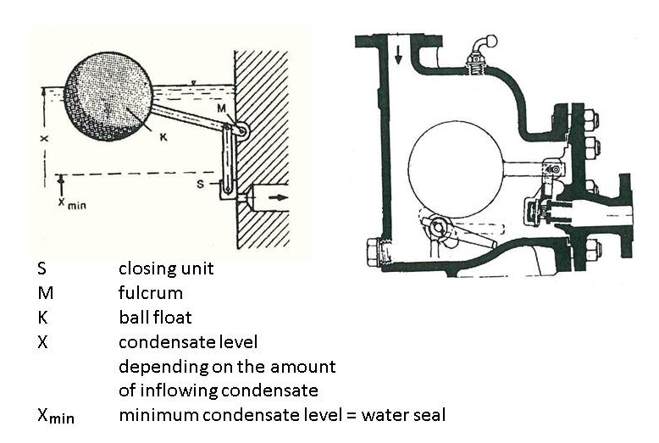
While the tank is empty/low the float is in its bottom position and it keeps the control valve in its closed position. When condensate flows into the trap, the float lifts thus opening the control valve and the pressure in the trap forces the condensate out. As the level drops, so does the float, until it closes off the outlet again. The condensate is thus removed but the steam remains behind.
- Thermostatic traps
These traps utilise the temperature difference between steam and condensate. They contain a regulating membrane with a liquid filling. This liquid remains in the liquid phase if in the presence of condensate, but evaporates in the presence of steam.
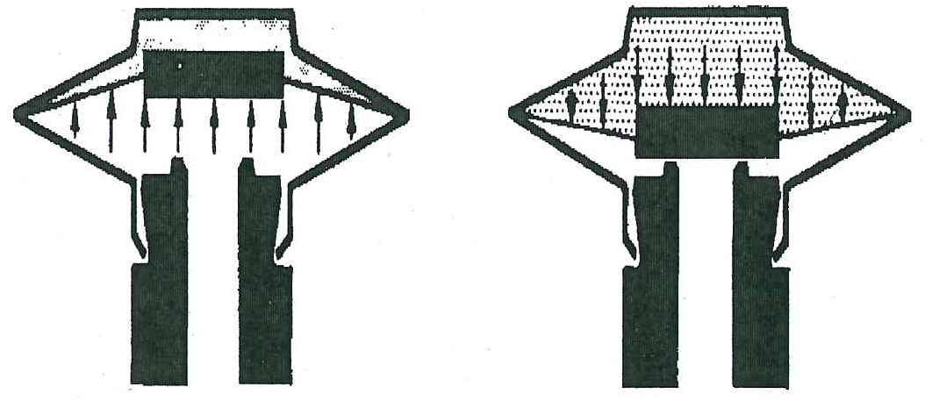
- Thermodynamics traps with valve disc
The condensate discharge is mainly effected as a function of the state of the medium flowing through the traps. Cold condensate can flow freely through the trap and the valve disc is kept fully open by the energy of flow. As soon as the condensate approaches boiling temperature, part of the condensate evaporates and produces a considerable increase in the velocity of flow. This will lead to a pressure drop underneath the valve disc which consequently moves towards the seat. Simultaneously steam will flow into the pressure chamber above the valve disc where the pressure increases until the trap is closed. The trap will not open again until the pressure above the valve disc has been sufficiently reduced. This is done by condensation (radiation of heat to the environment) and by a leak path provided at the valve disc (escape of steam to the outside).
Whether and when the trap will reopen after closing is independent of the amount of condensate formed, but determined by the temperature of the environment or whether the surroundings air is at rest or agitated .A second point is the finish of the sealing surfaces. The rougher the surface the quicker the trap will open, the smoother the surface, the later the opening.
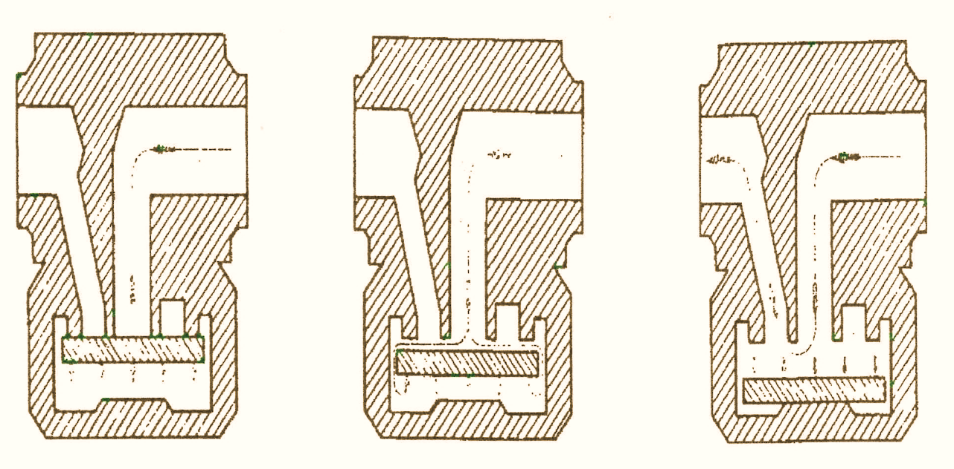
The steam trap must function correctly or steam will either be passing through the trap, with a resultant loss of pressure in the calandria, or if the steam trap is stuck in the closed position, the calandria will fill with water and the pan will stop boiling.

U-leg
The U-leg system of condensate removal consists of a long U-shaped pipe. The top of one leg is connected to the calandria drain and the top of the other leg is connected to the condensate tank. The bottom of the “U” should be as low as the ground level will permit. The “U” acts as a seal between calandria pressure and atmospheric pressure. If the “U” is not long enough to balance this pressure difference, water will be forced out of the “U” allowing steam to escape.
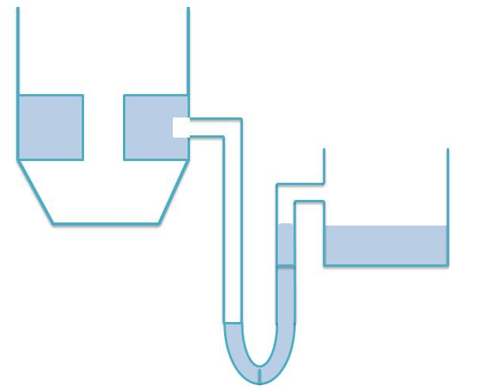

2.2.6 Pan feed system
Modern designs, although varied, have the same principles.
The objective is to give an even, unrestricted flow of feed into the pan. The best place for this to be done is under the calandria. Here the feed blends in with the natural circulation and good mixing is achieved as the massecuite rises up the tubes.
The feed ring or distribution pipe under the calandria should ideally be connected to the feed valve by a pipe entering under the calandria. The feed ring can be attached to the side of the pan, be halfway between the downtake and side of pan, or have a star arrangement.
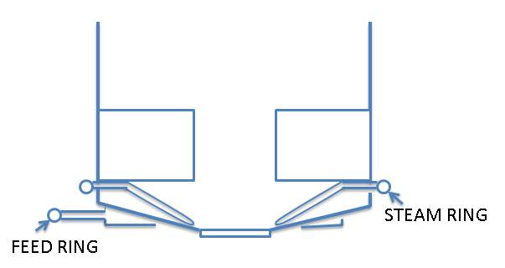


2.2.7 Circulation
Good circulation is critical for good/effective pan boiling. Circulation is promoted by the bubbles of vapour formed as the massecuite is heated in the tubes. As the bubbles rise they grow in size and agitate/mix the massecuite as they lift it towards the surface.
The massecuite boils and rises in the tubes and then moves down the central downtake to the bottom of the calandria.
Circulation is thus due to heating- if the heating is stopped, so does the circulation.
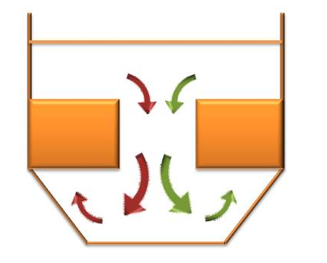
The central downtake in the calandria is almost half the diameter of the pan. The circulation is assisted by the difference in brix between the hot massecuite rising in the tubes and the cooler massecuite descending in the downtake. The descending massecuite is cooler as it has lost some of its heat by evaporation at the surface. The circulation can be said to be good if the difference in temperature between the massecuite under the calandria and 40mm above the calandria is not more than 3˚C when the pan is nearly full.
Circulation is hindered by the resistance of the shape and position of the tubes and by obstructions in the downtake.
The mixing effects of circulation are important in bringing new mother liquor into contact with the crystal surface thus assisting crystallisation.
The Circulation Ratio is the ratio of total tube cross-sectional area to downtake area. It has also become an important feature of pan design. This ratio should not be greater than 2.5. The lower the value, the better the circulation because the downtake size increases and does not restrict massecuite flow.
Stirrers are sometimes used in pans to improve the circulation of the massecuite in the pan. Stirrer speeds about 50rpm are used.
The pans which make white sugar in a refinery should be fitted with stirrers to improve pan circulation. Their use helps to minimise the formation of clusters of crystals (known as conglomerates).
Pans fitted with stirrers have the following advantages.
- Shorter boil times
- Lower steam pressure requirement
- Lower temperature requirement
- Less colour formation due to lower temperature
- Stirrer current requirement can be used as an indication of the strike point.
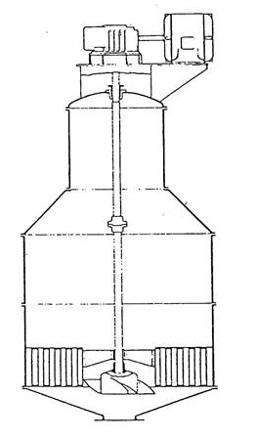

2.2.8 Entrainment separators: Savealls or catchalls
When a massecuite boils in a pan, small drops of mother liquor and/or crystals are thrown up into the vapour steam. This called entrainment.
If these drops are not stopped they will find their way into the condenser water and be lost causing a pollution problem as well as a money loss.
The saveall is the device used to trap the entrainment particles. The saveall can be internal (inside the pan) or external (between the pan and condenser).
There are many shapes and sizes of savealls but all are designed to the same principle. The normal design principle involves a rapid change in droplet direction or a reduction in droplet velocity. Since heavier droplets have a greater momentum than the small droplets, they are unable to change direction rapidly and impinge on the wall or separating device, coalesce, and return to the vessel. An entrainment separator has a series of baffles or obstructions which makes the vapour move around in curves and around corners. High velocities resulting from poor design or blockages in the separator will result in re-entrainment of coalesced droplets and sugar loss in the vapours.
A saveall can only work well if it is clean. A dirty saveall or a blocked saveall drain will cause a build-up of entrainment with possible re-entrainment. Savealls and drains should be cleaned weekly. It is an advantage to have a design that makes cleaning easy.
De-mister screens can be used to minimise entrainment. These screens are made of finely woven stainless steel wire. Care must be taken when replacing these screens – they must be placed the right way up or they will not be efficient.
Since there is normally a small pressure drop across an entrainment separator, it is normal to provide a sealing arrangement on the return line. The seal prevents vapour droplets from by- passing the separator. Common systems in use include J tubes, bayonet clip pots and U legs.

2.2.9 Cut over pipe
The cut-over line is a larger bore pipe of 250 - 300mm connecting the pans, seed receivers and magma tank together. The purpose of the cut over valve is to cut/transfer the product (seed and magma) between pans and receivers. This makes the pan floor more versatile as pans can be used for more than one duty.
Each pan and receiver has its own isolating valve which should be as close as possible to the pan or receiver to prevent any “dead zones” where massecuite can harden to form a blockage.
The seed is transferred from pan to pan by a difference in vacuum.
For example: If we wish to transfer/cut a seed from pan 1 to pan 2, the vacuum in pan 2 must be greater than that in pan 1(i.e. pan 2 must be at a lower absolute pressure). Note: it is not necessary to “break” the vacuum in pan 1 and return pan 1 to atmospheric pressure. Breaking and raising vacuum is time consuming and is a waste of energy. Simply reducing the vacuum in pan 1 (i.e. increasing the absolute pressure) will result in a pressure difference. When the necessary valves are opened the seed will be “sucked” from pan 1 into pan 2. The seed is actually being pushed from pan 1 to pan 2 by the higher pressure in pan 1 with respect to pan 2.
As the cut-over pipe usually affects all the pans and receivers, co-operation between pan boilers is necessary to prevent the mixing of seed. After use the cut-over pipe must be thoroughly steamed out and drained. Cut-over piping has flanges which are connected to a low pressure steam supply (V₁ vapour) to flush the line. The pipe must be cleaned to prevent a massecuite build-up and possible blockage and also to prevent the mixing of different sized grains which will affect the final sugar quality.

2.2.10 Sight glasses
Port hole-like windows up the side of the pan allow the pan boiler to see the level of boiling massecuite in the pan. Good illumination is provided and a scale calibrated in m³ gives an approximate measure of the volume of massecuite in the pan. A wash line (either hot water or steam is used) to wash the inside windows.
The sight glass is fitted into its seats with a rubber seal. This seal ensures that no air can leak into the pan. When replacing a sight glass a new seal should be used, as the old one is usually hard and cracked. The bolts securing the sight glass in place should not be over tightened and should be tightened evenly to prevent the glass cracking.
It is sometimes necessary to manually clean the inside of a sight glass because of scale build-up. This scale should be removed with hydrochloric acid.
If the scale is removed with a metal object the glass will be scratched and it will be difficult to see through the glass.

2.2.11 Breaking vacuum
The vacuum breaker valve is a valve isolating the air space of the pan from atmosphere. The purpose of the valve is to allow air into the pan to fill up the space under vacuum. This is necessary when the pan is ready to strike (be emptied).
The condenser water valve should be closed and the air pump stopped before the vacuum is broken or sugar could be entrained. The vacuum breaker line is fitted with a silencer to reduce the excessive noise experienced by air rushing through the line when vacuum is broken.

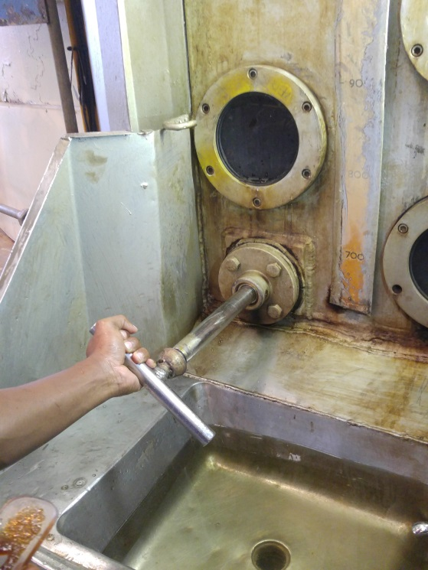
2.2.12 Proof stick
A proof stick is a device for withdrawing a sample of the boiling massecuite from the pan whilst the pan is under vacuum. It is mounted above the calandria and, below it on the side of the pan, there is a wash basin.
When drawing a sample it is important that the proof stick be clean. Therefore the proof stick must be pulled out and washed clean, allowed to return into the pan and withdrawn again with the sample.
A proof stick that is allowed to return into the pan dirty will take with it cold massecuite or mother liquor which could induce grain to form in the pan. This will cause odd size crystals to form and the resultant massecuite will be of the poor quality. The proof stick should be held and guided back into the pan, not released and allowed to go back on its own. If allowed to return on its own it can be sucked in quickly with the possibility of breaking or damaging the handle.

2.2.13 Manways
A manway or manhole provides access to the inside of the pan. A rubber seal ensures that the door is air tight when closed. Before closing the door ensure that the seal is clean as any dirt or sugar on the seal could cause an air leak which would make vacuum control difficult.
After working inside the pan make sure all equipment is removed and nobody is inside before closing the door. Do not overtighten the door. This could make it difficult to open and could also damage the threads on the locking bolt making it impossible to open or close.

2.2.14 Pan discharge door
The discharge door used for emptying out the massecuite on completion of a boiling has a diameter in the order of 0.75 metres.
Older pans have manually operated doors, but modern pan discharge doors and cut-over valves are opened and closed by the action of oil under pressure in a hydraulic cylinder. The oil under pressure is usually supplied from a central power pack at a working pressure of approximately 1MPa. This oil is pumped along small bore pipes to control panels for each pan. Each control panel usually consists of a button to start the pump and a lever to open or close the door or valve. The action of the lever either sends oil to the top or bottom of the actuating cylinder attached to the discharge door or cut-over valve either making it open or close.
Extras in the system can include lights to show when the door or valve is fully opened or closed. Non-return valves are also used to prevent the door or valve moving in the case of an oil leak in the piping.
The light showing that the door or valve is open or closed can be operated by pressure switches or limit switches. If operated by pressure switches, they will go on when maximum cylinder pressure is reached. This does not always mean that the door or valve is full open or closed. If a foreign object is jammed in the door or valve it will close on this object and the light will come on, even though the door or valve is not open or shut. This could be the case if the pan will not discharge or vacuum cannot be raised.
Oil leaks affect the pressure making the efficient operation of the door or valve impossible. Leaks should therefore be repaired promptly. The cylinder controlling the operating of the discharge door can be underneath the pan where maintenance is difficult, or on top of the pan with a long shaft running through the pan and downtake to the door.

2.2.15 Steaming out
The steaming out valve isolates the vapour 1 steam line from the air space of the pan. The purpose of the valve is to admit steam into the pan after it has been struck to melt all traces of the grain left behind.
The steaming should, if possible, be sent to an appropriate tank and not dropped onto the just-struck massecuite. It seems pointless to spend the time brixing a pan and then diluting the massecuite in the crystalliser with the hot steamings.
The steaming out of a pan also makes raising vacuum easier because there is a lot of hot vapour available to condense in the condenser.
It is possible to break the vacuum in the pan by opening the steaming out valve. This practice, although time saving, can cause problems. Because of the big pressure difference there would be a waste of steam and the steam could also melt the grain on the top of the strike as it is discharging.

2.2.16 Funnel
A small funnel is mounted on the side of the pan and is used for adding slurry when graining the pan.

2.2.17 Pan instrumentation
- A thermometer is mounted with its sensor just above the calandria.
- A vacuum gauge is connected near the top of the pan, well above the massecuite level.
When pairs are automatically controlled they are fitted with:
- A vacuum controller
- A massecuite level measuring device such as a DP cell or one measuring the capacitance of a wire partially immersed in the massecuite
- An indirect measure of supersaturation coefficient such as boiling point elevation conductivity or radio frequency.

2.3 OTHER PAN FLOOR EQUIPMENT

2.3.1 “Molasses blow-up tanks”
Molasses blow-up tanks are tanks on the pan floor used to supply conditioned molasses to the pans. These tanks are stirred vessels fitted with direct injection steam as a means of temperature control and are usually mounted above floor level.
The conditioning of the molasses feed is essential to remove all traces of small crystals/grain. Conditioning thus prevents odd size crystals forming in the pan. The small crystals are dissolved by raising the temperature using steam. The temperature of the molasses must be controlled because if allowed to drop the small crystal will not be dissolved and if the temperature is allowed to increase too much, decomposition and caramelisation could take place.
The function of the molasses blow-up tank is two-fold:
- The molasses is heated so that it has a temperature higher than that of the pan into which it will be introduced. This has the advantage that the molasses will flash when entering the pan, thus promoting circulation.
- The molasses is diluted with steam hot water to have a 70°Bx. The brix is measured by a conductivity meter that operates a valve to feed water/steam.
The brix of the feed can be controlled by a conductivity probe provided that the temperature is controlled at a fixed temperature.
The contents of the tank must be well mixed by a stirrer (or by a steam jet mixer) to prevent local hot spots with possible deterioration of the molasses.
The molasses from the centrifugals should be pumped to the storage tank and then pumped as required to the blow-up tank. Conditioned molasses is not normally allowed to overflow back to the storage tank or circulated as storage at high temperature could cause decomposition.
The molasses blow-up tank is also relatively small so that only the required amount of molasses is conditioned at any one time.
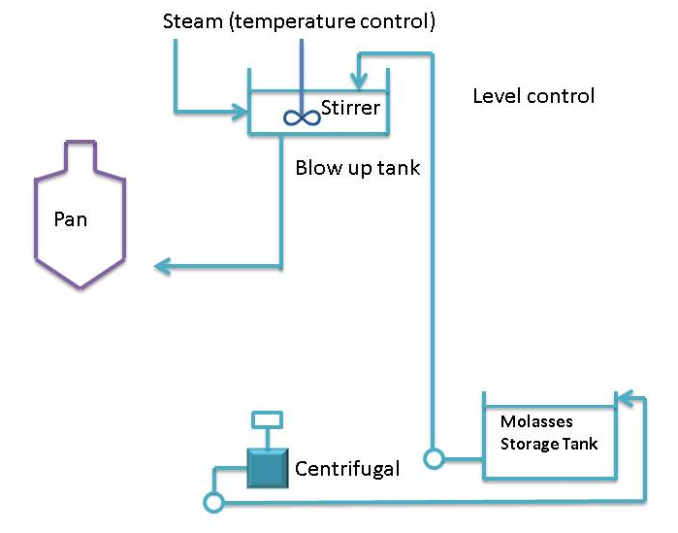

2.3.2 Strike receivers
Mounted below the discharge valve of a vacuum pan is a launder or pipe to transport the massecuite to the strike receiver when the pan is struck (emptied).
Strike receivers are special surge vessels designed to receive the massecuite as it falls from the pan. The strike receivers are fitted with stirring devices to keep the crystals in suspension and prevent them from settling on the bottom of the strike receiver.

2.3.3 Seed receiver
An immature (partially grown) massecuite that contains small crystals that require further growth is called a seed massecuite.
Seed receivers are usually totally enclosed cylindrical tanks with stirrers. They are connected to the pans by the cut-over line, and are used for the storage of seed.
Sight glasses are provided on the ends so that the level inside the receiver can be seen.
When cutting or transferring a seed between a pan and a receiver there must be a difference in vacuum between the two vessels. The vacuum in the pan must be decreased (i.e. the absolute pressure must be increased) and the vacuum in the seed receiver must be increased (i.e. the absolute pressure must be decreased). It is not necessary to completely break the vacuum in the pan; a difference in vacuum is all that is required. The seed will move from the low vacuum in the pan (i.e. higher absolute pressure) to the high vacuum in the seed receiver (i.e. lower absolute pressure).
Care must be taken - as the last bit of massecuite leaves the receiver or pan - that air is not sucked in as well, because this air could cause entrainment as it breaks through the massecuite layer on its way to the condenser and vacuum pump.
Seed receivers should be steamed out as often as possible to prevent mixed grain being used as seed and also to stop any decomposition and fermentation that could take place.

2.4 VALVES
A valve is used to isolate or regulate flow in a pipe line. There are many different valves available for many different uses. The most common ones in use on the pan floor are outlined below.

2.4.1 Diaphragm valve
The most common type of diaphragm valve is the Saunders valve. A rubber diaphragm acts against a ridge in the path of flow thereby regulating the flow. A good seal is provided by these valves.
These valves are easy to overhaul and the valve does not have to be removed from its position in the pipe line to be overhauled.
The valve has no glands so there are no leaks unless the diaphragm ruptures. Grease is not compatible with rubber so when overhauling, the spindle area must not overfilled with grease.
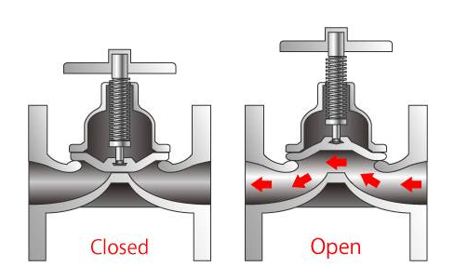

2.4.2 Gate valve
Gate valves are relatively expensive. Since they contain many moving parts they are not particularly reliable and if not treated/worked properly they will not seal off tightly.
The spindle turns in a gland that frequently leaks - either liquid out of the valve or air into the valve if it is under vacuum.
Gate valves are frequently used to regulate feed to pans and to control the cut-over line.
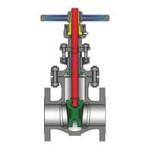

2.4.3 Butterfly valve
The most common use of butterfly valves on the pan floor is for the automatic control of condenser water.
Problems can be caused by a loose blade, a worn shaft and gland leaks. They are also prone to jamming is closed too tightly.
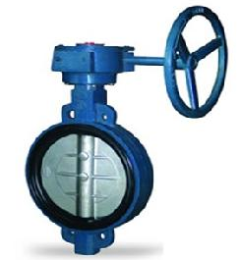
New designs are extremely reliable and they can be used as cut-over valves and as discharge valves.
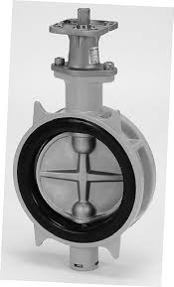
Butterfly valves are extensively used on pipes carrying massecuite, syrup, molasses etc.

2.4.4 Slide valve
The most common type of slide valves are the Stafsjo valves. Slide valves are good for massecuite and magma as the tongue or slide is smooth. There is a tendency for crystals to pack at the bottom of the slide causing leaks. The glands can also leak.
Steaming out points on the valve is advisable to clear stuck massecuite and free the slide if it jams with cold massecuite.
There are self- cleaning slide valves available which do not have the problem of leaking due to crystal build up, but they have an extra gland which is another possible source of leakage.
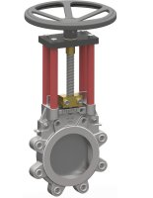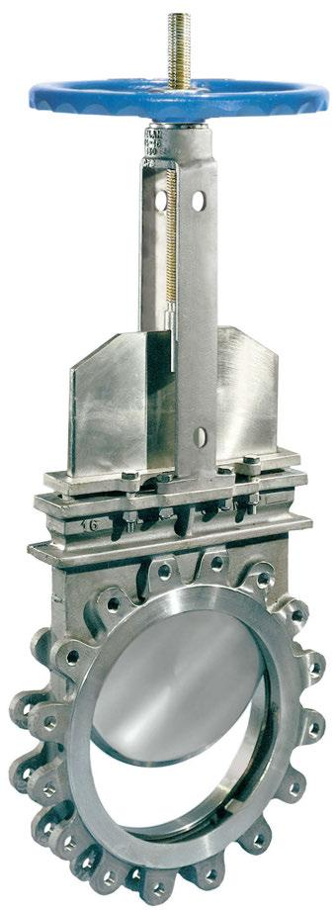

2.4.5 Steam valve
Steam valves, globe valves or plug and seat valves are tight sealing valves suitable for high pressures. They are reliable although the glands can leak. They are not suitable for liquids with suspended matter as this could damage the sealing surfaces.
Actuators can be fitted to this type of valve for automatic control.
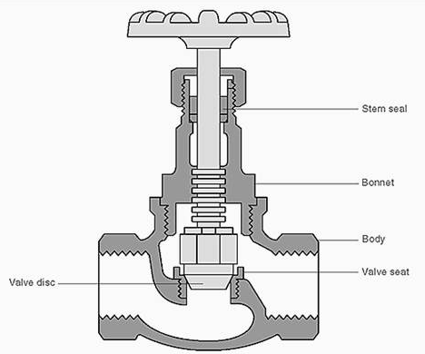

2.4.6 Ball valve
Ball valves are quick acting valves. The only real use on the pan floor for a ball valve is on the graining funnel. Very little maintenance is necessary.
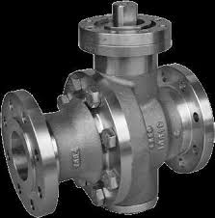

2.4.7 Float valve
Float valves are used to maintain a fixed level of liquid in a tank.

2.4.8 Non-Return valve
A non-return valve is inserted in a pipe line to prevent liquid flowing back along the pipe.
The most common type of non-return valve uses a pivoted flap which falls over an opening preventing reverse flow.
The Saunders non-return valve uses a rubber flap while other makes use of brass or cast iron flaps.

2.4.9 Safety valve
Safety valves can be fitted either to the calandria or the body of a pan.
The safety valve on the calandria is there in case there is a build-up of pressure. This is only likely to happen when the normal vapour pressure is exceeded due to a malfunction of a make-up valve from the high pressure steam line.
The safety valve on the body guards against excessive pressure inside the pan. This would only happen if the discharge door was closed, condenser water closed and air pump stopped and the steaming-out valve opened. With no safety valve the sight glasses would break causing possible personal injury.
For a safety valve to be effective it must be regularly overhauled. This overhaul should not consist only of a coat of paint because excess paint will jam the moving parts making the valve inefficient or inoperative.
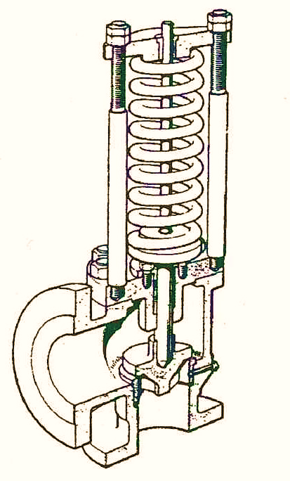

2.5 STARTING A BATCH PAN
Before starting up a batch pan a number of checks should always be made. These include checking that:
- The pan is empty
- There is nobody in the pan
- The manhole doors are securely closed
- The calandria has been drained of water- especially after testing for leaks
- The calandria steam valve is closed
- The condenser water valve is shut
- The vacuum pump is off
- The incondensible gas valve is closed
- The steaming drain and/or discharge door closed
- The cut-over valve is closed
- The vacuum breaker valve is closed.
After checking the above the pan is ready for vacuum to be raised.
It is possible to raise vacuum in a pan using the vacuum pump but this is a very slow process and may take about half an hour. The best way is to fill the pan with steam and after closing the discharge door, to condense this steam by opening water to the condenser. The sequence of steps involved is as follows:
- open the discharge door (or drain valve)
- open steam into the pan body (not the calandria)
- wait until the pan temperature has reached 90-95°, then :
- shut the discharge door (or drain line)
- shut the steam valve
- open the condenser water valve.
Full vacuum will be obtained within one minute.
Note that the steaming out operation heats up the body of the pan which is desirable for boiling a massecuite.
Problems
Should a pan not reach, or fail to maintain, vacuum, a leak is indicated on the pan.
The items to check are:
- Joints between flanges on the pan or lines connected to pan flanges
- The discharge door seal on the pan and other valves, viz. vacuum valve, vacuum breaker, cut-over valve.
- No injection water or else hot injection water. The latter happens when the cooling tower fans trip.
- A leak on the condenser tail pipe often at the water level in the sealing wall.
- The calandria may have broken tubes or tubes may need to be re-expanded. Sometimes it is necessary to blank off leaking Calandra tubes if there is insufficient time to replace them.
- The glands on stirrer motor shafts.
- Collapsed trays in condensers.
Calandria are tested for leaks by filling with cold water and looking underneath the calandria for leaks.
If difficulty is experienced in locating a leak on a pan, the pan may be either:
- filled with steam, or, in extreme cases
- filled with water.
At the start of a new season it is good practice to test all pans for possible leaks by raising vacuum, then shutting the vacuum line and observing the rate of fall of vacuum over, say, half an hour. Modern welded pans should show less than a change of vacuum of 3kPa in 30 minutes.

- Knowledge Topic 3: Graining a pan and growing a massecuite

3.1 GRAIN FORMATION
There are three basic methods of grain formation:
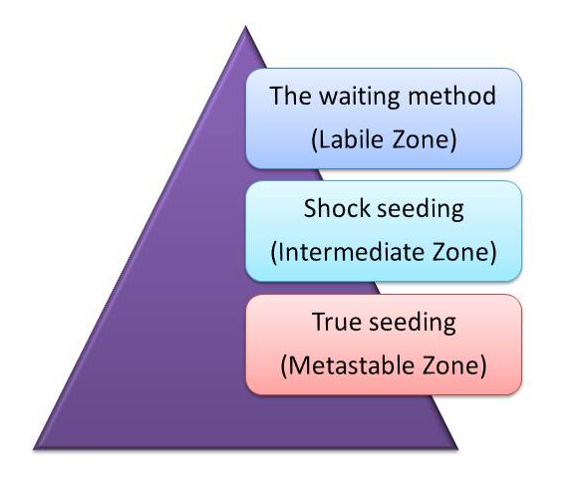

3.1.1 The waiting method
In the labile zone primary nucleation takes place. The mother liquor is concentrated into the labile zone and is kept there until sufficient crystals are formed. The boiling solution is then diluted into the metastable zone and kept there until the end of the strike.

3.1.2 Shock seeding
The solution is concentrated into the intermediate zone where secondary nucleation will take place. A small amount of powdered sugar is added and this induces the formation of further nuclei. To use this method the supersaturation must be higher than normal and is normally done in refineries. Once tiny crystals have formed throughout the solution the pan boiler is washed (with water or diluted feed) to get the correct number of crystals. When there are sufficient crystals present the solution is brought into the metastable zone and kept there until the end of the strike.
Shock seeding can be practised in refineries, but not in the raw house because the bands of supersaturation are higher for impure sugar solutions, so the solution needs to be concentrated more to get the correct supersaturation.

3.1.3 True seeding
True seeding relies on the fact that in the metastable zone existing crystals will grow and no new ones will form. The mother liquor is concentrated to the upper part of the metastable zone (SSC 1.25 - 1.35) and the required number of seed crystals is added in the form of a slurry. It is important to keep the supersaturation constant during this procedure. Boiling is continued in the metastable zone until the end of strike.
Historically, pan boiling was an art which relied on the skill of the pan boiler to judge the number of nuclei present when waiting or shock seeding - With true seeding the number of nuclei will depend on the amount of slurry used.
The grain does not appear immediately upon the introduction of the slurry and can take anything between 5 -10 minutes. In the meantime, the pan is kept boiling vigorously with the steam full on.
From then on the instrument keeps the supersaturation constant by controlling the water addition. The grain grows and must be allowed to do so until the voids are filled and the grain is close together. In fact, this is one of the most important phases of the process. It is only when one is sure that this stage has been carried out that feed is introduced and the boiling of the massecuite proper is started.
However, in order to ensure that full seeding is actually taking place, it is necessary to keep the boiling in the upper regions of the metastable zone. In order to determine this in a practical way, the following method may be used:
- With enough A molasses in the pan allow boiling to proceed until the molasses start to thicken, then take frequent samples with the proof-stick and examine a smear under the microscope. Carry on boiling and at a certain time microscopic crystals will appear almost at once. Note this point. This is the lower limit of the labile zone.
- Now open the wash water valve, dilute the molasses while taking samples with the proof stick. It is apparent after a while that the grains start to dissolve. This is the start of the undersaturated region. Note this point.
Take the distance between these 2 points and at a position between ½ and ⅔ of the distance from the saturation point is the region to grain. With trial and error this graining point can be very precisely obtained.

3.2 SLURRY
Slurry is ideally made by grinding refined sugar in a miniature ball mill with an organic fluid in which sucrose is insoluble. The method of manufacture differs quite considerably from factory to factory and the standard method of manufacture is difficult to enforce.
The S.M.R.I. recommended method is:
800g of refined sugar and 2 litres of methanol are tumbled for 12 hours.
The ball jar should contain 2500 10mm steel balls and should rotate at 74 r.p.m.
After 12 hours the ball jar should be diluted to 6 litres with methanol.
If the slurry is made the same way all the time, uniform, uniform size slurry will be made. If the correct amount of slurry is used when seeding the crystal size and content of the final massecuite will be uniform.
It can be calculated how much slurry is needed to produce a certain volume of massecuite of a fixed crystal size.
The quantity of grain in the slurry will determine the size of the final grain and the exhaustion of the massecuite. If a significant change in the final grain size is desired starting from a normal size of 0.30mm, it is necessary to change the amount of slurry by not less than 20% of the original volume.
The amount of slurry used for C boiling is about 1000mm/35m³ of massecuite and about half that for B-boilings.

3.3 GRAINING A PAN
The first step in making sugar from liquor is to grain the pan. This means introducing small crystals that are subsequently used as nuclei to grow the main sugar crystals.
The steps involved are as follows (Refer to the graph that follows):
- Raise vacuum in the pan as described before.
- Draw liquor of purity 75% (mixture of molasses and syrup) into the pan by opening the feed valve. The vacuum sucks the liquor into the pan. Shut the feed valve when the level in the pan is about 250mm above the top tube plate.
- Open steam to the calandria so that the liquor boils. Follow the progress of the boiling on the conductivity chart.
- Open the water feed until the conductivity indicates that the liquor is unsaturated. This water “wash” is important to dissolve any small/fine crystals that are present in the liquor. From A to B the conductivity of the liquor increases due to increased mobility of the ions present.
- Draw a sample of liquor using the proof stick and check that no small crystals are present (B to C).
- Allow the liquor to boil so that its concentration increases. From C to D the conductivity decreases indicating increasing concentration due to evaporation during boiling. The conductivity should be such that it indicates that the liquor has a supersaturation co-efficient of 1.30 and is within the metastable zone for a purity of 75%.
- At D, water feed is opened so that the addition of water just counter-balances the rate of evaporation.
- When the reading is steady at the desired conductivity value (i.e. the metastable zone), the predetermined quantity of slurry is added through the funnel on the side of the pan. Slurry is added at E.
Crystals at this stage are microscopic and very widely dispersed, so that that local rises in supersaturation can easily occur with an excessive evaporation rate. These local rises in supersaturation can be ascribed mainly to the greater diffusion paths of the sucrose molecules because of the sucrose crystals being so widely dispersed. For this reason it is endeavoured to grow the crystals so that they practicalyl fill the spaces occupied by the syrup or mother liquor before the volume of the massecuite its increased.
- At this concentration the crystals present in the pan will grow and become larger while the total volume of liquid remains the same. This reduces the distance between crystals. This step is called “bringing together” and is very critical in pan boiling. It must be well done so that, before going on to the next step, the crystal content has increased to a high level which can be assessed visually.
Bringing the grain together takes place from E to F. The level of supersaturation is controlled by careful boiling, supplying sufficient water to replace the water being evaporated. Steam supply is also kept constant. This boiling is merely to ensure circulation so that each grain is presented with fresh liquor. Bringing the grain together may take ½ to 1 hour.
Diffusion of the sucrose molecule is improved by the crystals contacting each other and replacing the exhausted layers of mother liquor around the crystal with fresh liquor.
Diffusion rate in high purity boilings can be increased by raising the temperature by reducing the vacuum. Increasing the temperature will:
- Lower the supersaturation
- Increase the crystallization rate
- Reduce the viscosity
- Increase the mobility
This should not be done with low purity massecuites due to the risk of reducing sugar decomposition at high temperatures.
- When bringing together is complete the water feed is shut off (at F) and the pan feed valve opened (syrup/molasses).
- From F to G the grain is grown and the pan gradually fills up to the strike level at which stage the pan feed is shut off (at G).
Under ideal conditions the liquor feed (syrup/molasses) should be fed into the pan continuously. If this is not possible it is better to give short regular feeds rather than long ones. Shorter, more regular feed, will not cause such a big change in supersaturation.
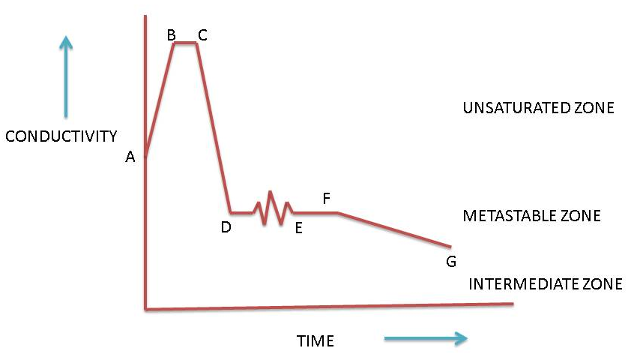
From F to G the seed massecuite is grown. Since the crystals grow because of sucrose deposition from the mother liquor; the impurities remain and accumulate in liquor. The purity of the liquor is thus decreased. As mentioned before, this decrease in purity increases the solubility of the sucrose. To maintain the liquor in the metastable zone, i.e. to maintain the correct supersaturation coefficient the concentration of the liquor (Brix) must be increased, hence the decrease in conductivity.
Furthermore, when growing the crystals and keeping the supersaturation of the mother liquor constant (1.3), the conductivity will also naturally decrease due to the changed ratio of crystal volume to mother liquor volume.
Depending on conditions in the pan, the feed during the growing phase can be syrup/molasses, a mixture of syrup/molasses and sweetwater alone.

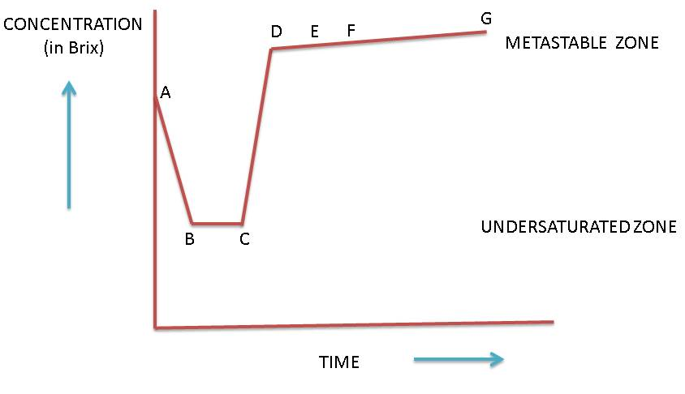
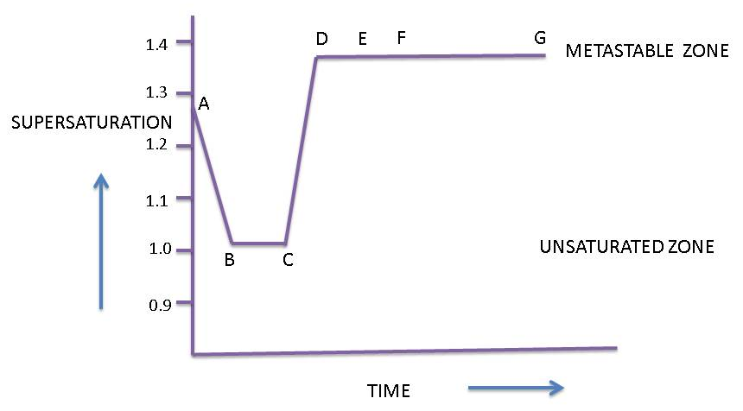
The pan now contains a mixture of small partially grown crystals and mother liquor known as SEED because it will be used to start off massecuite boiling proper.
At this stage:
- Steam to the calandria is shut off
- Water to the condenser is stopped
- The vacuum valve is closed
- The vacuum is broken.
The seed may then be transferred to the seed tank (using vacuum on the seed tank) or part may be transferred to another pan to start up a new boiling.
It is very important to note that the increase of brix during the boiling stage of a seed massecuite is very slight.

3.4 CONTROL OF SUPER SATURATION
For effective pan boiling it is essential that the vacuum remains constant throughout the boiling process. Tampering with the vacuum can easily cause fluctuations in supersaturation that can cause grain to dissolve or false grain to form.
When the vacuum remains constant the temperature and hence the total rate of evaporation of water vapour from the massecuite remains constant.
How is the rate of evaporation controlled?
The rate of evaporation is controlled by varying the amount of water that is available for evaporation. This is done by varying the amount of water fed by varying the amount of syrup/molasses feed supplied to the pan.
Example 1:
If we wish to reduce the rate of evaporation from the massecuite in the pan, we can take the following action:
- Add water
When this water is evaporated, the rate at which water is evaporated from the massecuite itself effectively decreases since the total rate of evaporation remains constant.
- Increase the syrup/molasses feed rate
The water present in the feed has the same effect as described above.
Example 2
If we wish to increase the rate of evaporation from the massecuite in the pan, we can take the following action:
- Reduce the water added
Since this is now not available for evaporation, the rate at which water is evaporated from the massecuite itself effectively increases since the total rate of evaporation remains constant.
- Decrease the syrup/molasses feed rate
Reducing the feed reduces the amount of water entering the pan which has the same effect as described above.
When the crystals are small and the absorbing surface is small, water is used to adjust the rate of evaporation. As the crystal grows and the absorbing surface increases the water feed is reduced and finally stopped. The rate of syrup/molasses feed is then used to control the rate of evaporation.
Should the evaporation rate prove excessive, causing the supersaturation to rise to a dangerous level, remedial action can take the form of the following:
- Feeding water to the pan to maintain an acceptable level of supersaturation. This water, known as movement water, can be reduced as the crystal surface increases, and finally closed off. This procedure is widely used in many countries and is advantageous in as far as there is no disturbance of the vacuum. The amount of water required is generally insignificant.
- Feeding liquor to the pan to achieve the same results as when adding water.
- Lowering the vacuum (i.e. increasing the absolute pressure) by approximately 10kPa will raise the temperature by roughly 10,6°C, which will, in turn, lower the level of supersaturation to within that of the metastable zone. Crystal growth will increase ±100% and the evaporation rate will decrease by approximately 1/3.
- Only reducing the steam supply to the calandria is likely to be the first reaction of the uninformed, as under atmospheric conditions, reduction of heat supply to a boiling solution will reduce the evaporation rate.
In the case of a vacuum pan, attempts at lowering the evaporation rate by reducing the steam supply, lowers the production of vapour thus producing an increase in vacuum due to an increase in the condenser water to vapour ratio. This results in a consequent increase in the evaporation rate.
To prevent this in practice, when the steam supply/pressure to the calandria drops (or is reduced) then immediately adjust the condenser water to maintain the normal pressure (vacuum) and boiling temperature which will prevent the supersaturation from rising further.
Controlling a pan by varying the steam supply is best left to pans having automating vacuum control installed.

3.5 AUTOMATIC VACUUM CONTROL
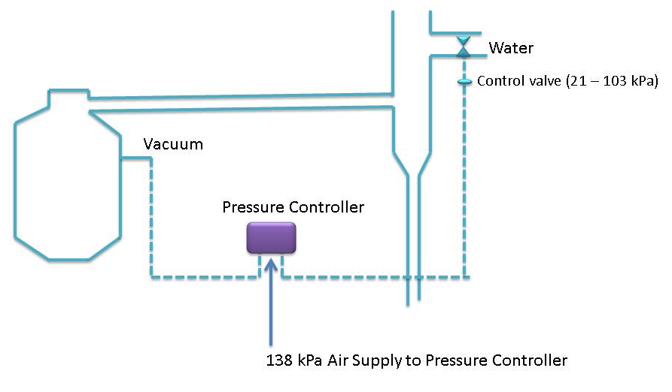
The pressure controller senses the vacuum in the pan and adjusts the water control valve accordingly. With increasing vacuum (i.e. decrease in absolute pressure) in the pan, the water supply to the condenser is decreased thus decreasing the vacuum (i.e. increasing the absolute pressure) in the pan.
This arrangement thus automatically compensates for variations in vacuum should the steam supply to the calandria be changed. The controller keeps the vacuum in the pan constant.
The pressure controller is supplied with air at 138 kPa and it operates the pneumatic water controlled valve with an air pressure of 21-103 kPa.

3.6 BOILING OF A MASSECUITE
Boiling of a massecuite starts off similarly to graining a pan except that instead of covering the calandria with liquor the pan is filled with seed to a level such that the top tube plate of the calandria is just covered.
When the pan is started up it is sometimes necessary to boil it on water initially to bring it together and also dissolve any unwanted tiny crystals which may have formed in the seed tank. It is then fed on liquor and the concentration of the mother liquor maintained in the metastable zone so that the crystals grow as the pan level rises.
When the pan is full the average size of the sugar crystals can be estimated by observing a sample from the pan proof stick under the microscope.
If the size of the crystals is too small the pan can be cut to another pan and the boiling continued. Cutting means taking part of the contents of one pan to another. When this is done the level of partially boiled massecuite must always cover the top tube plate of the calandria otherwise charring of massecuite may occur when steam is opened to the calandria. Cutting may be carried out more than once and boiling continued until the appropriate size of sugar crystals has been achieved.
When the crystals are big enough the pan is struck i.e. the massecuite is emptied out.
There are 9 distinct procedures involved in boiling a massecuite
- Washing the syrup/molasses while the footing is gently boiling. This is to dissolve any small crystals/grains.
- Concentrating the syrup/molasses to the metastable zone
- Formation of the grain slurry seeding. This is unnecessary if B-magma footing is introduced into an A- pan as a footing. The footing is also washed to remove very small grain and then normal boiling procedures take place.
- Bringing the grain together
- Growing the grain by the supersaturation in the upper part of the metastable zone to encourage rapid crystal growth. The pan boiler must check regularly for the formation of false grain.
- Cutting the seed across to another pan to split the seed equally between two pans.
- Boiling the massecuite. This involves growing the crystals further.
- Brixing up
- Striking

3.7 BRIX OF THE PAN FEED
The brix at which the liquor (syrup/molasses) is fed to the pan has marked effects on steam consumption. It can be proved by calculation that nearly twice as much steam is needed when using a molasses of 55°Bx than when using a molasses of 70°Bx.
High brix feed does have its limitations:
- In the case of syrup, excessive scaling can result in evaporation tubes if the syrup brix is too high
- High brix molasses means a high level of sucrose saturation which can increase the presence of unwanted crystals (false grain)
- Circulation in the pan can also be reduced by excessive viscosity caused by high brix.
To minimise steam consumption and prevent a loss of time, molasses should not be conditioned to below 70°Bx.

3.8 INFLUENCE OF HYDROSTATIC HEAD IN PAN BOILING
Hydrostatic head is the pressure experienced at the bottom of a massecuite due to the height of massecuite above. This increased pressure prevents the massecuite at the bottom from boiling. In effect, boiling takes place only in the upper layers of the massecuite, whilst circulation in the tubes below is provided by convection currents.
The hydrostatic head causes the bottom of the massecuite to be at the higher pressure than the top of the massecuite. The result is that the boiling point of the lower layers of massecuite is higher than the top.
Theoretical massecuite boiling points due to hydrostatic head
Depth below the  massecuite surface | Boiling temp  °C | Supersaturation
0cm | 58.6 | 1.20
100cm | 74.5 | 1.00
200cm | 84.0 | 0.89
300cm | 91.7 | 0.78

According to the theoretical values above, the temperature difference between the upper and bottom layers is 33.1°C. Such a large temperature difference is not recorded in practice. Furthermore, heating a liquor of 1.20 supersaturation at 58.6°C to a temperature of 91.7°C would result in the solution being undersaturated, thus able to dissolve the grain. There is no evidence of this occurring.
In reality, boiling takes place in the upper 40cm of the massecuite, whilst only heat transmission takes place in the calandria. The heated massecuite is circulated throughout the pan. The average temperature difference between the top and layers of massecuite is from between 2 and 3°C, depending on pan design.
Any false grain formation is thus likely to take place in the upper layers of the boiling massecuite and the higher the head of massecuite, the greater will be the boiling temperature of the massecuite in the tubes under equal conditions. The better the circulation, the more uniform will be the temperature distribution.
It is preferable to have:
- the massecuite restricted to 1.37-1.52m above the tubes
- a pan designed to give maximum circulation
- mechanically augmented circulation (stirring)

3.9 STRIKING A PAN
The steps involved in striking a pan are as follows:
- Brix up the pan. This involves shutting off the feed to the pan and allowing evaporation to continue. The supersaturation of the mother liquor will increase and crystallization continues giving improved crystal yield. The final brix is assessed via instruments (e.g. conductivity meter) or in the absence of instrumentation this is determined by taking a sample from the proof stick and forming a cone or a ball in the palm and noting how quickly it flattens. Note that overbrixing will make the massecuite too viscous and it will not flow from the pan. Should this happen the pan must be restarted by shutting the discharge door, raising vacuum with the vacuum pump and diluting the massecuite to make it fluid enough to be discharged. Under these circumstances entrainment is likely to occur.
- When brixing is complete shut off steam to the calandria.
- Close the vacuum valve.
- Shut off the injection water to the condenser.
- Open the vacuum breaker valve.
- When the pan has reached atmospheric pressure open the discharge door.
- Control the rate of discharge to prevent massecuite spillage.
- When the pan is empty, open the steaming out valve and observe the pan discharge.
- When the pan runnings have changed from massecuite to a consistency of syrup (a subjective evaluation) direct the pan runnings to the steaming tank.
- As soon as steaming is complete, raise vacuum in the pan as described previously or leave the pan if it is not required for further boiling.

3.10 DEALING WITH HIGHLY VISCOUS MASSECUITE
When the mother liquor of a massecuite has a very high no-pol content, the massecuite will have an abnormally high viscosity i.e. a viscosity in excess of that dictated by the brix of the massecuite.
When dealing with very viscous massecuite the following points must be borne in mind:
- Boil these viscous massecuites relatively slowly using movement water. This will ensure good circulation to compensate for the slow rate of diffusion. Localised rises in supersaturation and resulting false grain will be prevented.
- Do not reduce the steam supply to the calandria as the massecuite could easily lose its fluidity and become too viscous to handle.
- Care should be taken when raising the temperature of the massecuite as the increased evaporation rate could easily cause localised increased supersaturation with resulting false grain formation.

- Knowledge Topic 5: Pan Control and Automation

4.1 IMPORTANCE OF PAN CONTROL
For good pan operation the following is important:
- Constant pressure saturated steam at the required minimum pressure. Batch pans are not conductive to steady steam pressure as their steam demand varies from 0 to maximum available.
Steam flow to the calandria is generally lower at the start of the cycle than at the end, as the viscosity increases and circulation rate decreases as the pan builds up.
- Pan vacuum should be kept constant. Fluctuations in the absolute pressure can result in changes to the level of supersaturation, which can lead either to false grain formation or crystal dissolution. It is important to reduce the absolute pressure to as low a value as is practicable. This is to reduce the temperature of the massecuites to avoid Maillard Reaction.
Note:
Refinery pans > 20kPa abs.
A-pans 17kPa abs.
B- and C-pans 14kPa abs.
The higher the absolute pressure the higher will be the boiling point of the massecuite. This results in faster crystallisation rates. It also leads to higher sucrose losses and especially other undesirable reactions such as the Maillard reaction – hence the lower absolute pressure in the B- and C- pans where higher concentrations of impurities (such as reducing sugars and amino compounds which are the reactants in the Maillard reaction) occur.
- The temperature of feed and/or water to the pan should be higher than that of the boiling massecuite. This causes flashing as the feed enters the pan.
- The brix of feed should be constant. Feed to a pan may be added continuously or in slugs. At first glance it would appear that continuous feeding would assist in giving steadier operation of a pan. However if uniform distribution of feed in a pan is desired slug feeding should be more effective. This is because slow continuous feed will all be distributed through the openings in the feed ring closest to the feed pipe entry, while full flow for short time intervals should be distributed through all the feed ring openings. Unnecessary addition of hot water (movement water) to a pan is wasteful of steam and should be minimised.
- Whenever pan automation is applied it is important to maintain manual checks.
- The evaporation rate should be equal to or lower than the crystallisation rate in order to avoid the formation of false grain. Although evaporation rate is often controlled in continuous pans because of the stable conditions, it is seldom controlled in batch boilings because of the wide variations in flow which depend on prevailing conditions.

4.2 PAN AUTOMATION USING CONDUCTIVITY
The aim of pan control is to keep the massecuite in the correct supersaturation zone during the boiling. The supersaturation is controlled by controlling the brix of the solution. Conductivity is used as a measure of the brix.
It is very important to carry out the whole process at constant temperature because supersaturation is effected by temperature. To maintain the correct supersaturation using a conductivity curve as indicator of the brix increases during the growing phase, the temperature must be constant.
Different boilings utilise materials of different purities, hence the different boilings will have their own requirements in order to maintain the desired supersaturation i.e. each type of boiling (A-,B- and C- boilings) will have their own conductivity curve.
Conductivity is mostly used on lower grade boilings, for various reasons. Although, like other indirect measurements, it has its disadvantages, like being influenced to a certain degree by grain content, its simplicity, fast measurement response and low cost make it very attractive. Small incorrect influences on the conductivity are for a low grade massecuite of relatively small importance as the lower the purity of the massecuite the wider the metastable zone.
Conductivity cannot be used for high grade boilings (purity above 90) as the ash content is too low for reliable measurement and frequent control point changes will have to be made as opposed to low purity massecuites, where the set point may even remain unaltered for an entire crushing season.

4.3 USING COMPUTER CONTROL
Modern pans are automated so that they require less frequent supervision by the pan boiler. There are different methods to automate a pan, of which only two will be briefly discussed.

4.3.1 Method 1: Computer control
This method involves feeding a computer the required conductivity curve according to which the massecuite must be boiled. This is done by entering different massecuite levels in the pan together with the required conductivity at each level.
Example:
A-massecuite |  | B-massecuite |  | C-massecuite
Level  % | Conductivity (mA) | Level  % | Conductivity (mA) | Level % | Conductivity (mA)
40 | 80 | 40 | 74 | 55 | 44
45 | 80 | 45 | 69 | 59 | 44
50 | 78 | 50 | 68 | 62 | 44
55 | 78 | 55 | 66 | 69 | 44
60 | 78 | 60 | 64 | 71 | 44
65 | 78 | 65 | 62 | 75 | 43
68 | 77 | 68 | 60 | 78 | 43
71 | 76 | 71 | 58 | 80 | 42
73 | 76 | 73 | 54 | 82 | 40
75 | 75 | 75 | 53 | 85 | 39
76 | 75 | 80 | 52 | 89 | 36
80 | 74 | 85 | 50 | 90 | 35
83 | 73 | 90 | 50 | 95 | 35
90 | 72 | 95 | 50 | 100 | 25
95 | 71 | 98 | 48 | 105 | 26
100 | 70 | 100 | 43 | 110 | 24

As the pan boils the level of massecuite inside the pan rises. Level sensors detect this rise in level. As the level increases the computer varies the feed to the pan the so that the required conductivity is maintained. In other words, as the level increases the conductivity set point changes.
Example, for a B-massecuite boiling:
- At a level of 40% full, the feed (A-molasses) must be controlled to give the massecuite a brix corresponding to a conductivity of 74mA.
- At a level of 45% ful,l the feed (A-molasses) must be slightly decrease to increase the brix and give the massecuite a conductivity of 72mA etc.
The set points for B-massecuite boilings is shown below:
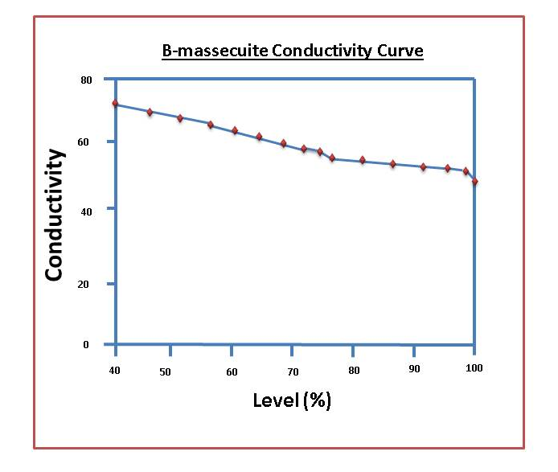
In practice the pan started is on manual control.
The steps involved are:
- washing the massecuite if necessary
- brixing to the required supersaturation for graining
- adding slurry.
The pan is then transferred to automatic control by the computer. As the pan fills up the computer decreases the conductivity set points so that the brix of the liquor in the pan increases. This is essential to maintain the correct level of supersaturation.
If the purity of the liquor and feed changes, the conductivity set points must be changed accordingly.
If the purity of the material used decreases, the liquor must have higher brix valves to give the required supersaturation. This is done by controlling the pan according to a lower conductivity curve. If the purity of the material increases, the conductivity curve is raised.
The decrease in conductivity can thus be changed so that the pan is boiled at optimum ‘’tightness’ without forming false grain.
Instead of conductivity, radio frequently (RF) or boiling point elevation can be used as a measure of the brix the massecuite. The principle is the same – the brix must increase as the pan level increases to maintain the correct supersaturation.

4.3.2 Method 2: Calcor Instruments
Here the pan is fitted with 6 level probes. A control panel is fitted with 5 conductivity control pods. Each pod is activated at a certain level. A pod is set with the brix that we wish the massecuite to have at that particular level.

Each conductivity pod is set using arbitrary valves between 0 and 10.
For example: for a B-massecuite
- At level 1, the pod is set at a value of 6
- At level 2, the pod is set at a value of 7
- At level 3, the pod is set at a value of 8
- At level 4, the pod is set at a value of 9
- At level 5, the pod is set at a value of 9.5
The Calcor controller thus senses the increased level in the pan and decreases the feed accordingly to achieve increase in the brix of the liquor. The arbitrary pod settings are not actual brix values, but are related to brix values.

4.3.3 The advantages of automation
- Faster boiling. This is because the optimum supersaturation coefficient can be maintained during boiling viz. high in the metastable zone but just below the intermediate zone. As a consequence better utilisation of equipment (pans) is achieved.
- Improved quality of product. More regular crystals free of conglomerates and false grain is produced.

- Knowledge Topic 6: Problems Experienced during Pan Boiling
Several problems can occur during pan boiling. Some of these are detrimental to the pan boiling process itself while others affect subsequent processing.

5.1 FALSE GRAIN
False grain is unwanted grain whose size does not compare with the desired size and is formed during the growing process of existing crystals by secondary nucleation. False grain is thus a new crop of crystal formed during a boiling and is caused when the supersaturation enters the intermediate zone but can also occur in the upper metastable zone. The term ‘’false’ is misleading because the new crystals formed are real sugar crystals which grow in the supersaturated mother liquor.
Conditions which are conducive to false grain formation are:
- Low crystal content in the boiling massecuite
Too few nuclei were introduced during the graining process. This results in a small crystal surface area with the crystals far apart. The sucrose cannot be deposited fast enough so new nuclei come out of solution.
- Evaporation rate in the pan too fast for the crystallization rate
Rapid boiling results in high supersaturations.
- Poor circulation
Poor circulation in the pan results in areas of high supersaturation. A loss of circulation will cause the top of the pan to cool off with an increase in the supersaturation of the mother liquor.
- Grain in the feed
Small crystals in the feed (or in the pan) from a previous boiling. Small crystals move through the centrifugal screen with the molasses and if not removed by molasses conditioning they will serve as nuclei for new crystals.
- Very large sugar crystals being boiled
The relatively large distances between these large crystals results in large diffusion paths for sucrose molecules and hence leads to areas of high supersaturation.
- Air leaks
Cold air leaking into a pan may shock the mother liquor when the supersaturation is near the intermediate zone. This will result in a crop of new crystals.
- High concentration of certain non-sugars
There is a depression in the growth rate in low purity massecuites where the concentration of non-sugars increases during the last part of the boiling.
It appears that some of the non-sugars are deposited on the crystal surface preventing growth. As growth slows down the supersaturation increases until secondary nucleation occurs. This can happen in the crystallisers as well, where the cooling increases the supersaturation.
- Sharp increase in vacuum or a drop in temperature during boiling
- Turbid feed
Small particles introduced with the feed may initiate crystallisation by acting as nuclei.
What should NOT be done in the event of false grain formation is the reduction of steam to the calandria to try and reduce the crystallisation rate. This will certainly reduce the evaporation rate, but in doing so will reduce the amount of vapour to the condenser, resulting in lower condenser water temperatures and increasing vacuum levels. This increases the supersaturation level, makes the mother liquor more viscous, and favours the development and growth of false grain.
The problems caused by false grain are experienced in the centrifugals.
- Inhibiting curing (centrifuging). The most dramatic effect is when the false grain has grown to a size such that it blocks the passages between the larger crystals and prevents drainage of molasses. Poor quality sugar results and under extreme conditions it is impossible to make an acceptable sugar. Maidstone factory was once stopped for 24 hours because of this problem.
- Increased sugar losses. If the false grain has had limited growth it does not block the drainage passages in the sugar layer but is carried away with the molasses. This leads to reduced exhaustion and, in the case of C-boiling, to reduced BHR.
False grain must be removed quickly because the longer it is there the harder it is to remove. To re-dissolve false grain the supersaturation coefficient must be reduced to just below the saturation line either by:
- Diluting the pan contents with water or
- Heating up the pan by reducing the vacuum (i.e. increasing the absolute pressure)
When this is done the massecuite will be slackened off and it will have to be tightened up again later. This must be done gradually or the false grain will come back. If the false grain has grown too much it is impractical to try and re-dissolve it. When removing false grain at the beginning of the boiling, care must be taken not to dissolve the small massecuite crystals.
Towards the end of the strike false grain is difficult to remove as the massecuite is tight and circulation not as good as at the beginning of the strike. Raising the temperature might dissolve the grain but the massecuite will now be too hot to strike and cooling might induce further false grain formation. Water cannot be used at this stage of the boiling as the volume of water required would be too great and sugar and water would be carried over into the saveall.

5.2 ACONITIC ACID
The concentration of aconitic acid in cane sometimes reaches levels such that it crystallises out, usually in the C-boilings. It looks like false grain under the microscope but differs in that it is not re-dissolved readily. To confirm whether the “false grain” is aconitic acid or not, a sample of massecuite is heated in a saturoscope and observed through the microscope. If solution of the false grain is not affected when the temperature reaches about 80°C, the presence of aconitic acid is confirmed.
Alternatively smear a sample of massecuite thinly across a microscope slide and observe under a microscope. To check whether the “milkiness” is false grain or aconitic acid, simply add a drop of water. If the milkiness disappears, the presence of false grain is confirmed.

5.3 WATER DILUTION OF MASSECUITE IN A PAN
Sometimes during boiling the massecuite may become more dilute unexpectedly. Causes of this may be:
- A leaking calandria. When a tube is broken the steam and condensate in the calandria may enter the massecuite in large amounts causing dilution.
- A badly leaking internal condenser.
- Water entering the pan because it does not escape fast enough down the condenser tail pipe. This occurs sometimes when the tail pipes discharge into a ring pipe returning injection water to the cooling towers. Such ring pipes must be adequately vented because air is often entrained with the water in the tail pipe when a pan is started up.
- A badly leaking water or feed valve.
- A faulty controller
In extreme cases the crystals in the pan may all be dissolved. The pan contents must then be returned to the relevant feed tank or, if not possible, used as feed through the cut over-line to another pan.

5.4 LOSS OF VACUUM
Causes of loss of vacuum may be:
- Interruption of the injection water supply.
- Hot injection water being fed to the pan condenser when the cooling tower fans trip
- Small losses of vacuum indicate a problem with the vacuum pump or possibly a collapsed tray in the condenser.
In such cases the pan must be shut down immediately. As this is an emergency shut down, the steam to the calandria is shut off as is also the pan feed.
In contrast to this, a controlled shut down of a pan involves:
- Partial dilution of the massecuite during boiling (grain must not be dissolved)
- Shut the feed and steam supplies
- Shut the condenser water and break vacuum

5.5 PAN NOT BOILING FAST ENOUGH
A slowing down of the boiling rate may indicate scaling of the tubes or fouling on the steam side. Cleaning of scale from pan tubes is necessary on A-pans on a monthly or bi-monthly basis. B-and C-pans require less cleaning than A’s. A fouling of the massecuite side of tubes in sometimes experienced often late in the season. It may be necessary to boil the pan out with water after every strike. The basic cause of this problem is not known.
Incondensible gasses build up in the calandria and can easily be cured by increased venting. Some steam is always lost with the incondensible gasses.
Inadequate condensate removal is often detected by banging in the condensate piping or calandria.

5.6 PURITY OF PAN FEED
Boiling rates are sensitive to purity and slow boiling may indicate leakage of lower purity materials into the pan feed. Specific impurities (some are oligosaccharides) affect the shape of the crystals growing in the massecuite by inhibiting the deposition of sucrose on some crystal faces. An extreme case is the formation of needles. In effect, sucrose is deposited on only two faces of the crystals so a marked reduction in crystallisation rate occurs.

5.7 LOW BRIX FEED
Low brix feed to a pan markedly increases the evaporation load on a pan.
Illustration
For a boiling 100 tons of massecuite at 95°Brix, the massecuite contains 95 tons brix and 5 tons water.
- If the feed to the pan is 70°Brix syrup, the quantity of syrup required to give 95 tons brix is calculated as follows:
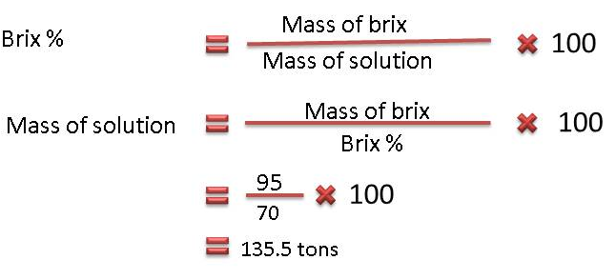
The quantity of the water to be evaporated
= mass of syrup required – mass of massecuite
= 135.5 – 100
= 35.5 tons
- If the feed to the pan is 60°Brix syrup, the quantity of syrup required to give 95 tons brix is calculated as follows:
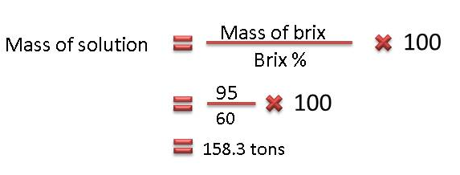
The quantity of water to be evaporated
= mass of syrup required – mass of massecuite
= 158.3 – 100
= 58.3 tons
Therefore 64% more water must be evaporated when the brix is 60 compared with 70.

5.8 HIGH VISCOSITY MASSECUITES
When the massecuites have a high non-pol content the massecuites tend to be very viscous, especially if they contain a relatively large amount of gums.
Highly viscous massecuite cannot be boiled at the optimum brix (‘tightness’) as they lose their fluidity. Since the brix cannot be increased so as keep the massecuite in the upper part of the metastable zone, the rate of crystal growth and the amount of sucrose recovered from the mother liquor is reduced. Exhaustion is thus reduced. This effect occurs periodically and is unavoidable since it is caused by components in the mother liquor which, in turn, is a function of cane quality.
Chemicals can be added to reduce the viscosity, but this is expensive and the cost of chemicals must be balanced against the reduced recovery of sucrose that results from boiling at lower brix. The temperature of the pan can also be increased slightly by lowering the vacuum (i.e. increasing the absolute pressure, but this reduces the supersaturation co-efficient).

- Knowledge Topic 7: Three Massecuite Boiling System

6.1 INTRODUCTION TO MASSECUITE BOILING
So far we have restricted our discussion to the operation of individual pans but the operation of the overall pan floor is more complex.
The amount of crystal present (crystal content) in a fluid and manageable massecuite must be less than 66%. If we were to attempt to exhaust syrup in one boiling from 80% to 30% purity, we would end up with an unmanageable viscous massecuite of ± 83 % crystal content.
Furthermore, if you have a supersaturated sugar solution with a supersaturation co-efficient of say 1.3 the best that can be done is to reduce the supersaturation co-efficient to 1.0. However, the solution will still contain a large amount of sucrose. To recover more sucrose, the crystals are recovered and water is again evaporated to make the solution supersaturated. As the supersaturated solution then returns to saturation point, more sucrose crystals are recovered.
It is therefore necessary to boil more than one grade of massecuite.
When selecting the process to be adopted the following is taken into account:
- The keeping quality of the sugar
- The refining quality of the sugar
- The amount of product recirculation (i.e. remelt)
- Flexibility and simplicity as a factory operation
- Steam consumption.
The aims during pan boiling are:
- Quality
To produce sugar of high purity, low colour and uniform crystal size
- Minimize losses
The aim is to recover the maximum amount of sugar at the desired quality. To do this, maximum exhaustion be achieve in each boiling. By doing this the quantity of massecuite boiled will be minimised. This is turn will minimize the quantity of steam used and further, will help to reduce the losses which take place in pan boilings.

6.2 THE 3-MASSECUITE BOILING SYSTEM
When syrup is boiled in a pan to produce a massecuite the crystals are separated from the mother liquor in a centrifugal to give A-sugar and A-molasses. The A molasses still contains sugar in solution which can be crystallised. Consequently a second boiling is made and the products from centrifuging this B-massecuite are B-sugar and B-molasses. In the same way B-molasses can be boiled in C-pans to give C-sugar and C-molasses (final molasses).This is called the 3-massecuite boiling system.
The quality of the sugar produced decreases from A- to B- to C-sugar. The quality of the B- and C-sugar can be increased appreciably by dissolving the sugar in water and recrystallising it. The B- and C-sugars are dissolved in the same tank (remelter) and added to the syrup so that only a single grade of sugar is produced by the factors. The practice of dissolving sugar in water in a factory is often called melting though it is actually dissolving a solute (sugar) in a solvent (water). Most South African sugar factories practice a partial remelt system in which all the C-sugar is melted but part of the B-sugar is used as footing (starting material/seed) for A-pans and only surplus B-sugar is melted. It must be noted that the cost of the recrystallization of B-or C-sugar is appreciable in terms of energy (steam) and extra equipment viz. remelter and pumps, pans and centrifugals.
In order to use B-sugar as footing for A-boilings, sugar from the B-centrifugals is mixed with a little water to make a mixture of crystals and mother liquor called B-magma. This mixing in the magma mixer removes the molasses film around the B-sugar crystals. Of course some crystal will be dissolved in making the magma. The magma is pumped to a stirred tank on the pan floor (the magma receiver) and, when required, drawn by vacuum into an A-pan so that the top tube plate of the calandria is covered. Boiling of the pan is started and fed with syrup. The resulting sugar crystals consist of a nucleus of B-sugar surrounded by a layer of A-crystal. Magma footing thus starts the A-boiling with relatively large (100 to 200 µm) B-sugar crystals.
After the B-magma footing has been “pulled” into the pan to cover the calandria, the magma is washed with water to dissolve the smaller crystals. This method of creating uniform crystals is successful because the dissolution rate of small sucrose crystals is greater than that of larger sucrose crystals. In addition, broken sucrose crystals grow on their broken surfaces (faces) so that broken crystals “repair” themselves. The results are crystals of similar size and uniform shape.
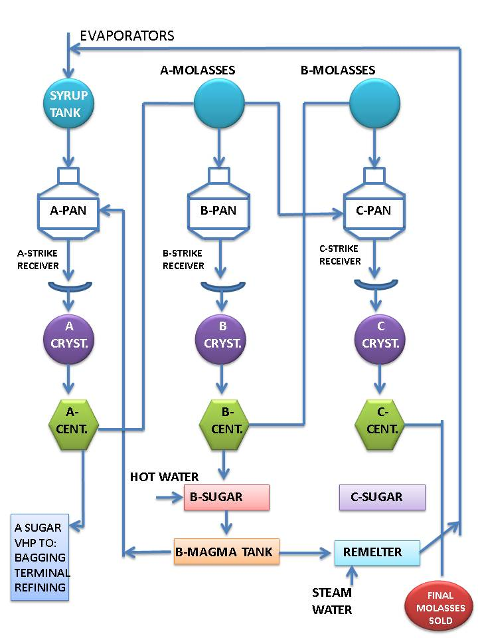
This system produces a good quality ‘A’ sugar which is suitable for export.
The quantities of massecuite produced by this system in volume per ton of brix in mixed juice are:
- ‘A’- Massecuite -1.08m³/ton brix in mixed juice
- ‘B’- Massecuite -1.04m³/ton brix in mixed juice
- ‘C’- Massecuite -1.25m³/ton brix in mixed juice
B- and C-massecuite are started by slurry seeding (graining). At the start of the season where no B-sugar is available the A-pans can also be started with slurry seeding.
One other aspect to be considered is pan graining. It has been found by experience that a purity of about 72 is ideal for graining a pan. At higher purities a less regular grain is formed while at lower purities the rate of growth is much slower.
Many factories start B-boilings by slurry seeding A-molasses which often has a purity about 70 - 72 but if the purity is say 62, syrup will be added to bring the purity up to the desired level. C-boiling is started by slurry seeding a mixture of A- and B-molasses of 70 - 72% purity. When it is desired to mix two liquors to achieve a particular purity of the mixture the quantities of each required can be calculated.
The 3-Massecuite boiling system can be summarised as follows:
C-massecuite (52% purity) is produced by slurry seeding a mixture (graining charge) of A-molasses and B-molasses and thereafter the pan is fed on B-molasses. This produces C-sugar (81% purity) and final molasses (36%). However, if the C-massecuite purity were to be, say, 45 because the B-molasses purity was very low it would be necessary to feed the C-seed on A-molasses initially and then change over to B-molasses in order to obtain the desired C-massecuite purity. If the C-massecuite purity were too low the crystal content would be too low and exhaustion would be lower than it should be. C-massecuite purity is usually in the range of 52 - 56.
The C-sugar is melted with the excess B magma and the melt (87% purity) is returned to syrup.
B-massecuite (69% purity) is produced by slurry seeding A-molasses to produce B-sugar. Some B-sugar is mixed with water and made into a magma (92% purity). B-molasses (47% purity) is produced.
A-massecuite (87% purity) is produced from the B-magma footing and syrup. This A-massecuite produces A-sugar (99% purity) and A-molasses (69% purity).
If the syrup input contains 100 parts of sucrose, approximately 90 parts will be found in sugar and 10 parts in final molasses. The graphs below show the variations of crystallization rate, sugar purity, viscosity and sucrose removal for the 3 boiling stages.
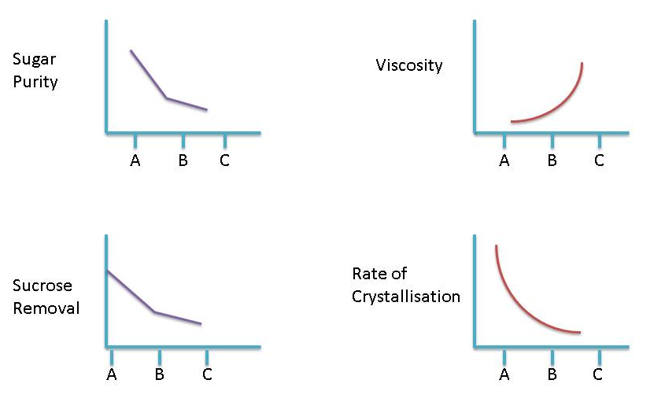
Special circumstances
- If the B-molasses purity is low, A-molasses will be used as footing for a C-boiling. The C-pan is then fed on B-molasses.
In the event of the B-molasses purity being very low, A-molasses is still used as footing for the C-boiling, but C-pan is then fed alternately on A- and B-molasses.

6.3 PAN FLOW DATA
The following diagram shows overall pan – flow data:
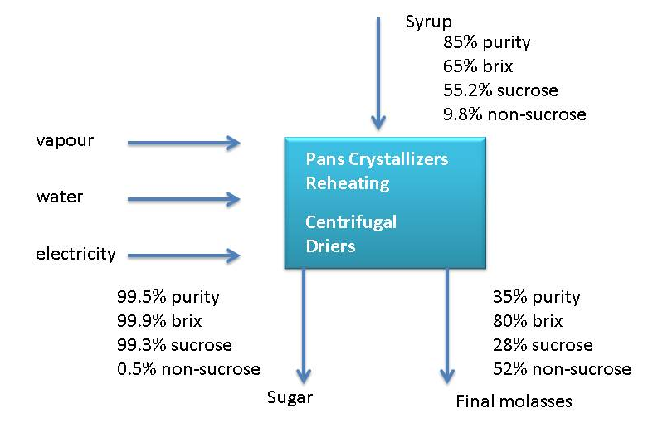
Some massecuite and molasses purities:
 | Purity | Brix | Boiling Time
Syrup | 83.5 | 65
A-massecuite | 83.5 | 95.8 | 3-4 hours
A-molasses | 65.1 | 78
B-massecuite | 66.6 | 94.8 | 4-6 hours
B-molasses | 45.2 | 78
C-massecuite | 53.8 | 96.6 | 8-10 hours
C-molasses | 34.0 | 80

6.4 CRYSTAL SIZE
Crystal size influences the exhaustion of the mother liquor as well as the curing of the massecuite and the formation of false grain. There are both advantages and disadvantages of big and small crystal. The ideal crystal size is very seldom achieved and the crystal size that is boiled is a compromise. A big grain (0.65 - 0.75mm) cures easily in the centrifugal but false grain forms easily due to the limited crystal surface area. A small grain does not cure very well, but because there is more crystal surface area, false grain doesn’t form easily. The false grain appears when the supersaturation is high and there is not enough crystal surface area for the sucrose to deposit itself on. The false grain is usually lost through the centrifugal screen with the molasses. This has the effect of raising the molasses purity. If the false grain is of a grain size that does not go between the centrifugal screen it will block the passages between the larger crystals and poor curing of the massecuite will result. This is more noticeable in batch machines.
The target grain sizes are:
- V.H.P. sugar is 0.65 - 0.77mm
- ‘B’ sugar is 0.35mm
- ‘C’ sugar is 0.15mm

6.5 TYPES OF CRYSTAL

6.5.1 False grain
“False grain” are small that formed spontaneously during the graining process of existing crystal.

6.5.2 Mixed grain
Mixed grain is a mixture of crystals of different sizes caused by false grain that is not removed but is allowed to grow.
The following can result in mixed grain:
- A too high supersaturation coefficient after seeding that allows nucleation to occur.
- Adding slurry too late after grain has formed on its own (spontaneous nucleation).
- Grain present in the feed.

6.5.3 Conglomerates
Conglomerates are three or more crystals stuck together. This happens mostly with high purities. They are caused by a high SSC immediately after seeding. Conglomerates are very problematic as they trap mother liquor and do not dry easily. Furthermore, washing in the centrifugal cannot remove this trapped mother liquor.

6.5.4 Rolled grain
Rolled grain is formed when one crystal grows through the centre of another. This happens very rarely.

6.5.5 Elongated crystal: needle grain
Needle grain is the term given to elongated grain. Elongation DOES NOT occur because the crystal is growing faster along axis, but because the crystal is not growing along the other axes.
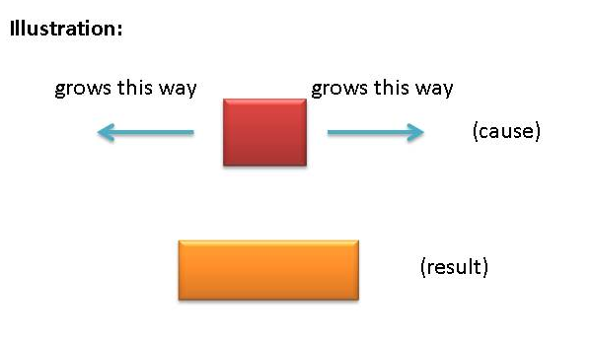
The reason for this aberration is as follows:
Due to the regular packing of sucrose molecules into the crystal, different faces of the crystal accommodate different impurities. The faces that don’t grow have an affinity for tri-saccharides that are attracted and adhere to the faces preventing further sucrose molecules from crystallizing onto this surface. Crystal elongation causes a reduced rate of crystallization. The elongated crystals are very fragile - they break and go through the centrifugal screen resulting in sucrose losses to the molasses.
The tri-saccharides which interfere with crystal formation are substituted sucroses.
- Kestoses:
These are sucrose substituted with fructose to yield G-F-F or F-G-F
- Theanderose:
These are sucrose substituted with glucose to yield G-G-F.
Needle grain makes boiling difficult and because of the limited surface area causes false grain formation. It also makes it difficult to exhaust the molasses as on curing it can go through the centrifugal screen causing high molasses purities.

6.5.6 Soft grain
Soft grain is formed in the pan during boiling. The corners of the crystal are rounded off due to:
- Poor circulation
- Low vacuum (relatively high absolute pressure) and resultant low supersaturation coefficient.
High boiling level which reduces circulation. Soft grain can be hardened by improving the circulation. Soft grain crumbles in centrifugals causing dust and reducing the yield as fragments end up in the molasses causing a purity rise.

6.6 VISCOSITY
Viscosity is the resistance to flow. Viscosity can affect ‘A’ and ‘B’-massecuites but will have more of an effect on ‘C’-massecuites. Viscosity in massecuites is caused by a high non-pol content (mainly waxes and gums).This usually happens when the cane is stale and sucrose deterioration has taken place. In certain cases raising purities can help overcome the viscosity problem but this does not help the exhaustion of the massecuite. When viscosity problems are encountered the following should be remembered
- Extra care is needed when seeding as viscosity will affect the feel of the slurry addition point.
- Slow down the boiling by using movement water. Viscosity slows down the diffusion rate, so by slowing down the boiling there will be more time for the sucrose molecules to move across to the crystals.
- Do not reduce the steam as this will reduce the temperature which will increase the viscosity.
- Boiling at a slightly higher temperature will reduce viscosity. This temperature must not be too high as false grain will form when the massecuite is cooled before striking.
- Chemicals can be added to reduce the viscosity.

6.7 MASSECUITE BRIX AT STRIKE
The brix of the massecuite at strike is governed by:
- Pan discharge door size and design
- Pan gutters
- Crystallizer design
- Massecuite pumps
Maximum exhaustion of massecuites is only possible with high brixes. High brixes also save time and fuel as less steam is needed in the later stages of boiling where the efficiency is low. Low massecuite brixes could mean that up to 30% more massecuite would have to be boiled.
Brix of strikes encountered in a raw sugar factory:
- A strike = 90 - 94°Bx
- B strike = 92 - 97°Bx
- C strike = 95 - 99°Bx
Brix of syrup, and A and B molasses is between 55 and 70°Brix.

Pan floor brix balance
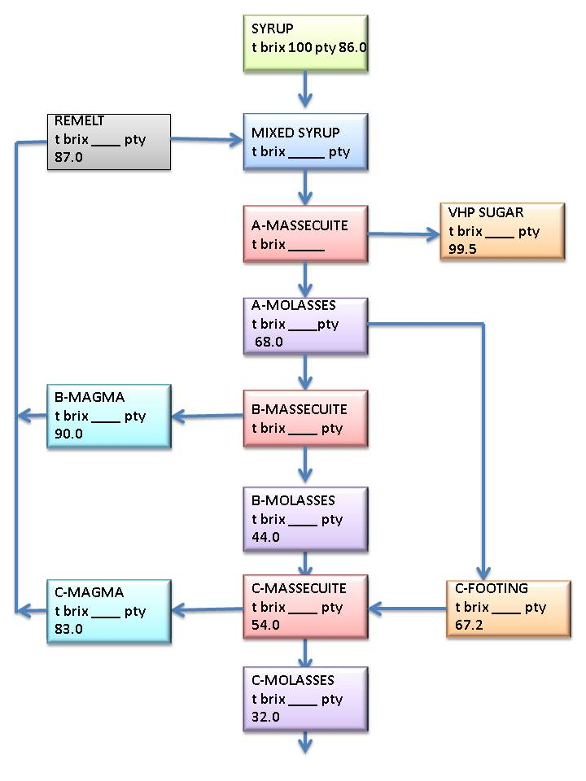

The following table lists some pan floor data:
 | BOILING GRADE
 | Refined | A-massecuite | B-Massecuite | C-massecuite
Massecuite purity | 99.9 | 86 | 70 | 54
Molasses purity | 99.6 | 66 | 45 | 32
Masssecuite brix | 92 | 93 | 95 | 97
Exhaustion | 60 | 68 | 65 | 60
Crystal content | 55 | 55 | 43 | 31
Purity drop | 0.3 | 20 | 25 | 22

Effect of massecuite brix on quantity of massecuite
High | ‘A’ Massecuite brix | low
less | ‘A’ Molasses | more
Less | ‘B’ Massecuite | more
High | ‘B’ Massecuite brix | low
Less | ‘B’ Molasses | more
Less | ‘C’ Massecuite | more
High | ‘C’ Massecuite brix | low
Less | ‘C’ Molasses | more
Good | Exhaustion | bad

- Knowledge Topic 8: Mixture Calculation

7.1 INTRODUCTION
As mentioned previously a purity of about 72% is ideal for graining a pan. When it is desired to mix two liquors of different purities to obtain a mixture of given purity, the relative quantities need to be calculated using mixture calculations.

7.2 USING FORMULAE
Consider the case where a feed of high purity is mixed with a feed of lower purity to give a mixture of a certain purity.
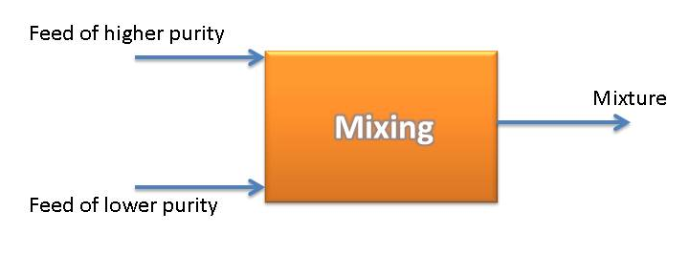
The following formulae apply:
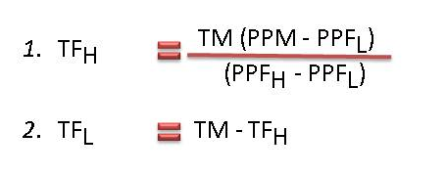
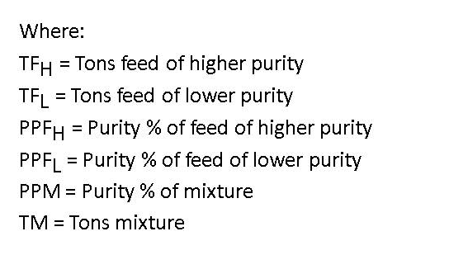
Example:
A molasses of purity 74% and B-molasses of purity 45% must be blended to prepare 100 tons of mixture at 72% purity. Find the amounts of each molasses required.
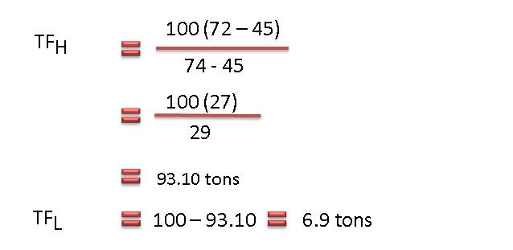

7.3 USING THE COBENZ DIAGRAM
The Cobenz diagram conveniently summaries the calculation performed in 7.2 above.
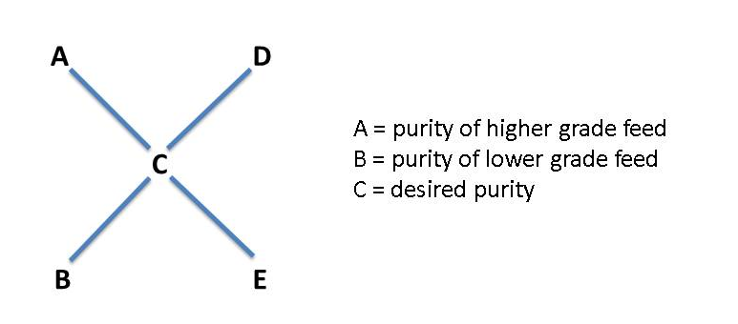
Thus: D = C – B (D = higher grade feed relative quantity)
E = A - C (E = lower grade feed relative quantity)
Example:
A-molasses of purity 74% and B-molasses of purity 45% must be blended to prepare 100 tons of mixture at 72% purity. Find the amounts of each molasses required.
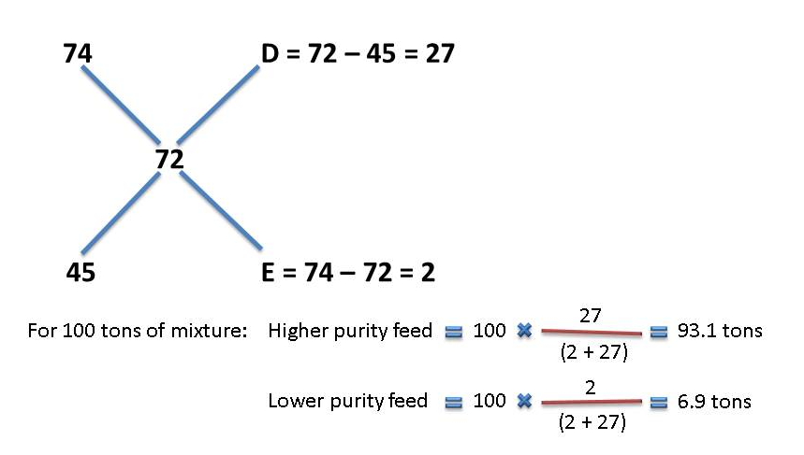
Note:
Instead of the mass of mixture that needs to be prepared we can use the volume of mixture that must be prepared. Using the Cobenz diagram we will determine the relative volumes of feed that must be combined.

- Knowledge Topic 9: Continuous Pan Boiling

8.1 DESIGN OF A CONTINUOUS PAN AND BASIC OPERATION
Continuous pans are divided into a number of cells/compartments (usually 12) that are separated from each other. The massecuite in each compartment is heated by steam fed to a calandria. The large calandria stretches throughout the pan.
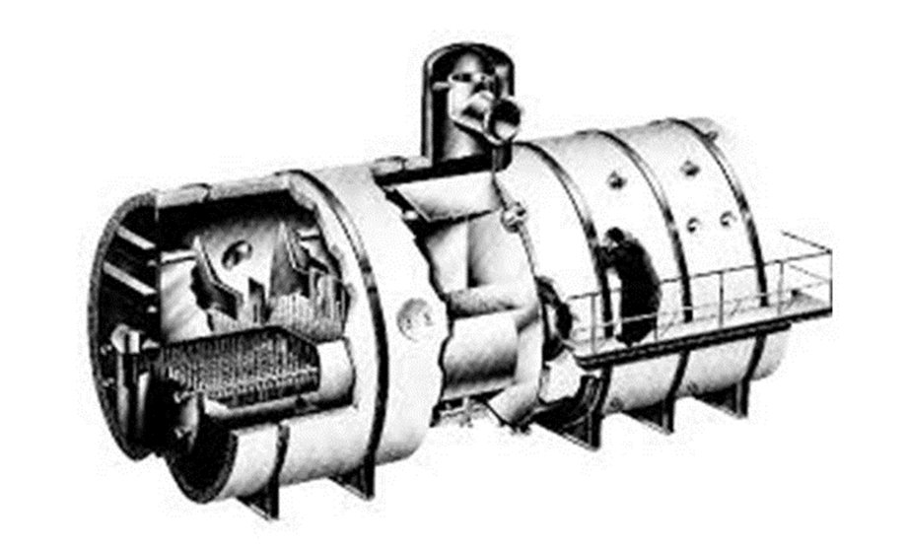
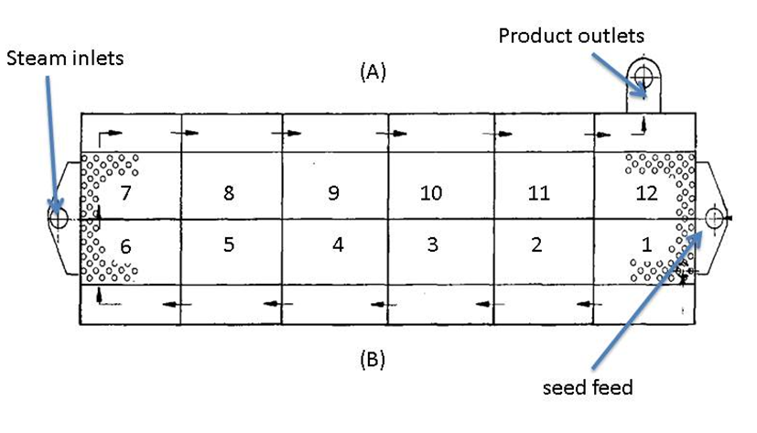

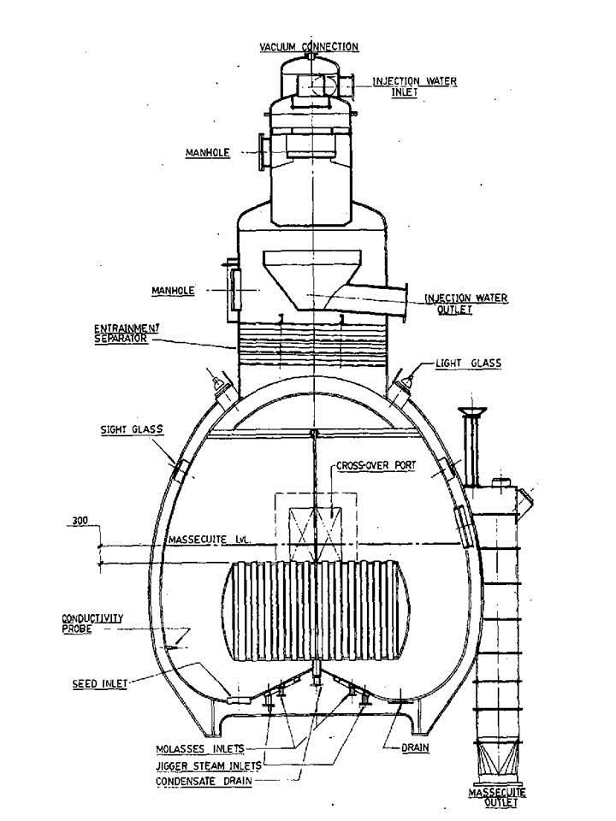
Seed massecuite is pumped into the first compartment of the continuous pan. The massecuite overflows from one compartment to the next via a weir. The flow of massecuite is driven by the flow of seed massecuite into the first compartment. Each compartment has a feed system to supply molasses (syrup in the case of a continuous A-pan), water or steam. As the massecuite flows towards the last compartment, crystals grow on the sucrose supplied in the feed. At any point in time the massecuite in the different compartments is at different stages in its change from seed to fully developed massecuite at the discharge end. As the massecuite progresses each subsequent compartment is set at a higher brix to maintain the massecuite in the metastable zone. The brix in each compartment is usually measured using a conductivity probe and is automatically controlled by varying the feed to that compartment.
The following table and graph shows the brix profile for the different compartments of a continuous C-vacuum pan as measured by conductivity probes.
Control compartments | Brix of massecuite | Conductivity set point
1 | 90.9 | 59
2 | 91.3 | 58
3 | 92 | 53
4 | 93 | 48
5 | 94 | 44
6 | 95 | 40
7 | 96 | 22

The low conductivity in the last cell is due to the “brixing up” that is necessary before discharging the massecuite to crystallisers.
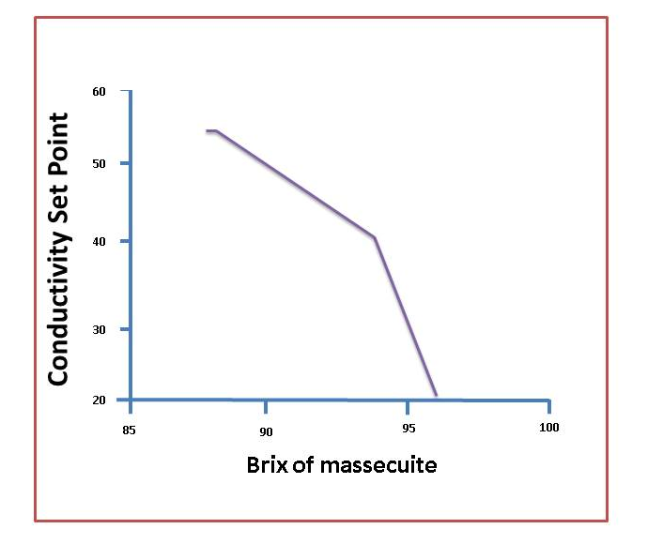
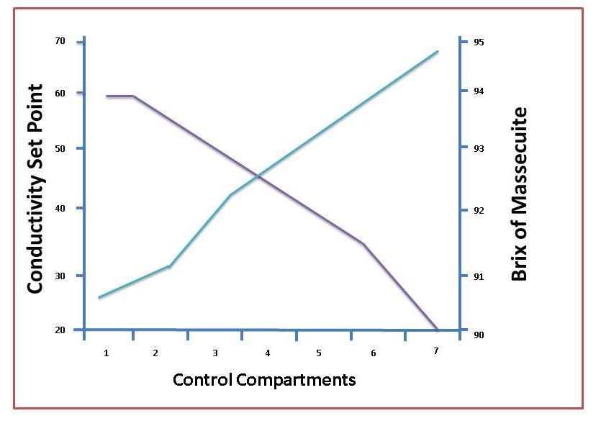
Note:
- In this case every second compartment is monitored for control purposes.
- The brix curve above is based on a massecuite purity of 53%. If the purity decreases the brixes of each cell must be increased to maintain optimum boiling conditions and vice versa.

8.2 PAN CONTROL
- Once a day, samples of the massecuite in the different control compartments are taken and sent to the laboratory for brix analysis. The results are plotted and compared with the target values.
If the brix of a particular cell is too low (i.e. the massecuite is ‘slack’), the conductivity set point of that cell is reduced so that the brix will increase. If the brix of a particular cell is too high (i.e. the massecuite is too ‘tight’), the conductivity set point of that cell is increased so that the brix will reduce.
- Each cell is also regularly checked for its feel (slack/tight) and for the presence of false grain.
If false grain has formed in a cell, the brix of the preceding cell is reduced by increasing its conductivity set point.
- The crystal content of all cells must also be checked periodically. The crystal content must be kept between 30 - 33%.
If the crystal content is low, the rate that seed massecuite is fed to the first compartment must be increased and vice versa.
The seed for a continuous pan is grown in a pan which is a batch pan using graining with slurry. A continuous pan is continuously fed with seed into its first compartment.
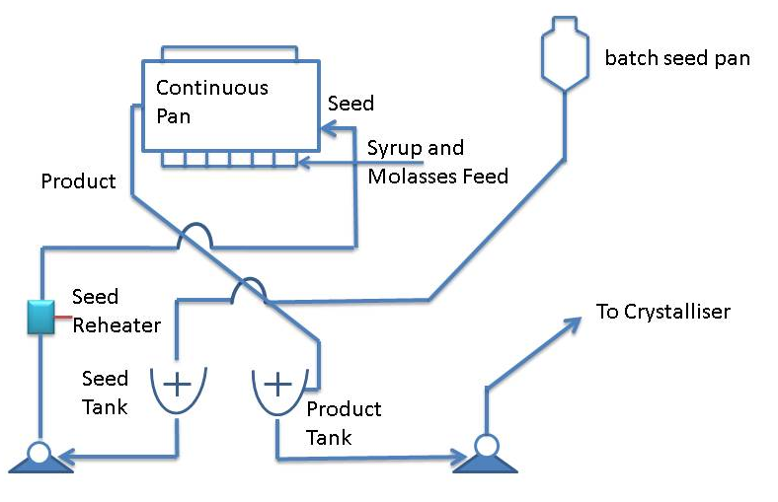
An A-continuous pan is fed with B-magma. Since this seed contains some small crystals; the feed is washed in the first few compartments by adding water to dissolve these small crystals.
A major difference between batch and continuous pans is the difference in hydrostatic head of the massecuite. In a continuous pan the hydrostatic is small and remains constant. The difference in temperature between the top and bottom of the massecuite is thus small.

- Knowledge Topic 10: Control Formulae

9.1 CRYSTAL CONTENT OF THE MASSECUITE
To control the operation of the pan floor and ensure maximum recovery of sucrose, we need to calculate certain performance parameters.
Crystal content is the mass of crystals as a percentage of the mass of massecuite.
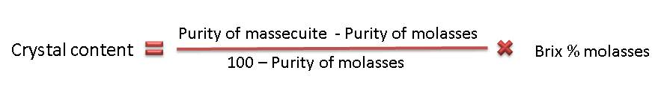
It is obviously desirable to maximize the crystal content of a massecuite but there are certain factors that limit crystal content:
- Impurities
- Viscosity/handling – the viscosity increases as the crystal content increases. The crystal content can thus not be too high or the massecuite cannot be handled in the factory.
In the raw house impurities limit the crystal content, while in refineries the viscosity /handling limits the crystal content.
In the raw house the crystal content is as follows:
- A-massecuite 55
- B-massecuite 43
- C-massecuite 30-35
In refineries the crystal content can be as high as 50%.

9.2 EXHAUSTION
This gives the amount of crystals of sucrose recovered as a percentage compared to the amount of sucrose available.
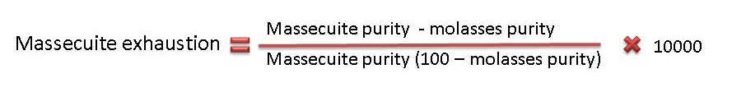
The normal exhaustions obtained in South African factories are:
- A-massecuite (typically 68%
- B-massecuite (typically 65%)
- C-massecuite (55 - 60%)
The factor (purity massecuite – purity molasses) or “massecuite purity drop” is important to exhaustion. In general, the greater the purity drop the better the exhaustion.
Factors that affect exhaustion
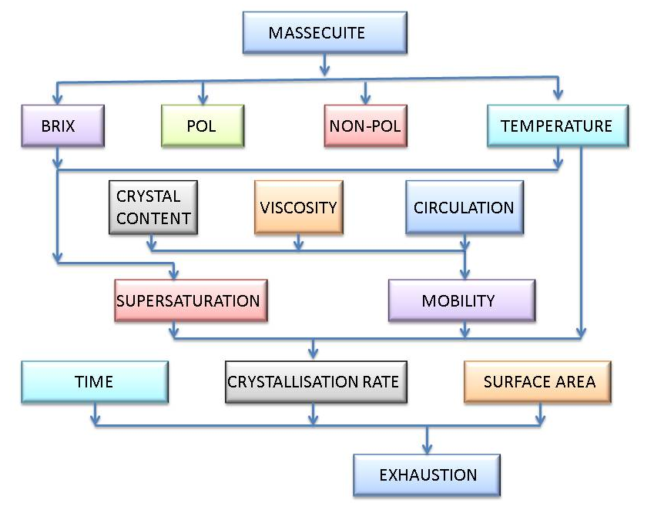

9.3 SJM FORMULA
This formula gives the % recovery of sucrose from a given feed, where sugar and molasses are made.
It ignores all losses except to molasses.
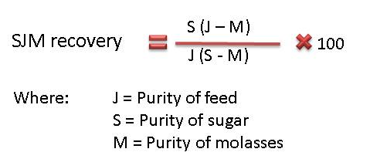
The SJM formula can be applied to all the following cases:
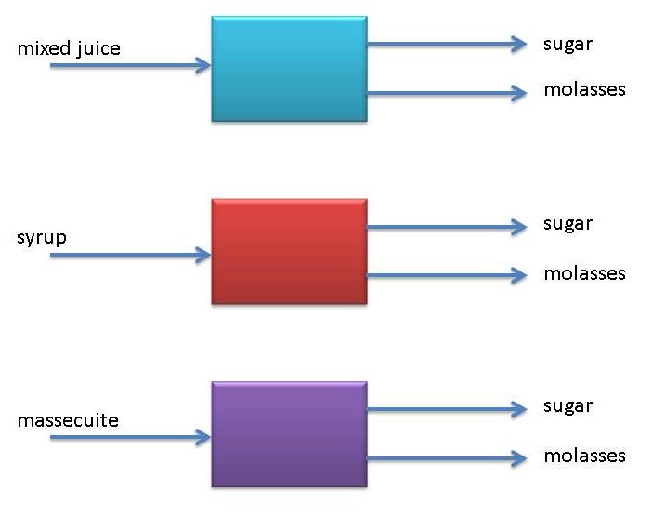
Example:
Calculate the SJM recovery if the syrup purity is 85%, the sugar purity 99.5 % and the purity of the molasses is 35%.
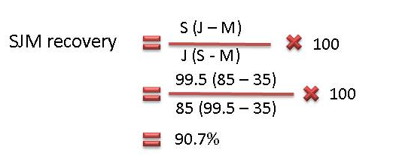
This means that 90.7% of the sucrose in syrup has been recovered in sugar.

