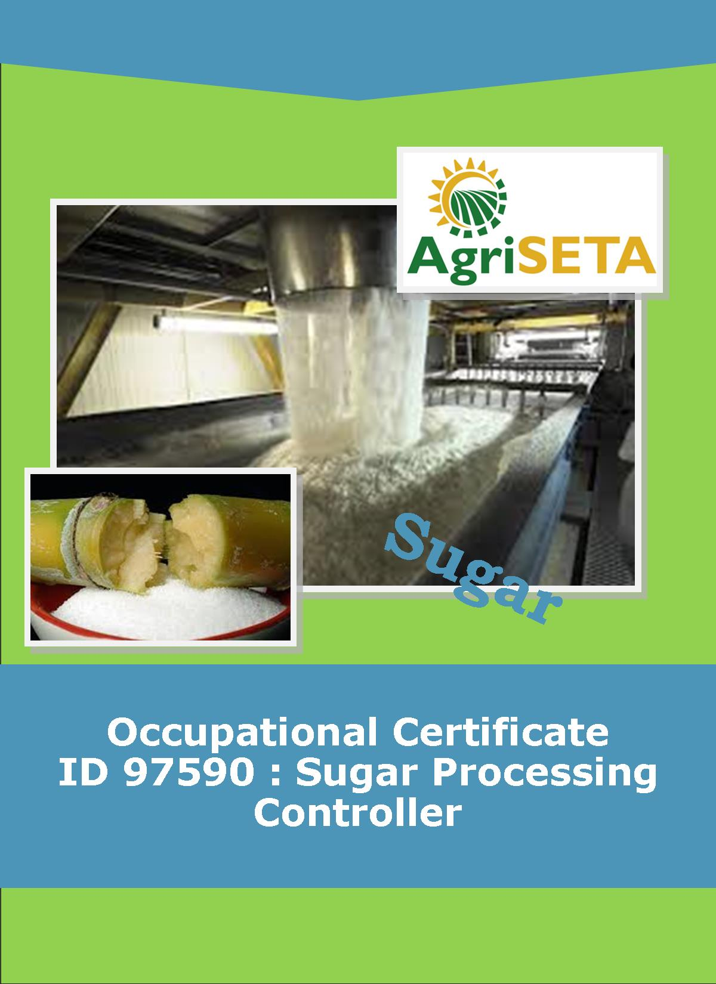
KNOWLEDGE COMPONENT: FACILITATOR FORMATIVE AND SUMMATIVE ASSESSMENT TOOLS AND MODEL ANSWERS : KNOWLEDGE MODULE 8 : CRYSTALLISATION, CENTRIFUGING AND DRYING
Occupational Certificate: Sugar Processing Controller

KNOWLEDGE COMPONENT: FACILITATOR FORMATIVE AND SUMMATIVE ASSESSMENT TOOLS AND MODEL ANSWERS : KNOWLEDGE MODULE 8 : CRYSTALLISATION, CENTRIFUGING AND DRYING
KNOWLEDGE COMPONENT: FACILITATOR FORMATIVE AND SUMMATIVE ASSESSMENT TOOLS AND MODEL ANSWERS : KNOWLEDGE MODULE 8 : CRYSTALLISATION, CENTRIFUGING AND DRYING
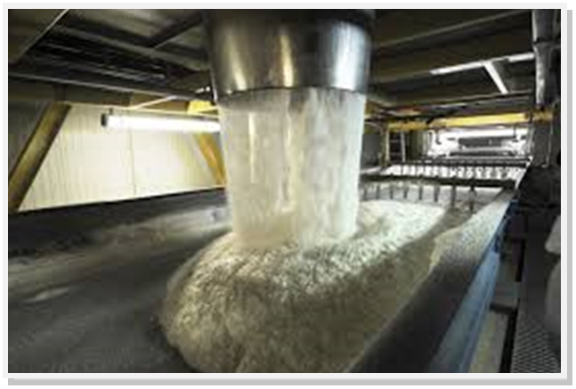
OCCUPATIONAL CERTIFICATE: SUGAR PROCESSING CONTROLLER

©Copyright AgriSETA
Telephone: +27 12 301 5600


AgriSETA holds the copyright to its publications and Web pages. Proper citation is requested.

TABLE OF CONTENTS
1. INTRODUCTION TO THE FACILITATOR ASSESSMENT TOOLKIT OF THE OCCUPATIONAL CERTIFICATE: SUGAR PROCESSING CONTROLLER 6
2. KNOWLEDGE MODULE 8: CRYSTALLISATION, CENTRIFUGING AND DRYING 7
2.1 Knowledge Topic 1: Theory of cooling crystallisation (20%) 8
2.2 Knowledge Topic 2: Crystalliser type and layout (10%) 11
2.3 Knowledge topic 3: Massecuite reheating (10%) 13
2.4 Knowledge topic 4: Theory of centrifuging (15%) 15
2.5 Knowledge topic 5: Exhaustion (5%) 21
2.6 Knowledge topic 6: Theory of sugar drying (10%) 24
2.7 Knowledge topic 7: Sugar driers (5%) 26
2.8 Knowledge topic 8: Sugar conditioning (5%) 28
2.9 Knowledge topic 9: Raw sugar quality (5%) 30
2.10 Knowledge topic 10: Problems experienced during crystallisation and separation (15%) 32
3. CONCLUSION OF KNOWLEDGE MODULE 8: CRYSTALLISATION, CENTRIFUGING AND DRYING 34
4. SUMMATIVE ASSESSMENT ACTIVITIES AND MODEL ANSWERS 35
5. WRITTEN ASSESSMENT 36
6. Written Assessment Total Marks 48

INTRODUCTION TO THE FACILITATOR ASSESSMENT TOOLKIT OF THE OCCUPATIONAL CERTIFICATE: SUGAR PROCESSING CONTROLLER
Dear Facilitator
This Toolkit has been created to assist you to assess the Formative Learning Activities of learners undertaking the NQF 5 Occupational Certificate: Sugar Processing Controller Qualification.
During the programme, Learners must be directed to their Learning and Activities Guide to complete Learning Activities associated with each module of the Knowledge Component.
The time allocated to the Learning Activities is provided in the Facilitator’s Implementation Guide, this Facilitator Assessment Toolkit and Model Answers and the Learning and Activities Guide.
The marks allocated to each Learning Activity is provided in this Facilitator Assessment Toolkit and Model Answers and the Learning and Activities Guide.
Instructions to be given to Learners
- They must work individually to present the results of each Learning Activity in each of the Learning and Activities Guides (Workbooks).
- They must complete all the sections.
- They must use a black pen and ensure that they complete the questions in their own handwriting.
- The time provided to complete each activity is shown.
- The marks they will attain for each learning activity are shown in brackets.

KNOWLEDGE MODULE 8: CRYSTALLISATION, CENTRIFUGING AND DRYING
NQF LEVEL: 4
CREDITS: 4
PURPOSE OF THE KNOWLEDGE MODULE: The main focus of the learning in this knowledge module is to build an understanding of the theory and science of sugar crystallisation, centrifuging and drying.
The learning will enable learners to demonstrate an understanding of:
- KM-08-KT01: Theory of cooling crystallization (20%)
- KM-08-KT02: Crystalliser type and layout (10%)
- KM-08-KT03: Massecuite reheating (10%)
- KM-08-KT04: Theory of centrifuging (15%)
- KM-08-KT05: Exhaustion (5%)
- KM-08-KT06: Theory of sugar drying (10%)
- KM-08-KT07: Sugar driers (5%)
- KM-08-KT08: Sugar conditioning (5%)
- KM-08-KT09: Raw sugar quality (5%)
- KM-08-KT10: Problems experienced during crystallization and separation

2.1 Knowledge Topic 1: Theory of cooling crystallisation (20%)
Topic elements to be covered include:
- KT0101 Rate of cooling
- KT0102 High and low purity crystallisation
- KT0103 Crystal size and content
- KT0104 Viscosity
- KT0105 Massecuite data
Internal Assessment Criteria and Weight
- IAC0101 An understanding of crystal growth during the cooling cycle can be demonstrated
- IAC0102 The relationship between crystal growth and final product quality can be explained
- (Weight 20%)
Learning activity 1.1: Individual Learning activity: 15 minutes (10marks)

Learning Objective: An understanding of crystal growth during the cooling cycle can be demonstrated.
Task: Read each question carefully and write your answer in the space provided.
1. What are the advantages of stirring and cooling? (4)
By stirring, the massecuite is kept in continual motion so that the sugar crystals continually come into contact with fresh mother liquor.
Cooling thus increases or maintains the supersaturation coefficient to continue crystal growth.

2 Discuss the 3 factors affecting the rate of crystallisation in a crystalliser. (6)

Sufficient crystal surface: Provided there is sufficient crystal surface area the rate of crystallisation will keep pace with the cooling rate, so false grain formation is unlikely. There is a chance though, of forming false grain when a hot massecuite is dropped into a cold crystalliser.

Maintenance of a sufficient supersaturation coefficient: The crystallisation rate will slow down as the temperature decreases because of viscosity. The rate of cooling must be limited to keep the supersaturation of the mother liquor in the metastable zone to avoid false grain formation.

Sufficient cooling time: There must be enough time available to reduce the temperature and maintain a sufficient SSC and not to reduce the temperature too quickly and increase the SSC sufficiently to form false grain.

Learning activity 1.2: Individual Learning activity: 20 minutes (18marks)
Learning Objective: The relationship between crystal growth and final product quality can be explained.
Task: Read each question carefully and write your answer in the space provided.
- Discuss the effect of viscosity on the rate of crystallisation(4)
Since viscosity increases as temperature decreases, viscosity will limit the degree of cooling that the crystalliser can handle and it will also affect the curing operation at the centrifugal. Viscosity will increase with a decrease in purity. Final molasses can have a viscosity up to 400 times greater than a saturated sucrose solution under the same conditions. Viscosity will vary according to the nature of the impurities. Viscosity is the limiting factor for crystallisation (and hence exhaustion) in C-massecuites. In addition, viscosity also affects centrifugal performances.

- Why does A-massecuite require less crystalliser time than C-massecuite?(4)
Exhaustion of C–massecuite mother liquor is very important (much more than for A-massecuite) because C-molasses leaves the factory and the sucrose it contains is lost. In C-massecuites the crystallisation rate is slowest but it is the last chance to recover sucrose. C-massecuites therefore spend a long time in the crystallisers.

- Discuss the factors that will affect the crystallisation of low purity massecuites.(6)
The crystallisation of low purity massecuites depends on:
- Crystallisation rate which depends on crystal content and surface area. Crystal size uniformity must therefore be optimised.
- Viscosity of molasses which will affect centrifugal performance.
Good mother liquor exhaustion requires work to be done in the pans, crystallisers and centrifugal.

- What are the massecuites residence times (4)
A – crystalliser 2 - 3 hours
B – crystalliser 7 - 8 hours
C – massecuite + 36 hours

2.2 Knowledge Topic 2: Crystalliser type and layout (10%)
Topic elements to be covered include:
- KT0201 Heat transfer
- KT0202 Speed of rotation
- KT0203 Drives
- KT0204 Cooling element corrosion
Internal Assessment Criteria and Weight
- IAC0201 Types of equipment can be identified and purpose of equipment components explained
- (Weight 10%)

Learning activity 2.1: Individual Learning activity: 15 minutes (12marks)
Learning Objective: Task: Types of equipment can be identified and purpose of equipment components explained.
1. Describe and sketch a crystalliser used at your factory? (8)
A learner may describe and sketch any type of crystalliser used on his/her factory.

2. What effect does the speed of rotation have on crystallisation rate? (2)
An increase in speed does little to improve crystallisation rate. This is fortunate as the load on the driving gear at increased speeds would be excessive.

3. What can be done to minimise cooling element corrosion? (2)
A closed cooling system treated with chemicals is advisable to minimise corrosion. Keeping the pH above 10 with caustic or the use of potassium dichromat will help.

2.3 Knowledge topic 3: Massecuite reheating (10%)
Topic elements to be covered include:
- KT0301 Application (When and why)
Internal Assessment Criteria and Weight
- IAC0301 The effects of crystallization can be assessed
- (Weight 10%)

Learning activity 3.1: Individual Learning activity: 30 minutes (12marks)
Learning Objective: Task: The purpose of vacuum and pressure in evaporation process can be explained.
1. Why is reheating of low purity massecuites necessary after cooling? (2)

Reheating is essential to reduce the viscosity of the massecuite for centrifugation.

2. Describe the various methods of reheating massecuite. (6)

Crystalliser heating: This is achieved by circulating warm water through the cooling elements. Ideally the water temperature should not be more than 2°C above saturation temperature. The heating should be as rapid as possible and with immediate curing molasses losses can be kept to a minimum.

Reheaters: Reheaters are either of the overflow or totally enclosed type. They have banks of tubes which are either staggered or in line. Heating water is pumped through the tubes from a heater which is temperature controlled. The water inlet temperature is about 7°C above that of the massecuite outlet temperature.
The heating elements of the reheater can be fixed or rotating. When the reheater is filled with massecuite, it is always filled from the bottom to ensure proper/complete filling. The temperature to which the massecuite is reheated will change during the season due to the changing massecuite viscosity. For example, unseasonal rain in October leads to a decrease in cane purity and to an increase in viscosity. The reheating temperature must thus be higher.

Resistance heaters: These heaters are situated in the feed pipe to the centrifugal and the massecuite is heated by electrodes supplied with +25kW of power.

3. How do we measure the work done in crystallisers? (2)
To assess the performance of the crystallisers the effect that the crystallisers have had on the mother liquor in the massecuite needs to be ascertained.

4. Define a “Nutsch” sample (2)
It is the sample of mother liquor.

2.4 Knowledge topic 4: Theory of centrifuging (15%)
Topic elements to be covered include:
- KT0401 Batch centrifugal operation
- KT0402 Continuous centrifugal operation
Internal Assessment Criteria and Weight
- IAC0401 Principles of centrifuging can be explained
- IAC0402 An understanding of the impact of centrifuging process on quality – cause and effect – can be demonstrated.
- (Weight 15%)

Learning activity 4.1: Individual Learning activity: 30 minutes (17marks)
Learning Objective: Principles of centrifuging can be explained
Task: Read each question carefully and write your answer in the space provided.
1. Make a simple sketch of a batch centrifugal, naming its main parts (8)
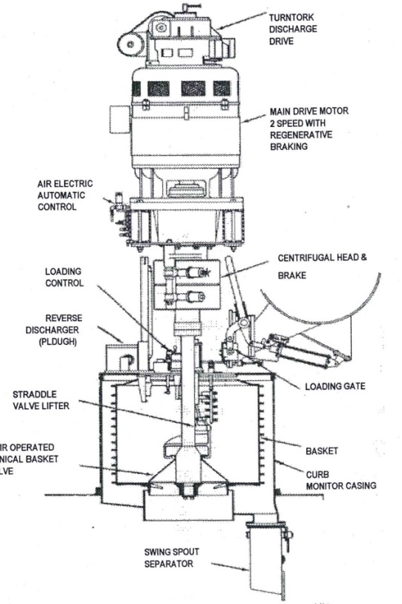

2. List the stages in which molasses is separated from crystals in a massecuite. (9)
- Gravity factor
- Time
- Viscosity of mother liquor
- Thickness of Sugar Layer
- Massecuite Quality
- Use of Steam and Water
- Screen Condition
- Machine Condition
- Competency of operator

Learning activity 4.2: Individual Learning activity: 10 minutes (6marks)
Learning Objective: An understanding of the impact of centrifuging process on quality – cause and effect – can be demonstrated.
Task: Read each question carefully and write your answer in the space provided.
- Describe typical batch centrifugal/ machine? (1)
A typical batch centrifuge is a large perforated drum with an internally fitted, perforated screen, all suspended at the bottom of a vertical spindle.

2. What are the 3 stages of removal of molasses? (3)
- Removal of the excess liquid
- Draining of the molasses between the crystals except for a thin film on
- Reduction of the film thickness

3. How can the performance of a centrifugal be assessed? (2)
The single most important factor in centrifuge performance is the force generated when spinning the basket at full speed.

Learning activity 4.3: Individual Learning activity: 1 hour (19 marks)
Learning Objective: An understanding of the impact of centrifuging process on quality – cause and effect – can be demonstrated.
Task: Read each question carefully and write your answer in the space provided.
- With the aid of a sketch, describe the construction of a continuous centrifugal.(8)

The BMA continuous centrifugal
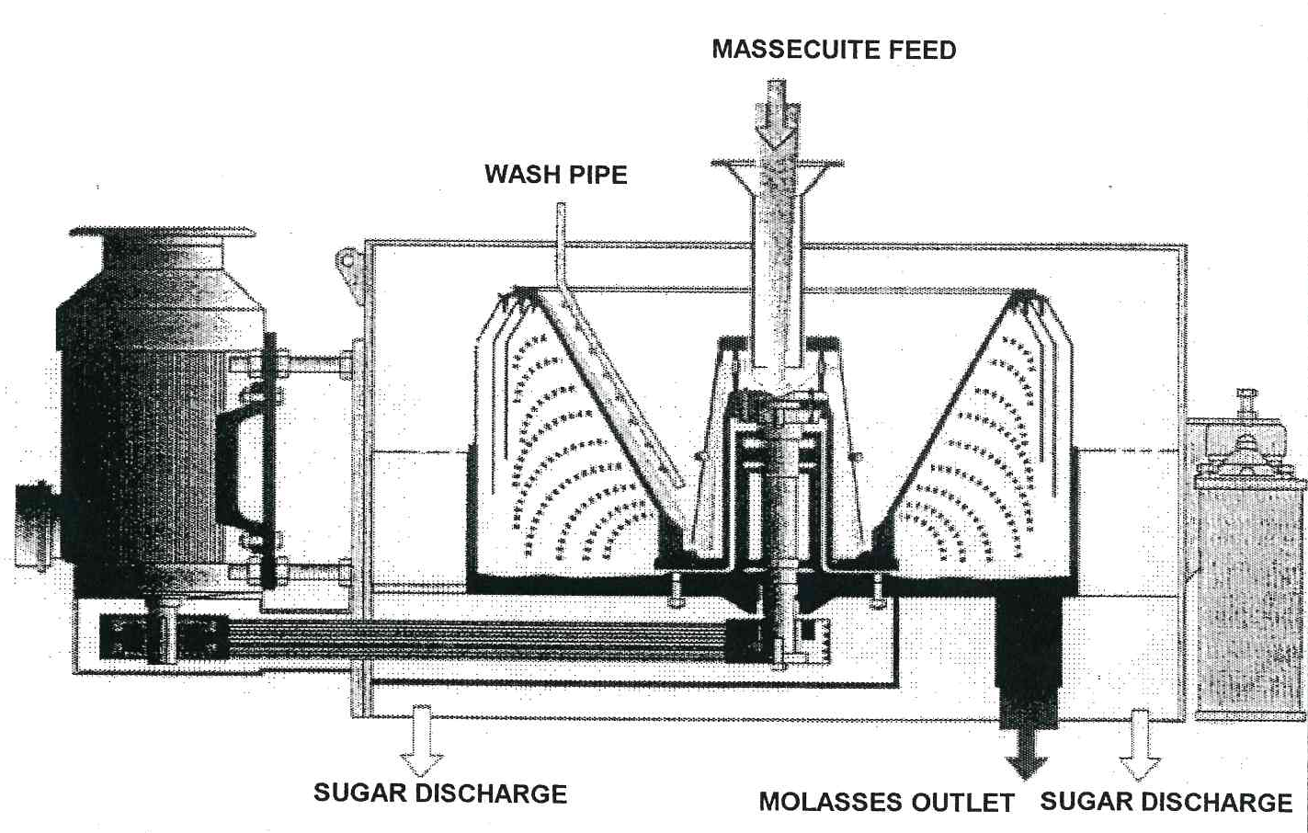

The Western State continuous centrifugal
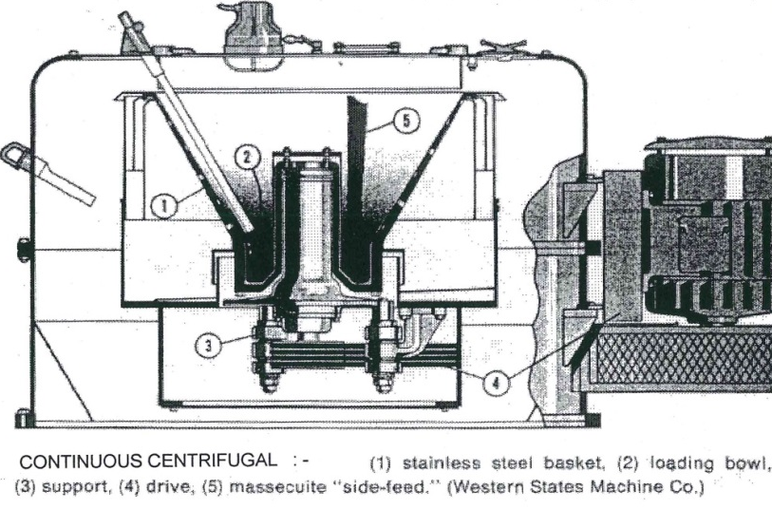
A continuous centrifugal consists of the following basic parts:
- The basket
- The acceleration cup
- The screen
- The feed system
- The sugar–collecting monitor casing
- The molasses–collecting casing
- The drive system and various controls

- What are the advantages of continuous centrifugal?(4)
- Reduced power demand
- Reduced initial cost
- Better safety
- Easier maintenance

- What are the slot widths for A-, B- and C- sugar screens? (3)
A=?
B=0.09mm
C=0, 06 mm wide.

- Name any 4 different makes of continuous centrifugal machines(4)
- Silver Weibull (USA)
- Fives-Lille (France)
- BMA (Germany)
- Western States (USA)
- Broadbent (England)

2.5 Knowledge topic 5: Exhaustion (5%)
Topic elements to be covered include:
- KT0501 Theory and calculations
- KT0502 Target purity
Internal Assessment Criteria and Weight
- IAC0501 An understanding of the impact of exhaustion on factory performance can be demonstrated
- IAC0502 Formula selection and use, calculations and data interpretation is performed correctly
- (Weight 5%)

Learning activity 5.1: Individual Learning activity: 10 minutes (6marks)
Learning Objective: An understanding of the impact of exhaustion on factory performance can be demonstrated
Task: Read each question carefully and write your answer in the space provided.
- What are the two non-sugars which are reducing sugars.(2)
(glucose and fructose) and ash

2. What is the influence of reducing sugar and ash on exhaustion? (Refer to solubility) (4)
Sucrose solubility is decreased by reducing sugars.
Sucrose solubility is increased by ash.

Learning activity 5.2: Individual Learning activity: 20 minutes (14marks)
Learning Objective: Formula selection and use, calculations and data interpretation is performed correctly
Task: Read each question carefully and write your answer in the space provided.
- What is a TPD and what is it used for? (2)
A target purity difference is calculated to give factory staff an idea of the extent to which the molasses has been exhausted of its sucrose. The TPD thus gives an indication of the performance of the C-station.

2. What is the formula for TPD? (2)
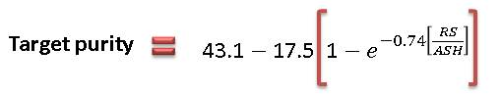

3. Consider the following TPD’s and state what the value indicates and if such a TPD value is possible? (6) (To be done in class)
(a) 2
(b) 0
(c) -1

2.6 Knowledge topic 6: Theory of sugar drying (10%)
Topic elements to be covered include:
- KT0601 Raw and refined sugars
- KT0602 Washed sugars
- KT0603 Micro organisms
- KT0604 Chemical treatment
- KT0605 Moisture control during storage
- KT0606 Deterioration in bulk
Internal Assessment Criteria and Weight
- IAC0601 An understanding of the sugar drying process can be demonstrated
- IAC0602 Critical control points can be listed and explained
- IAC0603 The impact on sugar quality and handling can be explained
- (Weight 10%)

Learning activity 6.1: Individual Learning activity: 20 minutes (13marks)
Learning Objective: An understanding of the sugar drying process can be demonstrated
Task: Read each question carefully and write your answer in the space provided.
1. Why does sugar need to be dried? (2)
To prevent the growth of micro-organisms which would cause deterioration and loss of sugar during storage?

- Name 3 significant groups of micro-organisms that may cause deterioration. (3)
The Mould Fungi
Osmophilic Fungi
Sporangeous Bacteria

3. What is the safety factor of sugar used for and how is it calculated. (2)
To control the moisture content of the sugar
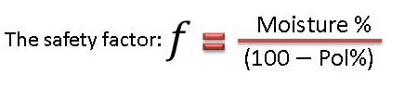

4. Name the drying mechanism (6)

Evaporation: Free water in the exposed surface film evaporates if the partial pressure of water in surrounding air is low enough.
Diffusion: Bound water diffuses through the amorphous layer due to water concentration gradient.

Crystallisation: Sucrose in the bound film crystallises due to supersaturation making water available for diffusion.

2.7 Knowledge topic 7: Sugar driers (5%)
Topic elements to be covered include:
- KT0701 Calculations
- KT0602 Types of driers
Internal Assessment Criteria and Weight
- IAC0701 The impact on sugar quality and handling can be explained
- IAC0702 Formula selection and use, calculations and data interpretation is performed correctly.
- (Weight 5%)

Learning activity 7.1: Individual Learning activity: 15 minutes (10marks)
Learning Objective: The impact on sugar quality and handling can be explained.
Task: Read each question carefully and write your answer in the space provided.
1. Briefly describe the operation of: (10)
(a) A rotary drum drier
The rotary cascade drier is the most common type of drier and consists of a rotating drum mounted at a small angle to the horizontal. Inside the drier are fixed vanes which pick up the sugar and drop it repeatedly from the top to bottom of the drier in a shower which should be as uniform as possible. The sugar moves down the drier while air is blown or drawn through the drier either counter-current or co-current to the flow of sugar.
(b) A fluidized bed drier
A fluidized bed drier/cooler is a vertical cylinder divided into an upper and lower compartment by a perforated plate. Both of these compartments are sub-divided vertically to give separate drying and cooling zones. A forced draught fan supplies air, some of which goes through a heat exchanger to provide hot air for drying. The wet sugar enters the drying zone and is fluidized by the hot air passing through the perforated plate. After drying the sugar passes through to the cooling zone where it is again fluidized by ambient air.
(c) A dust separator
The air drawn through the drier picks up a certain amount of fine sugar dust. This dust would be lost if a separator was not used. The separator could be either a centrifugal or cyclone type which separates the crystals either dry or dissolved in water. The air should be drawn through the separator rather than blown through, as any leaks would then be inwards instead of blowing sugar dust out. If a wet separator is used precautions must be taken to prevent the growth of micro-organisms in the water as this can also constitute a loss of sugar. Chemicals can be used to kill the bacteria or a once through system could be used.

2.8 Knowledge topic 8: Sugar conditioning (5%)
Topic elements to be covered include:
- KT0801 Why sugar cakes
- KT0802 Conditioning and data
- KT0803 Factors influencing conditioning
Internal Assessment Criteria and Weight
- IAC0801 An understanding of the sugar conditioning process can be demonstrated.
- IAC0802 The theory of conditioning can be explained
- (Weight 5%)

Learning activity 8.1: Individual Learning activity: 10 minutes (4marks)
Learning Objective: An understanding of the sugar conditioning process can be demonstrated
Task: Read each question carefully and write your answer in the space provided.
1. How does sugar conditioning differ from sugar drying? (4)
Sugar conditioning is practised to reduce the moisture content of refined sugar so as to prevent caking during transport/storage. Sugar is conditioned in a silo where a bed of sugar moves from top to bottom while warm air is passed from the bottom to the top.
A sugar drier consists of an arrangement for passing heated air with the flow of sugar to dry the sugar. The sugar is kept in motion so as to give efficient contact of the air with the sugar crystals.

2.9 Knowledge topic 9: Raw sugar quality (5%)
Topic elements to be covered include:
- KT0901 Standards, parameters and levels
Internal Assessment Criteria and Weight
- IAC0901 Knowledge of values required and the impact of deviations can be demonstrated
- IAC0902 Potential re-work parameters and consequences can be explained
- (Weight 5%)

Learning activity 9.1: Individual Learning activity: 15 minutes (12marks)
Learning Objective: Knowledge of values required and the impact of deviations can be demonstrated
Task: Read each question carefully and write your answer in the space provided.
- What are the specifications for raw / VHP sugar regarding the following: Pol, Colour, and Starch. Fines, Moisture and Ash (12)
Parameter | Standard | Factors Affecting the parameter
Pol | ˃ 99.3% | Pan Boiling Crystallisation and Centrifuging
Colour | ˂ 1350 ICUMSA units | All unit operations especially Clarification, Pan Boiling and Centrifuging
Starch | ˂ 150 ppm | Cane
Fines | ˂ 35% | Pan Boiling & Sugar Drying
Moisture | ˂ 0.1% | Centrifuging & Drying
Ash | ˂ 0.2% | Pan Boiling & Centrifuging

2.10 Knowledge topic 10: Problems experienced during crystallisation and separation (15%)
Topic elements to be covered include:
- KT01001 Process problems and standard responses
- KT01002 Data and trends
Internal Assessment Criteria and Weight
- IAC01001 Demonstrate problem solving techniques and data interpretationIAC0902 Potential re-work parameters and consequences can be explained
- (Weight 15%)

Learning activity 10.1: Individual Learning activity: 30 minutes (20marks)
Learning Objective: Problems experienced during crystallisation and separation can be demonstrated
Task: Read each question carefully and write your answer in the space provided.
1. What is the negative effect of broken/damaged cooling element? (2)
A broken/damaged element can cause water to leak into the massecuite

2. What is a Maillard reaction and what does it do? (6)
Maillard reactions are a whole host of reactions that occur where glucose and amino nitrogen (-NH₂) is present.
This is the worst important problem with pan floor operations. Maillard reactions give bread crust its characteristic colour and texture. It is very important in food processing because it gives colour, texture and taste. Maillard reactions are exothermic and produce heat which increases the rate of the reaction, which in turn produces more heat etc
Maillard reactions also produce CO₂ gas. In C-massecuite this causes foaming, swelling and overflow. In addition the Maillard reaction forms colour and high viscosity products

3. How will we know if a Maillard reaction has started? (2)
The temperature will not cool to say +40°C in the crystalliser, but will increase to 70°C +. The massecuite will start to foam and its volume will increase.

4. How can a Maillard reaction be prevented? (6)
- Keep the temperature as low as possible. This involves boiling water under higher vacuum. Obviously viscosity limits this in practice.
- Do not reduce the water content excessively. This means lowering the brix by boiling less “tight” massecuites. Lowering the brix from 97% to 95% increases the water content from 3% to 5%.
- Increase the purity of the massecuite, since Maillard reaction happens in impure solutions. For example: C-massecuite should be at 55 purity and not 50.

5. What can be done if a Maillard reaction has started? (4)
- Cool the massecuite by adding large amounts of dry ice or cold water.
- Dilute the massecuite.
- Add some chemicals. These contain sulphur compounds e.g. NaHSO₃ (sodium hydrogen sulphite) and Na₂SO₃ (sodium sulphite). These have the ability to slow down some of the reaction involved. The max amount of Na₂SO₃ is 400 ppm on massecuite.

CONCLUSION OF KNOWLEDGE MODULE 8: CRYSTALLISATION, CENTRIFUGING AND DRYING
Throughout this knowledge module you have been provided opportunities to complete formative learning activities. You have captured your results in this Learner Workbook.
The total marks for this Knowledge Module are as follows:
Knowledge Module | Total Marks | Marks attained
KM-08-KT01: Theory of cooling crystallisation (20%) | 28
KM-07-KT02: Crystalliser, type and layout (10%) | 12
KM-08-KT03: Massecuite reheating (10%) | 14
KM-08-KT04: Theory of centrifuging (15%) | 42
KM-08-KT05: Exhaustion (5%) | 20
KM-08-KT06: Theory of sugar drying (10%) | 13
KM-08-KT07: Sugar driers (5%) | 10
KM-08-KT08: Sugar conditioning (5%) | 4
KM-08-KT09: Raw sugar quality (5%) | 12
KM-08-KT10: Problems experienced during crystallisation and separation (15%) | 20
Total Marks | 175marks

SUMMATIVE ASSESSMENT ACTIVITIES AND MODEL ANSWERS
The learner is now required to complete the Summative Assessment (Multiple choice).
Facilitator instructions:
Once the facilitation of this Knowledge Module is completed:
- Allow the learners time to complete their Learner Workbooks (8 hours). There should be no blank activities and all activities should be completed in pen.
- The Summative Assessment Guide is then handed to each learner and the Summative Assessment is done (2hours)
- It should take approximately 16 hours to mark each Learner Workbook.
- Insert the marks obtained for each Knowledge Module into the Summative Assessment Guide of each learner in the space provided.
- Tally the total marks and complete the Summative Assessment Guide of each learner.
- Hand out each Summative Assessment Guide for final learner feedback and signing.
- Prepare certificates for the programme as required.

WRITTEN ASSESSMENT
8.1 | What is the best definition of the function of the crystallisers? |  | Mark Allocation
a. |  | Increasing the Brix of the massecuite.
b. |  | Reducing the SSC to 1 and allowing crystals to grow.
c. |  | Remove unwanted water from the massecuite.
d. |  | Cooling the massecuite to allow for curing.
e. |  | Reducing the viscosity of the massecuite. | 4

8.2 | Massecuite from the A pans is not cured directly after strike because; |  | Mark Allocation
a. |  | Massecuite needs to be stored before curing can begin.
b. |  | The massecuite is too hot for the centrifugals.
c. |  | The massecuite still contains supersaturated mother liquor.
d. |  | The viscosity of the massecuite is too low.
e. |  | None of the above. | 4

8.3 | Name one of the three factors that influence the rate of cooling and crystallisation. From the selection below. |  | Mark Allocation
a. |  | Maintain a saturated solution.
b. |  | Sufficient cooling time.
c. |  | Striving for maximum exhaustion.
d. |  | Long residence time.
e. |  | Maintenance of a consistent viscosity. | 4

8.4 | Massecuite in the crystallisers is stirred to; |  | Mark Allocation
a. |  | Increase the temperature of the massecuite.
b. |  | Ensure that the SSC is maintained.
c. |  | Prevent the crystals from settling.
d. |  | Keep the massecuite viscous.
e. |  | Increase the level of supersaturation. | 4

8.5 | Crystallisation needs to be limited as there will become a point where the massecuite will be too tight. What is this limiting factor? |  | Mark Allocation
a. |  | Viscosity of the massecuite.
b. |  | Crystal content of the massecuite.
c. |  | Massecuite temperature.
d. |  | Inability of the crystallisers to mix the massecuite.
e. |  | All of the above. | 4

8.6 | How does false grain affect the A batch centrifugals? |  | Mark Allocation
a. |  | Blocks the drainage space between the crystals and impacts separation.
b. |  | Does not have any impact.
c. |  | It will not slide up the screen.
d. |  | Will pass through the screen and increase molasses purity.
e. |  | Will speed up the curing. | 4

8.7 | What product can be added to lubricate the massecuite if the massecuite becomes too viscous to be stirred? |  | Mark Allocation
a. |  | Water.
b. |  | Syrup.
c. |  | Clear juice.
d. |  | Molasses.
e. |  | B-Magma. | 4

8.8 | Why will C massecuite need to be re-heated before curing? |  | Mark Allocation
a. |  | To increase the degree of supersaturation.
b. |  | To reduce the viscosity.
c. |  | To dissolve some of the sugar crystals.
d. |  | To make remelt.
e. |  | To make the solution unsaturated. | 4

8.9 | The approximate saturation temperature of C massecuite is; |  | Mark Allocation
a. |  | 100 ºC
b. |  | 55 ºC
c. |  | 75 ºC
d. |  | 46 ºC
e. |  | 40 ºC | 4

8.10 | What would a drop between the C massecuite Nutsch purity at strike and after crystallisation (before reheating) indicate? |  | Mark Allocation
a. |  | There would have been some crystals that dissolved during crystallisation.
b. |  | The crystallisers performed badly.
c. |  | Too much steam or water was used in the centrifugals.
d. |  | There was substantial crystal growth during crystallisation.
e. |  | The pan boiling cycle was incomplete. | 4

8.11 | What is Maillard reaction? |  | Mark Allocation
a. |  | A reaction between glucose, amino acids and proteins, producing heat and carbon dioxide.
b. |  | A reaction between sucrose, glucose and phosphates, producing heat and carbon dioxide.
c. |  | A reaction between various carbons in the sugar and the water in the massecuite, producing foam and dark colour.
d. |  | A reaction between the non-sugars and phosphates, producing foam and heat.
e. |  | All of the above. | 4

8.12 | What indicates that a Maillard reaction has occurred? |  | Mark Allocation
a. |  | The massecuite will give off a bad odour, hydrogen sulphide.
b. |  | There will be no impact on the massecuite, aside from a darker colour.
c. |  | The temperature will increase substantially and the massecuite will begin to foam.
d. |  | The massecuite will remain at the same temperature and will begin to foam.
e. |  | The massecuite will start to foam. | 4

8.13 | Which sugars does the Maillard reaction use up? |  | Mark Allocation
a. |  | Fructose.
b. |  | Glucose.
c. |  | Sucrose.
d. |  | Dextrose.
e. |  | All of the above. | 4

8.14 | What is the main force applied during centrifuging? |  | Mark Allocation
a. |  | Separation effect.
b. |  | Pressure.
c. |  | Time.
d. |  | Speed.
e. |  | Gravity. | 4

8.15 | What is the purpose of the wash water sprays in the centrifugal? |  | Mark Allocation
a. |  | To reduce sugar colour.
b. |  | To reduce the viscosity of the molasses film around the crystal.
c. |  | To assist the movement of molasses through the screens.
d. |  | To improve sugar quality.
e. |  | All of the above. | 4

8.16 | At what speed does the batch centrifugal run while charging? |  | Mark Allocation
a. |  | 200 – 500 RPM.
b. |  | 1000 – 1500 RPM.
c. |  | 40 – 90 RPM.
d. |  | 100 – 150 RPM.
e. |  | 0 – 40 RPM. | 4

8.17 | What is the usual speed of a continuous centrifugal? |  | Mark Allocation
a. |  | 1000 – 1500 RPM.
b. |  | 200 – 500 RPM.
c. |  | 2000 – 3000 RPM.
d. |  | 1500 – 2000 RPM.
e. |  | 3000 – 4000 RPM. | 4

8.18 | How does the massecuite that is fed into the continuous centrifugal get up to the speed of the basket? |  | Mark Allocation
a. |  | Labyrinth seal.
b. |  | Distributer cup.
c. |  | Main hub.
d. |  | Monitor casing.
e. |  | Acceleration cup. | 4

8.19 | Why would the B centrifugal have a wider slot in the screen than the C centrifugal? |  | Mark Allocation
a. |  | Because the crystal size of the B sugar is bigger than the crystal size of the C sugar.
b. |  | Because the C molasses is thinner than the B molasses.
c. |  | Because the B machines are also used for A sugar.
d. |  | Because the B sugar crystals are smaller than the C sugar crystals.
e. |  | Because the C sugar is more viscous. | 4

8.20 | Why is water added in the feed ring of a continuous centrifugal? |  | Mark Allocation
a. |  | To increase the temperature of the massecuite.
b. |  | To reduce the viscosity of and lubricate the massecuite.
c. |  | To wash the crystals.
d. |  | To dilute the molasses.
e. |  | To wash out the basket. | 4

8.21 | How does an operator check if a continuous centrifugal is not draining the molasses well? |  | Mark Allocation
a. |  | Check reports from the laboratory.
b. |  | Ensure that sufficient water is used to wash the crystals.
c. |  | Check with a stroboscope, looking for fingers of molasses up the cone.
d. |  | Check the load (amps) on the motor.
e. |  | See that the residence time is sufficient. | 4

8.22 | What is the main reason for batch centrifugals being used for A sugar. |  | Mark Allocation
a. |  | The A sugar needs to be washed to improve colour.
b. |  | A continuous centrifugal damages the crystal.
c. |  | A sugar is the final product and quality is important.
d. |  | Continuous centrifugals have a very short residence time.
e. |  | All of the above. | 4

8.23 | What will happen to the C molasses purity if there is excessive washing in the C centrifugals? |  | Mark Allocation
a. |  | The purity will decrease because sugar has been dissolved.
b. |  | The purity will increase because sugar has been dissolved.
c. |  | There will be no change in purity.
d. |  | The purity will increase because more molasses has been washed off.
e. |  | All of the above. | 4

8.24 | What makes up the biggest loss in the factory? |  | Mark Allocation
a. |  | Sucrose lost in final molasses.
b. |  | Sucrose lost in B molasses.
c. |  | Non-sucrose lost in final molasses.
d. |  | Non-sucrose lost in C sugar.
e. |  | None of the above. | 4

8.25 | The best definition for reducing sugars is; |  | Mark Allocation
a. |  | Sucrose
b. |  | Non-sucrose.
c. |  | Silica.
d. |  | Glucose and Fructose.
e. |  | Salts. | 4

8.26 | What is the best definition for target purity? |  | Mark Allocation
a. |  | The increase in molasses purity.
b. |  | Purity of final molasses after correction for reducing sugars.
c. |  | A lower molasses purity.
d. |  | The ability to extract less sucrose from molasses.
e. |  | The lowest possible molasses purity for a given reducing sugar to ash ratio. | 4

8.27 | TPD (target purity difference) depends on two variables. Which are these? |  | Mark Allocation
a. |  | Sucrose and Brix
b. |  | Glucose and fructose.
c. |  | Purity and exhaustion.
d. |  | Reducing sugars and Sucrose.
e. |  | Final Molasses and Target purity. | 4

8.28 | Which TPD is not possible to get. |  | Mark Allocation
a. |  | 3.0
b. |  | -1.0
c. |  | 0
d. |  | 2.0
e. |  | 1.5 | 4

8.29 | What is the main reason to dry sugar? |  | Mark Allocation
a. |  | To prevent caking.
b. |  | To prevent fungal and bacterial growth.
c. |  | To reduce colour formation.
d. |  | To prevent deterioration
e. |  | All of the above. | 4

8.30 | What type of moisture does sugar drying remove. |  | Mark Allocation
a. |  | Water that is stuck to the crystals.
b. |  | Water that trapped in the crystals.
c. |  | Free moisture.
d. |  | Bound moisture.
e. |  | All of the above. | 4

8.31 | What should the safety factor of sugar be after drying? |  | Mark Allocation
a. |  | Less than 0.23.
b. |  | More than 0.23.
c. |  | More than 1.0.
d. |  | Exactly 0.43.
e. |  | None of the above. | 4

8.32 | What analysis is used to determine the moisture content of raw sugar? |  | Mark Allocation
a. |  | Karl-Fischer titration.
b. |  | Moisture diffusion.
c. |  | Classical theory.
d. |  | Oven drying.
e. |  | Evaporation. | 4

8.33 | What operating conditions need to be considered for a sugar drier? |  | Mark Allocation
a. |  | Air flowrate.
b. |  | Air temperature.
c. |  | Sugar temperature.
d. |  | Sugar retention time.
e. |  | All of the above. | 4

8.34 | Sugar conditioning is applied to; |  | Mark Allocation
a. |  | Raw sugar in order to increase the safety factor.
b. |  | C sugar in order to reduce colour for the A sugar.
c. |  | Refined sugar in order to remove bound moisture.
d. |  | Refined sugar in order to remove free moisture.
e. |  | Raw sugar in order to remove free moisture. | 4

8.35 | The retention time in a sugar conditioning silo is; |  | Mark Allocation
a. |  | Approximately one day.
b. |  | Two to three days.
c. |  | Longer than five days.
d. |  | Less than 18 hours.
e. |  | Between 18 and 24 hours. | 4

Written Assessment Total Marks
TOTAL MARKS: 140
PASS MARK: 112
LEARNER MARKS
PERCENTAGE
ASSESSOR SIGNITURE:

