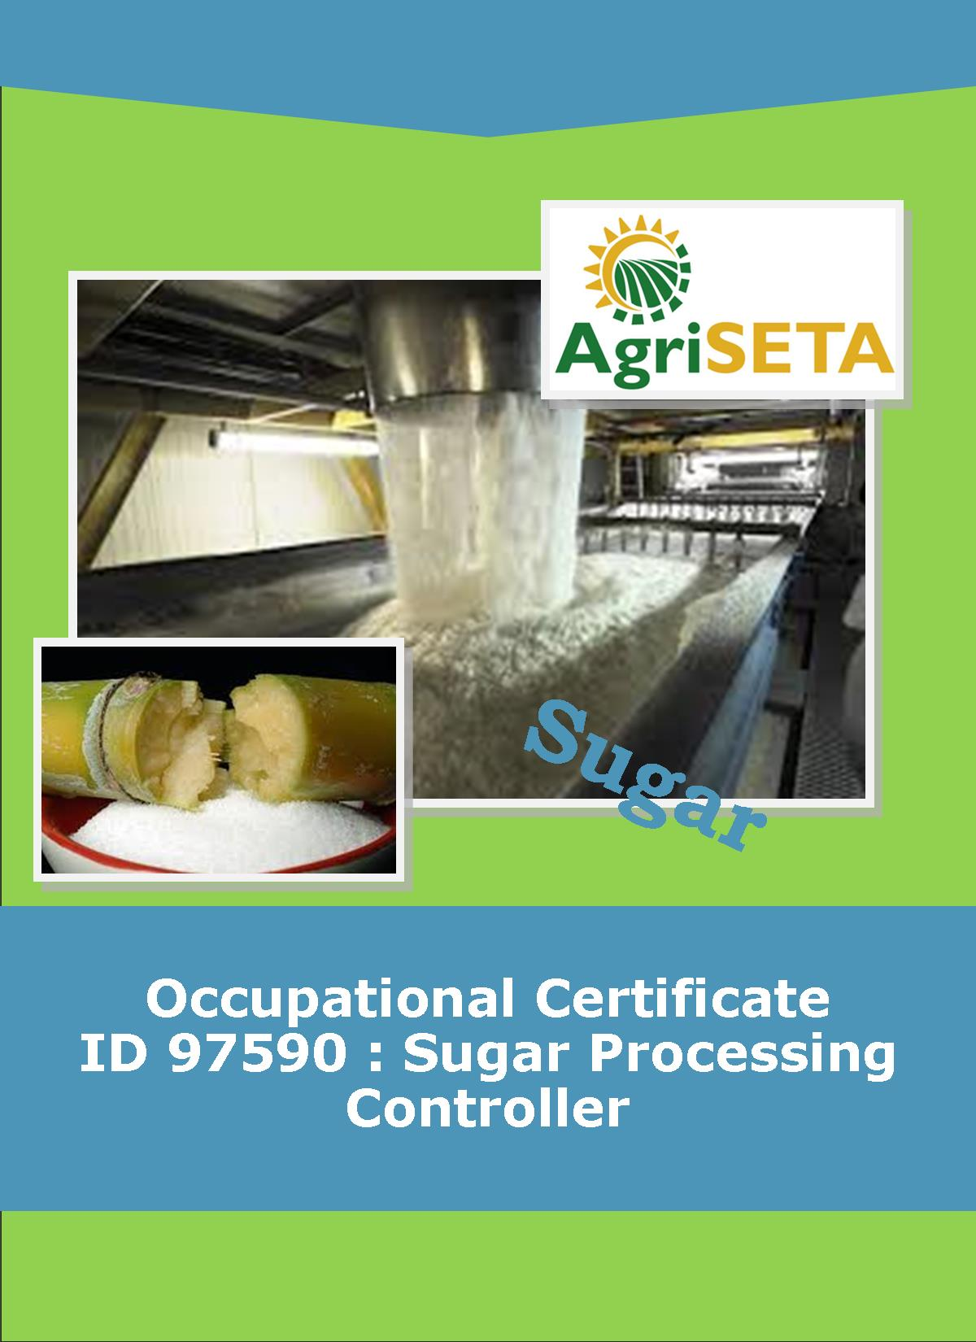
KNOWLEDGE COMPONENT:
KNOWLEDGE COMPONENT: LEARNER WORKBOOK 8: CRYSTALLISATION, CENTRIFUGING AND DRYING
Occupational Certificate: Sugar Processing Controller

KNOWLEDGE COMPONENT: LEARNER WORKBOOK 8:

CRYSTALLISATION, CENTRIFUGING AND DRYING
LEARNER WORKBOOK 8:
CRYSTALLISATION, CENTRIFUGING AND DRYING
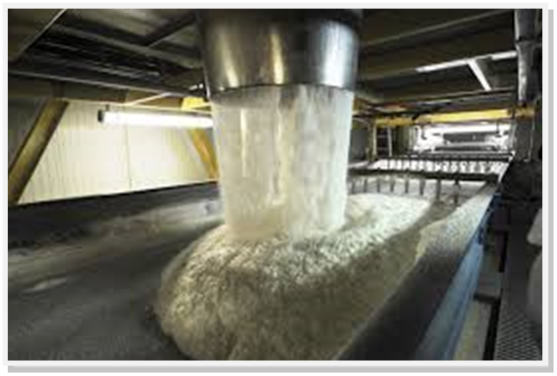
OCCUPATIONAL CERTIFICATE: SUGAR PROCESSING CONTROLLER

©Copyright AgriSETA
Telephone: +27 12 301 5600


AgriSETA holds the copyright to its publications and Web pages. Proper citation is requested.

TABLE OF CONTENTS
1. AN INTRODUCTION TO THIS LEARNER WORKBOOK 6
2. LEARNER DETAILS 7
3. FORMATIVE ASSESSMENT INSTRUCTIONS 8
4. KNOWLEDGE MODULE 8: CRYSTALLISATION, CENTRIFUGING AND DRYING 9
4.1 Knowledge Topic 1: Theory of cooling crystallisation (20%) 10
4.2 Knowledge Topic 2: Crystalliser type and layout (10%) 14
4.3 Knowledge topic 3: Massecuite reheating (10%) 17
4.4 Knowledge topic 4: Theory of centrifuging (15%) 20
4.5 Knowledge topic 5: Exhaustion (5%) 25
4.6 Knowledge topic 6: Theory of sugar drying (10%) 29
4.7 Knowledge topic 7: Sugar driers (5%) 32
4.8 Knowledge topic 8: Sugar conditioning (5%) 35
4.9 Knowledge topic 9: Raw sugar quality (5%) 37
4.10 Knowledge topic 10: Problems experienced during crystallisation and separation (15%) 40
5. CONCLUSION OF KNOWLEDGE MODULE 8: CRYSTALLISATION, CENTRIFUGING AND DRYING 43

AN INTRODUCTION TO THIS LEARNER WORKBOOK
This Knowledge Component Learner Workbook 8: Crystallisation, Centrifuging and Drying is intended to be used with the Knowledge Component Learning Resource: Book 8 (Textbook): Crystallisation, Centrifuging and Drying of the Occupational Qualification: Sugar Processing Controller NQF 4.
Guidance on the use of this Work Book is provided in the Learning Guide.

LEARNER DETAILS
First name
Surname
ID number
Mobile phone contact number
E-mail address
Postal address
Date on which you started this Knowledge Module
Date on which you completed this Knowledge Module
Declaration: | I hereby confirm that:  - I received the assessment plan and schedule.  - I understand my rights in terms of special needs, re-assessment, feedback and appeals against assessment decisions.  - I completed this formative assessment independently without assistance from anyone else.
Total Marks for Knowledge Module 8
Marks attained
Date:
Place:
Signature of Learner:
Signature of Assessor:

FORMATIVE ASSESSMENT INSTRUCTIONS
Instructions
- Work individually to present the results of each Learning Activity in this Learner Workbook.
- Complete all the sections.
- Use a black pen and ensure that you complete the questions in your own handwriting.
- A recommended time to complete each activity is shown.
- The marks you will attain for each learning activity are shown in brackets.
- The total marks obtained for each Knowledge Module must be transferred from the back of each Learner Workbook to the Learner Qualification Summative Assessment Tool.

KNOWLEDGE MODULE 8: CRYSTALLISATION, CENTRIFUGING AND DRYING
NQF LEVEL: 4
CREDITS: 4
PURPOSE OF THE KNOWLEDGE MODULE: The main focus of the learning in this knowledge module is to build an understanding of the theory and science of sugar crystallisation, centrifuging and drying.
The learning will enable learners to demonstrate an understanding of:
- KM-08-KT01: Theory of cooling crystallization (20%)
- KM-08-KT02: Crystalliser type and layout (10%)
- KM-08-KT03: Massecuite reheating (10%)
- KM-08-KT04: Theory of centrifuging (15%)
- KM-08-KT05: Exhaustion (5%)
- KM-08-KT06: Theory of sugar drying (10%)
- KM-08-KT07: Sugar driers (5%)
- KM-08-KT08: Sugar conditioning (5%)
- KM-08-KT09: Raw sugar quality (5%)
- KM-08-KT10: Problems experienced during crystallization and separation

4.1 Knowledge Topic 1: Theory of cooling crystallisation (20%)
Topic elements to be covered include:
- KT0101 Rate of cooling
- KT0102 High and low purity crystallisation
- KT0103 Crystal size and content
- KT0104 Viscosity
- KT0105 Massecuite data
Internal Assessment Criteria and Weight
- IAC0101 An understanding of crystal growth during the cooling cycle can be demonstrated
- IAC0102 The relationship between crystal growth and final product quality can be explained
- (Weight 20%)

Learning activity 1.1: Individual Learning activity: 15 minutes (10 marks)

Learning Objective: An understanding of crystal growth during the cooling cycle can be demonstrated.
Task: Read each question carefully and write your answer in the space provided.
1. What are the advantages of stirring and cooling? (4)

2 Discuss the 3 factors affecting the rate of crystallisation in a crystalliser. (6)

Learning activity 1.2: Individual Learning activity: 20 minutes (18marks)
Learning Objective: The relationship between crystal growth and final product quality can be explained.
Task: Read each question carefully and write your answer in the space provided.
- Discuss the effect of viscosity on the rate of crystallisation(4)

- Why does A-massecuite require less crystalliser time than C-massecuite?(4)

- Discuss the factors that will affect the crystallisation of low purity massecuite.(6)

- What are the massecuites residence times 4)

4.2 Knowledge Topic 2: Crystalliser type and layout (10%)
Topic elements to be covered include:
- KT0201 Heat transfer
- KT0202 Speed of rotation
- KT0203 Drives
- KT0204 Cooling element corrosion
Internal Assessment Criteria and Weight
- IAC0201 Types of equipment can be identified and purpose of equipment components explained
- (Weight 10%)

Learning activity 2.1: Individual Learning activity: 15 minutes (12marks)
Learning Objective: Task: Types of equipment can be identified and purpose of equipment components explained.
1. Describe and sketch a crystalliser used at your factory? (8)

2. What effect does the speed of rotation have on crystallisation rate? (2)

3. What can be done to minimise cooling element corrosion? (2)

4.3 Knowledge topic 3: Massecuite reheating (10%)
Topic elements to be covered include:
- KT0301 Application (When and why)
Internal Assessment Criteria and Weight
- IAC0301 The effects of crystallization can be assessed
- (Weight 10%)

Learning activity 3.1: Individual Learning activity: 30 minutes (12marks)
Learning Objective: Task: The purpose of vacuum and pressure in evaporation process can be explained.
1. Why is reheating of low purity massecuites necessary after cooling? (2)

2. Describe the various methods of reheating massecuite. (6)

3. How do we measure the work done in crystallisers? (2)

4. Define a “Nutsch” sample (2)

4.4 Knowledge topic 4: Theory of centrifuging (15%)
Topic elements to be covered include:
- KT0401 Batch centrifugal operation
- KT0402 Continuous centrifugal operation
Internal Assessment Criteria and Weight
- IAC0401 Principles of centrifuging can be explained
- IAC0402 An understanding of the impact of the centrifuging process on quality – cause and effect – can be demonstrated.
- (Weight 15%)

Learning activity 4.1: Individual Learning activity: 30 minutes (17 marks)
Learning Objective: Principles of centrifuging can be explained
Task: Read each question carefully and write your answer in the space provided.
1. Make a simple sketch of a batch centrifugal, naming its main parts (8)

2. List the stages in which molasses is separated from crystals in a massecuite. (9)
Learning activity 4.2: Individual Learning activity: 10 minutes (6marks)
Learning Objective: An understanding of the impact of centrifuging process on quality – cause and effect – can be demonstrated.
Task: Read each question carefully and write your answer in the space provided.
- Describe typical batch centrifugal/ machine? (1)

2. What are the 3 stages of removal of molasses? (3)

3. How can the performance of a centrifugal be assessed? (2)

Learning activity 4.3: Individual Learning activity: 1 hour (19 marks)
Learning Objective: An understanding of the impact of centrifuging process on quality – cause and effect – can be demonstrated.
Task: Read each question carefully and write your answer in the space provided.
- With the aid of a sketch, describe the construction of a continuous centrifugal.(8)
- What are the advantages of continuous centrifugal?(4)

- What are the slot widths for A-, B- and C- sugar screens? (3)

- Name any 4 different makes of continuous centrifugal machines(4)

4.5 Knowledge topic 5: Exhaustion (5%)
Topic elements to be covered include:
- KT0501 Theory and calculations
- KT0502 Target purity
Internal Assessment Criteria and Weight
- IAC0501 An understanding of the impact of exhaustion on factory performance can be demonstrated
- IAC0502 Formula selection and use, calculations and data interpretation is performed correctly
- (Weight 5%)

Learning activity 5.1: Individual Learning activity: 10 minutes (6 marks)
Learning Objective: An understanding of the impact of exhaustion on factory performance can be demonstrated
Task: Read each question carefully and write your answer in the space provided.
- What are the two non-sugars which are reducing sugars.(2)

2. What is the influence of reducing sugar and ash on exhaustion? (Refer to solubility) (4)

Learning activity 5.2: Individual Learning activity: 20 minutes (14 marks)
Learning Objective: Formula selection and use, calculations and data interpretation is performed correctly
Task: Read each question carefully and write your answer in the space provided.
1. What is a TPD and what is it used for? (2)

- What is the formula for TPD? (2)

- Consider the following TPD’s and state what the value indicates and if such a TPD value is possible? (6)
(a) 2
(b) 0
(c) -1

4.6 Knowledge topic 6: Theory of sugar drying (10%)
Topic elements to be covered include:
- KT0601 Raw and refined sugars
- KT0602 Washed sugars
- KT0603 Micro organisms
- KT0604 Chemical treatment
- KT0605 Moisture control during storage
- KT0606 Deterioration in bulk
Internal Assessment Criteria and Weight
- IAC0601 An understanding of the sugar drying process can be demonstrated
- IAC0602 Critical control points can be listed and explained
- IAC0603 The impact on sugar quality and handling can be explained
- (Weight 10%)

Learning activity 6.1: Individual Learning activity: 20 minutes (13marks)
Learning Objective: An understanding of the sugar drying process can be demonstrated
Task: Read each question carefully and write your answer in the space provided.
1. Why does sugar need to be dried? (2)

- Name 3 significant groups of micro-organisms that may cause deterioration. (3)

3. What is the safety factor of sugar used for and how is it calculated. (2)
4. Name the drying mechanism (6)

4.7 Knowledge topic 7: Sugar driers (5%)
Topic elements to be covered include:
- KT0701 Calculations
- KT0602 Types of driers
Internal Assessment Criteria and Weight
- IAC0701 The impact on sugar quality and handling can be explained
- IAC0702 Formula selection and use, calculations and data interpretation is performed correctly.
- (Weight 5%)

Learning activity 7.1: Individual Learning activity: 15 minutes (10marks)
Learning Objective: The impact on sugar quality and handling can be explained.
Task: Read each question carefully and write your answer in the space provided.
1. Briefly describe the operation of (10)
(a) A rotary drum drier
(b) A fluidized bed drier
(c) A dust separator

4.8 Knowledge topic 8: Sugar conditioning (5%)
Topic elements to be covered include:
- KT0801 Why sugar cakes
- KT0802 Conditioning and data
- KT0803 Factors influencing conditioning
Internal Assessment Criteria and Weight
- IAC0801 An understanding of the sugar conditioning process can be demonstrated.
- IAC0802 The theory of conditioning can be explained
- (Weight 5%)

Learning activity 8.1: Individual Learning activity: 10 minutes (4marks)
Learning Objective: An understanding of the sugar conditioning process can be demonstrated
Task: Read each question carefully and write your answer in the space provided.
1. How does sugar conditioning differ from sugar drying? (4)

4.9 Knowledge topic 9: Raw sugar quality (5%)
Topic elements to be covered include:
- KT0901 Standards, parameters and levels
Internal Assessment Criteria and Weight
- IAC0901 Knowledge of values required and the impact of deviations can be demonstrated
- IAC0902 Potential re-work parameters and consequences can be explained
- (Weight 5%)

Learning activity 9.1: Individual Learning activity: 15 minutes (12marks)
Learning Objective: Knowledge of values required and the impact of deviations can be demonstrated
Task: Read each question carefully and write your answer in the space provided.
1. What are the specifications for raw / VHP sugar regarding the following (12)
(a) Pol
(b) Colour
(c) Moisture
(d) Ash
(e) Starch
(f) Fines

4.10 Knowledge topic 10: Problems experienced during crystallisation and separation (15%)
Topic elements to be covered include:
- KT01001 Process problems and standard responses
- KT01002 Data and trends
Internal Assessment Criteria and Weight
- IAC01001 Demonstrate problem solving techniques and data interpretation
- IAC0902 Potential re-work parameters and consequences can be explained
- (Weight 15%)

Learning activity 10.1: Individual Learning activity: 30 minutes (20marks)
Learning Objective: Problems experienced during crystallisation and separation can be demonstrated
Task: Read each question carefully and write your answer in the space provided.
1. What is the negative effect of broken/damaged cooling element? (2)

2. What is a Maillard reaction and what does it do? (6)

3. How will we know if a Maillard reaction has started? (2)

4. How can a Maillard reaction be prevented? (6)

5. What can be done if a Maillard reaction has started? (4)

CONCLUSION OF KNOWLEDGE MODULE 8: CRYSTALLISATION, CENTRIFUGING AND DRYING
Throughout this knowledge module you have been provided opportunities to complete formative learning activities. You have captured your results in this Learner Workbook.
The total marks for this Knowledge Module are as follows:
Knowledge Module | Total Marks | Marks attained
KM-08-KT01: Theory of cooling crystallisation (20%) | 28
KM-07-KT02: Crystalliser, type and layout (10%) | 12
KM-08-KT03: Massecuite reheating (10%) | 14
KM-08-KT04: Theory of centrifuging (15%) | 42
KM-08-KT05: Exhaustion (5%) | 20
KM-08-KT06: Theory of sugar drying (10%) | 13
KM-08-KT07: Sugar driers (5%) | 10
KM-08-KT08: Sugar conditioning (5%) | 4
KM-08-KT09: Raw sugar quality (5%) | 12
KM-08-KT10: Problems experienced during crystallisation and separation (15%) | 20
Total Marks | 175marks



