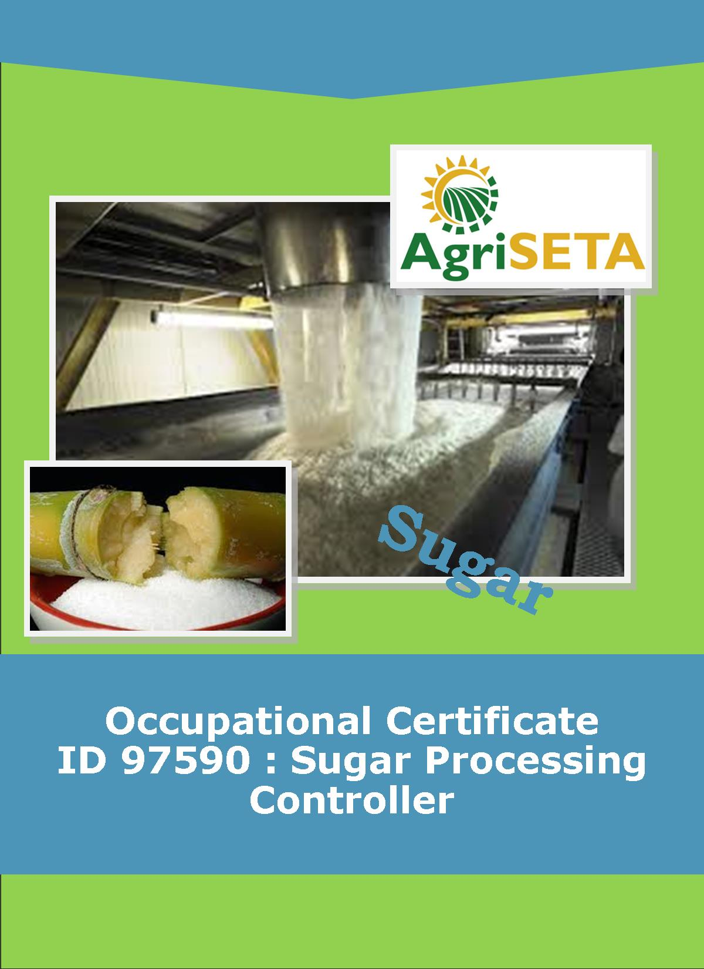
LEARNER SUMMATIVE ASSESSMENT TOOL KNOWLEDGE MODULE 8 : CRYSTALLISATION, CENTRIFUGING AND DRYING
KNOWLEDGE COMPONENT: LEARNER SUMMATIVE ASSESSMENT TOOL : KNOWLEDGE MODULE 8 : CRYSTILLISATION, CENTRIFIGING AND DRYING
Occupational Certificate: Sugar Processing Controller

LEARNER SUMMATIVE ASSESSMENT TOOL KNOWLEDGE MODULE 8 : CRYSTALLISATION, CENTRIFUGING AND DRYING
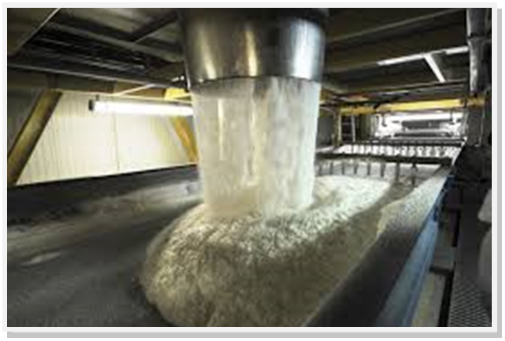
OCCUPATIONAL CERTIFICATE: ID 97590: SUGAR PROCESSING CONTROLLER

©Copyright AgriSETA
Telephone: +27 12 301 5600


AgriSETA holds the copyright to its publications and Web pages. Proper citation is requested.

TABLE OF CONTENTS

1. STAKEHOLDER INFORMATION 6
2. COMPETENCY SUMMARY OF ASSESSMENT 8
3. ASSESSMENT ALIGNMENT MATRIX (INTERGRATED OUTCOMES) 10
4. ASSESSMENT DECISION & EVIDENCE EVALUATION RECORD 14
5. OVERALL ASSESSMENT DECISION 16
6. EVIDENCE OF FEEDBACK 17
7. OVERALL RESULTS 18
8. ASSESSMENT REVIEW 19
9. FINAL DECISION 22
10. LEARNER FEEDBACK FORM 23
11. SUMMATIVE ASSESSMENT INSTRUCTIONS 24
12. WRITTEN ASSESSMENT 25
13. FINAL MARKS 35

STAKEHOLDER INFORMATION
LEARNER INFORMATION
Name
Surname
ID number
Mobile phone contact number
E-mail address
Physical address
Postal address
Employer Name
Employer Contact Details

ASSESSOR DETAILS
Name
Surname
Assessor ID
Project Name | Occupational Certificate ID 97590:Sugar Processing Controller
Module No. | Module 8: crystallisation, centrifuging and drying
Date of Assessment
Portfolio submission Date
Assessor Signature
Total Marks for Knowledge Module 8 | 150 marks
Marks attained
Place:

MODERATOR DETAILS
Moderator Name
Moderator ID
Moderator Signature
Date of Moderation

COMPETENCY SUMMARY OF ASSESSMENT
Module 8 | KM-08-KT01: Theory of cooling crystallisation | C | NYC
1 | 1.1. An understanding of crystal growth during the cooling cycle can be demonstrated
 | 1.2The relationship between crystal growth and final product quality can be explained
2 | KM-08-KT02: Crystalliser type and layout | - C | NYC
 | 2.1 Types of equipment can be identified and purpose of equipment components explained
3 | KM-08-KT03: Massecuite reheating | C | NYC
 | 3.1. The effect of crystallisation can be assessed
4. | KM-08-KT04: Theory of centrifuging | C | NYC
 | 4.1Principles of centrifuging can be explained
 | 4.2. An understanding of the impact of centrifuging process on quality - cause and effect - can be demonstrated
5 | KM-08-KT05:Exhaustion | C | NYC
 | 5.1.An understanding of the impact of exhaustion on factory performance can be demonstrated
 | 5.2. Formula selection and use, calculations and data interpretation is performed correctly
6 | KM-08-KT06:Theory of sugar drying | C | NYC
 | 6.1. An understanding of the sugar drying process can be demonstrated
 | 6.2. Critical Control Points can be listed and explained
 | 6.3. The impact on sugar quality and handling can be explained
7 | KM-08-KT07: Sugar driers | C | NYC
 | 7.1The impact on sugar quality and handling can be explained
 | 7.2Formula selection and use, calculations and data interpretation is performed correctly
8 | KM-08-KT08: Sugar conditioning | C | NYC
 | 8.1.An understanding of the sugar conditioning process can be demonstrated
 | 8.2. The theory of conditioning can be explained
9 | KM-08-KT09: Raw sugar quality | C | NYC
 | 9.1. Knowledge of values required and the impact of deviations can be demonstrated
 | 9.2. Potential re-work parameters and consequences can be explained
10 | KM-08-KT10: Problems experienced during crystallisation and separation | C | NYC
 | 10.1Demonstrate problem solving techniques and data interpretation

ASSESSMENT ALIGNMENT MATRIX (INTERGRATED OUTCOMES)
Module No: 8 | How it is assessed (Assessment methodology) | Where is it covered(learning material) | Where it is assessed |  | First Submission
Module No: 8 | How it is assessed (Assessment methodology) | Where is it covered(learning material) | Summative | Formative
SAQA ID Number: 97590 | Two methods of assessment are followed which are:  1. Summative assessment: written tests, knowledge questions using fundamental and reflexive questions.  2. Formative assessment: assignments, tasks, portfolio of evidence submitted and presentations. |  |  |  | Clearly meets all the criteria | Meets some but not all criteria | Clearly does not meet any of the criteria
Title: Crystallisation, Centrifuging and Drying,
NQF level and credits:
NQF Level 4: 8 Credits
Topic: 1 Theory of crystallisation |  | Page 11-14 | Question 8.1-8.7 page 24-25 | Learning Activity 1.1 -12 page 11-13
Assessment criteria: An understanding of crystal growth during the cooling cycle can be demonstrated
Assessment criteria: The relationship between crystal growth and final product quality can be explained
Topic 2. Crystalliser type and layout |  |  |  | Learning Activity 2.1 page 15&16
Assessment criteria: Types of equipment can be identified and purpose of equipment components explained
Topic 3. Massecuite reheating |  | Page 20-23 | Question 8.8-8.10  Page 26 page 26 | Learning Activity 3.1 page 19
Assessment criteria: The effect of crystallisation can be assessed
Topic 4. Theory of centrifuging |  | Page 24 | Question 8.14-8.24 page 27-30 | Learning Activity 4.1-4.3. page 21-24
Assessment criteria: Principles of centrifuging can be explained
Assessment criteria: An understanding of the impact of centrifuging process on quality - cause and effect - can be demonstrated
Topic 5: Exhaustion |  | Page 46 | Question 8.25-8.28 page 30-31 | Learning Activity 5.1&5.2 page 26-28
Assessment Criteria: An understanding of the impact of exhaustion on factory performance can be demonstrated
Assessment Criteria: Formula selection and use, calculations and data interpretation is performed correctly
Topic 6: Theory of sugar drying |  | Page 48-55 | Question 8.29-8.32 page 31-32 | Learning Activity 6.1 page 29
Assessment Criteria: An understanding of the sugar drying process can be demonstrated
Assessment Criteria: Critical Control Points can be listed and explained
Assessment Criteria: The impact on sugar quality and handling can be explained
Topic 7: Sugar driers |  | Page 56 | Question 8.33 page 32 | Learning Activity 7.1 page 34
Assessment Criteria: The impact on sugar quality and handling can be explained
Assessment Criteria: Formula selection and use, calculations and data interpretation is performed correctly
Topic 8: Sugar conditioning |  | Page 65 | Question 8.33-8.35 page 32 | Learning Activity 8.1 page 36
Assessment Criteria: An understanding of the sugar conditioning process can be demonstrated
Assessment Criteria: The theory of conditioning can be explained
Topic 9: Raw sugar quality |  |  |  | Learning Activity 9.1 page 38-39
Assessment Criteria: Knowledge of values required and the impact of deviations can be demonstrated
Assessment Criteria: Potential re-work parameters and consequences can be explained
Topic 10: Problems experienced during crystallisation and separation |  | Page 70-72 | Question 8.11-8.13 page 27 | Learning Activity 10.1 page 41-42
Assessment Criteria: Demonstrate problem solving techniques and data interpretation

ASSESSMENT DECISION & EVIDENCE EVALUATION RECORD
Candidate's Name: -

Assessor's Name: -

Practical assessment
I declare that this assessment is my own demonstration.

Marks: The learner is either “Met requirements” or “did not meet requirements”. If the learner did not meet requirements in an area, then he or she must be reassessed.
Learner achieved: Met requirements /Did not meet requirements
KNOWLEDGE MODULE 8:
Overall outcome:

Specific Outcome |  | Met requirements | Did not meet requirements | Comments
1

Specific Outcome |  | Met requirements | Did not meet requirements | Comments
2
 | Specific outcome | Met requirements | Did not meet requirements | Comments
3
 |  | Met requirements | Did not meet requirements | Comments
4 | Specific outcome
5 | Specific outcome | Met requirements | Did not meet requirements | Comments
6 | Specific outcome | Met requirements | Did not meet requirements | Comments
7 | Specific outcome | Met requirements | Did not meet requirements | Comments
8 | Specific outcome | Met requirements | Did not meet requirements | Comments
9 | Specific outcome | Met requirements | Did not meet requirements | Comments
10 | Specific outcome | Met requirements | Did not meet requirements | Comments

OVERALL ASSESSMENT DECISION
Assessors Comments:

Signature of Assessor:

Date:

EVIDENCE OF FEEDBACK
Module No :8
Level :4
Assessor :……………………………………………………………………………
Candidate :…………………………………………………………………………..
Date of final assessment:…………………………………………………………….
Evidence criteria | Achieved | Not
1. Constructive
2. Timeous (according to Plan)
3. Correct mode / medium
4. Participative
5. Developmental
6. Accurate
7. Specific
8. Documented
9. Directed to correct parties
Signing off date: …………………………………………….

..........……………. ………………………………….
Assessor Candidate

OVERALL RESULTS
OVERALL RESULT | Competent
OVERALL RESULT | Not Yet Competent
Declaration by Candidate
I, …………………………………………………………………….declare that I am satisfied that the feedback given to me by the Assessor was relevant, sufficient and done in a constructive manner. I accept the assessment decisions and do realise that have no further questions relating to this particular assessment process. I do realise that after this assessment decision, the moderator will either uphold or reverse this assessment decision taken by the assessor.
Candidate : _____________  _______________________  Date: __________________  Signature: ______________ |  | Assessor : _____________  _______________________  Date: __________________  Signature: ______________ |  | Moderator : _____________  _______________________  Date: __________________  Signature: ______________

ASSESSMENT REVIEW
Assessor’s Name |  |  |  |  |  |  |  |  | ID Number
Contact Details of Assessor |  | Email
 |  | Phone
 |  | Fax
PART 1
 | Review Criteria |  | Valid |  | Authentic | Current |  | Consistent |  |  | Reliable |  | Sufficient |  |  | Comments
Please conduct an honest review of the Assessment Instruments used in this assessment:
1 | Evidence Topic 1
 | Knowledge Assignment
 | Practical Assignment
 | Natural Occurring Evidence
 | Reflection
2 | Evidence Topic 2
 | Knowledge Assignment
 | Practical Assignment
 | Natural Occurring Evidence
 | Reflection
3 | Evidence Topic 3
 | Knowledge Assignment
 | Practical Assignment
 | Natural Occurring Evidence
 | Reflection
4 | Evidence Topic 4
 | Knowledge Assignment
 | Practical Assignment
 | Natural Occurring Evidence
 | Reflection
 | Historical Evidence Location Grid
 | CCFO Location Grid
PART 2
No | Review Criteria |  |  |  |  |  |  |  |  | Yes |  | No |  |  | Remarks
1 | Do you feel the candidate was appropriately selected and prepared for the RPL assessment?
2 | Did the candidate interpret the evidence requirements appropriately?
3 | Was the assessment free of potential assessment barriers such as language, literacy, access to resources?
4 | Was the assessment evidence presented by the candidate valid, authentic, current and sufficient?
5 | Was the candidate’s workplace access to evidence sufficiently supportive of the assessment strategy?
6 | Do you feel you could make a fair, valid and reliable assessment decision?
Recommendations
(Feedback on Validity, authenticity, currency and sufficiency of candidate evidence.)
Assessor Signature |  |  |  |  |  |  | Date Review Completed

FINAL DECISION
I………………………………………………………. hereby declare Ms/Mr

………………………………………… Competent Not Yet Competent

FEEDBACK TO LEARNER:

……………………..………………………..………………………..……………………

……………………..………………………..………………………..………………………

……………………..………………………..………………………..………………………

……………………..………………………..………………………..………………………

SIGN: …………………………………… DATE: ……………………..........................

LEARNER FEEDBACK:

……………………..………………………..………………………..………………………

……………………..………………………..………………………..………………………

……………………..………………………..………………………..………………………

……………………..………………………..………………………..………………………

SIGN: ……………………………………… DATE: …………………….......................

MODERATOR FEEDBACK:

………………………..………………………..………………………..……………………

………………………..………………………..………………………..……………………

……………………..………………………..………………………..………………………

……………………..………………………..………………………..………………………

SIGN: …………………………………… DATE: ……………………........................

LEARNER FEEDBACK FORM
CRITERIA | EVIDENCE | CRITERIA | EVIDENCE
How did your assessor encourage you and put you at ease during the assessment process? |  | Were you given clear and constructive feedback?
Were your assessor’s questions clear and pitched at the right level of language usage? |  | Did your assessor assess all the evidence provided by you?
Do you believe that all the assessment criteria and knowledge requirements of the standard you were being measured against were considered in your assessment? |  | Were you aware of any discrimination practice carried out by your assessor towards you?

LEARNER SIGNATURE:………………………………………………

DATE:.…………………………..

SUMMATIVE ASSESSMENT INSTRUCTIONS
Instructions
- Work individually and answer all questions.
- Use a black pen and ensure that you complete the questions in your own handwriting.
- Time to spend on this assessment is 2 hours.
- The marks you will attain for each question are shown in brackets.

WRITTEN ASSESSMENT
8.1 | What is the best definition of the function of the crystallisers? |  | Mark Allocation
a. |  | Increasing the Brix of the massecuite.
b. |  | Reducing the SSC to 1 and allowing crystals to grow.
c. |  | Remove unwanted water from the massecuite.
d. |  | Cooling the massecuite to allow for curing.
e. |  | Reducing the viscosity of the massecuite. | 4

8.2 | Massecuite from the A pans is not cured directly after strike because; |  | Mark Allocation
a. |  | Massecuite needs to be stored before curing can begin.
b. |  | The massecuite is too hot for the centrifugals.
c. |  | The massecuite still contains supersaturated mother liquor.
d. |  | The viscosity of the massecuite is too low.
e. |  | None of the above. | 4

8.3 | Name one of the three factors that influence the rate of cooling and crystallisation. From the selection below. |  | Mark Allocation
a. |  | Maintain a saturated solution.
b. |  | Sufficient cooling time.
c. |  | Striving for maximum exhaustion.
d. |  | Long residence time.
e. |  | Maintenance of a consistent viscosity. | 4

8.4 | Massecuite in the crystallisers is stirred to; |  | Mark Allocation
a. |  | Increase the temperature of the massecuite.
b. |  | Ensure that the SSC is maintained.
c. |  | Prevent the crystals from settling.
d. |  | Keep the massecuite viscous.
e. |  | Increase the level of supersaturation. | 4

8.5 | Crystallisation needs to be limited as there will become a point where the massecuite will be too tight. What is this limiting factor? |  | Mark Allocation
a. |  | Viscosity of the massecuite.
b. |  | Crystal content of the massecuite.
c. |  | Massecuite temperature.
d. |  | Inability of the crystallisers to mix the massecuite.
e. |  | All of the above. | 4

8.6 | How does false grain affect the A batch centrifugals? |  | Mark Allocation
a. |  | Blocks the drainage space between the crystals and impacts separation.
b. |  | Does not have any impact.
c. |  | It will not slide up the screen.
d. |  | Will pass through the screen and increase molasses purity.
e. |  | Will speed up the curing. | 4

8.7 | What product can be added to lubricate the massecuite if the massecuite becomes too viscous to be stirred? |  | Mark Allocation
a. |  | Water.
b. |  | Syrup.
c. |  | Clear juice.
d. |  | Molasses.
e. |  | B-Magma. | 4
8.8 | Why will C massecuite need to be re-heated before curing? |  | Mark Allocation
a. |  | To increase the degree of supersaturation.
b. |  | To reduce the viscosity.
c. |  | To dissolve some of the sugar crystals.
d. |  | To make remelt.
e. |  | To make the solution unsaturated. | 4

8.9 | The approximate saturation temperature of C massecuite is; |  | Mark Allocation
a. |  | 100 ºC
b. |  | 55 ºC
c. |  | 75 ºC
d. |  | 46 ºC
e. |  | 40 ºC | 4

8.10 | What would a drop between the C massecuite Nutsch purity at strike and after crystallisation (before reheating) indicate? |  | Mark Allocation
a. |  | There would have been some crystals that dissolved during crystallisation.
b. |  | The crystallisers performed badly.
c. |  | Too much steam or water was used in the centrifugals.
d. |  | There was substantial crystal growth during crystallisation.
e. |  | The pan boiling cycle was incomplete. | 4

8.11 | What is Maillard reaction? |  | Mark Allocation
a. |  | A reaction between glucose, amino acids and proteins, producing heat and carbon dioxide.
b. |  | A reaction between sucrose, glucose and phosphates, producing heat and carbon dioxide.
c. |  | A reaction between various carbons in the sugar and the water in the massecuite, producing foam and dark colour.
d. |  | A reaction between the non-sugars and phosphates, producing foam and heat.
e. |  | All of the above. | 4
8.12 | What indicates that a Maillard reaction has occurred? |  | Mark Allocation
a. |  | The massecuite will give off a bad odour, hydrogen sulphide.
b. |  | There will be no impact on the massecuite, aside from a darker colour.
c. |  | The temperature will increase substantially and the massecuite will begin to foam.
d. |  | The massecuite will remain at the same temperature and will begin to foam.
e. |  | The massecuite will start to foam. | 4

8.13 | Which sugars does the Maillard reaction use up? |  | Mark Allocation
a. |  | Fructose.
b. |  | Glucose.
c. |  | Sucrose.
d. |  | Dextrose.
e. |  | All of the above. | 4

8.14 | What is the main force applied during centrifuging? |  | Mark Allocation
a. |  | Separation effect.
b. |  | Pressure.
c. |  | Time.
d. |  | Speed.
e. |  | Gravity. | 4

8.15 | What is the purpose of the wash water sprays in the centrifugal? |  | Mark Allocation
a. |  | To reduce sugar colour.
b. |  | To reduce the viscosity of the molasses film around the crystal.
c. |  | To assist the movement of molasses through the screens.
d. |  | To improve sugar quality.
e. |  | All of the above. | 4
8.16 | At what speed does the batch centrifugal run while charging? |  | Mark Allocation
a. |  | 200 – 500 RPM.
b. |  | 1000 – 1500 RPM.
c. |  | 40 – 90 RPM.
d. |  | 100 – 150 RPM.
e. |  | 0 – 40 RPM. | 4

8.17 | What is the usual speed of a continuous centrifugal? |  | Mark Allocation
a. |  | 1000 – 1500 RPM.
b. |  | 200 – 500 RPM.
c. |  | 2000 – 3000 RPM.
d. |  | 1500 – 2000 RPM.
e. |  | 3000 – 4000 RPM. | 4

8.18 | How does the massecuite that is fed into the continuous centrifugal get up to the speed of the basket? |  | Mark Allocation
a. |  | Labyrinth seal.
b. |  | Distributer cup.
c. |  | Main hub.
d. |  | Monitor casing.
e. |  | Acceleration cup. | 4

8.19 | Why would the B centrifugal have a wider slot in the screen than the C centrifugal? |  | Mark Allocation
a. |  | Because the crystal size of the B sugar is bigger than the crystal size of the C sugar.
b. |  | Because the C molasses is thinner than the B molasses.
c. |  | Because the B machines are also used for A sugar.
d. |  | Because the B sugar crystals are smaller than the C sugar crystals.
e. |  | Because the C sugar is more viscous. | 4
8.20 | Why is water added in the feed ring of a continuous centrifugal? |  | Mark Allocation
a. |  | To increase the temperature of the massecuite.
b. |  | To reduce the viscosity of and lubricate the massecuite.
c. |  | To wash the crystals.
d. |  | To dilute the molasses.
e. |  | To wash out the basket. | 4

8.21 | How does an operator check if a continuous centrifugal is not draining the molasses well? |  | Mark Allocation
a. |  | Check reports from the laboratory.
b. |  | Ensure that sufficient water is used to wash the crystals.
c. |  | Check with a stroboscope, looking for fingers of molasses up the cone.
d. |  | Check the load (amps) on the motor.
e. |  | See that the residence time is sufficient. | 4

8.22 | What is the main reason for batch centrifugals being used for A sugar. |  | Mark Allocation
a. |  | The A sugar needs to be washed to improve colour.
b. |  | A continuous centrifugal damages the crystal.
c. |  | A sugar is the final product and quality is important.
d. |  | Continuous centrifugals have a very short residence time.
e. |  | All of the above. | 4

8.23 | What will happen to the C molasses purity if there is excessive washing in the C centrifugals? |  | Mark Allocation
a. |  | The purity will decrease because sugar has been dissolved.
b. |  | The purity will increase because sugar has been dissolved.
c. |  | There will be no change in purity.
d. |  | The purity will increase because more molasses has been washed off.
e. |  | All of the above. | 4
8.24 | What makes up the biggest loss in the factory? |  | Mark Allocation
a. |  | Sucrose lost in final molasses.
b. |  | Sucrose lost in B molasses.
c. |  | Non-sucrose lost in final molasses.
d. |  | Non-sucrose lost in C sugar.
e. |  | None of the above. | 4

8.25 | The best definition for reducing sugars is; |  | Mark Allocation
a. |  | Sucrose
b. |  | Non-sucrose.
c. |  | Silica.
d. |  | Glucose and Fructose.
e. |  | Salts. | 4

8.26 | What is the best definition for target purity? |  | Mark Allocation
a. |  | The increase in molasses purity.
b. |  | Purity of final molasses after correction for reducing sugars.
c. |  | A lower molasses purity.
d. |  | The ability to extract less sucrose from molasses.
e. |  | The lowest possible molasses purity for a given reducing sugar to ash ratio. | 4

8.27 | TPD (target purity difference) depends on two variables. Which are these? |  | Mark Allocation
a. |  | Sucrose and Brix
b. |  | Glucose and fructose.
c. |  | Purity and exhaustion.
d. |  | Reducing sugars and Sucrose.
e. |  | Final Molasses and Target purity. | 4
8.28 | Which TPD is not possible to get. |  | Mark Allocation
a. |  | 3.0
b. |  | -1.0
c. |  | 0
d. |  | 2.0
e. |  | 1.5 | 4

8.29 | What is the main reason to dry sugar? |  | Mark Allocation
a. |  | To prevent caking.
b. |  | To prevent fungal and bacterial growth.
c. |  | To reduce colour formation.
d. |  | To prevent deterioration
e. |  | All of the above. | 4

8.30 | What type of moisture does sugar drying remove. |  | Mark Allocation
a. |  | Water that is stuck to the crystals.
b. |  | Water that trapped in the crystals.
c. |  | Free moisture.
d. |  | Bound moisture.
e. |  | All of the above. | 4

8.31 | What should the safety factor of sugar be after drying? |  | Mark Allocation
a. |  | Less than 0.23.
b. |  | More than 0.23.
c. |  | More than 1.0.
d. |  | Exactly 0.43.
e. |  | None of the above. | 4
8.32 | What analysis is used to determine the moisture content of raw sugar? |  | Mark Allocation
a. |  | Karl-Fischer titration.
b. |  | Moisture diffusion.
c. |  | Classical theory.
d. |  | Oven drying.
e. |  | Evaporation. | 4

8.33 | What operating conditions need to be considered for a sugar drier? |  | Mark Allocation
a. |  | Air flowrate.
b. |  | Air temperature.
c. |  | Sugar temperature.
d. |  | Sugar retention time.
e. |  | All of the above. | 4

8.34 | Sugar conditioning is applied to; |  | Mark Allocation
a. |  | Raw sugar in order to increase the safety factor.
b. |  | C sugar in order to reduce colour for the A sugar.
c. |  | Refined sugar in order to remove bound moisture.
d. |  | Refined sugar in order to remove free moisture.
e. |  | Raw sugar in order to remove free moisture. | 4

8.35 | The retention time in a sugar conditioning silo is; |  | Mark Allocation
a. |  | Approximately one day.
b. |  | Two to three days.
c. |  | Longer than five days.
d. |  | Less than 18 hours.
e. |  | Between 18 and 24 hours. | 4

FINAL MARKS
TOTAL MARKS: 140
PASS MARK: 112
LEARNER MARKS
PERCENTAGE
ASSESSOR SIGNITURE:

