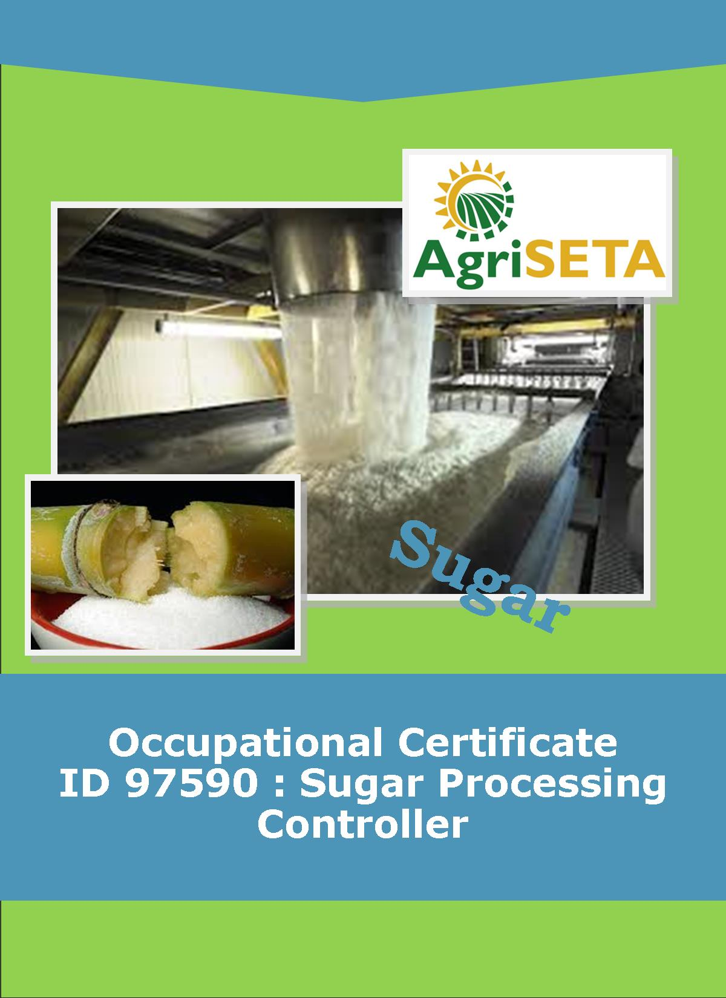
KNOWLEDGE COMPONENT: LEARNING RESOURCE:
BOOK 8: CRYSTALLISATION, CENTRIFUGING AND DRYING
OCCUPATIONAL QUALIFICATION: SUGAR PROCESSING CONTROLLER

KNOWLEDGE COMPONENT:
LEARNING RESOURCE

BOOK 8: CRYSTALLISATION, CENTRIFUGING AND DRYING
KNOWLEDGE COMPONENT:
LEARNING RESOURCE BOOK 8 : CRYSTALLISATION, CENTRIFUGAL AND DRYING
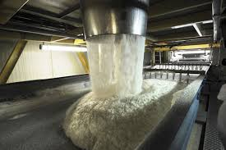
OCCUPATIONAL QUALIFICATION:
SUGAR PROCESSING CONTROLLER

©Copyright AgriSETA
Telephone: +27 12 301 5600


AgriSETA holds the copyright to its publications and Web pages. Proper citation is requested.

TABLE OF CONTENTS
AN INTRODUCTION TO THIS LEARNING RESOURCE 9
KNOWLEDGE MODULE 8 10
CRYSTALLISATION, CENTRIFUGING AND DRYING 10

1. Knowledge topic 1: Theory of cooling crystallisation 11
1.1 THEORY OF CRYSTALLISATION 11
1.2 RATE OF COOLING AND CRYSTALLISATION 12
1.2.1 Sufficient crystal surface 12
1.2.2 Maintenance of a sufficient supersaturation coefficient 12
1.2.3 Sufficient cooling time 12
1.3 HIGH PURITY CRYSTALLISATION 13
1.4 LOW PURITY CRYSTALLISATION 13
1.4.1 Crystal size and content 13
1.4.2 Viscosity 14
1.4.3 General Massecuite Data 14

2. Knowledge topic 2: Crystalliser Design and Layout 15
2.1 BASIC DESIGN 15
2.2 HEAT TRANSFER 18
2.3 SPEED OF ROTATION 18
2.4 CRYSTALLISER DRIVES 19
2.5 COOLING ELEMENT CORROSION 19

3. Knowledge topic 3: Massecuite reheating 20
3.1 INTRODUCTION 20
3.2 TYPICAL TEMPERATURE VARIATION FOR A C-MASSECUITE 20
3.3 TYPES OF REHEATERS 21
3.3.1 Crystalliser heating 21
3.3.2 Reheaters 21
3.3.3 Resistance heaters 21
3.4 ASSESSING THE EFFECT OF CRYSTALLISATION 22
3.5 ANALYSING THE MOTHER LIQUOR IN A MASSECUITE 22

4. Knowledge topic 4: Theory of centrifuging 24
4.1 INTRODUCTION 24
4.2 THEORY OF CENTRIFUGING 24
4.3 SEPARATIONAL EFFECT 24
4.4 BATCH CENTRIFUGALS - THE TYPICAL BATCH MACHINE 25
4.5 REMOVAL OF MOLASSES 27
4.6 CENTRIFUGAL COMPONENTS 27
4.6.1 The basket 27
4.6.2 Screens 27
4.6.3 Charging 28
4.6.4 Ploughs 28
4.6.5 Wash water and steam 29
4.6.6 Drives 30
4.6.7 Capacity of the basket 30
4.6.8 Control systems 31
4.6.9 Windage 31
4.6.10 Drip trays 32
4.6.11 Typical Operational Cycle 32
4.7 CONTINUOUS CENTRIFUGALS 33
4.8 BASIC OPERATION OF A CONTINUOUS CENTRIFUGAL 33
4.9 TYPES OF CONTINUOUS CENTRIFUGALS 35
4.9.1 The BMA continuous centrifugal 35
4.9.2 The Western State continuous centrifugal 36
4.10 MACHINE DESIGN 36
4.10.1 The basket 36
4.10.2 The acceleration cup 37
4.10.3 Screens 38
4.10.4 Feed system 39
4.10.5 The sugar collecting monitoring casing 40
4.10.6 The molasses collecting monitoring casing 40
4.11 FEATURES OF THE BMA CONTINUOUS CENTRIFUGAL 41
4.11.1 Fingers/pins 41
4.11.2 Distributor Cup 41
4.11.3 Acceleration Cone 42
4.11.4 Screen Security Ring 42
4.11.5 Side wall 42
4.11.6 Basket Support 42
4.12 THE DRIVE SYSTEM 42
4.13 CONTINUOUS CENTRIFUGAL OPERATION 42
4.14 FLEXIBILITY OF CONTINUOUS CENTRIFUGALS 43
4.15 CHOOSING A CENTRIFUGAL: BATCH OR CONTINUOUS? 44
4.16 RELATIONSHIP BETWEEN WASH WATER AND SUGAR QUALITY 44
4.17 DIFFERENT MAKES OF CONTINUOUS CENTRIFUGAL 45
4.18 CENTRIFUGAL PERFORMANCE 45

5. Knowledge topic 5: Exhaustion 46
5.1 THEORY AND CALCULATIONS 46
5.2 TARGET PURITY 46

6. Knowledge topic 6: Theory of drying 48
6.1 INTRODUCTION 48
6.2 MOISTURE CONTENT AND “SAFETY FACTORS” 48
6.3 COMPARING RAW AND REFINED SUGAR 49
6.4 WASHED SUGARS 49
6.5 MICRO-ORGANISMS 50
6.6 CHEMICAL TREATMENT 50
6.7 MOISTURE CONTROL DURING STORAGE 50
6.8 DETERIORATION IN BULK STORAGE 51
6.9 EQUILIBRIUM RELATIVE HUMIDITY (ERM) 52
6.10 CHANGES IN STORAGE OTHER THAN POL LOSS 52
6.11 SUMMARY 52
6.12 SUGAR DRYING THEORY 53
6.12.1 What is wet sugar? 53
6.12.2 Drying Stages 53
6.13 DRYING MECHANISM 54
6.13.1 Evaporation 54
6.13.2 Diffusion 54
6.13.3 Crystallisation 54
6.14 MOISTURE ANALYSIS 54
6.14.1 Oven drying 54
6.14.2 Karl-Fischer Titration 55
6.15 SOME TYPICAL FIGURES 55

7. Knowledge topic 7: Sugar driers 56
7.1 INTRODUCTION 56
7.2 CALCULATIONS FOR A SUGAR DRIER 56
7.3 TYPES OF SUGAR DRIERS 59
7.3.1 Rotary cascade 59
7.3.2 Rotary louvre 60
7.3.3 Fluidized bed 62
7.4 OPERATING CONSIDERATIONS FOR SUGAR DRIERS 64
7.5 DUST SEPARATORS 64

8. Knowledge topic 8: Sugar conditioning 65
8.1 WHY DOES DRY SUGAR CAKE? 65
8.1.1 Equilibrium Relative Humidity: 65
8.1.2 Moisture Migration 65
8.2 SUGAR CONDITIONING AND DATA 65
8.2.1 Sugar conditioning 65
8.2.2 Conditioning data 66
(1) Unconditioned sugar from the sugar drier 66
(2) Conditioned sugar 66
(3) Conditioning Air 67
(4) Typical silo 67
(5) Performance measures 67
(6) Conditioning removes BOUND moisture 67
8.3 FACTORS AFFECTING CONDITIONING 67
8.3.1 Temperature 67
8.3.2 Air Flow & Condition 67
8.3.3 Crystal Size & Distribution 67
8.3.4 Feed Sugar Moisture 68
8.3.5 A Typical Conditioning Curve: 68

9. Knowledge topic 9: Raw Sugar quality 69
9.1 RAW SUGAR QUALITY STANDARDS/DETERMINANTS 69
9.2 EXPORT SUGAR PENALTY/ BONUS 69

10. Knowledge topic 10: Problems experienced during crystallisation and separation 70
10.1 BROKEN/DAMAGED COOLING ELEMENT 70
10.2 CESSATION OF STIRRING 70
10.3 MAILLARD REACTION 70
10.3.1 What is a Maillard reaction? 70
10.3.2 How will we know if a Maillard reaction has started? 71
10.3.3 How can a Maillard reaction be prevented? 71
10.3.4 What can be done if a Maillard reaction has started? 71
10.3.5 What do we usually do wrong that initiates a Maillard reaction? 71
10.3.6 Evidence of a Maillard reaction 71

AN INTRODUCTION TO THIS LEARNING RESOURCE
This Knowledge Component Learning Resource: Book 8: Crystallisation, Centrifuging and Drying is intended to be used with the Knowledge Component Learner Workbook 8 (Formative Assessment Guide): Crystallisation, Centrifuging and Drying: Sugar Processing Controller NQF 4. It can also be used as a stand-alone information resource (text book).
This Learning Resource provides detailed information on the following topics:
- KM-08-KT01: Theory of cooling crystallisation (20%)
- KM-08-KT02: Crystalliser type and layout (10%)
- KM-08-KT03: Massecuite reheating (10%)
- KM-08-KT04: Theory of centrifuging (15%)
- KM-08-KT05: Exhaustion (5%)
- KM-08-KT06: Theory of sugar drying (10%)
- KM-08-KT07: Sugar driers (5%)
- KM-08-KT08: Sugar conditioning (5%)
- KM-08-KT09: Raw sugar quality (5%)
- KM-08-KT10: Problems experienced during crystallisation and separation (15%)
(Note: KM = Knowledge Module, KT = Knowledge Topic)

KNOWLEDGE MODULE 8

CRYSTALLISATION, CENTRIFUGING AND DRYING
Module number: 313908000-KM08: NQF Level 4: Credits 4
BACKGROUND
After boiling a massecuite and dropping it from a pan, the mother liquor in the massecuite is still significantly supersaturated and additional crystallisation can be induced by cooling the massecuite, since cooling decreases the solubility of sucrose and hence increaseS the supersaturation coefficient of the mother liquor. The sugar crystals present in the mother liquor will continue to grow and the supersaturation of the mother liquor will decrease until the mother liquor is saturated (i.e. SSC = 1).
Crystallisation by cooling after the massecuite has been discharged from the vacuum pan is also called “crystallisation in motion”.

Knowledge topic 1: Theory of cooling crystallisation

THEORY OF CRYSTALLISATION
The massecuite is slowly stirred as it cools from strike temperature to one approaching ambient (room) temperature. By stirring, the massecuite is kept in continual motion so that the sugar crystals continually come into contact with fresh mother liquor. The supersaturated sucrose will thus deposit itself on the existing crystals instead of forming new nuclei (false grain). By slowly lowering the temperature the solubility of sucrose is reduced and crystallisation continues. Cooling thus increases or maintains the supersaturation coefficient to continue crystal growth. Crystallisation is thus achieved by cooling as opposed to evaporation as in a vacuum pan. Originally crystallisation was attributed to retention time in the crystalliser. Modern practice advocates temperature drop as important and for this reason water cooling is now common practice.
Crystallisation in motion is aimed at reducing sucrose losses (Improving exhaustion). But the process before and after can affect the results. The work done in a crystalliser is no substitute for good pan boiling. Although good crystalliser work may compensate in a small way for poor pan boiling the best exhaustion can only be achieved by good work in both the pans and crystallisers.
As mentioned before, crystallisers are always stirred and it is especially important for high purity massecuites that the stirrers do not stop, otherwise the sugar crystals will settle to the bottom and fuse into a solid mass. If the stirring in A-crystalliser ceases for some reason a decision must be made within minutes to restart the stirrer immediately or to liquidate (empty) the crystalliser if the stirrer cannot be restarted.
Crystallisation is used extensively in a raw house, but not in a refinery. Why?
Due to the presence of impurities the crystallisation rates in raw house vacuum pans is relatively low so crystallisation by cooling in crystallisers is used to recover as much sucrose as possible. In refineries the massecuite purities are so high and the crystallisation rate so fast that all crystallisation is done in the pans. If refinery massecuites were allowed to cool, they would go “rock hard”.
For batch pans the massecuites discharged from the pans is dropped into a surge tank normally called a strike receiver, from which the massecuite is fed to the crystalliser. A continuous vacuum pan discharges directly into its crystalliser.

RATE OF COOLING AND CRYSTALLISATION
With low purity massecuites the crystallisation rate is slowed down by the high concentration of non-sugars relative to sucrose.
At low temperatures it is thought to be the accommodation rate which slows down the crystallisation rate and not the diffusion rate.
To ensure that the crystallisation rate is as fast as possible the following must be taken into account:

Sufficient crystal surface
Provided there is sufficient crystal surface area the rate of crystallisation will keep pace with the cooling rate, so false grain formation is unlikely. There is a chance though, of forming false grain when a hot massecuite is dropped into a cold crystalliser.

Maintenance of a sufficient supersaturation coefficient
The crystallisation rate will slow down as the temperature decreases because of viscosity. The rate of cooling must be limited to keep the supersaturation of the mother liquor in the metastable zone to avoid false grain formation.

Sufficient cooling time
There must be enough time available to reduce the temperature and maintain a sufficient SSC and not to reduce the temperature too quickly and increase the SSC sufficiently to form false grain
Typical massecuites residence times are as follows:
A – crystalliser 2 - 3 hours
B – crystalliser 7 - 8 hours
C – massecuite + 36 hours
Exhaustion of C–massecuite mother liquor is very important (much more than for A-massecuite) because C-molasses leaves the factory and the sucrose it contains is lost. In C-massecuites the crystallisation rate is slowest but it is the last chance to recover sucrose. C-massecuites therefore spend a long time in the crystallisers.
A-massecuites should not be cooled much below 50°C especially when producing VHP sugar, since the increased mother liquor viscosity will require excessive amounts of wash water in the centrifugal. This wash water will cause some crystal dissolution and hence the benefit of crystallisation is lost.

HIGH PURITY CRYSTALLISATION
Crystallisation used on high purity massecuites (i.e. A-massecuites) are used to maximise crystal size. If pan capacity is available then extra time spent boiling the massecuite will be more beneficial as regards increasing crystal size but if the ‘A’ pan station is under stress then the crystallisers can be used to improve the crystal size. Crystallisation via cooling in crystallisers is no substitute for poor pan boiling. Because of the high purity mother liquor and low viscosity of ‘A’ massecuites the cooling rates and crystallisation rates are much higher than low purity massecuites. Retention times can therefore be much shorter.

LOW PURITY CRYSTALLISATION
The aim of all crystallisation operations is maximum exhaustion. The crystals must be separated from the mother liquor in the centrifugal and poor separation means recirculation of non-sugars to the high purity massecuites which is detrimental to further crystallisation.
The crystallisation of low purity massecuites depends on:
- Crystallisation rate which depends on crystal content and surface area. Crystal size uniformity must therefore be optimised.
- Viscosity of molasses which will affect centrifugal performance.
Good mother liquor exhaustion requires work to be done in the pans, crystallisers and centrifugal.

Crystal size and content
With a low purity massecuite maximum crystal surface area is required as crystallisation rate is proportional to surface area. With high crystal content the layer of partially exhausted mother liquor surrounding the crystal will be thin and the crystals will be close together. Crystal surface area is inversely proportional to crystal size. This means that for a fixed crystal mass the surface area will be greater if the crystals are small. Small crystals are thus preferable, but separation of molasses in the centrifugal is not easy. This is made worse by viscosity. As the ideal requirements for crystallisation and separation are opposed to each other the boiled crystal size is a compromise. A uniform grain in the massecuite depends on the seeding of that pan. This is why true seeding must be carried out correctly. Crystal content also depends on massecuite purity.

Viscosity
Since viscosity increases as temperature decreases, viscosity will limit the degree of cooling that the crystalliser can handle and it will also affect the curing operation at the centrifugal. Viscosity will increase with a decrease in purity. Final molasses can have a viscosity up to 400 times greater than a saturated sucrose solution under the same conditions. Viscosity will vary according to the nature of the impurities. Viscosity is the limiting factor for crystallisation (and hence exhaustion) in C-massecuites. In addition, viscosity also affects centrifugal performances.

General Massecuite Data
 | A | B | C
M³ massecuite per ton brix in Mixed Juice (per hour) | 1.00 | 0.33 | 0.24

Knowledge topic 2: Crystalliser Design and Layout

BASIC DESIGN
Old crystallisers were usually horizontal, cylindrical or U-shaped vessels with simple stirrers rotating at + ½ r.p.m. They depended entirely on air cooling from the sides of the crystalliser and from the massecuite surface. As they were usually situated immediately below the pans where the ambient temperature is always high, with little air circulation, there was little cooling effect. Various types of horizontal and vertical water cooler crystallisers are now in use. The simplest water cooled crystalliser is the Blanchard type which consists of a hollow shaft about 250mm diameter with radial stubs welded to the shaft and closed at the end. Water is introduced into the central hollow shaft so that the radial arms fill up with water during the lower half of their revolution and then drain back as the arms rise above horizontal. Far more sophisticated cooling elements (normally finned tubes) are now used which offer better heat transfer rates.
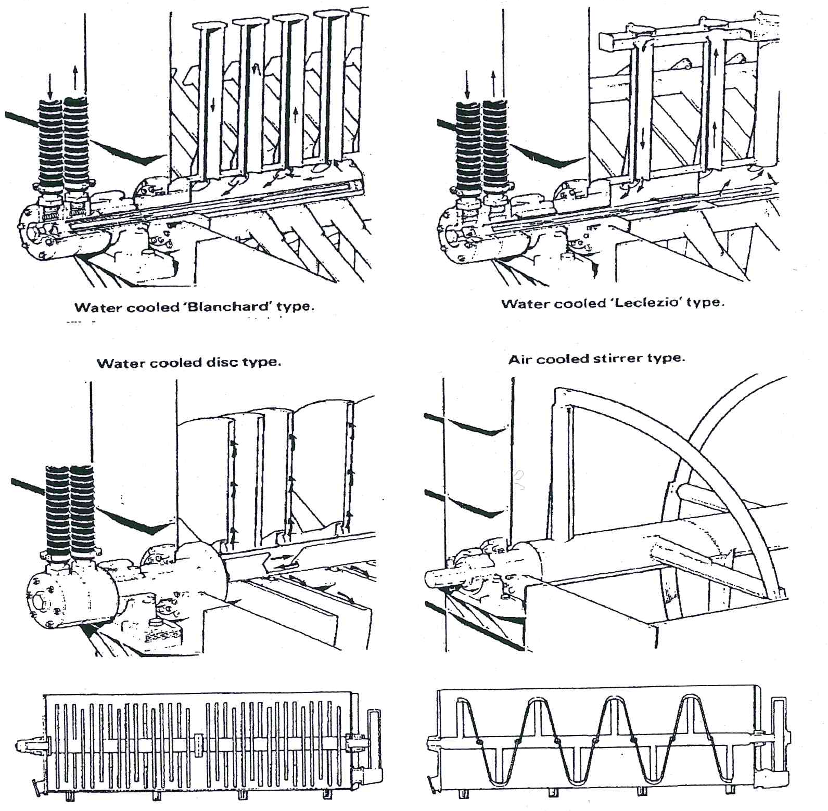
Originally all crystallisers were of the batch type: Each crystalliser being capable of taking one strike. Modern installations usually consist of a strike receiver and continuous crystallisers. The function of a strike receiver is, as the name implies, to receive the strike from the pan and supply a continuous steady feed to the crystallisers. The crystallisers are interconnected by ducting and the massecuite flows progressively from one crystalliser vessel to the next towards the centrifugal. Each crystalliser has cooling elements which are fed with water independently or in series. The cooling must be uniform and gradual without any local “coldspot”. Local overcooling can happen with individual cooling water but is less likely if cooling water is fed in series from the coolest to hottest crystalliser. Where possible crystallisers should be fed by gravity from the pans and/or strike receivers and again gravity feed should be used to the centrifugal. Pumping can damage crystals and if pumping is necessary the massecuites should be hot.
The modern trend is to install vertical crystallisers at ground level. Vertically mounted crystallisers have the advantage of space saving but since they are usually mounted at ground floor level, a liquidation pump is required for the liquidation of the massecuite at the end of the season.
When cooling is applied to a massecuite the crystal content may increase to a level where the massecuite loses its fluid characteristics i.e. the massecuite becomes too viscous to be stirred. To prevent this from happening, molasses from the centrifugal is added to the crystalliser to lubricate the massecuite.
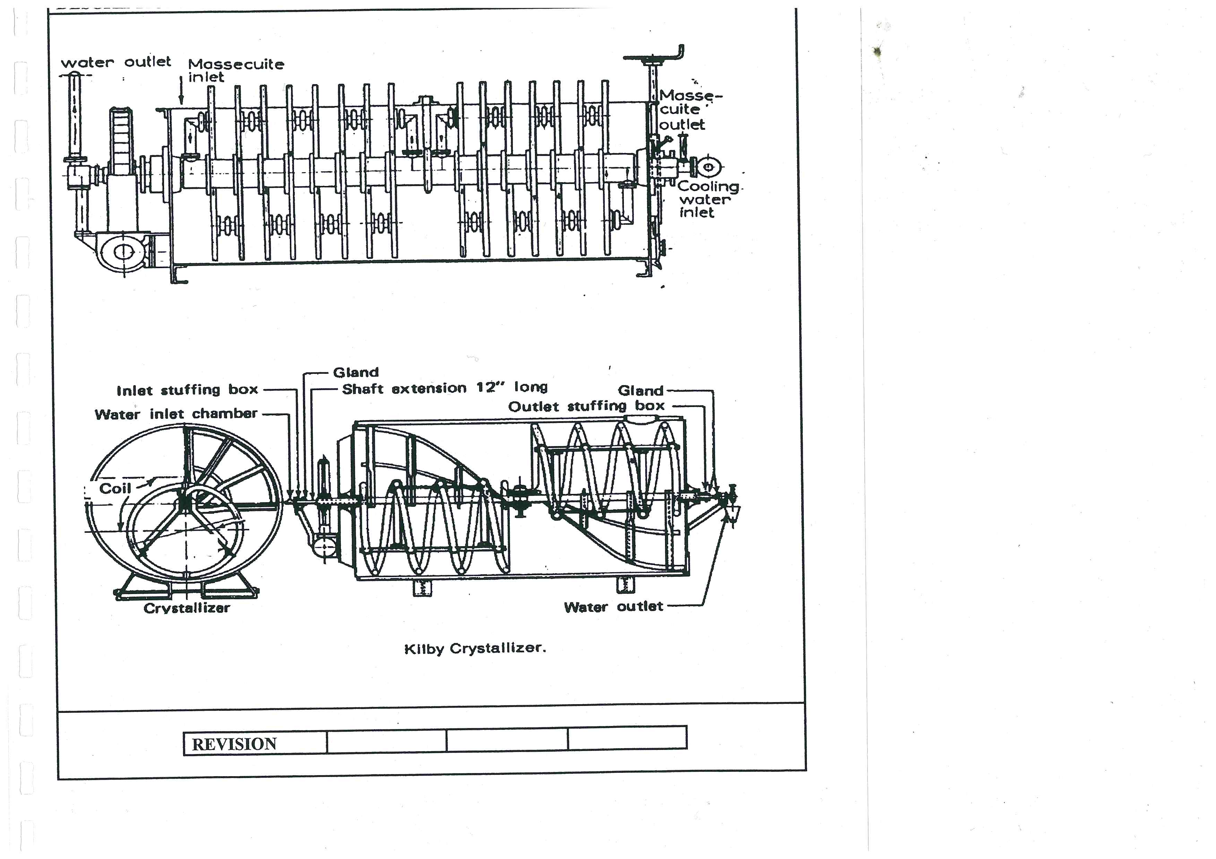
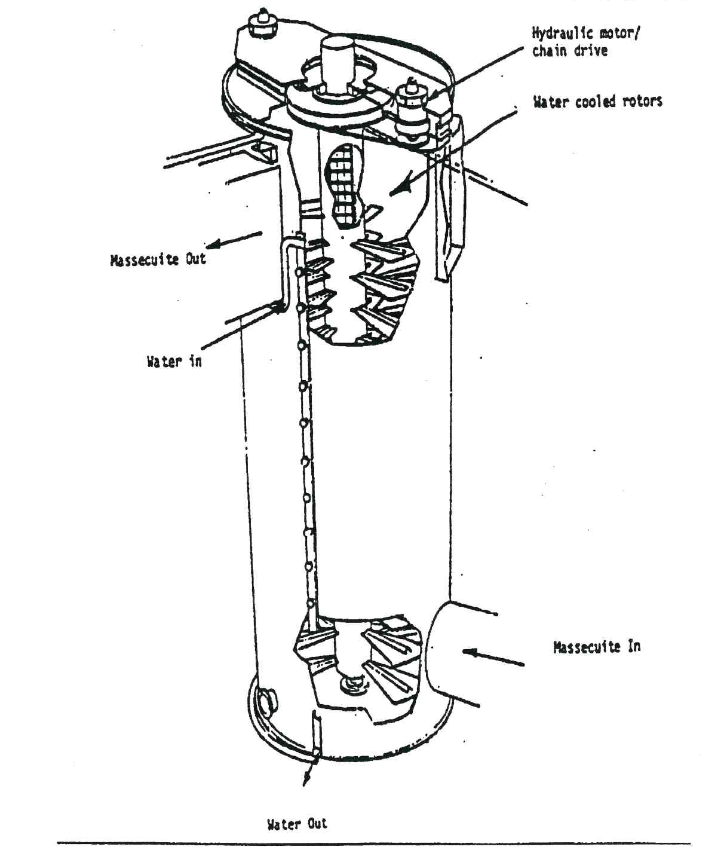
The diagram below shows the layout of a typical C-crystalliser station.
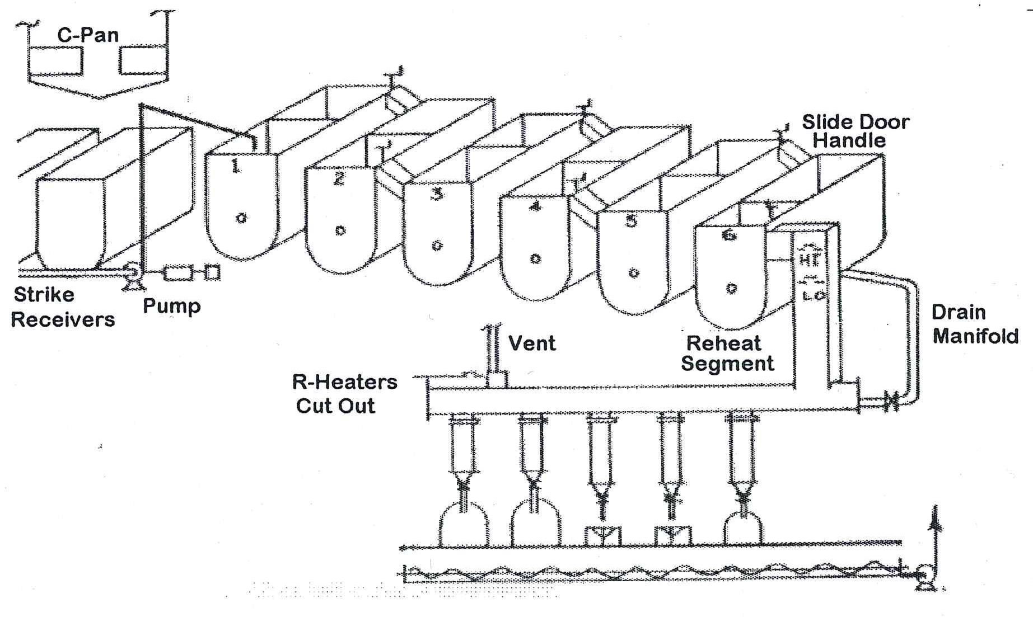
For a 375 tons cane per hour factory 6 x 100m³ water cooled C-crystallisers would typically be required.

HEAT TRANSFER
The heat transfer from the hot massecuite to the cooling water contained in the stirrer elements/fins is slow. This is due to the viscosity of the massecuite that limits turbulence and mixing in the massecuite.

SPEED OF ROTATION
Crystalliser speeds are low due to the high viscosity of massecuites and are of the following orders of magnitude.
  - A–massecuite 0.75 rpm
  - B–massecuite 0.5 rpm
  - C–massecuite 0.25 rpm
An increase in speed does little to improve crystallisation rate. This is fortunate as the load on the driving gear at increased speeds would be excessive.

CRYSTALLISER DRIVES
Crystallisers are usually driven by electric motors (typically 100 kW) through reduction gears. Hydraulic drives which are capable of high torque (turning force) at slow speeds are also used.

COOLING ELEMENT CORROSION
Dissolved oxygen in the cooling water will cause corrosion of metal cooling surfaces.
If the cooling element is not always full of water (Blanchard type) then the corrosion is worse. A closed cooling system treated with chemicals is advisable to minimise corrosion. Keeping the pH above 10 with caustic or the use of potassium dichromat will help.
Heat transfer is reduced when corrosion occurs and leaks might eventually develop with resultant dissolution of sugar in the massecuites.

Knowledge topic 3: Massecuite reheating

INTRODUCTION
A C-massecuite must not be cooled below 40°C in the crystallisers, because below this temperature the viscosity of the massecuite increases to the point where the massecuite losses its fluid properties and becomes unmanageable. The limiting factor for the separation of crystal and mother liquor in a C–massecuite is the viscosity of the mother liquor. A C–massecuite may be cooled as low as 40°C, but it must be reheated to about 54°C before centrifuging.
The molasses after cooling in the crystalliser is usually still supersaturated and the massecuite can be heated to saturation temperature without dissolving crystals. This operation requires careful control to avoid crystal dissolution.
Reheating can be carried out in the last compartment of the crystalliser, between the crystalliser and centrifugal or both.
The massecuite temperature should be brought up to saturation temperature as quickly as possible without crystal dissolution. The saturation temperature is normally about 55°C. In practice some sucrose does dissolve and the purity of the mother liquor does increase, but the increase is relatedly small. However, reheating is essential to reduce the viscosity of the massecuite for centrifugation.

TYPICAL TEMPERATURE VARIATION FOR A C-MASSECUITE
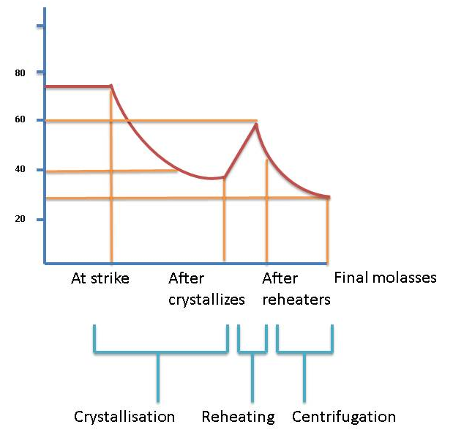

TYPES OF REHEATERS

Crystalliser heating
This is achieved by circulating warm water through the cooling elements. Ideally the water temperature should not be more than 2°C above saturation temperature. The heating should be as rapid as possible and with immediate curing molasses losses can be kept to a minimum.

Reheaters
Reheaters are either of the overflow or totally enclosed type. They have banks of tubes which are either staggered or in line. Heating water is pumped through the tubes from a heater which is temperature controlled. The water inlet temperature is about 7°C above that of the massecuite outlet temperature.
The heating elements of the reheater can be fixed or rotating. When the reheater is filled with massecuite, it is always filled from the bottom to ensure proper/complete filling. The temperature to which the massecuite is reheated will change during the season due to the changing massecuite viscosity. For example, unseasonal rain in October leads to a decrease in cane purity and to an increase in viscosity. The reheating temperature must thus be higher.

Resistance heaters
These heaters are situated in the feed pipe to the centrifugal and the massecuite is heated by electrodes supplied with +25kW of power.
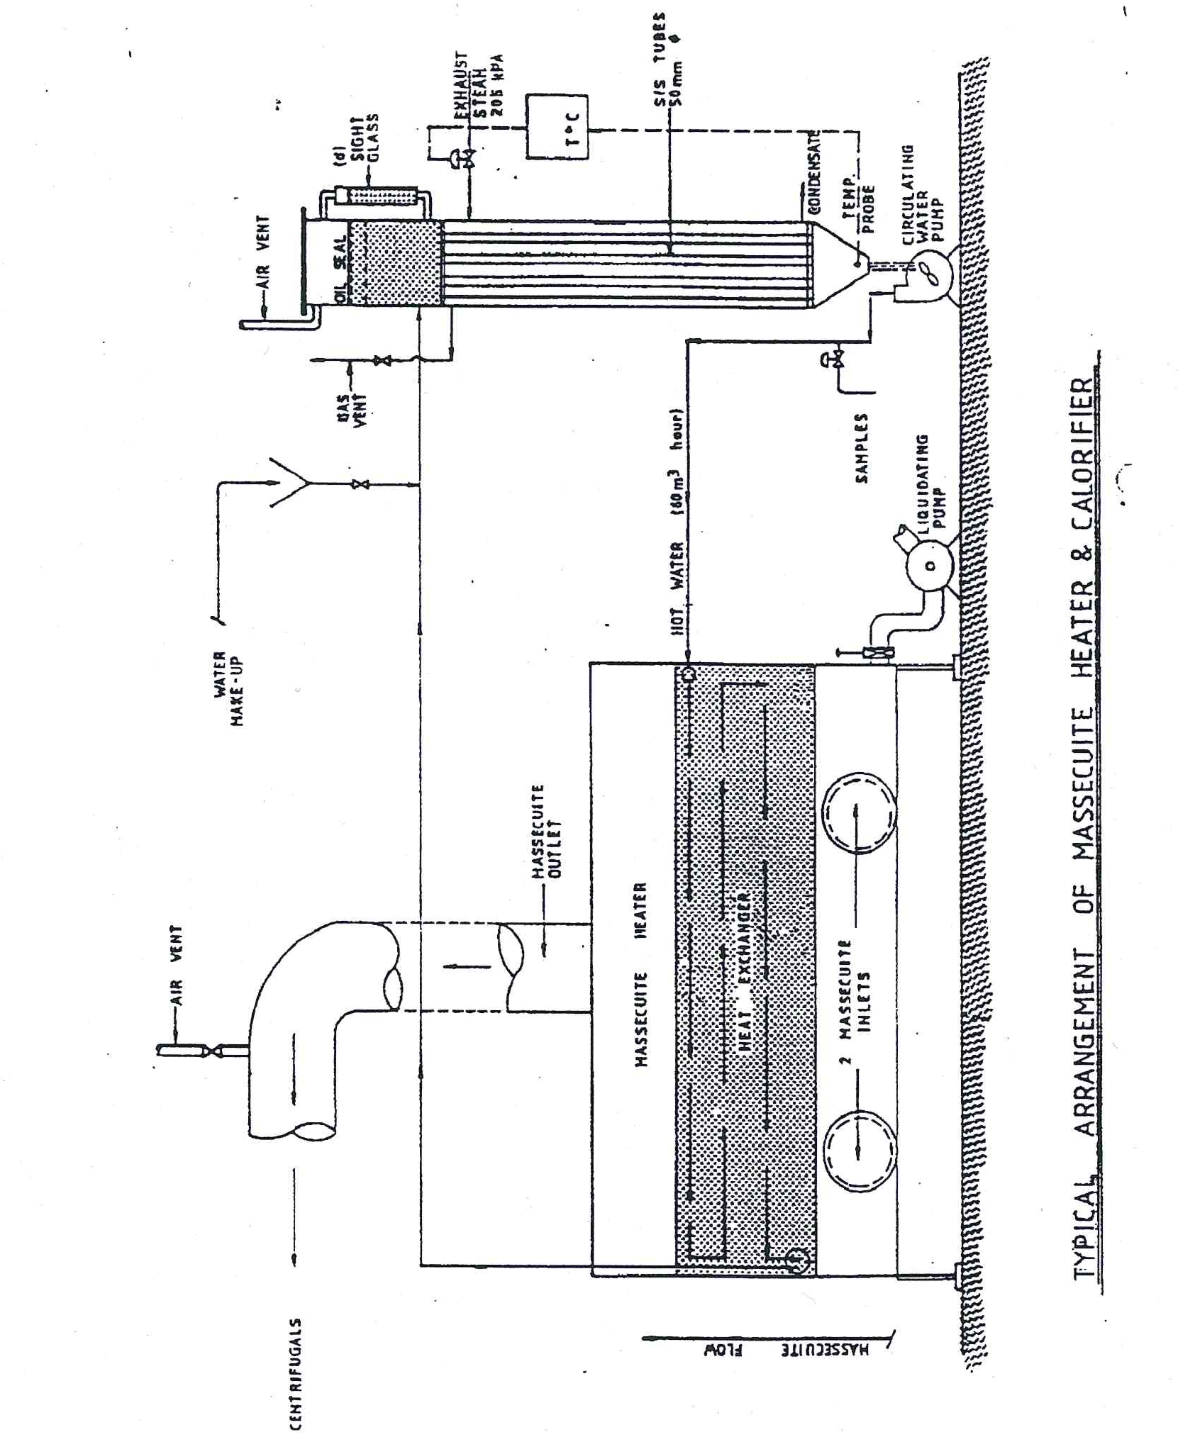

ASSESSING THE EFFECT OF CRYSTALLISATION
To assess the performance of the crystallisers the effect that the crystallisers have had on the mother liquor in the massecuite needs to be ascertained.

ANALYSING THE MOTHER LIQUOR IN A MASSECUITE
The mother liquor needs to be separated from the crystals it contains. This is done using air pressure in a nutsch apparatus and the sample of mother liquor obtained is called a Nutsch sample. The apparatus is very robust and represented as follows:
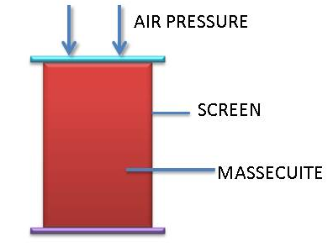
The mother liquor is forced through the holes in the screen while the crystals remain behind. The Nutsch sample is analysed for purity, because of the mother liquor indicates how much sucrose has been crystallised.
Nutsch samples are taken at strike, after the crystallisers and after the massecuite reheater. Molasses samples are already taken so the purity of the mother liquor after centrifugation is known.
Nutsch purities are the only way to gauge the effectiveness of the C-station. After crystallisation the Nutsch is at +40°C. Once the sample of massecuite is taken, the Nutsch filtration must be done quickly before the massecuite cools. The reason is that due to the massecuite’s high viscosity it filters slowly.
Sample Nutsch values for a C-station:
 | Apparent Purity | Change in Purity | Reason
At strike | 34.1
After crystallisation | 28.3 | -5 | Crystallisation in crystallisers
After reheater | 29.1 | +0.8 | Crystal dissolution
Final molasses | 29.6 | +0.5 | Crystal dissolution

This is a “good” Nutsch profile. Note that the crystallisers have produced a substantial purity drop in the mother liquor using relatively little energy. The final molasses shows an increase in purity because steam and water was used to wash the crystals in the centrifugal.

Knowledge topic 4: Theory of centrifuging

INTRODUCTION
After pan boiling it is necessary to separate the crystals from its mother liquor. The best known method at this time is to load the massecuite into a basket lined with a finely perforated screen and spin the basket at high speed to throw the molasses off the crystals.

THEORY OF CENTRIFUGING
The single most important factor in centrifuge performance is the force generated when spinning the basket at full speed. This is the force necessary to strip the molasses off. For convenience we express this force as a “Gravity factor” which is the number of times that this force exceeds the force due to gravity.
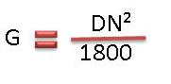
Where: G = Gravity factor
D = diameter in meters
N = revolutions per minute
At maximum speed the “G force” is about 1500.

SEPARATIONAL EFFECT
The separational effect does not depend only on the gravity factor but also on the time the centrifugal force is exerted, the viscosity of the molasses, the thickness of sugar layer and the quality of the massecuite.
In this context quality of massecuite refers to the complex of crystal habit and crystal size, as well as to the presence or absence of false grain and conglomerates.
The quality of the massecuite is the main factor which determines the separational effect.
The different factors affecting the separation of crystals from molasses are:
- Gravity factor
- Time
- Viscosity of mother liquor
- Thickness of Sugar Layer
- Massecuite Quality
- Use of Steam and Water
- Screen Condition
- Machine Condition
- Competency of operator

BATCH CENTRIFUGALS - THE TYPICAL BATCH MACHINE
A typical batch centrifuge is a large perforated drum with an internally fitted, perforated screen, all suspended at the bottom of a vertical spindle. The spindle is mounted in bearings and a flexible suspension at the top. The suspension and buffer assembly are in turn supported in the main frame of the machine upon which stands the drive arrangement. The basket rotates within a monitor casing which catches the molasses as it is separated from the crystals. The basket is lined with a backing screen and a liner. The thickness of the sugar layer in the basket is about 10cm.
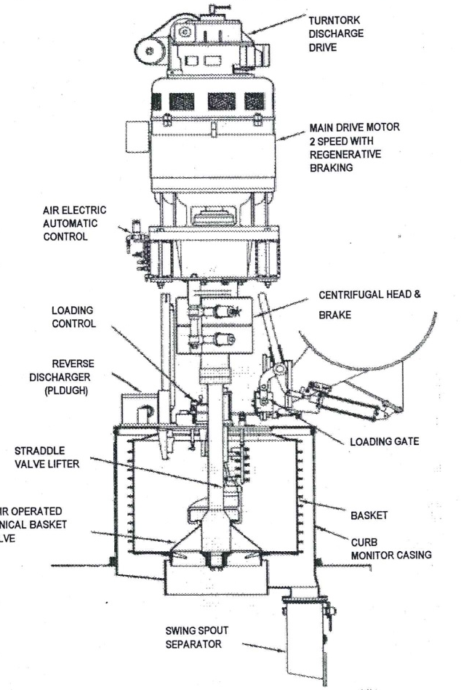
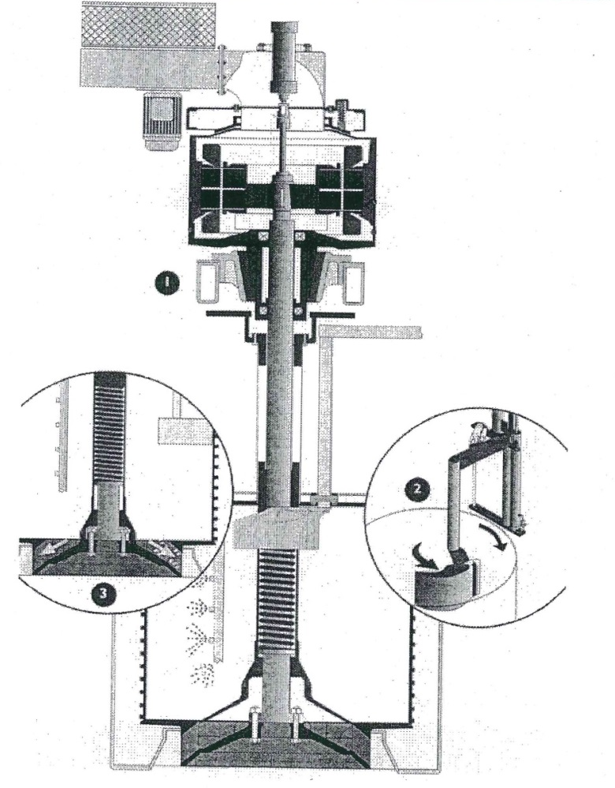

REMOVAL OF MOLASSES
The removal of molasses from the massecuite takes place in 3 stages:
- Removal of the excess liquid
- Draining of the molasses between the crystals except for a thin film on the crystal
- Reduction of the film thickness
Removal of molasses is fast during stage 1 and very slow during stage 3.

CENTRIFUGAL COMPONENTS

The basket
The centrifugal basket is usually made of stainless steel and is of welded construction. The basket is reinforced with hoops which provide a safeguard against bursting forces which could destroy the basket and its surroundings. As an extra safeguard the basket should be examined at regular intervals to detect any wear or stress damage.
Modern machines tend to have far bigger than their predecessors, especially as far as depth in concerned. The basket diameter is about 1370 mm and the depth approximately 1065mm. With a massecuite layer of 250 mm this results in a capacity of ± 1m³ of massecuite with a mass with a mass of about 1.6 tons.
The perforations in the basket are usually about 6mm in diameter and vary in number from 360-3500.
The discharge valve could be a flat plate which has to be lifted, a cone which is either raised, raised and titled, or a cone valve which is lowered. The cone which is lowered will give a clean discharge and does not obstruct the sugar flow.

Screens
The norm in batch machines is to have two screens in the basket. The outer screen being a supporting screen of course mesh to prevent the inner finer sugar screen from physically blinding the drainage holes in the basket. There are a few manufacturers that offer 3 screens. A typical arrangement would be:
Backing screen
Intermediate -
Sugar screen 0.5mm
Open Area 24%
Screen material is either stainless steel or brass. The sugar screen is slotted at one end and “tongued” at the other, to allow the two ends to be laced.

Charging
The normal method of charging a batch centrifugal is to introduce the massecuite from a spout at the rear of the machine and allow centrifugal force to draw it up the vertical side of the basket. An optimum speed must be selected to ensure the basket fills to the top flange but not so fast that imbalance is created. Due to massecuite’s high viscosity, charging speed is usually about 300rpm in order to get as near vertical a wall of massecuite as possible.
The control of how full the basket gets is an electro-mechanical device consisting of a “feeler arm” and limit switch or a “spiny” wheel which, when it touches the surface of the massecuite, spins and generates a signal.
The more modern machines on the market today have PLC’s which memorises the previous 3 or 4 charging period times and adjusts the rate of opening the feed valve and closing it, thus shortening the time required and improving the cycle time of the machines.

Ploughs
The plough is used to break up the wall of sugar in the basket after curing and guide it towards the discharge. The plough can either be parked inside the basket or on top of the monitor casing. The plough’s geometry and adjustment is the most critical item on the centrifuge. When “ploughing out” sugar it must be extremely close to the screen.
“Trailing geometry” has been designed into the plough such that, should it touch the basket, the plough will twist away from the screen and not dig in. This design also has a soft tip on the plough to preferentially wear, thus protecting the screen.
The sketch below shows the calculated trajectories at 25, 50 and 100 rpm from a basket of 1050mm diameter and 600 mm deep.
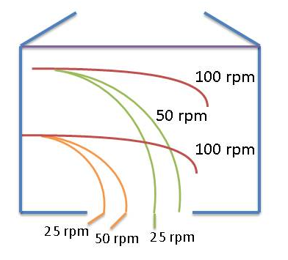
Obviously the basket speed during plough-out must be below 50/60 rpm if you want to clear the sugar out comfortably.

Wash water and steam
Washing devices are usually of the fixed spray design with either a single nozzle or several nozzles arranged to give full coverage of the sugar wall. The individual sprays can be adjusted to give greater concentrations in certain areas of the basket if required. The spray nozzles are mounted on a pipe, inserted through the top of the monitor casing. The pipe should have facilities for vertical and rotational adjustment. The timing of the wash and the quantity of water used is important.
The control of the wash is set by a timer and two or more applications of varying duration may in some cases be used. Hot water is used and in some cases it is superheated above 100ºC. The superheating is done in a heater. The flash from the water develops an atmosphere of vapour inside the basket. This increases the temperature of the sugar and aids the drying of the sugar after discharge.
A separate steam inlet is also usually fitted, which keeps the massecuite temperature up, which reduces the molasses viscosity and makes the separation easier.
Process requirements sometimes demand that the initial molasses runoff be separated from the physical washing of the sugar. This can be determined by having an automatic diversion valve or a flip-flop plate activated by the timer which brings the wash water into action. If syrup is used for the wash instead of water, there is an even greater need for this “clairce” to be returned to syrup rather than joining “A” molasses for further low grade boillings.

Drives
Modern batch machines are driven by AC variable speed drives either current modulated or voltage pulse width accelerated drives. A further drive is the pole changing unit where the motor was wound in such a way that by changing the pole connections it is possible to select one of 3 or 4 fixed speeds.
The AC variable speed drives with solid state invertors are the most energy efficient drives at this time, with relatively inexpensive squirrel cage motors and the facility of regenerative braking.

Capacity of the basket
The capacity of the basket may be expressed in volume of massecuite or in weight of sugar. Centrifugals are designed to receive a layer of massecuite or of sugar proportional to their diameter. The manufacturers generally provide for a massecuite layer of maximum thickness equal to 14 to 15% of the diameter of the basket.
It is generally the properties of the massecuite which determines the thickness of layer which can be handled. The volume of massecuite per charge will have the value:
V = $π$eH (D-e) for a flat top and bottom basket.
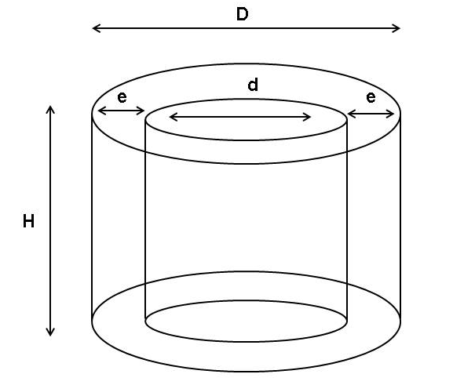
e has the values of 0.14 D theoretically and 0.12D practically.
Derivation
V = Volume of massecuite corresponding to the thickness “e” of massecuite (expressed in dm³)
e = thickness of the massecuite (in dm)
H = interior height of the centrifugal basket (in dm)
D = inside diameter of the basket (in dm)
Volume of massecuite = Volume of outer cylinder – Volume of inner cylinder
FOR INTEREST
V = $π$R²H – πr²H
But r = R – e
V = $π$R²H – $π$(R –e) ²H
V = $π$R²H – $π$[R² -2Re + e²]H
V = $π$R²H – $π$R²H - 2$π$ReH + $π$e²H
V = 2$π$ReH – $π$e²H
V = $π$eH (D-e)

Control systems
Control systems have improved over the years. The first electric controls used complicated electro-mechanical devices which sufficient from mechanical wear and deterioration.
The newer control systems use solid-state timing for all operations. This type of equipment has no moving parts, does not deteriorate with age and so can be expected to have a long life. Defects can be corrected quickly by replacing a card.

Windage
To overcome windage the top of the machines are sealed. Windage can cause the molasses to harden somewhat due to its cooling effect.

Drip trays
The slide valve for charging the machine is extremely difficult to seal 100% so that there are almost always drips of massecuite coming. To prevent these drips getting into the basket after the high speed purging is completed, particularly during plough-out, a drip tray slides into position.

Typical Operational Cycle
- accelerates to charge speed of 200 -500 rpm (5 seconds)
- charge of massecuite is loaded (10 seconds)
- accelerates to 1000 – 1500 rpm (30 seconds)
- during acceleration a water wash and steam wash may be used to improve drainage.
- full speed is held (40 seconds)
- deceleration using mechanical brake or regenerative braking (40 seconds)
- held at 40 – 90 rpm
- discharge valve opens
- ploughing mechanism is engaged
- sugar ploughed onto conveyor belt
- basket accelerates to charging speed and is washed to remove molasses and fines
- cycle is repeated
Before the conclusion of the acceleration period, washing with steam and water should start as waiting until top speed is obtained will result in the molasses film surrounding the crystal becoming “tough” owing to the cooling and drying of the air rushing into the basket.
Admitting steam immediately, charging faster and closing of the covers all reduce the cooling and drying out of the molasses film around crystals. Moreover, the higher temperature and the diluting action of the condensing steam will reduce the viscosity of the molasses film, and will increase the purging effect. The steam will also raise the temperature of the sugar which is important with regard to the subsequent drying of the sugar.

CONTINUOUS CENTRIFUGALS
Continuous machines are used mainly on low grade B- and C- massecuites with smaller more irregular grain size and shape and greater molasses viscosity. These all make the separation of molasses and crystals more difficult and it is therefore an important advantage of continuous machines that their G-factor is usually somewhat higher than for high grade batch units – going from 1 500 units in batch machines to 4 000 units at the rim of large continuous machines. The sugar layer in continuous machines is only 0.5 to 1.0 cm thick.
Continuous centrifugation has the following advantages:
- Reduced power demand
- Reduced initial cost
- Better safety
- Easier maintenance
Most continuous centrifugals run at a speed of 2000 – 3000rpm

BASIC OPERATION OF A CONTINUOUS CENTRIFUGAL
This machine consists of a conical basket with an angle of ±30º, with its larger diameter facing upwards. The basket is underdriven by ‘V’ belts from a motor placed alongside the machine. The machine is fed by gravity into or near the centre of the basket and the discharge is both continuous and automatic without any special loading or discharging devices. The basket rotates at a uniform speed, which reduces the power load, but the massecuite has to be accelerated to the full angular velocity of the basket. There is thus a difference in the relative motions between the massecuite and the basket until the massecuite attains the speed of the basket. The massecuite is accelerated again as it moves up the screen and the basket diameter increases. This motion involves wear of the screen and associated parts. The sugar leaves the screen at the full peripheral speed of the basket and the crystals strike the monitor casing after being slowed down slightly by air resistance. The motion between crystals and screen and discharge velocity causes breakage of the grain.
The forces acting on the sugar, give rise to a nett upward force provided the crystal is covered by a lubricant (mother liquor). This will displace the sugar upwards. The centrifugal is thus self-discharging provided massecuite continues to be fed in. If the feed is stopped the large nett upward force becomes smaller as the lubricant film is removed. The result is:
- The movement of the sugar is reduced
- The retention time is increased
- More molasses is removed
- The rate of movement is further reduced
Under practical conditions the sugar discharge stops as the feed is stopped. While operational a thin film of massecuite covers the whole screen, unpurged at the bottom and being progressively more purged towards the top. The film of massecuite will move according to the rate of feed. Any increase in the massecuite film thickness will result in flow forces which will cause the excess massecuite to spread over the screen. When this happens the sugar quality will drop and to improve quality, the input rate will have to be reduced. The massecuite film thickness is thus self-correcting to comply with the required quantity/quality.
The maximum achievable throughput rate for a machine with a given screen area, screen open area and gravity factor will depend on the massecuite viscosity.
Viscosity will have less effect on the curing than it has in a batch machine. The same applies to a small or mixed grain size, as the massecuite layer is so thin. Provided the massecuite retains fluidity a continuous centrifugal should be to cope with poor quality massecuites.
Lower throughputs generally give higher sugar purities and hence improved sugar quality. The reason for this is that lower throughputs result in a thinner massecuite layer which purges (loses its molasses) more easily.
However, a decrease in throughput does not necessarily increase the sugar quality above that normally achieved. This is because at low throughputs the molasses is removed from the crystal while the crystal is still some away from the top of the basket, and screen area is not being utilized.
Wash water should be applied at a rate such that it will only dilute the molasses film on each crystal, without any significant dissolution of the crystal. The dilution of the molasses film will lower its viscosity so that better curing will be achieved. The molasses (and water) will be rapidly removed from the crystal surface without raising the molasses purity. By reducing the massecuite wall thickness the filtering effect of the crystals is reduced and the separation of crystals from molasses is then carried out solely by the holes in the screen. Any smaller-than-hole crystals will not be retained by the bridging of larger crystals across the screen. Screen selection is thus extremely important as the screen must have a very small aperture with maximum possible screen open area and good wear characteristics.

TYPES OF CONTINUOUS CENTRIFUGALS

The BMA continuous centrifugal
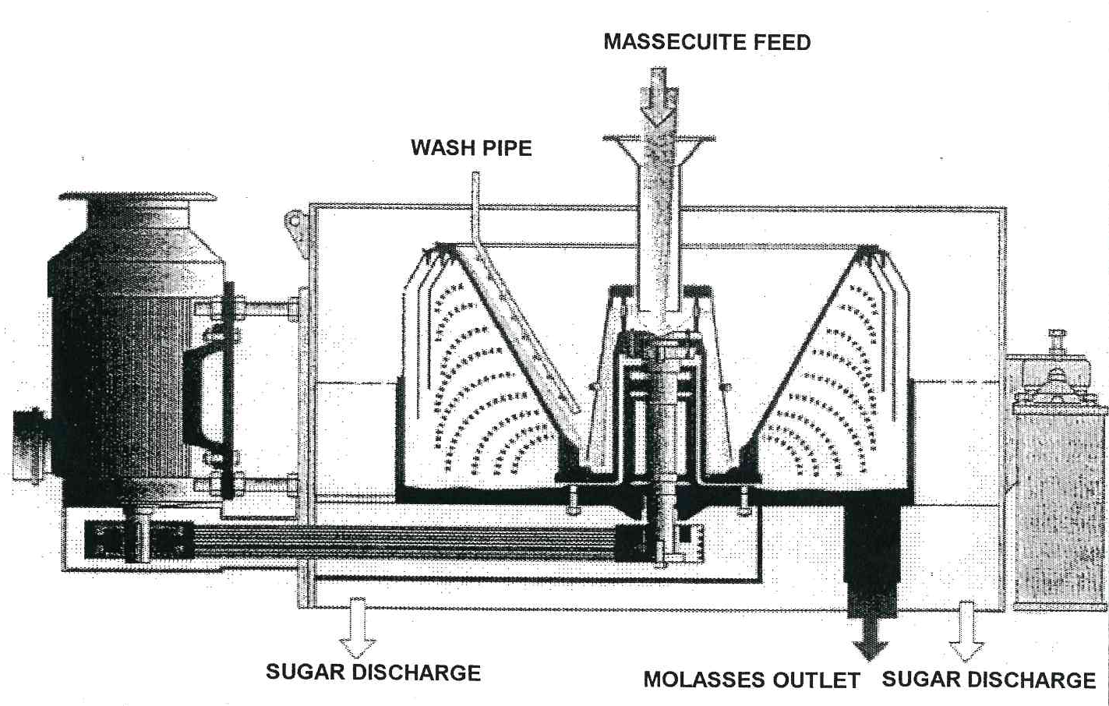

The Western State continuous centrifugal
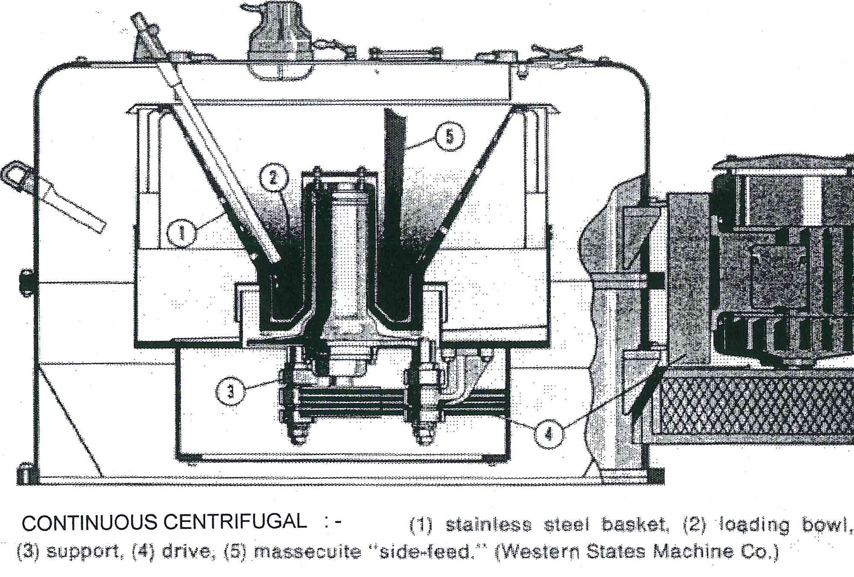

MACHINE DESIGN
A continuous centrifugal consists of the following basic parts:
- The basket
- The acceleration cup
- The screen
- The feed system
- The sugar–collecting monitor casing
- The molasses–collecting casing
- The drive system and various controls

The basket
The basket must have a specific cone angle to suit the massecuite to be cured. Basket angles have been standardized on 30° and 34° is normally used for low grade massecuites. Basket diameters are 1000, 800 and 600 mm.
The basket must be strong enough to resist the large pressures and forces developed as the basket rotates at high speed.
The basket can be either fabricated or a single piece casting.
The fabricated basket is made of radial ribs and a series of concentric rings welded to the ribs. A backing screen substructure is needed to support the centrifugal screen and this is usually made from a punched plate or from woven wire. Stress failure of a fabricated basket will normally be in the form of distortion with weld cracks. Sudden failure is unlikely. Baskets should be inspected regularly and any increase in vibration should be taken as a sign of possible distortion.
The solid basket is normally a one-piece stainless steel casting with machined drainage holes and channels. Heat treatment before and after machining relieves any stresses. The solid basket has the advantage of a smooth outline which reduces air resistance and windage. A backing screen of ground-flat woven wire is used to support the working sugar screen and allow molasses drainage. With correct heat treatment the solid basket is extremely strong, but any failure would be a sudden bursting with little warning. Although this risk is small, regular checks for hairline cracks from the drainage holes should be carried out.
The coupling of the basket to the drive system should be safe but simple enough to facilitate easy basket removal for machine overhaul.

The acceleration cup
The massecuite that enters the machine has to be accelerated into a circular path and to a high velocity. This must be done before the massecuite moves across the screen. It is also important that the distribution over the screen is even if good curing, and no vibration is to be attained. This is done by means of a cup, cylinder or disc at the lower end of the basket. The massecuite that is fed to the cup or disc is accelerated by frictional forces and flows under centrifugal force up the sloping sides of the cup and forms a thin uniform layer on the screen. The design of the cup has changed over years. The first ones were shallow and not very effective. The shallow cup could not effectively accelerate the massecuite, so distribution suffered with poor screen utilization and vibration. Newer designs either on-centre or off-centre have deeper, larger cups which sometimes have grooves or patterns inside to assist in massecuite pickup.
BMA uses a small cup supported on top of the bearing housing. From there the massecuite flows down an outer “bell” shaped acceleration cone, discharging horizontally outwards into the main distribution ring and then onto the screen.

Screens
The design of the screen is extremely important for good performance. It must have a hard surface to withstand the large forces generated by the continuous sliding of the massecuite and crystals across its surface. The screen must also be strong enough to resist deformation with the minimum amount of support from the basket. If there is too much support then the drainage of molasses is affected.
The screen must be held securely in the basket or it will be ejected with the sugar. The main clamp has to be at the bottom keeping the screen in tension and preventing any upward crumpling. A clamping ring can be used at the top of the basket or a number of small clips used instead.
The screen has numerous small precision-formed holes formed by photo-etching. The holes can be either circular or rectangular. Rectangular holes are favoured in South Africa. B–massecuite machines have screens with slot width 0.09mm and length between 1.8 and 2.8mm.
C massecuite machines have slots of similar length but are 0, 06 mm wide.
The whole size is related to grain size and molasses viscosity. The slots are tapered to reduce blinding. In some cases the bottom edge of the screen may be kept free of holes or have a reduced number of holes to give extra strength in the clamping region.
The percentage open area is important for molasses drainage and throughput and is limited by mechanical strength. The larger the percentage open area, the greater the capacity of the machine. Open areas of B screens will vary from 7 – 15% whilst C screens have open areas that vary between 5 and 10%.
To extend screen life a trap or mesh in the feed system can be used to prevent large objects from reaching the screen. The risk of screen damage in a continuous machine is far greater than in a batch machine. The screen must also be made from material that will resist possible chemical corrosion and also electrolytic action between the dissimilar metals of basket and screen.
Screen material is a nickel alloy base with a hard chrome layer on top or a stainless steel screen with laser cut slots. Sugar screens for continuous centrifuges are usually in four or five triangular segments which overlap one another and are mechanically clamped into the basket at the bottom. The working sugar screen is supported by one or two backing screens.

Feed system
The feed can be introduced either centrally or off-centre depending on the type of accelerating cup used. Centre feed, being symmetrical gives a more uniform massecuite distribution and minimises vibration. The feed valve is usually an iris valve which gives sensitive control and always feeds the massecuite on the valve centre line, which helps to ensure a uniform flow and action of the accelerating cup.
The application of water and steam wash varies according to the manufacturer. The wash water pipe usually runs down the slope length of the basket and either has a number of small holes facing the screen or spray nozzles may be used to cover a wider area. The application of water is controlled via a valve and flow-meter which gives an indication of flow rate.
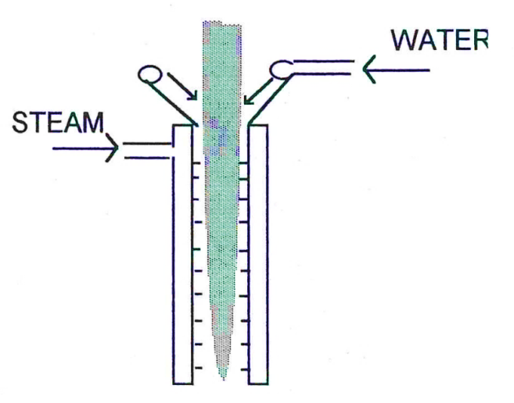
The massecuite leaves the feed spout some 400 – 500 mm above the steam/water mixer, narrowing as it falls to strike the distributor cap. In passing through the mixer, the water addition reduces the viscosity whilst the steam addition in raising the temperature assists in doing the same.
The mixer usually consists of a ring of pipe + 100mm diameter fabricated from 12 – 15 mm before tubing at the top, with 1.5 to 2.00 mm holes drilled at regular intervals to spray water onto the “rope” of massecuite.
Steam addition is done through a double walled pipe drilled on the inner circumference and length and either open or sealed at the lower end.
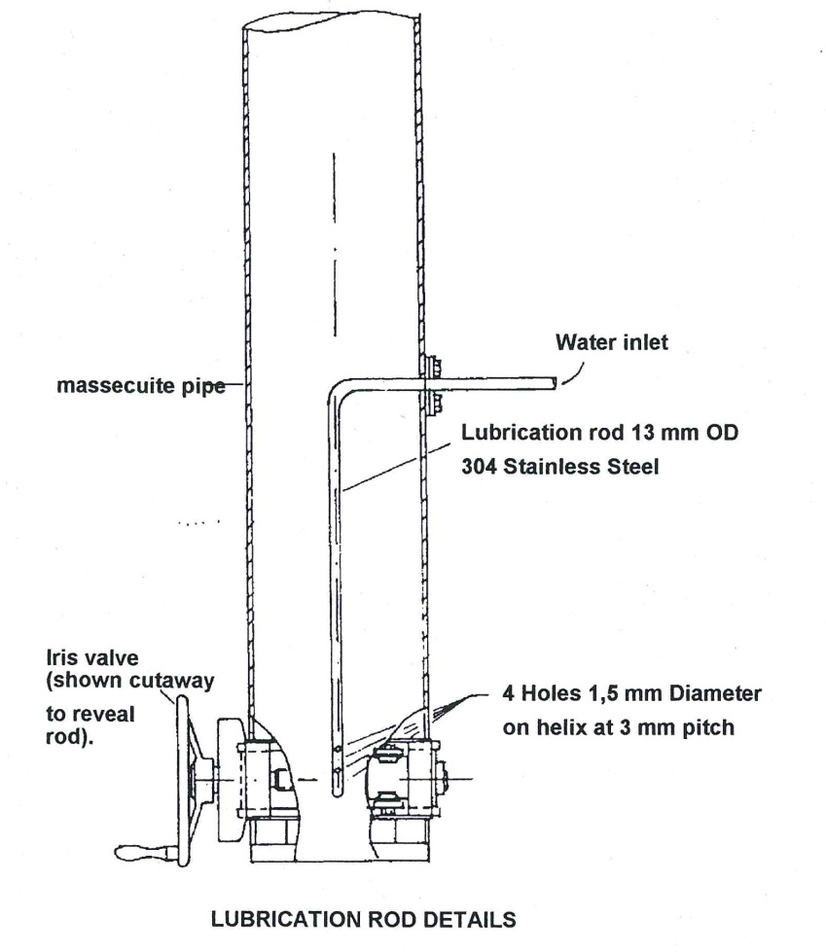
Water can also be added with a ‘lubrication rod’ which is a short length of pipe fitted vertically into the massecuite stream through the iris valve. The pipe is perforated and it is claimed that the water mixes readily with the massecuite, reducing the viscosity.
Low pressure steam can also be blown into the basket to maintain a warm humid condition which improves the movement of sugar across the upper part of the screen and reduces molasses viscosity. A steam jacket on the feed pipe can also be used to warm up the massecuite and reduce velocity before acceleration.

The sugar collecting monitoring casing
This monitor casing will contain the sugar as it is spun tangentially over the rim of the basket and decelerate it so that it will fall under gravity to the bottom of the casing. The bottom of the casing must be attached to a chute to discharge the sugar to a conveyor or melter.
The design of the casing must take into account the abrasive effect of the high velocity crystals impinging upon a narrow band of metal and also the corrosion caused by hot, humid acid conditions. The casing should also be fitted with some sort of sugar sampling device.

The molasses collecting monitoring casing
The molasses casing is an annular ring around the basket inside the sugar casing. The cured molasses is flung from the basket into this space. Again due to conditions, corrosion is a problem.
These should be some sort of labyrinth seal at the top to prevent molasses entering the sugar casing. The bottom of the casing will have an outlet for molasses drainage with some sort of liquid seal to prevent ‘windage’ problems.

FEATURES OF THE BMA CONTINUOUS CENTRIFUGAL
The basket and its fittings:
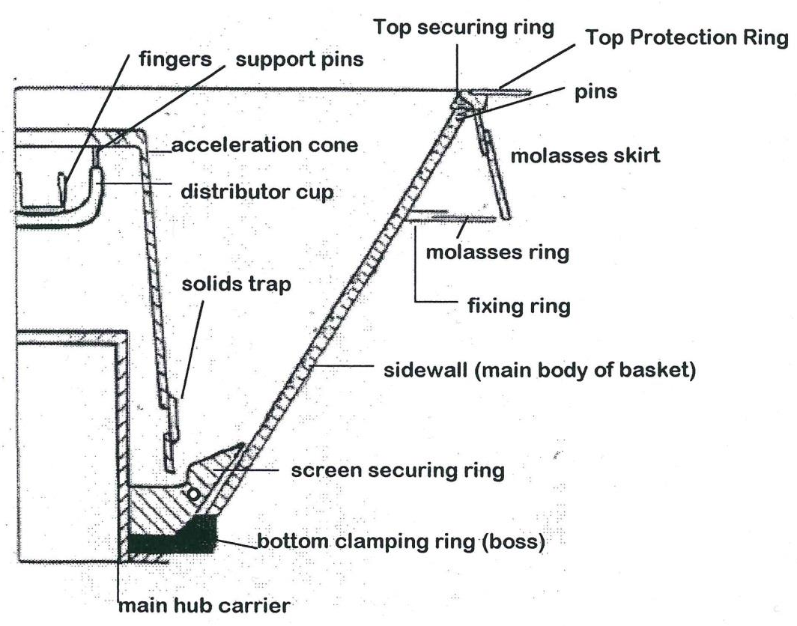

Fingers/pins
These fingers of which there may be 4 to 6 or 8 are installed in the distribution cup to improve the mixing of water, steam and massecuite in an attempt to raise the temperature and lower the viscosity at the last possible moment in order to reduce the potential of crystal dissolution.
The fingers also catch the massecuite, accelerate it and throw it to the outer wall of the distributor cup.

Distributor Cup
The distributor cup starts the massecuite spinning and as it climbs the vertical wall of the cup it is evenly spread around the periphery before passing the 6/8 pins holding the acceleration cup to the acceleration cone.

Acceleration Cone
The sole purpose of this cone is to further distribute the massecuite to a very thin layer and to accelerate it to as near the same angular velocity as the bottom of the main body of the basket as possible. The cone must also discharge below the top of the securing ring so that crystals do not impinge directly onto the screen.

Screen Security Ring
The ring clamps the lower end into the cone. It also has the function of gradually accelerating the product to the velocity of the screen itself.

Side wall
This cone is the support for the working screen. The drainage is achieved through the side wall. Baskets are produced at an angle of 30° off the vertical.

Basket Support
In most cases the basket is bottom supported on a relatively large diameter flange and is coupled to the drive shaft by several flexible buffers.

THE DRIVE SYSTEM
The basket shaft is supported by bearings which can either be force-fed oil lubricated or grease packed. The bottom of the shaft carries the pulley for the vee belt drive from the vertically mounted motor. Compared to a batch machine the motor is small and there is no provision for speed variation. The basket shaft is mounted on rubbers to damp out vibrations caused by irregular feeding and curing.
The drives are straight forward squirrel cage motors with star/delta starters. The installed power can vary from 30kW to 100kW. “B” machines will draw more power because the less viscous massecuite allows a greater mass to be fed to the centrifuge. The transmission from motor to basket is a “gear up” belt drive to 2200 rpm.

CONTINUOUS CENTRIFUGAL OPERATION
The machine is brought up to speed, checked for abnormal vibration and then the massecuite isolation valve is fully opened (usually a knife gate valve). The iris valve or volumetric control valve is then opened until predetermined load on the motor (amps) is obtained.
The water and steam to the feed nozzle must be adjusted and set to obtain an even and smooth flow of massecuite into the distributor cup to obtain the quality of sugar required.
Periodic checks (hourly) should be visually made on the sugar in the sampler and laboratory analysis of the molasses will give an indication of machine performance.
Regular checks using a stroboscope should be done (say 4 hourly) to visually check the crystal movement up the cone. If “fingers” of massecuite are seen then there is fouling of the distributor cup or acceleration cone, or the sugar screen or support mesh is beginning to blind, reducing the opportunity to drain molasses off the crystals.

FLEXIBILITY OF CONTINUOUS CENTRIFUGALS
As the residence time of the sugar is a matter of a few seconds the application of steam and/water hardly dissolves sugar and therefore does not raise the purity of the molasses significantly. If applied reasonably they act as lubricants only.
Due to the thin layer of massecuite in the basket, the continuous machine is capable of curing massecuite of much higher density. A poor quality strike which is difficult to process in a batch type centrifugal may cure reasonably well in a continuous machine.
The disadvantage of the continuous machine is the attrition of the crystals. When low grade sugars are cured continuously the crystals are protected over the whole length along the screen by the molasses film surrounding them. In the case of high grade sugar however the molasses film is removed at the beginning and the larger crystals are scratched and crushed when (largely free from protecting molasses film) they come into contact with edges of the perforation of the basket.
For the curing of B-sugars a different type of basket is used than for low grade sugars i.e. a basket with a wider top angle. The arrangement accelerates the speed of the crystal along the screen surface. As there is less time for drainage of the molasses the crystals move only a very short distance unprotected by their molasses film.
In addition to crystal attrition due to the contact between crystal and screen we have to reckon the more important damage done to the crystal after they have left the basket and hit the surrounding monitor casing.

CHOOSING A CENTRIFUGAL: BATCH OR CONTINUOUS?
The batch machine is very much more expensive than the continuous machine. The continuous machine on the other hand will not give you the quality specifications sugar required for VHP since it is not capable of “cleaning up” the A-crystal to meet 1350 units of colour without a great deal of washing. Crystals leaving the basket at high speed shatters on impact with the monitor casing, resulting in very high “fines” content.
Thus the normal route would be to select a batch machine for A-massecuite and use the continuous machines on B and C duty where the crystals go to remelt or magma where they are “cleaned” by dissolving the substandard particles.
Many mills use special continuous centrifuges with very large monitor casings for B sugar curing. The large monitor casing allows the crystal a longer trajectory so it slows down sufficiently to prevent damage. These crystals are then used to prepare magma as they are undamaged and are uniform in size and shape. This results in less wash water being required in the pans.
An Australian company has also developed a continuous machine for A-massecuites. It utilizes a deflector to deflect crystals downward.

RELATIONSHIP BETWEEN WASH WATER AND SUGAR QUALITY
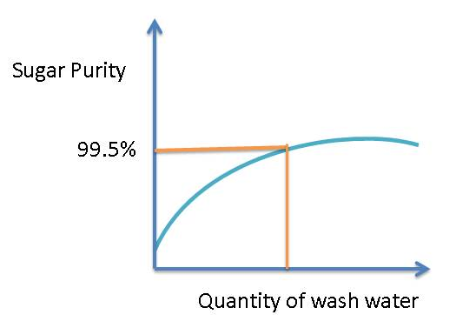
There is an optimal purity. To increase the purity further requires large amounts of water. This is undesirable because it dissolves crystals. Crystals can be washed with syrup, but this does not work too well. In a refinery jet 4 (final molasses) can be diluted and used to wash crystals in the centrifugal. This has a colour of about 400 – 1000 and hence the diluted molasses wash is followed by a very short water wash.

DIFFERENT MAKES OF CONTINUOUS CENTRIFUGAL
- Silver Weibull (USA)
- Fives-Lille (France)
- BMA (Germany)
- Western States (USA)
- Broadbent (England)

CENTRIFUGAL PERFORMANCE
The sugar and molasses must be regularly monitored both visually and by obtaining molasses purity data from the laboratory.
Careful monitoring can reveal the following:
- Excessive washing with water/steam
- Holes in the screens
- False grain
- Massecuite reheater problems (i.e. massecuite is too viscous)

Knowledge topic 5: Exhaustion

THEORY AND CALCULATIONS
Sucrose lost in final molasses constitutes the greatest loss of sugar in the factory.
The composition of non-sugars in final molasses has the biggest influence on exhaustion. The two main non-sugars are reducing sugars (glucose and fructose) and ash.
Sucrose solubility is decreased by reducing sugars.
AND
Sucrose solubility is increased by ash.
From the radio of the above two non-sugars (the RS/Ash ratio) it can be shown that molasses purity will decrease as the RS/Ash ratio increases.
The exhaustion of molasses thus increases as the RS/Ash ratio increases i.e. the sucrose recovered as crystals increases as the RS/Ash ratio increases.
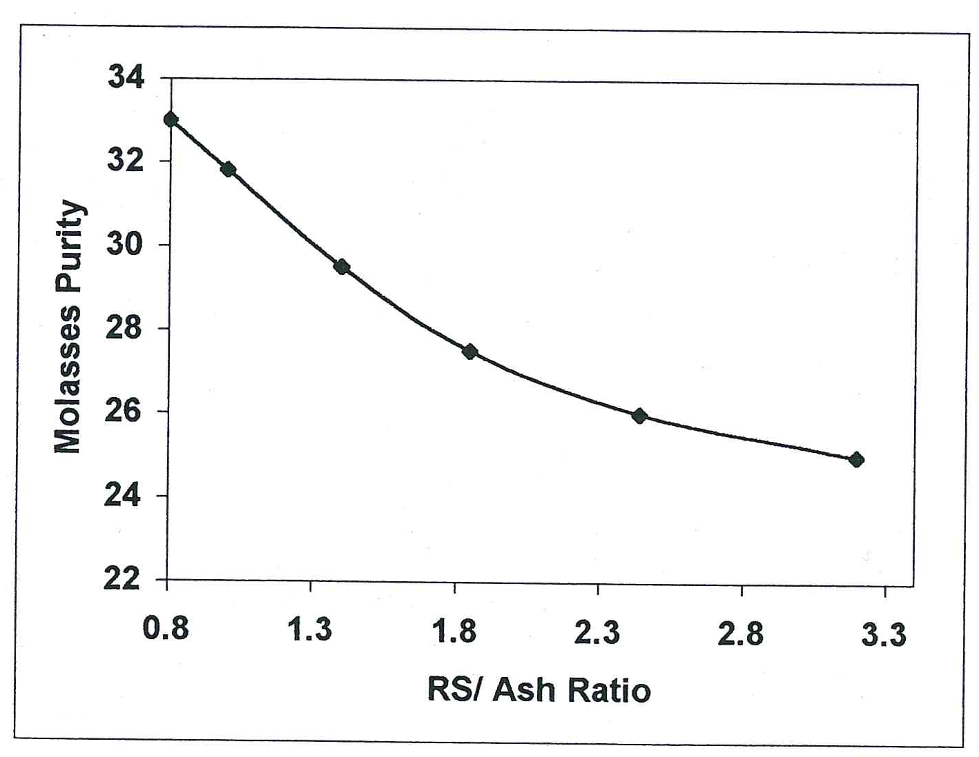

TARGET PURITY
This effect has led to a target purity formula being devised.
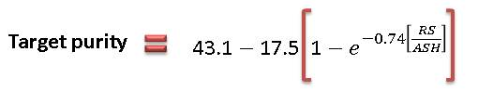
The molasses is analysed to obtain its reducing sugar to ash ratio and the target purity is then calculated. This target purity represents the lowest possible purity of molasses that can be obtained for the given RS/Ash ratio.
If the ash content increases relative to the reducing sugars content, the RS/Ash ratio increases and the target purity decreases.
When the reducing sugars increase relative to the ash content, the RS/Ash ratio increases and the target purity decreases.
A target purity difference (TPD) is calculated to give factory staff an idea of the extent to which the molasses has been exhausted of its sucrose. The TPD thus gives an indication of the performance of the C-station.
TPD = Purity of final molasses – Target purity of final molasses

Knowledge topic 6: Theory of drying

INTRODUCTION
The moisture content of the sugar leaving the centrifugal is too high for convenient handling and storage. The moisture content must be reduced to a value low enough to prevent the growth of micro-organisms which would cause deterioration and loss of sugar during storage.
A sugar will not deteriorate in storage if it:
- Is comparatively free from insoluble matter
- Has hard uniform and fair sized grain free from conglomerates
- Has a moisture content in relation to its pol to conform to certain “factors of safety”
- Is an “unwashed sugar” (i.e. the crystals are surrounded by their original film of molasses)?
- It has been manufactured under sanitary conditions to keep contamination by fungi, yeasts and bacteria to a minimum.

MOISTURE CONTENT AND “SAFETY FACTORS”
The commercial sugar leaving the centrifugal, which is to be packed for sale or export, generally has a moisture content of 0,5 – 2%. Moisture is very detrimental to the keeping qualities of the sugar when it exceeds a certain limit and particularly when it rises above 1%.
Since the micro-organisms that cause deterioration cannot develop in solutions of high density, the ratio of non-sucrose (non-pol) to the water in the molasses film surrounding the crystals is the determining factor in sugars of normal composition.
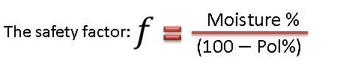
The safety factor should be less than 0.23.
The safety factor/limit depends on the proportion of impurities present in the sugar. A given % of water is more detrimental with a sugar of higher purity.

COMPARING RAW AND REFINED SUGAR
Why is a given moisture % more detrimental to the keeping quality of a refined sugar than for a raw sugar?
Let us compare raw and refined sugar.
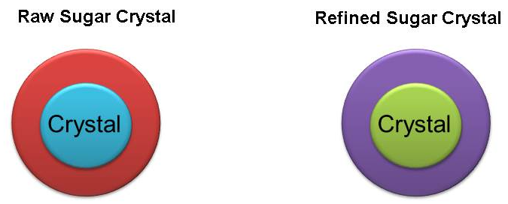
Surrounded by its original molasses layer | Has had its original molasses layer washed away. Surrounded by a saturated sugar solution
The molasses layer has a relatively high non-sucrose concentration (Fructose, glucose and salts). | The saturated sugar solution has a low concentration of non-sugars (Fructose, glucose and salts)
The molasses layer has a relatively high density (High brix). | The saturated solution has a relatively low density (lower brix).
Microorganisms cannot develop properly in the high density solution. | Microorganisms can develop easily.

WASHED SUGARS
The safety factor is valid only for sugars carrying their original film of molasses because washing a raw sugar reduces the density of the molasses film. In general, composition after washing must approximate to that of an unwashed sugar if a stable sugar is to be obtained.

MICRO-ORGANISMS
The loss of polarisation during storage of raw sugar is caused by the action of certain micro-organisms in the film of molasses surrounding the crystals.
Three significant groups of micro-organisms that may cause deterioration are:
- The Mould Fungi: These cause the commonest and most serious deterioration in storage. There are over 20 of these species of invertase producing moulds occurring in raw sugars.
- Osmophilic Fungi (frequently Torulae): They have a selective action for the levulose (fructose). They cause the reducing sugars to decrease with a corresponding increase in pol.
- Sporangeous Bacteria: Particularly the Mesentericus group. They originate on the cane or in the juice and are the least important factor in deterioration, as they are active only in relatively dilute molasses films (50 to 60°Bx)
The moulds and yeasts enter the sugar after manufacture, frequently by contamination of the centrifugal.

CHEMICAL TREATMENT
Deterioration can be prevented by chemical treatment. 0.5% Sodium Chloride by weight completely prevents deterioration of a sugar with a safety factor of 0.43.
Alternatively 50ppm of paraformaldehyde can be used. This is in the form of a fine powder that depolymerizes in 10 – 12 days releasing formaldehyde gas in the sugar. These chemical germicides are effective but with reasonable close control of moisture in the sugar at the centrifugal and fair storage conditions they appear unnecessary except under abnormal conditions.

MOISTURE CONTROL DURING STORAGE
The two controlling factors determining deterioration of raw sugars are:
- Action of micro-organisms in the molasses film surrounding the crystal.
- Sufficient moisture in the film to permit the microorganisms present to propagate (“effective Moisture level”).
Control of the moisture content of the sugar by safety factor is effective for the sugar as made, but moisture absorbed during storage is as detrimental as moisture left in the sugar at the centrifugal.
Many studies of the atmospheric conditions best for storage have been made and the consensus is that relative humidities (RH) of 60 to 70% is critical.
Definition: The relative humidity is the ratio of the partial pressure of the water vapour in the air to the partial pressure of water vapour in the air when saturated at the same temperature. This ratio is usually expressed as a percentage.
At 35 to 40°C absorption of moisture is very slow below 75% RH.
In general moisture increases were closely related to humidity and temperature, but sugars with high reducing sugar content absorb moisture much more rapidly than those low in reducing sugars.
Webster’s graphs of moisture content against RH for three temperatures show rapid increase in moisture with increased humidity and temperature when reducing sugars content is high, but relatively small changes if the reducing sugar content is low.
When sugar is stored in a well-constructed warehouse which can be tightly closed the moisture content (of the air) soon reaches an equilibrium with the sugar present and no further gain or loss of moisture by the sugar occurs. Large compact stacks are also an essential part of this plan.

DETERIORATION IN BULK STORAGE
It is generally recognised that little or no deterioration takes place in bulk piles. Bulk sugar keeps better than bagged sugar during long periods. The bulk sugar becomes moist on the surface at night when humidity is high and crusts over in the day when humidity is lower. The opposite is true with bagged sugar where the bag acts like a wick. All this presupposes a well-made raw sugar of suitable safety factor.

EQUILIBRIUM RELATIVE HUMIDITY (ERM)
ERH is used as an indicator/measure of the moisture absorptive qualities of different sugars.
Present evidence indicates that as the ERH of raw sugar rises above 65%, it is increasingly liable to give trouble in storage – both in deterioration and caking.
Equilibrium relative humidity is defined as that relative humidity of the atmosphere at which sugar neither absorbs nor loses moisture at constant temperature.
Between 10 and 30°C the keeping qualities of sugar are independent of temperature. Between 31 and 40°C and at humidity ranging from 50 – 78% it is only at the lowest humidities and temperatures that the safety factor is valid. The value of the critical humidity varies from 50 – 75% and is dependent largely on the reducing sugar content.

CHANGES IN STORAGE OTHER THAN POL LOSS
Increases in colour can be very significant. There is a direct relationship between darkening and nitrogen content which is related to the Maillard or “browning reaction” between amino acids and degradation products or reducing sugars.
The increase in colour during storage not only increases the colour in the molasses film surrounding the crystal but also increases the colour inside of the crystal.
Raw sugars should be properly cooled before warehousing.

SUMMARY
Why Dry Sugar?
- Reduce microbiological activity:
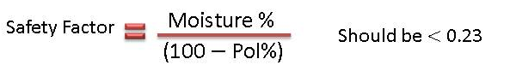
- Prevent caking by:
      - Drying
      - Cooling

SUGAR DRYING THEORY

What is wet sugar?
Sugar discharged from centrifugal has:
- Inherent Moisture: Moisture occluded in the crystals.
- Surface Moisture: Saturated “molasses” (sucrose) solution on the crystal surface.
Drying is concerned with removing the Surface Moisture.

Drying Stages
Classical Theory
- Constant-rate period: Moisture evaporates from the surface.
- Falling-rate period: Moisture migrates to the surface and evaporates.
Applied to sugar
- Constant-rate period:
- Moisture evaporates from the surface supersaturating the solution and causing crystallisation.
- Falling-rate period:
- Increased supersaturation slows evaporation (Raoult’s Law)
- Crystallisation begins forming an amorphous sugar layer on the crystal which hinders evaporation increasingly as the layer grows.
Moisture available on the surface is called FREE MOISTURE.
Moisture trapped under the layer is called BOUND MOISTURE
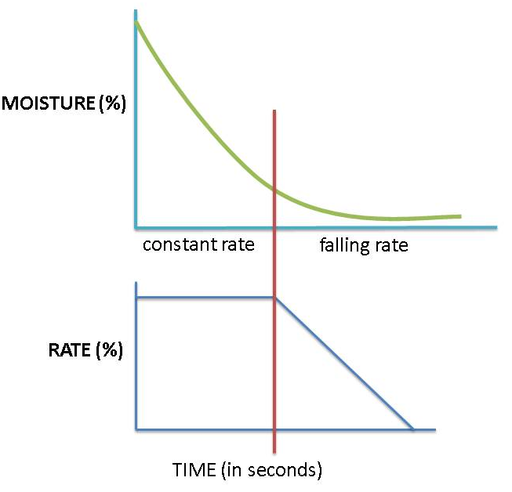

DRYING MECHANISM

Evaporation
Free water in the exposed surface film evaporates if the partial pressure of water in surrounding air is low enough.

Diffusion
Bound water diffuses through the amorphous layer due to water concentration gradient.

Crystallisation
Sucrose in the bound film crystallises due to supersaturation making water available for diffusion.
Rapid drying: Crystallisation occurs on amorphous layer.
Slow drying: Crystallisation takes place on crystal surface.

MOISTURE ANALYSIS

Oven drying
- Drying for 3 hours at 105°C – measures Free and some bound moisture.
- Used for analysis of raw and refined sugars.
- Drying for several hours / several days: Measures Free and Bound Moisture.

Karl-Fischer Titration
- Using methanol: Measures free and bound moisture
- Using formamide: Measures Free, bound and inherent moisture (occluded moisture).
- Used to analyse refined sugar that has been conditioned.

SOME TYPICAL FIGURES
Raw Sugar:
Wet: Moisture 0.5% - 1.00%
Temperature 60°C
Dry: Moisture 0.1%
Temperature 40°C
Refined Sugar
Wet: Moisture 0.5% - 1.00%
Temperature 70°C
Dry: Moisture 0.03%
Temperature 50°C

Knowledge topic 7: Sugar driers

INTRODUCTION
A sugar drier consists of an arrangement for passing heated air with the flow of sugar to dry the sugar. The sugar is kept in motion so as to give efficient contact of the air with the sugar crystals.

CALCULATIONS FOR A SUGAR DRIER
Drying by contact with hot air involves heating the air to increase its capacity for absorbing water and bringing it into intimate contact with the sugar, from which it evaporates the moisture.
There are two possible methods of circulation.
- Countercurrent flow where the air flows in the opposite direction to the sugar.
- Parallel flow where the air and the sugar flow in the same direction.
For safety, the calculation is based on the most unfavourable condition, that is, it is assumed that the ambient air is saturated before being heated.
On the other hand, the air leaving a dryer is generally not saturated; it is assumed that it has absorbed only – in the case of concurrent flow – two thirds of the quantity of water which it could have absorbed if it had left in a saturated condition.
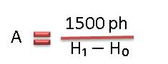
Where:
A = mass of air to be passed through the dryer (in kg/h)
P = mass of sugar to be dried (in kg/h)
h = moisture content of sugar relative to unity
H₀ = mass of water vapour contained in saturated air at the temperature t₀ (ambient temperature) of entry air to the heater (in kg/1000kg)
H₁ = mass of water vapour contained in saturated air at the temperature t₁ of exit air from the dryer (in kg/1000kg)
H₁ and H₀ are taken from a graph.
FOR INTEREST
Mass of moisture given off by sugar
= Mass of moisture absorbed by warm air
= ⅔(mass of moisture absorbed by warm air if it is left saturated).
Assuming the sugar loses all its moisture
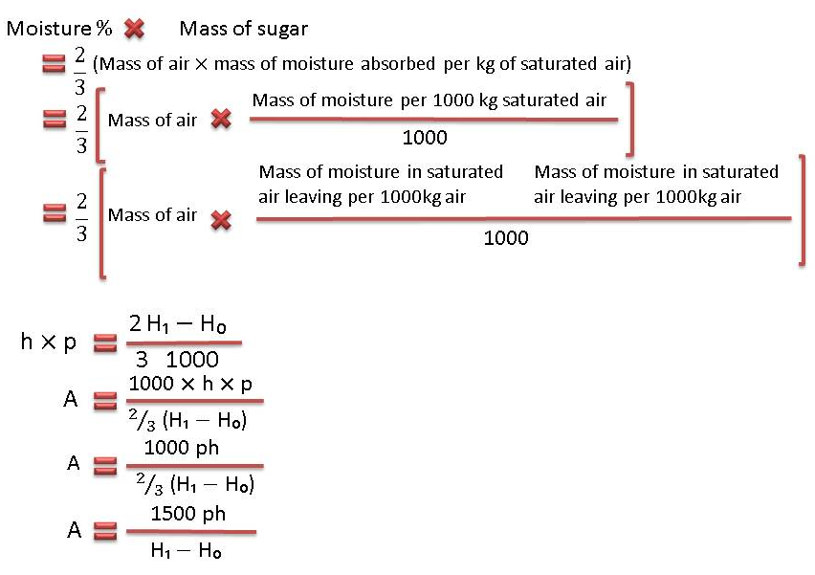

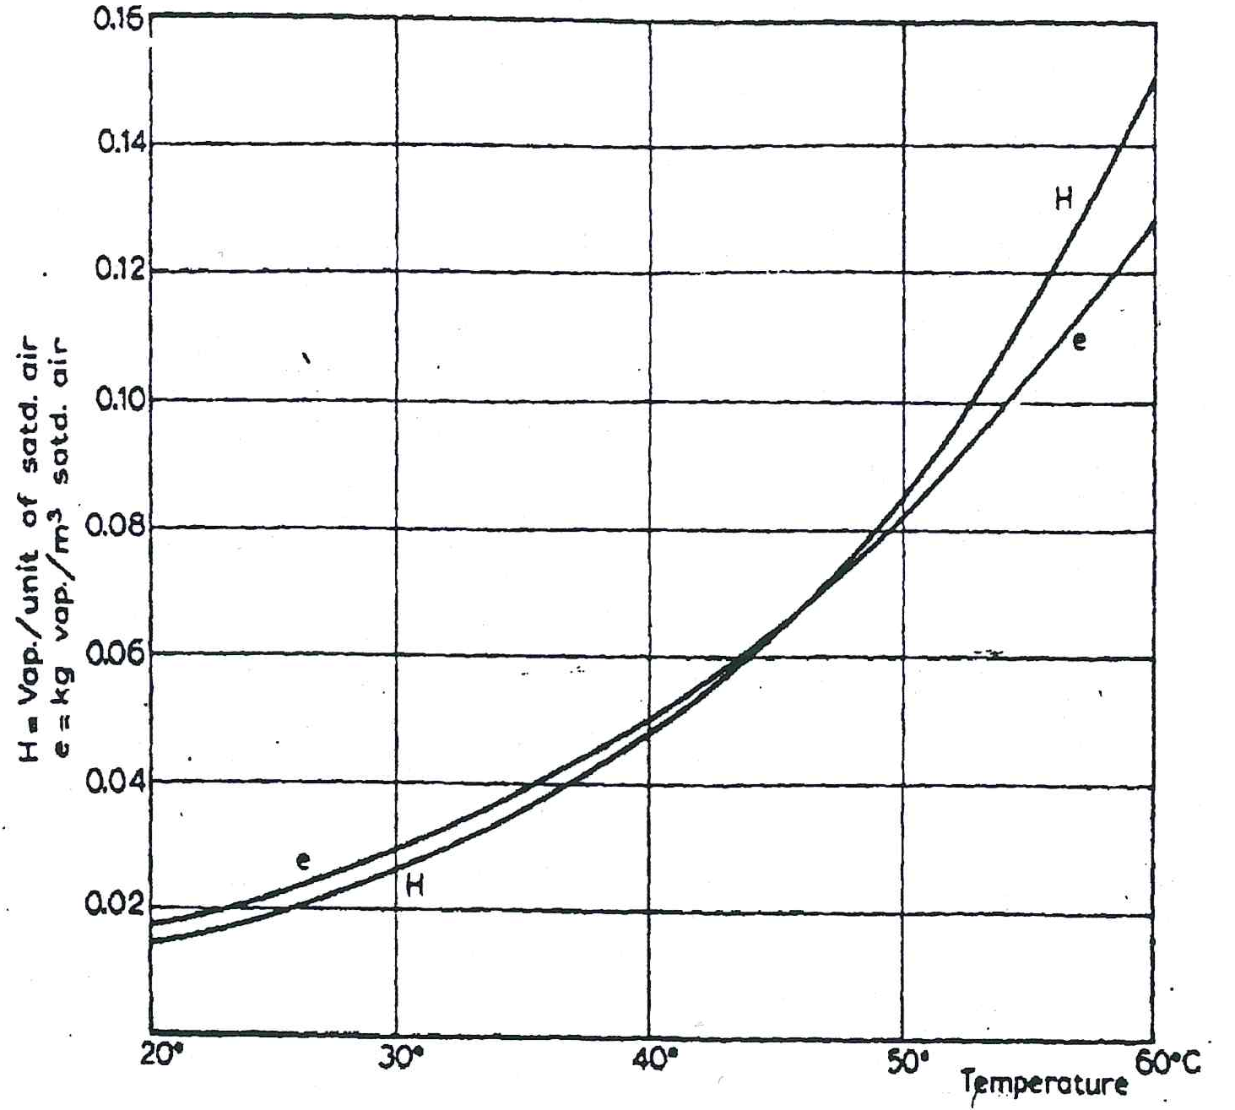
Knowing the mass of air, we may, if required, calculate from it the volume:
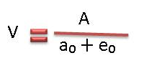
Where:
V = volume of air required in (m³/h)
a₀ = density of air at t₀ degrees (kg/m³)
e₀= mass of vapour contained in saturated air at t₀ degrees (kg/m³)

TYPES OF SUGAR DRIERS

Rotary cascade
The rotary cascade drier is the most common type of drier and consists of a rotating drum mounted at a small angle to the horizontal. Inside the drier are fixed vanes which pick up the sugar and drop it repeatedly from the top to bottom of the drier in a shower which should be as uniform as possible. The sugar moves down the drier while air is blown or drawn through the drier either counter-current or co-current to the flow of sugar.
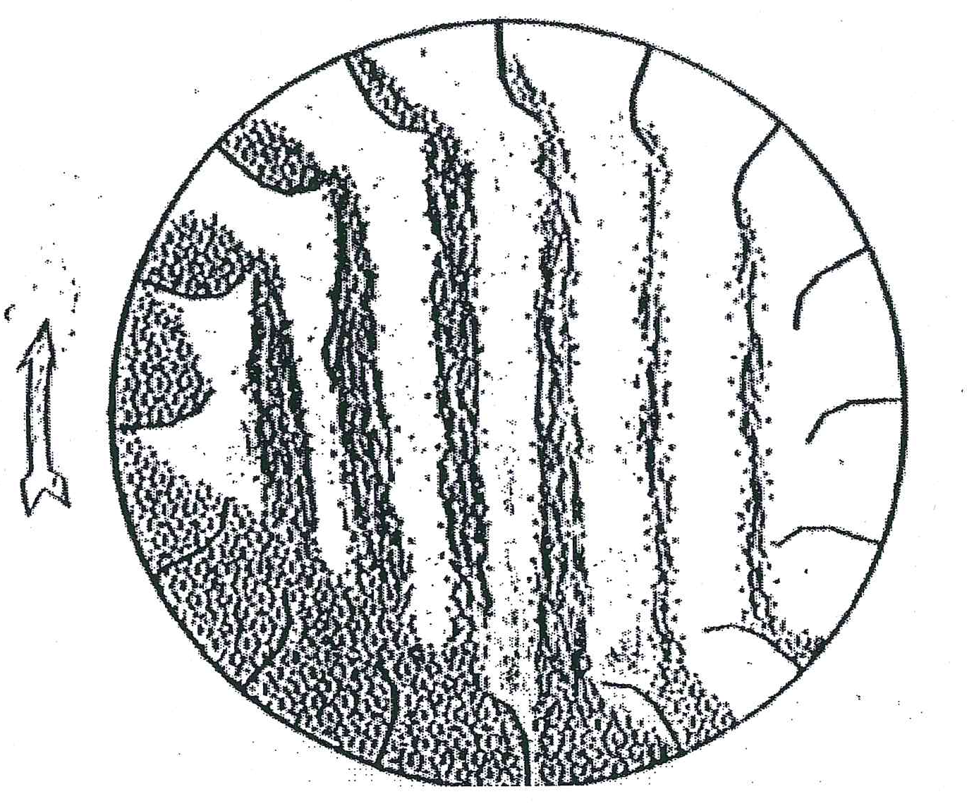
Advantages: | Disadvantages:
Simple construction and operation | Crystal damage is a risk
Good air/sugar contacting
High turndown possible
May be Co-or Counter-current

Rotary louvre
Here the sugar is held in a special “drum” consisting of louvres. The sugar lies at the bottom and is tumbled as the drum rotates. Hot air is blown through the sugar from the louvres below.
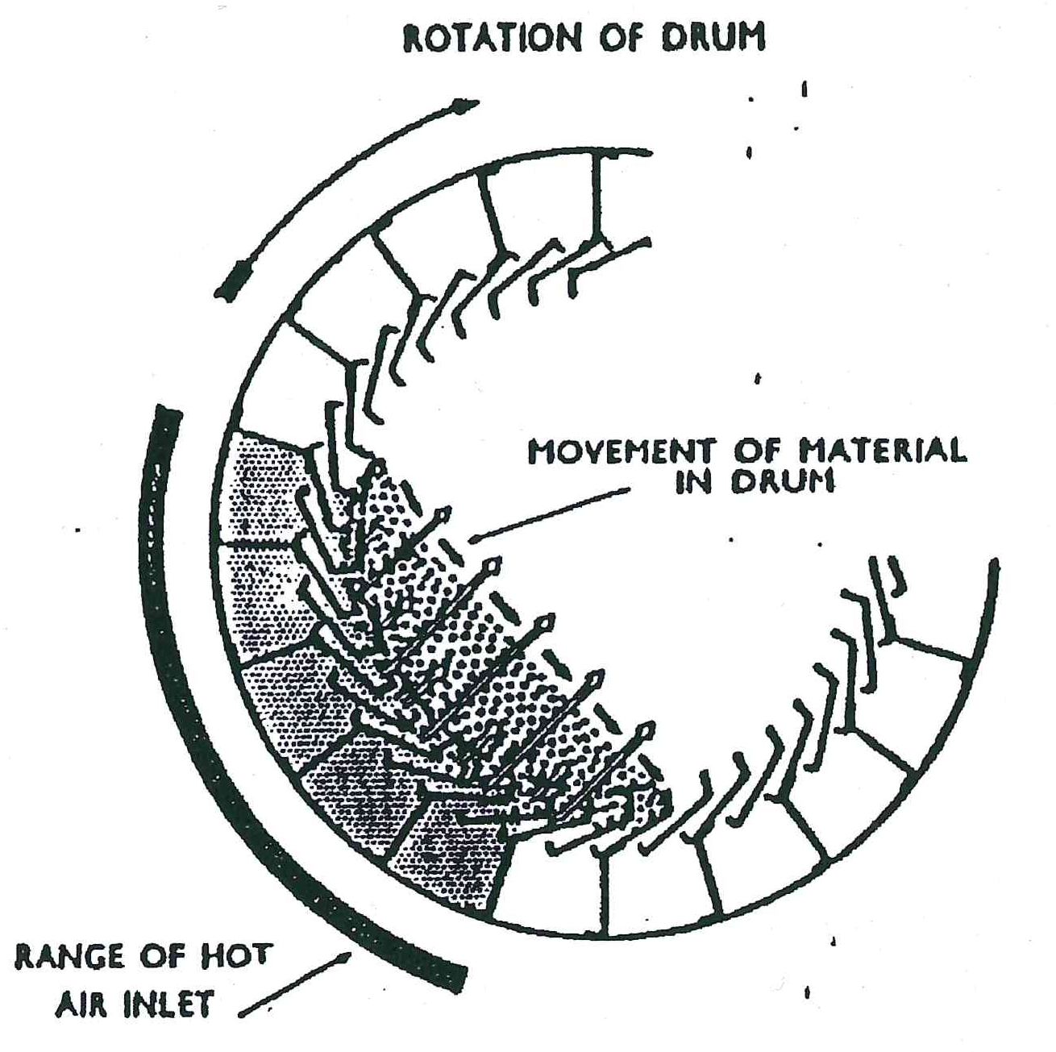
Advantages: | Disadvantages:
Low risk of crystal damage | Lower turndown without possible modification
Split air flows possible
Good air/sugar contacting if properly operated

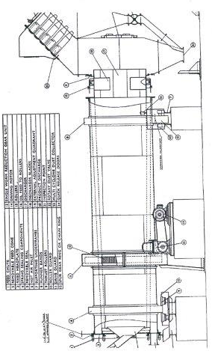

Fluidized bed
A fluidized bed drier/cooler is a vertical cylinder divided into an upper and lower compartment by a perforated plate. Both of these compartments are sub-divided vertically to give separate drying and cooling zones. A forced draught fan supplies air, some of which goes through a heat exchanger to provide hot air for drying. The wet sugar enters the drying zone and is fluidized by the hot air passing through the perforated plate. After drying the sugar passes through to the cooling zone where it is again fluidized by ambient air.
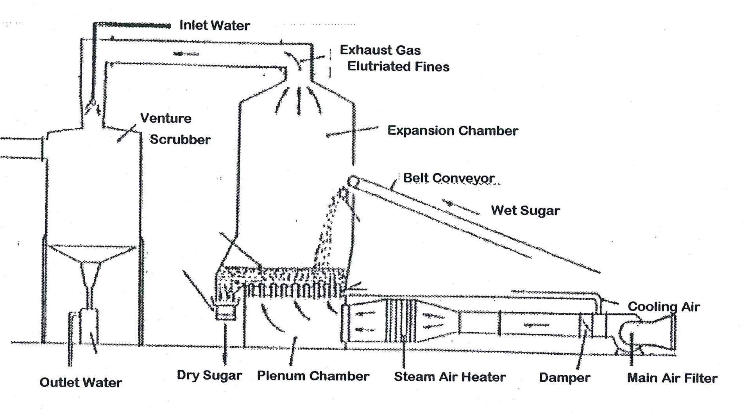
Advantages: | Disadvantages:
Lower floor space requirement | Feed sugar quality control necessary (recirculation).
Slower drying possible | Higher retention time allows sugar to cool excessively
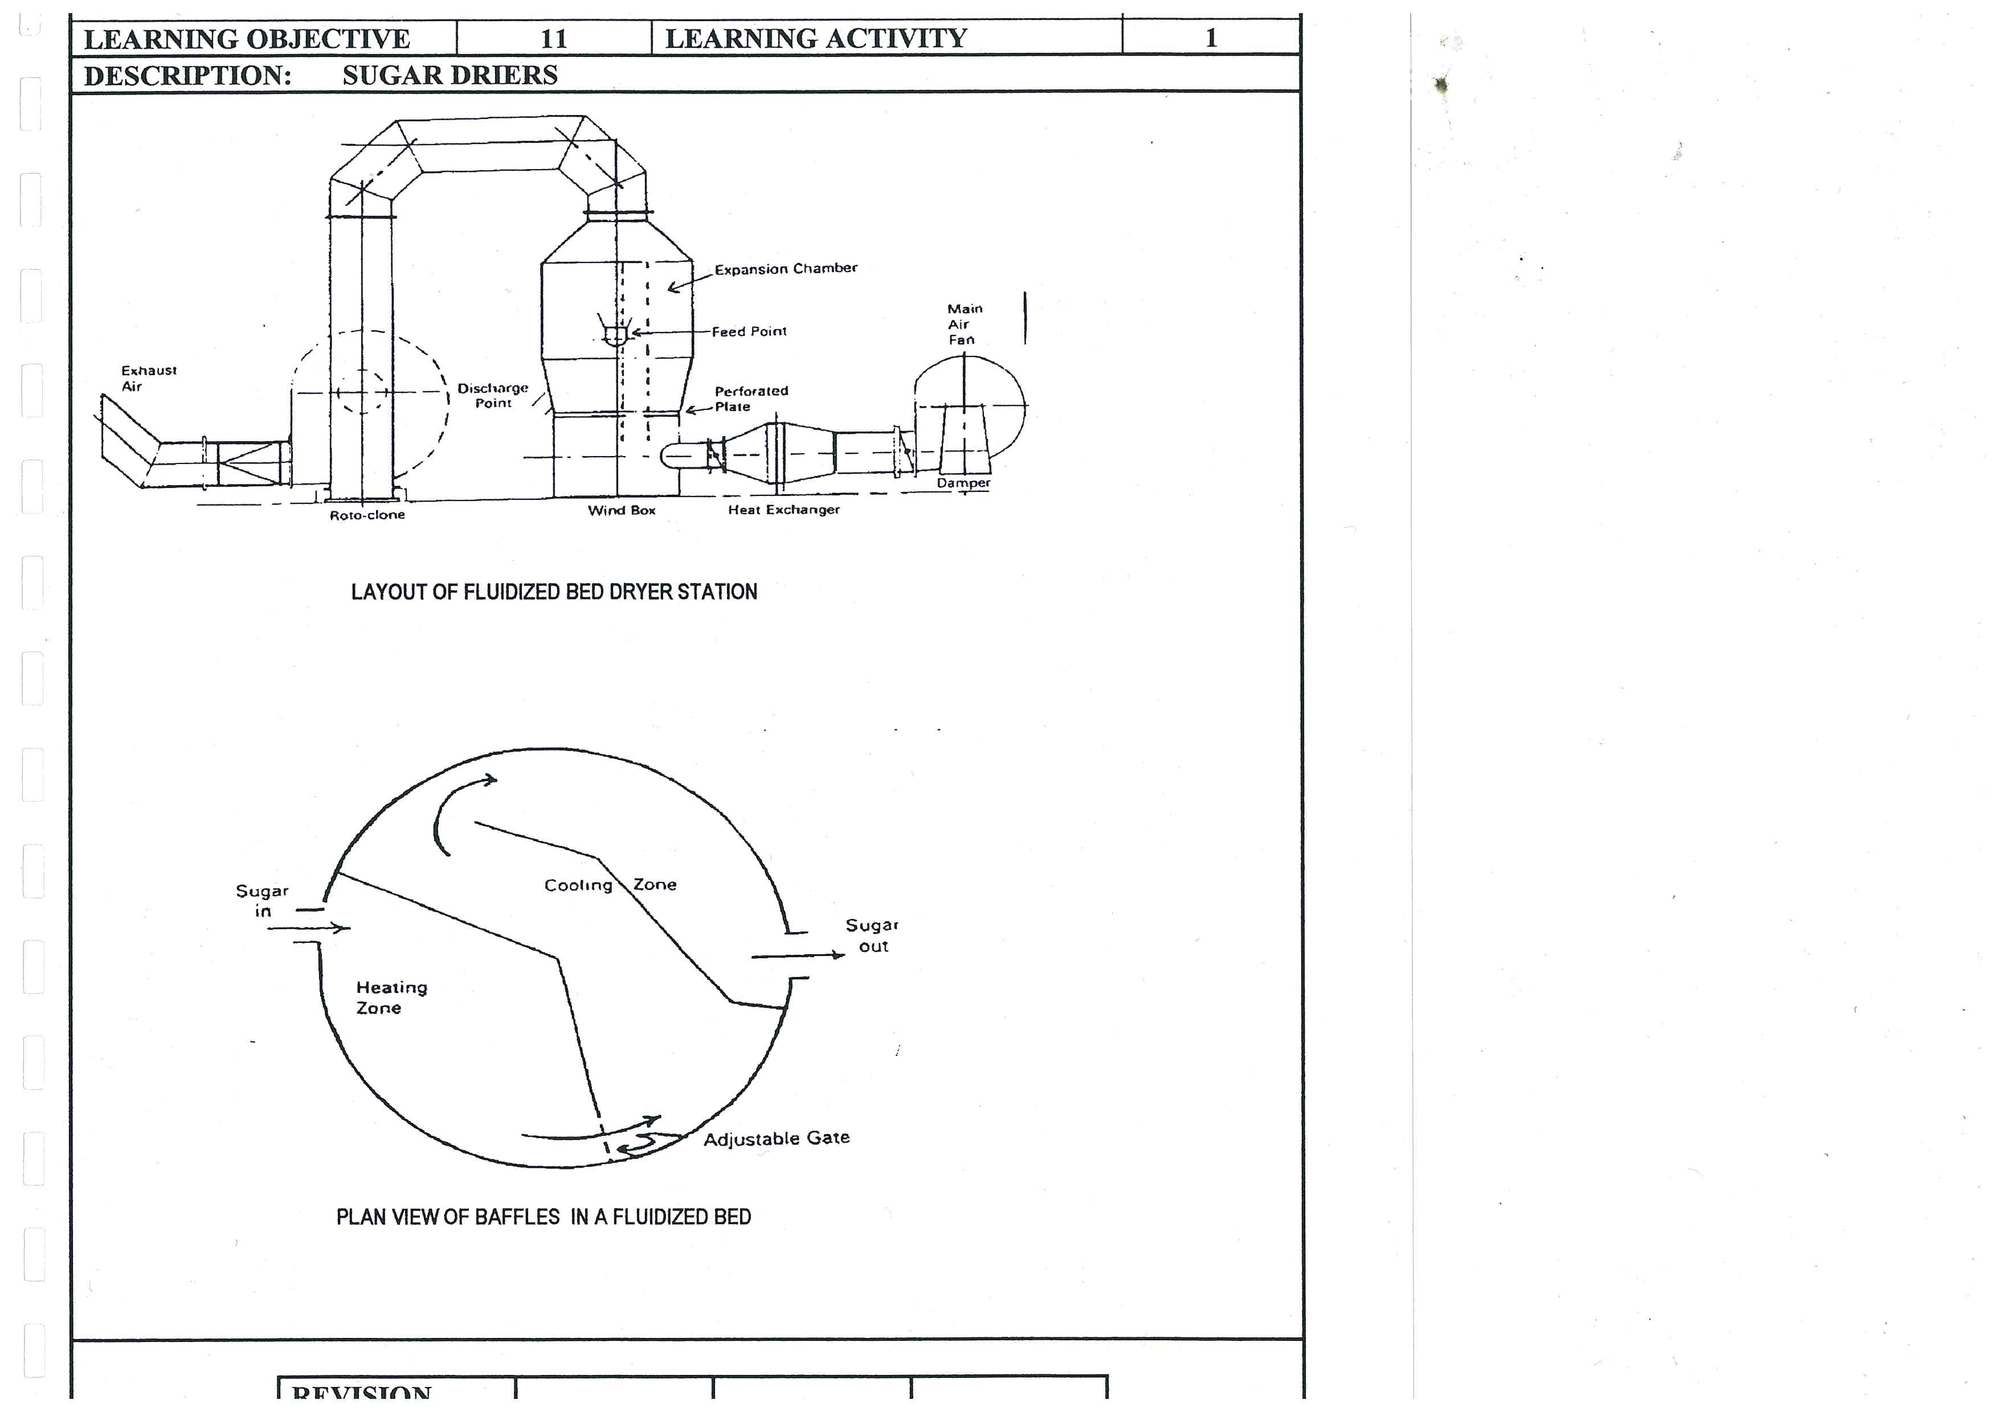

OPERATING CONSIDERATIONS FOR SUGAR DRIERS
- Air Flowrate
- Air Temperature
- Sugar Temperature
- Sugar Retention Time
  - Drier speed
  - Drier slope
  - Bed depth

DUST SEPARATORS
The air drawn through the drier picks up a certain amount of fine sugar dust. This dust would be lost if a separator was not used. The separator could be either a centrifugal or cyclone type which separates the crystals either dry or dissolved in water. The air should be drawn through the separator rather than blown through, as any leaks would then be inwards instead of blowing sugar dust out. If a wet separator is used precautions must be taken to prevent the growth of micro-organisms in the water as this can also constitute a loss of sugar. Chemicals can be used to kill the bacteria or a once through system could be used.

Knowledge topic 8: Sugar conditioning

WHY DOES DRY SUGAR CAKE?

Equilibrium Relative Humidity:
Refined sugar has an ERH of 76%. If the atmospheric humidity is above this, the sugar will absorb moisture. If the atmospheric humidity later drops below 76% the sugar will lose excess moisture, resulting in caking

Moisture Migration
Temperature gradients in sugar cause moisture to migrate to cold areas.
Moisture loss results in:
- Surface crystallisation
- Intercrystalline bridging
- Caking

SUGAR CONDITIONING AND DATA

Sugar conditioning
Sugar conditioning is practised to reduce the moisture content of refined sugar so as to prevent caking during transport/storage.
Sugar is conditioned in a silo where a bed of sugar moves from top to bottom while warm air is passed from the bottom to the top.

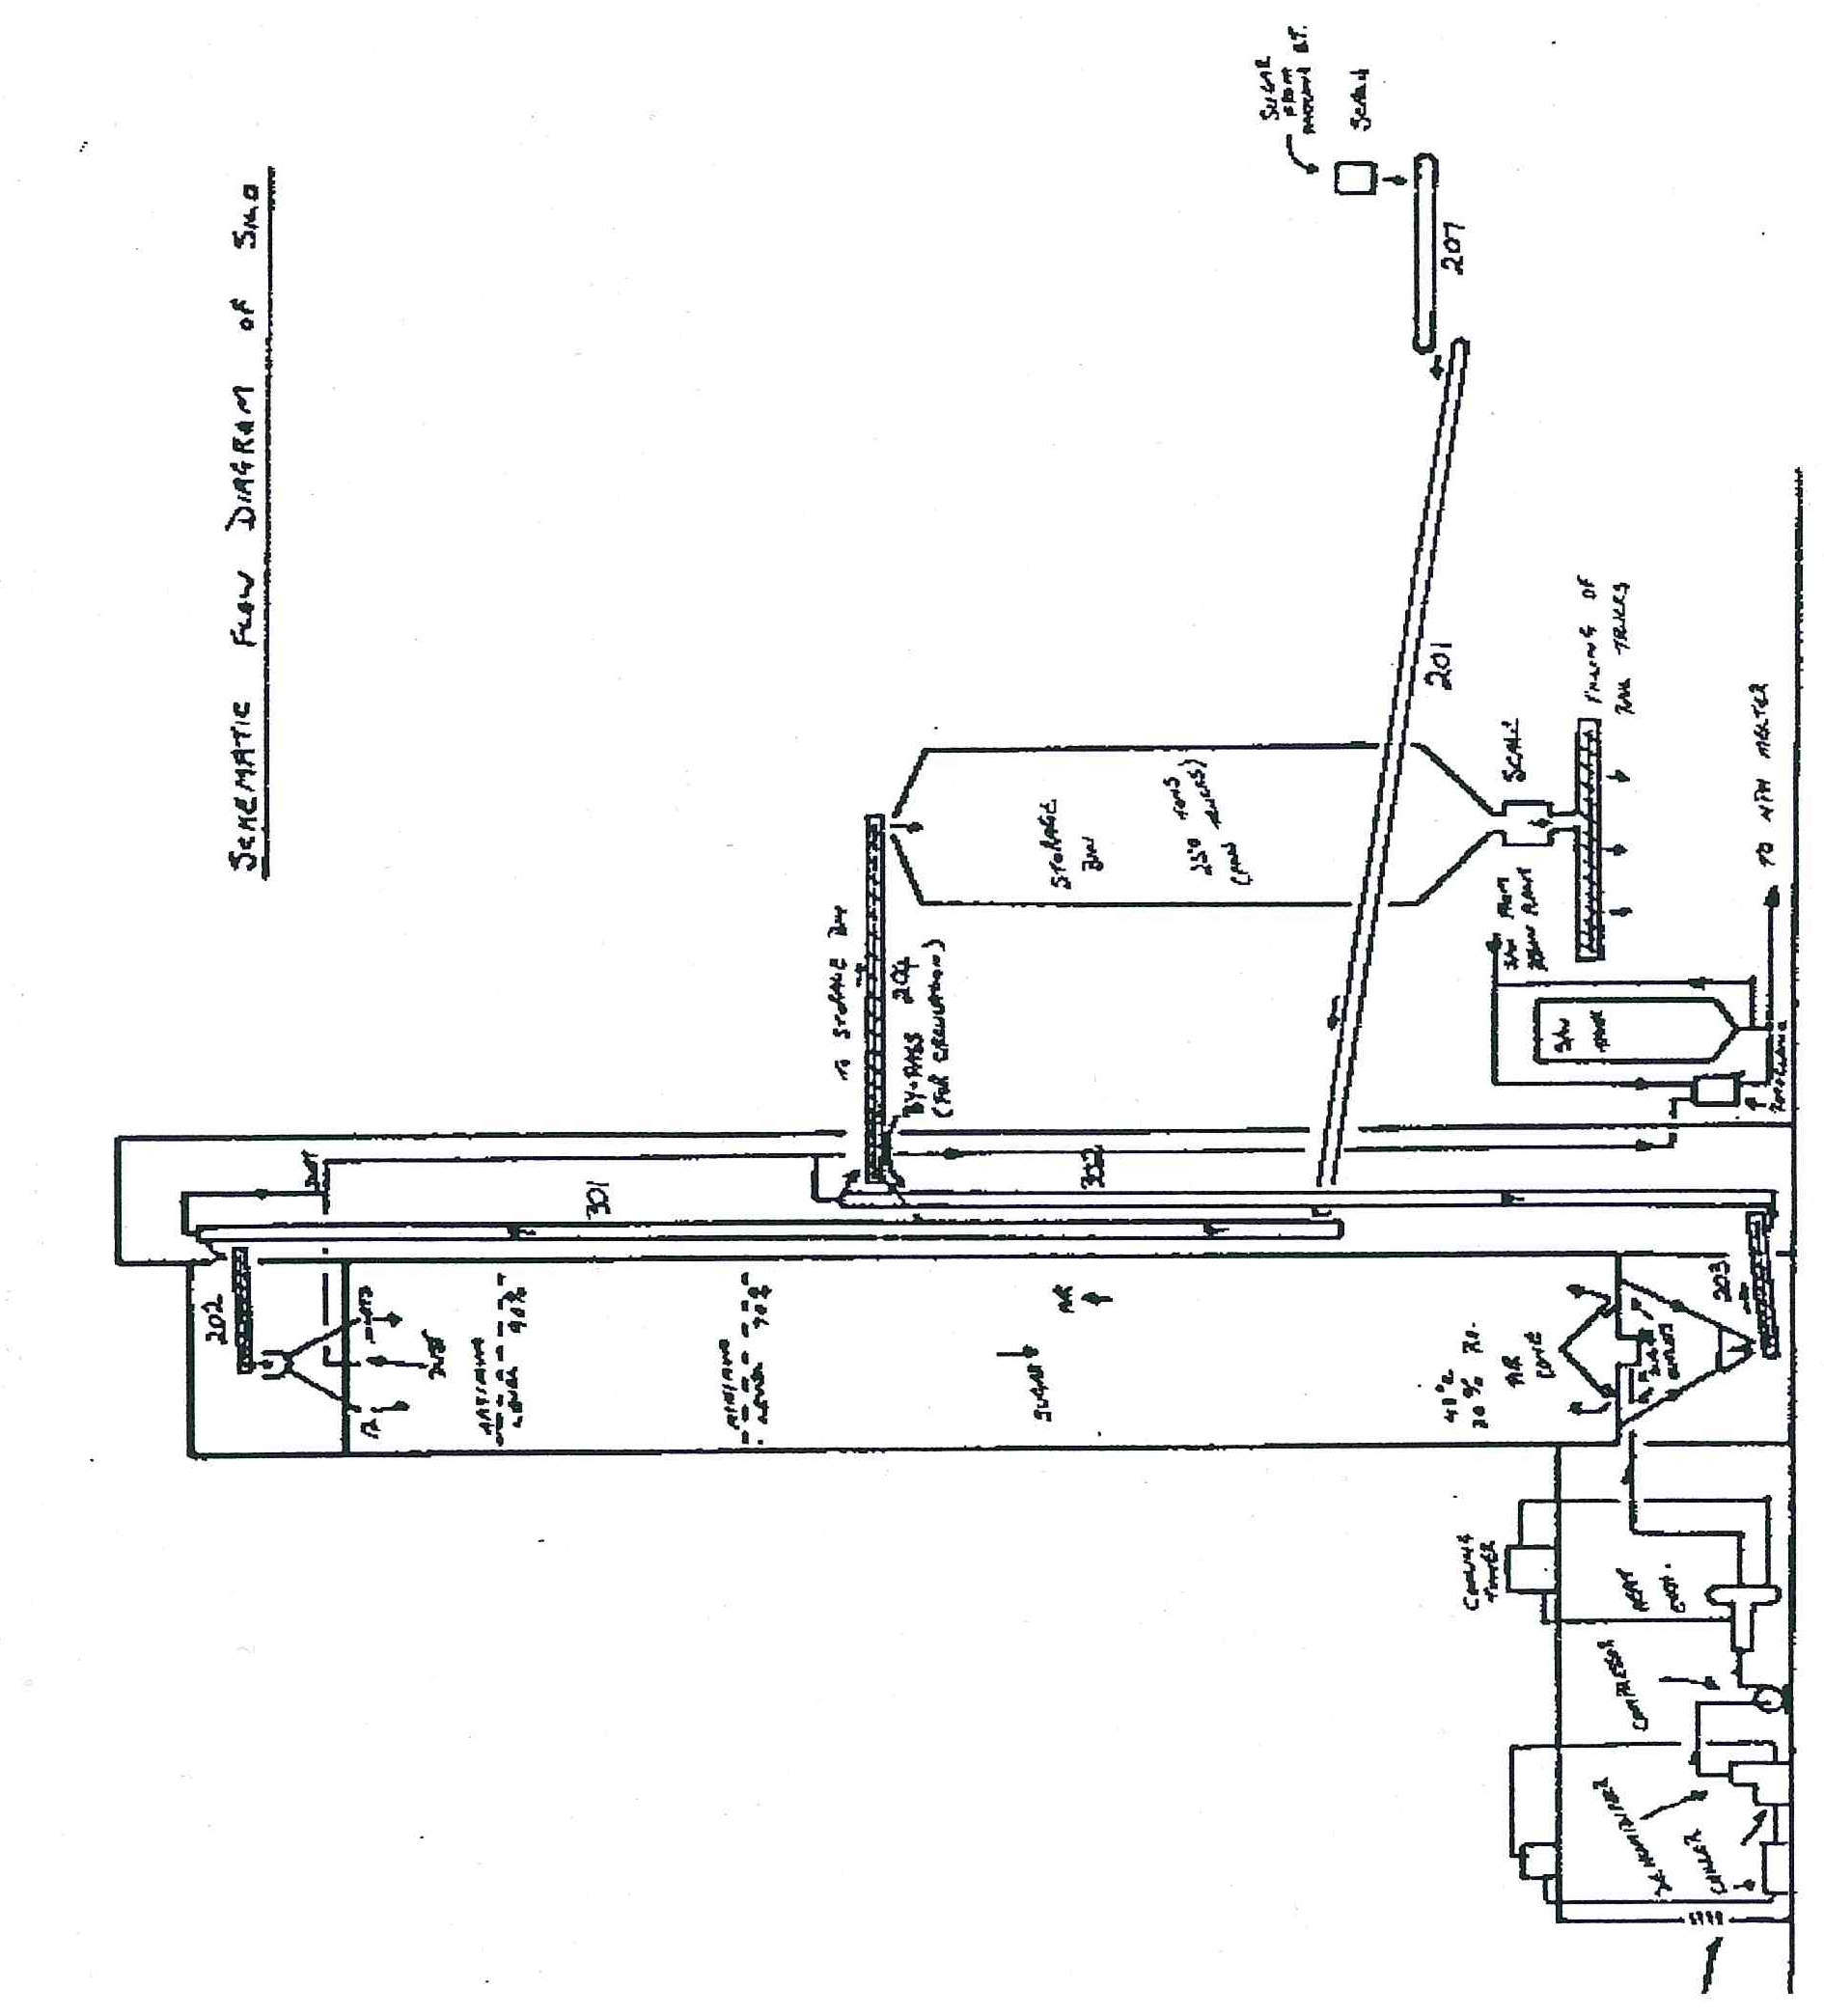

Conditioning data

Unconditioned sugar from the sugar drier
Oven moisture = 0.03% (Measures the Free and some of the Bound Moisture)
Karl-Fischer Moisture = 0.05% - 0.10% (Measures: Free, Bound and Inherent Moisture)

Conditioned sugar
Karl-Fischer Moisture ˂ 0.05% (Total Moisture)

Conditioning Air
Temperature = 42°C - 48°C
Relative Humidity ˂ 20%
Flowrate = 50 litres.min⁻¹.ton sugar⁻¹

Typical silo
Sugar hold up = 1200tons
Retention time = 48 – 72 hours

Performance measures
Test tube caking test
Karl Fischer moisture

Conditioning removes BOUND moisture

FACTORS AFFECTING CONDITIONING

Temperature
Temperature enhances diffusion and crystallisation.

Air Flow & Condition
Good distribution is required without overloading the dust extraction system.

Crystal Size & Distribution
- Smaller crystals conditions faster but cake easier.
- Refiners in USA sieve their sugar to remove fines for this reason.
- Low co-efficient of Variation improves conditioning and lowers caking propensity (i.e. tendency to cake).
- Low conglomerate count also aids conditioning.

Feed Sugar Moisture
The quantity of bound moisture and the nature of the amorphous layer in the feed sugar determines the conditioning rate.

A Typical Conditioning Curve:
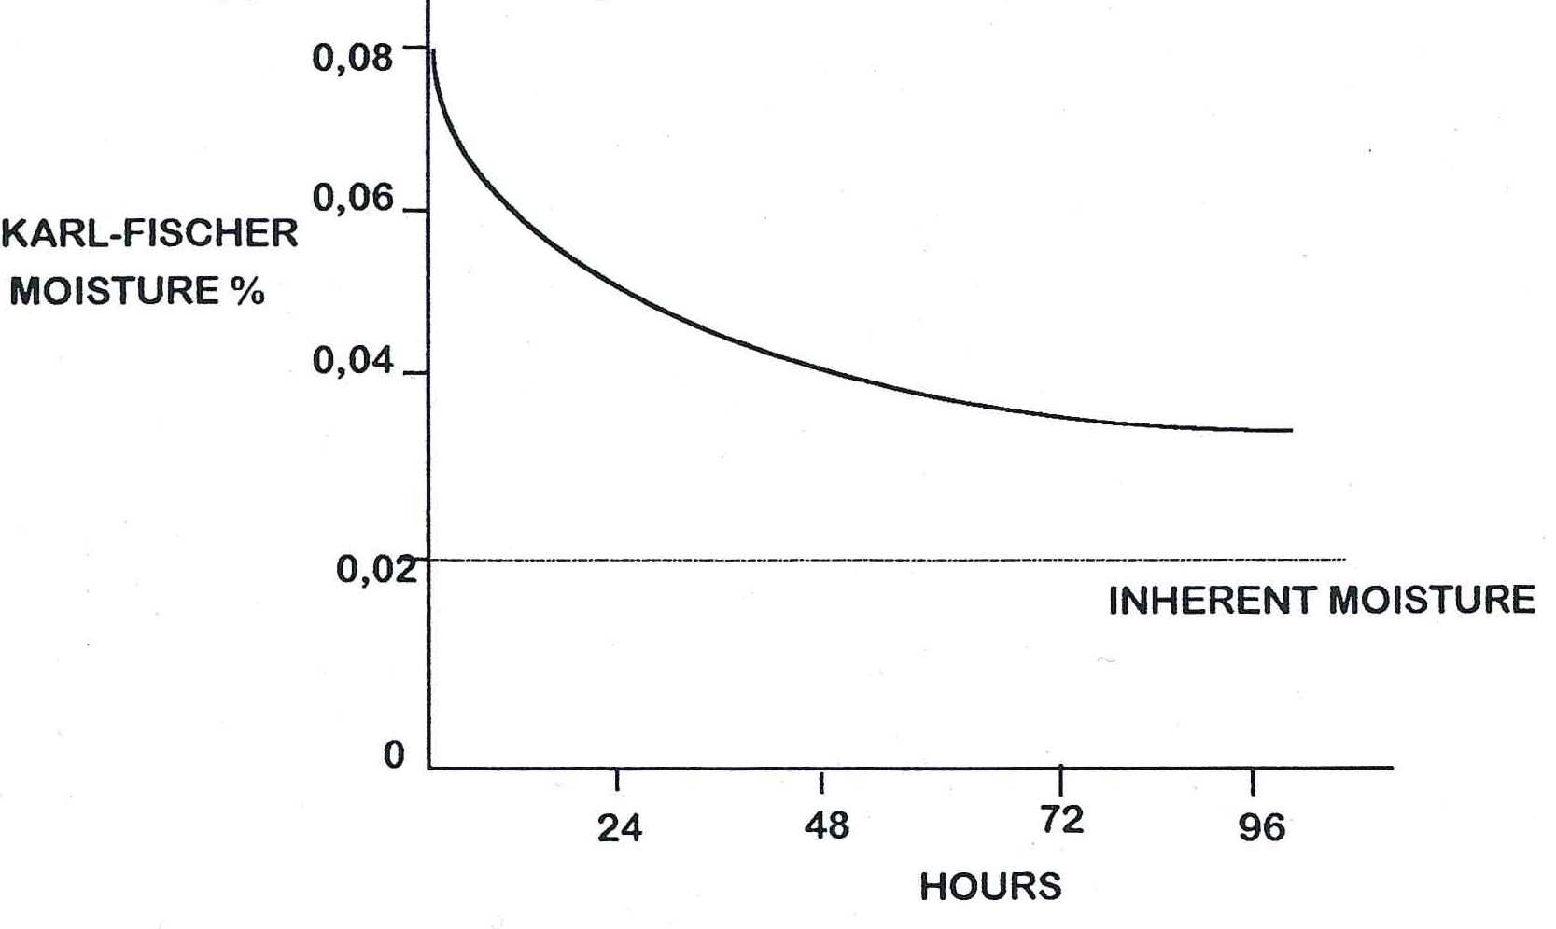

Knowledge topic 9: Raw Sugar quality

RAW SUGAR QUALITY STANDARDS/DETERMINANTS
Parameter | Standard | Factors Affecting the parameter
Pol | ˃ 99.3% | Pan Boiling Crystallisation and Centrifuging
Colour | ˂ 1350 ICUMSA units | All unit operations especially Clarification, Pan Boiling and Centrifuging
Starch | ˂ 150 ppm | Cane
Fines | ˂ 35% | Pan Boiling & Sugar Drying
Moisture | ˂ 0.1% | Centrifuging & Drying
Ash | ˂ 0.2% | Pan Boiling & Centrifuging

EXPORT SUGAR PENALTY/ BONUS
Parameter | Calculation | Example
Pol | 93.3% - Pol | 0.12% below specification = R1/ton
Colour | Colour - 1350 | 286 ICUMSA units above specification R1/ton
Starch | ppm - 150 | If starch is 67 ppm above specification = R1/ton
Fines | % Fines - 35 | If fines are 22% above specification = R1/ton

Knowledge topic 10: Problems experienced during crystallisation and separation

BROKEN/DAMAGED COOLING ELEMENT
A broken/damaged element can cause water to leak into the massecuite. This will be indicated by the purity of the mother liquor not decreasing satisfactorily during crystallisation.

CESSATION OF STIRRING
The stirring shaft can break or shear loose from the stirring elements or the stirring can cease due to some other reason. This would lead to crystals settling to the bottom of the crystallisers. In A-crystallisers especially crystal settling is rapid and a decision as to appropriate action must be taken within minutes i.e. resume/restore stirring or liquidate (empty) the crystallisers.

MAILLARD REACTION

What is a Maillard reaction?
This is the worst important problem with pan floor operations. Maillard reactions give bread crust its characteristic colour and texture. It is very important in food processing because it gives colour, texture and taste.
Maillard reactions are a whole host of reactions that occur where glucose and amino nitrogen (-NH₂) is present. The amino nitrogen group occurs in amino acids and proteins. The presence of glucose and amino nitrogen creates the potential for Maillard reactions, but heat and low water content (i.e. high concentration) is also required.
Maillard reactions are exothermic and produce heat which increases the rate of the reaction, which in turn produces more heat etc. Apart from producing excessive amounts of heat, Maillard reactions also produce CO₂ gas. In C-massecuite this causes foaming, swelling and overflow. In addition the Maillard reaction forms colour and high viscosity products. If allowed to proceed unchecked the Maillard reaction will carbonize the sugar.

How will we know if a Maillard reaction has started?
The temperature will not cool to say +40°C in the crystalliser, but will increase to 70°C +. The massecuite will start to foam and its volume will increase. The increase in temperature cause crystals to dissolve and massecuite is also lost due to overflow. Sucrose is thus lost chemically and physically.

How can a Maillard reaction be prevented?
- Keep the temperature as low as possible. This involves boiling water under higher vacuum. Obviously viscosity limits this in practice.
- Do not reduce the water content excessively. This means lowering the brix by boiling less “tight” massecuites. Lowering the brix from 97% to 95% increases the water content from 3% to 5%.
- Increase the purity of the massecuite, since Maillard reaction happens in impure solutions. For example: C-massecuite should be at 55 purity and not 50.

What can be done if a Maillard reaction has started?
- Cool the massecuite by adding large amounts of dry ice or cold water.
- Dilute the massecuite.
- Add some chemicals. These contain sulphur compounds e.g. NaHSO₃ (sodium hydrogen sulphite) and Na₂SO₃ (sodium sulphite). These have the ability to slow down some of the reaction involved. The max amount of Na₂SO₃ is 400 ppm on massecuite.

What do we usually do wrong that initiates a Maillard reaction?
A Maillard reaction normally starts in the hottest part of the C-station i.e. the C-pan. If there is poor circulation and a “dead spot” gets hot, a Maillard reaction is started. When the massecuite is dropped into the Strike receiver and moved to the crystallisers the Maillard reaction increases because of poor circulation.

Evidence of a Maillard reaction
Let us compare syrup and final molasses.
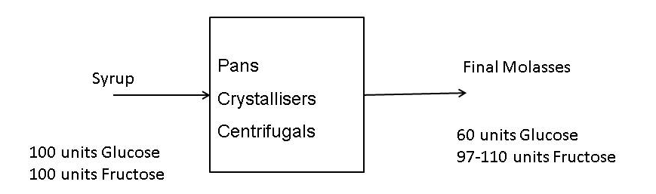
The amount of Fructose remains high or even increases because of inversion occurring.
The amount of Glucose reduces because the Maillard reaction uses up glucose molecules.
If a final molasses sample is taken and analysed there is always a 30-40 % glucose loss. This indicates that Maillard reactions are occurring but it normally remains controllable.

