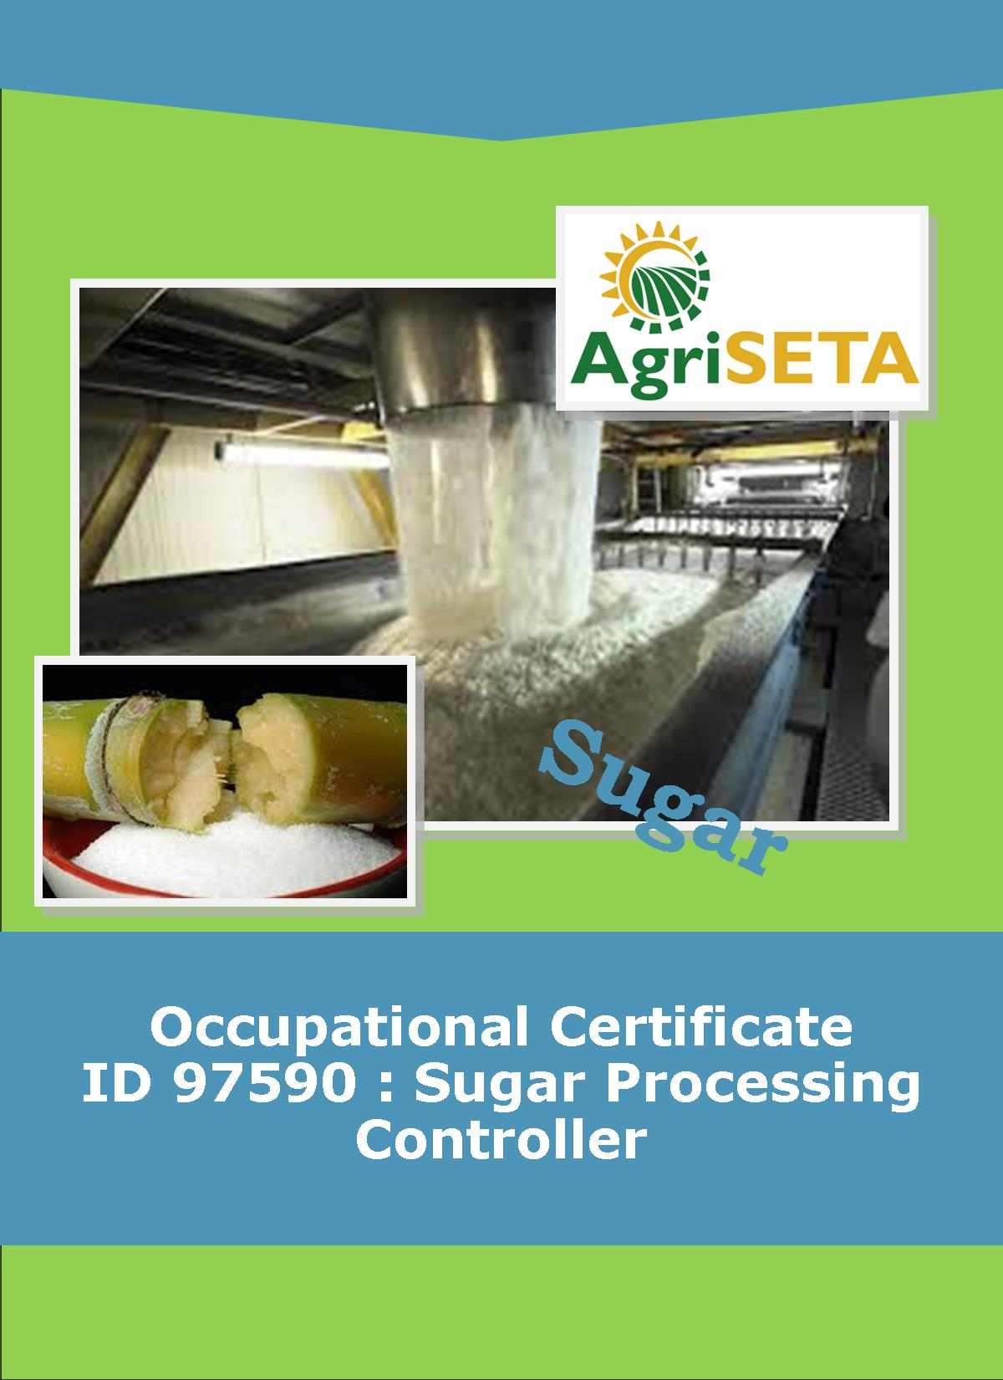
KNOWLEDGE COMPONENT: FACILITATOR FORMATIVE AND SUMMATIVE ASSESSMENT TOOLS AND MODEL ANSWERS : KNOWLEDGE MODULE 9 : WATER AND EFFLUENT TREATMENT
Occupational Certificate: Sugar Processing Controller

KNOWLEDGE COMPONENT: FACILITATOR FORMATIVE AND SUMMATIVE ASSESSMENT TOOLS AND MODEL ANSWERS : KNOWLEDGE MODULE 9 : WATER AND EFFLUENT TREATMENT
KNOWLEDGE COMPONENT: FACILITATOR FORMATIVE AND SUMMATIVE ASSESSMENT TOOLS AND MODEL ANSWERS : KNOWLEDGE MODULE 9 : WATER AND EFFLUENT TREATMENT
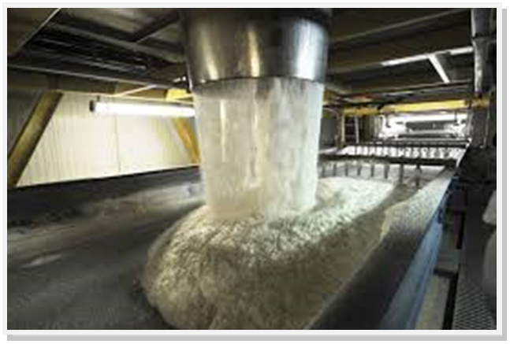
OCCUPATIONAL CERTIFICATE: SUGAR PROCESSING CONTROLLER

©Copyright AgriSETA
Telephone: +27 12 301 5600
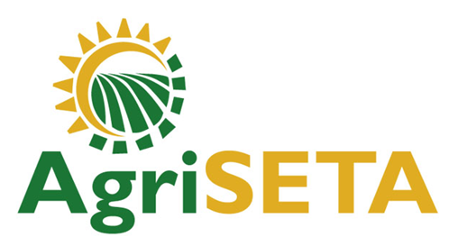

AgriSETA holds the copyright to its publications and Web pages. Proper citation is requested.

TABLE OF CONTENTS
1. INTRODUCTION TO THE FACILITATOR ASSESSMENT TOOLKIT OF THE OCCUPATIONAL CERTIFICATE: SUGAR PROCESSING CONTROLLER 6
2. KNOWLEDGE MODULE 9: WATER AND EFFLUENT TREATMENT 7
2.1 Knowledge Topic 1: Potable water technology (1%) 7
2.2 Knowledge Topic 2: Cooling water technology (1%) 13
2.3 Knowledge topic 3: Boiler water technology (1%) 16
2.4 Knowledge topic 4: Waste water / effluent technology (1%) 22
3. CONCLUSION OF KNOWLEDGE MODULE 9: WATER AND EFFLUENT TREATMENT 26
4. WRITTEN ASSESSMENT 27
5. Written Assessment Total Marks 37

INTRODUCTION TO THE FACILITATOR ASSESSMENT TOOLKIT OF THE OCCUPATIONAL CERTIFICATE: SUGAR PROCESSING CONTROLLER
Dear Facilitator
This Toolkit has been created to assist you to assess the Formative Learning Activities of learners undertaking the NQF 5 Occupational Certificate: Sugar Processing Controller Qualification.
During the programme, Learners must be directed to their Learning and Activities Guide to complete Learning Activities associated with each module of the Knowledge Component.
The time allocated to the Learning Activities is provided in the Facilitator’s Implementation Guide, this Facilitator Assessment Toolkit and Model Answers and the Learning and Activities Guide.
The marks allocated to each Learning Activity is provided in this Facilitator Assessment Toolkit and Model Answers and the Learning and Activities Guide.
Instructions to be given to Learners
- They must work individually to present the results of each Learning Activity in each of the Learning and Activities Guides (Workbooks).
- They must complete all the sections.
- They must use a black pen and ensure that they complete the questions in their own handwriting.
- The time provided to complete each activity is shown.
- The marks they will attain for each learning activity are shown in brackets.

KNOWLEDGE MODULE 9: WATER AND EFFLUENT TREATMENT
NQF LEVEL: 4
CREDITS: 4
PURPOSE OF THE KNOWLEDGE MODULE: The main focus of the learning in this knowledge module is to build an understanding of factory services.
The learning will enable learners to demonstrate an understanding of:
- KM-09-KT01: Potable water technology (1%)
- KM-09-KT02: Cooling water technology (1%)
- KM-09-KT03: Boiler water technology (1%)
- KM-09-KT04: Waste water / effluent technology (1%)

2.1 Knowledge Topic 1: Potable water technology (1%)
Topic elements to be covered include:
- KT0101 Technology and measurements
- KT0102 Treatment
- KT0103 Problem solving
Internal Assessment Criteria and Weight
- IAC0101 Water quality requirements can be explained
- (Weight 1%)

Learning activity 1.1: Individual Learning activity: 45 minutes (35marks)

Learning Objective: Water quality requirements can be explained.
Task: Read each question carefully and write your answer in the space provided.
1. Explain the difference between a suspension, a colloidal and a solution. (9)
Suspensions: A suspension is a mixture in which the particles of one (or more) of the substances are relatively large. These particles will have at least one dimension larger than 100nm. Finely divided clay in water is an example. Unless a suspension is stirred or shaken, the large particles will sooner or later settle out.
Colloidal dispersions: A colloidal dispersion is a mixture in which the particles of one (or more) substances are smaller than those in suspensions, but larger than those in solution. They will have at colloidal dispersion is starch in water. This mixture can be made so concentrated that it will look milky or so dilute that it will appear as clear and transparent as water. The colloidal particles are too small to be trapped by filter paper. Although a colloidal solution may appear clear, it will look milky when light is shone through it, since the particles are large enough to scatter the light.
Solutions: A solution is a mixture where all particles are of the order of atoms, ions or small molecules i.e. 0.1 – 1 nm. The particles are far too small to be separated by filtration and light shone through a solution is not scattered. A typical solution is sugar in water.

2. Compare surface waters to underground waters. (6)
Surface waters
Surface water can be divided into two main groups.
- Water with low colour and high turbidity: Most inland waters fall into this category. During floods, large quantities of suspended material are carried by rivers. However, the coarse material settles as soon as the flow rate decreases, but the colloidal or semi-colloidal material remains in suspension indefinitely.
- Water of high colour and low turbidity: Water in the coastal regions fall into this category. Colour is due to both dissolved and colloidal organic matter. These waters often contain very little inorganic salts, making them corrosive.
Underground waters
Underground water has percolated through soil and is therefore free from suspended matter. However, the water does leach (dissolve) out minerals from the soil. If the amount of dissolved minerals is not duly high, simple disinfection to destroy bacteria is usually enough to make the water potable (drinkable).

3. What factors must be considered when evaluating a water supply? (3)
Each water supply should be thoroughly investigated before being used for a specific purpose. Two waters with similar chemical properties may react in different ways to the same flocculant, requiring different purification processes.
The use to which the water will be put (e.g. drinking, industrial and agricultural) will determine the treatment / purification process that will be used.

4. List the sources of oxygen supply to, and the users of oxygen from, river water (12)
Sources of Oxygen Supply to River Water
- Reaeration from the air. This is related to the amount of mixing of the water surface: water flowing over rapids and waterfalls becomes more oxygenated than slow-moving water.
- Algal photosynthesis. Algae give off oxygen during photosynthesis, thus oxygenating the water.
- Oxygen in tributary flow.
- Reaeration from rainfall.
Users of Oxygen from River Water
- Biological oxidation of organic matter. Bacteria, feeding on (oxidising) organic foodstuff, consume oxygen.
- Respiration (breathing) of certain aquatic plants will remove oxygen from the water, as will the growth of sewage fungus.
- Bottom deposit processes. The upper layer will absorb oxygen or that support bacteria that in turn consume oxygen. Thus sugar, though non-toxic by itself, kills aquatic life indirectly by supporting bacteria that deoxygenate the water.

5. List the reasons for purifying potable water. (5)
- Water is made aesthetically acceptable. “It looks good”.
- Bacterial content is removed.
- Particulate matter is removed.
- Sediment that may deposit in pipework is removed.
- Taste is made acceptable.

Learning activity 1.2: Individual Learning activity: 30 minutes (23 marks)
Learning Objective: Water quality requirements can be explained
Task: Read each question carefully and write your answer in the space provided.
1. Show on a diagram the main steps in water purification. (5)
WATER PURIFICATION PROCESS
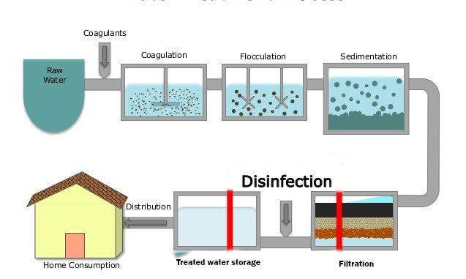

2. Explain the differences between coagulation and flocculation. (4)

Coagulation: This process neutralises the charges that keep colloidal particles apart, thus enabling them to “lump” together to form bigger particles that will settle.

Flocculation: This process “absorbs” colloids into a precipitate formed by a reaction. For example, aluminium sulphate, the basis of earlier water treatment chemicals, reacts with alkalinity in the water to form a precipitate of aluminium hydroxide:

3. Write out the reaction between aluminium sulphate and water. (2)
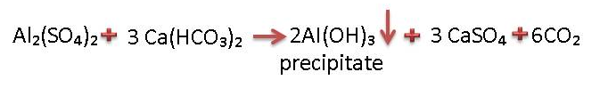

4. How is sedimentation similar to raw juice clarification? (4)
The original form of settling tank was the horizontal flow type. Modern tanks include a flocculating zone and mechanical sludge removal, or a sludge drain.
The clarifier settling tank has a built-in flocculation chamber and automatic sludge extraction. It is mostly used for plants with a capacity above 5 million litre / day.

5. Explain the mechanisms involved in filtration. (4)
- Adhesion: Particles stick to the grains of the filter medium. This is the more important mechanism.
- Straining: Particles are caught in openings that are too small to let them pass through.

6. Compare water quality before and after filtration. (2)
A filter is a bed of granular material that physically removes suspended matter from the water passing through it. The only change in water quality is therefore a reduction in its suspended solids content.

7. Define disinfection (2)
The process of cleaning something, especially with a chemical, in order to destroy bacteria.

Learning activity 1.3: Individual Learning activity: 30 minutes (18marks)
Learning Objective: Water quality requirements can be explained
Task: Read each question carefully and write your answer in the space provided.
1. How does chlorine function as a biocide? (2)
Chlorine kills pathogens such as bacteria and viruses by breaking the chemical bonds in their molecules. When chlorine gas is mixed with water, it forms two acids: hypochlorous (HOCl) acid and hydrochloric acid (HCl).

2. What factors influence the efficiency of chlorine as a disinfectant? (6)
- Suspended matter may envelop (surround) bacteria, shielding them from chlorine attachment/attack.
- Chlorine may react with organic substances, thus being wasted.
- Chlorine reacts with ammonia, forming chloramines that are less effective as a disinfectant.
- High temperatures increases the rate of disinfection, but chlorine is more stable at low temperatures.
- Sufficient contact time (10 to 15 minutes, but preferably several hours) ensures effective disinfection.
- Hypochlorous acid) HOCl) is rapidly decomposed by sunlight and is lost during aeration.

3. Draw a simple sketch of the water treatment plant at your factory (5)
A learner will draw sketch of the water treatment plant used in his/her workplace (5)

2.2 Knowledge Topic 2: Cooling water technology (1%)
Topic elements to be covered include:
- KT0201 Technology and measurements
- KT0202 Treatment
- KT0203 Problem solving
Internal Assessment Criteria and Weight
- IAC0201 An understanding of heat exchange principles and technology can be demonstrated
- IAC0202 Application principles can be explained
- (Weight 1%)

Learning activity 2.1: Individual Learning activity: 30 minute (16marks)
Learning Objective: Task: An understanding of heat exchange principles and technology can be demonstrated.
Task: Read each question carefully and write your answer in the space provided.
1. Explain the process of condensing water in a factory. (4)
A factory processing 100 tons cane produces 120 tons of clear juice and over 100 tons of water needs to be evaporated from the clear juice to produce syrup. If this is done in a quintuple effect evaporator station, 1/5 of this vapour would have to be condensed i.e. 20 tons. About 20 times more water is required than vapour i.e. about 400 tons. Condensing vapour from the evaporator train is the major user of condenser water in a sugar mill.

2. List the disadvantages of open evaporative cooling systems. (6)
Open evaporative cooling systems lose water due to wind (windage), and impurities concentrate during use as only pure water is evaporated
Water has to be bled off to control impurity levels, and fresh water has to be added to the system to replace water loos due to windage and bleedoff.
Not as effective as air conditioners in terms of cooling
Unsuitable for use in areas with high humidity
Several drawbacks and limitations due to humidity

3. Describe, and list the advantages of a closed cooling system. (6)
Cooling water is enclosed in a sealed system. Cooling of the water (after it has picked up heat) takes place in a shell and tube heat exchanger and not by open evaporation
Advantages: Require little maintenance because, once they are charged with chemicals, they normally remain charged.
A corrosion inhibitor is used to attack dissolved oxygen (coming from water make-up and leaks) thus preventing corrosion.

Learning activity 2.2: Individual Learning activity: 30 minute (14marks)
Learning Objective: Task: An understanding of heat exchange principles and technology can be demonstrated.
Task: Read each question carefully and write your answer in the space provided.
- Describe one-through systems (3)
In these simple systems, water is conveyed from its source (river), used in the condenser and then returned to its source. The supply temperature is usually low and rapid cooling can be achieved with minimum heat transfer surface. The need to save water and to protect the environment has virtually eliminated the use of once-through cooling systems.

- Compare cooling ponds with spray ponds.(4)

Cooling Ponds: Water is introduced into the pond and cooling is by natural evaporation, convection and radiation. Because cooling is very slow, the ponds have to be large. However, they consume less water than cooling towers as they dissipate only 55% of the added heat by evaporation, whereas the figure for cooling tower s is 80%.

Spray Ponds: The addition of piping and nozzles to a cooling pond allows water to be sprayed into the surrounding air, thus increasing the rate of evaporation, and enabling the use of smaller ponds. Windage losses range from 1-5 of the circulation rate and impurities from the surrounding area can easily enter the pond.

3. Define a cooling tower. (2)
A cooling tower is a partially enclosed space (air must be allowed entry) in which cooling by evaporation takes place.

4. Draw simple sketches showing the various types of cooling towers. (5)
Any of the following cooling towers may be drawn:
- Atmospheric spray filled tower
- Packed atmospheric tower
- Forced draft tower
- Induced draft counterflow tower
- Crossflow induced draft tower
- Counter hyperbolic t

2.3 Knowledge topic 3: Boiler water technology (1%)
Topic elements to be covered include:
- KT0301 Technology and measurements
- KT0302 Treatment
- KT0303 Problem solving
Internal Assessment Criteria and Weight
- IAC0301 An understanding of boiler water technology and trace elements can be demonstrated
- IAC0302 Water quality concepts and contaminants can be explained
- (Weight 1%)

Learning activity 3.1: Individual Learning activity:30 minute (18marks)
Learning Objective: Task: An understanding of boiler water technology and trace elements can be demonstrated
Task: Read each question carefully and write your answer in the space provided.
1. Make a sketch of a boiler, showing the scrubber, economiser, air heater, superheater, feedwater tank and pump, steam drum and mud drum, grate, deaerator, FD and ID fans etc. (5)
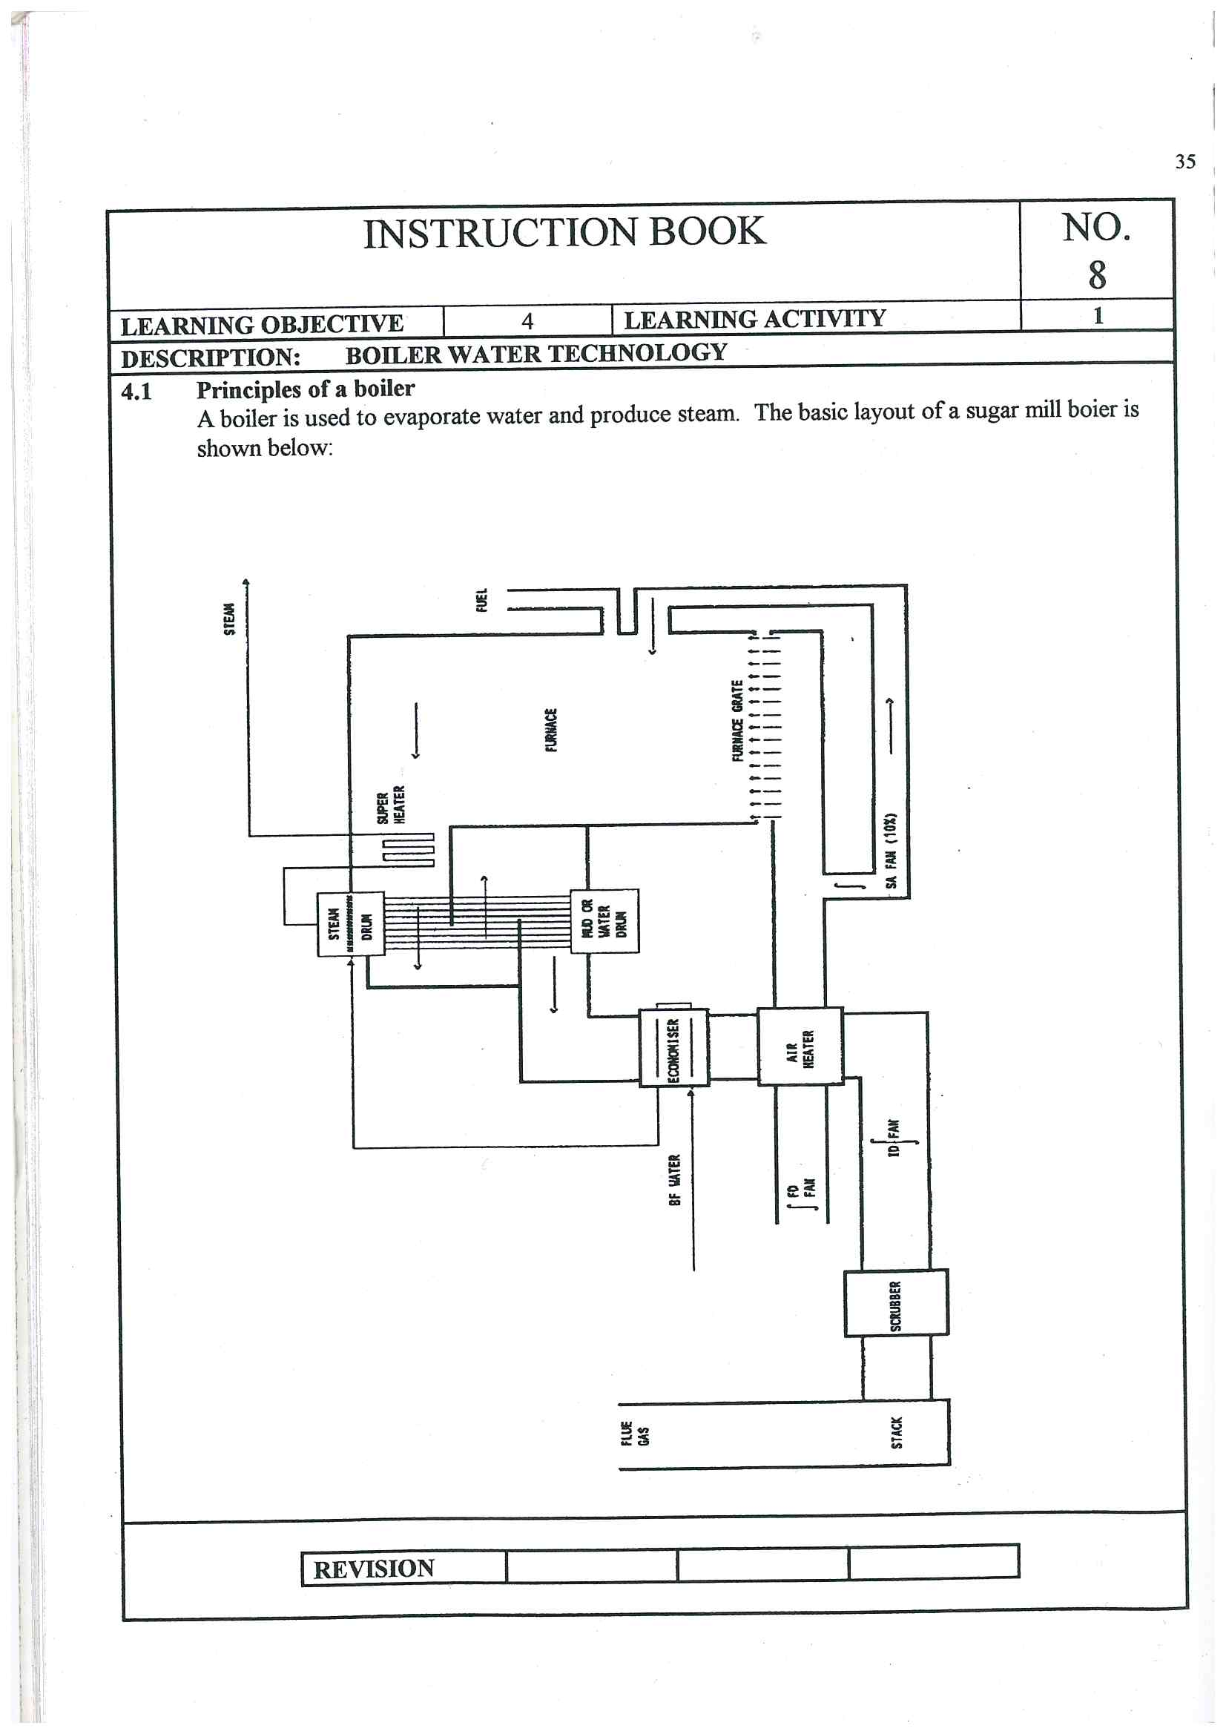
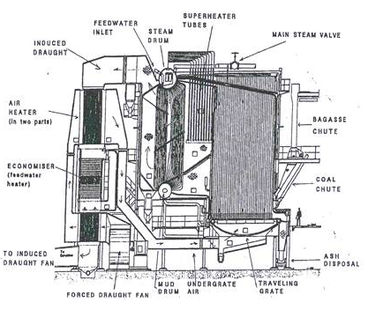
2. What happens if dissolved solids become too concentrated in boiler water and how can this be prevented? (4)
Substances will precipitate and cause scaling of the tubes which will reduce the heat transfer.
To prevent the dissolved solids from becoming too concentrated, “blowdown” is practices. This involves draining off some of the boiler water.

3. Differentiate between boiler water and boiler feed water. (4)
Boiler water: is the liquid phase of steam within a boiler. The term may also be applied to raw water intended for use in boilers, treated boiler feed water, steam condensate being returned to a boiler, or boiler blow down being removed from a boiler.
Boiler feed water; is an essential part of boiler operations. The feed water is put into the steam drum from a feed pump. In the steam drum the feed water is then turned into steam from the heat. After the steam is used it is then dumped to the main condenser. From the condenser it is then pumped to the deaerated feed tank. From this tank it then goes back to the steam drum to complete its cycle. The feed water is never open to the atmosphere.

4. What is, and what causes, carryover? (5)
Carryover occurs when steam is contaminated with boiler water

Causes of Carryover
- Foaming

Priming

Droplet entrainment

Silica Carryover
Learning activity 3.2: Individual Learning activity: 1hours (36marks)
Learning Objective: Task: An understanding of boiler water technology and trace elements can be demonstrated
Task: Read each question carefully and write your answer in the space provided.
1. Why should silica be controlled? (2)
Silica can enter steam in water carryover, or in volatile form at pressures above 3000kPa. Silica deposits on turbine blades and on tubes can cause serious damage

2. What does blow down mean? (2)
It is the practice of draining off some of the boiler water

3. Discuss scaling and corrosion; making reference to their causes, effects and control measures employed. (10)
Scaling
- Causes: Hardness refers to the total concentration of calcium (Ca²⁺) and magnesium ions (mg²⁺) in water. Calcium and magnesium in water are the main causes of scaling. They can deposit as phosphate, carbonate or sulphate scale. Silica, suspended solids, products of corrosion, and low alkalinity also lead to scaling.
- Effect: Scale acts as an insulator, reducing the rate of heat transfer. Tube overheating and subsequent failure can result. Tubes can even plug completely. Scale also provides a cover which corrosion can occur.
- Control measures:
Sludge conditioners are chemicals that ensure that precipitates remain in the form of sludge and are used to control scaling.
A chelant can be used to form a soluble complex with calcium and magnesium ions.
Crystal habit modifiers like phosphonates tend to increase the solubility of scale forming substances. On a cost effective basis the phosphate / phosphonate programme has been found to be most beneficial in the sugar industry and is very easy to control.
Hardness (Ca²⁺ and Mg²⁺ ions) can be removed from boiler feedwater by using ion exchange softener or de-mineralisation (cation/anion exchange), but this is very expensive and is generally not cost effective in the sugar industry.

Corrosion
- Causes: Corrosion is the reversion of a metal to its oxide. For example, when iron corrodes (rusts) it forms iron oxide (Fe₂O₃). Dissolved oxygen in water is the prime cause of corrosion. Carbon dioxide in water and alkalinities that are too high or too low can all cause corrosion.
- Effect: Corrosion fatigue is a type of metal cracking that results from the concentration of cyclic (heating and cooling) stresses at points of high corrosion. Caustic cracking results from the presence of caustic, stress, at least a trace of silica, and mechanism (like a slight leak) that allows water to concentrate on the stressed metal. Apart from shortening plant life, corrosion products can cause a scaling problem elsewhere in the boiler.
- Control measures:
- Remove dissolved oxygen
- Maintain alkaline condition pH > 11
- Attack corrosive gases in steam and condensate systems by using neutralising amines

4. Draw a deaerator. (5)
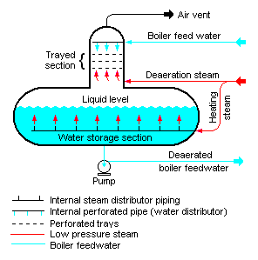

5. What is an oxygen scavenger? Give a reaction. (4)
An oxygen scavenger is also used to consume the residual oxygen.
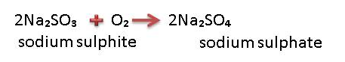
Scavengers must be applied upstream of economisers, so that economisers too can be protected.

6. How does boiler pressure affect boiler water specifications?(8)
Boiler Pressure (Mpa) | 0 – 2.0 | 2.0 – 3.5
Total Dissolved Solids mg/l | <3500 | <2500
Suspended Solids mg/l | <300 | <250
Hardness as CaCO₃ mg/l | <2 | <2
Phosphate as PO₄ mg/l | 30-60 | 30-60
Sulphite (SO₄) mg/l | 30-60 | 30-60
Hydrazine mg/l | 0.1-0.3 | 0.1-0.3
Oil mg/l | <7 | <7
Silica mg/l | <150 | <90
Total alkalinity as CaCO₃ mg/l | <700 | <500
Hydroxide ‘O’ alkalinity as CaCO₃ mg/l | >3 × silica | >3 × silica
pH range mg/l | 10.5-11.5 | 10.5-11.5
* For chelant programmes, phosphate is substituted by chelant. The concentration of which is specified by the supplier.
Boiler Pressure MPa | 0-1.5 | 1.5-3.5
Dissolved Oxygen (before oxygen scavenger is added) mg/l O₂ | <0.04 |  | <0.04
Total iron mg/l Fe | <0.100 |  | <0.050
Total copper mg/l Cu | <0.050 |  | <0.025
Total hardness mg/l | <0.300 |  | <0.300
pH range | 7.5 – 10.0 |  | 7.5 – 10.0
Non-volatile total organic carbon mg/l C | <1 | <1
Oil mg/l | <1 | <1

7. Describe the boiler water treatment programme at your factory. (5)
The learner will answer according to his/her factory water treatment programme procedures

2.4 Knowledge topic 4: Waste water / effluent technology (1%)
Topic elements to be covered include:
- KT0401 Technology and measurements
- KT0402 Treatment
- KT0403 Problem solving
Internal Assessment Criteria and Weight
- IAC0401 An understanding of wastewater treatment concepts and trace elements can be demonstrated
- IAC0402 Water quality concepts and contaminants can be explained
- (Weight 1%)

Learning activity 4.1: Individual Learning activity: 30 minute (18marks)
Learning Objective: An understanding of wastewater treatment concepts and trace elements can be demonstrated
Task: Read each question carefully and write your answer in the space provided.
1. List 6 aspects of the Water Amendment Act (1984) (6)
- Plants handling over 150m³ intakes from all sources on any one day require a permit.
- The purification of effluents to prescribed quality standards shall be considered to form a part of the manufacturing process.
- Purified effluent should be returned to the source of the intake water.
- All water (including rain water) draining from land on which industrial activity is carried out shall be deemed to be effluent.
- Irrigation of effluents is considered to be a temporary measure.
- Water pollution control officers are empowered to ensure that the Act is carried out.

2. List the general Standard for waste water or effluent. (10)
- Colour, taste and odour:Shall not contain any substance in a concentration capable of producing colour, taste or odour
- pH shall be between 5.5 – 9.5
- Dissolved oxygen: Shall be at least 75% saturated
- Typical (faecal) ecoli: Shall not contain any typical (faecal) ecoli per 100 ml
- Temperature: Shall not exceed 35°C
- Chemical oxygen demand: Shall not exceed 75 mgl⁻¹
- Conductivity :Shall not be increased by more than 75 milli-siemens per meter over that of the intake water
- Suspended solids :Shall not exceed 75mgl⁻¹
- Sodium :Shall not be increased by over 90mgl-1 above that of the intake water
- Soap, oil, grease: Shall not exceed 2.5mgl-1

3. How is polluting capacity of an effluent measured? (2)
Pollution is measured, broadly, by measuring the “food value” of the effluent to bacteria. This involves measuring the organic contents of the effluent.

Learning activity 4.2: Individual Learning activity: 1 hour (27marks)
Learning Objective: An understanding of the wastewater treatment concepts and trace elements can be demonstrated
Task: Read each question carefully and write your answer in the space provided.
- What is the difference between running losses and cleaning losses? Give examples of each.(15)
Running losses: running losses occur continuously, to a greater or lesser extent. Leaking joints and overflowing tanks are common examples. Careful operation can all but eliminate running losses.
Running losses are as follows:
- Milling and Diffusion, gutters should collect spillages and return it to process. Leaks must be attended to.
- Clarification. Filter cake spills can be carried away in floor washings and overload the effluent plant.
- Evaporation and Pan Boiling. Entrainment can contaminate the cooling water system, which could overload the effluent plant if some cooling water is bled of to the effluent plant.
- Centrifugation. Leakages and overflowing gutters can be a source of pollution.
- Drying. Sugar dust may not be a serious pollution hazard, but does represent a loss of pol.
- Bagasse. Bagasse undergoes slow biological degradation.
- Fly Ash. Scrubbers separate fly ash from boiler gases. Scrubber water (or smuts water) is high in suspended solids.
- Lubricants, drains from the crushing mills are the main sources of oil contamination.
- Condensate. Though not of high purity, the high temperature is unacceptable.
Cleaning losses: Cleaning losses occur only during cleaning operations. Heater and evaporator scale are examples of this.
Cleaning losses are as follows:
- Heaters: Scale can be handled by the solids disposal system, or the effluent plan.
- Clarifier: Over long stops, stale juice may have to be dumped. Dumping should be spread over few days so as not to overload the effluent plant.
- Evaporators, Pans and Boilers: When chemical cleaning is used, spent chemicals may be disposed of safely by being added very slowly to the effluent system. A specialist company must be used to handle hazardous waste.
- e.g. Lead acetate waste from the laboratory
- spent caustic soda from evaporator cleaning

2. Describe anaerobic effluent treatment. (4)
This is a large holding dam into which the raw effluent is pumped. Here bacteria readily decompose the effluent into acetic acid (CH₃COOH). This overloads the anaerobic bacteria so that they are not able to cope with decomposing the acids. The result is that the dam goes highly acidic and foul smelling.
We need to balance the system by continuously removing this acidic effluent, completing its decomposition into harmless products using aerobic bacteria.
This can be effectively accomplished by pumping some of the acidic effluent to a trickling filter of a large tank packed with rocks. Here aerobic bacteria grow and oxidise the effluent reducing the acid content. Part of this is pumped back to the anaerobic holding dam to prevent it becoming too acidic and the rest acts as feed for the aerobic digester. The sludge that flakes off acts as a good feed stock for the aerobic digester.

3. Describe aerobic effluent treatment (3)
Many bacteria are able to decompose effluent to harmless products if oxygen is present. However for good effect these bacteria require a high energy input in the form of especially oxygen but also of nitrogen and phosphorus.

4. Describe effluent treatment at your factory. (5)
A learner will describe effluent treatment according to his/her factory procedures

CONCLUSION OF KNOWLEDGE MODULE 9: WATER AND EFFLUENT TREATMENT
Throughout this knowledge module you have been provided opportunities to complete formative learning activities. You have captured your results in this Learner Workbook.
The total marks for this Knowledge Module are as follows:
Knowledge Module | Total Marks | Marks attained
KM-09-KT01: Potable water technology (1%) | 76
KM-09-KT02: Cooling water technology (1%) | 30
KM-09-KT03: Boiler water technology (1%) | 54
KM-09-KT04: Waste water / effluent technology (1%) | 45
Total Marks | 205marks

WRITTEN ASSESSMENT
9.1 | What constitutes a mixture? |  | Mark Allocation
a. |  | Fanta.
b. |  | Air.
c. |  | Water.
d. |  | A mixture of sugar and water.
e. |  | All of the above. | 4

9.2 | Which statement below best defines Colloidal Dispersions? |  | Mark Allocation
a. |  | A mixture where at least one of the particles are smaller than those in suspension, but larger than those in solution.
b. |  | A mixture where all particles are of the order of atoms, ions or small molecules.
c. |  | A mixture where all the particles are relatively large.
d. |  | A mixture where the solids can be separated by simple filtration.
e. |  | A mixture that a beam of light will shine through. | 4

9.3 | Oxygen is soluble in water at 20 oC, what is the approximate value? |  | Mark Allocation
a. |  | 20%.
b. |  | 29 ppm.
c. |  | 89%.
d. |  | 9 ppm.
e. |  | 50 ppm. | 4

9.4 | There are numerous users of oxygen from river water. Which of the following is NOT a user of oxygen in the river water? |  | Mark Allocation
a. |  | Bacteria
b. |  | Anaerobic products from the lower layer.
c. |  | Algal photosynthesis.
d. |  | Growth of sewage fungus.
e. |  | Certain aquatic plants. | 4

9.5 | What is the purpose of water purification? |  | Mark Allocation
a. |  | Removal of bacterial content.
b. |  | Removal of particles and any sediment.
c. |  | To make it clear and acceptable to the eye.
d. |  | To ensure that the taste is acceptable.
e. |  | All of the above. | 4

9.6 | What is the best definition for flocculation? |  | Mark Allocation
a. |  | Removal of the solids by filtration.
b. |  | Addition of chemicals to create a reaction to precipitate and entrap the colloids.
c. |  | To neutralise the charges that keep colloidal particles apart, allowing them to lump together and settle out.
d. |  | Removal of the sediment.
e. |  | Increase the viscosity and temperature of the water, precipitating out the colloidal matter. | 4

9.7 | The removal of coagulated or flocculated material and suspended solids happens in a; |  | Mark Allocation
a. |  | Jar test machine.
b. |  | Distribution channel.
c. |  | Pasveer ditch.
d. |  | Clarifier settling tank with a flocculation chamber and sludge removal system.
e. |  | Flocculation chamber. | 4
9.8 | What is the chemical responsible for the destruction of bacteria and viruses in potable water, after the chemical reaction with chlorine gas and water? |  | Mark Allocation
a. |  | Pressure filters.
b. |  | Chlorine.
c. |  | Hydrochloric acid.
d. |  | Hypochlorous acid.
e. |  | Atomic oxygen | 4

9.9 | Which of the sugar factory process below, uses condenser water? |  | Mark Allocation
a. |  | Condensers in the pan floor.
b. |  | Bearing cooling water.
c. |  | Evaporators.
d. |  | Crystallisers.
e. |  | All of the above. | 4

9.10 | What process in an open cooling system is used to cool down water? |  | Mark Allocation
a. |  | Heat exchange.
b. |  | Aeration.
c. |  | Evaporation.
d. |  | Chemical.
e. |  | Once through system. | 4

9.11 | A packed atmospheric cooling tower is known as; |  | Mark Allocation
a. |  | An inefficient way of cooling water.
b. |  | A closed cooling system.
c. |  | A once through cooling system.
d. |  | A spray pond.
e. |  | An open evaporative cooling system. | 4

9.12 | What will cause electrical potential (current) in a metal? |  | Mark Allocation
a. |  | When two different metals make contact with each other.
b. |  | When a piece of metal is submersed in water and the oxygen content of the water differs across the length of the piece of metal.
c. |  | Where the water temperature is the same from one end of a piece of metal to the other.
d. |  | When there is a reaction between the air and the water.
e. |  | None of the above. | 4

9.13 | Metal can oxidise in the cooling tower through a process of oxidation, where electrons will go into solution as metal ions. What is this point of the metal known as? |  | Mark Allocation
a. |  | Anode.
b. |  | Cathode.
c. |  | Reduction.
d. |  | Corrosion.
e. |  | Oxidation. | 4

9.14 | There are various sources of deposits that can cause scale and sludge in the cooling tower. Where do the deposits come from? |  | Mark Allocation
a. |  | From the sugar manufacturing process.
b. |  | Make up water.
c. |  | Air.
d. |  | Construction materials of the system.
e. |  | All of the above. | 4

9.15 | What is the most cost effective treatment of cooling tower water? |  | Mark Allocation
a. |  | Lime.
b. |  | Chemical agents.
c. |  | Time.
d. |  | Flocculants.
e. |  | Dispersants. | 4
9.16 | There are numerous types of microbial organisms found in cooling towers, like algae and fungi. Bacteria also exist. What are the oxygen requirements of anaerobic bacteria? |  | Mark Allocation
a. |  | Require oxygen to live.
b. |  | Require an absence of oxygen to live.
c. |  | Can live with or without oxygen.
d. |  | Feed on dead organic matter.
e. |  | Feed on living organic matter. | 4

9.17 | In selecting a micro biocide for cooling tower treatment, what factors need to be considered? |  | Mark Allocation
a. |  | Must be economical.
b. |  | Correct dosage is required.
c. |  | Must inhibit almost all activity.
d. |  | Minimal environmental impact.
e. |  | All of the above. | 4

9.18 | What will happen in a boiler if blowdown is not done. |  | Mark Allocation
a. |  | The steam condensed in the factory and returned to the boiler as boiler feed water will reduce and make up water will be required.
b. |  | The cycling of the superheated steam through the heating chamber will not reach superheated temperature.
c. |  | The total dissolved solids concentration of the boiler feed water continually decrease.
d. |  | The total dissolved solids will be diluted.
e. |  | The total dissolved solids will be concentrated to a point where excessive scaling can take place. | 4

9.19 | What is the best way to control the TDS? |  | Mark Allocation
a. |  | Blowdown once per shift for 30 seconds.
b. |  | Dump the boiler feed water when TDS is too high.
c. |  | Blowdown twice per shift for 15 seconds.
d. |  | Blowdown every 30 minutes for 5 seconds.
e. |  | Blowdown every hour for 10 seconds. | 4
9.20 | What occurs when steam is contaminated with boiler water? |  | Mark Allocation
a. |  | Carryover caused by high TDS causing scaling and corrosion in the boiler.
b. |  | Carryover, caused by high concentration of soluble and insoluble material in the boiler feed water.
c. |  | Carryover due to a sudden increase in steam offtake.
d. |  | Carryover by droplet entrainment.
e. |  | All of the above. | 4

9.21 | Scaling can occur in the water-side of the boiler tubes. Select most serious effect of scaling in a boiler, from the options below. |  | Mark Allocation
a. |  | Improved heat transfer.
b. |  | Tube overheating and failure.
c. |  | Provides cover for corrosion.
d. |  | Can cause a tube to plug.
e. |  | None of the above. | 4

9.22 | Corrosion in the boiler tubes can shorten the life of the boiler tubes. How is corrosion controlled in a boiler? |  | Mark Allocation
a. |  | Remove the dissolved oxygen in the boiler feed water by using an oxygen scavenger.
b. |  | Ensure that the boiler feed water is pre-heated in the economiser.
c. |  | Maintain an acidic condition of <11 pH.
d. |  | Use a chelanting agent like E.D.T.A. to treat the boiler feed water.
e. |  | Use sludge conditioners. | 4

9.23 | Gross contamination of boiler feed water by sugar will be noted from the following; |  | Mark Allocation
a. |  | Scaling of boiler tubes.
b. |  | Acid corrosion
c. |  | Considerable drop in pH
d. |  | Smell of burning sugar.
e. |  | All of the above. | 4

9.24 | What is the ideal pH for boiler feed water? |  | Mark Allocation
a. |  | The pH needs to be between 9.5 and 10.0
b. |  | The pH needs to be between 10.5 and 11.5
c. |  | The pH needs to be 7.
d. |  | The pH needs to be between 7 and 8.
e. |  | The pH needs to be between 4.5 and 6.5 | 4

9.25 | If the boiler feed water TDS level is correct and the chemical levels are too low, what is the best corrective action. |  | Mark Allocation
a. |  | Increase blowdown to every 30 minutes for 5 seconds.
b. |  | Blowdown at the normal frequency of once per hour, but increase the duration from 10 seconds to 30 seconds.
c. |  | Increase the chemical dosage.
d. |  | Reduce the time between blowdown, but increase the blowdown duration.
e. |  | Double the usual blowdown rate. | 4

9.26 | What is the best way in which to broadly measure the amount of pollution in waste water? |  | Mark Allocation
a. |  | By measuring the “food value” of the effluent to bacteria; being the organic content of the effluent.
b. |  | By measuring the amount of sucrose in the water.
c. |  | By measuring of the amount of methane, hydrogen sulphide and ammonia in the water.
d. |  | By measuring the conductivity of the water.
e. |  | None of the above. | 4

9.27 | Why will fish and other aquatic life die if sugar contaminates a river or stream? |  | Mark Allocation
a. |  | Sugar provides a food source for aerobic bacteria.
b. |  | Aerobic bacteria consume the dissolved oxygen in the water faster than it can be replaced.
c. |  | In the absence of oxygen anaerobic organisms multiply.
d. |  | Anaerobic organisms produce ammonia, hydrogen sulphide and methane.
e. |  | All of the above. | 4

9.28 | Why is the biological oxygen demand (BOD) not used as a routine test to measure the pollution impact of waste water? |  | Mark Allocation
a. |  | The results are inaccurate.
b. |  | The test takes too long for effective management.
c. |  | The chemicals are too expensive.
d. |  | The results are available immediately.
e. |  | BOD only measures the active organic content. | 4

9.29 | In terms of water purification, what does COD stand for? |  | Mark Allocation
a. |  | Carbon Dioxide.
b. |  | Calculated oxygen demand.
c. |  | Chlorine oxygen demand.
d. |  | Chemical oxygen demand.
e. |  | Calcium oxygen demand. | 4

9.30 | In controlling waste water or effluent, what can be used to reduce the BOD to a point where it can be returned to a river without causing harm? |  | Mark Allocation
a. |  | Chlorine.
b. |  | Lime.
c. |  | Bacteria.
d. |  | Methane.
e. |  | Carbon dioxide. | 4

9.31 | How must effluent be treated once sugar has been decomposed to an acidic anaerobic condition? |  | Mark Allocation
a. |  | Add carbon dioxide
b. |  | Introduce anaerobic bacteria.
c. |  | Remove the methane and acetic acid.
d. |  | Aerate the effluent introducing oxygen.
e. |  | Remove the sludge. | 4
9.32 | Which of the following statements best describe the features of an anaerobic dam? |  | Mark Allocation
a. |  | Acidic effluent needs to be drained and digestion completed using aerobic bacteria.
b. |  | Effluent needs to be de-silted before entering the dam.
c. |  | Maintain a COD content of less than 0.08 kg per cubic meter of dam volume.
d. |  | Dam itself must not be desilted as the anaerobic bacteria forms the sludge.
e. |  | All of the above. | 4

9.33 | How does an aerobic system ensure that the activity of aerobic bacteria is maintained? |  | Mark Allocation
a. |  | Ensure that sludge is removed from the Pasveer ditch
b. |  | Ensure that the MLSS is between 10 and 30 mgl⁻¹.
c. |  | Ensure that the sludge volume index is between 125 and 165 mgl⁻¹.
d. |  | Ensure that a high concentration of oxygen is maintained by violent aeration.
e. |  | Ensure that there is a high levels of chlorine. | 4

9.34 | Why are both anaerobic and aerobic systems required to treat effluent. |  | Mark Allocation
a. |  | Anaerobic dams can only deal with 80 % of the effluent if managed correctly.
b. |  | Anaerobic dams will become too acidic and bacteria cannot cope with the acid load.
c. |  | Acidic effluent needs to be drawn off to maintain the functioning of the anaerobic dam.
d. |  | The acidic effluent removed from an anaerobic dam needs to be treated further in an aerobic system.
e. |  | All of the above. | 4

9.35 | Where are most of the bacteria in an effluent system? (aerobic or anaerobic) |  | Mark Allocation
a. |  | Bacteria cling to the suspended solids and are retained in the sludge.
b. |  | Bacteria are mainly in the effluent water.
c. |  | Bacteria enter the system through the air.
d. |  | Bacteria are not retained in the effluent system and are removed by adding chlorine.
e. |  | None of the above. | 4

9.36 | What is the best definition for MLSS? |  | Mark Allocation
a. |  | The mixture of suspended solids in the mother liquor.
b. |  | The measurement of suspended solids in the mother liquor.
c. |  | Gives the suspended solids content of the mixed liquor or sludge and is a measure of the quantity of bacteria in the system.
d. |  | The combination of sludge and volatile solids that are in the mother liquor.
e. |  | The number of bacteria that are mixed in the sludge. | 4

9.37 | The sludge volume settling index (SVI) is a measure of an effluent system performance. Why is a low SVI desirable? |  | Mark Allocation
a. |  | A low SVI indicates dense sludge, which will indicate a high bacterial content.
b. |  | A low SVI will indicate that there is a high COD, which will improve effluent control in an anaerobic dam.
c. |  | A low SVI will indicate that the Pasveer ditch is not performing well and measures can be put in place to rectify this.
d. |  | A low SVI is not desirable, the higher the SVI the better the effluent system will perform.
e. |  | A low SVI indicates a low contamination of other pollutants from sugar factories. | 4

9.38 | Can sewage that is generated by a human community such as at a sugar mill be treated by the mill’s effluent system. |  | Mark Allocation
a. |  | Yes.
b. |  | No. | 2

Written Assessment Total Marks
TOTAL MARKS: 150
PASS MARK: 120
LEARNER MARKS
PERCENTAGE
ASSESSOR SIGNITURE:

