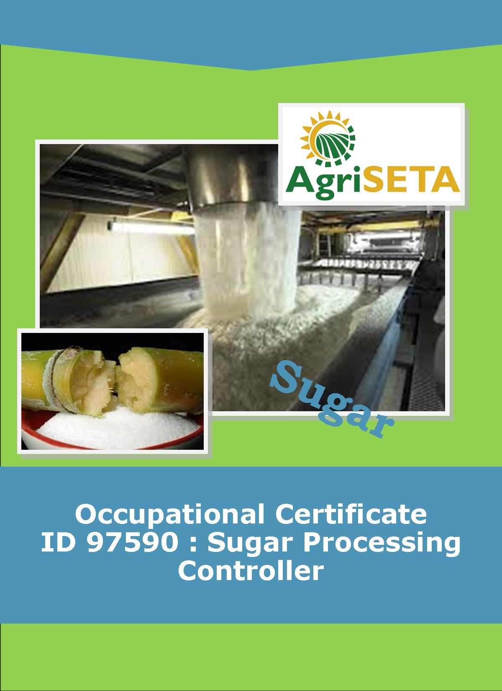
KNOWLEDGE COMPONENT:
KNOWLEDGE COMPONENT: LEARNER WORKBOOK 9: WATER AND EFFLUENT TREATMENT
Occupational Certificate: Sugar Processing Controller

KNOWLEDGE COMPONENT: LEARNER WORKBOOK 9:

WATER AND EFFLUENT TREATMENT
LEARNER WORKBOOK 9:
WATER AND EFFLUENT TREATMENT
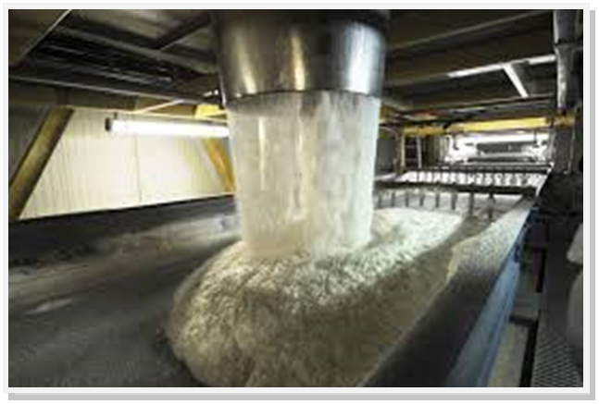
OCCUPATIONAL CERTIFICATE: SUGAR PROCESSING CONTROLLER

©Copyright AgriSETA
Telephone: +27 12 301 5600
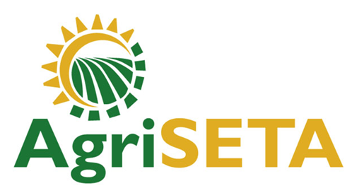

AgriSETA holds the copyright to its publications and Web pages. Proper citation is requested.

TABLE OF CONTENTS
1. AN INTRODUCTION TO THIS LEARNER WORKBOOK 6
2. LEARNER DETAILS 7
3. FORMATIVE ASSESSMENT INSTRUCTIONS 8
4. KNOWLEDGE MODULE 9: WATER AND EFFLUENT TREATMENT 9
4.1 Knowledge Topic 1: Potable water technology (30%) 10
4.2 Knowledge Topic 2: Cooling water technology (30%) 18
4.3 Knowledge topic 3: Boiler water technology (25%) 23
4.4 Knowledge topic 4: Waste water / effluent technology (15%) 30
5. CONCLUSION OF KNOWLEDGE MODULE 9: WATER AND EFFLUENT TREATMENT 35

AN INTRODUCTION TO THIS LEARNER WORKBOOK
This Knowledge Component Learner Workbook 9: Water and Effluent treatment is intended to be used with the Knowledge Component Learning Resource: Book 9 (Textbook): Water and Effluent treatment of the Occupational Qualification: Sugar Processing Controller NQF 4.
Guidance on the use of this Work Book is provided in the Learning Guide.

LEARNER DETAILS
First name
Surname
ID number
Mobile phone contact number
E-mail address
Postal address
Date on which you started this Knowledge Module
Date on which you completed this Knowledge Module
Declaration: | I hereby confirm that:  - I received the assessment plan and schedule.  - I understand my rights in terms of special needs, re-assessment, feedback and appeals against assessment decisions.  - I completed this formative assessment independently without assistance from anyone else.
Total Marks for Knowledge Module 9 | 205
Marks attained
Date:
Place:
Signature of Learner:
Signature of Assessor:

FORMATIVE ASSESSMENT INSTRUCTIONS
Instructions
- Work individually to present the results of each Learning Activity in this Learner Workbook.
- Complete all the sections.
- Use a black pen and ensure that you complete the questions in your own handwriting.
- A recommended time to complete each activity is shown.
- The marks you will attain for each learning activity are shown in brackets.
- The total marks obtained for each Knowledge Module must be transferred from the back of each Learner Workbook to the Learner Qualification Summative Assessment Tool.

KNOWLEDGE MODULE 9: WATER AND EFFLUENT TREATMENT
NQF LEVEL: 4
CREDITS: 4
PURPOSE OF THE KNOWLEDGE MODULE: The main focus of the learning in this knowledge module is to build an understanding of factory services.
The learning will enable learners to demonstrate an understanding of:
- KM-09-KT01: Potable water technology (30%)
- KM-09-KT02: Cooling water technology (30%)
- KM-09-KT03: Boiler water technology (25%)
- KM-09-KT04: Waste water / effluent technology (15%)

4.1 Knowledge Topic 1: Potable water technology (30%)
Topic elements to be covered include:
- KT0101 Technology and measurements
- KT0102 Treatment
- KT0103 Problem solving
Internal Assessment Criteria and Weight
- IAC0101 Water quality requirements can be explained
- (Weight 30%)

Learning activity 1.1: Individual Learning activity: 45 minutes (35 marks)

Learning Objective: Water quality requirements can be explained.
Task: Read each question carefully and write your answer in the space provided.
1. Explain the difference between a suspension, a colloidal and a solution.(9)

2. Compare surface waters to underground waters. (6)

3. What factors must be considered when evaluating a water supply? (3)

4. List the sources of oxygen supply to, and the users of oxygen from, river water (12)

5. List the reasons for purifying potable water. (5)

Learning activity 1.2: Individual Learning activity: 30 minutes (23 marks)
Learning Objective: Water quality requirements can be explained
Task: Read each question carefully and write your answer in the space provided.
1. Show on a diagram the main steps in water purification. (5)

2. Explain the differences between coagulation and flocculation. (4)

3. Write out the reaction between aluminium sulphate and water. (2)

4. How is sedimentation similar to raw juice clarification? (4)

5. Explain the mechanisms involved in filtration. (2)

6. Compare water quality before and after filtration. (2)

7. Define disinfection (2)

Learning activity 1.3: Individual Learning activity: 30 minutes (18 marks)
Learning Objective: Water quality requirements can be explained
Task: Read each question carefully and write your answer in the space provided.
1. How does chlorine function as a biocide? (2)

2. What factors influence the efficiency of chlorine as a disinfectant? (6)
3. Draw a simple sketch of the water treatment plant at your factory (5)

4.2 Knowledge Topic 2: Cooling water technology (30%)
Topic elements to be covered include:
- KT0201 Technology and measurements
- KT0202 Treatment
- KT0203 Problem solving
Internal Assessment Criteria and Weight
- IAC0201 An understanding of heat exchange principles and technology can be demonstrated
- IAC0202 Application principles can be explained
- (Weight 30%)

Learning activity 2.1: Individual Learning activity: 30 minutes (16 marks)
Learning Objective: Task: An understanding of heat exchange principles and technology can be demonstrated.
Task: Read each question carefully and write your answer in the space provided.
1. Explain the process of condensing water in a factory. (4)

2. List the disadvantages of open evaporative cooling systems. (6)

3. Describe, and list the advantages of a closed cooling system. (6)

Learning activity 2.2: Individual Learning activity: 30 minutes (14 marks)
Learning Objective: Task: An understanding of heat exchange principles and technology can be demonstrated.
Task: Read each question carefully and write your answer in the space provided.
1. Describe one-through systems (3)

2. Compare cooling ponds with spray ponds. (4)

3. Define a cooling tower.(2)

4. Draw simple sketches showing the various types of cooling towers. (5)

4.3 Knowledge topic 3: Boiler water technology (25%)
Topic elements to be covered include:
- KT0301 Technology and measurements
- KT0302 Treatment
- KT0303 Problem solving
Internal Assessment Criteria and Weight
- IAC0301 An understanding of boiler water technology and trace elements can be demonstrated
- IAC0302 Water quality concepts and contaminants can be explained
- (Weight 25%)

Learning activity 3.1: Individual Learning activity: 30 minutes (18 marks)
Learning Objective: Task: An understanding of boiler water technology and trace elements can be demonstrated
Task: Read each question carefully and write your answer in the space provided.
1. Make a sketch of a boiler, showing the scrubber, economiser, air heater, superheater, feedwater tank and pump, steam drum and mud drum, grate, deaerator, FD and ID fans etc. (5)

2. What happens if dissolved solids become too concentrated in boiler water and how can this be prevented? (4)

3. Differentiate between boiler water and boiler feedwater. (4)

4. What is, and what causes, carryover? (5)

Learning activity 3.2: Individual Learning activity: 1hour (36 marks)
Learning Objective: Task: An understanding of boiler water technology and trace elements can be demonstrated
Task: Read each question carefully and write your answer in the space provided.
1. Why should silica be controlled? (2)

2. What does blowdown mean? (2)

3. Discuss scaling and corrosion; making reference to their causes, effects and control measures employed. (10)

4. Draw a deaerator. (5)
5. What is an oxygen scavenger? Give a reaction. (4)

6. How does boiler pressure affect boiler water specifications? (8)

7. Describe the boiler water treatment programme at your factory. (5)

4.4 Knowledge topic 4: Waste water / effluent technology (15%)
Topic elements to be covered include:
- KT0401 Technology and measurements
- KT0402 Treatment
- KT0403 Problem solving
Internal Assessment Criteria and Weight
- IAC0401 An understanding of wastewater treatment concepts and trace elements can be demonstrated
- IAC0402 Water quality concepts and contaminants can be explained
- (Weight 15%)

Learning activity 4.1: Individual Learning activity: 30 minutes (18 marks)
Learning Objective: An understanding of wastewater treatment concepts and trace elements can be demonstrated
Task: Read each question carefully and write your answer in the space provided.
1. List 6 aspects of the Water Amendment Act (1984) (6)

2. List the general Standard for waste water or effluent. (10)

3. How is polluting capacity of an effluent measured? (2)

Learning activity 4.2: Individual Learning activity: 1 hour (22 marks)
Learning Objective: An understanding of the wastewater treatment concepts and trace elements can be demonstrated
Task: Read each question carefully and write your answer in the space provided.
- What is he difference between running losses and cleaning losses? Give examples of each. (15)
2. Describe anaerobic effluent treatment. (4)

3. Describe aerobic effluent treatment (3)

4. Describe effluent treatment at your factory.

CONCLUSION OF KNOWLEDGE MODULE 9: WATER AND EFFLUENT TREATMENT
Throughout this knowledge module you have been provided opportunities to complete formative learning activities. You have captured your results in this Learner Workbook.
The total marks for this Knowledge Module are as follows:
Knowledge Module | Total Marks | Marks attained
KM-09-KT01: Potable water technology (30%) | 76
KM-09-KT02: Cooling water technology (30%) | 30
KM-09-KT03: Boiler water technology (25%) | 54
KM-09-KT04: Waste water / effluent technology (15%) | 45
Total Marks | 205 marks

