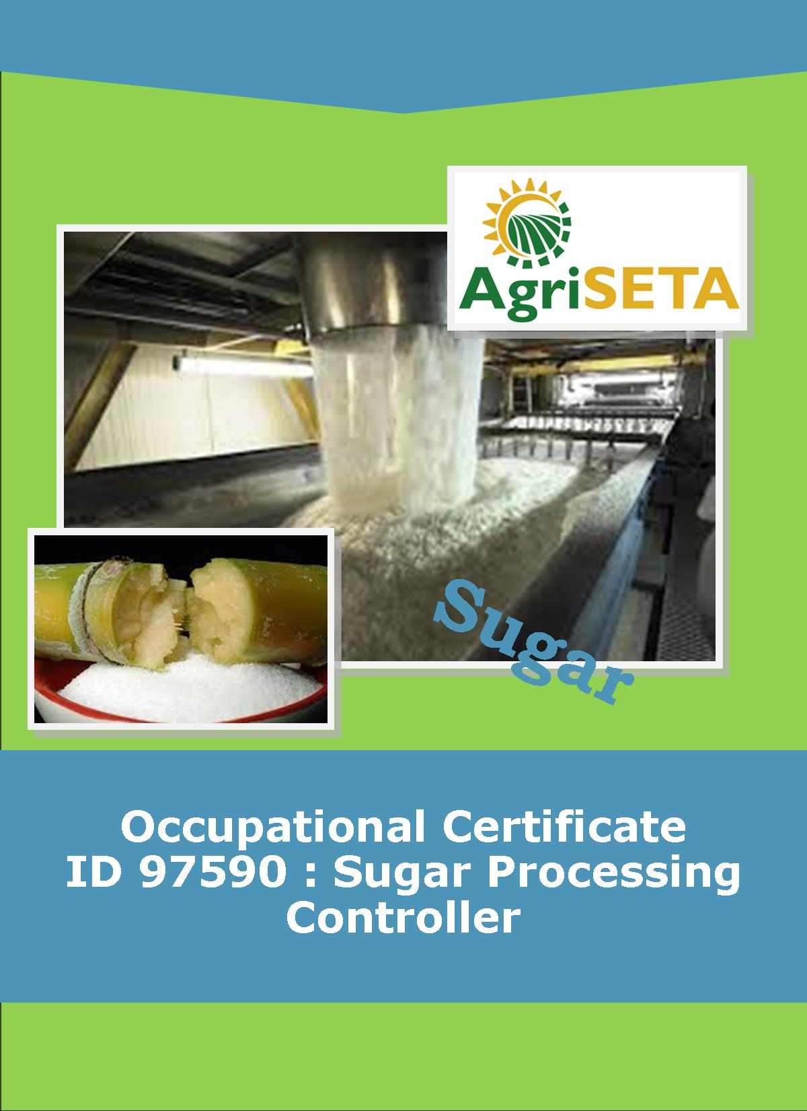
LEARNER SUMMATIVE ASSESSMENT TOOL : KNOWLEDGE MODULE 9: WATER AND EFFLUENT TREATMENT 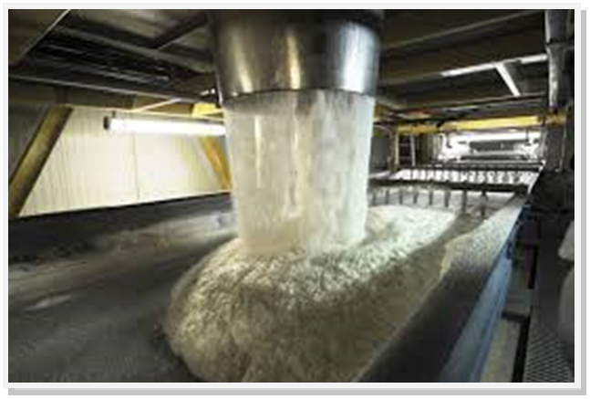
KNOWLEDGE COMPONENT: LEARNER SUMMATIVE ASSESSMENT TOOL : KNOWLEDGE MODULE 9 :
WATER AND EFFLUENT TREATMENT
Occupational Certificate: Sugar Processing Controller

LEARNER SUMMATIVE ASSESSMENT TOOL KNOWLEDGE MODULE 9: WATER AND EFFLUENT TREATMENT
OCCUPATIONAL CERTIFICATE: ID 97590: SUGAR PROCESSING CONTROLLER

©Copyright AgriSETA
Telephone: +27 12 301 5600


AgriSETA holds the copyright to its publications and Web pages. Proper citation is requested.

TABLE OF CONTENTS

1. STAKEHOLDER INFORMATION 6
2. COMPETENCY SUMMARY OF ASSESSMENT 8
3. ASSESSMENT ALIGNMENT MATRIX (INTERGRATED OUTCOMES) 9
4. ASSESSMENT DECISION & EVIDENCE EVALUATION RECORD 11
5. OVERALL ASSESSMENT DECISION 12
6. EVIDENCE OF FEEDBACK 13
7. OVERALL RESULTS 14
8. ASSESSMENT REVIEW 15
9. FINAL DECISION 17
10. LEARNER FEEDBACK FORM 18
11. SUMMATIVE ASSESSMENT INSTRUCTIONS 19
12. WRITTEN ASSESSMENT 20
13. FINAL MARKS 30

STAKEHOLDER INFORMATION
LEARNER INFORMATION
Name
Surname
ID number
Mobile phone contact number
E-mail address
Physical address
Postal address
Employer Name
Employer Contact Details

ASSESSOR DETAILS
Name
Surname
Assessor ID
Project Name | Occupational Certificate ID 97590:Sugar Processing Controller
Module No. | Module 9: Water and effluent treatment
Date of Assessment
Portfolio submission Date
Assessor Signature
Total Marks for Knowledge Module 9 | 150 marks
Marks attained
Place:

MODERATOR DETAILS
Moderator Name
Moderator ID
Moderator Signature
Date of Moderation

COMPETENCY SUMMARY OF ASSESSMENT
Module 9 | KM-09-KT01: Potable water technology | C | NYC
1 | 1.1.Water quality requirements can be explained
2 | KM-09-KT02: Cooling water technology | - C | NYC
 | 2.1.An understanding of heat exchange principles and technology can be demonstrated
 | 2.2.Application principles can be explained
3 | KM-09-KT03: Boiler water technology | C | NYC
 | 3.1.An understanding of boiler water treatment and trace elements can be demonstrated
 | 3.2.Water quality concepts and contaminants can be explained
4. | KM-09-KT04: Waste water / effluent technology | C | NYC
 | 4.1. An understanding of wastewater treatment concepts and trace elements can be demonstrated
 | 4.2. Water quality concepts and contaminants can be explained

ASSESSMENT ALIGNMENT MATRIX (INTERGRATED OUTCOMES)
Module No: 9 | How it is assessed (Assessment methodology) | Where is it covered (learning material) | Where it is assessed |  | First Submission
Module No: 9 | How it is assessed (Assessment methodology) | Where is it covered (learning material) | Summative | Formative
SAQA ID Number: 97590 | Two methods of assessment are followed which are:  1. Summative assessment: written tests, knowledge questions using fundamental and reflexive questions.  2. Formative assessment: assignments, tasks, portfolio of evidence submitted and presentations. |  |  |  | Clearly meets all the criteria | Meets some but not all criteria | Clearly does not meet any of the criteria
Title: Water and effluent treatment
NQF level and credits:
NQF Level 4: 4 Credits
Topic: 1 Potable water technology |  | Page 11-15 | Question 9.5-9.8 page 21 | Learning Activity 1.1-1.3 page 11-17
Assessment criteria: Water quality requirements can be explained
Topic 2. Cooling water technology |  | Page 16-26 | Question 9.9-9.17 page 22-24 | Learning Activity 2.1-2.2 page 19- 22
Assessment criteria: An understanding of heat exchange principles and technology can be demonstrated
Assessment criteria: Application principles can be explained
Topic 3. Boiler water technology |  | Page 27-37 | Question 9.18- 9.25 page 24-26 | Learning Activity 3.1-3.2 page 24-29
Assessment criteria: An understanding of boiler water treatment and trace elements can be demonstrated
Assessment criteria: Water quality concepts and contaminants can be explained
Topic 4. Waste water / effluent technology |  | Page 38 | Question 9.26-9.38 page 24-26 | Learning Activity 4.1 4.2 page 31-34
Assessment criteria: An understanding of wastewater treatment concepts and trace elements can be demonstrated
Assessment criteria: Water quality concepts and contaminants can be explained.

ASSESSMENT DECISION & EVIDENCE EVALUATION RECORD
Candidate's Name: -

Assessor's Name: -

Practical assessment
I declare that this assessment is my own demonstration.

Marks: The learner is either “Met requirements” or “did not meet requirements”. If the learner did not meet requirements in an area, then he or she must be reassessed.
Learner achieved: Met requirements /Did not meet requirements
KNOWLEDGE MODULE 9: WATER AND EFFLUENT TREATMENT
Overall outcome:

Specific Outcome |  | Met requirements | Did not meet requirements | Comments
1

Specific Outcome |  | Met requirements | Did not meet requirements | Comments
2
 | Specific outcome | Met requirements | Did not meet requirements | Comments
3
4 | Specific outcome | Met requirements | Did not meet requirements | Comments

OVERALL ASSESSMENT DECISION
Assessors Comments:

Signature of Assessor:

Date:

EVIDENCE OF FEEDBACK
Module No :9
Level :4
Assessor :……………………………………………………………………………
Candidate :…………………………………………………………………………..
Date of final assessment:…………………………………………………………….
Evidence criteria | Achieved | Not
1. Constructive
2. Timeous (according to Plan)
3. Correct mode / medium
4. Participative
5. Developmental
6. Accurate
7. Specific
8. Documented
9. Directed to correct parties
Signing off date: …………………………………………….

..........……………. ………………………………….
Assessor Candidate

OVERALL RESULTS
OVERALL RESULT | Competent
OVERALL RESULT | Not Yet Competent
Declaration by Candidate
I, …………………………………………………………………….declare that I am satisfied that the feedback given to me by the Assessor was relevant, sufficient and done in a constructive manner. I accept the assessment decisions and do realise that have no further questions relating to this particular assessment process. I do realise that after this assessment decision, the moderator will either uphold or reverse this assessment decision taken by the assessor.
Candidate : _____________  _______________________  Date: __________________  Signature: ______________ |  | Assessor : _____________  _______________________  Date: __________________  Signature: ______________ |  | Moderator : _____________  _______________________  Date: __________________  Signature: ______________

ASSESSMENT REVIEW
Assessor’s Name |  |  |  |  |  |  |  |  | ID Number
Contact Details of Assessor |  | Email
 |  | Phone
 |  | Fax
PART 1
 | Review Criteria |  | Valid |  | Authentic | Current |  | Consistent |  |  | Reliable |  | Sufficient |  |  | Comments
Please conduct an honest review of the Assessment Instruments used in this assessment:
1 | Evidence Topic 1
 | Knowledge Assignment
 | Practical Assignment
 | Natural Occurring Evidence
 | Reflection
2 | Evidence Topic 2
 | Knowledge Assignment
 | Practical Assignment
 | Natural Occurring Evidence
 | Reflection
3 | Evidence Topic 3
 | Knowledge Assignment
 | Practical Assignment
 | Natural Occurring Evidence
 | Reflection
4 | Evidence Topic 4
 | Knowledge Assignment
 | Practical Assignment
 | Natural Occurring Evidence
 | Reflection
5 | Evidence Topic 5
 | Knowledge Assignment
 | Practical Assignment
 | Natural Occurring Evidence
 | Reflection
PART 2
No | Review Criteria |  |  |  |  |  |  |  |  | Yes |  | No |  |  | Remarks
1 | Do you feel the candidate was appropriately selected and prepared for the RPL assessment?
2 | Did the candidate interpret the evidence requirements appropriately?
3 | Was the assessment free of potential assessment barriers such as language, literacy, access to resources?
4 | Was the assessment evidence presented by the candidate valid, authentic, current and sufficient?
5 | Was the candidate’s workplace access to evidence sufficiently supportive of the assessment strategy?
6 | Do you feel you could make a fair, valid and reliable assessment decision?
Recommendations
(Feedback on Validity, authenticity, currency and sufficiency of candidate evidence.)
Assessor Signature |  |  |  |  |  |  | Date Review Completed

FINAL DECISION
I………………………………………………………. hereby declare Ms/Mr

………………………………………… Competent Not Yet Competent

FEEDBACK TO LEARNER:

……………………..………………………..………………………..……………………

……………………..………………………..………………………..………………………

……………………..………………………..………………………..………………………

……………………..………………………..………………………..………………………

SIGN: …………………………………… DATE: ……………………..........................

LEARNER FEEDBACK:

……………………..………………………..………………………..………………………

……………………..………………………..………………………..………………………

……………………..………………………..………………………..………………………

……………………..………………………..………………………..………………………

SIGN: ……………………………………… DATE: …………………….......................

MODERATOR FEEDBACK:

………………………..………………………..………………………..……………………

………………………..………………………..………………………..……………………

……………………..………………………..………………………..………………………

……………………..………………………..………………………..………………………

SIGN: …………………………………… DATE: ……………………........................

LEARNER FEEDBACK FORM
CRITERIA | EVIDENCE | CRITERIA | EVIDENCE
How did your assessor encourage you and put you at ease during the assessment process? |  | Were you given clear and constructive feedback?
Were your assessor’s questions clear and pitched at the right level of language usage? |  | Did your assessor assess all the evidence provided by you?
Do you believe that all the assessment criteria and knowledge requirements of the standard you were being measured against were considered in your assessment? |  | Were you aware of any discrimination practice carried out by your assessor towards you?

LEARNER SIGNATURE:………………………………………………

DATE:.…………………………..

SUMMATIVE ASSESSMENT INSTRUCTIONS
Instructions
- Work individually and answer all questions.
- Use a black pen and ensure that you complete the questions in your own handwriting.
- Time to spend on this assessment is 2 hours.
- The marks you will attain for each question are shown in brackets.

WRITTEN ASSESSMENT
9.1 | What constitutes a mixture? |  | Mark Allocation
a. |  | Fanta.
b. |  | Air.
c. |  | Water.
d. |  | A mixture of sugar and water.
e. |  | All of the above. | 4

9.2 | Which statement below best defines Colloidal Dispersions? |  | Mark Allocation
a. |  | A mixture where at least one of the particles are smaller than those in suspension, but larger than those in solution.
b. |  | A mixture where all particles are of the order of atoms, ions or small molecules.
c. |  | A mixture where all the particles are relatively large.
d. |  | A mixture where the solids can be separated by simple filtration.
e. |  | A mixture that a beam of light will shine through. | 4

9.3 | Oxygen is soluble in water at 20 oC, what is the approximate value? |  | Mark Allocation
a. |  | 20%.
b. |  | 29 ppm.
c. |  | 89%.
d. |  | 9 ppm.
e. |  | 50 ppm. | 4

9.4 | There are numerous users of oxygen from river water. Which of the following is NOT a user of oxygen in the river water? |  | Mark Allocation
a. |  | Bacteria
b. |  | Anaerobic products from the lower layer.
c. |  | Algal photosynthesis.
d. |  | Growth of sewage fungus.
e. |  | Certain aquatic plants. | 4

9.5 | What is the purpose of water purification? |  | Mark Allocation
a. |  | Removal of bacterial content.
b. |  | Removal of particles and any sediment.
c. |  | To make it clear and acceptable to the eye.
d. |  | To ensure that the taste is acceptable.
e. |  | All of the above. | 4

9.6 | What is the best definition for flocculation? |  | Mark Allocation
a. |  | Removal of the solids by filtration.
b. |  | Addition of chemicals to create a reaction to precipitate and entrap the colloids.
c. |  | To neutralise the charges that keep colloidal particles apart, allowing them to lump together and settle out.
d. |  | Removal of the sediment.
e. |  | Increase the viscosity and temperature of the water, precipitating out the colloidal matter. | 4

9.7 | The removal of coagulated or flocculated material and suspended solids happens in a; |  | Mark Allocation
a. |  | Jar test machine.
b. |  | Distribution channel.
c. |  | Pasveer ditch.
d. |  | Clarifier settling tank with a flocculation chamber and sludge removal system.
e. |  | Flocculation chamber. | 4
9.8 | What is the chemical responsible for the destruction of bacteria and viruses in potable water, after the chemical reaction with chlorine gas and water? |  | Mark Allocation
a. |  | Pressure filters.
b. |  | Chlorine.
c. |  | Hydrochloric acid.
d. |  | Hypochlorous acid.
e. |  | Atomic oxygen | 4

9.9 | Which of the sugar factory process below, uses condenser water? |  | Mark Allocation
a. |  | Condensers in the pan floor.
b. |  | Bearing cooling water.
c. |  | Evaporators.
d. |  | Crystallisers.
e. |  | All of the above. | 4

9.10 | What process in an open cooling system is used to cool down water? |  | Mark Allocation
a. |  | Heat exchange.
b. |  | Aeration.
c. |  | Evaporation.
d. |  | Chemical.
e. |  | Once through system. | 4

9.11 | A packed atmospheric cooling tower is known as; |  | Mark Allocation
a. |  | An inefficient way of cooling water.
b. |  | A closed cooling system.
c. |  | A once through cooling system.
d. |  | A spray pond.
e. |  | An open evaporative cooling system. | 4

9.12 | What will cause electrical potential (current) in a metal? |  | Mark Allocation
a. |  | When two different metals make contact with each other.
b. |  | When a piece of metal is submersed in water and the oxygen content of the water differs across the length of the piece of metal.
c. |  | Where the water temperature is the same from one end of a piece of metal to the other.
d. |  | When there is a reaction between the air and the water.
e. |  | None of the above. | 4

9.13 | Metal can oxidise in the cooling tower through a process of oxidation, where electrons will go into solution as metal ions. What is this point of the metal known as? |  | Mark Allocation
a. |  | Anode.
b. |  | Cathode.
c. |  | Reduction.
d. |  | Corrosion.
e. |  | Oxidation. | 4

9.14 | There are various sources of deposits that can cause scale and sludge in the cooling tower. Where do the deposits come from? |  | Mark Allocation
a. |  | From the sugar manufacturing process.
b. |  | Make up water.
c. |  | Air.
d. |  | Construction materials of the system.
e. |  | All of the above. | 4

9.15 | What is the most cost effective treatment of cooling tower water? |  | Mark Allocation
a. |  | Lime.
b. |  | Chemical agents.
c. |  | Time.
d. |  | Flocculants.
e. |  | Dispersants. | 4
9.16 | There are numerous types of microbial organisms found in cooling towers, like algae and fungi. Bacteria also exist. What are the oxygen requirements of anaerobic bacteria? |  | Mark Allocation
a. |  | Require oxygen to live.
b. |  | Require an absence of oxygen to live.
c. |  | Can live with or without oxygen.
d. |  | Feed on dead organic matter.
e. |  | Feed on living organic matter. | 4

9.17 | In selecting a micro biocide for cooling tower treatment, what factors need to be considered? |  | Mark Allocation
a. |  | Must be economical.
b. |  | Correct dosage is required.
c. |  | Must inhibit almost all activity.
d. |  | Minimal environmental impact.
e. |  | All of the above. | 4

9.18 | What will happen in a boiler if blowdown is not done. |  | Mark Allocation
a. |  | The steam condensed in the factory and returned to the boiler as boiler feed water will reduce and make up water will be required.
b. |  | The cycling of the superheated steam through the heating chamber will not reach superheated temperature.
c. |  | The total dissolved solids concentration of the boiler feed water continually decrease.
d. |  | The total dissolved solids will be diluted.
e. |  | The total dissolved solids will be concentrated to a point where excessive scaling can take place. | 4

9.19 | What is the best way to control the TDS? |  | Mark Allocation
a. |  | Blowdown once per shift for 30 seconds.
b. |  | Dump the boiler feed water when TDS is too high.
c. |  | Blowdown twice per shift for 15 seconds.
d. |  | Blowdown every 30 minutes for 5 seconds.
e. |  | Blowdown every hour for 10 seconds. | 4
9.20 | What occurs when steam is contaminated with boiler water? |  | Mark Allocation
a. |  | Carryover caused by high TDS causing scaling and corrosion in the boiler.
b. |  | Carryover, caused by high concentration of soluble and insoluble material in the boiler feed water.
c. |  | Carryover due to a sudden increase in steam offtake.
d. |  | Carryover by droplet entrainment.
e. |  | All of the above. | 4

9.21 | Scaling can occur in the water-side of the boiler tubes. Select most serious effect of scaling in a boiler, from the options below. |  | Mark Allocation
a. |  | Improved heat transfer.
b. |  | Tube overheating and failure.
c. |  | Provides cover for corrosion.
d. |  | Can cause a tube to plug.
e. |  | None of the above. | 4

9.22 | Corrosion in the boiler tubes can shorten the life of the boiler tubes. How is corrosion controlled in a boiler? |  | Mark Allocation
a. |  | Remove the dissolved oxygen in the boiler feed water by using an oxygen scavenger.
b. |  | Ensure that the boiler feed water is pre-heated in the economiser.
c. |  | Maintain an acidic condition of <11 pH.
d. |  | Use a chelanting agent like E.D.T.A. to treat the boiler feed water.
e. |  | Use sludge conditioners. | 4

9.23 | Gross contamination of boiler feed water by sugar will be noted from the following; |  | Mark Allocation
a. |  | Scaling of boiler tubes.
b. |  | Acid corrosion
c. |  | Considerable drop in pH
d. |  | Smell of burning sugar.
e. |  | All of the above. | 4

9.24 | What is the ideal pH for boiler feed water? |  | Mark Allocation
a. |  | The pH needs to be between 9.5 and 10.0
b. |  | The pH needs to be between 10.5 and 11.5
c. |  | The pH needs to be 7.
d. |  | The pH needs to be between 7 and 8.
e. |  | The pH needs to be between 4.5 and 6.5 | 4

9.25 | If the boiler feed water TDS level is correct and the chemical levels are too low, what is the best corrective action. |  | Mark Allocation
a. |  | Increase blowdown to every 30 minutes for 5 seconds.
b. |  | Blowdown at the normal frequency of once per hour, but increase the duration from 10 seconds to 30 seconds.
c. |  | Increase the chemical dosage.
d. |  | Reduce the time between blowdown, but increase the blowdown duration.
e. |  | Double the usual blowdown rate. | 4

9.26 | What is the best way in which to broadly measure the amount of pollution in waste water? |  | Mark Allocation
a. |  | By measuring the “food value” of the effluent to bacteria; being the organic content of the effluent.
b. |  | By measuring the amount of sucrose in the water.
c. |  | By measuring of the amount of methane, hydrogen sulphide and ammonia in the water.
d. |  | By measuring the conductivity of the water.
e. |  | None of the above. | 4

9.27 | Why will fish and other aquatic life die if sugar contaminates a river or stream? |  | Mark Allocation
a. |  | Sugar provides a food source for aerobic bacteria.
b. |  | Aerobic bacteria consume the dissolved oxygen in the water faster than it can be replaced.
c. |  | In the absence of oxygen anaerobic organisms multiply.
d. |  | Anaerobic organisms produce ammonia, hydrogen sulphide and methane.
e. |  | All of the above. | 4
9.28 | Why is the biological oxygen demand (BOD) not used as a routine test to measure the pollution impact of waste water? |  | Mark Allocation
a. |  | The results are inaccurate.
b. |  | The test takes too long for effective management.
c. |  | The chemicals are too expensive.
d. |  | The results are available immediately.
e. |  | BOD only measures the active organic content. | 4

9.29 | In terms of water purification, what does COD stand for? |  | Mark Allocation
a. |  | Carbon Dioxide.
b. |  | Calculated oxygen demand.
c. |  | Chlorine oxygen demand.
d. |  | Chemical oxygen demand.
e. |  | Calcium oxygen demand. | 4

9.30 | In controlling waste water or effluent, what can be used to reduce the BOD to a point where it can be returned to a river without causing harm? |  | Mark Allocation
a. |  | Chlorine.
b. |  | Lime.
c. |  | Bacteria.
d. |  | Methane.
e. |  | Carbon dioxide. | 4

9.31 | How must effluent be treated once sugar has been decomposed to an acidic anaerobic condition? |  | Mark Allocation
a. |  | Add carbon dioxide
b. |  | Introduce anaerobic bacteria.
c. |  | Remove the methane and acetic acid.
d. |  | Aerate the effluent introducing oxygen.
e. |  | Remove the sludge. | 4

9.32 | Which of the following statements best describe the features of an anaerobic dam? |  | Mark Allocation
a. |  | Acidic effluent needs to be drained and digestion completed using aerobic bacteria.
b. |  | Effluent needs to be de-silted before entering the dam.
c. |  | Maintain a COD content of less than 0.08 kg per cubic meter of dam volume.
d. |  | Dam itself must not be desilted as the anaerobic bacteria forms the sludge.
e. |  | All of the above. | 4

9.33 | How does an aerobic system ensure that the activity of aerobic bacteria is maintained? |  | Mark Allocation
a. |  | Ensure that sludge is removed from the Pasveer ditch
b. |  | Ensure that the MLSS is between 10 and 30 mgl⁻¹.
c. |  | Ensure that the sludge volume index is between 125 and 165 mgl⁻¹.
d. |  | Ensure that a high concentration of oxygen is maintained by violent aeration.
e. |  | Ensure that there is a high levels of chlorine. | 4

9.34 | Why are both anaerobic and aerobic systems required to treat effluent. |  | Mark Allocation
a. |  | Anaerobic dams can only deal with 80 % of the effluent if managed correctly.
b. |  | Anaerobic dams will become too acidic and bacteria cannot cope with the acid load.
c. |  | Acidic effluent needs to be drawn off to maintain the functioning of the anaerobic dam.
d. |  | The acidic effluent removed from an anaerobic dam needs to be treated further in an aerobic system.
e. |  | All of the above. | 4

9.35 | Where are most of the bacteria in an effluent system? (aerobic or anaerobic) |  | Mark Allocation
a. |  | Bacteria cling to the suspended solids and are retained in the sludge.
b. |  | Bacteria are mainly in the effluent water.
c. |  | Bacteria enter the system through the air.
d. |  | Bacteria are not retained in the effluent system and are removed by adding chlorine.
e. |  | None of the above. | 4
9.36 | What is the best definition for MLSS? |  | Mark Allocation
a. |  | The mixture of suspended solids in the mother liquor.
b. |  | The measurement of suspended solids in the mother liquor.
c. |  | Gives the suspended solids content of the mixed liquor or sludge and is a measure of the quantity of bacteria in the system.
d. |  | The combination of sludge and volatile solids that are in the mother liquor.
e. |  | The number of bacteria that are mixed in the sludge. | 4

9.37 | The sludge volume settling index (SVI) is a measure of an effluent system performance. Why is a low SVI desirable? |  | Mark Allocation
a. |  | A low SVI indicates dense sludge, which will indicate a high bacterial content.
b. |  | A low SVI will indicate that there is a high COD, which will improve effluent control in an anaerobic dam.
c. |  | A low SVI will indicate that the Pasveer ditch is not performing well and measures can be put in place to rectify this.
d. |  | A low SVI is not desirable, the higher the SVI the better the effluent system will perform.
e. |  | A low SVI indicates a low contamination of other pollutants from sugar factories. | 4

9.38 | Can sewage that is generated by a human community such as at a sugar mill be treated by the mill’s effluent system. |  | Mark Allocation
a. |  | Yes.
b. |  | No. | 2

FINAL MARKS
TOTAL MARKS: 150
PASS MARK: 120
LEARNER MARKS
PERCENTAGE
ASSESSOR SIGNITURE:

