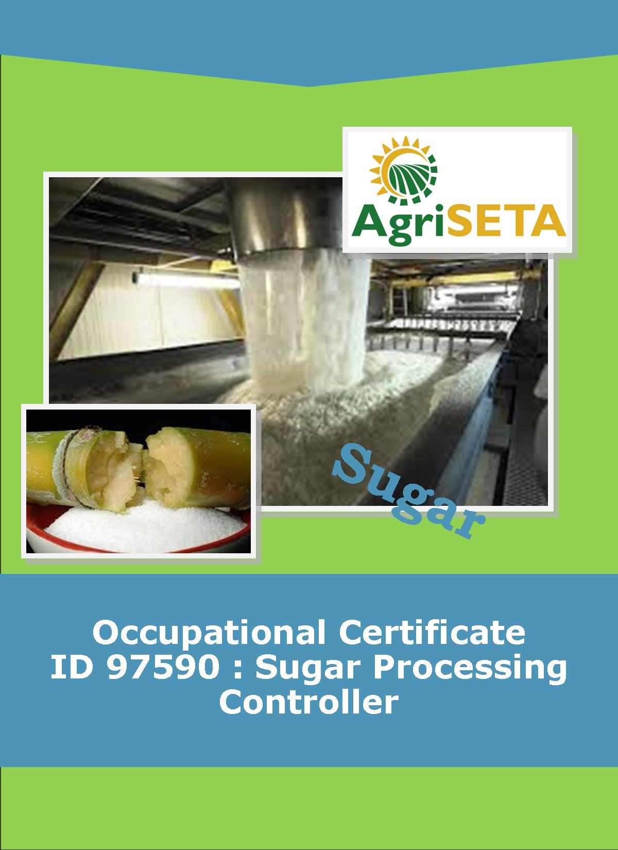
KNOWLEDGE COMPONENT: LEARNING RESOURCE: BOOK 9: WATER AND EFFLUENT TREATMENT
OCCUPATIONAL QUALIFICATION: SUGAR PROCESSING CONTROLLER

KNOWLEDGE COMPONENT:
LEARNING RESOURCE

BOOK 9: WATER AND EFFLUENT TREATMENT
KNOWLEDGE COMPONENT:
LEARNING RESOURCE
BOOK 9 : WATER AND EFFLUENT TREATMENT
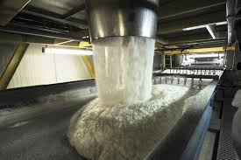
OCCUPATIONAL QUALIFICATION:
SUGAR PROCESSING CONTROLLER

©Copyright AgriSETA
Telephone: +27 12 301 5600


AgriSETA holds the copyright to its publications and Web pages. Proper citation is requested.

TABLE OF CONTENTS
AN INTRODUCTION TO THIS LEARNING RESOURCE 8
KNOWLEDGE MODULE 9 9
WATER AND EFFLUENT TREATMENT 9

1. Background 9
1.1 KINDS OF MIXTURES 9
1.1.1 Suspensions 9
1.1.2 Colloidal dispersions 9
1.1.3 Solutions 10
1.2 SOURCES OF WATER 10
1.2.1 Surface waters 10
1.2.2 Underground waters 10
1.3 EVALUATION OF A WATER SUPPLY 11
1.3.1 Importance of dissolved oxygen 11
1.3.2 Sources of Oxygen Supply to River Water 11
1.3.3 Users of Oxygen from River Water 11

2. Knowledge Topic 1: Potable Water Technology 13
2.1 SPECIFICATION FOR DRINKING WATER 13
2.2 PURPOSE OF WATER PURIFICATION 14
2.3 COAGULATION AND FLOCCULATION 14
2.3.1 Coagulation 14
2.3.2 Flocculation 14
2.4 REMOVAL OF COAGULATED OR FLOCCULATED MATERIAL AND SUSPENDED SOLIDS 15
2.4.1 Sedimentation 15
2.4.2 Filtration 17
2.5 DISINFECTION 17

3. Knowledge topic 2: Cooling Water Technology 19
3.1 INTRODUCTION 19
3.2 TYPES OF COOLING SYSTEMS 19
3.2.1 Open evaporative cooling systems 19
3.2.2 Closed systems 19
3.2.3 Once – through systems 20
3.3 OPEN EVAPORATIVE SYSTEMS 20
3.3.1 Cooling Ponds 20
3.3.2 Spray Ponds 20
3.3.3 Cooling Towers 21
3.4 CORROSION CONTROL 25
3.4.1 Mechanism of corrosion 25
3.4.2 Corrosion inhibitors 26
3.5 DEPOSIT CONTROL 26
3.5.1 Sources of deposits 26
3.5.2 Control methods 27
3.6 MICROBIOLOGICAL ASPECTS 27
3.6.1 Types of Microbiological organisms 28
3.6.2 Problems caused by Microbial activity 29
3.6.3 Control of microbial activity 29

4. Knowledge topic 3: Boiler Water Technology 31
4.1 PRINCIPLES OF A BOILER 31
4.2 CARRYOVER 36
4.2.1 Causes of Carryover 36
4.2.2 Effects of Carryover and preventive measures 37
4.3 SCALING 37
4.3.1 Effects of scaling 38
4.3.2 Causes of scaling and preventive measures 38
4.4 CORROSION 39
4.4.1 Effects of corrosion 39
4.4.2 Control measures 39
4.5 SUGAR IN BOILER WATER 40
4.6 PRE-TREATMENT 41
4.6.1 Clarification 41
4.6.2 Water softener/De-ionisation – cation/anion exchangers 41
4.7 BOILER FEED WATER SYSTEM 42
4.8 INTERPRETATION OF ANALYTICAL RESULTS 42
4.9 BOILER WATER AND BOILER FEEDWATER SPECIFICATIONS 43

5. Knowledge topic 4: Waste Water / Effluent Technology 44
5.1 LEGAL ASPECTS 44
5.2 THE GENERAL STANDARD FOR WASTE WATER OR EFFLUENT 44
5.3 MECHANISM OF POLLUTION WITH SUGAR 45
5.4 THE MEASUREMENT OF POLLUTION 45
5.4.1 Biological oxygen demand (BOD) 45
5.4.2 Chemical Oxygen demand (COD) 46
5.5 SOURCES OF POLLUTION IN A FACTORY 47
5.5.1 Running losses 47
5.5.2 Cleaning losses 49
5.6 IMPORTANCE OF GOOD HOUSEKEEPING 49
5.7 BASIC METHODS OF DEALING WITH EFFLUENT 49
5.7.1 Irrigation 49
5.7.2 Using controlled degradation 49
5.8 ANAEROBIC DIGESTION 50
5.9 AEROBIC DIGESTION 51
5.10 PRACTICAL EFFLUENT TREATMENT 51
5.10.1 Anaerobic holding dam 51
5.10.2 Aerobic systems 52
5.11 COMBINATION (ASH DAM) 53
5.12 CONTROL OF EFFLUENT PLANT OPERATIONS 53
5.12.1 Mixed Liquor Suspended Solids in Sludge (MLSS) 53
5.12.2 Mixed Liquor Volatile Suspended Solids (MLVSS) 54
5.12.3 Sludge Volume Index (SVI) 54
5.12.4 The food to micro-organism ratio (F:M ratio) 55
5.12.5 Temperature 56
5.12.6 Energy input 56
5.12.7 Nutrients Ratios 56
5.12.8 COD Loading 56
5.13 OTHER POLLUTANTS ORIGINATING FROM SUGAR FACTORIES 56
5.14 SEWAGE TREATMENT 57
5.15 CHARACTERISTICS OF SEWAGE 57

AN INTRODUCTION TO THIS LEARNING RESOURCE
This Knowledge Component Learning Resource: Book 9: Water and Effluent Treatment is intended to be used with the Knowledge Component Learner Workbook 9 (Formative Assessment Guide): Water and Effluent Treatment: Sugar Processing Controller NQF 4. It can also be used as a stand-alone information resource (text book).
This Learning Resource provides detailed information on the following topics:
- KM-09-KT01: Potable water technology (1%)
- KM-09-KT02: Cooling water technology (1%)
- KM-09-KT03: Boiler water technology (1%)
- KM-09-KT04: Waste water / effluent technology (1%)
(Note: KM = Knowledge Module, KT = Knowledge Topic)

KNOWLEDGE MODULE 9

WATER AND EFFLUENT TREATMENT
Module number: 313908000-KM09: NQF Level 4: Credits 4
1. Background
1.1 KINDS OF MIXTURES
Most of the things that we see around us are mixtures, not elements or compounds. A mixture is anything made up of two or more elements or compounds that are physically combined in no particular proportion by mass. Two substances can be mixed together in almost any ratio.
    - Suspensions
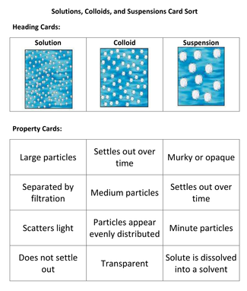
A suspension is a mixture in which the particles of one (or more) of the substances are relatively large. These particles will have at least one dimension larger than 100nm. Finely divided clay in water is an example. Unless a suspension is stirred or shaken, the large particles will sooner or later settle out. Suspension of solids in fluids can nearly always be separated by simple filtration.
    - Colloidal dispersions
A colloidal dispersion is a mixture in which the particles of one (or more) substances are smaller than those in suspensions, but larger than those in solution. They will have at least one dimension in the range of 1 to 10nm (0.000 001 – 0.00001mm). A typical colloidal dispersion is starch in water. This mixture can be made so concentrated that it will look milky or so dilute that it will appear as clear and transparent as water. The colloidal particles are too small to be trapped by filter paper. Although a colloidal solution may appear clear, it will look milky when light is shone through it, since the particles are large enough to scatter the light.
    - Solutions
A solution is a mixture where all particles are of the order of atoms, ions or small molecules i.e. 0.1 – 1 nm. The particles are far too small to be separated by filtration and light shone through a solution is not scattered. A typical solution is sugar in water.
1.2 SOURCES OF WATER
Water can come from either the earth’s surface (surface waters) or from below ground level (underground waters).
    - Surface waters
Surface water can be divided into two main groups.

Water with low colour and high turbidity
Most inland waters fall into this category. During floods, large quantities of suspended material are carried by rivers. However, the coarse material settles as soon as the flow rate decreases, but the colloidal or semi-colloidal material remains in suspension indefinitely.

Water of high colour and low turbidity
Water in the coastal regions fall into this category. Colour is due to both dissolved and colloidal organic matter. These waters often contain very little inorganic salts, making them corrosive.
    - Underground waters
Underground water has percolated through soil and is therefore free from suspended matter. However, the water does leach (dissolve) out minerals from the soil. If the amount of dissolved minerals is not unduly high, simple disinfection to destroy bacteria is usually enough to make the water potable (drinkable).
1.3 EVALUATION OF A WATER SUPPLY
Each water supply should be thoroughly investigated before being used for a specific purpose. Two waters with similar chemical properties may react in different ways to the same flocculant, requiring different purification processes.
The use to which the water will be put (e.g. drinking, industrial and agricultural) will determine the treatment / purification process that will be used.
    - Importance of dissolved oxygen
Oxygen is essential to life and may be said to be most important element. It occurs as the free element O₂, and in combination with almost all other elements. It forms 20% by volume of air, 89% by mass of water and 50% by mass of the earth’s crust.
Most aquatic life is dependent on dissolved oxygen. Oxygen is only very slightly soluble in water at 20°C $±$9 mg / litre (i.e. $±$9ppm).
    - Sources of Oxygen Supply to River Water
- Reaeration from the air. This is related to the amount of mixing of the water surface: water flowing over rapids and waterfalls becomes more oxygenated than slow-moving water.
- Algal photosynthesis. Algae give off oxygen during photosynthesis, thus oxygenating the water.
- Oxygen in tributary flow.
- Reaeration from rainfall.
    - Users of Oxygen from River Water
- Biological oxidation of organic matter. Bacteria, feeding on (oxidising) organic foodstuffs, consume oxygen.
- Respiration (breathing) of certain aquatic plants will remove oxygen from the water, as will the growth of sewage fungus.
- Bottom deposit processes. The upper layer will absorb oxygen from the air, while anaerobic products from the lower layers, released into the water, will consume oxygen there.
- Industrial waste that contains chemicals that react with oxygen or that support bacteria that in turn consume oxygen. Thus sugar, though non-toxic by itself, kills aquatic life indirectly by supporting bacteria that deoxygenate the water.

2. Knowledge Topic 1: Potable Water Technology
2.1 SPECIFICATION FOR DRINKING WATER
Constituent (Values in mg/l⁻¹) | SABS (1971)
pH | 6-9
Total Dissolved solids | <500
Iron (Total) | <0.3
Calcium | N.S.
Magnesium | <100
Total Hardness (CaCO₃) | 20-200
Chloride (Cl⁻) | <250
Sulphate (SO₄³⁻) | <250
Manganese | <0.1
Nitrate (NO₃⁻) | 10 as N
Fluoride (F) | 1.0 – 1.5
Aluminium (Al³⁺) | N.S.
Values in µgl⁻¹
Arsenic | <50
Copper (Cu²⁺) | <1 000
Cyanide (CN) | <10
Lead (Pb²⁺) | <50
Mercury (Total)(Hg²⁺) | N.S.
Phenol compounds | <1
Zinc (Zn²⁺) | <5 000
Bacteria | Nil / 100ml
Viruses | N.S.

N.S. = not specified
2.2 PURPOSE OF WATER PURIFICATION
- Water is made aesthetically acceptable. “It looks good”.
- Bacterial content is removed.
- Particulate matter is removed.
- Sediment that may deposit in pipework is removed.
- Taste is made acceptable.
2.3 COAGULATION AND FLOCCULATION
Natural waters contain:
- Colloidal clays
- Colloids from domestic and industrial waste
- Live and decayed algae.
- Bacterial cells.
- Organic matter.
- Colour colloids
Colloids can be destabilised (made to settle) by coagulation or flocculation.
    - Coagulation
This process neutralises the charges that keep colloidal particles apart, thus enabling them to “lump” together to form bigger particles that will settle.
    - Flocculation
This process “absorbs” colloids into a precipitate formed by a reaction.
For example, aluminium sulphate, the basis of earlier water treatment chemicals, reacts with alkalinity in the water to form a precipitate of aluminium hydroxide:
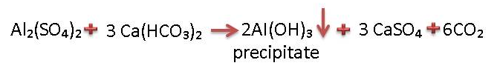
The precipitate entraps the colloids, thus removing them. (Compare this reaction to the reaction between calcium and phosphate in juice clarification). A flocculant is also added to promote settling of the precipitate particles.
Coagulation reactions, basically electrical neutralisation, are almost instantaneous and rapid mixing for about 30 seconds is sufficient.
Flocculation on the other hand requires 30 – 60 minutes for completion.
The jar test is used to determine correct chemical dosage rates. The “machine” consists of 5 identical stirred beakers. The water under test is placed in the beakers, and different concentrations of chemicals are added to each e.g. 5, 10, 15, 20 and 25ppm. The concentration that produces the clearest water within a given time is the optimum dosage rate.
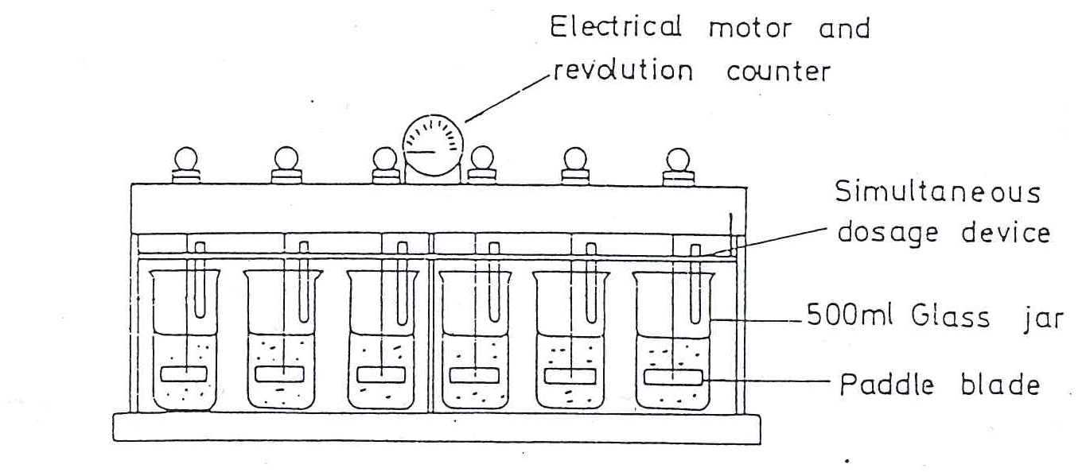
2.4 REMOVAL OF COAGULATED OR FLOCCULATED MATERIAL AND SUSPENDED SOLIDS
    - Sedimentation
The original form of settling tank was the horizontal flow type. Modern tanks include a flocculating zone and mechanical sludge removal, or a sludge drain.
The clarifier settling tank has a built-in flocculation chamber and automatic sludge extraction. It is mostly used for plants with a capacity above 5 million litre / day.
The factors that influence sedimentation are:
- Size, shape and mass of particles.
- Viscosity (and consequently temperature) of the water.
- Surface area of the tank
- Water flow rate
- Depth of the tank
- Retention time, or time available for settling
- Design of inlet and outlet systems
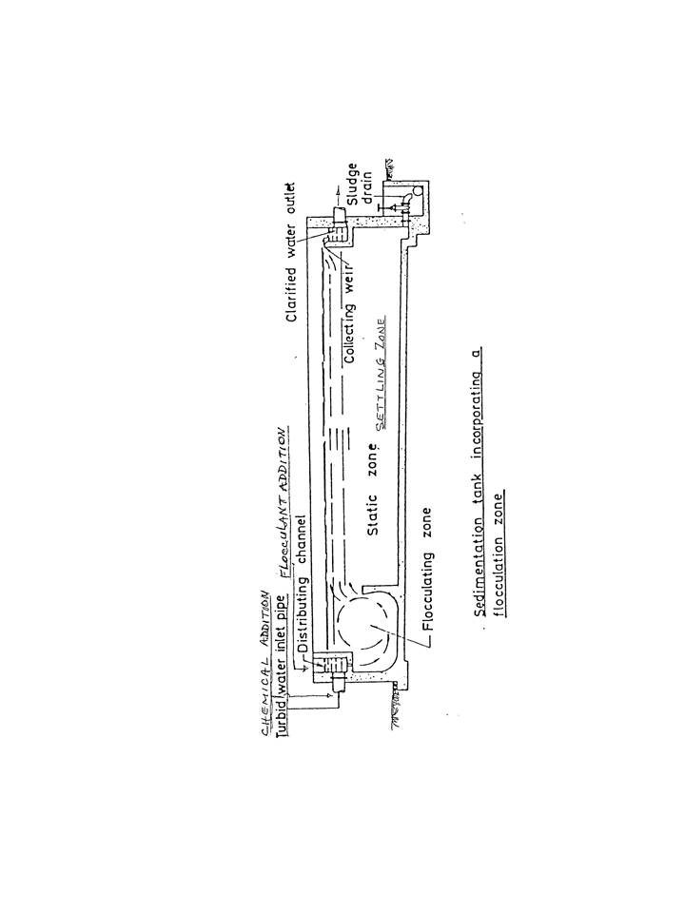

    - Filtration
A filter is a bed of granular material that physically removes suspended matter from the water passing through it. The only change in water quality is therefore a reduction in its suspended solids content.
Open manually operated filters have been substituted for semi-automatic gravity filters. Pressure filters are used where the supply is already being pumped. Two mechanisms are involved where a dilute suspension is filtered through porous media.
- Adhesion: Particles stick to the grains of the filter medium. This is the more important mechanism.
- Straining: Particles are caught in openings that are too small to let them pass through.
Sand filters have been used for many years to treat water.
2.5 DISINFECTION
Chlorine is the most commonly used disinfectant for potable water. When chlorine gas is mixed with water, it forms two acids: hypochlorous (HOCl) acid and hydrochloric acid (HCl).
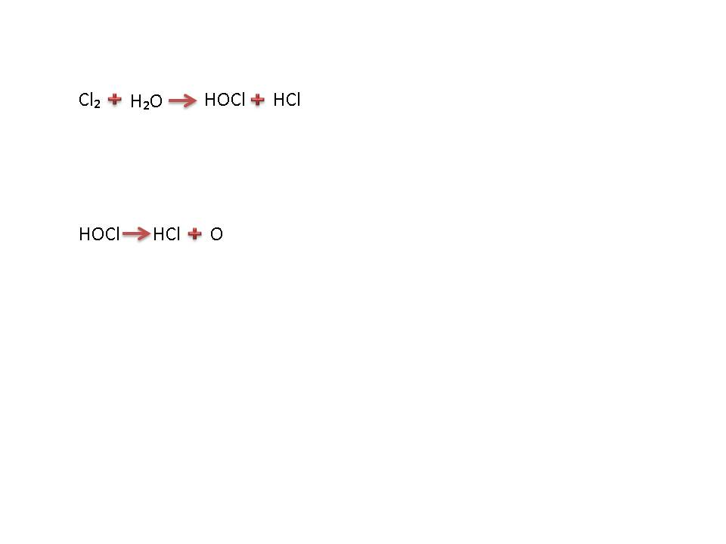
The hypochlorous acid is unstable and readily decomposes to yield hydrochloric acid and atomic (nascent) oxygen.
The atomic oxygen is very reactive. It attacks bacteria and viruses and bonds to them destroying them in the process.
Chlorination is carried out at a pH of 6.5 to 7 as this ensures minimal corrosion.
Residual Chlorine refers to the amount of unreacted (extra) chlorine in the water and, between pH 6 and 8, 0.2ppm residual chlorine is sufficient to ensure protection.
Efficient chlorination depends on:
- Uninterrupted dosing
- Uniform distribution to all parts of the water mass
- Matching the chlorine dosage to the bacterial content of the water.
The efficiency of chlorine as a disinfectant is influenced by several factors.
- Suspended matter may envelop (surround) bacteria, shielding them from chlorine attachment/attack.
- Chlorine may react with organic substances, thus being wasted.
- Chlorine reacts with ammonia, forming chloramines that are less effective as a disinfectant.
- High temperatures increases the rate of disinfection, but chlorine is more stable at low temperatures.
- Sufficient contact time (10 to 15 minutes, but preferably several hours) ensures effective disinfection.
- Hypochlorous acid (HOCl) is rapidly decomposed by sunlight and is lost during aeration.
Disinfectants other than chlorine include ozone, ultra-violet radiation, and heat.

3. Knowledge topic 2: Cooling Water Technology
3.1 INTRODUCTION
A factory processing 100 tons cane produces 120 tons of clear juice and over 100 tons of water needs to be evaporated from the clear juice to produce syrup. If this is done in a quintuple effect evaporator station, 1/5 of this vapour would have to be condensed i.e. 20 tons. About 20 times more water is required than vapour i.e. about 400 tons. Condensing vapour from the evaporator train is the major user of condenser water in a sugar mill.
Condenser water is also used in vacuum pans, and at the rotary vacuum filters. Other water users include air extraction pumps (sealing water), bearings (for cooling) and crystallisers.
During the process of condensing vapour the water’s temperature increases and this water then has to be cooled before it can be reused.
Several unit operations in the factory produce hot water. The main sources of hot water in a factory are the evaporators and pans, juice heaters and boiler blowdown.
3.2 TYPES OF COOLING SYSTEMS

3.2.1 Open evaporative cooling systems
Water is cooled by evaporation. The driving force is the difference in temperature between the hot water and the temperature of the surrounding air. Water can be brought into contact with air by using cooling towers, cooling ponds, or spray ponds.
Open evaporative cooling systems lose water due to wind (windage), and impurities concentrate during use as only pure water is evaporated. Water has to be bled off to control impurity levels, and fresh water has to be added to the system to replace water loss due to windage and bleedoff.

3.2.2 Closed systems
Cooling water is enclosed in a sealed system. Cooling of the water (after it has picked up heat) takes place in a shell and tube heat exchanger and not by open evaporation. These systems require little maintenance because, once they are charged with chemicals, they normally remain charged.
The closed system is actually two related systems:
- A sealed system for circulating water (e.g. the channels in the block of a car engine) and heat exchanger for cooling the water (the radiator).
- A corrosion inhibitor is used to attack dissolved oxygen (coming from water make-up and leaks) thus preventing corrosion. Organic based inhibitors form water-insoluble film with metal ions on the metal surface but are biodegradable and thus microbiological control is necessary. Chlorine is usually used as a biocide.
Deposition could be a problem where high make-up rates are used due to leaks.

3.2.3 Once – through systems
In these simple systems, water is conveyed from its source (river), used in the condenser and then returned to its source. The supply temperature is usually low and rapid cooling can be achieved with minimum heat transfer surface. The need to save water and to protect the environment has virtually eliminated the use of once-through cooling systems.
3.3 OPEN EVAPORATIVE SYSTEMS
Equipment used:
    - Cooling Ponds
Water is introduced into the pond and cooling is by natural evaporation, convection and radiation. Because cooling is very slow, the ponds have to be large. However, they consume less water than cooling towers as they dissipate only 55% of the added heat by evaporation, whereas the figure for cooling towers is 80%.
    - Spray Ponds
The addition of piping and nozzles to a cooling pond allows water to be sprayed into the surrounding air, thus increasing the rate of evaporation, and enabling the use of smaller ponds.
Windage losses range from 1-5% of the circulation rate and impurities from the surrounding area can easily enter the pond.
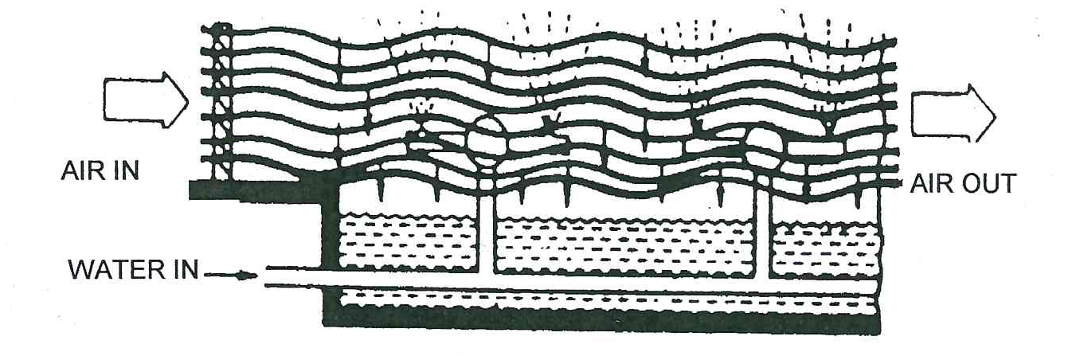
    - Cooling Towers
A cooling tower is a partially enclosed space (air must be allowed entry) in which cooling by evaporation takes place. Several types are in use.

Atmosphere spray-filled towers
Have nozzles spraying water downward through a cross-flow of wind driven air. Air enters and leaves through louvres.

A packed atmosphere tower
Sprays water downward over packing or filling. The filling breaks up the flow of water, exposing more wetted surface, thus increasing the cooling efficiency. Mechanical draft towers use fans to move large quantities of air through the unit. In forced draft towers, the fan pushes atmospheric air through the packing, while in induced draft towers the fan draws moisture-laden air through the packing.
Counterflow towers have air moving counter to water while in crossflow towers air moves horizontally through water that falls vertically. Drift eliminators (like entrainment separators) remove water from the air before it leaves the unit.
Hyperbolic towers are natural draft units built of concrete. They are a few hundred meters tall, and have a shape that optimises air flow and gives structural stability. They are very expensive to build but are cheaper to run due to the absence of the fans.

Atmospheric spray filled tower
Packed atmospheric tower
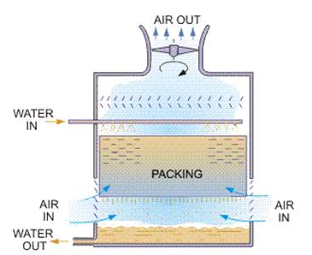
Forced draft tower
Induced draft counterflow tower
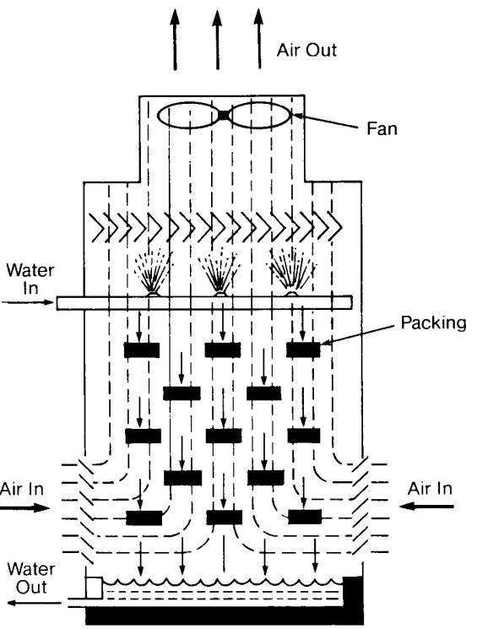
Crossflow induced draft tower
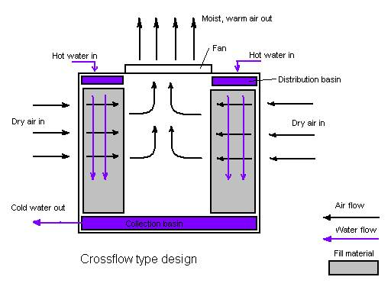
Counter hyperbolic tower
  - CORROSION CONTROL
    - Mechanism of corrosion
Corrosion is a process in which a difference in electrical potential develops between two metals in contact or between different parts of a single metal due to temperature differences or differences in oxygen content of the water.
At some parts of the metal, the metal dissolves and goes into solution as metal ions. In the process of going into solution as ions the metal atoms lose electrons. Losing electrons is called oxidation and the place where oxidation occurs is called the anode. The reaction is as follows:
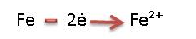
The electrons move to another part of the metal where these electrons are used and cause other reactions to occur. When a substance takes up electrons the process is called reduction and the place where reduction occurs is called the cathode. Electrons thus move from the anode (where they are released) to the cathode where they are used.
The process of corrosion can be summarised as follows:
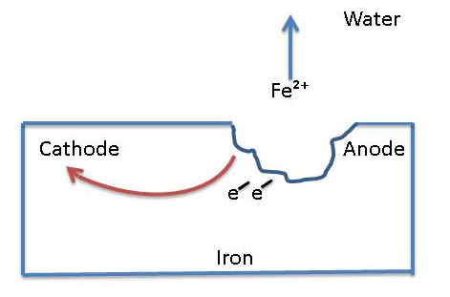
If the metal is exposed to the air, the Fe²⁺ ions formed can combine with oxygen to form oxides of iron like Fe₂O₃. The resulting brown compound is called rust.
Polarisation techniques aim at reducing the potential difference, thus reducing the driving force in corrosion. When this potential is zero, the metal is in a passive state. Temperature differences in a metal can also cause cathode/anode corrosion.
    - Corrosion inhibitors
Inhibitors are defined as anodic, cathodic or both depending on the reaction that the inhibitor controls.
Inhibition results from three general mechanisms:
- The inhibitor molecule is absorbed (by itself or with metal ions) forming a thin protective film on the metal surface.
- The inhibitor causes the metal to form its own protective film of metal oxide.
- The inhibitor reacts with a potentially corrosive substance in the water.
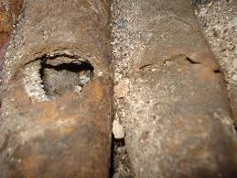
Chemical factors that affect corrosion are: pH, dissolved salts that can attack passive oxide films or precipitate to form protective barriers, dissolved gases like carbon dioxide and oxygen, and microorganisms that promote acid attack.
Physical factors include temperature (hot areas become anodic), water velocity (high velocities cause erosion and can remove passive films), suspended solids, and metal quality aspects.
  - DEPOSIT CONTROL
    - Sources of deposits
Deposits can originate in the water. Precipitated salts of calcium and magnesium form dense scale and sludge which are usually quite adherent. Calcium carbonate, calcium sulphate, calcium and magnesium silicates and calcium phosphate are the more prevalent compounds found in cooling water.
Mud, clay, biological matter etc. may enter a system through the make-up supply. These settle in cooling tower basins, sealing wells etc. reducing working volumes and heat transfer surfaces, and enabling “under-deposit corrosion” to go unchecked.
Flocculants (contamination) can originate in the air used to cool water in the tower. A cooling tower acts as air cleaner, and saturates the water with oxygen and carbon dioxide. Flocculants can come from the construction materials of the system (iron oxide) and from the process (sugar, oil, and bagasse).
    - Control methods
Ions that cause deposits can be removed using lime or ion exchange techniques but because of the large volume of cooling water the cost of this is prohibitive.
Chemical agents called polymers are used to modify the precipitates so that they do not form adherent scales. Polymers can act as flocculants or dispersants.
Flocculants bridge small particles together, creating a high density floc and reducing the surface area for attachments, thus reducing the amount of scaling.
Dispersants act in an opposite manner, they impart like charges to flocculant particles, forcing them to remain in suspension. Most cooling water fouling material carry slight negative charges; anionic dispersants are used to increase these charges. Because of the large volume of cooling water, chemical treatment at most factories consists simply of pH correction using lime, which is both cheap and available.
  - MICROBIOLOGICAL ASPECTS
Microorganisms are found everywhere in nature. They play vital roles in the health of man and animal alike. Some microorganisms are beneficial while others (pathogens) carry diseases like typhoid fever, amoebic dysentery, cholera etc.
As an isolated single cell, a microorganism presents no problem in cooling water. However, the cooling tower provides optimum conditions for microbial growth (warm temperatures and ideal pH) and bacterial concentration may increase by six million in the time it takes for salts to increase by six.
    - Types of Microbiological organisms
Three kinds of micro organic life forms exist:

Algae
Algae need air, water and sunlight for growth. Cooling tower sidewalls provide an excellent growth environment. All algae produce oxygen which can accelerate corrosion. Blue-green algae can extract nitrogen from the air and from organic nitrogen compounds, thus attacking nitrate based corrosion inhibitors. Brown algae (called diatoms) cause silica fouling. Algae favour temperatures in the range 18 -40°C and pH’s from 5.5 - 8.9.

Fungi
Fungi can be considered non-photosynthetic plants.
About 20% of fungal groups are capable of using wood as a nutrient and can therefore destroy wood where it is used as packing in cooling towers. This is generally not a problem since the modern trend is to use plastic or stainless steel as packing material. Fungi cause discolouration of water and wood. They thrive at lower temperatures than algae (0 - 38°C) and at a wider pH range: 2-8, with the optimum at 5.6.

Bacteria
Many bacteria species may appear in cooling water systems. Agents toxic to one species may have little effect on others.
Bacteria can be categorised as given below:
Shape
- Spherical (Coccus)
- Rod like (Baccillus)
- Curved or comma-shaped (spirillum)
Temperature requirements
- Cold liking (Psychrophilic): 0 - 25°C
- Moderate temperature liking (Mesophilic): 20 - 45°C
- Heat liking (Thermophilic): 45 - 70°C
Oxygen requirements
- Aerobic: need air to live
- Anaerobic: must have absence of air to live
Nutritional requirements
- Energy from oxidation of inorganic compounds
- Energy from both organic and inorganic material
- Feed on living organic matter
- Feed on dead or decaying matter
    - Problems caused by Microbial activity
Metal corrosion can be caused by oxygen released by bacteria, however, their primary contribution to corrosion is related to “under-deposit corrosion”.
An oxygen-deficient area would be found under a slime deposit, forming a “differential aeration cell”, leading to an anodic site under the slime and cathodic regions elsewhere.
Deposits are caused when slime adheres to surfaces, and entraps suspended matter. Tower packing that gets covered with slime can resist air flow and result in increased water droplets size, decreasing the cooling efficiency and increasing the cooling water temperature.
    - Control of microbial activity
The selection of a microbiocide involves several factors:
- It must inhibit almost all activity
- It must be economical
- Dosage must be correct, and the microbiocide must be correctly applied
- Oxidising biocides should not be used where wood deterioration could occur
- Effects on the environment should be minimal
Chlorine is a widely used biocide (see notes on drinking water treatment). Chlorine, hypochlorites, chlorine dioxide and ozone are oxidising biocides that attack wood while biocides like copper salts and amines are non-oxidising.

4. Knowledge topic 3: Boiler Water Technology
4.1 PRINCIPLES OF A BOILER
A boiler is used to evaporate water and produce steam. The basic layout of a sugar mill boiler is shown below:
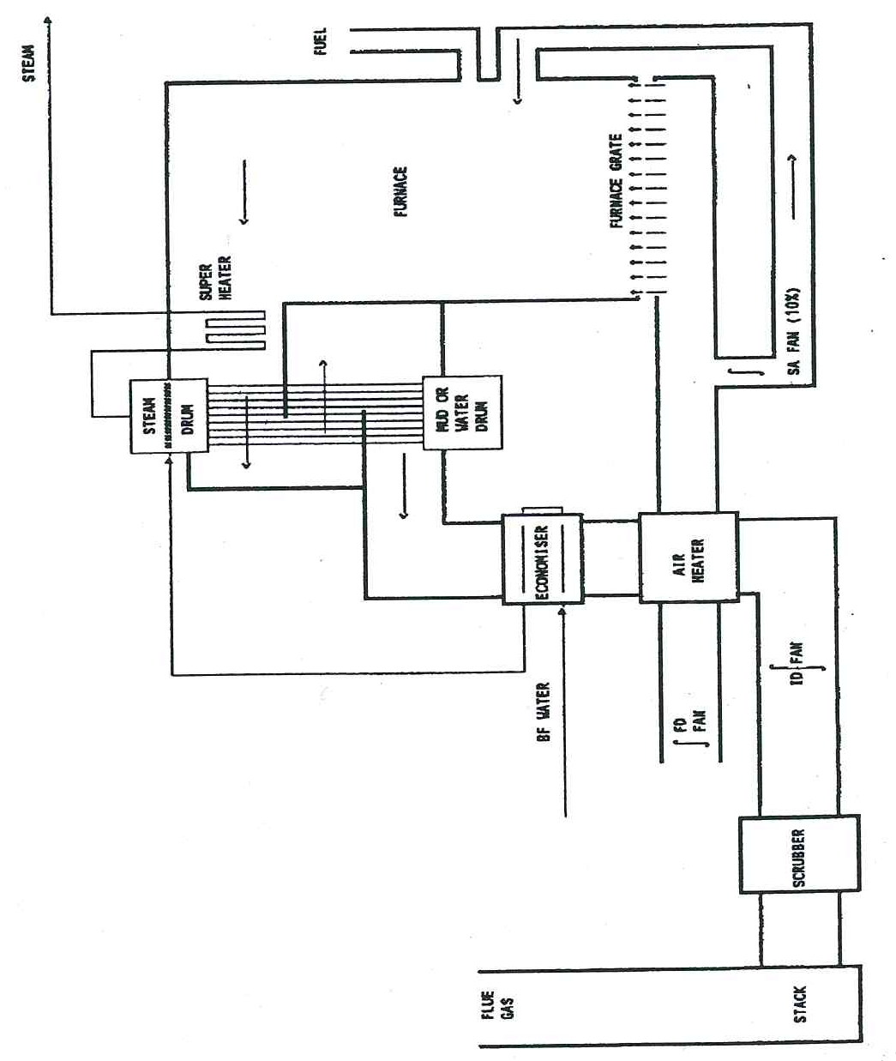
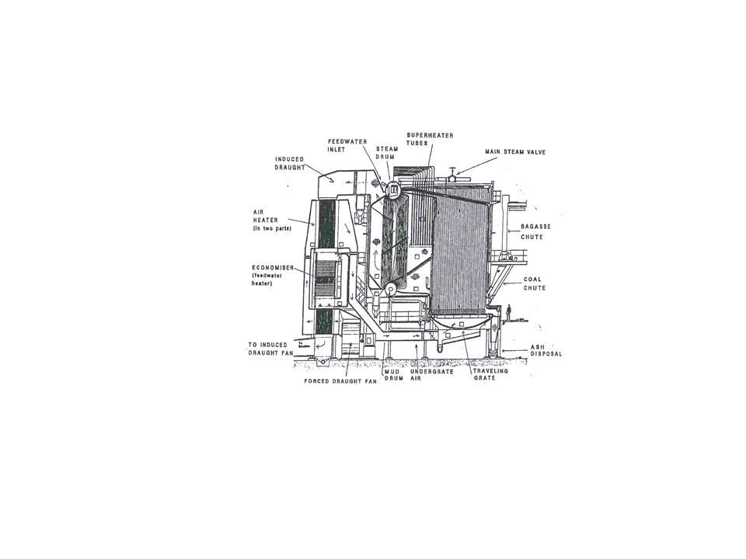
A sugar mill boiler has two drums connected by tubes. The top drum (steam drum) is half filled with water while the bottom drum (mud drum) is completely filled with water.
The forced draft fan (FD Fan) blows air into the combustion chamber where a fuel (bagasse/coal) is burned to produce hot gases.
These gases are channelled so that they move between the tubes connecting the steam and mud drums. In the process the water in the tubes is heated and the water in the steam drum boils to produce steam. The steam produced in the top drum is extracted via tubing and is heated further (superheated) by piping this steam through superheater tubes placed in the path of the hot gases from the combustion chamber.
After passing through the tubes the hot gases pass through an economiser where it heats the water fed to the boiler and then these gases pass through an air heater where it heats up the air before the air is fed to the combustion chamber. After this temperature of the combustion gases is too low to be useful and these gases (called flue gasses) are extracted by the induced draft fan (ID fan) and fed to the stack for disposal to the atmosphere.
In summary, a boiler receives feedwater, adds heat to it from the burning of a fuel and converts it to steam.
When water evaporates to produce steam, the steam coming off is much purer than the water. This is because the dissolved substance/impurities present in the water do not evaporate. The concentration of dissolved substances thus increases as more and more water is evaporated. The term "cycle of concentration” is used to refer to the number of times that the solids in a given volume of water are concentrated.
As illustration consider a boiler fed with water containing 10g dissolved solids per litre:
- 2 litres of the boiler feedwater will thus contain 20g dissolved solids, which is a concentration of 10g dissolved solids per litre.
- If ½ of the water is evaporated to leave only 1 litre of boiler water, it will have a concentration of 20g dissolved solids per litre. This is one cycle of concentration.
- If 1 litre of boiler feedwater (concentration of 10g/l) is fed to increase the volume of boiler water back to 2 litres it will have a concentration of 15g dissolved solids per litre.
- If ½ of the water is evaporated to leave only 1 litre of boiler water, it will have a concentration of 30g dissolved solids per litre. This is the two cycles of concentration.
The cycles of concentration can be represented diagrammatically as follows:
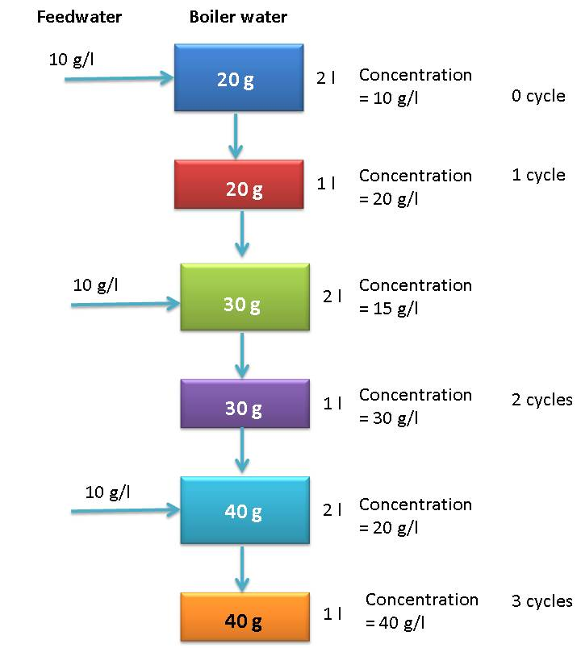
The total amount of dissolved substances in boiler water is referred to as the “total dissolved solids” (TDS) and is measured using conductivity.
The TDS is expressed in ppm (parts per million) which is the mg of dissolved solids per litre of boiler water (mg/l)
If the dissolved solids in boiler water are allowed to become too concentrated, substances will precipitate and cause scaling of the tubes which will reduce the heat transfer.
To prevent the dissolved solids from becoming too concentrated, “blowdown” is practiced. This involves draining off some of the boiler water.
In the steam drum the blowdown is taken from just below the water surface because this is where the concentration of dissolved solids is greatest.
Since the water drained off during blowdown is replaced by boiler feedwater containing a lower concentration of dissolved substances, this is a method to keep the concentration of dissolved substances in boiler water at acceptable levels.
Blowdown is also done from the bottom of the mud drum. This removes sediments and precipitates (mud) that have settled at the bottom this drum.
The following graphs show that shorter more frequent blowdown is more beneficial in controlling the TDS than longer less frequent blowdown.
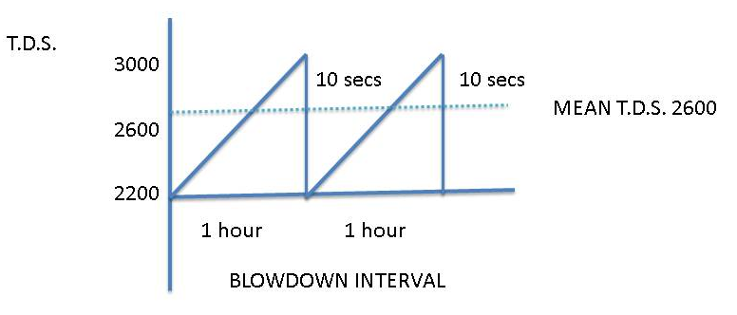
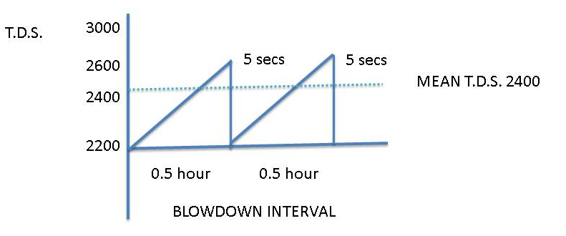
Since the steam coming off the water is much purer than the water, the steam can, in theory, be condensed without contamination and be returned to the boiler as feedwater.
In practice, the system is not closed, condensates pick up foreign material and have to be dumped, leading to the need to use make-up water. Impurities carried by the make-up are thus added to the boiler. These impurities cause carryover, scaling and corrosion.
4.2 CARRYOVER
Carryover occurs when steam is contaminated with boiler water.

4.2.1 Causes of Carryover

(a) Foaming
Bubbles of froth form and leave with the steam. Very high concentrations of solubles or insolubles cause foaming e.g. oils, alkalis, organic matter like sugar, etc. Organic antifoams are used to control foaming.

(b) Priming
An increase in steam offtake can cause a surge in water level resulting in steam entraining water. This is called priming. Other causes are operating at too high a water level and faulty separating equipment used to separate water and steam.
The rapid jetting of water out of the boiler may pass through the system so quickly that it may not manifest itself in the superheater header, but will pass directly to the turbines and settle out as a deposit on the turbine blades, mainly as caustic Soda which is the highest chemical constituent in the Boiler water. This will damage the turbine blades.

Droplet entrainment
Droplets are thrown off into steam as the steam bubbles burst.

Silica Carryover
Silica can enter steam in water carryover, or in volatile form at pressures above 3000kPa. Silica deposits on turbine blades and on tubes can cause serious damage.

4.2.2 Effects of Carryover and preventive measures
Solids deposit on superheater tubes and turbines result in overheating, corrosion and eventual failure. In direct contact heaters, contaminated steam can contaminate the material being processed.
Carryover can be controlled by:
- Maintaining the recommended dissolved and suspended solids concentration
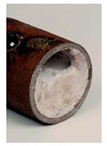
- Avoiding high water levels
- Steady boiler operation
- Dumping contaminated condensate
- Using antifoams and sludge conditioners
- Ensuring proper condition of steam/water separating equipment in the steam drum.
4.3 SCALING
Scaling results from impurities precipitating as their saturation levels are reached from suspended matter becoming hard and adherent.
Typical scales formed in boilers:
Calcium carbonate (CaCo₃) | Relatively hard deposit
Iron Silicate
Calcium silicate | Hard brittle deposit
Magnesium silicate
Calcium sulphate | Hard scale

4.3.1 Effects of scaling
Scale acts as an insulator, reducing the rate of heat transfer. Tube overheating and subsequent failure can result. Tubes can even plug completely. Scale also provides a cover which corrosion can occur.

4.3.2 Causes of scaling and preventive measures
Hardness refers to the total concentration of calcium (Ca²⁺) and magnesium ions (Mg²⁺) in water. Calcium and magnesium in water are the main causes of scaling. They can deposit as phosphate, carbonate or sulphate scale. Silica, suspended solids, products of corrosion, and low alkalinity also lead to scaling. Where chemicals do not precipitate directly onto tubes, they may form sludges that subsequently become adherent.
- Sludge conditioners are chemicals that ensure that precipitates remain in the form of sludge and are used to control scaling. Excess sludge is removed by blowdown.
Calcium (ca²⁺) ions can be removed by precipitating as calcium phosphate
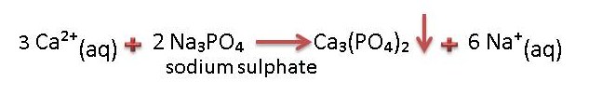
Magnesium (mg²⁺) ions can be removed by precipitating as magnesium hydroxide
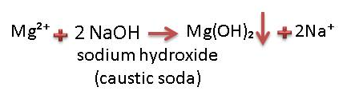
The Ca₃(PO₄)₂ and Mg(OH)₂ precipitates are very fine and are easily conditioned by the dispersants in the boiler chemical compounds and ultimately removed via blowdown.
- A chelant can be used to form a soluble complex with calcium and magnesium ions. Common chelants are E.D.T.A. and N.T.A. The use of chelants is limited by the following factors.
- High cost
- Corrosive nature
- Not suitable for high hardness levels
- Crystal habit modifiers like phosphonates tend to increase the solubility of scale forming substances.
On a cost effective basis the phosphate / phosphonate programme has been found to be most beneficial in the sugar industry and is very easy to control.
- Hardness (Ca²⁺ and Mg²⁺ ions) can be removed from boiler feedwater by using ion exchange softener or de-mineralisation (cation/anion exchange), but this is very expensive and is generally not cost effective in the sugar industry.
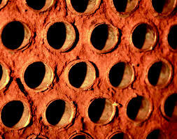
4.4 CORROSION

4.4.1 Effects of corrosion
Corrosion is the reversion of a metal to its oxide. For example, when iron corrodes (rusts) it forms iron oxide (Fe₂O₃). Dissolved oxygen in water is the prime cause of corrosion. Carbon dioxide in water, and alkalinities that are too high or too low can all cause corrosion.
Corrosion fatigue is a type of metal cracking that results from the concentration of cyclic (heating and cooling) stresses at points of high corrosion.
Caustic cracking results from the presence of caustic, stress, at least a trace of silica, and a mechanism (like a slight leak) that allows water to concentrate on the stressed metal.
Apart from shortening plant life, corrosion products can cause a scaling problem elsewhere in the boiler.

4.4.2 Control measures

Remove dissolved oxygen
Since the solubility of oxygen in water decreases with increase in temperature, a deaerator heats the water and thus expels oxygen, reducing its concentration down to 0.007 – 0.04ppm. The basic principle of operation of a deaerator is as follows:
- A spray of water is created and steam is passed through it.
- The deaerator removes air in two ways.
  - It heats the water which reduces the solubility of air.
  - Since the concentration of air in the steam is very low, air diffuses (moves) from the water to the steam.
An oxygen scavenger is also used to consume the residual oxygen.
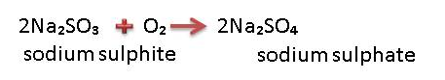
Scavengers must be applied upstream of economisers, so that economisers too can be protected.

Maintain alkaline condition pH > 11

Use neutralizing amines
Attack corrosive gases in steam and condensate systems by using neutralising amines that increase condensate pH and filming amines that form protective films on metal surfaces.
4.5 SUGAR IN BOILER WATER
Gross contamination of boiler water with sugar can be noted from:
- A considerable drop in pH as the sugar is degraded into other compounds including acids.
- The distinctive smell of burnt sugar.
Contamination of boiler water with sugar causes:
- Acid corrosion
- Scaling of tubes
- Carryover of sugar containing boiler water into the steam due to foaming
Once contamination of boiler feedwater and boiler water is noted, the following corrective action must be taken:
- Dumping the contaminated sweet condensate that is used as boiler feedwater.
- Increasing the caustic (NaOH) dosage to neutralise the acids formed due to sugar degradation.
- Increasing the rate of blowdown.
4.6 PRE-TREATMENT
Raw water consists of:
- Suspended solids – silt
- Silica – dissolved and colloidal
- Dissolved solids – anions and cautions
The quality of the water must be improved before it can be used as boiler feedwater.

4.6.1 Clarification
Various types of clarifiers are used in conjunction with a suitable flocculant. The universal flocculant is Aluminium Sulphate (Alum). pH adjustment is done with Soda Ash (Sodium Carbonate) or Lime.

4.6.2 Water softener/De-ionisation – cation/anion exchangers
The water softener usually contains a cation exchange Resin or Zeolite Bead. This will remove calcium and magnesium hardness. Silica is not removed. De-ionisation will remove both cations and anions in the raw water. They are not normally used in the Sugar Industry because of high capital and operational costs.

4.7 BOILER FEED WATER SYSTEM
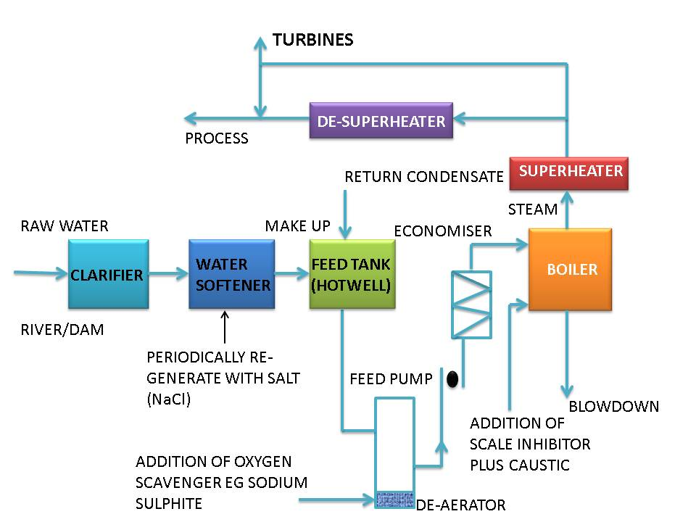
4.8 INTERPRETATION OF ANALYTICAL RESULTS
 | Control limits | Example (1) | Example (2)
Hardness | Nil | Nil | Nil
O. Alkalinity | 250-300 | 450 | 10
P. Alkalinity | 300-450 | 700 | 150
Total dissolved
Solids (T.D.S.) | Max. 2200 | 3500 | 2000
Suspended Solids | Max. 220 | 480 | 180
Silica | Max. 70 | 150 | 70
Phosphate | 20-60 | 80+ | 10
Sulphites | 20-60 | 80 | 15
Example 1
The T.D.S., Alkalinites, Phosphates, Suspended Solids and Silica levels are all too high. By doubling the blowdown rate all the parameters will be halved.
Example 2
The T.D.S. level is correct. However, the chemical levels are low. Therefore the corrective action is to increase chemical dosages.
4.9 BOILER WATER AND BOILER FEEDWATER SPECIFICATIONS
Boiler Pressure (MPa) | 0 – 2.0 | 2.0 – 3.5
Total Dissolved Solids mg/l | <3500 | <2500
Suspended Solids mg/l | <300 | <250
Hardness as CaCO₃ mg/l | <2 | <2
Phosphate as PO₄ mg/l | 30-60 | 30-60
Sulphite (SO₄) mg/l | 30-60 | 30-60
Hydrazine mg/l | 0.1-0.3 | 0.1-0.3
Oil mg/l | <7 | <7
Silica mg/l | <150 | <90
Total alkalinity as CaCO₃ mg/l | <700 | <500
Hydroxide ‘O’ alkalinity as CaCO₃ mg/l | >3 × silica | >3 × silica
pH range mg/l | 10.5-11.5 | 10.5-11.5
* For chelant programmes, phosphate is substituted by chelant. The concentration of which is specified by the supplier.
Boiler Pressure MPa | 0-1.5 | 1.5-3.5
Dissolved Oxygen (before oxygen scavenger is added) mg/l O₂ | <0.04 |  | <0.04
Total iron mg/l Fe | <0.100 |  | <0.050
Total copper mg/l Cu | <0.050 |  | <0.025
Total hardness mg/l | <0.300 |  | <0.300
pH range | 7.5 – 10.0 |  | 7.5 – 10.0
Non-volatile total organic carbon mg/l C | <1 | <1
Oil mg/l | <1 | <1

5. Knowledge topic 4: Waste Water / Effluent Technology
5.1 LEGAL ASPECTS
Initially, the Water Act of 1956 controlled water usage. Its many weaknesses led to a decline in the quality of water. The law presently in force is the Water Amendment Act (1984) and chief aspects of this legislation are:
- Plants handling over 150m³ intakes from all sources on any one day require a permit.
- The purification of effluents to prescribed quality standards shall be considered to form a part of the manufacturing process.
- Purified effluent should be returned to the source of the intake water.
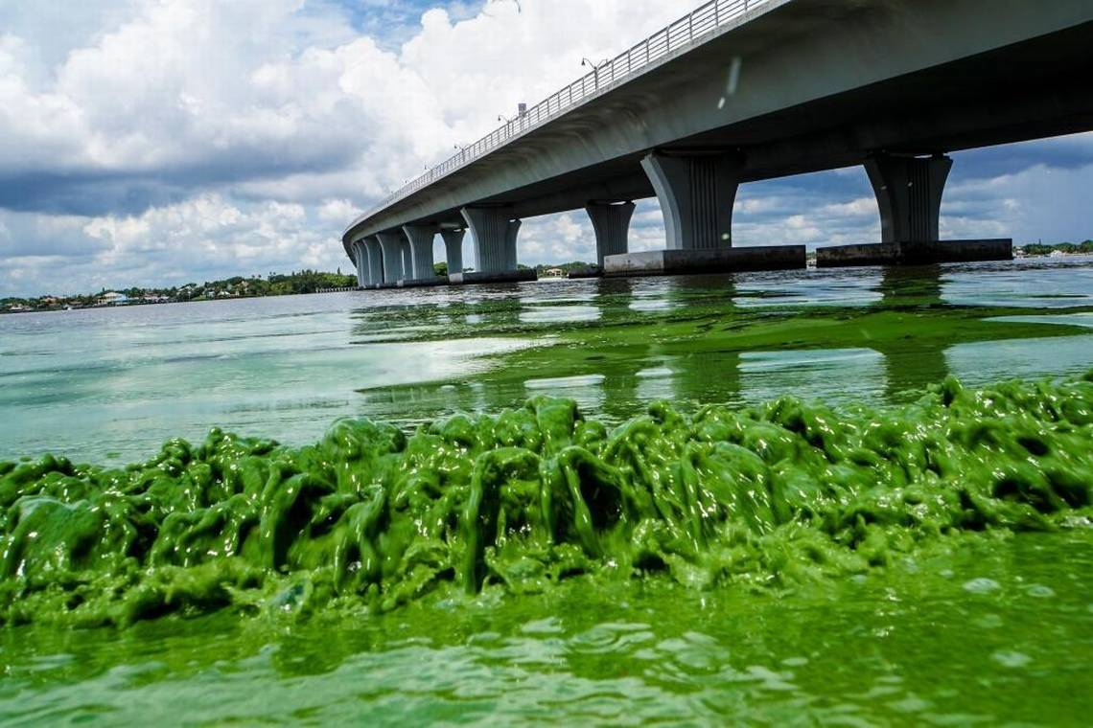
- All water (including rain water) draining from land on which industrial activity is carried out shall be deemed to be effluent.
- Irrigation of effluents is considered to be a temporary measure.
- Water pollution control officers are empowered to ensure that the Act is carried out.
A special standard applicable to specified areas and a General Standard (applicable in the sugar belt) are laid out.
5.2 THE GENERAL STANDARD FOR WASTE WATER OR EFFLUENT
- Colour, taste and odour : Shall not contain any substance in a concentration capable of producing colour, taste or odour
- pH shall be between 5.5 – 9.5
- Dissolved oxygen : Shall be at least 75% saturated
- Typical (faecal) E. coli : Shall not contain any typical (faecal) E. coli per 100 ml
- Temperature : Shall not exceed 35°C
- Chemical oxygen demand : Shall not exceed 75 mgl⁻¹
- Conductivity : Shall not be increased by more than 75 milli-Siemens per meter over that of the intake water
- Suspended solids : Shall not exceed 25mgl⁻¹
- Sodium: Shall not be increased by over 90mgl⁻¹ above that of the intake water
- Soap, oil, grease : Shall not exceed 2.5mgl⁻¹
5.3 MECHANISM OF POLLUTION WITH SUGAR
Sugar Mill effluent cannot be discharged directly into a river or stream. Although sugar is non-toxic, it provides a food source for aerobic bacteria which consume the dissolved oxygen in the water faster than it can be replaced. Fish and other aquatic life subsequently “suffocate” in the deoxygenated water. When there is no more oxygen, anaerobic organisms begin to multiply, producing methane, hydrogen sulphide and ammonia. The water stinks and tastes bitter. Usually insoluble metals become soluble, turning the water black. The sugar concentration in the water may only be in parts per million, but its effect on aquatic life is devastating.
5.4 THE MEASUREMENT OF POLLUTION
Pollution is measured, broadly, by measuring the “food value” of the effluent to bacteria. This involves measuring the organic contents of the effluent.

5.4.1 Biological oxygen demand (BOD)
This measures the level of Biological Oxygen Demand that the effluent will generate if released into the environment.
The BOD is measured in the laboratory by seeding a quantity of the effluent with bacteria and noting the oxygen consumption in milligrams oxygen per litre of effluent (mg/l).
However, biological processes are slow and it takes up to 5 days to measure the BOD, such as waiting period is of no use practically. BOD measures the oxygen demand caused by substances degrading due to microbiological action.
Reaction:
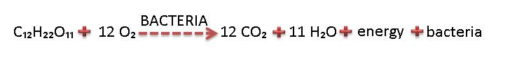
342g sugar reducing requires 384g O₂
Approximate ratio - 1 part sugar: 1 part oxygen

5.4.2 Chemical Oxygen demand (COD)
Here a sample of effluent is mixed with a quantity of H₂SO₄ (Sulphuric acid) and KMnO₄ (potassium permanganate) and the amount of oxygen used by the KMnO₄ is measured. The COD is a measure of the “total organics content” i.e. degradable substances as well as the less easily degradable substances. COD results are available within hours.
The legal COD limit is 75mg O₂ per litre effluent.
Consider the graph below:
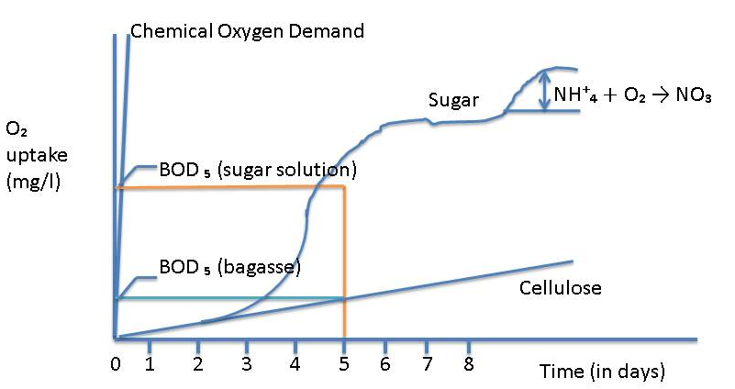
Notice:
- The rapid degradation of sugar (BOD after 5 days is high)
- The relatively slow degradation of cellulose (BOD after 5 days is low)
- The rapid increase in COD after a few hours
The COD for an effluent sample is always greater than the BOD of the sample, since some compounds cannot be decomposed by bacteria.
For fresh sugar effluent it has been found that the COD is approximately twice the BOD.
5.5 SOURCES OF POLLUTION IN A FACTORY
Running losses occur continuously, to a greater or lesser extent. Leaking joints and overflowing tanks are common examples. Careful operation can all but eliminate running losses. Cleaning losses occur only during cleaning operations. Heater and evaporator scale are examples of this.

5.5.1 Running losses
- Milling and Diffusion. Gutters should collect spillages and return it to process. Leaks must be attended to.
- Clarification: Filter cake spills can be carried away in floor washings and overload the effluent plant.
- Evaporation and Pan Boiling: Entrainment can contaminate the cooling water system, which could overload the effluent plant if some cooling water is bled off to the effluent plant.
- Centrifugation: Leakages and overflowing gutters can be a source of pollution.
- Drying: Sugar dust may not be a serious pollution hazard, but does represent a loss of pol.
- Bagasse: Bagasse undergoes slow biological degradation.
- Fly Ash: Scrubbers separate fly ash from boiler gases. Scrubber water (or smuts water) is high in suspended solids.
- Lubricants: Drains from the crushing mills are the main sources of oil contamination.
- Condensate: Though not of high purity, the high temperature is unacceptable.
Simplified Waste water flow diagram for a raw sugar factory
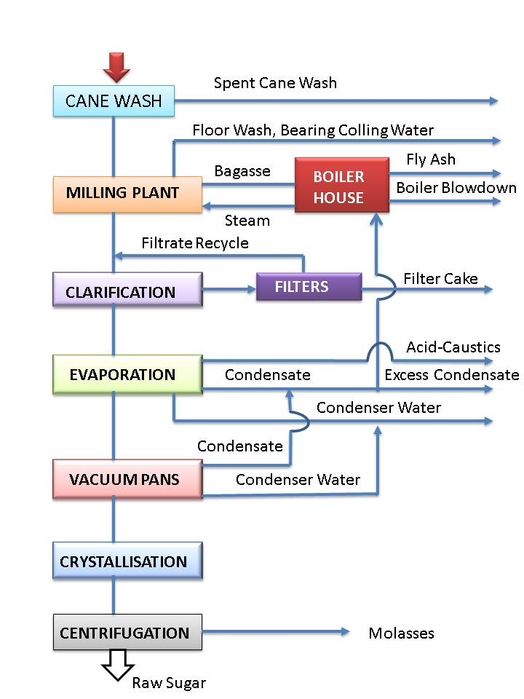

5.5.2 Cleaning losses
- Heaters: Scale can be handled by the solids disposal system, or the effluent plant.
- Clarifier: Over long stops, stale juice may have to be dumped. Dumping should be spread over few days so as not to overload the effluent plant.
- Evaporators, Pans and Boilers: When chemical cleaning is used, spent chemicals may be disposed of safely by being added very slowly to the effluent system. A specialist company must be used to handle hazardous waste e.g. Lead acetate waste from the laboratory and spent caustic soda from evaporator cleaning
5.6 IMPORTANCE OF GOOD HOUSEKEEPING
The potential sources of pollution given above readily indicate how important good housekeeping is. A clean factory produces less effluent, looks better, loses less pol, has fewer accidents and is a great place to work in.
5.7 BASIC METHODS OF DEALING WITH EFFLUENT

5.7.1 Irrigation
When pumped onto fields as irrigation, sugar effluent is dispersed and its decomposition has no negative environmental impact.
Sugar effluent from an agricultural perspective only has value due to the water it contains – it has no nutritional value to plants. Irrigation is a good method of effluent disposal, it cannot be used during rain when the fields are wet, since the effluent would simply run off into streams and rivers. For this reason law requires a holding dam with 7 days capacity to be available.

5.7.2 Using controlled degradation
Bacteria can be utilised to degrade effluent to a level that its BOD is so low that the effluent can be released into a river without causing harm.
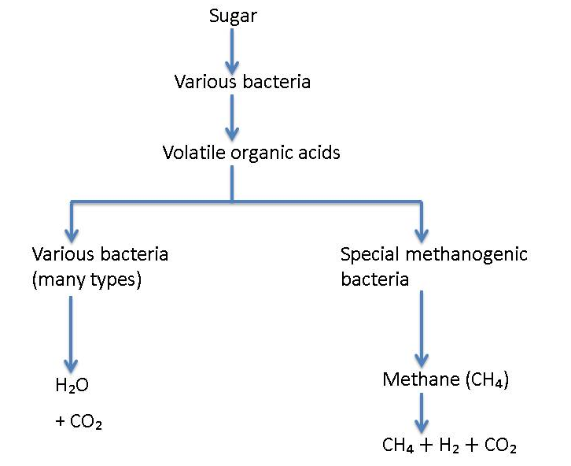
This clearly shows that once a sugar effluent has been decomposed to the acidic anaerobic (lack of oxygen) conditions only a few specialised effluent can reduce the bacteria into further harmless products.
Therefore the acidic partially decomposed effluent needs to be aerated so that it will readily decompose further.
5.8 ANAEROBIC DIGESTION
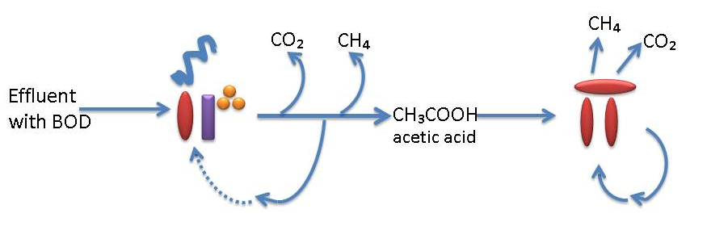
Anaerobic digestion of effluent takes place in two stages. Bacteria first decomposes the effluent into Carbon dioxide (CO₂₎), methane (CH₄) and acetic acid. Specialised methanogenic bacteria then convert the acetic acid into methane and carbon dioxide.
If the effluent load is too big, the acidity increases to such a level that the second methanogenic decomposition step is inhibited and the whole process stagnates.
Using this process also requires a large volume of sludge to be maintained since the sludge contains the bacteria. This is to protect and nurture the methanogenic bacteria that have a “long” doubling time.
5.9 AEROBIC DIGESTION
Aerobic digestion involves oxygen consuming bacteria converting the sucrose in the effluent to carbon dioxide and water.
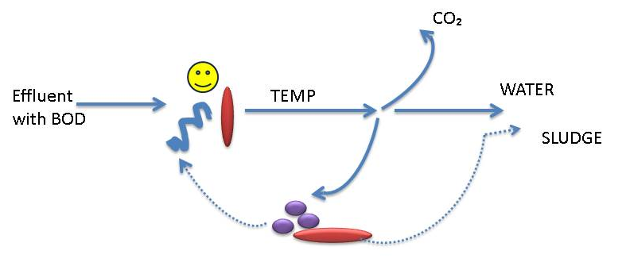
During aerobic digestion the bacteria multiply quite rapidly since these bacteria have a low “doubling time”. The result is that a rich sludge forms that contains the bacteria.
In order to grow the sludge, nitrogen and phosphate must be added. Oxygen is obviously essential and this is added to the water by mechanical aerators that “beat” the water surface.
5.10 PRACTICAL EFFLUENT TREATMENT

5.10.1 Anaerobic holding dam
This is a large holding dam into which the raw effluent is pumped. Here bacteria readily decompose the effluent into acetic acid (CH₃COOH). This overloads the anaerobic bacteria so that they are not able to cope with decomposing the acids. The result is that the dam goes highly acidic and foul smelling.
We need to balance the system by continuously removing this acidic effluent, completing its decomposition into harmless products using aerobic bacteria.
This can be effectively accomplished by pumping some of the acidic effluent to a trickling filter of a large tank packed with rocks. Here aerobic bacteria grow and oxidise the effluent reducing the acid content. Part of this is pumped back to the anaerobic holding dam to prevent it becoming too acidic and the rest acts as feed for the aerobic digestor. The sludge that flakes off acts as a good feed stock for the aerobic digestor.
Anaerobic digestion is the cheapest method of treating effluent and it is capable of removing 60% of the effluent. However, when overloaded only 5% of the effluent is decomposed.
An anaerobic dam can take months to set up. The effluent must be de-silted before being fed into the dam. Since the anaerobic bacteria forms a sludge we do not want to de-silt the dam itself because this would result in a loss of bacteria. To prevent the anaerobic dam from becoming overloaded the COD must be below 0.08 kg of COD per m³ of dam volume.
It is important to note that an anaerobic dam cannot deal with the effluent on its own. The acidic effluent must be removed for further decomposition in an aerobic digestor.

5.10.2 Aerobic systems
Many bacteria are able to decompose effluent to harmless products if oxygen is present. However for good effect these bacteria require a high energy input in the form of especially oxygen but also of nitrogen and phosphorus.

Pasveer Ditch
Aerobic digestors are usually in the form of a pasveer ditch. This is a circular ditch in the form of a racetrack. In a pasveer ditch the water moves around slowly “pushed” by the aeration disks that beat the surface. The sludge containing the bacteria is carried in suspension. Periodically some water is drawn off into a clarification zone, the sludge is settled and the treated effluent discharged. The settling area is again flooded and the sludge returned to the system.
A brown colour indicates a “good” sludge that will settle well.

Activated Sludge Stirrer
An activated sludge consists of micro-organisms that can oxidise (decompose) effluent.
Here the sludge is violently stirred in a tank thus keeping the sludge in suspension. This system requires a separate clarifier for settling so that the sludge containing the bacteria can be returned to the tank.
The problem with these systems is that periodically the bacteria composition becomes such that the sludge will not settle. The sludge is then lost with the discharged effluent. This loss to bacteria greatly reduces the efficiency of the effluent treatment plant.
At times it is necessary to destroy all the unwanted bacteria by chlorination and to make a fresh start.
Turning off the aerators for 1 hour a day also tends to selectively destroy the bacteria that tend to float.
5.11 COMBINATION (ASH DAM)
All new mills will employ a novel approach. Here an “ash dam” needs to be created with alternate layers of sand and smuts (black). Effluent is fed from the top, percolates through these layers and leaves at the bottom sufficiently digested for discharge into river or stream.
The top of the pile supports aerobic activity and the bottom anaerobic digestion.
5.12 CONTROL OF EFFLUENT PLANT OPERATIONS
To ensure effective effluent treatment the bacteria must be very active and must be kept within the system.
Several parameters need to be monitored.

5.12.1 Mixed Liquor Suspended Solids in Sludge (MLSS)
This gives the suspended solids content of the mixed liquor (sludge) and is a measure of the level of bacteria in the system. A certain minimum level is required to ensure that the effluent is digested. The MLSS for a pasveer ditch needs to be from 1000 – 3000 mg/l.
The MLSS of a sample of effluent is measured by filtering, drying the filter paper and contents and massing the dry solids.

5.12.2 Mixed Liquor Volatile Suspended Solids (MLVSS)
The MLVSS is that portion of suspended solids that consist of active micro-organisms.
For good performance 80% of the suspended solids (MLSS) must be organic (MLVSS).
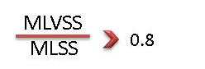

5.12.3 Sludge Volume Index (SVI)
The SVI is the volume in ml occupied by 1 g of activated sludge after settling for 30 minutes. The SVI indicates how well the bacteria containing the sludge settle.
During bacterial decomposition of effluent, products are produced as well as more bacteria. To keep the system functioning we need to keep some bacteria in the system. Sufficient bacteria can be retained in the system if there are enough suspended solids for the bacteria to adhere to so that they will settle.
However, our bacteria do not contain many solids. The bacteria thus tend to float and are lost with the discharge of treated effluent.
The SVI indicates how well the sludge containing the bacteria settles. This allows us to monitor the bacterial losses.
The test is easy to perform. 1 litre of solution is taken and allowed to settle for 30 minutes.
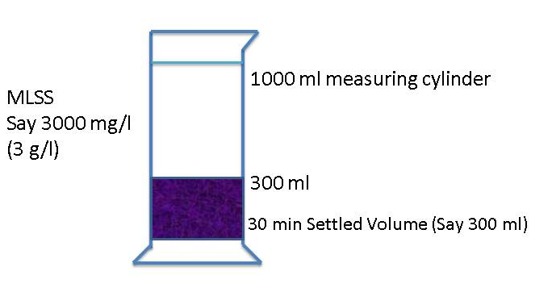
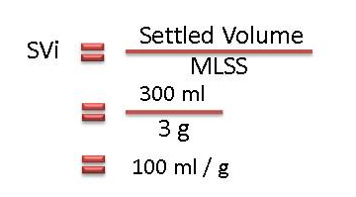
The critical SVI is 120 ml/g, with the aim being 65 ml/g.
The SVI is thus the volume occupied by 1 g of sludge.
Dense sludge is more desirable because it settles well. We thus seek to obtain a low SVI.
Causes of a high SVI
- Higher sugar content of the effluent
- Low pH
- High food: Microorganism ratio
- COD: Nitrogen: Phosphorus not correct
A bulking sludge is a voluminous sludge that carries over into the clear effluent discharged from the effluent plant. This is highly undesirable as it constitutes a loss of bacteria. Sludge with an SVI above 150 ml/g will probably result in bulking.

5.12.4 The food to micro-organism ratio (F:M ratio)
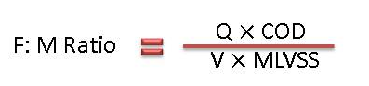
Where:
Q = effluent flow into the plant in m³/day
COD = COD in mg oxygen/l
V = Volume in mixed liquor in m³
MLVSS = Mixed liquor volatile suspended solids in mg/l

For a pasveer ditch the optimal F: M ratio is $±$0.4

5.12.5 Temperature
Temperature plays an important role. If it is too low the bacterial activity is impaired.

5.12.6 Energy input
The energy unit in the form of aeration is about 1 kWh for 1.5 to 2.4 kg of COD.

5.12.7 Nutrients Ratios
COD : Nitrogen : Phosphorous
100 : 0.6 : 1 for anaerobic digestion 1
- : 2.00 : 0.4 for aerobic digestion

5.12.8 COD Loading
The COD loading is the ratio of COD in feed per day to the volume of mixed liquor.
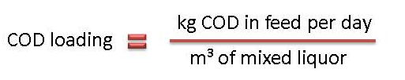
5.13 OTHER POLLUTANTS ORIGINATING FROM SUGAR FACTORIES
- Suspended solids: not to exceed 25 mg/l
- Soap, Oil or Grease: Not to exceed 2.5 mg/l
A soap or grease spill entering the effluent can be easily mopped up using bagasse as an absorbent.
- Lead: Maximum concentration of 0.1 mg/l
Significant amounts of lead acetate are used as clarification agent in Mill laboratories. These cannot be discarded directly as the legal lead concentration would be greatly exceeded.
Filter papers with the lead precipitate is collected in specially marked containers and disposed of via Wastetech.
5.14 SEWAGE TREATMENT
Sewage can be defined as water borne waste produced by a human community. In S.A. sewage is piped through the sewage system to a sewage treatment works. Rainwater is not allowed to mix with this system as this would enormously increase the load, especially in the summer months.
Factories not close to large municipalities will have their own sewage treatment works, often combined with their effluent treatment plant.
5.15 CHARACTERISTICS OF SEWAGE
Omitting items like coins and cutlery and clothing (that inevitably get into the sewage system), domestic sewage contains about 1 g of organic matter per litre. A small amount of mineral matter is present, coming mainly from pipe abrasion and (unwanted) stormwater.
Pollutants in sewage are found in three forms:
- Dissolved impurities: This is matter in true solution.
- Solid matter: Vegetable matter, faeces, paper, soil etc. are carried in suspension, most of it settling out in the sedimentation tank. This bottom sludge forms about 1% of the volume of the sewage and itself will contain 4% by mass of solids and 96% water (Compare this to underflow from a raw sugar clarifier).
- Colloidal matter: These are particles too small to settle out with the sludge.
Quantity of sewage
The daily volume of sewage contributed per person varies widely from 100 – 300 litres. The oxygen required for treating this sewage is 5.6 – 8.4 litres (or 5 times these volumes of air).
Aims of treatment
The treatment of sewage is carried out to:
- Make it hygienically safe
- Eliminate bad smells and make it aesthetically pleasing
- Make it safe for discharging to a river or dam with no resulting damage
- Make it fit for reuse like irrigation, drinking, industrial purposes etc.
Basic principles
Modern sewage treatment relies mainly on processes that are carried out by living organisms called bacteria. These processes occur naturally in streams, where pollution results only if the stream is over-loaded with waste.
In addition to biological processes, screening is carried out to remove solid material. Treatment with chlorine is necessary to destroy disease causing bacteria that are found in large quantities in sewage.
