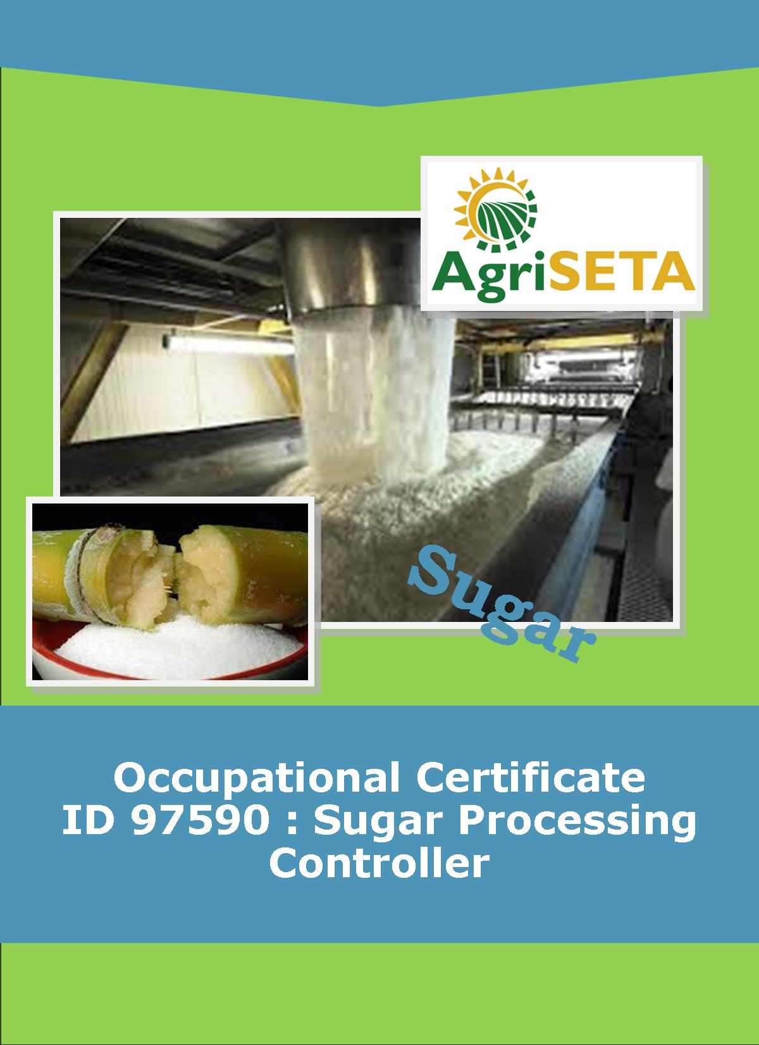
KNOWLEDGE COMPONENT: FACILITATOR FORMATIVE AND SUMMATIVE ASSESSMENT TOOLS AND MODEL ANSWERS: KNOWLEDGE MODULE 10: SUGAR REFINING
Occupational Certificate: Sugar Processing Controller

KNOWLEDGE COMPONENT: FACILITATOR FORMATIVE AND SUMMATIVE ASSESSMENT TOOLS AND MODEL ANSWERS:

KNOWLEDGE MODULE 10: SUGAR REFINING
KNOWLEDGE COMPONENT: FACILITATOR FORMATIVE AND SUMMATIVE ASSESSMENT TOOLS AND MODEL ANSWERS: KNOWLEDGE MODULE 10: SUGAR REFINING
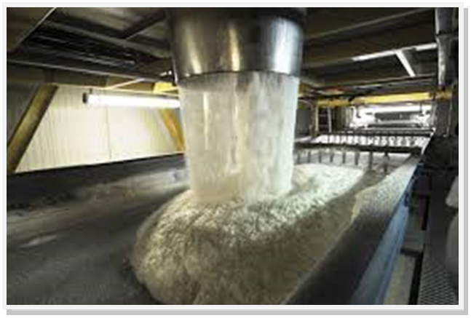
OCCUPATIONAL CERTIFICATE: SUGAR PROCESSING CONTROLLER

©Copyright AgriSETA
Telephone: +27 12 301 5600


AgriSETA holds the copyright to its publications and Web pages. Proper citation is requested.

TABLE OF CONTENTS
1. INTRODUCTION TO THE FACILITATOR ASSESSMENT TOOLKIT OF THE OCCUPATIONAL CERTIFICATE: SUGAR PROCESSING CONTROLLER 6
2. KNOWLEDGE MODULE 10: SUGAR JUICE REFINING 7
2.1 Knowledge Topic 1: Principles of colour removal (30%) 8
2.2 Knowledge Topic 2: Sugar refining technology (30%) 18
2.3 Knowledge topic 3: Refinery balance and calculations (25%) 29
3. CONCLUSION OF KNOWLEDGE MODULE 10: SUGAR REFINING 31
4. WRITTEN ASSESSMENT 32
5. Written Assessment Total Marks 40

INTRODUCTION TO THE FACILITATOR ASSESSMENT TOOLKIT OF THE OCCUPATIONAL CERTIFICATE: SUGAR PROCESSING CONTROLLER
Dear Facilitator
This Toolkit has been created to assist you to assess the Formative Learning Activities of learners undertaking the NQF 5 Occupational Certificate: Sugar Processing Controller Qualification.
During the programme, Learners must be directed to their Learning and Activities Guide to complete Learning Activities associated with each module of the Knowledge Component.
The time allocated to the Learning Activities is provided in the Facilitator’s Implementation Guide, this Facilitator Assessment Toolkit and Model Answers and the Learning and Activities Guide.
The marks allocated to each Learning Activity is provided in this Facilitator Assessment Toolkit and Model Answers and the Learning and Activities Guide.
Instructions to be given to Learners
- They must work individually to present the results of each Learning Activity in each of the Learning and Activities Guides (Workbooks).
- They must complete all the sections.
- They must use a black pen and ensure that they complete the questions in their own handwriting.
- The time provided to complete each activity is shown.
- The marks they will attain for each learning activity are shown in brackets.

KNOWLEDGE MODULE 10: SUGAR JUICE REFINING
NQF LEVEL: 5
CREDITS: 4
PURPOSE OF THE KNOWLEDGE MODULE: The main focus of the learning in this knowledge module is to build an understanding of the theory and science of sugar refining.
The learning will enable learners to demonstrate an understanding of:
- KM-10-KT01: Principles of colour removal (30%)
- KM-10-KT02: Sugar refining technology (30)
- KM-09-KT03: Refinery balance and calculations (25)
- KM-09-KT04: Problems experienced during sugar refining (15%)

2.1 Knowledge Topic 1: Principles of colour removal (30%)
Topic elements to be covered include:
- KT0101 Raw sugar quality
- KT0102 Melting
- KT0103 Colour removal
Internal Assessment Criteria and Weight
- IAC0101 An understanding of the sugar refining process can be demonstrated
- Critical control points can be listed and explained
- (Weight 30%)

Learning activity 1.1: Individual Learning activity: 1.5 hours (44marks)

Learning Objective: An understanding of the sugar refining process can be demonstrated.
Task: Read each question carefully and write your answer in the space provided.
1. What is the purpose of a refinery? (2)
The purpose of the refinery is to remove impurities from sugar crystals

2 Distinguish between a back-end and a central refinery. (4)
Back end refinery: this is whereby the refinery is attached to a raw sugar mill, In back-end refineries, raw sugar produced in the mill is converted to refined sugar with a higher purity for local consumption, export, or bottling companies. Wastage is used for heat generation in the sugar mills.
Central refinery: this is whereby the refinery stands separately and accepts very high pol (VHP) as it raw material.

3. List the nine main steps in refining. (9)
- Affination. The molasses film around the crystal is washed off using a saturated sugar solution. The sugar is then centrifuged. All S.A. refineries receive VHP sugars and do not need to employ this step.
- Melting. The crystal is dissolved in water.
- Colour removal. Clarification similar to rawhouse work (carbonatation, sulphitation or phosphatation) is carried out, or special processes using ion exchange resins or granular carbon are employed.
- Evaporation. The fine liquor (sfter decolourisation) is concentrated to near saturation.
- Crystallisation. Crystals are boiled in vacuum pans, similar to the procedure in rawhouse work.
- Centrifugation. Batch centrifugal separate crystals from the molasses (called jet, green or run-off in refining).
- Drying and conditioning. Drying expels surface moisture. While conditioning, a much longer process, expels moisture bound on (and possibly within) the crystal.
- Packaging.
- Exhaustion of run-off. Run-off is boiled in as many steps as is required to maximise sucrose recovery.

4. What does “colour” mean in refining work? (2)
Colour in sugar is a complex mixture of many different chemicals. Colour can originate in the cane plant, can be modified during the process, or can come from contamination during processing. Colour: A refinery does nothing more than remove colour. High colour would require more work.

5. How can colour be categorized chemically? (6)
  - Phenolics: These are naturally occurring compounds like dyes and plant pigments.
  - Caramels: These are thermal degradation products of sucrose.
  - Melanoidins: These are reaction products of amino compounds with sugars. This type of reaction is referred to as the Maillard reaction.
  - Alkaline degradation products of reducing sugars: These are produced by high temperatures and high pH’s.

6. What effect does pH have on colour measurement? (2)
Most sugars colourants are pale at pH 4 due to low ionisation at this pH. At pH 9 ionisation is almost complete and colourants are darker.

7. Comment on crystallization as a colour removal process. (2)
Crystallisation: This is the most effective mechanism, colour bodies tend to remain in mother liquor.

8. Distinguish between absorption and adsorption. (4)
Absorption: Colour bodies are trapped within a crystalline or porous precipitate or absorbent.
Adsorption: Colour bodies are adsorbed in the pores on the surface of the adsorbent. Decolourising carbons function in this way.

9. What is bone char, granular carbon, granula activated carbon and powdered carbon? (6)
Bone char: Animal bones are charred at 700°C, giving an adsorbent of 10% carbon and 90% calcium phosphate. Contact with liquor takes place in char cisterns and exhausted char is dried, kilned and cooled. Bone char can be used hundreds of times.
Granular carbon: This is also called granular activated carbon. It is a high carbon (60%) adsorbent made from coal and is replacing bone char because of its six-fold greater capacity. It can be used about 25 times.
Powdered carbon: Finely divided powdered carbon needs very short contact times and is economical for small scale seasonal operations. It cannot be regenerated.

10. Why is affination unnecessary in VHP sugars? (2)
Because the sugar is off very high pol, and affination is necessary when removing the contaminants in raw sugar

11. Sketch a melter, including the main process conditions. (5)
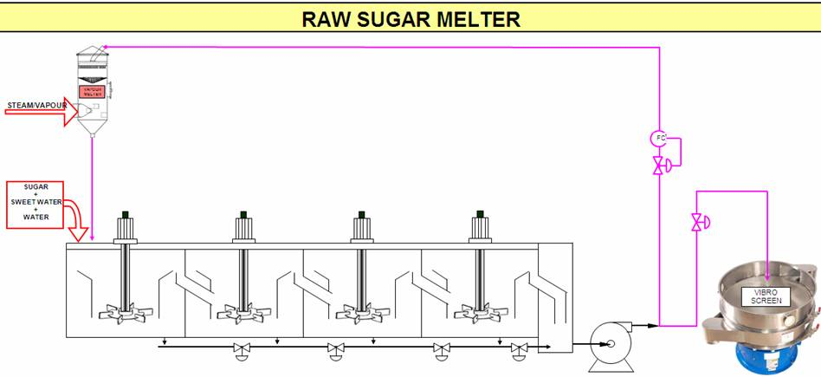

Learning activity 1.2: Individual Learning activity: 1 hour (20 marks)
Learning Objective: An understanding of the sugar refining process can be demonstrated
Task: Read each question carefully and write your answer in the space provided.
1. Distinguish between rawhouse clarification and refinery decolourisation. (4)
Raw house clarification: In a rawhouse, sugar boiled from a mother liquor of 85% purity has a purity of 99.5% crystallisation itself is a very effective purifying step. Sugar boiled from melt at 99.5% purity will itself have purities approaching 99.9% but the low colour required will not be attained.
Refinery decolourisation: it is a colour removal processes (ion exchange).

2. What is the most common refining process used in South Africa and which refineries use this process? (4)
The most common being carbonatation followed by sulphitation (Malelane, Pongola, Gledhow, Ubombo Ranches). Umfolozi uses sulphitation alone, while Entumeni uses the Talo process. Phosphatation followed by ion exchange is practised at Noodsberg, while Hullet Refineries follow carbonation with ion exchange.

3. Write the main carbonatation reaction. (1)
Calcium carbonate

4. Explain why carbonatation is carried out in two stages. (2)
Carbonatation is carried out in two stages. The precipitate is formed in stage 1 and in the second stage it is allowed to agglomerate for good filtration.

5. Summarise the advantages and disadvantages of flue gas as a source of CO₂ in carbonatation. (4)
The advantages of flue gas carbonatation are:
- Lower capital cost. A kiln and limestone handling equipment is not required.
- Lower operating cost. Even with the benefit that a kiln can produce lime and CO₂ the cost of operation is still in favour of flue gas. This is especially so where lime has to be transported over long distances.
The disadvantages of flue gas are:
- Sodium carbonate scrubbing if coal is used as a fuel.
- A higher volume of flue gas (at 12% CO₂ by volume) has to be handled compared to kiln gas (30%).

6. Sketch the carbonatation process, including the main process conditions in the sketch. (5)
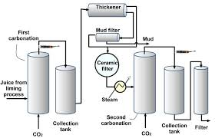

Learning activity 1.3: Individual Learning activity: 20 minutes (10 marks)
Learning Objective: An understanding of the sugar refining process can be demonstrated
Task: Read each question carefully and write your answer in the space provided.
1. Which refinery practices sulphitation alone? (1)
Umfolozi refinery

2. Give reactions that illustrate: (2)
(a) The burning of Sulphur to produce SO₂
The gas produced has an SO₂ content of 18% and a temperature around 810°C. At this temperature the formation of SO₂ could occur, this gas combined with water, would form sulphuric acid. The gas is rapidly cooled to a temperature of 50°C before addition to melt.

(b) The reaction of SO₂ with limed melt (2)
The calcium sulphite precipitate entraps impurities and has to be filtered off. Sulphur dioxide gas has a bleaching effect, giving the refined sugar a pleasing sparkle.

3. Sketch the sulphitation process, including the main process conditions in the sketch. (5)
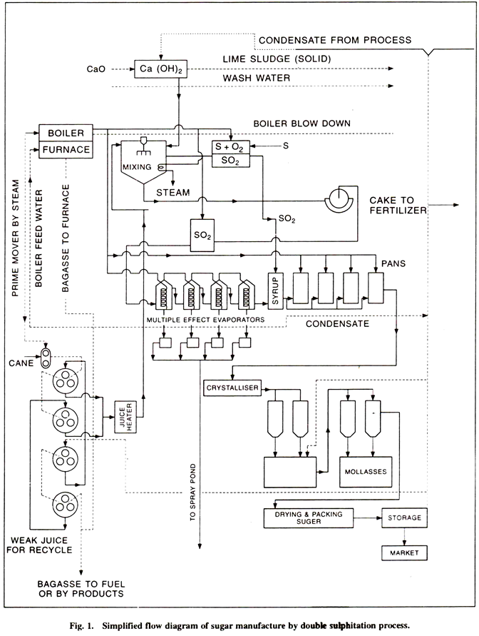

Learning activity 1.4: Individual Learning activity: 30 minutes (17 marks)
Learning Objective: An understanding of the sugar refining process can be demonstrated
Task: Read each question carefully and write your answer in the space provided.
1. Which refinery uses the phosphatation technique? (1)
Noodsberg refinery

2. Why is phosphatation most like raw juice clarification? (2)
The precipitate formed is tri-calcium phosphate, the same as that formed in raw juice clarification, giving rise to “phosphor-defecation”, an alternative name for this process.

3. Why is lime sucrate more effective than milk-of-lime? (2)
Lime is considerably more soluble in a sugar solution than in water. The calcium in lime sucrate is therefore in a much more available form to give more rapid and efficient pH control than milk-of-lime.

4. Discuss the use of Talofloc as a decolouriser. (4)
The simultaneous dosage of Talofloc, a cationic decolouriser, greatly improves colour removal. Talofloc also selectively precipitates colourants that are responsible for irreversible fouling of ion exchange resins, thus extending resin life and reducing regeneration costs.
At room temperature Talofloc is a white pasty solid. It is heated in water bath to 65°C, taking about 4 hours. At 50°C the chemical becomes a mobile liquid (and above 80°C it becomes a dangerous fire hazard). Pipelines carrying Talofloc are heated to 65°C by a water Jacket.

5. Sketch a simple flotation clarifier. (5)
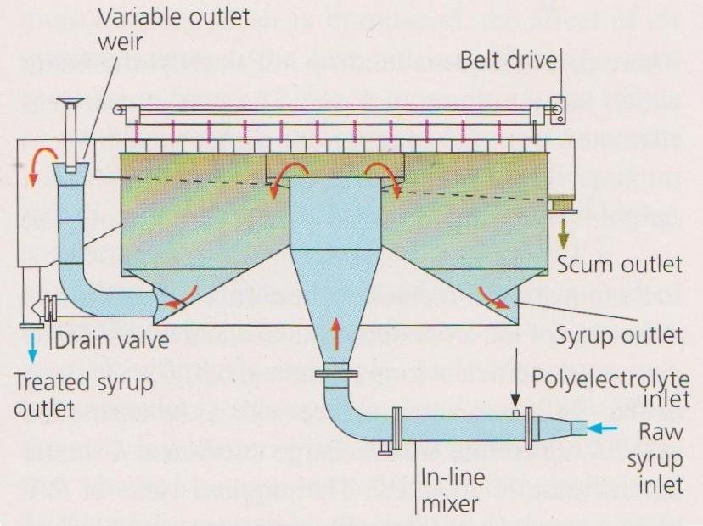

6. How is aeration carried out in flotation clarification? (3)
Treated liquor flows to an aeration tank. Aeration is effected by bleeding air into the suction side of a pump that returns a portion of clarified liquor to the aeration tank. (Taloflote dosage occurs immediately before the Talo clarifier). Aerated liquor is fed to the Talo clarifier where the air rises, carrying with it the tricalcium phosphate precipitate.

Learning activity 1.5: Individual Learning activity: 1 hour (32 marks)
Learning Objective: An understanding of the sugar refining process can be demonstrated
Task: Read each question carefully and write your answer in the space provided.
1. List two types of ion exchange resins. (2)
- Polystyrenic Resins: This type removes colour by both adsorption and ion exchange.
- Polyacrylic Resins: Colour removal is mainly by ion exchange, adsorption is minimal.

2. By what mechanism does ion exchange resin remove colour? (1)
Resin vessels

3. What does bed volume refer to? (2)
The liquor flowrate through the vessel is normally given in bed volumes of liquor over a specified time, for example, if the bed volume is 7m³ and the vessel is operating at 12 bed volumes per hour, the liquor throughput is 84m³ (12x7) per hour.

4. What is a polymerised colourant? (2)
It is whereby some colour bodies pass through the pores of the resin beads and become fixed onto the inside cavities

5. Resins deteriorate in two ways. What are they? (2)
- Mechanical breakdown: Resultant fines cause resistance to flow.
- Fouling of pores and surfaces: Precipitates and organic impurities cause fouling.

6. Sketch a resin vessel. (5)
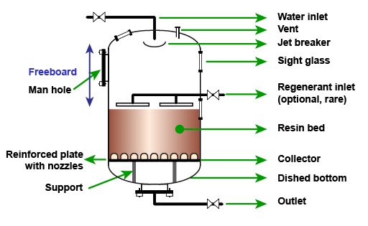
7. List the steps involved in regenerating resin. (14)
- Sweetening off: The bed has handled (say) 70 bed volumes of liquor and is in need of regeneration. Liquor feed is shut and condensate is used to displace the liquor. Fine liquor brix would decrease. When this brix falls below 40% the sweetwater is diverted to the melter. Sweetening off stops when the sweetwater is down to 1% brix.
- Backwashing: The resin bed acts as a filter, entrapping suspended matter. Backwashing involves forcing condensate upwards through the bed to remove entrapped particles. Backwashing also removes fine resin particles that hinder percolation through the bed.
- Settling: After backwashing, the beads are allowed to settle for ±10 minutes to form a new bed.
- Condensate removal: Air pressure is increased, forcing condensate out through the bottom of the bed.
- Regeneration: This is done in two stages. Firstly, reclaim brine (“strong” brine from the previous regeneration) is pumped through the bed. Secondly, fresh brine flows through the bed. The efficiency of regeneration can be increased if the resin is allowed to soak for as long as possible.
- Desalting: Salt is flushed out of the resin with condensate, the waste going to effluent except for the latter stage that is directed to the brine reclaim tank. This will be used for the next regeneration (see (e) above). After complete removal of salt, the regeneration is complete.
- Sweetening on: Liquor is introduced into the vessel in procedure that is the inverse of sweetening off. The low brix discharge liquor is sent to the sweetwater tank until its brix rises to ± 40%, when it is directed to the fine liquor tank.

8. Compare colour removal by ion exchange with other methods. (4)
Advantage of resins are the low cost of installation and regeneration, ease of maintenance, small space requirements and the short contact time required, which permits high flow rates.
A possibility is the contamination of the sugar with amine odours (resins are basic anionic quartnary ammonium compounds which could lead to an increase in colour during boiling. More sucrose could be lost to molasses as a result of an increase in liquor chloride content and waste brine and waste acid has to be disposed of. Ion exchange resins are expensive.

2.2 Knowledge Topic 2: Sugar refining technology (30%)
Topic elements to be covered include:
- KT0201 Filtration
- KT0202 Evaporation
- KT0203 Sugar boiling
- KT0204 Drying and conditioning
Internal Assessment Criteria and Weight
- IAC0201 An understanding of the refining process and associated equipment can be demonstrated
- (Weight 30%)

Learning activity 2.1: Individual Learning activity: 45 minutes (19 marks)
Learning Objective: Task: An understanding of the refining process and associated equipment can be demonstrated
1. How does raw house filtration differ from refinery filtration? (4)
In the rawhouse the underflow from the clarifier (mud) is mixed with a filter aid (bagacillo) and treated separately from the clarifier overflow (clear juice).
In the refinery, whole liquor (containing the precipitate) is forced through the clot of a special filter. The process is carried out at about 65% brix. Precipitate deposits on the cloth and the precipitate itself serves as the filtering medium.

2. Show on a sketch how an auto-filter operates. (5)
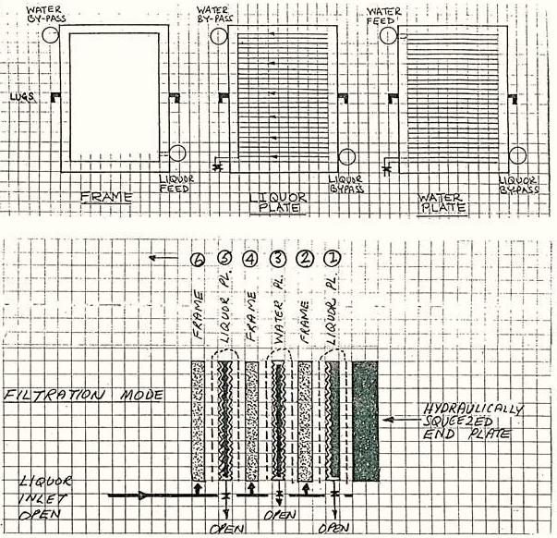

3. How are the plates and frame filter press components held together during operation? (10)
The plates and frames are rectangular, resting on two horizontal bars by lugs on their longer vertical edges.
During operation a hydraulically loaded ram squeezes the plates and frames together. All the plates are channelled, and all channels communicate with outlet taps.
The frames (2,4,6,8 etc.) are rather like empty picture frames and simply form a space into which liquor is fed in at the bottom, and in which a cake layer will develop.
Filtered liquor passes through a layer of cake, through a cloth and enters the channels on the juice plate on one side and the water plate on the other. (Cake builds up from two cloth surfaces towards the centre). From the channels the liquor exits through taps at the bottom of all the plates.
The liquor plates (1,5,9,13 etc.) have neither liquor nor water inlets and serve only to provide a channelled surface connected to an outlet tap to enable clear liquor removal (filtration mode) and sweetwater removal (washing mode). Their by-pass ports allow water to feed adjacent water plates (at the top) and liquor to feed adjacent frames (at the bottom).
The water plates (3, 7, 11, 15 etc.) are similar to the liquor plates except for the one vital difference; their channels can be fed with water from the top, in a direction counter to liquor flow. This facility is used during cake de-sweetening. The water plate thus serves a dual function; like the liquor plate it provides a channelled surface to support the cloth, but it also enables the cake to de-sweetened. During de-sweetening the outlet taps on all the water plates are shut to prevent short-circuiting. The by-pass port at the bottom allows liquor to feed adjacent frames.

Learning activity 2.2: Individual Learning activity: 30 minutes (22 marks)
Learning Objective: An understanding of the refining process and associated equipment can be demonstrated
Task: Read each question carefully and write your answer in the space provided.
1. Give a brief description of a typical auto-filter (4)
A typical auto-filter consists of 56 leaves rotating in a horizontal tank of liquor. A filtered liquor pipe connected to each leaf exits the ends of the tank, 28 on each side. Each pipe has a glass section to enable the operator to check the condition of the filtered liquor.
The leaf is basically a rounded rectangle of metal, channelled on both sides. All the channels communicate with an outlet port on one edge. An envelope of cloth covers the leaf entirely, except for the outlet port. A rubber gasket seals the cloth in a groove running along the edge of the leaf.

2. Why is liquor evaporated? (2)
The liquor leaving the evaporators is referred to as white liquor, fine liquor or evaporated liquor.

3. What is the main difference between refined and raw sugar? (4)
Raw Sugar: are produced directly from the cane juice in a Sugar Mill, which is always located close to cane fields. After the juice is extracted and clarified, it undergoes a single-crystallization process. Crystals are centrifuged to remove most of the cane molasses. Raw cane sugars generally have less than 2% molasses and, as a result, have a delicate molasses flavor and a color ranging from blond to pale brown. The sucrose content generally varies from 97 to 99%.
Refined Sugar: In sugar processing, the term "refined" means the same thing as "purified." White sugar is combined with naturally occurring minerals to strip away impurities. The sugar is washed and filtered through carbon, decolorized and recrystallized. This purified sugar is further processed into a fine crystal form, dried and passed through multiple screens to remove minerals and impurities before it is packaged

4. Distinguish between straight boiling, in-boiling and back-boiling. (12)

Straight boiling: In this conventional system, (say) eight first strikes are boiled from liquor with about 47% of the brix in liquor remaining in the first run-off.
Four second strikes are produced from the first run-off, with 50% of the brix in the first run-off remaining in the second run-off. Two third strikes are boiled from the third run-off, with 53% of the brix in the second run-off remaining in the third run-off. One fourth strike is boiled from this run-off with 56% of the brix in the third run-off remaining in the fourth run-off.

In-boiling: In this system some first run-off is mixed with evaporated liquor and the first strikes are boiled from this mixture that consists of 60% evaporated liquor solids and 40% run-off solids. As no impurities leave the system, white sugar colour and ash continues to increase, this is allowed until the permissible limits are reached. The run-off is then isolated and directed to rawhouse remelt and a new cycle commences.

Back-boiling: Each pan is started on evaporated liquor and finished on 40% run-off from previous strikes. (this system differs from in-boiling in the point at which evaporated liquor enters the system). Again as no impurities are eliminated, colour and ash will increase. As the colour limit is reached, run-off is accumulated and boiled into one “all syrup” pan. This removes impurities from the system and a new cycle commences.

Learning activity 2.3: Individual Learning activity: 2hours (63marks)
Learning Objective: An understanding of the refining process and associated equipment can be demonstrated
Task: Read each question carefully and write your answer in the space provided.
1. Define the following concepts: (3)
(a) Solution
It is a dissolved sucrose; it is a mixture of sugar and water.

(b) Sucrose solubility
Sucrose solubility means the concentration of sucrose in a saturated solution which is in equilibrium with sucrose in the solid state. Solubility of sucrose in water is of fundamental importance in defining the supersaturation, or driving force of sucrose crystal growth.

2. Define the following concepts (5)
(a) Saturated solution
A saturated solution is one that contains the maximum amount of dissolved substances (solute) at a particular temperature.

(b) Supersaturated solution
Contains more solute at a certain temperature than a saturated at this temperature.it is formed when 20g of water is evaporated from a 290g sucrose/100g water saturated sucrose solution at 60°C, a supersaturated solution of 78.4°Bx

(c) Supersaturation coefficient
The supersaturated coefficient is the “driving force” in sugar boiling.

3. There are three zones of supersaturation, explain what happens in the each zone. (6)
(i) The metastable zone
At concentrations that fall in the metastable zone any sucrose crystal present will continue to grow until the concentration falls to the level at which the solution is just saturated.

(ii) The intermediate zone
At concentration that fall in the intermediate zone crystals will not only grow, but new crystal will form in the presence of other crystals.

(iii) Labile zone
At concentration which falls in the table zone, new crystals will from spontaneously. Crystal growth will be rapid.

4. The two basic ways in which crystals can be formed are primary and secondary nucleation, define them. (4)
(a) Primary nucleation
Is the formation of crystal nuclei in supersaturated solution by aggregation of molecules

(b) Secondary nucleation
Refers to sugar crystals formed in a supersaturated sucrose solution in which sugar crystals are already present.

5. Crystals can be formed in a pan by the following methods, explain them. (8)
(a) The waiting method
The labile zone primary nucleation takes place. The mother liquor is concentrated into the labile zone and is kept there until sufficient crystal is formed. The boiling solution is then diluted into the metastable zone and kept there until the end of the strike.

(b) Shock seeding

The solution is concentrated into the intermediate zone where secondary nucleation will take place. A small amount of power sugar is added and this induces the formation of further nuclei. To use this method the supersaturation must be higher than normal and is normally done in refineries. Once tiny crystals have formed throughout the solution the pan boiler washed (with water or diluted feed) to get the correct number of crystals. When there are sufficient crystals present the solution is brought into the metastable zone and kept there until the end of the strike.
Shock seeding can be practised in refiners, but not in the solution need to be concentrated more to get the correct supersaturation.

(c) True seeding
True seeding relies on the fact that in the metastable zone existing crystals will grow and no new ones will form. The mother liquor is concentrated to the upper part of the metastable zone (SSC 1.25-1.35) and the required number of seed crystals is added in the form of slurry. It is important to keep the supersaturation constant during this procedure. Boiling is continued in the metastable zone until the end of strike.

6. Explain the two basic factors affecting the rate of crystal growth (4)
(a) The diffusion rate
Sucrose molecules will diffuse through the film which surrounds the crystal. This depends mainly on the viscosity of the film and on the degree of supersaturation of mother liquor in contact with it;

(b) The accommodation rate
Sucrose molecules are deposited on the crystal surface. This is influenced by presence in mother liquor of some impurities like raffinose and other oligosaccharides which interfere with incorporation of sucrose molecules into the crystal lattice.

7. Explain the following factors that affect the two rates above. (8)
(a) Viscosity
Viscosity is the measure of resistance to sheer or angular deformation Viscosity is very important because it affects the mobility of the sucrose molecules. A more viscous massecuite offers more resistance to the movement of sucrose molecules as they migrate towards the crystals. Massecuite viscosity decreases with increase in temperature and increases with decrease in purity. Viscosity also affects the mixing between mother liquor and crystals.

(b) Temperature
Sucrose crystals grow faster the higher the temperature. However, a higher temperature reduces the supersaturation which is the main driving force of crystallisation. The higher the temperature, the higher the concentration required to maintain the same rate of crystallisation.

(c) Supersaturation coefficient
The rate exhaustion of sucrose from solution by crystallisation is proportional to the square of the supersaturation coefficient. So, in practice, for pure sucrose solutions, a supersaturation coefficient of 1.44 (i.e. 1.20²) should not be exceeded as crystallization becomes uncontrollable and false grain results.

(d) Purity
Crystallisation rate decreases as purity decreases. The rate of crystallisation in the raw house is thus slow too very slow compared to crystallisation in a refinery

8. Explain the three factors that cause an increase in the boiling point of a sugar solution (6)
(a) Brix
The higher the Brix, the higher is its boiling point above the corresponding boiling point of water (at the same pressure).

(b) Pressure above the liquid
At a pressure P₁ water boils at T°C and the water and vapour temperature is T°C.At the same pressure P₁, a sugar solution has to be heated to higher temperature before its vapour pressure is to P₁ and it boils.

(c) Hydrostatic head
The hydrostatic head causes the bottom of the massecuite to be at the higher pressure than the top of the massecuite. The result is that the boiling point of the lower layers of massecuite is higher than the top.

9. How are grains formed in refinery pans? (10)
By introducing small crystals that are subsequently used as nuclei to grow the main sugar crystals. The following steps takes place:
- Raise vacuum in the pan as described before.
- Draw liquor of purity 75% (mixture of molasses and syrup) into the pan by opening the feed valve. The vacuum sucks the liquor into the pan. Shut the feed valve when the level in the pan is about 250mm above the top tube plate.
- Open steam to the calandria so that the liquor boils. Follow the progress of the boiling on the conductivity chart.
- Open the water feed until the conductivity indicates that the liquor is unsaturated. This water “wash” is important to dissolve any small/fine crystals that are present in the liquor. From A to B the conductivity of the liquor increases due to increased mobility of the ions present.
- Draw a sample of liquor using the proof stick and check that no small crystals are present (B to C).
- Allow the liquor to boil so that its concentration increases. From C to D the conductivity decreases indicating increasing concentration due to evaporation during boiling. The conductivity should be such that it indicates that the liquor has a supersaturation co-efficient of 1.30 and is within the metastable zone for a purity of 75%.
- At D, water feed is opened so that the addition of water just counter-balances the rate of evaporation.
- When the reading is steady at the desired conductivity value (i.e. the metastable zone), the predetermined quantity of slurry is added through the funnel on the side of the pan. Slurry is added at E.
- At this concentration the crystals present in the pan will grow and become larger while the total volume of liquid remains the same. This reduces the distance between crystals. This step is called “bringing together” and is very critical in pan boiling. It must be well done so that, before going on to the next step, the crystal content has increased to a high level which can be assessed visually.

10. List the techniques of pan control. (6)
- Constant pressure saturated steam at the required minimum pressure
- Pan vacuum should be kept constant
- The temperature of feed and/or water to the pan should be higher than that of the boiling massecuite.
- The brix of feed should be constant
- Whenever pan automation is applied it is important to maintain manual checks.
- The evaporation rate should be equal to or lower than the crystallisation rate in order to avoid the formation of false grain.

11. Why is conductivity not used to control boiling? (3)
Conductivity is mostly used on lower grade boilings, for various reasons. Conductivity cannot be used for high grade boilings (purity above 90) as the ash content is too low for reliable measurement and frequent control point changes will have to be made as opposed to low purity massecuites, where the set point may even remain unaltered for an entire crushing season.

Learning activity 2.4: Individual Learning activity: 30 minutes (18 marks)
Learning Objective: An understanding of the refining process and associated equipment can be demonstrated
Task: Read each question carefully and write your answer in the space provided.
1. Define the following types of moisture: (6)
Free moisture: This moisture is found in the sugar solution surrounding the crystals as they leave the centrifugal and is easily driven off in conventional dryers.
Bound moisture: In a sugar dryer the outer layer of free moisture is driven off, causing microscopic crystals to form in that layer. This “skin” of crystals traps the remaining free moisture which is now referred to as bound moisture.
Inherent moisture: This consists of packets of sugar solution that have become trapped within the crystal during its growth. Inherent moisture diffuses through the crystal at a very slow rate. How much inherent moisture is driven off during conditioning is not known.

2. What is and what causes caking? (2)
In a sugar dryer the outer layer of free moisture is driven off, causing microscopic crystals to form in that layer. This “skin” of crystals traps the remaining free moisture which is now referred to as bound moisture. Caking of refined sugar occurs when this moisture migrates from hot to cold areas within the sugar mass.

3. How does drying differ from conditioning? (4)

Drying : Conventional drying using rotary louvre or fluidised bed dryers serves to remove free moisture, reducing the moisture content from around 1% (sugar leaving the centrifugals) to 0.1% . VHP sugar dried in this way can be kept for years without significant deterioration. Refined sugar, however, if transported over long distances or stored over long periods, will tend to cake because of the presence of bound moisture.

Conditioning: Conditioning is a longer and slower process than drying and consists basically of passing hot dry air through the sugar for about 40 hours. The longer time is needed to allow movement of the moisture through the skin

4. What is Karl Fischer moisture and how is it measured? (2)
In the special procedure employed, the crystals are dissolved in form amide and the moisture content is measured by titration. (This is the Karl Fischer method).

5. What conditions are necessary for sugar dust explosion? (4)
- The dust concentration must exceed 40g m³ of air (for a dust particle diameter of 0.08 microns).
- The air humidity must be below 60%.
- The oxygen content of air must be 10 – 125 (it is actually well above this).
- A source of ignition (electric or electrostatic spark, a cigarette, a naked flame etc.) of sufficient energy must be present.

2.3 Knowledge topic 3: Refinery balance and calculations (25%)
Topic elements to be covered include:
- KT0301 Sucrose solubility
- KT0302 Raw sugar pol
- KT0303 Moisture
- KT0304 Brix
- KT0305 Purity
Internal Assessment Criteria and Weight
- IAC0301 Formula selection and use selection and use, calculations and data interpretation is performed correctly
- (Weight 25%)

Learning activity 3.1: Individual Learning activity: 15 minutes (10marks)
Learning Objective: Task: The purpose of vacuum and pressure in evaporation process can be explained.
1. What is the significance of ash in refining? (2)
The ash content stabilises from fine liquor onwards and is therefore useful in tracking crystallisation efficiency

2. Compare the equations for massecuite and overall refinery yield. (6)
Massecuite yield = $\frac{\text{CA \% Bx Run-off -CA \% Bx Mcte}}{\text{CA \% Bx Run-off -CA \& Bx sugar}}$ x 100
An average massecuite yield of 46% is normal and figures around 50% indicate very good pan and centrifugal work.
Overall refinery yield = $\frac{\text{CA \% Bx Return syrup -CA \% Bx F. Liquor }}{\text{CA \% Bx Return syrup -CA \% Bx sugar}}$ x 100
This yield ranges from 75 – 80% for 3 massecuite boiling systems and 80 – 90% for 4 massecuite boiling systems.

3. Distinguish between process and packing yields. (2)
The process yield refers to how much product (refined sugar and others) could be produced from the raw sugar
The packing yield refers to the efficiency of the packaging of the sugar.

CONCLUSION OF KNOWLEDGE MODULE 10: SUGAR REFINING
Throughout this knowledge module you have been provided opportunities to complete formative learning activities. You have captured your results in this Learner Workbook.
The total marks for this Knowledge Module are as follows:
Knowledge Module | Total Marks | Marks attained
KM-10-KT01: Principles of colour removal (30%) | 91
KM-10-KT02: Sugar refining technology (30%) | 122
KM-10-KT03: Refinery balance and calculations (25%) | 10
KM-10-KT04: Problems experienced during sugar refining (15%)
Total Marks | 223 marks

WRITTEN ASSESSMENT
10.1 | What is the objective of sugar refining? |  | Mark Allocation
a. |  | To remove the molasses from the crystal.
b. |  | To remove impurities from VHP sugar crystals.
c. |  | To package VHP sugar, making it more marketable.
d. |  | To dissolve VHP sugar crystals and remove trapped solids.
e. |  | All of the above. | 4

 | What is removed from VHP sugar? |  | Mark Allocation
a. |  | Molasses.
b. |  | Enzymes.
c. |  | Brix.
d. |  | Colour.
e. |  | Total dissolved solids. | 4

10.3 | When only the molasses surrounding the crystal is removed from VHP sugar, the process is known as; |  | Mark Allocation
a. |  | Decolourisation.
b. |  | Carbonatation.
c. |  | Affinition.
d. |  | Sulphitation.
e. |  | Phosphatation. | 4

10.4 | Melt Brix is controlled at; |  | Mark Allocation
a. |  | 65 – 70 %
b. |  | 60 – 65 %
c. |  | 70 – 75%
d. |  | 75 – 80 %
e. |  | Below 60 % | 4

10.5 | What is the name of the two processes responsible for colour removal? |  | Mark Allocation
a. |  | Sulphitation and decolourisation.
b. |  | Decolourisation and ion exchange.
c. |  | Clarification and carbonatation.
d. |  | Crystallisation and decolourisation.
e. |  | Ion exchange and sulphitation. | 4

10.6 | Select the most accurate description of carbonatation. |  |  | Mark Allocation
a. |  |  | CO₂ gas is bubbled through melt that has been limed to 11.0 pH, precipitating calcium carbonate.
b. |  | CO₂ gas is bubbled through melt that has been limed to 8.2 pH, precipitating calcium carbonate.
c. |  | SO₂ gas is bubbled through melt that has been limed to 8.2 pH, precipitating calcium sulphite.
d. |  | SO₂ gas is bubbled through melt that has been limed to 11.0 pH, precipitating calcium sulphite.
e. |  | All of the above. |  |  | 4

10.7 | Which statement accurately reflects the purpose of sulphitation? |  |  | Mark Allocation
a. |  | It can be the primary and secondary decolourisation process, resulting in good colour removal and bleaching of the crystal.
b. |  | It is an expensive decolourisation process.
c. |  | Uses sulphur dioxide which is highly corrosive.
d. |  | It produces a cake that filters easily.
e. |  | All of the above. |  |  | 4
10.8 | What is the main difference in operation between carbonatation, sulphitation and phosphatation? |  |  | Mark Allocation
a. |  |  | Phosphatation requires the lowest pH.
b. |  |  | Sulphitation requires the lowest temperature.
c. |  |  | The precipitate rises to the surface in carbonatation.
d. |  |  | The precipitate sinks to the bottom in phosphatation.
e. |  |  | All of the above. |  | 4

10.9 | Ion exchange resins help remove colour in the clarified melt. Which is the best statement that accurately describes this process. |  | Mark Allocation
a. |  | The melt passes through the ion exchange resin and colour is removed by osmosis.
b. |  | Colour bodies carry a positive charge and attach themselves to the negatively charged resin.
c. |  | Colour bodies carry a negative charge and attach themselves to the positively charged resin.
d. |  | Colour bodies carry a positive charge and are dissolved by the negative chlorine ion that is attached to the positively charged resin.
e. |  | All of the above. |  | 4

10.10 | Resin can be used multiple times, until all the chloride ions have been replaced by colour bodies. No more colour can be removed. Which process best describes what should happen when this occurs? |  | Mark Allocation
a. |  | Backwash.
b. |  | Sweetening on.
c. |  | Regeneration of resin.
d. |  | Replace the resin.
e. |  | Desalting. |  | 4

10.11 | What solution is used for regeneration? |  | Mark Allocation
a. |  | A 10% NaCl solution at 12 pH.
b. |  | A 12% NaCl solution at 10 pH.
c. |  | A 10% CaCl₂ solution at 12 pH.
d. |  | A 12% CaCl₂ solution at 10 pH.
e. |  | Any of the above. |  |  | 4

10.12 | What is the filter medium that is used in either rotary or plate and frame filters. |  | Mark Allocation
a. |  | Bagacillo.
b. |  | Talofloc.
c. |  | Bone char.
d. |  | Screens.
e. |  | Synthetic cloth. |  | 4

10.13 | In a plate and frame filter, what specific function are the water plates used for? |  | Mark Allocation
a. |  | To de-sweeten the cake.
b. |  | To wash out the filter.
c. |  | To dilute the melt.
d. |  | To ensure that the right Brix is achieved.
e. |  | To act as a filter medium. |  | 4

10.14 | What is the source of the sludge that is fed into a plate and frame filter? |  | Mark Allocation
a. |  | From the sugar manufacturing process.
b. |  | From the anaerobic dam.
c. |  | From the aerobic system.
d. |  | From the rotary auto-filters.
e. |  | From the decolourised melt. |  | 4

10.15 | The evaporation stage in a refinery is used to; |  | Mark Allocation
a. |  | Concentrate the melt to 60 % Brix.
b. |  | Concentrate the melt to 65 % Brix.
c. |  | Concentrate the melt to 70 % Brix.
d. |  | Concentrate the melt to 75 % Brix.
e. |  | Concentrate the melt to 80 % Brix. | 4

10.16 | Which boiling systems from the selection below, are used to refine sugar? |  | Mark Allocation
a. |  | Back-boiling.
b. |  | In-boiling.
c. |  | Straight-boiling.
d. |  | All of the above.
e. |  | None of the above. | 4

10.17 |  | What are the main differences between pan boiling in a raw-house and a refinery? |  |  | Mark Allocation
a. |  |  | The purity of the melt is higher.
b. |  |  | The SSC zones are much narrower in a refinery.
c. |  |  | There is no “bringing together” phase in the refinery due to the high purities.
d. |  |  | The three-massecuite boiling system is not used in a refinery.
e. |  |  | All of the above. |  | 4
10.18 | The purity of melt is very close to 100%. What is the purity of the fourth jet, or jet 4 and what is the next process in a refinery? |  |  |  | Mark Allocation
a. |  |  |  | At about 88% and jet 4 can undergo further recovery, used as sweet water or high test molasses (HTM).
b. |  |  |  | At about 88% purity and jet 4 is then recycled to the melt.
c. |  |  |  | At about 88% purity and sent to the raw-house remelt.
d. |  |  |  | At about 78% and jet 4 can undergo further recovery, used as sweet water or high test molasses (HTM).
e. |  |  |  | At about 78% purity and jet 4 is then recycled to the melt. | 4

10.19 | In back-boiling, certain products are not removed and accumulated in run-off. Once the colour limit is reached, what happens to the run-off? |  | Mark Allocation
a. |  | It is isolated and then diverted to the raw-house remelt.
b. |  | It is sent to the recovery house for further crystallisation.
c. |  | It is accumulated and boiled into one all syrup pan.
d. |  | It is sent to the raw house syrup tank.
e. |  | The run-off ends up as final molasses. | 4

10.20 | If crystallisers are used in a refinery, why is the retention time shorter in a refinery than in a raw-house? |  | Mark Allocation
a. |  | The crystallisers are very large.
b. |  | The crystallisers are small and require a quick turnaround time.
c. |  | The retention time is longer in a refinery than a raw-house.
d. |  | The purities of the massecuite are much higher.
e. |  | None of the above. | 4

10.21 | Why are continuous centrifugals not used to cure refined sugar? |  | Mark Allocation
a. |  | Capital cost of installation is too high.
b. |  | The purities of the massecuite are too high.
c. |  | Due to the longer retention times in the crystalliser.
d. |  | All of the above.
e. |  | None of the above. | 4

10.22 | Why is conventional drying in a fluidised bed, rotary drier or other sugar drying equipment not practiced in a refinery? |  | Mark Allocation
a. |  | Because the refined sugar is dried by conditioning.
b. |  | Due to damage of the crystals that will occur in conventional drying.
c. |  | Conventional sugar drying is practiced in a refinery.
d. |  | The curing process in a refinery reduces the moisture content to acceptable levels.
e. |  | Due to the high purity of the sugar and the low impurities. | 4

10.23 | There are three types of moisture associated with sugar. Free moisture, bound moisture and inherent moisture. Which type of moisture is specifically removed by sugar conditioning? |  | Mark Allocation
a. |  | Free moisture.
b. |  | Bound moisture.
c. |  | Inherent moisture.
d. |  | None of the above.
e. |  | All of the above. | 4

10.24 | What measures are used to analyse the massecuite yields in a refinery? |  | Mark Allocation
a. |  | Brix balance.
b. |  | Conductivity ash balance.
c. |  | Undetermined loss.
d. |  | Conductivity ash % Brix.
e. |  | Sugar purity. | 4

10.25 | Refinery performance can be measured by colour balances. Where is most of the colour of the raw sugar entering the refinery removed? |  | Mark Allocation
a. |  | Melting.
b. |  | Clarification
c. |  | Decolourising.
d. |  | Evaporation.
e. |  | Crystallisation. | 4

Written Assessment Total Marks
TOTAL MARKS: 100
PASS MARK: 80
LEARNER MARKS
PERCENTAGE
ASSESSOR SIGNITURE:

