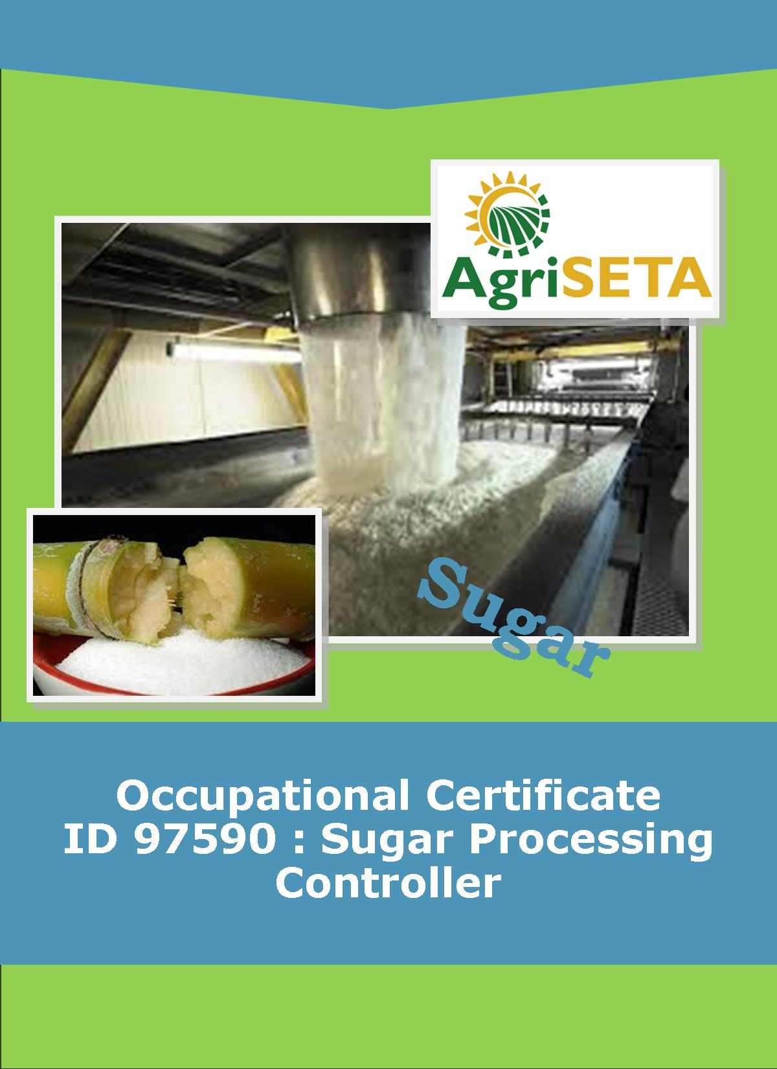
LEARNER SUMMATIVE ASSESSMENT TOOL: KNOWLEDGE MODULE 10:
KNOWLEDGE COMPONENT: LEARNER SUMMATIVE ASSESSMENT TOOL KNOWLEDGE MODULE 10: SUGAR REFINING
Occupational Certificate: Sugar Processing Controller

LEARNER SUMMATIVE ASSESSMENT TOOL KNOWLEDGE MODULE 10:

SUGAR REFINING
SUGAR REFINING
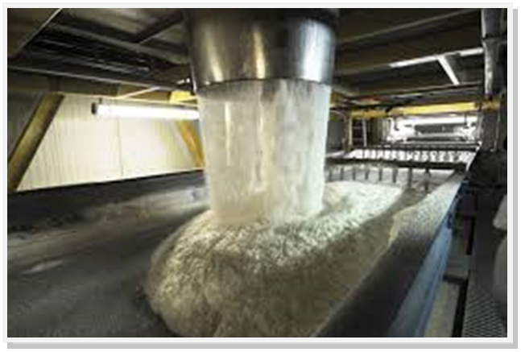
OCCUPATIONAL CERTIFICATE: ID 97590: SUGAR PROCESSING CONTROLLER

©Copyright AgriSETA
Telephone: +27 12 301 5600


AgriSETA holds the copyright to its publications and Web pages. Proper citation is requested.

TABLE OF CONTENTS

1. STAKEHOLDER INFORMATION 6
2. COMPETENCY SUMMARY OF ASSESSMENT 8
3. ASSESSMENT ALIGNMENT MATRIX (INTERGRATED OUTCOMES) 9
4. ASSESSMENT DECISION & EVIDENCE EVALUATION RECORD 11
5. OVERALL ASSESSMENT DECISION 12
6. Evidence of feedback 13
7. OVERALL RESULTS 14
8. ASSESSMENT REVIEW 15
9. FINAL DECISION 17
10. LEARNER FEEDBACK FORM 18
11. SUMMATIVE ASSESSMENT INSTRUCTIONS 19
12. WRITTEN ASSESSMENT 20
13. FINAL MARKS 28

STAKEHOLDER INFORMATION
LEARNER INFORMATION
Name
Surname
ID number
Mobile phone contact number
E-mail address
Physical address
Postal address
Employer Name
Employer Contact Details

ASSESSOR DETAILS
Name
Surname
Assessor ID
Project Name | Occupational Certificate ID 97590:Sugar Processing Controller
Module No. | Module 10: Sugar Refining
Date of Assessment
Portfolio submission Date
Assessor Signature
Total Marks for Knowledge Module 9 | 100 marks
Marks attained
Place:

MODERATOR DETAILS
Moderator Name
Moderator ID
Moderator Signature
Date of Moderation

COMPETENCY SUMMARY OF ASSESSMENT
Module 9 | KM-10-KT01: Principles of colour removal | C | NYC
1 | 1.1. An understanding of the sugar refining process can be demonstrated
 | 1.2. Critical Control Points can be listed and explained
2 | KM-10-KT02: Sugar refining technology | C | NYC
 | 2.1 An understanding of the refining process and associated equipment can be demonstrated
3 | KM-10-KT03: Refinery balance and calculations | C | NYC
 | 3.1. Formula selection and use selection and use, calculations and data interpretation is performed correctly
4. | KM-10-KT04: Problems experienced during sugar refining | C | NYC
 | 4.1. An understanding of trouble shooting and standard responses related to sugar refining can be demonstrated

ASSESSMENT ALIGNMENT MATRIX (INTERGRATED OUTCOMES)
Module No: 10 | How it is assessed (Assessment methodology) | Where is it covered (learning material) | Where it is assessed |  | First Submission
Module No: 10 | How it is assessed (Assessment methodology) | Where is it covered (learning material) | Summative | Formative
SAQA ID Number: 97590 | Two methods of assessment are followed which are:  1. Summative assessment: written tests, knowledge questions using fundamental and reflexive questions.  2. Formative assessment: assignments, tasks, portfolio of evidence submitted and presentations. |  |  |  | Clearly meets all the criteria | Meets some but not all criteria | Clearly does not meet any of the criteria
Title: Sugar Refining
NQF level and credits:
NQF Level 4: 8 Credits
Topic: 1 Principles of colour removal |  | Page 8-21 | Question 10.1-10.11 page 20-22 | Learning Activity 1.1-1.5 page 11-20
Assessment criteria: An understanding of the sugar refining process can be demonstrated
Assessment criteria: Critical Control Points can be listed and explained
Topic 2. Sugar refining technology |  | Page 22-30 | Question 10.12-10.26 page 20-22 | Learning Activity 2.1-2.4 page 27- 40
Assessment criteria: An understanding of the refining process and associated equipment can be demonstrated
Topic 3. Refinery balance and calculations |  | Page 31-55 |  | Learning Activity 3.1-page 42-43
Assessment criteria: Formula selection and use selection and use, calculations and data interpretation is performed correctly
Topic 4. Problems experienced during sugar refining |  | Page 56
Assessment criteria: An understanding of trouble shooting and standard responses related to sugar refining can be demonstrated

ASSESSMENT DECISION & EVIDENCE EVALUATION RECORD
Candidate's Name: -

Assessor's Name: -

Practical assessment
I declare that this assessment is my own demonstration.
Marks: The learner is either “Met requirements” or “did not meet requirements”. If the learner did not meet requirements in an area, then he or she must be reassessed.
Learner achieved: Met requirements /Did not meet requirements
KNOWLEDGE MODULE 10:SUGAR REFINING
Overall outcome:

Specific Outcome |  | Met requirements | Did not meet requirements | Comments
1
Specific Outcome |  | Met requirements | Did not meet requirements | Comments
2
Specific outcome |  | Met requirements | Did not meet requirements | Comments
3
Specific outcome |  | Met requirements | Did not meet requirements | Comments
4

OVERALL ASSESSMENT DECISION
Assessors Comments:

Signature of Assessor:

Date:

Evidence of feedback
Module No : 10
Level :5
Assessor :……………………………………………………………………………
Candidate :…………………………………………………………………………..
Date of final assessment:…………………………………………………………….
Evidence criteria | Achieved | Not
1. Constructive
2. Timeous (according to Plan)
3. Correct mode / medium
4. Participative
5. Developmental
6. Accurate
7. Specific
8. Documented
9. Directed to correct parties
Signing off date: …………………………………………….

..........……………. ………………………………….
Assessor Candidate

OVERALL RESULTS
OVERALL RESULT | Competent
OVERALL RESULT | Not Yet Competent
Declaration by Candidate
I, …………………………………………………………………….declare that I am satisfied that the feedback given to me by the Assessor was relevant, sufficient and done in a constructive manner. I accept the assessment decisions and do realise that have no further questions relating to this particular assessment process. I do realise that after this assessment decision, the moderator will either uphold or reverse this assessment decision taken by the assessor.
Candidate : _____________  _______________________  Date: __________________  Signature: ______________ |  | Assessor : _____________  _______________________  Date: __________________  Signature: ______________ |  | Moderator : _____________  _______________________  Date: __________________  Signature: ______________

ASSESSMENT REVIEW
Assessor’s Name |  |  |  |  |  |  |  |  | ID Number
Contact Details of Assessor |  | Email
 |  | Phone
 |  | Fax
PART 1
 | Review Criteria |  | Valid |  | Authentic | Current |  | Consistent |  |  | Reliable |  | Sufficient |  |  | Comments
Please conduct an honest review of the Assessment Instruments used in this assessment:
1 | Evidence Topic 1
 | Knowledge Assignment
 | Practical Assignment
 | Natural Occurring Evidence
 | Reflection
2 | Evidence Topic 2
 | Knowledge Assignment
 | Practical Assignment
 | Natural Occurring Evidence
 | Reflection
3 | Evidence Topic 3
 | Knowledge Assignment
 | Practical Assignment
 | Natural Occurring Evidence
 | Reflection
4 | Evidence Topic 4
 | Knowledge Assignment
 | Practical Assignment
 | Natural Occurring Evidence
 | Reflection
PART 2
No | Review Criteria |  |  |  |  |  |  |  |  | Yes |  | No |  |  | Remarks
1 | Do you feel the candidate was appropriately selected and prepared for the RPL assessment?
2 | Did the candidate interpret the evidence requirements appropriately?
3 | Was the assessment free of potential assessment barriers such as language, literacy, access to resources?
4 | Was the assessment evidence presented by the candidate valid, authentic, current and sufficient?
5 | Was the candidate’s workplace access to evidence sufficiently supportive of the assessment strategy?
6 | Do you feel you could make a fair, valid and reliable assessment decision?
Recommendations
(Feedback on Validity, authenticity, currency and sufficiency of candidate evidence.)
Assessor Signature |  |  |  |  |  |  | Date Review Completed

FINAL DECISION
I………………………………………………………. hereby declare Ms/Mr

………………………………………… Competent Not Yet Competent

FEEDBACK TO LEARNER:

……………………..………………………..………………………..……………………

……………………..………………………..………………………..………………………

……………………..………………………..………………………..………………………

……………………..………………………..………………………..………………………

SIGN: …………………………………… DATE: ……………………..........................

LEARNER FEEDBACK:

……………………..………………………..………………………..………………………

……………………..………………………..………………………..………………………

……………………..………………………..………………………..………………………

……………………..………………………..………………………..………………………

SIGN: ……………………………………… DATE: …………………….......................

MODERATOR FEEDBACK:

………………………..………………………..………………………..……………………

………………………..………………………..………………………..……………………

……………………..………………………..………………………..………………………

……………………..………………………..………………………..………………………

SIGN: …………………………………… DATE: ……………………........................

LEARNER FEEDBACK FORM
CRITERIA | EVIDENCE | CRITERIA | EVIDENCE
How did your assessor encourage you and put you at ease during the assessment process? |  | Were you given clear and constructive feedback?
Were your assessor’s questions clear and pitched at the right level of language usage? |  | Did your assessor assess all the evidence provided by you?
Do you believe that all the assessment criteria and knowledge requirements of the standard you were being measured against were considered in your assessment? |  | Were you aware of any discrimination practice carried out by your assessor towards you?

LEARNER SIGNATURE:………………………………………………

DATE:.…………………………..

SUMMATIVE ASSESSMENT INSTRUCTIONS
Instructions
- Work individually and answer all questions.
- Use a black pen and ensure that you complete the questions in your own handwriting.
- Time to spend on this assessment is 2hours.
- The marks you will attain for each question are shown in brackets.

WRITTEN ASSESSMENT
10.1 | What is the objective of sugar refining? |  | Mark Allocation
a. |  | To remove the molasses from the crystal.
b. |  | To remove impurities from VHP sugar crystals.
c. |  | To package VHP sugar, making it more marketable.
d. |  | To dissolve VHP sugar crystals and remove trapped solids.
e. |  | All of the above. | 4

10.2 | What is removed from VHP sugar? |  | Mark Allocation
a. |  | Molasses.
b. |  | Enzymes.
c. |  | Brix.
d. |  | Colour.
e. |  | Total dissolved solids. |  | 4

10.3 | When only the molasses surrounding the crystal is removed from VHP sugar, the process is known as; |  | Mark Allocation
a. |  | Decolourisation.
b. |  | Carbonatation.
c. |  | Affinition.
d. |  | Sulphitation.
e. |  | Phosphatation. | 4

10.4 | Melt Brix is controlled at; |  | Mark Allocation
a. |  | 65 – 70 %
b. |  | 60 – 65 %
c. |  | 70 – 75%
d. |  | 75 – 80 %
e. |  | Below 60 % | 4

10.5 | What is the name of the two processes responsible for colour removal? |  | Mark Allocation
a. |  | Sulphitation and decolourisation.
b. |  | Decolourisation and ion exchange.
c. |  | Clarification and carbonatation.
d. |  | Crystallisation and decolourisation.
e. |  | Ion exchange and sulphitation. | 4

10.6 | Select the most accurate description of carbonatation. |  | Mark Allocation
a. |  | CO₂ gas is bubbled through melt that has been limed to 11.0 pH, precipitating calcium carbonate.
b. |  | CO₂ gas is bubbled through melt that has been limed to 8.2 pH, precipitating calcium carbonate.
c. |  | SO₂ gas is bubbled through melt that has been limed to 8.2 pH, precipitating calcium sulphite.
d. |  | SO₂ gas is bubbled through melt that has been limed to 11.0 pH, precipitating calcium sulphite.
e. |  | All of the above. | 4

10.7 | Which statement accurately reflects the purpose of sulphitation? |  | Mark Allocation
a. |  | It can be the primary and secondary decolourisation process, resulting in good colour removal and bleaching of the crystal.
b. |  | It is an expensive decolourisation process.
c. |  | Uses sulphur dioxide which is highly corrosive.
d. |  | It produces a cake that filters easily.
e. |  | All of the above. | 4

10.8 | What is the main difference in operation between carbonatation, sulphitation and phosphatation? |  | Mark Allocation
a. |  | Phosphatation requires the lowest pH.
b. |  | Sulphitation requires the lowest temperature.
c. |  | The precipitate rises to the surface in carbonatation.
d. |  | The precipitate sinks to the bottom in phosphatation.
e. |  | All of the above. | 4

10.9 | Ion exchange resins help remove colour in the clarified melt. Which is the best statement that accurately describes this process. |  | Mark Allocation
a. |  | The melt passes through the ion exchange resin and colour is removed by osmosis.
b. |  | Colour bodies carry a positive charge and attach themselves to the negatively charged resin.
c. |  | Colour bodies carry a negative charge and attach themselves to the positively charged resin.
d. |  | Colour bodies carry a positive charge and are dissolved by the negative chlorine ion that is attached to the positively charged resin.
e. |  | All of the above. | 4

10.10 | Resin can be used multiple times, until all the chloride ions have been replaced by colour bodies. No more colour can be removed. Which process best describes what should happen when this occurs? |  | Mark Allocation
a. |  | Backwash.
b. |  | Sweetening on.
c. |  | Regeneration of resin.
d. |  | Replace the resin.
e. |  | Desalting. | 4

10.11 | What solution is used for regeneration? |  | Mark Allocation
a. |  | A 10% NaCl solution at 12 pH.
b. |  | A 12% NaCl solution at 10 pH.
c. |  | A 10% CaCl₂ solution at 12 pH.
d. |  | A 12% CaCl₂ solution at 10 pH.
e. |  | Any of the above. | 4

10.12 | What is the filter medium that is used in either rotary or plate and frame filters. |  | Mark Allocation
a. |  | Bagacillo.
b. |  | Talofloc.
c. |  | Bone char.
d. |  | Screens.
e. |  | Synthetic cloth. | 4

10.13 | In a plate and frame filter, what specific function are the water plates used for? |  |  | Mark Allocation
a. |  | To de-sweeten the cake.
b. |  | To wash out the filter.
c. |  | To dilute the melt.
d. |  | To ensure that the right Brix is achieved.
e. |  | To act as a filter medium. |  | 4
10.14 | What is the source of the sludge that is fed into a plate and frame filter? |  |  | Mark Allocation
a. |  | From the sugar manufacturing process.
b. |  | From the anaerobic dam.
c. |  | From the aerobic system.
d. |  | From the rotary auto-filters.
e. |  | From the decolourised melt. | 4

10.15 | The evaporation stage in a refinery is used to; |  | Mark Allocation
a. |  | Concentrate the melt to 60 % Brix.
b. |  | Concentrate the melt to 65 % Brix.
c. |  | Concentrate the melt to 70 % Brix.
d. |  | Concentrate the melt to 75 % Brix.
e. |  | Concentrate the melt to 80 % Brix. |  | 4

10.16 | Which boiling systems from the selection below, are used to refine sugar? |  | Mark Allocation
a. |  | Back-boiling.
b. |  | In-boiling.
c. |  | Straight-boiling.
d. |  | All of the above.
e. |  | None of the above. |  | 4

10.17 | What are the main differences between pan boiling in a raw-house and a refinery? |  | Mark Allocation
a. |  | The purity of the melt is higher.
b. |  | The SSC zones are much narrower in a refinery.
c. |  | There is no “bringing together” phase in the refinery due to the high purities.
d. |  | The three-massecuite boiling system is not used in a refinery.
e. |  | All of the above. |  | 4
10.18 | The purity of melt is very close to 100%. What is the purity of the fourth jet, or jet 4 and what is the next process in a refinery? |  | Mark Allocation
a. |  | At about 88% and jet 4 can undergo further recovery, used as sweet water or high test molasses (HTM).
b. |  | At about 88% purity and jet 4 is then recycled to the melt.
c. |  | At about 88% purity and sent to the raw-house remelt.
d. |  | At about 78% and jet 4 can undergo further recovery, used as sweet water or high test molasses (HTM).
e. |  | At about 78% purity and jet 4 is then recycled to the melt. |  | 4

10.19 | In back-boiling, certain products are not removed and accumulated in run-off. Once the colour limit is reached, what happens to the run-off? |  | Mark Allocation
a. |  | It is isolated and then diverted to the raw-house remelt.
b. |  | It is sent to the recovery house for further crystallisation.
c. |  | It is accumulated and boiled into one all syrup pan.
d. |  | It is sent to the raw house syrup tank.
e. |  | The run-off ends up as final molasses. |  | 4

10.20 | If crystallisers are used in a refinery, why is the retention time shorter in a refinery than in a raw-house? |  | Mark Allocation
a. |  | The crystallisers are very large.
b. |  | The crystallisers are small and require a quick turnaround time.
c. |  | The retention time is longer in a refinery than a raw-house.
d. |  | The purities of the massecuite are much higher.
e. |  | None of the above. |  | 4

10.21 | Why are continuous centrifugals not used to cure refined sugar? |  | Mark Allocation
a. |  | Capital cost of installation is too high.
b. |  | The purities of the massecuite are too high.
c. |  | Due to the longer retention times in the crystalliser.
d. |  | All of the above.
e. |  | None of the above. |  | 4

10.22 | Why is conventional drying in a fluidised bed, rotary drier or other sugar drying equipment not practiced in a refinery? |  | Mark Allocation
a. |  | Because the refined sugar is dried by conditioning.
b. |  | Due to damage of the crystals that will occur in conventional drying.
c. |  | Conventional sugar drying is practiced in a refinery.
d. |  | The curing process in a refinery reduces the moisture content to acceptable levels.
e. |  | Due to the high purity of the sugar and the low impurities. | 4

10.23 | There are three types of moisture associated with sugar. Free moisture, bound moisture and inherent moisture. Which type of moisture is specifically removed by sugar conditioning? |  | Mark Allocation
a. |  | Free moisture.
b. |  | Bound moisture.
c. |  | Inherent moisture.
d. |  | None of the above.
e. |  | All of the above. | 4

10.24 | What measures are used to analyse the massecuite yields in a refinery? |  | Mark Allocation
a. |  | Brix balance.
b. |  | Conductivity ash balance.
c. |  | Undetermined loss.
d. |  | Conductivity ash % Brix.
e. |  | Sugar purity. | 4

10.25 | Refinery performance can be measured by colour balances. Where is most of the colour of the raw sugar entering the refinery removed? |  | Mark Allocation
a. |  | Melting.
b. |  | Clarification
c. |  | Decolourising.
d. |  | Evaporation.
e. |  | Crystallisation. | 4

FINAL MARKS
TOTAL MARKS: 100
PASS MARK: 80
LEARNER MARKS
PERCENTAGE
ASSESSOR SIGNATURE:

