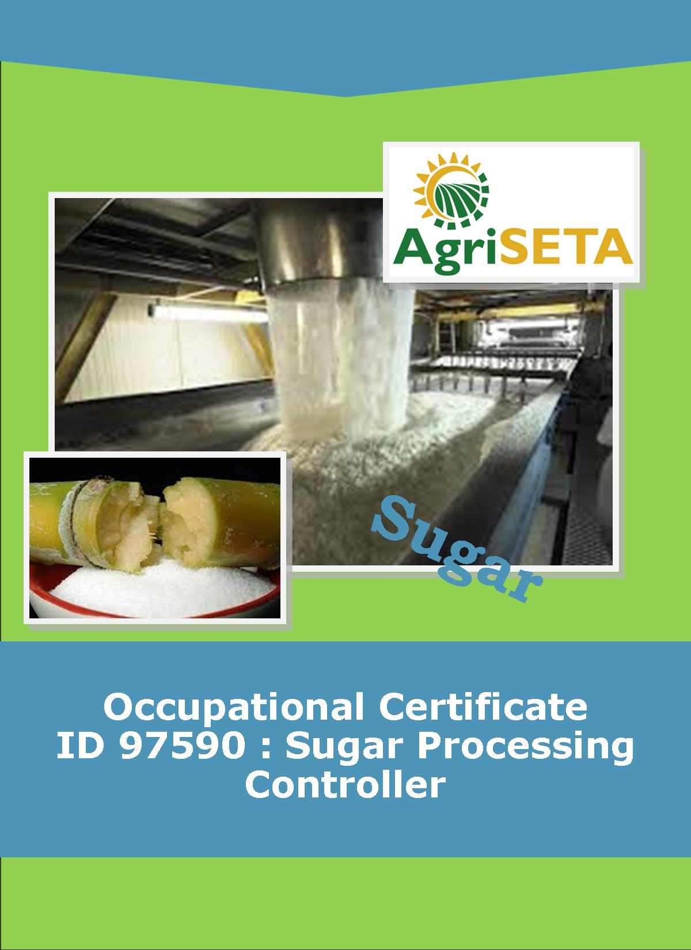
KNOWLEDGE COMPONENT: LEARNING RESOURCE: BOOK 10: SUGAR REFINING
OCCUPATIONAL QUALIFICATION: SUGAR PROCESSING CONTROLLER

KNOWLEDGE COMPONENT:
LEARNING RESOURCE

BOOK 10: SUGAR REFINING
KNOWLEDGE COMPONENT:
LEARNING RESOURCE
BOOK 10: SUGAR REFINING
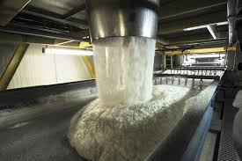
OCCUPATIONAL QUALIFICATION:
SUGAR PROCESSING CONTROLLER

©Copyright AgriSETA
Telephone: +27 12 301 5600


AgriSETA holds the copyright to its publications and Web pages. Proper citation is requested.

TABLE OF CONTENTS
AN INTRODUCTION TO THIS LEARNING RESOURCE 7
KNOWLEDGE MODULE 10 8
SUGAR REFINING 8

1. Background to Sugar Refining 8
1.1 AN OVERVIEW OF THE PROCESS 8
1.2 MAIN STEPS IN REFINING 9
1.3 SPECIFICATIONS OF REFINED, BROWN AND VHP SUGAR 10
2. Knowledge Topic 1: Principles of colour removal 11
2.1 RAW SUGAR QUALITY 11
2.1.1 Effects of raw sugar quality on refining 11
2.1.2 The nature of sugar colourants 11
2.1.3 Mechanisms of colour removal 12
2.1.4 Decolourisation agents and processes 12
2.2 MELTING 13
2.3 COLOUR REMOVAL 14
2.3.1 Carbonatation 14
(1) Carbonatation reactions 14
(2) Flue gas as a source of CO₂ 15
(3) Carbonatation method 15
(4) Assessment of carbonatation 16
2.3.2 Sulphitation 17
(1) Production of SO₂ gas 18
(2) Sulphitation reactions 18
(3) Sulphitation method 18
(4) Assessment of sulphitation 19
2.3.3 Phosphatation 19
(1) Phosphatation reactions 19
(2) Phosphatation method 19
(3) Preparation of lime sucrate 19
(4) Use of a decolouriser 20
(5) Use of a Flotation Aid 20
(6) Flotation clarification 20
(7) Filtration of clarified liquor 21
(8) Assessment of phosphatation 21
2.3.4 Ion exchange 21
(1) Ion exchange resins 21
(2) Resin vessels 22
(3) Regeneration of resin 23
(4) Assessment of ion exchange 24

3. Knowledge Topic 2: Sugar refining technology 25
3.1 FILTRATION 25
3.1.1 Auto-filters with rotating leaves 25
3.1.2 Plate and frame filter presses 26
3.1.3 Other filter types 28
3.2 Evaporation 28
3.3 Sugar boiling 29
3.3.1 Boiling schemes 29
(1) Straight boiling 29
(2) In-boiling 30
(3) Back-boiling 30
3.3.2 Pan boiling 30
(4) Review of crystallization theory 30
(2) Grain formation in refinery pans 32
(3) Growth of the grain 32
(4) Control of pans 32
3.4 Drying and conditioning 33
3.4.1 Moisture associated with sugar crystals 33
(1) Free moisture 33
(2) Bound moisture 33
(3) Inherent moisture 34
3.4.2 Drying 34
3.4.3 Conditioning 34
3.4.4 Sugar as a Fire hazard 35

4. Knowledge topic 3: Refinery balance and calculations 36
4.1 REFINERY PERFORMANCE 36
4.1.1 Yields based on conductivity ash 36
4.1.2 Sucrose and colour balances 36

5. Knowledge topic 4: Problems experienced during sugar refining 38
The 21 Commandments of Sugar Refining 38

6. Sources and further reading 39

AN INTRODUCTION TO THIS LEARNING RESOURCE
This Knowledge Component Learning Resource: Book 10: Sugar Refining is intended to be used with the Knowledge Component Learner Workbook 10 (Formative Assessment Guide): Sugar Refining: Sugar Processing Controller NQF 5. It can also be used as a stand-alone information resource (text book).
This Learning Resource provides detailed information on the following topics:
- KM-10-KT01: Principles of colour removal (30%)
- KM-10-KT02: Sugar refining technology (30%)
- KM-10-KT03: Refinery balance and calculations (25%)
- KM-10-KT04: Problems experienced during sugar refining (15%)
(Note: KM = Knowledge Module, KT = Knowledge Topic)

KNOWLEDGE MODULE 10

SUGAR REFINING
Module number: 313908000-KM10: NQF Level 5: Credits 4
- Background to Sugar Refining

1.1 AN OVERVIEW OF THE PROCESS
Very high pol (VHP) sugar, as produced by a raw sugar mill, has a pol of over 99.3% and moisture of 0.15%. This gives a brix of 99.85% (100 – 0.15) and hence a non-pol content of 0.55% (brix – pol). This non-pol represents impurities in the VHP sugar.
The purpose of the refinery is to remove impurities from sugar crystals.
The refinery, whether it is attached to a raw sugar mill (a backend refinery), or whether it stands separately as a “central” refinery, accepts VHP sugar as its raw material. The sugar is dissolved (melted) and the melt is processed similarly to mixed juice in the boiling house. Melt purity, however, is over 99% and what is measured in refinery products are impurities, in the form of units of colour.
Melt colour is removed by various clarification processes. The clarified melt is evaporated and up to 4 crops of crystals are boiled from this. These crystals are combined to form commercial refined sugar. The resultant “final molasses” may be boiled to produce more crystals that will be re-melted, may be recycled to rawhouse syrup (in backend refineries) or may be used as a by-product.
Re-crystallisation (from a higher purity mother liquor) is alone responsible for a considerable amount of colour removal but other techniques must be employed to obtain the low colour of white sugar.
Supersaturation coefficients are very difficult to control in refinery boiling because the zones of supersaturation are narrow and the crystal growth rate is extremely rapid. Grain formation is done by “shocking” the pan into spontaneous grain formation just before (it is hoped) the labile zone is reached. This is achieved by introducing powdered sugar, sugar slurry, or sugar dust into the pan.
In rawhouse clarification, a “sponge” of tri-calcium phosphate is formed in the juice (at 10% brix) and this sponge is settled. Melt clarification, however, takes place at 65% brix. The resultant precipitate is made to form a cake on the cloth of a special filter and the “whole” liquor is forced through this cake. This optimises solids removal and decolourisation.
When the mat becomes too thick to allow easy passage of liquor through it, it has to be de-sweetened. This is done by running water (rather than more melt) through the filter. The resultant sweetwater is used for duties like re-melting.
The de-sweetened precipitate is diluted and filtered again before being discarded. Some processes use flotation clarification. The treated melt is aerated and the precipitate rises in the form of a scum that is skimmed off the surface.

1.2 MAIN STEPS IN REFINING
- Affination. The molasses film around the crystal is washed off using a saturated sugar solution. The sugar is then centrifuged. All S.A. refineries receive VHP sugars and do not need to employ this step.
- Melting. The crystal is dissolved in water.
- Colour removal. Clarification similar to rawhouse work (carbonatation, sulphitation or phosphatation) is carried out, or special processes using ion exchange resins or granular carbon are employed.
- Evaporation. The fine liquor (after decolourisation) is concentrated to near saturation.
- Crystallisation. Crystals are boiled in vacuum pans, similar to the procedure in rawhouse work.
- Centrifugation. Batch centrifugals separate crystals from the molasses (called jet, green or run-off in refining).
- Drying and conditioning. Drying expels surface moisture, while conditioning, a much longer process, expels moisture bound on (and possibly within) the crystal.
- Packaging.
- Exhaustion of run-off. Run-off is boiled in as many steps as is required to maximise sucrose recovery.

1.3 SPECIFICATIONS OF REFINED, BROWN AND VHP SUGAR
Parameter | Refined sugar | Brown sugar | VHP sugar for export
Pol °S | - | - | $>$99.30
Moisture% | $<$0.06 | - | $<$0.18
Safety factor | - | $<$ 0.23 | -
Reducing sugars% | $<$0.02 | - | -
Conductivity ash% | $<$0.03 | - | $<$0.20
ICUMSA 420 colour | $<$80 | - | $<$1350
Unfiltered 420 colour | $<$110 | - | -
Starch ppm | - | - | $<$150
Fines % | - | - | $<$30
SO, ppm | $<$25 | - | -
(ICUMSA: Inter. Commission for Uniform Methods of Sugar Analysis)

- Knowledge Topic 1: Principles of colour removal

2.1 RAW SUGAR QUALITY

2.1.1 Effects of raw sugar quality on refining
- Ash: Increasing quantities of ash cause greater sucrose losses in molasses and reduces the efficiency of decolourisation resin. Ash is impurities that increase the load on the refinery. Conductivity ash is used to measure refinery performance.
- Starch: Starch reduces filterability and increases the consumption of filter aid.
- Colour: A refinery does nothing more than remove colour. High colour would require more work.
- Moisture: Excessive moisture makes storage of the raw sugar risky due to the danger of microbiological deterioration.
- Crystal size and shape: These factors become significant when affination is carried out.
- Conglomerates: Conglomerates tend to be high in colour because of trapped mother liquor.

2.1.2 The nature of sugar colourants
Colour in sugar is a complex mixture of many different chemicals. Colour can originate in the cane plant, can be modified during the process, or can come from contamination during processing. Researchers have devised a chemically based categorisation of colour.
  - Phenolics: These are naturally occurring compounds like dyes and plant pigments.
  - Caramels: These are thermal degradation products of sucrose.
  - Melanoidins: These are reaction products of amino compounds with sugars. This type of reaction is referred to as the Maillard reaction.
  - Alkaline degradation products of reducing sugars: These are produced by high temperatures and high pH’s.
Colourants can also be classified according to molecular weights.
Most sugars colourants are pale at pH 4 due to low ionisation at this pH. At pH 9 ionisation is almost complete and colourants are darker.

2.1.3 Mechanisms of colour removal
Five general mechanisms can be detailed:
- Absorption: Colour bodies are trapped within a crystalline or porous precipitate or absorbent.
- Adsorption: Colour bodies are adsorbed in the pores on the surface of the adsorbent. Decolourising carbons function in this way.
- Ion exchange: Colourants are retained by resin through which liquor is passed.
- Precipitation: Soluble colour bodies are precipitated, together with absorption and possibly some adsorption.
- Crystallisation: This is the most effective mechanism, colour bodies tend to remain in mother liquor.

2.1.4 Decolourisation agents and processes
- Bone char: Animal bones are charred at 700°C, giving an adsorbent of 10% carbon and 90% calcium phosphate. Contact with liquor takes place in char cisterns and exhausted char is dried, kilned and cooled. Bone char can be used hundreds of times.
- Granular carbon: This is also called granular activated carbon. It is a high carbon (60%) adsorbent made from coal and is replacing bone char because of its six-fold greater capacity. It can be used about 25 times.
- Powdered carbon: Finely divided powdered carbon needs very short contact times and is economical for small scale seasonal operations. It cannot be regenerated.
- Ion exchange: Most colour compounds in raw sugar are anionic and can be exchanged for Cl⁻ within a bed of resin. Regeneration can be carried out cheaply with salt; the process is faster and cheaper than carbon decolourisation and requires smaller plant. However, it generates more effluent and removes less colour than carbon.
- Precipitation processes: These include carbonatation, sulphitation and phosphatation.
- Talofloc: This Tate and Lyle process produces about 20% of the world’s refined cane sugar. The process involves adding a quaternary ammonium compound (Talofloc) to the liquor. This combines with the negative sites on the colourants, forming an insoluble product normally trapped in a precipitate of tricalcium phosphate. (The Talofloc process is usually carried out with phosphatation).

2.2 MELTING
The sugar is dissolved in sweetwater, condensate or any other available water. Heat (steam injection) and mechanical stirring are employed to speed dissolution. The melter is basically a horizontal tank, with a stirrer rotating at 20 – 30 rpm.
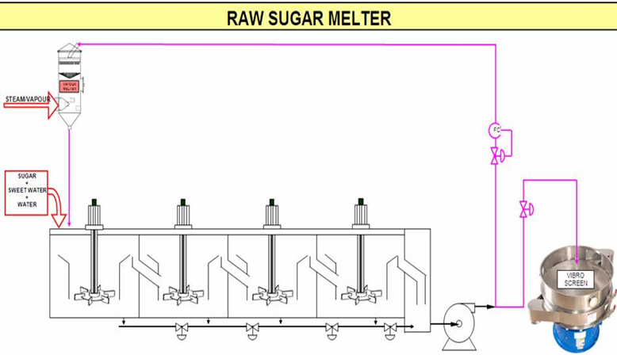
Melt brix is controlled at 65 – 70%. High brixes lead to high viscosities which will slow down subsequent clarification reactions. Low brixes will mean additional work for the evaporators.
Low temperatures increase viscosities while high temperatures can increase inversion. Some colour increase normally occurs in melters.
Impurities in the water fed to the melter will contaminate the melt.
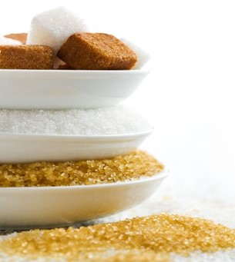
Melt contains some insoluble material like sand, fibre, wax, gums, starch and dextran, and some colloidal material. These may have escaped removal in the rawhouse, or may have appeared subsequently.

2.3 COLOUR REMOVAL
In a rawhouse, sugar boiled from a mother liquor of 85% purity has a purity of 99.5% crystallisation itself is a very effective purifying step. Sugar boiled from melt at 99.5% purity will itself have purities approaching 99.9% but the low colour required will not be attained. Colour has to be removed from melt before crystallisation. Several colour removal processes are in use, with some processes called clarification (carbonatation, sulphitation, phosphatation) and some processes called decolourisation (ion exchange). These processes are used in various combinations, the most common being carbonatation followed by sulphitation (Malelane, Pongola, Gledhow, Ubombo Ranches). Umfolozi uses sulphitation alone, while Entumeni uses the Talo process. Phosphatation followed by ion exchange is practised at Noodsberg, while Hullet Refineries follow carbonatation with ion exchange.

2.3.1 Carbonatation
Carbonatation uses inexpensive reagents, carbon dioxide gas, and lime. The CO₂ is most cheaply obtained from the flue gas of boilers (12% CO₂ by volume). This is done at Malelane and Hullet Refineries, while Pongola and Gledhow burn limestone to produce both CO₂ and burnt lime.

Carbonatation reaction
The reaction involved is:
Ca(OH)₂ + CO₂ → CaCO₃ + H₂O
Calcium carbonate is the precipitate that is produced. This precipitate is both voluminous and gelatinous, and has a large surface area on which colour and ash can be absorbed. Insoluble material can also be trapped within the precipitate.
The form of the calcium carbonate crystals has an important bearing on filtrability. Large crystals (well agglomerated) are filter easily. The presence of cane starch results in finely dispersed precipitate crystals that are difficult to filter. It is for this reason that an enzyme (that breaks down starch) is added to the syrup in the raw sugar factory.
Carbonatation is carried out in two stages. The precipitate is formed in stage 1 and in the second stage it is allowed to agglomerate for good filtration.

Flue gas as a source of CO₂
Flue gas must be scrubbed to remove sulphur compounds (especially from the burning of coal) and then cooled to about 50°C. Water scrubbing is sufficient for gas from bagasse fired boilers, but a second scrubbing with 5% sodium carbonate is required if coal is fired.
The volume of flue gas required is around 140 m³ per ton of solids in melt.
The advantages of flue gas carbonatation are:
- Lower capital cost. A kiln and limestone handling equipment is not required.
- Lower operating cost. Even with the benefit that a kiln can produce lime and CO₂ the cost of operation is still in favour of flue gas. This is especially so where lime has to be transported over long distances.
The disadvantages of flue gas are:
- Sodium carbonate scrubbing if coal is used as a fuel.
- A higher volume of flue gas (at 12% CO₂ by volume) has to be handled compared to kiln gas (30%).

Carbonatation method
- Liming and gassing
Melt is limed to a pH of 11.0. Carbon dioxide is then bubbled through the melt in two stages in vessels called saturators. As calcium carbonate is precipitated, the pH drops.
The first stage (in which the precipitate is formed) is operated at an outlet melt pH of 9.5 and the second stage (in which the precipitate is conditioned for good filtrability) is operated at a pH of 8.2. At pH’s lower than 8.2 calcium re-dissolves in the form of calcium bicarbonate while at higher values precipitation is incomplete.
Saturator temperatures are maintained at 85°C using steam.
The first stage saturators use 80 – 90% of the CO₂ while the second stage uses the remainder. The retention time in the saturators is up to 2 hours.
- Filtration and cake treatment
Carbonated liquor is filtered in horizontal auto-filters or vertical leaf pressure filters. The leaves of the filter could be rotary or static, and are covered with a synthetic fabric that can be acid washed and reused, unlike cotton cloths. Calcium carbonate filters readily, hence no filter aid or pre-coating of the filter is required. The filter is run semi-continuously, each cycle lasting 2 – 4 hours, after which the cake is sluiced off the leaves with hot water. The cake is then re-filtered and de-sweetened in separate plate and frame filters. Sweetwater is used for re-melting sugar. Filtration is covered in detail later.
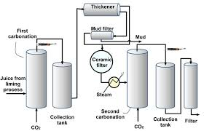

Assessment of carbonatation
Carbonatation gives good colour removal, with greater removal of impurities such as sulphates and sparingly soluble calcium salts. Chemical costs are low and the technique is reasonably flexible to cope with varying raw sugar quality.
The capital investments required for carbonatation is comparatively higher and a greater volume of cake is produced that has to be disposed of.

2.3.2 Sulphitation
Sulphitation as the primary colour removal process is rarely practised for fear that the sugar may contain excessive SO₂. However, this is the sole colour removal method used at the Umfolozi Refinery.
The SO₂ gas is produced by burning rock sulphur, and the dosage rate is around 5 – 7 kg of rock sulphur per ton of refined sugar made. Sulphitation is carried out in two stages similarly to carbonatation.
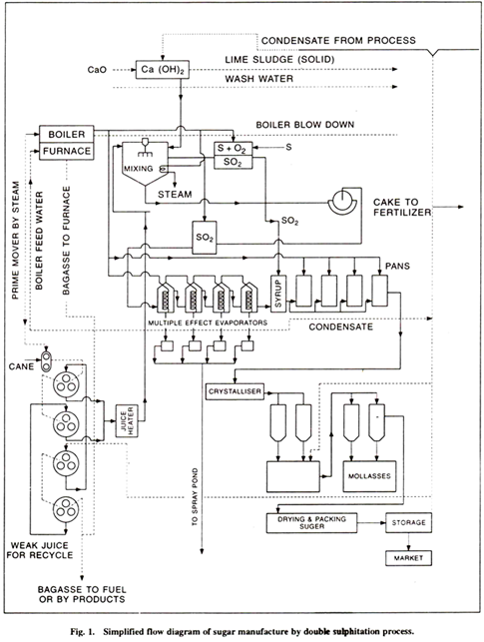

Production of SO₂ gas
Sulphur is melted using steam and is maintained at 135°C, this being the temperature at which minimum viscosity prevails. The molten sulphur is pumped to a pre-heated burner where ignition takes place. The reaction is:
S + O₂ → SO₂
The gas produced has an SO₂ content of 18% and a temperature around 810°C. At this temperature the formation of SO₃ could occur: this gas combined with water, would form sulphuric acid. The gas is rapidly cooled to a temperature of 50°C before addition to melt.

Sulphitation reactions
The reaction of lime with melt has already been studied. Calcium hydroxide reacts with SO₂ as follows:
Ca(OH)₂ + SO₂ → CaSO₃
The calcium sulphite precipitate entraps impurities and has to be filtered off. Sulphur dioxide gas has a bleaching effect, giving the refined sugar a pleasing sparkle.

Sulphitation method
Gassing of the melt is done in two stages at Umfolozi and in a single at Malelane. In the two-stage system the liquor outlet pH is maintained at 8.2 after the first stage and at 7.1 after the second stage. The outlet pH from Malelane’s single stage gassing is also 7.1.
Sulphitation vessels are tanks at the bottom of which a slotted pipe feeds SO₂ into the liquor. Lime is added to the liquor before its entry into the vessel and pH control is obtained by adjustment of lime dosage. A sulphitation tower is a vessel containing a packing which breaks up the liquor into droplets, increasing the area for SO₂ absorption. Mixing takes place in counter-current fashion, SO₂ moving upwards while liquor falls downwards and is withdrawn at the bottom. The Malelane sulphur tower is packed with clay mixer rings.
Sulphited liquor at Umfolozi is held in a stirred steam-heated retention tank at 90°C to allow completion of the precipitation reaction. This raised temperature is necessary as the calcium sulphite crystals have a lower solubility at 90°C than at 80°C.
(It must be noted that Malelane uses carbonatation followed by sulphitation, whereas Umfolozi uses sulphitation alone.)
Filtration of the precipitate is done in pressure filters similar to those used for filtering carbonatation liquor.

Assessment of sulphitation
Sulphitation gives good colour removal by a fairly simple process. The cake produced filters easily. Disadvantages of this technique are the higher cost of chemicals (sulphur is expensive) and the careful control of SO₂ production to prevent acid corrosion of structures. Sulphur dioxide is an extremely toxic gas and every care must be taken in its use. Molten sulphur, at its high temperature, is also a hazard.

2.3.3 Phosphatation
The only phosphatation refinery in South Africa is at Noodsberg, where this colour removal process is followed by ion exchange treatment. Lime is added in the form of lime sucrate. The precipitate formed is tri-calcium phosphate, the same as that formed in raw juice clarification, giving rise to “phospho-defecation”, an alternative name for this process.

Phosphatation reactions
The basic reaction is between calcium hydroxide (from lime sucrate) and phosphoric acid:
Ca(OH)₂ + H₃PO₄ → Ca₃(PO₄)₂
The precipitate of tri-calcium phosphate is aerated and removed by flotation.

Phosphatation method
Undiluted phosphoric acid (65% strength) is dosed at 500ppm on melt solids. This is done in a small reaction tank where the melt is at 65% brix and 70°C. Lime sucrate is simultaneously added to bring the liquor pH to 7. About 800ppm lime sucrate on melt solids is required.

Preparation of lime sucrate
Milk-of-lime from the rawhouse is mixed with filtered liquor in a stirred tank. The mixture is stirred for 1 hour, then left to age for 2 hours to complete the formation of calcium sucrate. (Lime is considerably more soluble in a sugar solution than in water. The calcium in lime sucrate is therefore in a much more available form to give more rapid and efficient pH control than milk-of-lime).

Use of a decolouriser
The simultaneous dosage of Talofloc, a cationic decolouriser, greatly improves colour removal. Talofloc also selectively precipitates colourants that are responsible for irreversible fouling of ion exchange resins, thus extending resin life and reducing regeneration costs.
At room temperature Talofloc is a white pasty solid. It is heated in water bath to 65°C, taking about 4 hours. At 50°C the chemical becomes a mobile liquid (and above 80°C it becomes a dangerous fire hazard). Pipelines carrying Talofloc are heated to 65°C by a water jacket.

Use of a Flotation Aid
Taloflote, used in conjunction with Talofloc in a flotation clarifier, gives rapid floc flotation, brilliant clarified liquor and stable, free-draining scums. The temperature and retention time in the clarifier is reduced, giving lower sucrose losses and increased plant capacity.
The preparation of Taloflote is similar to the preparation of flocculants in the rawhouse.

Flotation clarification
Treated liquor flows to an aeration tank. Aeration is effected by bleeding air into the suction side of a pump that returns a portion of clarified liquor to the aeration tank. (Taloflote dosage occurs immediately before the Talo clarifier). Aerated liquor is fed to the Talo clarifier where the air rises, carrying with it the tricalcium phosphate precipitate. The precipitate forms a layer of scum which is continuously scraped off to fall into a sloped annular channel. Clarified liquor leaves the vessel from underneath via an adjustable weir box at the operating level of the clarifier, similar to the mud off-take in the rawhouse Rapidorr.
A portion of clarified liquor is led back upstream for aeration (see above).
The scum floated off the clarifier is diluted with water at 80°C, reaerated dosed with Taloflote, and treated in a small de-sweetening flotation clarifier. The sweetwater is used in the melting station while the mud is recycled to mixed juice in the rawhouse.
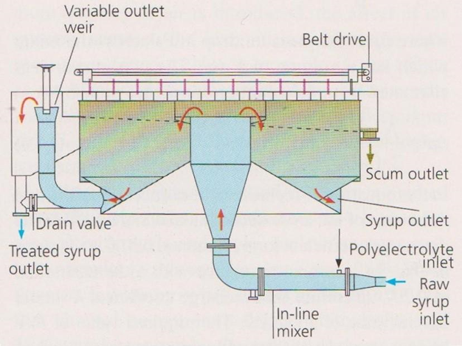
A Simple flotation clarifier

Filtration of clarified liquor
Carryover of precipitate is inevitable. Scum would cause fouling of the ion exchange resin bed and must therefore be removed. Filtration is done in rotary leaf filters coated with a filter aid to optimise solids removal.

Assessment of phosphatation
The capital investment is lower when compared to carbonatation. The plant is easy to automate, neat and compact as gases (large volumes) are not used. A relatively small amount of sweetwater is generated.
On the negative side, the extent of colour removal is only half of what can be obtained by carbonatation. Chemical costs are higher as both Talofloc and Taloflote are expensive. Furthermore, resin life is reduced where ion exchange follows phosphatation.

2.3.4 Ion exchange

Ion exchange resins
Two major categories of resins are in use:
- Polystyrenic Resins: This type removes colour by both adsorption and ion exchange.
- Polyacrylic Resins: Colour removal is mainly by ion exchange, adsorption is minimal. The advantage of this type is that it is less subject to fouling.
Most sugar colourants have negative charges. The chloride ion attached to the resins, also negatively charged, repels the colour body. The chloride ion goes into solution while the colour body, having greater affinity for the resin, attaches itself to it (This increase in liquor chloride content increases ash in sugar).
Some colour bodies pass through the pores of the resin beads and become fixed onto the inside cavities, giving rise to polymerised colourants.
The capacity of the resin for colour removal decreases with use, depending on the nature of the colourants being removed. If the colour removal capacity of new resin is taken as 100% the table below gives the fall-off in efficiency for various stages of resin life:
Period of resin life | Colour removal capacity
1st few cycles | 85 – 90
1st 25% of life | 70
30 – 40% | 60
Remainder | 50

Resin is good for typically 250 – 350 cycles, with each cycle representing 50 – 100 bed volumes of liquor.
Two types of deterioration of resin occur:
- Mechanical breakdown: Resultant fines cause resistance to flow.
- Fouling of pores and surfaces: Precipitates and organic impurities cause fouling.

Resin vessels
Resin vessels are columns 2.3 – 3.3 m diameter, 3.3 – 4 m high with a bed depth of 0.6 to 2 m. The high freeboard is required because the resin volume doubles during backwashing. The inside of the vessel and all piping that come into contact with regenerant chemicals are rubber-lined to prevent corrosion.
A stainless steel header above the resin bed admits liquor into the vessel while the liquor is withdrawn through wipes covered with woven sieves within the lower part of the resin bed. Air pressure within the vessel is about 200 – 300 kPa.
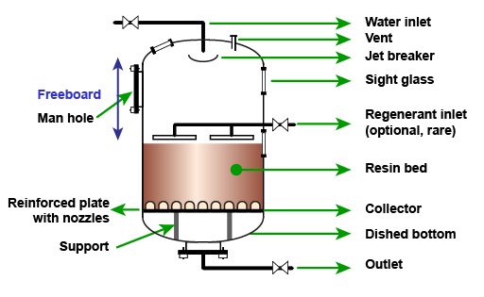
The liquor flowrate through the vessel is normally given in bed volumes of liquor over a specified time. Ffor example, if the bed volume is 7m³ and the vessel is operating at 12 bed volumes per hour, the liquor throughput is 84m³ (12x7) per hour.

Regeneration of resin
When all the chloride ions within the resin have been replaced by colour bodies the resin is exhausted – it cannot remove more colour. A 10% NaCl (brine) solution is used for regeneration. An increase in the pH of the brine solution is necessary to remove polymerised colourants. Caustic soda (NaOH) is added to the brine to bring its pH to 12. However, some polymerised colourants form a network within the bead and cannot be removed.
A typical regeneration cycle would occur as follows:
- Sweetening off: The bed has handled (say) 70 bed volumes of liquor and is in need of regeneration. Liquor feed is shut and condensate is used to displace the liquor. Fine liquor brix would decrease. When this brix falls below 40% the sweetwater is diverted to the melter. Sweetening off stops when the sweetwater is down to 1% brix.
- Backwashing: The resin bed acts as a filter, entrapping suspended matter. Backwashing involves forcing condensate upwards through the bed to remove entrapped particles. Backwashing also removes fine resin particles that hinder percolation through the bed.
- Settling: After backwashing, the beads are allowed to settle for ±10 minutes to form a new bed.
- Condensate removal: Air pressure is increased, forcing condensate out through the bottom of the bed.
- Regeneration: This is done in two stages. Firstly, reclaim brine (“strong” brine from the previous regeneration) is pumped through the bed. Secondly, fresh brine flows through the bed. The efficiency of regeneration can be increased if the resin is allowed to soak for as long as possible.
- Desalting: Salt is flushed out of the resin with condensate, the waste going to effluent except for the latter stage that is directed to the brine reclaim tank. This will be used for the next regeneration (see (e) above). After complete removal of salt, the regeneration is complete.
- Sweetening on: Liquor is introduced into the vessel in a procedure that is the inverse of sweetening off. The low brix discharge liquor is sent to the sweetwater tank until its brix rises to ± 40%, when it is directed to the fine liquor tank.
Regeneration using 4% hydrochloric acid is carried out after about 20 cycles with caustic being used to neutralise the acid to prevent inversion. This acid wash removes organic foulants.

Assessment of ion exchange
Advantages of resins are the low cost of installation and regeneration, ease of maintenance, small space requirements and the short contact time required, which permits high flow rates.
A possibility is the contamination of the sugar with amine odours (resins are basic anionic quarternary ammonium compounds which could lead to an increase in colour during boiling). More sucrose could be lost to molasses as a result of an increase in liquor chloride content and waste brine and used acid has to be disposed of. Ion exchange resins are expensive.

- Knowledge Topic 2: Sugar refining technology

3.1 FILTRATION
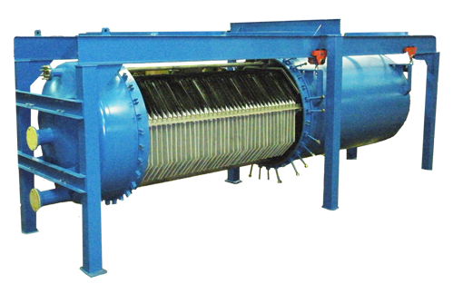
Filtration in refinery work differs considerably from the rawhouse. In the rawhouse the underflow from the clarifier (mud) is mixed with a filter aid (bagacillo) and treated separately from the clarifier overflow (clear juice). In the refinery, whole liquor (containing the precipitate) is forced through the cloth of a special filter. The process is carried out at about 65% brix. Precipitate deposits on the cloth and the precipitate itself serves as the filtering medium. When the cake becomes too thick for easy passage of the liquor, it is de-sweetened and discarded. The two most common filters are the Smith auto-filter (for use on carbonatation liquor) and the plate and frame filter (sulphitation liquor).

3.1.1 Auto-filters with rotating leaves
A typical auto-filter consists of 56 leaves rotating in a horizontal tank of liquor. A filtered liquor pipe connected to each leaf exits the ends of the tank, 28 on each side. Each pipe has a glass section to enable the operator to check the condition of the filtered liquor.
The leaf is basically a rounded rectangle of metal, channelled on both sides. All the channels communicate with an outlet port on one edge. An envelope of cloth covers the leaf entirely, except for the outlet port. A rubber gasket seals the cloth in a groove running along the edge of the leaf.
During operation the leaf rotates; filtered liquor is forced through the cloth, collects in the channels and drains out through the outlet pipes. Liquor becomes clear only after a layer of cake has formed on the clot. Facilities exist therefore for separating cloudy liquor from clear liquor. When the cake builds up sufficiently (after ±4 hours) it is sluiced out and desweetened in plate and frame filters.

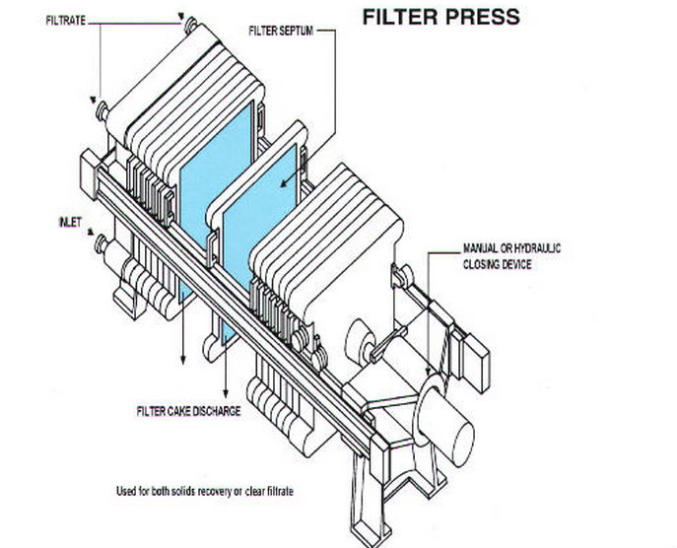
3.1.2 Plate and frame filter presses
The plates and frames are rectangular, resting on two horizontal bars by lugs on their longer vertical edges. During operation a hydraulically loaded ram squeezes the plates and frames together. All the plates are channelled, and all channels communicate with outlet taps. Two types of plates are found: liquor plates and water plates, and both types have cloths draped over their channelled surfaces. Refer to the sketches below.
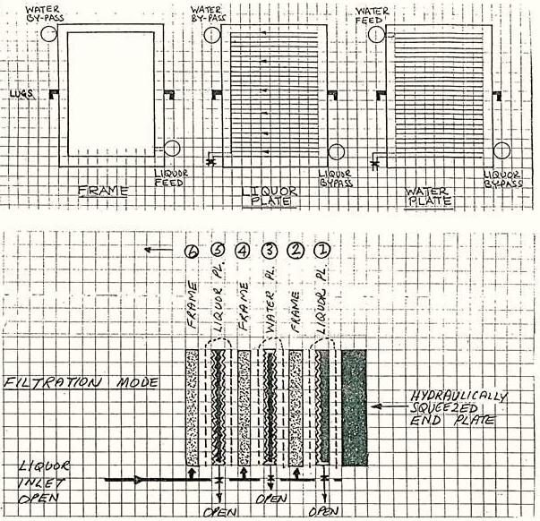
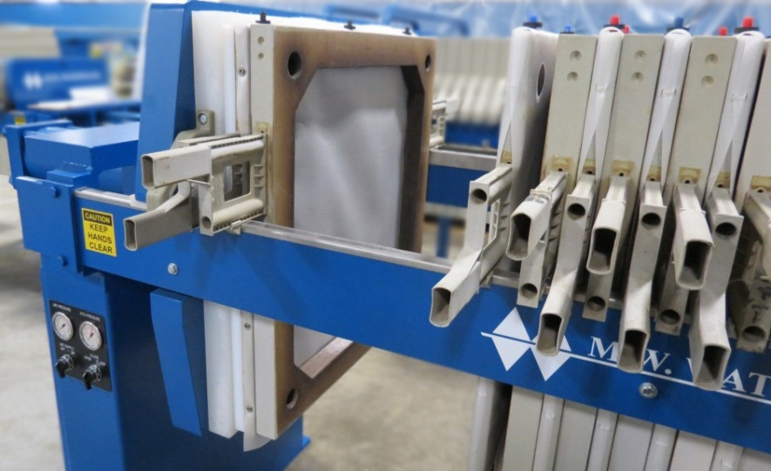
The frames (2,4,6,8 etc.) are rather like empty picture frames and simply form a space into which liquor is fed in at the bottom, and in which a cake layer will develop. Filtered liquor passes through a layer of cake, through a cloth and enters the channels on the juice plate on one side and the water plate on the other. Cake thus builds up from two cloth surfaces towards the centre. From the channels the liquor exits through taps at the bottom of all the plates.
The liquor plates (1,5,9,13 etc.) have neither liquor nor water inlets and serve only to provide a channelled surface connected to an outlet tap to enable clear liquor removal (filtration mode) and sweetwater removal (washing mode). Their by-pass ports allow water to feed adjacent water plates (at the top) and liquor to feed adjacent frames (at the bottom).
The water plates (3, 7, 11, 15 etc.) are similar to the liquor plates except for one vital difference; their channels can be fed with water from the top, in a direction counter to liquor flow. This facility is used during cake de-sweetening. The water plate thus serves a dual function; like the liquor plate it provides a channelled surface to support the cloth, but it also enables the cake to be de-sweetened.
During de-sweetening the outlet taps on all the water plates are shut to prevent short-circuiting. The by-pass port at the bottom allows liquor to feed adjacent frames.

The sketch below shows a plate and frame press in the washing mode.
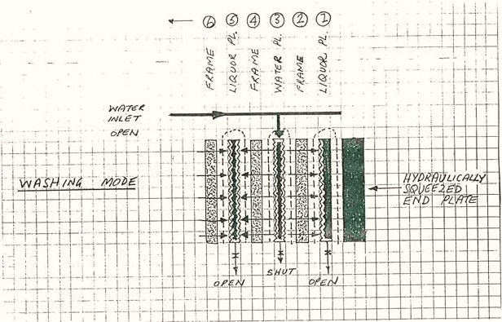

3.1.3 Other filter types
Filtration technology continues to develop at a faster pace than other unit operations in the sugar factory. The factory where you are employed may not have the types of filters described above. If this is the case. Study your filter and write notes about it here. Include basic diagrams.

3.2 Evaporation
Most purification stages in a refinery are carried out at about 60% brix. Before crystallisation in vacuum pans the filtered liquor is concentrated to 70% brix, usually by double or triple effect evaporation.
Concentration in evaporators gives a steam saving and also reduces the boiling time in the pans, increasing pan capacity and saving energy. Typical rawhouse evaporation runs at 85% on clear juice whereas refinery evaporation is merely around 14% on liquor depending on the brix increase required.
Vapour 1 is used as the heating medium, except in central refineries. Some colour increase is inevitable during evaporation because of thermal degradation.
The liquor leaving the evaporators is referred to as white liquor, fine liquor or evaporated liquor.

3.3 Sugar boiling
Boiling times in a refinery are much faster because the melt purity is much nearer to 100%. However, conglomerates form easily and can cause problems in subsequent operations.
Higher purity liquors contain less impurities and hence have a lower electrical conductivity. Conductivity is therefore not used to control white sugar pans. Other techniques of measuring supersaturation, e.g. boiling point elevation, have to be employed.
Tube and plate calandria pans as found in the rawhouse are used, while pans with ribbon calandrias are also employed. These use higher pressure steam but produce good circulation without the use of stirrers.
Establishment of grain by true seeding is near impossible as the various zones of supersaturation are extremely narrow. Shock seeding, using varying amounts of powdered sugar, is carried out.

Boiling schemes

Straight boiling
In this conventional system, (say) eight first strikes are boiled from liquor with about 47% of the brix in liquor remaining in the first run-off.
Four second strikes are produced from the first run-off, with 50% of the brix in the first run-off remaining in the second run-off. Two third strikes are boiled from the third run-off, with 53% of the brix in the second run-off remaining in the third run-off. One fourth strike is boiled from this run-off with 56% of the brix in the third run-off remaining in the fourth run-off.
The resultant blend of white sugar is thus made up of 8 parts first sugar, 4 parts second sugar, 2 parts third sugar and 1 part fourth sugar. Although fourth sugar (and possibly third) may not on their own meet the colour specification, when blended in the above proportions no problem is experienced.
The fourth run-off, at purity of about 88% can be recycled to syrup (in a rawhouse) or can be used as a by-product. An alternative scheme (practised by Hullet Refineries) is to boil further crops of crystals in the so-called “recovery house”, then remelt these crystals (after centrifugation) together with the incoming raw sugar.
Compared with the other boiling systems (see below), the straight boiling system has much more material in process as run-off must be accumulated for the next strike. More equipment is needed as pans, run-off tanks, mixers and centrifugals have to be provided for each grade of strike.

In-boiling
In this system some first run-off is mixed with evaporated liquor and the first strikes are boiled from this mixture that consists of 60% evaporated liquor solids and 40% run-off solids. As no impurities leave the system, white sugar colour and ash continues to increase, this is allowed until the permissible limits are reached. The run-off is then isolated and directed to rawhouse remelt and a new cycle commences.
In this system, the stock in process is minimal, as are the vessels required.

Back-boiling
Each pan is started on evaporated liquor and finished on 40% run-off from previous strikes. This system differs from in-boiling in the point at which evaporated liquor enters the system. Again, as no impurities are eliminated, colour and ash will increase. As the colour limit is reached, run-off is accumulated and boiled into one “all syrup” pan. This removes impurities from the system and a new cycle commences.

Pan boiling

Review of crystallization theory
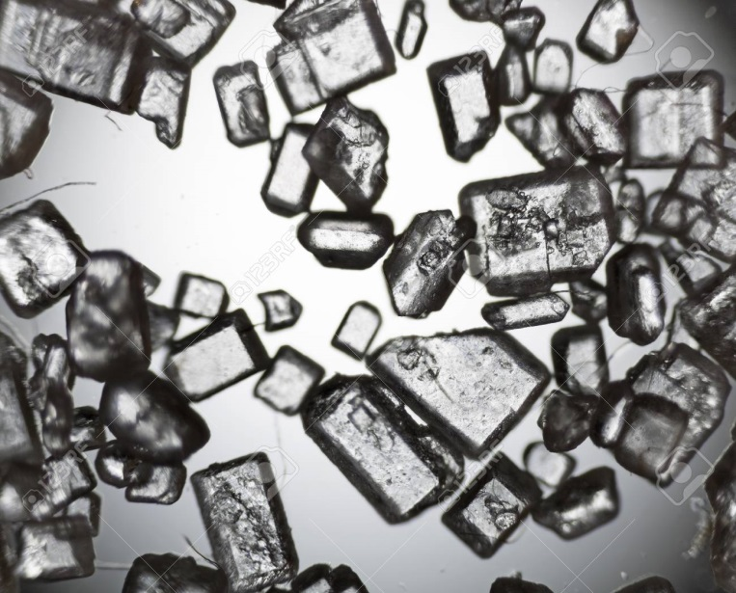
Review Crystallisation Theory by revising the following topics:
- Solution
- Sucrose solubility
- Effect of reducing sugars and ash on sucrose solubility
- Saturated solution
- Supersaturated solution
- Supersaturation co-efficient
- The three zones of supersaturation:
  - The metastable zone
  - The intermediate zone
  - The labile zone
- The two basic ways in which crystals can be formed
  - Primary nucleation
  - Secondary nucleation
- Crystals can be formed in a pan by:
  - The waiting method
  - Schock seeding
  - True seeding
- The two basic factors affecting the rate of crystal growth are:
  - The diffusion rate
  - The accommodation rate
- The factors that affect the two rates of crystal growth are:
  - Viscosity
  - Temperature
  - Supersaturation co-efficient
  - Purity
- The three factors that cause an increase in the boiling point of a sugar solution are:
  - Brix
  - Pressure above the liquid
  - Hydrostatic head

Grain formation in refinery pans
In practise, varying quantities of slurry or sugar dust are added to the tightened fine liquor. Whether this is true seeding (all crystals come from outside) or shock seeding (crystals are allowed to form spontaneously) is an argued point. However, the more the number of added crystals, the more likely it is that the pan is being true-seeded. The pan may be held on water for a few minutes to prevent conglomerate formation and to “harden” the crystal.

Growth of the grain
In rawhouse work, this is carried out in two stages. The first stage, in which crystals are grown on sucrose already in the mother liquor, is called “bringing the grain together”.
Because of the higher purities in refineries, bringing the grain together is a step rarely carried out. Once the grain has been established, the pan is fed on liquor and crystal growth continues.

Control of pans
(a) Boiling point elevation (BPE)
The temperature at the surface of a boiling massecuite is always higher than the temperature of water boiling under the same vacuum. This is because of the brix in the mother liquor. As the SSC increases, the brix increases and so does the boiling point elevation. Where this technique is used, a heated water pot is connected to the vapour space of the pan and two temperatures are measured: the temperature of the boiling water and the temperature of the massecuite. An instrument computes the difference and this signal is used to control the feed valve.
(b) Consistency
This term describes the combined effect of mother liquor viscosity and crystal content. The current needed to turn a small impeller (in the massecuite) at constant speed is measured and varies with both viscosity and crystal content. This reading is used for pan control.
(c) Radio Frequency Control
This is a recent development and consists essentially of measuring the electrical properties of a massecuite subjected to radio frequencies. The electronics consists of a radio frequency generator, a probe and tuning circuit and a detector and amplifier that feeds signal to a control valve.
This technique can be used to measure crystal content and mother liquor brix simultaneously. The probe is less affected by scaling. The system is cheaper than nuclear density meters or refractometers and can be used to control syrup and molasses brix as well.
(d) Refractometer brix
A built-in pan refractometer is used to measure the brix of the mother liquor. Like all the other techniques given above this too is an indirect way of measuring the SSC.

3.4 Drying and conditioning
Crystalliser and centrifugal work in a refinery are similar to rawhouse practise and will not be covered in detail. The higher purities mean much shorter crystalliser retention times. Refined sugar is produced exclusively by batch centrifugals because of the crystal breakage problem inherent in continuous machines.

3.4.1 Moisture associated with sugar crystals

Free moisture
This moisture is found in the sugar solution surrounding the crystals as they leave the centrifugal and is easily driven off in conventional dryers.

Bound moisture
In a sugar dryer the outer layer of free moisture is driven off, causing microscopic crystals to form in that layer. This “skin” of crystals traps the remaining free moisture which is now referred to as bound moisture. Caking of refined sugar occurs when this moisture migrates from hot to cold areas within the sugar mass. Crystals dissolve wherever the moisture deposits, and when the moisture leaves, crystallisation again occurs. This successive crystallisation knits the main crystals together causing the hardening referred to as caking. During sugar conditioning it is bound moisture that is driven off.

Inherent moisture
This consists of packets of sugar solution that have become trapped within the crystal during its growth. Inherent moisture diffuses through the crystal at a very slow rate. How much inherent moisture is driven off during conditioning is not known.

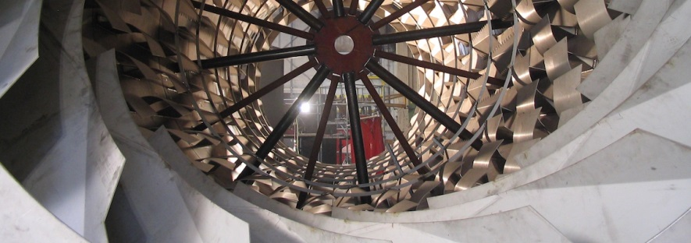
3.4.2 Drying
Conventional drying using rotary louvre or fluidised bed dryers serves to remove free moisture, reducing the moisture content from around 1% (sugar leaving the centrifugals) to 0.1%. VHP sugar dried in this way can be kept for years without significant deterioration. Refined sugar, however, if transported over long distances or stored over long periods, will tend to cake because of the presence of bound moisture.
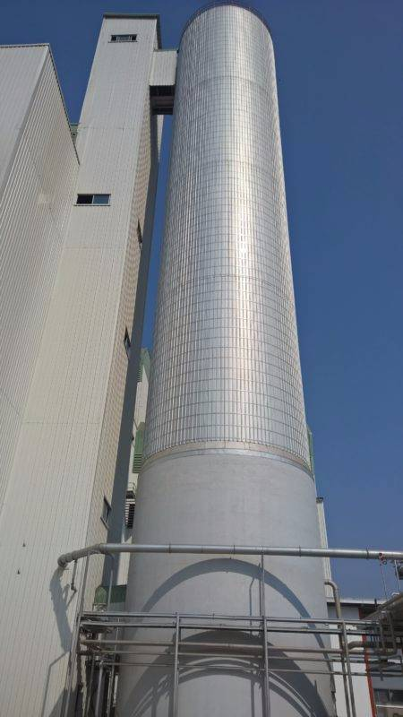
Removal of bound moisture is done by a process called conditioning.

3.4.3 Conditioning
Conditioning is a longer and slower process than drying and consists basically of passing hot dry air through the sugar for about 40 hours. The longer time is needed to allow movement of the moisture through the skin already referred to.
A typical conditioning silo may be 8m in diameter by 30m high. Sugar is introduced at the top and de-humidified air is blown in at the bottom. Air temperature is around 42°C at a relative humidity of 20%.
The moisture content of sugar entering the silo (dried sugar) is 0.1%. Sugar leaves the silo at 0.045% moisture. It must be noted that this is not oven-dried moisture as the moisture bound within the crystal is not released in an oven. In the special procedure employed, the crystals are dissolved in formamide and the moisture content is measured by titration (This is the Karl Fischer method).

Conditioning silos are installed at Hullet Refineries, Noodsberg and Gledhow. Conditioned sugar is transported in bulk to bottlers, canners and other bulk consumers both on the coast and inland.

3.4.4 Sugar as a Fire hazard
Any carbohydrates dust (sugar, flour, meal etc.) can burn and burn explosively. Four conditions are necessary for an explosion to occur.
- The dust concentration must exceed 40g m³ of air (for a dust particle diameter of 0.08 microns).
- The air humidity must be below 60%.
- The oxygen content of air must be 10 – 125 (it is actually well above this).
- A source of ignition (electric or electrostatic spark, a cigarette, a naked flame etc.) of sufficient energy must be present.

Operators working in areas where dry sugar is handled must be aware of the danger of dust explosions, must be trained to use firefighting equipment and must always be alert for conditions that could cause an explosion.

- Knowledge topic 3: Refinery balance and calculations

4.1 REFINERY PERFORMANCE
It is difficult to arrive at accurate sucrose balances in high purity refinery products. Impurity balances are often used to assess performance.

4.1.1 Yields based on conductivity ash
The impurity used is as measured by conductivity (CA). CA is determined for all streams and reported relatively to brix (CA % brix). The ash content stabilises from fine liquor onwards and is therefore useful in tracking crystallisation efficiency.
Two formulae are in use: massecuite yield and overall refinery yield.
Massecuite yield = $\frac{\text{CA \% Bx Run-off -CA \% Bx Mcte}}{\text{CA \% Bx Run-off -CA \& Bx sugar}}$ x 100
An average massecuite yield of 46% is normal and figures around 50% indicate very good pan and centrifugal work.
Overall refinery yield = $\frac{\text{CA \% Bx Return syrup -CA \% Bx F. Liquor }}{\text{CA \% Bx Return syrup -CA \% Bx sugar}}$ x 100
This yield ranges from 75 – 80% for 3 massecuite boiling systems and 80 – 90% for 4 massecuite boiling systems.
Undetermined losses cannot be confidently stated where unmeasured material like sweetwater and dryer lumps are returned to the rawhouse.

4.1.2 Sucrose and colour balances
An alternative scheme is to consider the yield of saleable product per unit of raw sugar processed. Sucrose balances are done to account for the sucrose entering the refinery. The balance involves:
Inputs: Raw sugar
Other sugar
Outputs: Refined sugar
Molasses and syrup
Speciality sugars
Losses: Effluent
Filter cake
Packaging overweights
Condenser water
The overall yield is broken down into process and packing yields. The process yield refers to how much product (refined sugar and others) could be produced from the raw sugar, the packing yield refers to the efficiency of the packaging of the sugar.
Refinery performance can also be assessed by colour balances. A typical colour profile across Hullet Refineries is (figures are loss or gain in colour):
Melting | +15%
Carbonatation | -50%
Ion exchange | -60%
Evaporation | + 5%
Crystallisation | -92%

5. Knowledge topic 4: Problems experienced during sugar refining
The problems associated with sugar refining can be humorously explained in the following “21 Commandments of Sugar Refining”.

The 21 Commandments of Sugar Refining
- Thou shalt remember for eternity that refining consisteth of a number of separations.
- Thou shalt not mix two items that thou hast separated.
- Thou shalt diligently optimise each separation.
- Thou shalt strive to achieve standards and not to exceed them, what needest thou to prove?
- Thou shalt store syrups cool and neutral or slightly alkaline, heat and acidity are abominations.
- Thou shalt heat process steams as late and as fast as possible for thine enemy inversion moves about like a roaring lion.
- Thou shalt keep all stocks low, for thine adversaries Inversion and Bugs seekest to destroy thy hard-earned Pol.
- Thou shalt carry out all processes in the twinkling of an eye.
- Thou shalt minimise the number of operations.
- Thou shalt strive to keep all operations simple.
- Thou shalt opt for neither large nor small – but economic.
- Thou shalt add water to nothing, and where thou canst not help thyself, thou shalt add water using the eye-dropper of an ant.
- Thou shalt thicken sweetwater by adding sugar to it, it is a transgression to evaporate water from it.
- Thou shalt not dissolve crystals, notwithstanding 13.
- Thou shalt not add ash anywhere, ash belongeth unto Lucifer.
- Thou shalt not reprocess, why makest thee thine enemies to rejoice?
- Thou shalt not insist on being technically correct, after the manner of the mule, if thine action doth put shekels down the drain.
- Thou shalt work in a clean plant for from such plants issue forth excellent results.
- Thou shalt remember that a Band-Aid and Pratley Putty refinery run by the righteous is better than a Rolls Royce refinery driven by the ungodly.
- Thou shalt be extremely cautious of sugar dust, for when it doth explode, it doth flatten everything around it, thyself included. Surely thou dost not desire to return unto dust in this manner?
Thou shalt inscribe these commandments on the doorposts of thine heart and not depart from them for as long as thou dost tarry in the refining business, neither shalt thou murmur that thy doorposts lacketh space, thou shalt learn to write smaller.
6. Sources and further reading
Meads, G.P. and Chen, J.C., Cane Sugar Handbook, John Wiley & Sons, 10th Edition, New York. 1977, Ch. 18 and 19
Jenkins, G.H., Introduction to Cane Sugar Technology, Elservier Pub. Co., Amsterdam 1966, Ch.28
Anon., Laboratory Manual for South African Sugar Factories, S.A. Sugar Technologists’ Assoc., Mt. Edgecombe 1985
Wiche, H.F. and Pillay, J.V., Summaries of Talks presented at the Collogium on refining held at SMRI on 24 October 1985, Sugar Milling Research Institute, Tech. Report No. 1432, 6 Feb 1986, University of Natal, Durban
Loker, C.R., Refinery Operations, Hullet Refineries Limited
Rein, G.S., Notes on Sugar Refining, C.S. Smith sugar Ltd., Gledhow
Baikow, V.E, Manufacture and Refining of Raw Cane Sugar, Elservier Pub. Co., 2nd Edition, Amsterdam 1982, Ch. 19 – 29

