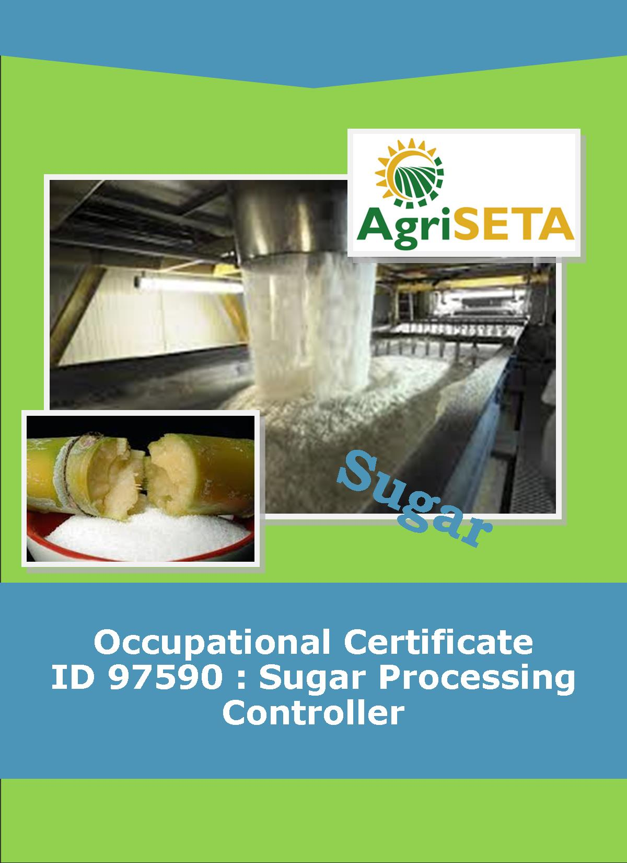**LEARNER SUMMATIVE ASSESSMENT TOOL: KNOWLEDGE MODULE 11:**

**KNOWLEDGE COMPONENT: LEARNER SUMMATIVE ASSESSMENT TOOL: KNOWLEDGE MODULE 11: OPERATIONS MANAGEMENT**

**Occupational Certificate: Sugar Processing Controller**

**LEARNER SUMMATIVE ASSESSMENT TOOL**

**KNOWLEDGE MODULE 11: OPERATIONS MANAGEMENT**

**OPERATIONS MANAGEMENT**

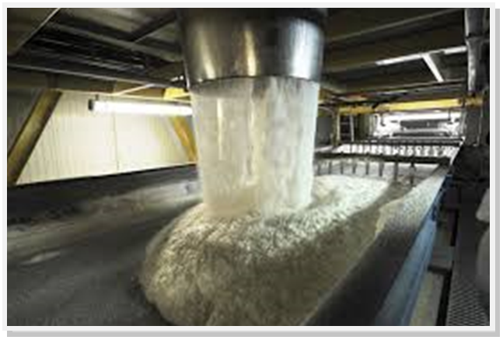

**OCCUPATIONAL CERTIFICATE: ID 97590: SUGAR PROCESSING CONTROLLER**

**©Copyright AgriSETA**

**Telephone: +27 12 301 5600**



AgriSETA holds the copyright to its publications and Web pages. Proper citation is requested.

**TABLE OF CONTENTS**

1. STAKEHOLDER INFORMATION 6

2. COMPETENCY SUMMARY OF ASSESSMENT 8

3. ASSESSMENT ALIGNMENT MATRIX (INTERGRATED OUTCOMES) 9

4. ASSESSMENT DECISION & EVIDENCE EVALUATION RECORD 11

5. OVERALL ASSESSMENT DECISION 12

6. Evidence of feedback 13

7. OVERALL RESULTS 14

8. ASSESSMENT REVIEW 15

9. FINAL DECISION 17

10. LEARNER FEEDBACK FORM 18

11. SUMMATIVE ASSESSMENT INSTRUCTIONS 19

12. WRITTEN ASSESSMENT 20

13. FINAL MARKS 28

1. STAKEHOLDER INFORMATION

|  |  |
| --- | --- |
| **LEARNER INFORMATION** | |
| **Name** |  |
| **Surname** |  |
| **ID number** |  |
| **Mobile phone contact number** |  |
| **E-mail address** |  |
| **Physical address** |  |
| **Postal address** |  |
| **Employer Name** |  |
| **Employer Contact Details** |  |

|  |  |
| --- | --- |
| **ASSESSOR DETAILS** | |
| **Name** |  |
| **Surname** |  |
| **Assessor ID** |  |
| **Project Name** | Occupational Certificate ID 97590:Sugar Processing Controller |
| **Module No.** | **Module 11: Operations Management** |
| **Date of Assessment** |  |
| **Portfolio submission Date** |  |
| **Assessor Signature** |  |
| **Total Marks for Knowledge Module 9** | 102 marks |
| **Marks attained** |  |
| **Place:** |  |

|  |  |
| --- | --- |
| **MODERATOR DETAILS** | |
| **Moderator Name** |  |
| **Moderator ID** |  |
| **Moderator Signature** |  |
| **Date of Moderation** |  |

1. COMPETENCY SUMMARY OF ASSESSMENT

|  |  |  |  |
| --- | --- | --- | --- |
|  | | | |
| **Module 9** | **KM-11-KT01: General operational management concepts** | **C** | **NYC** |
| **1** | 1.1. Operational management can be explained in terms of the role and function of the Operational Manager in a production environment |  |  |
| **2** | **KM-11-KT02: Employment relations management** | **C** | **NYC** |
|  | 2.1 The concept of fairness as applied in industrial relations can be explained |  |  |
|  | 2.2. An understanding of the use of procedures and codes to manage industrial relations can be demonstrated |  |  |
|  | 2.3. Principles of conflict resolution can be explained |  |  |
| **3** | **KM-11-KT03: Financial management concepts** | **C** | **NYC** |
|  | 3.1. An understanding of production costs under the control of the operational manager can be demonstrated |  |  |
|  | 3.2. The budgeting process and the use of budgets for cost control purposes can be defined and explained |  |  |
| **4.** | **KM-11-KT04: Personnel management concepts** | **C** | **NYC** |
|  | 4.1. An understanding of personnel management concepts under the control of the operational manager can be demonstrated |  |  |

1. ASSESSMENT ALIGNMENT MATRIX (INTERGRATED OUTCOMES)

|  |  |  |  |  |  |  |  |
| --- | --- | --- | --- | --- | --- | --- | --- |
| **Module No: 11** | **How it is assessed (Assessment methodology)** | **Where is it covered (learning material)** | **Where it is assessed** | | **First Submission** | | |
|  | **Summative** | **Formative** |
| **SAQA ID Number:** 97590 | Two methods of assessment are followed which are:  1. Summative assessment: written tests, knowledge questions using fundamental and reflexive questions.  2. Formative assessment: assignments, tasks, portfolio of evidence submitted and presentations. |  |  |  | **Clearly meets all the criteria** | **Meets some but not all criteria** | **Clearly does not meet any of the criteria** |
| **Title: Operations Management** |  |  |  |  |  |  |
| **NQF level and credits:**  NQF Level 5: 12 Credits |  |  |  |  |  |  |
| **Topic: 1** General operational management concepts |  | Question 11.1-11.4&11.8 page 20-21 | Learning Activity 1.1-1.2 page 11-15 |  |  |  |
| **Assessment criteria**: Operational management can be explained in terms of the role and function of the Operational Manager in a production environment |  | Question 11.20&11.21 page 26-27 |  |  |  |  |
| **Topic 2. Employment relations management** |  |  | Question 11.13 page 2 | Learning Activity 2.1-2.4 page17-26 |  |  |  |
| **Assessment criteria:** **The concept of fairness as applied in industrial relations can be explained** |  | Question 11.14-11.17 page 24-26 |  |  |  |  |
| **Assessment criteria:** **An understanding of the use of procedures and codes to manage industrial relations can be demonstrated** |  |  |  |  |  |  |  |
| **Assessment criteria** **Principles of conflict resolution can be explained** |  |  |  |  |  |  |  |
| **Topic 3. Financial management concepts** |  |  | Question 11.5-11.6 page 21-22 | Learning Activity 3.1page 28-30 |  |  |  |
| **Assessment criteria: An understanding of production costs under the control of the operational manager can be demonstrated** |  | Question 11.11 page 23 |  |  |  |  |
|  | Question 11.10 page 23 |
| **Assessment criteria:** **The budgeting process and the use of budgets for cost control purposes can be defined and explained** |  |  |  |  |  |  |  |
| **Topic 4. Personnel management concepts** |  |  | Question 11.7 page 22 | Learning Activity 4.1-4.4 page 31-41 |  |  |  |
| **Assessment criteria: An understanding of personnel management concepts under the control of the operational manager can be demonstrated** |  |  | Question 11.18-11.19 page 26 |  |  |  |  |

1. ASSESSMENT DECISION & EVIDENCE EVALUATION RECORD

|  |  |  |  |  |
| --- | --- | --- | --- | --- |
| Candidate's Name: - | | | | |
| Assessor's Name: - | | | | |
| **Practical assessment**  I declare that this assessment is my own demonstration.  Marks: The learner is either “Met requirements” or “did not meet requirements”. If the learner did not meet requirements in an area, then he or she must be reassessed.  **Learner achieved: Met requirements /Did not meet requirements** | | | | |
| **KNOWLEDGE MODULE 11:OPERATIONS MANAGEMENT** | | | | |
| **Overall outcome:** | | | | |
| **Specific Outcome** | | **Met requirements** | **Did not meet requirements** | **Comments** |
| 1 |  |  |  |  |
| **Specific Outcome** | | **Met requirements** | **Did not meet requirements** | **Comments** |
| 2 |  |  |  |  |
|  | **Specific outcome** | **Met requirements** | **Did not meet requirements** | **Comments** |
| 3 |  |  |  |  |
|  | **Specific outcome** | **Met requirements** | **Did not meet requirements** | **Comments** |
| 4 |  |  |  |  |

1. OVERALL ASSESSMENT DECISION

|  |
| --- |
|  |
| **Assessors Comments:** |
| Signature of Assessor: |
| Date: |

1. Evidence of feedback

|  |  |  |
| --- | --- | --- |
| **Module No : 12**  **Level :5**  **Assessor :**……………………………………………………………………………  **Candidate :**…………………………………………………………………………..  **Date of final assessment:**……………………………………………………………. | | |
| **Evidence criteria** | **Achieved** | **Not** |
| 1. Constructive |  |  |
| 2. Timeous (according to Plan) |  |  |
| 3. Correct mode / medium |  |  |
| 4. Participative |  |  |
| 5. Developmental |  |  |
| 6. Accurate |  |  |
| 7. Specific |  |  |
| 8. Documented |  |  |
| 9. Directed to correct parties |  |  |
| **Signing off date:** …………………………………………….  ..........……………. ………………………………….  **Assessor Candidate** | | |

1. OVERALL RESULTS

|  |  |  |  |  |
| --- | --- | --- | --- | --- |
| **OVERALL RESULT** | **Competent** | |  | |
| **Not Yet Competent** | |  | |
| Declaration by Candidate | | | | |
| I, …………………………………………………………………….declare that I am satisfied that the feedback given to me by the Assessor was relevant, sufficient and done in a constructive manner. I accept the assessment decisions and do realise that have no further questions relating to this particular assessment process. I do realise that after this assessment decision, the moderator will either uphold or reverse this assessment decision taken by the assessor. | | | | |
| **Candidate : _____________**  **_______________________**  **Date: __________________**  **Signature: ______________** | | **Assessor : _____________**  **_______________________**  **Date: __________________**  **Signature: ______________** | | **Moderator : _____________**  **_______________________**  **Date: __________________**  **Signature: ______________** |

1. ASSESSMENT REVIEW

|  |  |  |  |  |  |  |  |  |  |  |  |  |  |  |  |  |
| --- | --- | --- | --- | --- | --- | --- | --- | --- | --- | --- | --- | --- | --- | --- | --- | --- |
| **Assessor’s Name** | |  | | | | | | | **ID Number** | | | | |  | | |
| **Contact Details of Assessor** | | **Email** | |  | | | | | | | | | | | | |
| **Phone** | |  | | | | | | | | | | | | |
| **Fax** | |  | | | | | | | | | | | | |
| **PART 1** | | | | | | | | | | | | | | | | |
|  | **Review Criteria** | | **Valid** | | **Authentic** | **Current** | | **Consistent** | | | **Reliable** | | **Sufficient** | | | **Comments** |
| ***Please conduct an honest review of the Assessment Instruments used in this assessment:*** | | | | | | | | | | | | | | | | |
| 1 | Evidence Topic 1 | |  | |  |  | |  | | |  | |  | | |  |
|  | Knowledge Assignment | |  | |  |  | |  | | |  | |  | | |  |
| Practical Assignment | |
| Natural Occurring Evidence | |
| Reflection | |
| 2 | Evidence Topic 2 | |  | |  |  | |  | | |  | |  | | |  |
|  | Knowledge Assignment | |  | |  |  | |  | | |  | |  | | |  |
| Practical Assignment | |
| Natural Occurring Evidence | |
| Reflection | |
| 3 | Evidence Topic 3 | |  | |  |  | |  | | |  | |  | | |  |
|  | Knowledge Assignment | |  | |  |  | |  | | |  | |  | | |  |
| Practical Assignment | |
| Natural Occurring Evidence | |
| Reflection | |
| 4 | Evidence Topic 4 | |  | |  |  | |  | | |  | |  | | |  |
|  | Knowledge Assignment | |  | |  |  | |  | | |  | |  | | |  |
|  | Practical Assignment | |
|  | Natural Occurring Evidence | |
|  | Reflection | |
| **PART 2** | | | | | | | | | | | | | | | | |
| **No** | **Review Criteria** | | | | | | | | | **Yes** | | **No** | | | **Remarks** | |
| 1 | Do you feel the candidate was appropriately selected and prepared for the RPL assessment? | | | | | | | | |  | |  | | |  | |
| 2 | Did the candidate interpret the evidence requirements appropriately? | | | | | | | | |  | |  | | |  | |
| 3 | Was the assessment free of potential assessment barriers such as language, literacy, access to resources? | | | | | | | | |  | |  | | |  | |
| 4 | Was the assessment evidence presented by the candidate valid, authentic, current and sufficient? | | | | | | | | |  | |  | | |  | |
| 5 | Was the candidate’s workplace access to evidence sufficiently supportive of the assessment strategy? | | | | | | | | |  | |  | | |  | |
| 6 | Do you feel you could make a fair, valid and reliable assessment decision? | | | | | | | | |  | |  | | |  | |
| **Recommendations** | | | | | | | | | | | | | | | | |
| ***(Feedback on Validity, authenticity, currency and sufficiency of candidate evidence.)*** | | | | | | | | | | | | | | | | |
|  | | | | | | | | | | | | | | | | |
|  | | | | | | | | | | | | | | | | |
|  | | | | | | | | | | | | | | | | |
|  | | | | | | | | | | | | | | | | |
|  | | | | | | | | | | | | | | | | |
|  | | | | | | | | | | | | | | | | |
|  | | | | | | | | | | | | | | | | |
|  | | | | | | | | | | | | | | | | |
|  | | | | | | |  | | | | | | | | | |
| **Assessor Signature** | | | | | | | **Date Review Completed** | | | | | | | | | |

1. FINAL DECISION

|  |
| --- |
| **I………………………………………………………. hereby declare Ms/Mr**  **………………………………………… Competent Not Yet Competent** |
| **FEEDBACK TO LEARNER:**  **……………………..………………………..………………………..……………………**  **……………………..………………………..………………………..………………………**  **……………………..………………………..………………………..………………………**  **……………………..………………………..………………………..………………………**  **SIGN: …………………………………… DATE: ……………………..........................** |
| **LEARNER FEEDBACK:**  **……………………..………………………..………………………..………………………**  **……………………..………………………..………………………..………………………**  **……………………..………………………..………………………..………………………**  **……………………..………………………..………………………..………………………**  **SIGN: ……………………………………… DATE: …………………….......................** |
| **MODERATOR FEEDBACK:**  **………………………..………………………..………………………..……………………**  **………………………..………………………..………………………..……………………**  **……………………..………………………..………………………..………………………**  **……………………..………………………..………………………..………………………**  **SIGN: …………………………………… DATE: ……………………........................** |

1. LEARNER FEEDBACK FORM

|  |  |  |  |
| --- | --- | --- | --- |
| **CRITERIA** | **EVIDENCE** | **CRITERIA** | **EVIDENCE** |
| How did your assessor encourage you and put you at ease during the assessment process? |  | Were you given clear and constructive feedback? |  |
| Were your assessor’s questions clear and pitched at the right level of language usage? |  | Did your assessor assess all the evidence provided by you? |  |
| Do you believe that all the assessment criteria and knowledge requirements of the standard you were being measured against were considered in your assessment? |  | Were you aware of any discrimination practice carried out by your assessor towards you? |  |

**LEARNER SIGNATURE:………………………………………………**

**DATE:.…………………………..**

1. SUMMATIVE ASSESSMENT INSTRUCTIONS

**Instructions**

* Work individually and answer all questions.
* Use a black pen and ensure that you complete the questions in your own handwriting.
* Time to spend on this assessment is **1.5 hours.**
* The marks you will attain for each question are shown in brackets.

1. WRITTEN ASSESSMENT

**Candidate instruction:** Complete the following multiple-choice questionnaire by marking the most appropriate response with an x in the space provided.

|  |  |  |  |  |  |
| --- | --- | --- | --- | --- | --- |
| **Scope of Assessment** | | **Exit Level Outcome/s** | | **Module/s** | |
|  | | 1. :**Operations Management** | | **11** | |
| **Alignment – Learning Outcome 1,2,3&4: General, Employment, Financial and Personnel Management**  **Award one mark for selection of valid “x”. One mark = Competent** | | | | | |
| **11.1** | **What is the role of the operational manager?** | | | | **Mark Allocation** | |
| **a** | 🞎 | | Provides the mode of operation to accomplish the objectives. | |  | |
| **b.** | 🞎 | | Changing plans according to results of control task | |  | |
| **c.** | 🞎 | | Determining and defining the objectives | |  | |
| **d.** | 🞎 | | Responsible for the technical management, supervision and control of industrial production processes | |  | |
| **e.** | 🞎 | | Specifying policy and procedures | | 4 | |

|  |  |  |  |  |
| --- | --- | --- | --- | --- |
| **11.2** | **Definition of Leadership is:** | | **Mark Allocation** | |
| **a.** | 🞎 | A scientific process which could be defined as the determination of those future activities required to achieve the objectives. | |  | |
| **b.** | 🞎 | The relationship between people, work and resources used to achieve the common objectives (goals) | |  | |
| **c.** | 🞎 | The process of selecting a particular strategy or course of action from among alternative courses of action with the objective of obtaining the greatest satisfaction of the goals. | |  | |
| **d.** | 🞎 | It is a process of ensuring that manufacturing processes run reliably and efficiently. | |  | |
| **e.** | 🞎 | The process of social influence in which one person can enlist the aid and support of others in the accomplishment of a common task | | 4 | |

|  |  |  |  |
| --- | --- | --- | --- |
| **11.3** | **What is Scheduling?** | | **Mark Allocation** |
| **a.** | 🞎 | the relationship between people, work and resources used to achieve the common objectives (goals) |  |
| **b.** | 🞎 | the process of arranging, controlling and optimizing work and workloads in a production process |  |
| **c.** | 🞎 | Anticipating future problems and developing plans for unforeseen circumstances |  |
| **d.** | 🞎 | Forecasting uncertainties |  |
| **e.** | 🞎 | process of social influence in which one person can enlist the aid and support of others in the accomplishment of a common task | 4 |

|  |  |  |  |
| --- | --- | --- | --- |
| **11.4** | **What does seeing the big picture mean?** | | **Mark Allocation** |
| **a.** | 🞎 | A desire to solve complex problems and discover patterns in events is particularly prevalent. |  |
| **b.** | 🞎 | To arrange, control and optimize work |  |
| **c.** | 🞎 | The ability of a successful manager to rise above a particular situation and see it in its broader context, and then to descend to attend to the detail |  |
| **d.** | 🞎 | To believe in what you are doing. |  |
| **e.** | 🞎 | The capacity to perceive the need for action and then to do something about it | 4 |

|  |  |  |  |
| --- | --- | --- | --- |
| **11.5** | **What are variable costs?** | | **Mark Allocation** |
| **a.** | 🞎 | Are those costs that are constant and have to be paid regularly, although their value may change over time, for example, rent, electricity, salaries, etc. |  |
| **b.** | 🞎 | Are costs which cannot be directly linked to the production of the crop that the farm sells |  |
| **c.** | 🞎 | Are those that change depending on the time of year and what is happening on the farm, for example, fertiliser, raw materials, diesel, agrochemicals, etc. |  |
| **d.** | 🞎 | Consist of all non-directly allocatable variable costs |  |
| **e.** | 🞎 | Are costs directly related to the production of the product that generates the income | 4 |

|  |  |  |  |
| --- | --- | --- | --- |
| **11.6** | **What is budgeting?** | | **Mark Allocation** |
| **a.** | 🞎 | An amount which is in the bank at the end of the year |  |
| **b.** | 🞎 | Acquiring the personnel and other resources necessary to get the tasks don |  |
| **c.** | 🞎 | Is an essential financial management tool which involves planning and controlling of finances for a specific period |  |
| **d.** | 🞎 | A process of implementing a decision |  |
| **e.** | 🞎 | Is the assignment of authority and responsibility to another person | 4 |

|  |  |  |  |
| --- | --- | --- | --- |
| **11.7** | **What is a contract?** | | **Mark Allocation** |
| **a.** | 🞎 | A natural person (an individual) or a group of individuals such as a partnership, a company or a close corporation that has full contractual capacity |  |
| **b.** | 🞎 | A document used to determine the future of cash flow for a specific business. |  |
| **c.** | 🞎 | A legal document, a binding agreement between two or more legal persons that is enforceable by law |  |
| **d.** | 🞎 | A document which you present to potential sponsors or clients to receive funding or get your project approved. |  |
| **e.** | 🞎 | A document used to make an offer for the supply of goods or services | 4 |

|  |  |  |  |
| --- | --- | --- | --- |
| **11.8** | **Why is control necessary, choose two correct answers** | | **Mark Allocation** |
| **a.** | 🞎 | In order to implement the plan that has been developed |  |
| **b.** | 🞎 | Although everything may be going according to plan, the dynamic nature of the environment could result in a plan becoming outdated |  |
| **c.** | 🞎 | To Identify and define problems and opportunities |  |
| **d.** | 🞎 | Help choose the best alternative |  |
| **e.** | 🞎 | Planning is often hampered by an uncertain environment and incomplete knowledge. Some of the assumptions made could easily be incorrect; therefore adjustments and modifications are often necessary. | 8 |

|  |  |  |  |
| --- | --- | --- | --- |
| **11.9** | **What is delegation** | | **Mark Allocation** |
| **a.** | 🞎 | To Identify and define problems and opportunities |  |
| **b.** | 🞎 | To accept responsibility for the decision and its consequences |  |
| **c.** | 🞎 | Is the assignment of authority and responsibility to another person (normally from a manager to a subordinate) to carry out specific activities. |  |
| **d.** | 🞎 | To identify and define problems and opportunities |  |
| **e.** | 🞎 | A process of implementing a decision | 4 |

|  |  |  |  |
| --- | --- | --- | --- |
| **11.10** | **Choose two correct answers, the main steps in company budgetary control are:** | | **Mark Allocation** |
| **a.** | 🞎 | Definition of objectives |  |
| **b.** | 🞎 | Correcting deviations from standards and plans. |  |
| **c.** | 🞎 | Keeping the relevant records |  |
| **d.** | 🞎 | Assessing labour and material requirements, and availability. |  |
| **e.** | 🞎 | Budget approval | 8 |

|  |  |  |  |
| --- | --- | --- | --- |
| **11.11** | **Define waste** | | **Mark Allocation** |
| **a.** | 🞎 | Correction of defective material or errors |  |
| **b.** | 🞎 | is a transaction in which the contract states the sale of property |  |
| **c.** | 🞎 | Handling and investigation of rejected or recalled products, including transport costs |  |
| **d.** | 🞎 |  |  |
| **e.** | 🞎 | Poor work performance, errors, poor organization and poor communication in the plant. | 4 |

**TRUE OR FALSE QUESTIONS:**

**Award one mark for each selection of valid “T/F”.**

|  |  |  |  |
| --- | --- | --- | --- |
| **11.12** | **True or False the following are the characteristics of being a leader** | | **Mark Allocation** |
| **a.** | 🞎 | Intelligence |  |
| **b.** | 🞎 | Initiative |  |
| **c.** | 🞎 | Self-assurance |  |
| **d.** | 🞎 | Seeing the big picture |  |
| **e.** | 🞎 | determination | 5 |

|  |  |  |  |
| --- | --- | --- | --- |
| **11.13** | **The following are laws and regulations which relates to human resource management.** | | **Mark Allocation** |
| **a.** | 🞎 | The Adult Basic Education and Training Act |  |
| **b.** | 🞎 | Demotion, dismissal or summary dismissal |  |
| **c.** | 🞎 | The Agricultural Labour Act, 1993 (Act No. 147 of 1993 |  |
| **d.** | 🞎 | Employment Equity Act, 1998 (Act No. 55 of 1998) |  |
| **e.** | 🞎 | Skills Development Act, 1998 (Act No. 97 of 1998): | 5 |

|  |  |  |  |
| --- | --- | --- | --- |
| **11.14** | **True or False results of bad communication are:** | | **Mark Allocation** |
| **a.** | 🞎 | Conflict |  |
| **b.** | 🞎 | Demotivation |  |
| **c.** | 🞎 | Poor working relationship |  |
| **d.** | 🞎 | Motivation |  |
| **e.** | 🞎 | High production | 5 |

|  |  |  |  |  |
| --- | --- | --- | --- | --- |
| **11.15** | **True or False the following are procedures to follow when employer is dissatisfied** | | | **Mark Allocation** |
| **a.** | 🞎 | Fire an employee immediately |  | |
| **b.** | 🞎 | Written warning |  | |
| **c.** | 🞎 | Issue an employee with a penalty |  | |
| **d.** | 🞎 | Final written warning |  | |
| **e.** | 🞎 | Demotion, dismissal or summary dismissal | 5 | |

|  |  |  |  |  |
| --- | --- | --- | --- | --- |
| **11.16** | **True or False benefits of on the job training for both employer and employee are:** | | **Mark Allocation** | |
| **a.** | 🞎 | Improved performance | |  | |
| **b.** | 🞎 | To give full details of what is expected of you as an employee | |  | |
| **c.** | 🞎 | Update employee’s skills | |  | |
| **d.** | 🞎 | To enable equality at the workplace | |  | |
| **e.** | 🞎 | Satisfy personal growth needs | | 5 | |

|  |  |  |  |  |
| --- | --- | --- | --- | --- |
| **11.17** | **True or False causes of strikes are:** | | **Mark Allocation** | |
| **a.** | 🞎 | Unfair treatment | |  | |
| **b.** | 🞎 | High wages | |  | |
| **c.** | 🞎 | Unfair payments | |  | |
| **d.** | 🞎 | Poor working conditions | |  | |
| **e.** | 🞎 | Good communication | | 5 | |

|  |  |  |  |  |
| --- | --- | --- | --- | --- |
| **11.18** | **True of False the following are different types of contract.** | | **Mark Allocation** | |
| **a.** | 🞎 | Employment contracts | |  | |
| **b.** | 🞎 | Contract to purchase | |  | |
| **c.** | 🞎 | Marketing contracts | |  | |
| **d.** | 🞎 | A proposal document | |  | |
| **e.** | 🞎 | Credit agreements | | 5 | |

|  |  |  |  |  |
| --- | --- | --- | --- | --- |
| **11.19** | **True or False the purpose of a contract is?** | | **Mark Allocation** | |
| **a.** | 🞎 | To balance the risks | |  | |
| **b.** | 🞎 | To get more power over someone | |  | |
| **c.** | 🞎 | Provide certainty | |  | |
| **d.** | 🞎 | To get funding | |  | |
| **e.** | 🞎 | To avoid disputes | | 5 | |

|  |  |  |  |  |
| --- | --- | --- | --- | --- |
| **11.20** | **True of False the functions of leaders are?** | | **Mark Allocation** | |
| **a.** | 🞎 | Provide for the well-being of the led | |  | |
| **b.** | 🞎 | Do employee payments | |  | |
| **c.** | 🞎 | Provide a social organization in which people feel relatively secure | |  | |
| **d.** | 🞎 | Hiring of new staff | |  | |
| **e.** | 🞎 | Provide a set of beliefs. | | 5 | |

|  |  |  |  |  |
| --- | --- | --- | --- | --- |
| **11.21** | **The decision making process consist of the following steps.** | | **Mark Allocation** | |
| **a.** | 🞎 | Identify and define problems or opportunities | |  | |
| **b.** | 🞎 | Gather and analyse relevant information, opinions and facts | |  | |
| **c.** | 🞎 | Identify and analyse alternative actions and solutions | |  | |
| **d.** | 🞎 | Make the decision – choose the best option | |  | |
| **e.** | 🞎 | Accept responsibility for the decision and its consequences | | 5 | |

1. FINAL MARKS

**TOTAL MARKS: 102**

**PASS MARK: 82**

|  |  |
| --- | --- |
| **LEARNER MARKS** |  |
| **PERCENTAGE** |  |
| **ASSESSOR SIGNATURE:** | |