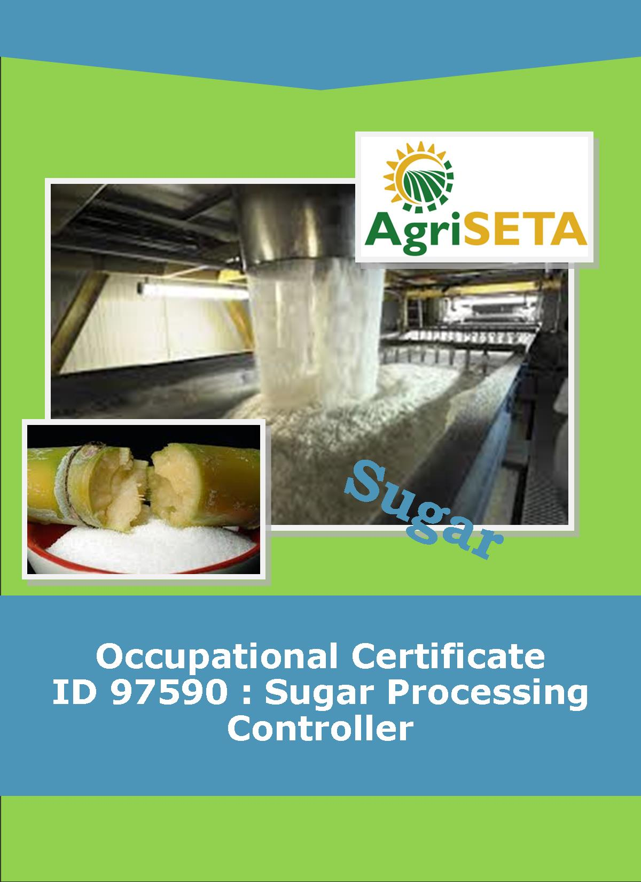**KNOWLEDGE COMPONENT:**

**KNOWLEDGE COMPONENT: LEARNER WORKBOOK 12: SAFETY, HEALTH, ENVIRONMENT, RISK AND QUALITY CONTROL (SHERQ)**

**Occupational Certificate: Sugar Processing Controller**

**KNOWLEDGE COMPONENT: LEARNER WORKBOOK 12:**

**SAFETY, HEALTH, ENVIRONMENT, RISK AND QUALITY CONTROL (SHERQ)**

**LEARNER WORKBOOK 12:**

**SAFETY, HEALTH, ENVIRONMENT, RISK AND QUALITY CONTROL (SHERQ)**

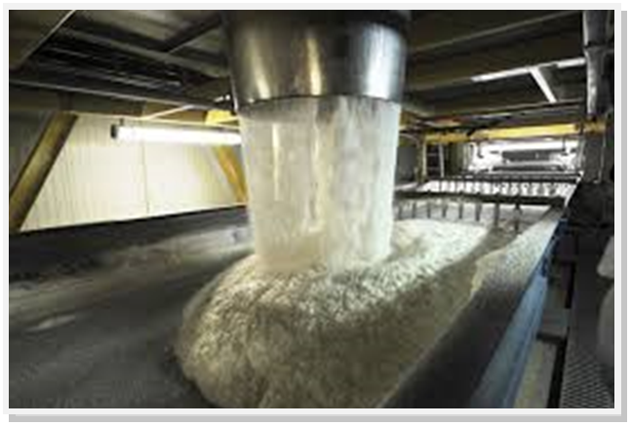

**OCCUPATIONAL CERTIFICATE: SUGAR PROCESSING CONTROLLER**

**©Copyright AgriSETA**

**Telephone: +27 12 301 5600**

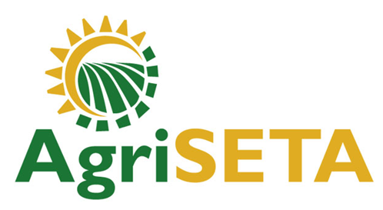

AgriSETA holds the copyright to its publications and Web pages. Proper citation is requested.

**TABLE OF CONTENTS**

1. AN INTRODUCTION TO THIS LEARNER WORKBOOK 6

2. LEARNER DETAILS 7

3. FORMATIVE ASSESSMENT INSTRUCTIONS 8

4. KNOWLEDGE MODULE 12: SAFETY, HEALTH, ENVORONMENT, RISK AND QUALITY CONTROL (SHERQ) 9

4.1 Knowledge Topic 1: Quality management (20%) 10

4.2 Knowledge Topic 2: Occupational safety, health and environmental protection management concepts (25%) 15

4.3 Knowledge topic 3: Controlling quality (20%) 22

4.4 Knowledge topic 4: Environmental protection and pollution concepts (10%) 25

4.5 Knowledge topic 5: Contamination control (10%) 28

4.6 Knowledge topic 6: Risk control and safety practices (15%) 32

5. CONCLUSION OF KNOWLEDGE MODULE 12: SAFETY, HEALTH, ENVIRONMENT, RISK AND QUALITY CONTROL (SHERQ) 37

1. AN INTRODUCTION TO THIS LEARNER WORKBOOK

This Knowledge Component Learner Workbook 12: Safety, Health, Environment, Risk and Quality Control (SHERQ) is intended to be used with the Knowledge Component Learning Resource: Book 12 (Textbook): Safety, Health, Environment, Risk and Quality Control of the Occupational Qualification: Sugar Processing Controller NQF 5.

Guidance on the use of this Work Book is provided in the Learning Guide.

1. LEARNER DETAILS

|  |  |
| --- | --- |
| First name |  |
| Surname |  |
| ID number |  |
| Mobile phone contact number |  |
| E-mail address |  |
| Postal address |  |
| Date on which you started this Knowledge Module |  |
| Date on which you completed this Knowledge Module |  |
| Declaration: | I hereby confirm that:   * I received the assessment plan and schedule. * I understand my rights in terms of special needs, re-assessment, feedback and appeals against assessment decisions. * I completed this formative assessment independently without assistance from anyone else. |
| Total Marks for Knowledge Module 12 | **163** |
| Marks attained |  |
| Date: |  |
| Place: |  |
| Signature of Learner: |  |
| Signature of Assessor: |  |

1. FORMATIVE ASSESSMENT INSTRUCTIONS

**Instructions**

* Work individually to present the results of each Learning Activity in this Learner Workbook.
* Complete all the sections.
* Use a black pen and ensure that you complete the questions in your own handwriting.
* A recommended time to complete each activity is shown.
* The marks you will attain for each learning activity are shown in brackets.
* The total marks obtained for each Knowledge Module must be transferred from the back of each Learner Workbook to the Learner Qualification Summative Assessment Tool.

1. KNOWLEDGE MODULE 12: SAFETY, HEALTH, ENVORONMENT, RISK AND QUALITY CONTROL (SHERQ)

**NQF LEVEL: 5**

**CREDITS: 8**

**PURPOSE OF THE KNOWLEDGE MODULE: The main focus of the learning in this knowledge module is to build an understanding of the safety, health, environment, risk and quality control (SHERQ) terms, concepts and established principles applied to first level operational managers.**

The learning will enable learners to demonstrate an understanding of:

* KM-12-KT01: Quality management (20%)
* KM-12-KT02: Occupational safety, health and environmental protection management concepts (25%)
* KM-12-KT03: Controlling quality (20%)
* KM-12-KT04: Environmental protection and pollution concepts (10%)
* KM-12-KT05: Contamination control (10%)
* KM-12-KT06: Risk control and safety practices (15%)

4.1 Knowledge Topic 1: Quality management (20%)

Topic elements to be covered include:

* KT0101 Quality management systems (HACCP, ISO)
* KT0102 Quality administration and reporting
* KT0103 Quality audit procedures

Internal Assessment Criteria and Weight

* IAC0101 Quality management systems can be defined and explained in terms of the purpose of the system, administrative and reporting requirements
* IAC0102 The auditing procedures and importance of maintaining quality certification status can be explained
* (Weight 20%)

**Learning activity 1.1: Individual Learning activity: 45 minutes (30 marks)**



**Learning Objective:** Quality management systems can be defined and explained in terms of the purpose of the system, administrative and reporting requirements

**Task:** Read each question carefully and write your answer in the space provided.

1. What does HACCP stand for? (2)

|  |
| --- |
|  |
|  |

2 Name seven principles of the HACCP concept (14)

|  |
| --- |
|  |
|  |
|  |
|  |
|  |
|  |
|  |
|  |
|  |
|  |
|  |
|  |
|  |
|  |
|  |
|  |
|  |
|  |
|  |
|  |
|  |
|  |

3. Illustrate the ISO cycle (5)

|  |
| --- |
|  |

4. Name five conditions that accidents can lead to (5)

|  |
| --- |
|  |
|  |
|  |
|  |
|  |
|  |

5. Define QMI and explain what is it purpose (2)

|  |
| --- |
|  |
|  |
|  |
|  |

6. What is a quality audit procedure? (2)

|  |
| --- |
|  |
|  |
|  |
|  |
|  |
|  |
|  |
|  |

4.2 Knowledge Topic 2: Occupational safety, health and environmental protection management concepts (25%)

Topic elements to be covered include:

* KT0201 Introduction to the legislative framework that regulates workplace safety, health and environmental protection including appointments, compliance audits, repercussion and personal liability
* KT0202 General overview of statutory provisions of the Act including reporting of IOD, incident investigation and reporting, statutory registers
* KT0203 Incident investigation and reporting procedures
* KT0204 Risk management concepts and practices

Internal Assessment Criteria and Weight

* IAC0201 Responsibilities and delegated authorities of different appointments and management officials can be explained
* IAC0202 Statutory provisions that regulates the sugar milling industry can be listed and their impact explained
* (Weight 25%)

**Learning activity 2.1: Group Learning activity: 15 minutes (15 marks)**



**Learning Objective:** The concept of fairness as applied in industrial relations can be explained

**Task:** Form 4 groups. Do this by assigning everyone a number from 1 to 4. All the “ones” form one group, all the “twos” form the next group, all the “threes” form the third group and all the “fours” form the fourth group.

When you are in your groups, elect one person to be the group’s scribe (the person who will write down the points of your discussion), elect one person to be the group’s time-keeper (this person reminds the group that they are running out of time for the exercise) and one person who will be the group’s reporter (the person who will explain your findings to the class).

1. List and discuss three regulations or legislation Acts pertaining to Safety, Health and the Environment in the space provided below. (10)

|  |
| --- |
|  |
|  |
|  |
|  |
|  |
|  |
|  |
|  |
|  |
|  |
|  |
|  |
|  |

2. How is the OHSA Act applied in the workplace? (5)

|  |
| --- |
|  |
|  |
|  |
|  |
|  |
|  |
|  |

**Learning activity 2.2: Group Learning activity: 30 minutes (10 marks)**



**Learning Objective:** Statutory provision that regulates the sugar milling industry can be listed.

**Task:** Form 4 groups. Do this by assigning everyone a number from 1 to 4. All the “ones” form one group, all the “twos” form the next group, all the “threes” form the third group and all the “fours” form the fourth group.

When you are in your groups, elect one person to be the group’s scribe (the person who will write down the points of your discussion), elect one person to be the group’s time-keeper (this person reminds the group that they are running out of time for the exercise) and one person who will be the group’s reporter (the person who will explain your findings to the class).

1. Use a copy of OHSA that you acquired at your nearest Labour Centre to study the rights of workers in the workplace and capture them in the space provided below. (10)

Answers will be based on the rights stipulated in the OHSA Act.

|  |
| --- |
|  |
|  |
|  |
|  |
|  |
|  |
|  |
|  |
|  |
|  |
|  |
|  |
|  |
|  |
|  |
|  |
|  |
|  |
|  |
|  |
|  |
|  |
|  |
|  |
|  |
|  |
|  |
|  |
|  |

**Learning activity 2.3: Individual Learning activity: 30 minutes (20marks)**



**Learning Objective:** Responsibilities and delegated authorities of different appointments and management officials can be explained

**Task:** Read each question carefully and write your answer in the space provided.

1. Define the following acronyms: SHE and OHSA (2)

|  |
| --- |
|  |
|  |
|  |
|  |

2. What is the aim of COIDA in the workplace? (4)

|  |
| --- |
|  |
|  |
|  |
|  |

3. Mention any three duties of the employer to ensure safety and good working environment. (6)

|  |
| --- |
|  |
|  |
|  |
|  |
|  |

4. Who undertakes investigation, when an accident or incident occurs in the workplace (2)

|  |
| --- |
|  |
|  |
|  |

5. What are the steps to be followed when reporting and claiming from the Compensation Fund? (6)

|  |
| --- |
|  |
|  |
|  |
|  |
|  |
|  |
|  |
|  |
|  |

4.3 Knowledge topic 3: Controlling quality (20%)

Topic elements to be covered include:

* KT0301 Quality Control vs Quality Assurance
* KT0302 Key process stages or factors that could affect quality (Critical Control Points)
* KT0303 Quality indicators at critical stages
* KT0304 Causes of quality problems and remedial actions

Internal Assessment Criteria and Weight

* IAC0301 The control of quality can be described in terms of critical stages in the process, quality indicators, causes of typical quality problems and remedial actions
* (Weight 20%)

**Learning activity 3.1: Individual Learning activity: 30 minutes (12marks)**



**Learning Objective:** The control of quality can be described in terms of critical stages in the process, quality indicators, causes of typical quality problems and remedial actions.

**Task:** Read each question carefully and write your answer in the space provided.

1. True or False, GMP stands for Good Manufacturing Practices. (2)

|  |
| --- |
|  |
|  |

2. There are several elements that are common to a GMP system. These elements cover areas of practice that require attention in the system. Name three. (6)

|  |
| --- |
|  |
|  |
|  |
|  |
|  |
|  |
|  |
|  |
|  |

3. Mention two basic control measures that can be used to eliminate hazards or risks? (2)

|  |
| --- |
|  |
|  |
|  |
|  |
|  |
|  |
|  |

4.4 Knowledge topic 4: Environmental protection and pollution concepts (10%)

Topic elements to be covered include:

* KT0401 Environmental pollution concepts
* KT0402 Sources of and impact of contaminants on the natural environment specific to the sugar milling industry
* KT0403 General rules related to waste control and management
* KT0404 The impact of environmental pollution on natural resources, communities and the economy
* KT0405 Global warming and green production principles

Internal Assessment Criteria and Weight

* IAC0401 Measures to minimise the impact of a sugar mill on the environment can be explained
* (Weight 10%)

**Learning activity 4.1: Individual Learning activity: 30 minutes (12marks)**



**Learning Objective:** Measures to minimise the impact of a sugar mill on the environment can be explained

**Task:**

1. What are the two main environment concerns in the sugar mill? (2)

|  |
| --- |
|  |
|  |

2. What is the main source of air pollution from the sugar mill? And what are the major pollutants? (4)

|  |
| --- |
|  |
|  |
|  |

2. Describe the consequences or negative impacts of the following environmental concerns (4)

• Excessive electricity consumption

• Excessive water use

|  |
| --- |
|  |
|  |
|  |
|  |
|  |
|  |

3. What is the use of sugarcane waste (bagasse)? (2)

|  |
| --- |
|  |
|  |

4.5 Knowledge topic 5: Contamination control (10%)

Topic elements to be covered include:

* KT0501 Pest control principles and practices
* KT0502 Product contamination and deterioration cause by equipment or facilities
* KT0503 Preventative actions for microbial and mycotoxin contamination

Internal Assessment Criteria and Weight

* IAC0501 Contamination control concepts can be explained from a food and product perspective
* (Weight 10%)

**Learning activity 5.1: Individual Learning activity: 1 hour (32 marks)**



**Learning Objective:** Contamination control concepts can be explained from a food safety and product quality perspective.

**Task:**

1**.** Describe the following signs of rodents’ activity in a workplace (4)

* Rodent droppings
* Gnawing teeth marks

|  |
| --- |
|  |
|  |
|  |
|  |
|  |
|  |
|  |

2. Name 3 sources of contamination (3)

|  |
| --- |
|  |
|  |
|  |
|  |

3. Identify measures to control microbial contamination in sugarcane (10)

|  |
| --- |
|  |
|  |
|  |
|  |
|  |
|  |
|  |
|  |
|  |

4. Name five types of fungi found in plants (5)

|  |
| --- |
|  |
|  |
|  |
|  |
|  |

5. The prevention of mycotoxin contamination in agricultural commodities can be divided into three levels. Discuss them. (10)

|  |
| --- |
|  |
|  |
|  |
|  |
|  |
|  |
|  |
|  |
|  |
|  |
|  |

4.6 Knowledge topic 6: Risk control and safety practices (15%)

Topic elements to be covered include:

* KT0601 Risk control concepts
* KT0602 Equipment and mechanical system safety
* KT0603 Basic electrical safety
* KT0604 Emergency response
* KT0605 Dust explosion and spontaneous combustion risks
* KT0606 Fire risks and preventative measures
* KT0607 Access and movement control

Internal Assessment Criteria and Weight

* IAC0601 Risk control and safety practices common to the sugar milling industry can be explained and motivated
* (Weight 15%)

**Learning activity 6.1: Individual Learning activity: 1.5 hours (24marks)**



**Learning Objective:** Contamination control concepts can be explained from a food safety and product quality perspective

**Task:**

1. South Africa is experiencing an electricity supply crisis. Find a newspaper, magazine or internet article explaining the problem and ways in which the government and private sector are planning to resolve the crisis. Paste the article in the space below or insert it into your workbook here. Write a short essay (300 to 450 words) on how you can assist to reduce your energy consumption, both at home and at work. (10)

|  |
| --- |
| Paste your newspaper article here! |
| Write your essay in the space below (or use an extra paper if required) |
|  |
|  |
|  |
|  |
|  |
|  |
|  |
|  |
|  |
|  |
|  |
|  |
|  |
|  |
|  |
|  |
|  |
|  |
|  |
|  |

2. Differentiate between mechanical and non-mechanical hazards (6)

|  |
| --- |
|  |
|  |
|  |
|  |
|  |
|  |
|  |
|  |
|  |
|  |
|  |
|  |
|  |

4. List four natural disasters. (4)

|  |
| --- |
|  |
|  |
|  |
|  |
|  |

5. Define dust explosion and combustion (4)

|  |
| --- |
|  |
|  |
|  |
|  |
|  |

1. CONCLUSION OF KNOWLEDGE MODULE 12: SAFETY, HEALTH, ENVIRONMENT, RISK AND QUALITY CONTROL (SHERQ)

Throughout this knowledge module you have been provided opportunities to complete formative learning activities. You have captured your results in this Learner Workbook.

The total marks for this Knowledge Module are as follows:

|  |  |  |
| --- | --- | --- |
| **Knowledge Module** | **Total Marks** | **Marks attained** |
| M-12-KT01: Quality management (20%) | 30 |  |
| KM-12-KT02: Occupational safety, health and environmental protection management concepts (25%) | 55 |  |
| KM-12-KT03: Controlling quality (20%) | 10 |  |
| KM-12-KT04: Environmental protection and pollution concepts (10%) | 12 |  |
| KM-12-KT05: Contamination control (10%) | 32 |  |
| KM-12-KT06: Risk control and safety practices (15%) | 24 |  |
| **Total Marks** | **163 marks** |  |

