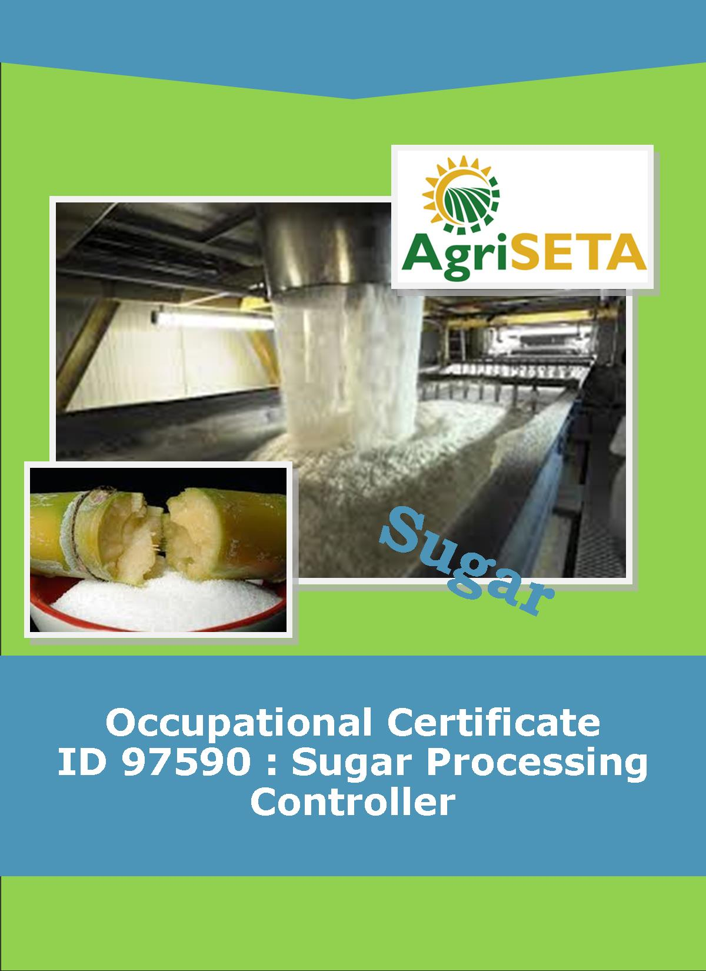**LEARNER SUMMATIVE ASSESSMENT TOOL KNOWLEDGE MODULE 12: SAFETY, HEALTH, ENVIRONMENT, RISK AND QUALITY CONTROL, (SHERQ)**

**KNOWLEDGE COMPONENT: LEARNER SUMMATIVE ASSESSMENT TOOL KNOWLEDGE MODULE 12: SAFETY, HEALTH, ENVIRONMENT, RISK AND QUALITY CONTROL, (SHERQ)**

**Occupational Certificate: Sugar Processing Controller**

**LEARNER SUMMATIVE ASSESSMENT TOOL KNOWLEDGE MODULE 12:**

**SAFETY, HEALTH, ENVIRONMENT, RISK AND QUALITY CONTROL, (SHERQ)**

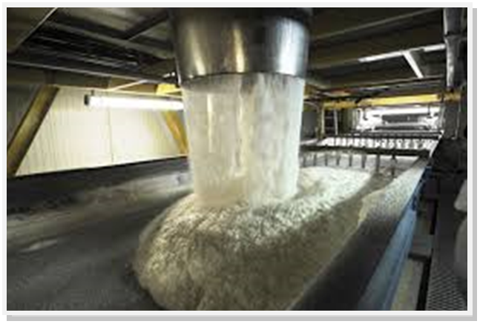

**OCCUPATIONAL CERTIFICATE: ID 97590: SUGAR PROCESSING CONTROLLER**

**©Copyright AgriSETA**

**Telephone: +27 12 301 5600**

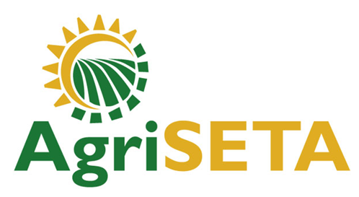

AgriSETA holds the copyright to its publications and Web pages. Proper citation is requested.

**TABLE OF CONTENTS**

1. STAKEHOLDER INFORMATION 6

2. COMPETENCY SUMMARY OF ASSESSMENT 8

3. ASSESSMENT ALIGNMENT MATRIX (INTERGRATED OUTCOMES) 9

4. ASSESSMENT DECISION & EVIDENCE EVALUATION RECORD 11

5. OVERALL ASSESSMENT DECISION 13

6. Evidence of feedback 14

7. OVERALL RESULTS 15

8. ASSESSMENT REVIEW 16

9. FINAL DECISION 18

10. LEARNER FEEDBACK FORM 19

11. SUMMATIVE ASSESSMENT INSTRUCTIONS 20

12. WRITTEN ASSESSMENT 21

13. FINAL MARKS 28

1. STAKEHOLDER INFORMATION

|  |  |
| --- | --- |
| **LEARNER INFORMATION** | |
| **Name** |  |
| **Surname** |  |
| **ID number** |  |
| **Mobile phone contact number** |  |
| **E-mail address** |  |
| **Physical address** |  |
| **Postal address** |  |
| **Employer Name** |  |
| **Employer Contact Details** |  |

|  |  |
| --- | --- |
| **ASSESSOR DETAILS** | |
| **Name** |  |
| **Surname** |  |
| **Assessor ID** |  |
| **Project Name** | Occupational Certificate ID 97590:Sugar Processing Controller |
| **Module No.** | **Module 12: Safety, Health, Environment, Risk And Quality Control, (SHERQ)** |
| **Date of Assessment** |  |
| **Portfolio submission Date** |  |
| **Assessor Signature** |  |
| **Total Marks for Knowledge Module 9** | 90 marks |
| **Marks attained** |  |
| **Place:** |  |

|  |  |
| --- | --- |
| **MODERATOR DETAILS** | |
| **Moderator Name** |  |
| **Moderator ID** |  |
| **Moderator Signature** |  |
| **Date of Moderation** |  |

1. COMPETENCY SUMMARY OF ASSESSMENT

|  |  |  |  |
| --- | --- | --- | --- |
|  | | | |
| **Module 9** | **KM-12-KT01: Quality management** | **C** | **NYC** |
| **1** | 1.1. Quality management systems can be defined and explained in terms of the purpose of the system, administrative and reporting requirements |  |  |
|  | 1.2. The auditing procedures and importance of maintaining quality certification status can be explained |  |  |
| **2** | **KM-12-KT02: Occupational safety, health and environmental protection management concepts** | **C** | **NYC** |
|  | 2.1 Responsibilities and delegated authorities of different appointments and management officials can be explained |  |  |
|  | 2.2. Statutory provisions that regulates the sugar milling industry can be listed and their impact explained |  |  |
|  | 2.3. The concept |  |  |
| **3** | **KM-12-KT03: Controlling quality** | **C** | **NYC** |
|  | 3.1. The control of quality can be described in terms of critical stages in the process, quality indicators, causes of typical quality problems and remedial actions |  |  |
| **4.** | **KM-12-KT04: Environmental protection and pollution concepts** | **C** | **NYC** |
|  | 4.1. Measures to minimise the impact of a sugar mill on the environment can be explained |  |  |
| **5** | **KM-12-KT05: Contamination control** | **C** |  |
|  | 5.1. Contamination control concepts can be explained from a food safety and product quality perspective |  |  |
| **6** | **KM-12-KT06: Risk control and safety practices** | **C** |  |
|  | 6.1. Risk control and safety practices common to the sugar milling industry can be explained and motivated |  |  |

1. ASSESSMENT ALIGNMENT MATRIX (INTERGRATED OUTCOMES)

|  |  |  |  |  |  |  |  |
| --- | --- | --- | --- | --- | --- | --- | --- |
| **Module No: 12** | **How it is assessed (Assessment methodology)** | **Where is it covered (Learning material)** | **Where it is assessed** | | **First Submission** | | |
|  | **Summative** | **Formative** |
| **SAQA ID Number:** 97590 | Two methods of assessment are followed which are:  1. Summative assessment: written tests, knowledge questions using fundamental and reflexive questions.  2. Formative assessment: assignments, tasks, portfolio of evidence submitted and presentations. |  |  |  | **Clearly meets all the criteria** | **Meets some but not all criteria** | **Clearly does not meet any of the criteria** |
| **Title: Safety, Health, Environment, Risk and Quality Control, (SHERQ)** |  |  |  |  |  |  |
| **NQF level and credits:**  NQF Level 5: 8 Credits |  |  |  |  |  |  |
| **Topic: 1** Quality management | Page 12-15 | Question 12.1-12.3 &12.12 page 21,22&25 | Learning Activity 1.1 page 10-14 |  |  |  |
| **Assessment criteria**:  Quality management systems can be defined and explained in terms of the purpose of the system, administrative and reporting requirements |  |  |  |  |  |  |
| **Assessment criteria**: The auditing procedures and importance of maintaining quality certification status can be explained |  |  |  |  |  |  |  |
| **Topic 2. Occupational safety, health and environmental protection management concepts** |  | Page 16-27 | Question 12.4-12.6 & 12.11,13&15 page 22,25,26 | Learning Activity 2.1-2.3 page 11-21 |  |  |  |
| **Assessment criteria:** Responsibilities and delegated authorities of different appointments and management officials can be explained |  |  |  |  |  |  |
| **Assessment criteria:** Statutory provisions that regulates the sugar milling industry can be listed and their impact explained |  |  |  |  |  |  |  |
| **Assessment Criteria:**  **The concept** |  |  |  |  |  |  |  |
| **Topic 3. Controlling quality** |  | Page 28-35 | Question 12.7 page 23 | Learning Activity 3.1 page 23 |  |  |  |
| **Assessment criteria: The control of quality can be described in terms of critical stages in the process, quality indicators, causes of typical quality problems and remedial actions** |  |  |  |  |  |  |
| **Topic 4. Environmental protection and pollution concepts** |  | Page 36-45 | Question 12.8-12.10 & 12.18 page 23,24&27 | Learning Activity 4.1 page 26-27 |  |  |  |
| **Assessment criteria: Measures to minimise the impact of a sugar mill on the environment can be explained** |  |  |  |  |  |  |  |
| **Topic 5. Contamination control** |  | Page 46-55 | Question 12.16,12.17 & 12.19 page 26 | Learning Activity 5.1 page 29-31 |  |  |  |
| **Assessment criteria:Contamination control concepts can be explained from a food safety and product quality perspective** |  |  |  |  |  |  |  |
| **Topic 6.** **Risk control and safety practices** |  | Page 56-72 | Question 12.20 page 27 | Learning Activity 6.1 page 33-36 |  |  |  |
| **Assessment criteria:** **Risk control and safety practices common to the sugar milling industry can be explained and motivated** |  |  |  |  |  |  |  |

1. ASSESSMENT DECISION & EVIDENCE EVALUATION RECORD

|  |  |  |  |  |
| --- | --- | --- | --- | --- |
| Candidate's Name: - | | | | |
| Assessor's Name: - | | | | |
| **Practical assessment**  I declare that this assessment is my own demonstration.  Marks: The learner is either “Met requirements” or “did not meet requirements”. If the learner did not meet requirements in an area, then he or she must be reassessed.  **Learner achieved: Met requirements /Did not meet requirements** | | | | |
| **KNOWLEDGE MODULE 12:** **SAFETY, HEALTH, ENVIRONMENT, RISK AND QUALITY CONTROL (SHERQ)** | | | | |
| **Overall outcome:** | | | | |
| **Specific Outcome** | | **Met requirements** | **Did not meet requirements** | **Comments** |
| 1 |  |  |  |  |
| **Specific Outcome** | | **Met requirements** | **Did not meet requirements** | **Comments** |
| 2 |  |  |  |  |
|  | **Specific outcome** | **Met requirements** | **Did not meet requirements** | **Comments** |
| 3 |  |  |  |  |
|  | **Specific outcome** | **Met requirements** | **Did not meet requirements** | **Comments** |
| 4 |  |  |  |  |
|  | **Specific outcome** | **Met requirements** | **Did not meet requirements** | **Comments** |
| 5 |  |  |  |  |
|  | **Specific outcome** | **Met requirements** | **Did not meet requirements** | **Comments** |
| 6 |  |  |  |  |

1. OVERALL ASSESSMENT DECISION

|  |
| --- |
|  |
| **Assessors Comments:** |
| Signature of Assessor: |
| Date: |

1. Evidence of feedback

|  |  |  |
| --- | --- | --- |
| **Module No : 12**  **Level :5**  **Assessor :**……………………………………………………………………………  **Candidate :**…………………………………………………………………………..  **Date of final assessment:**……………………………………………………………. | | |
| **Evidence criteria** | **Achieved** | **Not** |
| 1. Constructive |  |  |
| 2. Timeous (according to Plan) |  |  |
| 3. Correct mode / medium |  |  |
| 4. Participative |  |  |
| 5. Developmental |  |  |
| 6. Accurate |  |  |
| 7. Specific |  |  |
| 8. Documented |  |  |
| 9. Directed to correct parties |  |  |
| **Signing off date:** …………………………………………….  ..........……………. ………………………………….  **Assessor Candidate** | | |

1. OVERALL RESULTS

|  |  |  |  |  |
| --- | --- | --- | --- | --- |
| **OVERALL RESULT** | **Competent** | |  | |
| **Not Yet Competent** | |  | |
| Declaration by Candidate | | | | |
| I, …………………………………………………………………….declare that I am satisfied that the feedback given to me by the Assessor was relevant, sufficient and done in a constructive manner. I accept the assessment decisions and do realise that have no further questions relating to this particular assessment process. I do realise that after this assessment decision, the moderator will either uphold or reverse this assessment decision taken by the assessor. | | | | |
| **Candidate : _____________**  **_______________________**  **Date: __________________**  **Signature: ______________** | | **Assessor : _____________**  **_______________________**  **Date: __________________**  **Signature: ______________** | | **Moderator : _____________**  **_______________________**  **Date: __________________**  **Signature: ______________** |

1. ASSESSMENT REVIEW

|  |  |  |  |  |  |  |  |  |  |  |  |  |  |  |  |  |
| --- | --- | --- | --- | --- | --- | --- | --- | --- | --- | --- | --- | --- | --- | --- | --- | --- |
| **Assessor’s Name** | |  | | | | | | | **ID Number** | | | | |  | | |
| **Contact Details of Assessor** | | **Email** | |  | | | | | | | | | | | | |
| **Phone** | |  | | | | | | | | | | | | |
| **Fax** | |  | | | | | | | | | | | | |
| **PART 1** | | | | | | | | | | | | | | | | |
|  | **Review Criteria** | | **Valid** | | **Authentic** | **Current** | | **Consistent** | | | **Reliable** | | **Sufficient** | | | **Comments** |
| ***Please conduct an honest review of the Assessment Instruments used in this assessment:*** | | | | | | | | | | | | | | | | |
| 1 | Evidence Topic 1 | |  | |  |  | |  | | |  | |  | | |  |
|  | Knowledge Assignment | |  | |  |  | |  | | |  | |  | | |  |
| Practical Assignment | |
| Natural Occurring Evidence | |
| Reflection | |
| 2 | Evidence Topic 2 | |  | |  |  | |  | | |  | |  | | |  |
|  | Knowledge Assignment | |  | |  |  | |  | | |  | |  | | |  |
| Practical Assignment | |
| Natural Occurring Evidence | |
| Reflection | |
| 3 | Evidence Topic 3 | |  | |  |  | |  | | |  | |  | | |  |
|  | Knowledge Assignment | |  | |  |  | |  | | |  | |  | | |  |
| Practical Assignment | |
| Natural Occurring Evidence | |
| Reflection | |
| 4 | Evidence Topic 4 | |  | |  |  | |  | | |  | |  | | |  |
|  | Knowledge Assignment | |  | |  |  | |  | | |  | |  | | |  |
|  | Practical Assignment | |
|  | Natural Occurring Evidence | |
|  | Reflection | |
| 5 | Evidence Topic 5 | |  | |  |  | |  | | |  | |  | | |  |
|  | Knowledge Assignment | |  | | | | | | | | | | | | | |
|  | Practical Assignment | |
|  | Natural Occurring Evidence | |  | | | | | | | | | | | | | |
|  | Reflection | |  | | | | | | | | | | | | | |
| **PART 2** | | | | | | | | | | | | | | | | |
| **No** | **Review Criteria** | | | | | | | | | **Yes** | | **No** | | | **Remarks** | |
| 1 | Do you feel the candidate was appropriately selected and prepared for the RPL assessment? | | | | | | | | |  | |  | | |  | |
| 2 | Did the candidate interpret the evidence requirements appropriately? | | | | | | | | |  | |  | | |  | |
| 3 | Was the assessment free of potential assessment barriers such as language, literacy, access to resources? | | | | | | | | |  | |  | | |  | |
| 4 | Was the assessment evidence presented by the candidate valid, authentic, current and sufficient? | | | | | | | | |  | |  | | |  | |
| 5 | Was the candidate’s workplace access to evidence sufficiently supportive of the assessment strategy? | | | | | | | | |  | |  | | |  | |
| 6 | Do you feel you could make a fair, valid and reliable assessment decision? | | | | | | | | |  | |  | | |  | |
| **Recommendations** | | | | | | | | | | | | | | | | |
| ***(Feedback on Validity, authenticity, currency and sufficiency of candidate evidence.)*** | | | | | | | | | | | | | | | | |
|  | | | | | | | | | | | | | | | | |
|  | | | | | | | | | | | | | | | | |
|  | | | | | | | | | | | | | | | | |
|  | | | | | | | | | | | | | | | | |
|  | | | | | | | | | | | | | | | | |
|  | | | | | | | | | | | | | | | | |
|  | | | | | | | | | | | | | | | | |
|  | | | | | | | | | | | | | | | | |
|  | | | | | | |  | | | | | | | | | |
| **Assessor Signature** | | | | | | | **Date Review Completed** | | | | | | | | | |

1. FINAL DECISION

|  |
| --- |
| **I………………………………………………………. hereby declare Ms/Mr**  **………………………………………… Competent Not Yet Competent** |
| **FEEDBACK TO LEARNER:**  **……………………..………………………..………………………..……………………**  **……………………..………………………..………………………..………………………**  **……………………..………………………..………………………..………………………**  **……………………..………………………..………………………..………………………**  **SIGN: …………………………………… DATE: ……………………..........................** |
| **LEARNER FEEDBACK:**  **……………………..………………………..………………………..………………………**  **……………………..………………………..………………………..………………………**  **……………………..………………………..………………………..………………………**  **……………………..………………………..………………………..………………………**  **SIGN: ……………………………………… DATE: …………………….......................** |
| **MODERATOR FEEDBACK:**  **………………………..………………………..………………………..……………………**  **………………………..………………………..………………………..……………………**  **……………………..………………………..………………………..………………………**  **……………………..………………………..………………………..………………………**  **SIGN: …………………………………… DATE: ……………………........................** |

1. LEARNER FEEDBACK FORM

|  |  |  |  |
| --- | --- | --- | --- |
| **CRITERIA** | **EVIDENCE** | **CRITERIA** | **EVIDENCE** |
| How did your assessor encourage you and put you at ease during the assessment process? |  | Were you given clear and constructive feedback? |  |
| Were your assessor’s questions clear and pitched at the right level of language usage? |  | Did your assessor assess all the evidence provided by you? |  |
| Do you believe that all the assessment criteria and knowledge requirements of the standard you were being measured against were considered in your assessment? |  | Were you aware of any discrimination practice carried out by your assessor towards you? |  |

**LEARNER SIGNATURE:………………………………………………**

**DATE:.…………………………..**

1. SUMMATIVE ASSESSMENT INSTRUCTIONS

**Instructions**

* Work individually and answer all questions.
* Use a black pen and ensure that you complete the questions in your own handwriting.
* Time to spend on this assessment is **1.5hours.**
* The marks you will attain for each question are shown in brackets.

1. WRITTEN ASSESSMENT

**Candidate instruction:** Complete the following multiple-choice questionnaire by marking the most appropriate response with an x in the space provided.

|  |  |  |
| --- | --- | --- |
| **Scope of Assessment** | **Exit Level Outcome/s** | **Module/s** |
|  | 1. : Safety, Health, Environment, Risk and Quality control | **12** |
| **Alignment – Learning Outcome 1:** **Safety, Health, Environment, Risk and Quality control**  **Award four marks for selection of valid “x”. Four marks = Competent** | | |

|  |  |  |  |
| --- | --- | --- | --- |
| **12.1** | **What does safety in a workplace mean?** | | **Mark Allocation** |
| **a.** | 🞎 | Minding your own business |  |
| **b.** | 🞎 | Wearing PPE’s |  |
| **c.** | 🞎 | Accident prevention |  |
| **d.** | 🞎 | Fixing a broken machine |  |
| **e.** | 🞎 | Being negligent | **(4)** |

|  |  |  |  |  |  |
| --- | --- | --- | --- | --- | --- |
| **12.2** | **How to ensure a safe working area?** | | | **Mark Allocation** | |
| **a.** | 🞎 | Keeping your own working station clean |  | |
| **b.** | 🞎 | Making sure all administration work is up to date |  | |
| **c.** | 🞎 | Living the tools and equipment laying around after working |  | |
| **d.** | 🞎 | By always wearing clean protective clothing |  | |
| **e.** | 🞎 | Maintaining good housekeeping in the workplace | **(4)** | |

|  |  |  |  |
| --- | --- | --- | --- |
| **12.3** | **What is the aim of HACCP?** | | **Mark Allocation** |
| **a.** | 🞎 | It specifies requirements for a food safety management system |  |
| **b.** | 🞎 | It provides cleaning and sanitation services, transportation, storage and distribution services for food companies |  |
| **c.** | 🞎 | It prevents food spoilage |  |
| **d.** | 🞎 | It enables potential consumer risks caused by food consumption to be identified and controlled using preventive measures. |  |
| **e.** | 🞎 | Cure food borne illnesses | **(4)** |

|  |  |  |  |
| --- | --- | --- | --- |
| **12.4** | **What is the purpose of the COIDA Act?** | | **Mark Allocation** |
| **a.** | 🞎 | Provides administration training for sugar industries |  |
| **b.** | 🞎 | To give effect to the right to fair labour practices |  |
| **c.** | 🞎 | To achieve equity in the workplace by promoting equal opportunity and fair treatment in employment |  |
| **d.** | 🞎 | To provide for Compensation in the case of disablement caused by occupational injuries or diseases, sustained or contracted by employees in the course of their employment, or death resulting from such injuries or disease; and to provide for matters connected therewith. |  |
| **e.** | 🞎 | Provide health and hygiene services in the workplace | **(4)** |

|  |  |  |  |
| --- | --- | --- | --- |
| **12.5** | **What are the employee’s duties with regards to workplace incident/accidents?** | | **Mark Allocation** |
| **a.** | 🞎 | An employee is under a duty to report within 3 days to the divisional inspector any incident in the workplace involving the death or injury |  |
| **b.** | 🞎 | Employees have a duty to co-operate with employers to enable them to fulfil their statutory duties under the Health and Safety at the workplace |  |
| **c.** | 🞎 | Help the injured employee |  |
| **d.** | 🞎 | All of the above |  |
| **e.** | 🞎 | None of the above | **(4)** |

|  |  |  |  |
| --- | --- | --- | --- |
| **12.6** | **The benefits of employers whom undertake accident investigation include?** | | **Mark Allocation** |
| **a.** | 🞎 | a better understanding of risk and provision of information for use in risk assessment |  |
| **b.** | 🞎 | prevention of accidents and incidents in the future |  |
| **c.** | 🞎 | a powerful vehicle for motivating organisational learning and activating cultural change |  |
| **d.** | 🞎 | a useful means of demonstrating the status of safety management in an organisation which in turn can be used to assist in litigation claims and developing arguments for lowering insurance premiums |  |
| **e.** | 🞎 | All of the above | **(4)** |

|  |  |  |  |
| --- | --- | --- | --- |
| **12.7** | **Define Quality Assurance** | | **Mark Allocation** |
| **a.** | 🞎 | Ensuring clean and hygienic area |  |
| **b.** | 🞎 | It is the prevention of problems |  |
| **c.** | 🞎 | Assigning duties to sub-ordinates |  |
| **d.** | 🞎 | The process of detecting any problem that occurs |  |
| **e.** | 🞎 | None of the above | **(4)** |

|  |  |  |  |
| --- | --- | --- | --- |
| **12.8** | **What are the major pollutants that cause air pollution in the sugar industry?** | | **Mark Allocation** |
| **a.** | 🞎 | carbon monoxide |  |
| **b.** | 🞎 | Sulfer dioxide, |  |
| **c.** | 🞎 | nitrogen oxide |  |
| **d.** | 🞎 | All of the above |  |
| **e.** | 🞎 | None of the above | **(4)** |

|  |  |  |  |
| --- | --- | --- | --- |
| **12.9** | **How does a sugar mill manage waste?** | | **Mark Allocation** |
| **a.** | 🞎 | Determining the origin of waste streams; |  |
| **b.** | 🞎 | Classifying waste into categories, |  |
| **c.** | 🞎 | Implementation of on-site waste management systems |  |
| **d.** | 🞎 | Determining the origin of waste streams; |  |
| **e.** | 🞎 | All of the above | **(4)** |

|  |  |  |  |
| --- | --- | --- | --- |
| **12.10** | **When is the primary prevention of mycotoxins done** | | **Mark Allocation** |
| **a.** | 🞎 | If the invasion of some fungi begins in commodities at early phase |  |
| **b.** | 🞎 | Once the products are heavily infested by toxic fungi |  |
| **c.** | 🞎 | before the fungal infestation and mycotoxin contamination |  |
| **d.** | 🞎 | All of the above |  |
| **e.** | 🞎 | None of the above | **(4)** |

**Award one mark for selection of valid “T/F”. One mark = Competent**

|  |  |  |  |
| --- | --- | --- | --- |
| **12.11** | **True or False: The Occupational Health and Safety Act aims to** | | **Mark Allocation** |
| **a.** | 🞎 | Prevent pollution and ecological degradation |  |
| **b.** | 🞎 | Reduce incidents and accidents; |  |
| **c.** | 🞎 | Protect the environment for workers and their communities; |  |
| **d.** | 🞎 | Make sure that workers get a fair pay |  |
| **e.** | 🞎 | Produce effective communication between workers, employers and communities. | **(5)** |

|  |  |  |  |
| --- | --- | --- | --- |
| **12.12** | **The ISC Cycle includes the following actions** | | **Mark Allocation** |
| **a.** | 🞎 | Plan |  |
| **b.** | 🞎 | Do |  |
| **c.** | 🞎 | Check |  |
| **d.** | 🞎 | Act |  |
| **e.** | 🞎 | Evaluate | **(5)** |

|  |  |  |  |
| --- | --- | --- | --- |
| **12.13** | **The following are aims of the National Environmental Management Act** | | **Mark Allocation** |
| **a.** | 🞎 | Sustainable development must be ensured for future generations; |  |
| **b.** | 🞎 | Ensure equality at a work place |  |
| **c.** | 🞎 | Pollution and ecological degradation is prevented |  |
| **d.** | 🞎 | Aims to realise the rights set out in the Constitution by providing a framework for a structured and quality uniform health |  |
| **e.** | 🞎 | Everyone has the right to an environment that is not harmful to his or her health or wellbeing; | **(5)** |

|  |  |  |  |
| --- | --- | --- | --- |
| **12.14** | **How to report an accident** | | **Mark Allocation** |
| **a.** | 🞎 | Explain where it happened (location) |  |
| **b.** | 🞎 | How it happened |  |
| **c.** | 🞎 | When it happened (time/date) |  |
| **d.** | 🞎 | Injuries/death |  |
| **e.** | 🞎 | What caused the accident | **(5)** |

|  |  |  |  |
| --- | --- | --- | --- |
| **12.15** | **True or False; the following steps are investigation guides?** | | **Mark Allocation** |
| **a.** | 🞎 | Gathering information. |  |
| **b.** | 🞎 | Not conducting a investigation |  |
| **c.** | 🞎 | Analysing information. |  |
| **d.** | 🞎 | Identifying risk control measures. |  |
| **e.** | 🞎 | Producing and implementing an action plan. | **(5)** |

|  |  |  |  |
| --- | --- | --- | --- |
| **12.16** | **True or False; Hazards are classified in the following types?** | | **Mark Allocation** |
| **a.** | 🞎 | Physical |  |
| **b.** | 🞎 | Chemical |  |
| **c.** | 🞎 | Biological |  |
| **d.** | 🞎 | Radiation |  |
| **e.** | 🞎 | Ergonomic | **(5)** |

|  |  |  |  |
| --- | --- | --- | --- |
| **12.17** | **True or False the following are sources of contamination in the sugar mill?** | | **Mark Allocation** |
| **a.** | 🞎 | Sugarcane |  |
| **b.** | 🞎 | Soil |  |
| **c.** | 🞎 | Handlers |  |
| **d.** | 🞎 | Transportation |  |
| **e.** | 🞎 | Debris | **(5)** |

|  |  |  |  |
| --- | --- | --- | --- |
| **12.18** | **Waste management involves** | | **Mark Allocation** |
| **a.** | 🞎 | Waste minimisation |  |
| **b.** | 🞎 | Inappropriate disposal |  |
| **c.** | 🞎 | Reduce |  |
| **d.** | 🞎 | Re-use |  |
| **e.** | 🞎 | Recycle | **(5)** |

|  |  |  |  |
| --- | --- | --- | --- |
| **12.19** | **The following is done to control invasion of microorganisms in sugarcane** | | **Mark Allocation** |
| **a.** | 🞎 | Do not maintain high temperatures in diffuser |  |
| **b.** | 🞎 | Clean harvested canes |  |
| **c.** | 🞎 | Cleaning of the equipment and maintenance of hygiene |  |
| **d.** | 🞎 | Conduction unhealthy practices |  |
| **e.** | 🞎 | No delay in clarification step after extraction: | **(5)** |

|  |  |  |  |
| --- | --- | --- | --- |
| **12.20** | **True or False: Risk Management process involves** | | **Mark Allocation** |
| **a.** | 🞎 | Identifying hazards |  |
| **b.** | 🞎 | Assessing risk |  |
| **c.** | 🞎 | Determining controls |  |
| **d.** | 🞎 | Implementing controls |  |
| **e.** | 🞎 | Review and Audit | **(5)** |

1. FINAL MARKS

**TOTAL MARKS: 90**

**PASS MARK: 72**

|  |  |
| --- | --- |
| **LEARNER MARKS** |  |
| **PERCENTAGE** |  |
| **ASSESSOR SIGNATURE:** | |