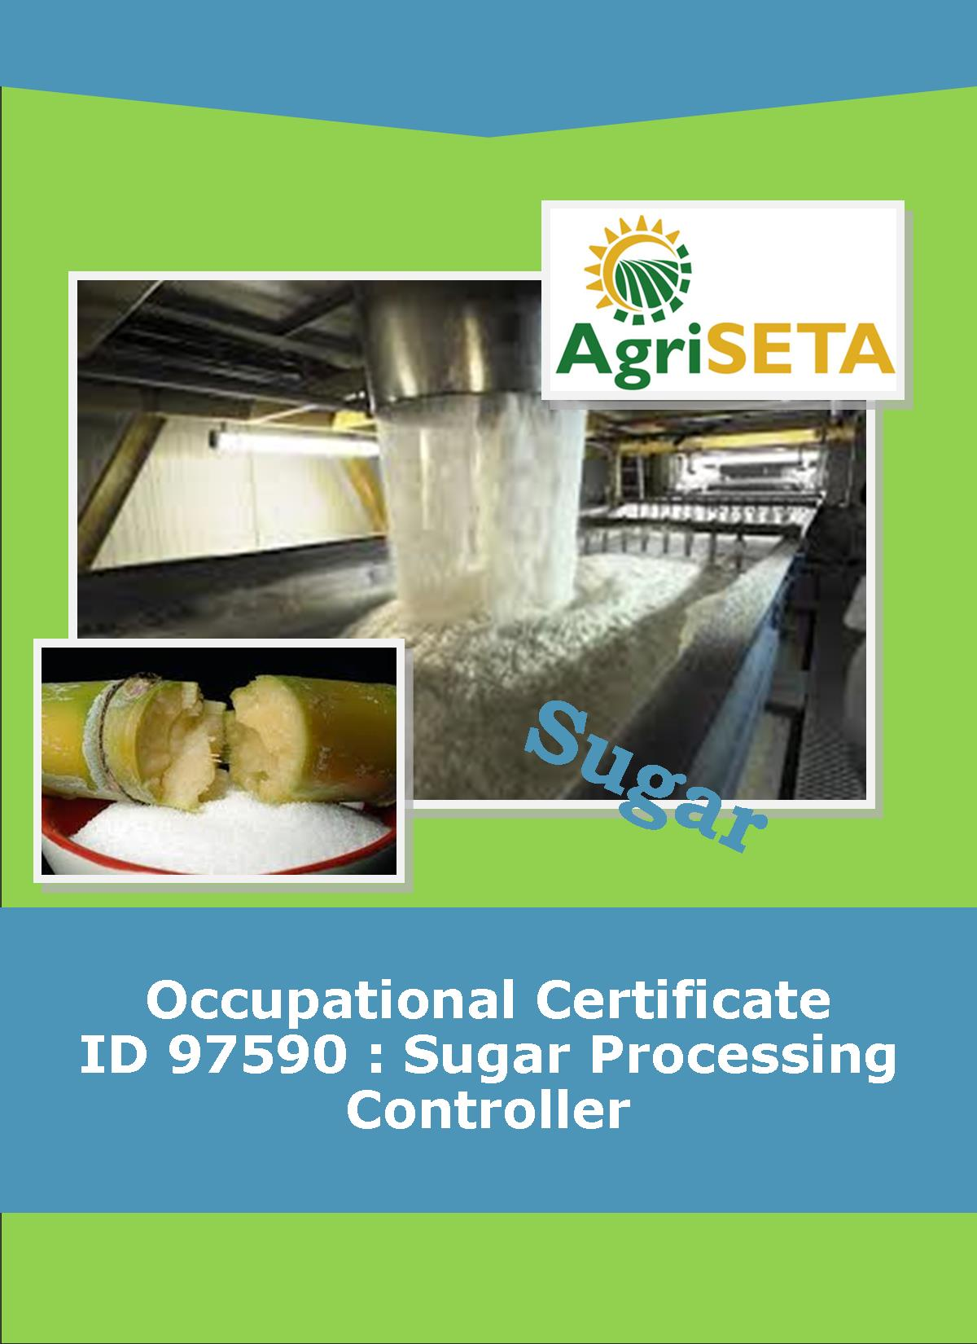
KNOWLEDGE COMPONENT:
KNOWLEDGE COMPONENT: LEARNER WORKBOOK 13: MECHANICAL MAINTENANCE
Occupational Certificate: Sugar Processing Controller

KNOWLEDGE COMPONENT: LEARNER WORKBOOK 13

MECHANICAL MAINTENANCE
LEARNER WORKBOOK 13:
MECHANICAL MAINTENANCE
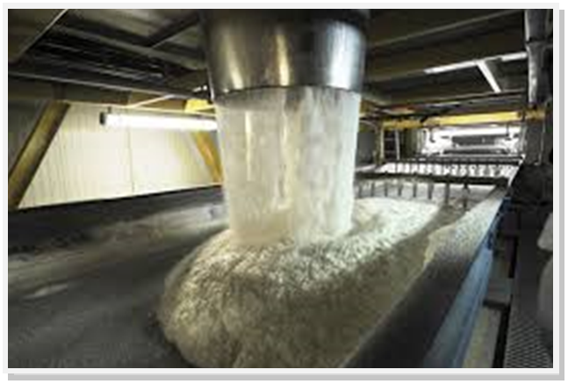
OCCUPATIONAL CERTIFICATE: SUGAR PROCESSING CONTROLLER

©Copyright AgriSETA
Telephone: +27 12 301 5600
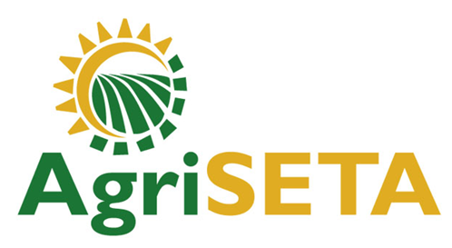

AgriSETA holds the copyright to its publications and Web pages. Proper citation is requested.

TABLE OF CONTENTS
1. AN INTRODUCTION TO THIS LEARNER WORKBOOK 6
2. LEARNER DETAILS 7
3. FORMATIVE ASSESSMENT INSTRUCTIONS 8
4. KNOWLEDGE MODULE 13: MECHANICAL MAINTENANCE 9
4.1 Knowledge Topic 1: Mechanical maintenance principles and concepts (70%) 10
4.2 Knowledge Topic 2: Principles of preventative maintenance (30%) 17
5. CONCLUSION OF KNOWLEDGE MODULE 13: MECHANICAL MAINTENANCE 23

AN INTRODUCTION TO THIS LEARNER WORKBOOK
This Knowledge Component Learner Workbook 13: Mechanical maintenance is intended to be used with the Knowledge Component Learning Resource: Book 13 (Textbook): Mechanical Maintenance of the Occupational Qualification: Sugar Processing Controller NQF 5.
Guidance on the use of this Work Book is provided in the Learning Guide.

LEARNER DETAILS
First name
Surname
ID number
Mobile phone contact number
E-mail address
Postal address
Date on which you started this Knowledge Module
Date on which you completed this Knowledge Module
Declaration: | I hereby confirm that:  - I received the assessment plan and schedule.  - I understand my rights in terms of special needs, re-assessment, feedback and appeals against assessment decisions.  - I completed this formative assessment independently without assistance from anyone else.
Total Marks for Knowledge Module 13 | 96 marks
Marks attained
Date:
Place:
Signature of Learner:
Signature of Assessor:

FORMATIVE ASSESSMENT INSTRUCTIONS
Instructions
- Work individually to present the results of each Learning Activity in this Learner Workbook.
- Complete all the sections.
- Use a black pen and ensure that you complete the questions in your own handwriting.
- A recommended time to complete each activity is shown.
- The marks you will attain for each learning activity are shown in brackets.
- The total marks obtained for each Knowledge Module must be transferred from the back of each Learner Workbook to the Learner Qualification Summative Assessment Tool.

KNOWLEDGE MODULE 13: MECHANICAL MAINTENANCE
NQF LEVEL: 5
CREDITS: 4
PURPOSE OF THE KNOWLEDGE MODULE: The main focus of the learning in this knowledge module is to build an understanding of mechanical maintenance principles and concepts that relates to sugar mill.
The learning will enable learners to demonstrate an understanding of:
- KM-13-KT01: Mechanical maintenance principles and concepts (70%)
- KM-13-KT02: Principles of preventative maintenance (30%)

4.1 Knowledge Topic 1: Mechanical maintenance principles and concepts (70%)
Topic elements to be covered include:
- KT0101 Methods for monitoring and controlling mechanical equipment based on operating parameters
- KT0102 Maintenance requirements for pumps
- KT0103 Maintenance requirements for motors
- KT0104 Maintenance requirements for heating equipment
- KT0105 Maintenance requirements for cooling equipment
Internal Assessment Criteria and Weight
- IAC0101 The maintenance requirements for mechanical components can be explained
- (Weight 70%)

Learning activity 1.1: Individual Learning activity: 45 minutes (28 marks)
Learning Objective: The maintenance requirements for mechanical components can be explained
Task: Read each question carefully and write your answer in the space provided.
- List five most important benefits of a properly managed preventive maintenance program. (10)

- During the pump routine inspections 9 tasks are performed name 5. (5)

- After the all inspections are done and the pump’s performance is still not satisfactory. What is the procedure to follow? (7)
- Name 6 parameters that need to be monitored regularly in order to understand the performance of the pump? (6)

Learning activity 1.2: Individual Learning activity: 45 minutes (28 marks)
Learning Objective: The maintenance requirements for mechanical components can be explained
Task: Read each question carefully and write your answer in the space provided.
- What are the two (2) schedules of lubrication system maintenance? (2)

- Name five (5) basic guidelines to maintenance of motor controls (10)

- From the cooling towers maintenance checklist, list six tasks that need to be performed when maintaining towers. (6)

- Discuss five preventative maintenance tips to ensure that your boiler is safe and reliable. (10)

4.2 Knowledge Topic 2: Principles of preventative maintenance (30%)
Topic elements to be covered include:
- KT0201 Scheduling and planning preventative maintenance
- KT0202 Principles of preventative maintenance
- KT0203 Reasons for preventative maintenance
Internal Assessment Criteria and Weight
- IAC0201 The roles and responsibilities of the sugar processing controller in preventative maintenance can be explained and motivated
- (Weight 30%)

Learning activity 2.1: Individual Learning activity: 1.5 hours (40 marks)
Learning Objective: The role and responsibilities of the sugar processing controller in preventative maintenance can be explained and motivated
Task: Read each question carefully and write your answer in the space provided.
- What is the aim of preventative maintenance? (2)

- Discuss four principles of planning preventative maintenance (8)

- Provide a description for “planning and scheduling preventative maintenance” (2)

- Discuss five (5) maintenance scheduling principles(10)

- Explain the principles of preventative maintenance.(8)

- Name and discuss five (5) good reasons why it is important to have preventative maintenance. (10)

CONCLUSION OF KNOWLEDGE MODULE 13: MECHANICAL MAINTENANCE
Throughout this knowledge module you have been provided opportunities to complete formative learning activities. You have captured your results in this Learner Workbook.
The total marks for this Knowledge Module are as follows:
Knowledge Module | Total Marks | Marks attained
KM-13-KT01: Mechanical maintenance principles and concepts (70%) | 56
KM-13-KT02: Principles of preventative maintenance (30%) | 40
Total Marks | 96 marks

