
KNOWLEDGE COMPONENT: LEARNING RESOURCE:
BOOK 13: MECHANICAL MAINTENANCE
OCCUPATIONAL QUALIFICATION: SUGAR PROCESSING CONTROLLER

KNOWLEDGE COMPONENT:
LEARNING RESOURCE

BOOK 13: MECHANICAL MAINTENANCE
KNOWLEDGE COMPONENT:
LEARNING RESOURCE
BOOK 13: MECHANICAL MAINTENANCE
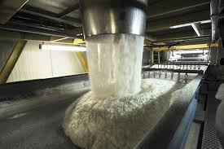
OCCUPATIONAL QUALIFICATION:
SUGAR PROCESSING CONTROLLER

©Copyright AgriSETA
Telephone: +27 12 301 5600


AgriSETA holds the copyright to its publications and Web pages. Proper citation is requested.

TABLE OF CONTENTS
AN INTRODUCTION TO THIS LEARNING RESOURCE 7
KNOWLEDGE MODULE 13 8
MECHANICAL MAINTENANCE 8
1. Knowledge Topic 1: Mechanical maintenance principles and concepts 10
1.1 METHODS FOR MONITORING AND CONTROLLING MECHANICAL EQUIPMENT BASED ON OPERATING PARAMETERS 10
1.1.1 Developing a maintenance plan 10
1.1.2 Parameters which can be monitored during maintenance procedures 13
1.2 MAINTENANCE REQUIREMENTS FOR PUMPS 14
1.2.1 Centrifugal pumps 14
1) Precautions against damage of centrifugal pumps 14
2) Centrifugal Pump Inspection Schedule 15
(a) Routine inspections 15
(b) Three-month inspections 16
(c) Annual inspections 17
1.3 MAINTENANCE REQUIREMENTS FOR MOTORS 18
1.3.1 Basic guidelines to motor maintenance 19
1.3.2 Lubrication system maintenance 20
1) Daily scheduled maintenance 20
2) Periodic scheduled maintenance 21
1.3.3 Basic guidelines to maintenance of motor controls 23
1.3.4 Maintenance of some specific mill equipment that use motors 24
1) Crane maintenance and inspection 24
2) Maintenance of diffuser 25
1.4 MAINTENANCE REQUIREMENTS FOR HEATING EQUIPMENT 25
1.4.1 Maintenance of boilers 26
1) Cleaning 26
2) Blowdown 26
3) Monitor and Manage Water Quality 26
4) Inspect Insulation 26
5) Maintain Accurate Service/Maintenance Logs 26
1.5 MAINTENANCE REQUIREMENTS FOR COOLING EQUIPMENT 27
1.5.1 Maintenance checklist for cooling towers 27
1.5.2 Chillers (if used) 28

2. Knowledge Topic 2: Principles of preventative maintenance 30
2.1 SCHEDULING AND PLANNING PREVENTATIVE MAINTENANCE 30
2.1.1 Planning Preventative maintenance 30
1) Planning Principle 1 30
2) Planning Principle 2 30
3) Planning Principle 3 30
4) Planning Principle 4 31
5) Planning Principle 5 31
6) Planning Principle 6 31
2.1.2 Maintenance Scheduling Principles 31
1) Scheduling Principle 1 31
2) Scheduling Principle 2 32
3) Scheduling Principle 3 32
4) Scheduling Principle 4 32
5) Scheduling Principle 5 33
6) Scheduling Principle 6 33
2.2 PRINCIPLES OF PREVENTATIVE MAINTENANCE 33
2.2.1 Planning 34
2.2.2 Discipline 34
2.2.3 Consider Equipment Maintenance History 34
2.2.4 Preventive Maintenance Training 35
2.3 REASONS FOR PREVENTATIVE MAINTENANCE 35
2.3.1 Save Money 35
2.3.2 Maximize Efficiency 35
2.3.3 Prolong Equipment Life 35
2.3.4 Reduce Maintenance Costs 36
2.3.5 Improve Safety and Reliability 36

AN INTRODUCTION TO THIS LEARNING RESOURCE
This Knowledge Component Learning Resource: Book 13: Mechanical maintenance is intended to be used with the Knowledge Component Learner Workbook 13 (Formative Assessment Guide): Mechanical maintenance: Sugar Processing Controller NQF 5. It can also be used as a stand-alone information resource (text book).
This Learning Resource provides detailed information on the following topics:
- KM-13-KT01: Mechanical maintenance principles and concepts (70%)
- KM-13-KT02: Principles of preventative maintenance (30%)
(Note: KM = Knowledge Module, KT = Knowledge Topic)

KNOWLEDGE MODULE 13

MECHANICAL MAINTENANCE
Module number: 313908000-KM-13: NQF Level 5: Credits 4
BACKGROUND
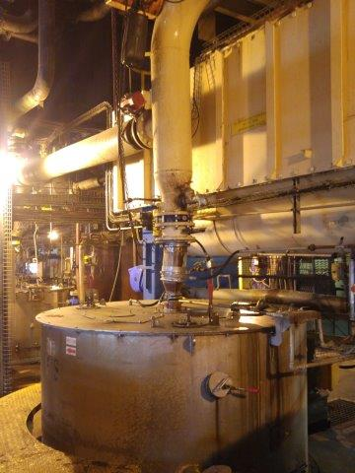
The main purpose of regular maintenance is to ensure that all equipment required for production is operating at 100% efficiency at all times.
The term ‘if it’s not broken, don’t fix it’ unfortunately still applies in many industries. This is NOT the correct way of managing maintenance in a Sugar Mill. Due to the high costs of unscheduled downtime, a preventative maintenance programme needs to be put in place.
Furthermore, by implementing a preventive maintenance programme, you are assured that your equipment is operating safely both as regards to damage to the equipment as well as the safety of the operators and the factory. With regular preventative maintenance, possible issues can be nipped in the bud before they have a chance to cause harm.
Normal wear and tear can result in lower machine efficiency. Preventive maintenance assures optimal working conditions and increases the life span of the equipment.
A planned preventive maintenance programme may cause small hindrances in production, but, these short delays are manageable and expected. This is a much more controlled situation than the downtime caused by an unexpected breakdown. Because it is planned, the production division can propose the optimal time for the maintenance to be carried out and can factor in the nuisance to production it will cause. Preventative maintenance procedures take less time than emergency repairs and replacements.
Here are the most important benefits of a properly managed preventive maintenance programme:
- Equipment downtime is decreased and the number of major repairs are reduced.
- Better conservation of assets and increased life expectancy of assets, thereby eliminating premature replacement of machinery and equipment.
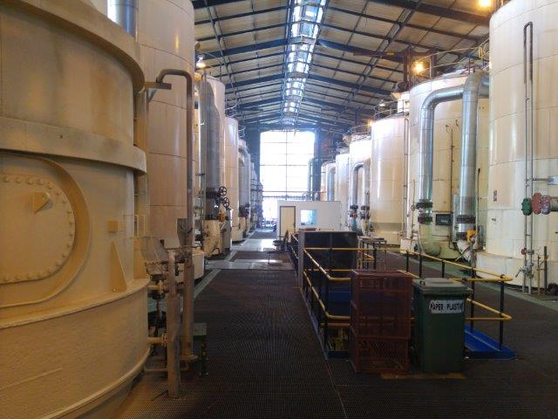
- Reduced overtime costs and more economical use of maintenance workers due to working on a scheduled basis instead of a crash basis to repair breakdowns.
- Timely, routine repairs leads to fewer large-scale repairs.
- Improved safety and quality conditions for everyone in the factory.

  - Knowledge Topic 1: Mechanical maintenance principles and concepts

METHODS FOR MONITORING AND CONTROLLING MECHANICAL EQUIPMENT BASED ON OPERATING PARAMETERS

Developing a maintenance plan
The benefits of implementing a preventative maintenance programme have been described in the introduction to this module (Background). Such a preventative maintenance plan can follow the “Plan, Do, Check, Act” cycle as shown below.
For example, under “Plan”, the goal of the preventative maintenance programme would be:
- To reduce downtime and emergency stoppages due to breakdowns,
- To improve equipment performance to 100%, and
- To reduce accidents due to wear and tear and faulty equipment to zero.

The maintenance manager would then need to implement the programme (The “Do” component of the plan), check that the maintenance work done and when it was done had the desired effect (The “Check” – to reach the goals) and then either continue to improve the plan, or change the plan (“Act”), if the maintenance work and when it was done did not assist in bringing the organization closer to the target goals.
These activities are illustrated in the graphic below.
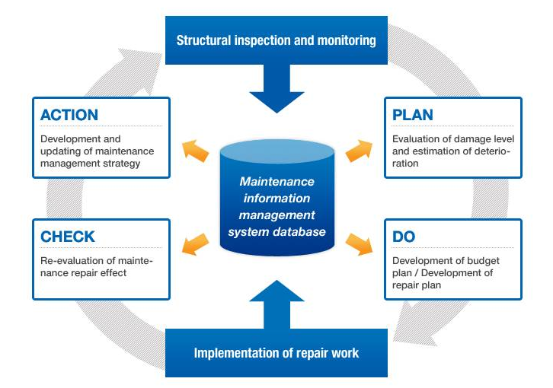
Any maintenance system and procedures must be designed to include manufacturer’s recommendations. Maintenance log records, tests, graphs and charts, are the basis for the history of plant equipment. This is needed for statistics, control purposes, for formulating and modifying preventative/maintenance inspection plans and schedules.
Major maintenance should be planned for plant shut down periods (for economic reasons of not interfering with productive time when plant and equipment are needed). When reconditioning of parts is necessary, replacements must be available – thus, ordering of parts should form part of the plan. Ensure that everything needed for the plan/schedule is available on time to avoid costly delays.
Requests for maintenance work should be invited from each section of the factory. These must be by formal requisition (in writing) and be treated as a works order. In this way the production staff are part of the maintenance plan, are comfortable with the time when maintenance will be done, can provide inputs and feedback to the maintenance team regarding the performance of the equipment and can highlight issues that they feel need to be addressed (for example, a fault that they have noticed in the machine’s operation).
Maintenance work should not be undertaken by production staff (except in an emergency and only if they are experienced and qualified to do so), unless it is done under the supervision of the maintenance department.
Maintenance stores must also be properly managed – with the correct parts available when necessary and back-up parts that regularly require replacement available in the store room or available on short notice. The absence of a vital part can lead to an expensive shut-down of a production process.
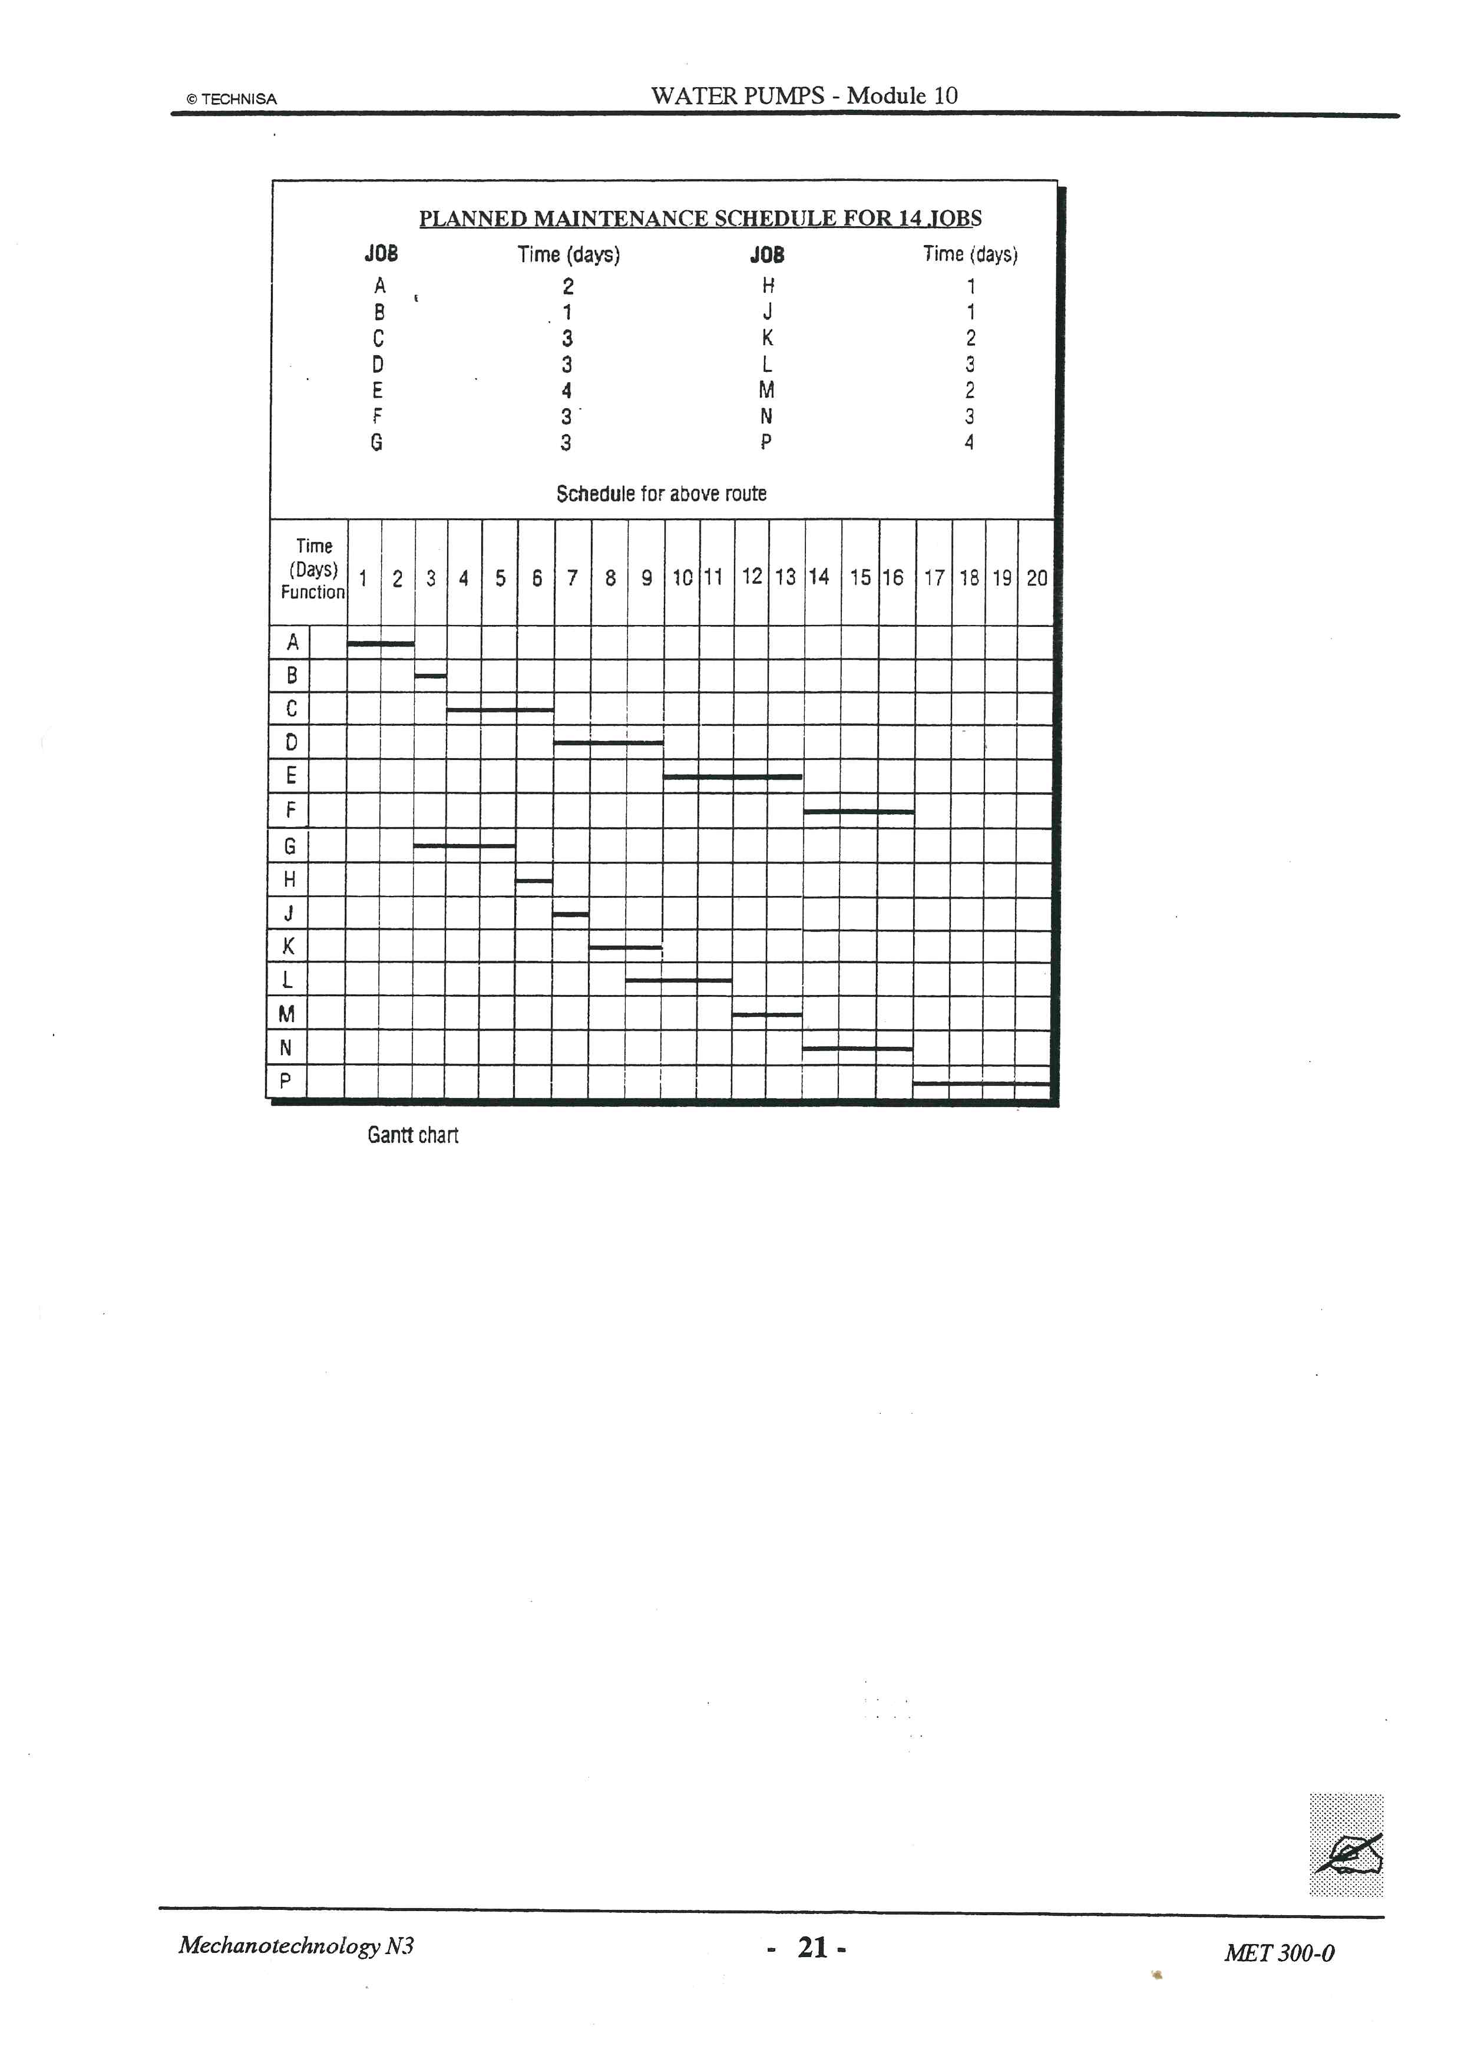
It is acknowledged that despite any amount of planning and scheduling, breakdowns outside of the planning can occur. This is the necessary but difficult part of managing maintenance work, because a sudden breakdown may need immediate action and can upset schedules and parts in stock. To limit situations such as these allowances should be made in the maintenance department’s work schedules and planning for carrying out emergency repairs.
However, most of the time the employees of the maintenance department should be busy with planned maintenance.
Such plans should cover a period of at least twelve months, during which time all normal items of upkeep should be covered.
A planned maintenance schedule could be compiled in the following format once inputs from the various departments and machine operators have been received.

Parameters which can be monitored during maintenance procedures
Although each piece of equipment will have its own maintenance schedule and specific components that need to be maintained (these would be provided by the manufacturer’s guidelines), there are also specialized testing that can assist the maintenance department to ensure the integrity of the equipment which might not be picked up during scheduled maintenance checks. Such specialized tests could include the testing of the following performance parameters:
- Vibration analysis and diagnostics.
- Lubricant analysis.
- Acoustic emission (airborne ultrasound)
- Infrared thermography.
- Ultrasound testing (material thickness/flaw testing)
For example, with vibration monitoring it should be noted that every rotating machine has its own vibration characteristics. Changes, caused for example by unbalance or rolling element bearing damage, always leave their dynamic "fingerprint". Critical machine parts can be monitored by means of vibration analysis to ensure the early detection of damage and to prevent a possible total failure.
In general however, preventative maintenance will include:
- Lubrication
- Sharpening of blades as required (or replacement of dull blades)
- Thorough cleaning of valves, screens and pipes
- Replacement of bearings
- Re-welding of joins that have weakened
- Removal of scale and rust
- Replacement of old, worn or defective parts
- Replacement of old, worn or defective seals.
This maintenance, as mentioned before will depend on the piece of equipment, its age, its frequency of use, and previous maintenance work. Some maintenance guidelines of specific equipment such as pumps, motors, heating and cooling equipment is discussed below.

MAINTENANCE REQUIREMENTS FOR PUMPS

Centrifugal pumps
Pumps are responsible for moving fluids and viscous, thick semi-solids through the Sugar Mill. The threat of leakage and blockages are the main performance limiting variables that pump maintenance aims to prevent.
Operating problems in a centrifugal pump which can cause damage to the centrifugal pump can be either hydraulic or mechanical. In the first category (hydraulic), a pump may fail to deliver liquid, it may deliver insufficient capacity or develop insufficient pressure, or it may lose its prime after starting. In the second category (mechanical), it may consume excessive power or display symptoms of other mechanical difficulties that may develop at the seal chambers or at the bearings such as excessive vibration or noise or breakage of some pump parts. Increased wear at the running clearances must be classified as a mechanical problem because it will result in the reduction of the net pump capacity, a hydraulic symptom without necessarily causing a mechanical breakdown or even excessive vibration. So it is important to classify symptoms and causes separately.
Daily inspections should be made and any irregularities in the operation of a pump should be recorded and reported immediately. This applies to changes in the sound of a running pump, abrupt changes in bearing temperatures and seal chamber leakage.
A check of pressure gauges and of flow meters and vibration should be made regularly during the day. If recording instruments are provided a daily check should be made to determine whether the current capacity, pressure, power consumption or vibration level indicates that further inspection is required. Trending charts should be produced to allow observation of changes as a function of time. Certain trends may allow for scheduled outages to address deterioration of specific performance values.

Precautions against damage of centrifugal pumps
Centrifugal pumps must be monitored regularly, correctly and accurately according to a specific plan which is made by specially trained personnel. The following six parameters should be regularly monitored to understand how a pump is performing:
- Suction pressure (Ps)
- Discharge pressure (Pd)
- Flow (Q)
- Pump speed (N)
- Pump efficiency (η)
- Power.
The advantages of regular monitoring of pumps are -
- No dismantling of the pump is necessary.
- Offers cost savings and energy savings by increasing the pump availability and reliability coefficients for pumps.
- The time to maintain the pump set may be predicted and planned more accurately and in a qualified manner in line with predictive and planned maintenance strategies.
- If a flow meter is installed to measure process liquid flow, then the pump monitor is able to verify the accuracy of the meter readings.
In addition, it is very important to monitor some other conditions for centrifugal pumps during normal operation such as:-
- Vibration monitoring.
- Oil level and scheduled oil analysis.

Centrifugal Pump Inspection Schedule
Centrifugal pump inspection should be done regularly. But for different pumps the level of checking varies with how frequently these pump inspections are carried out. During routine pump inspections only the easy-to-monitor factors such as pressure, temperature, vibration etc. need to be checked. But during quarterly inspections, shaft alignment and oil levels should also be checked. Some typical inspection schedules are discussed below along with the checklist of activities to be performed.

Routine inspections
Perform the following tasks whenever you check the pump during routine inspections:
- Check the level and condition of the oil through the sight glass on the bearing frame.
- Check for unusual noise, vibration, and bearing temperatures.
- Check the pump and piping for leaks.
- Analyze the vibration.
- Inspect the discharge pressure.
- Inspect the temperature.
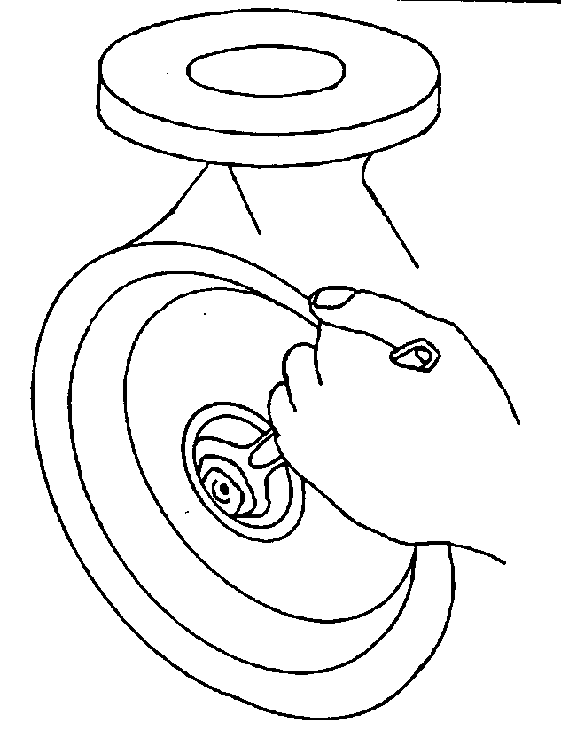
- Check the seal chamber and stuffing box for leaks.
- Ensure that there are no leaks from the mechanical seal.
- Adjust or replace the packing in the stuffing box if you notice excessive leaking.

Three-month inspections
Perform the following tasks every three months:
- Check that the foundation and the hold-down bolts are tight.
- Check the mechanical seal if the pump has been left idle, and replace as required.
- Change the oil every three months (2000 operating hours) at minimum.
- Change the oil more often if there are adverse atmospheric or other conditions that might contaminate or break down the oil.
- Check the shaft alignment, and realign as required.
- Clean bearing bracket from any oil if found.
- Check oil drain plug.
- Lubricate the bearings.
- Inspect suction and discharge flanges for any leak.
- Inspect pump casing for any unusual damage signs.
- Inspect the seal.
- If the pump is offline check the coupling and its shims for any damage.
- Make sure that the coupling guard is well tightened to pump base plate.
- Check that motor alignment bolts are all in place.

Annual inspections
Perform the following inspections once each year:
- Check the pump capacity.
- Check the pump pressure.
- Check the pump power.
If the pump performance does not satisfy the process requirements, and the process requirements have not changed, then do the following:
- Disassemble the pump.
- Clean all the parts thoroughly.
- Inspect for wear or damage and compile a condition report.
- Decide on the action - which could be to a) replace worn parts or b) to replace any damaged components, if necessary.
- Re-assemble the pump.
- Check it’s operation and measure it’s post-maintenance performance.
- Commission the maintenance action/job and hand back the equipment to the operator.
An example of a condition report is shown below.
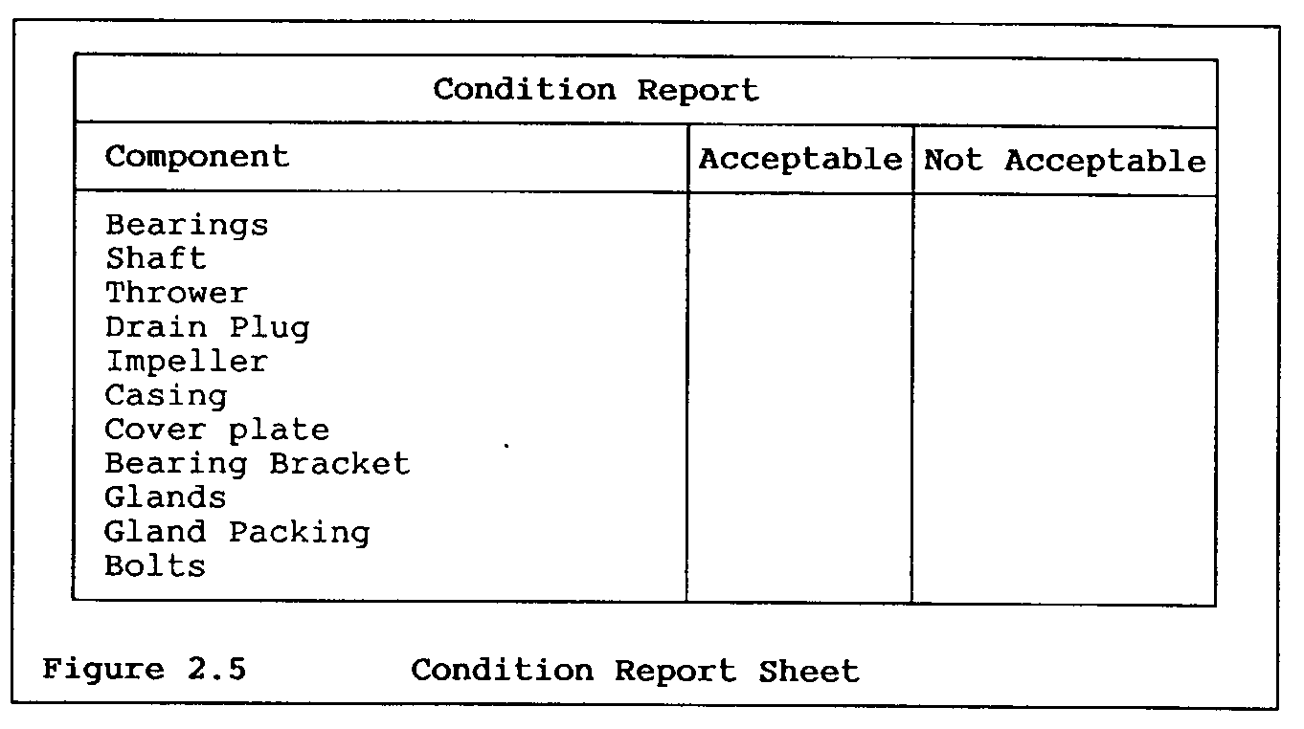

MAINTENANCE REQUIREMENTS FOR MOTORS
Motors provide the driving forces inside many of the pieces of equipment found in the Sugar Mill. Motors are responsible, in part, for the physical moving of the parts within these pieces of equipment that pull, carry, push, turn, and pump, the cane, the bagasse, the mixed juice, the massecuite and the final sugar through the various processes of the Sugar Mill.
A well-planned preventive maintenance program is the key to dependable, long-life operation of motors and generators. In modern plant operations, unscheduled stoppages of production equipment or long repair shutdowns are intolerable. The high cost of the resultant downtime eats deeply into profits. Although management probably realizes the value of a good preventive maintenance (PM) program, they sometimes resist the investment in proper tools, instruments, practices, or technical assistance. Therefore, it's very important that the maintenance manager show how a properly planned motor/generator preventative maintenance program is justified (This can only be done if proper record-keeping of the maintenance function is kept).
Each motor will have its own capacities, requirements and parameters that need to be maintained and tested. Examples of the maintenance requirements of motors in general and then a few types of motors specifically are provided below.

Basic guidelines to motor maintenance
Here are some general guidelines for motor maintenance (specific advice regarding motor lubrication and motor control maintenance is provided thereafter):
- Lubrication. Lubricate regularly according to manufacturer's instructions. On sleeve-bearing and other oil-lubricated machines, check oil reservoirs on a regular basis. In poor environments, change oil at least once a month. Never over-lubricate; excess grease or oil can get into windings and deteriorate insulation. Be sure to use only the lubricant specified for the machine in question. However, you should also check into the possibility of using modern lubricants that have excellent life and lubricating qualities.
- Bearing inspection. Bearing failures are one of the most common causes of motor failures. Typical bearing problems include improper lubrication, misalignment of the motor with the load, replacement with the wrong type of bearing, excessive loading, and harsh environments.
- On essential motors or those that are heavily used or frequently duty cycled, you should check bearings daily using a stethoscope or infrared scanner (or camera, if appropriate). Check bearing surface temperature with a thermometer, electronic temperature sensing devices, or stick-on temperature indicating labels. Compare temperature of hot bearings with the temperatures of normally operating bearings. Check oil rings and watch for excessive end play.
- Belt inspection. Check belt tension; belts should have about 1 in. of play. Sheaves should be seated firmly with little or no play. Couplings should be tight, within tolerances, and should operate without excessive noise. An alignment check should be made on all motor-generator sets and on motor-load couplings when trouble is suspected.
- Motor mount inspection. Check mounting bolts, steel base plates for possible warping, and concrete base for cracking or spalling.
- Annually, perform vibration-analysis tests. Excessive vibration may be hard to detect by hand, but it could be enough to shorten motor life significantly. It can cause bearing failure, metal fatigue of parts, or failure of windings. The cause of vibration is usually mechanical in nature, such as excessive belt tension, defective sleeve or ball bearings, misalignment, or improper balance. The most common cause is the unbalance of a rotating member (the motor rotor, rotating load, or other drive train component). Simple testing of the motor is done by uncoupling the load or removing the belts and then running the motor. Electrical problems also can cause vibration.
Field vibration analysis can be accomplished by using a portable instrument that identifies vibrations and displays their amplitudes and frequencies.
- Motor temperature control. Restricted ventilation will cause a motor to operate at a higher than desired temperature. Dirt, dust, chemicals, snow, oil, grass, weeds, etc., can clog ventilation passages of an open-frame motor. Keep motor clean and cool. In poor environments, blow out dirt with dry compressed air (no more than 50 lbs) as often as needed.
- Pull and disassemble important motors during scheduled shutdowns for thorough inspection, testing, cleaning, checking of bearings, couplings or accessories, or complete reconditioning.
- Record keeping. Keep accurate records. Perform annual insulation-resistance (IR) and other appropriate tests. Important motors should also receive a thorough visual inspection, as well as voltage and current checks. All values should be recorded and compared each year. The trend of the readings will indicate the condition of the motor and offer a guide to its reliability.

Lubrication system maintenance
Maintenance work can be divided into two schedules; daily and periodic.

1) Daily scheduled maintenance
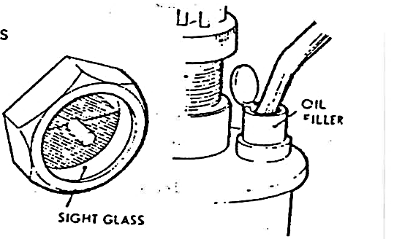
The maintenance schedule will normally include the following general checks, plus special checks applicable to the particular piece of equipment.
- Check all oil bath, reservoir and sump levels (usually by dipstick or sight glass). Top up as necessary.
- Lubricate any points as detailed in the maintenance schedule.
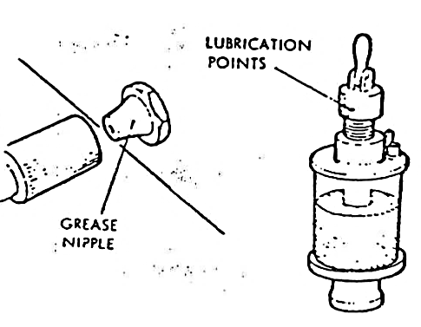
- Check visually for any obvious signs of damage, e.g. broken pipe securing clips and chafing of incorrectly supported pipes.
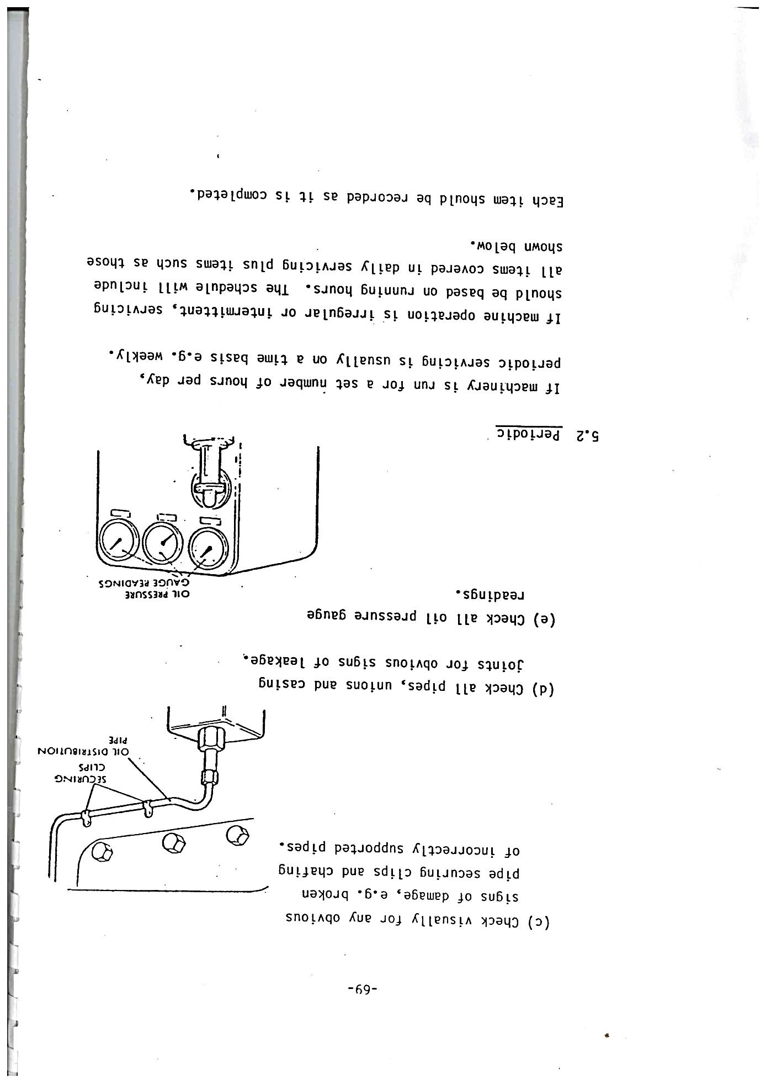
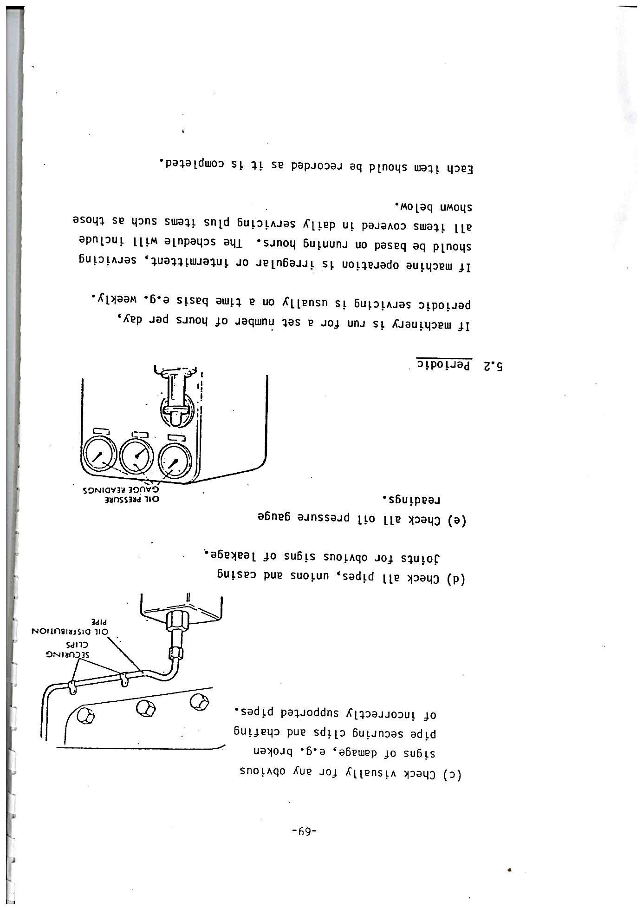
- Check all pipes, unions and casing joints for obvious signs of leakage.
- Check all oil pressure gauge readings.

Periodic scheduled maintenance
If machinery is running for a set number of hours per day, periodic servicing usually on a time basis e.g. weekly can be done. If the machine operation is irregular or intermittent, servicing should be based on running hours. The schedule will include all items covered in daily servicing plus items such as those shown below.
Each item should be recorded as it is completed:
- Drain sump, oil bath or reservoir (This is best achieved when oil is hot)
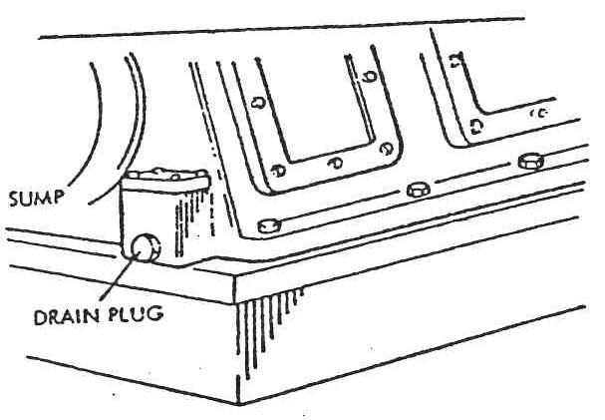
- Remove dirty filters
- Flush system with flushing oil if specified.
- Fit new or clean filters as required.
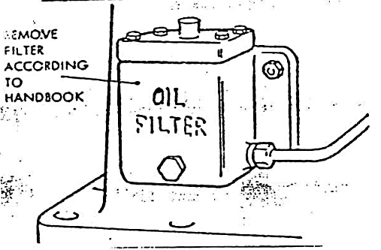
- Refill system with fresh oil of correct grade.
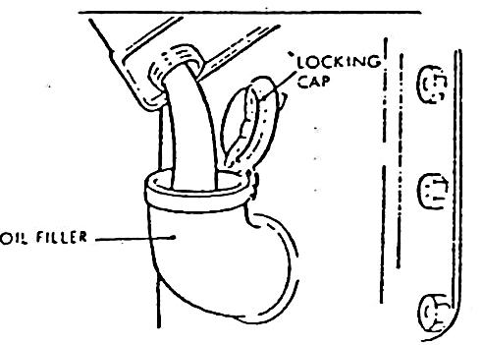
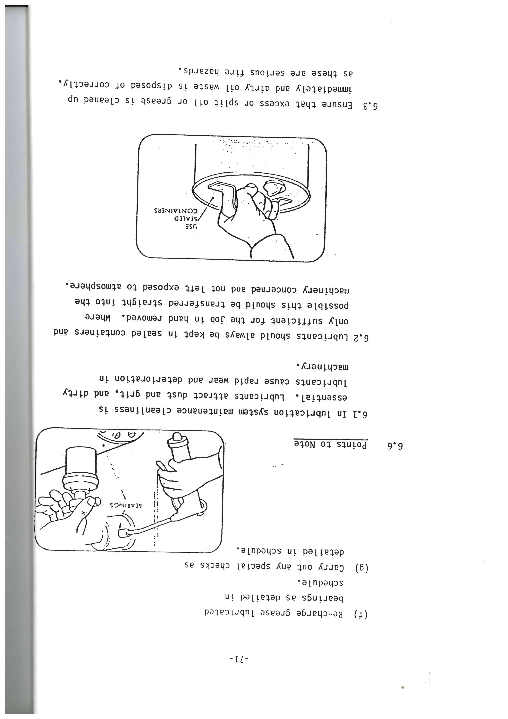
- Re-charge grease lubricated bearings as detailed in schedule.
- Carry out any special checks as detailed in schedule.

- In lubrication system maintenance cleanliness is essential. Lubricants attract dust and grit, and dirty lubricants cause rapid wear and deterioration in machinery.
- Lubricants should always be kept in sealed containers and only the amount sufficient for the job at hand should be removed from the container. Where possible this should be transferred straight into the machinery concerned and not left exposed to the atmosphere.
- Ensure that excess or split oil or grease is cleaned up immediately and dirty oil waste is disposed of correctly, as these are serious fire hazards.
- Never mix grades of lubricant. If it should be necessary to use a piece of lubricating equipment with a different grade of oil, the equipment must be thoroughly cleaned before putting in the new grade and thoroughly cleaned again as soon as the job is completed.
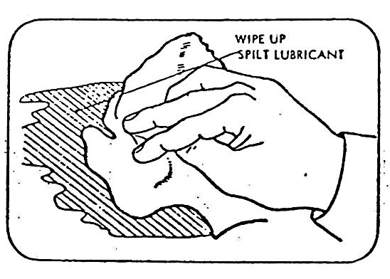

Basic guidelines to maintenance of motor controls
These guidelines will help you maintain motor controls.
- Cleanliness. In poor environments, blow out dirt weekly; in normal environments, a quarterly or semi-annual cleaning should be adequate. Make sure that dust or contamination is kept off high-voltage equipment. This is important because dust may contain conducting materials that could form unwanted circuit paths, resulting in current leakage or possible grounds or short circuits.
- Moving parts inspection. Moving parts should operate easily without excessive friction. Check operation of contactors and relays by hand, feeling for any binding or sticking. Look for loose pins, bolts, or bearings. If the control is dirty, it should be wiped or blown clean.
- Contact inspection. Check contacts for pitting and signs of overheating, such as discoloration of metal, charred insulation, or odor. Be sure contact pressure is adequate and the same on all poles; verify with manufacturer's specification. Watch for frayed flexible leads.
- Contact resistance testing. On essential controls, perform contact-resistance tests with a low-resistance ohmmeter on a regular basis. Proper contact resistance should be about 50 micro-ohms. Record readings for future comparison. This will indicate trends in the condition of contacts.
- Overloads relay inspection. Overload relays should receive a thorough inspection and cleaning. You also should check for proper setting. In general, maintenance requirements for these relays include checking that the rating or trip setting takes into account ambient temperature as well as the higher inrush currents of modern, energy-efficient motors. You also should verify that contacts are clean and free from oxidation and that the relay will operate dependably when needed. Relays should be tested and calibrated every one to three years.

Maintenance of some specific mill equipment that use motors

Crane maintenance and inspection
Lifting equipment must be inspected regularly (usually monthly) and tested annually. The load test is in two parts:
- Can the crane lift and hold its test weight?
- Is the deflection within the allowable limit?
Cranes must be tested according to the code of practice to which they were manufactured. Gantry Cranes are often built to BS466. This code allows deflection of 1/750 of the span of the gantry.
Some important features of cranes that need care in inspection and testing are:
- The hoist rope - check for fraying
- The hook - check for spreading
- The brake - does it support the load
- Top and bottom limit switches
- Load limiting device - correctly calibrated?

Maintenance of diffuser
One of the major advantages of diffusion vs milling is the greatly reduced maintenance cost. Very little routine weekly maintenance is required. The following items generally need attention on an annual basis:
- Chain runners wear and generally need to be replaced every few years.
- Lifting screw flights wear in spite of hard-facing on the edges of the flights. They need periodic attention.
- Routine pump maintenance is required. Pumps generally run at low speeds (˂ 1000 rpm) to minimise wear due to sand.
- A check on corrosion of trays and structural steelwork, particularly at the feed end of the diffuser where pH’s are lower, is necessary.
- Chain pins and bushes need to be replaced. They have a life of between 5 and 20 years, depending on the materials and the type of design of chain.
- The diffuser driver (variable speed motor and reduction gears) needs routine maintenance.

MAINTENANCE REQUIREMENTS FOR HEATING EQUIPMENT
The sugar mill is largely dependent on heating of the sugar liquids to effect the conditions for extracting, evaporating and crystallising. Without heat many of the sugar mill operations cannot be performed.

Maintenance of boilers
Pressure vessels, such as industrial boilers, can be sensitive to a variety of scaling and heat loss issues if they are not properly maintained. Follow the five preventative maintenance tips below to ensure that your boiler remains safe, efficient, and reliable.

Cleaning
Scale, soot and other forms of residue can cover the inside surface of a boiler’s tubes, thereby reducing heat transfer efficiency and increasing the chance of a breakdown. A coating of residue as little as 0.0012 – 0.002 centimetres thick can reduce heat transfer by upwards of 10%. Cleaning of tubes, whether by mechanical (brush) or chemical means should be done at least annually and will help to prevent this issue.

Blowdown
High concentrations of total dissolved solids (TDSs) in boiler units can cause matter to precipitate from the water and create scale. This build-up reduces efficiency and increases the likelihood of boiler failure. Regular and minor, boiler blowdowns involve draining water from the boiler and can prevent high TDS concentrations that allows solids to precipitate.

Monitor and Manage Water Quality
Water quality has a significant impact on boiler performance. In order to maintain water quality in a boiler, regular checks/testing of dissolved minerals, returned condensate, and the presence of a de-aerator are essential. Inspections should take place more frequently as the size and operating pressure of the boiler increases.

Inspect Insulation
Insulation is important for any surface with a temperature frequently in excess of 50°C. Un-insulated steam and condensate piping, valves, or fittings on boiler systems can result in critical heat loss and reduced boiler efficiency. It is therefore necessary to inspect and repair insulation regularly.

Maintain Accurate Service/Maintenance Logs
The best way to ensure a boiler is performing efficiently is to maintain accurate service and maintenance logs. Recording water and flue gas temperatures, as well as pressure, on a daily basis provides the information needed to maintain optimal performance and diagnose problems as they arise during the course of operation.

MAINTENANCE REQUIREMENTS FOR COOLING EQUIPMENT
Proper maintenance of cooling equipment will not only extend their life but also cut operating costs. Dirty or poorly maintained cooling equipment will not only decrease your cooling efficiency, contributing to lost capacity, but it also runs the risk of failure leading to outages and downtime.

Maintenance checklist for cooling towers
It is recommended to perform scheduled maintenance on the cooling towers twice per year, as follows:
- Check the holding tank in the wet towers and remove all large debris.
- Remove all screens (some people refer to them as air scrubbers) and clean.
- Pressure wash the entire cooling tower.
- Check entire unit for rust. Remove any rust that is not removed from pressure washing.
- Check drains and clean.
- Lubricate all bearings both on motors and belt pulleys.
- Look for excessive belt ware, check belts for alignment and proper tension.
- Check all electrical wiring for loose or discolored connections.
- Check and clean all water nozzles that feed the return condenser water to the towers.
- Inspect the bottom of the towers for any water leaks. Make sure all leaks are repaired.
- Look for excessive corrosion, this could indicate improper chemical treatment program.
- Be sure and clean the area around the cooling towers. Remember they are like big vacuum cleaners that pull outside air into them to cool your condenser water. A dirty environment can impact the efficiency of the cooling system.
With cooling towers turned back on.
- Check fans for proper balance. If they become unbalanced, this can place extra stress on motors and bearings.
- Amp-probe drive motors for proper readings. You can find the proper rating on the motor nameplate.

Chillers (if used)
While the cooling system is running:
- Observe the cooling system’s operation, listen for any unusual noise.
- Check all electrical wiring using an IR (infrared scanner), this will show any loose or overloaded electrical connections.
- Attach A/C gauges and check for proper coolant readings.
- Check and make sure all gauges are in proper working order.
- Check all valves and piping, observe and list any leaks that will require repair or replacement.
While the cooling system is shut down:
- Clean all condenser tubes. This is typically done with a long motorized brush or a water cleaning unit. These units are fairly inexpensive and ensure the job is done right. Each tube must be properly cleaned to ensure maximum heat transfer. If they are found to be excessively corroded, you may want to be sure your chemical treatment is sufficient.
- Consider running a fiber optic camera into the condenser tubes to make sure nothing was missed. If you find excessive corrosion in these tubes, call the chemical company you are using and have them evaluate the chemicals.
- Restart the unit and amp-probe the power feeding the chiller (while under load) to be sure you are drawing proper power (check the nameplate on the unit for proper loads).
- Clean the outside of the entire chiller and the area around it.

  - Knowledge Topic 2: Principles of preventative maintenance

2.1 SCHEDULING AND PLANNING PREVENTATIVE MAINTENANCE
Preventative maintenance programs aim to prevent equipment failures before they occur. Maintenance is regularly planned and performed on a piece of equipment while the equipment is still working, so that it does not break down unexpectedly. Implementing a successful preventive maintenance program can be time consuming and costly, but the rewards are well worth the effort.
Planning involves thinking in terms of what you see, what you are expected to do, what you know, what you have, what you are able to do, your interpretation and finally taking action.

Planning Preventative maintenance

Planning Principle 1
It is very important that the role of the planner/scheduler is identified to be independent of the other activities going on within a plant or facility. Responsibilities of the planner/scheduler should include:
- Planning emergency work
- Acting as a relief supervisor
- Becoming a material expeditor
- Working on tools
- Becoming a “go-for” for the maintenance / operations supervisor

Planning Principle 2
A planner must focus on arranging current and future maintenance work, as well as allocating the appropriate resources, parts, finances, costs, and reliability information for each project. The planner must also emphasize constant improvement, for planning, doing, checking, and acting on or adjusting schedules.

Planning Principle 3
When implementing different components of your preventative maintenance schedule take advantage of the ISO Standards of relevance to your equipment, factory and industry for best practice tips and ease of compliance. These standards may include guidance regarding work order histories, equipment registry, parts registry and more.

Planning Principle 4
Once tasks are identified, an important principle of maintenance planning is to ensure all instructions are documented and standardized. The best planners have experience estimating time and comparing actuals of work done in bite size chunks in order to bring efficiencies into the next iteration of carrying out preventive maintenance.

Planning Principle 5
Sometimes it’s not best to reinvent the wheel for all pieces of equipment. Planners should take advantage of standard plans and manufacturer’s guidelines and enhance them. Plans will also take into account and recognize the skills of technicians and help determine whether manufacturer’s technicians rather than internal technicians should be used.

Planning Principle 6
Take advantage of data from past work to properly estimate appropriate and accurate plans for the future. This will make maintenance time more available and the more maintenance time available, the more maintenance activity can be performed.
- Measuring how much time technicians actually spend on the job site versus other activities determines the effectiveness of the maintenance planning program: (Obtaining parts or tools, etc.).
- Delays are not part of a technician’s job and should be avoided.
- Sampling maintenance time periodically can be used to measure how effective planning can be.
- Use this as a metric to determine how effective your maintenance team is and look for ways to improve performance when gaps emerge

Maintenance Scheduling Principles

Scheduling Principle 1
To set realistic goals and schedules, the planner/scheduler must look at the appropriate resources for the work to be performed and then estimate the hours and effort it will require. To manage this process and avoid roadblocks, try to plan to the lowest required skill level available and work upwards.
If you work the opposite way, organizations may end up in a situation where skills are available, but the sort of work available is not appropriate for the priority level skill element. As a best practice, at the beginning of a project, identify skills for:
- Persons
- Work hours
- Duration of work

Scheduling Principle 2
For the most effective scheduling, identifying job priorities in order of importance. Determine what this measure of importance is – it could be most downtime first (then lesser cost next), highest loss of profit first (then less profit loss next), lowest cost first (then higher cost next), highest safety impact first (then least impact on safety next), highest danger first (then less dangerous next), etc. as relevant. Better yet, a weighting and scoring matrix could be used to prioritise using ALL these indices working with parties from management, sales and production. Such prioritization is useful in terms of getting everyone to understand the importance of maintenance and its impact on the mill.

Scheduling Principle 3
Scheduling from forecasts of the maintenance required helps to increase productivity. If the work orders are generated 10 days in advance, then more details can be put into the scheduling. These details include the resources required, the availability of parts, and the work to be done. Consider what jobs can be put together, what jobs can be grouped, what condition monitoring work is outstanding and can it be bundled, and any proactive work that can be done in advance.

Scheduling Principle 4
To help set up an organization’s maintenance team for success, scheduling work for every hour available is a good rule of thumb, and allows for organizations to achieve practical goals.

Scheduling Principle 5
When it comes down to daily activities, the planner/scheduler should leave the detail of the planning and scheduling to a crew leader or technician supervisor. With proper training, these crew members can use the plan and take advantage of their own functionality to realign the resources based on their priorities for the day. This should be easy enough if the planning and scheduling is proactive, but knowing that potential emergencies and urgent activities might interrupt the day, there is still a chance that it can be done if 80-90% of the day is planned out.

Scheduling Principle 6
In order to keep employees engaged, begin measuring performance by analysis of scheduled success. This measure avoids supervisors feeling the calculation gives an unfair poorer-than-actual view of their performance, and offers the crew any benefit of any doubt.

Scheduling Principles Summary
If your organization is failing to plan, then you’re planning to fail. Maintenance planning and scheduling is a systematic approach to optimize efficiencies while maximizing work performance, and the most critical element to ensuring proactive maintenance.

2.2 PRINCIPLES OF PREVENTATIVE MAINTENANCE
Designing and later on implementing a good PM program is one of the most challenging areas of maintenance management. Very often, a significant part of the maintenance resources are wasted on inefficient tasks.
One of the main reasons is due to the fact that business owners are not using all the data coming from the equipment and providing valuable insight into their assets’ health. Some of them don’t know how to use it or are simply overwhelmed. Storing and analyzing the information coming from the equipment regularly is a great way of measuring the performance and evaluating both the strengths and the weaknesses of the facility.
Another challenge is the lack of standards and direction, leading to longer time intervals between preventive interventions and resulting in equipment damage. To have everything running as smoothly as possible, everybody should know his or her role. A preventative maintenance plan can optimize the time of your maintenance staff and improve internal communication by encouraging technicians to provide and share on the platform feedback from their inspections.
The following principles will help you ensure that your preventative maintenance program is set up and ready to identify potential problems before becoming a serious issue.

Planning
Planning is one of the pillars of preventive maintenance. When tasks are efficiently scheduled, delays between maintenance jobs are minimized and maintenance resources are maximized. Scheduling maintenance tasks and creating a preventative maintenance management plan will list maintenance labour hours, materials, technicians and reasons for each work order. This information can be used later on for reports for the establishment of overall improvement strategies.

Discipline
The second pillar of an effective preventative maintenance programme is discipline. Discipline means that the organization should stick to planned maintenance and reinforce the quality of maintenance work. Collecting valid fault data is one of the preconditions for the establishment of an effective preventive maintenance system. Therefore, to successfully implement preventive maintenance, it is important to have sufficient data on the failures to be evaluated.
When production deadlines are approaching, equipment utilization rates are high and interventions on machines may be difficult. Furthermore, the objective of a preventative maintenance program is the regular inspections where access to equipment is scheduled in a timely manner. Therefore, a good preventive maintenance program requires discipline and support of all involved teams to coordinate availability and create time for equipment inspection.

Consider Equipment Maintenance History
As mentioned before, all data related to previous failures is of crucial importance for the creation of a preventative maintenance program. Previous incidents, the type and operation of the machine, and the manufacturer’s recommendations should be considered when defining the type and frequency of the maintenance.

Preventive Maintenance Training
Preventative maintenance training encourages autonomous maintenance and ensures that all machine operators and maintenance technicians are familiar with basic maintenance practices such as lubrication of various crucial components, oil changes, cleaning, functional checks and repairing of some issues.

REASONS FOR PREVENTATIVE MAINTENANCE
A successful preventive maintenance program improves the performance and safety of your company’s valuable assets. Equally important, regularly scheduled maintenance helps you avoid unplanned downtime.
Here are 5 good reasons why a proactive preventive maintenance approach will reduce your costs and improve overall operations.

Save Money
Unplanned downtime caused by equipment failure can cost a fortune in lost production revenue, not to mention emergency repair costs.
From paying technicians overtime to the cost of overnight parts delivery, everything is more expensive in an emergency especially when a production line goes down. A preventive maintenance program is simply good business.

Maximize Efficiency
Regular equipment maintenance optimizes operations so you can run at maximum efficiency.
Keeping your equipment running at optimal potential increases uptime, enhancing production while reducing costs. Poorly maintained equipment uses a lot more power, resulting in increased energy costs that add up over time. Well-maintained equipment also reduces scrap (waste, redo, recall) produced by machinery that’s operating at a sub-par performance level.

Prolong Equipment Life
Predictive maintenance programs result in longer lasting, better-performing equipment.
According to Plant Engineering’s survey, aging equipment is the leading cause of unscheduled downtime. Regular maintenance protects your investment and improves both your equipment’s lifespan and performance. More efficient, effective equipment translates to higher profits.

Reduce Maintenance Costs
Reactive maintenance is widely thought to be anywhere from 2 to 5 times more expensive than preventive maintenance. Over a period of time, regularly scheduled maintenance minimizes breakdowns and makes for much quicker, easier repairs when issues do arise.
It’s simply smarter to replace components that wear down before they fail. Preventing problems before they occur is always going to be less expensive than equipment failures.

Improve Safety and Reliability
Poorly operating machinery can create hazards and unsafe working conditions. Dulled and warped edges on equipment with grinding gears can be dangerous. Regular maintenance inspections ensure that faulty equipment doesn’t cause injury. And when your equipment is in safe working order, your employees stay safe as well.

A preventive maintenance program can help you earn a reputation as a reliable partner in the Sugar Processing Chain. Putting this proactive strategy in place goes a long way to helping you complete projects on time and deliver products without delay.

