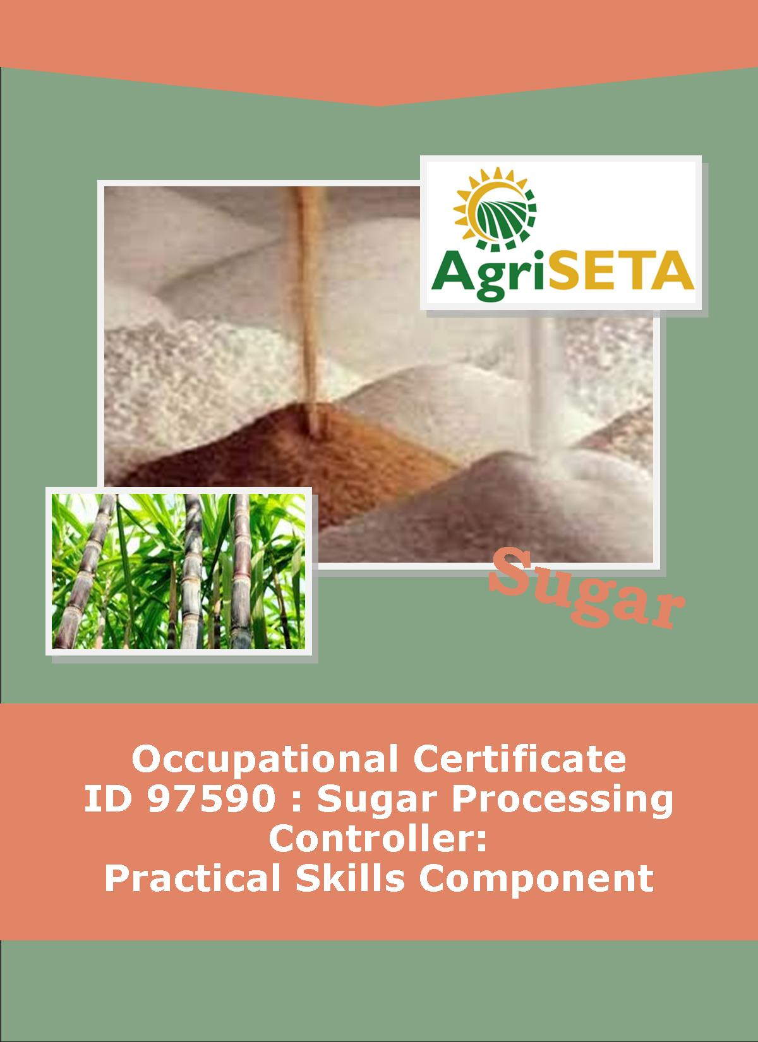
This Log Book belongs to:
__________________________________
Practical Skills Component:
Log Book
OCCUPATIONAL QUALIFICATION: SUGAR PROCESSING CONTROLLER

PRACTICAL SKILLS COMPONENT:

LOG BOOK
PRACTICAL SKILLS COMPONENT:
LOG BOOK
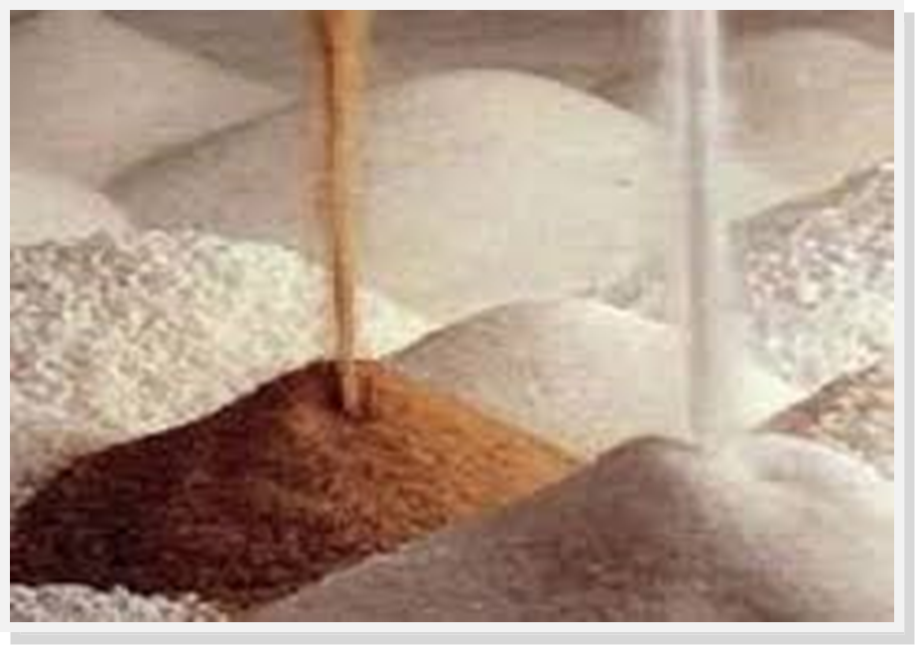
OCCUPATIONAL QUALIFICATION:
SUGAR PROCESSING CONTROLLER

©Copyright AgriSETA
Telephone: +27 12 301 5600
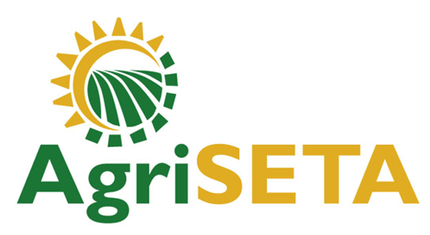

AgriSETA holds the copyright to its publications and Web pages. Proper citation is requested.

TABLE OF CONTENTS
1. AN INTRODUCTION TO THIS LOG BOOK 7
1.1 Practical Skills Module Specifications 7
1.2 Types of Assessment Tools that will be used in the Practical Skills Component 7
1.3 Completing your Log Book 8
1.4 How to use the Competence Checklists 9
1.5 How to use the Preparation Matrices 9

2. PRACTICAL SKILLS MODULE 1 11
2.1 Monitor and Control Sugar Processing Equipment 11
2.2 Preparation Matrix for Practical Skills Module 1 12
2.3 Competence Checklist for Practical Skills Module 1 15

3. PRACTICAL SKILLS MODULE 2 47
3.1 Control sugar milling operations and resources 47
3.2 Preparation Matrix for Practical Skills Module 2 48
3.3 Competence Checklist for Practical Skills Module 2 51

4. PRACTICAL SKILLS MODULE 3 57
4.1 Monitor and direct subordinate performance and conduct 57
4.2 Preparation Matrix for Practical Skills Module 3 58
4.3 Competence Checklist for Practical Skills Module 3 61

5. PRACTICAL SKILLS MODULE 4 64
5.1 Enforce compliance to Safety, Health, Environmental protection and Quality standards 64
5.2 Preparation Matrix for Practical Skills Module 4 65
5.3 Competence Checklist for Practical Skills Module 4 68

6. PRACTICAL SKILLS MODULE 5 80
6.1 Conduct and respond to in-line quality tests and reports 80
6.2 Preparation Matrix for Practical Skills Module 5 81
6.3 Competence Checklist for Practical Skills Module 5 84

7. PRACTICAL SKILLS MODULE 6 91
7.1 Inspect and coordinate maintenance of equipment 91
7.2 Preparation Matrix for Practical Skills Module 6 92
7.3 Competence Checklist for Practical Skills Module 6 95

8. PRACTICAL SKILLS MODULE 7 99
8.1 Compile and present production reports 99
8.2 Preparation Matrix for Practical Skills Module 7 100
8.3 Competence Checklist for Practical Skills Module 7 103

9. SUMMARY LEARNER ASSESSMENT RECORD 109
9.1 Learner Assessment Record 109
9.2 Stakeholder information 110
9.2.1 Learner Details 110
9.2.2 Mill Supervisor Details 110
9.2.3 Programme Assessor Details 111
-o0o-

AN INTRODUCTION TO THIS LOG BOOK

Practical Skills Module Specifications
This Log Book is intended to be used for the Practical Skills Component of the Occupational Qualification: Sugar Processing Controller NQF 5. This Log Book contains the following Practical Skills Module Specifications:
- 313908000-PM-01, Monitor and control sugar processing equipment, NQF Level 5, Credits 16
- 313908000-PM-02, Control sugar milling operations and resources, NQF Level 5, Credits 8
- 313908000-PM-03, Monitor and direct subordinate performance and conduct, NQF Level 5, Credits 8
- 313908000-PM-04, Enforce compliance to Safety, Health, Environmental protection and Quality standards, NQF Level 5, Credits 6
- 313908000-PM-05, Conduct and respond to in-line quality tests and reports, NQF Level 5, Credits 8
- 313908000-PM-06, Inspect and coordinate maintenance of equipment, NQF Level 5, Credits 8
- 313908000-PM-07, Compile and present production reports, NQF Level 4, Credits 4

Types of Assessment Tools that will be used in the Practical Skills Component
Throughout this Occupational Qualification there are three assessment tools or ways of recording knowledge and practical skills. The first method is related to the underpinning knowledge and takes the form of written assessments (as has generally been the case in the Formative Assessment within the Knowledge Component preceding the Practical Skills Component). These have taken the form of multiple choice assessments and short structured questions requiring explanation on the part of the learner. It has also included practical or homework assignments during the formative assessment.
The second and third types of assessment tools are related to the ways in which the assessor can gather and record evidence for the practical skills that you, the learner, must demonstrate. A competence checklist is a list of activities or performance outcomes that you, the learner, must be seen to be able to do in order to be considered competent in the tasks being assessed. The checklist provides a space to state that either “Yes, the learner successfully carried out this activity” or, “No, the learner has not yet achieved this standard”.
Checklists are provided in this Log Book and you, the learner, has to show that the tasks can be performed to the standard stated – The method of assessment is “observation of performance under realistic conditions”. Alternatively performance may be observed under controlled conditions such as a simulated work environment in a training centre workshop or registered Assessment Centre (if the necessary tools and equipment or systems are available for such assessment).
The third method that can be used to assess practical skills is the provision of opportunities for practical assignments. These are tasks that you will be required to complete. In these cases, your supervisor will provide instructions for you to follow in order that you can demonstrate your competence. Practical assignments may ask you to produce a product (e.g. a plan, a report, a design, a drawing, a schematic), or it may require observation by the supervisor of your performance, or a combination of the two.

Completing your Log Book
Once each of these competence checklists are completed and signed off, the Learner Log Book document and all its Supporting Evidence must be handed to the relevant QCTO Assessment Quality Partner for verification.
A summary “Learner Assessment Record” is provided at the back of the Learner Log Book and is a record of your progress over the entire Practical Skills Component. This should be completed by the Mill Supervisor and a certified copy inserted into the Summative Guide (In the Work Experience Component).

How to use the Competence Checklists
The Competence Checklists for each of the Practical Skills Modules contained in this Log Book appear as follows. A few guidelines on how to use these Checklists are shown below:
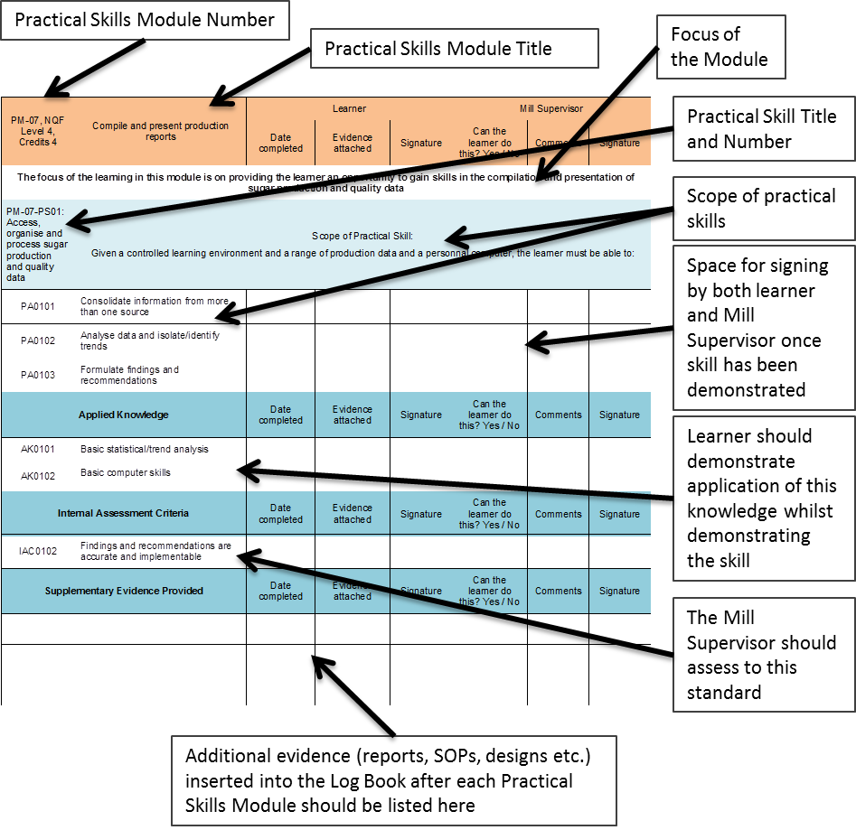

How to use the Preparation Matrices
To prepare for each Practical Skills Module a Preparation Matrix has been provided for your use. Use this to plan your work in collaboration with the Mill Supervisor.
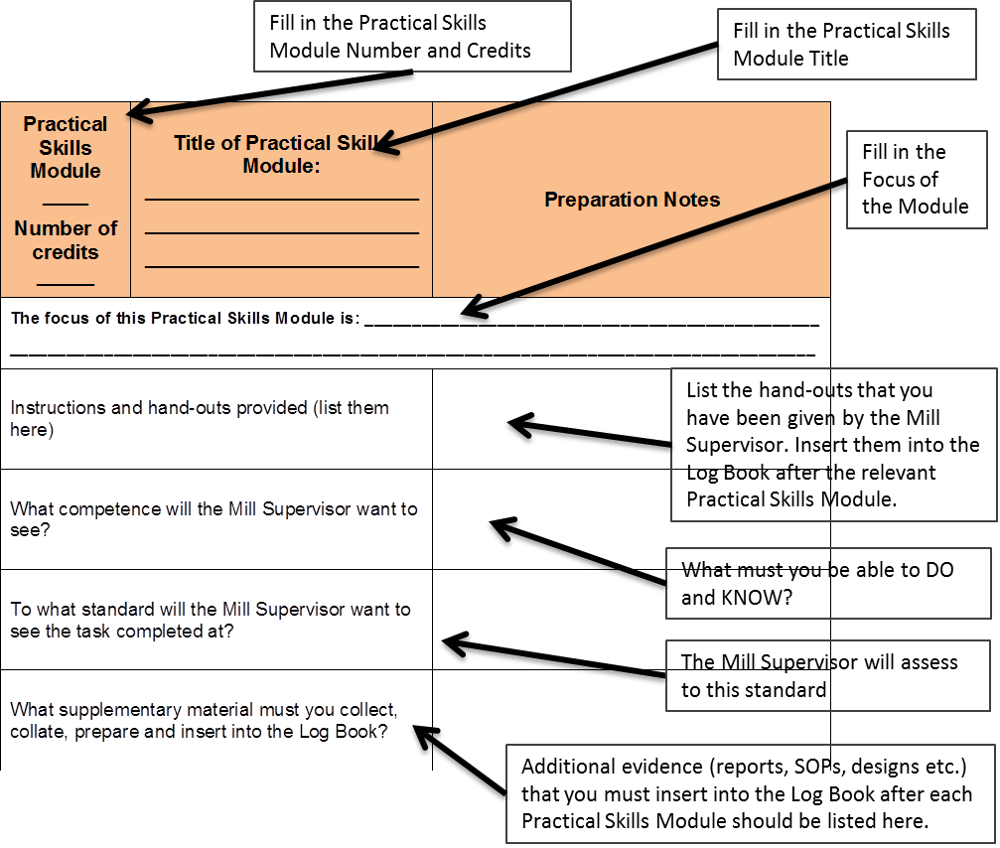
(Note: PM = Practical Skills Module, PA = Practical Skill Assessment Scope, AK = Applied Knowledge)

PRACTICAL SKILLS MODULE 1

Monitor and Control Sugar Processing Equipment
Module number: 313908000-PM01: NQF Level 5: Credits 16
The focus of the learning in this module is on providing the learner an opportunity to gain the practical skills related to monitoring and controlling sugar processing equipment and processes in a controlled learning environment.
The learner will be required to:
- PM-01-PS01: Monitor and control cane yard operations
- PM-01-PS02: Monitor and control cane milling and juice extraction operations
- PM-01-PS03: Monitor and control sugar juice clarification and filtration operations
- PM-01-PS04: Monitor and control evaporation operations
- PM-01-PS05: Monitor and control pan boiling operations
- PM-01-PS06: Monitor and control centrifugal operations
- PM-01-PS07: Control and adjust material flow for a sugar milling production unit or line
- PM-01-PS08: Set up, monitor and adjust sugar processing equipment settings
- PM-01-PS09: Monitor demand, supply and efficient utilisation of services and utilities

Preparation Matrix for Practical Skills Module 1
Practical Skills Module ____  Number of credits _____ | Title of Practical Skills Module: ________________________  ________________________  ________________________ | Preparation Notes
The focus of this Practical Skills Module is: ______________________________________________________________________
__________________________________________________________________________________________________________
Instructions and hand-outs provided (list them here)
What competence will the Mill Supervisor want to see?
To what standard will the Mill Supervisor want to see the task completed at?
What supplementary material must you collect, collate, prepare and insert into the Log Book?

Competence Checklist for Practical Skills Module 1
PM01: NQF Level 5: Credits 16 | Monitor and Control Sugar Processing Equipment | Learner |  |  | Mill Supervisor
PM01: NQF Level 5: Credits 16 | Monitor and Control Sugar Processing Equipment | Date completed | Evidence attached | Signature | Can the learner do this? Yes / No | Comments | Signature
The focus of the learning in this module is on providing the learner an opportunity to gain the practical skills related to monitoring and controlling sugar processing equipment and processes in a controlled learning environment.
PM-01-PS01: Monitor and control cane yard operations | Scope of Practical Skill:  Given operational control parameters, plans and schedules, orders for a production unit and a controlled learning environment, the learner must be able to:
PA0101 | Develop or adjust a daily production plan based on production targets
PA0102 | Determine the resources required to ensure that the production plan and targets are met
PA0103 | Plan the utilisation of storage space to meet production schedules
PA0104 | Set and communicate production targets
PA0105 | Plan production line usage for optimal plant output
PA0106 | Monitor the achievement of production targets and initiate corrective measures
Applied Knowledge |  | Date completed | Evidence attached | Signature | Can the learner do this? Yes / No | Comments | Signature
AK0101 | Production capacity of the production line
AK0102 | Storage capacity
AK0103 | Production planning
Internal Assessment Criteria |  | Date completed | Evidence attached | Signature | Can the learner do this? Yes / No | Comments | Signature
IAC0101 | Operational schedules of the unit or line are aligned to the production plan
IAC0102 | Targets are clearly formulated and measurable
IAC0103 | Measures to address deviations from planned targets can be explained
Supplementary Evidence Provided |  | Date completed | Evidence attached | Signature | Can the learner do this? Yes / No | Comments | Signature
PM-01-PS02: Monitor and control cane milling and juice extraction operations | Scope of Practical Skill  Given a controlled learning environment, a sugar mill production line or unit, and production schedules, the learner must be able to:
PA0201 | Coordinate start-up equipment in a production line
PA0202 | Coordinate shut-down of equipment in a production line
PA0203 | Control and coordinate operational processes (e.g. purging, cleaning, lock out, emergency stop) for a production line
PA0204 | Oversee equipment change-over procedures
PA0205 | Conduct shift handover procedures
Applied Knowledge |  | Date completed | Evidence attached | Signature | Can the learner do this? Yes / No | Comments | Signature
AK0201 | Workplace safety and operational requirements
AK0202 | Start-up and shut-down sequence
AK0203 | Standard procedures for various production line operating processes
Internal Assessment Criteria |  | Date completed | Evidence attached | Signature | Can the learner do this? Yes / No | Comments | Signature
IAC0201 | Production line start up and shut downs are coordinated within safety and operational requirements
IAC0202 | Specific processes are performed in terms of standard operating procedures
Supplementary Evidence Provided |  | Date completed | Evidence attached | Signature | Can the learner do this? Yes / No | Comments | Signature
PM-01-PS03: Monitor and control sugar juice clarification and filtration operations | Scope of Practical Skill  Given a controlled learning environment, a sugar mill production line and production schedules, the learner must be able to:
PA0301 | Achieve consistent flow and availability of material over various operational stages
PA0302 | Recognise and respond to deviations observed at various stages of an operation
PA0303 | Optimise equipment operation in terms of material availability and flow
PA0304 | Solve operational problems
Applied Knowledge |  | Date completed | Evidence attached | Signature | Can the learner do this? Yes / No | Comments | Signature
AK0101 | Equipment settings
AK0302 | Operating standards
AK0303 | Optimisation practices
AK0304 | Common deviations and standard responses
AK0305 | Problem-solving techniques
Internal Assessment Criteria |  | Date completed | Evidence attached | Signature | Can the learner do this? Yes / No | Comments | Signature
IAC0301 | Material flow requirements and quality standards are met
IAC0302 | Problem areas that falls outside of the delegated responsibility of the Feed Miller can be explained
IAC0303 | Potential problem areas can be recognised and remedial actions explained
Supplementary Evidence Provided |  | Date completed | Evidence attached | Signature | Can the learner do this? Yes / No | Comments | Signature
PM-01-PS04: Monitor and control evaporation operations | Scope of Practical Skill  Given a controlled learning environment, a sugar mill production line or unit, production schedules and operational specifications, the learner must be able to:
PA0401 | Set up the production line equipment to production specifications
PA0402 | Read, analyse and respond to instrumentation readings to conduct process control
PA0403 | Adjust equipment settings to maintain equipment operation within required specifications
PA0404 | Make/initiate process adjustments to meet production targets and product specifications
PA0405 | Monitor key set/control points and initiate appropriate response to maintain quality control protocols
PA0406 | Evaluate implications of changes and cause and affect relations within a process when making adjustments
PA0407 | Recognise early warning signs of emerging deviations
PA0408 | Recognise the point at which things, that fall outside of normal procedures, go badly wrong and respond appropriately
Applied Knowledge |  | Date completed | Evidence attached | Signature | Can the learner do this? Yes / No | Comments | Signature
AK0401 | Equipment operation
AK0402 | Operating parameters
AK0403 | Product quality specifications and deviations
AK0404 | Corrective actions
AK0405 | Warning signs
Internal Assessment Criteria |  | Date completed | Evidence attached | Signature | Can the learner do this? Yes / No | Comments | Signature
IAC0401 | Operating standards of equipment are set and maintained within defined parameters
IAC0402 | Early warning signs of potential problems and remedial actions can be explained
IAC0403 | Problem areas that falls outside of the delegated responsibility of the Sugar Miller can be explained
Supplementary Evidence Provided |  | Date completed | Evidence attached | Signature | Can the learner do this? Yes / No | Comments | Signature
PM-01-PS05: Monitor and control pan boiling operations | Scope of Practical Skill  Given a controlled learning environment, a sugar mill production line and production schedules, the learner must be able to:
PA0501 | Draft a procedure for the inspection and monitoring of utilities and services
PA0502 | Recognise sign of energy waste or inefficient utilisation
PA0503 | Recognise signs of steam, air and water shortages and initiate corrective measures
PA0504 | Conduct emergency shut down and start-up procedures
Applied Knowledge |  | Date completed | Evidence attached | Signature | Can the learner do this? Yes / No | Comments | Signature
AK0501 | Levels/volumes of utility or services required to maintain normal operations
AK0502 | Reporting procedures
AK0503 | Precautionary/emergency measures or production shut-down procedures
Internal Assessment Criteria |  | Date completed | Evidence attached | Signature | Can the learner do this? Yes / No | Comments | Signature
IAC0501 | Energy efficiency levels are maintained within set standards and parameters
IAC0502 | Emerging supply shortages are recognised and corrective measures initiated to address the situation
Supplementary Evidence Provided |  | Date completed | Evidence attached | Signature | Can the learner do this? Yes / No | Comments | Signature
PM-01-PS06: Monitor and control centrifugal operations | Scope of Practical Skill  Given a controlled learning environment, a sugar mill production line or unit, production schedules and operational specifications, the learner must be able to:
PA0601 | Set up the production line equipment to production specifications
PA0602 | Read, analyse and respond to instrumentation readings to conduct process control
PA0603 | Adjust equipment settings to maintain equipment operation within required specifications
PA0604 | Make/initiate process adjustments to meet production targets and product specifications
PA0605 | Monitor key set/control points and initiate appropriate response to maintain quality control protocols
PA0606 | Evaluate implications of changes and cause and affect relations within a process when making adjustments
PA0607 | Recognise early warning signs of emerging deviations
PA0608 | Recognise the point at which things, that fall outside of normal procedures, go badly wrong and respond appropriately
Applied Knowledge |  | Date completed | Evidence attached | Signature | Can the learner do this? Yes / No | Comments | Signature
AK0601 | Equipment operation
AK0602 | Operating parameters
AK0603 | Product quality specifications and deviations
AK0604 | Corrective actions
AK0605 | Warning signs
Internal Assessment Criteria |  | Date completed | Evidence attached | Signature | Can the learner do this? Yes / No | Comments | Signature
IAC0601 | Operating standards of equipment are set and maintained within defined parameters
IAC0602 | Early warning signs of potential problems and remedial actions can be explained
IAC0603 | Problem areas that falls outside of the delegated responsibility of the Sugar Miller can be explained
Supplementary Evidence Provided |  | Date completed | Evidence attached | Signature | Can the learner do this? Yes / No | Comments | Signature
PM-01-PS07: Control and adjust material flow for a sugar milling production unit or line | Scope of Practical Skill  Given a controlled learning environment, a sugar mill production line or unit, production schedules and operational specifications, the learner must be able to:
PA0701 | Set up the production line equipment to production specifications
PA0702 | Read, analyse and respond to instrumentation readings to conduct process control
PA0703 | Adjust equipment settings to maintain equipment operation within required specifications
PA0704 | Make/initiate process adjustments to meet production targets and product specifications
PA0705 | Monitor key set/control points and initiate appropriate response to maintain quality control protocols
PA0706 | Evaluate implications of changes and cause and affect relations within a process when making adjustments
PA0707 | Recognise early warning signs of emerging deviations
PA0708 | Recognise the point at which things, that fall outside of normal procedures, go badly wrong and respond appropriately
Applied Knowledge |  | Date completed | Evidence attached | Signature | Can the learner do this? Yes / No | Comments | Signature
AK0701 | Equipment operation
AK0702 | Operating parameters
AK0703 | Product quality specifications and deviations
AK0704 | Corrective actions
AK0705 | Warning signs
Internal Assessment Criteria |  | Date completed | Evidence attached | Signature | Can the learner do this? Yes / No | Comments | Signature
IAC0701 | Operating standards of equipment are set and maintained within defined parameters
IAC0702 | Early warning signs of potential problems and remedial actions can be explained
IAC0703 | Problem areas that falls outside of the delegated responsibility of the Sugar Miller can be explained
Supplementary Evidence Provided |  | Date completed | Evidence attached | Signature | Can the learner do this? Yes / No | Comments | Signature
PM-01-PS08: Set up, monitor and adjust sugar processing equipment settings | Scope of Practical Skill  Given a controlled learning environment, a sugar mill production line or unit, production schedules and operational specifications, the learner must be able to:
PA0801 | Set up the production line equipment to production specifications
PA0802 | Read, analyse and respond to instrumentation readings to conduct process control
PA0803 | Adjust equipment settings to maintain equipment operation within required specifications
PA0804 | Make/initiate process adjustments to meet production targets and product specifications
PA0805 | Monitor key set/control points and initiate appropriate response to maintain quality control protocols
PA0806 | Evaluate implications of changes and cause and affect relations within a process when making adjustments
PA0807 | Recognise early warning signs of emerging deviations
PA0808 | Recognise the point at which things, that fall outside of normal procedures, go badly wrong and respond appropriately
Applied Knowledge |  | Date completed | Evidence attached | Signature | Can the learner do this? Yes / No | Comments | Signature
AK0801 | Equipment operation
AK0802 | Operating parameters
AK0803 | Product quality specifications and deviations
AK0804 | Corrective actions
AK0805 | Warning signs
Internal Assessment Criteria |  | Date completed | Evidence attached | Signature | Can the learner do this? Yes / No | Comments | Signature
IAC0801 | Operating standards of equipment are set and maintained within defined parameters
IAC0802 | Early warning signs of potential problems and remedial actions can be explained
IAC0803 | Problem areas that falls outside of the delegated responsibility of the Feed Miller can be explained
Supplementary Evidence Provided |  | Date completed | Evidence attached | Signature | Can the learner do this? Yes / No | Comments | Signature
PM-01-PS09: Monitor demand, supply and efficient utilisation of services and utilities | Scope of Practical Skill  Given a controlled learning environment, a sugar mill production line or unit, production schedules and operational specifications, the learner must be able to:
PA0901 | Set up the production line equipment to production specifications
PA0902 | Read, analyse and respond to instrumentation readings to conduct process control
PA0903 | Adjust equipment settings to maintain equipment operation within required specifications
PA0904 | Make/initiate process adjustments to meet production targets and product specifications
PA0905 | Monitor key set/control points and initiate appropriate response to maintain quality control protocols
PA0906 | Evaluate implications of changes and cause and affect relations within a process when making adjustments
PA0907 | Recognise early warning signs of emerging deviations
PA0908 | Recognise the point at which things, that fall outside of normal procedures, go badly wrong and respond appropriately
Applied Knowledge |  | Date completed | Evidence attached | Signature | Can the learner do this? Yes / No | Comments | Signature
AK0901 | Equipment operation
AK0902 | Operating parameters
AK0903 | Product quality specifications and deviations
AK0904 | Corrective actions
AK0905 | Warning signs
Internal Assessment Criteria |  | Date completed | Evidence attached | Signature | Can the learner do this? Yes / No | Comments | Signature
IAC0901 | Operating standards of equipment are set and maintained within defined parameters
IAC0902 | Early warning signs of potential problems and remedial actions can be explained
IAC0903 | Problem areas that falls outside of the delegated responsibility of the Sugar Miller can be explained
Supplementary Evidence Provided |  | Date completed | Evidence attached | Signature | Can the learner do this? Yes / No | Comments | Signature

PRACTICAL SKILLS MODULE 2

Control sugar milling operations and resources
Module Number 313908000-PM-02, NQF Level 5, Credits 8
The focus of the learning in this module is on providing the learner an opportunity to practice the skills required to execute planning and monitoring activities to control sugar milling operations and resources to ensure the achievement of plant efficiency targets.
The learner will be required to:
- PM-02-PS01: Plan and schedule sugar milling operations to meet production targets
- PM-02-PS02: Monitor and control stock levels of raw materials used in sugar processing

Preparation Matrix for Practical Skills Module 2
Practical Skills Module ____  Number of credits _____ | Title of Practical Skills Module: ________________________  ________________________  ________________________ | Preparation Notes
The focus of this Practical Skills Module is: ______________________________________________________________________
__________________________________________________________________________________________________________
Instructions and hand-outs provided (list them here)
What competence will the Mill Supervisor want to see?
To what standard will the Mill Supervisor want to see the task completed at?
What supplementary material must you collect, collate, prepare and insert into the Log Book?

Competence Checklist for Practical Skills Module 2
PM-02, NQF Level 5, Credits 8 | Control sugar milling operations and resources | Learner |  |  | Mill Supervisor
PM-02, NQF Level 5, Credits 8 | Control sugar milling operations and resources | Date completed | Evidence attached | Signature | Can the learner do this? Yes / No | Comments | Signature
The focus of the learning in this module is on providing the learner an opportunity to practice the skills required to execute planning and monitoring activities to control sugar milling operations and resources to ensure the achievement of plant efficiency targets.
PM-02-PS01: Plan and schedule sugar milling operations to meet production targets | Scope of Practical Skill:  Given production targets, the learner must be able to:
PA0101 | List the materials and estimated volumes required for a production shift
PA0102 | Determine the resources required to ensure that the production plan and targets are met
PA0103 | Plan labour needs and a shift roster
PA0104 | Schedule finished product storage according to available storage
Applied Knowledge |  | Date completed | Evidence attached | Signature | Can the learner do this? Yes / No | Comments | Signature
AK0101 | Production scheduling
AK0102 | Raw material volumes for specific products
AK0103 | Shift schedules
AK0104 | Communication
Internal Assessment Criteria |  | Date completed | Evidence attached | Signature | Can the learner do this? Yes / No | Comments | Signature
IAC0101 | Production scheduling meets production targets
IAC0102 | The impact of not meeting scheduled targets can be explained
Supplementary Evidence Provided |  | Date completed | Evidence attached | Signature | Can the learner do this? Yes / No | Comments | Signature
PM-02-PS02: Monitor and control stock levels of raw materials used in sugar processing | Scope of Practical Skill:  Given records of stock on hand, stock usage data and production schedules, the learner must be able to:
PA0201 | Compile estimates of stocks required in the production of different products
PA0202 | Reconcile production needs with stocks on hand
PA0203 | Determine minimum reordering levels for stock items
PA0204 | Determine stock loss levels (waste) based on historical data provided
PA0205 | Complete stock control reports
Applied Knowledge |  | Date completed | Evidence attached | Signature | Can the learner do this? Yes / No | Comments | Signature
AK0201 | Operational stock requirements for specific products
AK0202 | Stock control
AK0203 | Standard corrective actions
Internal Assessment Criteria |  | Date completed | Evidence attached | Signature | Can the learner do this? Yes / No | Comments | Signature
IAC0201 | Stock level estimates, waste and re-ordering volumes are correctly determined
IAC0202 | Stock control records are accurately completed
Supplementary Evidence Provided |  | Date completed | Evidence attached | Signature | Can the learner do this? Yes / No | Comments | Signature

PRACTICAL SKILLS MODULE 3

Monitor and direct subordinate performance and conduct
Module Number 313908000-PM-03, NQF Level 5, Credits 8
The focus of the learning in this module is on providing the learner an opportunity to apply the practical skills required to direct subordinate performance and conduct to ensure the achievement of plant efficiency targets.
- PM-03-PS01: Direct subordinate performance and conduct

Preparation Matrix for Practical Skills Module 3
Practical Skills Module ____  Number of credits _____ | Title of Practical Skills Module: ________________________  ________________________  ________________________ | Preparation Notes
The focus of this Practical Skills Module is: ______________________________________________________________________
__________________________________________________________________________________________________________
Instructions and hand-outs provided (list them here)
What competence will the Mill Supervisor want to see?
To what standard will the Mill Supervisor want to see the task completed at?
What supplementary material must you collect, collate, prepare and insert into the Log Book?

Competence Checklist for Practical Skills Module 3
PM-03, NQF Level 5, Credits 8 | Control sugar milling operations and resources | Learner |  |  | Mill Supervisor
PM-03, NQF Level 5, Credits 8 | Control sugar milling operations and resources | Date completed | Evidence attached | Signature | Can the learner do this? Yes / No | Comments | Signature
PM-03-PS01: Direct subordinate performance and conduct | Scope of Practical Skill:  Given company HR policies and procedures, standard forms and access to the BCOE, the learner must be able to:
PA0301 | Set performance targets and direct personnel performance
PA0302 | Maintain shop floor discipline
PA0303 | Resolve a workplace grievance
PA0304 | Resolve shop floor conflict
Applied Knowledge |  | Date completed | Evidence attached | Signature | Can the learner do this? Yes / No | Comments | Signature
AK0101 | Performance management and performance targets
AK0302 | Disciplinary codes and procedures
AK0303 | Grievance procedures
AK0304 | Workplace conflict resolution
Internal Assessment Criteria |  | Date completed | Evidence attached | Signature | Can the learner do this? Yes / No | Comments | Signature
IAC0301 | Performance agreements are reached and measurable targets agreed upon
IAC0302 | Performance levels and monitored and corrected where required
IAC0303 | Disciplinary procedures and standard practices can be explained and applied
IAC0304 | Grievance procedures and standard practices can be explained and applied
IAC0305 | Conflict resolution practices can be explained and applied
Supplementary Evidence Provided |  | Date completed | Evidence attached | Signature | Can the learner do this? Yes / No | Comments | Signature

PRACTICAL SKILLS MODULE 4

Enforce compliance to Safety, Health, Environmental protection and Quality standards
Module Number 313908000-PM-04, NQF Level 5, Credits 6
The focus of the learning in this module is on providing the learner an opportunity to monitor and execute control over Safety, Health, Environmental and Quality (SHEQ) Procedures in a controlled learning environment.
The learner will be required to:
- PM-04-PS01: Investigate and report incidents
- PM-04-PS02: Execute control over Safety, Health, Environment and Quality (SHEQ) control procedures
- PM-04-PS03: Maintain records and registers in compliance with Safety, Health, Environment and Quality (SHEQ) regulations
- PM-04-PS04: Perform Hazard Identification and Risk Analysis assessment (HIRA)

Preparation Matrix for Practical Skills Module 4
Practical Skills Module ____  Number of credits _____ | Title of Practical Skills Module: ________________________  ________________________  ________________________ | Preparation Notes
The focus of this Practical Skills Module is: ______________________________________________________________________
__________________________________________________________________________________________________________
Instructions and hand-outs provided (list them here)
What competence will the Mill Supervisor want to see?
To what standard will the Mill Supervisor want to see the task completed at?
What supplementary material must you collect, collate, prepare and insert into the Log Book?

Competence Checklist for Practical Skills Module 4
PM-04, NQF Level 5, Credits 6 | Enforce compliance to Safety, Health, Environmental protection and Quality standards | Learner |  |  | Mill Supervisor
PM-04, NQF Level 5, Credits 6 |  | Date completed | Evidence attached | Signature | Can the learner do this? Yes / No | Comments | Signature
The focus of the learning in this module is on providing the learner an opportunity to monitor and execute control over Safety, Health, Environmental and Quality (SHEQ) Procedures in a controlled learning environment.
PM-04-PS01: Investigate and report incidents | Scope of Practical Skill:  Given case studies or scenarios on industrial incidents, the learner must be able to:
PA0101 | Conduct an incident/accident investigation in accordance with procedures and regulatory requirements
PA0102 | Establish an official record in accordance with regulatory requirements and submit a report
PA0103 | Formulate recommendations on preventive measures
Applied Knowledge |  | Date completed | Evidence attached | Signature | Can the learner do this? Yes / No | Comments | Signature
AK0101 | Investigation procedures
AK0102 | Reporting procedures
AK0103 | Process knowledge
Internal Assessment Criteria |  | Date completed | Evidence attached | Signature | Can the learner do this? Yes / No | Comments | Signature
IAC0101 | Investigation reports are accurately and comprehensively completed
IAC0102 | Recommendations on preventative measures are explained in terms of impact, preventative value and practicability
Supplementary Evidence Provided |  | Date completed | Evidence attached | Signature | Can the learner do this? Yes / No | Comments | Signature
PM-04-PS02: Execute control over Safety, Health, Environment and Quality (SHEQ) control procedures | Scope of Practical Skill:  Given a controlled learning environment, a sugar mill, the learner must be able to:
PA0201 | Develop a SHEQ inspection sheet and standard procedure
PA0202 | Conduct inspections to identify actual or potential unsafe work practices or conditions
PA0203 | Develop a standard procedure to maintain the lock down status of equipment in a production line
PA0204 | Direct a simulated emergency evacuation procedure
PA0205 | Develop a standard procedure to enforce restrictions and access to high risk areas
PA0206 | Develop a standard procedure and inspection sheet for recognising factors in stored products and raw material that would result in unsafe products
PA0207 | Develop a standard procedure and inspection sheet to inspect housekeeping and sanitation practices
Applied Knowledge |  | Date completed | Evidence attached | Signature | Can the learner do this? Yes / No | Comments | Signature
AK0201 | SHEQ procedures
AK0202 | HACCP
Internal Assessment Criteria |  | Date completed | Evidence attached | Signature | Can the learner do this? Yes / No | Comments | Signature
IAC0201 | Standard procedures and inspection sheets addresses all the critical control areas and are practically implementable
Supplementary Evidence Provided |  | Date completed | Evidence attached | Signature | Can the learner do this? Yes / No | Comments | Signature
PM-04-PS03: Maintain records and registers in compliance with Safety, Health, Environment and Quality (SHEQ) regulations | Scope of Practical Skill  Given different scenarios, examples of SHEQ records, the learner must be able to:
PA0301 | Maintain statutory Safety, Health and Environmental protection registers
PA0302 | Perform a SHEQ inspection and complete SHEQ forms
PA0303 | Evaluate SHEQ records and formulate corrective measures
PA0304 | Draft a SHEQ feedback report
Applied Knowledge |  | Date completed | Evidence attached | Signature | Can the learner do this? Yes / No | Comments | Signature
AK0101 | Statutory register requirements
AK0302 | SHEQ inspection procedures
AK0303 | Reporting and recording procedures
Internal Assessment Criteria |  | Date completed | Evidence attached | Signature | Can the learner do this? Yes / No | Comments | Signature
IAC0301 | Statutory registers are complete and accurate
IAC0302 | SHEQ reports and documents are complete and accurate
Supplementary Evidence Provided |  | Date completed | Evidence attached | Signature | Can the learner do this? Yes / No | Comments | Signature
PM-04-PS04: Perform Hazard Identification and Risk Analysis assessment (HIRA) | Scope of Practical Skill  Given controlled learning environment in a operational sugar production unit, the learner must be able to:
PA0401 | Draft a HIRA assessment sheet
PA0402 | Conduct inspections to identify actual or potential unsafe work practices or conditions
PA0403 | Formulate corrective measures to address unsafe work practices
Applied Knowledge |  | Date completed | Evidence attached | Signature | Can the learner do this? Yes / No | Comments | Signature
AK0401 | Assessment procedures
AK0402 | Risks and corrective measures
AK0403 | Reporting and recording procedures
AK0404 | The process of continuous risk assessment
AK0405 | Documentation required
AK0406 | Hazards and risks likely to be encountered
AK0407 | Consequences for not conforming to legal and specified requirements
Internal Assessment Criteria |  | Date completed | Evidence attached | Signature | Can the learner do this? Yes / No | Comments | Signature
IAC0401 | The process of continuous risk assessment and document requirements is explained
IAC0402 | The physical and environmental conditions that poses risks are identified and consequences for not conforming to legal and specified requirements is explained
IAC0403 | A systematic approach is followed to recognise risks
IAC0404 | Remedial actions that are formulated are practically implementable
Supplementary Evidence Provided |  | Date completed | Evidence attached | Signature | Can the learner do this? Yes / No | Comments | Signature

PRACTICAL SKILLS MODULE 5

Conduct and respond to in-line quality tests and reports
Module Number 313908000-PM-05, NQF Level 5, Credits 8
The focus of the learning in this module is on providing the learner an opportunity to monitor quality standards and to initiate the responses to correct these in a controlled learning environment.
The learner will be required to:
- PM-05-PS01: Use observations, instruments, gauges and in-process tests to execute quality checks at various stages of sugar processing
- PM-05-PS02: Read and respond to sugar quality reports

Preparation Matrix for Practical Skills Module 5
Practical Skills Module ____  Number of credits _____ | Title of Practical Skills Module: ________________________  ________________________  ________________________ | Preparation Notes
The focus of this Practical Skills Module is: ______________________________________________________________________
__________________________________________________________________________________________________________
Instructions and hand-outs provided (list them here)
What competence will the Mill Supervisor want to see?
To what standard will the Mill Supervisor want to see the task completed at?
What supplementary material must you collect, collate, prepare and insert into the Log Book?

Competence Checklist for Practical Skills Module 5
PM-05, NQF Level 5, Credits 8 | Conduct and respond to in-line quality tests and reports | Learner |  |  | Mill Supervisor
PM-05, NQF Level 5, Credits 8 | Conduct and respond to in-line quality tests and reports | Date completed | Evidence attached | Signature | Can the learner do this? Yes / No | Comments | Signature
The focus of the learning in this module is on providing the learner an opportunity to monitor quality standards and to initiate the responses to correct these in a controlled learning environment.
PM-05-PS01: Use observations, instruments, gauges and in-process tests to execute quality checks at various stages of sugar processing | Scope of Practical Skill:  Given in-process samples of material and required specifications, the learner must be able to:
PA0101 | Conduct in-line quality inspections and sample analysis at various sugar processing stages
PA0102 | Conduct sensory assessments on quality at various sugar processing stages
PA0103 | Direct and schedule sampling frequency in response to quality tests and observations
PA0104 | Collect and prepare control samples for quality verification purposes at various sugar processing stages
PA0105 | Validate the accuracy of application equipment, scales and flow meters
Applied Knowledge |  | Date completed | Evidence attached | Signature | Can the learner do this? Yes / No | Comments | Signature
AK0101 | Testing equipment, instruments and gauges
AK0102 | Validation procedures and tolerances
AK0103 | Product standards
AK0104 | Sampling procedures
AK0105 | Common deviations and standard responses
Internal Assessment Criteria |  | Date completed | Evidence attached | Signature | Can the learner do this? Yes / No | Comments | Signature
IAC0101 | Quality factors affecting production line operations are identified
IAC0102 | Samples are analysed in accordance with accepted practices
IAC0103 | Quality control actions and frequencies are adjusted in response to quality results
IAC0104 | The implications of incorrect product data and/or the unavailability of data on the quality of the final product can be explained
Supplementary Evidence Provided |  | Date completed | Evidence attached | Signature | Can the learner do this? Yes / No | Comments | Signature
PM-05-PS02: Read and respond to sugar quality reports | Scope of Practical Skill:  Given quality reports, the learner must be able to:
PA0201 | Read and interpret reports on sugar quality, formulate actions to address deviations
PA0202 | Solve quality problems and formulate actions to address areas or processes that are repeatedly causing quality problems
PA0203 | Identify variations or deviations in technical performance of equipment from production and quality reports and formulate corrective actions
Applied Knowledge |  | Date completed | Evidence attached | Signature | Can the learner do this? Yes / No | Comments | Signature
AK0201 | Product specifications
AK0202 | Process knowledge
AK0203 | Equipment specifications
Internal Assessment Criteria |  | Date completed | Evidence attached | Signature | Can the learner do this? Yes / No | Comments | Signature
IAC0201 | Corrective actions that has to be initiated in good time to maintain quality standards and minimise loss can be explained
IAC0202 | Quality standards are monitored and maintained at various stages of the feed milling line
Supplementary Evidence Provided |  | Date completed | Evidence attached | Signature | Can the learner do this? Yes / No | Comments | Signature

PRACTICAL SKILLS MODULE 6

Inspect and coordinate maintenance of equipment
Module Number 313908000-PM-06, NQF Level 5, Credits 8
The focus of the learning in this module is on providing the learner an opportunity to gain skills in first line maintenance of equipment used in a sugar mill production line.
The learner will be required to:
- PM-06-PS01: Perform mechanical inspections on sugar processing equipment

Preparation Matrix for Practical Skills Module 6
Practical Skills Module ____  Number of credits _____ | Title of Practical Skills Module: ________________________  ________________________  ________________________ | Preparation Notes
The focus of this Practical Skills Module is: ______________________________________________________________________
__________________________________________________________________________________________________________
Instructions and hand-outs provided (list them here)
What competence will the Mill Supervisor want to see?
To what standard will the Mill Supervisor want to see the task completed at?
What supplementary material must you collect, collate, prepare and insert into the Log Book?

Competence Checklist for Practical Skills Module 6
PM-06, NQF Level 5, Credits 8 | Inspect and coordinate maintenance of equipment | Learner |  |  | Mill Supervisor
PM-06, NQF Level 5, Credits 8 | Inspect and coordinate maintenance of equipment | Date completed | Evidence attached | Signature | Can the learner do this? Yes / No | Comments | Signature
The focus of the learning in this module is on providing the learner an opportunity to gain skills in first line maintenance of equipment used in a sugar mill production line.
PM-06-PS01: Perform mechanical inspections on sugar processing equipment | Scope of Practical Skill:  Given a controlled learning environment, a sugar mill production line or unit, the learner must be able to:
PA0101 | Inspect sugar processing equipment for soundness and compliance with safety, health, environmental and quality assurance requirements
PA0102 | Detect technical problems and prioritise repairs in terms of associated risk of specific failure, safety risks or product loss
PA0103 | Generate maintenance requests (not scheduled)
PA0104 | Monitor and control the execution of standard equipment care and lubrication procedures to ensure operational functionality
PA0105 | Evaluate completed maintenance work by inspections, spot checks and machine runs
PA0106 | Recognise and initiate corrective actions when equipment is not operating to specification
PA0107 | Measure and record production downtime per category/incident/equipment
PA0108 | Present daily downtime trends by means of a graphical display against baseline targets
Applied Knowledge |  | Date completed | Evidence attached | Signature | Can the learner do this? Yes / No | Comments | Signature
AK0101 | Standard maintenance procedures and documentation
AK0102 | Indicators of mechanical problems on processing unit and equipment
AK0103 | Standard equipment settings and operating standards
AK0104 | Causes of mechanical problems
AK0105 | Safety risks and protective measures
Internal Assessment Criteria |  | Date completed | Evidence attached | Signature | Can the learner do this? Yes / No | Comments | Signature
IAC0101 | Inspection of equipment is performed and recorded in accordance with standard procedures Functioning of mechanical equipment, indicators of faults or variations from normal operation and/or imminent mechanical failure and fault finding principles can be explained
Supplementary Evidence Provided |  | Date completed | Evidence attached | Signature | Can the learner do this? Yes / No | Comments | Signature

PRACTICAL SKILLS MODULE 7

Compile and present production reports
Module Number 313908000-PM-07, NQF Level 4, Credits 4
The focus of the learning in this module is on providing the learner an opportunity to gain skills in the compilation and presentation of sugar production and quality data
The learner will be required to:
- PM-07-PS01: Access, organise and process sugar production and quality data
- PM-07-PS02: Compile reports and present sugar production data

Preparation Matrix for Practical Skills Module 7
Practical Skills Module ____  Number of credits _____ | Title of Practical Skills Module: ________________________  ________________________  ________________________ | Preparation Notes
The focus of this Practical Skills Module is: ______________________________________________________________________
__________________________________________________________________________________________________________
Instructions and hand-outs provided (list them here)
What competence will the Mill Supervisor want to see?
To what standard will the Mill Supervisor want to see the task completed at?
What supplementary material must you collect, collate, prepare and insert into the Log Book?

Competence Checklist for Practical Skills Module 7
PM-07, NQF Level 4, Credits 4 | Compile and present production reports | Learner |  |  | Mill Supervisor
PM-07, NQF Level 4, Credits 4 | Compile and present production reports | Date completed | Evidence attached | Signature | Can the learner do this? Yes / No | Comments | Signature
The focus of the learning in this module is on providing the learner an opportunity to gain skills in the compilation and presentation of sugar production and quality data
PM-07-PS01: Access, organise and process sugar production and quality data | Scope of Practical Skill:  Given a controlled learning environment and a range of production data and a personnal computer, the learner must be able to:
PA0101 | Consolidate information from more than one source
PA0102 | Analyse data and isolate/identify trends
PA0103 | Formulate findings and recommendations
Applied Knowledge |  | Date completed | Evidence attached | Signature | Can the learner do this? Yes / No | Comments | Signature
AK0101 | Basic statistical/trend analysis
AK0102 | Basic computer skills
Internal Assessment Criteria |  | Date completed | Evidence attached | Signature | Can the learner do this? Yes / No | Comments | Signature
IAC0101 | Data is analysed accurately
IAC0102 | Findings and recommendations are accurate and implementable
Supplementary Evidence Provided |  | Date completed | Evidence attached | Signature | Can the learner do this? Yes / No | Comments | Signature
PM-07-PS02: Compile reports and present sugar production data | Scope of Practical Skill:  Given production information, the learner must be able to:
PA0201 | Compile a production report
PA0202 | Compile a presentation
PA0203 | Present the report at a simulated meeting
PA0204 | Present daily production trends by means of a graphical display
Applied Knowledge |  | Date completed | Evidence attached | Signature | Can the learner do this? Yes / No | Comments | Signature
AK0201 | Production reports
AK0202 | Presentation skills
Internal Assessment Criteria |  | Date completed | Evidence attached | Signature | Can the learner do this? Yes / No | Comments | Signature
IAC0201 | The reports are well structured and key information is captured
IAC0202 | Presentations are well structured and presented
IAC0203 | Graphical displays are accurate and with trends clearly illustrated
Supplementary Evidence Provided |  | Date completed | Evidence attached | Signature | Can the learner do this? Yes / No | Comments | Signature

SUMMARY LEARNER ASSESSMENT RECORD
As soon as you have completed all the Practical Skills Modules successfully, this form and the stakeholder information below should be completed and the Log Book with all its supplementary information should be handed to the relevant QCTO Assessment Quality Partner for verification.
A certified copy of this entire section (Section 9: Summary Learner Assessment Record) must be inserted into your Summative Guide (In the Work Experience Component).

Learner Assessment Record
Practical Skills Module | Credits | Can the Learner do this? | Signature of Mill Supervisor | Date
313908000-PM-01, Monitor and control sugar processing equipment | 16
313908000-PM-02, Control sugar milling operations and resources | 8
313908000-PM-03, Monitor and direct subordinate performance and conduct | 8
313908000-PM-04, Enforce compliance to Safety, Health, Environmental protection and Quality standards | 6
313908000-PM-05, Conduct and respond to in-line quality tests and reports | 8
313908000-PM-06, Inspect and coordinate maintenance of equipment | 8
313908000-PM-07, Compile and present production reports | 4

Stakeholder information

Learner Details
First name:
Surname:
ID number:
Telephone number:
Mobile number:
E-mail address:
Postal address:
Start date of workplace experience:
Completion date of workplace experience:
Signature of learner:

Mill Supervisor Details
Organisation / workplace:
Workplace designation (of Mill Supervisor):
First name:
Surname:
ID number:
Telephone number:
Mobile number:
E-mail address:
Postal address:
Date completed:
Signature:

Programme Assessor Details
Company:
First name:
Surname:
ID number:
Telephone number:
Mobile number:
E-mail address:
Postal address:
Date assessed:
Signature:

