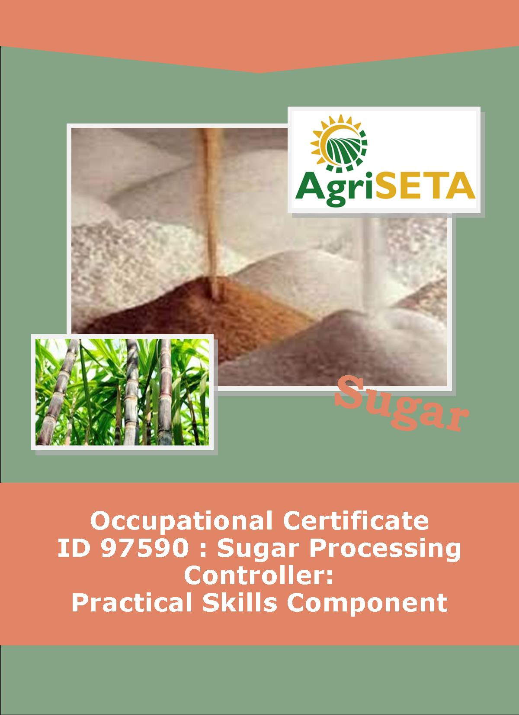
Practical Skills Component:
Mill Supervisor Guide
OCCUPATIONAL QUALIFICATION: SUGAR PROCESSING CONTROLLER

PRACTICAL SKILLS COMPONENT:

MILL SUPERVISOR GUIDE
PRACTICAL SKILLS COMPONENT:
MILL SUPERVISOR GUIDE
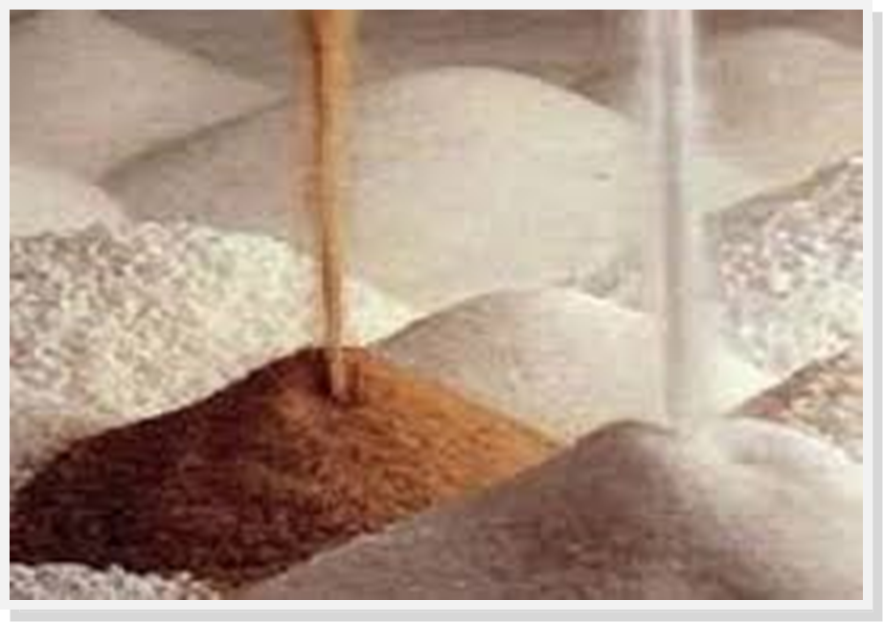
OCCUPATIONAL QUALIFICATION:
SUGAR PROCESSING CONTROLLER

©Copyright AgriSETA
Telephone: +27 12 301 5600
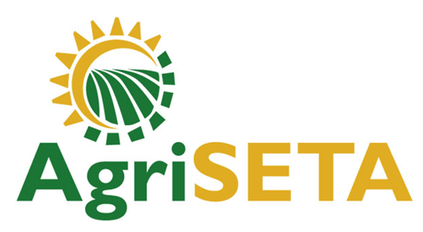

AgriSETA holds the copyright to its publications and Web pages. Proper citation is requested.

TABLE OF CONTENTS
1. AN INTRODUCTION TO THIS SUPERVISOR GUIDE AND THE PRACTICAL SKILLS MODULES OF THE SUGAR PROCESSING CONTROLLER OCCUPATIONAL CERTIFICATE 8
1.1 Practical Skills Modules of the Sugar Processing Controller Occupational Certificate 8
1.2 Types of Assessment Tools 8
1.3 Observation of Performance 10
1.4 Creating a Realistic Work Environment at an Assessment Centre VS practicals during a Mill Factory Floor Experience 12
1.5 The Competence Checklist and Practical Assignments 13
1.6 Preparing Assessment Plans 14
1.6.1 Planning 14
1.6.2 Methods to be used 15
1.6.3 Resources required 16
1.7 Conducting the Assessment 16
1.7.1 Brief the learners 16
1.7.2 Observing during Assessment 17
1.7.3 Prepared talks and demonstrations as a means of assessment 17
1.7.4 Written assessments 17
1.7.5 Practical assessments 18
1.8 Giving feedback on performance and completing the assessment records 18
1.8.1 Giving Assessment Feedback 18
1.8.2 Completing Assessment Records 19

2. PRACTICAL SKILLS MODULE 1 22
2.1 Monitor and Control Sugar Processing Equipment 22
2.2 Preparation Matrix for Practical Skills Module 1 23
2.3 Competence Checklist for Practical Skills Module 1 27
2.4 Provider Programme Accreditation Criteria 59
2.4.1 Physical Requirements: 59
2.4.2 Human Resource Requirements: 59
2.4.3 Legal Requirements: 59
2.4.4 Exemptions 59

3. PRACTICAL SKILLS MODULE 2 60
3.1 Control sugar milling operations and resources 60
3.2 Preparation Matrix for Practical Skills Module 2 61
3.3 Competence Checklist for Practical Skills Module 2 65
3.4 Provider Programme Accreditation Criteria 71
3.4.1 Physical Requirements: 71
3.4.2 Human Resource Requirements: 71
3.4.3 Legal Requirements: 71
3.4.4 Exemptions 71

4. PRACTICAL SKILLS MODULE 3 72
4.1 Monitor and direct subordinate performance and conduct 72
4.2 Preparation Matrix for Practical Skills Module 3 73
4.3 Competence Checklist for Practical Skills Module 3 77
4.4 Provider Programme Accreditation Criteria 80
4.4.1 Physical Requirements: 80
4.4.2 Human Resource Requirements: 80
4.4.3 Legal Requirements: 80
4.4.4 Exemptions 80

5. PRACTICAL SKILLS MODULE 4 81
5.1 Enforce compliance to Safety, Health, Environmental protection and Quality standards 81
5.2 Preparation Matrix for Practical Skills Module 4 82
5.3 Competence Checklist for Practical Skills Module 4 86
5.4 Provider Programme Accreditation Criteria 98
5.4.1 Physical Requirements: 98
5.4.2 Human Resource Requirements: 98
5.4.3 Legal Requirements: 98
5.4.4 Exemptions 98

6. PRACTICAL SKILLS MODULE 5 99
6.1 Conduct and respond to in-line quality tests and reports 99
6.2 Preparation Matrix for Practical Skills Module 5 100
6.3 Competence Checklist for Practical Skills Module 5 104
6.4 Provider Programme Accreditation Criteria 111
6.4.1 Physical Requirements: 111
6.4.2 Human Resource Requirements: 111
6.4.3 Legal Requirements: 111
6.4.4 Exemptions 111

7. PRACTICAL SKILLS MODULE 6 112
7.1 Inspect and coordinate maintenance of equipment 112
7.2 Preparation Matrix for Practical Skills Module 6 113
7.3 Competence Checklist for Practical Skills Module 6 117
7.4 Provider Programme Accreditation Criteria 121
7.4.1 Physical Requirements: 121
7.4.2 Human Resource Requirements: 121
7.4.3 Legal Requirements: 121
7.4.4 Exemptions 121

8. PRACTICAL SKILLS MODULE 7 122
8.1 Compile and present production reports 122
8.2 Preparation Matrix for Practical Skills Module 7 123
8.3 Competence Checklist for Practical Skills Module 7 127
8.4 Provider Programme Accreditation Criteria 133
8.4.1 Physical Requirements: 133
8.4.2 Human Resource Requirements: 133
8.4.3 Legal Requirements: 133
8.4.4 Exemptions 133

9. SUMMARY LEARNER ASSESSMENT RECORD 134
9.1.1 Learner Details 134
9.1.2 Learner Assessment Record 134
9.1.3 Mill Supervisor Details 135
9.1.4 Programme Assessor Details 136
-o0o-

AN INTRODUCTION TO THIS SUPERVISOR GUIDE AND THE PRACTICAL SKILLS MODULES OF THE SUGAR PROCESSING CONTROLLER OCCUPATIONAL CERTIFICATE

Practical Skills Modules of the Sugar Processing Controller Occupational Certificate
This Supervisor Guide is intended to be used by the Supervisor of a learner completing the Practical Skills Component of the Occupational Qualification: Sugar Processing Controller NQF 5. The purpose of this Supervisor Guide is to give advice about the practical supervision and assessment required of Supervisors regarding the following Practical Skills Module Specifications:
- 313908000-PM-01, Monitor and control sugar processing equipment, NQF Level 5, Credits 16
- 313908000-PM-02, Control sugar milling operations and resources, NQF Level 5, Credits 8
- 313908000-PM-03, Monitor and direct subordinate performance and conduct, NQF Level 5, Credits 8
- 313908000-PM-04, Enforce compliance to Safety, Health, Environmental protection and Quality standards, NQF Level 5, Credits 6
- 313908000-PM-05, Conduct and respond to in-line quality tests and reports, NQF Level 5, Credits 8
- 313908000-PM-06, Inspect and coordinate maintenance of equipment, NQF Level 5, Credits 8
- 313908000-PM-07, Compile and present production reports, NQF Level 4, Credits 4

Types of Assessment Tools
Throughout this Occupational Qualification there are three assessment tools or ways of recording knowledge and practical skills. The first method is related to the underpinning knowledge and takes the form of written assessments (as has generally been the case in the Formative Assessment within the Knowledge Component preceding the Practical Skills Component). These have taken the form of multiple choice assessments and short structured questions requiring explanation on the part of the learner. It has also included practical or homework assignments during the formative assessment.
The second and third types of assessment tools are related to the ways in which you can gather and record evidence for the practical skills that a learner must demonstrate. A competence checklist is a list of activities or performance outcomes that a learner must be seen to be able to do in order to be considered competent in the tasks being assessed. The checklist provides a space to state that either “Yes, the learner successfully carried out this activity” or, “No, the learner has not yet achieved this standard”.
Checklists will be provided and the learner has to show that the tasks can be performed to the standard stated – The method of assessment is “observation of performance under realistic conditions”. Alternatively performance can be observed under controlled conditions such as a simulated work environment in a training centre workshop or registered Assessment Centre (if the necessary tools and equipment or systems are available for such assessment).
The third method that can be used to assess practical skills is to provide opportunities for practical assignments. These are required tasks for learners to complete. Practical assignments ensure that all the learners are asked to undertake the same activity in order to demonstrate their practical skills. There are instructions for the learner to follow and there is a marking guide. The marking guide is an alternative to the competence checklist and is a list of the things that the candidate must successfully complete in order to demonstrate competence. The practical assignment may ask the learner to produce a product (e.g. a plan, a report, a design, a drawing, a schematic), or it may require observation of performance, or a combination of the two.
Whether a competence checklist or whether practical assignments are used, these methods are the ways in which you can ensure that the evidence of successful performance is collected and documented in an organised way. This means that everyone can see that the process for assessing practical skills is fair, valid and reliable.

Observation of Performance
Observation of performance is always preferable, as long as they meet the following conditions:
- The assessment (observation) is valid, because it accurately reflects the objectives and content of the syllabus, and does not introduce bias or irrelevant demands.
- The assessment is reliable – It can be checked and confirmed by a second party.
- The assessment is the learner’s own work – it is authentic.
- The assessment is current – It is a reflection of what the learner can do now, not at some time in the past.
- The assessment allows learners equal and frequent opportunity to show competence.
- It is efficient and cost-effective.
- There is sufficient feedback about the result of the assessment.
Although assessment through observation of performance in the real work place as part of work, in actual work placements and in a realistic work environment would be the ideal, there are several disadvantages to the assessment of practical skills in a real work place environment. These disadvantages include:
- The need to involve a workplace supervisor in the assessment which would require training of such a supervisor
- Can be disruptive to normal work procedures of a mill
- Insurance and legal issues may be a problem when “not-yet-competent” learners are allowed onto the factory floor.
- Normal work routine may need to be varied to enable assessment and feedback to take place (placing a further planning burden on the supervisor).
- It may be difficult to arrange placements.
However, the advantages far outweigh the disadvantages. In the case of on-the-job training organised by a company for their own employees, these include:
- Candidate does real job in real environment
- Opportunity for employers to improve quality of workforce through on-the-job training
- Can observe and then promote good workers
- Minimises disruption if learning programme is part of on-the-job training
- Motivates employees
- More cost effective than sending employees on a course off-site
On-the-job training is the approach most likely to be used as part of an training programme organised by a company for its employees.
Sometimes however, candidates are not employees of a company and require work place experience placements.
Advantages of work place experience placements include:
- Popular with new candidates
- Opportunity for candidates to sample real work before making career decisions
- Gives access to real world equipment and facilities (especially up-to-date equipment)
- Opportunity to work alongside more experience people and to observe
- Work can be carried out within realistic environment and conditions – for example working to realistic times to complete a job
- Opportunity for employers to observe and recruit new employees
- Successful performance is a good predictor of future ability
For those candidates who are not yet employed, special measures to absorb the learner into the work-force may need to be taken. This may include:
- The training centre needs to integrate work placements into the whole programme – No new candidate should be left without the opportunity to complete their Practical Skills Component
- The training centre needs to decide who should provide work placements, when the work placement will take place, where it will take place and how long it needs to be for a thorough assessment to take place
- The prospective employer will need to undertake a “Workplace Experience” contract with the learner
- Providing the learner with orientation to the Health and Safety policies of the work place before moving on to the factory floor
- Providing the learner with the necessary PPE’s to operate safely on the factory floor
- Strong supervision to ensure that the learner is safe and able to undertake tasks according to the work place policies and Standard Operating Procedures

Creating a Realistic Work Environment at an Assessment Centre VS practicals during a Mill Factory Floor Experience
Creating a realistic work environment within an Assessment Centre has several advantages:
- Can be set up within a training centre or assessment centre
- Easy to integrate into training programmes, if on site.
- Available to learners throughout the training programme.
- Good face validity.
- Less pressure to complete observation and practical assessments within time frame of a work placement – Provides opportunities for learners to repeat and practise skills.
- May avoid some insurance and legal issues that make work placements difficult.
However, disadvantages include:
- May be expensive to set up and equip.
- Equipment needs to reflect current work practices – re-equipping can be expensive.
- Can protect learners from real work pressures.
- Benefits may be limited if staff lack recent work experience.
In the case of Sugar Milling, the possibility of creating a simulated work experience will be a difficult and expensive undertaking. It is thus suggested that the Practical Skills Component of the Sugar Processing Controller Qualification presented here should take place through a work experience placement.
For the Practical Skills Component to follow the Knowledge Component seamlessly, the following must be done:
- The Practical Skills Component placements must be arranged by the training centre
- Employers and supervisors need to be familiarised with the requirements of the Practical Skills Component Assessment process and supervisory responsibilities
For the Assessment of the Practical Skills Component an environment and exercises that meet the syllabus outcomes must be found in the work place. As far as possible, employers should use real-world job sheets or Standard Operating Procedures to assist the learner to understand the tasks required of him/her. In this case the learner may be asked to follow the instructions on the job sheet and the assessor uses the exercise to observe the learner performing the tasks. The competence checklist is then used to confirm each of the competencies as they are demonstrated. The aim of each exercise is to make the task as realistic as possible but should also aim to provide carefully controlled situations that ensure the safety of the learner.
The Practical Skills Component Log Book of the learner will help the supervisor to plan exercises that cover all of the assessment and outcome criteria on a particular competence checklist.
Observation of performance and appraisal of products using workshop activities, practical assignments and tasks can also be used as evidence of competency, as relevant. Such “outside of factory floor” assignments have the following advantages:
- The supervisor can structure assignments to match the learner’s development and learning.
- Allows focussing on specific skills.
- Can be used alongside Knowledge Modules and theory lessons to re-enforce learning and put theory into practice.
- Candidate can make mistakes in a “safe” environment.
- Provides an opportunity to practise skills before the Work Place Component.
It should be remembered that:
- The Practical Skills Component does not give experience of real work.
- It is difficult to predict what the learner’s performance will be when faced with the real work environment.

The Competence Checklist and Practical Assignments
For each Skills Module a Competence Checklist must be used to plan a set of activities that will allow the learner to demonstrate competence in the required practical skills. This will involve using equipment in a workshop or factory setting or the application of a skill in a practical assignment (for example, a report, Standard Operating Procedure, a presentation, a design, a schematic, etc.).
With practical assignments:
- All learners can be assessed to the same standard using the same activities.
- Assignments can be designed to ensure that all relevant skills are practised and demonstrated.
- Assignments allow candidates to put theory learning into practice.
- Provide the opportunity to practice and show transferable skills relevant to work.
Planned practical assignments provide a structured approach to the assessment of practical skills. Practical assignments are always structured in the same way – They contain:
- Preparation notes and instructions to the facilitator/assessor – including requirements for the assignment
- Candidate instructions (To be found in the Practical Skills Component Log Book).
- A marking scheme.
- Completion criteria.
- Supplementary material needed to complete the assignment.
Some practical assignment competence can be observed over time (for example: Select and use protective clothing and equipment at all times), or it can be the result of an agreed set of tasks observed on a specific occasion. If the supervisor works with the learner in the workshop, he/she knows, from observation, that the learner consistently wears the appropriate protective clothing in the workshop (not just when a particular task is performed).
Thus, the completion of a competence checklist is a process that takes place over time and is not completed as a last minute effort to meet a deadline nor does the checklist need to be completed in the order provided.

Preparing Assessment Plans

Planning
Be clear about what it is that has to be assessed. What is the learner being asked to do, show, know, produce – to what standard and under what conditions? This information must to translated into the form of a competence checklist or practical assignment marking scheme. In both of these it is stated what has to be seen, produced, observed or explained and under what conditions. This information is presented in the form of “Scope of Practical Skills” (What the learner should be able to do) and “Applied Knowledge” (What the learner is required to know). The “Internal Assessment Criteria” provide the facilitator/assessor with criteria with which to ensure that the objectives or outcomes of the Practical Skills Module are achieved.
Before each Competency Checklist in this Mill Supervisor Guide a Preparation Matrix has been inserted for your use. It looks as follows:
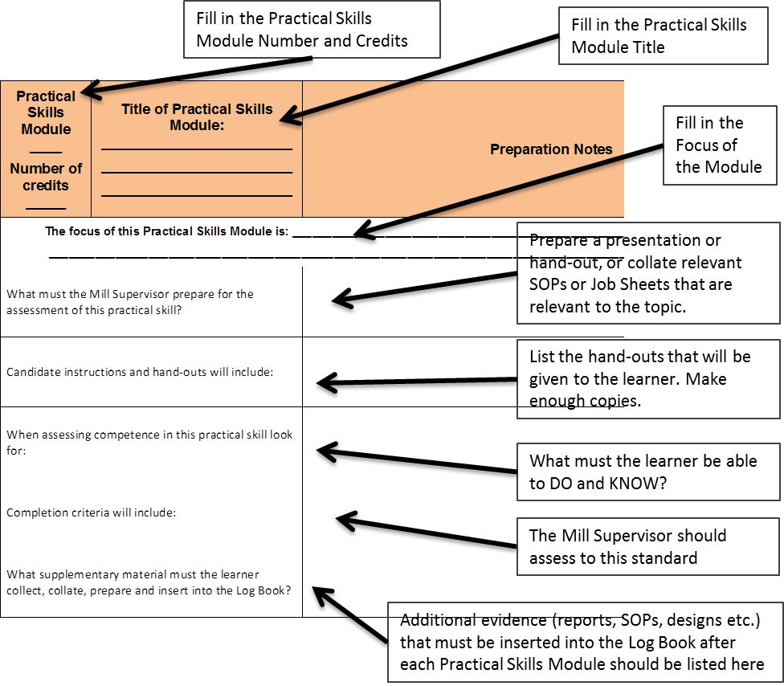

Methods to be used
Assessment of the Practical Skills Component of this course will be formative and summative. Formative assessment, through Competence Checklists, can be used throughout the Practical Skills Component to assess the progress that a student is making towards the final goals. The results are regularly reviewed with the learner – The supervisor will discuss with the learner what has been achieved and what still needs to be learned.
Practical assignments that must be completed within a particular time period, will be used as the summative assessment for the Practical Skills Component and must be inserted into the Log Book once completed.

Resources required
Please note that the Practical Skills Component is planned to take place at an operational Sugar Mill. The ideal Physical, Human Resource and Legal Requirements for each Practical Skills Module are provided at the end of each Practical Skills Module section of this Supervisor Guide. The choice of location and method will depend on the skill being assessed, the time available, and the resources required.
Realistically the supervisor may decide to use a combination of simulated work experience in a workshop as well as observation in a real work setting. Keep in mind that assessment methods should be valid, reliable, cost-effective, and achievable in terms of the time and resources available to you.

Conducting the Assessment

Brief the learners
Before the Practical Skills Component and its assessment takes place, share your planning with the learners either as a group, or individually (especially if the learner has a special need). Stress that the observation of a learner’s performance is not intended to be an examination and that it will take place over time. Explaining the assessment process ensures that assessment is never a surprise or unannounced activity. Explain whether the assessment will be formative (as part of the learning) or summative (part of the final record of evidence of competency). Provide the learners with a description of what you plan to do and what is expected of them to demonstrate competency. These are the items on the competence checklist and “Scope of Practical Skills” list. You should explain what it is you are going to ask the learner to do in order to be given the opportunity to demonstrate the skills. Also be clear as to what physical evidence the learner must collect and place into his/her Log Book for summative assessment of the Practical Skills Component. Make sure that the learner understands what it is you will be looking for.
Hand out the Practical Skills Component Log Book as part of the briefing. Each learner needs to know how the Log Book will be used, when it should be signed, when to present it to the supervisor for signature and what supplementary evidence needs to be inserted.
Each candidate needs to know what you will do with the information that you collect by observation. If you are using the competence checklist to observe performance, you will be looking at the performance outcomes to see which statements can be marked as competent. The competence checklist in the Learner Log Book will be what you submit to the visiting verifier as your evidence for stating that the learner has met the requirements for the Practical Skills Component of the qualification.
The learner also needs to know what will happen if you do not mark him/her as competent during the observation. This means that the candidate has not yet achieved the standard required. An opportunity for the candidate to attempt the activity again should be provided, after you have explained what evidence you are still looking for.
By briefing the learners in this way you are gaining their agreement to your plan and the assessment process. A pre-assessment verification form can be signed by the learners present to provide assurance that the learners understand the assessment process.

Observing during Assessment
You will need to plan your observations with each individual learner. Ensure that you confirm your observation, and the underlying knowledge component of a task, with supplementary questions that start with words such as “Why”, “Where”, “How” and “When”. It is best to develop a set of questions that you are going to ask every learner to answer.

Prepared talks and demonstrations as a means of assessment
A prepared talk with or without a demonstration can also be used to observe competence. Here a topic (or a list of topics) can be prepared and the learners can choose the topic that they would like to prepare a talk and demonstration about. Make it clear to the learners what they should include in the prepared talk and demonstration and how it is relevant to the objectives and outcomes of the Practical Skills Module. The competency checklist can then be marked during the learner’s presentation. Be sure that you know what you are looking for (do you want one or two reasons for a specific decision, for example). Use supplementary questions following the presentation to close any gaps in the competency checklist.

Written assessments
For the Practical Skills Component, written assessment may take the form of essays or reports. Written examinations or tests are rarely used for practical assessment. Written tests could be used during formative assessment to determine the learners’ underpinning level of knowledge about their practical tasks.
Reports are normal in a real work experience context – especially at the control or supervisory level – thus, the task to write a report provides evidence that the learner knows where to find the information, how to collect and collate it, and how it needs to be presented in a realistic work context. Using company policy documents and Standard Operating Procedures, and real world reporting sheets can assist to provide realistic context to written reports required of the learner.

Practical assessments
Practical tasks used for assessment purposes should provide learners with a set of instructions to follow in order to complete a specific task, a test of the resulting “product” for functionality and an explanation of the outcomes of, or reasons for, the task. Practical tasks designed for Practical Skills Assessment must be valid and reliable. That is, it must test a skill or skills that are relevant to the syllabus and it must be based on clearly understood criteria that are applied to all the learners in the same way.

Giving feedback on performance and completing the assessment records

Giving Assessment Feedback
Positive feedback on those parts of the assessment that went well should always be given during the one-on-one feedback session following the Practical Skills Assessment. Here you can explain to the learner what you liked and why you felt that the learner achieved the outcomes successfully. If you have done a thorough pre-assessment meeting you can re-iterate the points that you were specifically looking for that the learner was able to demonstrate. A positive approach is also however necessary when providing the learner feedback regarding those aspects that were perhaps not positively achieved. Here you should explain what the learner failed to demonstrate and how he/she can improve on those aspects of the Practical Skills. Again, if you have done a thorough pre-assessment meeting, those aspects that were not demonstrated successfully should come as no surprise to the learner. Provide the learner guidance on how these particular skills can be improved, allow them time in the workshop or on the factory floor to improve those skills and make a future date and time when and where a re-assessment can take place. Give the learner some tips and guidance on what they should specifically concentrate on to improve their performance.
Giving positive feedback will allow the learner to remain comfortable throughout the assessment process. Remember, the aim is to find out what the person can do, not a means to find fault or to catch the candidate out by requiring them to undertake unexpected tasks, or asking deliberately difficult questions.
Always congratulate the learner for those parts of the assessment that went well and then ask them what they thought about their performance. This starts a conversation which will enable the learner to accept the assessment results and feedback positively.
Once the assessment feedback is complete, the suprvisor must provide guidance on what the future action must be. This may mean moving onto the next Practical Skills Module, or, if all the Practical Skills Modules are complete, that the candidate may move onto the Work Place Experience Component of the qualification. If the assessment outcome is not yet competent, then a future time and place for re-assessment must be provided. Allow enough time for the learner to practise those Practical Skills that were not successfully completed. This may require that the learner be given access to the workshop and tools outside of normal times, or be allowed to spend more time on the factory floor. This has a time, safety and personnel implication which will need to be considered. Proper planning for such learners will be required so that they do not fall behind the rest of the learning activities.
If the Practical Skills cannot be successfully demonstrated, a learner may re-enter the Practical Skills Component. If the learner is not interested in re-entering the Skills Component, it should be remembered that a “Part Qualification” certificate for the credits of the Knowledge Component would, at this point, already be in the possession of the learner, so they would not be walking away empty handed from the entire programme.

Completing Assessment Records
The following tools need to be completed for every assessment undertaken:

The Competence Checklist
The competence checklist will take the following form:
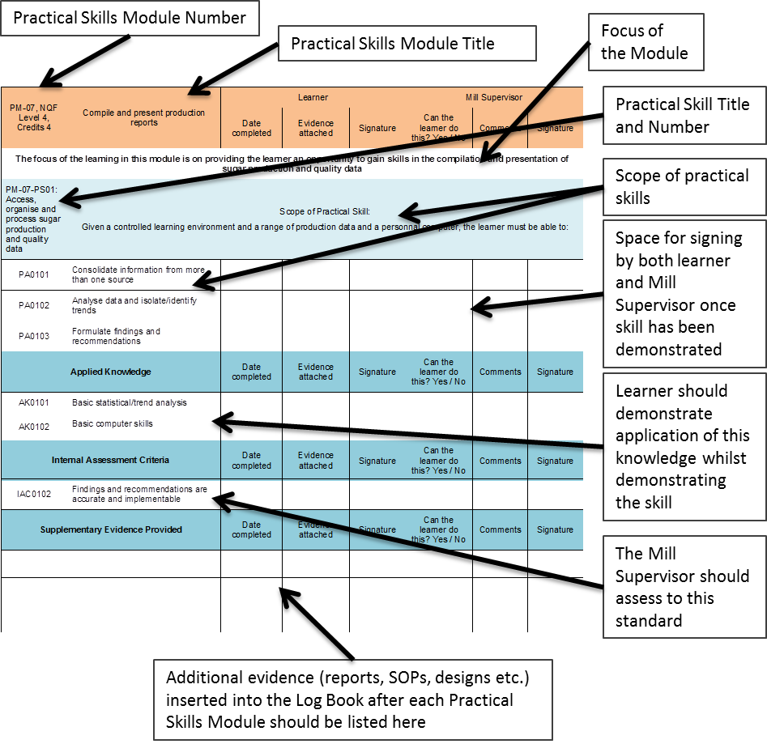
Once each of these competence checklists are completed and signed off, the Learner Log Book document and all its Supporting Evidence must be handed to the relevant QCTO Assessment Quality Partner for verification.
A summary “Learner Assessment Record” is also provided at the back of the Learner Log Book and is a record of the learner’s progress over the entire Practical Skills Component.
Keep in mind that the Practical Skills Component requires either a result of “Yes, the learner has achieved this” or “No, the learner has not yet achieved this”, since you are using assessment to show that a person has successfully acquired and demonstrated all of the competencies necessary for successful performance. There is no need to grade the results (as with a written assessment in the Knowledge Component).
(Note: PM = Practical Skills Module, PA = Practical Skill Assessment Scope, AK = Applied Knowledge)

PRACTICAL SKILLS MODULE 1

Monitor and Control Sugar Processing Equipment
Module number: 313908000-PM01: NQF Level 5: Credits 16
The focus of the learning in this module is on providing the learner an opportunity to gain the practical skills related to monitoring and controlling sugar processing equipment and processes in a controlled learning environment.
The learner will be required to:
- PM-01-PS01: Monitor and control cane yard operations
- PM-01-PS02: Monitor and control cane milling and juice extraction operations
- PM-01-PS03: Monitor and control sugar juice clarification and filtration operations
- PM-01-PS04: Monitor and control evaporation operations
- PM-01-PS05: Monitor and control pan boiling operations
- PM-01-PS06: Monitor and control centrifugal operations
- PM-01-PS07: Control and adjust material flow for a sugar milling production unit or line
- PM-01-PS08: Set up, monitor and adjust sugar processing equipment settings
- PM-01-PS09: Monitor demand, supply and efficient utilisation of services and utilities

Preparation Matrix for Practical Skills Module 1
Practical Skills Module ____  Number of credits _____ | Title of Practical Skills Module: ________________________  ________________________  ________________________ | Preparation Notes
The focus of this Practical Skills Module is: ______________________________________________________________________
__________________________________________________________________________________________________________
What must the Mill Supervisor prepare for the assessment of this practical skill?
Candidate instructions and hand-outs will include:
When assessing competence in this practical skill look for:
Completion criteria will include:
What supplementary material must the learner collect, collate, prepare and insert into the Log Book?

Competence Checklist for Practical Skills Module 1
PM01: NQF Level 5: Credits 16 | Monitor and Control Sugar Processing Equipment | Learner |  |  | Mill Supervisor
PM01: NQF Level 5: Credits 16 | Monitor and Control Sugar Processing Equipment | Date completed | Evidence attached | Signature | Can the learner do this? Yes / No | Comments | Signature
The focus of the learning in this module is on providing the learner an opportunity to gain the practical skills related to monitoring and controlling sugar processing equipment and processes in a controlled learning environment.
PM-01-PS01: Monitor and control cane yard operations | Scope of Practical Skill:  Given operational control parameters, plans and schedules, orders for a production unit and a controlled learning environment, the learner must be able to:
PA0101 | Develop or adjust a daily production plan based on production targets
PA0102 | Determine the resources required to ensure that the production plan and targets are met
PA0103 | Plan the utilisation of storage space to meet production schedules
PA0104 | Set and communicate production targets
PA0105 | Plan production line usage for optimal plant output
PA0106 | Monitor the achievement of production targets and initiate corrective measures
Applied Knowledge |  | Date completed | Evidence attached | Signature | Can the learner do this? Yes / No | Comments | Signature
AK0101 | Production capacity of the production line
AK0102 | Storage capacity
AK0103 | Production planning
Internal Assessment Criteria |  | Date completed | Evidence attached | Signature | Can the learner do this? Yes / No | Comments | Signature
IAC0101 | Operational schedules of the unit or line are aligned to the production plan
IAC0102 | Targets are clearly formulated and measurable
IAC0103 | Measures to address deviations from planned targets can be explained
Supplementary Evidence Provided |  | Date completed | Evidence attached | Signature | Can the learner do this? Yes / No | Comments | Signature
PM-01-PS02: Monitor and control cane milling and juice extraction operations | Scope of Practical Skill  Given a controlled learning environment, a sugar mill production line or unit, and production schedules, the learner must be able to:
PA0201 | Coordinate start-up equipment in a production line
PA0202 | Coordinate shut-down of equipment in a production line
PA0203 | Control and coordinate operational processes (e.g. purging, cleaning, lock out, emergency stop) for a production line
PA0204 | Oversee equipment change-over procedures
PA0205 | Conduct shift handover procedures
Applied Knowledge |  | Date completed | Evidence attached | Signature | Can the learner do this? Yes / No | Comments | Signature
AK0201 | Workplace safety and operational requirements
AK0202 | Start-up and shut-down sequence
AK0203 | Standard procedures for various production line operating processes
Internal Assessment Criteria |  | Date completed | Evidence attached | Signature | Can the learner do this? Yes / No | Comments | Signature
IAC0201 | Production line start up and shut downs are coordinated within safety and operational requirements
IAC0202 | Specific processes are performed in terms of standard operating procedures
Supplementary Evidence Provided |  | Date completed | Evidence attached | Signature | Can the learner do this? Yes / No | Comments | Signature
PM-01-PS03: Monitor and control sugar juice clarification and filtration operations | Scope of Practical Skill  Given a controlled learning environment, a sugar mill production line and production schedules, the learner must be able to:
PA0301 | Achieve consistent flow and availability of material over various operational stages
PA0302 | Recognise and respond to deviations observed at various stages of an operation
PA0303 | Optimise equipment operation in terms of material availability and flow
PA0304 | Solve operational problems
Applied Knowledge |  | Date completed | Evidence attached | Signature | Can the learner do this? Yes / No | Comments | Signature
AK0101 | Equipment settings
AK0302 | Operating standards
AK0303 | Optimisation practices
AK0304 | Common deviations and standard responses
AK0305 | Problem-solving techniques
Internal Assessment Criteria |  | Date completed | Evidence attached | Signature | Can the learner do this? Yes / No | Comments | Signature
IAC0301 | Material flow requirements and quality standards are met
IAC0302 | Problem areas that falls outside of the delegated responsibility of the Feed Miller can be explained
IAC0303 | Potential problem areas can be recognised and remedial actions explained
Supplementary Evidence Provided |  | Date completed | Evidence attached | Signature | Can the learner do this? Yes / No | Comments | Signature
PM-01-PS04: Monitor and control evaporation operations | Scope of Practical Skill  Given a controlled learning environment, a sugar mill production line or unit, production schedules and operational specifications, the learner must be able to:
PA0401 | Set up the production line equipment to production specifications
PA0402 | Read, analyse and respond to instrumentation readings to conduct process control
PA0403 | Adjust equipment settings to maintain equipment operation within required specifications
PA0404 | Make/initiate process adjustments to meet production targets and product specifications
PA0405 | Monitor key set/control points and initiate appropriate response to maintain quality control protocols
PA0406 | Evaluate implications of changes and cause and affect relations within a process when making adjustments
PA0407 | Recognise early warning signs of emerging deviations
PA0408 | Recognise the point at which things, that fall outside of normal procedures, go badly wrong and respond appropriately
Applied Knowledge |  | Date completed | Evidence attached | Signature | Can the learner do this? Yes / No | Comments | Signature
AK0401 | Equipment operation
AK0402 | Operating parameters
AK0403 | Product quality specifications and deviations
AK0404 | Corrective actions
AK0405 | Warning signs
Internal Assessment Criteria |  | Date completed | Evidence attached | Signature | Can the learner do this? Yes / No | Comments | Signature
IAC0401 | Operating standards of equipment are set and maintained within defined parameters
IAC0402 | Early warning signs of potential problems and remedial actions can be explained
IAC0403 | Problem areas that falls outside of the delegated responsibility of the Sugar Miller can be explained
Supplementary Evidence Provided |  | Date completed | Evidence attached | Signature | Can the learner do this? Yes / No | Comments | Signature
PM-01-PS05: Monitor and control pan boiling operations | Scope of Practical Skill  Given a controlled learning environment, a sugar mill production line and production schedules, the learner must be able to:
PA0501 | Draft a procedure for the inspection and monitoring of utilities and services
PA0502 | Recognise sign of energy waste or inefficient utilisation
PA0503 | Recognise signs of steam, air and water shortages and initiate corrective measures
PA0504 | Conduct emergency shut down and start-up procedures
Applied Knowledge |  | Date completed | Evidence attached | Signature | Can the learner do this? Yes / No | Comments | Signature
AK0501 | Levels/volumes of utility or services required to maintain normal operations
AK0502 | Reporting procedures
AK0503 | Precautionary/emergency measures or production shut-down procedures
Internal Assessment Criteria |  | Date completed | Evidence attached | Signature | Can the learner do this? Yes / No | Comments | Signature
IAC0501 | Energy efficiency levels are maintained within set standards and parameters
IAC0502 | Emerging supply shortages are recognised and corrective measures initiated to address the situation
Supplementary Evidence Provided |  | Date completed | Evidence attached | Signature | Can the learner do this? Yes / No | Comments | Signature
PM-01-PS06: Monitor and control centrifugal operations | Scope of Practical Skill  Given a controlled learning environment, a sugar mill production line or unit, production schedules and operational specifications, the learner must be able to:
PA0601 | Set up the production line equipment to production specifications
PA0602 | Read, analyse and respond to instrumentation readings to conduct process control
PA0603 | Adjust equipment settings to maintain equipment operation within required specifications
PA0604 | Make/initiate process adjustments to meet production targets and product specifications
PA0605 | Monitor key set/control points and initiate appropriate response to maintain quality control protocols
PA0606 | Evaluate implications of changes and cause and affect relations within a process when making adjustments
PA0607 | Recognise early warning signs of emerging deviations
PA0608 | Recognise the point at which things, that fall outside of normal procedures, go badly wrong and respond appropriately
Applied Knowledge |  | Date completed | Evidence attached | Signature | Can the learner do this? Yes / No | Comments | Signature
AK0601 | Equipment operation
AK0602 | Operating parameters
AK0603 | Product quality specifications and deviations
AK0604 | Corrective actions
AK0605 | Warning signs
Internal Assessment Criteria |  | Date completed | Evidence attached | Signature | Can the learner do this? Yes / No | Comments | Signature
IAC0601 | Operating standards of equipment are set and maintained within defined parameters
IAC0602 | Early warning signs of potential problems and remedial actions can be explained
IAC0603 | Problem areas that falls outside of the delegated responsibility of the Sugar Miller can be explained
Supplementary Evidence Provided |  | Date completed | Evidence attached | Signature | Can the learner do this? Yes / No | Comments | Signature
PM-01-PS07: Control and adjust material flow for a sugar milling production unit or line | Scope of Practical Skill  Given a controlled learning environment, a sugar mill production line or unit, production schedules and operational specifications, the learner must be able to:
PA0701 | Set up the production line equipment to production specifications
PA0702 | Read, analyse and respond to instrumentation readings to conduct process control
PA0703 | Adjust equipment settings to maintain equipment operation within required specifications
PA0704 | Make/initiate process adjustments to meet production targets and product specifications
PA0705 | Monitor key set/control points and initiate appropriate response to maintain quality control protocols
PA0706 | Evaluate implications of changes and cause and affect relations within a process when making adjustments
PA0707 | Recognise early warning signs of emerging deviations
PA0708 | Recognise the point at which things, that fall outside of normal procedures, go badly wrong and respond appropriately
Applied Knowledge |  | Date completed | Evidence attached | Signature | Can the learner do this? Yes / No | Comments | Signature
AK0701 | Equipment operation
AK0702 | Operating parameters
AK0703 | Product quality specifications and deviations
AK0704 | Corrective actions
AK0705 | Warning signs
Internal Assessment Criteria |  | Date completed | Evidence attached | Signature | Can the learner do this? Yes / No | Comments | Signature
IAC0701 | Operating standards of equipment are set and maintained within defined parameters
IAC0702 | Early warning signs of potential problems and remedial actions can be explained
IAC0703 | Problem areas that falls outside of the delegated responsibility of the Sugar Miller can be explained
Supplementary Evidence Provided |  | Date completed | Evidence attached | Signature | Can the learner do this? Yes / No | Comments | Signature
PM-01-PS08: Set up, monitor and adjust sugar processing equipment settings | Scope of Practical Skill  Given a controlled learning environment, a sugar mill production line or unit, production schedules and operational specifications, the learner must be able to:
PA0801 | Set up the production line equipment to production specifications
PA0802 | Read, analyse and respond to instrumentation readings to conduct process control
PA0803 | Adjust equipment settings to maintain equipment operation within required specifications
PA0804 | Make/initiate process adjustments to meet production targets and product specifications
PA0805 | Monitor key set/control points and initiate appropriate response to maintain quality control protocols
PA0806 | Evaluate implications of changes and cause and affect relations within a process when making adjustments
PA0807 | Recognise early warning signs of emerging deviations
PA0808 | Recognise the point at which things, that fall outside of normal procedures, go badly wrong and respond appropriately
Applied Knowledge |  | Date completed | Evidence attached | Signature | Can the learner do this? Yes / No | Comments | Signature
AK0801 | Equipment operation
AK0802 | Operating parameters
AK0803 | Product quality specifications and deviations
AK0804 | Corrective actions
AK0805 | Warning signs
Internal Assessment Criteria |  | Date completed | Evidence attached | Signature | Can the learner do this? Yes / No | Comments | Signature
IAC0801 | Operating standards of equipment are set and maintained within defined parameters
IAC0802 | Early warning signs of potential problems and remedial actions can be explained
IAC0803 | Problem areas that falls outside of the delegated responsibility of the Feed Miller can be explained
Supplementary Evidence Provided |  | Date completed | Evidence attached | Signature | Can the learner do this? Yes / No | Comments | Signature
PM-01-PS09: Monitor demand, supply and efficient utilisation of services and utilities | Scope of Practical Skill  Given a controlled learning environment, a sugar mill production line or unit, production schedules and operational specifications, the learner must be able to:
PA0901 | Set up the production line equipment to production specifications
PA0902 | Read, analyse and respond to instrumentation readings to conduct process control
PA0903 | Adjust equipment settings to maintain equipment operation within required specifications
PA0904 | Make/initiate process adjustments to meet production targets and product specifications
PA0905 | Monitor key set/control points and initiate appropriate response to maintain quality control protocols
PA0906 | Evaluate implications of changes and cause and affect relations within a process when making adjustments
PA0907 | Recognise early warning signs of emerging deviations
PA0908 | Recognise the point at which things, that fall outside of normal procedures, go badly wrong and respond appropriately
Applied Knowledge |  | Date completed | Evidence attached | Signature | Can the learner do this? Yes / No | Comments | Signature
AK0901 | Equipment operation
AK0902 | Operating parameters
AK0903 | Product quality specifications and deviations
AK0904 | Corrective actions
AK0905 | Warning signs
Internal Assessment Criteria |  | Date completed | Evidence attached | Signature | Can the learner do this? Yes / No | Comments | Signature
IAC0901 | Operating standards of equipment are set and maintained within defined parameters
IAC0902 | Early warning signs of potential problems and remedial actions can be explained
IAC0903 | Problem areas that falls outside of the delegated responsibility of the Sugar Miller can be explained
Supplementary Evidence Provided |  | Date completed | Evidence attached | Signature | Can the learner do this? Yes / No | Comments | Signature

Provider Programme Accreditation Criteria

Physical Requirements:
- Access to a sugar processing line
- Meet requirements as set out by the QCTO appointed AQP for accreditation of skills development providers

Human Resource Requirements:
- Meet requirements as set out by the QCTO appointed AQP for accreditation of skills development providers
- Facilitators with expert knowledge in the scope of the module

Legal Requirements:
- Compliance with occupational health, safety and environmental protection regulations
- Personal protective equipment

Exemptions
- None recognised

PRACTICAL SKILLS MODULE 2

Control sugar milling operations and resources
Module Number 313908000-PM-02, NQF Level 5, Credits 8
The focus of the learning in this module is on providing the learner an opportunity to practice the skills required to execute planning and monitoring activities to control sugar milling operations and resources to ensure the achievement of plant efficiency targets.
The learner will be required to:
- PM-02-PS01: Plan and schedule sugar milling operations to meet production targets
- PM-02-PS02: Monitor and control stock levels of raw materials used in sugar processing

Preparation Matrix for Practical Skills Module 2
Practical Skills Module ____  Number of credits _____ | Title of Practical Skills Module: ________________________  ________________________  ________________________ | Preparation Notes
The focus of this Practical Skills Module is: ______________________________________________________________________
__________________________________________________________________________________________________________
What must the Mill Supervisor prepare for the assessment of this practical skill?
Candidate instructions and hand-outs will include:
When assessing competence in this practical skill look for:
Completion criteria will include:
What supplementary material must the learner collect, collate, prepare and insert into the Log Book?

Competence Checklist for Practical Skills Module 2
PM-02, NQF Level 5, Credits 8 | Control sugar milling operations and resources | Learner |  |  | Mill Supervisor
PM-02, NQF Level 5, Credits 8 | Control sugar milling operations and resources | Date completed | Evidence attached | Signature | Can the learner do this? Yes / No | Comments | Signature
The focus of the learning in this module is on providing the learner an opportunity to practice the skills required to execute planning and monitoring activities to control sugar milling operations and resources to ensure the achievement of plant efficiency targets.
PM-02-PS01: Plan and schedule sugar milling operations to meet production targets | Scope of Practical Skill:  Given production targets, the learner must be able to:
PA0101 | List the materials and estimated volumes required for a production shift
PA0102 | Determine the resources required to ensure that the production plan and targets are met
PA0103 | Plan labour needs and a shift roster
PA0104 | Schedule finished product storage according to available storage
Applied Knowledge |  | Date completed | Evidence attached | Signature | Can the learner do this? Yes / No | Comments | Signature
AK0101 | Production scheduling
AK0102 | Raw material volumes for specific products
AK0103 | Shift schedules
AK0104 | Communication
Internal Assessment Criteria |  | Date completed | Evidence attached | Signature | Can the learner do this? Yes / No | Comments | Signature
IAC0101 | Production scheduling meets production targets
IAC0102 | The impact of not meeting scheduled targets can be explained
Supplementary Evidence Provided |  | Date completed | Evidence attached | Signature | Can the learner do this? Yes / No | Comments | Signature
PM-02-PS02: Monitor and control stock levels of raw materials used in sugar processing | Scope of Practical Skill:  Given records of stock on hand, stock usage data and production schedules, the learner must be able to:
PA0201 | Compile estimates of stocks required in the production of different products
PA0202 | Reconcile production needs with stocks on hand
PA0203 | Determine minimum reordering levels for stock items
PA0204 | Determine stock loss levels (waste) based on historical data provided
PA0205 | Complete stock control reports
Applied Knowledge |  | Date completed | Evidence attached | Signature | Can the learner do this? Yes / No | Comments | Signature
AK0201 | Operational stock requirements for specific products
AK0202 | Stock control
AK0203 | Standard corrective actions
Internal Assessment Criteria |  | Date completed | Evidence attached | Signature | Can the learner do this? Yes / No | Comments | Signature
IAC0201 | Stock level estimates, waste and re-ordering volumes are correctly determined
IAC0202 | Stock control records are accurately completed
Supplementary Evidence Provided |  | Date completed | Evidence attached | Signature | Can the learner do this? Yes / No | Comments | Signature

Provider Programme Accreditation Criteria

Physical Requirements:
- Access to a sugar processing line
- Meet requirements as set out by the QCTO appointed AQP for accreditation of skills development providers

Human Resource Requirements:
- Meet requirements as set out by the QCTO appointed AQP for accreditation of skills development providers
- Facilitators with expert knowledge in the scope of the module

Legal Requirements:
- Compliance with occupational health, safety and environmental protection regulations
- Personal protective equipment

Exemptions
- None recognised

PRACTICAL SKILLS MODULE 3

Monitor and direct subordinate performance and conduct
Module Number 313908000-PM-03, NQF Level 5, Credits 8
The focus of the learning in this module is on providing the learner an opportunity to apply the practical skills required to direct subordinate performance and conduct to ensure the achievement of plant efficiency targets.
- PM-03-PS01: Direct subordinate performance and conduct

Preparation Matrix for Practical Skills Module 3
Practical Skills Module ____  Number of credits _____ | Title of Practical Skills Module: ________________________  ________________________  ________________________ | Preparation Notes
The focus of this Practical Skills Module is: ______________________________________________________________________
__________________________________________________________________________________________________________
What must the Mill Supervisor prepare for the assessment of this practical skill?
Candidate instructions and hand-outs will include:
When assessing competence in this practical skill look for:
Completion criteria will include:
What supplementary material must the learner collect, collate, prepare and insert into the Log Book?

Competence Checklist for Practical Skills Module 3
PM-03, NQF Level 5, Credits 8 | Control sugar milling operations and resources | Learner |  |  | Mill Supervisor
PM-03, NQF Level 5, Credits 8 | Control sugar milling operations and resources | Date completed | Evidence attached | Signature | Can the learner do this? Yes / No | Comments | Signature
PM-03-PS01: Direct subordinate performance and conduct | Scope of Practical Skill:  Given company HR policies and procedures, standard forms and access to the BCOE, the learner must be able to:
PA0301 | Set performance targets and direct personnel performance
PA0302 | Maintain shop floor discipline
PA0303 | Resolve a workplace grievance
PA0304 | Resolve shop floor conflict
Applied Knowledge |  | Date completed | Evidence attached | Signature | Can the learner do this? Yes / No | Comments | Signature
AK0101 | Performance management and performance targets
AK0302 | Disciplinary codes and procedures
AK0303 | Grievance procedures
AK0304 | Workplace conflict resolution
Internal Assessment Criteria |  | Date completed | Evidence attached | Signature | Can the learner do this? Yes / No | Comments | Signature
IAC0301 | Performance agreements are reached and measurable targets agreed upon
IAC0302 | Performance levels and monitored and corrected where required
IAC0303 | Disciplinary procedures and standard practices can be explained and applied
IAC0304 | Grievance procedures and standard practices can be explained and applied
IAC0305 | Conflict resolution practices can be explained and applied
Supplementary Evidence Provided |  | Date completed | Evidence attached | Signature | Can the learner do this? Yes / No | Comments | Signature

Provider Programme Accreditation Criteria

Physical Requirements:
- Meet requirements as set out by the QCTO appointed AQP for accreditation of skills development providers

Human Resource Requirements:
- Meet requirements as set out by the QCTO appointed AQP for accreditation of skills development providers
- Facilitators with expert knowledge in the scope of the module

Legal Requirements:
- Compliance with occupational health, safety and environmental protection regulations

Exemptions
- None recognised

PRACTICAL SKILLS MODULE 4

Enforce compliance to Safety, Health, Environmental protection and Quality standards
Module Number 313908000-PM-04, NQF Level 5, Credits 6
The focus of the learning in this module is on providing the learner an opportunity to monitor and execute control over Safety, Health, Environmental and Quality (SHEQ) Procedures in a controlled learning environment.
The learner will be required to:
- PM-04-PS01: Investigate and report incidents
- PM-04-PS02: Execute control over Safety, Health, Environment and Quality (SHEQ) control procedures
- PM-04-PS03: Maintain records and registers in compliance with Safety, Health, Environment and Quality (SHEQ) regulations
- PM-04-PS04: Perform Hazard Identification and Risk Analysis assessment (HIRA)

Preparation Matrix for Practical Skills Module 4
Practical Skills Module ____  Number of credits _____ | Title of Practical Skills Module: ________________________  ________________________  ________________________ | Preparation Notes
The focus of this Practical Skills Module is: ______________________________________________________________________
__________________________________________________________________________________________________________
What must the Mill Supervisor prepare for the assessment of this practical skill?
Candidate instructions and hand-outs will include:
When assessing competence in this practical skill look for:
Completion criteria will include:
What supplementary material must the learner collect, collate, prepare and insert into the Log Book?

Competence Checklist for Practical Skills Module 4
PM-04, NQF Level 5, Credits 6 | Enforce compliance to Safety, Health, Environmental protection and Quality standards | Learner |  |  | Mill Supervisor
PM-04, NQF Level 5, Credits 6 |  | Date completed | Evidence attached | Signature | Can the learner do this? Yes / No | Comments | Signature
The focus of the learning in this module is on providing the learner an opportunity to monitor and execute control over Safety, Health, Environmental and Quality (SHEQ) Procedures in a controlled learning environment.
PM-04-PS01: Investigate and report incidents | Scope of Practical Skill:  Given case studies or scenarios on industrial incidents, the learner must be able to:
PA0101 | Conduct an incident/accident investigation in accordance with procedures and regulatory requirements
PA0102 | Establish an official record in accordance with regulatory requirements and submit a report
PA0103 | Formulate recommendations on preventive measures
Applied Knowledge |  | Date completed | Evidence attached | Signature | Can the learner do this? Yes / No | Comments | Signature
AK0101 | Investigation procedures
AK0102 | Reporting procedures
AK0103 | Process knowledge
Internal Assessment Criteria |  | Date completed | Evidence attached | Signature | Can the learner do this? Yes / No | Comments | Signature
IAC0101 | Investigation reports are accurately and comprehensively completed
IAC0102 | Recommendations on preventative measures are explained in terms of impact, preventative value and practicability
Supplementary Evidence Provided |  | Date completed | Evidence attached | Signature | Can the learner do this? Yes / No | Comments | Signature
PM-04-PS02: Execute control over Safety, Health, Environment and Quality (SHEQ) control procedures | Scope of Practical Skill:  Given a controlled learning environment, a sugar mill, the learner must be able to:
PA0201 | Develop a SHEQ inspection sheet and standard procedure
PA0202 | Conduct inspections to identify actual or potential unsafe work practices or conditions
PA0203 | Develop a standard procedure to maintain the lock down status of equipment in a production line
PA0204 | Direct a simulated emergency evacuation procedure
PA0205 | Develop a standard procedure to enforce restrictions and access to high risk areas
PA0206 | Develop a standard procedure and inspection sheet for recognising factors in stored products and raw material that would result in unsafe products
PA0207 | Develop a standard procedure and inspection sheet to inspect housekeeping and sanitation practices
Applied Knowledge |  | Date completed | Evidence attached | Signature | Can the learner do this? Yes / No | Comments | Signature
AK0201 | SHEQ procedures
AK0202 | HACCP
Internal Assessment Criteria |  | Date completed | Evidence attached | Signature | Can the learner do this? Yes / No | Comments | Signature
IAC0201 | Standard procedures and inspection sheets addresses all the critical control areas and are practically implementable
Supplementary Evidence Provided |  | Date completed | Evidence attached | Signature | Can the learner do this? Yes / No | Comments | Signature
PM-04-PS03: Maintain records and registers in compliance with Safety, Health, Environment and Quality (SHEQ) regulations | Scope of Practical Skill  Given different scenarios, examples of SHEQ records, the learner must be able to:
PA0301 | Maintain statutory Safety, Health and Environmental protection registers
PA0302 | Perform a SHEQ inspection and complete SHEQ forms
PA0303 | Evaluate SHEQ records and formulate corrective measures
PA0304 | Draft a SHEQ feedback report
Applied Knowledge |  | Date completed | Evidence attached | Signature | Can the learner do this? Yes / No | Comments | Signature
AK0101 | Statutory register requirements
AK0302 | SHEQ inspection procedures
AK0303 | Reporting and recording procedures
Internal Assessment Criteria |  | Date completed | Evidence attached | Signature | Can the learner do this? Yes / No | Comments | Signature
IAC0301 | Statutory registers are complete and accurate
IAC0302 | SHEQ reports and documents are complete and accurate
Supplementary Evidence Provided |  | Date completed | Evidence attached | Signature | Can the learner do this? Yes / No | Comments | Signature
PM-04-PS04: Perform Hazard Identification and Risk Analysis assessment (HIRA) | Scope of Practical Skill  Given controlled learning environment in a operational sugar production unit, the learner must be able to:
PA0401 | Draft a HIRA assessment sheet
PA0402 | Conduct inspections to identify actual or potential unsafe work practices or conditions
PA0403 | Formulate corrective measures to address unsafe work practices
Applied Knowledge |  | Date completed | Evidence attached | Signature | Can the learner do this? Yes / No | Comments | Signature
AK0401 | Assessment procedures
AK0402 | Risks and corrective measures
AK0403 | Reporting and recording procedures
AK0404 | The process of continuous risk assessment
AK0405 | Documentation required
AK0406 | Hazards and risks likely to be encountered
AK0407 | Consequences for not conforming to legal and specified requirements
Internal Assessment Criteria |  | Date completed | Evidence attached | Signature | Can the learner do this? Yes / No | Comments | Signature
IAC0401 | The process of continuous risk assessment and document requirements is explained
IAC0402 | The physical and environmental conditions that poses risks are identified and consequences for not conforming to legal and specified requirements is explained
IAC0403 | A systematic approach is followed to recognise risks
IAC0404 | Remedial actions that are formulated are practically implementable
Supplementary Evidence Provided |  | Date completed | Evidence attached | Signature | Can the learner do this? Yes / No | Comments | Signature

Provider Programme Accreditation Criteria

Physical Requirements:
- Access to a sugar processing line
- Meet requirements as set out by the QCTO appointed AQP for accreditation of skills development providers

Human Resource Requirements:
- Meet requirements as set out by the QCTO appointed AQP for accreditation of skills development providers
- Facilitators with expert knowledge in the scope of the module

Legal Requirements:
- Compliance with occupational health, safety and environmental protection regulations
- Personal protective equipment

Exemptions
- None recognised

PRACTICAL SKILLS MODULE 5

Conduct and respond to in-line quality tests and reports
Module Number 313908000-PM-05, NQF Level 5, Credits 8
The focus of the learning in this module is on providing the learner an opportunity to monitor quality standards and to initiate the responses to correct these in a controlled learning environment.
The learner will be required to:
- PM-05-PS01: Use observations, instruments, gauges and in-process tests to execute quality checks at various stages of sugar processing
- PM-05-PS02: Read and respond to sugar quality reports

Preparation Matrix for Practical Skills Module 5
Practical Skills Module ____  Number of credits _____ | Title of Practical Skills Module: ________________________  ________________________  ________________________ | Preparation Notes
The focus of this Practical Skills Module is: ______________________________________________________________________
__________________________________________________________________________________________________________
What must the Mill Supervisor prepare for the assessment of this practical skill?
Candidate instructions and hand-outs will include:
When assessing competence in this practical skill look for:
Completion criteria will include:
What supplementary material must the learner collect, collate, prepare and insert into the Log Book?

Competence Checklist for Practical Skills Module 5
PM-05, NQF Level 5, Credits 8 | Conduct and respond to in-line quality tests and reports | Learner |  |  | Mill Supervisor
PM-05, NQF Level 5, Credits 8 | Conduct and respond to in-line quality tests and reports | Date completed | Evidence attached | Signature | Can the learner do this? Yes / No | Comments | Signature
The focus of the learning in this module is on providing the learner an opportunity to monitor quality standards and to initiate the responses to correct these in a controlled learning environment.
PM-05-PS01: Use observations, instruments, gauges and in-process tests to execute quality checks at various stages of sugar processing | Scope of Practical Skill:  Given in-process samples of material and required specifications, the learner must be able to:
PA0101 | Conduct in-line quality inspections and sample analysis at various sugar processing stages
PA0102 | Conduct sensory assessments on quality at various sugar processing stages
PA0103 | Direct and schedule sampling frequency in response to quality tests and observations
PA0104 | Collect and prepare control samples for quality verification purposes at various sugar processing stages
PA0105 | Validate the accuracy of application equipment, scales and flow meters
Applied Knowledge |  | Date completed | Evidence attached | Signature | Can the learner do this? Yes / No | Comments | Signature
AK0101 | Testing equipment, instruments and gauges
AK0102 | Validation procedures and tolerances
AK0103 | Product standards
AK0104 | Sampling procedures
AK0105 | Common deviations and standard responses
Internal Assessment Criteria |  | Date completed | Evidence attached | Signature | Can the learner do this? Yes / No | Comments | Signature
IAC0101 | Quality factors affecting production line operations are identified
IAC0102 | Samples are analysed in accordance with accepted practices
IAC0103 | Quality control actions and frequencies are adjusted in response to quality results
IAC0104 | The implications of incorrect product data and/or the unavailability of data on the quality of the final product can be explained
Supplementary Evidence Provided |  | Date completed | Evidence attached | Signature | Can the learner do this? Yes / No | Comments | Signature
PM-05-PS02: Read and respond to sugar quality reports | Scope of Practical Skill:  Given quality reports, the learner must be able to:
PA0201 | Read and interpret reports on sugar quality, formulate actions to address deviations
PA0202 | Solve quality problems and formulate actions to address areas or processes that are repeatedly causing quality problems
PA0203 | Identify variations or deviations in technical performance of equipment from production and quality reports and formulate corrective actions
Applied Knowledge |  | Date completed | Evidence attached | Signature | Can the learner do this? Yes / No | Comments | Signature
AK0201 | Product specifications
AK0202 | Process knowledge
AK0203 | Equipment specifications
Internal Assessment Criteria |  | Date completed | Evidence attached | Signature | Can the learner do this? Yes / No | Comments | Signature
IAC0201 | Corrective actions that has to be initiated in good time to maintain quality standards and minimise loss can be explained
IAC0202 | Quality standards are monitored and maintained at various stages of the feed milling line
Supplementary Evidence Provided |  | Date completed | Evidence attached | Signature | Can the learner do this? Yes / No | Comments | Signature

Provider Programme Accreditation Criteria

Physical Requirements:
- Access to a sugar processing line
- Meet requirements as set out by the QCTO appointed AQP for accreditation of skills development providers

Human Resource Requirements:
- Meet requirements as set out by the QCTO appointed AQP for accreditation of skills development providers
- Facilitators with expert knowledge in the scope of the module

Legal Requirements:
- Compliance with occupational health, safety and environmental protection regulations
- Personal protective equipment

Exemptions
- None recognised

PRACTICAL SKILLS MODULE 6

Inspect and coordinate maintenance of equipment
Module Number 313908000-PM-06, NQF Level 5, Credits 8
The focus of the learning in this module is on providing the learner an opportunity to gain skills in first line maintenance of equipment used in a sugar mill production line.
The learner will be required to:
- PM-06-PS01: Perform mechanical inspections on sugar processing equipment

Preparation Matrix for Practical Skills Module 6
Practical Skills Module ____  Number of credits _____ | Title of Practical Skills Module: ________________________  ________________________  ________________________ | Preparation Notes
The focus of this Practical Skills Module is: ______________________________________________________________________
__________________________________________________________________________________________________________
What must the Mill Supervisor prepare for the assessment of this practical skill?
Candidate instructions and hand-outs will include:
When assessing competence in this practical skill look for:
Completion criteria will include:
What supplementary material must the learner collect, collate, prepare and insert into the Log Book?

Competence Checklist for Practical Skills Module 6
PM-06, NQF Level 5, Credits 8 | Inspect and coordinate maintenance of equipment | Learner |  |  | Mill Supervisor
PM-06, NQF Level 5, Credits 8 | Inspect and coordinate maintenance of equipment | Date completed | Evidence attached | Signature | Can the learner do this? Yes / No | Comments | Signature
The focus of the learning in this module is on providing the learner an opportunity to gain skills in first line maintenance of equipment used in a sugar mill production line.
PM-06-PS01: Perform mechanical inspections on sugar processing equipment | Scope of Practical Skill:  Given a controlled learning environment, a sugar mill production line or unit, the learner must be able to:
PA0101 | Inspect sugar processing equipment for soundness and compliance with safety, health, environmental and quality assurance requirements
PA0102 | Detect technical problems and prioritise repairs in terms of associated risk of specific failure, safety risks or product loss
PA0103 | Generate maintenance requests (not scheduled)
PA0104 | Monitor and control the execution of standard equipment care and lubrication procedures to ensure operational functionality
PA0105 | Evaluate completed maintenance work by inspections, spot checks and machine runs
PA0106 | Recognise and initiate corrective actions when equipment is not operating to specification
PA0107 | Measure and record production downtime per category/incident/equipment
PA0108 | Present daily downtime trends by means of a graphical display against baseline targets
Applied Knowledge |  | Date completed | Evidence attached | Signature | Can the learner do this? Yes / No | Comments | Signature
AK0101 | Standard maintenance procedures and documentation
AK0102 | Indicators of mechanical problems on processing unit and equipment
AK0103 | Standard equipment settings and operating standards
AK0104 | Causes of mechanical problems
AK0105 | Safety risks and protective measures
Internal Assessment Criteria |  | Date completed | Evidence attached | Signature | Can the learner do this? Yes / No | Comments | Signature
IAC0101 | Inspection of equipment is performed and recorded in accordance with standard procedures Functioning of mechanical equipment, indicators of faults or variations from normal operation and/or imminent mechanical failure and fault finding principles can be explained
Supplementary Evidence Provided |  | Date completed | Evidence attached | Signature | Can the learner do this? Yes / No | Comments | Signature

Provider Programme Accreditation Criteria

Physical Requirements:
- Access to a sugar processing line
- Meet requirements as set out by the QCTO appointed AQP for accreditation of skills development providers

Human Resource Requirements:
- Meet requirements as set out by the QCTO appointed AQP for accreditation of skills development providers
- Facilitators with expert knowledge in the scope of the module

Legal Requirements:
- Compliance with occupational health, safety and environmental protection regulations
- Personal protective equipment

Exemptions
- None recognised

PRACTICAL SKILLS MODULE 7

Compile and present production reports
Module Number 313908000-PM-07, NQF Level 4, Credits 4
The focus of the learning in this module is on providing the learner an opportunity to gain skills in the compilation and presentation of sugar production and quality data
The learner will be required to:
- PM-07-PS01: Access, organise and process sugar production and quality data
- PM-07-PS02: Compile reports and present sugar production data

Preparation Matrix for Practical Skills Module 7
Practical Skills Module ____  Number of credits _____ | Title of Practical Skills Module: ________________________  ________________________  ________________________ | Preparation Notes
The focus of this Practical Skills Module is: ______________________________________________________________________
__________________________________________________________________________________________________________
What must the Mill Supervisor prepare for the assessment of this practical skill?
Candidate instructions and hand-outs will include:
When assessing competence in this practical skill look for:
Completion criteria will include:
What supplementary material must the learner collect, collate, prepare and insert into the Log Book?

Competence Checklist for Practical Skills Module 7
PM-07, NQF Level 4, Credits 4 | Compile and present production reports | Learner |  |  | Mill Supervisor
PM-07, NQF Level 4, Credits 4 | Compile and present production reports | Date completed | Evidence attached | Signature | Can the learner do this? Yes / No | Comments | Signature
The focus of the learning in this module is on providing the learner an opportunity to gain skills in the compilation and presentation of sugar production and quality data
PM-07-PS01: Access, organise and process sugar production and quality data | Scope of Practical Skill:  Given a controlled learning environment and a range of production data and a personnal computer, the learner must be able to:
PA0101 | Consolidate information from more than one source
PA0102 | Analyse data and isolate/identify trends
PA0103 | Formulate findings and recommendations
Applied Knowledge |  | Date completed | Evidence attached | Signature | Can the learner do this? Yes / No | Comments | Signature
AK0101 | Basic statistical/trend analysis
AK0102 | Basic computer skills
Internal Assessment Criteria |  | Date completed | Evidence attached | Signature | Can the learner do this? Yes / No | Comments | Signature
IAC0101 | Data is analysed accurately
IAC0102 | Findings and recommendations are accurate and implementable
Supplementary Evidence Provided |  | Date completed | Evidence attached | Signature | Can the learner do this? Yes / No | Comments | Signature
PM-07-PS02: Compile reports and present sugar production data | Scope of Practical Skill:  Given production information, the learner must be able to:
PA0201 | Compile a production report
PA0202 | Compile a presentation
PA0203 | Present the report at a simulated meeting
PA0204 | Present daily production trends by means of a graphical display
Applied Knowledge |  | Date completed | Evidence attached | Signature | Can the learner do this? Yes / No | Comments | Signature
AK0201 | Production reports
AK0202 | Presentation skills
Internal Assessment Criteria |  | Date completed | Evidence attached | Signature | Can the learner do this? Yes / No | Comments | Signature
IAC0201 | The reports are well structured and key information is captured
IAC0202 | Presentations are well structured and presented
IAC0203 | Graphical displays are accurate and with trends clearly illustrated
Supplementary Evidence Provided |  | Date completed | Evidence attached | Signature | Can the learner do this? Yes / No | Comments | Signature

Provider Programme Accreditation Criteria

Physical Requirements:
- Meet requirements as set out by the QCTO appointed AQP for accreditation of skills development providers

Human Resource Requirements:
- Meet requirements as set out by the QCTO appointed AQP for accreditation of skills development providers
- Facilitators with expert knowledge in the scope of the module

Legal Requirements:
- Compliance with occupational health, safety and environmental protection regulations

Exemptions
- None recognised

SUMMARY LEARNER ASSESSMENT RECORD
At the back of the Learner Practical Skills Log Book a summary “Learner Assessment Record” is provided (as shown below). As soon as the learner has completed all the Practical Skills Modules successfully, this form and the stakeholder information should be completed and the Log Book with all its supplementary information should be handed to the relevant QCTO Assessment Quality Partner for verification.

Learner Details
First name:
Surname:
ID number:
Telephone number:
Mobile number:
E-mail address:
Postal address:
Start date of workplace experience:
Completion date of workplace experience:
Signature of learner:

Learner Assessment Record
Practical Skills Module | Credits | Can the Learner do this? | Signature of Mill Supervisor | Date
313908000-PM-01, Monitor and control sugar processing equipment | 16
313908000-PM-02, Control sugar milling operations and resources | 8
313908000-PM-03, Monitor and direct subordinate performance and conduct | 8
313908000-PM-04, Enforce compliance to Safety, Health, Environmental protection and Quality standards | 6
313908000-PM-05, Conduct and respond to in-line quality tests and reports | 8
313908000-PM-06, Inspect and coordinate maintenance of equipment | 8
313908000-PM-07, Compile and present production reports | 4

Mill Supervisor Details
Organisation / workplace:
Workplace designation (of Mill Supervisor):
First name:
Surname:
ID number:
Telephone number:
Mobile number:
E-mail address:
Postal address:
Date completed:
Signature:

Programme Assessor Details
Company:
First name:
Surname:
ID number:
Telephone number:
Mobile number:
E-mail address:
Postal address:
Date assessed:
Signature:

