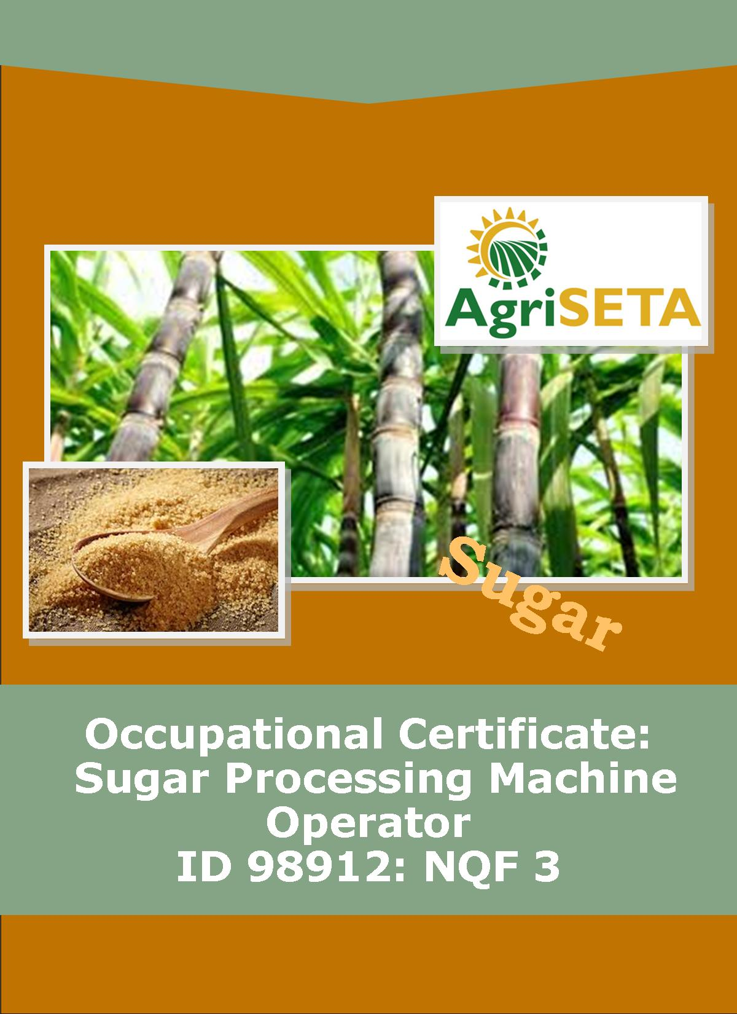
KNOWLEDGE COMPONENT: FACILITATOR IMPLEMENTATION GUIDE: KNOWLEDGE MODULE 1: OCCUPATIONAL SAFETY, HEALTH AND ENVIRONMENTAL PROTECTION
KNOWLEDGE COMPONENT: FACILITATOR IMPLEMENTATION GUIDE: KNOWLEDGE MODULE 1: OCCUPATIONAL SAFETY, HEALTH AND ENVIRONMENTAL PROTECTION
OCCUPATIONAL CERTIFICATE: SUGAR PROCESSING MACHINE OPERATOR

KNOWLEDGE COMPONENT: FACILITATOR IMPLEMENTATION GUIDE

KNOWLEDGE MODULE 1: OCCUPATIONAL SAFETY, HEALTH AND ENVIRONMENTAL PROTECTION

OCCUPATIONAL CERTIFICATE: SUGAR PROCESSING MACHINE OPERATOR

©Copyright AgriSETA
Telephone: +27 12 301 5600


AgriSETA holds the copyright to its publications and Web pages. Proper citation is requested.

TABLE OF CONTENTS
1. INTRODUCTION TO THE FACILITATOR IMPLEMENTATION GUIDE OF THE OCCUPATIONAL CERTIFICATE: SUGAR PROCESSING MACHINE OPERATOR: KNOWLEDGE MODULE 3: BASIC BUSINESS STUDIES 6
2. PROGRAMME ADMINISTRATION AND PLANNING 8
2.1 PROGRAMME PLANNING 8
2.2 LEARNER RECRUITMENT 8
2.3 IMPLEMENTING THE PROGRAMME 9
2.4 IMPLEMENTATION DOCUMENTATION 10
3. KNOWLEDGE TOPIC 1: The Productive Work Environment (40%) 12
4. KNOWLEDGE TOPIC 2: Productivity and Productivity Improvement (20%) 20
5. KNOWLEDGE TOPIC 3: The Myths of the Money Tree (40%) 23

INTRODUCTION TO THE FACILITATOR IMPLEMENTATION GUIDE OF THE OCCUPATIONAL CERTIFICATE: SUGAR PROCESSING MACHINE OPERATOR: KNOWLEDGE MODULE 1: OCCUPATIONAL SAFETY, HEALTH AND ENVIRONMENTAL PROTECTION
Dear Facilitator
This Guide has been created to assist you to facilitate the NQF 3 Occupational Certificate: Sugar Processing Machine Operator Qualification: Knowledge Module 1: Occupational Safety, Health and Environmental Protection.
The following materials form part of this programme:
Name of Document | Numbers required | When to use
Qualification Guide | 1 per learner + 1 for facilitator | At start of programme
Knowledge Component
Learning Resources (Textbooks) | 4 per learner + 4 for facilitator | Hand out at start of each module
Learning and Activities Guides (Workbooks) | 4 per learner + 4 for facilitator | Hand out at start of each module
Learner Summative Assessment Tool (Assessment documents) | 4 per learner + 4 for facilitator/assessor | Assessment to be conducted at end of each module
Facilitator Implementation Guide (This Guide) | 4 for facilitator | Retained by facilitator
Facilitator Assessment Tools and Model Answers | 4 for facilitator | Retained by facilitator
Practical Skills Component
Learner Log Book | 1 for learner + 1 for facilitator | Hand out at start of Practical Skills Component
Mill Supervisor Guide | 1 for facilitator and 1 for Mill Supervisor | Retained by facilitator and Mill Supervisor
Workplace Experience Component
Learner Statement of Work Experience and Summative Guide | 1 per learner | Hand out at start of Workplace Component

This implementation guide will provide the facilitator with guidance regarding the implementation of the programme. This guidance will include:
- Instructions to the facilitator
- The format of the facilitation
- Slides to use during facilitation
- Guidance on directing learners to their assignments
- Recommended reading and further resources to be used during facilitation
Let’s get started!

PROGRAMME ADMINISTRATION AND PLANNING

There are several administrative activities that must be completed before, during and after the training. These include:
- Programme planning,
- Learner recruitment; and
- Implementing the programme

2.1 PROGRAMME PLANNING

The project team and training division meet to:
- Plan all the activities that must take place in order for the Occupational Certificate: Sugar Processing Machine Operator to take place.
- Assign people who will be responsible for facilitating the training (facilitators for theoretical component and instructors for the practical component), for assessment (Both formative and summative) and moderation.
- Decide on the resources that must be purchased and made available during training.
- Assign people responsible for gathering all the required resources.
- Decide on the duration of this Occupational Certificate.
- Ensure that all candidates have venues for the Work Experience Component (before the programme starts)

2.2 LEARNER RECRUITMENT
- Provide learner information forms to all learners for completion.
- Collect all learners’ qualifications, CVs and I.D. copies.
- Evaluate the applications for eligibility for enrolment to the Occupational Certificate.
- Inform learners who have been successfully selected to the Occupational Certificate by way of a welcome letter.
- Inform learners who have been successfully selected to the Occupational Certificate of the first day of the programme.
- Upload of learners to the AgriSETA database
- Receive the proof of uploads from the AgriSETA

2.3 IMPLEMENTING THE PROGRAMME
- Compile a detailed implementation plan and programme schedule.
- Edit, print and prepare the appropriate learning material.
- Purchase and prepare stationery packs for learners (if applicable)
- Purchase stationery for facilitator.
- Book training venues for theoretical and practical components as required by the programme schedule.
- As the programme proceeds hand-out learning materials.
- Train according to the implementation guidelines provided in this manual. Remember to be well prepared before each training session. Find additional learning resources such as examples, samples, photos, posters, videos, pamphlets and additional textbooks etc. which can add value to the learning experience.
- Build site visits and field trips into the programme as often as possible. Invite guest speakers from the industry and specifically from sugar mills to share their experience with the learners.
- Guide the learners through their individual and group exercises and assignments in the Formative Assessment Guide and provide inputs where required.
- Request the assessor to assess the modules as the training proceeds (Formative and summative).
- Obtain feedback from the learners on, at least, a weekly basis regarding their satisfaction with the programme (Venue, Facilitation, Logistics, Amenities). Evaluate the feedback and address issues raised as quickly as possible providing feedback to the learners as to how these issues were addressed.
- Ensure that learners understand the Training Provider appeals procedures and the Code of Conduct of the Training Provider.
- As Competency Results become available ensure that these are sent to the relevant functionary for data capture and, if relevant, upload to the AgriSETA database.
- Ensure that learners are eligible to proceed to the practical component of the Occupational Certificate before signing off on the Knowledge Component.
- Ensure that learners are eligible to proceed to the Work Experience Component of the Occupational Certificate before signing off on the Practical Component.
- Ensure that Mentors for the Work Experience Component are adequately briefed on their role and responsibilities before placing the learner for the Work Experience Component.
- Explain the final Competency evaluation based on the handing in of the completed “Learner Statement of Work Experience and Summative Guide”.
- Once competency is declared ensure that results are uploaded to AgriSETA and request the relevant department to print the award certificates (as relevant).
- Issue certificates to the successful candidates.

2.4 IMPLEMENTATION DOCUMENTATION
The Training Provider will provide templates of the following documents to the facilitator as requested:
- Learner recruitment form
- Training schedule
- Welcome letter
- Attendance registers
- Daily evaluation form
- Learner upload forms
- Individual learner progress report forms

KNOWLEDGE TOPIC 1: The Statutory Framework of Safety, Health and Environmental Protection in the Workplace (10%)
INSTRUCTIONS TO FACILITATOR
Purpose: To introduce the candidates to Knowledge Module 1: Occupational Safety, Health and Environmental Protection.
Objectives: By the end of the session the candidates will:
- Have received their Sugar Processing Machine Operator Knowledge Component Learner Guide – Book 1 (Textbook),
- Have received their Sugar Processing Machine Operator Knowledge Component Formative Assessment Guide – Workbook 1,
- Understand general- and sugar processing-specific safe work practices in an industrial environment,
- Be aware of the topics that will be dealt with within this module.
Procedure: Hand out the participant materials and conduct a presentation. Allow time for learning activities.
Participant Materials: Hand-out the following participant materials
- The Learner Guide Book 1 (Textbook)
- The Learner Formative Assessment Guide – Workbook 1
Presentation: Do a presentation introducing Occupational Safety, Health and Environmental Protection in the Sugar Industry covering the following aspects:
- Background to OHS
- Introduction to the legislative framework
- Regulation and enforcement of the Act
- Appointment, functions, rights and duties of Health and Safety Committees and Representatives at work
- Duties and responsibilities of persons at work
Slides: Use the following slides for your presentation and refer frequently to the Learning Resource for further information.
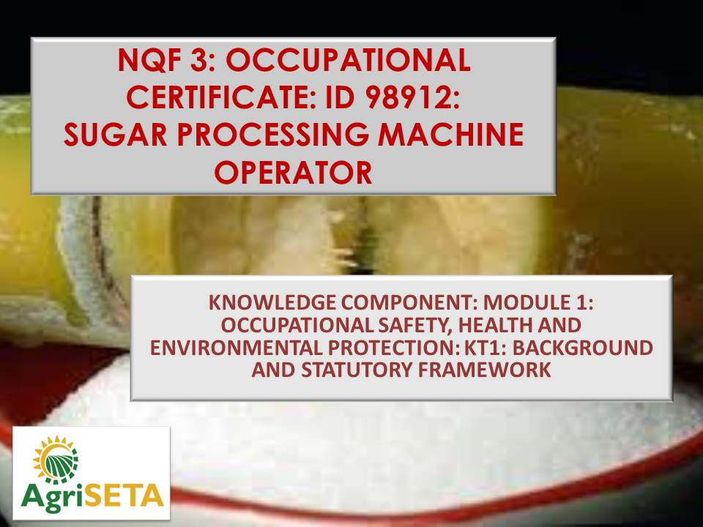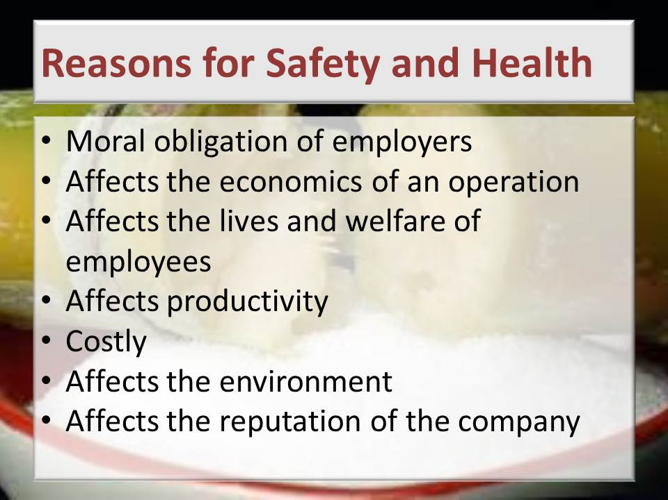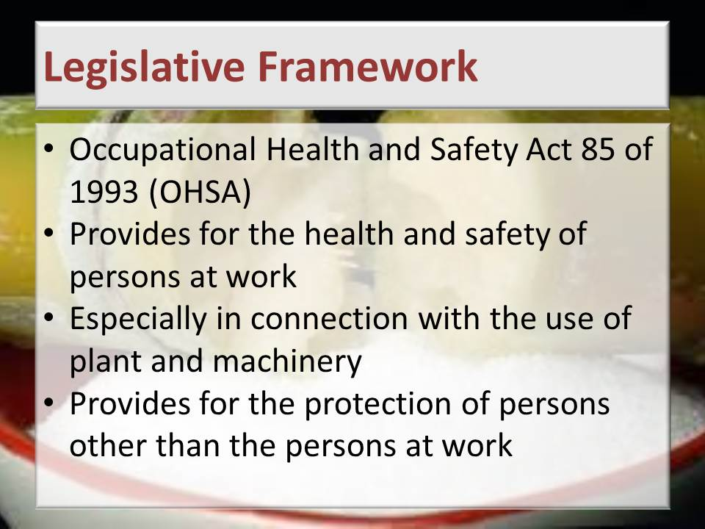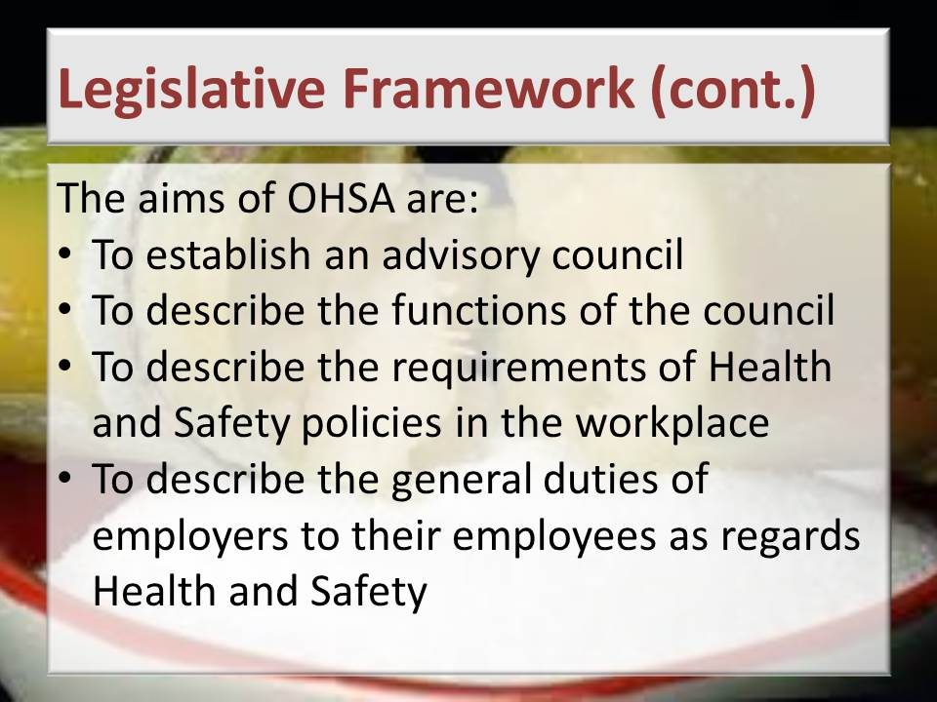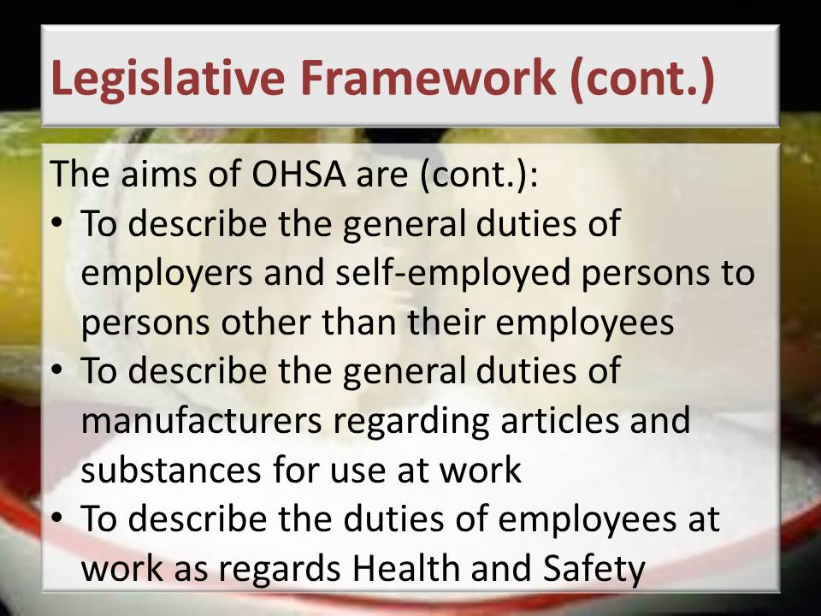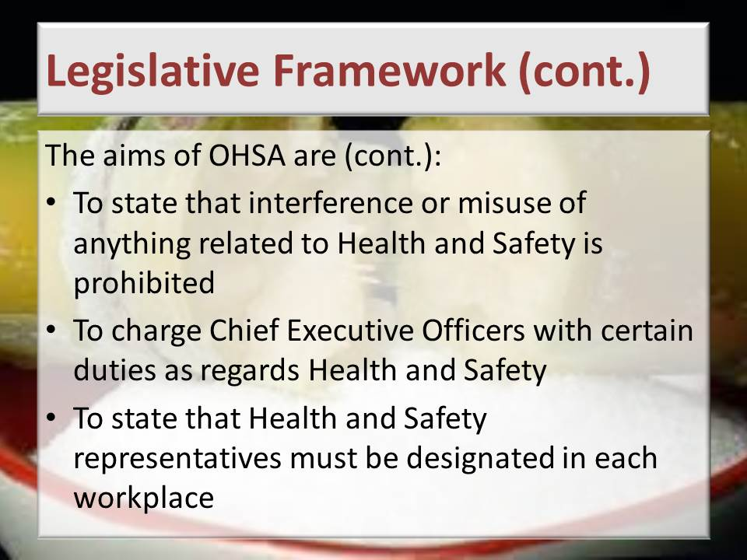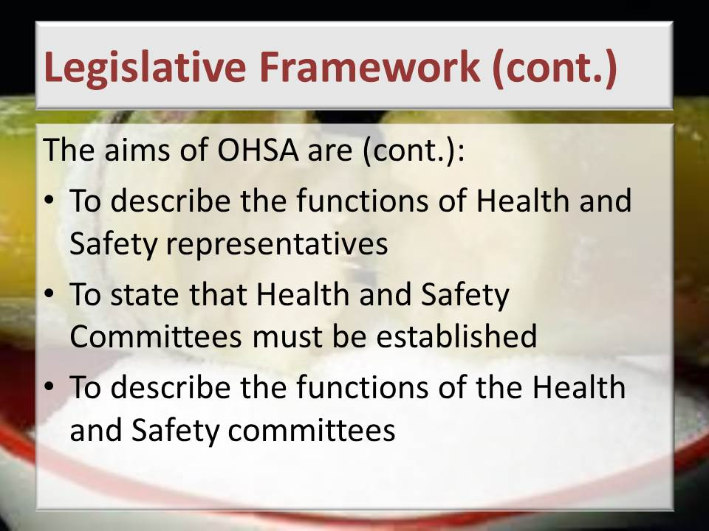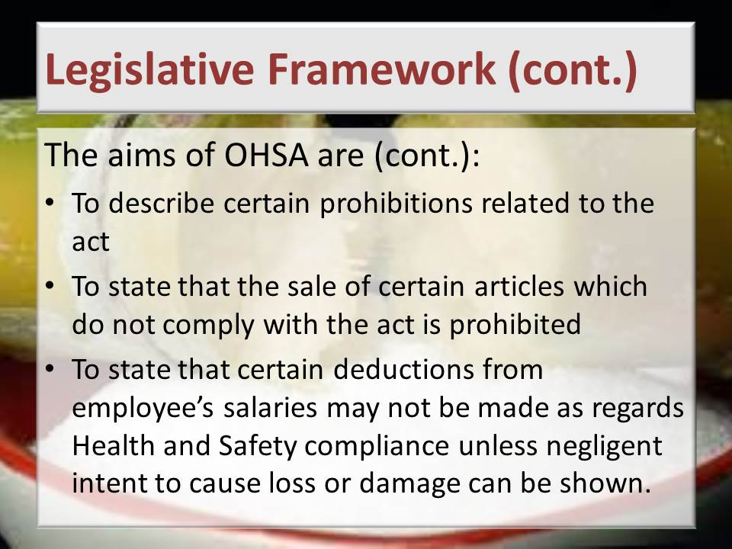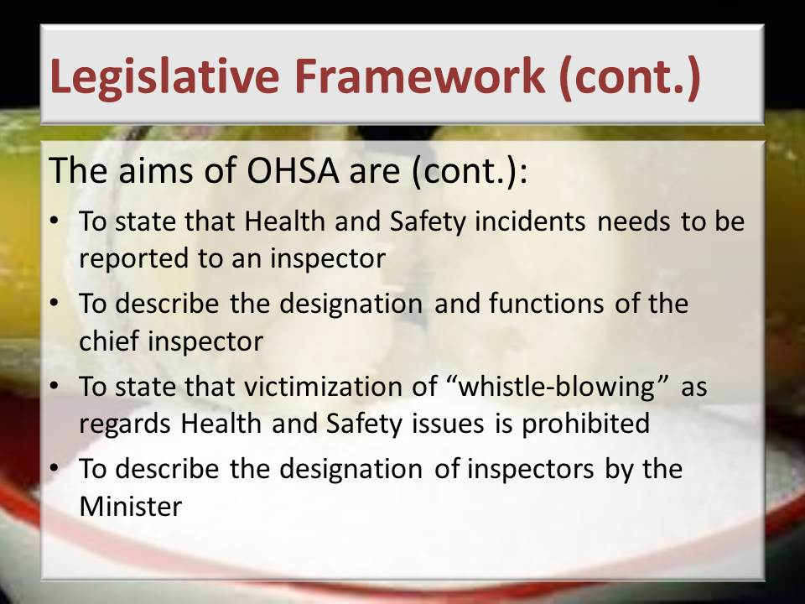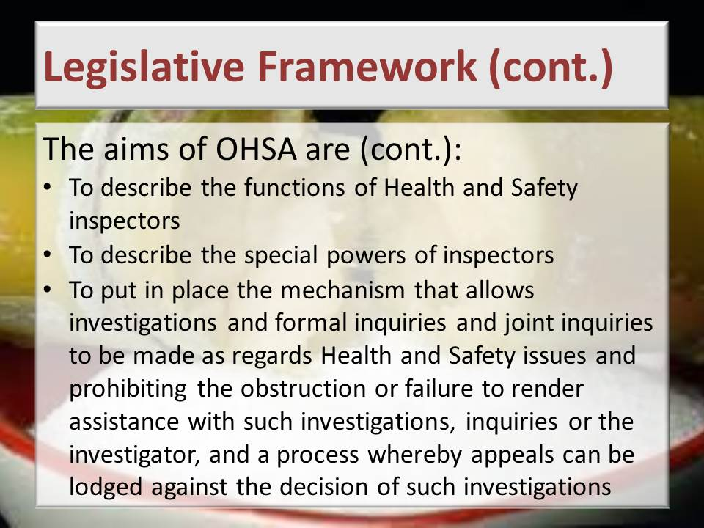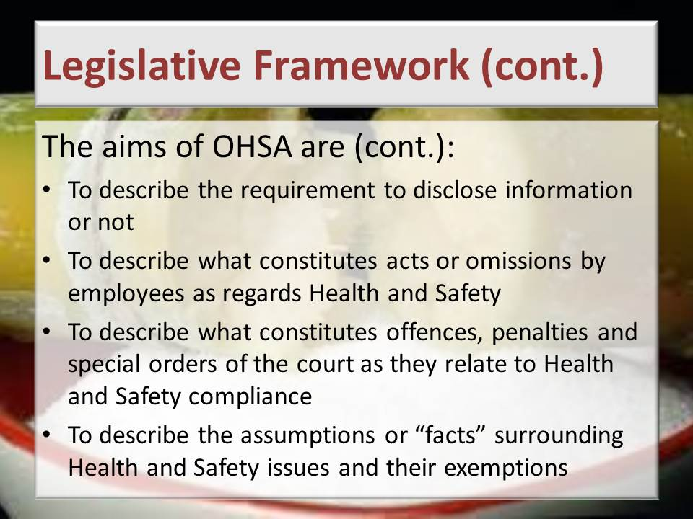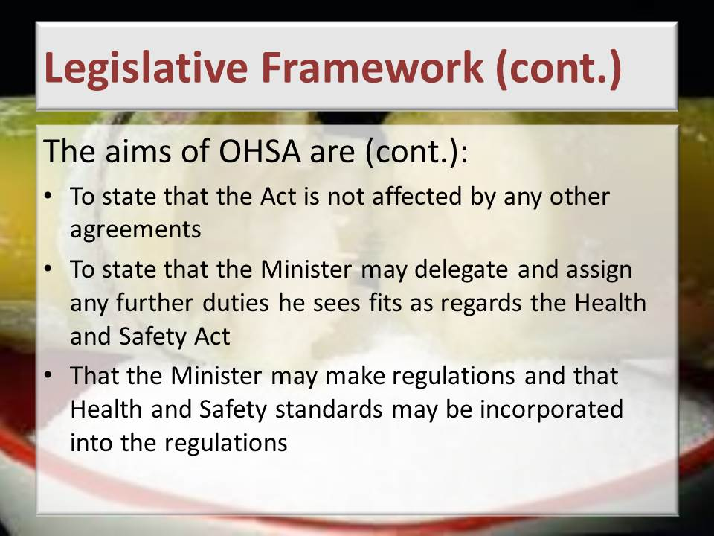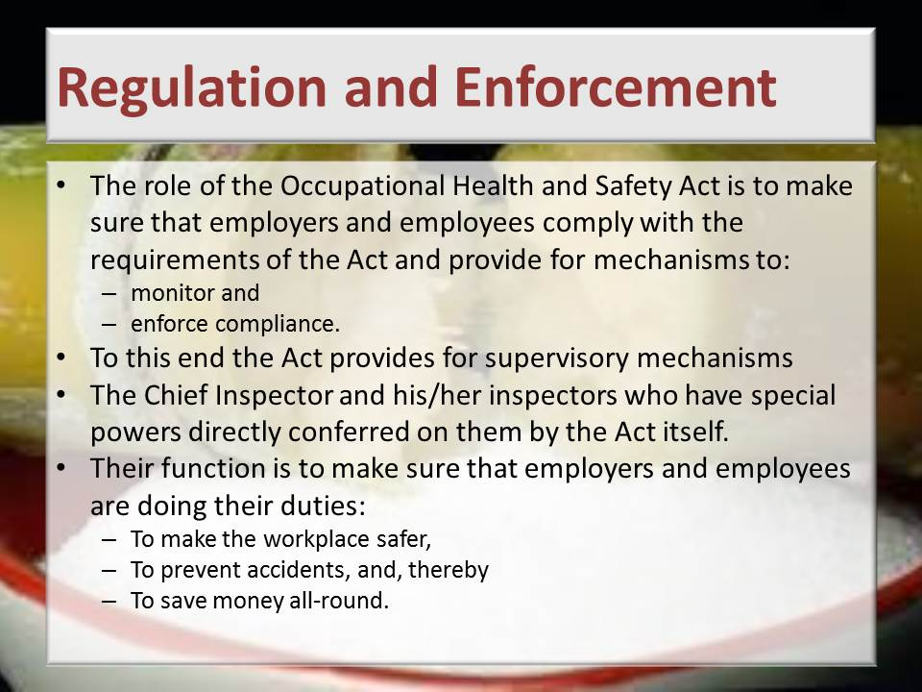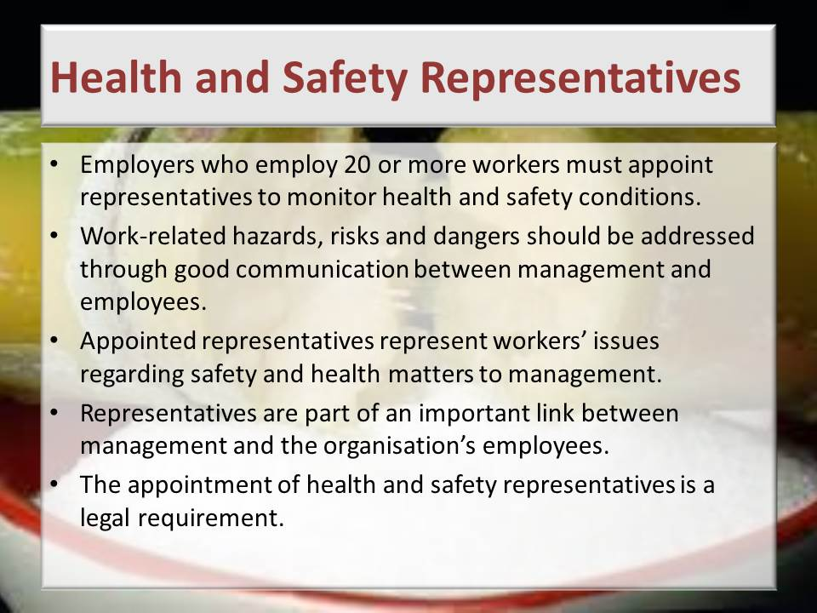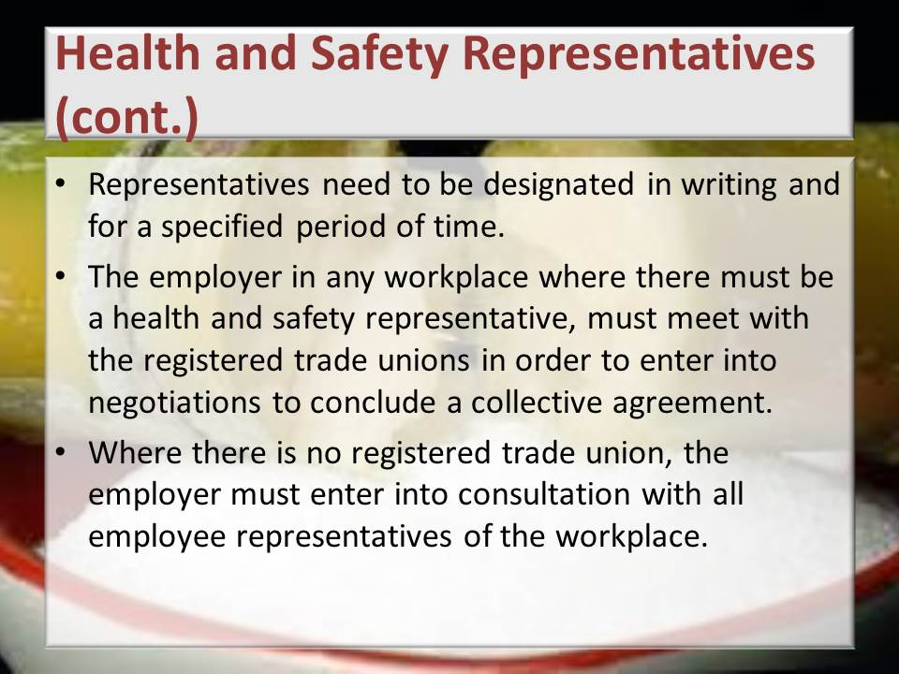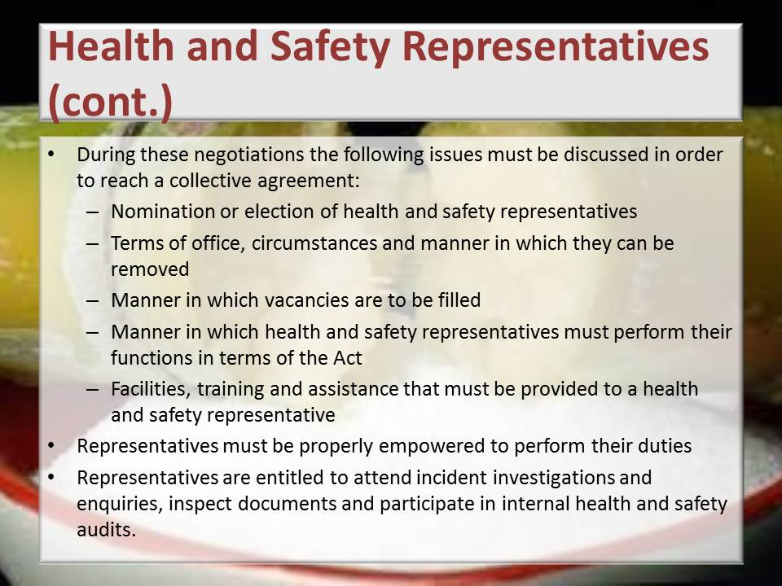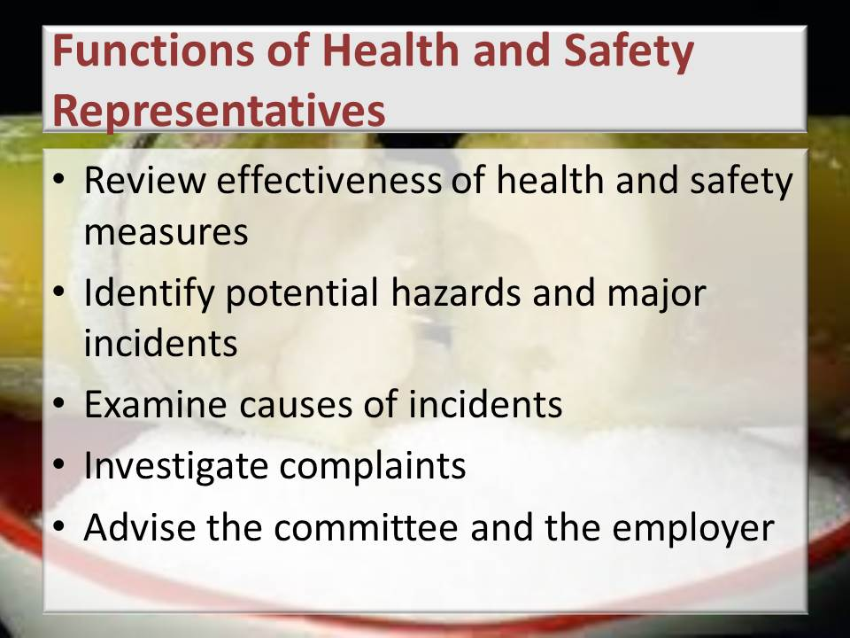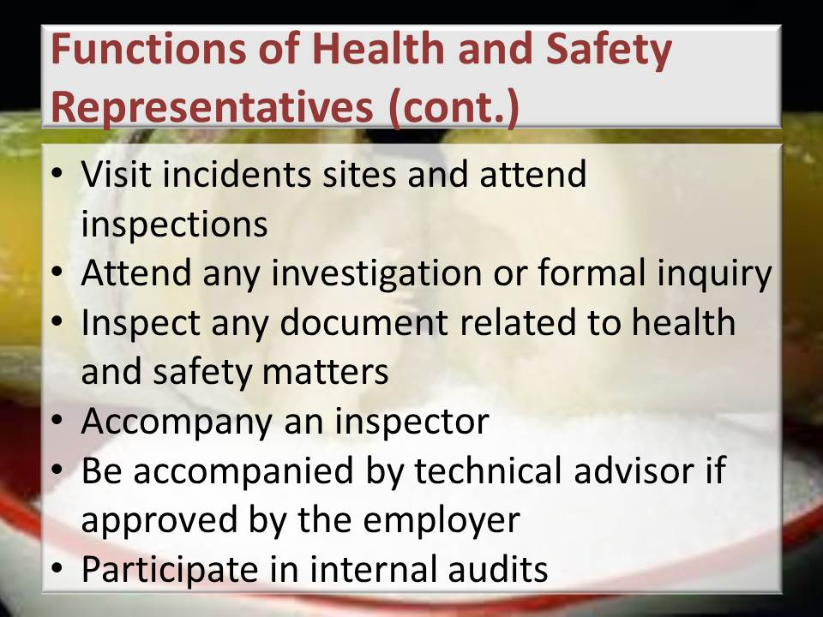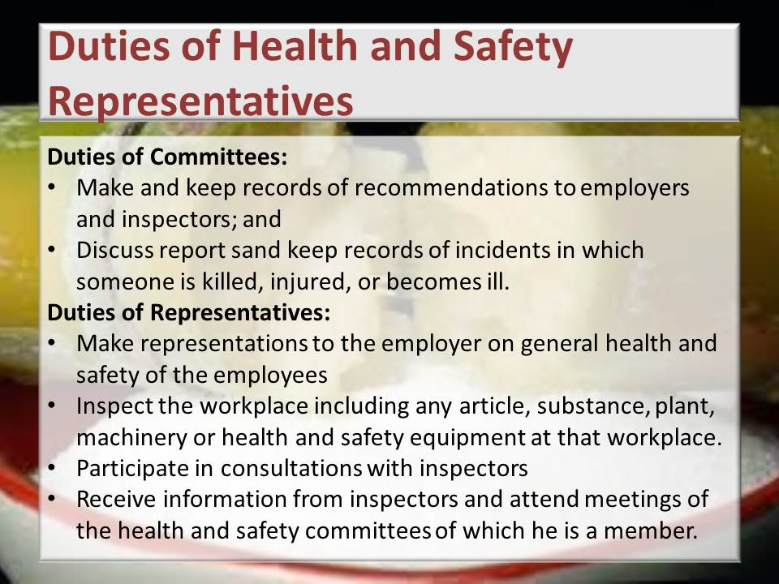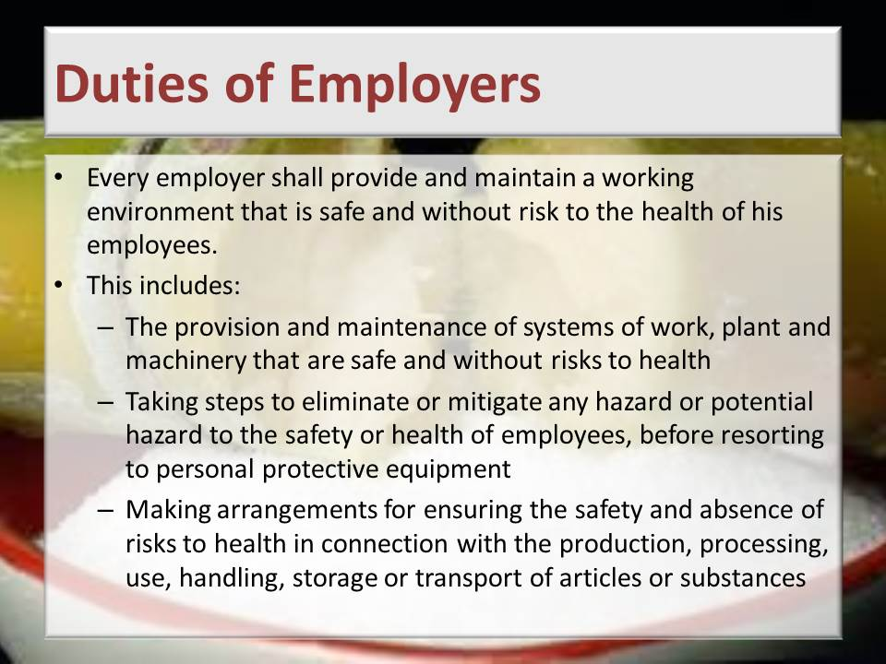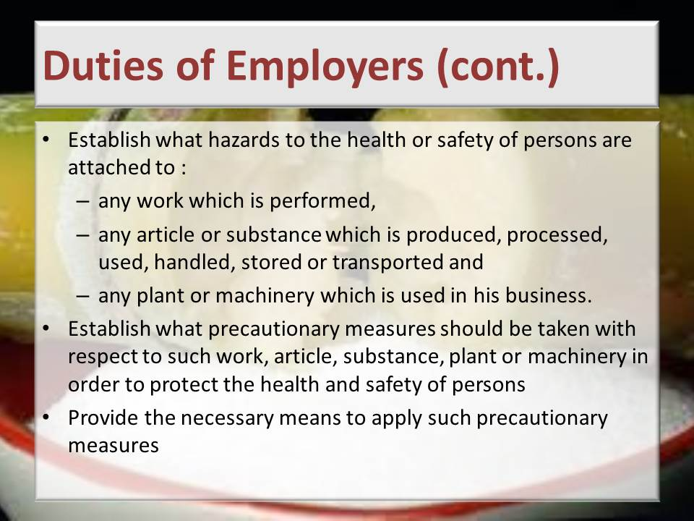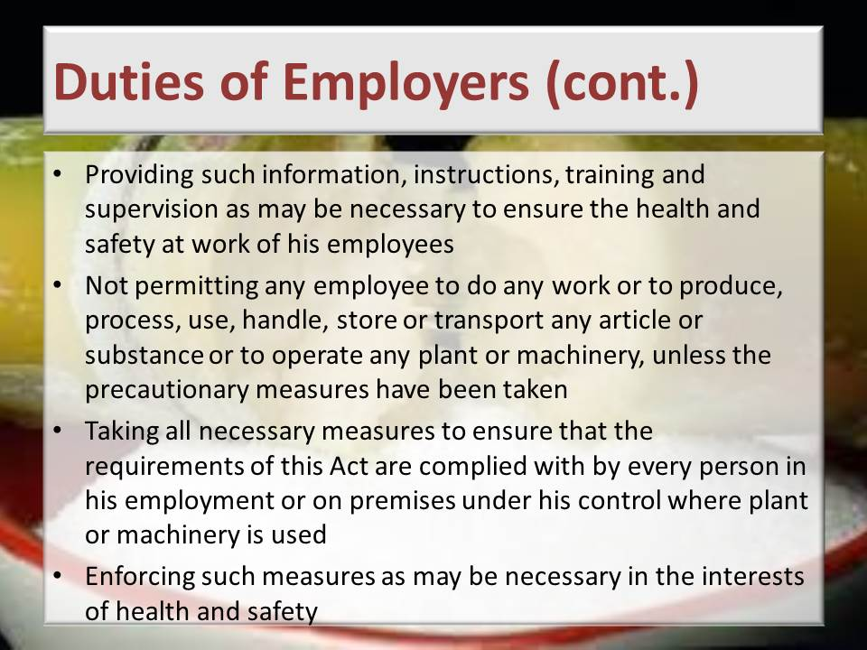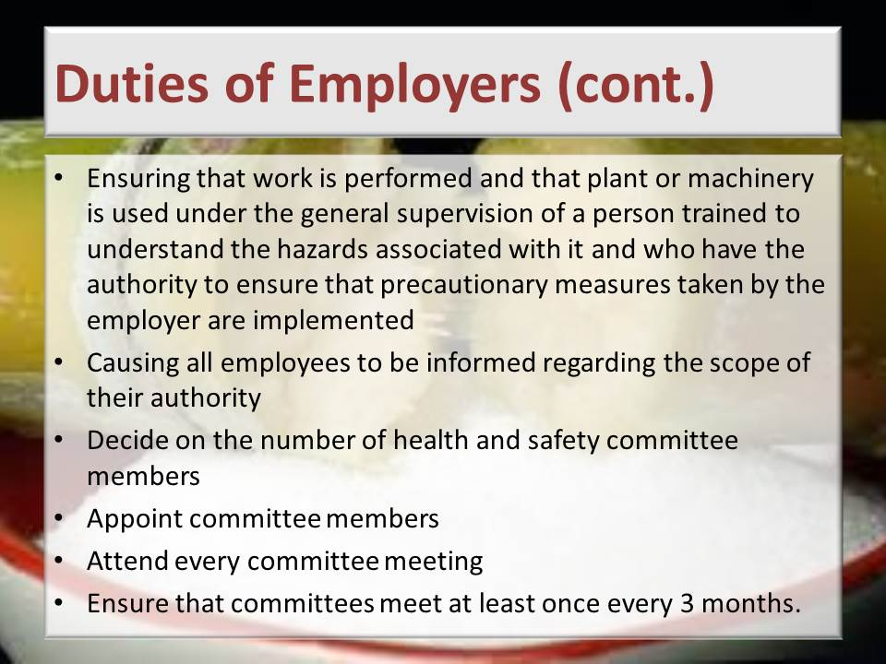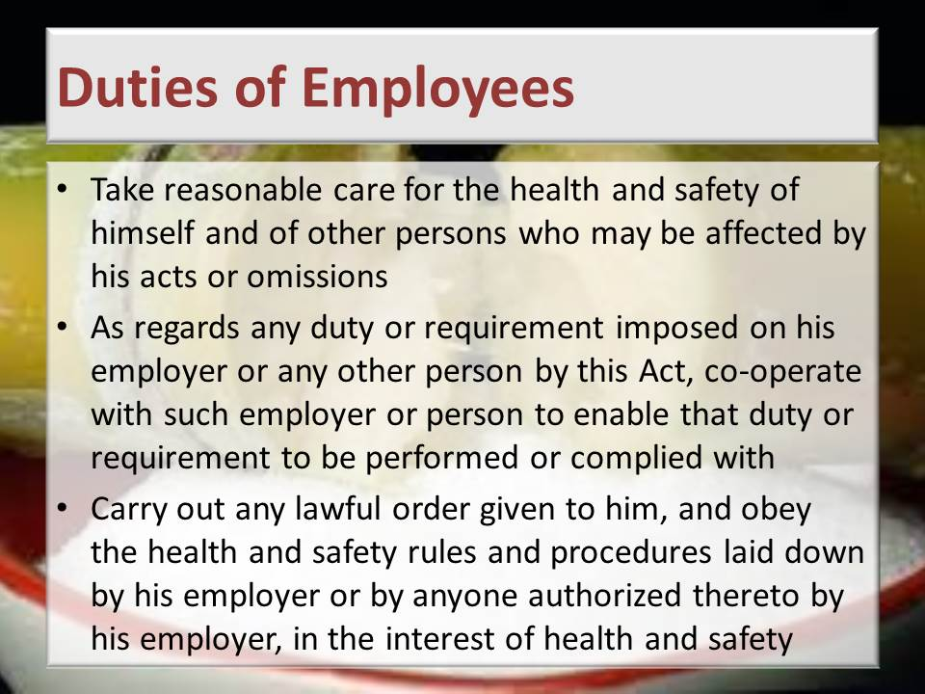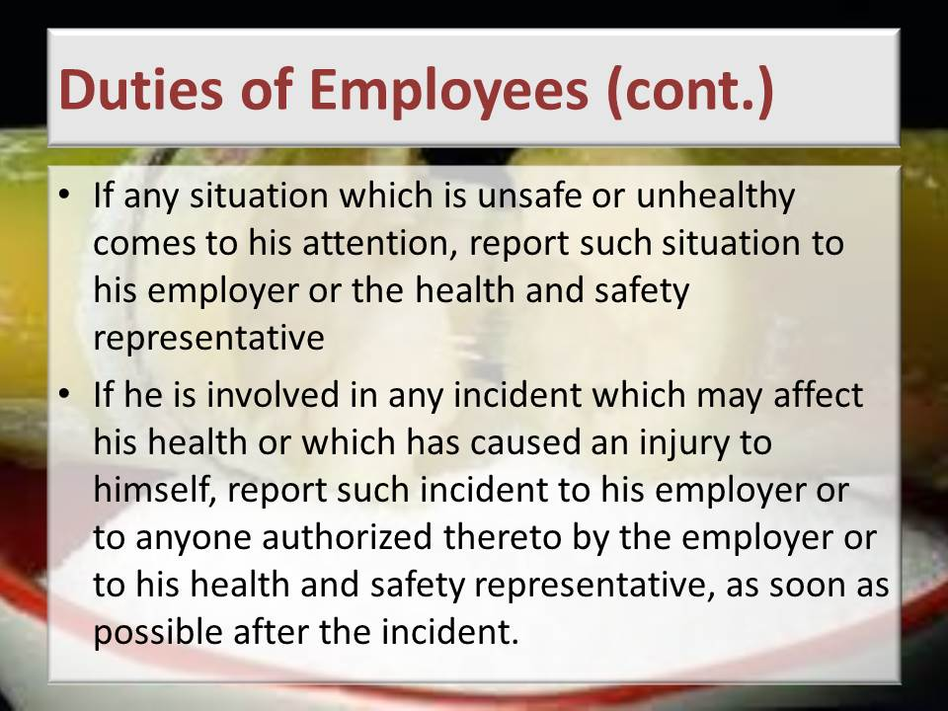
Learning activity: Guide learners to Page 11 of the Learner Workbook 1. Learners are instructed to complete Learning activity 1.1. (30 minutes)
Guide learners to Page 13 of the Learner Workbook 1. Learners are instructed to complete Learning activity 1.2. (45 minutes)
Total time taken: Presentation: 4 hours
Learning activity 1.1, 1.2: 2 hours
Close: Move on to the next session

KNOWLEDGE TOPIC 2: General Rules and Principles of Safe Work Practices (30%)
INSTRUCTIONS TO FACILITATOR
Purpose: To introduce the candidates to Knowledge Topic 2: General rules and principles of safe work practices.
Objectives: By the end of the session the candidates will:
- Be able to explain general rules and principles of safe work practices for different scenarios.
Procedure: Conduct a presentation and allow time for learning activities.
Participant Materials: The learner will use the following materials:
- The Learner Guide Book 1 (Textbook)
- The Learner Formative Assessment Guide – Workbook 1
Presentation: Do a presentation about the general rules and principles of safe work practices covering the following aspects:
- Good housekeeping practices and risks
- Safety signs and symbols
- Personal protective equipment
- Machine guarding and operational safety precautions
- Lock out procedures
- Emergency procedures
- Restricted entrance
- Fire prevention
- Incident on duty and reporting
- Universal precautions when attending to injured persons
- Provisions related to intoxication, unauthorized use of motorized or mobile equipment
- Safe material lifting
- Material stacking
Slides: Use the following slides for your presentation and refer frequently to the Learning Resource for more detailed information. NB. Presentation: 16 hours (Do the presentations of this Knowledge Component over a period of 5 to 10 days allowing time for learning activities between the relevant groups of slides).
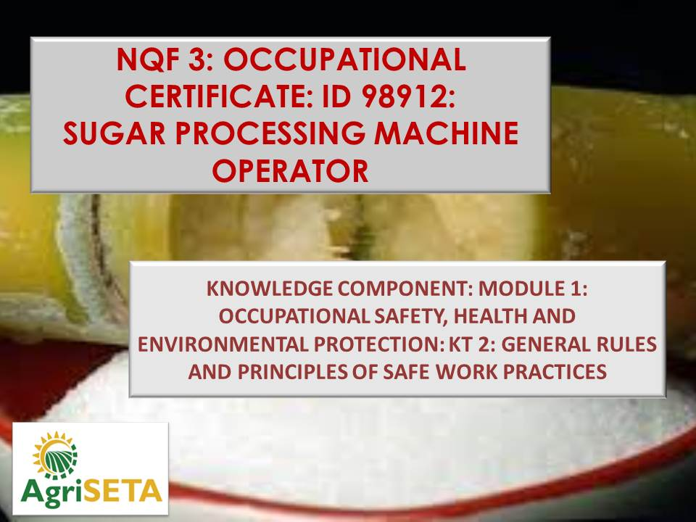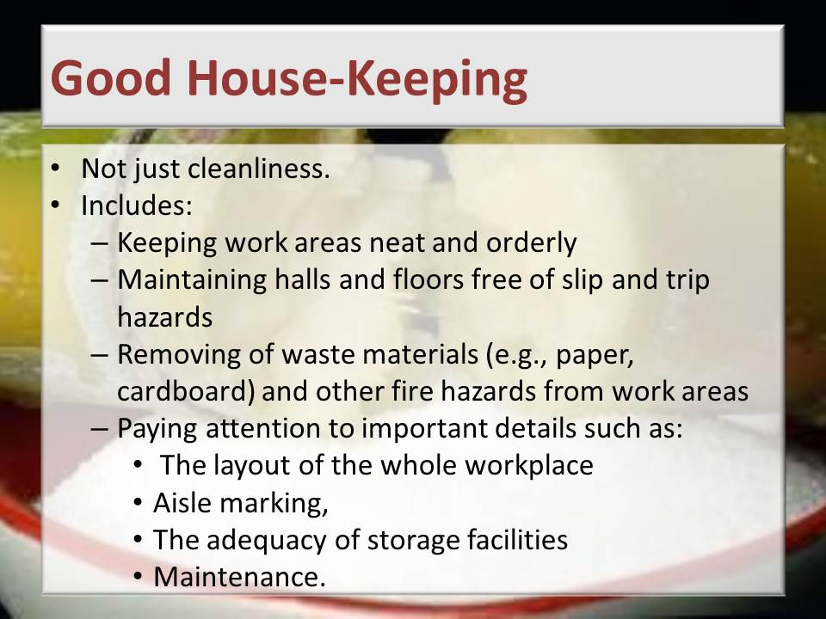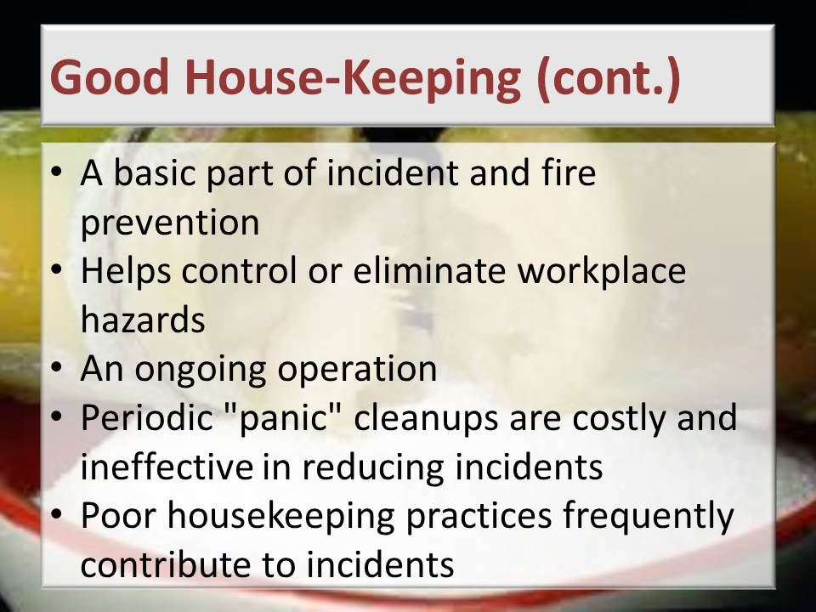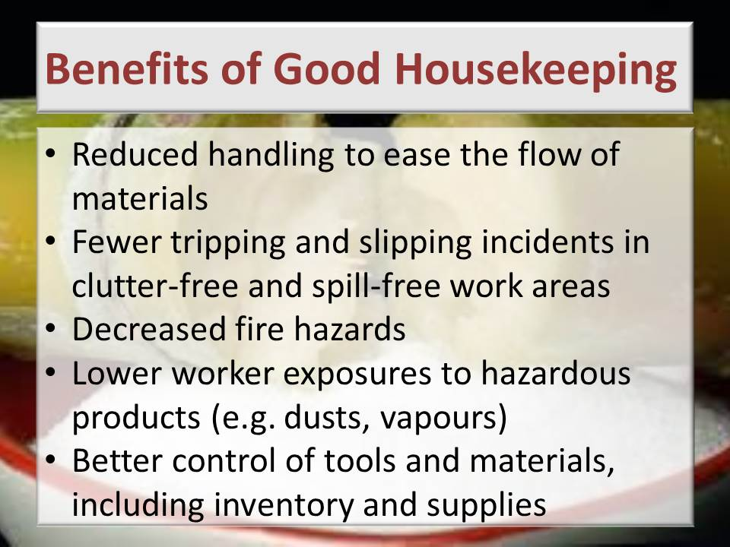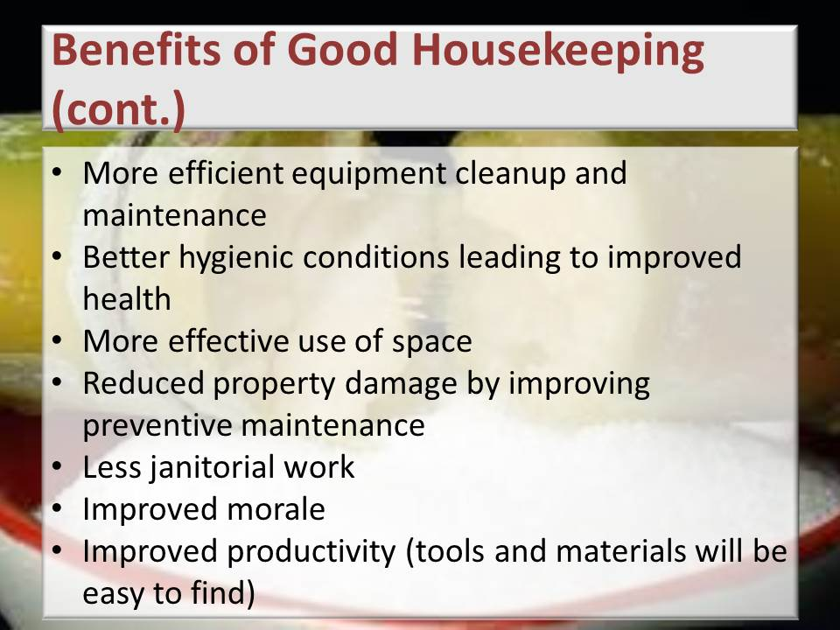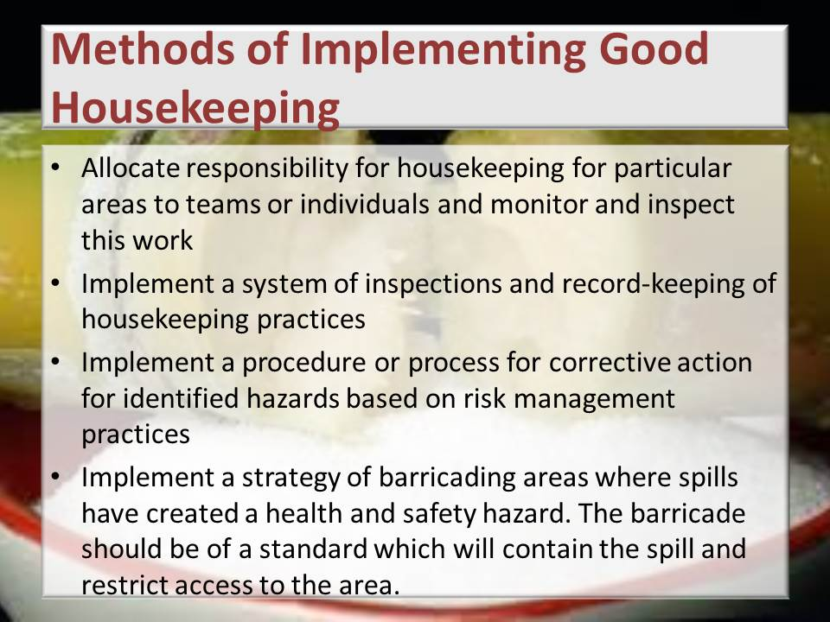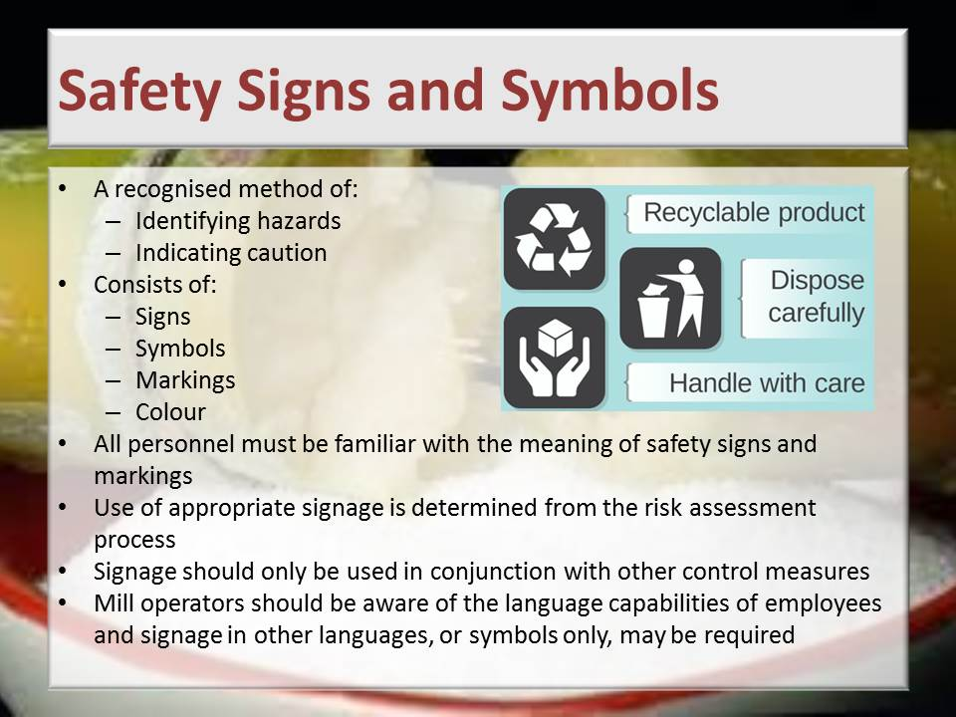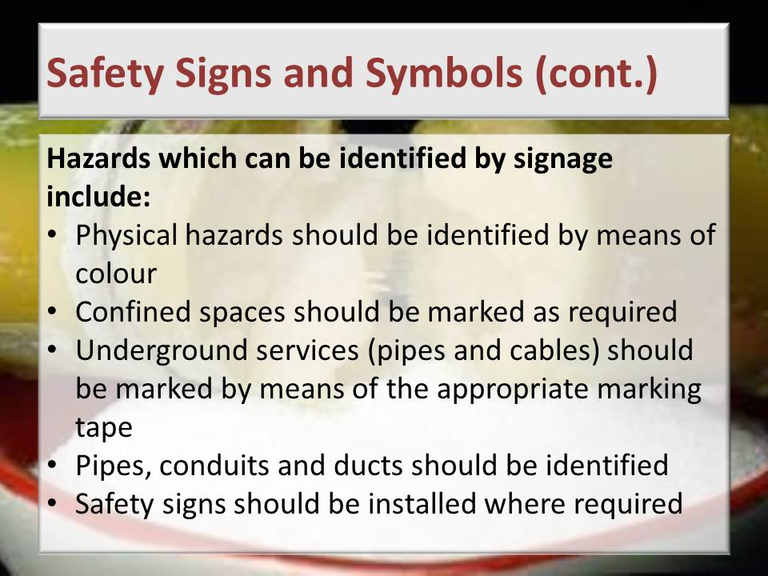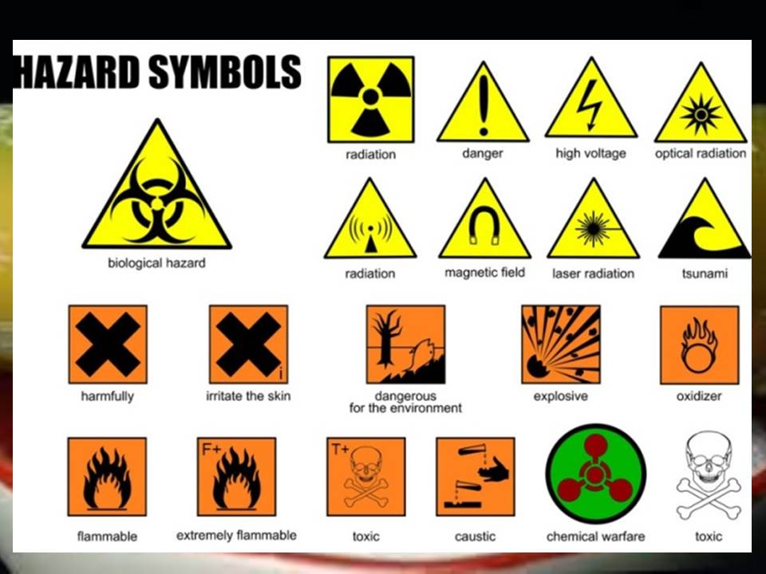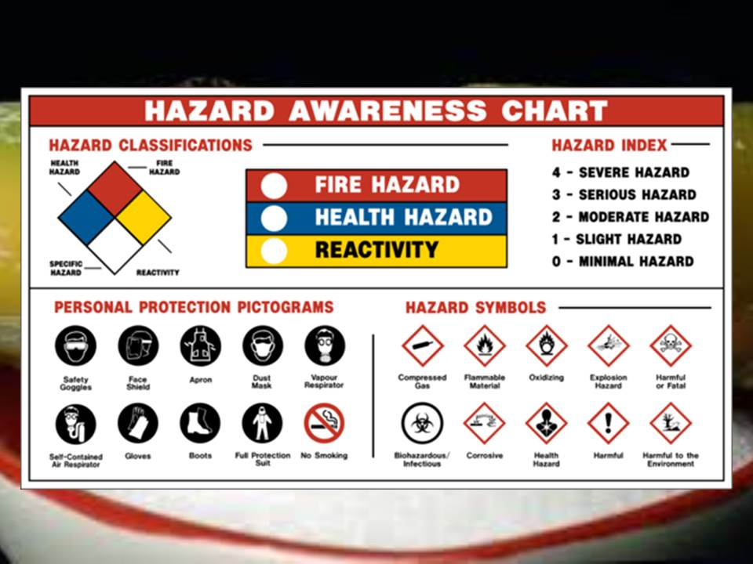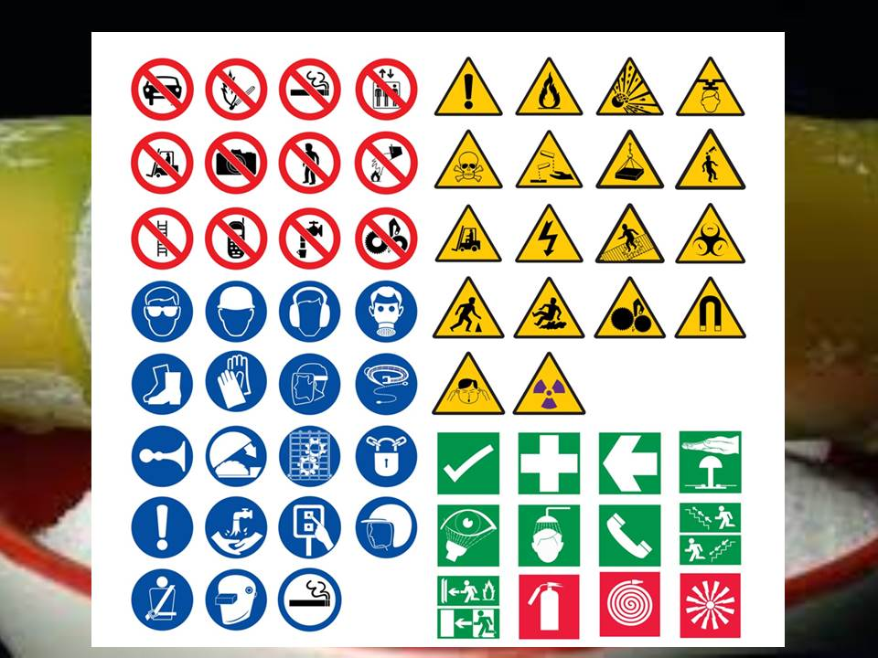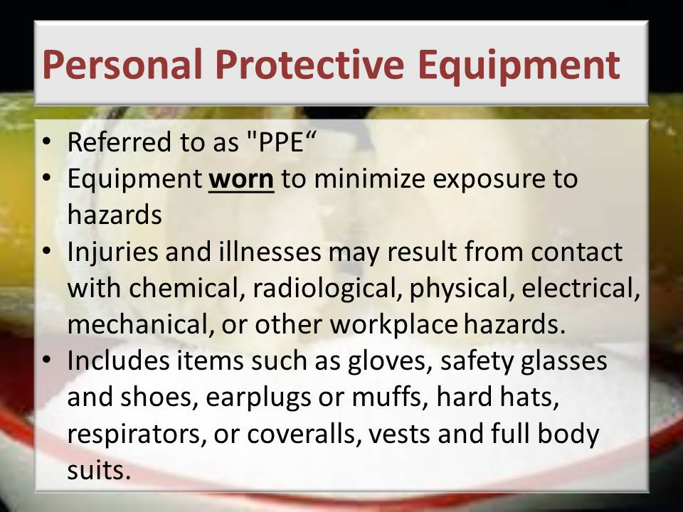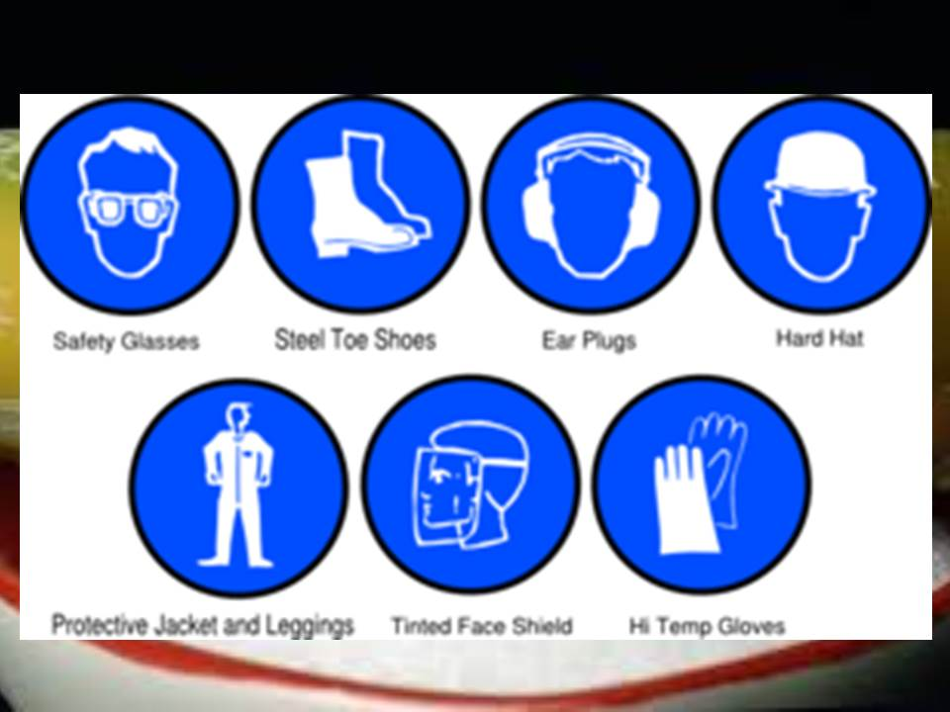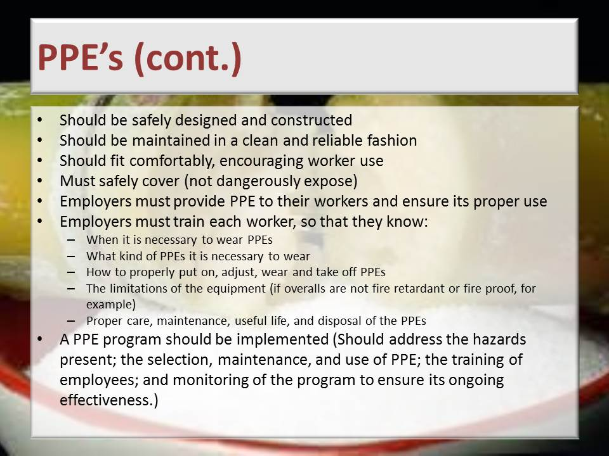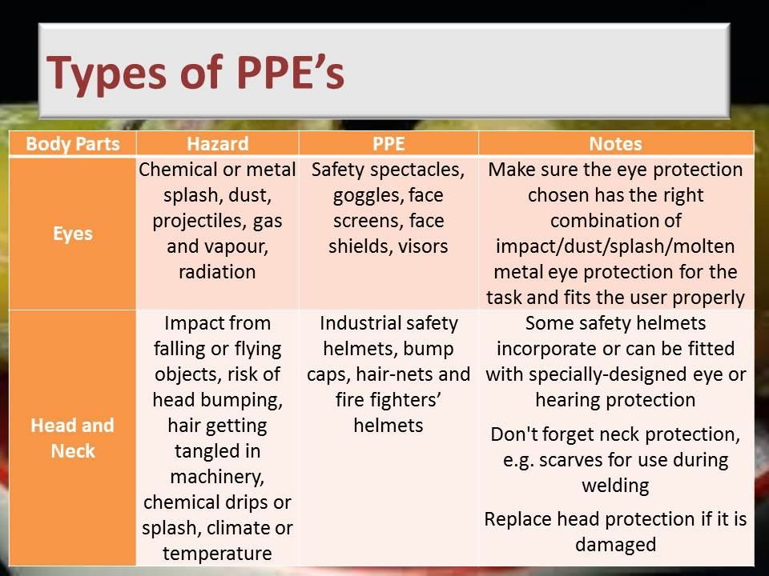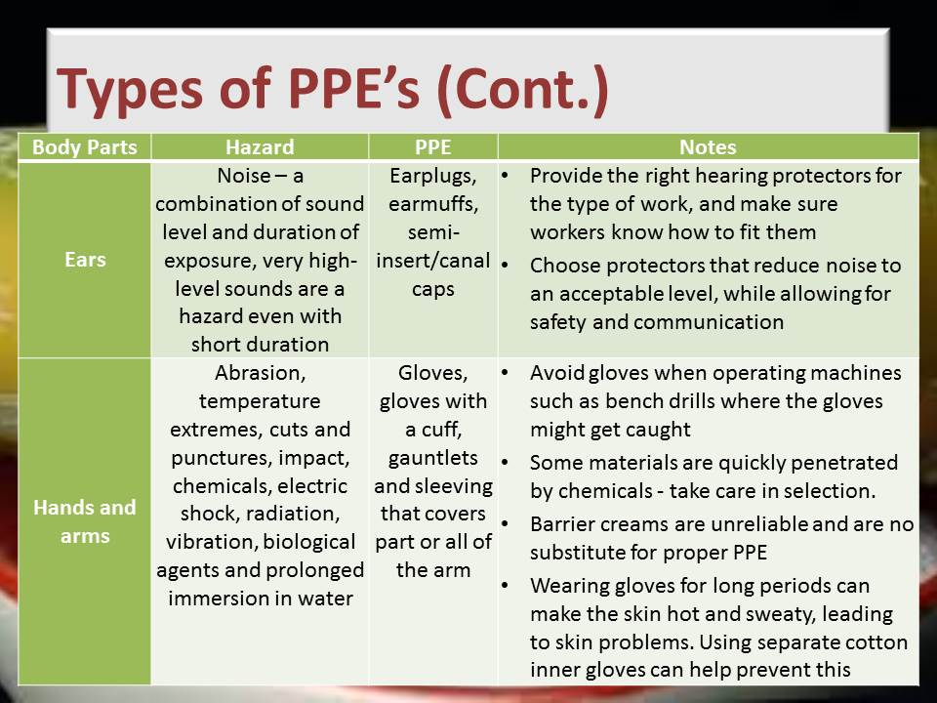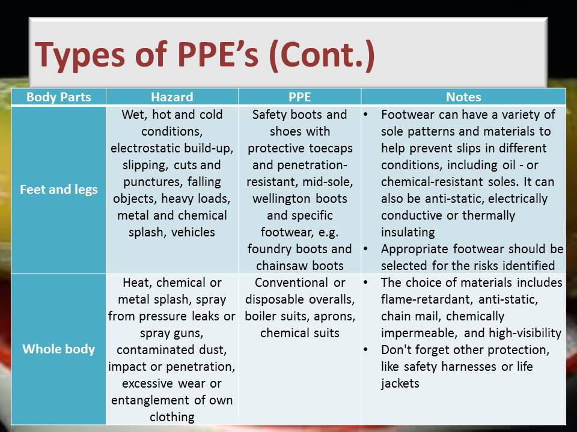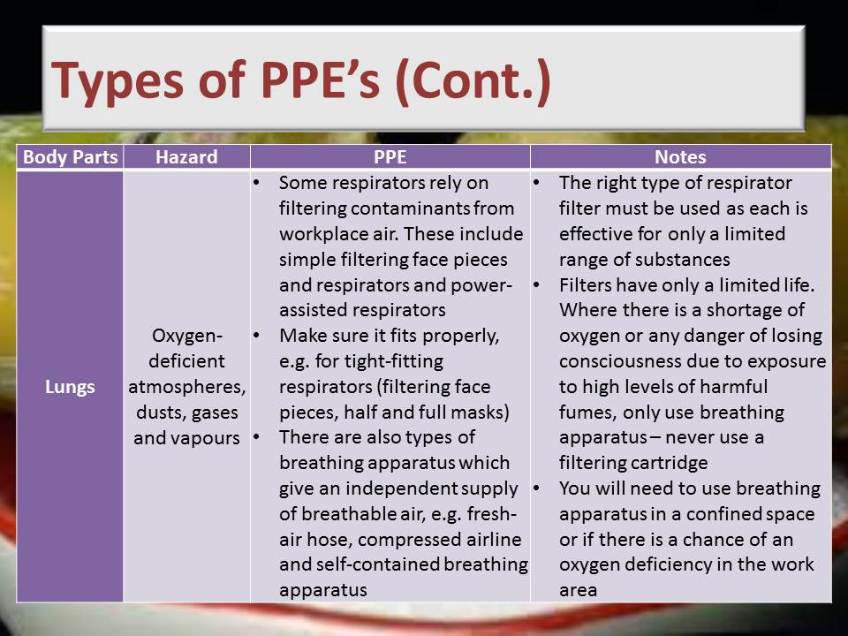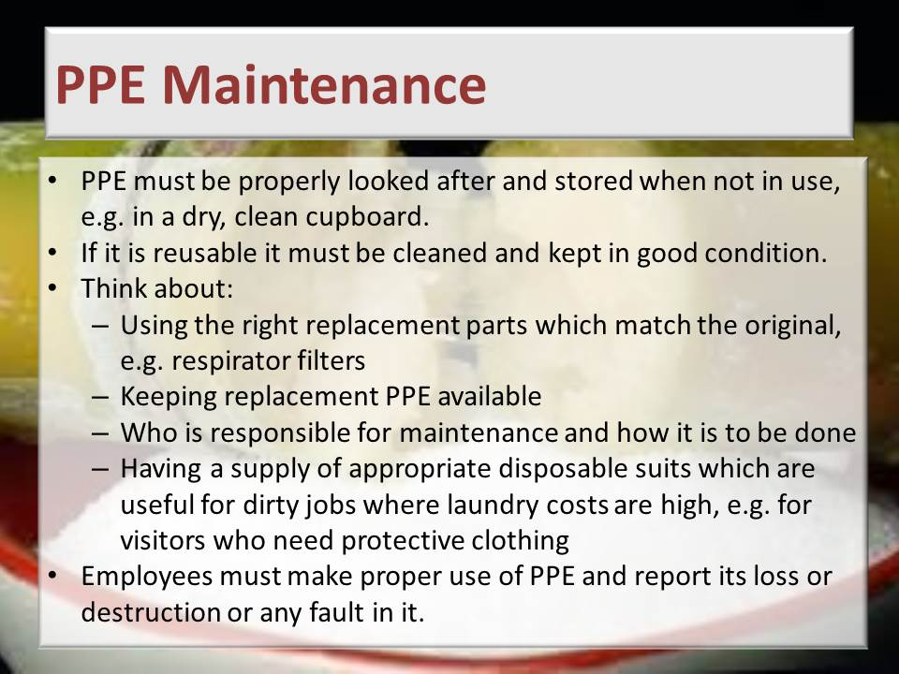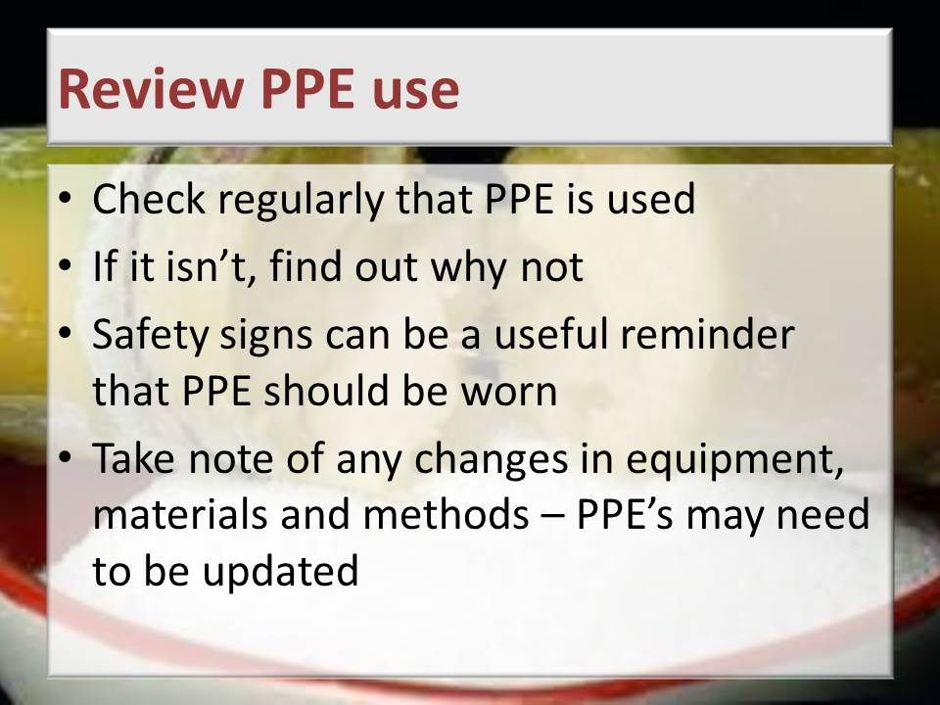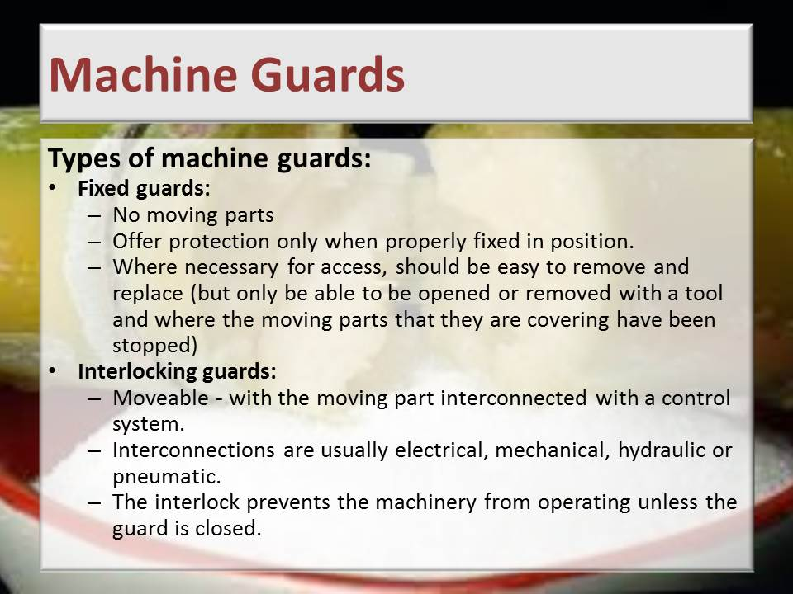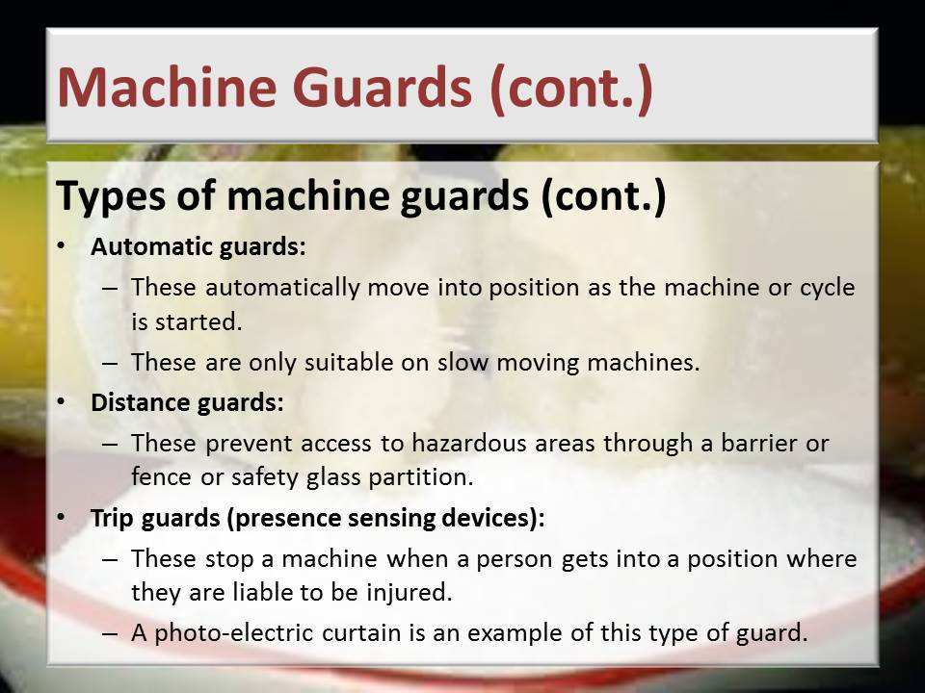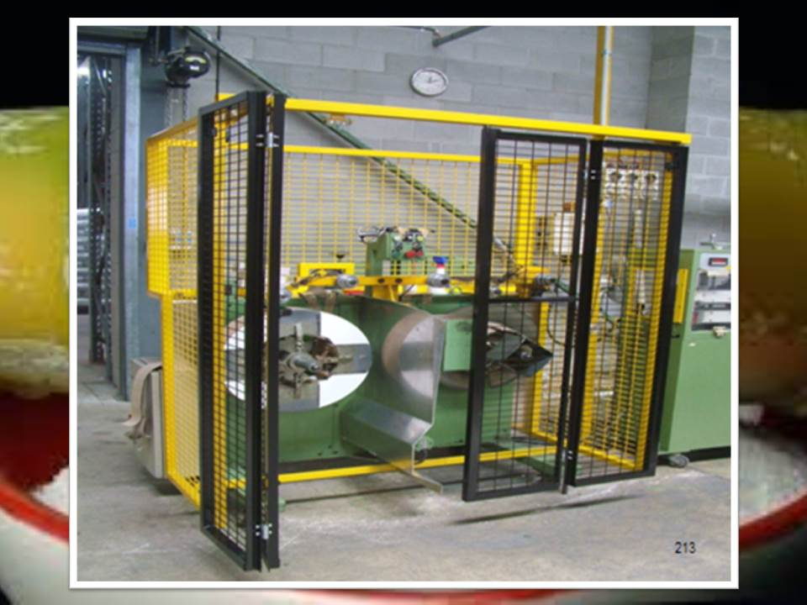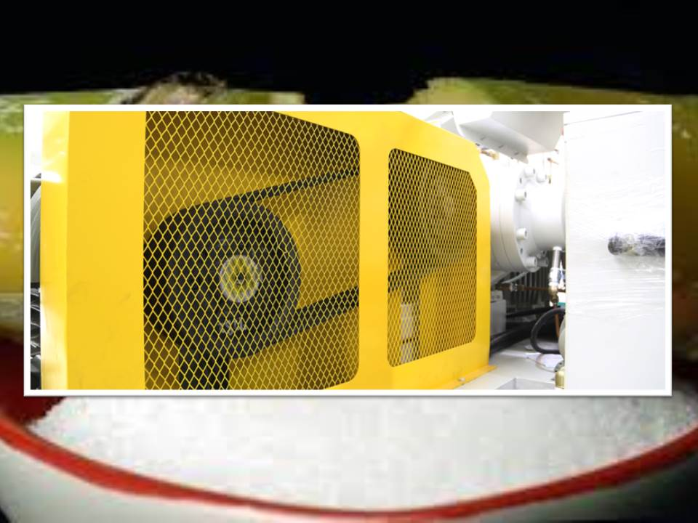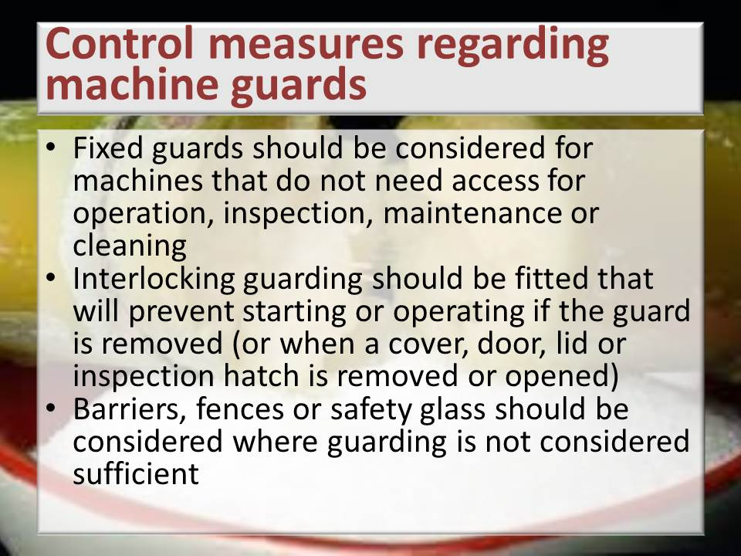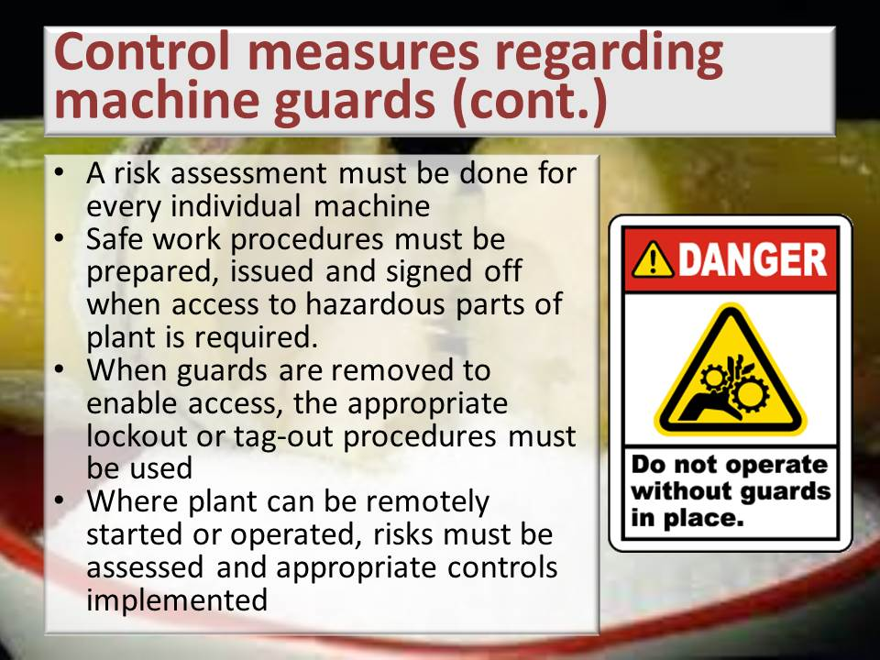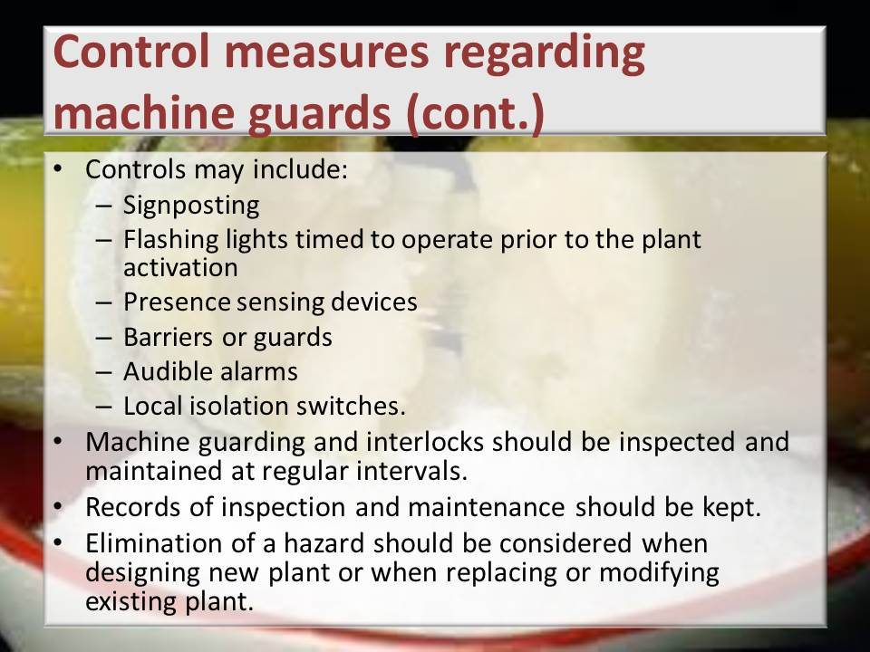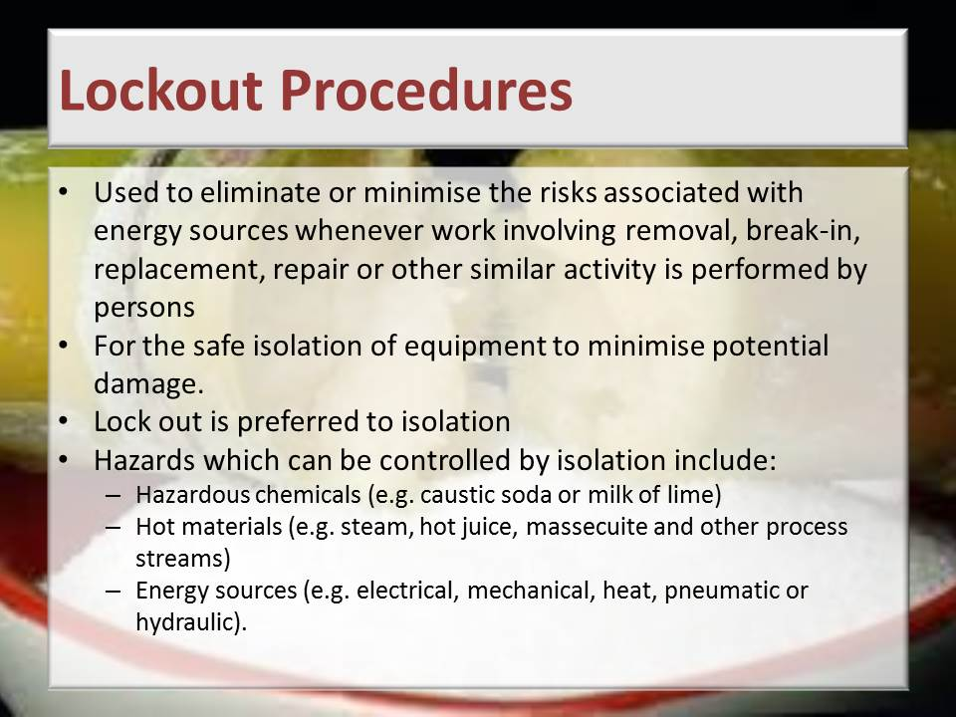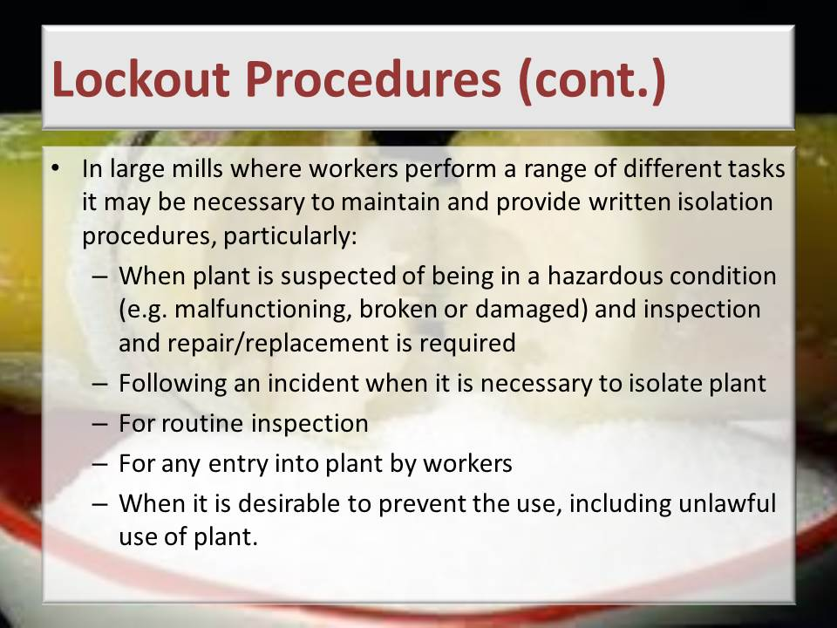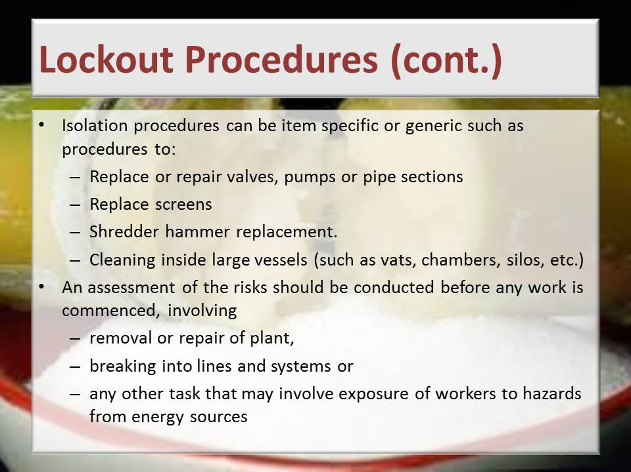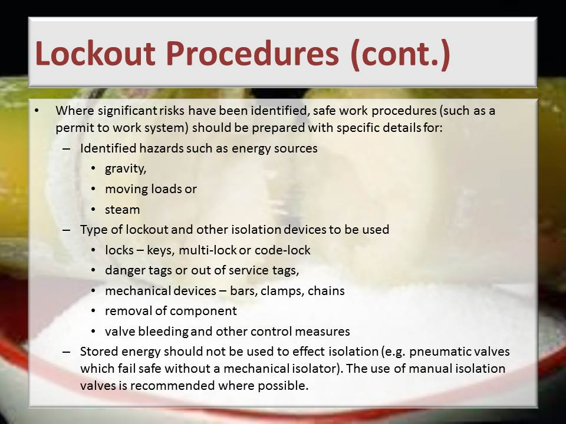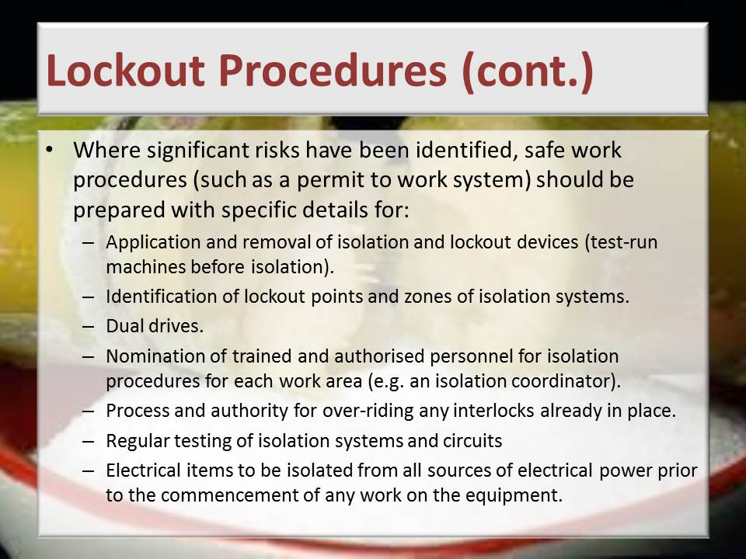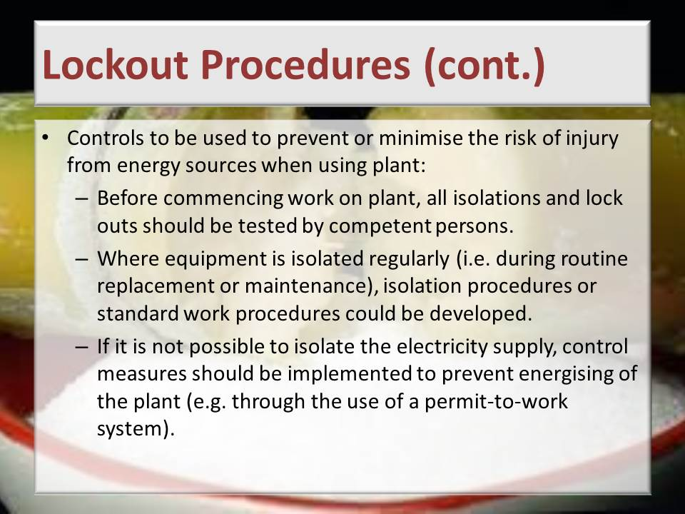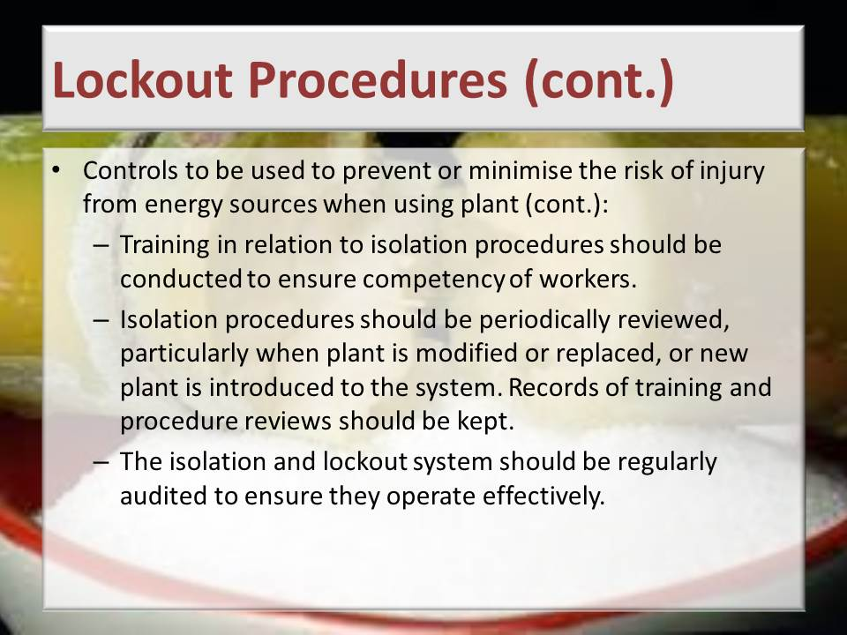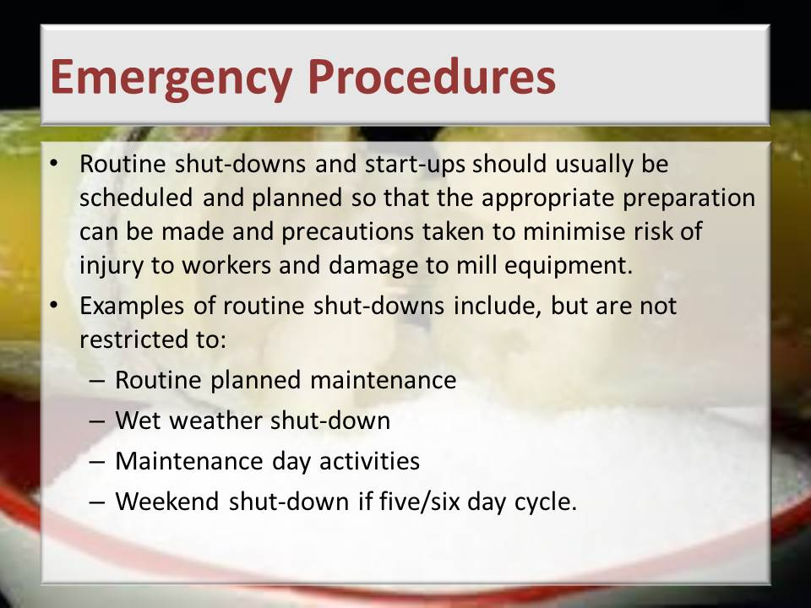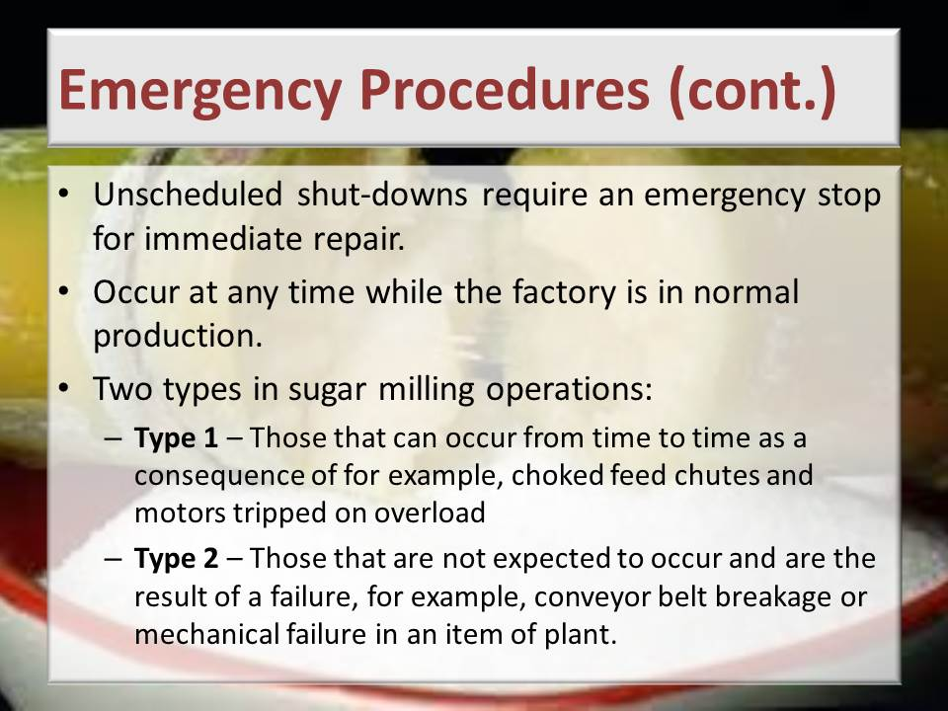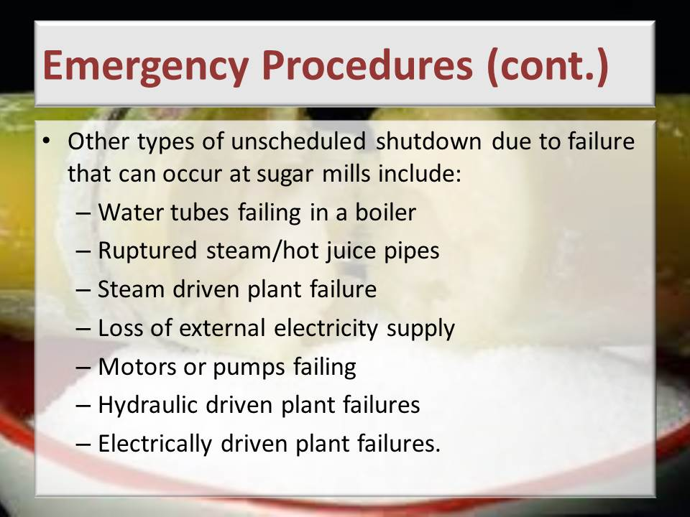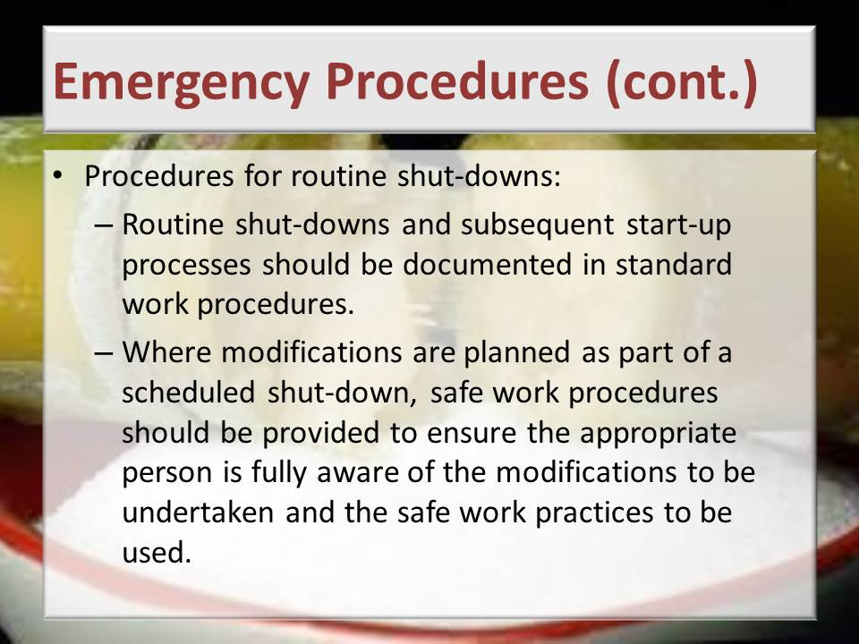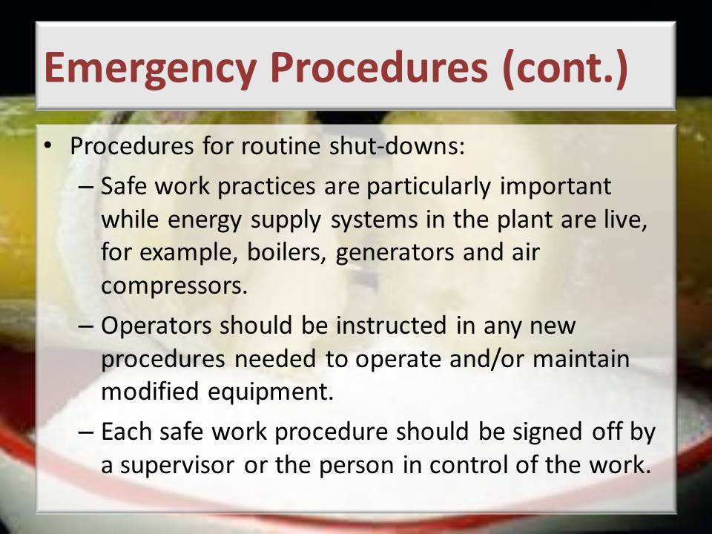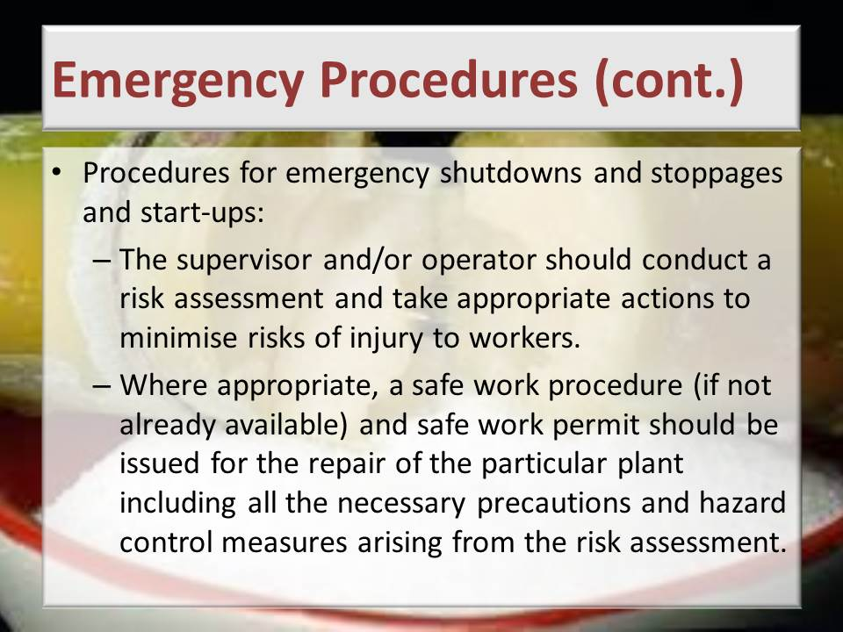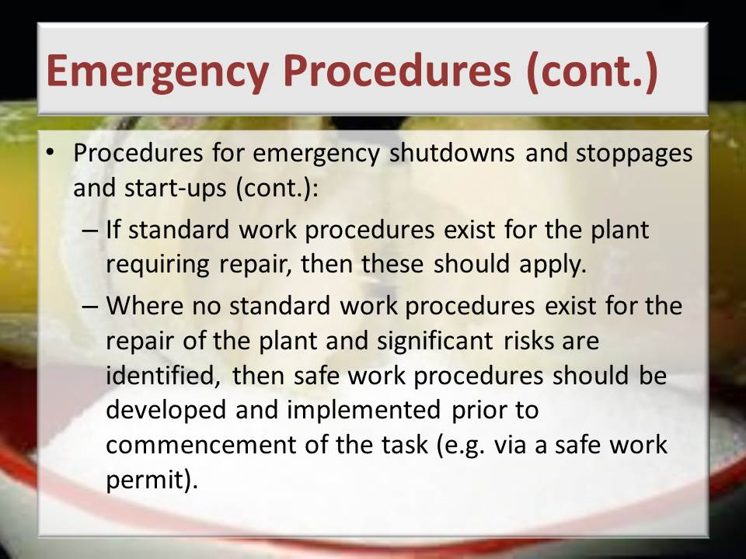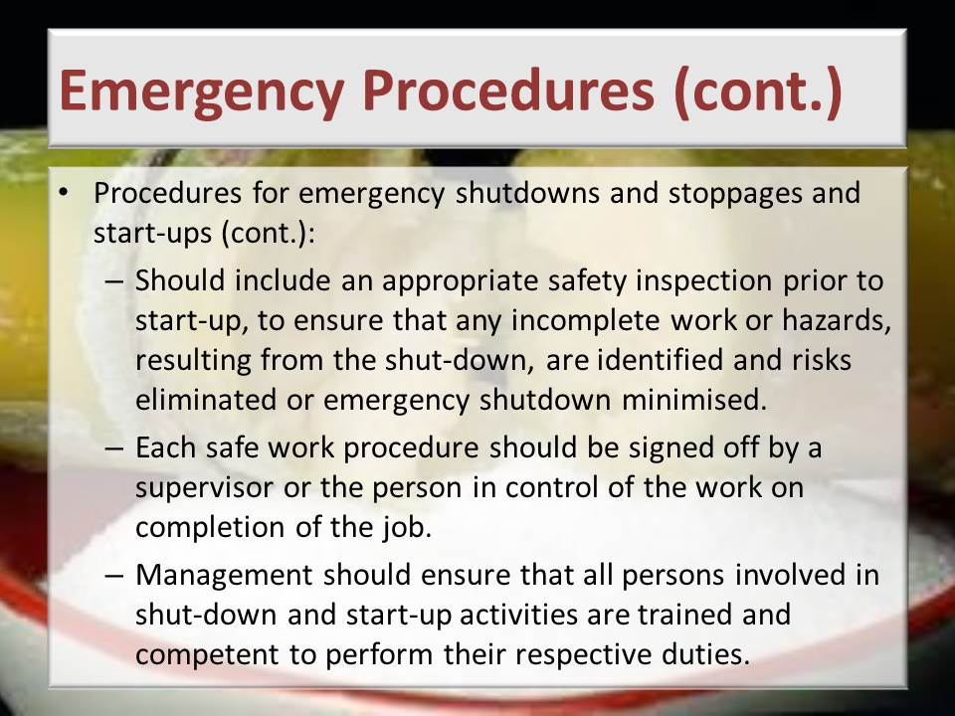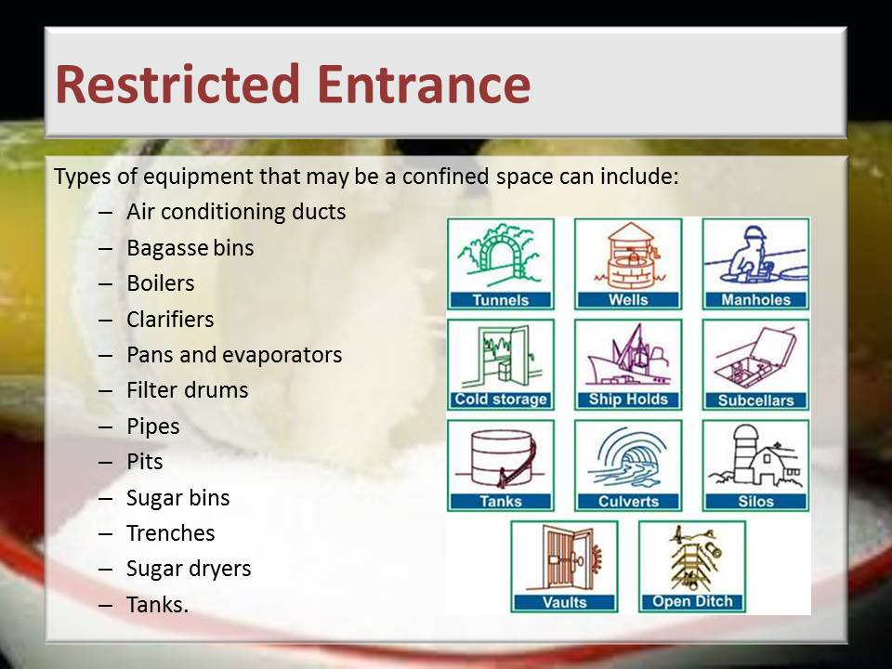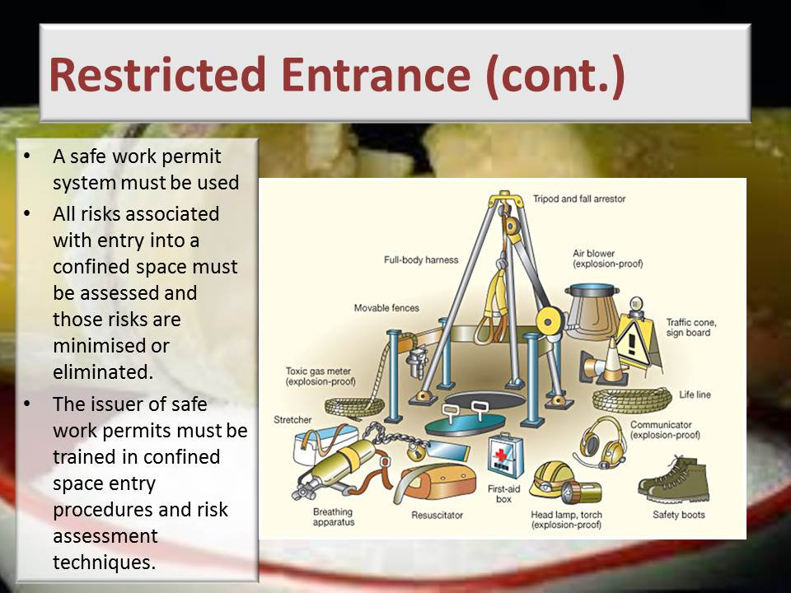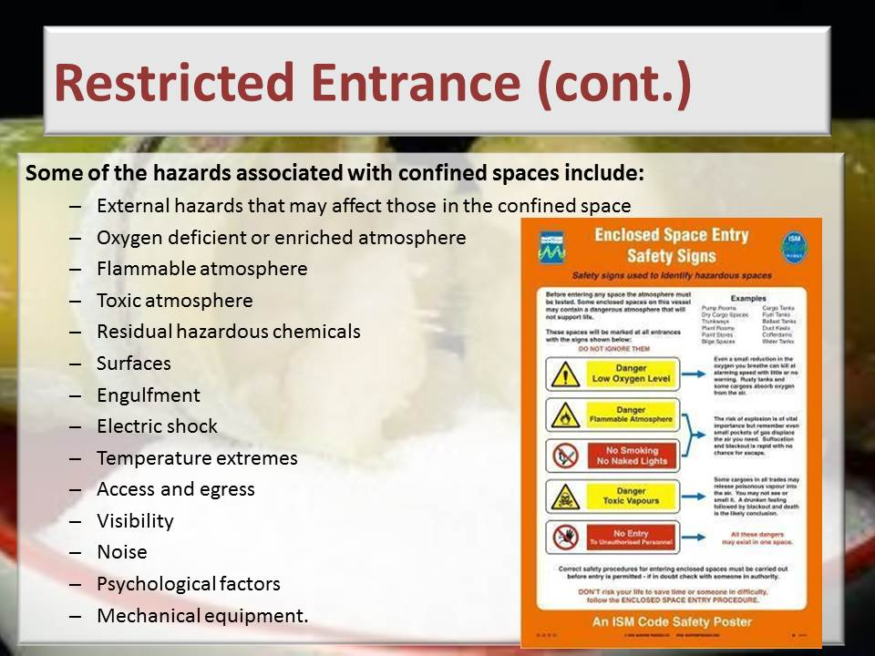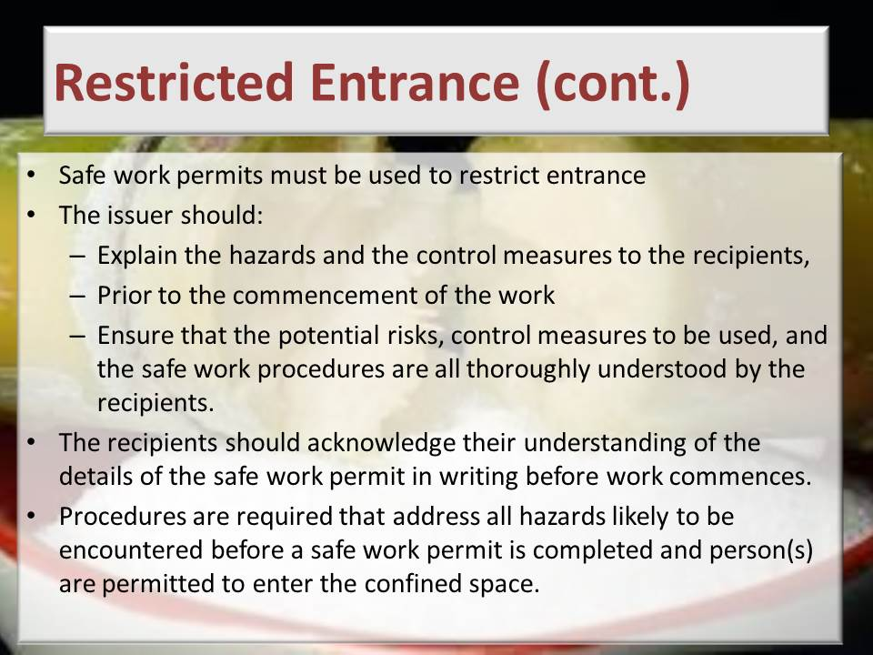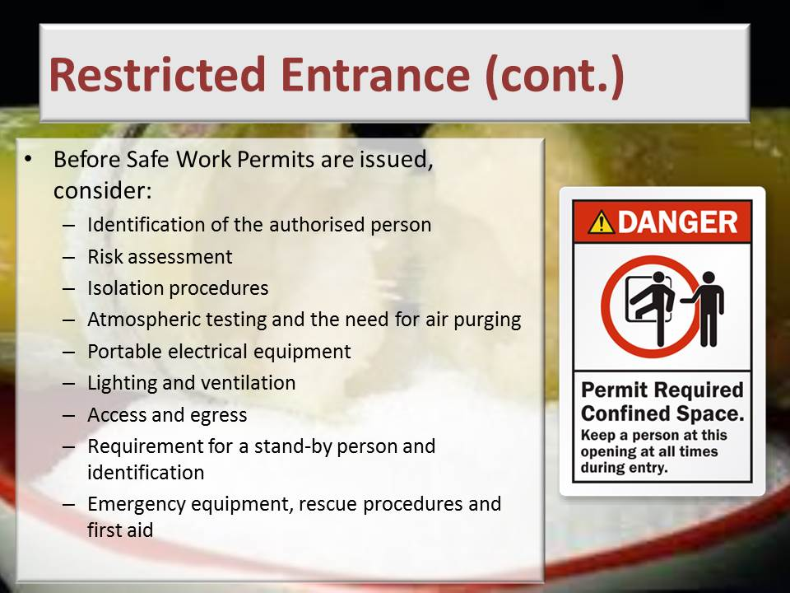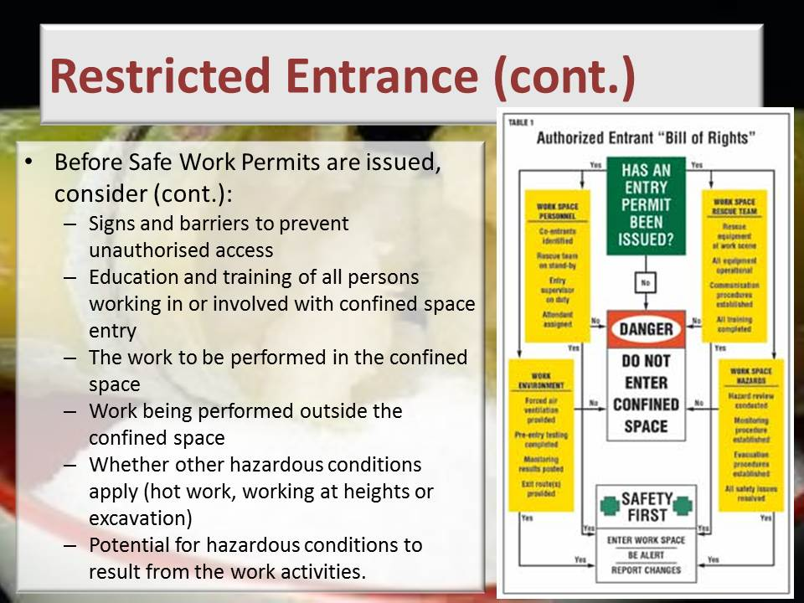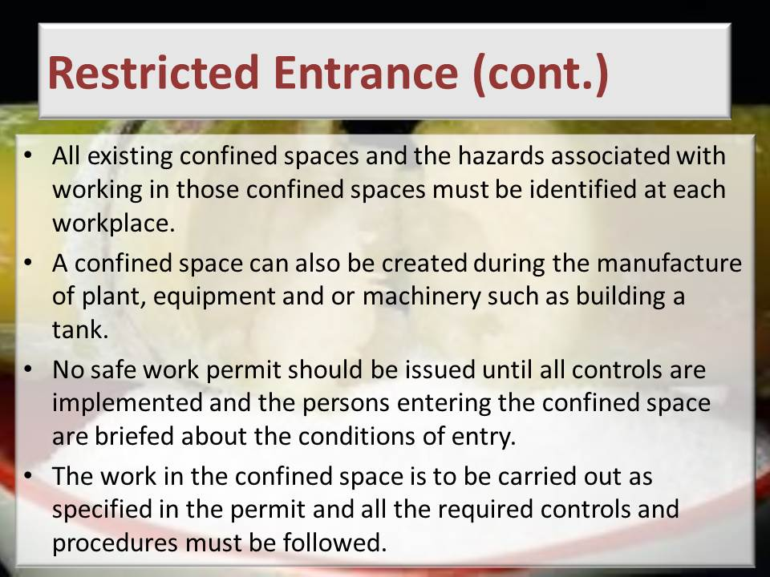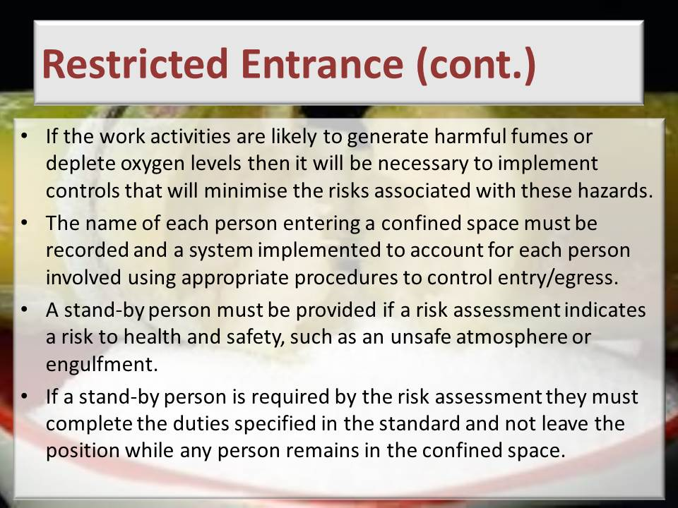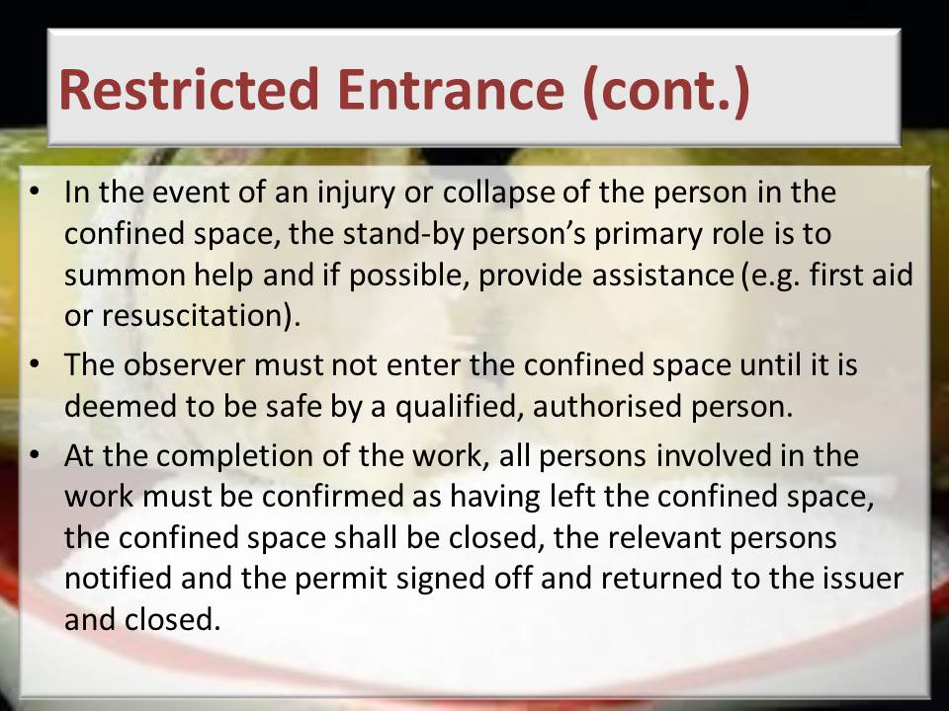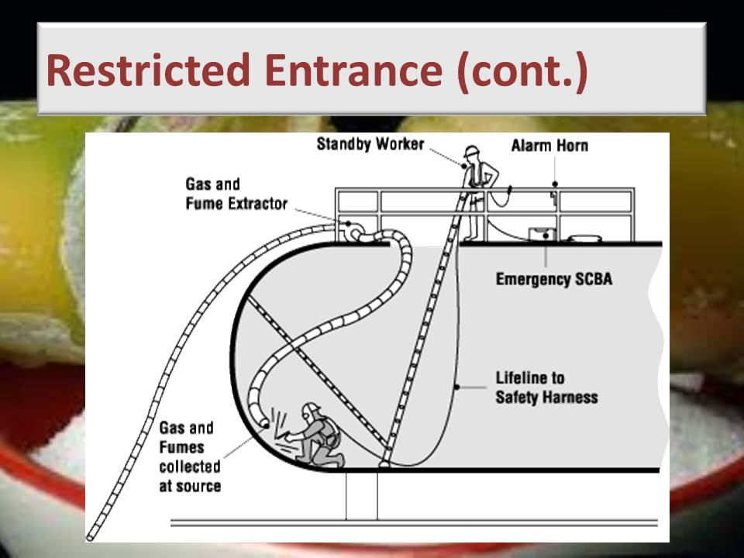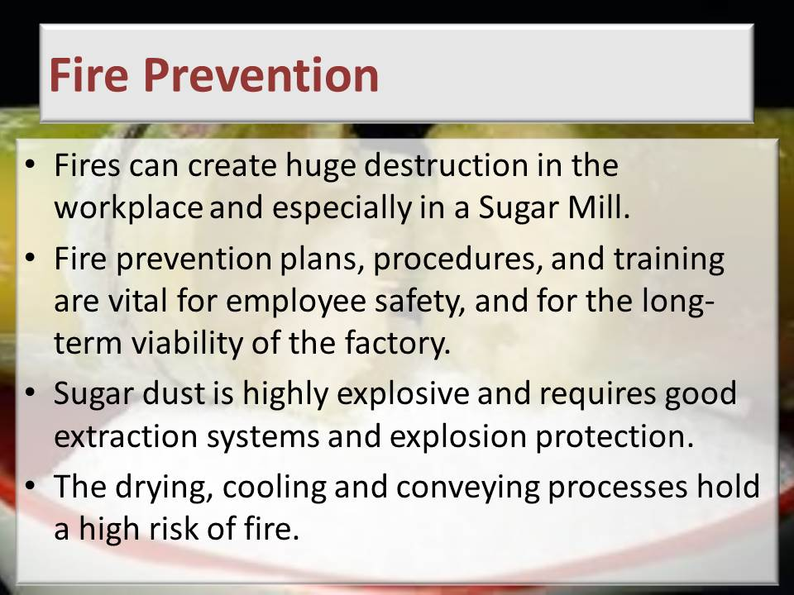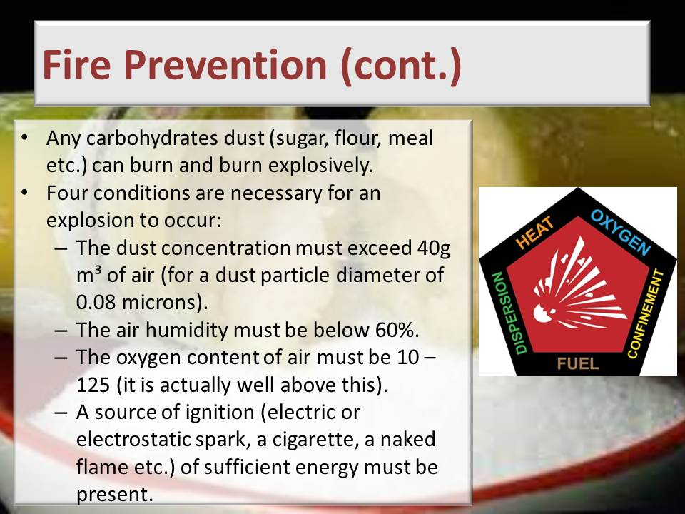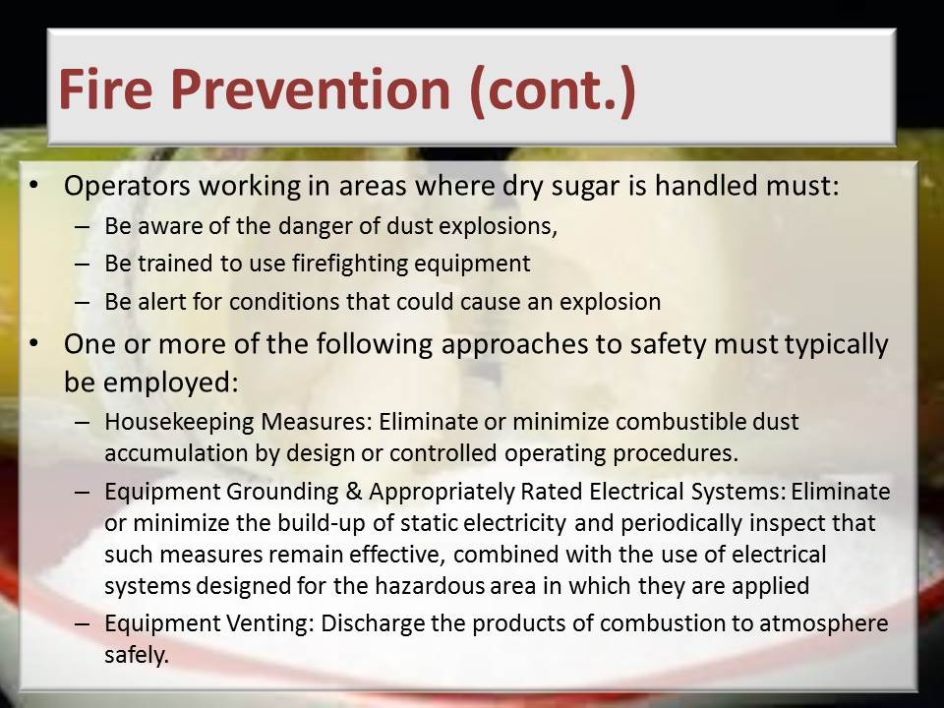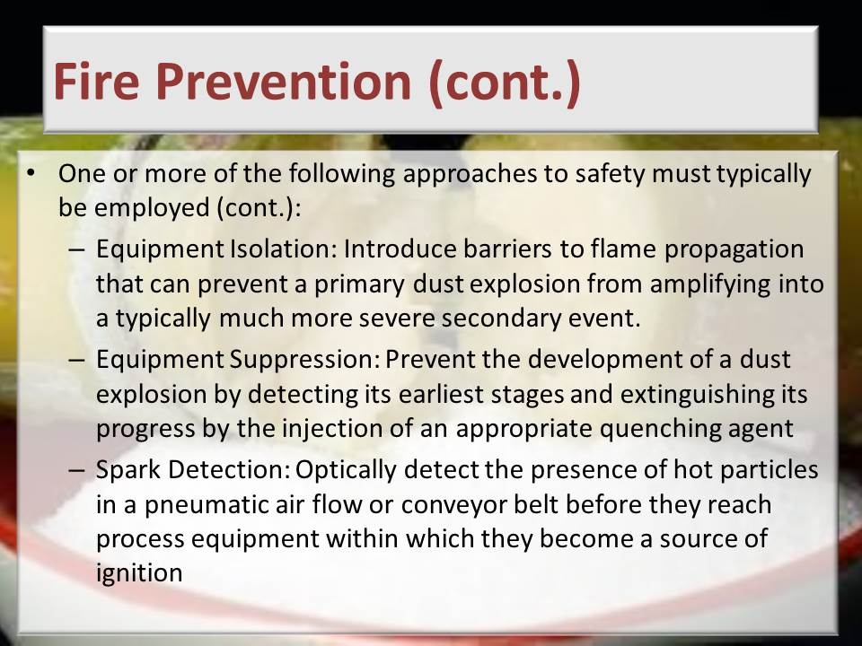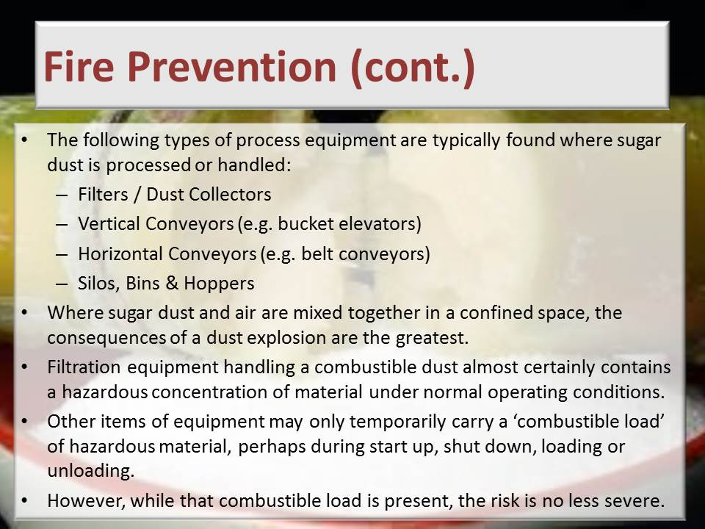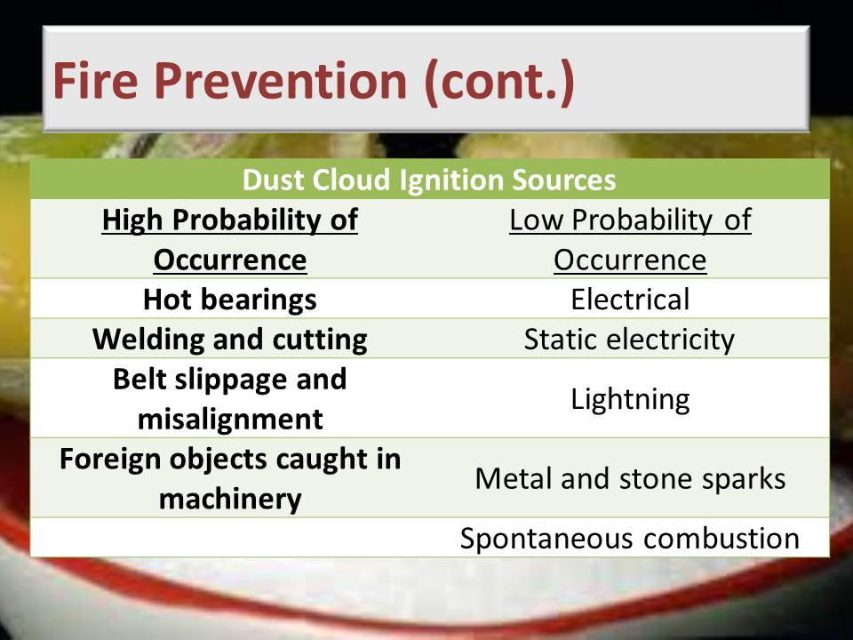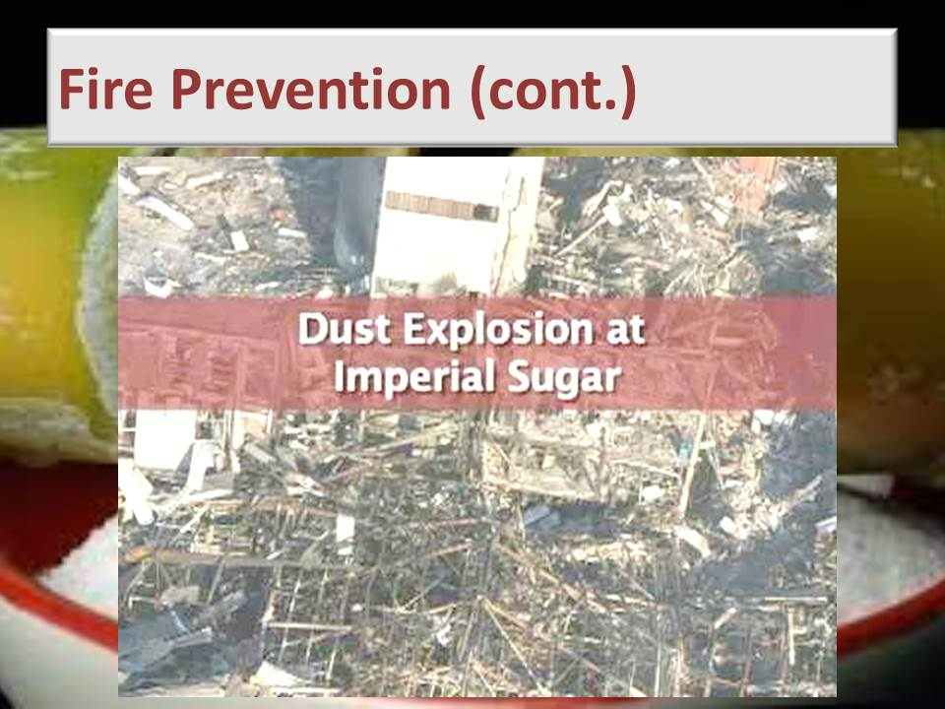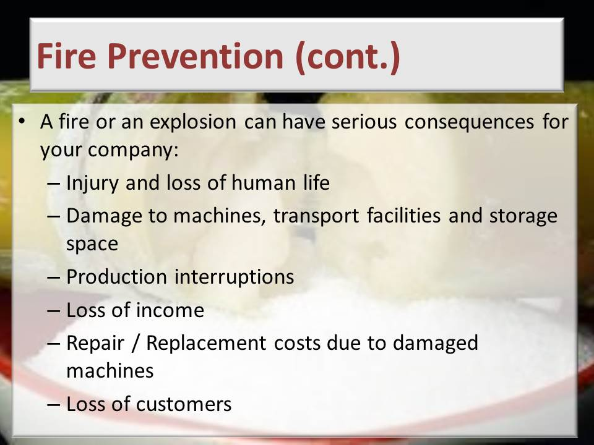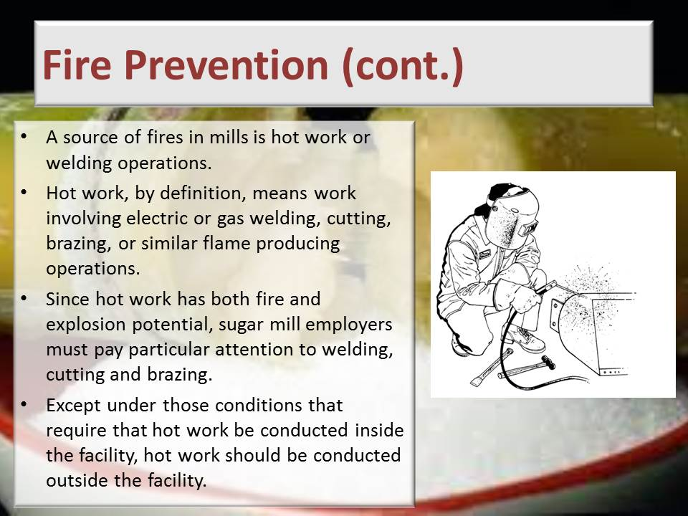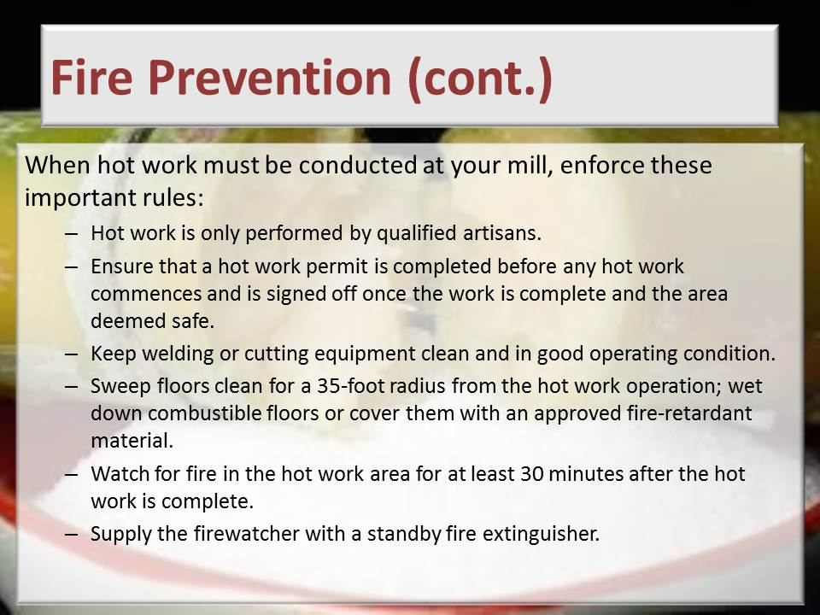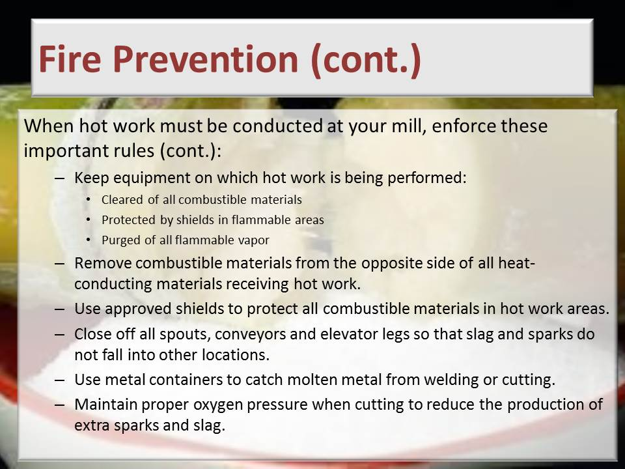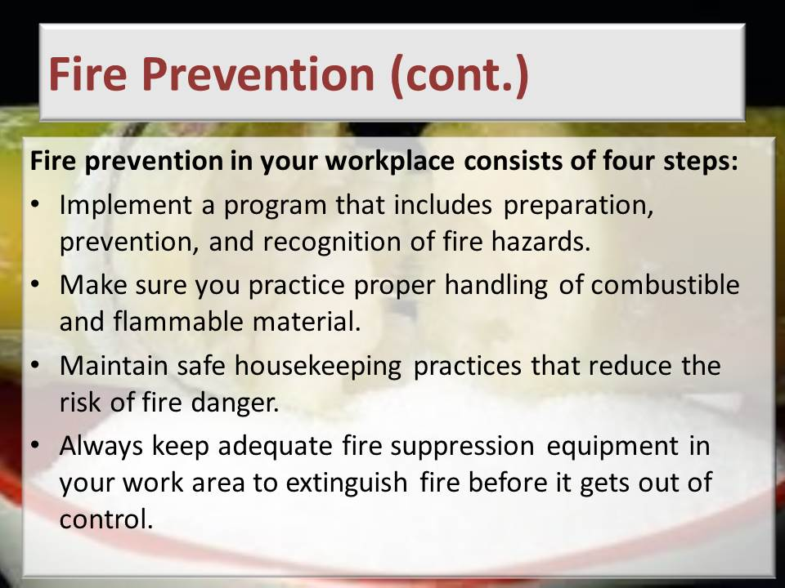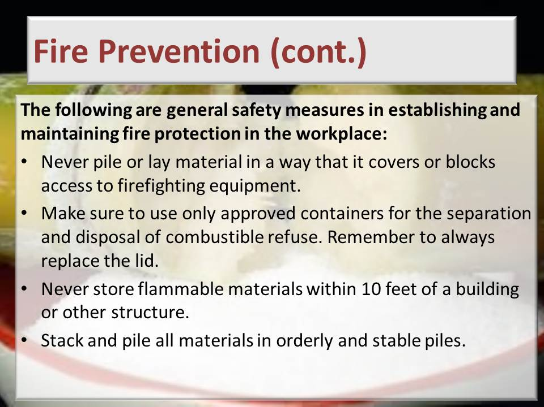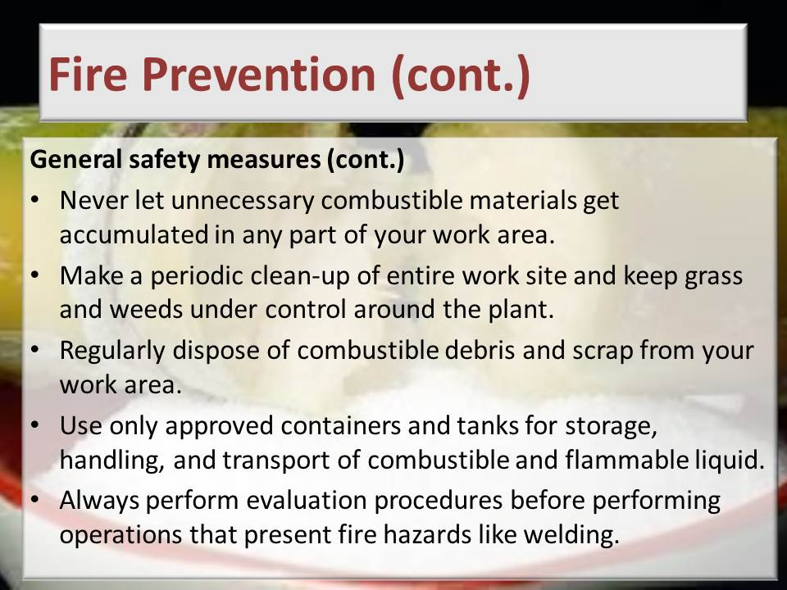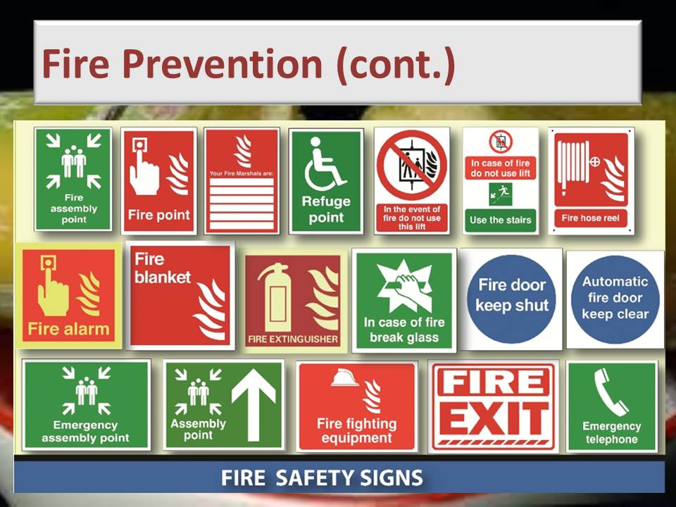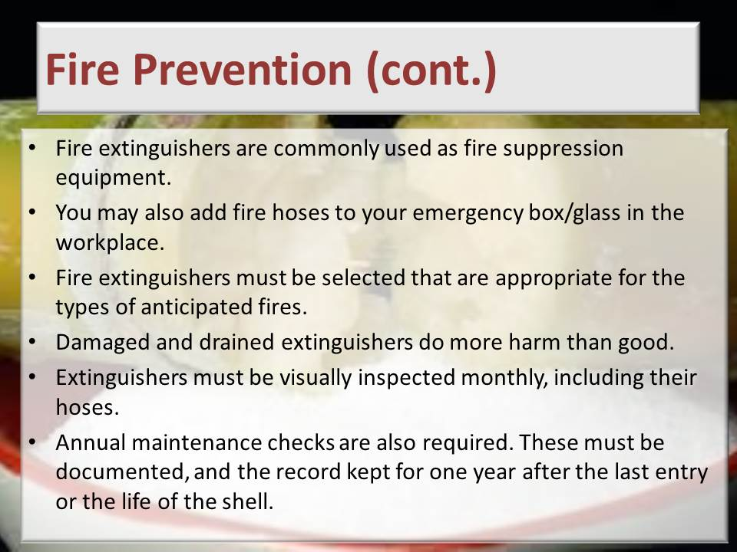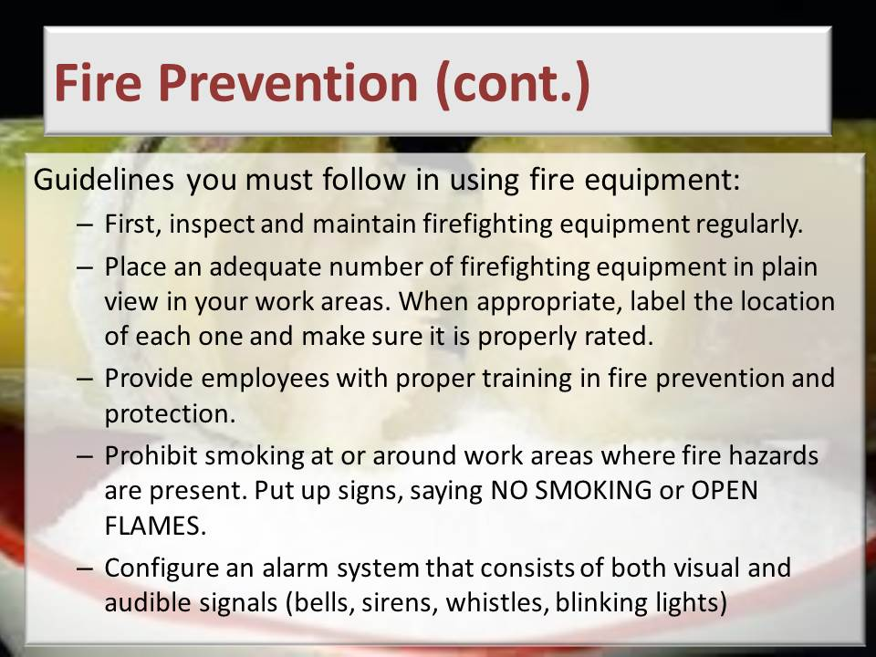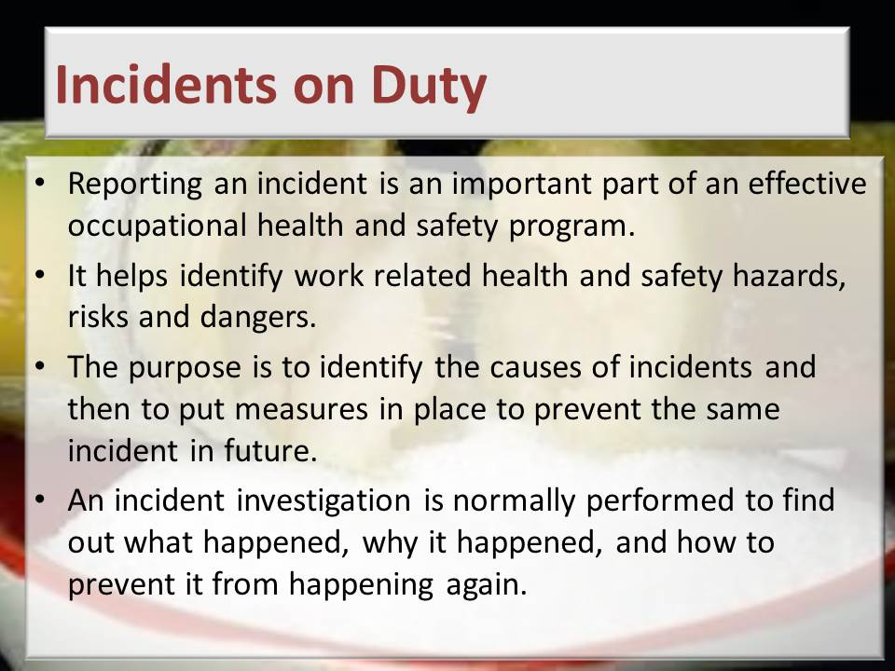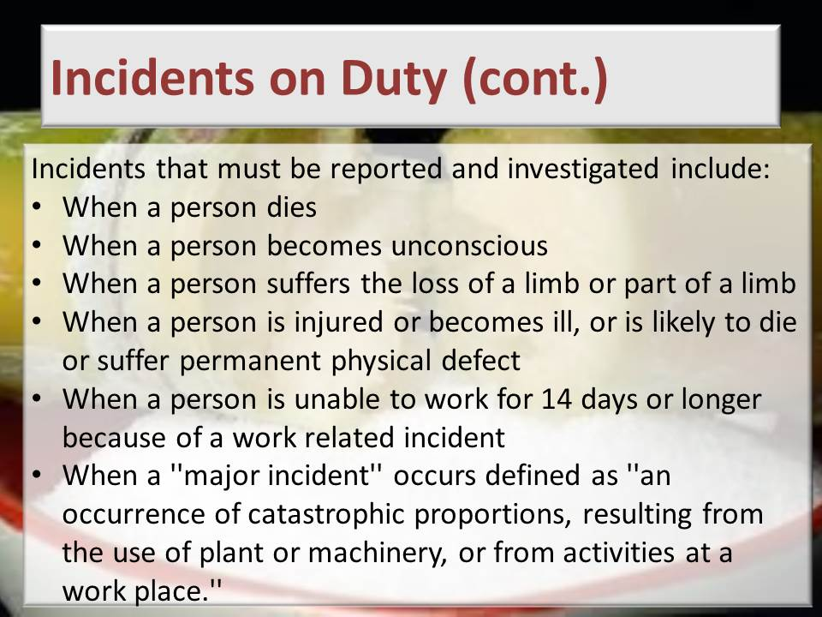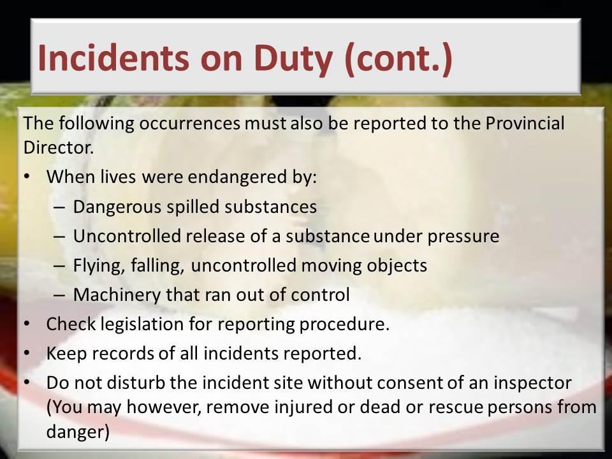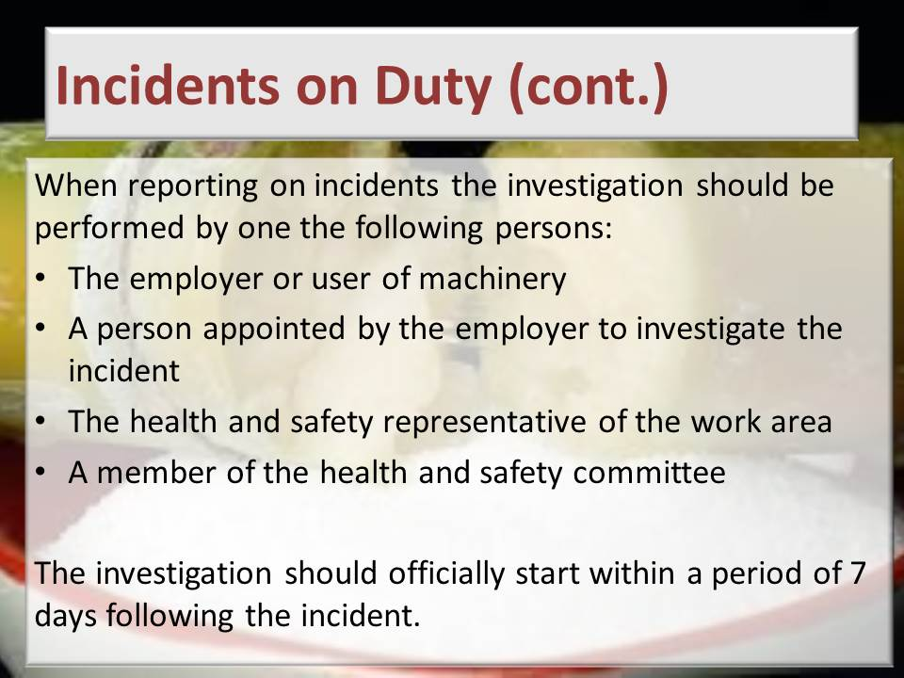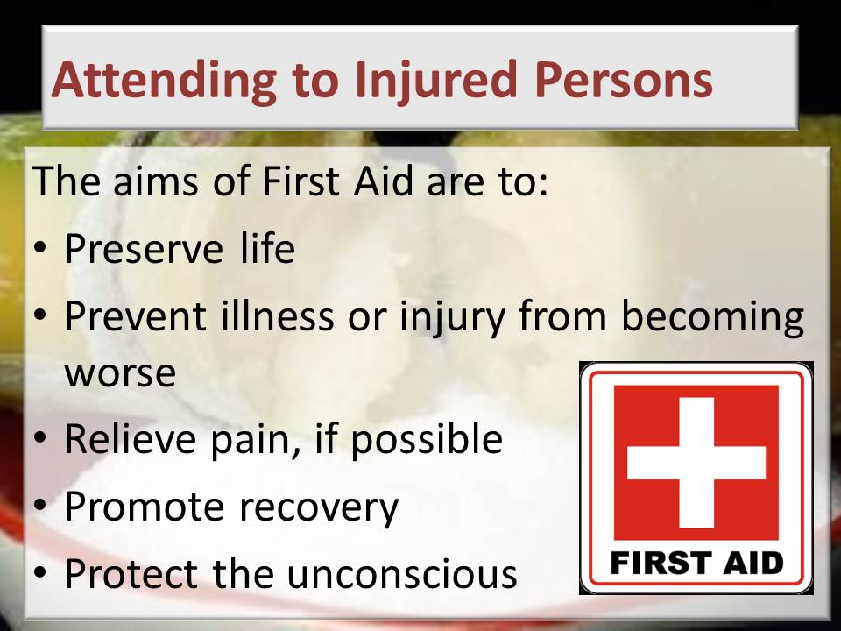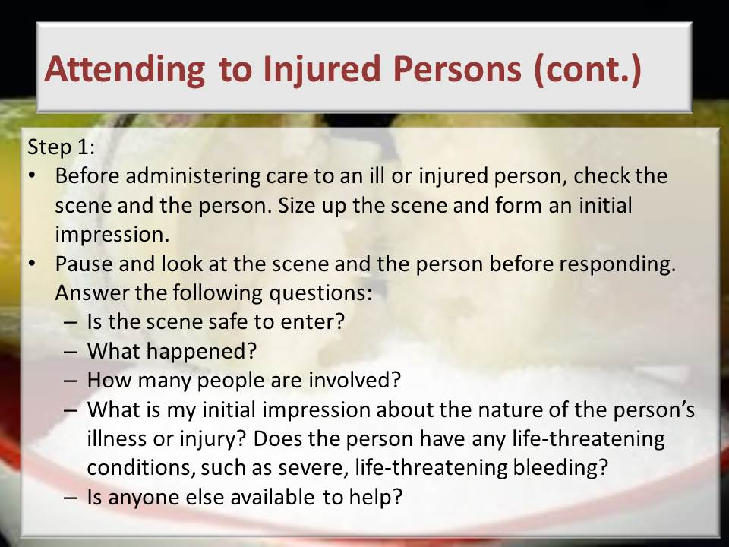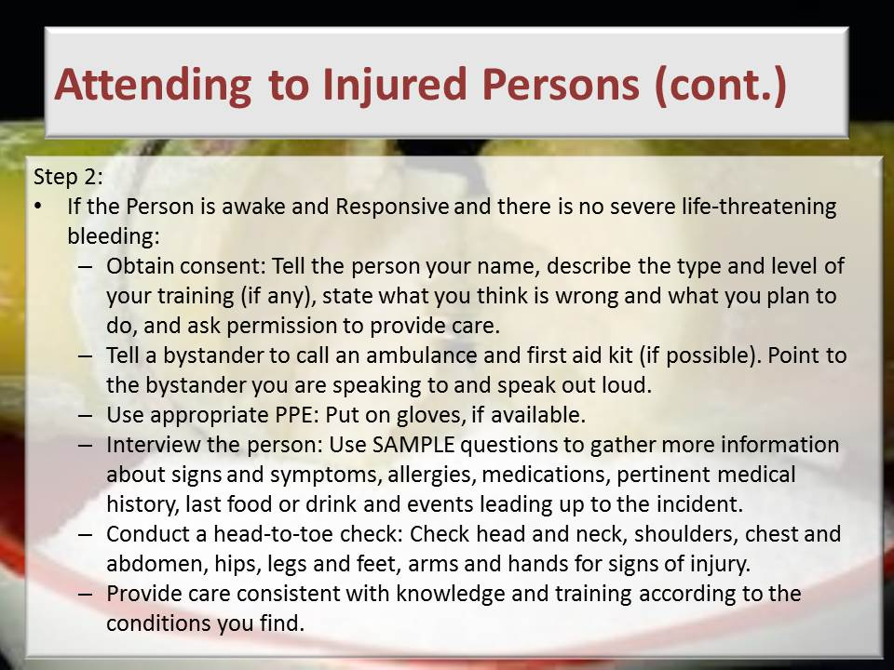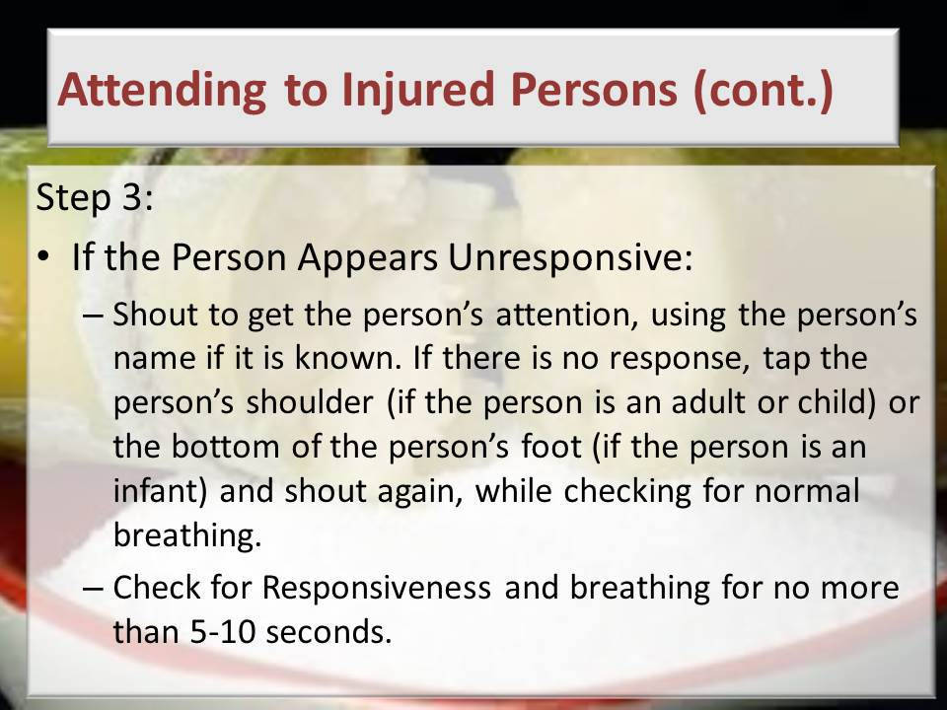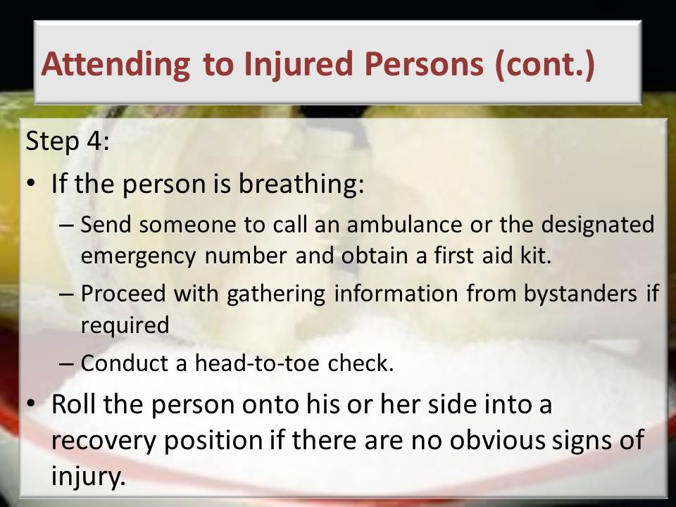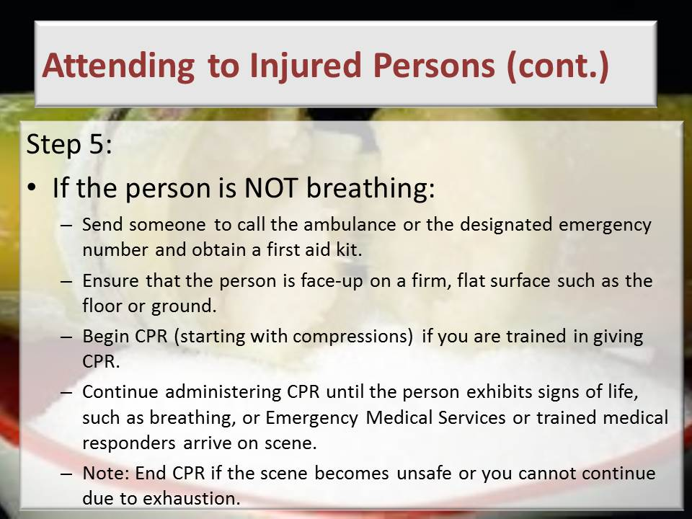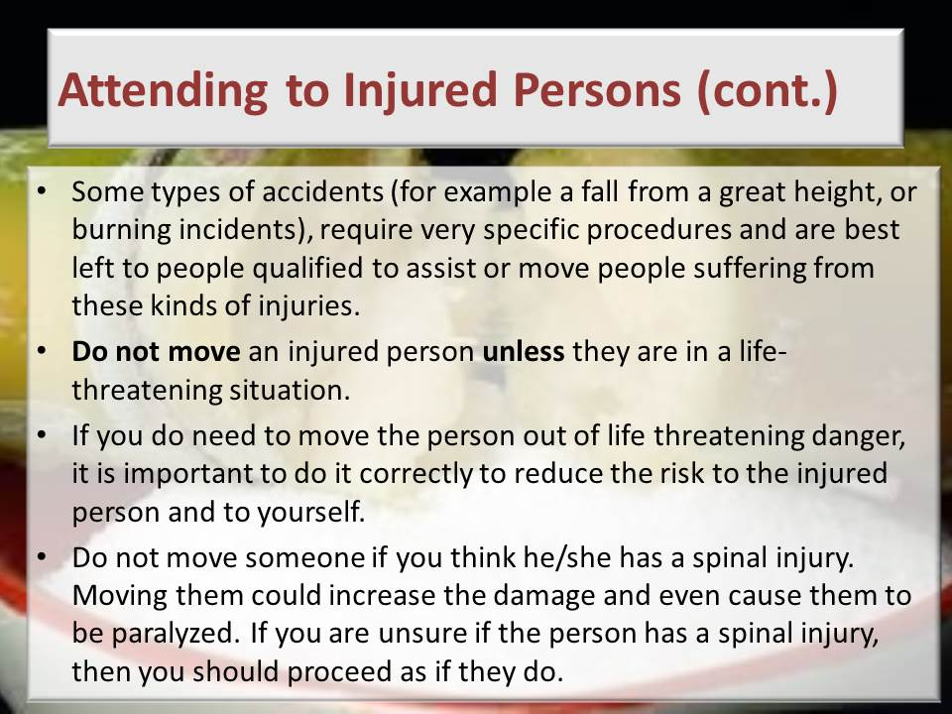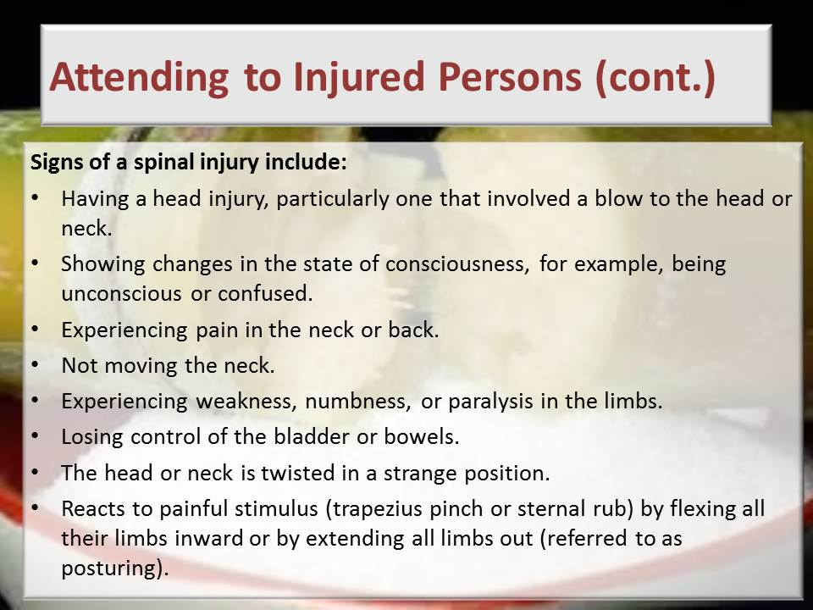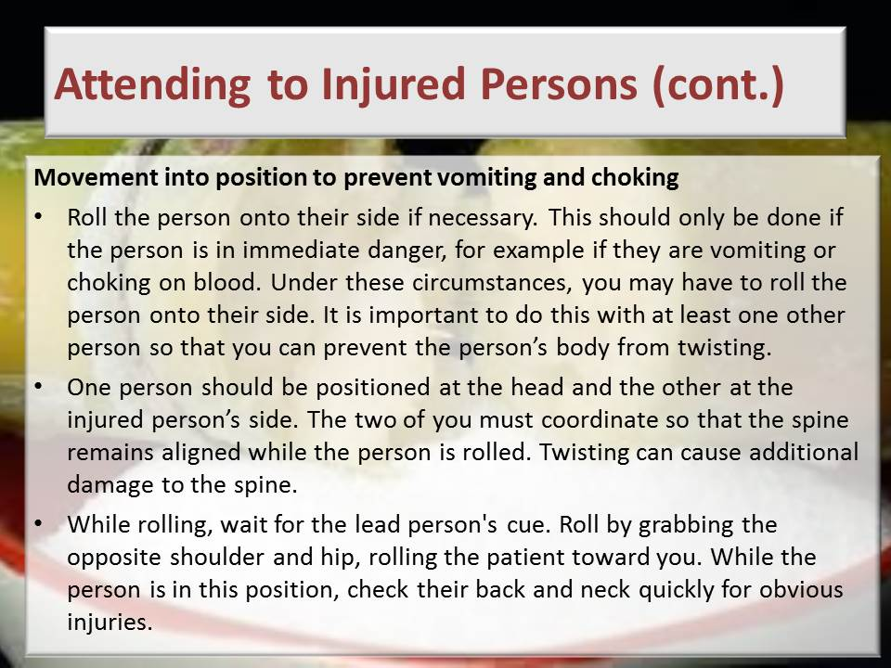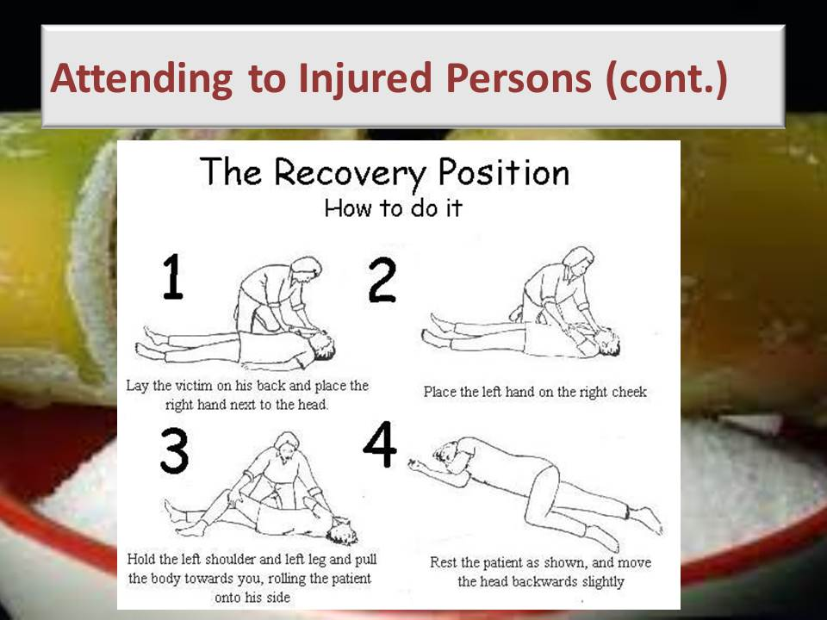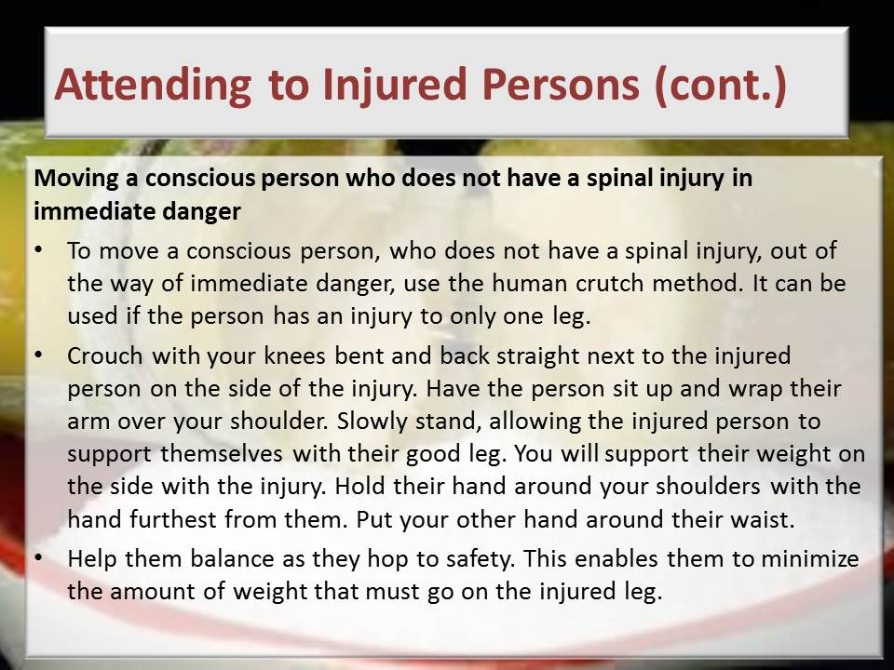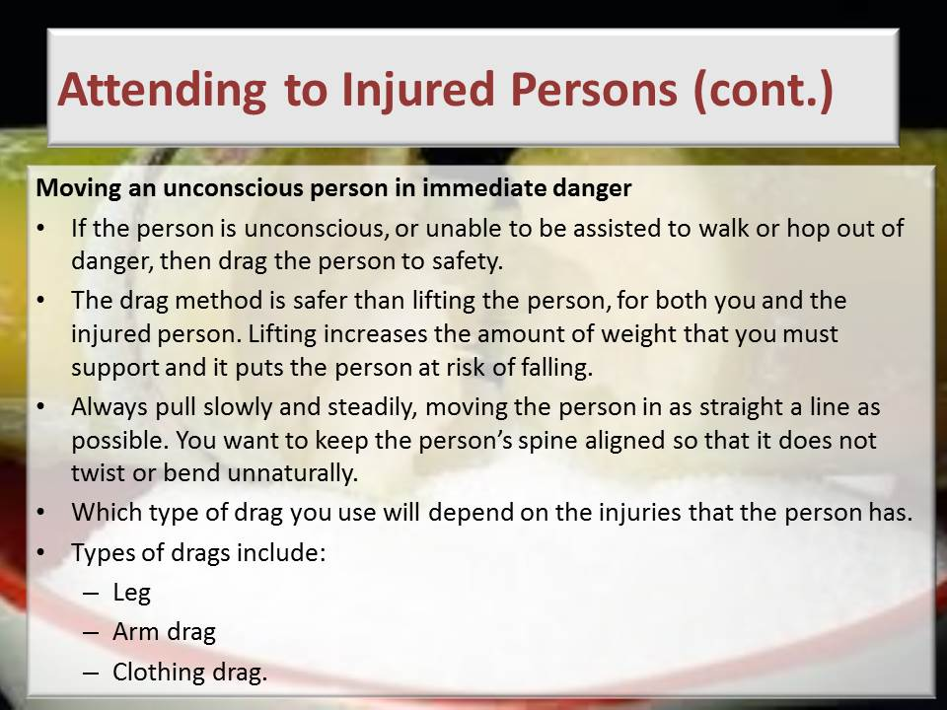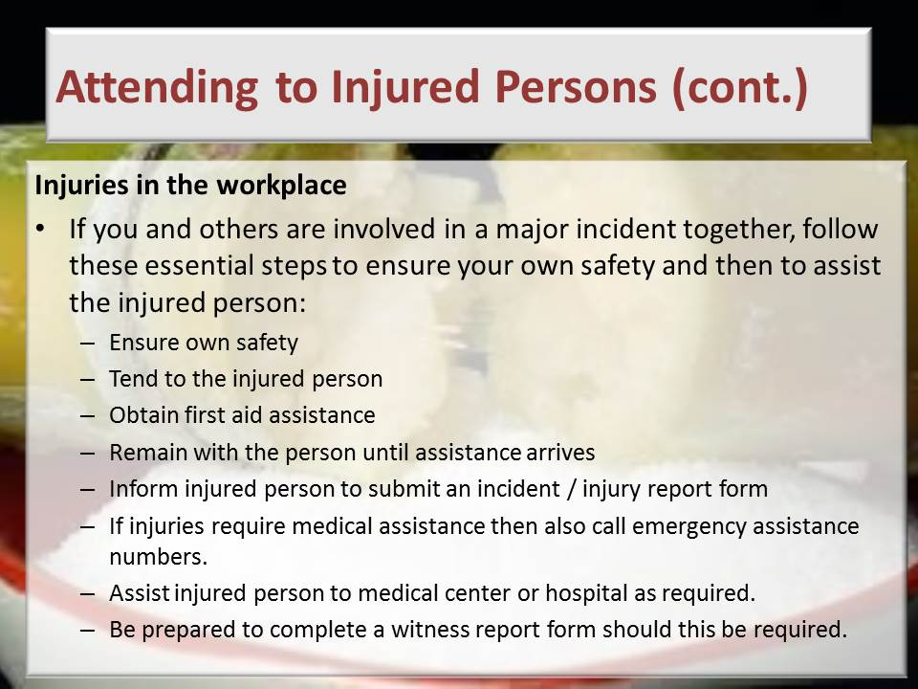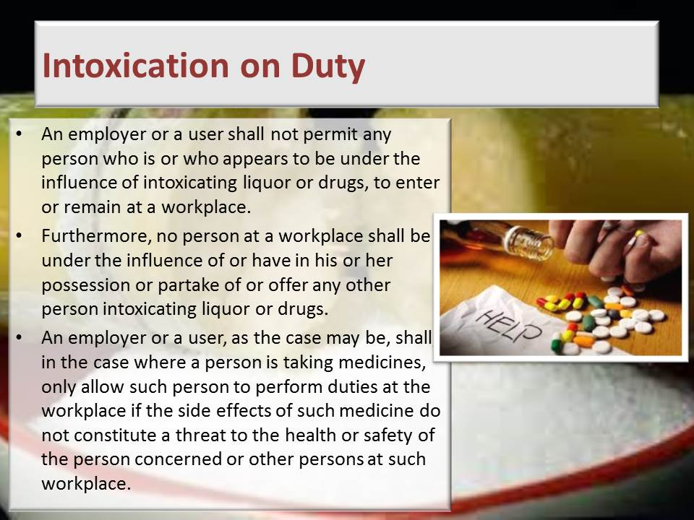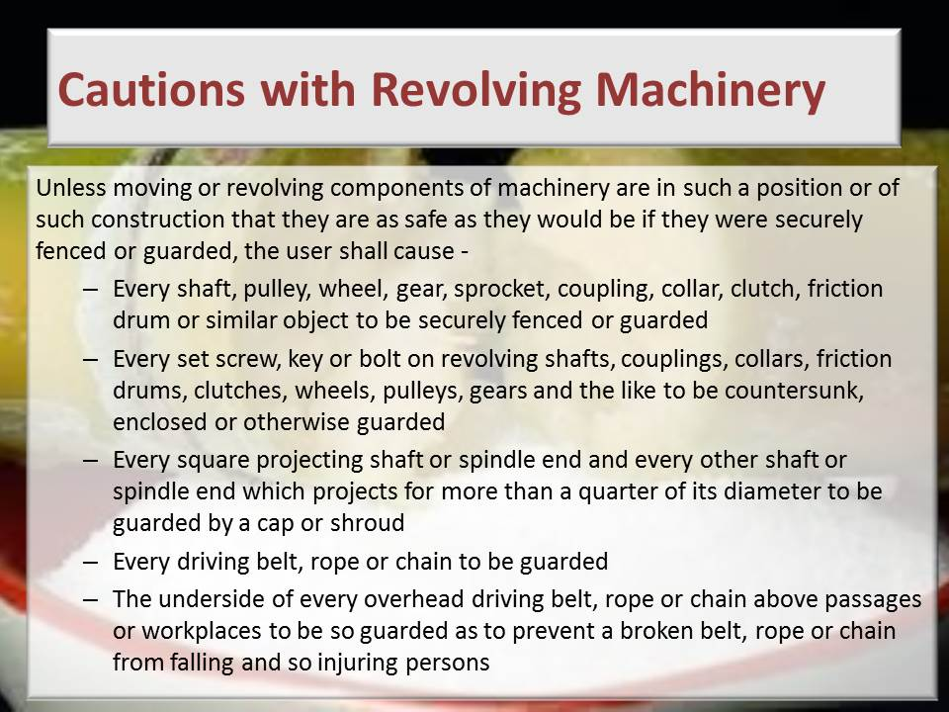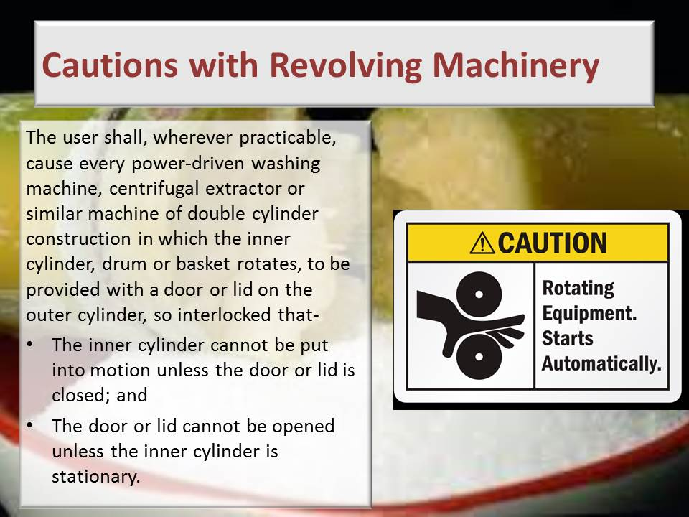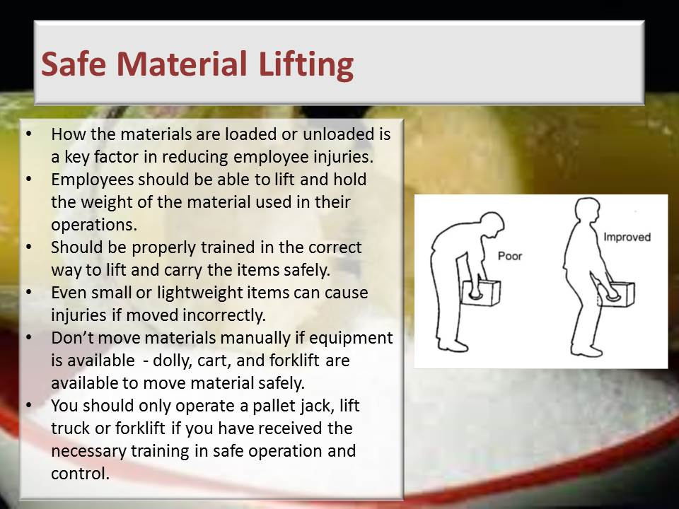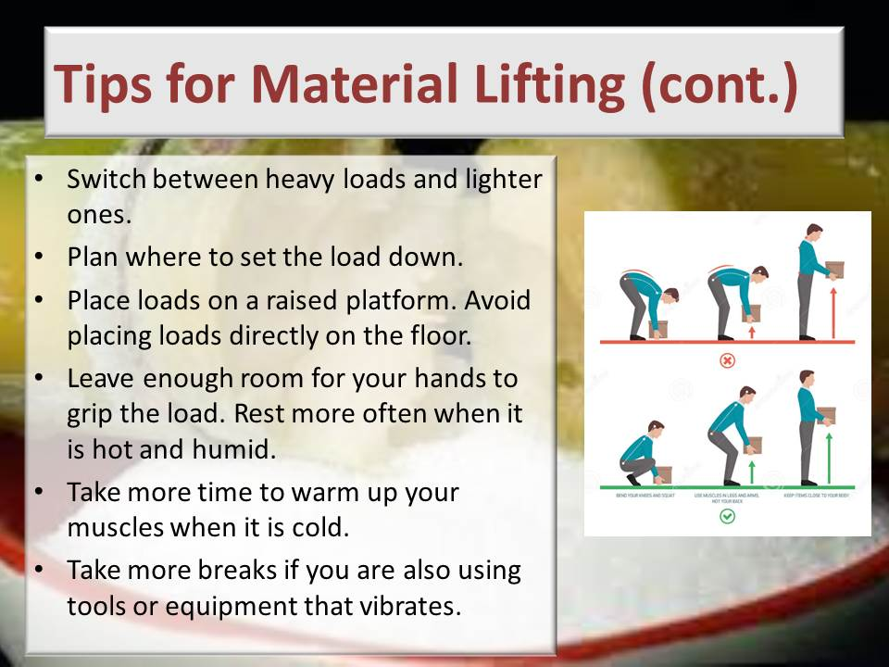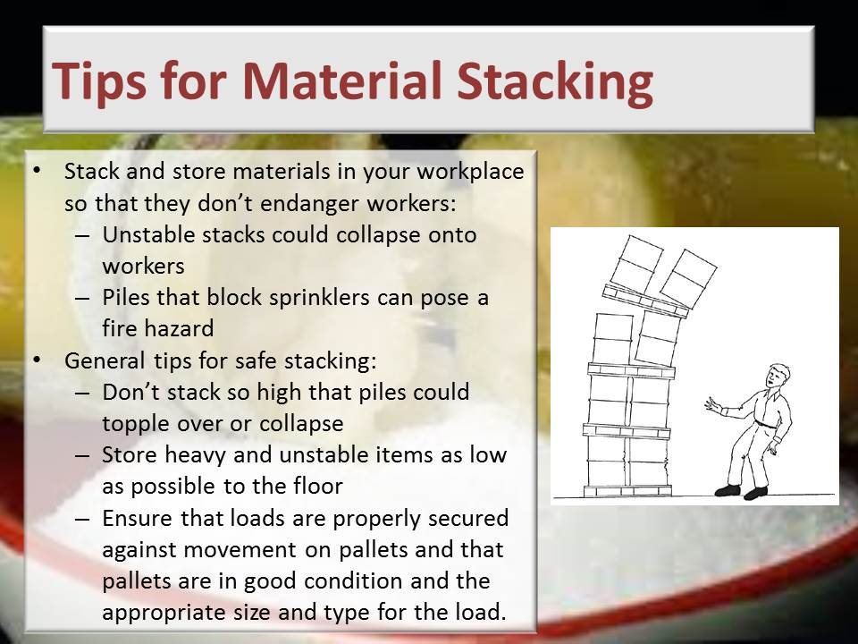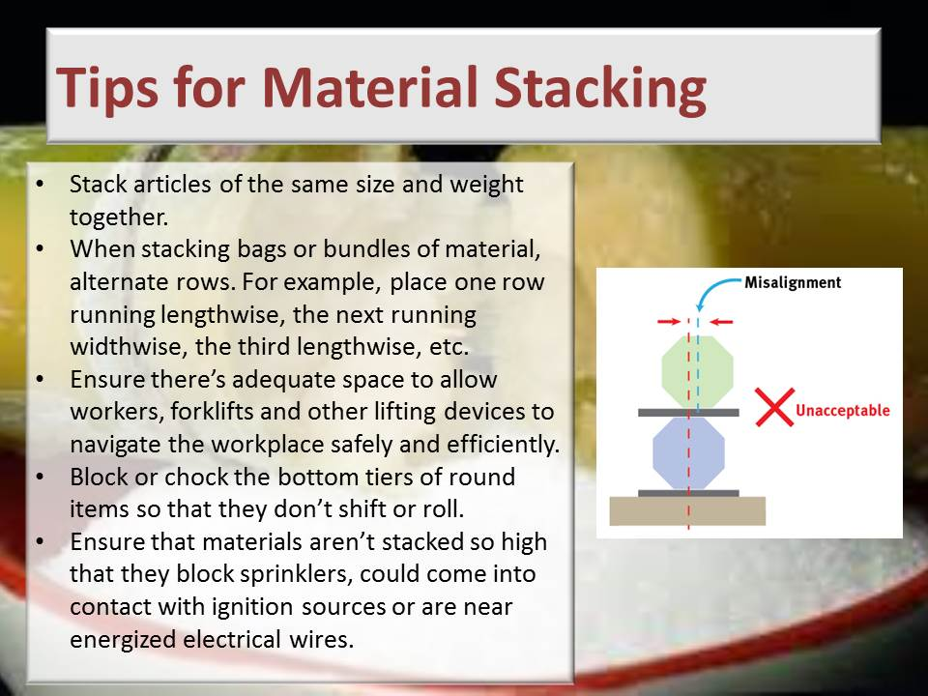
Learning activity: Guide learners to Page 18 of the Learner Workbook 1. Learners are instructed to complete Learning activity 2.1. (2 hours)
Guide learners to Page 24 of the Learner Workbook 1. Learners are instructed to complete Learning activity 2.2. (30 minutes)
Guide learners to Page 27 of the Learner Workbook 1. Learners are instructed to complete Learning activity 2.3. (30 minutes)
Guide learners to Page 30 of the Learner Workbook 1. Learners are instructed to complete Learning activity 2.4. (2 hours)
Guide learners to Page 32 of the Learner Workbook 1. Learners are instructed to complete Learning activity 2.5. (30 minutes)
Guide learners to Page 36 of the Learner Workbook 1. Learners are instructed to complete Learning activity 2.6. (30 minutes)
Total time taken: Presentation: 16 hours (Do the presentations of this Knowledge Component over a period of 5 to 10 days allowing time for learning activities between the relevant groups of slides).
Learning activities 2.1, 2.2, 2.3, 2.4, 2.5, 2.6: 6 hours
Close: Move on to the next session

KNOWLEDGE TOPIC 3: Sugar Processing Specific Health and Safety and Environmental Protection Concepts (50%)
INSTRUCTIONS TO FACILITATOR
Purpose: To introduce the candidates to Knowledge Topic 3: Sugar processing specific health, safety and environmental protection concepts.
Objectives: By the end of the session the candidates will:
- Be able to explain the safety risks and measures to address these safety risks in a sugar processing environment.
Procedure: Conduct a presentation and allow time for learning activities.
Participant Materials: The learner will use the following materials:
- The Learner Guide Book 1 (Textbook)
- The Learner Formative Assessment Guide – Workbook 1
Presentation: Do a presentation covering the following topics:
- Specific risks in a Sugar Processing Plant
- Restricted access areas in a Sugar Processing Plant
- Environmental pollution and preventative measures
- Hazardous chemicals and chemical handling
- Waste handling
Slides: Use the following slides for your presentation referring frequently to the Learning Resource for more detail.
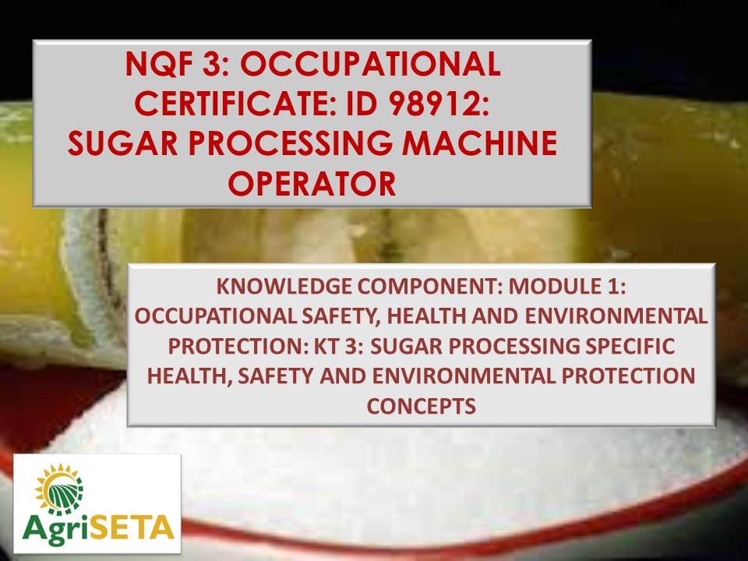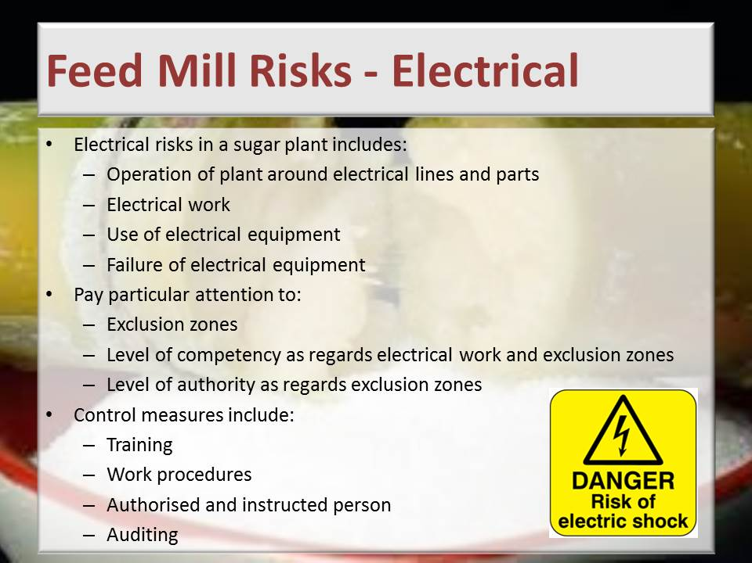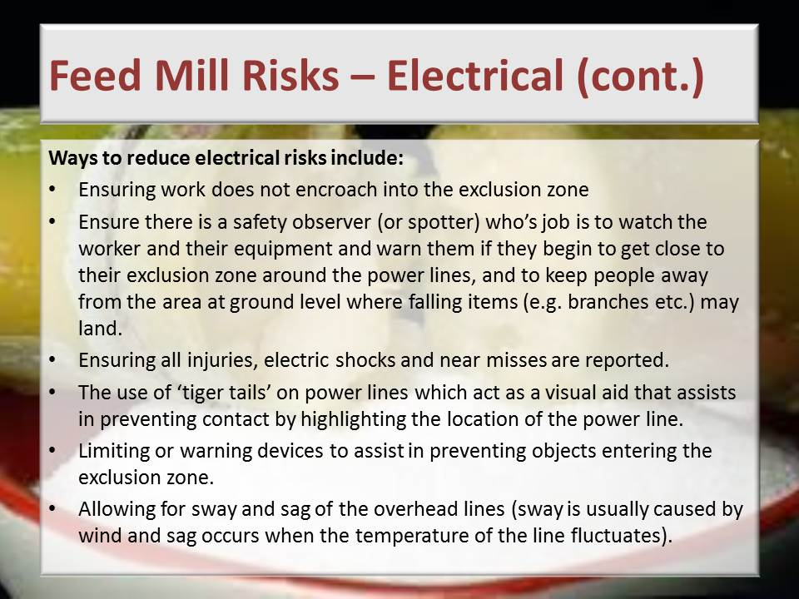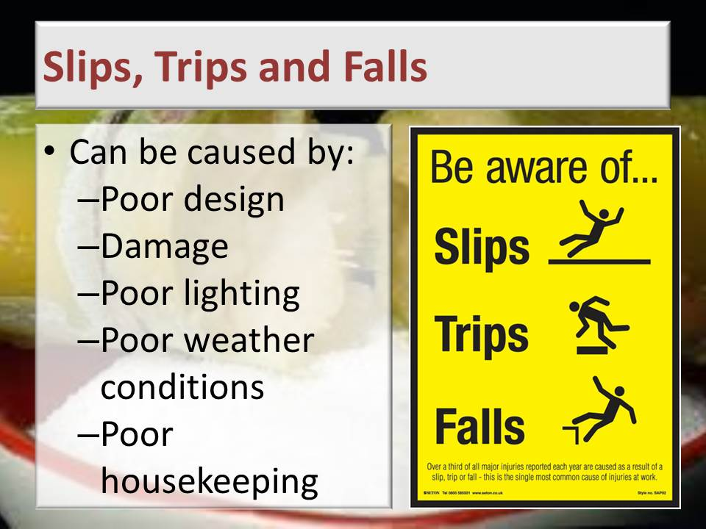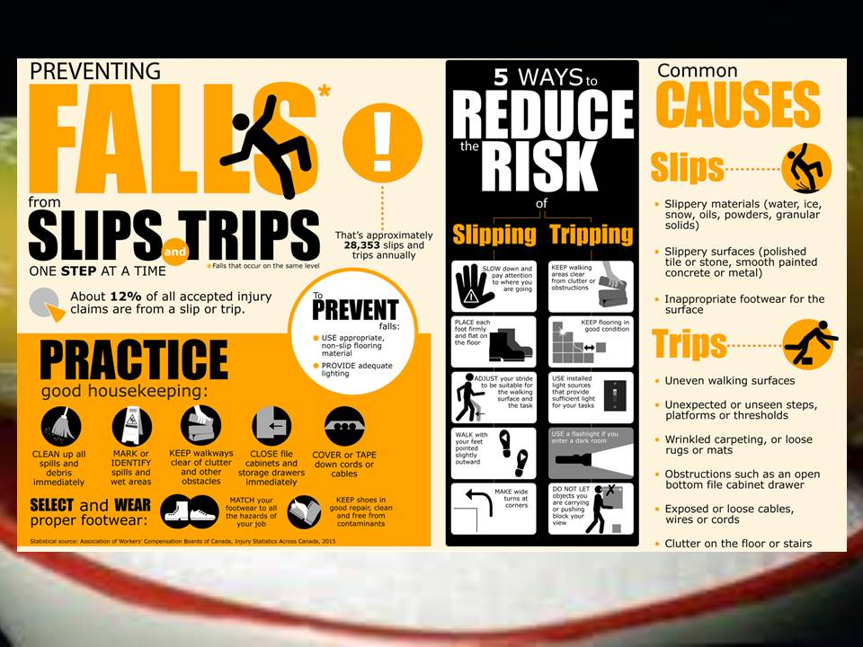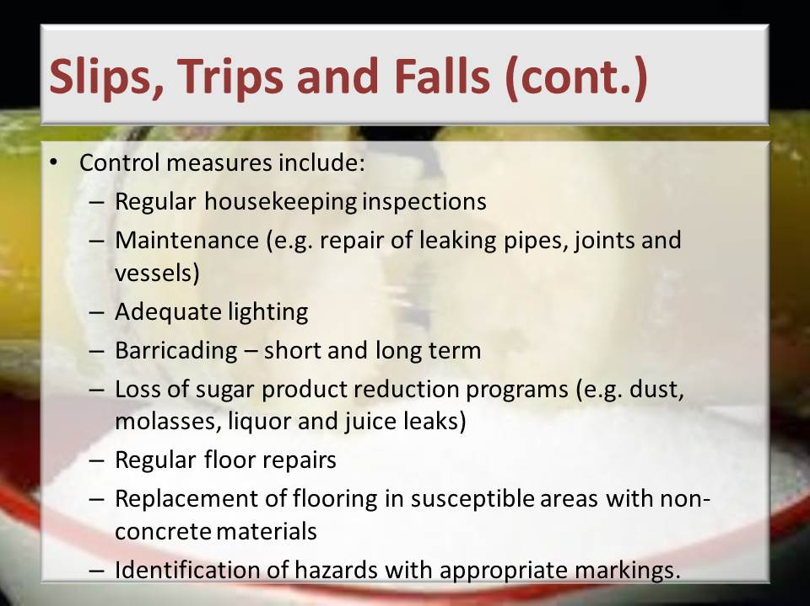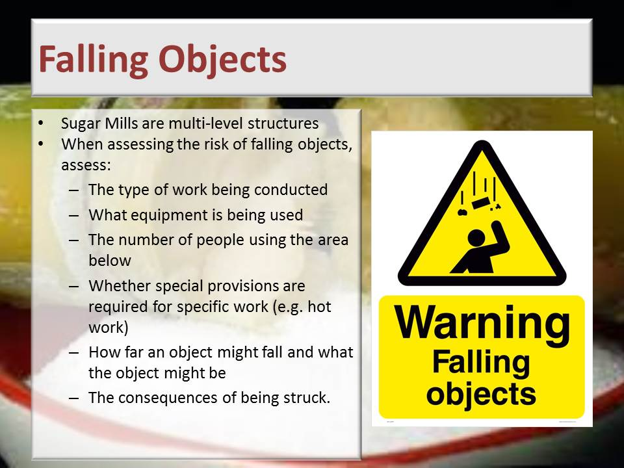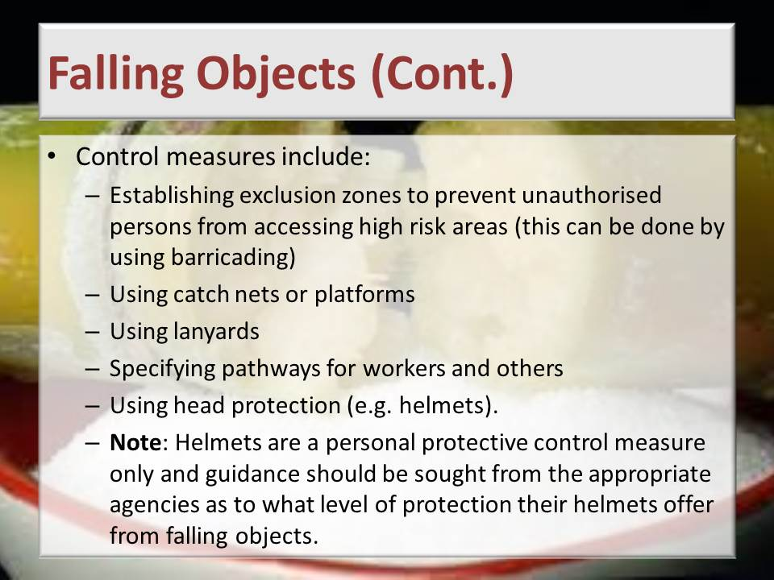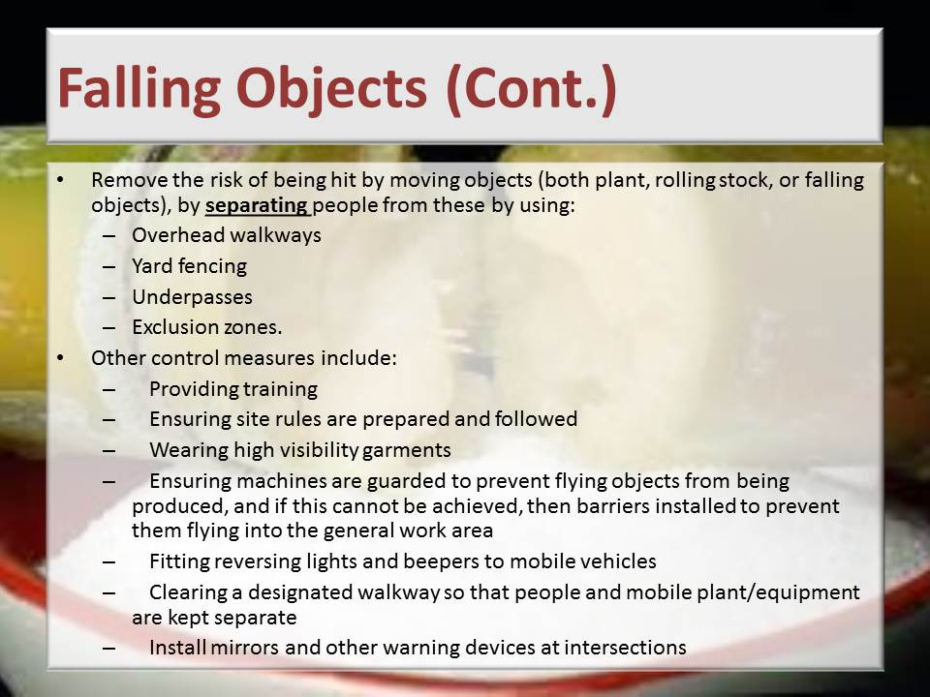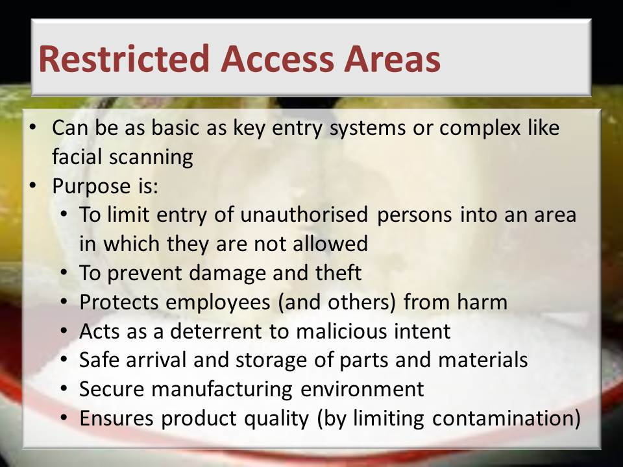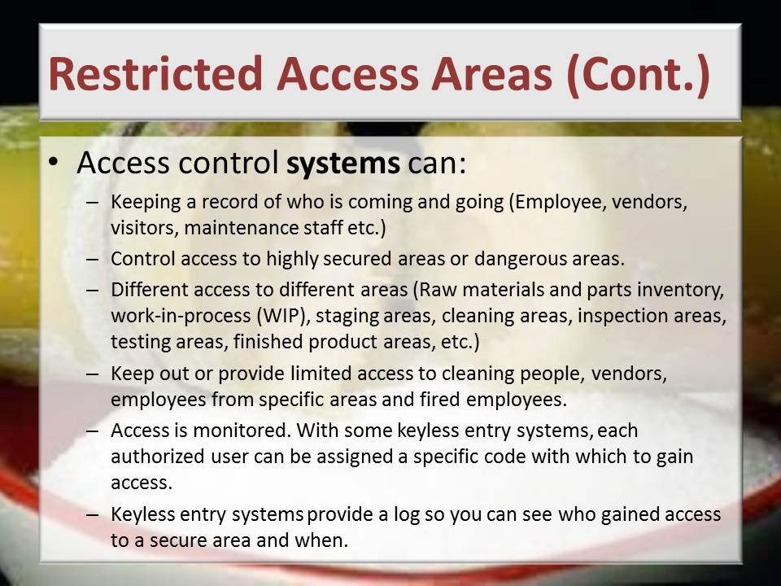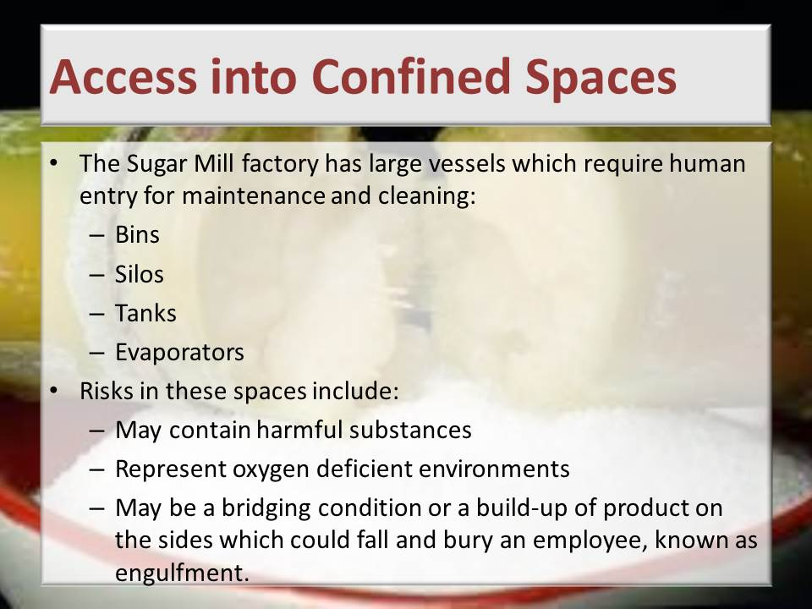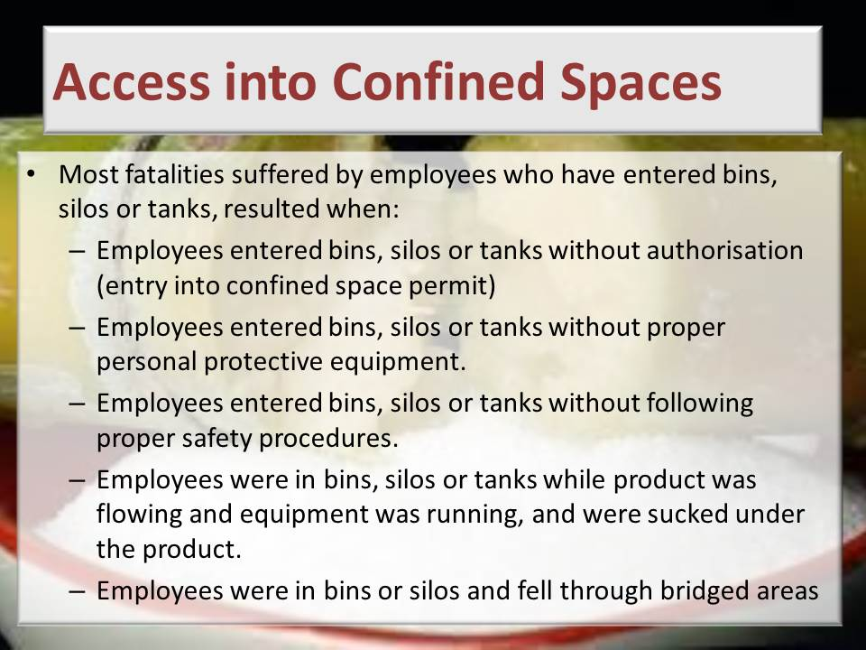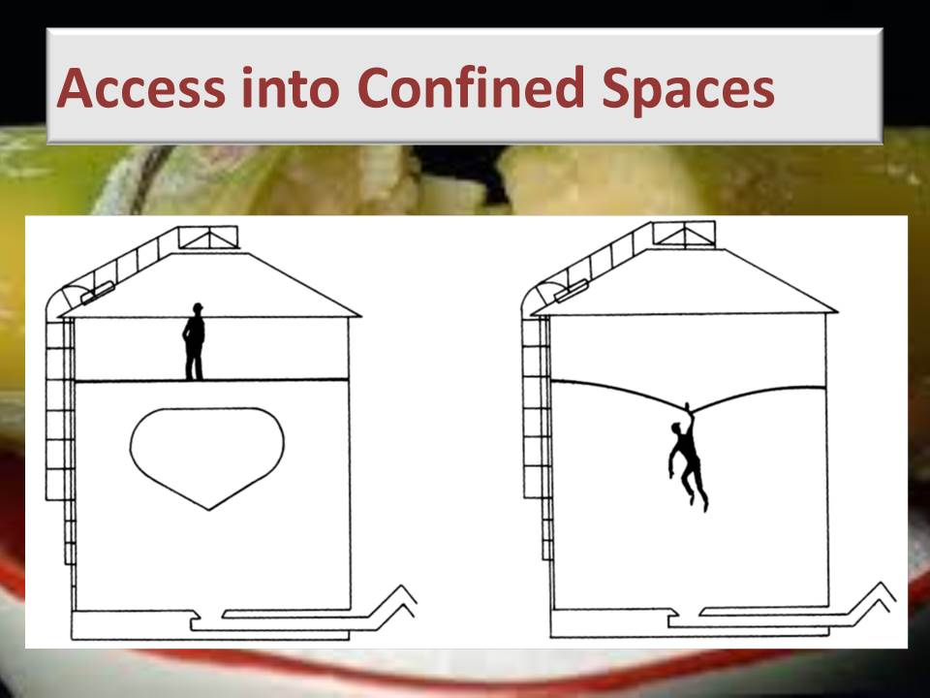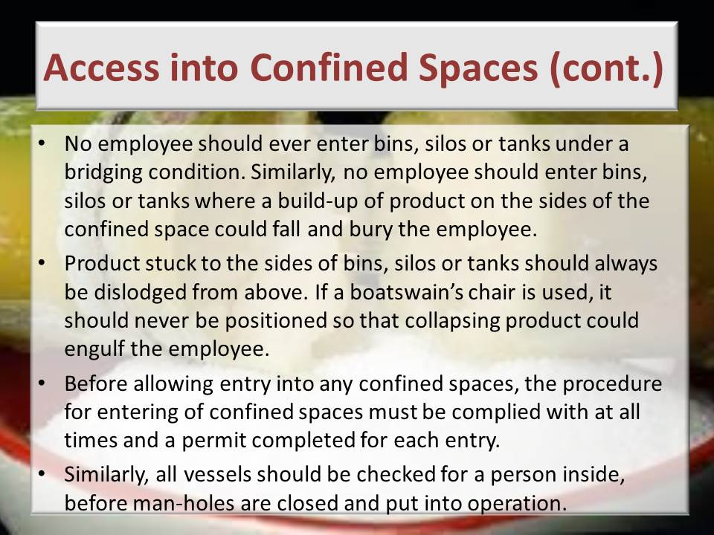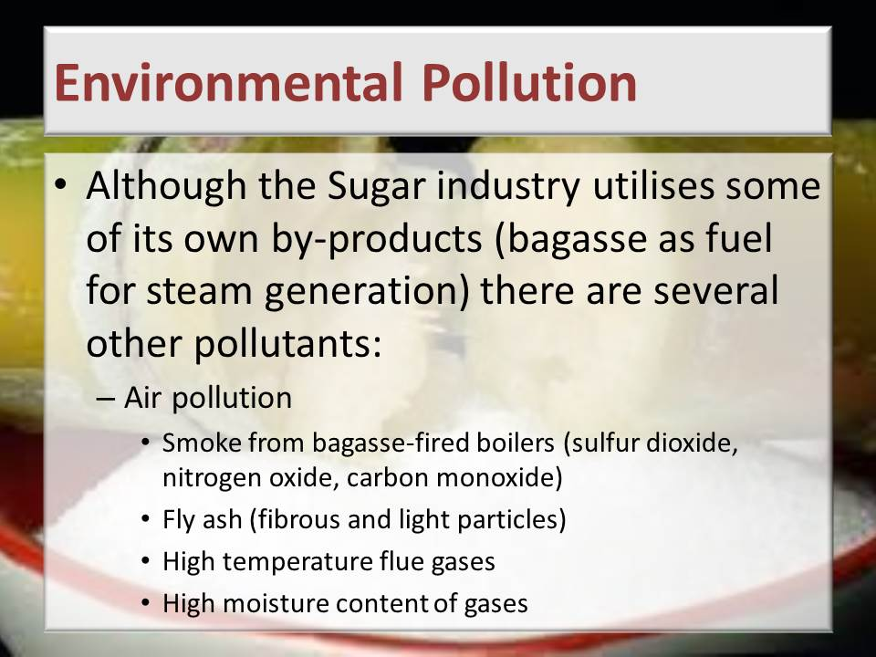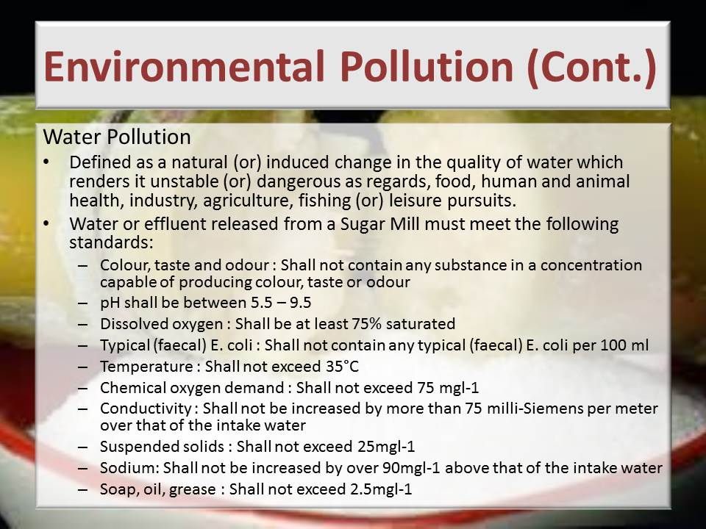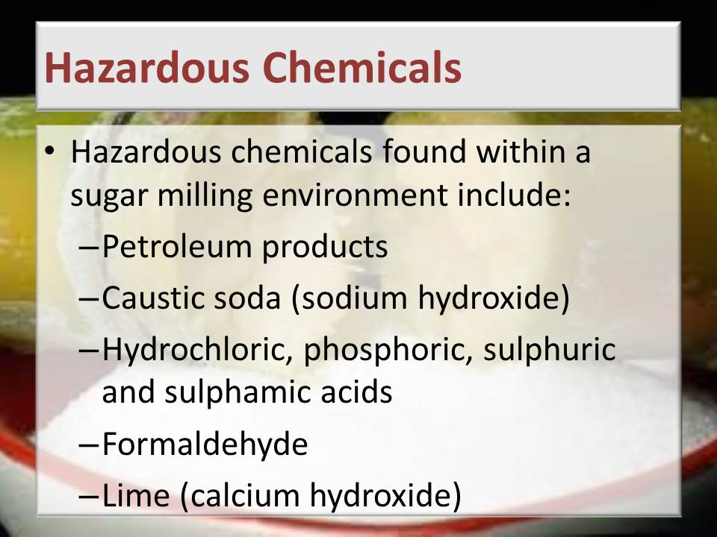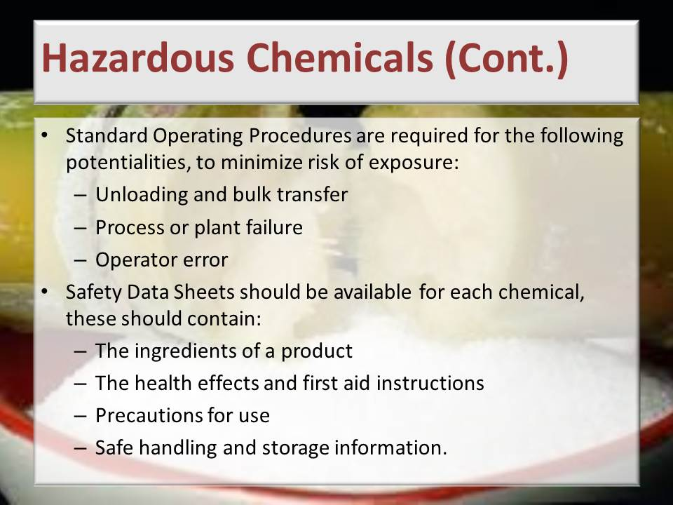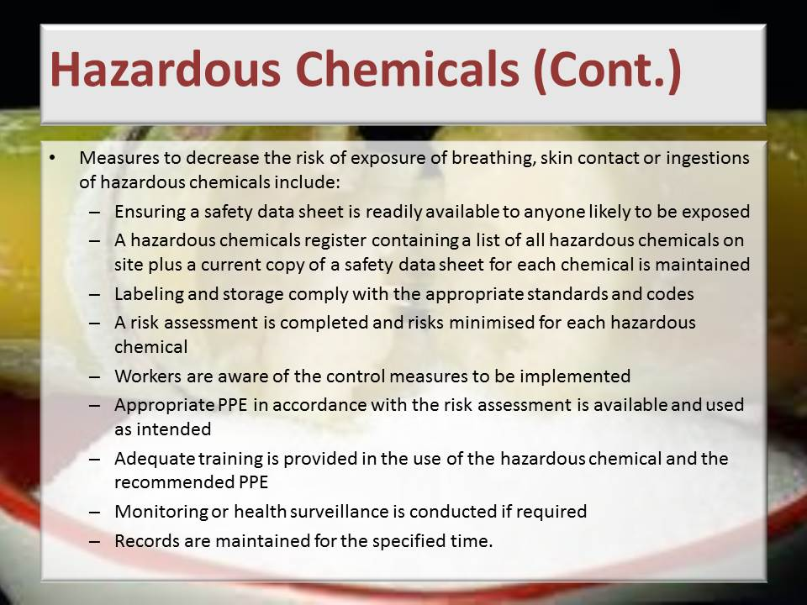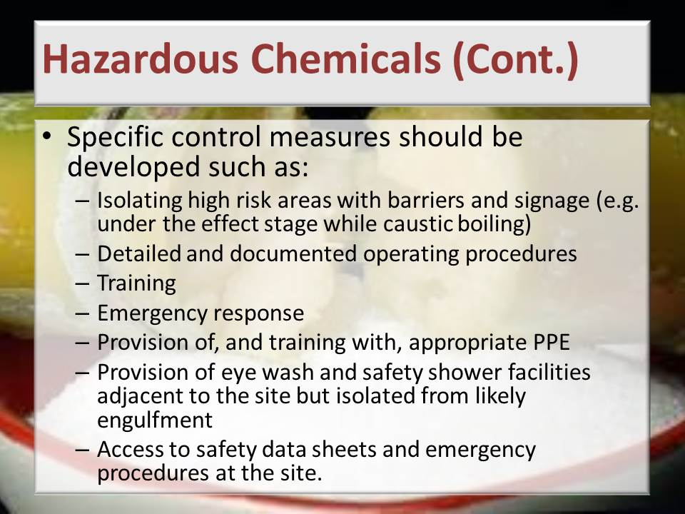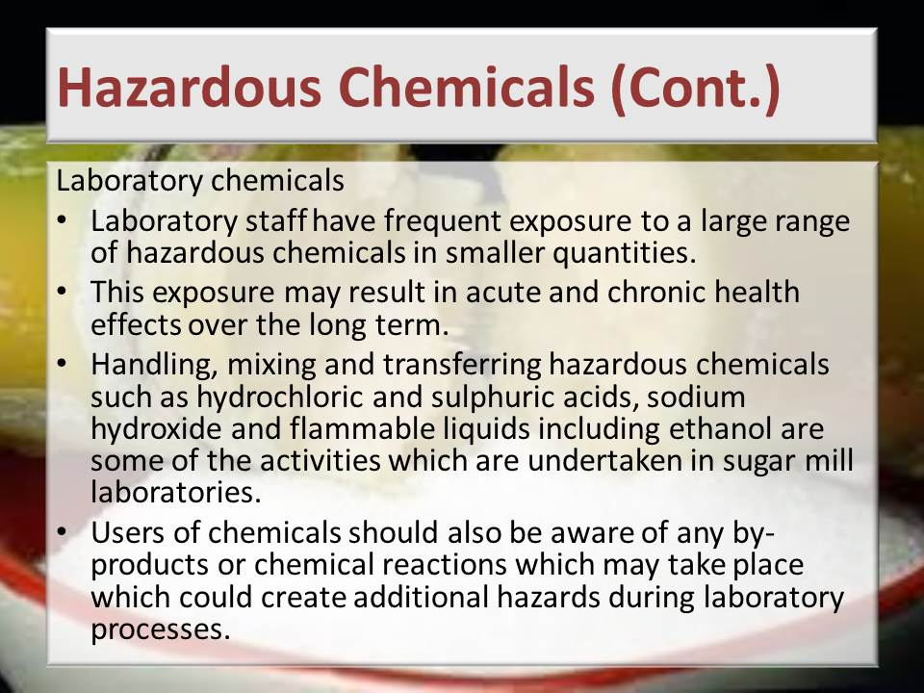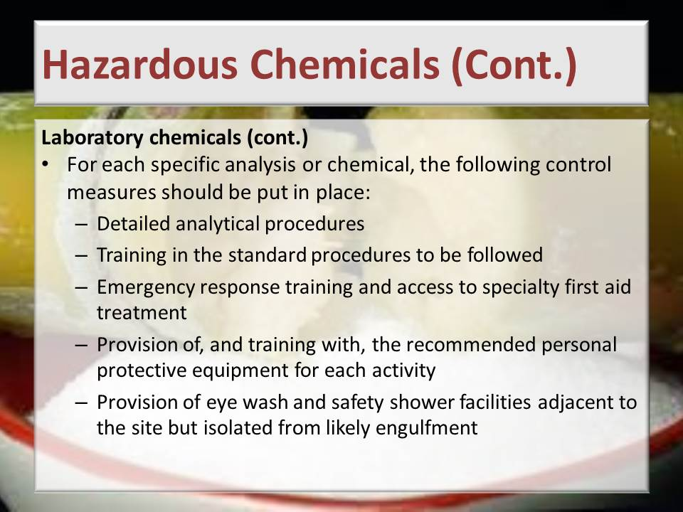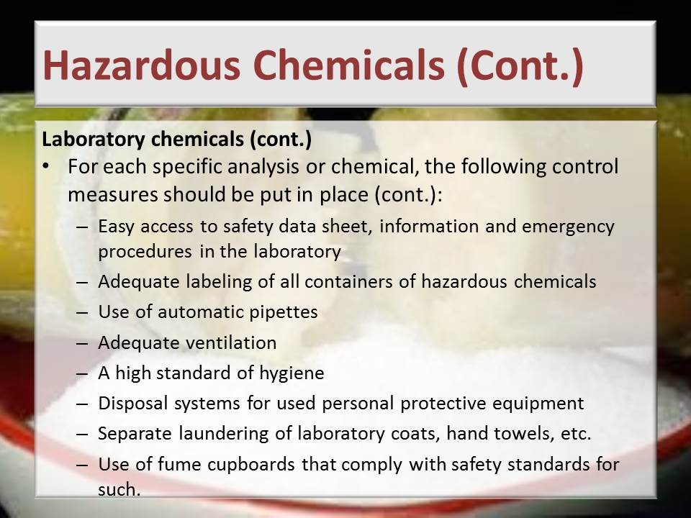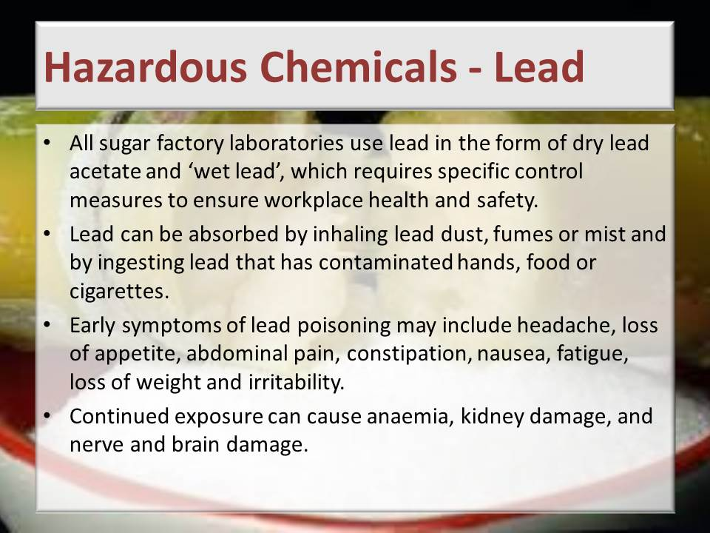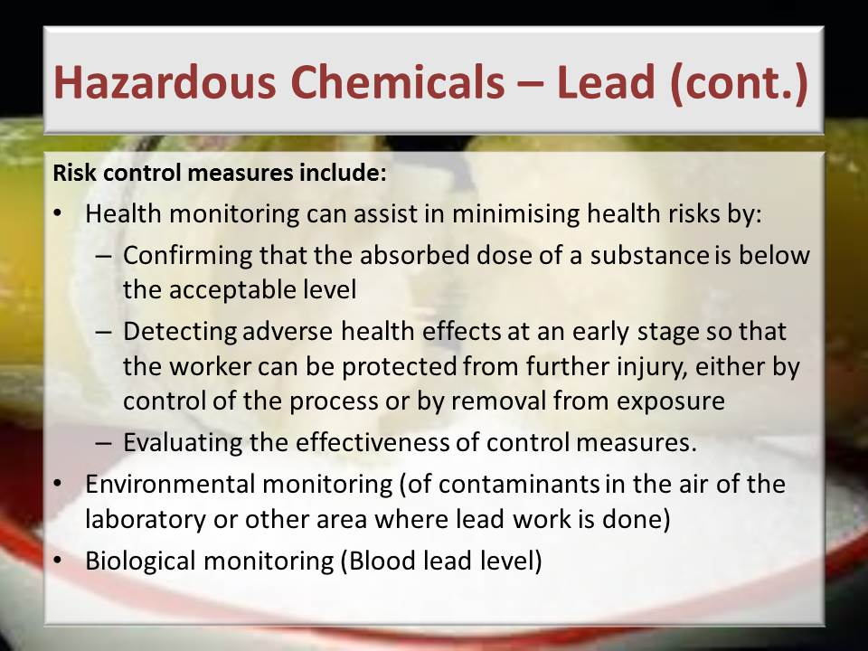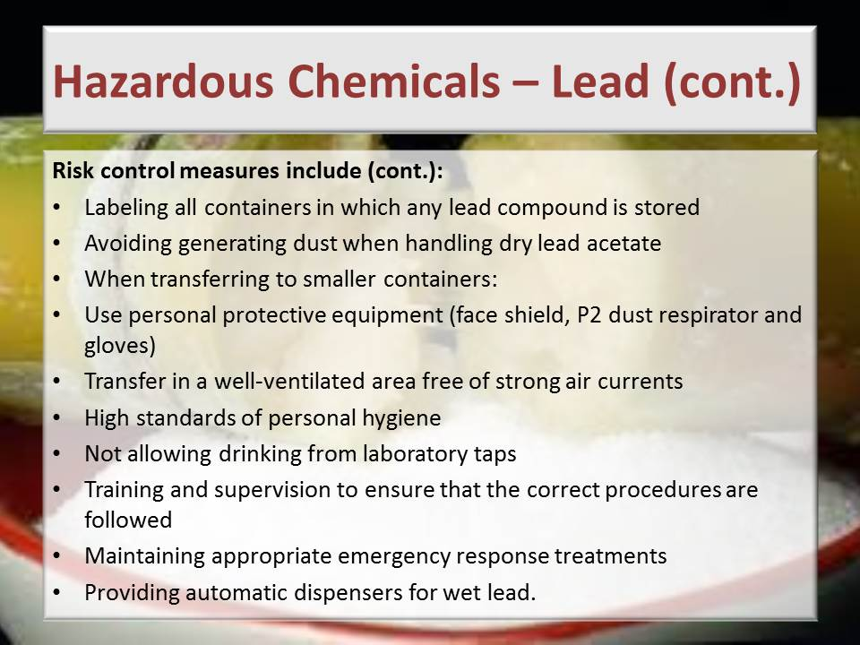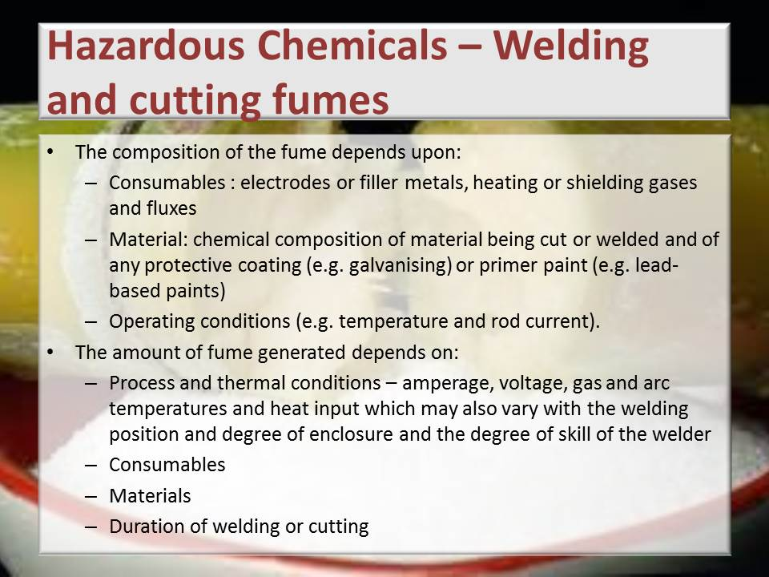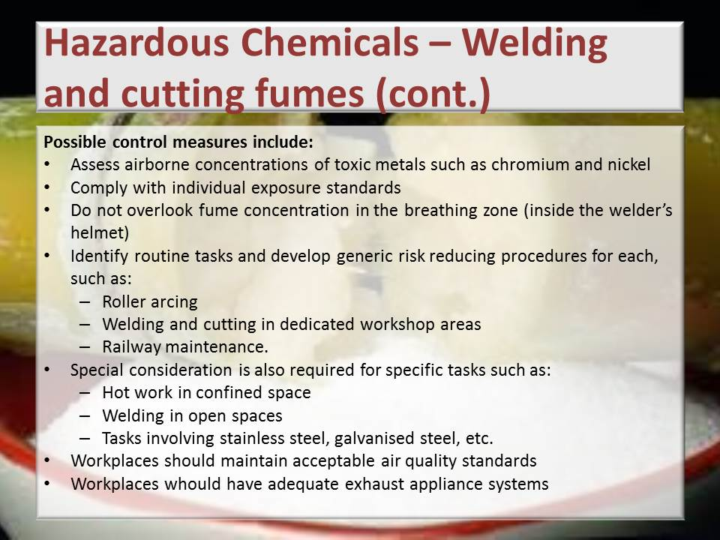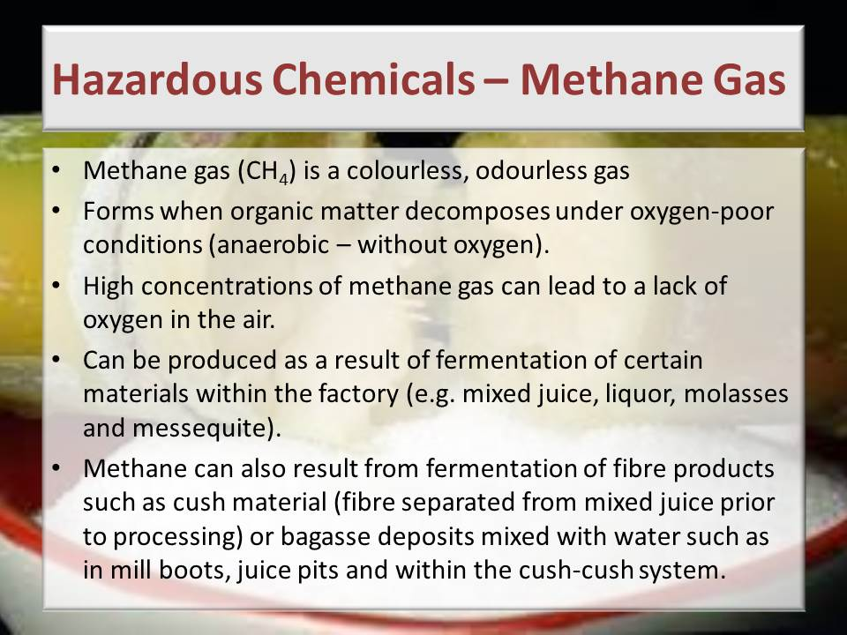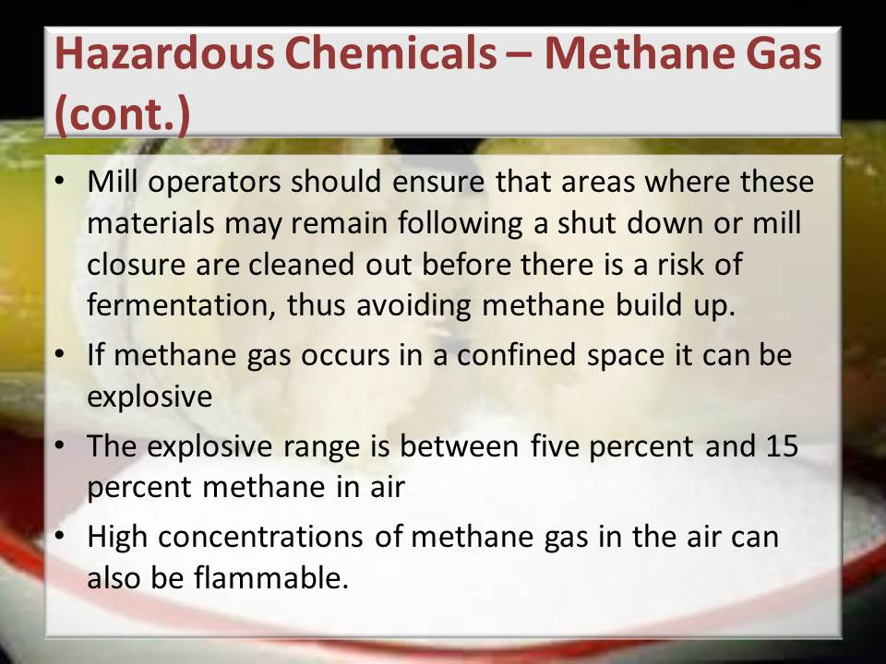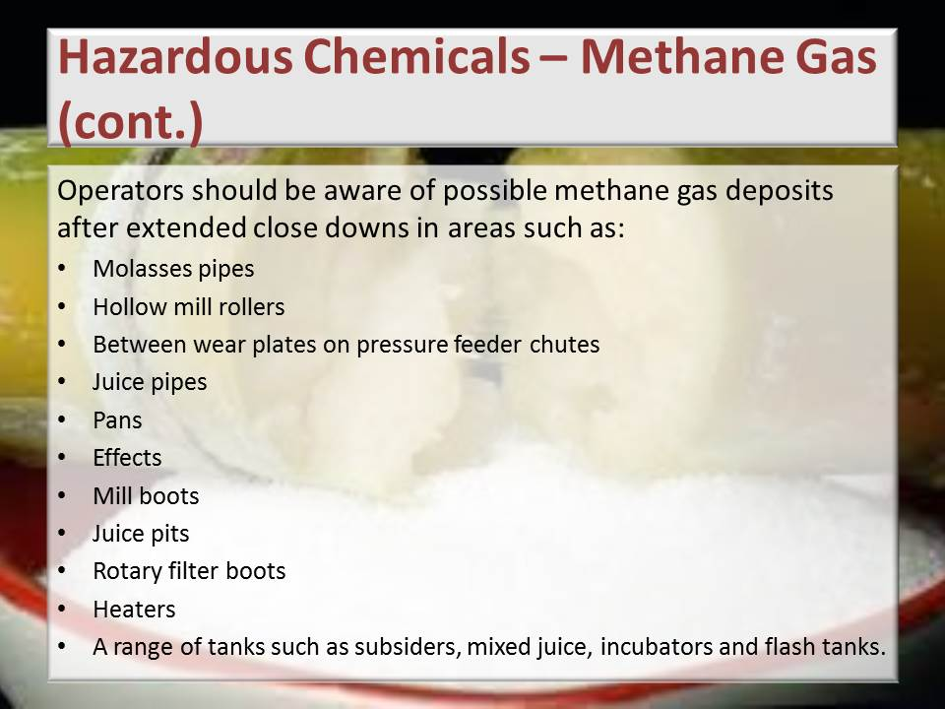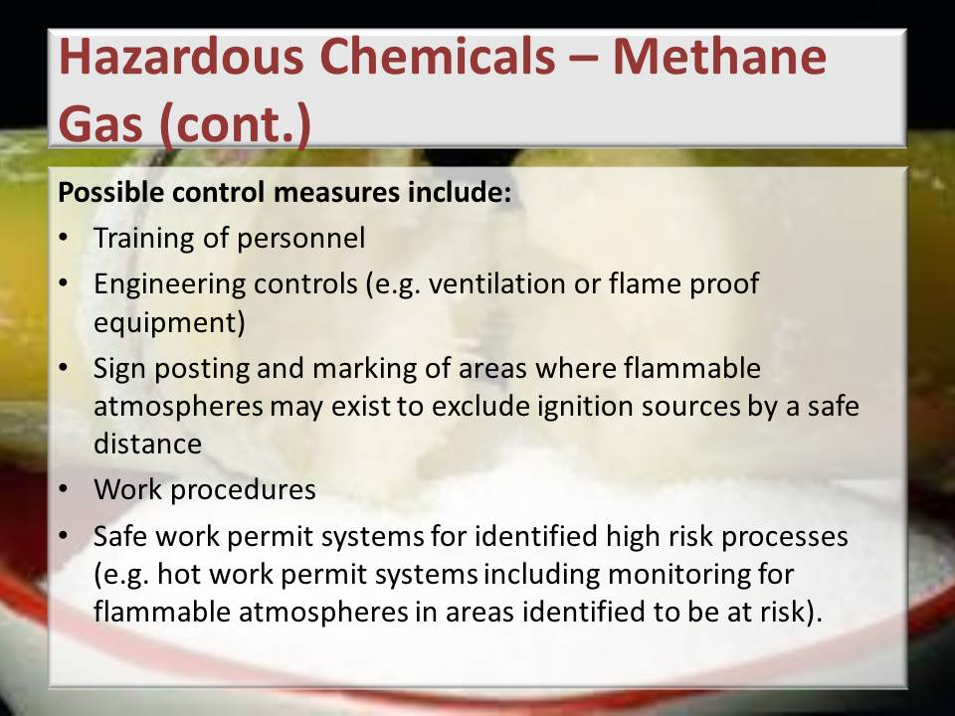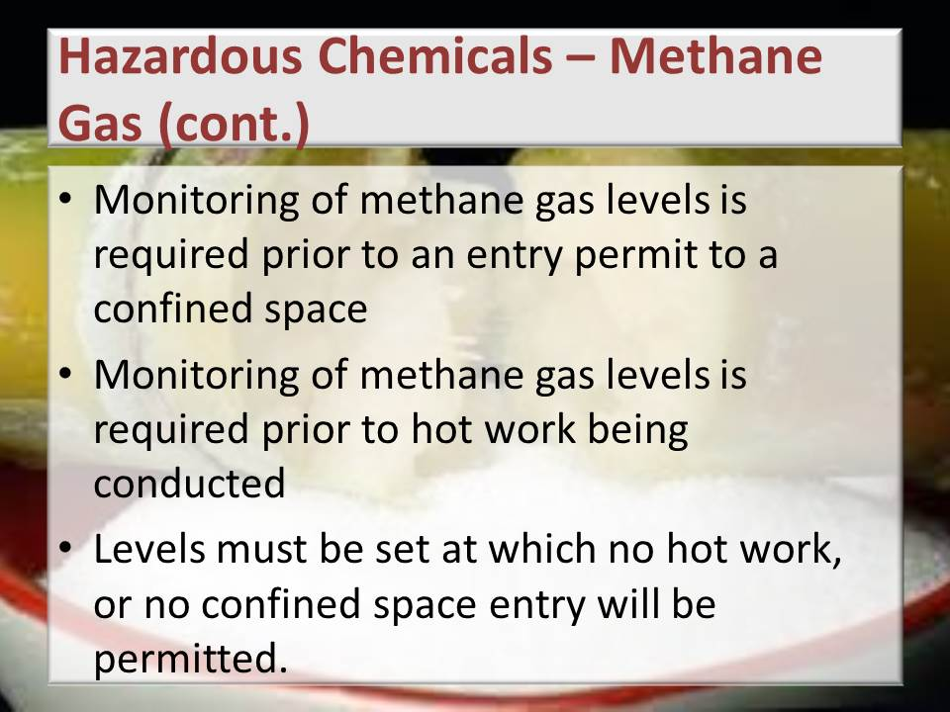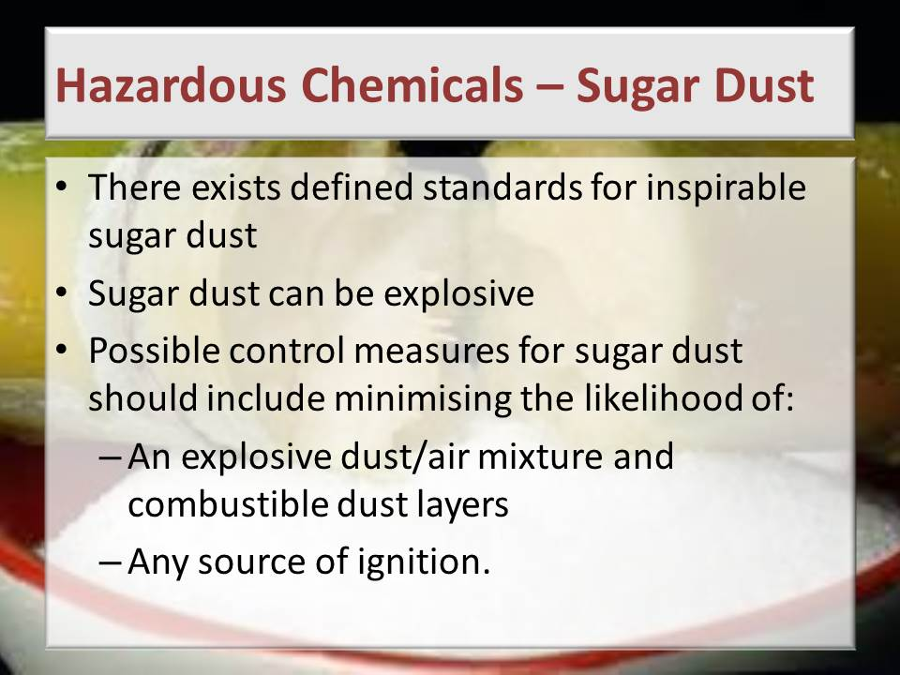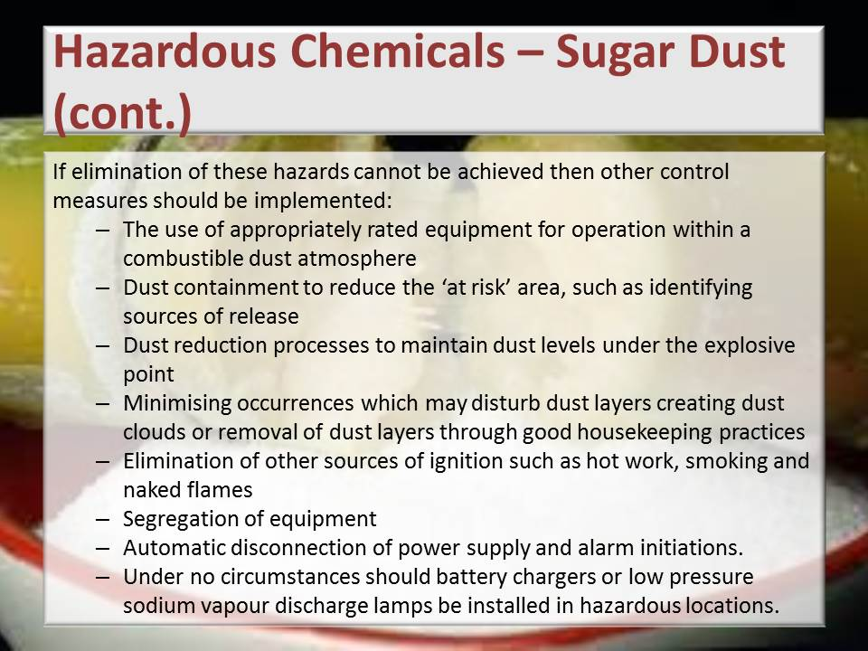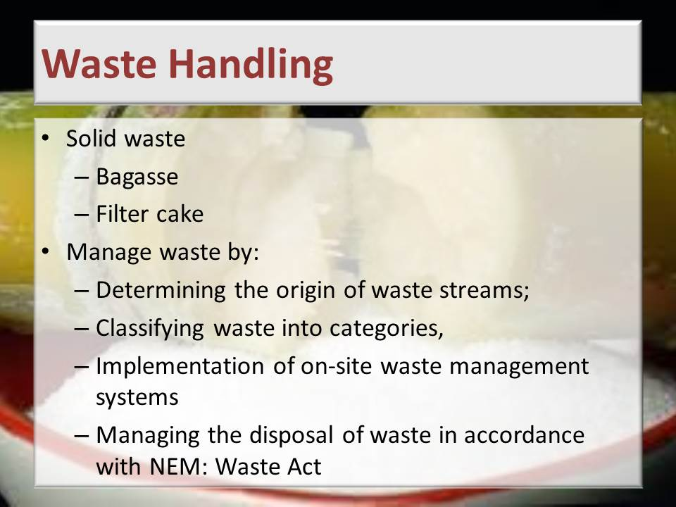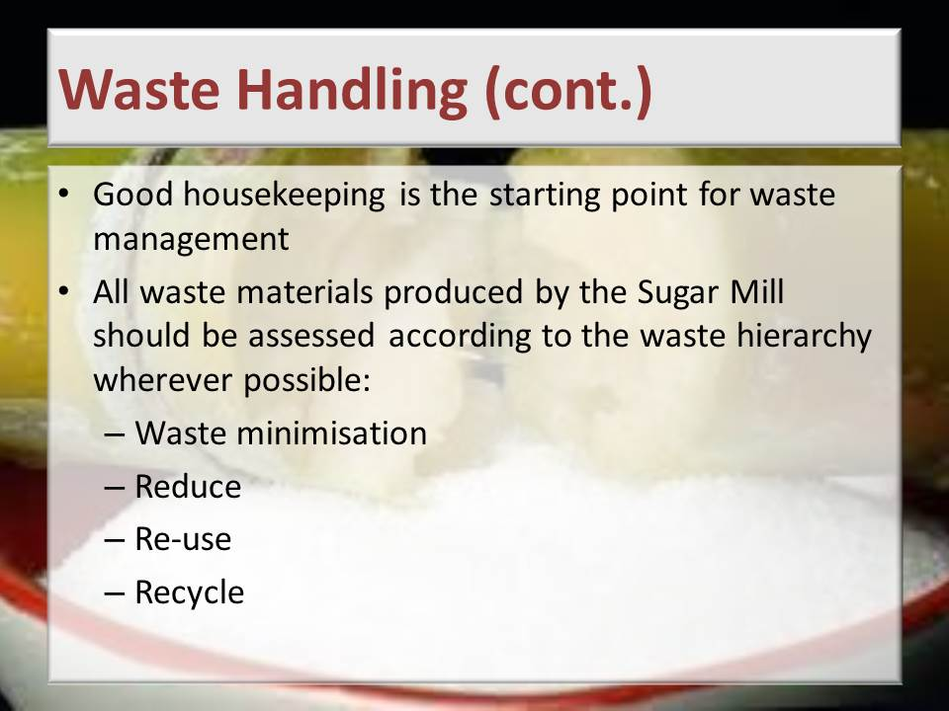
Learning activity: Guide learners to Page 41 of the Learner Workbook 1. Learners are instructed to complete Learning activity 3.1 (1 hour)
Guide learners to Page 45 of the Learner Workbook 1. Learners are instructed to complete Learning activity 3.2 (30 minutes)
Guide learners to Page 48 of the Learner Workbook 1. Learners are instructed to complete Learning activity 3.3 (1 hour)
Guide learners to Page 52 of the Learner Workbook 1. Learners are instructed to complete Learning activity 3.4 (10 minutes)
Total time taken: Presentation: 7 hours
Learning activities 3.1, 3.2, 3.3, 3.4: 3 hours
Close: Move on to the next session

KNOWLEDGE TOPIC 4: Environmental Protection and Pollution Concepts (10%)
INSTRUCTIONS TO FACILITATOR
Purpose: To introduce the candidates to Knowledge Topic 4: Environmental Protection and Pollution Concepts.
Objectives: By the end of the session the candidates will:
- Be able to explain environmental pollution risks and preventative measures.
Procedure: Conduct a presentation and allow time for learning activities.
Participant Materials: The learner will use the following materials:
- The Learner Guide Book 1 (Textbook)
- The Learner Formative Assessment Guide – Workbook 1
Presentation: Do a presentation covering the following topics:
- Carbon footprint, global warming and green production principles
- Sources of and impact of contaminates on the natural environment
- General rules related to waste control measures
- The impact of environmental pollution on natural resources, communities and the economy
Slides: Use the following slides for your presentation referring frequently to the Learning Resource for more detail.
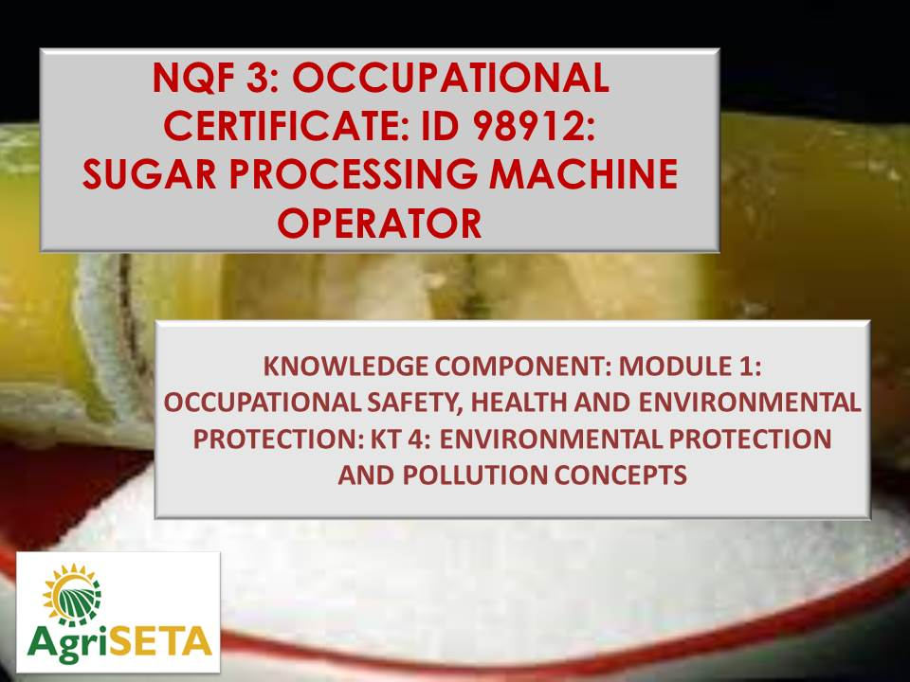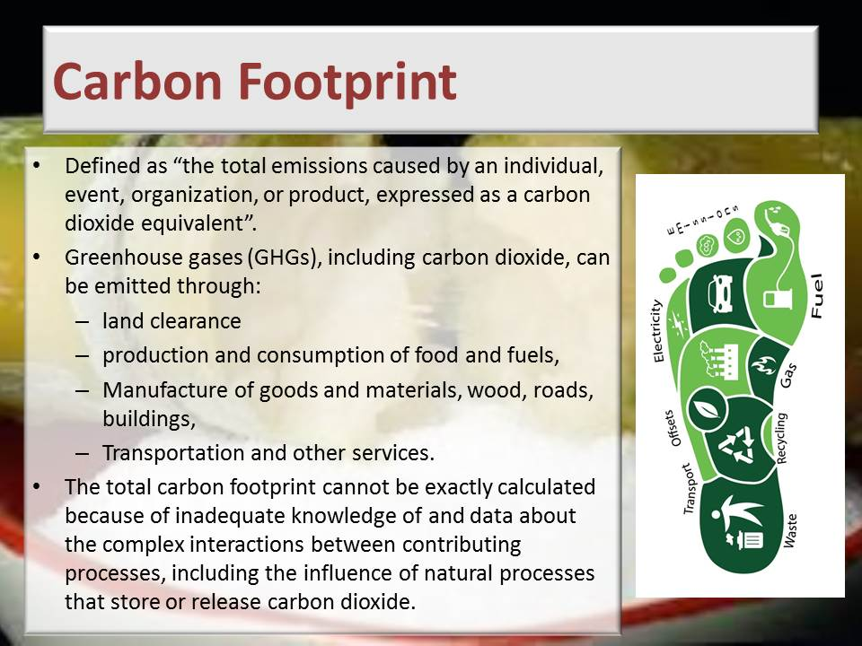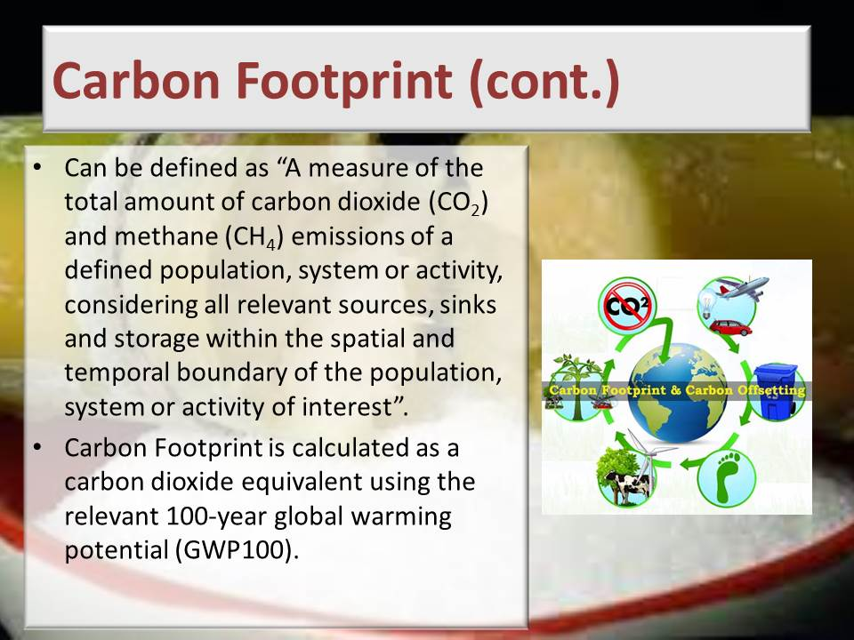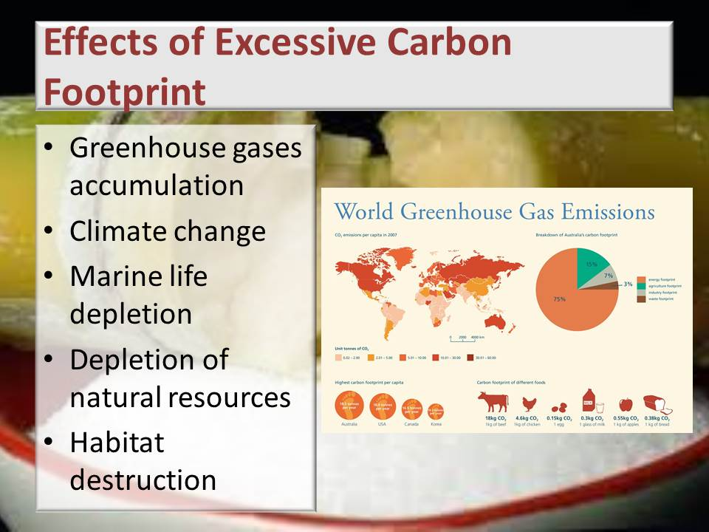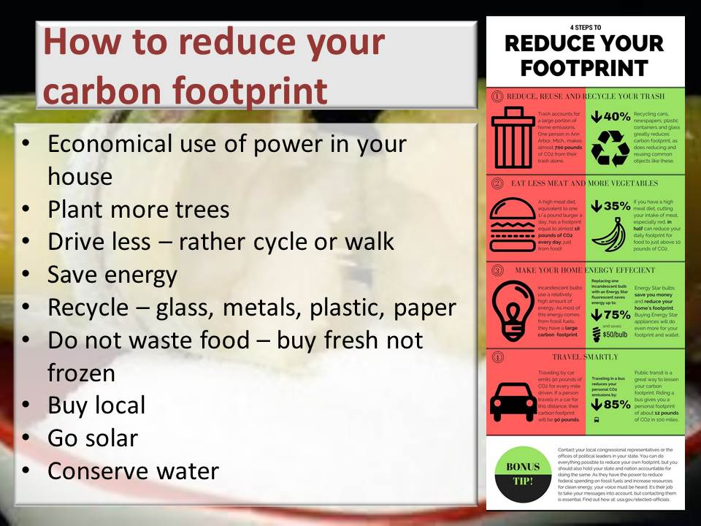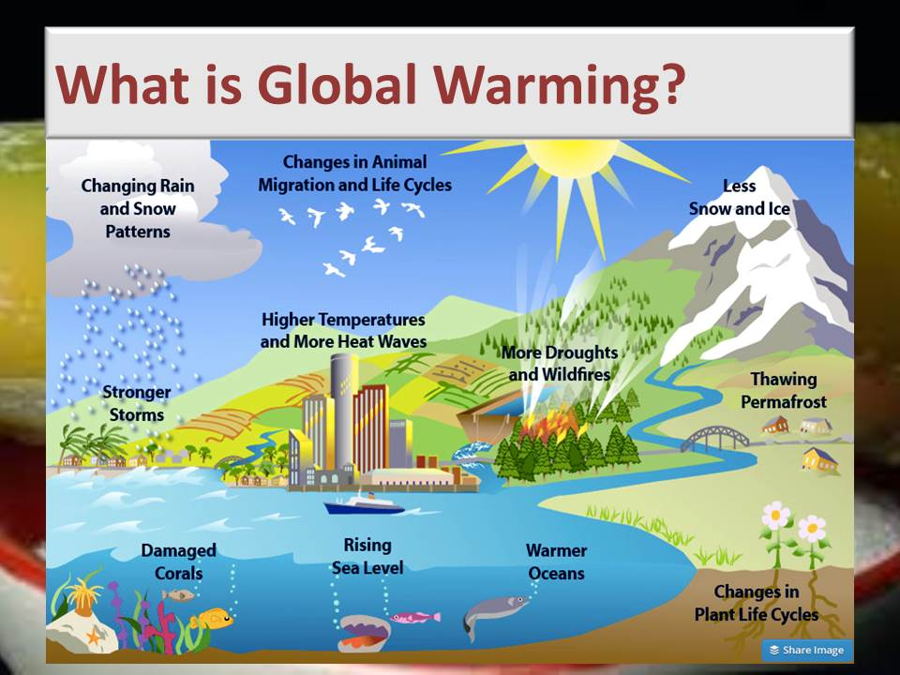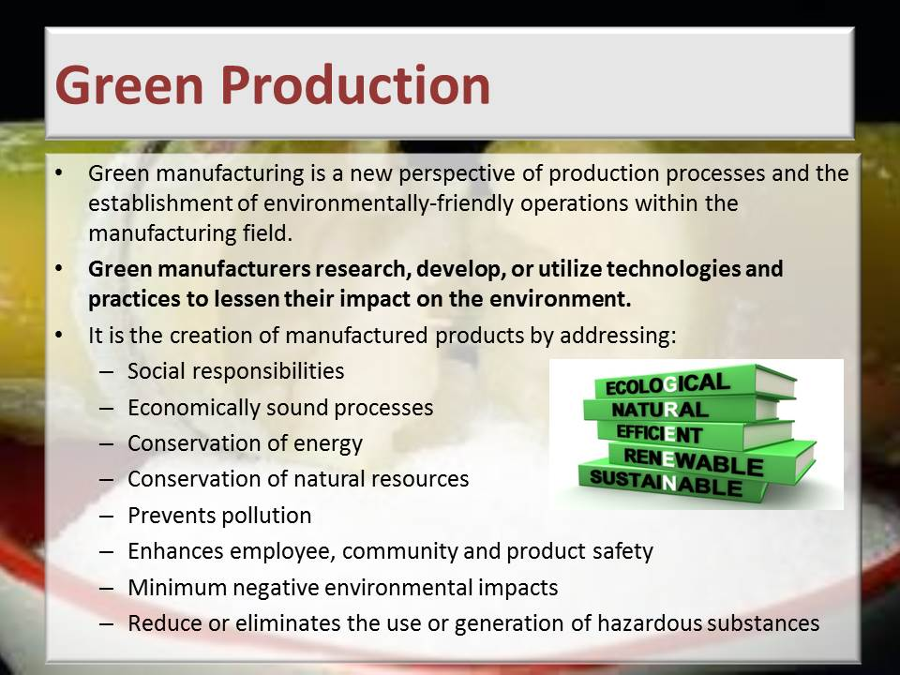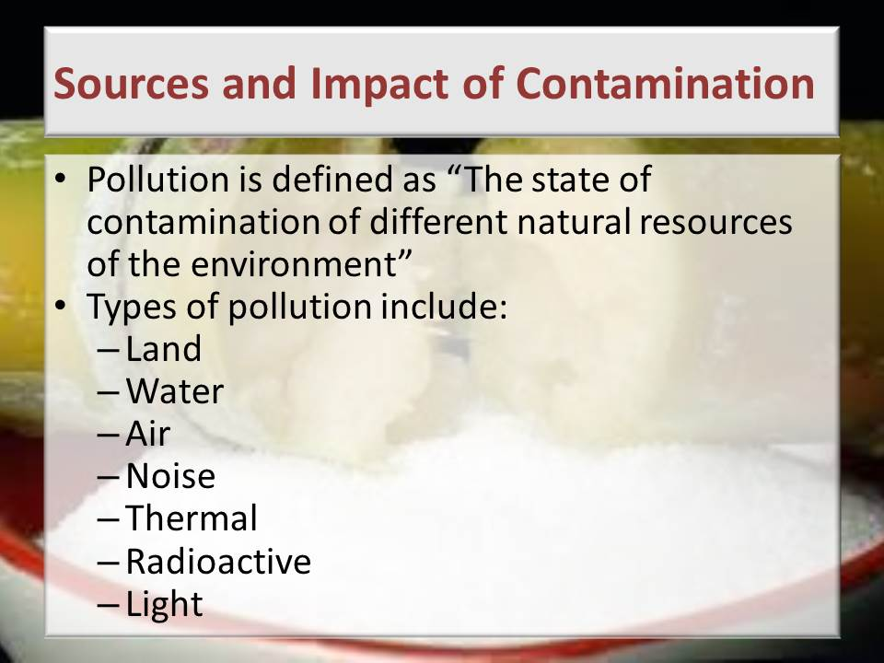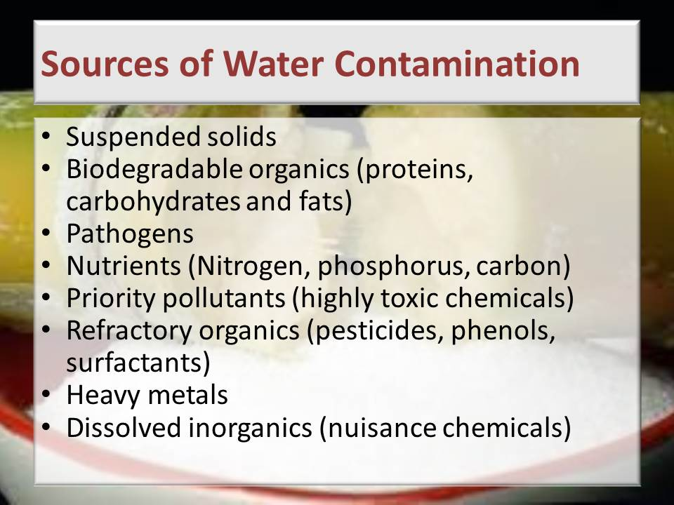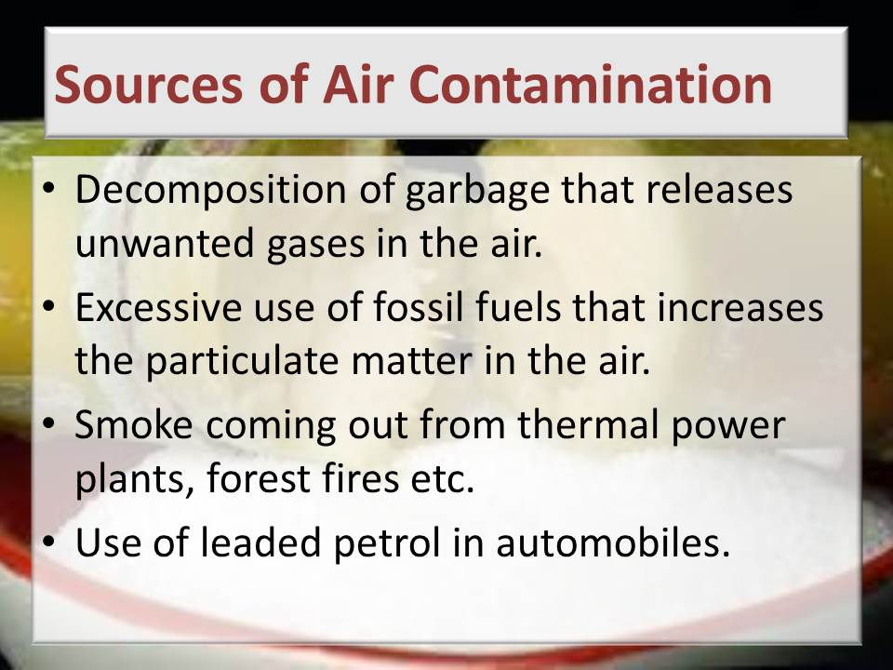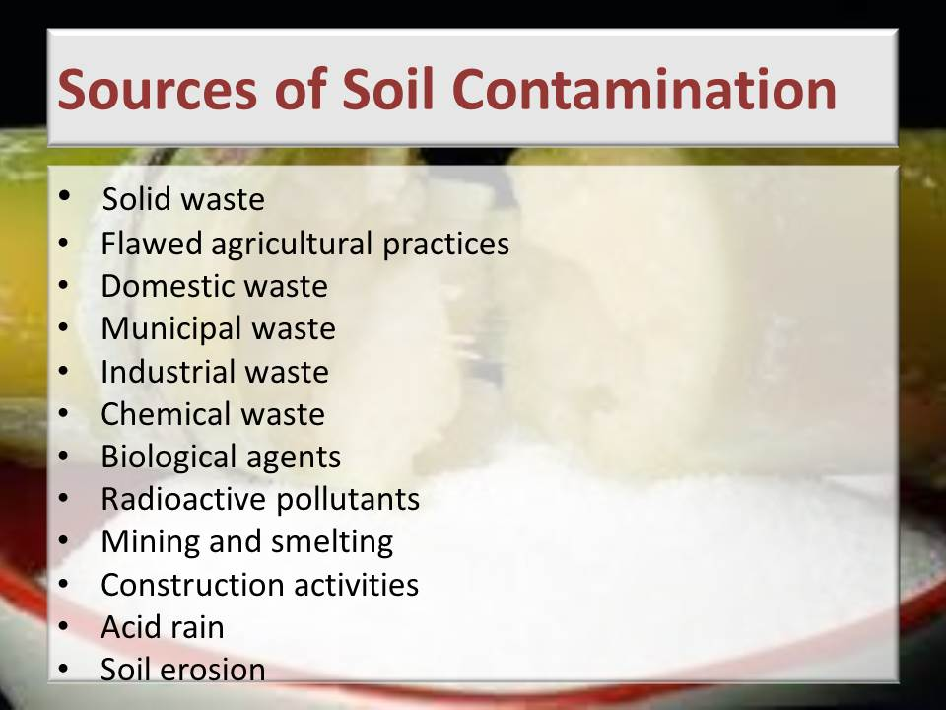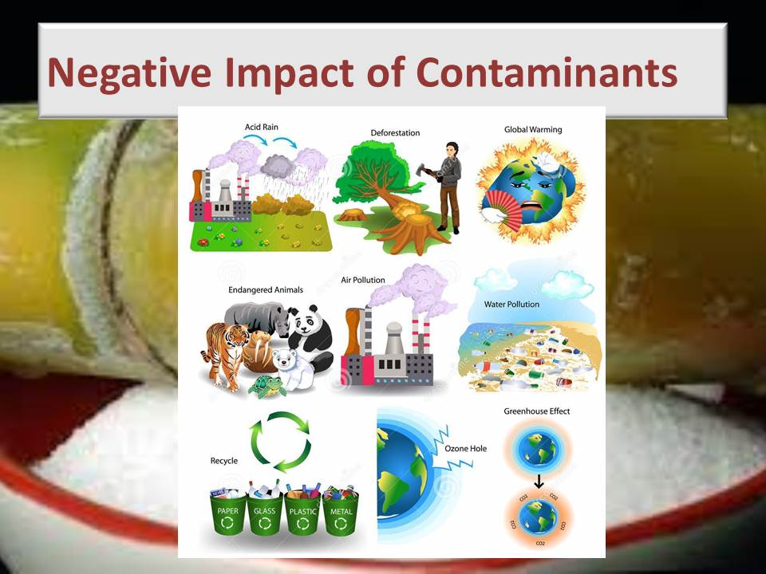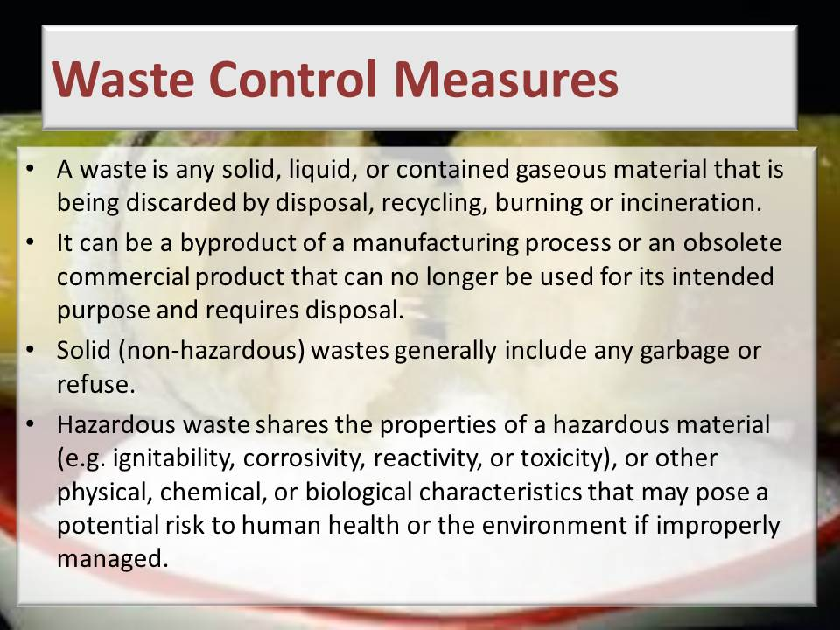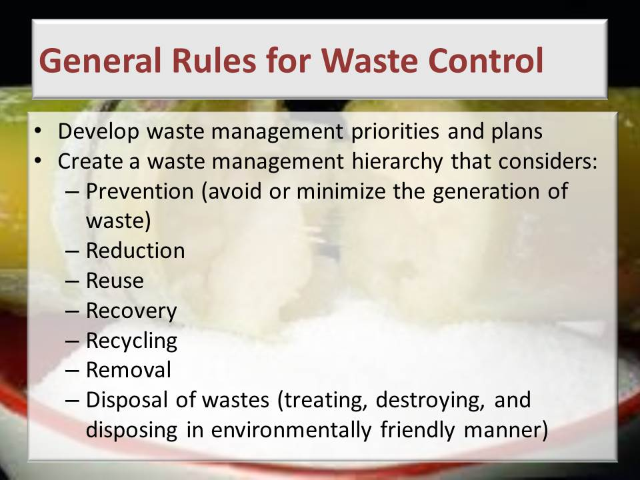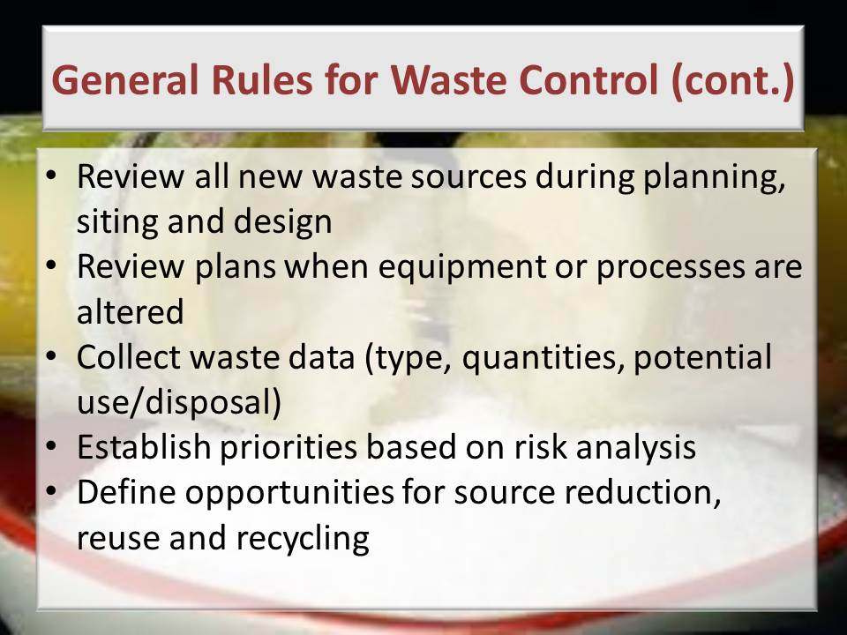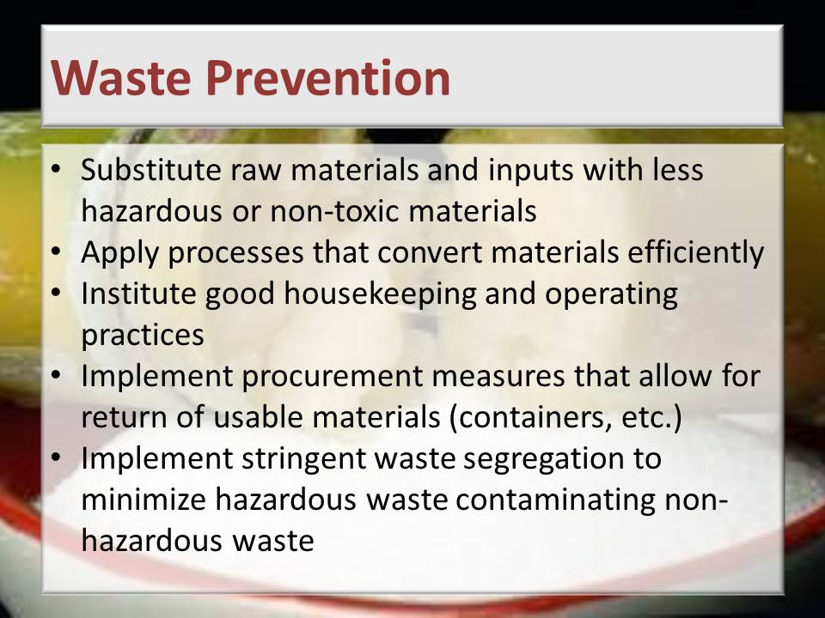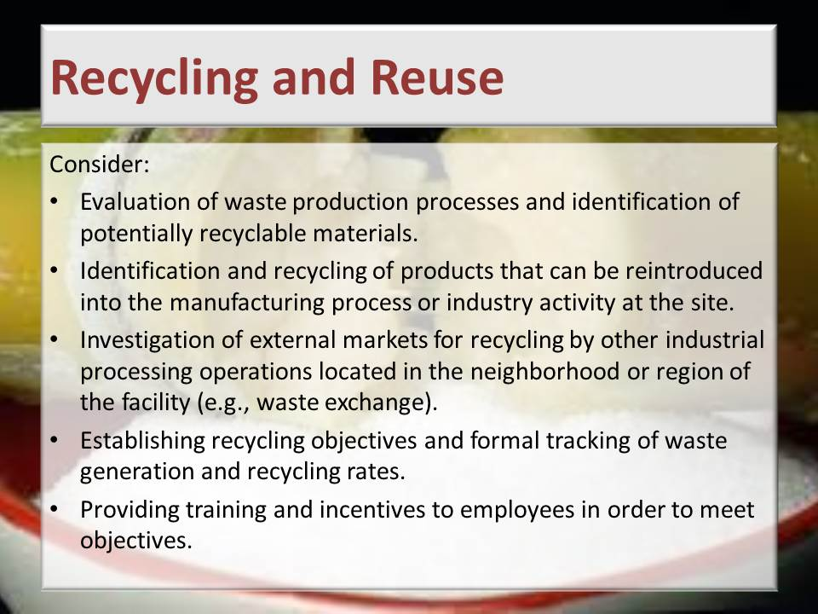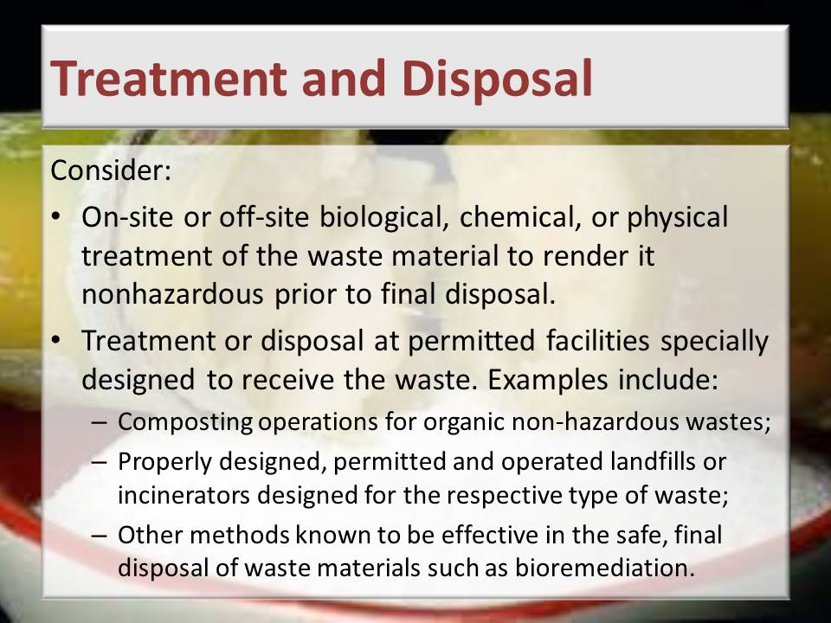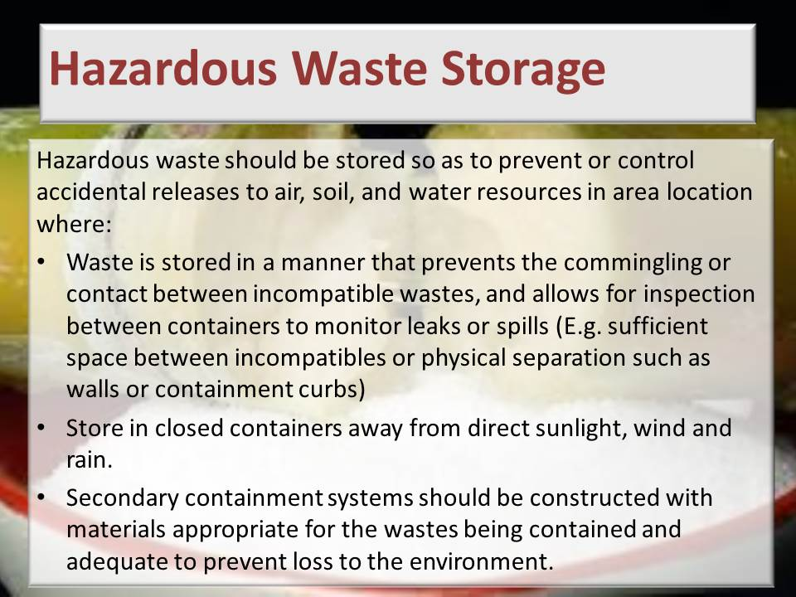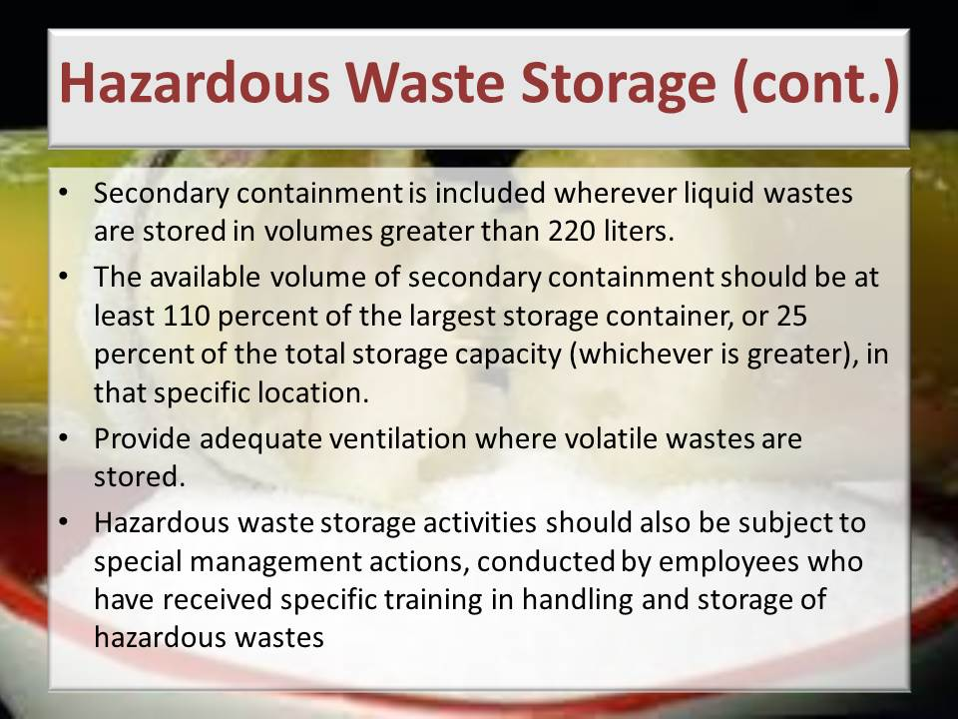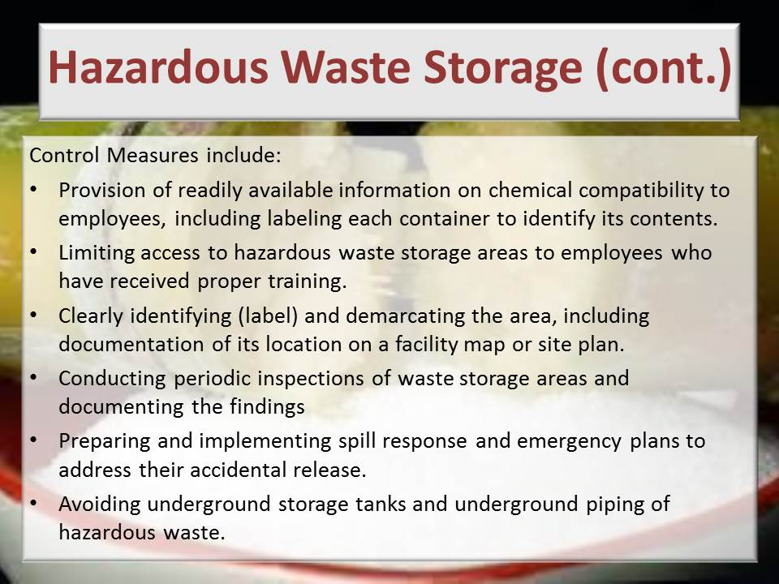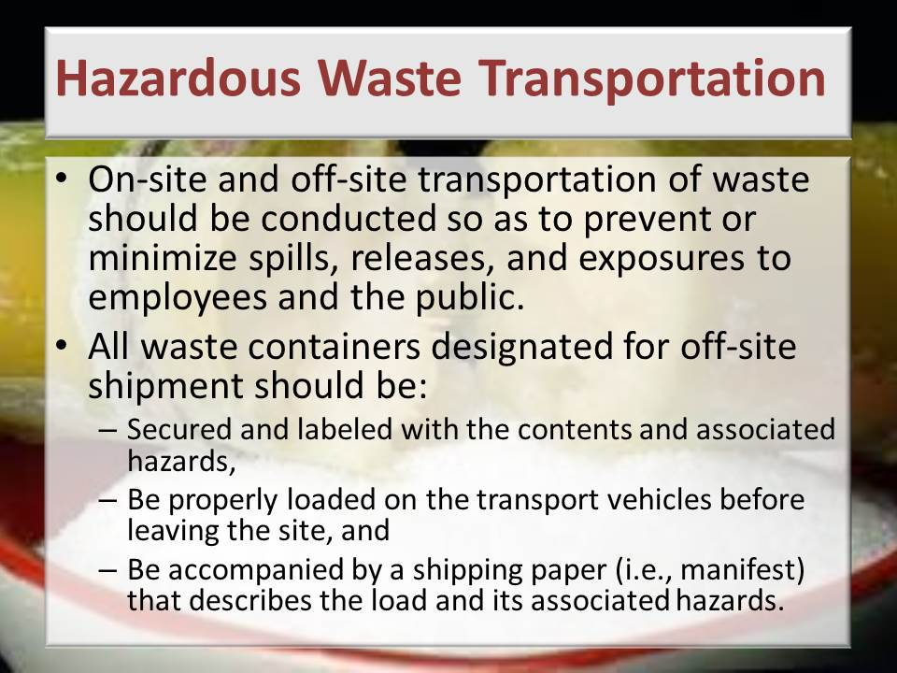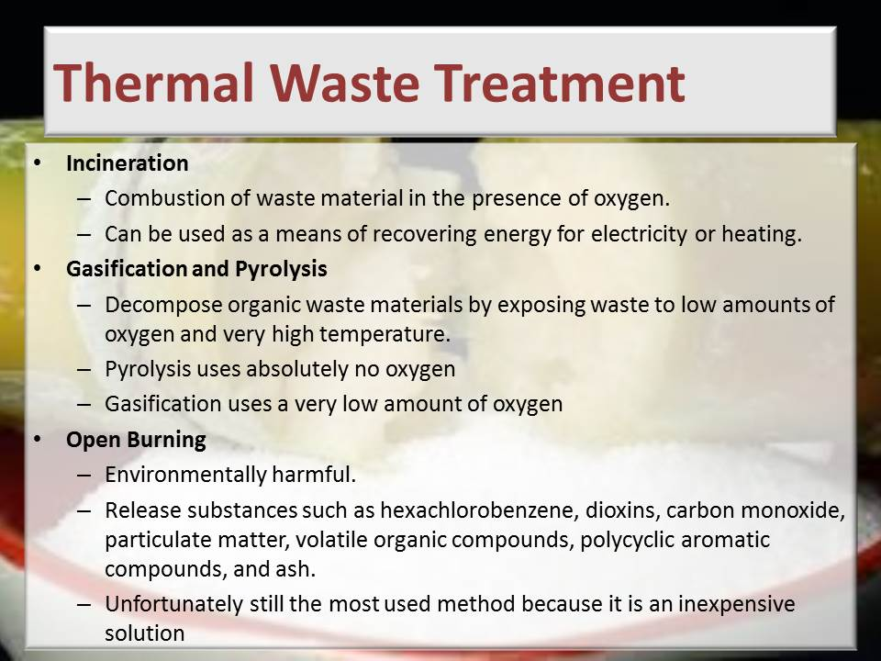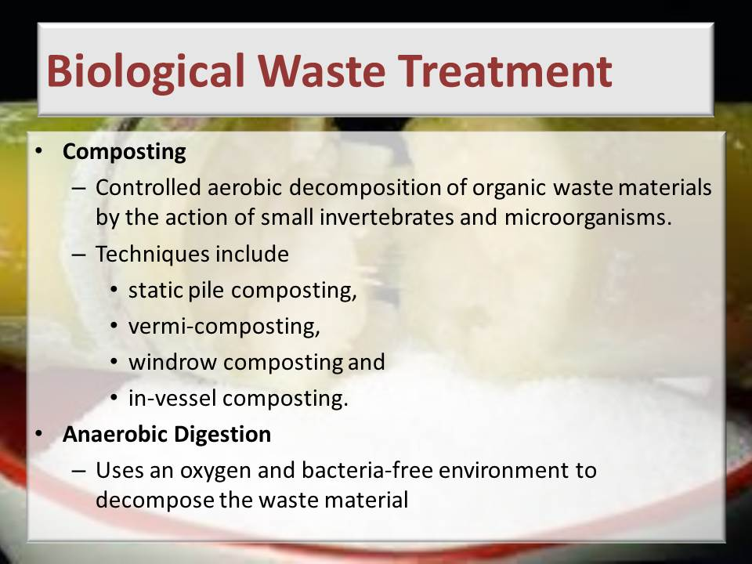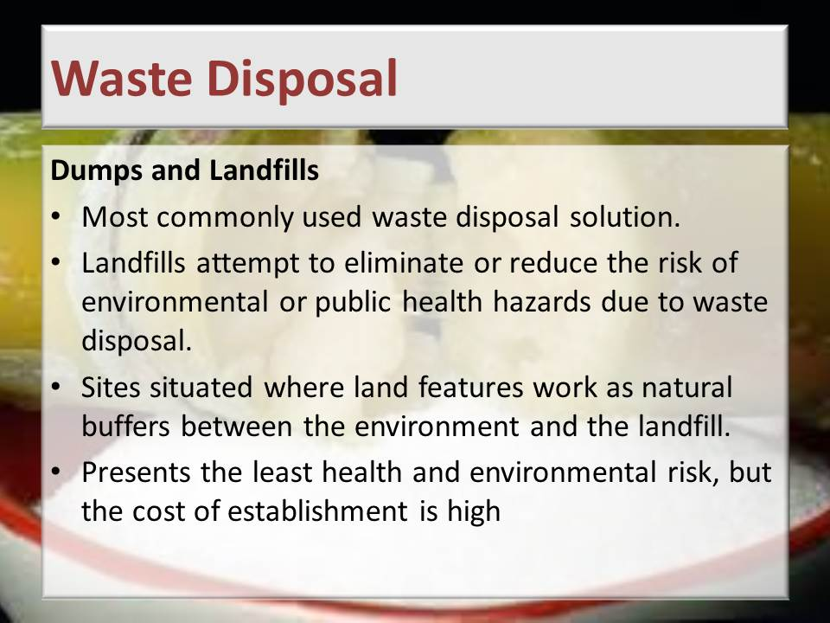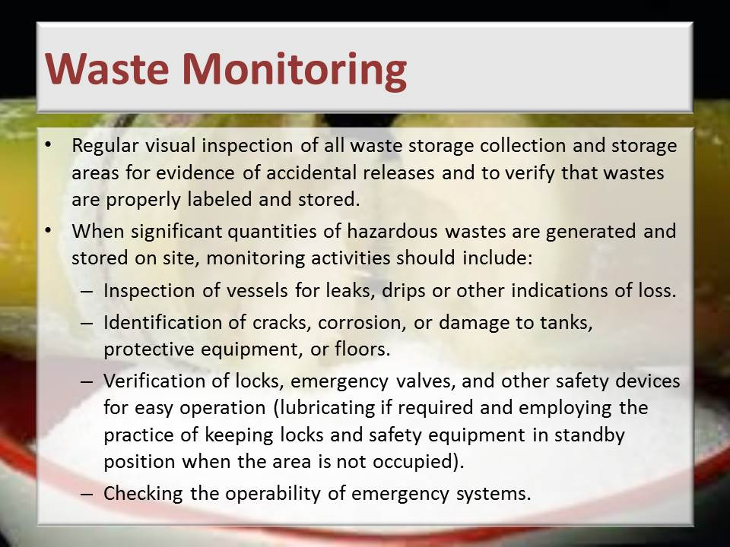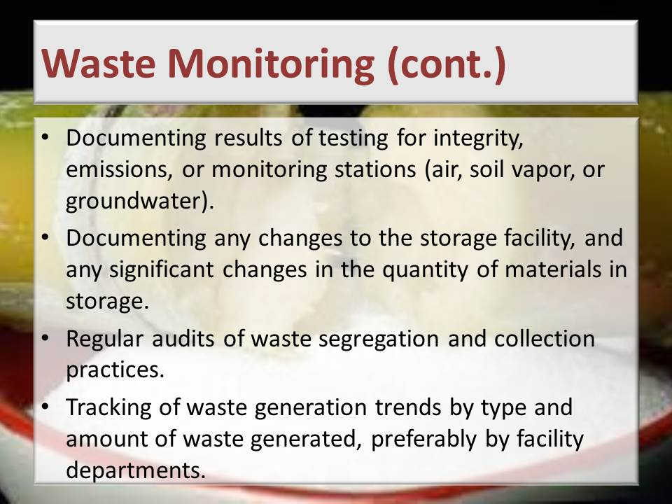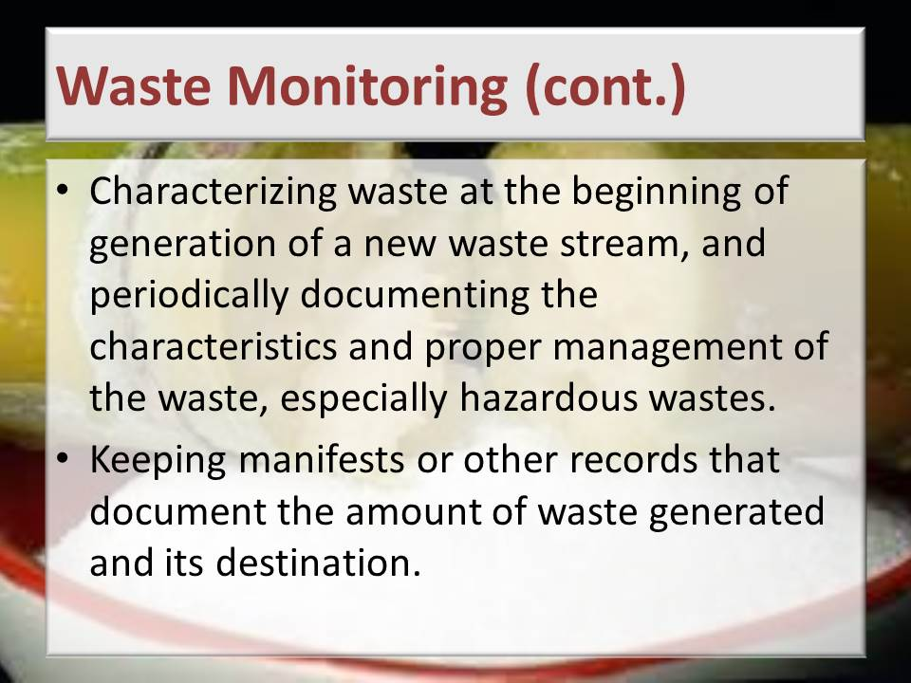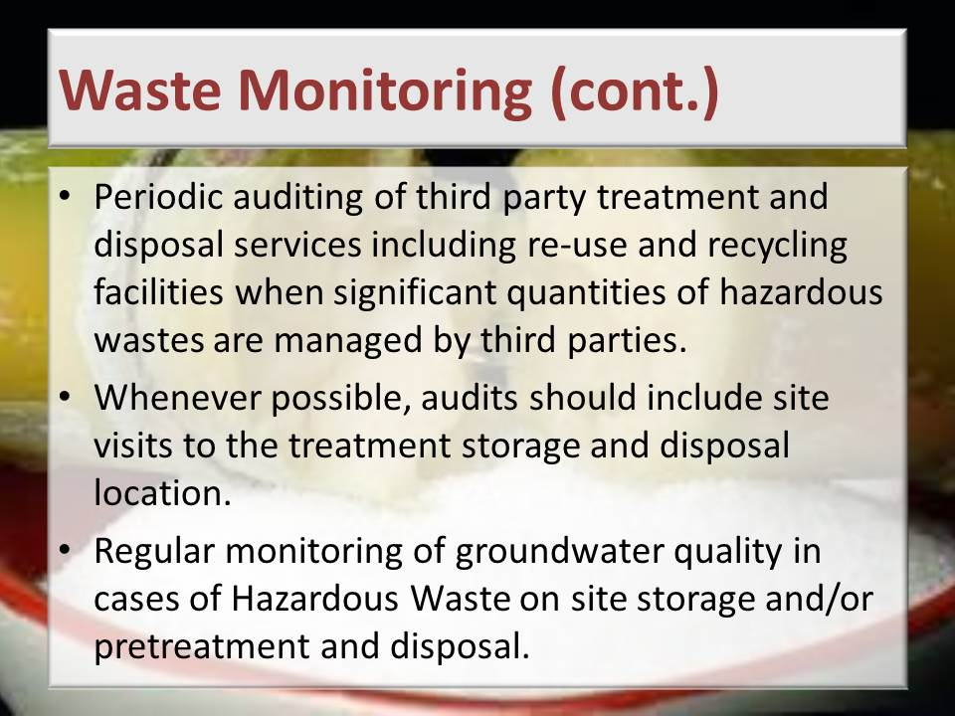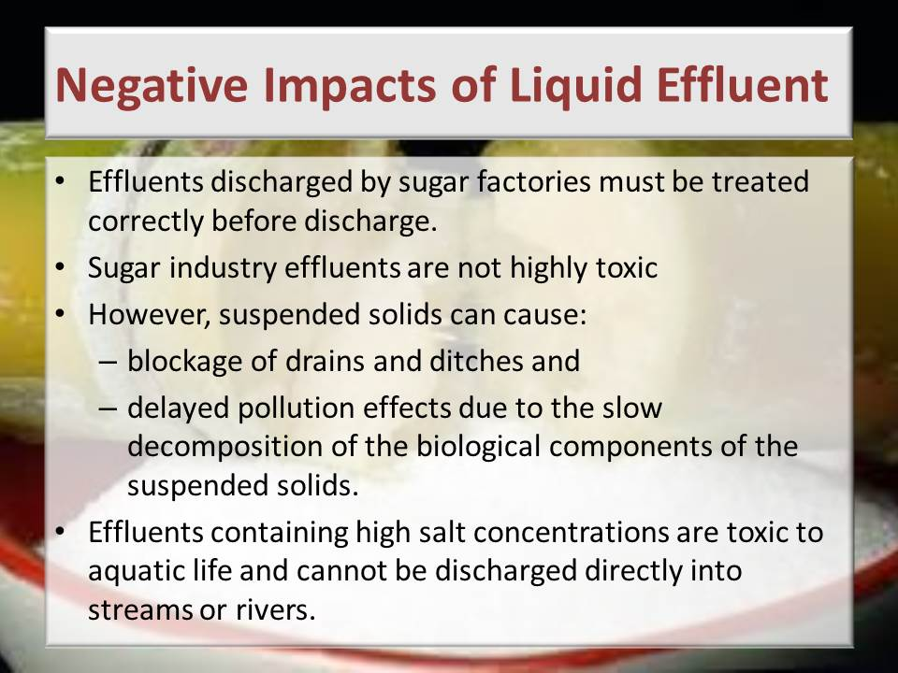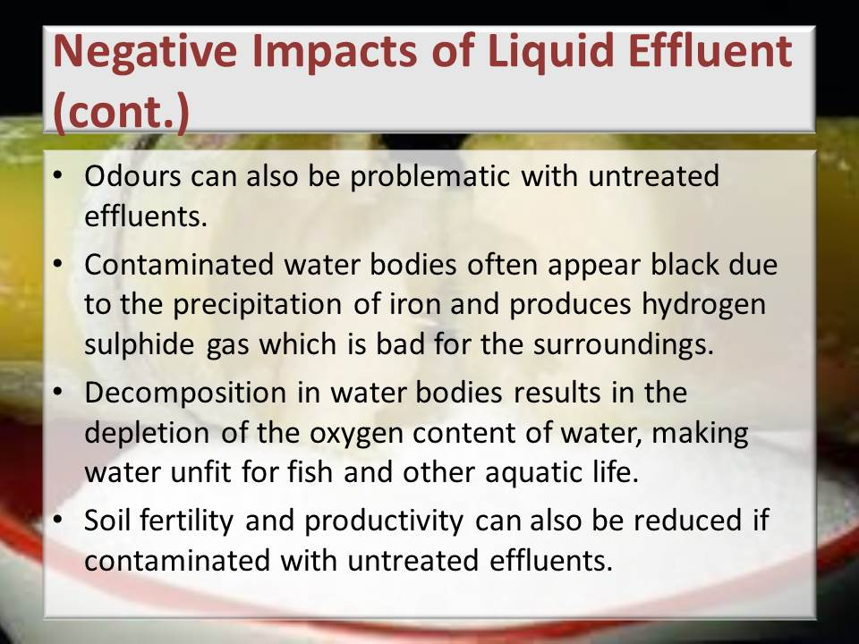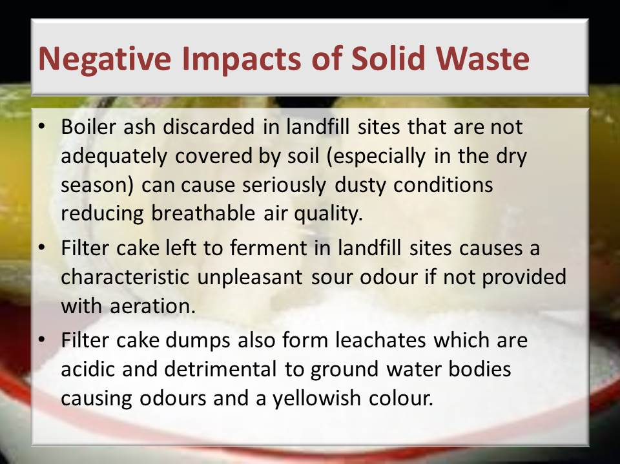
Learning activity: Guide learners to Page 54 of the Learner Workbook 1. Learners are instructed to complete Learning activity 4.1 (30 minutes)
Guide learners to Page 57 of the Learner Workbook 1. Learners are instructed to complete Learning activity 4.2 (2 hours)
Total time taken: Presentation: 6 hours
Learning activities 4.1, 4.2: 3 hours
Close: This concludes this Knowledge Module. Provide time for the learners to complete their Formative Assessments and to prepare for their Summative Assessments. Collect the Formative Assessment documents for marking. Schedule a date, time and place for the Summative Assessment and conduct this. Capture the marks from both the Formative and Summative Assessments in the Formative and Summative Assessment Guides as well as the NQF 3 Summative Guide.
Close: Move on to the next Knowledge Module.



