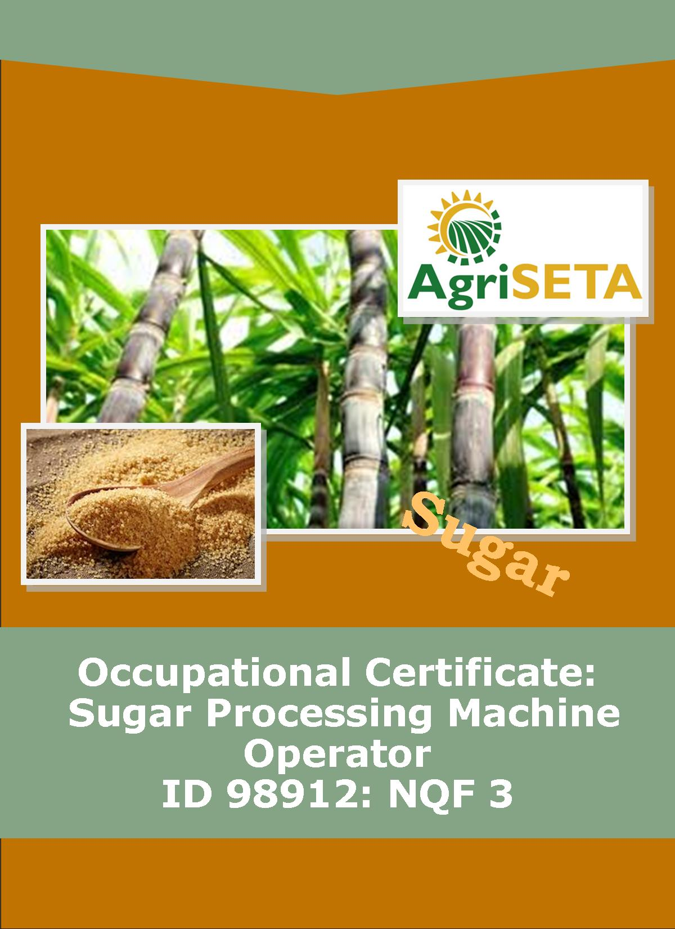
KNOWLEDGE COMPONENT:
KNOWLEDGE COMPONENT: LEARNER WORKBOOK 1: OCCUPATIONAL SAFETY, HEALTH AND ENVIRONMENTAL PROTECTION
Occupational Certificate: Sugar Processing Machine Operator

KNOWLEDGE COMPONENT: LEARNER WORKBOOK 1:

OCCUPATIONAL SAFETY, HEALTH AND ENVIRONMENTAL PROTECTION
LEARNER WORKBOOK 1:
OCCUPATIONAL SAFETY, HEALTH AND ENVIRONMENTAL PROTECTION
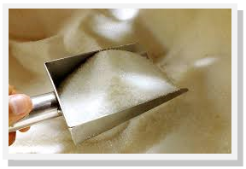
OCCUPATIONAL CERTIFICATE: SUGAR PROCESSING MACHINE OPERATOR

©Copyright AgriSETA
Telephone: +27 12 301 5600
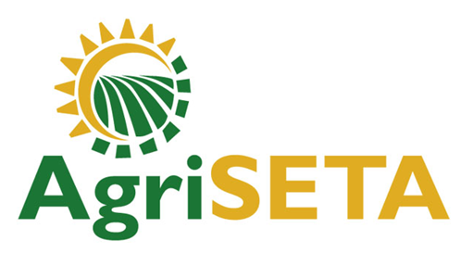

AgriSETA holds the copyright to its publications and Web pages. Proper citation is requested.

TABLE OF CONTENTS
1. AN INTRODUCTION TO THIS LEARNER WORKBOOK 6
2. LEARNER DETAILS 7
3. FORMATIVE ASSESSMENT INSTRUCTIONS 8
4. KNOWLEDGE MODULE 1: OCCUPATIONAL SAFETY, HEALTH AND ENVIRONMENTAL PROTECTION 9
4.1 Knowledge Topic 1: The statutory framework of Safety, Health and Environmental Protection in the workplace (10%) 10
4.2 Knowledge Topic 2: General rules and principles of safe work practices (30%) 17
4.3 Knowledge Topic 3: Sugar processing specific health, safety and environmental protection concepts (50%) 40
4.4 Knowledge Topic 4: Environmental protection and pollution concepts (10%) 53
5. CONCLUSION OF KNOWLEDGE MODULE 1: OCCUPATIONAL SAFETY, HEALTH AND ENVIRONMENTAL PROTECTION 63

AN INTRODUCTION TO THIS LEARNER WORKBOOK
This Knowledge Component Learner Workbook 1: Occupational Safety, Health and Environmental Protection is intended to be used with the Knowledge Component Learning Resource: Book 1 (Textbook): Occupational Safety, Health and Environmental Protection of the Occupational Qualification: Sugar Processing Machine Operator NQF 3.
Guidance on the use of this Work Book is provided in the Learning Guide.

LEARNER DETAILS
First name
Surname
ID number
Mobile phone contact number
E-mail address
Postal address
Date on which you started this Knowledge Module
Date on which you completed this Knowledge Module
Declaration: | I hereby confirm that:  - I received the assessment plan and schedule.  - I understand my rights in terms of special needs, re-assessment, feedback and appeals against assessment decisions.  - I completed this formative assessment independently without assistance from anyone else.
Total Marks for Knowledge Module 1 | 430 marks
Marks attained
Date:
Place:
Signature of Learner:
Signature of Assessor:

FORMATIVE ASSESSMENT INSTRUCTIONS
Instructions
- Work individually to present the results of each Learning Activity in this Learner Workbook.
- Complete all the sections.
- Use a black pen and ensure that you complete the questions in your own handwriting.
- A recommended time to complete each activity is shown.
- The marks you will attain for each learning activity are shown in brackets.
- The total marks obtained for each Knowledge Module must be transferred from the back of each Learner Workbook to the Learner Qualification Summative Assessment Tool.

KNOWLEDGE MODULE 1: OCCUPATIONAL SAFETY, HEALTH AND ENVIRONMENTAL PROTECTION
NQF LEVEL: 3
CREDITS: 4
PURPOSE OF THE KNOWLEDGE MODULE: The main focus of the learning in this knowledge module is to build an understanding of general and sugar processing specific safe work practices in an industrial environment.
The learning will enable learners to demonstrate an understanding of:
- KM-01-KT01: The statutory framework of Safety, Health and Environmental Protection in the workplace (10%)
- KM-01-KT02: General rules and principles of safe work practices (30%)
- KM-01-KT03: Sugar processing specific health, safety and environmental protection concepts (50%)
- KM-01-KT04: Environmental protection and pollution concepts (10%)

4.1 Knowledge Topic 1: The statutory framework of Safety, Health and Environmental Protection in the workplace (10%)
Topic elements to be covered include:
- KT0101 Introduction to the legislative framework
- KT0102 Regulation and enforcement of the Act
- KT0103 Appointment, functions, rights and duties of Health and Safety Committees and Representatives at work
- KT0104 Duties and responsibilities of persons at work
Internal Assessment Criteria and Weight
- IAC0101 The statutory provisions of the Act can be explained
- IAC0102 Duties and responsibilities of persons at work can be explained
- IAC0103 Functions, rights and duties of appointed persons can be explained
- (Weight 10%)

Learning activity 1.1: Individual Learning activity: 30 minutes (20 marks)

Learning Objective: The statutory provisions of the Act can be explained.
Task: Read each question carefully and write your answer in the space provided.
- What does OHSA stand for? (2)

- In the workplace, why is it important to have OHSA regulations visible or posted on a wall? Mention three (3) points. (6)
- List five (5) examples of the aims of the OHSA?(10)

- Discuss the role of OHSA in the workplace.(2)
Learning activity 1.2: Individual Learning activity: 45 minutes (35 marks)
Learning Objective: Duties and responsibilities of persons at work can be explained.
Task: Read each question carefully and write your answer in the space provided.
- List two (2) tips or important things that must be considered when appointing the health and safety representative.(4)

- Discuss five (5) functions of the health and safety representative.(5)

- Discuss the duties of employers with regards to health and safety in the working environment.(10)

- Discuss the duties of employees with regards to health and safety in the workplace.(10)
- Discuss the duties of health and safety committees and representatives at work.(6)

4.2 Knowledge Topic 2: General rules and principles of safe work practices (30%)
Topic elements to be covered include:
- KT0201 Good housekeeping practices and risks
- KT0202 Safety signs and symbols
- KT0203 Personal protective equipment
- KT0204 Machine guarding and operational safety precautions
- KT0205 Lock out procedures
- KT0206 Emergency procedures
- KT0207 Restricted entrance
- KT0208 Fire prevention
- KT0209 Incident on duty and reporting
- KT0210 Universal precautions when attending to injured persons
- KT0211 Provisions related to intoxication, unauthorized use of motorized or mobile equipment
- KT0212 Safe material lifting
- KT0213 Material stacking
Internal Assessment Criteria and Weight
- IAC0201 General rules and principles of safe work practices can be explained for different scenarios
- (Weight 30%)

Learning activity 2.1: Individual Learning activity: 2 hours (61 marks)
Learning Objective: General rules and principles of safe work practices can be explained for different scenarios.
Task: Read each question carefully and write your answer in the space provided.
- Define good housekeeping practices.(4)

- List three (3) methods for maintaining good housekeeping in the working environment.(6)

- Provide the meanings of the following signs.(6)

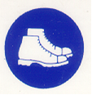

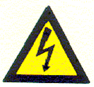
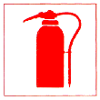


- What does PPE stands for?(1)

- Complete the following table to show your understanding of which PPE should be used for each part of the body.(15)
Body Parts | Hazard | PPE | Notes
Eyes
Ears
Hands and arms
Feet and legs
- Give three (3) examples of health and safety hazards that can occur in the sugar mill factory.(3)

- Discuss the importance of periodic checks of health and safety equipment in the workplace.(4)

- Why is it important to maintain PPE’s? (2)

- List six (6) types of machine guards.(5)

- List the possible control measures for the machine guards.(6)
- Discuss the need for safety signs in the workplace. (2)

- Discuss the importance for sugar mills to provide written isolation procedures. Provide examples of where isolation procedures are required.(7)
Learning activity 2.2: Group Learning activity: 30 minutes (15 marks)

Learning Objective: General rules and principles of safe work practices can be explained for different scenarios.
Task: Form 4 groups. Do this by assigning everyone a number from 1 to 4. All the “ones” form one group, all the “twos” form the next group, all the “threes” form the third group and all the “fours” form the fourth group.
When you are in your groups, elect one person to be the group’s scribe (the person who will write down the points of your discussion), elect one person to be the group’s time-keeper (this person reminds the group that they are running out of time for the exercise) and one person who will be the group’s reporter (the person who will explain your findings to the class).
- Discuss and capture a list of housekeeping tasks that the team is responsible for on a daily, weekly and monthly basis. Think about each part of the factory. What housekeeping tasks should be done regularly on a continuous basis to ensure a safe and healthy working environment? (15)
When the time is finished groups report back to the class. Capture any housekeeping task that you overlooked in your list.
Learning activity 2.3: Individual Learning activity: 30 minutes (21 marks)
Learning Objective: General rules and principles of safe work practices can be explained for different scenarios.
Task: Read each question carefully and write your answer in the space provided.
- Identify hazards that can be controlled by isolation.(3)

- Discuss the reasons for implementing emergency procedures in the milling industry.(2)
- List six (6) types of unscheduled shutdowns that may occur in the sugar mill.(6)

- Discuss the control measures for emergency shutdowns and stoppages.(6)
- Explain the meanings of each of these warning signs (4)
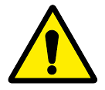
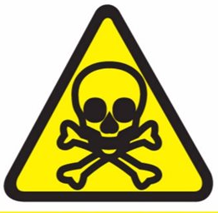
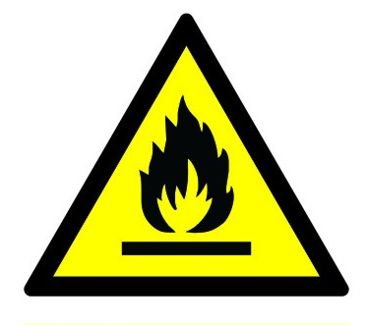


Learning activity 2.4: Group Learning activity: 2 hours (20 marks)
Learning Objective: General rules and principles of safe work practices can be explained for different scenarios.
Make an appointment with the Sugar Mill manager for a comprehensive walking tour of the factory. The aim of the tour is to visit each of the parts and processes within the factory environment, from the delivery of raw materials through to the loading of the final product for delivery to the customers. At each process or piece of machinery discuss the risks and the hazards that are present at that place.
Use the space provided below to name each part of the factory and to describe the risk or hazard associated with that part of the factory. Discuss and note ways in which accidents at these points can be avoided. (20)
Part of factory | Risk or Hazard | How accidents can be avoided

Learning activity 2.5: Individual Learning activity: 30 minutes (30 marks)
Learning Objective: General rules and principles of safe work practices can be explained for different scenarios
Task: Read each question carefully and write your answer in the space provided.
- What does hot work mean?(2)

- Discuss the guidelines you need to follow when using fire suppression equipment (fire extinguishers etc.).(6)

- List four (4) steps for fire prevention at your workplace.(4)

- What is a dust explosion and what are the conditions that cause a dust explosion?(6)

- List two (2) types of process equipment found where sugar dust is processed.(2)

6. Discuss the general safety measures in maintaining fire protection in the workplace.(10)

Learning activity 2.6: Individual Learning activity: 30 minutes (24 marks)
Learning Objective: General rules and principles of safe work practices can be explained for different scenarios.
Task: Read each question carefully and write your answer in the space provided.
- What is the first thing you should do when you come across an injured person?(1)

- Discuss two (2) steps to follow when you encounter an injured person. (5)

- List six (6) signs of a spinal injury.(6)

- Discuss three (3) ways you can use to move an unconscious person out of immediate danger depending on the injuries sustained. (6)

- List six (6) tips for safe lifting in the working environment.(6)

4.3 Knowledge Topic 3: Sugar processing specific health, safety and environmental protection concepts (50%)
Topic elements to be covered include:
- KT0301 Specific risks in a Sugar Processing Plant
- KT0302 Restricted access areas in a Sugar Processing Plant
- KT0303 Environmental pollution and preventative measures
- KT0304 Hazardous chemicals and chemical handling
- KT0305 Waste handling
Internal Assessment Criteria and Weight
- IAC0301 Risks and measures to address risks can be explained
- (Weight 50%)

Learning activity 3.1: Individual Learning activity: 1 hour (37 marks)
Learning Objective: Risks and measures to address risks can be explained
Task: Read each question carefully and write your answer in the space provided.
- List four (4) types of electrical risks in a sugar mill.(4)

- Discuss eight (8) control measures for slips, trips and falls in the workplace.(8)

- What can be done to minimise the risks of being hit by a moving object?(7)
- Explain the benefit of access control systems in a Sugar Processing Plant.(4)

- Discuss the reasons for access control systems in the Sugar Processing Plant.(8)

- List five (5) types of vessels that can be found in a Sugar Mill Factory.(4)

- Why is it important to have restricted access into confined spaces?(2)

Learning activity 3.2: Individual Learning activity: 30 minutes (24 marks)
Learning Objective: Risks and measures to address risks can be explained.
Task: Read each question carefully and write your answer in the space provided.
- Mention the main source of air pollution from the Sugar industry?(1)

- List three (3) major pollutants in the Sugar Industry.(3)

- List five (5) types of hazardous chemicals found within the sugar mill.(5)
- Discuss the methods of risk reduction within sugar milling operations regarding hazardous chemicals.(10)

- Laboratory staff may have frequent exposure to a large range of hazardous chemicals in small quantities. What control measures can be implemented to minimise the risk of exposure. Mention five (5) points. (5)

Learning activity 3.3: Individual Learning activity: 1 hour (39 marks)
Learning Objective: Risks and measures to address risks can be explained.
Task: Read each question carefully and write your answer in the space provided.
- List eight (8) early symptoms of lead poisoning.(8)

- Discuss the possible control measures for lead to ensure health and safety in the workplace.(10)

- The fumes and gases arising from welding and cutting processes may contain hazardous chemicals. List three (3) hazardous components of fumes.(3)

- Discuss two (2) types of ventilation systems.(4)

- What is methane gas?(2)

- Discuss the conditions where sugar dust can cause an explosion.(4)

- Discuss the monitoring of methane gas before permitting entry to a flammable atmosphere.(6)

- What is filter cake? (2)

Learning activity 3.4: Individual Learning activity: 10 minutes (6 marks)
Learning Objective: Risks and measures to address risks can be explained.
Task: Read each question carefully and write your answer in the space provided.
- What is bagasse?(2)

- Discuss how the sugar mill manages bagasse and filter cake waste.(4)

4.4 Knowledge Topic 4: Environmental protection and pollution concepts (10%)
Topic elements to be covered include:
- KT0401 Carbon footprint, global warming and green production principles
- KT0402 Sources of and impact of contaminates on the natural environment
- KT0403 General rules related to waste control measures
- KT0404 The impact of environmental pollution on natural resources, communities and the economy
Internal Assessment Criteria and Weight
- IAC0401 Environmental pollution risks and preventative measures can be explained
- (Weight 10%)

Learning activity 4.1: Individual Learning activity: 30 minutes (28 marks)
Learning Objective: Environmental pollution risks and preventative measures can be explained.
Task: Read each question carefully and write your answer in the space provided.
- What is the carbon footprint?(2)

- List the effects of an excessive carbon footprint.(5)

- Define Global warming.(2)

- Discuss the goal of green manufacturing.(2)

- Define environmental pollution.(2)
- List ten (8) sources of water contamination.(8)

- Describe the negative impacts of pollution on the environment.(7)
Learning activity 4.2: Individual Learning activity: 2 hours (70 marks)
Learning Objective: Environmental pollution risks and preventative measures can be explained.
Task: Read each question carefully and write your answer in the space provided.
- Discuss the practices to be followed by facilities that generate and store waste.(10)

- List four (4) types of waste management strategies.(8)

- Discuss four (4) preventative strategies of waste.(8)

- How can waste be stored so as to prevent contaminating the environment?(10)
- Discuss the three (3) techniques of thermal waste treatment.(6)

- Discuss biological waste treatment techniques.(4)

- What is the most common waste disposal solution?(1)

- Discuss the negative impacts of liquid effluent on the environment.(8)
- Discuss the monitoring activities associated with management of hazardous and non-hazardous waste.(15)

CONCLUSION OF KNOWLEDGE MODULE 1: OCCUPATIONAL SAFETY, HEALTH AND ENVIRONMENTAL PROTECTION
Throughout this knowledge module you have been provided opportunities to complete formative learning activities. You have captured your results in this Learner Workbook.
The total marks for this Knowledge Module are as follows:
Knowledge Module | Total Marks | Marks attained
KM-01-KT01: The statutory framework of Safety, Health and Environmental Protection in the workplace (10%) | 55
KM-01-KT02: General rules and principles of safe work practices (30%) | 171
KM-01-KT03: Sugar processing specific health, safety and environmental protection concepts (50%) | 106
KM-01-KT04: Environmental protection and pollution concepts (10%) | 98
Total Marks | 430marks



