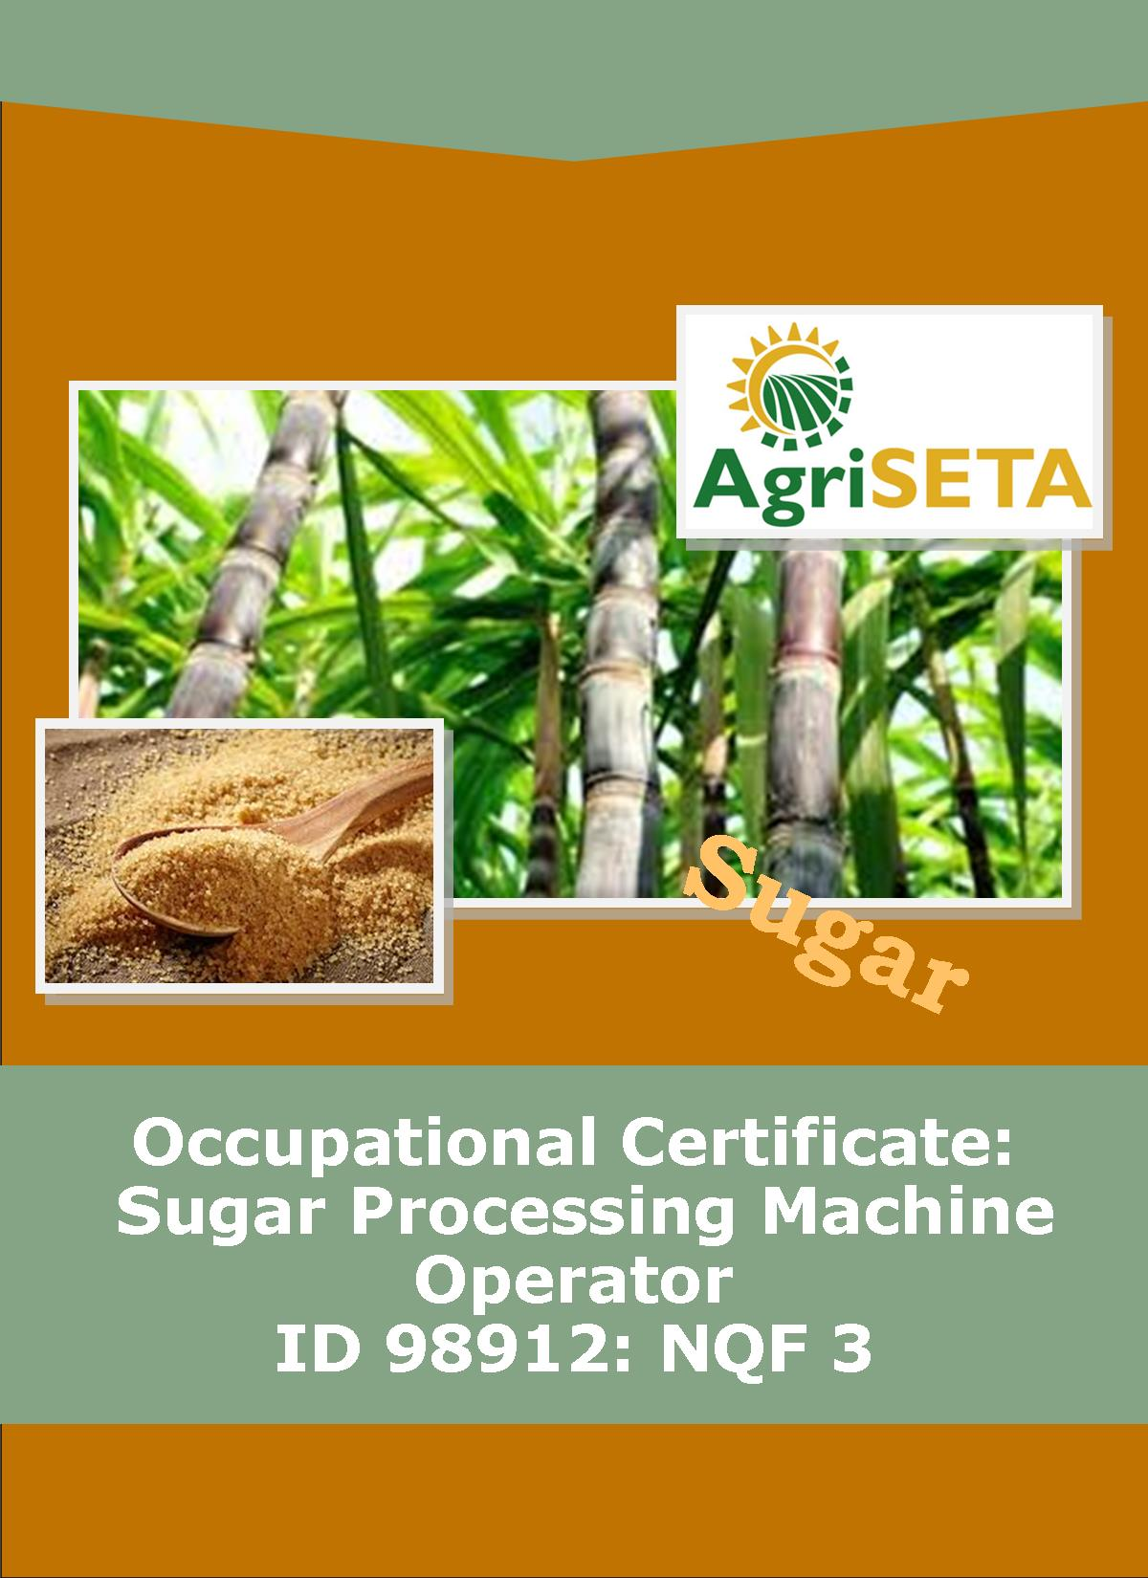
LEARNER SUMMATIVE ASSESSMENT TOOL: KNOWLEDGE MODULE 1: OCCUPATIONAL SAFETY, HEALTH AND ENVIRONMENTAL PROTECTION
KNOWLEDGE COMPONENT: LEARNER SUMMATIVE ASSESSMENT TOOL KNOWLEDGE MODULE 1: OCCUPATIONAL SAFETY, HEALTH AND ENVIRONMENTAL PROTECTION
Occupational Certificate: Sugar Processing Machine Operator

LEARNER SUMMATIVE ASSESSMENT TOOL

KNOWLEDGE MODULE 1:
OCCUPATIONAL SAFETY, HEALTH AND ENVIRONMENTAL PROTECTION
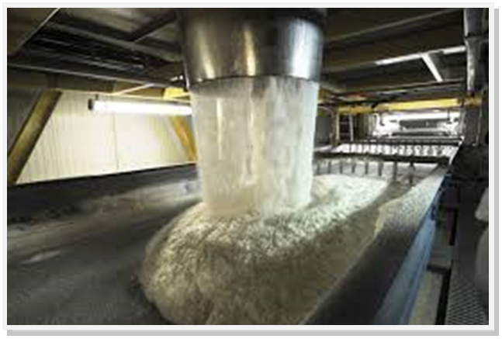
OCCUPATIONAL CERTIFICATE: ID 98912: SUGAR PROCESSING MACHINE OPERATOR

©Copyright AgriSETA
Telephone: +27 12 301 5600
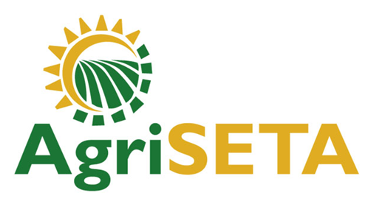

AgriSETA holds the copyright to its publications and Web pages. Proper citation is requested.

TABLE OF CONTENTS

1. STAKEHOLDER INFORMATION 6
2. COMPETENCY SUMMARY OF ASSESSMENT 8
3. ASSESSMENT ALIGNMENT MATRIX (INTERGRATED OUTCOMES) 10
4. ASSESSMENT DECISION & EVIDENCE EVALUATION RECORD 12
5. OVERALL ASSESSMENT DECISION 13
6. Evidence of feedback 14
7. OVERALL RESULTS 15
8. ASSESSMENT REVIEW 16
9. FINAL DECISION 18
10. LEARNER FEEDBACK FORM 19
11. SUMMATIVE ASSESSMENT INSTRUCTIONS 20
12. WRITTEN ASSESSMENT 21
13. FINAL MARKS 29

STAKEHOLDER INFORMATION
LEARNER INFORMATION
Name
Surname
ID number
Mobile phone contact number
E-mail address
Physical address
Postal address
Employer Name
Employer Contact Details

ASSESSOR DETAILS
Name
Surname
Assessor ID
Project Name | Occupational Certificate ID 98912:Sugar Processing Controller
Module No. | Module 1: Occupational Safety, Health and Environmental Protection
Date of Assessment
Portfolio submission Date
Assessor Signature
Total Marks for Knowledge Module 9 | 90 marks
Marks attained
Place:

MODERATOR DETAILS
Moderator Name
Moderator ID
Moderator Signature
Date of Moderation

COMPETENCY SUMMARY OF ASSESSMENT
Module 1 | KM-1-KT01: The statutory framework of Safety, Health and Environmental Protection in the Workplace | C | NYC
1 | 1.1. Introduction to the legislative framework
 | 1.2.Regulation and enforcement of the Act
 | 1.3.Appointment, functions, rights and duties of Health and Safety Committees and Representatives at work
 | 1.4. Duties and responsibilities of persons at work
2 | KM-1-KT02: General rules and principles of safe work practices | C | NYC
 | 2.1 Good housekeeping practices and risks
 | 2.2.Safety signs and symbols
 | 2.3.Personal protective equipment
 | 2.4.Machine guarding and operational safety precautions
 | 2.5. Lock out procedures
 | 2.6. Emergency procedures
 | 2.7. Restricted entrance
 | 2.8. Fire prevention
 | 2.9. Incident on duty and reporting
 | 2.10. Universal precautions when attending to injured persons
 | 2.11. Provisions related to intoxication, unauthorised use of motorised or mobile equipment
 | 2.12. Safe material lifting
 | 2.13. Material stacking
3 | KM-1-KT03: Sugar processing specific health, safety and environmental protection concepts | C | NYC
 | 3.1. Specific risks in a Sugar Processing Plant
 | 3.2. Restricted access areas in a Sugar Processing Plant
 | 3.3. Environmental pollution and preventative measures
 | 3.4. Hazardous chemicals and chemical handling
 | 3.5. Waste handling
4 | KM-1-KT05: Environmental protection and pollution concepts | C | NYC
 | 4.1. Carbon footprint, global warming and green production principles
 | 4.2. Sources of and impact of contaminates on the natural environment
 | 4.3. General rules related to waste control measures
 | 4.4. The impact of environmental pollution on natural resources, communities and the economy

ASSESSMENT ALIGNMENT MATRIX (INTERGRATED OUTCOMES)
Module No: 1 | How it is assessed (Assessment methodology) | Where is it covered (learning material) | Where it is assessed |  | First Submission
Module No: 1 | How it is assessed (Assessment methodology) |  | Summative | Formative
SAQA ID Number: 98912 | Two methods of assessment are followed which are:  1. Summative assessment: written tests, knowledge questions using fundamental and reflexive questions.  2. Formative assessment: assignments, tasks, portfolio of evidence submitted and presentations. |  |  |  | Clearly meets all the criteria | Meets some but not all criteria | Clearly does not meet any of the criteria
Title: Occupational Safety, Health and Environmental Protection
NQF level and credits:
NQF Level 2: 4 Credits
Topic: 1 The statutory framework of Safety, Health and Environmental Protection in the Workplace |  | Page 10 | Question 1.1 page 21
Assessment criteria:  The statutory provisions of the Act can be explained |  | Page 10-11 | Question 1.2 page 21 | Learning Activity 1.1 page11-12
Assessment criteria:  Duties and responsibilities of persons at work can be explained |  | Page 13-14 | Question 1.3 page 22 | Learning Activity 1.2 page13-16
Assessment criteria:  Functions, rights and duties of appointed persons can be explained |  | Page 14-18 | Question 1.4 page 22
Topic 2. General rules and principles of safe work practices |  | Page 19 | Question 1.5 page 22
Assessment criteria: General rules and principles of safe work practices can be explained for different scenarios |  | Page 19-56 | Question 1.6 page 23 | Learning Activity 2.1 page18-23
 |  | Page 19-56 | Question 1.7 page 23
 |  |  |  | Learning Activity 2.2 page 24-26
 |  | Page 19-56 | Question 1.8 page 23
 |  |  |  | Learning Activity 2.3 page 27-29
 |  | Page 19-56 | Question 1.9 page 24
 |  |  |  | Learning Activity 2.4 page30-31
 |  | Page 19-56 | Question 1.10 page 24
 |  | Page 19-56 | Question 1.11 page 25
 |  | Page 19-56 | Question 1.12 page 25
 |  |  |  | Learning Activity 2.5 page 32-35
 |  | Page 19-56 | Question 1.13 page 25
 |  |  |  | Learning Activity 2.6 page 36-39
 |  | Page 19-56 | Question 1.14 page 26
 |  | Page 19-56 | Question 1.15 page 26
 |  | Page 19-56 | Question 1.16 page 26
Topic 3. Sugar processing specific health, safety and environmental protection concepts |  | Page 57
Assessment criteria: Risks and measures to address risks can be explained |  | Page 57-78 | Question 1.17page 27 | Learning Activity 3.1 page41-44
 |  |  |  | Learning Activity 3.2.page 45-47
 |  |  |  | Learning Activity 3.3.page 48-51
 |  |  |  | Learning Activity 3.4.page 52
Topic 4. Environmental protection and pollution concepts |  | Page 79
Assessment criteria: Environmental pollution risks and preventative measures can be explained |  | Page 79-94 | Question 1.18 page 27 | Learning Activity 4.1.page 54-56
 |  | Page 79-94 | Question 1.19 page 27
 |  |  |  | Learning Activity 4.2.page 57-62
 |  | Page 79-94 | Question 1.20 page 28

ASSESSMENT DECISION & EVIDENCE EVALUATION RECORD

Candidate's Name: -

Assessor's Name: -

Practical assessment
I declare that this assessment is my own demonstration.
Marks: The learner is either “Met requirements” or “did not meet requirements”. If the learner did not meet requirements in an area, then he or she must be reassessed.
Learner achieved: Met requirements /Did not meet requirements
KNOWLEDGE MODULE 1: OCCUPATIONAL SAFETY,HEALTH AND ENVIRONMENTAL PROTECTION
Overall outcome:

 | Specific Outcome | Met requirements | Did not meet requirements | Comments
1
 | Specific outcome | Met requirements | Did not meet requirements | Comments
2
 | Specific outcome | Met requirements | Did not meet requirements | Comments
3
 | Specific outcome | Met requirements | Did not meet requirements | Comments
4

OVERALL ASSESSMENT DECISION
Assessors Comments:

Signature of Assessor:

Date:

Evidence of feedback
Module No : 1
Level :2
Assessor :……………………………………………………………………………
Candidate :…………………………………………………………………………..
Date of final assessment:…………………………………………………………….
Evidence criteria | Achieved | Not
1. Constructive
2. Timeous (according to Plan)
3. Correct mode / medium
4. Participative
5. Developmental
6. Accurate
7. Specific
8. Documented
9. Directed to correct parties
Signing off date: …………………………………………….

..........……………. ………………………………….
Assessor Candidate

OVERALL RESULTS
OVERALL RESULT | Competent
OVERALL RESULT | Not Yet Competent
Declaration by Candidate
I, …………………………………………………………………….declare that I am satisfied that the feedback given to me by the Assessor was relevant, sufficient and done in a constructive manner. I accept the assessment decisions and do realise that have no further questions relating to this particular assessment process. I do realise that after this assessment decision, the moderator will either uphold or reverse this assessment decision taken by the assessor.
Candidate : _____________  _______________________  Date: __________________  Signature: ______________ |  | Assessor : _____________  _______________________  Date: __________________  Signature: ______________ |  | Moderator : _____________  _______________________  Date: __________________  Signature: ______________

ASSESSMENT REVIEW
Assessor’s Name |  |  |  |  |  |  |  |  | ID Number
Contact Details of Assessor |  | Email
 |  | Phone
 |  | Fax
PART 1
 | Review Criteria |  | Valid |  | Authentic | Current |  | Consistent |  |  | Reliable |  | Sufficient |  |  | Comments
Please conduct an honest review of the Assessment Instruments used in this assessment:
1 | Evidence Topic 1
 | Knowledge Assignment
 | Practical Assignment
 | Natural Occurring Evidence
 | Reflection
2 | Evidence Topic 2
 | Knowledge Assignment
 | Practical Assignment
 | Natural Occurring Evidence
 | Reflection
3 | Evidence Topic 3
 | Knowledge Assignment
 | Practical Assignment
 | Natural Occurring Evidence
 | Reflection
4 | Evidence Topic 4
 | Knowledge Assignment
 | Practical Assignment
 | Natural Occurring Evidence
 | Reflection
PART 2
No | Review Criteria |  |  |  |  |  |  |  |  | Yes |  | No |  |  | Remarks
1 | Do you feel the candidate was appropriately selected and prepared for the RPL assessment?
2 | Did the candidate interpret the evidence requirements appropriately?
3 | Was the assessment free of potential assessment barriers such as language, literacy, access to resources?
4 | Was the assessment evidence presented by the candidate valid, authentic, current and sufficient?
5 | Was the candidate’s workplace access to evidence sufficiently supportive of the assessment strategy?
6 | Do you feel you could make a fair, valid and reliable assessment decision?
Recommendations
(Feedback on Validity, authenticity, currency and sufficiency of candidate evidence.)
Assessor Signature |  |  |  |  |  |  | Date Review Completed

FINAL DECISION
I………………………………………………………. hereby declare Ms/Mr

………………………………………… Competent Not Yet Competent

FEEDBACK TO LEARNER:

……………………..………………………..………………………..……………………

……………………..………………………..………………………..………………………

……………………..………………………..………………………..………………………

……………………..………………………..………………………..………………………

SIGN: …………………………………… DATE: ……………………..........................
LEARNER FEEDBACK:

……………………..………………………..………………………..………………………

……………………..………………………..………………………..………………………

……………………..………………………..………………………..………………………

……………………..………………………..………………………..………………………

SIGN: ……………………………………… DATE: …………………….......................
MODERATOR FEEDBACK:

………………………..………………………..………………………..……………………

………………………..………………………..………………………..……………………

……………………..………………………..………………………..………………………

……………………..………………………..………………………..………………………

SIGN: …………………………………… DATE: ……………………........................

LEARNER FEEDBACK FORM
CRITERIA | EVIDENCE | CRITERIA | EVIDENCE
How did your assessor encourage you and put you at ease during the assessment process? |  | Were you given clear and constructive feedback?
Were your assessor’s questions clear and pitched at the right level of language usage? |  | Did your assessor assess all the evidence provided by you?
Do you believe that all the assessment criteria and knowledge requirements of the standard you were being measured against were considered in your assessment? |  | Were you aware of any discrimination practice carried out by your assessor towards you?

LEARNER SIGNATURE:………………………………………………

DATE:.…………………………..

SUMMATIVE ASSESSMENT INSTRUCTIONS
Instructions
- Work individually and answer all questions.
- Use a black pen and ensure that you complete the questions in your own handwriting.
- Time to spend on this assessment is 1.5hours.
- The marks you will attain for each question are shown in brackets.

WRITTEN ASSESSMENT
Candidate instruction: Complete the following multiple-choice questionnaire by marking the most appropriate response with an x in the space provided.
Scope of Assessment | Exit Level Outcome/s | Module/s
 | 1. Occupational Safety, Health and Environmental Protection | 1
Alignment – Learning Outcome 1: Occupational Safety, Health, Environmental Protection

Award four marks for selection of valid “x”. Four marks = Competent

1.1 | The OHS Act serves to provide |  | Mark Allocation
a. |  | The protection of persons other than persons at work against hazards to health and safety arising out of or in connection with the activities of persons at work
b. |  | to establish an advisory council for occupational health and safety; and to provide for matters connected therewith
c. |  | For the health and safety of persons at work and for the health and safety of persons in connection with the use of plant and machinery
d. |  | All of the above
e. |  | None | (4)

1.2 | Choose the most correct answer; the role of the inspectors is to? |  |  | Mark Allocation
a. |  | To establish an advisory council for Occupational Health and Safety.
b. |  | To determine what category of work will be termed listed work
c. |  | To describe certain prohibitions related to the act
d. |  | To describe the designation of inspectors by the Minister
e. |  | To make sure that employers and employees are doing their bit to make the workplace safer, to prevent accidents, and, thereby to save money all-round | (4)
1.3 | The following issues must be discussed during the negotiations of appointing committees and representatives? |  | Mark Allocation
a. |  | Nomination or election of health and safety representatives
b. |  | Terms of office, circumstances and manner in which they can be removed
c. |  | Manner in which vacancies are to be filled
d. |  | All of the above
e. |  | None | (4)

1.4 | Which function is not of the OHSA committees? |  | Mark Allocation
a. |  | Make and keep records of recommendations to employers and inspectors
b. |  | Discuss report sand keep records of incidents in which someone is killed, injured, or becomes ill.
c. |  | Visit incidents sites and attend inspections
d. |  | All of the above
e. |  | None | (4)

1.5 | What are the benefits of effective housekeeping? |  | Mark Allocation
a. |  | Decreased fire hazards
b. |  | Better control of tools and materials, including inventory and supplies
c. |  | Better hygienic conditions leading to improved health
d. |  | Less janitorial work
e. |  | All of the above | (4)

1.6 | What is the meaning of the following sign?  |  | Mark Allocation
a. |  | Explosion risk
b. |  | Hot surface sign
c. |  | High voltage sign
d. |  | Toxic sign
e. |  | General warning sign | (4)

1.7 | What are PPE used for? |  | Mark Allocation
a. |  | To promote cleanliness
b. |  | To minimize exposure to hazards that cause serious workplace injuries and illnesses
c. |  | To make the job easy
d. |  | To impress the boss
e. |  | None | (4)

1.8 | Monitor and review of PPE involves? |  | Mark Allocation
a. |  | Checking regularly that PPE is used. If it isn’t, find out why not
b. |  | Safety signs can be a useful reminder that PPE should be worn
c. |  | Take note of any changes in equipment, materials and methods you may need to update what you provide
d. |  | All of the above
e. |  | None | (4)

1.9 | Which statement applies to fixed guards machine? |  | Mark Allocation
a. |  | are moveable, with the moving part interconnected with a control system
b. |  | prevent access to hazardous areas through a barrier or fence or safety glass partition
c. |  | automatically move into position as the machine or cycle is started
d. |  | stop a machine when a person gets into a position where they are liable to be injured
e. |  | have no moving parts and offer protection only when properly fixed in position | (4)

1.10 | Types of equipment that may be a confined space can include? |  | Mark Allocation
a. |  | Bagasse bins
b. |  | Boilers
c. |  | Pipes
d. |  | Sugar dryers
e. |  | All of the above | (4)

Award one mark for selection of valid “T/F”. One mark = Competent
1.11 | True/False the following are types of machine guards? |  | Mark Allocation
a. |  | Fixed guards
b. |  | Interlocking guards
c. |  | Distance guards
d. |  | Trip guards
e. |  | Automatic guards | (5)

1.12 | True/False the following are hazards which can be controlled by isolation? |  | Mark Allocation
a. |  | caustic soda
b. |  | steam
c. |  | Energy sources
d. |  | hot juice
e. |  | hydraulic | (5)

1.13 | True/False the following are conditions necessary for dust explosion to occur? |  | Mark Allocation
a. |  | The dust concentration must exceed 40g m³ of air (for a dust particle diameter of 0.08 microns).
b. |  | The air humidity must be below 60%.
c. |  | A source of ignition (electric or electrostatic spark, a cigarette, a naked flame etc.
d. |  | Filter cake
e. |  | The oxygen content of air must be 10 – 125 (it is actually well above this). | (5)

1.14 | True/False the following incidents should be reported and investigated? |  | Mark Allocation
a. |  | When a person dies
b. |  | When a person becomes unconscious
c. |  | When a person suffers the loss of a limb or part of a limb
d. |  | When a person is unable to work for 14 days or longer because of a work related incident
e. |  | When are person had a minor and injury and treated | (5)

1.15 | True/False the following are signs of spinal injury? |  | Mark Allocation
a. |  | Headache
b. |  | Not moving the neck
c. |  | Losing control of the bladder or bowels.
d. |  | Being unconscious or confused.
e. |  | The head or neck is twisted in a strange position | (5)

1.16 | True/False the following are methods of moving an unconscious person in immediate danger? |  | Mark Allocation
a. |  | Leg drag method
b. |  | Arm drag method
c. |  | Clothing drag method
d. |  | human crutch method
e. |  | Rolling the person onto their side | (5)

1.17 | True/False: the following are sources of air pollution? |  | Mark Allocation
a. |  | Heavy metals
b. |  | Decomposition of garbage that releases unwanted gases in the air
c. |  | Use of leaded petrol in automobiles
d. |  | Solid waste
e. |  | Pathogens | (5)

1.18 | The following are the negative environmental impacts of pollution. |  | Mark Allocation
a. |  | Acid rain
b. |  | Global warming
c. |  | Greenhouse effect
d. |  | Ozone hole
e. |  | Endangered animals | (5)

1.19 | True/False: Hazardous waste should be stored? |  | Mark Allocation
a. |  | Store in closed containers away from direct sunlight, wind and rain
b. |  | In a manner that prevents the commingling or contact between incompatible wastes, and allows for inspection between containers to monitor leaks or spills.
c. |  | Provide adequate ventilation where volatile wastes are stored
d. |  | Anyhow in the landfill site
e. |  | In the river banks | (5)

1.20 | True or False: The following are classified as thermal waste treatment techniques? |  | Mark Allocation
a. |  | Composting
b. |  | Incineration
c. |  | Open Burning
d. |  | Anaerobic Digestion
e. |  | Gasification and Pyrolysis | (5)

FINAL MARKS

TOTAL MARKS: 90
PASS MARK: 72
LEARNER MARKS
PERCENTAGE
ASSESSOR SIGNATURE:

