
KNOWLEDGE COMPONENT: LEARNING RESOURCE: BOOK 1: OCCUPATIONAL SAFETY, HEALTH AND ENVIRONMENTAL PROTECTION
OCCUPATIONAL QUALIFICATION: SUGAR PROCESSING MACHINE OPERATOR

KNOWLEDGE COMPONENT:
LEARNING RESOURCE

BOOK 1: OCCUPATIONAL SAFETY, HEALTH AND ENVIRONMENTAL PROTECTION
KNOWLEDGE COMPONENT: LEARNING RESOURCE BOOK 1: OCCUPATIONAL SAFETY, HEALTH AND ENVIRONMENTAL PROTECTION
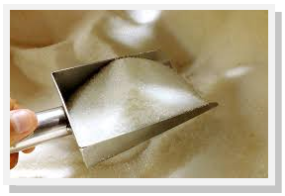
OCCUPATIONAL QUALIFICATION:
SUGAR PROCESSING MACHINE OPERATOR

©Copyright AgriSETA
Telephone: +27 12 301 5600
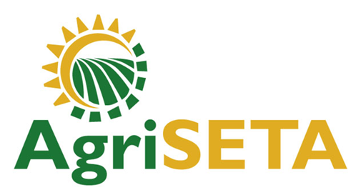

AgriSETA holds the copyright to its publications and Web pages. Proper citation is requested.

TABLE OF CONTENTS
KNOWLEDGE MODULE 1 OCCUPATIONAL SAFETY, HEALTH AND ENVIRONMENTAL PROTECTION 9

1. Knowledge Topic 1: The statutory framework of Safety, Health and Environmental Protection in the Workplace 10
1.1 INTRODUCTION TO THE LEGISLATIVE FRAMEWORK 10
1.2 REGULATION AND ENFORCEMENT OF THE ACT 12
1.3 APPOINTMENT, FUNCTIONS, RIGHTS AND DUTIES OF HEALTH AND SAFETY COMMITEES AND REPRESENTATIVES AT WORK 13
1.3.1 Appointment of health and safety committees and representatives at work 13
1.3.2 OHSA representatives 14
1.3.3 Functions of health and safety representatives (section 18 of the OHS Act) 14
1.3.4 Duties of health and safety committees and representatives at work 15
1.4 DUTIES AND RESPONSIBILITIES OF PERSONS AT WORK 15
1.4.1 Duties of Employers 16
1.4.2 Duties of Employees 17

2. Knowledge Topic 2: General rules and principles of safe work practices 19
2.1 GOOD HOUSEKEEPING PRACTICES AND RISKS 19
2.1.1. Benefits of good housekeeping 19
2.1.2. Key methods for maintaining good housekeeping 19
2.2 SAFETY SIGNS AND SYMBOLS 20
2.3 PERSONAL PROTECTIVE EQUIPMENT 23
2.3.1 What is PPE? 23
2.3.2 Why is PPE important? 24
2.3.3 Types of PPE’s to be used 24
2.3.4 PPE Maintenance 26
2.4 MACHINE GUARDING AND OPERATIONAL SAFETY PRECAUTIONS 27
2.4.1 Types of machine guards 27
2.4.2. Possible control measures with machine guards 28
2.5 LOCK OUT PROCEDURES 29
2.5.1. Where lock-out or isolations procedures may be required 29
2.5.2. Possible control measures regarding isolation and lockout 31
2.6 EMERGENCY PROCEDURES 32
2.6.1 Reasons for implementing emergency procedures 32
2.6.2 Possible control measures for emergency shutdowns and stoppages 33
2.7 RESTRICTED ENTRANCE 33
2.7.1 Types of equipment that constitute confined spaces 33
2.7.2 Possible control measures for work in confined spaces 36
2.8 FIRE PREVENTION 39
2.8.1 Dust explosions and spontaneous combustion risks 39
2.8.2 Fire risks and preventative measures 41
2.9 INCIDENT ON DUTY AND REPORTING 45
2.10 UNIVERSAL PRECAUTIONS WHEN ATTENDING TO INJURED PERSONS 47
2.10.1 Steps to follow when you encounter an injured person 48
2.10.2 How to move an injured person who is in immediate danger 50
2.11 PROVISIONS RELATED TO INTOXICATION, UNAUTHORISED USE OF MOTORISED OR MOBILE EQUIPMENT 53
2.11.1 Intoxication 53
2.11.2 Revolving machinery 53
2.11.3 Washing machines, centrifugal extractors, etc. 54
2.12 SAFE MATERIAL LIFTING 54
2.13 MATERIAL STACKING 56

3. Knowledge topic 3: Sugar processing specific health, safety and environmental protection concepts 57
3.1 SPECIFIC RISKS IN A SUGAR PROCESSING PLANT 57
3.1.1 Electrical Risks 57
3.1.2 Slips, trips and falls 59
3.1.3 Falling objects 60
3.2 RESTRICTED ACCESS AREAS IN A SUGAR PROCESSING PLANT 62
3.3 ENVIRONMENTAL POLLUTION AND PREVENTATIVE MEASURES 65
3.3.1 Air pollution in the sugar industry 65
3.4 HAZARDOUS CHEMICALS AND CHEMICAL HANDLING 66
3.4.1 Types of hazardous chemicals in a Sugar Mill 66
3.4.2 Laboratory chemicals 68
3.4.3 Lead 69
3.4.4 Welding and cutting fumes 71
3.4.5 Methane gas 73
3.4.6 Sugar dust 75
3.5 WASTE HANDLING 76

4. Knowledge topic 4: Environmental protection and pollution concepts 79
4.1 CARBON FOOTPRINT, GLOBAL WARMING AND GREEN PRODUCTION PRINCIPLES 79
4.1.1 What is “Carbon Footprint”? 79
4.1.2 What is Global Warming? 81
4.1.3 Green Production 81
4.2 SOURCES OF AND IMPACT OF CONTAMINATES ON THE NATURAL ENVIRONMENT 84
4.3 GENERAL RULES RELATED TO WASTE CONTROL MEASURES 86
4.3.1 General waste management 87
4.3.2 Hazardous waste management 89
4.4 THE IMPACT OF ENVIRONMENTAL POLLUTION ON NATURAL RESOURCES, COMMUNITIES AND THE ECONOMY 93
4.4.1 Negative impacts of liquid effluent 93
4.4.2 Impact of Solid Waste 94

AN INTRODUCTION TO THIS LEARNING RESOURCE
This Knowledge Component Learning Resource: Book 1: Occupational Safety, Health and Environmental Protection: is intended to be used with the Knowledge Component Learner Workbook 1 (Formative Assessment Guide): Occupational Safety. Health and Environmental Protection: Sugar Processing Machine Operator NQF 3. It can also be used as a stand-alone information resource (text book).
This Learning Resource provides detailed information on the following topics:
- KM-1-KT01: The statutory framework of Safety, Health and Environmental Protection in the Workplace (10%)
- KM-1-KT02: General rules and principles of safe work practices (30%)
- KM-1-KT03: Sugar processing specific health, safety and environmental protection concepts (50%)
- KM-1-KT04: Environmental protection and pollution concepts (10%)
(Note: KM = Knowledge Module, KT = Knowledge Topic)

KNOWLEDGE MODULE 1 OCCUPATIONAL SAFETY, HEALTH AND ENVIRONMENTAL PROTECTION
Module number: 716106000-KM-01: NQF Level 2: Credits 4
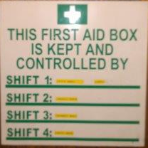
BACKGROUND
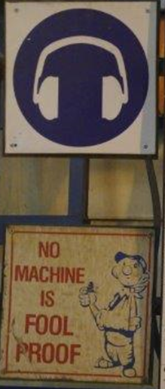
It is important, right at the outset, to remember that, apart from all the moral issues, occupational health and safety is also an economic issue: injuries suffered at the workplace and diseases contracted as a result of certain occupations have a number of consequences. They affect the lives and welfare of employees, they affect productivity, and they are costly.
There are also some cost-implications for the state, as a large part of costs incurred by occupational injuries and diseases are borne by the state in the form of, for example, compensation paid to ill and injured employees. The state also bears a part of the medical costs, and has to provide facilities for rehabilitating injured or ill employees where this is at all possible.
Similarly, industrial companies need to take responsibility for the maintenance and management of their effects on the environment in which they operate. This means that systems need to be set in place, and monitored and maintained which ensure zero negative impact to the social and natural environment in which they operate.

1. Knowledge Topic 1: The statutory framework of Safety, Health and Environmental Protection in the Workplace

1.1 INTRODUCTION TO THE LEGISLATIVE FRAMEWORK
The Occupational Health and Safety Act 85 of 1993 (abbreviated to OHSA) serves to provide for the health and safety of persons at work and for the health and safety of persons in connection with the use of plant and machinery; the protection of persons other than persons at work against hazards to health and safety arising out of or in connection with the activities of persons at work; to establish an advisory council for occupational health and safety; and to provide for matters connected therewith.
The aims of the Occupational Health and Safety Act are as follows:
- To establish an advisory council for Occupational Health and Safety
- To describe the functions of the council, the constitution of the council, the period of office and remuneration of the members of the council and provide for the establishment of technical committees of the council
- To describe the requirements of Health and Safety policies in the workplace
- To describe the general duties of employers to their employees as regards Health and Safety
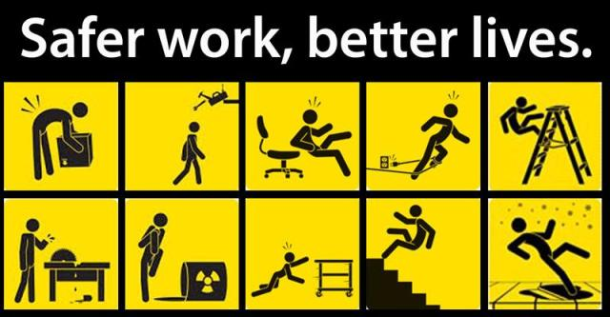
- To describe the general duties of employers and self-employed persons to persons other than their employees
- To describe the general duties of manufacturers and others regarding articles and substance for use at work
- To determine what category of work will be termed listed work
- To describe the general duties of employers regarding listed work
- To describe the duty of employers to inform their employees of the Health and Safety issues related to the work
- To describe the general duties of employees at work as regards Health and Safety
- To state that interference or misuse of anything related to Health and Safety is prohibited
- To charge Chief Executive Officers with certain duties as regards Health and Safety
- To state that Health and Safety representatives must be designated in each workplace
- To describe the functions of Health and Safety representatives
- To state that Health and Safety Committees must be established
- To describe the functions of the Health and Safety committees
- To describe certain prohibitions related to the act
- To state that the sale of certain articles which do not comply with the act is prohibited
- To state that certain deductions from employee’s salaries may not be made as regards Health and Safety compliance unless negligent intent to cause loss or damage can be shown.
- To state that Health and Safety incidents needs to be reported to an inspector
- To describe the designation and functions of the chief inspector
- To state that victimization of “whistle-blowing” as regards Health and Safety issues is prohibited
- To describe the designation of inspectors by the Minister
- To describe the functions of Health and Safety inspectors
- To describe the special powers of inspectors

- To put in place the mechanism that allows investigations and formal inquiries and joint inquiries to be made as regards Health and Safety issues and prohibiting the obstruction or failure to render assistance with such investigations, inquiries or the investigator, and a process whereby appeals can be lodged against the decision of such investigations
- To describe the requirement to disclose information or not
- To describe what constitutes acts or omissions by employees as regards Health and Safety
- To describe what constitutes offences, penalties and special orders of the court as they relate to Health and Safety compliance
- To describe the assumptions or “facts” surrounding Health and Safety issues and their exemptions
- To state that the Act is not affected by any other agreements
- To state that the Minister may delegate and assign any further duties he sees fits as regards the Health and Safety Act
- That the Minister may make regulations and that Health and Safety standards may be incorporated into the regulations

1.2 REGULATION AND ENFORCEMENT OF THE ACT
The role of the Occupational Health and Safety Act is to make sure that employers and employees comply with the requirements of the Act and provide for mechanisms to monitor and enforce such compliance. To this end the Act provides for supervisory mechanisms, the Chief Inspector and his/her inspectors who have special powers directly conferred on them by the Act itself. These inspectors should not be seen as the enemy: Their function is; after all, to make sure that employers and employees are doing their bit to make the workplace safer, to prevent accidents, and, thereby to save money all-round.

1.3 APPOINTMENT, FUNCTIONS, RIGHTS AND DUTIES OF HEALTH AND SAFETY COMMITEES AND REPRESENTATIVES AT WORK

1.3.1 Appointment of health and safety committees and representatives at work
According to Section 17 of the Occupational Health and Safety Act (Act 85 of 1993), employers who employ 20 or more workers on premises must appoint representatives to monitor health and safety conditions. One of the key principals of the OHS Act is that work related hazards, risks and dangers should be addressed through good communication between management and employees. Appointed representatives represent workers’ issues regarding safety and health matters to management. Representatives are part of an important link between management and the organisation’s employees.
The appointment of health and safety representatives is a legal requirement. Representatives need to be designated in writing and for a specified period of time. It is important to note that the appointment of representatives should be done in accordance with the agreement as contemplated in the General Administrative Regulations of the Occupational Health and Safety Act.
General Administrative Regulation 6 stipulates that after commencing business, the employer in any workplace where there must be a health and safety representative, must meet with the registered trade unions in order to enter into negotiations to conclude a collective agreement. Where there is no registered trade union, the employer must enter into consultation with all employee representatives of the workplace.
During these negotiations the following issues must be discussed in order to reach a collective agreement:
- Nomination or election of health and safety representatives
- Terms of office, circumstances and manner in which they can be removed
- Manner in which vacancies are to be filled
- Manner in which health and safety representatives must perform their functions in terms of the Act
- Facilities, training and assistance that must be provided to a health and safety representative

1.3.2 OHSA representatives
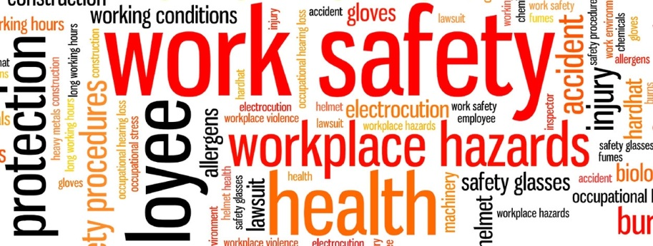
According to section 17 of the OHS Act, shops and offices must have at least 1 representative for every 100 workers or part thereof. All other workplaces must have at least 1 representative for every 50 workers or part thereof. The same section stipulates that representatives should be full-time workers who are familiar with the workplace.
According to the Act, representation activities must be performed during ordinary working hours.
Employers who have appointed 2 or more health and safety representatives must form health and safety committees. 1 or more health and safety committees must be formed when:
- employers have appointed 2 or more health and safety representatives; or
- Inspectors instruct employers to do so.

1.3.3 Functions of health and safety representatives (section 18 of the OHS Act)
It is the employer's duty to ensure that representatives are properly empowered to perform their duties as health and safety representatives. Representatives are entitled to attend incident investigations and enquiries, inspect documents and participate in internal health and safety audits.
Representatives may:
- Review effectiveness of health and safety measures
- Identify potential hazards and major incidents
- Examine causes of incidents
- Investigate complaints
- Advise the committee and the employer
Representatives shall be entitled to:
- Visit incidents sites and attend inspections
- Attend any investigation or formal inquiry
- Inspect any document related to health and safety matters
- Accompany an inspector
- Be accompanied by technical advisor if approved by the employer
- Participate in internal audits

1.3.4 Duties of health and safety committees and representatives at work
Duties of Committees:
- Make and keep records of recommendations to employers and inspectors; and
- Discuss report sand keep records of incidents in which someone is killed, injured, or becomes ill.
Duties of Representatives:
- Make representations to the employer on general health and safety of the employees
- Inspect the workplace including any article, substance, plant, machinery or health and safety equipment at that workplace.
- Participate in consultations with inspectors
- Receive information from inspectors and attend meetings of the health and safety committees of which he is a member.

1.4 DUTIES AND RESPONSIBILITIES OF PERSONS AT WORK

1.4.1 Duties of Employers
- Every employer shall provide and maintain, as far as is reasonably practicable, a working environment that is safe and without risk to the health of his employees.
- Without derogating from the generality of an employer's duties under subsection (1), the matters to which those duties refer include in particular:
  - The provision and maintenance of systems of work, plant and machinery that, as far as is reasonably practicable, are safe and without risks to health;
  - Taking such steps as may be reasonably practicable to eliminate or mitigate any hazard or potential hazard to the safety or health of employees, before resorting to personal protective equipment;
  - Making arrangements for ensuring, as far as is reasonably practicable, the safety and absence of risks to health in connection with the production, processing, use, handling, storage or transport of articles or substances;
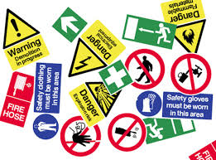
  - Establishing, as far as is reasonably practicable, what hazards to the health or safety of persons are attached to any work which is performed, any article or substance which is produced, processed, used, handled, stored or transported and any plant or machinery which is used in his business, and he shall, as far as is reasonably practicable, further establish what precautionary measures should be taken with respect to such work, article, substance, plant or machinery in order to protect the health and safety of persons, and he shall provide the necessary means to apply such precautionary measures;
- Providing such information, instructions, training and supervision as may be necessary to ensure, as far as is reasonably practicable, the health and safety at work of his employees;
- As far as is reasonably practicable, not permitting any employee to do any work or to produce, process, use, handle, store or transport any article or substance or to operate any plant or machinery, unless the precautionary measures contemplated in paragraphs above, or any other precautionary measures which may be prescribed, have been taken;
- Taking all necessary measures to ensure that the requirements of this Act are complied with by every person in his employment or on premises under his control where plant or machinery is used;
- Enforcing such measures as may be necessary in the interests of health and safety;
- Ensuring that work is performed and that plant or machinery is used under the general supervision of a person trained to understand the hazards associated with it and who have the authority to ensure that precautionary measures taken by the employer are implemented; and
- Causing all employees to be informed regarding the scope of their authority as contemplated in section 37 (1) (b).
- Decide on the number of health and safety committee members;
- Appoint committee members;
- Attend every committee meeting; and
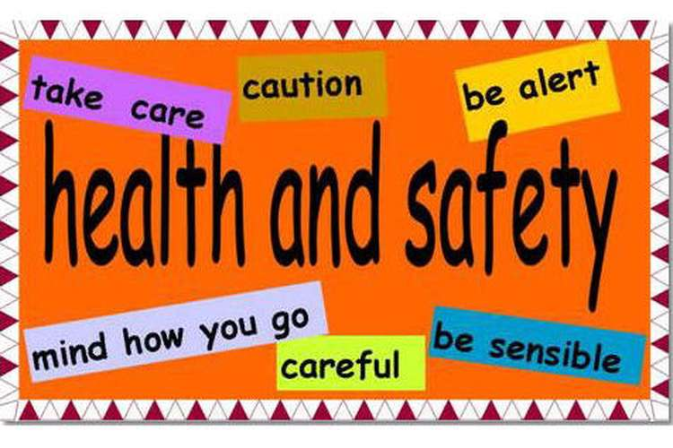
- Ensure that committees meet at least once every 3 months.

1.4.2 Duties of Employees
Every employee shall at work:
- Take reasonable care for the health and safety of himself and of other persons who may be affected by his acts or omissions;
- As regards any duty or requirement imposed on his employer or any other person by this Act, co-operate with such employer or person to enable that duty or requirement to be performed or complied with;
- carry out any lawful order given to him, and obey the health and safety rules and procedures laid down by his employer or by anyone authorized thereto by his employer, in the interest of health and safety;
- if any situation which is unsafe or unhealthy comes to his attention, as soon as practicable report such situation to his employer or the health and safety representative for his workplace or section thereof, as the case may be, who shall report it to the employer; and
- if he is involved in any incident which may affect his health or which has caused an injury to himself, report such incident to his employer or to anyone authorized thereto by the employer, or to his health and safety representative, as soon as practicable but not later than the end of the particular shift during which the incident occurred, unless the circumstances were such that the reporting of the incident was not possible, in which case he shall report the incident as soon as possible thereafter.

2. Knowledge Topic 2: General rules and principles of safe work practices

2.1 GOOD HOUSEKEEPING PRACTICES AND RISKS
Housekeeping is not just cleanliness. It includes keeping work areas neat and orderly, maintaining halls and floors free of slip and trip hazards, and removing of waste materials (e.g., paper, cardboard) and other fire hazards from work areas. It also requires paying attention to important details such as the layout of the whole workplace, aisle marking, the adequacy of storage facilities, and maintenance.
Good housekeeping is also a basic part of incident and fire prevention. Effective housekeeping can help control or eliminate workplace hazards. Poor housekeeping practices frequently contribute to incidents. If the sight of paper, debris, clutter and spills is accepted as normal, then other more serious hazards may be taken for granted. Effective housekeeping is an ongoing operation: it is not a one-time or hit-and-miss cleanup done occasionally. Periodic "panic" cleanups are costly and ineffective in reducing incidents.

2.1.1. Benefits of good housekeeping
Effective housekeeping results in:
- Reduced handling to ease the flow of materials
- Fewer tripping and slipping incidents in clutter-free and spill-free work areas
- Decreased fire hazards
- Lower worker exposures to hazardous products (e.g. dusts, vapours)
- Better control of tools and materials, including inventory and supplies
- More efficient equipment cleanup and maintenance
- Better hygienic conditions leading to improved health
- More effective use of space
- Reduced property damage by improving preventive maintenance
- Less janitorial work
- Improved morale
- Improved productivity (tools and materials will be easy to find)

2.1.2. Key methods for maintaining good housekeeping
Methods for maintaining good housekeeping include:
- Allocate responsibility for housekeeping for particular areas to teams or individuals and monitor and inspect this work
- Implement a system of inspections and record-keeping of housekeeping practices
- Implement a procedure or process for corrective action for identified hazards based on risk management practices
- Implement a strategy of barricading areas where spills have created a health and safety hazard. The barricade should be of a standard which will contain the spill and restrict access to the area.

2.2 SAFETY SIGNS AND SYMBOLS
Safety signs are a recognised method of identifying hazards and indicating caution within a workplace and consist of signs, symbolic signs, markings and colour. Signs have a range of applications but should be considered an administrative control only. This section covers the issues associated with the identification of hazards by means of signage with an aim to ensure known hazards are identified by means of signs, markings or colour and that all personnel are familiar with the meaning of safety signs and markings.
The use of appropriate signage will be determined from the risk assessment process. Signage should only be used in conjunction with other control measures. Mill operators should be aware of the language capabilities of employees and signage in other languages or symbols only may be required.
Hazards which can be identified by signage include:
- Physical hazards should be identified by means of colour,
- Confined spaces should be marked as required
- underground services (pipes and cables) should be marked by means of the appropriate marking tape
- Pipes, conduits and ducts should be identified
- Safety signs should be installed where required.

Hazard Signs/Symbols
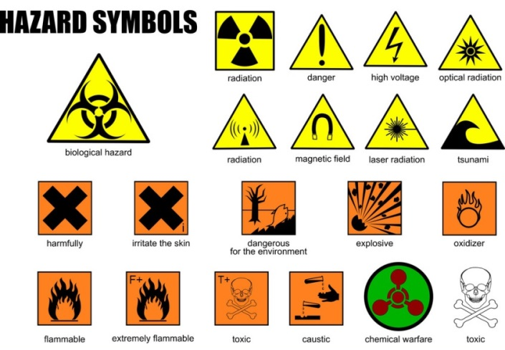
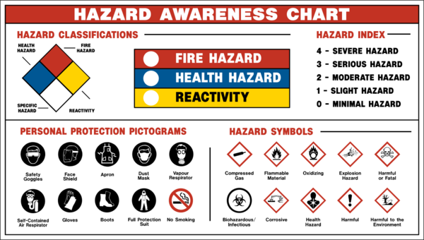

Instruction Signs/Symbols
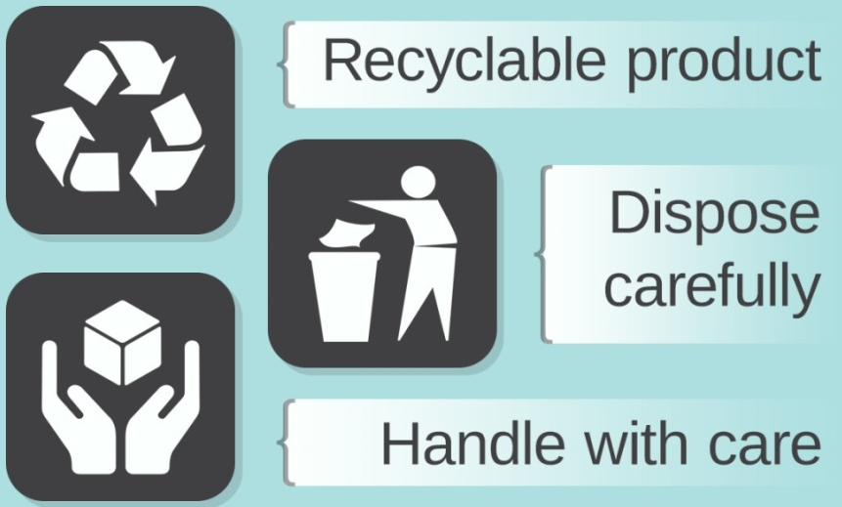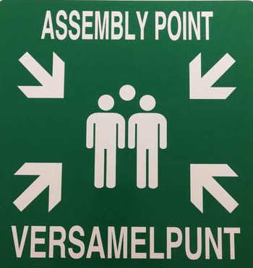
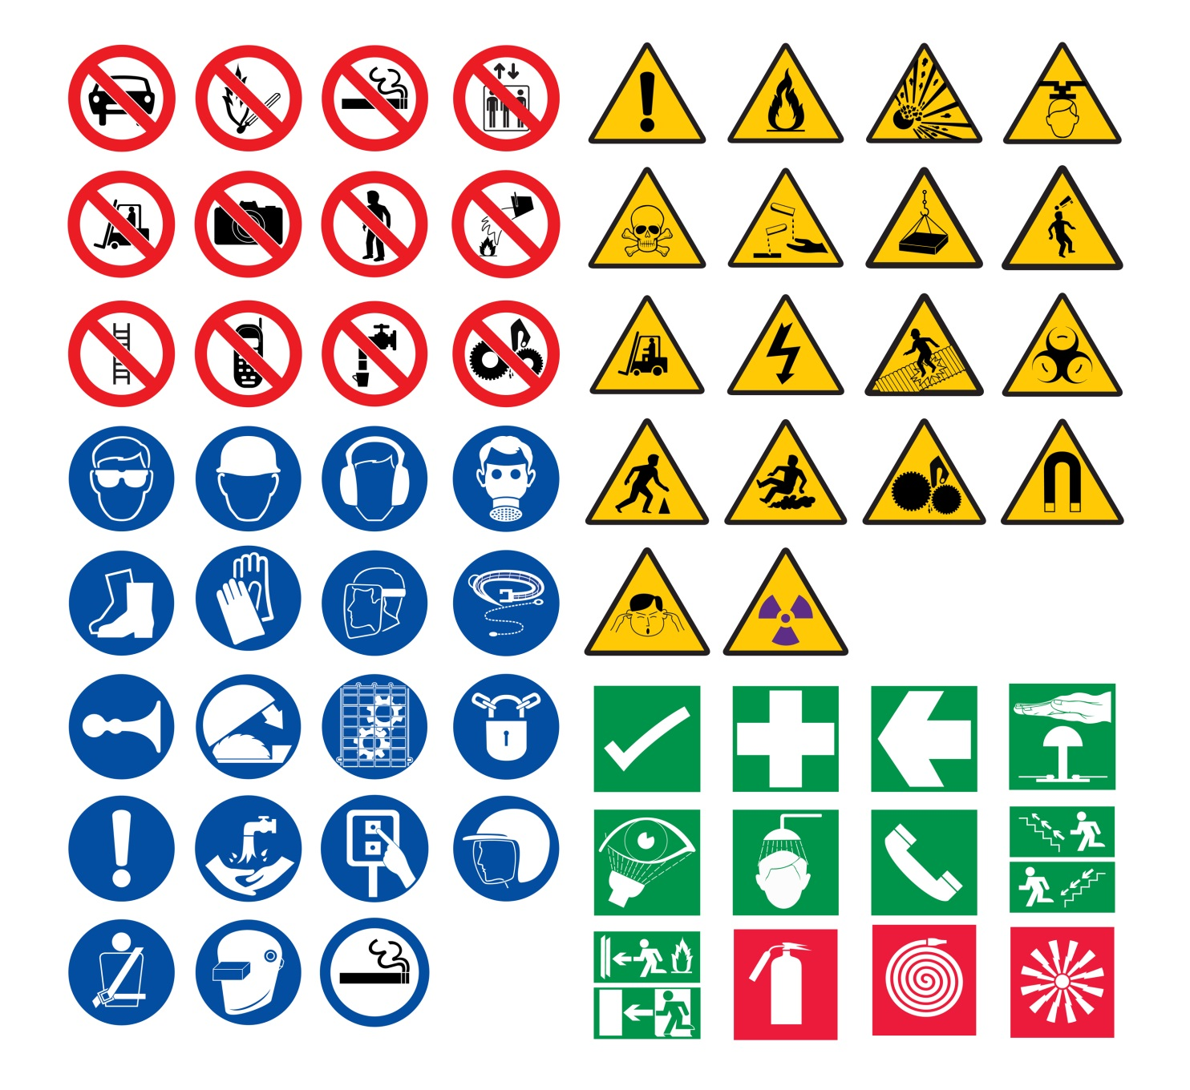

2.3 PERSONAL PROTECTIVE EQUIPMENT

2.3.1 What is PPE?
Personal protective equipment, commonly referred to as "PPE", is equipment worn to minimize exposure to hazards that cause serious workplace injuries and illnesses. These injuries and illnesses may result from contact with chemical, radiological, physical, electrical, mechanical, or other workplace hazards. Personal protective equipment may include items such as gloves, safety glasses and shoes, earplugs or muffs, hard hats, respirators, or coveralls, vests and full body suits.
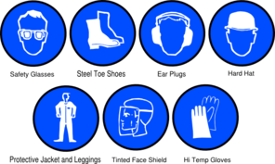
All personal protective equipment should be safely designed and constructed, and should be maintained in a clean and reliable fashion. It should fit comfortably, encouraging worker use. If the personal protective equipment does not fit properly, it can make the difference between being safely covered or dangerously exposed. When engineering, work practice, and administrative controls are not feasible or do not provide sufficient protection, employers must provide personal protective equipment to their workers and ensure its proper use. Employers are also required to train each worker who is required to use personal protective equipment so that they know:
- When it is necessary to wear PPEs
- What kind of PPEs it is necessary to wear
- How to properly put on, adjust, wear and take off PPEs
- The limitations of the equipment (if overalls are not fire retardant or fire proof, for example)
- Proper care, maintenance, useful life, and disposal of the PPEs
If PPE is to be used, a PPE program should be implemented. This program should address the hazards present; the selection, maintenance, and use of PPE; the training of employees; and monitoring of the program to ensure its ongoing effectiveness.

2.3.2 Why is PPE important?
Making the workplace safe includes providing instructions, procedures, training and supervision to encourage people to work safely and responsibly. Even where engineering controls and safe systems of work have been applied, some hazards might remain. These include injuries to:
- the lungs, e.g. from breathing in contaminated air
- the head and feet, e.g. from falling materials
- the eyes, e.g. from flying particles or splashes of corrosive liquids
- the skin, e.g. from contact with corrosive materials
- the body, e.g. from extremes of heat or cold
PPE is needed in these cases to reduce the risk.

2.3.3 Types of PPE’s to be used
Body Parts | Hazard | PPE | Notes
Eyes | Chemical or metal splash, dust, projectiles, gas and vapour, radiation | Safety spectacles, goggles, face screens, face shields, visors | Make sure the eye protection chosen has the right combination of impact/dust/splash/molten metal eye protection for the task and fits the user properly
Head and Neck | Impact from falling or flying objects, risk of head bumping, hair getting tangled in machinery, chemical drips or splash, climate or temperature | Industrial safety helmets, bump caps, hair-nets and fire fighters’ helmets | Some safety helmets incorporate or can be fitted with specially-designed eye or hearing protection  Don't forget neck protection, e.g. scarves for use during welding  Replace head protection if it is damaged
Ears | Noise – a combination of sound level and duration of exposure, very high-level sounds are a hazard even with short duration | Earplugs, earmuffs, semi-insert/canal caps | Provide the right hearing protectors for the type of work, and make sure workers know how to fit them  Choose protectors that reduce noise to an acceptable level, while allowing for safety and communication
Hands and arms | Abrasion, temperature extremes, cuts and punctures, impact, chemicals, electric shock, radiation, vibration, biological agents and prolonged immersion in water | Gloves, gloves with a cuff, gauntlets and sleeving that covers part or all of the arm | Avoid gloves when operating machines such as bench drills where the gloves might get caught  Some materials are quickly penetrated by chemicals - take care in selection.  Barrier creams are unreliable and are no substitute for proper PPE  Wearing gloves for long periods can make the skin hot and sweaty, leading to skin problems. Using separate cotton inner gloves can help prevent this
Feet and legs | Wet, hot and cold conditions, electrostatic build-up, slipping, cuts and punctures, falling objects, heavy loads, metal and chemical splash, vehicles | Safety boots and shoes with protective toecaps and penetration-resistant, mid-sole, wellington boots and specific footwear, e.g. foundry boots and chainsaw boots | Footwear can have a variety of sole patterns and materials to help prevent slips in different conditions, including oil - or chemical-resistant soles. It can also be anti-static, electrically conductive or thermally insulating  Appropriate footwear should be selected for the risks identified
Lungs | Oxygen-deficient atmospheres, dusts, gases and vapours | Some respirators rely on filtering contaminants from workplace air. These include simple filtering face pieces and respirators and power-assisted respirators  Make sure it fits properly, e.g. for tight-fitting respirators (filtering face pieces, half and full masks)  There are also types of breathing apparatus which give an independent supply of breathable air, e.g. fresh-air hose, compressed airline and self-contained breathing apparatus | The right type of respirator filter must be used as each is effective for only a limited range of substances  Filters have only a limited life. Where there is a shortage of oxygen or any danger of losing consciousness due to exposure to high levels of harmful fumes, only use breathing apparatus – never use a filtering cartridge  You will need to use breathing apparatus in a confined space or if there is a chance of an oxygen deficiency in the work area
Whole body | Heat, chemical or metal splash, spray from pressure leaks or spray guns, contaminated dust, impact or penetration, excessive wear or entanglement of own clothing | Conventional or disposable overalls, boiler suits, aprons, chemical suits | The choice of materials includes flame-retardant, anti-static, chain mail, chemically impermeable, and high-visibility  Don't forget other protection, like safety harnesses or life jackets

2.3.4 PPE Maintenance
PPE must be properly looked after and stored when not in use, e.g. in a dry, clean cupboard. If it is reusable it must be cleaned and kept in good condition.
Think about:
- Using the right replacement parts which match the original, e.g. respirator filters
- Keeping replacement PPE available
- Who is responsible for maintenance and how it is to be done
- Having a supply of appropriate disposable suits which are useful for dirty jobs where laundry costs are high, e.g. for visitors who need protective clothing
Employees must make proper use of PPE and report its loss or destruction or any fault in it.
Monitor and review
- Check regularly that PPE is used. If it isn’t, find out why not
- Safety signs can be a useful reminder that PPE should be worn
- Take note of any changes in equipment, materials and methods you may need to update what you provide.

2.4 MACHINE GUARDING AND OPERATIONAL SAFETY PRECAUTIONS

2.4.1 Types of machine guards
The types of guards and their suitability for particular applications include:
Fixed guards
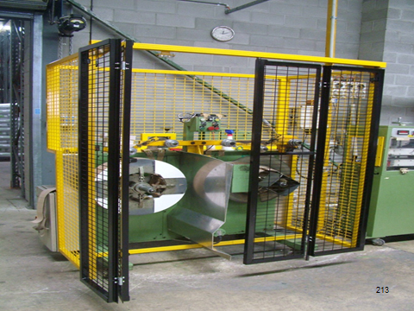
They have no moving parts and offer protection only when properly fixed in position. Where necessary for access, fixed guards should be easy to remove and replace but only be able to be opened or removed with a tool and where the moving parts that they are covering have been stopped.
Interlocking guards
These are moveable, with the moving part interconnected with a control system. Interconnections are usually electrical, mechanical, hydraulic or pneumatic. The interlock prevents the machinery from operating unless the guard is closed.
Automatic guards
These automatically move into position as the machine or cycle is started. These are only suitable on slow moving machines.
Distance guards
These prevent access to hazardous areas through a barrier or fence or safety glass partition.
Trip guards (presence sensing devices)
These stop a machine when a person gets into a position where they are liable to be injured. A photo-electric curtain is an example of this type of guard.

2.4.2. Possible control measures with machine guards
Management should conduct a separate risk assessment for each item of plant and any associated system of work used with that machine. The risk assessment should prioritize the risks associated with each machine individually so that effort can be directed to eliminating or controlling risks that have a high potential to cause harm. Fixed guards should be used where access is not necessary for operation, inspection, and maintenance or cleaning. 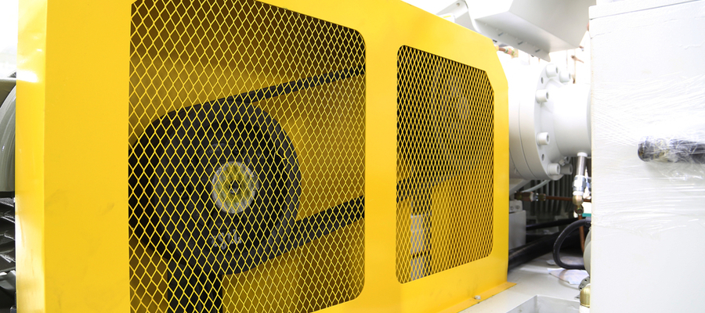
Where a risk assessment indicates a significant risk to workers required to work in close proximity to or interact with plant (e.g. power presses), interlocking guarding should be fitted that would prevent starting or operating the machine if the guard is removed. The system should be designed so that it is difficult to tamper with or bypass the interlock.
Interlocks should be fitted to all items of plant that may present a hazard if removed or changed (e.g. openings on tanks under high pressure or high temperature, exposed blades on disintegrators or a cutter or grinder). Such interlocks should prevent the plant from operating whenever the cover, door, lid or inspection hatch is removed or opened.
Where guarding is considered insufficient or easy to tamper with, the erection of barriers, fences or safety glass partitions should be considered. If an interlock system is malfunctioning and there is a need to operate the plant, a risk assessment may indicate that a barrier or fence may be a suitable short-term alternative. If appropriate, presence sensing devices may be fitted to prevent the plant from starting or operating.
Safe work procedures should be prepared, issued and signed off when access to hazardous parts of plant is required. The procedures should identify the circumstances where access to guarded parts is safe. This will prevent the need to tamper with guarding or interlocks. During the period when a guard is removed to enable access, appropriate lockout and tagout procedures should be used. The risks associated with plant that is remotely started and/or operated should be assessed and appropriate controls implemented.
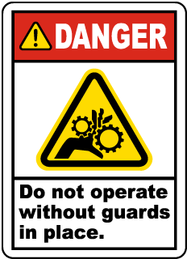
Controls may include:
- Signposting
- Flashing lights timed to operate prior to the plant activation
- Presence sensing devices
- Barriers or guards
- Audible alarms
- Local isolation switches.
Machine guarding and interlocks should be inspected and maintained at regular intervals. Records of inspection and maintenance should be kept. Elimination of a hazard should be considered when designing new plant or when replacing or modifying existing plant.

2.5 LOCK OUT PROCEDURES

2.5.1. Where lock-out or isolations procedures may be required
Isolation is used to eliminate or minimise the risks associated with energy sources whenever work involving removal, break-in, replacement, repair or other similar activity is performed by persons, or for the safe isolation of equipment to minimise potential damage. In the majority of cases lock out is the preferred method.
Hazards which can be controlled by isolation include:
- Hazardous chemicals (e.g. caustic soda or milk of lime)
- Hot materials (e.g. steam, hot juice, massecuite and other process streams)
- Energy sources (e.g. electrical, mechanical, heat, pneumatic or hydraulic).
In large mills where workers perform a range of different tasks it may be necessary to maintain and provide written isolation procedures, particularly:
- When plant is suspected of being in a hazardous condition (e.g. malfunctioning, broken or damaged) and inspection and repair/replacement is required
- Following an incident when it is necessary to isolate plant
- For routine inspection
- For any entry into plant by workers
- When it is desirable to prevent the use, including unlawful use of plant.
Isolation procedures can be item specific or generic such as procedures to:
- Replace or repair valves, pumps or pipe sections
- Replace screens
- Shredder hammer replacement.
- Cleaning inside large vessels (such as vats, chambers, silos, etc.)
An assessment of the risks should be conducted before any work involving removal or repair of plant, breaking into lines and systems or any other task that may involve exposure of workers to hazards from energy sources, is commenced.
Where significant risks have been identified, safe work procedures (such as a permit to work system) should be prepared with specific details for:
- Identified hazards such as energy sources (e.g. gravity, moving loads or steam).
- Type of lockout and other isolation devices to be used (e.g. locks – keys, multi-lock or code-lock, danger tags, out of service tags, mechanical devices – bars, clamps, chains, or removal of component, valve bleeding and other control measures).
- Stored energy should not be used to effect isolation (e.g. pneumatic valves which fail safe without a mechanical isolator). The use of manual isolation valves is recommended where possible.
- Application and removal of isolation and lockout devices (test-run machines before isolation).
- Identification of lockout points and zones of isolation systems.
- Dual drives.
- Nomination of trained and authorised personnel for isolation procedures for each work area (e.g. an isolation coordinator).
- Process and authority for over-riding any interlocks already in place.
- Regular testing of isolation systems and circuits, and
- Electrical items to be isolated from all sources of electrical power prior to the commencement of any work on the equipment.

2.5.2. Possible control measures regarding isolation and lockout
The following controls can be used to prevent or minimise the risk of injury from energy sources when using plant:
- Before commencing work on plant, all isolations and lock outs should be tested by competent persons.
- Where equipment is isolated regularly (i.e. during routine replacement or maintenance), isolation procedures or standard work procedures could be developed and used as required. If it is not possible to isolate the electricity supply, control measures should be implemented to prevent energising of the plant (e.g. through the use of a permit-to-work system).
- Training in relation to isolation procedures should be conducted to ensure competency of workers who are required to comply with those procedures. Isolation procedures should be periodically reviewed, particularly when plant is modified or replaced, or new plant is introduced to the system. Records of training and procedure reviews should be kept, and
- The isolation and lockout system should be regularly audited to ensure they operate effectively.

2.6 EMERGENCY PROCEDURES

2.6.1 Reasons for implementing emergency procedures
Routine shut-downs and start-ups should usually be scheduled and planned so that the appropriate preparation can be made and precautions taken to minimise risk of injury to workers and damage to mill equipment. Examples of routine shut-downs include, but are not restricted to:
- Routine planned maintenance
- Wet weather shut-down
- Maintenance day activities
- Weekend shut-down if five/six day cycle.
Unscheduled shut-downs, as the name implies, usually require an emergency stop for immediate repair. They occur at any time while the factory is in normal production. There are two types of unscheduled shut-downs within sugar milling operations:
Type 1 – Those that can occur from time to time as a consequence of for example, choked feed chutes and motors tripped on overload
Type 2 – Those that are not expected to occur and are the result of a failure, for example, conveyor belt breakage or mechanical failure in an item of plant.
Other types of unscheduled shutdown due to failure that can occur at sugar mills include:
- Water tubes failing in a boiler
- Ruptured steam/hot juice pipes
- Steam driven plant failure
- Loss of external electricity supply
- Motors or pumps failing
- Hydraulic driven plant failures
- Electrically driven plant failures.
Routine shut-downs and subsequent start-up processes should be documented in standard work procedures. These procedures can be made available in a number of ways such as paper based, as in a folder system or, on-line and printable from a maintenance management system.
Where modifications are planned as part of a scheduled shut-down, safe work procedures should be provided to ensure the appropriate person is fully aware of the modifications to be undertaken and the safe work practices to be used. This is particularly important while energy supply systems in the plant are live, for example, boilers, generators and air compressors. Operators should be instructed in any new procedures needed to operate and/or maintain modified equipment. Each safe work procedure should be signed off by a supervisor or the person in control of the work.

2.6.2 Possible control measures for emergency shutdowns and stoppages
For unscheduled and emergency shut-downs and start-ups, the supervisor and/or operator should conduct a risk assessment and take appropriate actions to minimise risks of injury to workers. Where appropriate, a safe work procedure (if not already available) and safe work permit should be issued for the repair of the particular plant including all the necessary precautions and hazard control measures arising from the risk assessment.
Following an emergency shut-down, if standard work procedures exist for the plant requiring repair, then these should apply. Where no standard work procedures exist for the repair of the plant and significant risks are identified, then safe work procedures should be developed and implemented prior to commencement of the task (e.g. via a safe work permit).
The process should include an appropriate safety inspection prior to start-up, to ensure that any incomplete work or hazards, resulting from the shut-down, are identified and risks eliminated or emergency shutdown minimised. Each safe work procedure should be signed off by a supervisor or the person in control of the work on completion of the job. Management should ensure that all persons involved in shut-down and start-up activities are trained and competent to perform their respective duties.

2.7 RESTRICTED ENTRANCE

2.7.1 Types of equipment that constitute confined spaces
Within sugar milling operations a range of plant is installed which meets the definition for a confined space.
Types of equipment that may be a confined space can include:
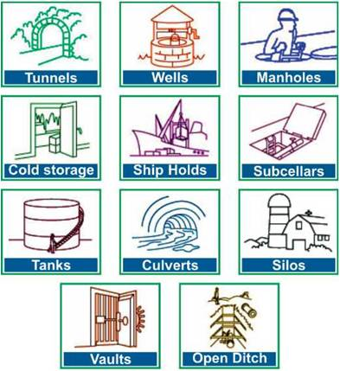
- Air conditioning ducts
- Bagasse bins
- Boilers
- Clarifiers
- Pans and evaporators
- Filter drums
- Pipes
- Pits
- Sugar bins
- Trenches
- Sugar dryers
- Tanks.
A safe work permit system must be used to ensure that all risks associated with entry into a confined space are assessed and those risks are minimised or, where possible, eliminated. The issuer of safe work permits must be trained in confined space entry procedures and risk assessment techniques.
Some of the hazards associated with confined spaces include:
- Oxygen deficient or enriched atmosphere
- Flammable atmosphere
- Toxic atmosphere
- External hazards that may affect those in the confined space
- Residual hazardous chemicals
- Surfaces
- Engulfment
- Electric shock
- Temperature extremes
- Access and egress
- Visibility
- Noise
- Psychological factors
- Mechanical equipment.
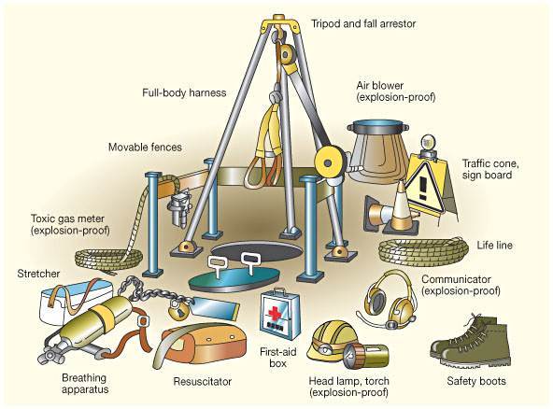

2.7.2 Possible control measures for work in confined spaces
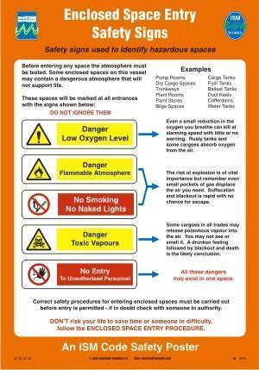
The issuer should explain the hazards and the control measures to the recipients, prior to the commencement of the work and ensure that the potential risks, control measures to be used, and the safe work procedures are all thoroughly understood by the recipients. The recipients should acknowledge their understanding of the details of the safe work permit in writing before work commences.
Procedures are required that address all hazards likely to be encountered before a safe work permit is completed and person(s) are permitted to enter the confined space. Issues to be considered include:
- Identification of the authorised person
- Risk assessment
- Isolation procedures
- Atmospheric testing and the need for air purging
- Portable electrical equipment
- Lighting and ventilation
- Access and egress
- Requirement for a stand-by person and identification
- Emergency equipment, rescue procedures and first aid
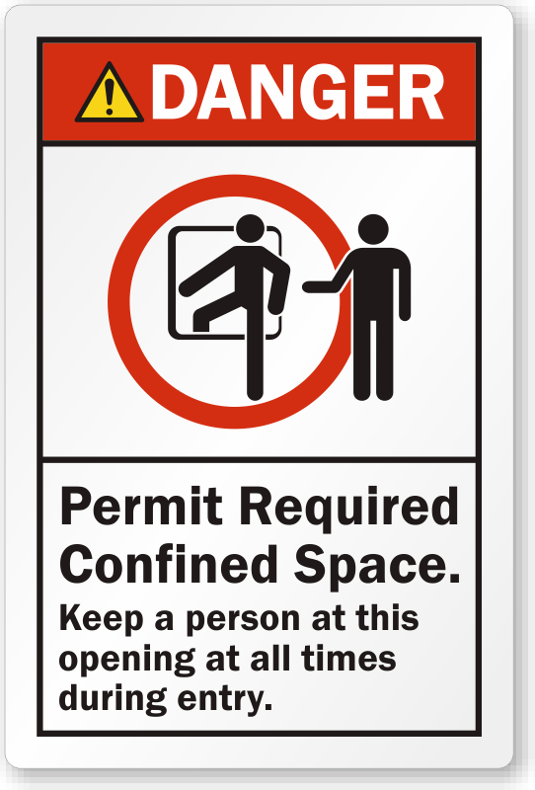
- Signs and barriers to prevent unauthorised access
- Education and training of all persons working in or involved with confined space entry
- The work to be performed in the confined space
- Work being performed outside the confined space
- Whether other hazardous conditions apply (hot work, working at heights or excavation)
- Potential for hazardous conditions to result from the work activities.
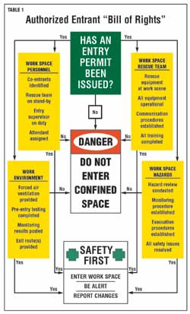
All existing confined spaces and the hazards associated with working in those confined spaces must be identified at each workplace. A confined space can also be created during the manufacture of plant, equipment and or machinery such as building a tank.
No safe work permit should be issued until all controls are implemented and the persons entering the confined space are briefed about the conditions of entry.
The work in the confined space is to be carried out as specified in the permit and all the required controls and procedures must be followed. If the work activities are likely to generate harmful fumes or deplete oxygen levels then it will be necessary to implement controls that will minimise the risks associated with these hazards.
The name of each person entering a confined space must be recorded and a system implemented to account for each person involved using appropriate procedures to control entry/egress. A stand-by person must be provided if a risk assessment indicates a risk to health and safety, such as an unsafe atmosphere or engulfment.
If a stand-by person is required by the risk assessment they must complete the duties specified in the standard and not leave the position while any person remains in the confined space. In the event of an injury or collapse of the person in the confined space, the stand-by person’s primary role is to summon help and if possible, provide assistance (e.g. first aid or resuscitation). The observer must not enter the confined space until it is deemed to be safe by a qualified, authorised person.
At the completion of the work, all persons involved in the work must be confirmed as having left the confined space, the confined space shall be closed, the relevant persons notified and the permit signed off and returned to the issuer and closed.
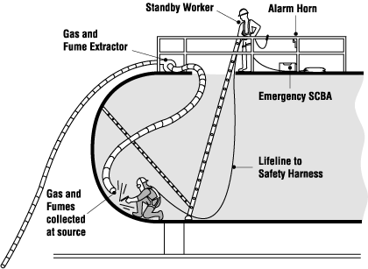

2.8 FIRE PREVENTION
Fires can create huge destruction in the workplace and especially in a Sugar Mill. Fire prevention plans, procedures, and training are vital for employee safety, and for the long-term viability of the factory.
Sugar dust is highly explosive and requires good extraction systems and explosion protection. The drying, cooling and conveying processes hold a high risk of fire.

2.8.1 Dust explosions and spontaneous combustion risks
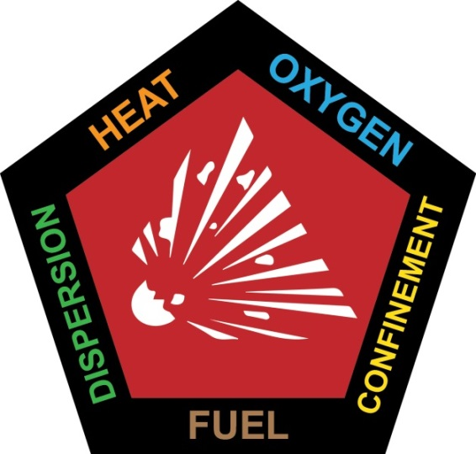
Any carbohydrates dust (sugar, flour, meal etc.) can burn and burn explosively. Four conditions are necessary for an explosion to occur.
- The dust concentration must exceed 40g m³ of air (for a dust particle diameter of 0.08 microns).
- The air humidity must be below 60%.
- The oxygen content of air must be 10 – 125 (it is actually well above this).
- A source of ignition (electric or electrostatic spark, a cigarette, a naked flame etc.) of sufficient energy must be present.
Operators working in areas where dry sugar is handled must be aware of the danger of dust explosions, must be trained to use firefighting equipment and must always be alert for conditions that could cause an explosion.
The owner / operator of a sugar processing or handling facility is faced with choices in the safety measures that can be combined to meet the requirements of these Standards. One or more of the following approaches to safety must typically be employed:
- Housekeeping Measures: Eliminate or minimize combustible dust accumulation by design or controlled operating procedures.
- Equipment Grounding & Appropriately Rated Electrical Systems: Eliminate or minimize the build-up of static electricity and periodically inspect that such measures remain effective, combined with the use of electrical systems designed for the hazardous area in which they are applied
- Equipment Venting: Discharge the products of combustion to atmosphere safely.
- Equipment Isolation: Introduce barriers to flame propagation that can prevent a primary dust explosion from amplifying into a typically much more severe secondary event.
- Equipment Suppression: Prevent the development of a dust explosion by detecting its earliest stages and extinguishing its progress by the injection of an appropriate quenching agent
- Spark Detection: Optically detect the presence of hot particles in a pneumatic air flow or conveyor belt before they reach process equipment within which they become a source of ignition
The following types of process equipment are typically found where sugar dust is processed or handled:
- Filters / Dust Collectors
- Vertical Conveyors (e.g. bucket elevators)
- Horizontal Conveyors (e.g. belt conveyors)
- Silos, Bins & Hoppers
Where sugar dust and air are mixed together in a confined space, the consequences of a dust explosion are the greatest. Filtration equipment handling a combustible dust almost certainly contains a hazardous concentration of material under normal operating conditions. Other items of equipment may only temporarily carry a ‘combustible load’ of hazardous material, perhaps during start up, shut down, loading or unloading. However, while that combustible load is present, the risk is no less severe. If the potential for a combustible load cannot be eliminated, protection measures are required. The table below presents typical sources of ignition that have been identified:
Dust Cloud Ignition Sources
High Probability of Occurrence | Low Probability of Occurrence
Hot bearings | Electrical
Welding and cutting | Static electricity
Belt slippage and misalignment | Lightning
Foreign objects caught in machinery | Metal and stone sparks
 | Spontaneous combustion

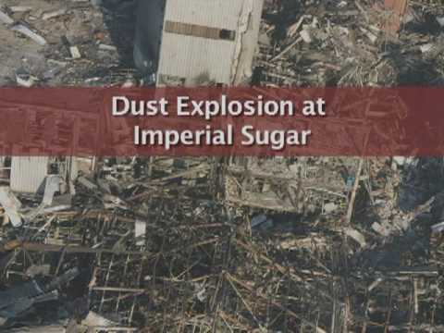

2.8.2 Fire risks and preventative measures
A fire or an explosion can have serious consequences for your company:
- Injury and loss of human life
- Damage to machines, transport facilities and storage space
- Production interruptions
- Loss of income
- Repair / Replacement costs due to damaged machines
- Loss of customers
Hot work (Welding and/or cutting operations)
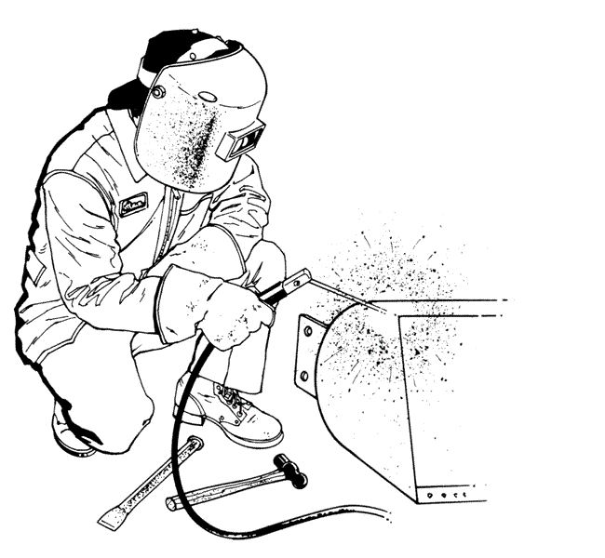
A source of fires in mills is hot work or welding operations. Hot work, by definition, means work involving electric or gas welding, cutting, brazing, or similar flame producing operations. Since hot work has both fire and explosion potential, sugar mill employers must pay particular attention to welding, cutting and brazing.
Except under those conditions that require that hot work be conducted inside the facility, hot work should be conducted outside the facility. When hot work must be conducted at your mill, enforce these important rules:
- Hot work is only performed by qualified artisans.
- Ensure that a hot work permit is completed before any hot work commences and is signed off once the work is complete and the area deemed safe.
- Keep welding or cutting equipment clean and in good operating condition.
- Sweep floors clean for a 35-foot radius from the hot work operation; wet down combustible floors or cover them with an approved fire-retardant material.
- Watch for fire in the hot work area for at least 30 minutes after the hot work is complete.
- Supply the firewatcher with a standby fire extinguisher.
- Keep equipment on which hot work is being performed:
- Cleared of all combustible materials
- Protected by shields in flammable areas
- Purged of all flammable vapor
- Remove combustible materials from the opposite side of all heat-conducting materials receiving hot work.
- Use approved shields to protect all combustible materials in hot work areas.
- Close off all spouts, conveyors and elevator legs so that slag and sparks do not fall into other locations.
- Use metal containers to catch molten metal from welding or cutting.
- Maintain proper oxygen pressure when cutting to reduce the production of extra sparks and slag.
Fire prevention in your workplace consists of four steps:
- Implement a program that includes preparation, prevention, and recognition of fire hazards.
- Make sure you practice proper handling of combustible and flammable material.
- Maintain safe housekeeping practices that reduce the risk of fire danger.
- Always keep adequate fire suppression equipment in your work area to extinguish fire before it gets out of control.
General safety measures
The following are general safety measures in establishing and maintaining fire protection in the workplace:
- Never pile or lay material in a way that it covers or blocks access to firefighting equipment.
- Make sure to use only approved containers for the separation and disposal of combustible refuse. Remember to always replace the lid.
- Never store flammable materials within 10 feet of a building or other structure.
- Stack and pile all materials in orderly and stable piles.
- Never let unnecessary combustible materials get accumulated in any part of your work area.
- Make a periodic clean-up of entire work site and keep grass and weeds under control around the plant.
- Regularly dispose of combustible debris and scrap from your work area.
- Use only approved containers and tanks for storage, handling, and transport of combustible and flammable liquid.
- Always perform evaluation procedures before performing operations that present fire hazards like welding.
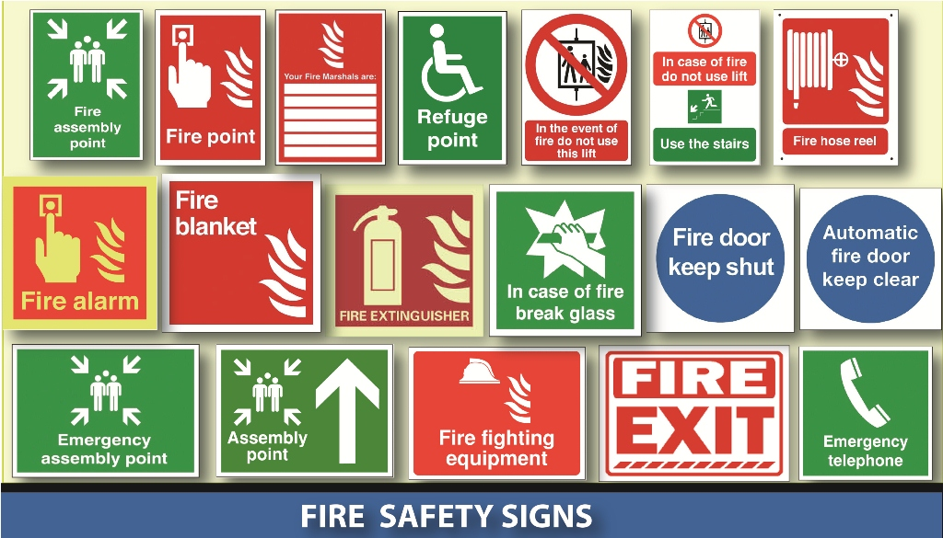
Fire extinguishers are commonly used as fire suppression equipment. You may also add fire hoses to your emergency box/glass in the workplace. Here are guidelines you must follow in using fire equipment:
- First, inspect and maintain firefighting equipment regularly.
- Place an adequate number of firefighting equipment in plain view in your work areas. When appropriate, label the location of each one and make sure it is properly rated.
- Provide employees with proper training in fire prevention and protection.
- Prohibit smoking at or around work areas where fire hazards are present. Put up signs, saying NO SMOKING or OPEN FLAMES.
- Configure an alarm system that consists of both visual and audible signals (bells, sirens, whistles, blinking lights)
Fire extinguishers must be selected that are appropriate for the types of anticipated fires. Damaged and drained extinguishers do more harm than good. To prevent this from happening, extinguishers must be visually inspected monthly, including their hoses. Annual maintenance checks are also required. These must be documented, and the record kept for one year after the last entry or the life of the shell.

2.9 INCIDENT ON DUTY AND REPORTING
Reporting an incident is an important part of an effective occupational health and safety program. It helps identify work related health and safety hazards, risks and dangers. The purpose is to identify the causes of incidents and then to put measures in place to prevent the same incident in future. In other words an incident investigation is normally performed to find out what happened, why it happened, and how to prevent it from happening again. The same innovative approach is demonstrated through the stipulations of the Occupational Health and Safety Act. According to the Act, the employer or user of machinery should formally investigate all section 24 incidents as well as any other incident where more medical treatment than the normal first aid is required.
Section 24 incidents that should be reported and investigated include the following types of incidents:
- When a person dies
- When a person becomes unconscious
- When a person suffers the loss of a limb or part of a limb
- When a person is injured or becomes ill, or is likely to die or suffer permanent physical defect
- When a person is unable to work for 14 days or longer because of a work related incident
- When a ''major incident'' occurs. (Based on Legislation in section 24(a) and (b), of the Occupational Health and Safety Act) Section 1 of the Occupational Health and Safety Act defines it as ''an occurrence of catastrophic proportions, resulting from the use of plant or machinery, or from activities at a work place.''
The following occurrences must also be reported to the Provincial Director. When lives were endangered by:
- Dangerous spilled substances
- Uncontrolled release of a substance under pressure
- Flying, falling, uncontrolled moving objects
- Machinery that ran out of control
Based on Legislation in section 24(c), of the Occupational Health and Safety Act - The procedure for reporting is:
The above mentioned incidents; Section 24(a); (b) and (c) occurrences; should be reported immediately to the Provincial Director. It should be done by telephone, fax, or similar means of communication. They should also be reported to the Provincial Director within 7 days using the WCL 1 or WCL 2 forms. If the injured person dies after notice the employer or user shall notify the Provincial Director of the death by fax or similar means of communication. Based on Legislation in GAR 8, of the Occupational Health and Safety Act.- The prescribed recording and investigation of incidents:
The employer or user should keep record of all section 24 incidents and any other incident where medical treatment or first aid is involved. This must be done in the form of the prescribed ''Annexure 1'' form. Take note that records need to be kept for a period of at least three years. (Based on Legislation in GAR 9, of the Occupational Health and Safety Act).
The incident site may not be disturbed without the consent of an inspector in the case where a person:
- Dies
- Loses of limb or part of limb
- Is likely to die
You may however:
- Remove injured or dead
- Rescue persons from danger
The investigation should be performed by one the following persons:
- The employer or user of machinery
- A person appointed by the employer to investigate the incident
- The health and safety representative of the work area
- A member of the health and safety committee
The investigation should officially start within a period of 7 days and be finalised as soon as is reasonably practicable, or within the contracted period in the case of contracted workers. An employer must ensure that the incident record can be examined by the health and safety committee. (Based on Legislation in GAR 9, of the Occupational Health and Safety Act.).

2.10 UNIVERSAL PRECAUTIONS WHEN ATTENDING TO INJURED PERSONS
By administering immediate care during an emergency, you can help an ill or injured person before Emergency Medical Services arrive. And you may be able to help save a life. However, even after training, remembering the right first aid steps – and administering them correctly – can be difficult. Here are a few basic steps to follow when you come upon an injured person. Afterwards some basic ways to move injured people (who are in immediate danger) are discussed. Remember that the aims of first aid are to:
- Preserve life
- Prevent illness or injury from becoming worse
- Relieve pain, if possible
- Promote recovery
- Protect the unconscious

2.10.1 Steps to follow when you encounter an injured person
Step 1:
- Before administering care to an ill or injured person, check the scene and the person. Size up the scene and form an initial impression.
- Pause and look at the scene and the person before responding. Answer the following questions:
  - Is the scene safe to enter?
  - What happened?
  - How many people are involved?
  - What is my initial impression about the nature of the person’s illness or injury? Does the person have any life-threatening conditions, such as severe, life-threatening bleeding?
  - Is anyone else available to help?
Step 2:
- If the Person is awake and Responsive and there is no severe life-threatening bleeding:
  - Obtain consent: Tell the person your name, describe the type and level of your training (if any), state what you think is wrong and what you plan to do, and ask permission to provide care.
  - Tell a bystander to call an ambulance and first aid kit (if possible). Point to the bystander you are speaking to and speak out loud.
  - Use appropriate PPE: Put on gloves, if available.
  - Interview the person: Uses SAMPLE questions to gather more information about signs and symptoms, allergies, medications, pertinent medical history, last food or drink and events leading up to the incident.
  - Conduct a head-to-toe check: Check head and neck, shoulders, chest and abdomen, hips, legs and feet, arms and hands for signs of injury.
  - Provide care consistent with knowledge and training according to the conditions you find.
Step 3:
- If the Person Appears Unresponsive:
  - Shout to get the person’s attention, using the person’s name if it is known. If there is no response, tap the person’s shoulder (if the person is an adult or child) or the bottom of the person’s foot (if the person is an infant) and shout again, while checking for normal breathing.
  - Check for Responsiveness and breathing for no more than 5-10 seconds.
Step 4:
- If the person is breathing:
  - Send someone to call an ambulance or the designated emergency number and obtain a first aid kit.
  - Proceed with gathering information from bystanders if required
  - Conduct a head-to-toe check.
  - Roll the person onto his or her side into a recovery position if there are no obvious signs of injury.
Step 5:
If the person is NOT breathing:
- Send someone to call the ambulance or the designated emergency number and obtain a first aid kit.
- Ensure that the person is face-up on a firm, flat surface such as the floor or ground.
- Begin CPR (starting with compressions) if you are trained in giving CPR.
- Continue administering CPR until the person exhibits signs of life, such as breathing, or Emergency Medical Services or trained medical responders arrive on scene.
- Note: End CPR if the scene becomes unsafe or you cannot continue due to exhaustion.

2.10.2 How to move an injured person who is in immediate danger
There are several general principles to apply when assisting an injured person. Please note however, that some types of accidents (for example a fall from a great height, or burning incidents), require very specific procedures and are best left to people qualified to assist or move people suffering from these kinds of injuries.
Do not move an injured person unless they are in a life-threatening situation. Moving an injured person can worsen the injury. If the person has a spinal injury it can cause them to be permanently paralyzed. If the person is not in immediate, life threatening danger, call emergency responders for medical help. If you do need to move the person out of life threatening danger, it is important to do it correctly to reduce the risk to the injured person and to yourself.
Do not move someone if you think he/she has a spinal injury. Moving them could increase the damage and even cause them to be paralyzed. If you are unsure if the person has a spinal injury, then you should proceed as if they do.
Signs of a spinal injury include:
- Having a head injury, particularly one that involved a blow to the head or neck.
- Showing changes in the state of consciousness, for example, being unconscious or confused.
- Experiencing pain in the neck or back.
- Not moving the neck.
- Experiencing weakness, numbness, or paralysis in the limbs.
- Losing control of the bladder or bowels.
- The head or neck is twisted in a strange position.
- Reacts to painful stimulus (trapezius pinch or sternal rub) by flexing all their limbs inward or by extending all her limbs out (referred to as posturing).
Movement into position to prevent vomiting and choking
Roll the person onto their side if necessary. This should only be done if the person is in immediate danger, for example if they are vomiting or choking on blood. Under these circumstances, you may have to roll the person onto their side. It is important to do this with at least one other person so that you can prevent the person’s body from twisting.
One person should be positioned at the head and the other at the injured person’s side. The two of you must coordinate so that the spine remains aligned while the person is rolled. Twisting can cause additional damage to the spine.
While rolling, wait for the lead person's cue. Roll by grabbing the opposite shoulder and hip, rolling the patient toward you. While the person is in this position, check their back and neck quickly for obvious injuries.
Moving a conscious person who does not have a spinal injury in immediate danger
To move a conscious person, who does not have a spinal injury, out of the way of immediate danger, use the human crutch method. If the person is conscious and can move on their own, this method might be the most effective. It can be used if the person has an injury to only one leg.
Crouch with your knees bent and back straight next to the injured person on the side of the injury. Have the person sit up and wrap their arm over your shoulder. Slowly stand, allowing the injured person to support themselves with their good leg. You will support their weight on the side with the injury. Hold their hand around your shoulders with the hand furthest from them. Put your other hand around their waist.
Help them balance as they hop to safety. This enables them to minimize the amount of weight that must go on the injured leg.
Moving an unconscious person in immediate danger
If the person is unconscious, or unable to be assisted to walk or hop out of danger, then drag the person to safety. The drag method is safer than lifting the person, for both you and the injured person. Lifting increases the amount of weight that you must support and it puts the person at risk of falling. Always pull slowly and steadily, moving the person in as straight a line as possible. You want to keep the person’s spine aligned so that it does not twist or bend unnaturally. Which type of drag you use will depend on the injuries that the person has.
Leg drag —This method is used when the person has no leg injuries, but cannot walk. Bend at your knees so that your back remains straight, but you can hold the person’s ankles. Lean back and slowly and steadily use your weight to drag the person to safety. Be careful not to drag the person over surfaces or objects that may injure them. If you are sure that the person has not suffered a spinal injury, you can lift the head and put something underneath to protect it. If you think the person might have a spinal injury, you should move the head as little as possible.
Arm drag — This method is necessary when the person has leg injuries. Bend your legs and keep your back straight. This will protect your own back. Lift the person’s arms above the head and grasp the person by the elbows. Squeeze the elbows against the sides of the head so that it remains supported and does not drag on the ground. Use your own weight to lean back and slowly drag the person to safety.
Clothing drag — If the person has injuries on both the arms and legs, it may be necessary to drag them by their clothing. If you use this method, pay attention to the clothing to make sure that it doesn’t suddenly tear and cause the person’s head to bang on the ground. Bend your knees and grip the clothing under the armpits. Lean back and use your weight to drag the person.
Injuries in the workplace
If you and others are involved in a major incident together, follow these essential steps to ensure your own safety and then to assist the injured person:
- Ensure own safety
- Tend to the injured person
- Obtain first aid assistance
- Remain with the person until assistance arrives
- Inform injured person to submit an incident / injury report form
- If injuries require medical assistance then also call emergency assistance numbers.
- Assist injured person to medical center or hospital as required.
- Be prepared to complete a witness report form should this be required.

2.11 PROVISIONS RELATED TO INTOXICATION, UNAUTHORISED USE OF MOTORISED OR MOBILE EQUIPMENT

2.11.1 Intoxication
Subject to the provisions of the OHSA Act an employer or a user, as the case may be, shall not permit any person who is or who appears to be under the influence of intoxicating liquor or drugs, to enter or remain at a workplace.
Furthermore, no person at a workplace shall be under the influence of or have in his or her possession or partake of or offer any other person intoxicating liquor or drugs.
An employer or a user, as the case may be, shall, in the case where a person is taking medicines, only allow such person to perform duties at the workplace if the side effects of such medicine do not constitute a threat to the health or safety of the person concerned or other persons at such workplace.

2.11.2 Revolving machinery
Unless moving or revolving components of machinery are in such a position or of such construction that they are as safe as they would be if they were securely fenced or guarded, the user shall cause -
(a) Every shaft, pulley, wheel, gear, sprocket, coupling, collar, clutch, friction drum or similar object to be securely fenced or guarded;
(b) Every set screw, key or bolt on revolving shafts, couplings, collars, friction drums, clutches, wheels, pulleys, gears and the like to be countersunk, enclosed or otherwise guarded;
(c) Every square projecting shaft or spindle end and every other shaft or spindle end which projects for more than a quarter of its diameter to be guarded by a cap or shroud;
(d) Every driving belt, rope or chain to be guarded; and
(e) The underside of every overhead driving belt, rope or chain above passages or workplaces to be so guarded as to prevent a broken belt, rope or chain from falling and so injuring persons: Provided that the provisions of this paragraph shall not apply where in the opinion of an inspector no danger exists in the case of light belts due to the nature thereof and the speed of operation.

2.11.3 Washing machines, centrifugal extractors, etc.
The user shall, wherever practicable, cause every power-driven washing machine, centrifugal extractor or similar machine of double cylinder construction in which the inner cylinder, drum or basket rotates, to be provided with a door or lid on the outer cylinder, so interlocked that-
(a) The inner cylinder cannot be put into motion unless the door or lid is closed; and
(b) The door or lid cannot be opened unless the inner cylinder is stationary.

2.12 SAFE MATERIAL LIFTING
Handling material is a daily function in many workplaces. All too often, this task is taken for granted with little knowledge or attention given to the consequences if it is done incorrectly. All employees need to look at and evaluate how materials are handled inside and outside of their workplace. Whether the operation involves delivering or receiving material, an area should be designated for that purpose.
How the materials are loaded or unloaded is a key factor in reducing employee injuries. Persons involved in material handling should be able to lift and hold the weight of the material used in their operations. They must also be properly trained in the correct way to lift and carry the items. Remember, no matter how small or lightweight an item is, an injury can still occur if you move it incorrectly. Lifting, carrying or moving materials safely will decrease your chances of getting injured.
Keep in mind there are many times it is not necessary for an individual to lift and carry material manually. Various types of equipment - dolly, cart, and forklift are available to move material safely. Depending upon the type of operation, using a dolly or cart to move material can result in minimal disruption of work flow and can also prevent injuries. However, only trained operators should use a powered pallet jack/lift truck or forklift.
Pallet jacks can be used to carry heavier loads from one area to another. It is imperative that materials are placed on the jack in a safe and secure manner to avoid having the load shift, fall off, roll over or impair the operator’s vision. You should only operate a pallet jack, lift truck or forklift if you have received the necessary training in safe operation and control.
Tips for safe lifting:
- Plan before you lift. Remove anything that is in the way. Pushing is easier than pulling. Pulling is easier than carrying. Lowering loads causes less strain than lifting.
- Get help for heavy or bulky loads. Use equipment like a cart to help when possible.
- Warm up your muscles with gentle stretches before you lift. This is very important if you have been sitting for more than 15 minutes before lifting.
- Test the weight of the load first. Be sure that you can handle it safely. A big load of the same weight will put more strain on your body than a small load. Break your load into smaller or lighter loads.
- Face the way you need to move. Avoid twisting or side bending. Turn your entire body. Place your feet wide apart to keep your balance.
- Hold the load close to your body. Grip the load using your whole hand not just the fingers. Using your whole hand will give you the greatest grip area and strength. Balance your load evenly between both arms.
- Lift with as straight a back as is comfortable. Tighten your abdominal (stomach) muscles. Bend your legs so they do the lifting.
- Keep the load between shoulder and knee height. Avoid reaching. Change your position and stretch to relax and rest your tired muscles. You need time to recover your strength between lifts to be able to work safely. Repeated and long lifts are the most tiring. Switch between heavy loads and lighter ones. Plan where to set the load down. Place loads on a raised platform. Leave enough room for your hands to grip the load. Avoid placing loads directly on the floor.
- Rest more often when it is hot and humid.
- Take more time to warm up your muscles when it is cold.
- Take more breaks if you are also using tools or equipment that vibrates.

2.13 MATERIAL STACKING
It’s important to ensure that you properly stack and store materials in your workplace so that they don’t endanger workers. For example, unstable stacks could collapse onto workers and piles that block sprinklers can pose a fire hazard. Naturally, you must comply with the requirements for safely storing materials in your jurisdiction’s OHS regulations, both when storing materials on racks or in piles/stacks. But here are eight general tips for safe stacking:
- Ensure that materials aren’t stacked so high that they’re in danger of toppling over or collapsing.
- Store heavy and unstable items as low as possible to the floor.
- Ensure that loads are properly secured against movement on pallets and that pallets are in good condition and the appropriate size and type for the load.
- Where possible, try to stack articles of the same size and weight together.
- When stacking bags or bundles of material, alternate rows. For example, place one row running lengthwise, the next running widthwise, the third lengthwise, etc.
- Ensure there’s adequate space to allow workers, forklifts and other lifting devices to navigate the workplace safely and efficiently.
- Block or chock the bottom tiers of round items so that they don’t shift or roll.
- Ensure that materials aren’t stacked so high that they block sprinklers, could come into contact with ignition sources or are near energized electrical wires.

3. Knowledge topic 3: Sugar processing specific health, safety and environmental protection concepts

3.1 SPECIFIC RISKS IN A SUGAR PROCESSING PLANT

3.1.1 Electrical Risks
Typical electrical risks within a sugar milling environment include:
- Operation of plant around electrical lines and parts
- Electrical work
- Use of electrical equipment
- Failure of electrical equipment.
Overhead power lines
Contact with overhead power lines can cause death. Even if you don’t touch the power lines you are still in danger, as electricity can arc or jump gaps. Working near overhead electrical power lines is therefore a very dangerous activity unless the appropriate precautions are taken. Workers and equipment (e.g. hand held or power tools or mobile work platforms) must stay outside defined exclusion zones around overhead power lines.
An exclusion zone is a safety envelope which surrounds the power line and is designed to keep people out of harm’s way and away from the risk of sustaining electrical injuries. It is against the law to go inside an exclusion zone. You can, however, reduce your exclusion zone size by becoming an authorised or instructed person, but the exclusion zone itself is not eliminated unless the power lines are de-energised and/or isolated. These exclusion zones operate for the use of plant and equipment (including elevating work platforms).
The actual size of an exclusion zone depends upon the voltage of the lines, the competence/training level of the worker, and the way that the worker is accessing the work area. For low voltage power lines (anything under 1000 volts) along a road, or a service line connecting a property to the power lines on a road, the exclusion zone is generally three meters. A smaller exclusion zone may be possible, but only after consultation with the local electricity supplier and following the requirements of the electrical safety legislation, which may include the use of an authorised person, instructed person trained and accredited worker or safety observer.
Exclusion zone distances for high voltage lines vary somewhat, but for high voltage lines attached to either wooden or concrete power poles, the exclusion zone is also generally three meters. Where power lines are on steel towers or large easements, the local electricity supplier should be contacted. Please check with your local electricity authority prior to working near power lines.
If you expect that your work may cause a person and/or equipment part to come closer than the exclusion zone of overhead power lines, you must ensure a risk assessment is conducted and control measures are consistent with the risk assessment and any requirements of the electrical entity who is responsible for the line.
You are not allowed to start work near the overhead power lines without meeting these requirements. Therefore it is critical that you assess the work requirements prior to arriving to do the work.
Control measures for electricity
Mill operators should ensure that safe systems of work are in place which enables the organisation to comply with the OHSA. This may include:
- Training
- Work procedures
- Authorised and instructed persons
- Auditing.
There are a number of devices available that either assist in preventing contact with power lines or reduce the degree of risk in the event of contact. Such devices include:
- Ensuring work does not encroach into the exclusion zone - all work is to be conducted outside the exclusion zone.
- When using items of plant near power lines (e.g. elevating work platforms) ensure there is a safety observer (or spotter) who’s job is to watch the worker and their equipment and warn them if they begin to get close to their exclusion zone around the power lines, and to keep people away from the area at ground level where falling items (e.g. branches etc.) may land.
- Ensuring all injuries, electric shocks and near misses are reported to the person conducting a business or undertaking. It may also be required to notify the local electricity supplier of certain electrical events.
- The use of ‘tiger tails’ on power lines which act as a visual aid that assists in preventing contact by highlighting the location of the power line. Only low voltage lines (under 1000 volts) can be continuously covered with tiger tails, which leaves the higher lines on power poles (usually at least 11,000 volts) exposed. NOTE: tiger tails do not insulate the wires and therefore the ‘exclusion zone’ must be maintained.
- Limiting or warning devices to assist in preventing objects entering the exclusion zone. If a limiting or warning device is used, the system should be designed to be ‘fail safe’.
- Allowing for sway and sag of the overhead lines (sway is usually caused by wind and sag occurs when the temperature of the line fluctuates).
The exclusion zones for power lines of some power authorities may differ. It is the responsibility of the person conducting a business or undertaking or person in control of the workplace to check with the person in control of the overhead electric line.

3.1.2 Slips, trips and falls
Slips, trips and falls are a cause of injury in most large workplaces and can be caused by poor design, damage and in particular, poor levels of, or incorrectly placed, lighting.
Sugar manufacturing has some particular processes which may affect the risk of slips, trips and falls for example, reactions between concrete and sugar products (sugar dust, molasses, or massecuite) which can damage floors and walkways.
Varying weather conditions can also create slippery conditions in sugar mills.
Possible control measures for slips, trips and falls
A range of control measures could be used to reduce the risks associated with slips, trips and falls, for example:
- Regular housekeeping inspections
- Maintenance (e.g. repair of leaking pipes, joints and vessels)
- Adequate lighting
- Barricading – short and long term
- Loss of sugar product reduction programs (e.g. dust, molasses, liquor and juice leaks)
- Regular floor repairs
- Replacement of flooring in susceptible areas with non-concrete materials
- Identification of hazards with appropriate markings.

3.1.3 Falling objects
Sugar mills are multi-level installations and have some structures which can be higher than 60 metres like chimney stacks. Operators should consider a range of issues when assessing the risk of injury from falling objects, including:
- The type of work being conducted
- What equipment is being used
- The number of people using the area below
- Whether special provisions are required for specific work (e.g. hot work)
- How far an object might fall and what the object might be
- The consequences of being struck.
Possible control measures for falling objects
The following are examples of control measures that may be used to prevent or minimise exposure to the risk of being hit by falling objects:
- Establishing exclusion zones to prevent unauthorised persons from accessing high risk areas (this can be done by using barricading)
- Using catch nets or platforms
- Using lanyards
- Specifying pathways for workers and others
- Using head protection (e.g. helmets).
Note: Helmets are a personal protective control measure only and guidance should be sought from the appropriate agencies as to what level of protection their helmets offer from falling objects.
Hitting and being hit by moving objects
Hitting and being hit by moving objects is a major hazard at sugar mills. This can be caused by:
- Cluttered workplaces
- Workers colliding with moving plant or equipment (e.g. rolling stock in a mill yard)
- Lack of warning signs fitted at intersections
- Doors opening into walkways
- Plant not maintained in safe condition (e.g. unguarded or inadequately guarded machinery which generates flying objects such as splinters, metal fragments and dust)
- Lack of appropriate personal protective equipment such as safety glasses to protect eyes from slivers of wood, metal, concrete or sparks
- Lack of warning signs and devices (flickering lights or sirens) on moving plant and vehicles such as forklifts.
Possible control measures for hitting and being hit by moving objects
Mills which utilise cane railway delivery systems have large storage and delivery areas for both empty and full bins around the factory.
The risk of injury from persons walking through rolling stock is eliminated if access is provided to work areas without the need to walk through bins in mill yards.
Preventing or minimising exposure to the risk of being hit by moving objects can be achieved through separation, for example:
- Overhead walkways
- Yard fencing
- Underpasses
- Exclusion zones.
Other possible control measures that can be used to minimise or prevent the risk of injury from hitting or being hit by moving objects include:
- Providing training
- Ensuring site rules are prepared and followed
- Wearing high visibility garments
- Ensuring machines are guarded to prevent flying objects from being produced, and if this cannot be achieved, then barriers installed to prevent them flying into the general work area
- Fitting reversing lights and beepers to mobile vehicles
- Clearing a designated walkway so that people and mobile plant/equipment are kept separate
- Install mirrors and other warning devices at intersections.

3.2 RESTRICTED ACCESS AREAS IN A SUGAR PROCESSING PLANT
The need for access control in any manufacturing facility is acknowledged. Access control systems can be as basic as key entry systems or as complex as facial scanning. The obvious benefit of access control systems is to limit the entry of unauthorized intruders or personnel into areas in which they are not allowed. Access control assists to protect a business against damage and theft, protects employees from harm and provides a deterrent to acts of sabotage or malicious intent. It is especially important to ensure that people, with no knowledge of the dangers of the factory, should be kept out of the manufacturing area.
Manufacturing enterprises have the further challenges of ensuring safe arrival and storing of parts and raw materials, secure manufacturing processes, protection against theft and casualties, and reliable delivery of finished goods to ensure customer satisfaction.
Controlling access to and within the site and protecting information and automation systems from breaches is also essential. Physical or digital security lapses, whether accidental or malicious, can cause significant damage, particularly when those lapses harm personnel, the equipment or environment, or compromise quality.

Reasons for an access control system
- Keeping a record of who is coming and going: Controlling your employee, vendor, visitor, and maintenance staff access.
- Control access to highly secured areas or dangerous areas. For manufacturing facilities this means different areas of the manufacturing facility might need different security access in order to keep unauthorized people out. Examples include raw materials and parts inventory, work-in-process (WIP), staging areas, cleaning areas, inspection areas, testing areas, finished product areas.
- You may need to keep out or provide limited access to cleaning people, vendors, employees from specific areas and fired employees.
- Access is monitored. With some keyless entry systems, each authorized user can be assigned a specific code with which to gain access. Also, keyless entry systems provide a log so you can see who gained access to a secure area and when.

Access into confined spaces
The Sugar Mill factory consists of a range of vessels (bins, silos, tanks, evaporators), some of which require human entry for their maintenance and cleaning.
Entry into any confined space is hazardous because these spaces may contain harmful substances or represent oxygen deficient environments or there may be a bridging condition or a build-up of product on the sides which could fall and bury an employee, known as engulfment.
Most fatalities suffered by employees who have entered bins, silos or tanks, resulted when:
    - Employees entered bins, silos or tanks without authorisation (entry into confined space permit)
    - Employees entered bins, silos or tanks without proper personal protective equipment.
    - Employees entered bins, silos or tanks without following proper safety procedures.
    - Employees were in bins, silos or tanks while product was flowing and equipment was running, and were sucked under the product.
    - Employees were in bins or silos and fell through bridged areas (see the figure below).
No employee should ever enter bins, silos or tanks under a bridging condition. Similarly, no employee should enter bins, silos or tanks where a build-up of product on the sides of the confined space could fall and bury the employee.
Product stuck to the sides of bins, silos or tanks should always be dislodged from above. If a boatswain’s chair is used, it should never be positioned so that collapsing product could engulf the employee.
Before allowing entry into any confined spaces, the procedure for entering of confined spaces must be complied with at all times and a permit completed for each entry. Similarly, all vessels should be checked for a person inside, before man-holes are closed and put into operation.

3.3 ENVIRONMENTAL POLLUTION AND PREVENTATIVE MEASURES
The Sugar Industry is one of the unique industrial sectors which utilizes its own by-products viz "bagasse" as fuel for generation of power and steam for process requirements.

3.3.1 Air pollution in the sugar industry
The main source of air pollution from the sugar industry is the bagasse-fired boiler. The major pollutants are sulfur dioxide, nitrogen oxide and carbon monoxide.
A wide variety of particulate emission control systems have been tried out in the sugar industry. However, commercially viable designs are yet to be proven in the field. While selecting control systems the following factors should be taken into consideration:
- Typical nature of fly ash, that is, fibrous and light particles;
- High temperature of flue gas;
- High moisture content in fuel gas and
- Fluctuations in boilers load due to varying process requirement.
3.2.2. Water Pollution in the Sugar Industry
Water pollution may be defined as a natural (or) induced change in the quality of water which renders it unstable (or) dangerous as regards, food, human and animal health, industry, agriculture, fishing (or) leisure pursuits.
The general standard for waste water or effluent released from a Sugar Mill is:
- Colour, taste and odour : Shall not contain any substance in a concentration capable of producing colour, taste or odour
- pH shall be between 5.5 – 9.5
- Dissolved oxygen : Shall be at least 75% saturated
- Typical (faecal) E. coli : Shall not contain any typical (faecal) E. coli per 100 ml
- Temperature : Shall not exceed 35°C
- Chemical oxygen demand : Shall not exceed 75 mgl-1
- Conductivity : Shall not be increased by more than 75 milli-Siemens per meter over that of the intake water
- Suspended solids : Shall not exceed 25mgl-1
- Sodium: Shall not be increased by over 90mgl-1 above that of the intake water
- Soap, oil, grease : Shall not exceed 2.5mgl-1

3.4 HAZARDOUS CHEMICALS AND CHEMICAL HANDLING

3.4.1 Types of hazardous chemicals in a Sugar Mill
Hazardous chemicals found within a sugar milling environment include:
- Petroleum products
- Caustic soda (sodium hydroxide)
- Hydrochloric, phosphoric, sulphuric and sulphamic acids
- Formaldehyde
- Lime (calcium hydroxide).
Sugar mill operators should identify high risk activities involving these chemicals and implement control measures which minimise the risk of exposure. For example, the following activities require standard operating procedures which will minimize the risk of exposure:
- Unloading and bulk transfer
- Process or plant failure
- Operator error.
Possible control measures for hazardous chemicals
The main risk associated with hazardous chemicals is the potential for exposure to site personnel and other persons. Exposure can occur by breathing in the chemical, through skin contact where a chemical is absorbed through the skin or ingestion when eating with contaminated hands.
Hazardous chemicals within sugar milling operations have methods of risk reduction prescribed by a regulation which include:
- Ensuring a safety data sheet is readily available to anyone likely to be exposed to the hazardous chemical
- A hazardous chemicals register containing a list of all hazardous chemicals on site plus a current copy of a safety data sheet for each chemical is maintained
- Labeling and storage comply with the appropriate standards and codes
- A risk assessment is completed and risks minimised for each hazardous chemical
- Workers are aware of the control measures to be implemented
- Appropriate PPE in accordance with the risk assessment is available and used as intended
- Adequate training is provided in the use of the hazardous chemical and the recommended PPE
- Monitoring or health surveillance is conducted if required
- Records are maintained for the specified time.
Safety Data Sheets provide important information on hazardous chemicals including:
- The ingredients of a product
- The health effects and first aid instructions
- Precautions for use
- Safe handling and storage information.
Specific control measures should be developed such as:
- Isolating high risk areas with barriers and signage (e.g. under the effect stage while caustic boiling)
- Detailed and documented operating procedures
- Training
- Emergency response
- Provision of, and training with, appropriate PPE
- Provision of eye wash and safety shower facilities adjacent to the site but isolated from likely engulfment
- Access to safety data sheets and emergency procedures at the site.

3.4.2 Laboratory chemicals
Laboratory staff may have frequent exposure to a large range of hazardous chemicals in smaller quantities. It is important to minimise the risk of exposure so as to reduce the possibility of acute and chronic health effects over the long term.
Handling, mixing and transferring hazardous chemicals such as hydrochloric and sulphuric acids, sodium hydroxide and flammable liquids including ethanol are some of the activities which are undertaken in sugar mill laboratories. Users of chemicals should also be aware of any by-products or chemical reactions which may take place which could create additional hazards during laboratory processes.
Possible control measures for laboratory chemicals
Specific control measures should be implemented for each separate activity involving a hazardous chemical in mill laboratories. The most appropriate control measures will depend on the particular circumstances of use and the hazardous chemical, however typical control measures should include:
- Detailed analytical procedures
- Training in the standard procedures to be followed
- Emergency response training and access to specialty first aid treatment
- Provision of, and training with, the recommended personal protective equipment for each activity
- Provision of eye wash and safety shower facilities adjacent to the site but isolated from likely engulfment
- Easy access to safety data sheet, information and emergency procedures in the laboratory
- Adequate labeling of all containers of hazardous chemicals
- Use of automatic pipettes
- Adequate ventilation
- A high standard of hygiene
- Disposal systems for used personal protective equipment
- Separate laundering of laboratory coats, hand towels, etc.
- Use of fume cupboards that comply with safety standards for such.

3.4.3 Lead
All sugar factory laboratories use lead in the form of dry lead acetate and ‘wet lead’, which requires specific control measures to ensure workplace health and safety. Lead can be absorbed by inhaling lead dust, fumes or mist and by ingesting lead that has contaminated hands, food or cigarettes.
Early symptoms of lead poisoning may include headache, loss of appetite, abdominal pain, constipation, nausea, fatigue, loss of weight and irritability. Continued exposure can cause anaemia, kidney damage, and nerve and brain damage.
Possible control measures for Lead
In certain situations, Sugar Mills must arrange and pay for health monitoring where laboratory workers (or others) are exposed to lead. This health monitoring must be done by, or under the supervision of, registered medical practitioner with experience in health monitoring. Health monitoring, which includes biological monitoring, can assist in minimising the risk to health from lead exposure by:
- Confirming that the absorbed dose of a substance is below the acceptable level
- Detecting adverse health effects at an early stage so that the worker can be protected from further injury, either by control of the process or by removal from exposure
- Evaluating the effectiveness of control measures.
The primary technique for monitoring the working environment is usually to determine the concentrations of an airborne contaminant and then compare the result with the relevant exposure standard. However, if lead dust or fume can been ingested or inhaled, biological monitoring techniques should also be used (e.g. in lead risk work, biological monitoring would measure the blood lead level of individual workers). Biological monitoring has the specific advantage that it can take account of issues that dictate an individual’s response to particular hazardous chemicals. Some of these factors include size, fitness, personal hygiene, work practices, smoking and nutritional status.
Health monitoring should not be used as an alternative to proper implementation and maintenance of control measures designed to prevent exposure. In circumstances where a risk assessment determines the job not to be a lead risk work, a risk assessment should again be conducted within five years after the last assessment. The risk assessment must be conducted sooner if there is a significant change in the way a lead process is done at the workplace or if there is a significant change in the amount of lead, or the amount of lead contained in a thing at the workplace.
Provided that the risk assessment has been conducted at prescribed intervals and appropriate control measures are adhered to, then the status as a lead process rather than lead risk work can be maintained. It is recommended that all new laboratory workers have baseline and mid-season samples to identify those workers whose absorption of lead is significant.
Appropriate control measures include:
- Labeling all containers in which any lead compound is stored
- Avoiding generating dust when handling dry lead acetate
- When transferring to smaller containers:
- Use personal protective equipment (face shield, P2 dust respirator and gloves)
- Transfer in a well-ventilated area free of strong air currents
- High standards of personal hygiene
- Not allowing drinking from laboratory taps
- Training and supervision to ensure that the correct procedures are followed
- Maintaining appropriate emergency response treatments
- Providing automatic dispensers for wet lead.

3.4.4 Welding and cutting fumes
The fumes and gases arising from welding and cutting processes may contain a number of hazardous chemicals. The welding/cutting arc can cause reactions which produce oxides of nitrogen, carbon monoxide and other gaseous contaminants. The intense ultraviolet radiation emitted from some arcs may also give rise to significant quantities of ozone.
The composition of the fume depends upon:
- Consumables : electrodes or filler metals, heating or shielding gases and fluxes
- Material: chemical composition of material being cut or welded and of any protective coating (e.g. galvanising) or primer paint (e.g. lead-based paints)
- Operating conditions (e.g. temperature and rod current).
The amount of fume generated depends on:
- Process and thermal conditions – amperage, voltage, gas and arc temperatures and heat input which may also vary with the welding position and degree of enclosure and the degree of skill of the welder
- Consumables
- Materials
- Duration of welding or cutting.
Possible control measures for welding and cutting fumes
When assessing the risks associated with a particular welding or cutting process, consideration should be given to airborne concentrations of toxic metals, such as chromium and nickel that may be generated from the parent metal or electrode. In addition to complying with the individual exposure standards for specific contaminants, the fume concentration in the breathing zone (which is inside a welder’s helmet when a helmet is worn) should not exceed five mg/m³ TWA (time weighted average).
When selecting control measures, routine tasks should be identified so that generic procedures can be developed and documented for future use. Within sugar milling operations repetitive tasks include:
- Roller arcing
- Welding and cutting in dedicated workshop areas
- Railway maintenance.
Special consideration is also required for specific tasks such as:
- Hot work in confined space
- Welding in open spaces
- Tasks involving stainless steel, galvanised steel, etc.
A workplace where airborne contaminants hazardous to the health of workers are generated should:
- Have air quality acceptable to the standard specified when mechanical ventilation is introduced
- Have exhaust appliance systems which prevent or minimise the risks from exposure to those airborne contaminants.
Ventilation systems can be of two types. When the airborne contaminants comprise of low to moderately toxic materials generated only in small amounts, general forced dilution ventilation, either as supplied air or as extracted air systems, can be employed.
Where airborne contaminants are generated in moderate to large quantities or comprise of toxic or very toxic materials, a local exhaust ventilation system should be used. The exhaust appliance in use must be capable of reducing the level of airborne contaminants such that an involved worker’s exposure is not more than the relevant exposure specified in the standards. Air-conditioning systems are not considered suitable for control of atmospheric contaminants.

3.4.5 Methane gas
Methane gas (CH₄) is a colourless, odourless gas that forms when organic matter decomposes under oxygen-poor conditions (anaerobic – without oxygen). High concentrations of methane gas can lead to a lack of oxygen in the air.
Within a sugar milling environment methane or ‘fermentation’ gas can be produced as a result of fermentation of certain materials within the factory (e.g. mixed juice, liquor, molasses and messequite). Methane can also result from fermentation of fibre products such as cush material (fibre separated from mixed juice prior to processing) or bagasse deposits mixed with water such as in mill boots, juice pits and within the cush-cush system. Mill operators should ensure that areas where these materials may remain following a shut down or mill closure are cleaned out before there is a risk of fermentation, thus avoiding methane build up.
If methane gas occurs in a confined space it can be explosive; the explosive range is between five percent and 15 percent methane in air and high concentrations of methane gas in the air can also be flammable.
Operators should be aware of possible methane gas deposits after extended close downs in areas such as:
- Molasses pipes
- Hollow mill rollers
- Between wear plates on pressure feeder chutes
- Juice pipes
- Pans
- Effects
- Mill boots
- Juice pits
- Rotary filter boots
- Heaters
- A range of tanks such as subsiders, mixed juice, incubators and flash tanks.
Possible control measures for methane gas
Documented procedures should be in place to identify or control potential explosive atmospheres prior to entry by personnel or work from outside the vessel or pipe (particularly for hot work). Mill operators should consider the hierarchy of controls in dealing with potential risks from methane gas explosion, including:
- Training of personnel
- Engineering controls (e.g. ventilation or flame proof equipment)
- Sign posting and marking of areas where flammable atmospheres may exist to exclude ignition sources by a safe distance
- Work procedures
- Safe work permit systems for identified high risk processes (e.g. hot work permit systems including monitoring for flammable atmospheres in areas identified to be at risk).
Monitoring for methane gas before permitting entry to potentially flammable atmospheres
Monitoring for methane gas is required prior to an entry permit being issued for hot work or any other work that could possibly introduce an ignition source into an area where methane gas may be in the flammable range.
An entry permit for work being carried out in a confined space must show evidence of monitoring concentrations of methane gas in the atmosphere of the space less than five percent of its Lower Explosive Limit (LEL).
If it is not reasonably practicable to limit the atmospheric concentration of methane gas in a confined space to less than five percent of its LEL and the atmospheric concentration of the methane gas in the space is equal to or greater than five percent, but less than 10 percent of its LEL, the work permit must ensure that any worker is immediately removed from the space unless a suitably calibrated, continuous-monitoring flammable gas detector is used in the space.
However; if the concentration of methane gas in the space is equal to or greater than 10 percent of its LEL, the instruction must ensure that any worker is immediately removed from the space and no further work may be permitted.

3.4.6 Sugar dust
The exposure standard for inspirable sugar dust which should be observed provides for an allowable time-weighted average (TWA) airborne concentration for sugar dust of 10 mg/m3. This value is a standard value for all inspirable dusts containing no asbestos and less than one percent crystalline silica. Inspirable dust refers to particles where the equivalent aerodynamic diameter is greater than 10μm.
Under certain conditions, sugar dust can also be explosive. The conditions that must be fulfilled simultaneously for a sugar dust explosion to occur are:
- At least nine percent by volume (at atmospheric pressure) of oxygen
- A sugar dust concentration greater than 20 g/m3
- A minimum ignition energy of 30 mJ
- For an electrostatic spark ignition – a minimum field strength of 20 kV/cm.
Possible control measures for sugar dust
Sugar mill operators should evaluate areas where combustible dusts are or may be present. In general, operations which involve handling, production or storage of sugar which create sugar dust should utilise equipment which is designed, operated and maintained so that releases of dust are minimised.
Control measures which should be considered include eliminating the likelihood of:
- An explosive dust/air mixture and combustible dust layers
- Any source of ignition.
If elimination of these hazards cannot be achieved then other control measures should be implemented which reduce the risk of the occurrence of an explosive atmosphere or ignition source. For example:
- The use of appropriately rated equipment for operation within a combustible dust atmosphere (for example Zone 20, 21 or 22)
- Dust containment to reduce the ‘at risk’ area, such as identifying sources of release
- Dust reduction processes to maintain dust levels under the explosive point
- Minimising occurrences which may disturb dust layers creating dust clouds or removal of dust layers through good housekeeping practices
- Elimination of other sources of ignition such as hot work, smoking and naked flames
- Segregation of equipment
- Other associated control conditions (e.g. automatic disconnection of power supply and alarm initiations).
- Under no circumstances should battery chargers or low pressure sodium vapour discharge lamps be installed in hazardous locations.

3.5 WASTE HANDLING
Solid Waste
Solid waste in the sugar Industry includes bagasse, filter cake, filter paper, boiler ash, sludge, and filter paper containing Pb.
Bagasse is the solid waste that comes from the mill station after the extraction of sap. The amount of bagasse produced is estimated at 30 percent of the total weight of sugar cane.
Filter cake is the solid waste that comes from the screening process (filtration) of the cane juice purification station. By using a belt conveyor, filter cake can be removed from the rotary vacuum filter, placed on a truck and dumped into landfill sites. Filter cake waste ranges between 3-4 percent of the weight of cane.
The sugar mills manage waste by:
- Determining the origin of waste streams;
- Classifying waste into categories,
- Implementation of on-site waste management systems
- Managing the disposal of waste in accordance with NEM: Waste Act

Importance of good housekeeping
The potential sources of pollution given above readily indicate how important good housekeeping is. A clean factory produces less effluent, looks better, loses less pol, has fewer accidents and is a great place to work in.
Waste Management
Some solid waste can be managed within the production approach. A starting point for all waste management, is to implement good housekeeping so as to minimize any leaks during the production process. Sugarcane waste originating from sugarcane harvesting such as the top parts can be used as fodder and dry leaves can be used as boiler fuel.
Bagasse is normally used in boilers for fuels, but it may be used to produce other products such as paper, wallboard, and furfural. Filter cake from the purification process is collected and disposed of to landfill or requested by the public in accordance with the requirements of the standard operating procedure (SOP) that has been agreed between the parties. Most filter cake is requested by the public. In the landfill, the activity of microorganisms in filter cake causes the organic material to form leachate which smells. Filter cake can be used as the raw material for organic fertilizer (composting).
Boiler Ash (non-coal) is periodically dumped into landfill after it is first cooled with sprayed water. The boiler ash originating from coal can be stored and then sent to a 3rd party who is licensed to manufacture paving blocks from this material. Non-coal boiler ash can be used in the same manner as filter cake and processed into compost. Filter cake ash and bagasse ash can also be used as materials for solid concrete brick and hollow concrete brick. Bagasse fly ash obtained from the local sugar industry is an inexpensive and effective adsorbent for the removal of cadmium and nickel from wastewater.
All waste materials produced by the Sugar Mill should be assessed according to the waste hierarchy (shown below) wherever possible:
- Waste minimisation
- Reduce
- Re-use
- Recycle

4. Knowledge topic 4: Environmental protection and pollution concepts

4.1 CARBON FOOTPRINT, GLOBAL WARMING AND GREEN PRODUCTION PRINCIPLES

4.1.1 What is “Carbon Footprint”?
A carbon footprint is historically defined as the total emissions caused by an individual, event, organization, or product, expressed as a carbon dioxide equivalent. Greenhouse gases (GHGs), including carbon dioxide, can be emitted through land clearance and the production and consumption of food, fuels, manufactured goods, materials, wood, roads, buildings, transportation and other services.
In most cases, the total carbon footprint cannot be exactly calculated because of inadequate knowledge of and data about the complex interactions between contributing processes, including the influence of natural processes that store or release carbon dioxide. Therefore, carbon footprint can be defined as a measure of the total amount of carbon dioxide (CO₂) and methane (CH₄) emissions of a defined population, system or activity, considering all relevant sources, sinks and storage within the spatial and temporal boundary of the population, system or activity of interest. Carbon Footprint is calculated as a carbon dioxide equivalent using the relevant 100-year global warming potential (GWP100).
Effects of an excessive carbon footprint
- Greenhouse gases accumulation
- Climate change
- Marine life depletion
- Depletion of natural resources
- Habitat destruction
How to reduce your personal carbon footprint
It is everybody’s responsibility to reduce their carbon footprint both in their private lives and in their work environments. Here follows a few suggestions on what individuals can do to reduce their individual carbon footprint:
- Reduction in your carbon footprint can be brought from the economical use of electric power in the house. By using fluorescent or CFL bulbs, about 70 kg carbon dioxide can be reduced by a household in a year.
- Another way to reduce carbon dioxide is plantation. Plant more and more trees. A single tree absorbs one ton of carbon dioxide in its lifetime. You can become ‘carbon-neutral’ that means you must plant as many trees as necessary to completely erase your carbon footprint. You should also take care of them so that they absorb the entire carbon dioxide emitted by you.
- Avoid short-distance travel in your own vehicle. Driving to work is probably the biggest contributor to your personal carbon footprint counting. If more people resort to using cars for personal travel, it will only result in traffic congestion and poor air quality. It is recommended that you reduce the use of your personal vehicle and use public transportation, while travelling to work. If your workplace is around your home then walk or cycle your way to it – an exercise that will help you stay fit too.
- Save energy as much as possible. An effective way to cut your carbon footprint is by using energy star-rated products. Star-rated devices save up to 15 percent power. This saving also reduces your extra expenses.
- Do not leave gadgets on standby mode as this way they produce several kilos of carbon dioxide.
- Purchase electronic products with a lasting utility. As responsible citizens, we should stop changing our mobile phone handsets on some flimsy pretext to control our carbon footprint.
- Operate the washing machine only when there are sufficient numbers of clothes to wash.
- Install a much more water and energy efficient dishwasher, do not let your washer use electric heat or a fan to dry the dishes, just keep them in an open environment and let them air dry.
- Adopt recycling for glass, metals, plastic and paper, etc.
- Inflate your vehicle’s tyres properly and save up to 3 percent fuel per month.
- Do not waste food. It takes a lot of energy to prepare it. Eat fresh food instead of frozen food.
- Energy consumption can be reduced by using locally available foods.
- Use natural (renewable) energy whenever possible.
- Enabling solar panels can save yourmoney and also bring down the carbon footprint of your home.
- Light coloured paints on the walls of the house are also helpful.
- We should avoid wastage of water and should try to optimize its consumption. Selecting energy-efficient faucet, toilet, dishwasher and washing machines goes a long way in reducing water wastage.

4.1.2 What is Global Warming?
Global Warming is defined as “a gradual increase in the overall temperature of the earth's atmosphere generally attributed to the greenhouse effect caused by increased levels of carbon dioxide, CFCs, and other pollutants.” Temperatures today are 0.74 °C (1.33 °F) higher than 150 years ago. The effects of global warming are the environmental and social changes caused (directly or indirectly) by human emissions of greenhouse gases. There is a scientific consensus that climate change is occurring, and that human activities are the primary driver. Many impacts of climate change have already been observed, including glacier retreat, changes in the timing of seasonal events (e.g., earlier flowering of plants), and changes in agricultural productivity.
Future effects of climate change will vary depending on climate change policies and social development. The two main policies to address climate change are reducing human greenhouse gas emissions (climate change mitigation) and adapting to the impacts of climate change.

4.1.3 Green Production
Green manufacturing is the renewal of production processes and the establishment of environmentally-friendly operations within the manufacturing field. Green manufacturers research, develop, or utilize technologies and practices to lessen their impact on the environment.
Sustainable manufacturing is the creation of manufactured products through economically-sound processes that minimize negative environmental impacts while conserving energy and natural resources. Sustainable manufacturing also enhances employee, community and product safety.
The goal of green manufacturing is to prevent pollution and save energy through the discovery and development of new knowledge that reduces and/or eliminates the use or generation of hazardous substances in the design, manufacture, and application of chemical products or processes.
Companies must be more environmentally conscious, focus on sustainable practices and materials, and become more socially responsible corporations. Current manufacturing activities have caused the degradation of the environment, the depletion of resources at an accelerated rate, global warming, and affected the quality of life.

New technologies and the short life cycle of products consumes resources that hinder sustainable growth. Thus, companies have to transform their manufacturing activities, not only to increase competitiveness but to consider the impact of their activities on the environment in a socially responsible manner. Environmentally conscious manufacturing, when practiced, addresses environmental concerns and provides the means of managing the depletion of resources. Enhancing the understanding of the practices of Environmental Conscious Manufacturing or “Green” manufacturing and their reduced impacts on the environment will enable companies to develop their green manufacturing strategies.
The schematic below provides the 8 issues where manufacturing companies can reduce their impacts.
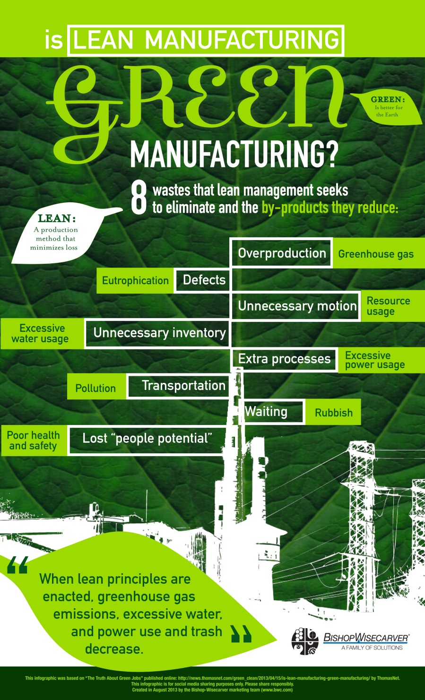

4.2 SOURCES OF AND IMPACT OF CONTAMINATES ON THE NATURAL ENVIRONMENT
Environmental pollution is defined as the state of contamination of different natural resources of the environment with the introduction of poisonous chemicals and gases into the atmosphere of the earth which leads to the destruction of natural resources such as land, air or water. Pollutants may be regarded as primary or secondary pollutants and may have short term or long term effects on the environment depending on whether they can decompose or not, and the way in which they cause damage to the environment.
The accumulation of these pollutants in the environment is a cause of great concern and can include land, water, air, noise, thermal, radioactive or light pollution.
Sources of water contamination
- Suspended solids
- Biodegradable organics (proteins, carbohydrates and fats)
- Pathogens
- Nutrients (Nitrogen, phosphorus and carbon)
- Priority pollutants (highly toxic chemicals)
- Refractory organics (pesticides, phenols, surfactants)
- Heavy metals
- Dissolved inorganics (nuisance chemicals).
Sources of air contamination
- Decomposition of garbage that releases unwanted gases in the air.
- Excessive use of fossil fuels that increases the particulate matter in the air.
- Smoke coming out from thermal power plants, forest fires etc.
- Use of leaded petrol in automobiles.
Sources of soil contamination
- Solid waste
- Flawed agricultural practices:
- Domestic waste:
- Municipal waste:
- Industrial waste:
- Chemical waste
- Biological agents
- Radioactive pollutants
- Mining and smelting:
- Construction activities
- Acid rain
- Soil erosion
The impact of contaminants on the environment
Negative impacts of pollution on the environment are depicted in the graphics below.
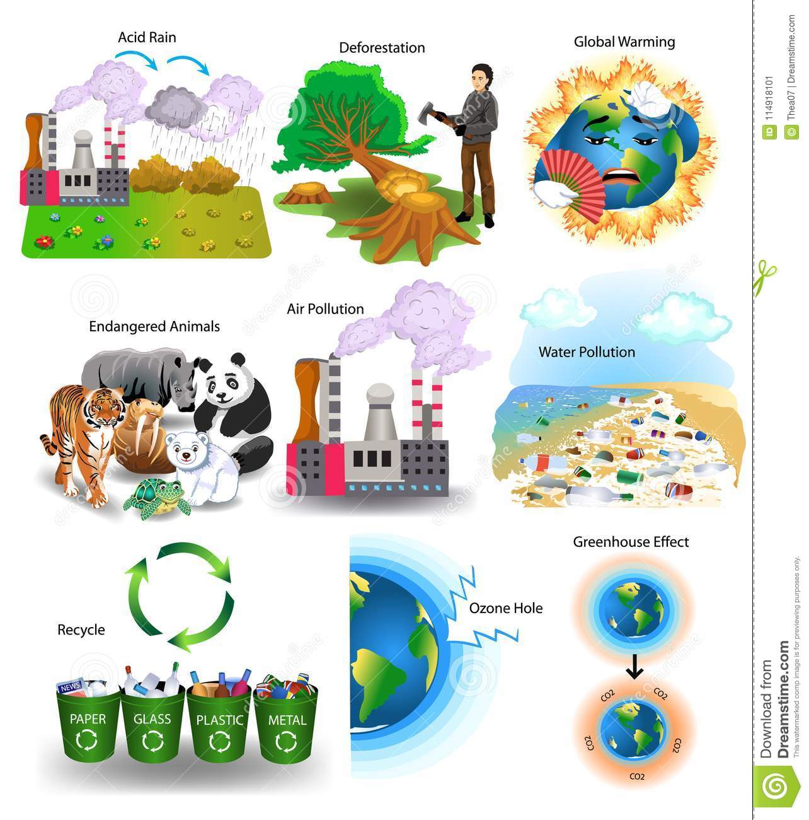

4.3 GENERAL RULES RELATED TO WASTE CONTROL MEASURES
A waste is any solid, liquid, or contained gaseous material that is being discarded by disposal, recycling, burning or incineration. It can be a byproduct of a manufacturing process or an obsolete commercial product that can no longer be used for its intended purpose and requires disposal.
Solid (non-hazardous) wastes generally include any garbage or refuse. Hazardous waste shares the properties of a hazardous material (e.g. ignitability, corrosivity, reactivity, or toxicity), or other physical, chemical, or biological characteristics that may pose a potential risk to human health or the environment if improperly managed.
Facilities that generate and store wastes should practice the following:
- Establishing waste management priorities at the outset of activities based on an understanding of potential Environmental, Health, and Safety (EHS) risks and impacts and considering waste generation and its consequences
- Establishing a waste management hierarchy that considers prevention, reduction, reuse, recovery, recycling, removal and finally disposal of wastes.
- Avoiding or minimizing the generation of waste materials, as far as practicable
- Where waste generation cannot be avoided but has been minimized, implementing the recovering and reusing of waste
- Where waste cannot be recovered or reused, treating, destroying, and disposing of it in an environmentally sound manner

4.3.1 General waste management
- Waste Management Planning
Effective planning and implementation of waste management strategies should include:
- Review of new waste sources during planning, siting, and design activities, including during equipment modifications and process alterations, to identify expected waste generation, pollution prevention opportunities, and necessary treatment, storage, and disposal infrastructure.
- Collection of data and information about the process and waste streams in existing facilities, including characterization of waste streams by type, quantities, and potential use/disposal.
- Establishment of priorities based on a risk analysis that takes into account the potential EHS risks during the waste cycle and the availability of infrastructure to manage the waste in an environmentally sound manner.
- Definition of opportunities for source reduction, as well as reuse and recycling.
- Waste Prevention
Processes should be designed and operated to prevent, or minimize, the quantities of wastes generated and hazards associated with the wastes generated in accordance with the following strategy:
- Substituting raw materials or inputs with less hazardous or toxic materials, or with those where processing generates lower waste volumes.
- Applying manufacturing processes that convert materials efficiently, providing higher product output yields, including modification of design of the production process, operating conditions, and process controls.
- Instituting good housekeeping and operating practices, including inventory control to reduce the amount of waste resulting from materials that are out-of-date, off specification, contaminated, damaged, or excessive to plant needs.
- Instituting procurement measures that recognize opportunities to return usable materials such as containers and which prevents the over-ordering of materials.
- Minimizing hazardous waste generation by implementing stringent waste segregation to prevent the commingling of non-hazardous and hazardous waste to be managed.
- Recycling and Reuse
In addition to the implementation of waste prevention strategies, the total amount of waste may be significantly reduced through the implementation of recycling plans, which should consider the following elements:
- Evaluation of waste production processes and identification of potentially recyclable materials.
- Identification and recycling of products that can be reintroduced into the manufacturing process or industry activity at the site.
- Investigation of external markets for recycling by other industrial processing operations located in the neighborhood or region of the facility (e.g., waste exchange).
- Establishing recycling objectives and formal tracking of waste generation and recycling rates.
- Providing training and incentives to employees in order to meet objectives.
- Treatment and Disposal
If waste materials are still generated after the implementation of feasible waste prevention, reduction, reuse, recovery and recycling measures, waste materials should be treated and disposed of and all measures should be taken to avoid potential impacts to human health and the environment. Selected management approaches should be consistent with the characteristics of the waste and local regulations, and may include one or more of the following:
- On-site or off-site biological, chemical, or physical treatment of the waste material to render it nonhazardous prior to final disposal.
- Treatment or disposal at permitted facilities specially designed to receive the waste. Examples include: composting operations for organic non-hazardous wastes; properly designed, permitted and operated landfills or incinerators designed for the respective type of waste; or other methods known to be effective in the safe, final disposal of waste materials such as bioremediation.

4.3.2 Hazardous waste management
Waste Storage
Hazardous waste should be stored so as to prevent or control accidental releases to air, soil, and water resources in area location where:
- Waste is stored in a manner that prevents the commingling or contact between incompatible wastes, and allows for inspection between containers to monitor leaks or spills. Examples include sufficient space between incompatibles or physical separation such as walls or containment curbs
- Store in closed containers away from direct sunlight, wind and rain.
- Secondary containment systems should be constructed with materials appropriate for the wastes being contained and adequate to prevent loss to the environment.
- Secondary containment is included wherever liquid wastes are stored in volumes greater than 220 liters. The available volume of secondary containment should be at least 110 percent of the largest storage container, or 25 percent of the total storage capacity (whichever is greater), in that specific location.
- Provide adequate ventilation where volatile wastes are stored.
Hazardous waste storage activities should also be subject to special management actions, conducted by employees who have received specific training in handling and storage of hazardous wastes:
- Provision of readily available information on chemical compatibility to employees, including labeling each container to identify its contents.
- Limiting access to hazardous waste storage areas to employees who have received proper training.
- Clearly identifying (label) and demarcating the area, including documentation of its location on a facility map or site plan.
- Conducting periodic inspections of waste storage areas and documenting the findings
- Preparing and implementing spill response and emergency plans to address their accidental release.
- Avoiding underground storage tanks and underground piping of hazardous waste.
Hazardous waste transportation
On-site and off-site transportation of waste should be conducted so as to prevent or minimize spills, releases, and exposures to employees and the public. All waste containers designated for off-site shipment should be secured and labeled with the contents and associated hazards, be properly loaded on the transport vehicles before leaving the site, and be accompanied by a shipping paper (i.e., manifest) that describes the load and its associated hazards.
Waste Treatment
Waste treatment includes thermal and biological waste treatment.
    - Thermal waste treatment techniques
- Incineration is one of the most common waste treatment methods. This approach involves the combustion of waste material in the presence of oxygen. This thermal treatment method is commonly used as a means of recovering energy for electricity or heating. This approach has several advantages. It quickly reduces waste volume, lessens transportation costs and decreases harmful greenhouse gas emissions.
- Gasification and Pyrolysis are two similar methods, both of which decompose organic waste materials by exposing waste to low amounts of oxygen and very high temperature. Pyrolysis uses absolutely no oxygen while gasification allows a very low amount of oxygen in the process. Gasification is more advantageous as it allows the burning process to recover energy without causing air pollution.
- Open Burning is a legacy thermal waste treatment that is environmentally harmful. The incinerators used in such process have no pollution control devices. They release substances such as hexachlorobenzene, dioxins, carbon monoxide, particulate matter, volatile organic compounds, polycyclic aromatic compounds, and ash. Unfortunately, this method is still practiced by many organisations internationally, as it offers an inexpensive solution to solid waste.
    - Biological waste treatment techniques
- Composting is a frequently used waste disposal or treatment method which is the controlled aerobic decomposition of organic waste materials by the action of small invertebrates and microorganisms. The most common composting techniques include static pile composting, vermi-composting, windrow composting and in-vessel composting.
- Anaerobic Digestion also uses biological processes to decompose organic materials. Anaerobic Digestion, however, uses an oxygen and bacteria-free environment to decompose the waste material where composting must have air to enable the growth of microbes.
Waste Disposal
- Dumps and Landfills
Sanitary landfills provide the most commonly used waste disposal solution. These landfills are desired to eliminate or reduce the risk of environmental or public health hazards due to waste disposal. These sites are situated where land features work as natural buffers between the environment and the landfill. For instance, the landfill area can be comprised of clay soil which is quite resistant to hazardous wastes or is characterized by an absence of surface water bodies or a low water table, preventing the risk of water pollution.
The use of sanitary landfills presents the least health and environmental risk, but the cost of establishing such landfills is comparatively higher than other waste disposal methods.
Controlled dumps are more or less the same as sanitary landfills. These dumps comply with many of the requirements for being a sanitary landfill but may lack one or two. Such dumps may have a well-planned capacity but no cell-planning. There may be no or partial gas management, basic record keeping, or regular cover.
Bioreactor landfills are the result of recent technological research. These landfills use superior microbiological processes to speed up waste decomposition. The controlling feature is the continuous addition of liquid to sustain optimal moisture for microbial digestion. The liquid is added by re-circulating the landfill leachate. When the amount of leachate is not adequate, liquid waste such as sewage sludge is used.
Monitoring
Monitoring activities associated with the management of hazardous and non-hazardous waste should include:
- Regular visual inspection of all waste storage collection and storage areas for evidence of accidental releases and to verify that wastes are properly labeled and stored. When significant quantities of hazardous wastes are generated and stored on site, monitoring activities should include:
  - Inspection of vessels for leaks, drips or other indications of loss.
  - Identification of cracks, corrosion, or damage to tanks, protective equipment, or floors.
  - Verification of locks, emergency valves, and other safety devices for easy operation (lubricating if required and employing the practice of keeping locks and safety equipment in standby position when the area is not occupied).
  - Checking the operability of emergency systems.
- Documenting results of testing for integrity, emissions, or monitoring stations (air, soil vapor, or groundwater).
- Documenting any changes to the storage facility, and any significant changes in the quantity of materials in storage.
- Regular audits of waste segregation and collection practices.
- Tracking of waste generation trends by type and amount of waste generated, preferably by facility departments.
- Characterizing waste at the beginning of generation of a new waste stream, and periodically documenting the characteristics and proper management of the waste, especially hazardous wastes.
- Keeping manifests or other records that document the amount of waste generated and its destination.
- Periodic auditing of third party treatment and disposal services including re-use and recycling facilities when significant quantities of hazardous wastes are managed by third parties. Whenever possible, audits should include site visits to the treatment storage and disposal location.
- Regular monitoring of groundwater quality in cases of Hazardous Waste on site storage and/or pretreatment and disposal.

4.4 THE IMPACT OF ENVIRONMENTAL POLLUTION ON NATURAL RESOURCES, COMMUNITIES AND THE ECONOMY

4.4.1 Negative impacts of liquid effluent
The sugarcane industry can be a very polluting industry and would inflict serious damage to the environment, if effluents discharged by sugar factories are not treated correctly before discharge. This is the case even though sugar industrial pollution is not as toxic or detrimental to the environment as effluents from tanneries, paper mills and refineries. However, large quantities of wastewater are discharged by sugar mills with high concentrations of suspended solids in the raw effluent which could cause blockage of drains and ditches and delayed pollution effects due to the slow decomposition of the biological components of the suspended solids.
Effluents containing high salt concentrations are toxic to aquatic life and cannot be discharged directly into streams or rivers. Odours can also be problematic with untreated effluents. Contaminated water bodies often appear black due to the precipitation of iron and produces hydrogen sulphide gas which is bad for the surroundings. Decomposition in water bodies results in the depletion of the oxygen content of water, making water unfit for fish and other aquatic life. Soil fertility and productivity can also be reduced if contaminated with untreated effluents.

4.4.2 Impact of Solid Waste
Boiler ash discarded in landfill sites that are not adequately covered by soil (especially in the dry season) can cause seriously dusty conditions reducing breathable air quality.
Filter cake left to ferment in landfill sites causes a characteristic unpleasant sour odour if not provided with aeration. Filter cake dumps also form leachates which are acidic and detrimental to ground water bodies causing odours and a yellowish colour.

