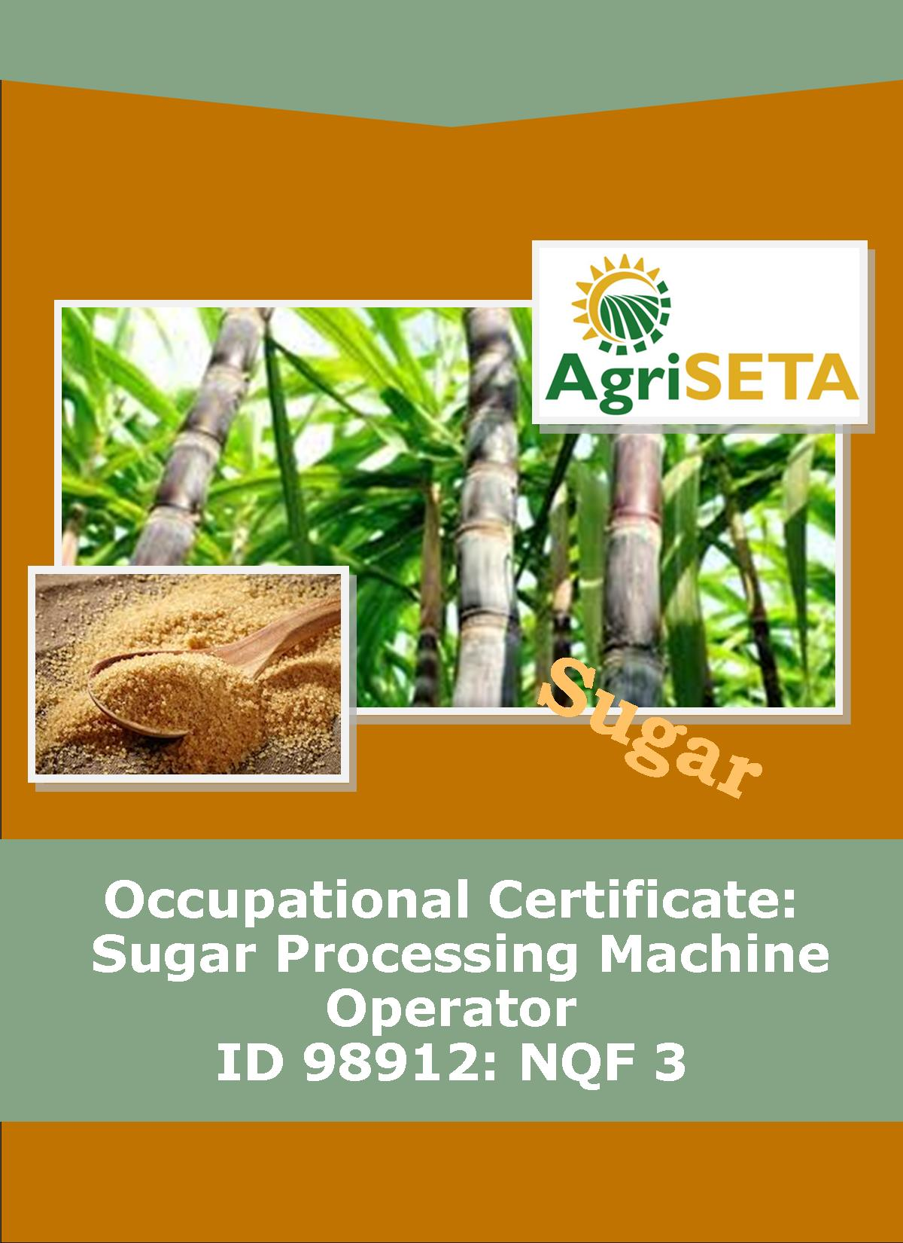**KNOWLEDGE COMPONENT:**

**KNOWLEDGE COMPONENT: LEARNER WORKBOOK 2: SUGAR PROCESSING EQUIPMENT AND TECHNOLOGY**

**Occupational Certificate: Sugar Processing Machine Operator**

**KNOWLEDGE COMPONENT: LEARNER WORKBOOK 2:**

**BOOK 2: SUGAR PROCESSING EQUIPMENT AND TECHNOLOGY**

**LEARNER WORKBOOK 2:**

**SUGAR PROCESSING EQUIPMENT AND TECHNOLOGY**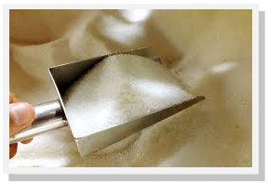

**OCCUPATIONAL CERTIFICATE: SUGAR PROCESSING MACHINE OPERATOR**

**©Copyright AgriSETA**

**Telephone: +27 12 301 5600**

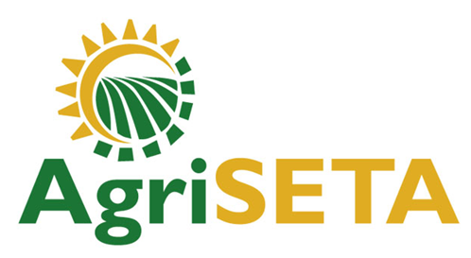

AgriSETA holds the copyright to its publications and Web pages. Proper citation is requested.

**TABLE OF CONTENTS**

1. AN INTRODUCTION TO THIS LEARNER WORKBOOK 6

2. LEARNER DETAILS 7

3. FORMATIVE ASSESSMENT INSTRUCTIONS 8

4. KNOWLEDGE MODULE 2: SUGAR PROCESSING EQUIPMENT AND TECHNOLOGY 9

4.1 Knowledge Topic 1: Equipment hygiene and cleaning (10%) 10

4.2 Knowledge Topic 2: Raw and refined sugar processing equipment and technology (30%) 20

4.3 Knowledge Topic 3: Introduction to mechanical systems (25%) 35

4.4 Knowledge Topic 4: Introduction to process flow and control (5%) 51

4.5 Knowledge Topic 5: Mechanical workshop practices (10%) 57

4.6 Knowledge Topic 6: Maintenance (10%) 62

4.7 Knowledge Topic 7: Energy, utilities and services (10%) 66

5. CONCLUSION OF KNOWLEDGE MODULE 2: SUGAR PROCESSING EQUIPMENT AND TECHNOLOGY 71

1. AN INTRODUCTION TO THIS LEARNER WORKBOOK

This Knowledge Component Learner Workbook 2: Sugar processing equipment and technology is intended to be used with the Knowledge Component Learning Resource: Book 2 (Textbook): Sugar processing equipment and technology of the Occupational Qualification: Sugar Processing Machine Operator NQF 3.

Guidance on the use of this Work Book is provided in the Learning Guide.

1. LEARNER DETAILS

|  |  |
| --- | --- |
| First name |  |
| Surname |  |
| ID number |  |
| Mobile phone contact number |  |
| E-mail address |  |
| Postal address |  |
| Date on which you started this Knowledge Module |  |
| Date on which you completed this Knowledge Module |  |
| Declaration: | I hereby confirm that:   * I received the assessment plan and schedule. * I understand my rights in terms of special needs, re-assessment, feedback and appeals against assessment decisions. * I completed this formative assessment independently without assistance from anyone else. |
| Total Marks for Knowledge Module 2 | 512 marks |
| Marks attained |  |
| Date: |  |
| Place: |  |
| Signature of Learner: |  |
| Signature of Assessor: |  |

1. FORMATIVE ASSESSMENT INSTRUCTIONS

**Instructions**

* Work individually to present the results of each Learning Activity in this Learner Workbook.
* Complete all the sections.
* Use a black pen and ensure that you complete the questions in your own handwriting.
* A recommended time to complete each activity is shown.
* The marks you will attain for each learning activity are shown in brackets.
* The total marks obtained for each Knowledge Module must be transferred from the back of each Learner Workbook to the Learner Qualification Summative Assessment Tool.

1. KNOWLEDGE MODULE 2: SUGAR PROCESSING EQUIPMENT AND TECHNOLOGY

**NQF LEVEL: 3**

**CREDITS: 24**

**PURPOSE OF THE KNOWLEDGE MODULE: The main focus of the learning in this knowledge module is to build an understanding of the mechanical knowledge of equipment, systems and technology used in a sugar processing plant.**

The learning will enable learners to demonstrate an understanding of:

* KM-02-KT01: Equipment hygiene and cleaning (10%)
* KM-02-KT02: Raw and refined sugar processing equipment and technology (30%)
* KM-02-KT03: Introduction to mechanical systems (25%)
* KM-02-KT04: Introduction to process flow and control (5%)
* KM-02-KT05: Mechanical workshop practices (10%)
* KM-02-KT06: Maintenance (10%)
* KM-02-KT07: Energy, utilities and services (10%)

4.1 Knowledge Topic 1: Equipment hygiene and cleaning (10%)

Topic elements to be covered include:

* KT0101 Cleaning processes(CIP)
* KT0102 Cleaning materials and chemicals
* KT0103 Equipment hygiene and product quality standards
* KT0104 Causes of equipment contamination and general preventative and cleaning practices

Internal Assessment Criteria and Weight

* IAC0101 The importance of equipment hygiene can be explained
* IAC0102 Safe handling of cleaning chemical and empty containers can be explained
* (Weight 10%)

**Learning activity 1.1: Individual Learning activity: -15 minutes (14 marks)**



**Learning Objective:** The importance of equipment hygiene can be explained.

**Task:** Read each question carefully and write your answer in the space provided.

1. Mention six (6) examples of sugar equipment you know. (6)

|  |
| --- |
|  |
|  |
|  |
|  |
|  |
|  |

1. What are the steps involved in sugar processing? (6)

|  |
| --- |
|  |
|  |
|  |
|  |
|  |
|  |

1. What does Cleaning in Place (CIP) mean? (2)

|  |
| --- |
|  |
|  |
|  |
|  |
|  |
|  |

**Learning activity 1.2: Individual Learning activity: 1.5 hours (70 marks)**



**Learning Objective:** Safe handling of cleaning chemical and empty containers can be explained.

**Task:** Read each question carefully and write your answer in the space provided.

1. List ten (10) examples of sugar processing equipment. (10)

|  |
| --- |
|  |
|  |
|  |
|  |
|  |
|  |
|  |
|  |
|  |
|  |

1. Mention the two ways of performing CIP. (2)

|  |
| --- |
|  |
|  |

1. Mention and discuss four (4) parameters that are used in cleaning. (8)

|  |
| --- |
|  |
|  |
|  |
|  |
|  |
|  |
|  |
|  |
|  |
|  |
|  |
|  |
|  |
|  |
|  |
|  |
|  |
|  |
|  |
|  |

1. Discuss the procedure often followed in cleaning the plant. (12)

|  |
| --- |
|  |
|  |
|  |
|  |
|  |
|  |
|  |
|  |
|  |
|  |
|  |
|  |
|  |
|  |
|  |
|  |
|  |
|  |
|  |

1. What are the main components of all formulated detergents? (2)

|  |
| --- |
|  |
|  |

1. Mention and discuss the additional components included in all formulated detergents. (8)

|  |
| --- |
|  |
|  |
|  |
|  |
|  |
|  |
|  |
|  |
|  |
|  |

1. List all three (3) types of chemical cleaning agents with their weight percentages. (3)

|  |
| --- |
|  |
|  |
|  |

1. Describe how the wash-down should be done to prevent contaminating the production area. (4)

|  |
| --- |
|  |
|  |
|  |
|  |
|  |
|  |
|  |
|  |
|  |

1. Discuss seven (7) general safety rules at the sugar mill. (7)

|  |
| --- |
|  |
|  |
|  |
|  |
|  |
|  |
|  |
|  |
|  |
|  |
|  |
|  |
|  |
|  |
|  |
|  |
|  |
|  |

1. Mention six (6) rules that are applied in Hygiene Zone 2. (6)

|  |
| --- |
|  |
|  |
|  |
|  |
|  |
|  |
|  |
|  |
|  |
|  |

1. In Hygiene Zone 3, the maintenance staff must do the following……(4)

|  |
| --- |
|  |
|  |
|  |
|  |
|  |
|  |
|  |
|  |
|  |
|  |

1. Mention four forms of equipment contamination. (4)

|  |
| --- |
|  |
|  |
|  |
|  |
|  |

4.2 Knowledge Topic 2: Raw and refined sugar processing equipment and technology (30%)

Topic elements to be covered include:

* KT0201 Cane handling equipment
* KT0202 Cane preparation equipment
* KT0203 Juice processing equipment
* KT0204 Crystallisation and crystal recovery equipment
* KT0205 Ancillary boiler equipment

Internal Assessment Criteria and Weight

* IAC0201 Equipment components can be identified from diagrams of the equipment
* IAC0202 The working principles of the equipment can be explained
* IAC0203 The operating principles of the equipment can be explained
* IAC0204 Care for, cleaning and routine maintenance practices can be explained
* (Weight 30%)

**Learning activity 2.1: Individual Learning activity: 15 minutes (17 marks)**



**Learning Objective:** Equipment components can be identified from diagrams of the equipment.

**Task:** Read each question carefully and write your answer in the space provided.

1. Explain the weighing and off-loading process of the harvested cane. (4)

|  |
| --- |
|  |
|  |
|  |
|  |
|  |
|  |
|  |
|  |

1. What is the shredder? (1)

|  |
| --- |
|  |
|  |
|  |
|  |

1. What is the task of the diffuser or mills? (2)

|  |
| --- |
|  |
|  |
|  |
|  |

1. What is the purpose of a leveller in cane preparation? (2)

|  |
| --- |
|  |
|  |
|  |

1. Briefly describe the Cane Testing Services. (2)

|  |
| --- |
|  |
|  |
|  |
|  |
|  |
|  |

1. What is the pulverised cane discharged by the shedder called? (1)

|  |
| --- |
|  |

7. How many rollers are found in the extraction plant and how many rollers in each mill? (2)

|  |
| --- |
|  |
|  |
|  |

1. How is the prepared cane fed to the mills? (2)

|  |
| --- |
|  |
|  |
|  |

9. What is the residue that leaves the last mill called? (1)

|  |
| --- |
|  |

**Learning activity 2.2: Individual Learning activity: 10 minutes (14 marks)**



**Learning Objective:** The operating principles of the equipment can be explained.

**Task:** Read each question carefully and write your answer in the space provided.

1. Define imbibition. (2)

|  |
| --- |
|  |
|  |
|  |
|  |

1. What is the difference between a bagasse diffuser and cane diffuser? (2)

|  |
| --- |
|  |
|  |
|  |

1. What is the advantage of a diffuser over that of a milling train? (2)

|  |
| --- |
|  |
|  |
|  |

1. What colour is the mixed juice before purification? (1)

|  |
| --- |
|  |
|  |

1. List the five (5) steps followed in removing impurities from the mixed juice. (5)

|  |
| --- |
|  |
|  |
|  |
|  |
|  |
|  |

1. Mention two (2) stages of mixed juice heating .(2)

|  |
| --- |
|  |
|  |
|  |

**Learning activity 2.3: Individual Learning activity: - 2 hours (82 marks)**



**Learning Objective:** Care for, cleaning and routine maintenance practices can be explained.

**Task:** Read each question carefully and write your answer in the space provided.

1. What is a flocculant? (1)

|  |
| --- |
|  |
|  |

1. What are the two essential things that need to be kept constant in order to obtain maximum purification? (2)

|  |
| --- |
|  |
|  |

1. Also used for manual pH controls are a)………………. and b)…………………..(2)

|  |
| --- |
|  |
|  |

1. Mention two (2) disadvantages of using milk of lime with high concentration. (2)

|  |
| --- |
|  |
|  |

1. Name the two (2) functions of the rotating shaft.(2)

|  |
| --- |
|  |
|  |
|  |
|  |

1. For proper clarification the following points should be kept in mind. List four (4) points. (4)

|  |
| --- |
|  |
|  |
|  |
|  |
|  |
|  |
|  |
|  |
|  |

1. Name and discuss the two (2) types of clarifiers found in South African factories. (4)

|  |
| --- |
|  |
|  |
|  |
|  |
|  |
|  |
|  |
|  |
|  |
|  |
|  |

1. What are the two stages involved when removing considerable quantities of water by evaporation? (2)

|  |
| --- |
|  |
|  |
|  |
|  |

1. What are the advantages of the Kestner evaporator? (2)

|  |
| --- |
|  |
|  |
|  |
|  |

1. Define entrainment. (1)

|  |
| --- |
|  |
|  |

1. Name the chemical that is used in cleaning the tubes of the evaporator. (1)

|  |
| --- |
|  |
|  |

1. What causes entrainment? List three (3) points. (3)

|  |
| --- |
|  |
|  |
|  |
|  |
|  |
|  |

1. The evaporators consist of the following parts: The vapour pipe, the condenser, Injection water, Airline, The Calandria, The baffles and the Steam trap. Describe each of these parts. (14)

|  |
| --- |
|  |
|  |
|  |
|  |
|  |
|  |
|  |
|  |
|  |
|  |
|  |
|  |
|  |
|  |
|  |
|  |
|  |
|  |
|  |

15. What is the mixture of sugar crystals and mother liquor called? (1)

|  |
| --- |
|  |
|  |

1. The problem of false grain cannot be over-emphasized. List four (4) of the problems. (4)

|  |
| --- |
|  |
|  |
|  |
|  |
|  |
|  |
|  |

1. Name two (2) types of centrifugals. (2)

|  |
| --- |
|  |
|  |

1. Discuss three advantages of continuous centrifugal machines.(6)

|  |
| --- |
|  |
|  |
|  |
|  |
|  |
|  |
|  |
|  |
|  |
|  |
|  |
|  |

1. Crystals are found in molasses when the following occurs. (3)

|  |
| --- |
|  |
|  |
|  |
|  |

1. Name the two (2) components found in the final molasses. (2)

|  |
| --- |
|  |
|  |
|  |
|  |
|  |
|  |
|  |

1. Define the following: Pan, Batch pan, Continuous pan, Molasses, Seed magma, Proof stick, Vacuum breaker and Feed manifold. (16)

|  |
| --- |
|  |
|  |
|  |
|  |
|  |
|  |
|  |
|  |
|  |
|  |
|  |
|  |
|  |
|  |
|  |
|  |
|  |
|  |
|  |

1. What is the boiler? (2)

|  |
| --- |
|  |
|  |

1. Mention and discuss the three (3) systems that boilers are made up of. (6)

|  |
| --- |
|  |
|  |
|  |
|  |
|  |
|  |
|  |
|  |
|  |
|  |
|  |

4.3 Knowledge Topic 3: Introduction to mechanical systems (25%)

Topic elements to be covered include:

* KT0301 Material handling equipment (actuators, elevators, conveyors)
* KT0302 Pumping systems (pipes, fittings, valves)
* KT0303 Drives (direct and indirect drives) (motors, turbines, hydraulic, gear boxes, clutches)
* KT0304 Scales
* KT0305 Air moving equipment (fans, compressors, vacuum pump)

Internal Assessment Criteria and Weight

* IAC0301 Equipment components can be identified from diagrams of the equipment
* IAC0302 The working principles of the equipment can be explained
* (Weight 25%)

**Learning activity 3.1: Individual Learning activity: 30 minutes (32 marks)**



**Learning Objective:** Equipment components can be identified from diagrams of the equipment.

**Task:** Read each question carefully and write your answer in the space provided.

1. What is the material handling equipment? (2)

|  |
| --- |
|  |
|  |
|  |

1. What is an actuator? (2)

|  |
| --- |
|  |
|  |
|  |

1. How do actuators operate? (2)

|  |
| --- |
|  |
|  |
|  |
|  |

1. Name and describe six (6) different types of actuators. (12)

|  |
| --- |
|  |
|  |
|  |
|  |
|  |
|  |
|  |
|  |
|  |
|  |
|  |
|  |
|  |
|  |

1. Name three (3) different types of elevators. (3)

|  |
| --- |
|  |
|  |
|  |
|  |
|  |
|  |

1. What is a conveyor system? (2)

|  |
| --- |
|  |
|  |

1. Name two (2) types of conveyors used in the Sugar factory. (2)

|  |
| --- |
|  |
|  |

1. List seven (7) types of conveyors. (7)

|  |
| --- |
|  |
|  |
|  |
|  |
|  |
|  |
|  |
|  |

**Learning activity 3.2: Individual Learning activity: -10 minutes (15 marks)**



**Learning Objective:** Equipment components can be identified from diagrams of equipment.

**Task:** Read each question carefully and write your answer in the space provided.

1. What is the function of pipes? (2)

|  |
| --- |
|  |
|  |

1. Describe two kinds of material used to make different pipes and tubes in the Sugar industry. (2)

|  |
| --- |
|  |
|  |

1. Identify and name the following chain vices. (3)

|  |
| --- |
| C:\Users\Scientific Roets\Pictures\Chain vice 1.jpg |
| C:\Users\Scientific Roets\Pictures\Chain vice 2.jpg |
| C:\Users\Scientific Roets\Pictures\Chain vice 4.jpg |

1. What do the following acronyms stand for? (4)

|  |
| --- |
| NPT: |
| BSPT: |
| NPSM: |
| ISO: |

1. Sockets are available in two types. Name and state their functions. (4)

|  |
| --- |
|  |
|  |

**Learning activity 3.3: Individual Learning activity: -15 minutes (19 marks)**



**Learning Objective:** Equipment components can be identified from diagrams of equipment.

**Task:** Read each question carefully and write your answer in the space provided.

1. What are valves used for? (2)

|  |
| --- |
|  |
|  |
|  |

1. List five (5) types of valves. (5)

|  |
| --- |
|  |
|  |
|  |
|  |
|  |

1. What is the most common type of diaphragm valve? (1)

|  |
| --- |
|  |
|  |

1. What causes the safety relief valve to blow? (2)

|  |
| --- |
|  |
|  |
|  |

1. Complete the following diagram of a safety relief valve. (9)

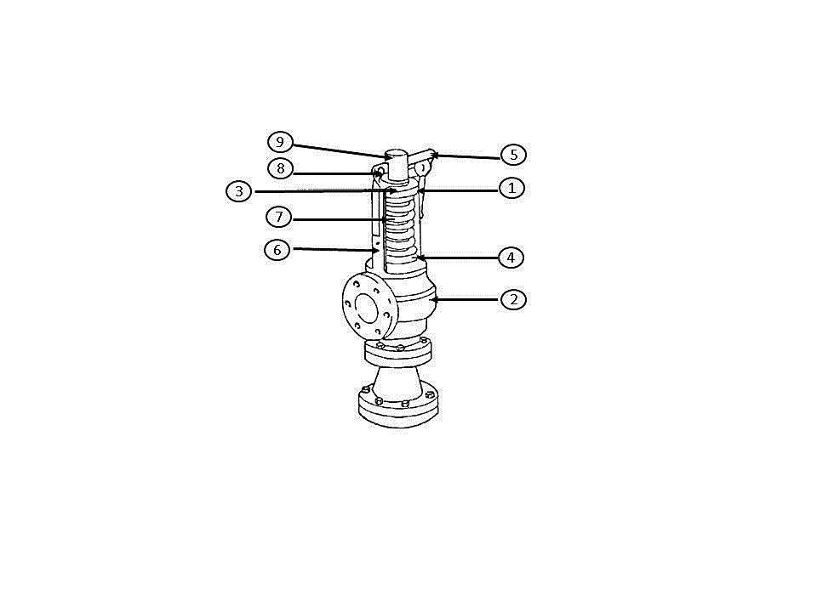

|  |
| --- |
|  |
|  |
|  |
|  |
|  |
|  |

**Learning activity 3.4: Individual Learning activity: -15 minutes (17 marks)**



**Learning Objective:** The working principles of the equipment can be explained.

**Task:** Read each question carefully and write your answer in the space provided.

1. What is a hydraulic motor and its function? (3)

|  |
| --- |
|  |
|  |
|  |
|  |

1. What is a turbine? (2)

|  |
| --- |
|  |
|  |
|  |
|  |

1. List four (4) types of turbines. (4)

|  |
| --- |
|  |
|  |
|  |
|  |

1. Name and briefly describe the functions of a hydraulic system. (8)

|  |
| --- |
|  |
|  |
|  |
|  |
|  |
|  |
|  |
|  |
|  |
|  |
|  |
|  |
|  |

**Learning activity 3.5: Individual Learning activity: -1.5 hours (53 marks)**



**Learning Objective:** The working principles of the equipment can be explained.

**Task:** Read each question carefully and write your answer in the space provided.

1. Name the five (5) basic components of a hydraulic circuit. (5)

|  |
| --- |
|  |
|  |
|  |
|  |
|  |
|  |
|  |

1. The pressure accumulator can carry out many tasks in a hydraulic circuit, list them. (4)

|  |
| --- |
|  |
|  |
|  |
|  |
|  |

1. List 5 different types of accumulators. (5)

|  |
| --- |
|  |
|  |
|  |
|  |
|  |
|  |

1. What is a gear? (2)

|  |
| --- |
|  |
|  |
|  |
|  |

1. Describe the different types of gears and the conditions under which they are used. (12)

|  |
| --- |
|  |
|  |
|  |
|  |
|  |
|  |
|  |
|  |
|  |
|  |
|  |
|  |
|  |
|  |
|  |
|  |
|  |
|  |
|  |
|  |

1. Name two disadvantages of the cone clutch. (2)

|  |
| --- |
|  |
|  |
|  |
|  |

1. Explain under what conditions a centrifugal clutch would be used. (2)

|  |
| --- |
|  |
|  |
|  |
|  |

1. What are the advantages of using a multi-plate disc clutch? (3)

|  |
| --- |
|  |
|  |
|  |
|  |
|  |

1. Name three different types of mechanical balances used in the industry. (3)

|  |
| --- |
|  |
|  |
|  |
|  |
|  |
|  |

1. What precautions should be observed when using a balance? Name five. (5)

|  |
| --- |
|  |
|  |
|  |
|  |
|  |
|  |
|  |
|  |
|  |

1. What is the function of vacuum pumps? (2)

|  |
| --- |
|  |
|  |
|  |
|  |

1. Name four ways in which a pump transfers liquid. (4)

|  |
| --- |
|  |
|  |
|  |
|  |
|  |
|  |
|  |
|  |

1. Explain how a pump can be primed. (4)

|  |
| --- |
|  |
|  |
|  |
|  |
|  |
|  |
|  |

4.4 Knowledge Topic 4: Introduction to process flow and control (5%)

Topic elements to be covered include:

* KT0401 Flow diagrams and symbols
* KT0402 Instrumentation and control systems
* KT0403 Process communication (Up-stream and down-stream)

Internal Assessment Criteria and Weight

* IAC0401 Equipment and process stages can be identified from a flow diagram
* IAC0402 Instrumentation and control systems can be identified and the uses explained
* (Weight 5%)

**Learning activity 4.1: Individual Learning activity: 10 minutes (17 marks)**



**Learning Objective:** Equipment and process stages can be identified from a flow diagram.

**Task:** Read each question carefully and write your answer in the space provided.

1. List nine steps in the manufacturing process of sugar. (9)

|  |
| --- |
|  |
|  |
|  |
|  |
|  |
|  |
|  |
|  |
|  |

1. How is each step of sugar production from cane monitored for quality and quantity parameters? (2)

|  |
| --- |
|  |
|  |
|  |

1. The goal of instrumentation and control is to improve……? (6)

|  |
| --- |
|  |
|  |
|  |
|  |
|  |
|  |
|  |
|  |

**Learning activity 4.2: Individual Learning activity: 30 minutes (29 marks)**



**Learning Objective:** Instrumentation and control systems can be identified and the uses explained.

**Task:** Read each question carefully and write your answer in the space provided.

1. Name and discuss the challenges to solid level measurement. (8)

|  |
| --- |
|  |
|  |
|  |
|  |
|  |
|  |
|  |
|  |
|  |
|  |
|  |
|  |
|  |
|  |

1. List 5 types of solid level measuring sensors. (5)

|  |
| --- |
|  |
|  |
|  |
|  |
|  |
|  |
|  |
|  |
|  |

1. At the cane preparation stage the following is measured and controlled. (8)

|  |
| --- |
|  |
|  |
|  |
|  |
|  |
|  |
|  |
|  |

1. List the variables that need to be controlled in the evaporator. (8)

|  |
| --- |
|  |
|  |
|  |
|  |
|  |
|  |
|  |
|  |
|  |
|  |
|  |
|  |
|  |
|  |

4.5 Knowledge Topic 5: Mechanical workshop practices (10%)

Topic elements to be covered include:

* KT0501 Tools and measuring equipment for lubricating and cleaning
* KT0502 Mechanical workshop safety
* KT0503 Basic engineering symbols
* KT0504 Use of equipment manuals
* KT0505 Properties and use of lubricants, sealants, fasteners and locking devices

Internal Assessment Criteria and Weight

* IAC0501 The use of technical manuals and engineering symbols can be demonstrated
* IAC0502 Workshop tools and measuring instruments can be identified and their uses explained
* IAC0503 Workshop safety practices can be explained
* IAC0504 Tools, equipment and materials used for lubrication and cleaning used for general equipment maintenance can be identified and their uses explained
* (Weight 10%)

**Learning activity 5.1: Individual Learning activity: 40 minutes (47 marks)**



**Learning Objective:** Tools, equipment and materials used for lubrication and cleaning used for general equipment maintenance can be identified and their uses explained

**Task:** Read each question carefully and write your answer in the space provided.

1. List 10 lubrication and cleaning tools and measuring equipment. (10)

|  |
| --- |
|  |
|  |
|  |
|  |
|  |
|  |
|  |
|  |
|  |
|  |
|  |
|  |
|  |
|  |

1. What are the employee’s responsibilities toward safety? (4)

|  |
| --- |
|  |
|  |
|  |
|  |
|  |
|  |
|  |

1. What should be considered when one assesses machinery and equipment for possible mechanical hazards? (8)

|  |
| --- |
|  |
|  |
|  |
|  |
|  |
|  |
|  |
|  |
|  |
|  |
|  |

1. What are examples of unsafe conditions in the workplace? (7)

|  |
| --- |
|  |
|  |
|  |
|  |
|  |
|  |
|  |
|  |

1. True or False: Engineering drawings, electrical instructions and tool instruction manuals all use different symbols to denote universal concepts within each field. (1)

|  |
| --- |
|  |

1. What do manufacturer instructions provide us with? (6)

|  |
| --- |
|  |
|  |
|  |
|  |
|  |
|  |
|  |

1. Name three types of lubricants available for commercial use. (3)

|  |
| --- |
|  |
|  |
|  |

1. List two types of mechanical locking devices and their function. (4)

|  |
| --- |
|  |
|  |
|  |

9. List 4 shortcomings of Mechanical Locking Devices. (4)

|  |
| --- |
|  |
|  |
|  |
|  |

4.6 Knowledge Topic 6: Maintenance (10%)

Topic elements to be covered include:

* KT0601 Preventative maintenance
* KT0602 Care for assets

Internal Assessment Criteria and Weight

* IAC0601 The importance of preventative maintenance and care for assets can be explained
* (Weight 10%)

**Learning activity 6.1: Individual Learning activity: 45 minutes (37 marks)**



**Learning Objective:** The importance of preventative maintenance and care for assets can be explained.

**Task:** Read each question carefully and write your answer in the space provided.

1. The preventive maintenance function is sub-divided into….? (2)

|  |
| --- |
|  |
|  |

1. Name and discuss 4 forms of preventive maintenance. (8)

|  |
| --- |
|  |
|  |
|  |
|  |
|  |
|  |
|  |
|  |
|  |
|  |

1. Several other terms which are often used as synonyms for preventive maintenance are? (12)

|  |
| --- |
|  |
|  |
|  |
|  |
|  |
|  |
|  |
|  |
|  |
|  |
|  |
|  |
|  |
|  |
|  |
|  |
|  |
|  |
|  |

1. What are the various elements of a preventative maintenance system in an industry? (10)

|  |
| --- |
|  |
|  |
|  |
|  |
|  |
|  |
|  |
|  |
|  |
|  |
|  |

1. List the important objectives of preventative maintenance. (5)

|  |
| --- |
|  |
|  |
|  |
|  |
|  |
|  |

4.7 Knowledge Topic 7: Energy, utilities and services (10%)

Topic elements to be covered include:

* KT0701 Steam
* KT0702 Electricity
* KT0703 Compressed air
* KT0704 Water

Internal Assessment Criteria and Weight

* IAC0701 The uses of energy, utilities and steam in the processing lines can be explained
* (Weight 10%)

**Learning activity 7.1: Individual Learning activity: 1 hour (49 marks)**



**Learning Objective:** The uses of energy, utilities and steam in the processing lines can be explained.

**Task:** Read each question carefully and write your answer in the space provided.

1. Mention two (2) uses of steam in the sugar mill. (4)

|  |
| --- |
|  |
|  |
|  |
|  |
|  |

1. List the two (2) drums of a sugar mill boiler connected by the tubes. (2)

|  |
| --- |
|  |
|  |
|  |

1. True or False: The forced draft fan (FD Fan) blows air into the combustion chamber where a fuel (bagasse/coal) is burned to produce hot gases. (1)

|  |
| --- |
|  |

1. What are the two (2) common evaporator vessels? (2)

|  |
| --- |
|  |
|  |

1. List twelve (12) places where electricity is used in the sugar mill. (12)

|  |
| --- |
|  |
|  |
|  |
|  |
|  |
|  |
|  |
|  |
|  |
|  |
|  |
|  |
|  |
|  |

1. How is electricity generated in the Sugar Mill? (2)

|  |
| --- |
|  |
|  |
|  |
|  |

1. List two (2) uses of compressed air. (2)

|  |
| --- |
|  |
|  |

1. What are the water requirements in the sugar process? (7)

|  |
| --- |
|  |
|  |
|  |
|  |
|  |
|  |
|  |

1. Draw a diagram showing streams containing water entering and leaving a sugar mill. (17)

|  |
| --- |
|  |

1. CONCLUSION OF KNOWLEDGE MODULE 2: SUGAR PROCESSING EQUIPMENT AND TECHNOLOGY

Throughout this knowledge module you have been provided opportunities to complete formative learning activities. You have captured your results in this Learner Workbook.

The total marks for this Knowledge Module are as follows:

|  |  |  |
| --- | --- | --- |
| **Knowledge Module** | **Total Marks** | **Marks attained** |
| KM-02KT01: Equipment hygiene and cleaning (10%) | 84 |  |
| KM-02-KT02: Raw and refined sugar processing equipment and technology (30%) | 113 |  |
| KM-02-KT03: Introduction to mechanical systems (25%) | 136 |  |
| KM-02-KT04: Introduction to process flow and control (5%) | 46 |  |
| KM-02-KT05: Mechanical workshop practices (10%) | 47 |  |
| KM-02-KT06: Maintenance (10%) | 37 |  |
| KM-02-KT07: Energy, utilities and services (10%) | 49 |  |
| **Total Marks** | **512 marks** |  |

