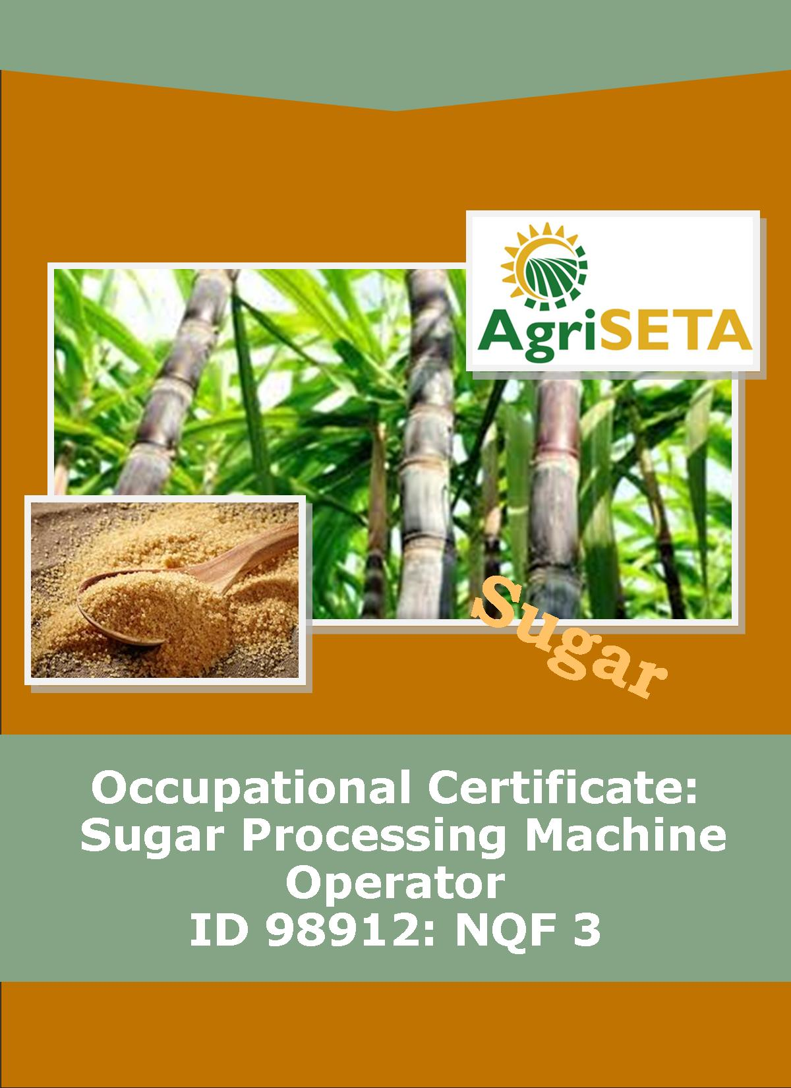
KNOWLEDGE COMPONENT:
KNOWLEDGE COMPONENT: LEARNER WORKBOOK 4: QUALITY ASSURANCE
Occupational Certificate: Sugar Processing Machine Operator

KNOWLEDGE COMPONENT: LEARNER WORKBOOK 4:

KNOWLEDGE MODULE 4: QUALITY ASSURANCE
LEARNER WORKBOOK: KNOWLEDGE MODULE 4: QUALITY ASSURANCE
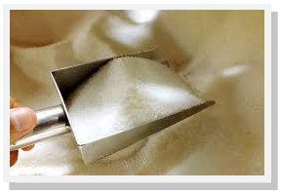
OCCUPATIONAL CERTIFICATE: SUGAR PROCESSING MACHINE OPERATOR

©Copyright AgriSETA
Telephone: +27 12 301 5600
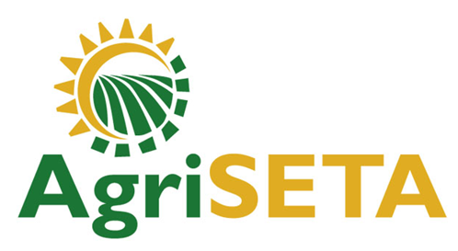

AgriSETA holds the copyright to its publications and Web pages. Proper citation is requested.

TABLE OF CONTENTS
1. AN INTRODUCTION TO THIS LEARNER WORKBOOK 6
2. LEARNER DETAILS 7
3. FORMATIVE ASSESSMENT INSTRUCTIONS 8
4. KNOWLEDGE MODULE 4: QUALITY ASSURANCE 9
4.1 Knowledge Topic 1: Quality Control and Assurance (25%) 10
4.2 Knowledge Topic 2: Sampling principles and methods (50%) 19
4.3 Knowledge Topic 3: Principles of food safety and quality assurance (25%) 36
5. CONCLUSION OF KNOWLEDGE MODULE 4: QUALITY ASSURANCE 45

AN INTRODUCTION TO THIS LEARNER WORKBOOK
This Knowledge Component Learner Workbook 4: Quality Assurance is intended to be used with the Knowledge Component Learning Resource: Book 4 (Textbook): Quality Assurance of the Occupational Qualification: Sugar Processing Machine Operator NQF 3.
Guidance on the use of this Work Book is provided in the Learning Guide.

LEARNER DETAILS

First name
Surname
ID number
Mobile phone contact number
E-mail address
Postal address
Date on which you started this Knowledge Module
Date on which you completed this Knowledge Module
Declaration: | I hereby confirm that:  - I received the assessment plan and schedule.  - I understand my rights in terms of special needs, re-assessment, feedback and appeals against assessment decisions.  - I completed this formative assessment independently without assistance from anyone else.
Total Marks for Knowledge Module 4 | 255 marks
Marks attained
Date:
Place:
Signature of Learner:
Signature of Assessor:

FORMATIVE ASSESSMENT INSTRUCTIONS
Instructions
- Work individually to present the results of each Learning Activity in this Learner Workbook.
- Complete all the sections.
- Use a black pen and ensure that you complete the questions in your own handwriting.
- A recommended time to complete each activity is shown.
- The marks you will attain for each learning activity are shown in brackets.
- The total marks obtained for each Knowledge Module must be transferred from the back of each Learner Workbook to the Learner Qualification Summative Assessment Tool.

KNOWLEDGE MODULE 4: QUALITY ASSURANCE
NQF LEVEL: 3
CREDITS: 8
PURPOSE OF THE KNOWLEDGE MODULE: The main focus of the learning in this knowledge module is to build an understanding of quality assurance terms, concepts and established principles applied in sugar milling.
The learning will enable learners to demonstrate an understanding of:
- KM-04-KT01: Quality Control and Assurance (25%)
- KM-04-KT02: Sampling principles and methods (50%)
- KM-04-KT03: Principles of food safety and quality assurance (25%)

4.1 Knowledge Topic 1: Quality Control and Assurance (25%)
Topic elements to be covered include:
- KT0101 Quality management systems
- KT0102 Quality control and assurance
- KT0103 Quality indicators and specification
- KT0104 Key control points
- KT0105 Quality reports
- KT0106 Traceability
Internal Assessment Criteria and Weight
- IAC0101 An understanding of quality control and assurance can be demonstrated by responding to a range of questions on related concepts and practices
- (Weight 25%)

Learning activity 1.1: Individual Learning activity: 15 minutes (11 marks)
Learning Objective: An understanding of quality control and assurance can be demonstrated by responding to a range of questions on related concepts and practices
Task: Read each question carefully and write your answer in the space provided.
- Define quality assurance. (2)

- What does the term “QMS” stands for and provide its definition?(4)

- Mention five (5) purposes of a Quality Management System (5)

Learning activity 1.2: Individual Learning activity: 2 hours (63 marks)
Learning Objective: An understanding of quality control and assurance can be demonstrated by responding to a range of questions on related concepts and practices.
Task: Read each question carefully and write your answer in the space provided.
- What is the difference between Quality Assurance and Quality Control? (4)

- What is the main goal of quality assurance (QA)? (2)

- List five (5) types of quality assurance systems that are available in the food industry. (5)

- Discuss the purpose of Good Manufacturing Practice (GMP) in the sugar industry. (4)

- Good Manufacturing Practice (GMP) in cane sugar production is the most effective way to minimise defects. Mention six (6) types of controls that can be implemented. (6)

- List three (3) examples of foreign material types that can be found in the final product of sugar.(3)

- Briefly explain the following implementation strategies of GMP: (a) Planning, (b) Monitoring and verification and (c) Commitment and policy. (12)

- Discuss the meaning of Hazard Analysis Critical Control Point (HACCP) (4)

- Discuss five (5) of the seven principles of HACCP. (10)

- Define the meaning of “traceability”. (2)

- Mention three (3) key benefits of traceability. (3)

- Briefly discuss all four (4) traceability systems phases. (8)

4.2 Knowledge Topic 2: Sampling Principles and Methods (50%)
Topic elements to be covered include:
- KT0201 Representative sampling
- KT0202 Sampling techniques and equipment
- KT0203 Handling and storages of samples
- KT0204 Sample records and labels
- KT0205 Sampling frequency
Internal Assessment Criteria and Weight
- IAC0201 The concept “Representative sampling” can be defined and explained
- IAC0202 An understanding of sampling techniques and equipment used at various stages in the sugar milling process can be demonstrated
- IAC0203 Sample handling, storage, recording and labelling practices can be demonstrated
- (Weight 50%)

Learning activity 2.1: Individual Learning activity: 30 minutes (31 marks)
Learning Objective: The concept “Representative sampling” can be defined and explained.
Task: Read each question carefully and write your answer in the space provided.
- Briefly describe representative sampling. (2)

- Discuss four (4) methods of how to take representative samples. (8)

- .Name and discuss the purposes of representative sampling. (8)

- Explain good sampling techniques. (2)

- List the apparatus used for cane sampling. (5)

- Discuss the procedure of taking the first expressed juice sample. (6)

Learning activity 2.2: Group Learning activity: 15 minutes (10 marks)
Learning Objective: An understanding of sampling techniques and equipment used at various stages in the sugar milling process can be demonstrated.
Task: Form 4 groups. Do this by assigning everyone a number from 1 to 4. All the “ones” form one group, all the “twos” form the next group, all the “threes” form the third group and all the “fours” form the fourth group.
When you are in your groups, elect one person to be the group’s scribe (the person who will write down the points of your discussion), elect one person to be the group’s time-keeper (this person reminds the group that they are running out of time for the exercise) and one person who will be the group’s reporter (the person who will explain your findings to the class).
In your groups, discuss one of the following sampling techniques used along the sugar manufacturing process: Final bagasse, Insoluble solids determination, Clarified juice, and Remelt. (10)

Learning activity 2.3: Individual Learning activity: 30 minutes (17 marks)
Learning Objective: The concept “Representative sampling” can be defined and explained.
Task: Read each question carefully and write your answer in the space provided.
- Discuss the sampling techniques for A-, B- and C- massecuite. (5)

- Name five (5) apparatus used in sampling final molasses. (5)
- How are the samples for Magma and A- and B- molasses taken? (2)

- How are B-, C1- and C2-sugars sampling done? (5)

Learning activity 2.4: Individual Learning activity: 1 hour (67 marks)
Learning Objective: An understanding of sampling techniques and equipment used at various stages in the sugar milling process can be demonstrated.
Task: Read each question carefully and write your answer in the space provided.
- Name two (2) types of electronic cane trackers. (2)

- Briefly discuss the method of operation for the integrated circuit cane tracker. (8)

- How are the electronic cane trackers maintained? (2)

- What is the purpose of a cane sampler? (2)

- Briefly discuss the operation cycle of the cane sampler (sliding gate for use with slat elevators). (5)

- Mention four (4) points that must receive attention to ensure the smooth operation of the gates with regards to maintenance. (5)

- Discuss the method of operation for the cane sub-sampler. (3)

- Name and discuss the function of three types of screw conveyors. (6)

- What is the purpose of the sample shredder? (2)

- Briefly discuss the seven (7) steps of the maintenance procedure for the sample shredder. (7)

- Name two (2) types of samplers that are approved in the case of final bagasse. (2)

- Briefly discuss the method of operation for the swing sampler. (3)

- Discuss the handling and storage of samples. (10)

- Different stages of the sugar process require sampling at different frequencies; Discuss the frequencies of the following stages: Mixed juice, Filter feed (mud) for pH and pol and insoluble solids, Syrup, Filtrate and A- sugar. (10)

4.3 Knowledge Topic 3: Principles of Food Safety and Quality Assurance (25%)
Topic elements to be covered include:
- KT0301 HACCP
- KT0302 Personal hygiene
- KT0303 Food safety protective measures
Internal Assessment Criteria and Weight
- IAC0301 The focus of HACCP and measures to meet standards in a sugar mill can be explained
- IAC0302 The importance of meeting HACCP standards from sustainable business perspective can be explained
- IAC0303 Personal hygiene measures that must be met by all employees can be listed and explained
- (Weight 25%)

Learning activity 3.1: Individual Learning activity: 30 minutes (18 marks)
Learning Objective: The focus of HACCP and measures to meet standards in a sugar mill can be explained.
Task: Read each question carefully and write your answer in the space provided.
- There are seven critical control points (CCP) that can be identified in the production line of sugarcane that require monitoring. Briefly discuss CCP 2, CCP 3, CCP 4 and CCP 5. (12)

- What does “HACCP” stand for? (1)

- Mention five (5) heavy metals of primary concern contained in commercial fertilizers and sewage sludge. (5)

Learning activity 3.2: Individual Learning activity: 30 minutes (22 marks)
Learning Objective: Personal hygiene measures that must be met by all employees can be listed and explained.
Task: Read each question carefully and write your answer in the space provided.
- Define personal hygiene. (2)

- Name the items of Personal Protective Equipment that must be worn by sugar factory workers at all times. State the names and the reason it must be worn. (4)

- List three (3) contaminants carried over by ordinary clothes. (3)

- When should sugar factory workers wash their hands? (5)

- What is used to cover cuts and sores on your hands? (2)

- Mention six (6) infections that can cause workers to be excluded from work. (6)

Learning activity 3.3: Individual Learning activity: 15 minutes (11 marks)
Learning Objective: Personal hygiene measures that must be met by all employees can be listed and explained.
Task: Read each question carefully and write your answer in the space provided.
- Briefly discuss what “food safety” means. (2)

- List and discuss three (3) basic requirements of food safety. (3)

- Name and briefly discuss the three (3) types of food safety hazards. (6)

Learning activity 3.4: Group Learning activity: 5 minutes (5 marks)
Learning Objective: Personal hygiene measures that must be met by all employees can be listed and explained.
Task: Form 4 groups. Do this by assigning everyone a number from 1 to 4. All the “ones” form one group, all the “twos” form the next group, all the “threes” form the third group and all the “fours” form the fourth group.
When you are in your groups, elect one person to be the group’s scribe (the person who will write down the points of your discussion), elect one person to be the group’s time-keeper (this person reminds the group that they are running out of time for the exercise) and one person who will be the group’s reporter (the person who will explain your findings to the class).
As a responsible adult working in the food sector, which diseases would make you, voluntarily, remove yourself from production activities? Be honest and imagine whether you would like someone else with these diseases to carry on working with your foods, and possibly put you and your loved ones at risk.
If I have these diseases I will not work with feed products

CONCLUSION OF KNOWLEDGE MODULE 4: QUALITY ASSURANCE
Throughout this knowledge module you have been provided opportunities to complete formative learning activities. You have captured your results in this Learner Workbook.
The total marks for this Knowledge Module are as follows:
Knowledge Module | Total Marks | Marks attained
KM-04-KT01: Quality Control and Assurance (25%) | 74
KM-04-KT02: Sampling principles and methods (50%) | 125
KM-04-KT03: Principles of food safety and quality assurance (25%) | 56
Total Marks | 255 marks

