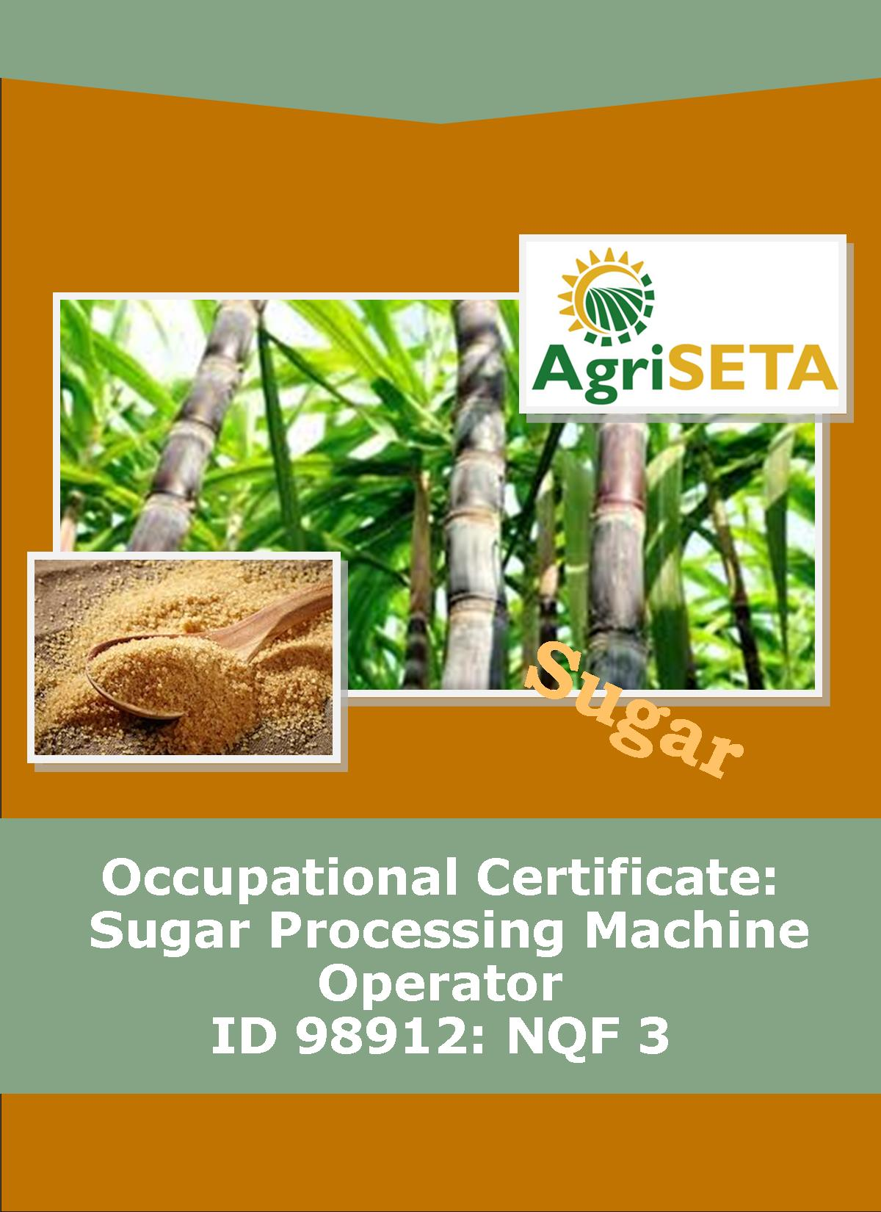
LEARNER SUMMATIVE ASSESSMENT TOOL: KNOWLEDGE MODULE 4:
KNOWLEDGE COMPONENT: LEARNER SUMMATIVE ASSESSMENT TOOL: KNOWLEDGE MODULE 4: QUALITY ASSURANCE
Occupational Certificate: Sugar Processing Machine Operator

LEARNER SUMMATIVE ASSESSMENT TOOL

KNOWLEDGE MODULE 4: QUALITY ASSURANCE
QUALITY ASSURANCE
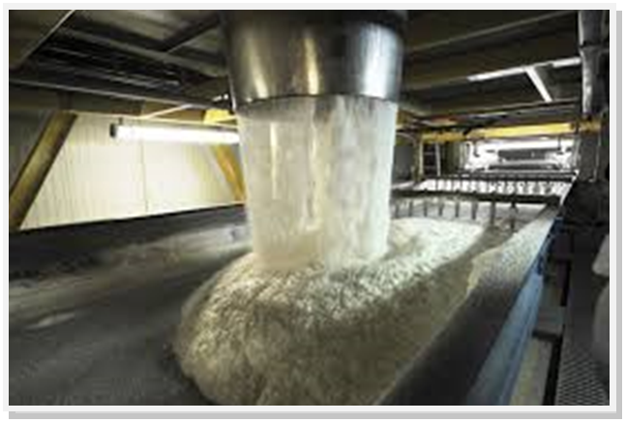
OCCUPATIONAL CERTIFICATE: ID 98912: SUGAR PROCESSING MACHINE OPERATOR

©Copyright AgriSETA
Telephone: +27 12 301 5600
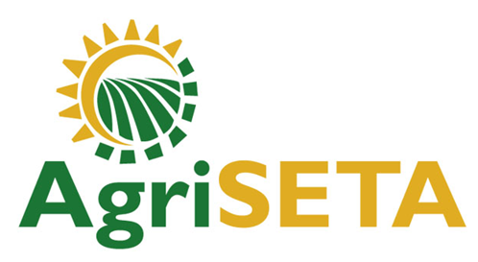

AgriSETA holds the copyright to its publications and Web pages. Proper citation is requested.

TABLE OF CONTENTS

1. STAKEHOLDER INFORMATION 6
2. COMPETENCY SUMMARY OF ASSESSMENT 8
3. ASSESSMENT ALIGNMENT MATRIX (INTERGRATED OUTCOMES) 9
4. ASSESSMENT DECISION & EVIDENCE EVALUATION RECORD 11
5. OVERALL ASSESSMENT DECISION 12
6. Evidence of feedback 13
7. OVERALL RESULTS 14
8. ASSESSMENT REVIEW 15
9. FINAL DECISION 17
10. LEARNER FEEDBACK FORM 18
11. SUMMATIVE ASSESSMENT INSTRUCTIONS 19
12. WRITTEN ASSESSMENT 20
13. FINAL MARKS 28

STAKEHOLDER INFORMATION
LEARNER INFORMATION
Name
Surname
ID number
Mobile phone contact number
E-mail address
Physical address
Postal address
Employer Name
Employer Contact Details

ASSESSOR DETAILS
Name
Surname
Assessor ID
Project Name | Occupational Certificate ID 98912::Sugar Processing Machine Operator
Module No. | Module 4:Quality Assurance
Date of Assessment
Portfolio submission Date
Assessor Signature
Total Marks for Knowledge Module 4 | 90 marks
Marks attained
Place:

MODERATOR DETAILS
Moderator Name
Moderator ID
Moderator Signature
Date of Moderation

COMPETENCY SUMMARY OF ASSESSMENT
Module 9 | KM-4-KT01: Quality Control and Assurance | C | NYC
1 | 1.1.Quality management systems
 | 1.2.Quality control and assurance
 | 1.3.Quality indicators and specification
 | 1.4.Key control points
 | 1.5.Quality reports
 | 1.6.Traceability
2 | KM-4-KT02: Sampling principles and methods | C | NYC
 | 2.1.Representative sampling
 | 2.2. Sampling techniques and equipment
 | 2.3. Handling and storages of samples
 | 2.4.Sample records and labels
 | 2.5.Sampling frequency
3 | KM-4-KT03: Principles of food safety and quality assurance | C | NYC
 | 3.3. HACCP
 | 3.2. Personal hygiene
 | 3.4. Food safety protective measures

ASSESSMENT ALIGNMENT MATRIX (INTERGRATED OUTCOMES)
Module No: 4 | How it is assessed (Assessment methodology) | Where is it covered (learning material) | Where it is assessed |  | First Submission
 |  |  | Summative | Formative
SAQA ID Number: 98912: | Two methods of assessment are followed which are:  1. Summative assessment: written tests, knowledge questions using fundamental and reflexive questions.  2. Formative assessment: assignments, tasks, portfolio of evidence submitted and presentations. |  |  |  | Clearly meets all the criteria | Meets some but not all criteria | Clearly does not meet any of the criteria
Title: Operations Management
NQF level and credits:
NQF Level 5: 12 Credits
Topic: 1 Quality Control and Assurance |  | Page 11 | Question 4.1 page 20
Assessment criteria: An understanding of quality control and assurance can be demonstrated by responding to a range of questions on related concepts and practices |  | Page 11-26 | Question 4.2,4.3 and 4 4page 20-21 | Learning Activity1.1page 11 -12
 |  |  | Question 4.12 page 24 | Learning Activity 1.2 page 13-18
Topic 2. Sampling principles and methods |  | Page 27
Assessment criteria: The concept “Representative sampling” can be defined and explained |  | Page 27 | Question 4.5 page 21 | Learning Activity 2.1- page 20-23
 |  |  |  | Learning Activity 2.3 page 27-28
 |  |  | Question 4.10 and 4.13 page 23
Assessment criteria: An understanding of sampling techniques and equipment used at various stages in the sugar milling process can be demonstrated |  | Page 28-75 | Question 4.6,4.7 and 4.8 page 22 | Learning Activity 2.2 page 24-26
 |  |  |  | Learning Activity 2.4- page 29-35
 |  |  | Question 4.15 page 25
 |  |  | Question 4.20 page 27
Assessment criteria Sampling handling, storage, recording and labeling practices can be demonstrated |  | Page 76-79 | Question 4.14 and 4.16 page 25
Topic 3. Principles of food safety and quality assurance |  | Page 80 | Question 4.9 page 23
Assessment criteria: The focus of HACCP and measures to meet standards in a sugar mill can be explained |  | Page 80-86 | Question 4.11 page 24 | Learning Activity 3.1 page 37-38
Assessment criteria: The importance of meeting HACCP standards from sustainable business perspective can be explained
Assessment criteria: Personal hygiene measures that must be met by all employees can be listed and explained |  | Page 86-93 | Question 4.17, 4.18 and 4.19 page 26 | Learning Activity 3.2 page 39-41
 |  |  |  | Learning Activity 3.3 page 42-43
 |  |  |  | Learning Activity 3.4 page 44

ASSESSMENT DECISION & EVIDENCE EVALUATION RECORD
Candidate's Name: -

Assessor's Name: -

Practical assessment
I declare that this assessment is my own demonstration.

Marks: The learner is either “Met requirements” or “did not meet requirements”. If the learner did not meet requirements in an area, then he or she must be reassessed.
Learner achieved: Met requirements /Did not meet requirements
KNOWLEDGE MODULE 4:QUALITY ASSURANCE
Overall outcome:

Specific Outcome |  | Met requirements | Did not meet requirements | Comments
1
Specific Outcome |  | Met requirements | Did not meet requirements | Comments
2
Specific outcome |  | Met requirements | Did not meet requirements | Comments
3

OVERALL ASSESSMENT DECISION
Assessors Comments:

Signature of Assessor:

Date:

Evidence of feedback
Module No : 4
Level :3
Assessor :……………………………………………………………………………
Candidate :…………………………………………………………………………..
Date of final assessment:…………………………………………………………….
Evidence criteria | Achieved | Not
1. Constructive
2. Timeous (according to Plan)
3. Correct mode / medium
4. Participative
5. Developmental
6. Accurate
7. Specific
8. Documented
9. Directed to correct parties
Signing off date: …………………………………………….

..........……………. ………………………………….
Assessor Candidate

OVERALL RESULTS
OVERALL RESULT | Competent
 | Not Yet Competent
Declaration by Candidate
I, …………………………………………………………………….declare that I am satisfied that the feedback given to me by the Assessor was relevant, sufficient and done in a constructive manner. I accept the assessment decisions and do realise that have no further questions relating to this particular assessment process. I do realise that after this assessment decision, the moderator will either uphold or reverse this assessment decision taken by the assessor.
Candidate : _____________  _______________________  Date: __________________  Signature: ______________ |  | Assessor : _____________  _______________________  Date: __________________  Signature: ______________ |  | Moderator : _____________  _______________________  Date: __________________  Signature: ______________

ASSESSMENT REVIEW

Assessor’s Name |  |  |  |  |  |  |  |  | ID Number
Contact Details of Assessor |  | Email
 |  | Phone
 |  | Fax
PART 1
 | Review Criteria |  | Valid |  | Authentic | Current |  | Consistent |  |  | Reliable |  | Sufficient |  |  | Comments
Please conduct an honest review of the Assessment Instruments used in this assessment:
1 | Evidence Topic 1
 | Knowledge Assignment
 | Practical Assignment
 | Natural Occurring Evidence
 | Reflection
2 | Evidence Topic 2
 | Knowledge Assignment
 | Practical Assignment
 | Natural Occurring Evidence
 | Reflection
3 | Evidence Topic 3
 | Knowledge Assignment
 | Practical Assignment
 | Natural Occurring Evidence
 | Reflection
4 | Evidence Topic 4
 | Knowledge Assignment
 | Practical Assignment
 | Natural Occurring Evidence
 | Reflection
PART 2
No | Review Criteria |  |  |  |  |  |  |  |  | Yes |  | No |  |  | Remarks
1 | Do you feel the candidate was appropriately selected and prepared for the RPL assessment?
2 | Did the candidate interpret the evidence requirements appropriately?
3 | Was the assessment free of potential assessment barriers such as language, literacy, access to resources?
4 | Was the assessment evidence presented by the candidate valid, authentic, current and sufficient?
5 | Was the candidate’s workplace access to evidence sufficiently supportive of the assessment strategy?
6 | Do you feel you could make a fair, valid and reliable assessment decision?
Recommendations
(Feedback on Validity, authenticity, currency and sufficiency of candidate evidence.)
Assessor Signature |  |  |  |  |  |  | Date Review Completed

FINAL DECISION
I………………………………………………………. hereby declare Ms/Mr

………………………………………… Competent Not Yet Competent

FEEDBACK TO LEARNER:

……………………..………………………..………………………..……………………

……………………..………………………..………………………..………………………

……………………..………………………..………………………..………………………

……………………..………………………..………………………..………………………

SIGN: …………………………………… DATE: ……………………..........................

LEARNER FEEDBACK:

……………………..………………………..………………………..………………………

……………………..………………………..………………………..………………………

……………………..………………………..………………………..………………………

……………………..………………………..………………………..………………………

SIGN: ……………………………………… DATE: …………………….......................

MODERATOR FEEDBACK:

………………………..………………………..………………………..……………………

………………………..………………………..………………………..……………………

……………………..………………………..………………………..………………………

……………………..………………………..………………………..………………………

SIGN: …………………………………… DATE: ……………………........................

LEARNER FEEDBACK FORM
CRITERIA | EVIDENCE | CRITERIA | EVIDENCE
How did your assessor encourage you and put you at ease during the assessment process? |  | Were you given clear and constructive feedback?
Were your assessor’s questions clear and pitched at the right level of language usage? |  | Did your assessor assess all the evidence provided by you?
Do you believe that all the assessment criteria and knowledge requirements of the standard you were being measured against were considered in your assessment? |  | Were you aware of any discrimination practice carried out by your assessor towards you?

LEARNER SIGNATURE:………………………………………………

DATE:.…………………………..

SUMMATIVE ASSESSMENT INSTRUCTIONS
Instructions
- Work individually and answer all questions.
- Use a black pen and ensure that you complete the questions in your own handwriting.
- Time to spend on this assessment is 1.5 hours.
- The marks you will attain for each question are shown in brackets.

WRITTEN ASSESSMENT
Candidate instruction: Complete the following multiple-choice questionnaire by marking the most appropriate response with an x in the space provided.
Scope of Assessment |  | Exit Level Outcome/s |  | Module/s
 |  | 4. Quality Assurance |  | 4
Alignment – Learning Outcome 1, 2, and 3: Quality control and assurance, Sampling principles and methods, Principles of food safety and quality assurance.

Award one mark for selection of valid “x”. One mark = Competent
4.1 | What is quality assurance? |  |  |  | Mark Allocation
a |  |  | It is a formalised system that documents processes, procedures, and responsibilities for achieving quality policies and objectives
b. |  |  | It is a set of activities for ensuring quality in products by identifying defects in the actual products produced
c. |  |  | It is a process used to learn if the product is up to standard, and will satisfy the consumer
d. |  |  | They are detailed requirements that define the quality of a product, service or process.
e. |  |  | None of the above |  | 4

4.2 | Which of the following is a minimum control requirement for food processing operation? |  | Mark Allocation
a. |  | Personnel hygiene
b. |  | Cleaning and sanitation
c. |  | Waste management
d. |  | Pest management
e. |  | All of the above |  | 4

4.3 | What does control measure mean? |  | Mark Allocation
a. |  | means any action or activity that is used to prevent, reduce to acceptable levels, or eliminate a hazard
b. |  | means to prevent, eliminate, or eradicate
c. |  | Means a procedure in a food process at which a control measure can be applied and at which control is essential to prevent, reduce to an acceptable level, or eliminate an identified food hazard
d. |  | means washing with water of adequate sanitary quality
e. |  | means the maximum or minimum value to which a physical, biological or chemical parameter must be controlled | 4

4.4 | What is traceability? |  | Mark Allocation
a. |  | It is a systematic approach to the identification, evaluation, and control of food safety hazards.
b. |  | It is a specific quality process or outcome (or both), such as an inspection test plan, quality communications plan or non-conformance report.
c. |  | It is the ability to track any food through all stages of production, processing and distribution (including importation and at retail).
d. |  | All of the above
e. |  | None | 4

4.5 | What is a representative sample? |  | Mark Allocation
a. |  | A sample that includes some stagnant (“old”) product.
b. |  | a sample that is not representative
c. |  | A sample that is covered to avoid moisture lose to the atmosphere
d. |  | a true reflection of the bulk material
e. |  | None | 4

4.6 | Which of the following is the procedure to sample final bagasse? |  | Mark Allocation
a. |  | A catch sample is taken using the long handled copper container
b. |  | Transfer all the catch samples to the billycan, cover with the lid and take it to the laboratory.
c. |  | The sample must be taken from the front and across the whole length of the front roller
d. |  | The sample must be collected continuously over the hour
e. |  | None | 4

4.7 | Which of the following equipment is used to sample cane? |  | Mark Allocation
a. |  | Copper container attached to a long handle (1000 cm³); Enamelled seamless billycan with lid (3 litres)
b. |  | Cutter sampler, Seamless stainless steel bucket with lid (12 litre)
c. |  | Electronic cane tracker, Cane sub-sampler, Sample table, Sample shredder and Enamelled billycan with lid (seamless container and 6 litre capacity)
d. |  | Hatch sampler or, if not applicable, swing sampler, Sample receptacle – enamelled billycan with lid, seamless construction (6 litre capacity), Mixing table (stainless steel top)
e. |  | Container with handle (500 cm³), Enamelled or stainless steel seamless billycan with lid (1 litre) | 4

4.8 | What is the function of a cane sampler? |  | Mark Allocation
a. |  | To remove the locking pin and swing the handle down until it rests on the guide wheel.
b. |  | It is to provide a representative sample of cane from a consignment by means of a series of catch samples of the prepared cane taken after the shredder.
c. |  | Transfer the sub-sample to the sample shredder disturbing the sample evenly in the shredder compartment.
d. |  | To push the sample box into the bagasse stream ensuring that the leading edge moves beyond the rear of the falling bagasse stream and then reverse the stroke.
e. |  | are used to show the progress of cane consignments along the mill carriers | 8

4.9 | What does HACCP stand for? |  | Mark Allocation
a. |  | Hazard Analysis Collection Control Point
b. |  | Hazard Authority Critical Control Process
c. |  | Hazard Analysis Critical Control Point
d. |  | All of the above
e. |  | None | 4

4.10 | How to take representative sample? |  | Mark Allocation
a. |  | When taking a sample of product (say juice) ensure that you have not included some stagnant (“old”) product that may have been trapped in the sampling pipe.
b. |  | Beware of using containers and lids that are contaminated i.e. dirty or wet.
c. |  | Do not leave samples to stand as they will deteriorate due to chemical and bacterial degradation.
d. |  | All of the above
e. |  | None | 4

TRUE OR FALSE QUESTIONS:
Award one mark for each selection of valid “T/F”.
4.11 | True or False the following are principles of HACCP? |  | Mark Allocation
a. |  | Analyze hazards:
b. |  | Identify critical control points:
c. |  | Planning
d. |  | Establish procedures to verify that the system is working properly
e. |  | Review and improvement | 5

4.12 | True or False the following issues form part of a traceability system? |  | Mark Allocation
a. |  | Identification
b. |  | Link
c. |  | Registry
d. |  | Communication
e. |  | Reliability | 5

4.13 | True or False the following are purpose of representative sampling? |  | Mark Allocation
a. |  | Reliability
b. |  | Accuracy
c. |  | Ingredient verification
d. |  | Traceability
e. |  | Product traceability | 5

4.14 | True or False the following is the syrup sampling procedure. |  | Mark Allocation
a. |  | A catch sample is taken hourly from the take-off pipe situated on the delivery side of the pump.
b. |  | Before collecting the sample the take-off pipe valve must be opened and the pipe flushed with syrup.
c. |  | Once the pipe has been flushed clean, collect ca. 500 cm³ in the clean dry sample receptacle.
d. |  | Put the lid on the receptacle and take it to the laboratory.
e. |  | In the laboratory place the receptacle in a water trough to cool. | 5

4.15 | True or False the following are sampling equipment? |  | Mark Allocation
a. |  | Cane Sampler
b. |  | Bunsen burner
c. |  | The microprocessor cane tracker
d. |  | Crucible
e. |  | Screw conveyors |  | 5

4.16 | True or False the following are different sampling frequencies? |  | Mark Allocation
a. |  | Whole Stick Cane
b. |  | Final Bagasse
c. |  | Mixed juice
d. |  | Clarified juice
e. |  | Filtrate |  | 5

4.17 | True or False the following are basic requirements for food safety? |  | Mark Allocation
a. |  | Of enough shelf life
b. |  | Low quality food
c. |  | Free of contaminants
d. |  | Low shelf life
e. |  | Safe for consumption |  | 5

4.18 | True or False the following are types of food safety hazards? |  | Mark Allocation
a. |  | P - Physical food safety hazards
b. |  | chemical substance
c. |  | C - Chemical food safety hazards
d. |  | B - Biological food safety hazards
e. |  | poor sanitation |  | 5

4.19 | True of False personal hygiene practices involves taking care of the following? |  | Mark Allocation
a. |  | Hands
b. |  | Cuts and Sores
c. |  | Spilled blood
d. |  | Nose, Mouth and Ears
e. |  | Hair |  | 5

4.20 | True or False the following are critical control points and parameters requiring monitoring in the sugarcane production line? |  | Mark Allocation
a. |  | Sugarcane growing
b. |  | Sugar extraction
c. |  | Crystallisation and centrifugation
d. |  | Drying and cooling of sugar
e. |  | Sugar storage |  | 5

FINAL MARKS
TOTAL MARKS: 90
PASS MARK: 72
LEARNER MARKS
PERCENTAGE
ASSESSOR SIGNATURE:

