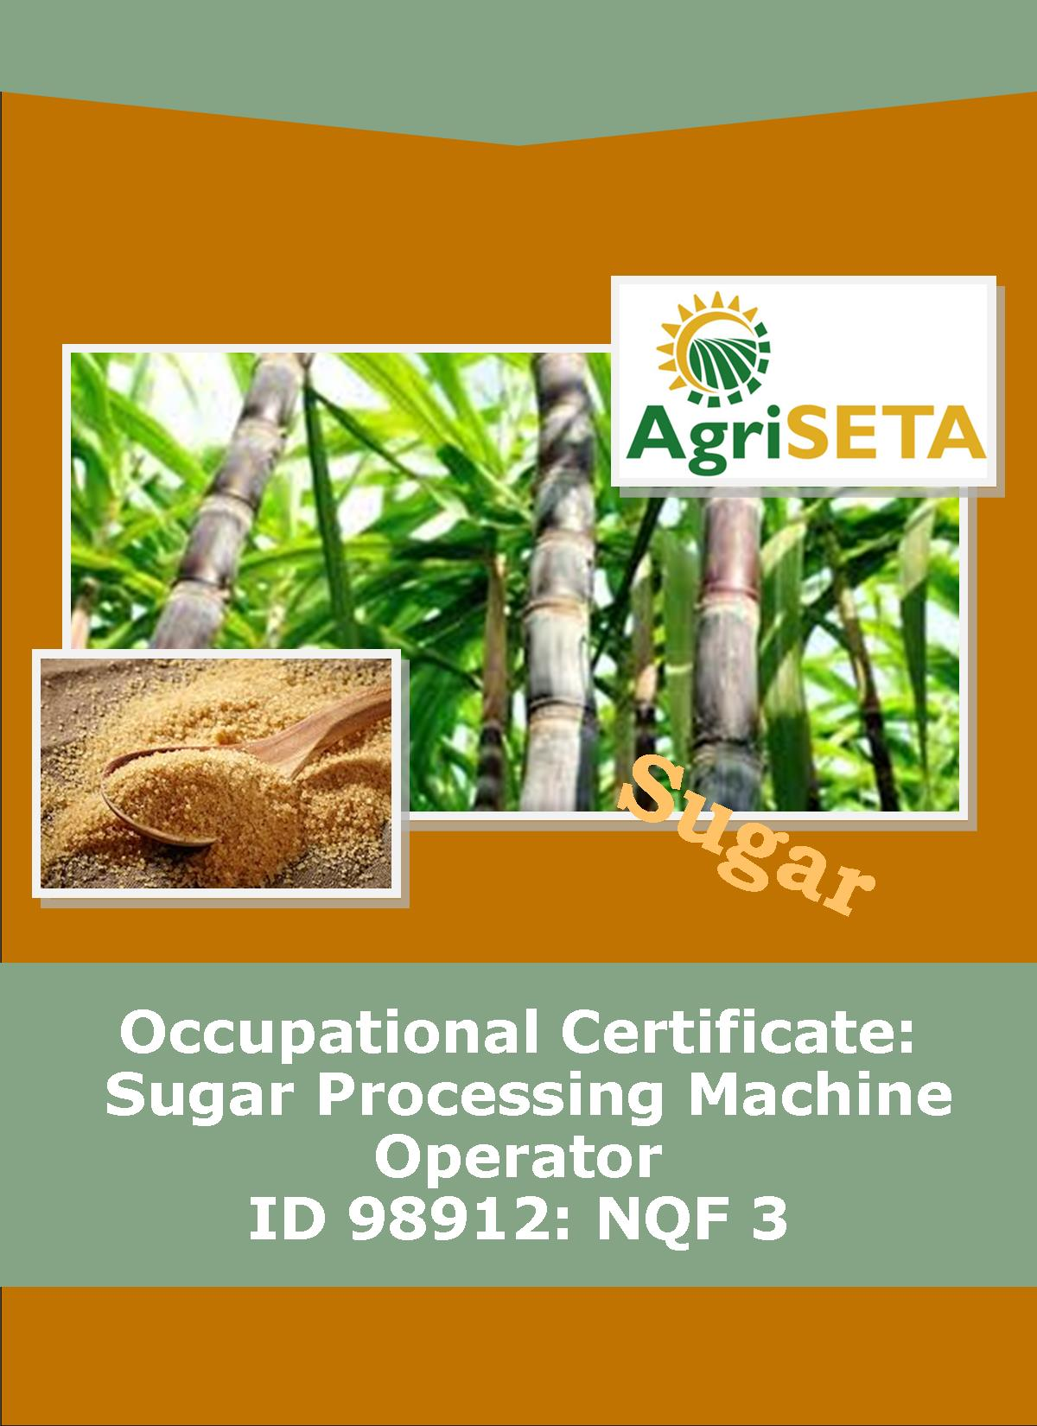
KNOWLEDGE COMPONENT: LEARNING RESOURCE: BOOK 4: QUALITY ASSURANCE
OCCUPATIONAL QUALIFICATION: SUGAR PROCESSING MACHINE OPERATOR

KNOWLEDGE COMPONENT:
LEARNING RESOURCE

BOOK 4: QUALITY ASSURANCE
KNOWLEDGE COMPONENT: LEARNING RESOURCE BOOK 4: QUALITY ASSURANCE
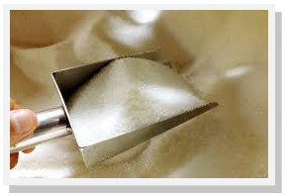
OCCUPATIONAL QUALIFICATION:
SUGAR PROCESSING MACHINE OPERATOR

©Copyright AgriSETA
Telephone: +27 12 301 5600

AgriSETA holds the copyright to its publications and Web pages. Proper citation is requested.

TABLE OF CONTENTS
AN INTRODUCTION TO THIS LEARNING RESOURCE 9
KNOWLEDGE MODULE 4 10
QUALITY ASSURANCE 10

1. Knowledge Topic 1: Quality Control and Assurance 11
1.1 QUALITY MANAGEMENT SYSTEMS 11
1.1.1 Introduction 11
1.2 QUALITY CONTROL AND ASSURANCE 12
1.2.1 Quality Assurance – Defect prevention 12
1.2.2 Quality control – Defect identification 13
1.3 QUALITY INDICATORS AND SPECIFICATIONS 13
1.3.1 Good Manufacturing practices 13
1.3.2 Good manufacturing practices in the sugar industry 15
1.3.3 How do we implement it? 15
(1) Commitment and policy 16
(2) Planning 16
(3) Implementation 17
(4) Monitoring and verification 20
(5) Review and improvement 20
1.4 KEY CONTROL POINTS 21
1.4.1 HACCP’s Seven Principles 21
1.4.2 Definition of terms in HACCP 22
1.5 QUALITY REPORTS 24
1.6 TRACEABILITY 24
1.6.1 Traceability systems 25

2. Knowledge Topic 2: Sampling principles and methods 27
2.1 REPRESENTATIVE SAMPLING 27
2.1.1 How to take representative samples 27
2.1.2 The purpose of representative sampling 27
2.2 SAMPLING TECHNIQUES AND EQUIPMENT 28
2.2.1 Sampling techniques 28
2.2.2 Sampling along the sugar manufacturing process 29
(1) Cane 29
(a) Prepared cane for direct analysis 29
(b) Procedure for personnel operating the electronic cane tracker 29
(c) Procedure for personnel operating at sample point 30
(2) Final bagasse 31
(a) Procedure 32
(3) First expressed juice 33
(4) Mixed juice 33
(a) Pol, Brix and sucrose 33
(b) Insoluble solids determination 35
c) Reducing Sugars and pH 36
(5) Clarified juice 37
(6) Filter feed (mud) 38
(a) pH 38
(b) Brix, Bagacillo and suspended solids % feed (For the determination of bagacillo ratio and filter retention) 38
(c) Pol and insoluble solids (press water clarifier mud only) 39
(7) Filter cake 39
(a) Pol and moisture 39
(8) Filtrate 40
(a) Brix and pol determination 40
(b) Brix and mud solids % filtrate (for the determination of filter retention) 40
(9) Syrup 40
(10) Remelt 41
(11) A-, B- and C- massecuite 42
(12) Magma 43
(13) A- and B- molasses 43
(14) Final molasses 43
(15) B-, C1- and C2- sugars 44
(16) A- sugar 44
2.2.3 Sampling equipment 45
(1) Electronic cane trackers 45
(a) Integrated circuit cane tracker 45
(b) Microprocessor cane tracker 48
(2) Cane Sampler 52
(a) Sliding gate (for use with slat elevators) 52
(b) Swing gate (for use with belt conveyor) 54
(3) Cane sub-sampler 56
(4) Screw conveyors 58
(5) Motor Control Panel 59
(6) Logic control panel 60
(7) Sample Shredder 62
(8) Final bagasse samplers 64
(a) Full width hatch 64
(b) Swing sampler 64
(9) Mixed juice sampler - Cold juice (for all analyses other than insoluble solids) 65
(10) Mixed juice sampler - Hot juice (for all analyses other than insoluble solids) 67
(11) Mixed juice sampler - insoluble solids 68
(12) Juice mixer 70
(13) Molasses sampler 70
(14) Sugar sampler 71
(15) Grab Sampler for whole stick cane 73
2.3 HANDLING AND STORAGE OF SAMPLES 76
(1) Packaging 76
(2) Sealing 76
(3) Marking 76
(4) Documents accompanying samples 76
(5) Storage of samples 76
2.4 SAMPLE RECORDS AND LABELS 77
2.5 SAMPLING FREQUENCY 77
(1) Whole Stick Cane 77
(2) Final Bagasse 77
(3) Mixed juice 77
(4) Clarified juice 78
(5) Filter feed (mud): 78
(6) Filter cake 78
(7) Filtrate 78
(8) Syrup 78
(9) Remelt 78
(10) A-, B- and C- massecuite 79
(11) Magma: 79
(12) A- and B- Molasses 79
(13) Final molasses: 79
(14) B-, C1- and C2- Sugars: 79
(15) A-Sugar: 79

3. Knowledge topic 3: Principles of food safety and quality assurance 80
3.1 HACCP 80
3.1.1 Application of HACCP to production of sugar and its co-products 80
(1) Construction of a process flow diagram 80
(2) Identification of Critical Control points and parameters requiring monitoring in the production line 81
(a) Sugarcane growing (CCP 1) 81
(b) Sugar extraction (CCP 2) 82
(c) Crystallisation and centrifugation (CCP 3) 82
(d) Drying and cooling of sugar (CCP 4) 83
(e) Sugar storage (CCP 5) 84
(f) Packaging (CCP 6) 84
(g) Transportation (CCP 7) 85
3.2 PERSONAL HYGIENE 86
3.2.1 Good personal health and hygiene practices 86
3.2.2 Personal Protective Equipment 86
3.2.3 Personal Hygiene Practices 87
(1) Hands 87
(2) Cuts and Sores 88
(3) Spilled blood 88
(4) Nose, Mouth and Ears 89
(5) Hair 89
(6) Smoking 89
(7) Jewelry and Perfume 90
(8) General Health 90
3.3 FOOD SAFETY PROTECTIVE MEASURES 91
3.3.1 The purpose of food safety 91
3.3.2 Food Safety Practices & Procedures 91
3.3.3 Types of food safety hazards 92
(1) Physical food safety hazards 92
(2) Chemical food safety hazards 92
(3) Biological food safety hazards 93

AN INTRODUCTION TO THIS LEARNING RESOURCE
This Knowledge Component Learning Resource: Book 4: Quality Assurance is intended to be used with the Knowledge Component Learner Workbook 4 (Formative Assessment Guide): Quality Assurance: Sugar Processing Controller NQF 3. It can also be used as a stand-alone information resource (text book).
This Learning Resource provides detailed information on the following topics:
- KM-04-KT01: Quality Control and Assurance (25%)
- KM-04-KT02: Sampling principles and methods (50%)
- KM-03-KT03: Principles of food safety and quality assurance (25%)
(Note: KM = Knowledge Module, KT = Knowledge Topic)

KNOWLEDGE MODULE 4

QUALITY ASSURANCE
Module number: 716106000-KM-04: NQF Level 3: Credits 8
BACKGROUND
Producing a product that meets the exacting standards of consumers requires a thorough quality system, able to measure and control the extraction, clarification, and crystallization of a premium quality, low color sugar. This challenge includes the monitoring of many parameters throughout the process. At each step the time, temperature, concentration, pH, and purity need to be measured and adjusted to the proper levels necessary to ensure process efficiency and quality of the final product.
Inline monitoring ensures that the product is consistently 100% pure and that the sugar crystals are free of color and any of the impurities present in the sugar cane that was harvested.
Quality assurance is an important part of the sugar manufacturing process. It enables the sugar factory to maintain a desired standard for the quality of the final product. It can be vital for preventing mistakes or defects that affect customer confidence or the quality of the factory output.
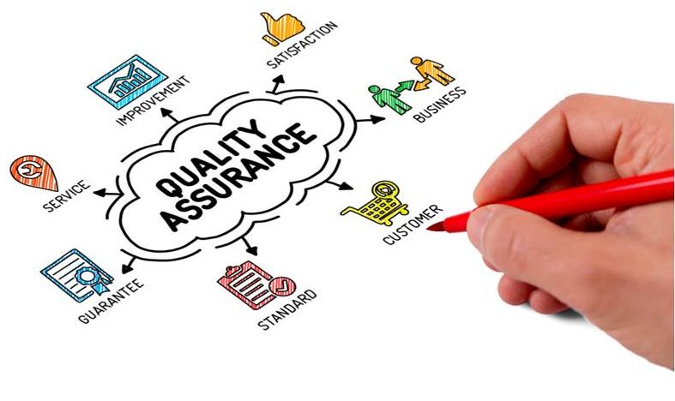
Quality assurance is a process used to learn if the product is up to standard, and will satisfy the consumer. The idea is to deliver a product that consistently keeps up a high quality. It is a proactive approach where defects are detected before a product goes public. This is vital to customer satisfaction. When customers are happy, your company is in a much better position to do well.
  - Knowledge Topic 1: Quality Control and Assurance

1.1 QUALITY MANAGEMENT SYSTEMS

1.1.1 Introduction
A quality management system (QMS) is defined as a formalised system that documents processes, procedures, and responsibilities for achieving quality policies and objectives. A QMS helps coordinate and direct an organization’s activities to meet customer and regulatory requirements and improve its effectiveness and efficiency on a continuous basis.
Quality management systems keep up with market globalization and are consequently applied as standard worldwide. Quality management systems (QMS) are indispensable in each sector of the food industry, to ensure safe, quality food for the consumer.
A quality management system (QMS) system can be defined as: a set of coordinated activities to direct and control an organization in order to continually improve the effectiveness and efficiency of its performance.
ISO 9001:2015, the international standard specifying requirements for quality management systems, is the most prominent approach to quality management systems.
While some use the term "QMS" to describe the ISO 9001 standard or the group of documents detailing the QMS, it actually refers to the entirety of the system. The documents only serve to describe the system.
Quality management systems serve many purposes, including:
- Improving processes
- Reducing waste
- Lowering costs
- Facilitating and identifying training opportunities
- Engaging staff
- Setting organization-wide direction

1.2 QUALITY CONTROL AND ASSURANCE
Quality assurance (QA) is a set of activities for ensuring quality in the processes by which products are developed. The goal of QA is to improve development and test processes so that defects don't arise when the product is being developed.
Although they’re closely related and both encompass aspects of quality management, quality control and quality assurance are fundamentally different in their focus. Quality assurance is process oriented and focuses on defect prevention. Quality control is product oriented and focuses on defect identification.

1.2.1 Quality Assurance – Defect prevention
Quality assurance (QA) is a set of activities for ensuring quality in the processes by which products are developed or manufactured. It is a proactive process and aims to prevent defects by concentrating on the process used to make the product. The goal of QA is to improve development and test processes so that defects don’t arise while the product is being developed or manufactured.
QA can be achieved by establishing a good quality management system and assessing its adequacy. What’s more, everyone on the team involved in developing a product is responsible for quality assurance.
The Quality Assurance (QA) systems available today include: GMPs (Good Manufacturing Practices), GHPs (Good Hygiene Practices), GAPs (Good Agricultural Practices), GLPs (Good Laboratory Practices) or other prerequisite systems and HACCP (Hazard Analysis Critical Control Point).

1.2.2 Quality control – Defect identification
Quality control (QC) is a set of activities for ensuring quality in products by identifying defects in the actual products produced. It is a reactive process and aims to identify (and correct) defects in finished products. For example, slightly torn sugar packaging which may break when transported.
QC can be achieved by identifying and eliminating sources of quality problems to ensure customer’s requirements are continually met. It involves the inspection aspect of quality management and is typically the responsibility of a specific team tasked with testing products for defects.

1.3 QUALITY INDICATORS AND SPECIFICATIONS
Quality specifications are detailed requirements that define the quality of a product, service or process. Quality includes tangible elements such as measurements and intangible elements such as smell and taste.

1.3.1 Good Manufacturing practices
The guidelines for GMP were initially developed for pharmaceutical companies but were later modified for food production. For the latter purpose GMP aims to ensure foods free of extraneous matter such as glass, machine filings and insect parts. It is a code involving quality control procedures which enable producers to guarantee that their products are hygienic. It can also be described as good housekeeping.
GMP also ensures the application of product specifications.
The specifications can have a regulatory, commercial or in-house origin. It is a practical system to ensure that things are done 'right, first time, every time, and on time'. GMP can show how to redesign the process to eliminate potential errors.
The regulations cover every aspect of food production, employee training, plant design, equipment specifications, cleaning, sanitation and quality assurance. In South Africa, GMP is not a regulation, but forms part of the Food, Disinfectants and Cosmetics Act of 1972.
GMP is more relevant to meeting most customers' needs than ISO (although ISO remains a requirement for some customers). Even though for food manufacturing concerns GMP should be part of a quality management system such as ISO 9000, it is found that many food factories which have ISO accreditation (including producers of raw and refined sugar) do not have an operating GMP system in place. The ISO 9000 system requires that each organisation sets its own quality standards, and correct implementation will ensure that these standards are met consistently. If the safety and health stipulations required by GMP do not form part of the company's quality criteria, then the company can be ISO 9000 accredited without performing GMP. It is suggested to any organisation making food products that, before contemplating ISO 9000 accreditation, it ensures that GMP procedures have been implemented and are running successfully. GMP is more practical and involves less cost because it can be tailored to the factory's special needs without requiring much wasteful documentation. A food company which is ISO 9000 accredited and perceives that it does not have a formal GMP system is advised to incorporate GMP.
In essence GMP is concerned with how things are done. It is a system of tools used to design, and build, safety and quality into the product. In an industrial operation it is impossible to achieve zero foreign matter inclusions in the product or zero package failures. These however cost a great deal.
Good manufacturing practice (GMP) in cane sugar production is the most cost effective way to minimise defects. The philosophy behind GMP is that there are controls in place that ensure the attainment of the stated quality targets. For a food processing operation the minimum controls required include:
- Personnel hygiene
- Cleaning and sanitation
- Waste management
- Pest management
- Management of foreign objects, chemicals and microorganisms
- Planned maintenance.

1.3.2 Good manufacturing practices in the sugar industry
Is GMP simply 'nice to have', or do sugar factories really need it? The extraction of sugar from cane and the production of pure white, or good raw, sugar involves a complex set of operations, the main aim of which is the removal of impurities. It is the function of sugar technology to remove the impurities originally present in the cane, but the aim of GMP is to ensure that no unnecessary, additional foreign materials are introduced during the process. Examples of the type of foreign materials which have been found in the final product are: bagacillo, dust, micro-organisms, welding globules, glass fragments, spider webs, bird feathers, fibres and paper from packing material, rodent faeces, insects, lubricating oil, cigarette butts, matches and a variety of other objects.
In an era where the customer is king the detection of one or more of these in just a single batch of product can do irreparable harm to the economic wellbeing of the sugar factory. The question should not be, 'Do we need GMP?', but rather, 'Can we afford not to have it?' Apart from enabling a factory to satisfy the expectations of its customers, a GMP system has a number of additional benefits such as reduced waste, improved cost and production control, less re-work and improved staff motivation and performance.

1.3.3 How do we implement it?
Implementation strategies vary, but essentially there are five elements:
- Commitment and policy
- Planning
- Implementation
- Monitoring and verification
- Review and improvement.
These five steps are common to the implementation of all management systems and are used for IS0 9000 and hazard analysis critical control point (HACCP). The steps will be dealt with in turn.

Commitment and policy
It is essential that management is convinced of the need to introduce GMP. They must understand not only the benefits of GMP, but also appreciate the resources required to make it work. What is necessary is a clear understanding of what controls are already in place and what improvements need to be made. Once the decision has been taken to introduce GMP, management will formulate a general GMP policy which will form part of the organisation's overall business plan and mission. This policy will not be cast in stone, but may be revised as more progress is made with the system. It will incorporate the company's vision, core values and beliefs and should take account of the image the organisation hopes to gain.
Once formalized, the commitment to keep it going cannot be transferred and then ignored. It can be communicated by posters, incentive schemes, announcements, notices, articles in the organisation's newsletters and through media such as e-mail. The responsibility for the overall effectiveness would be given to a senior person who has sufficient authority and competence. He would set up a steering committee that would guide its implementation.

Planning
Careful initial planning is essential. It is necessary to appoint a champion to take charge of the implementation. That person's task will be to set up a task force to investigate what needs to be achieved, draft a preliminary strategy, make a rough estimate of the resources required and consider allocation of responsibilities. The members of the task force must have appropriate knowledge, experience of operations and proficiency in auditing techniques. If the required competence is not available in the organisation, it will probably be necessary to send selected staff on short training courses or to use an outside consultant. The cost estimate will probably include staff and employee time, training needs, consulting assistance, materials, process modifications and a database for information management.
Before the task force commences setting objectives and making cost and resource estimates, it will conduct a preliminary GMP review to assess 'where are we now?’ This may necessitate interviewing experienced personnel, seeing for themselves the state of different operations and using existing information systems on maintenance and inventory control.
This review will identify those aspects of its operation which affect the quality of its final product. It is important to benchmark oneself against standards accepted worldwide.
The outcome of the review will be a set of prioritised objectives and targets and a management system to meet these.
Examples of appropriate objectives for a cane sugar factory include:
- Minimise leaks from pipes, pumps, flanges and seals
- Reduce bagacillo and dust levels in the crystalliser and drier sections of the factory
- Minimise air draughts by which micro-organisms can be introduced to the production areas
- Minimise spillages of sugar
- Minimise damage to finished product
- Minimise the presence of birds, rodents and insects in the packing station and warehouse.
Targets will specify measurable actions and incorporate time schedules or limits. Examples of targets are:
- There will be no bottles, cans, sandwiches or cigarette butts in the work area
- Dust filters to sugar driers will be cleaned once a day during the morning shift
- The target for re-work of sugar from damaged packets will be less than X tons per month
- Rodent bait stations will be checked once a week and results recorded in a designated file.
The task force will also consider training requirements and consulting services necessary for implementation of the system.

Implementation
Some of the major aspects that need to be addressed by a GMP in cane sugar factories include the following:
- Damage to packets in the warehouse must be kept to a minimum so as to avoid expensive rework of spilt sugar, and attraction of pests. Similarly, spillages from conveyor belts need to be minimised.
- The dust normally generated in a sugar packing station at conveyor transfer points and packing machines needs to be eliminated by installing dust extraction systems, because when sugar dust settles in the factory environment it is difficult to control bees, insects, birds and other pests. Furthermore sugar dust makes good housekeeping impossible.
- A policy on personnel hygiene needs to be drawn up and enforced. Wash basins with soap and clean towels need to be available in accessible positions, particularly near the packing station. Separate, closed rest rooms where staff can eat and drink, store their belongings and take showers must be provided. Eating, drinking and smoking in the work area should not be permitted.
- A planned (preventative) maintenance system will keep juice leaks to a minimum. Microbial contamination via juice recycled from the factory floor can lead to processing problems caused by microbial polysaccharides and can affect the quality of the final product. Informal (weekend) maintenance is unacceptable.
- Strong air currents within the factory, and particularly those that originate from outside the factory, must be minimised as they inevitably contain micro-organisms, soil particles, furnace fly-ash and bagacillo which contaminate the final product. Control of these air currents may necessitate structural modifications.
- Pipe lagging needs to be inspected regularly and steps taken to prevent deteriorated lagging material from entering product streams.
- Formalised cleaning schedules must be drawn up for the different work areas.
- Steps need to be taken to keep lubricants out of the process stream (e.g. massecuite).
- A policy on the control of glass will be necessary. Once glass has entered the process stream, particularly after the clarifier, it is virtually impossible to remove except by remelting and re-crystallising the sugar. All electric lighting near process vessels needs to be protected by Perspex covers. No bottles should be allowed in the process area. Seed slurry should be dispensed from a stainless steel tank, not glass bottles.
- Formal procedures need to be established which deal with the different kinds of waste. Product that is spilt must be collected in special containers that will not be used for other types of waste. String and wrappings from packing material must be accumulated in designated areas and collected for recycling. Metal off-cuts, bolts and welding rods which are left over after minor repairs must not be left lying around.
Each of these aspects is dealt with by a three-tiered methodology:
- Company policy - e.g. all sugar packers will wear white protective overalls.
- Procedures - groups of documented instructions which explain concisely and clearly how the policies are to be achieved. Procedures are specific for a group of people, e.g. dress code.
- Work instructions - these are procedures for individuals, e.g. how the operator will monitor online temperature.
At the commencement of implementation, identified responsibilities are assigned to certain key people. These people require good human relations and communication skills, as well as intimate knowledge of their particular operation. They will have responsibility for involving the workers in their areas to help devise solutions to the problems that have been identified. The multi-disciplinary team approach is the only one that will work in the long term because those that have to run the system must own it. The solutions will include schedules, procedures and checks that ensure identified problems do not recur, or are contained. Fairly accurate estimates of resource requirements and equipment modifications can then be made.
Procedures need to be well documented so as to be easily available and understandable by those who have to implement them. A manual must be compiled which contains the GMP policy, objectives and targets, as well as the detailed procedures.
Copies of the manual must be given to the main departments, but a procedure must be established whereby all modifications are inserted in their correct places in all manuals.
For budget and financial control purposes it may be beneficial to have a computerised tracking system which will record the major expenditure items and extra resources needed as well as the measurable benefits (e.g. reduced number of customer complaints, reduced breakdown time, reduced quantities of product that had to be re-worked) from the implemented GMP programme. This will facilitate estimation of return on investment.

Monitoring and verification
Monitoring involves checking that the procedures are being carried out effectively and that they achieve their objectives.
Regular feedback on problems encountered in performing the required tasks, how these can be overcome and how the stipulated procedures could be improved must be given. Each department must determine how the feedback is best given.
Only essential aspects of findings should be recorded. There is no benefit in collecting useless data. Where it is necessary corrective action must be instituted as soon as possible. When this involves modification of existing procedures, these must be documented and incorporated in the manual. Application of this principle will help ensure that people do not become set in their ways and carry out their tasks without thinking, but contribute to making the system more effective.

Review and improvement
The review process requires that the safety team conducts scheduled self-inspections. It may be necessary that periodic inspections are undertaken by a third party to obtain objectivity. The inspections will identify quality improvement projects which in turn need to be planned, implemented and monitored. This begins the never ending cycle of quality improvement which is part of total quality management.
Thorough reporting after the audits and formalised procedures for dealing with the audit findings are necessary.

1.4 KEY CONTROL POINTS
Hazard analysis critical control point (HACCP) is a system that identifies and monitors specific food-borne hazard-biological, chemical or physical properties that can adversely affect the safety of the food product. The HACCP system identifies biological, chemical and physical hazards at specific points in the flow of food and the ways these contaminants can be prevented from causing or spreading food-borne illness.

1.4.1 HACCP’s Seven Principles
HACCP focuses on how food flows through the process – in the case of sugar cane, from raw cane to processed and packaged sugar. At each step in the sugar production process there are a variety of potential hazards. HACCP provides managers with the framework for implementing control procedures for each hazard. It does this through identifying critical control points (CCPs). These are points in the process where hazards are more likely to be introduced. The seven principles of HACCP include:
- Analyze hazards: Potential hazards associated with food and measures to control those hazards are identified. The hazards could be biological, such as microbes: chemical, such as toxins; or physical, such as ground glass or metal fragments.
- Identify critical control points: These are points in a food’s production process at which the potential hazard can be controlled or eliminated.
- Establish preventive measures with critical limits for each control point: For sugar processing this may be temperature minimums or maximums, pH, pressure limits, time limits or colour ranges which are specific to each stage of the manufacturing process.
- Establish procedures to monitor the critical control points: Such procedures might include determining how and by whom pH, temperature, pressure, colour, etc. should be monitored. This can also be done electronically by sensors and monitors.
- Establish corrective actions to be taken when monitoring shows that a critical limit has not been met: For example, rework may be necessary if the pH level at a certain process was not achieved within a pre-determined period of time.
- Establish procedures to verify that the system is working properly: For example, test sensors, timers, pH meters, thermometers and other recording devices on a routine and monitored basis (i.e. not only the measurement must be taken regularly (point 4 above), but a system must be put in place to also check that the measurement instruments are accurate and working properly).
- Establish effective recordkeeping to document the HACCP system: This would include records of hazards and their control methods, the monitoring safety requirements, and the action taken to correct potential problems. Each of these principles must be backed by sound scientific knowledge; for example, published microbiological studies on time and temperature factors for controlling food-borne pathogens.
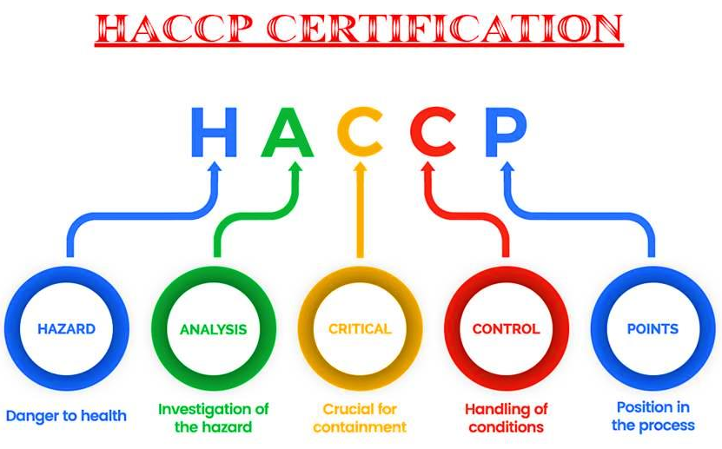

1.4.2 Definition of terms in HACCP
- Cleaning means washing with water of adequate sanitary quality.
- Control means to prevent, eliminate, or eradicate.
- Control measure means any action or activity that is used to prevent, reduce to acceptable levels, or eliminate a hazard.
- Critical control point (CCP) means a point, step, or procedure in a food process at which a control measure can be applied and at which control is essential to prevent, reduce to an acceptable level, or eliminate an identified food hazard.
- Critical limit means the maximum or minimum value to which a physical, biological or chemical parameter must be controlled at a critical control point to prevent, eliminate, or reduce to an acceptable level the occurrence of the identified hazard.
- Food hazard means any biological, chemical, or physical agent that is reasonably likely to cause illness or injury in the absence of its control.
- Hazard Analysis and Critical Control Points (HACCP) means a systematic approach to the identification, evaluation, and control of food safety hazards.
- HACCP Plan means the written document that is based upon the principles of HACCP and delineates the procedures to be followed.
- HACCP Team means the group of people who are responsible for developing, implementing, and maintaining the HACCP system.
- Hazard Analysis means the process of collecting and evaluating information on hazards associated with the food under consideration to decide which are significant and must be addressed in the HACCP plan.
- Juice means the aqueous liquid expressed or extracted from the cane.
- Juice concentrate means the aqueous liquid extracted from the cane and reduced in volume through the removal of water from the juice.
- Monitor means to conduct a planned sequence of observations or measurements to assess whether a process, point or procedure is under control and to produce an accurate record for future use in verification.
- Process Authority means an expert in the processes for controlling pathogenic microorganisms in food, and, as such, is qualified by training and experience to evaluate all of the aspects of your pathogen control measures, e.g. process time, temperature, type of equipment, etc. and determine that your measures, if properly implemented, will control pathogens effectively.
- Shelf stable product means a product that is hermetic ally sealed and when stored at room temperature, should not demonstrate any microbial growth.
- Validation means that element of verification focused on collecting and evaluating scientific and technical information to determine whether the HACCP system, when properly implemented, will control effectively the identified food hazards.
- Verification means those activities, other than monitoring, that establish the validity of the HACCP plan and that the system is operating according to the plan. It includes validation procedures.

1.5 QUALITY REPORTS
A quality report is a report which documents a specific quality process or outcome (or both), such as an inspection test plan, quality communications plan or non-conformance report.
When reporting on quality, changes in quality from a previous measurement should be reported, as well as the maintenance of a quality standard over time, and the quality measured in relation to the industry norms.
When reporting on quality, the methods used to collect the data should, not only be standardized, but reported along with the data so that relevant comparisons can be made.
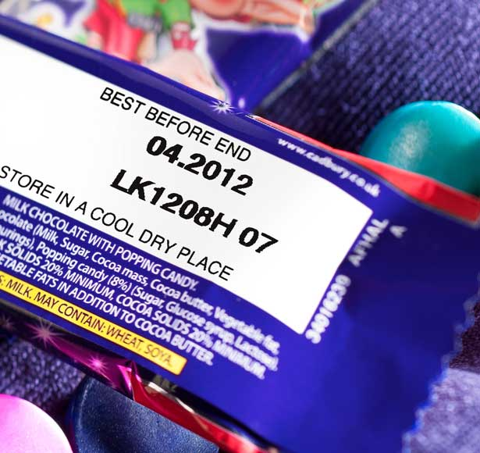
Quality reports will be generated from data collected at specific times, from specific points, by specific people (or monitors or gauges). A report cannot merely present the collected data, but must also analyse the data and make recommendations. Reports need to be read and the recommendations for improved quality implemented. Records need to be kept for a period of time as recommended by the particular industry, or as recommended by equipment manufacturers.

1.6 TRACEABILITY
Traceability is the ability to track any food through all stages of production, processing and distribution (including importation and at retail). For food processing businesses, traceability should extend to being able to identify the source of all food inputs such as: raw materials.
Traceability has three key benefits; it increases supply chain visibility, improves quality control systems and reduces risk.
By keeping a record of the entire production and distribution history, suppliers are able to react quickly to any issues. In the case of a product recall, for example, suppliers can determine the source of the problem and tell distributors to remove the product from shelves. This protects the supplier from legal action and the consumer from a potentially dangerous product.
Traceability can also be used to prove certain attributes of a product such as its ethical credentials or country of origin. As consumers become more aware of how products are made and the issues surrounding manufacturing, transparency is valued.
As supply chains become increasingly globalized and complex, the ability to track and trace products from farm to fork becomes more difficult, even as it becomes more important. Three things you can do to improve:
- Tools for product identification must become increasingly robust to accommodate wider and more complicated supply and distribution channels.
- Food recall systems need to be adaptable to expanding distribution networks.
- Enhancing visibility at each point in the supply chain and expediting the food recall process are at the heart of food traceability and tracking strategies.

1.6.1 Traceability systems
These issues form part of a traceability system:
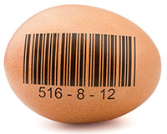
- Identification: Identification of the products and standardization of information and of the parts which influence the quality of a product.
- Link: The management throughout the supply chain among the lots and logistic units.
- Registry: The data and the information recorded throughout the production and logistic process.
- Communication: The greater the association and alignment of the information along the supply chain, the greater will be the capability of management to respond to quality issues.
Therefore, in order for the traceability system to be really effective it is necessary for the entire sugar processing process to be properly identified and documented, in such a way that allows access to each stage of its history throughout production: The various paths that the product takes and the changes that the product may suffer along the way until its final consumption. Some information about the production process needs to be carefully measured and followed (monitored), as well as integrated into a proper information system.

  - Knowledge Topic 2: Sampling principles and methods
In the Sugar Mill quality control and quality assurance depends on the taking of representative and accurate samples along the production line, the laboratory analysis thereof, the results of the analyses monitored and corrective action taken if required. As a Sugar Processing Machine Operator you will inevitably be responsible for taking such samples as part of your daily duties.

2.1 REPRESENTATIVE SAMPLING
Samples must be representative of the material being sampled. A representative sample is a true reflection of the bulk material. A biased sample is a sample that is not representative. It is pointless to analyse perfectly a sample that is not representative or to sample and analyse perfectly and then make errors in the calculation of results.

2.1.1 How to take representative samples
- When taking a sample of product (say juice) ensure that you have not included some stagnant (“old”) product that may have been trapped in the sampling pipe.
- Beware of using containers and lids that are contaminated i.e. dirty or wet.
- Do not leave samples to stand as they will deteriorate due to chemical and bacterial degradation.
- Keep samples covered so that they do not lose moisture to the atmosphere or become contaminated with dirt and other substances (Use an up-side down watch glass for this purpose – if the vesicle is small enough - or keep the sampling container lid closed until analysis).
- Before sub-sampling a product for analysis, mix it thoroughly first since many products contain substances that settle to the bottom. Taking a quantity from the top would then yield a biased sample. Examples are: juice, massecuite, molasses, sugar etc.

2.1.2 The purpose of representative sampling
- Reliability – Representative sampling needs to be reliable, from validation of the raw ingredients to quality testing at each key processing stage. It is the only way to ensure confidence in food testing results.
- Accuracy – Representative sampling will allow for dependable ingredient analysis and traceability, it must be accurate, and the way samples are collected needs to be efficient without introducing bias.
- Ingredient verification – Representative sampling at the control points of a quality assurance process will assist to verify that the parameters of the product being produced is according to the standards required at that point.
- Product traceability – Tracking and verifying ingredients from farm to final product throughout the supply chain requires a statistically sound sampling plan. A product tracing plan can help organize the documentation of the production and distribution chain of the product and allow for the efficient collection of data required by the traceability system.

2.2 SAMPLING TECHNIQUES AND EQUIPMENT

2.2.1 Sampling techniques
Good sampling techniques ensures that the sample taken represents the material from which it is taken in an unbiased manner. The nature and importance of the material will govern the sampling specification as to size and frequency. It is easier to obtain a small representative sample if the material is homogeneous, like clarified juice, than if it is a product of mixed composition like cane.
Where great accuracy is not required, catch samples taken at fairly large time intervals will often be adequate, particularly when the variability in the composition of the material to be sampled is relatively small. However, where great accuracy is required, continuous sampling should be employed and care should be taken that the ratio between the mass of the fraction of the sample extracted in each unit of time and the mass of the material it represents, is constant.
It is sometimes better to take frequent catch samples than a continuous sample, for example, it is desirable to obtain information on the variability of the composition of the material. Catch samples are also taken when there is possibility that a continuous sample will deteriorate during the sample period.
Cleanliness of sampling devices and sample receptacles is essential. This calls for a planned and regular programme of cleaning. In this regard duplicate sets of samplers and receptacles will greatly facilitate cleaning operations and must be provided wherever possible. Sample receptacles should be seamless and constructed of stainless steel or copper and must be covered to minimise evaporation and contamination.
The importance of mixing the primary sample before sub-sampling cannot be over stressed and details are given below, under the procedures described, for the various products.

2.2.2 Sampling along the sugar manufacturing process

Cane

Prepared cane for direct analysis
For cane payment purposes, individual cane consignments are sampled and therefore there is a need for accurate identification of consignments up to the sample point.
When the first mill is by-passed for mechanical reasons, cane sampling must continue and the miller shall provide the equipment and labour necessary for transferring the excess cane sample back to process.
Apparatus: Electronic cane tracker, Cane sub-sampler, Sample table, Sample shredder and Enamelled billycan with lid (seamless construction and 6 litre capacity)

Procedure for personnel operating the electronic cane tracker
- Visually follow the progress of the consignment on the carrier system up to the point where the electronic cane tracker is designed to take over.
- Make allowance as dictated by local conditions for intermixed cane so as to ensure that this will not be sampled. Apart from this the sampling period should correspond with the passage of the maximum percentage of a consignment. Special circumstances, e.g. group testing, may dictate that one sample will be taken to represent the cane from more than one supplier, but this will be done only on specific instructions from the Cane Testing Services Manager.
- Once all intermixed cane has passed the cane tracker starting point, cause the electronic cane tracker to follow the progress of the consignment.
- Complete the weighbridge ticket with details required and consign the ticket to the laboratory. Enter the relevant details (cane tracker number and, if applicable, bundle numbers), via the keyboard.
- As the end of a consignment passes the cane tracking initiating point, depress the stop button.
- After every new consignment check that the tracker output counter number plus the number of consignments in transit, equals the tracker input counter number. If these figures do not agree, immediately investigate the reason and take the necessary measures.
- If for any reason mixing of cane from different suppliers occurs after the head of a consignment has passed the cane tracking initiating point, tracking must be interrupted so as to avoid sampling the intermixed portion. When this occurs, one consignment will be shown as two on the display and sampling staff must be advised immediately what action to take. Such incidents must always be recorded.
- Check frequently that the tracker output counter corresponds with the sample point counter.

Procedure for personnel operating at sample point
- On receiving the cane tracker signal (the green light signal and bell) to commence sampling, place the clean sample receptacle in the appropriate position.
- Note the size of the consignment as shown on the cane tracker display and adjust the cane sub-sampler secondary stage reject interval timer so as to obtain the optimum size sample (10 kg) in the sample receptacle.
- Fill in a sample ticket showing the sample point counter number and the receptacle number.
- After a factory maintenance stop reject the cane from the first two cane sampler openings as a precaution against the possible presence of water in the sampling equipment.
- At the end of the sample run which is indicated by the red signaling light and bell, tip the contents of the sample receptacle onto the table provided.
Note: All subsequent cane sampling operations must be done as thoroughly and quickly as possible to avoid selective sampling and loss of moisture.
- Mix the cane and then spread into a layer 50-70 mm thick. By randomly taking handfuls of cane collect one sub-sample of about 2 kg. Care must be taken not to shake the cane held in the hand as this will result in particle size selection.
- Discard the excess sample on the mixing table.
- Transfer the sub-sample to the sample shredder disturbing the sample evenly in the shredder compartment.
- After shredding, transfer the sample from the shredder sample receiver to the enamelled billycan, taking the precaution of first wiping out the billycan with a portion of the cane sample and rejecting this cane portion. At some installations a pneumatic sample conveyor system has been installed. In these instances transfer the sample from the shredder sample receiver to the plastic bag provided. Close the bag by tying a knot at the open end and prick the plastic a few times to release trapped air. Fit the plastic bag into the canvas carrier bag which is attached to a pneumatic sample conveyor shuttle.
- Immediately convey the sample in the closed billycan with relevant sample ticket to the laboratory, or alternatively, where pneumatic sample conveyors are in operation, place the shuttle with carrier bag attached in the air tube system.
- The work area as well as all equipment must be maintained in a clean state at all times.

Final bagasse
Because of the difficulties of continuous sampling of bagasse, catch samples are taken at regular intervals. Different types and configurations of bagasse conveyors at mills have given rise to various methods for obtaining a sample representative of the full depth and width of the final bagasse blanket. Ideally sampling should be through a hatch situated in the base plate of the bagasse elevator just after the last mill. Such a hatch must span the full width of the elevator and open sufficiently to allow the fall-out of a complete slat-load of bagasse. Opening and closing of the hatch must be with a snap action to avoid bias.
However, the increasing trend in the South African Industry towards the use of belt conveyors precludes the use of a sample hatch and at mills where this already exists, use of the “swing” sampler is recommended.
Apparatus: Hatch sampler or, if not applicable, swing sampler, Sample receptacle – enamelled billycan with lid, seamless construction (6 litre capacity), Mixing table (stainless steel top)

Procedure
- Regardless of chokes or other irregularities of crushing, a sample of bagasse should be taken at a predetermined time every hour. If the mill is not crushing at the sampling time, no sample shall be taken for that hour.
- If the hatch sampler is used, the hatch is opened so as to allow a full slat-load of bagasse to fall through. Reject this sample and collect a second sample for analysis.
- If the swing sampler is used the sampling procedure is as follows:
- Remove the locking pin and swing the handle down until it rests on the guide wheel.
- Push the sample box into the bagasse stream ensuring that the leading edge moves beyond the rear of the falling bagasse stream and then reverse the stroke.
- The hatch sample is mixed on the sample table while that obtained with the swing sampler is mixed in the sampler box.
- In either case random handfuls which are placed in the sample receptacle, are taken to provide a sub-sample of ca. 1 kg. If sub-sampling by hand, care must be taken not to shake the bagasse held in the hand as this will result in a biased sample.
- Immediately convey the bagasse sample in the closed sample receptacle to the laboratory.

First expressed juice
Apparatus: Copper container attached to a long handle (1000 cm³); Enamelled seamless billycan with lid (3 litres)
Procedure
- A catch sample is taken using the long handled copper container.
- The sample must be taken from the front and across the whole length of the front roller, the sample receptacle being moved steadily across the length of the roller. If the sample receptacle fills up before the end of the sweep, it must be withdrawn, the contents emptied into the clean, dry billycan, and sampling continued from the point at which it was interrupted.
- Transfer all the catch samples to the billycan, cover with the lid and take it to the laboratory.

Mixed juice

Pol, Brix and sucrose
Apparatus: Mixed juice sampler (with chiller for hot juice), Sample receptacle - seamless stainless steel bucket with lid (15 litre) (with immersion cooler for hot juice), Juice mixer, Bottle - wide mouth, with lid (450 cm³), Measuring cylinder (50 cm³), Polythene tubing (100 micron wall thickness; the tubing is flattened at manufacture to give a width of 75 mm), Heat sealer, Alcohol bath, Deep freezer (-40°C)
Reagent: Juice preservative
Procedure
- The sample must be collected continuously over the hour.
- At the commencement of the hour, add juice preservative to the clean dry sample receptacle (0.2 cm³ preservative per litre of juice to be collected) and position the receptacle with lid at the sampler outlet.
- At the end of the hour remove the sample receptacle at the same time as the scale reading is taken and replace with a second receptacle, previously cleaned and dried and to which the requisite quantity of juice preservative has subsequently been added.
- The receptacle containing the juice is kept covered with the lid and immediately conveyed to the laboratory.
- In the laboratory thoroughly mix the juice in the receptacle using the juice mixer.
- Transfer a portion of the juice into a 450 cm³ bottle taking the precaution of first rinsing the bottle with a portion of the juice and discarding the rinsings.
- The samples for pol, Brix and sucrose analyses are drawn from the 450 cm³ bottle. For sucrose analysis, however, hourly samples are not analysed individually, but analysis is conducted instead on a weekly composite sample prepared as described in steps (viii) to (xiii) below.
- Cut a 125 mm length of the plastic tubing and double seal one end using the strip heat sealer.
- Rinse the measuring cylinder with a portion of the mixed juice (discard the rinsings) and then measure out an aliquot of approximately 20 cm³ but proportional to the tonnage of the mixed juice recorded for the hour.
- Pour the juice from the measuring cylinder into the plastic sachet.
- Double seal the sachet approximately 40 mm from the open end, taking care to expel as much of the air as possible before sealing.
- Label and seal the remaining 40 mm portion of the sachet in accordance with the requirements of the CTS laboratory.
- Place the sachet in the alcohol bath stored in the deep freezer so as to ensure rapid freezing.
- After 10 minutes in the alcohol bath transfer the sachet with frozen mixed juice sample to the storage container in the deep freezer.
- Repeat these steps throughout the week for each hourly mixed juice sample.
- At the end of the week the frozen sachets are dispatched to the SMRI in the insulated containers provided for this purpose.
Procedure for thawing frozen mixed juice samples
The operation is carried out at the SMRI laboratory.
- Remove the frozen sachets from the container and hang them on the special racks provided.
- Immerse the rack of frozen samples in the ambient temperature running water bath for 10 minutes.
- Remove the rack from the water bath, allow the excess water to drain and immerse the rack with samples in the alcohol bath for a few seconds.
- Remove the rack with samples from the alcohol bath and stand for 20 minutes in the air chamber (ambient temperature) so that the sachets are dried by a forced draught of air.
- Remove the sachets from the rack and place on a clean sheet of paper towelling. Cover with a second sheet of paper towelling and gently press so as to absorb any remaining moisture/alcohol.
- Inspect for any evidence of juice leaks and discard any sachets found to be leaking.
- Cut open the sachets and expel the contents into a clean dry 6 litre billycan.
- Once all the juice has been transferred from the sachets to the billycan, thoroughly stir the composite sample and place the lid on the billycan.

Insoluble solids determination
Representative sampling of mixed juice for insoluble solids requires proper sampler design and positioning in view of the propensity for heavy insoluble solids to segregate and not be dispersed uniformly through the juice flow.
Apparatus: Cutter sampler, Seamless stainless steel bucket with lid (12 litre)
Reagent: Juice preservative
Procedure
- Sampling is conducted over the shift such that each hour two cuts (forward and back) are taken across the full cross section of the juice flow.
- The sampler delivers approximately 5 litres of juice over the shift at the cut frequency specified in (i) above.
- Just before the beginning of the shift take the clean dry sample bucket and add 1 cm³ of juice preservative (0.2 cm³ per litre of sample).
- At the beginning of the shift, place the sample bucket with lid beneath the sampler outlet. The outflow from the sampler is led through the lid opening and onto the receptacle by means of a length of polythene tubing.
- Depress the control valve which activates the sampler to move fully across and then back again through the juice stream.
- Repeat step (v) each hour throughout the shift.
- At the end of the shift remove the sample receptacle with the sample for analysis and replace with a clean, dry receptacle to which 1 cm³ of juice preservative has subsequently been added.
- All the samples in the sample receptacle must be taken to the laboratory for subsampling; do not discard any if the sample is larger than usual.
Note: If for some reason the sample receptacle is found to have filled to overflowing the whole sample must be rejected as it will be biased.
- In the laboratory the sample is cooled if necessary prior to sub-sampling and analysis.

c) Reducing Sugars and pH
Apparatus: Mixed juice sampler, sample receptacle – seamless stainless steel bucket with lid (15 litre), Juice mixer, Bottle – wide mouth with lid (450 cm³), refrigerator
Procedure
Samples for the above analyses are taken from the samples collected for the pol and brix determination described above. For reducing sugars analysis 100 cm³ of the hourly sample is placed in a bottle used to collect a four hour composite sample. The latter is stored in the refrigerator.

Clarified juice
Because of the danger of evaporation inherent in the sampling of a hot liquid, catch sampling is preferable to continuous sampling unless suitable adequate techniques can be employed to prevent evaporation.
Apparatus: Container with handle (200 cm³); Enamelled or stainless steel billycan with lid (1 litre); Juice mixer; Bottle with lid (1 litre); Refrigerator
Procedure
- Sampling is conducted every hour using the sampling container.
- After flushing the sample line take a 500 cm³ catch sample from a suitable point in the clear juice line representing the total clarified juice flow.
- Cover the sample receptacle with the lid and convey the sample to the laboratory.
- In the laboratory cool the sample to ambient temperature by standing the billycan in the water trough.
- Once ambient temperature is attained remove the can from the trough and wipe down the exterior to remove adhering water.
- From the well-stirred sample, transfer ca. 100 cm³ to a clean dry beaker for the pH determination and a transfer ca. 100 cm³ to the clean dry compositing bottle to which was added 0.2 cm³ preservative prior to the addition of the first aliquot of juice.
- Place the lid on the compositing bottle and store in the refrigerator.
- Steps (ii) to (vii) are repeated hourly.
- At the end of 4 hours the 4 hourly composite sample is brought to room temperature by placing the bottle in the tap water trough for 10 – 15 minutes.

Filter feed (mud)

(a) pH
Apparatus: Container with handle (500 cm³), Enamelled or stainless steel seamless billycan with lid (1 litre)
Procedure
- A catch sample is taken every hour from each mud pump.
- Transfer the individual catch samples to clean dry billycans and cover with lids.
- in the laboratory each sample is cooled to ambient temperature by standing the billycan in a water trough.
- Ehen a sample attained ambient temperature, remove the can from the trough and dry the exterior.
- From the well stirred sample transfer sufficient into a 50 cm³ beaker for a pH determination.

Brix, Bagacillo and suspended solids % feed (For the determination of bagacillo ratio and filter retention)
When determining filter retention it is necessary to synchronise the sampling of filter feed and filtrate.
Apparatus: Copper container with handle (500 cm³); Enamelled or stainless steel seamless billycan with lid (3 litres).
Procedure
- A series of catch samples of the mud feed to the filters is taken for the duration of a test at a point after the addition of the bagacillo used as filter aid.
- At the end of the sampling period take the billycan to the laboratory.
- In the laboratory cool the sample to ambient temperature by standing the billycan in a water trough for approximately 30 minutes.
- When the sample has attained ambient temperature, remove the can from the trough and dry the exterior.

Pol and insoluble solids (press water clarifier mud only)
When press water clarifier mud is not returned to the mixed juice but instead is weighed and then sent to the filters, it is necessary for cane payment and factory control purposes to determine the Pol and insoluble solids content of the mud.
Apparatus: Sample receptacle - enamelled seamless billycan with lid (3 litre), Bottle - wide mouth with glass stopper (2 litre), Beaker (250 cm³, graduated)
Procedure
- Take a catch sample once an hour using the clean dry billycan.
- Take the sample from across the mud flow as it discharges from the weigh tank of the scale.
- Put the lid on the billycan and convey the sample to the laboratory.
- In the laboratory cool the sample to ambient by standing in a water trough at room temperature for approximately 30 minutes.
- When the sample has attained ambient temperature remove the can from the trough and dry the exterior.
- Add 0.3 cm³ juice preservative to the clean dry bottle.
- Rapidly stir the sample in the billycan and using the beaker transfer 150 cm³ of the agitated sample to the bottle.
- Repeat steps (i) to (vii) each hour until the end of the 8-hour shift.

Filter cake

Pol and moisture
Apparatus: Enamelled or stainless steel seamless billycan with lid (3 litre)
Procedure
- A catch sample is taken every hour from the full width of each filter.
- Hold the clean dry billycan at one end of the scraper plate at a level just below the discharge and move the can along the length of the scraper plate at a rate sufficient to collect a sample from the full width of the filter.
- Place the lid on the billycan and convey the sample to the laboratory.
- Cool the sample in the water bath until ambient temperature is attained

Filtrate

Brix and pol determination
Apparatus: Copper container with handle (500 cm³); Enamelled or stainless steel seamless billycan with lid (1 litre)
Procedure
- A catch sample is taken every 4 hours using the copper container.
- Rinse the copper container well with the filtrate and take a catch sample.
- Transfer the sample to the clean dry billycan.
- Place the lid on the billycan and take it to the laboratory.
- In the laboratory cool the sample to ambient temperature by standing the billycan in a water trough for approximately 30 minutes.
- When ambient temperature has been attained, remove the can from the trough and dry the exterior.

Brix and mud solids % filtrate (for the determination of filter retention)
When determining filter retention it is necessary to synchronise the sampling of filter feed and filtrate. A series of catch samples is taken for the duration of a test.

Syrup
Apparatus: Sample receptacle, seamless stainless steel or enamelled billycan with lid (1 litre); Juice mixer; Bottle with lid (1 litre); Refrigerator
Procedure
- A catch sample is taken hourly from the take-off pipe situated on the delivery side of the pump.
- Before collecting the sample the take-off pipe valve must be opened and the pipe flushed with syrup.
- Once the pipe has been flushed clean, collect ca. 500 cm³ in the clean dry sample receptacle.
- Put the lid on the receptacle and take it to the laboratory.
- In the laboratory place the receptacle in a water trough to cool.
- When the sample has attained ambient temperature (after ca. 30 minutes) remove the receptacle from the water trough and dry the exterior.
- From the agitated sample draw sufficient to fill a small beaker (50 cm³) for the hourly pH determination, first taking the precaution of rinsing the beaker with syrup and discarding the rinsings.
- Draw a further fixed volume (50 cm³) or fixed mass (50 g) of syrup and pour this into the clean dry bottle.
- Put the lid on the bottle and store in the refrigerator.
- Successive hourly aliquots are poured into the same bottle.
- At the end of the 8 hour shift, take the bottle from the refrigerator and bring to room temperature by placing the bottle in a water trough at room temperature for 10 – 15 minutes.

Remelt
Apparatus: Sample receptacle. Seamless stainless steel or enamelled billycan with lid (1 litre); Bottle with lid (1 litre); Refrigerator
Procedure
- A catch sample is taken hourly from a short take-off pipe with the stopcock, after the brix controller.
- Before taking the sample the take-off pipe valve must be opened fully and the sample pipe flushed with remelt so as to clear any sugar crystals and remelt from the sample pipe.
- Once the pipe has been flushed clean, collect ca. 500 cm³ of remelt in the clean dry sample receptacle.
- Put the lid on the receptacle and convey the sample to the laboratory.
- In the laboratory stand the sample receptacle in a water trough and allow to cool.
- When the sample has attained ambient temperature (after ca. 30 minutes) remove the receptacle from the water trough and dry the exterior.
- From the well agitated sample, transfer a fixed volume (100 cm³) into the clean dry bottle.
- Put the lid on the bottle and store in the refrigerator.
- Successive hourly aliquots are poured into the same bottle.
- At the end of the 8 hour shift, the sample is brought to room temperature by standing it in a water trough at room temperature for 10 – 15 minutes.

A-, B- and C- massecuite
Apparatus: Brass container (1 litre); enamelled billycans with lids (1 litre, 5 litre); heavy duty balance
Procedure
The composition of massecuite varies from point to point within a pan due to imperfect circulation and therefore several catch samples should be taken at regular intervals while the massecuite is discharging.
- Using brass container take catch samples at regular intervals from the gutter, neglecting the first fraction of the strike before commencing sampling.
- Each catch sample is transferred to the 5 litre billycan.
- Put the lid on the billycan and convey the sample to the laboratory.
Note: Samples of C- massecuite may also be taken before and after reheating.

Magma
Catch samples are taken as required.

A- and B- molasses
Catch samples are taken from the “blow up” tanks as required.

Final molasses
Apparatus: Continuous sampler; stainless steel bucket, seamless with lid (15 litre); Stout rod for mixing the sample, Light duty balance; enamelled billycan with lid (5 litre)
Procedure
- The sample is collected continuously over 2 hours.
- At the beginning of the 2 hour period place the clean dry stainless steel bucket at the sampler outlet so that the molasses flows directly through the lid opening into the bucket.
- At the end of the 2 hour period remove the sample container and replace with a clean dry one.
- Take the sample bucket with sample to the laboratory, keeping the bucket covered with its lid.
- In the laboratory mix the sample thoroughly with the stout rod.
- Weigh into the billycan a mass of molasses proportional to the tons of molasses recorded for the 2 hour period (ca. 4 g/ton molasses).
- Place the lid on the billycan and store in a safe place.
- The remainder of the 2 hourly sample is used for brix and pol determination.
- Steps (ii) to (viii) are repeated every 2 hours until the end of the week.
- At the end of the week, heat the composite sample in a water bath to 50°C and mix thoroughly with the stout rod.

B-, C1- and C2- sugars
These sugars are sampled from the continuous centrifugals, but it is difficult to obtain representative samples from these machines and the problem has not yet been fully resolved even with the sampler described below.
Apparatus: Sampling scoop (see figure below); Enamelled billycan with lid (5 litre)
Procedure
- Remove the sampling scoop from the slot provided in the top of the centrifugal casing and scrape off all adhering sugar.
- Replace with the concave side facing against the direction of rotation of the centrifugal basket.
- Leave for about 3 minutes and then scrape off the sugar which has collected, into the billycan.
- At the end of the 2 hour period take the combined samples to the laboratory for analysis.

A- sugar
Samples are best taken automatically with a semi-continuous sampler and care must be exercised at all stages to avoid loss or absorption of moisture.
Apparatus: Sugar sampler and receptacle
Procedure
- At the beginning of the hour brush off all sugar adhering to the sampler
- Place the clean dry sample receptacle in a position such that the sugar sample falls directly into the funnel opening.
- At the end of the hour remove the receptacle and replace the funnel top with a closed lid.
- Take the sealed container to the laboratory for sub-sampling and analysis.

2.2.3 Sampling equipment

Electronic cane trackers
Electronic cane trackers are used to show the progress of cane consignments along the mill carriers, facilitate the identification of each consignment by means of electromechanical or electronic counters, automatically activate (or de -activate) the cane sub-sampling apparatus when the start (or end) of a cane consignment reaches the secondary sub-sampler, and controls the cane sampler to operate only during the sampling period.
Two types of electronic cane trackers are in use:
- The integrated circuit cane tracker
- The microprocessor cane tracker

Integrated circuit cane tracker
Description
Three cane carriers (represented respectively by 21, 10 and 8 lights) are shown on the mimic display panel in Figure 1. The mimic panel consists of the start and stop buttons, the two counters and the panel lights (light emitting diodes).
The principle of operation is described by reference to Figure 2, which represents the last two carriers of the carrier system. Assuming that the sprocket drive for carrier No. 2 has 14 teeth on a 150 mm pitch, each revolution corresponds to a carrier travel of 2.1 m. If the carrier has a burden length of 10.5 m then 5 sprocket revolutions will account for the 10.5 m of carrier travel. If one light on the VDU screen is made to represent half a revolution of the drive sprocket, i.e. 1.05 m of carrier travel, then 10 lights will represent the full burden length of No. 2 carrier.
Similarly carrier No. 3, having a sprocket drive with 12 teeth on a 150 mm pitch, i.e. 1.8m per revolution and a burden length of 7.2 m to the cane sampler, would be represented by 8 lights on the VDU screen.
The pulse generator (PG) consists of a switch that is activated by two cams attached to the head shaft of the carrier and set 180° apart.
Method of operation
- As the head of a new consignment passes the starting point, press the input (start) button. A light will come on for each pulse received from the pulse generator beginning from the starting point and the mimic panel input counter number will increase by one digit. The lights are illuminated to correspond with the movement of the cane consignment along the cane carriers to the sampling point.
- As the head of the consignment reaches the cane sampler, the hatch frequency timer and a time delay circuit are activated. The delay timer is pre-set to allow sufficient time for the sample to pass through the sampling equipment to the secondary sub-sampler. Once the delay time has expired the bell rings, the green light comes on at the sampling point and the sub-sampler is automatically activated. The output counters on the master and slave mimic panels (the latter situated at the sampling station) are increased by one digit. The slave mimic panel is an exact replica of the master panel and thus the sample installation attendant is fully informed as to the length of the consignment and the duration of the sampling period.
- As the end of the consignment passes the starting point, press the stop button and observe that the first two lights on the mimic panel go out indicating the end of the consignment. As the end of the consignment progresses along the carrier, the corresponding lights are sequentially extinguished. When the end of the consignment reaches the cane sampler, the time delay circuit is activated (as for the start of the consignment). At the end of the time delay period, the red light comes on and the secondary sub-sampler is automatically deactivated. During the no-sampling period (red light on), the secondary sub-sampler remains in the reject position and the hatch remains closed.
- The red light stays on until, at the start of another sampling period, the green light comes on again.
Maintenance
- The electronic cane tracker requires no maintenance.
- For fault finding in the event of cane tracker failure see the manual for integrated circuit cane trackers issued by the Automation Department of the SICB.

Microprocessor cane tracker
Description
The method whereby progress of cane consignments along the carrier system is monitored is identical to that employed for the integrated circuit cane trackers, viz. pulse generators activated by cams attached to the head (or tail) shaft of the carrier. However the design of the microprocessor cane tracker is such that a greater resolution is attained (by using four cams set at 90° to one another instead of two cams at 180°) at negligible additional cost compared with the integrated circuit cane tracker.
Referring to Figure 3 it is seen that the unit consists of two VDU’s (1) and a keyboard (2).The second VDU is situated at the cane sampling station. A stop/start button (3) permits demarcation of the beginning and the end of each consignment. Pulse generators are represented by light emitting diodes (4), which flash each time a pulse is generated.
A typical layout shown on the VDU is represented in Figure 4 below. The upper half of the screen shows information concerning consignments currently on the carrier system with each line of data running from left to right pertaining to one consignment.
The centre section of the screen portrays information regarding the progress of cane consignments along the mill cane carriers. The carriers are represented by lines running across the screen whilst cane consignments are depicted by asterisks with a reference number allocated to each consignment. Messages from the computer and information keyed in through the keyboard are displayed at the bottom left hand corner of the screen.
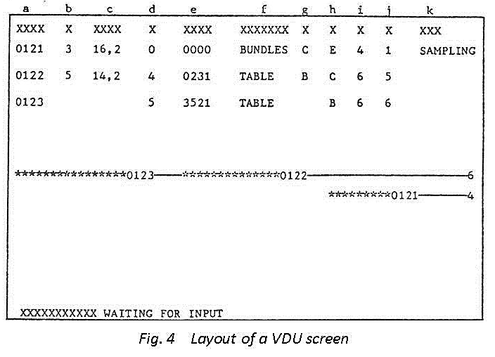
Details of the layout of Figure 4 are given in the key below:
- Consignment number.
- The carrier (designated by a number) on which the tail of the consignment is positioned.
- Length in metres of the consignment tail from the end of the carrier reflected in b above.
- The carrier number on which the head of the consignment is positioned. Where the head of the consignment has reached the sample point a 0 is indicated.
- Length in metres of the head of the consignment from the end of the carrier reflected in d above.
- Name or description of cane off-loading point, e.g. table, tippler etc.
- The pulse generator that will indicate the next forward movement of the tail of the consignment.
- The pulse generator that will indicate the next forward movement of the head of the consignment.
- The input point where tracking of the consignment commenced.
- The carrier that the head of the consignment was on immediately prior to the current carrier.
- Messages pertaining to an individual consignment.
- Last entry via the keyboard (“XXXXXX” at bottom left of panel)
- General messages (“Waiting for input” at bottom left of panel.
As the head of the consignment reaches the cane sampler the hatch frequency timer and delay circuit are activated. The delay timer is pre-set to allow sufficient time for the sample to pass through the sampling equipment to the secondary sub-sampler. Once the delay time has expired the bell rings, the green light comes on at the sampling point, the sub-sampler is automatically activated and the consignment number for the consignment concerned is shown. In addition the position of the tail of the consignment is also depicted, thus giving the sample installation attendant an indication of the sample period duration.
When the end of the consignment reaches the cane sampler, the time delay circuit is activated (as for the start of the consignment). At the end of the time delay period, the bell rings, the red light comes on and the secondary sub-sampler is automatically de - activated. During the no-sampling period (red light on) the secondary sub-sampler remains in the reject position, the hatch remains closed, and the number of the consignment last sampled is shown.
Modern cane tracker interfaces may appear as shown below.
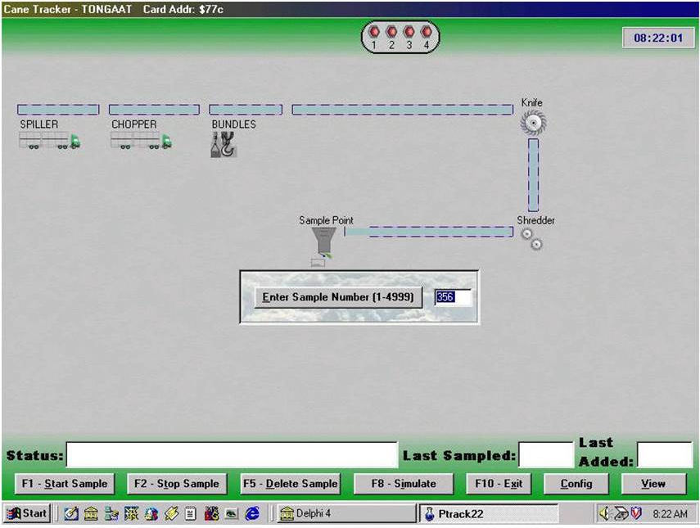
Method of Operation
- Switch on the equipment at the start of the week. A message ‘Waiting for Input’ will be visible at the bottom of the VDU while consignment number 0001 (the number of the first consignment to be tracked) is displayed in the top left-hand corner (see Figure 4).
- As the head of a new consignment passes the stop / start input point, press the stop/start button (3) shown in Figure 3. The button will light up. On the VDU an asterisk will appear for each pulse received from the pulse generator, with each new asterisk displacing the preceding ones to the right and thereby simulating the movement of the consignment along the carrier. The first asterisk is preceded by the consignment number.
- When the tail of the consignment reaches the stop / start input point, press the stop/start button to demarcate the end of the consignment. The light on the stop / start button will go off and the end of the consignment will be shown on the screen.
- If circumstances require that a consignment which is being tracked should not be sampled, key in the numerals 09 after the consignment number, e.g. 432109 to change consignment 4321 to mixed status. This decision may be reversed provided that the consignment has not reached the hatch by replacing the numerals 09 by 08, e.g. 432108.
- After a power failure the display screen will be cleared and the first consignment number generated will be 0001. To continue from the last consignment number prior to the power failure, e.g. 1234, press the CLEAR and then the ALL keys followed by 1234. The next consignment number generated will be 1235 as required. Note that whenever CLEAR ALL is entered all data displayed on the screen will be lost.
Maintenance
The microprocessor cane tracker requires no maintenance and faults are attended to by the Automation Centre of the SICB.

Cane Sampler
The purpose of the sampler is to provide a representative sample of cane from a consignment by means of a series of catch samples of the prepared cane taken after the shredder.
Description

Sliding gate (for use with slat elevators)
Figures 5 and 6 are respectively side elevation and plan view sketches of the cane sampler. The sampler is mounted in the base of the slat elevator (1) feeding the first mill/diffuser (through feed chute (2)) and is situated at the top end of the elevator. The cut-away hatch spans the full width of the elevator and is closed by a gate (3) operated by a double acting pneumatic cylinder (4). The gate is supported by flanged wheels running on guide rails on either side of the elevator. The upper end of the gate has a rubber skirt (5) which closes the gap between the gate and the hinged plate (6) which opens downwards as indicated by the arrow.
The hinged plate is operated by a second double acting pneumatic cylinder. Thus when the hatch is opened cane falls into the feed screw conveyor (7) instead of into the mill feed chute (2). When the hatch is closed, feed to the first mill is resumed, the interruption in feed being negligible.
The operation cycle is as follows:
Two electronic timers respectively control the frequency and the duration of the hatch opening. Upon receipt of a signal from the frequency timer, a two-way solenoid valve is activated and the pneumatic cylinder moves the gate so as to open the hatch. The timer controlling the duration of the hatch opening then de -activates the solenoid valve and the hatch is closed. The rubber skirt is now behind the hinged plate (6), i.e. on the screw conveyor side of the hinged plate, and with this configuration there is the danger of cane particles collecting in the gap between the hinged plate and the rubber skirt. Accordingly, as the gate closes the hatch, contact is made with a micro-switch that, via a timer, activates the two-way solenoid valve of a second pneumatic cylinder. At the end of the pre-set time the hinged plate is opened and then closed behind the rubber skirt, i.e. the skirt is now on the feed chute side of the hinged plate. Movement of the gate, both in opening and closing the hatch, is a snap action in order to avoid cane particle size selection.
A locking pin is used to prevent the gate from sliding open should the air pressure fail and acts as a safety lock if maintenance work is to be carried out in the vicinity of the cane sampler.

Swing gate (for use with belt conveyor)
A sketch of the cane sampler is shown in Figure 7 below. Cane from the shredder is conveyed by a rubber belt (1) to the feed chute of the first mill (2). The sampler gates form part of the feed chute and are referred to as the swing gate (3) which deflects the cane flow through the hatch cut in the wall of the mill feed chute, and the drop gate (4) which in turn opens the hatch and directs the cane flow into the feed screw conveyor trough (5). Both gates are operated by double acting pneumatic cylinders and swing to the positions shown by the straight dotted lines. The gates and hatch span the full width of the cane stream flowing into the mill feed chute and thus in the sampling position the complete flow of cane is diverted through the hatch. As in the case of the sliding gate cane sampler, interruption of the feed to the first mill is negligible.
The operation cycle is as follows:
The operation is controlled by four timers, one for the frequency of both hatch openings, one for the duration of drop hatch opening, one for the interval between drop and swing hatch opening and one timer for the duration of swing hatch opening.
On receipt of a signal from the frequency timer, the drop hatch solenoid valve is energised and opens the drop door via a double acting cylinder. After a set time, the interval timer sends a signal to the solenoid valve of the swing hatch which then opens via a double acting cylinder. The timer controlling the duration of the swing hatch then de-energises the swing hatch solenoid valve causing the hatch to close.
The final step in the cycle is the de -energising of the drop hatch solenoid valve by the drop hatch duration timer.
The drop gate is fitted with a locking pin to prevent it falling open if the air pressure should fail.
Method of operation (both types of cane sampler)
- At start-up open the air supply valve and ensure that the air pressure is at least 500 kPa gauge.
- Remove the locking pin(s).
- Turn the cane sampler switch on the logic control panel to the ‘on’ position. The cane sampler will then operate automatically in accordance with the settings on the timers controlling the frequency and duration of opening, as long as the remainder of the sampling equipment is running and the ‘logic control’ switch is in the ‘on’ position.
- The timer controlling the duration of opening should be set to obtain a fallout of 30 - 50kg cane at each hatch opening. The frequency timer should be set such that the previous fall-out is just clear of the section of the conveyor directly under the hatch when it is next opened.
- Engage the locking pins and shut off the air supply when the mill is not crushing.
Maintenance
It is essential that the gates should at all times move with a snap action so as to avoid particle size selection. To ensure smooth operation the following points must receive close attention:
- The moisture trap on the air line must be checked regularly to ensure a supply of clean, dry air. Drain when necessary, paying particular attention under excessively humid conditions.
- The air lubricator must be topped up with oil (of the recommended grade) when necessary and cleaned out weekly.
- Hinge pins (swing gate, drop gate and hinged plate) must be greased once per shift.
- Guide rails (sliding gate) must be cleaned once per shift.
- Pneumatic cylinder rods must be cleaned and lightly oiled once per day.

Cane sub-sampler
The sample from the cane sampler is sub-sampled by a two stage reciprocating sub-sampler which is designed to give a representative sample of manageable size.
Description
A sketch of the cane sub-sampler is presented in Figure 8. Essentially it consists of two sub-samplers in series. Each stage has a reciprocating hinged steel plate (flap) and depending on its position, the cane is either accepted or rejected. As indicated in Figure 8 the primary stage sub-sampler (1) is in the accept position and the cane stream is being deflected to the short transverse scroll (2) which feeds the cane to the secondary stage (3). For representative sub-sampling it is necessary that the system be tuned as follows:
- The primary stage flap (1) should be operated at the highest possible frequency. However, end effects require that both accept and reject settings be not less than two seconds, and hence they are set at this level. In addition the flap must move with a snap action.
- The transverse scroll (2) is of a diameter large enough to accept the maximum cane fallout from flap (1) without choking. The speed of the scroll (rpm) is set to provide continuous bulking, i.e. a fallout from flap (1) should be moved to the side just in time for the next to be received so that successive fallouts lie shoulder to shoulder. The pitch of the scroll is designed so that above the secondary stage, i.e. at flap (3), the cane breaks off in small lumps.
- The secondary stage, flap (3), must always be set at two seconds in the accept position, whilst the reject setting shall be at a minimum of two seconds. The frequency of sampling is thus adjusted by varying the reject setting so as to provide the prescribed amount of sample in the sample container. The prescribed amount is defined as the maximum quantity of cane that can be efficiently hand sub-sampled on the sample table.
The flaps are pneumatically driven and the reject/accept settings are set via electronic timers. As depicted in the sketch both the primary and the secondary stage chutes are stepped so as to allow the top edge of the flap to rest in the recess and thereby avoid the danger of small cane particles finding their way past this edge.
As a precaution, the controls for the secondary sub-sampler are connected through an interlock to the electronic cane tracker in such a way that during a no-sampling period (i.e. red light showing on output panel) the sub-sampler remains in the reject position. During this period all cane in the sampling system is returned to the mills. During a “sample” period (i.e. green light showing on output counter) the secondary sub-sampler is brought into operation.

Method of operation
- At the commencement of the week turn on the air supply to the pneumatic cylinders.
- The sub-sampler will commence operating as soon as the logic control panel is switched on. Sub-sampling frequency will depend on the electronic timer settings.
- Shut off the air supply to the cylinders when the mill is not crushing.
Maintenance
- Steam out thoroughly once a day. Any build-up of fine cane particles in corners must be cleaned out.
- The moisture trap on the air line must be checked regularly to ensure a supply of clean, dry air. Drain when necessary, paying particular attention under excessively humid conditions.
- The air lubricator must be topped up with oil (of the recommended grade) when necessary and cleaned out weekly.
- Once per day grease the flap bearings.
- Pneumatic cylinder reds must be cleaned and lightly oiled once per day.
- Adjust the air pressure by means of the air pressure regulator such that the flap moves rapidly but does not bang excessively against the chute walls. It is essential that the action of the flap be quick and smooth. If not, remedial action must be taken immediately.

Screw conveyors
In general, installations have between two and five screw conveyors. They are:
- Feed screw conveyors which transport cane from under the cane sampler to the cane sub-sampler.
- Sample screw conveyor which transports the sample from the cane sub-sampler primary stage to the secondary stage.
- Reject screw conveyors (one or two) which transport the reject portion of the cane from the two stages of the cane sub-sampler back to the mill.
The reject cane may be handled as follows:
- Deposited onto the feed roll of the first mill, or
- Screwed into the vertical chute feeding the first mill, or
- Fed back onto the elevator before the cane sampler. In this latter instance to ensure that a sample is not contaminated with cane from the previous consignment, the no sampling interval between consignments is pre-set to have a minimum delay equal to the time taken for cane to travel from the cane sampler, through the sub-sampling circuit, back onto the carrier again and past the cane sampler. Thus if the actual time taken for the cane to travel the full circuit is 58 seconds, the minimum for the no sampling interval between the end of one consignment and the commencement of the next will be of this magnitude. This ensures that the sampling system is cleared of all cane from the previous consignment before the cane sampler commences operating again.
Method of operation
- See motor control panel (4.5) and logic control panel (4.6) for start-up procedure.
- If a choke occurs, padlock the motor control panel main switch in the ‘off’ position, place a ‘Danger Do Not Start’ tag on the handle and retain the padlock key in your possession. Remove the screw conveyor covers and clear the cane by hand. Continual choking is generally symptomatic of excessive cane fall-out from the cane sampler.

Motor Control Panel
The motor control panel houses all the switchgear, fuses, etc. for the operation of the sample installation.
Figure 9 shows a typical motor control panel. There is an individual ammeter as well as start and stop buttons for each motor in the sample installation. All the sampling equipment motors are electrically inter-locked so that if, for example, the final reject conveyor motor should stop, all the other motors will automatically trip out. Therefore, in starting the sampling installation, the individual motors must be started in a set sequence. The main switch (1) must be locked in the ‘off’ position if any maintenance work is being done on the sampling installation. Modern control panels may look like the panel shown below.

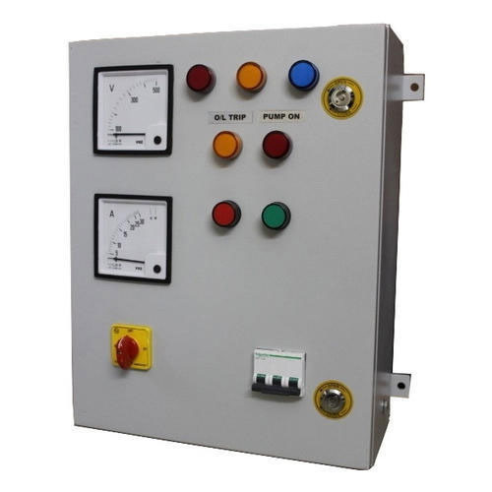

Logic control panel
The logic control panel contains the relays and timers controlling the sampling and subsampling operations.
Description
The front of the logic control panel is shown in Figure 10. The cane sampler test button (1) allows the hatch to be opened and to stay open for as long as the button is depressed. The switch (2) is an on-off switch for the cane sampler pneumatic solenoid valves. The timer (3) is for adjusting the cane sub-sampler secondary stage reject interval to suit the size of the consignment being sampled. The timers in the panel interior are depicted in Figure 11.
The various timers depicted above are as follows:
T1 — Cane sub-sampler primary stage accept timer.
T2 — Cane sub-sampler primary stage reject timer.
T3 — Cane sub-sampler secondary stage accept timer.
T4 — Cane sub-sampler secondary stage reject timer. (A back-up for the timer (3) shown in Figure 10).
T6 — Cane sampler operating frequency timer.
T7 — Drop gate action to swing gate action interval timer (swing gate sampler only).
T10 — Cane sampler hinged plate (auxiliary hatch) cycle duration timer (sliding gate samplers only).
T11 — Swing gate cycle duration timer (swing gate sampler only).
T12 — Drop gate or sliding gate cycle duration timer (depending on the type of sampler).

Sample Shredder
This machine is designed to reduce the particle size of the cane from the cane sub-sampler to a size suitable for analysis.
Description
A photograph of a sample shredder with the clutch safety cover removed is presented in Figure 12. Figure 13 shows the sample receiver in position over the shredder opening.
The shredder consists essentially of a steel casing containing a main shaft with seven metal discs welded to it. These discs carry four steel rods which support the fourteen hard-faced mild steel swing hammers (1). There is a single hinged door (2) and the cane is loaded into and removed from the shredder via this door. Drive to the shredder is by an electric motor (3) either through a pneumatic clutch and disc brake assembly (4) or a hydraulic system.
The shredder motor is engaged by pressing the clutch start button (5). This activates a timer within the control panel and causes the brake to disengage and the clutch to engage. The timer is set to give a running time of five seconds before the clutch is allowed to disengage and the brake to engage. The sequence is automatic. The door is fitted with a safety switch (6) which prevents the clutch engaging unless the door is closed or the sample receiver is in position.
Method of operation
- Start the motor by pressing the start button (7).
- Open the door (2).
- Introduce the sub-sample of cane (ca. 2kg).
- Close the door and secure.
- Start the shredder by pressing the clutch engage button (5).
- When the shredder has stopped, open the door and attach the clean sample receiver to the opening.
- Engage the clutch again (press button 5), in order to discharge the shredded cane into the sample receiver.
- Transfer the sample in the receiver to the sample container.
- The motor should be switched off only for lengthy stops such as the weekend stop. Thus the procedure followed for all samples after the first will usually involve steps (b) to (h) only.
Maintenance
- Steam out the inside of the shredder casing once daily.
- Ensure that the door seals are in good condition to prevent loss of juice during the shredding operation.
- Check for worn swing hammers. Symptoms of worn hammers are poor preparation and poor discharge of the sample into the sample receiver.
- Check for worn hammer bushes. Hammers will feel loose if worn.
- Check the shredding time frequently - too long a shredding time will result in an untoward temperature rise in the cane (3°C is normal).
- In the case of pneumatic clutches check that the clutch engages fully. If slipping is observed, check that the air pressure is 400 – 500 kPa gauge. If the air pressure is correct, readjust the clutch.
- Check the operation of the safety micro-switch by pressing the clutch start button with the door open. The clutch should not be engaged unless the switch is faulty.
- Check that none of the swing hammers is stuck in the ‘swing down’ position as this will cause poor ejection of cane.

Final bagasse samplers
Two types of samplers are approved, i.e. the full width hatch where there is a slat elevator leading from the last mill or the swing sampler which is used where belt-carriers operate.
Description

Full width hatch
The full width hatch is of a design basically similar to that used for cane (see Figures 5 and 6) but in the case of final bagasse the hatch is situated as near to the discharge from the last mill as possible. Hence there is no need for the rubber skirt and hinged plate as illustrated in Figure 5.

Swing sampler
The swing sampler is illustrated in Figure 14 and is designed to obtain a sample from the full width and depth of the bagasse stream while it is in a state of free fall from one conveyor to the next. The sampler is suspended by lengths of flat bar (1) which are pivoted at the upper end (2) and counter balanced at (3).
The sample box itself pivots on the pins (4) to facilitate discharge of the sample residue and when not in use is stored with the handle (6) in the vertical position locked on bracket (5) with a locking pin. The sampler is pushed into the bagasse stream by the handle (6), which rests on the guide wheels (7).
Method of operation
- Full width hatch
- The hatch is operated pneumatically by depressing the hatch-operating button. It will open for a pre-set interval before closing again.
- Ensure that the hatch opens fully so as to allow the full depth of the bagasse on the slat to fall through. Check that opening and closing of the hatch is with a snap action.
- Swing sampler
- The sampler is operated manually.
- Remove the locking pin and swing the handle (6) down until it rests on the wheel (7).
- Push the sample box into the bagasse stream ensuring that the leading edge moves beyond the rear of the falling bagasse stream and then reverse the stroke.
Maintenance
- Full width hatch
- The moisture trap on the air line must be checked regularly to ensure a supply of clean, dry air to the pneumatic cylinder. Drain when necessary, paying particular attention under excessively humid conditions.
- The air lubricator must be topped up with oil (of the recommended grade) when necessary and cleaned out weekly.
- Guide rails must be cleaned once per day.
- Pneumatic cylinder rods must be cleaned and lightly oiled once per day.
- Swing sampler
No routine maintenance is required.

Mixed juice sampler - Cold juice (for all analyses other than insoluble solids)
The sampler is designed to provide a representative sample of the liquid fraction of the juice passing through the scale.
Description
The sampler is illustrated in Figure 15. It consists of a copper tube of 19mm diameter having holes 2,5mm diameter with a pitch of 25mm. It is positioned at the sampling point so that its perforated end covers the full width of the juice outflow as it discharges from the scale tank.
Method of operation
- In setting up the sampler the angle of the holes must be set so that the sample bucket is approximately three-quarters full after one hour of normal crushing and should not be altered during the sampling period.
- The sampler outlet shall penetrate into the sample bucket through an opening provided in the side of the bucket.
- The stainless steel sample bucket shall be covered and situated so that contamination of the contents from outside sources is avoided.
Maintenance
Once per shift the sampler must be replaced with a duplicate one which has been steam cleaned and allowed to dry.

Mixed juice sampler - Hot juice (for all analyses other than insoluble solids)
The sampler is designed to provide a cooled representative sample of the liquid fraction of the juice passing through the scale.
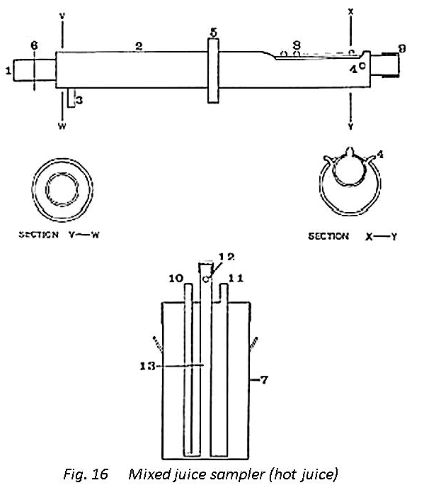
Description
The sampler is illustrated in Figure 16. It consists of a copper tube (1) of 19 mm diameter having holes 2.5 mm diameter with a pitch of 25 mm. It is provided with a water-cooled jacket (2) with cooling water inlet pipe (3) and outlet pipes (4). The cooling jacket is attached eccentrically to the sampler tube. Splashing of mixed juice through the opening in the scale discharge pipe provided for the sampler is eliminated by the splash guard (5) and the drip ring (6) prevents any liquid from the outside of the sampler running into the sample receiver (7). The portion of the tube provided with nipple openings (8) covers the full width of the juice outflow as it discharges from the scale tank. Nipple openings instead of plain perforations are provided for the hot juice sampler to avoid ingress into the sample of any juice concentrated by evaporation. The non-discharging end of the sampler is closed with the screw cap (9).
The sample receiver (7) provided with these samplers is fitted with an immersion cooler for further cooling of the sample and maintaining it at ambient temperature. Cooling water flows into the cooler via the inlet tube (10) and out again via the outlet tube (11). The sampler outlet penetrates the aperture (12) while the juice flows down the inlet tube (13).
Method of operation
- Set up the sampler with the nipple openings at an angle such that the sample receiver will be approximately three-quarters full after one hour of normal crushing. This setting must not be varied during the hour.
- Attach the water hose connections and turn on the cooling water.
- Check that there are no water leaks at the connections.
Maintenance
- Once per shift the sampler and immersion cooler must be replaced with a duplicate set which has been steam cleaned and allowed to dry.
- On replacing the sampling equipment check that there are no water leaks into the sampler tube from the cooling jacket or into the sample receiver from the immersion cooler.

Mixed juice sampler - insoluble solids
The sampler is designed to provide a representative sample of mixed juice. This sampler differs from those described above in that the sample obtained has the true insoluble solids to liquid ratio of the juice.
Description
The sampler is illustrated in Figure 17. It consists of the cutter (1) which is moved horizontally and at a uniform speed across the full width of the free-falling stream of juice from the mixed juice pipe (2). The cutter is positioned in a splash guard (3) which is mounted on rails and driven by a pneumatic piston (4). The cutter inlet gap is set at an opening that is a minimum of three times the diameter of the largest particles present in the juice - at present a standard gap of 4mm is used. The cutter outflow capacity exceeds the inflow so as to prevent overflowing with consequent bias in the sample.
From the cutter the sample flows into a 12 litre stainless steel bucket through a hole in the lid via a plastic tube. The sample container stand is attached to the splash guard.
Method of operation
- Place the sample bucket in position at the start of the shift and insert the plastic tube through the lid opening.
- Once per hour depress the control valve which activates the sampler to move once (to and fro) through the juice stream.
- At the end of the shift remove the sample bucket with the sample for analysis and replace with a clean dry bucket.
Maintenance
- At the end of each shift the sampler must be steam cleaned. After each steam cleaning the first sample cut must be rejected.
- The compressed air moisture trap must be checked regularly and drained when necessary so as to ensure a supply of clean dry air.
- The air lubricator must be topped up with oil (of recommended grade) when necessary and cleaned out weekly.
- Guide rails must be cleaned once per shift.
- Pneumatic cylinder rods must be cleaned and lightly oiled once per day.

Juice mixer
This consists of a brass rod (6 x 500mm) which is attached at one end to the centre of a perforated brass disc (thickness 3mm, 150mm Ø). Mixing of the juice sample is achieved by holding the rod at the end remote from the plate and plunging the plate up and down in the juice a few times.

Molasses sampler
The sampler (Figure 18) consists of a small 21 rpm gear pump (Oberdorfer 1000 S – 5) driven by an induction type electric motor (1), single phase, 220 volt. 150 watt. 1400 rpm. The 21 rpm of the gear pump is achieved by means of a gear box (2).
The pump is installed so that a trough (figure 19) feeding the pump is directly under the discharge chute of the molasses scale. This trough is 150 mm long, 25 mm wide, increases from 5 mm to 30 mm in depth and is connected to the pump by means of a short rubber tube (12 mm ID). With the every scale discharge, molasses flushes the trough (Figure 19) and then fills it. As the valve closes at the end of the scale discharge, the pump is activated by means of a time switch which allows the pump to run for a set time (usually from 15 – 30 seconds depending on the rate of molasses production). The pumped molasses is then discharged into a sealed sample container. The pumping time is adjusted so that a constant volume (about 30 cm³) of molasses is pumped per ton of molasses produced.

Sugar sampler
The sampler is designed to take a semi-continuous sample of the product sugar at a point immediately before the scale and where the sugar is in a state of free-fall from a conveyor.
Description
The sugar sampler is illustrated in Figure 20. It consists of the scoop (1) which is moved horizontally through 360° about the shaft (2). Motive power for the shaft is provided by the carrier head shaft via a reduction gear box (3). The gear box reduction is such that the sugar stream is sampled once every 30 seconds. A scraper (not visible in Figure 20) positioned mid-stream in the sugar flow is designed to remove the sugar from the scoop so that the sample is taken from the centre of the stream.
As the scoop passes another scraper (4) all the sugar is removed and drops into the sample receptacle (5).
Method of operation
Once installed the operation of the sampler is automatic.
Maintenance
- At the end of each hourly sample period, and after removal of the sample receptacle, brush off all sugar adhering to the sampler arms, scoop and scraper.
- Once per week check the gear box oil level and top up if necessary.

Grab Sampler for whole stick cane
Description
The grab sampler is illustrated in Figure 21. The grab is fitted with tines (1), 185 mm in length, three on either side, with a pitch of 280 mm. it is mounted on a hydraulically operated tower which permits three dimensional movement.
Operation of the grab sampler is by means of five levers each clearly marked to indicate the particular movement controlled by its operation.
Method of operation
- Switch on the power supply to the hydraulic pump
- Operate the sampler as desired by means of the appropriate lever. Ensure that the sample taking is random.
- When the sampling operation has been completed bring the grab to rest on the ground and do not leave it in an elevated position.
Maintenance
- Check the oil seals for leaks and the hoses for wear daily.
- Once per week check the oil level and top up, if necessary, with the appropriate grade of oil.
- Once per week check all hinge and pivot points for wear.
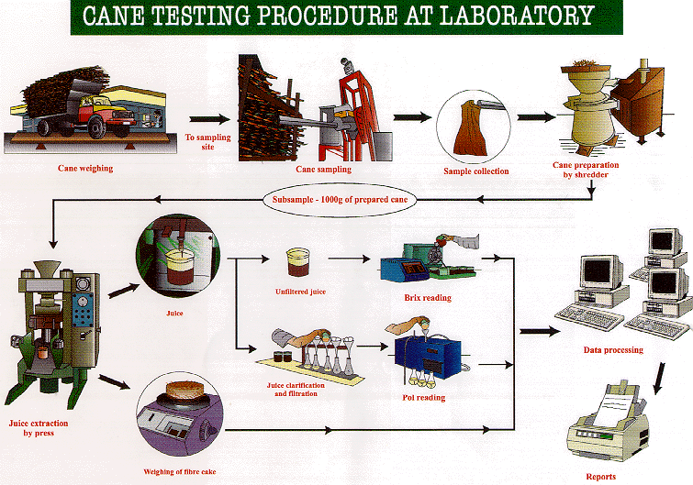

2.3 HANDLING AND STORAGE OF SAMPLES

Packaging
After sampling, the sample containers must be checked for leaks. The outer surface of packages must be clean and dry. If leaks occur, caps and stoppers should be reinforced or replaced. Another inspection should then be carried out, and if leaks persist fresh samples should be taken.
The sample containers used for the packaging of liquid samples should be filled to approximately 90 % of their total holding capacity.

Sealing
Depending on your internal policies and procedures, the sample container may need to be sealed to prevent unauthorised or inappropriate handling of samples (and ensure the integrity of the contents). In this case the seal must be firmly attached and stable in order to prevent damage during sample storage or transport, and to safeguard the chain of evidence.

Marking
The markings on labels must be clearly legible and permanent in order to prevent deletion or substitution/alteration during storage, handling and transport. Health and safety regulations must be observed. Warning signs, markings and symbols indicating potential hazards should be placed on packages holding samples of hazardous goods/compounds.

Documents accompanying samples
The accompanying documents must be kept in line with rules laid down by the company Quality Assurance policies and procedures.

Storage of samples
Storage conditions are determined by the characteristics and properties of the samples taken and the subsequent analysis that needs to be done. Storage conditions should ensure that the sample is not altered in any way that might affect the parameters to be analysed.
If the sample cannot be transferred to the laboratory immediately, an alternative storage space should be provided/sought that fulfils the conditions for safeguarding the quality and identity of the samples. Health and safety and environmental regulations must be observed.
A quality management system should specify:
- Who is responsible for accepting samples for storage and transport for analysis, and record keeping;
- Who is responsible for monitoring the sample storage deadlines;
- Who is responsible for sample disposal after expiry of these dates;
- Who is responsible for ensuring that the storage conditions for the samples are met at all times.

2.4 SAMPLE RECORDS AND LABELS
The markings on labels must be clearly legible and permanent in order to prevent deletion or substitution/alteration during storage, handling and transport of samples. Health and safety regulations must be observed. Warning signs, markings and symbols indicating potential hazards should be placed on packages holding samples of hazardous goods/compounds.
Documents such as waybills that accompany a sample must be kept in line with rules laid down by the company Quality Assurance policies and procedures.

2.5 SAMPLING FREQUENCY
Different stages of the sugar process require sampling (for quality control purposes) at different frequencies. For example:

Whole Stick Cane
A representative sample is taken per consignment.

Final Bagasse
Because of the difficulties of continuous sampling of bagasse, catch samples are taken at regular intervals. A sample of bagasse should be taken at a predetermined time every hour. If the mill is not crushing at the sampling time, no sample shall be taken for that hour.

Mixed juice
For Pol, Brix and sucrose analysis, the sample must be collected continuously over an hour (pooled sample per hour), every hour throughout the week. For Insoluble solids determination, the sample is taken each hour throughout the shift. For reducing sugars and pH a four hour composite sample is made from the sample taken for pol and brix determination.

Clarified juice
Sampling is conducted every hour.

Filter feed (mud):
- pH: A catch sample is taken every hour from each mud pump
- Brix, Bagacillo and suspended solids % feed (for the determination of bagacillo ratio and filter retention): A series of catch samples of the mud feed to the filters is taken for the duration of the test at a point after the addition of the bagacillo used as filter aid.
- Pol and insoluble solids (press water clarifier mud only): Take a catch sample once an hour.

Filter cake
- Pol and moisture: A catch sample is taken every hour from the full width of each filter.

Filtrate
- Brix and Pol determination: A catch sample is taken every 4 hours using the copper container.
- Brix and mud solids % filtrate (for the determination of filter retention): A series of catch samples is taken for the duration of a test.

Syrup
A catch sample is taken hourly from the take-off pipe situated on the delivery side of the pump.

Remelt
A catch sample is taken hourly from a short take off pipe with stopcock, after the brix controller.

A-, B- and C- massecuite
Using the brass container, take catch samples at regular intervals from the gutter, neglecting the first fraction of the strike before commencing sampling.

Magma:
Catch samples are taken as required.

A- and B- Molasses
Catch samples are taken from the “blow up” tanks as required.

Final molasses:
A sample is collected continuously over 2 hours.

B-, C1- and C2- Sugars:
Take the samples on conservative machines over a period of 2 hours.

A-Sugar:
Samples are best taken automatically with a semi-continuous sampler over an hour.

  - Knowledge topic 3: Principles of food safety and quality assurance

3.1 HACCP
Hazard Analysis Critical Control Point, or HACCP, is a systematic preventative approach to food safety from biological, chemical, and physical hazards in production processes that can cause the finished product to be unsafe and designs measures to reduce these risks to a safe level.
White sugar, molasses and pulp from the sugar manufacturing process are either directly consumed, used as a main component for confectionery purposes, or molasses and pulp are frequently used as animal feeds and eventually find their way back to humans when the latter consume meat. Therefore, it is of great importance to ensure the standard quality and safe production of sugar and its co-products.
Implementation of Hazard Analysis Critical Control Point (HACCP) constitutes a crucial step in producing safe sugar. Identification of critical control points makes possible the control of all parameters which could eventually deteriorate the final product. Application of HACCP system shows that the production line can be adequately controlled especially when HACCP is implemented within the framework of a quality control system such as ISO 9001.

3.1.1 Application of HACCP to production of sugar and its co-products

(1) Construction of a process flow diagram
A flow diagram can be used for the application of HACCP. It may be either detailed or just a simple outline of the process flow. In all cases, flow diagram construction is an important first step because it will provide clear descriptions of all the steps involved in the process, from raw material to the end product.
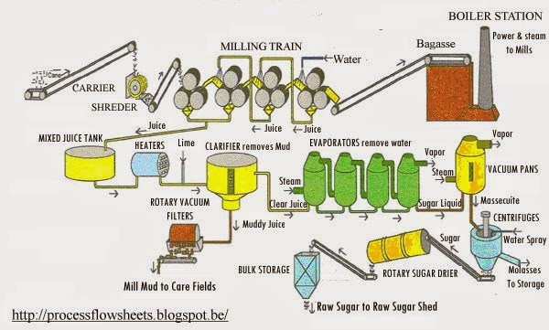

(2) Identification of Critical Control points and parameters requiring monitoring in the production line

Sugarcane growing (CCP 1)
Agricultural practices such as the use of commercial fertilisers as well as sewage sludge produced from the treatment of domestic and industrial waste waters, constitute one of the primary input sources of metals in agro-ecosystems raising their content in the ground.
The heavy metals of primary concern contained in commercial fertilisers and sewage sludge are Cd, Zn, Cu, Pb, and Ni. These heavy metals can possibly be carried over from the ground into the plants and finally into the products of the white sugar manufacturing process.
Herbicides, insecticides and fungicides are widely used for the control of weeds, insects and diseases in sugarcane production. Their use can lead to the detection of residual traces of such chemicals in white sugar, molasses and bagasse. In addition, according to the type used, pesticides can contribute to the increase in heavy metal soil content.
The heavy metal and pesticide residue contents of white sugar, molasses and bagasse depend to a large extent on the quality of the processed sugarcane. The appropriate use of fertilisers and pesticides according to supplier instructions is essential for assuring that raw material will not be seriously contaminated. Following the steps of the CCP decision tree, the control of the fertilisers and pesticides used, is crucial for the elimination of heavy metal presence in sugar.

Sugar extraction (CCP 2)
The microorganisms entering the extraction system mainly originate from the cane fields and vary proportionally to the microbial population of the soil in which the sugarcane is grown. Extraction system conditions such as temperature, pH value, water activity and sugar content favour microbial growth as well as sugar losses. Microbial activity leads to the formation of reducing sugars due to sucrose degradation and production of secondary metabolites such as organic acids and exopolysaccharides (dextran, levan). In addition to the sugar losses caused by microorganisms, microbial activity presents significant difficulties in the sugar manufacturing process due to the formation of slime (levan, dextran) which clogs pipes and filters and the production of lactic acid that induces corrosion of steel in the extractor and ancillary systems.
Microbial flora of the extraction system consists mainly of mesophiles (Lactobacillus and Leuconostoc) and thermophiles (Bacillus stearothermophilus, B.pumilus, Clostridium). For inhibiting microbial growth in the extraction system, the sugar factory may employ chemical control with the use of formalin (40% aqueous solution of formaldehyde), quaternary ammonium compounds, dithiocarbamates and sulphur dioxide. The disinfection program in the sugar industry is mainly based on the use of formaldehyde which is considered as the most effective biocide in the prevention of sugar losses due to lactic acid producing bacteria. However, its use has been recently associated with carcinogenic effects in workers exposed to it. The selection of biocides and their amounts used should be based not only on their effectiveness but also on their residual quantities found in sugar, molasses and bagasse.
Sugarcane contains saponins (glycosides of hydrophobic alcohols) that enter the extraction system thereby leading to the formation of foamy solutions. Foaming of flume water and raw juices inhibits the circulation of liquids affecting the overall processes of sugar production. Sugar factories employ antifoaming agents such as modified fatty acids to reduce the problems associated with saponins. The use of antifoaming agents in excessive amounts can lead to traces of them in molasses and bagasse.

Crystallisation and centrifugation (CCP 3)
Thick juice coming from the evaporation plant contains a low number of microorganisms due to the high temperature treatment. However, the next process steps cause microbial contamination of syrups and consequently sugar losses. High levels of humidity and temperature in the sugar refinery as well as the remains of sugar dust or syrup that remains as a thin film on walls, floors and pipes, favour microbial growth and generate sources of contamination. Strict measures in combination with hygienic precautions should be taken in order to avoid microbial contamination from these factory environmental conditions. These measures could include improved air circulation (or improved air extraction), sugar house temperature regulation when possible, fast operation under high technologically acceptable temperatures, general cleanliness of the production process and equipment. When possible, storage tanks and pipes of the system should be covered, monitored, cleaned and sterilised using officially approved cleaning agents and disinfectants.
Special care should be taken in the use of appropriate filters, which are able to remove more than 90% of the bacteria present in juices. Moreover, heating of the standard liquor at a temperature of 90°C should destroy microorganisms which enter the crystallisation stage.
The centrifugation process is considered crucial for sugar manufacture since any downgraded sugar quality during this manufacturing stage is irreversible and no correction stage is possible at subsequent stages. During centrifugation the major part of the microbial population is removed together with syrup by centrifugal force. However, crystal sugar conglomerates prevent removal of microbes due to the fact that microorganisms are trapped inside them. Formation of crystal conglomerates should be avoided by the use of appropriate technological practices. Wash water, used during centrifugation, may be one of the major sources of sugar microbial contamination. Therefore, filtration and sterilisation of the wash water which comes into contact with sugar is essential.
During centrifugation, one of the major concerns should be the materials such as the discharger and washing devices and screens which come into contact with the final product (sugar). Centrifugation equipment should be constructed of materials that minimise any risk of contamination because of substance migration into the sugar. Stainless steel is usually preferred to other materials because of its ability to maintain a high level of performance while keeping corrosion to a minimum.

Drying and cooling of sugar (CCP 4)
Serious microbiological problems arise during the drying and cooling sugar manufacturing stages. Airborne microorganisms constitute the main source of microbial contamination since sugar dust is a suitable carrier of mould spores.
The formation of moist sugar crusts on the conveying devices as well as condensed water on the ceilings that may drop onto the conveyors are the main components of sugar microbial contamination. The most important action to avoid sugar contamination is the implementation of sanitary measures in agreement with high hygienic standards. All the premises including conveyors should be constantly monitored and cleaned using the appropriate disinfectants. The enclosure of conveyors on which sugar is transported and the installation of air filters for dust collection are considered essential measures for reducing the contamination risk.
The presence of foreign bodies such as metals, glasses and plaster from the walls and ceilings should be of major concern during the drying/cooling stage of sugar manufacturing. Techniques such as metal detection and X-ray systems, widely applied for the detection of foreign bodies buried inside a food product, should be employed in order to assure white sugar safety. As in the case of the centrifugation stage, product-contact surfaces such as conveyor belts, drum dryers and screens should be constructed of such materials that minimise any risk of sugar contamination.

Sugar storage (CCP 5)
White sugar is stored in large sacks in storehouses and as bulk in silos. Sacked sugar is stored in piles whose height depends on the crushing strength of the full sacks. The storehouse into which the sacks are placed should be ventilated to ensure the regulation of temperature and relative air humidity. Long term sugar storage depends on the maintenance of certain temperature and humidity conditions that prevent sugar from becoming hard or caked or excessively wet.
High storage temperatures (above 25°C) and relative humidity of the air above 60% induce sugar crystal agglomeration. The number of micro-organisms in sugar depends on the conditions of storage such as temperature, moisture and ventilation.
Monitoring of temperature and relative air humidity is essential for long term storage of sugar. The storehouses and silos should comply with high standards of hygiene to prevent microbial contamination and sugar quality downgrading. No storage of products other than sugar should be allowed in the storehouses where the sugar bags are piled. For bulk sugar storage it is essential that the air used for silo conditioning is filtered in order to prevent microbial contamination.

Packaging (CCP 6)
White sugar is packaged into multi-wall paper sacks. At this stage the encountered hazards can be of microbiological, physical and chemical origin. Microbial contamination of sugar during packaging may originate from the packaging material, the equipment used and personnel. Therefore, high standards related both to food hygiene and personnel hygiene should be maintained within the packaging area. Sugar-contact surfaces should be constantly monitored and cleaned; air filters for dust collection should be used and sanitary measures for storerooms of the packaging materials should be practiced. Physical hazards originating from foreign materials found in packaged sugar are eliminated by the use of metal or X-ray detectors.
Chemical hazards most frequently originate from the packaging material. The direct contact of sugar with packaging paper could lead to chemical contamination of sugar due to migration of heavy metals, paraffin components, dyes and chlorinated organic compounds. The presence of these toxicants in foods could represent a threat to consumer health. Paper sacks should be approved for food packaging, purchased from official suppliers and adequately packaged when consignments are received.

Transportation (CCP 7)
Sugar transportation is carried out by tanker vehicles (bulk) or covered trucks (packaged sugar).
Regardless of the way that sugar is dispatched to customers, the vehicles used should only be used for food transportation and they should be inspected for chemical remains and for the presence of foreign materials and condensed water which may eventually become sources of microbial contamination. During bulk transportation, tanker vehicles should be loaded through flexible pipes that are constructed from materials approved for coming into contact with foods. Special care should also be taken with the pipe connections, so as to avoid contamination of the sugar.
In conclusion, although the sugar industry is considered one of safest industries in terms of occurring incidents and outbreaks caused by its product/co-products, the implementation of HACCP substantially improves the safety of these products. In fact, a closer inspection of critical control points introduces the range of the most crucial parameters (moisture, heavy metals, pesticides, herbicides, extraneous materials) within the acceptable limits as prescribed by the corresponding legislation.
Furthermore, HACCP helps to improve the hygiene of personnel as well the factory thus ensuring the prevention of cross-contamination. In general, the benefits from HACCP implementation are substantially enhanced when HACCP is applied in a factory in conjunction with a Total Quality Management system such as ISO or GMP.

3.2 PERSONAL HYGIENE

3.2.1 Good personal health and hygiene practices
Ensuring that employees in the sugar industry look after their health is not only good for the production and supply of safe and quality food to the consumer, it is also good for:
- The overall image and productivity of the company (the company becomes well-known for its safe product and workers are healthy and take less leave),
- It is good for the individual worker (the worker is a healthier individual), and
- The health of his family and community (the worker does not transmit diseases to the people around him).
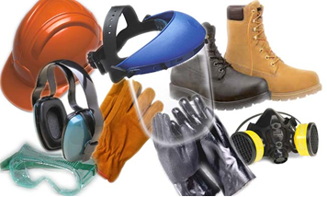
Personal hygiene is the basic concept of cleaning, grooming and caring for our bodies so that we remain healthy. While it is an important part of our daily lives at home, personal hygiene isn't just about combed shiny hair and brushed teeth; it's important for worker health and safety in the workplace. Workers who pay attention to personal hygiene can prevent the spread of micro-organisms and disease, reduce their exposure to chemicals and contaminants, and avoid developing skin allergies, skin conditions, and chemical sensitivities.

3.2.2 Personal Protective Equipment
The first principle of good hygiene is to avoid exposure to hazardous substances or conditions by forming a barrier over the skin with personal protective equipment (PPE) such as gloves, coveralls, and boots. It is important to check the PPE often for excessive contamination, wear, tears, cuts, or pinholes. Workers should clean, decontaminate or replace protective equipment frequently to make sure it doesn't collect or absorb irritants. If protective equipment becomes too soiled during the job, the worker should stop and replace it with clean equipment.
All sugar factor workers should wear clean, washable, light-coloured protective clothing, preferably without external pockets (which may get snagged by moving equipment). Protective clothing must be suitable for the work being carried out and should completely cover ordinary clothes. It is worn to protect the product from the risk of contamination, not just to keep private clothing clean.
Dust, pet hairs and woolen fibres are some of the contaminants carried on ordinary clothing.
Outdoor clothes and personal effects must not be brought into the sugar production or handling areas, but should be stored in suitable lockers or cupboards.
All personnel and visitors must wear protective clothing in all processing and storage areas. This includes hair restraints. The type of protective clothing and the frequency of changing must comply with company standards.
The following PPE must be worn at all times:
Overalls: To protect your body from products and spillages.
Safety boots/gum boots: To protect your feet from falling objects.

3.2.3 Personal Hygiene Practices

Hands
As the hands are often in direct contact with the product and the equipment used to manufacture the product, they are one of the main routes for contaminating sugar and transferring sugar poisoning bacteria. Sugar factory workers must wash their hands regularly throughout the working day, drying them by using single service roller towels, disposable paper towels or hot air dryers.
All those working in the sugar factory must wash their hands -
- At the beginning of a shift.
- Before handling any equipment.
- After lunch and tea breaks.
- After handling product and before they handle other product.
- Immediately after going to the toilet, blowing their nose, coughing, sneezing, smoking, eating, combing or touching their hair, handling waste product or rubbish and handling cleaning equipment.
Basic hand washing and skin care can prevent work exposures and disease. Good washing and scrubbing with water and soap helps to remove bacteria, contaminants, and chemicals. It can also prevent exposure by ingestion and cross-contamination of the surfaces and objects we touch.
Hand washing involves more than a quick rinse under a faucet. To wash hands properly, workers should first wet them under the faucet and then use liquid or bar soap. Hands should be held out of the water until all skin surfaces are scrubbed and lathered for at least twenty seconds. Workers can then rinse with clean water and dry their hands with a disposable towel.
To wash hands with a hand sanitizer, workers should apply the appropriate amount of sanitizer into the palm of the hand, and then rub hands together until they are dry, being careful to cover all surfaces of the hands (Please note: For some job activities, hand sanitizers are not an acceptable means of hand cleaning).
Showering and face-washing after work is also a good idea.

Cuts and Sores
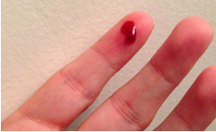
Cuts and sores can provide an ideal place for bacterial growth. To prevent contamination of product by harmful bacteria and blood, these wounds must be completely covered by waterproof dressings, (preferably coloured to help locate them if they come loose) and suitable gloves. Waterproof dressings will also help prevent cuts from going septic.

Spilled blood
If an accident occurs where blood is spilled, the area must be isolated and inspected and the line of equipment cleaned and sanitised.

Nose, Mouth and Ears
Around 40% of adults carry Staphylococci bacteria in their nose or mouth. Coughing and sneezing can carry the bacteria in droplets for a surprisingly large distance. Using disposable single-use paper tissues is preferable to handkerchiefs.
Discharges from the ears, eyes and nose may also contaminate product and sugar factory workers should see their Doctor if suffering from any of these infections.
Therefore, employees must not -
- Cough or sneeze over or around the sugar product.
- Pick or scratch their nose while working.

Hair
As hair is constantly falling out this can result in sugar being contaminated and so sugar factory workers should wear a suitable head covering, with long hair being adequately tied back.
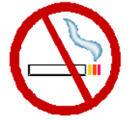
The combing of hair and adjustment of head coverings must not be done in sugar processing and handling areas.

Smoking
It is illegal to use tobacco, (e.g. cigarettes, pipes or cigars) in sugar production, handling and storage areas or while handling or delivering sugar. Not only is this to prevent cigarette ends and ash from contaminating the sugar product, but also because:
- People touch their lips while smoking and may transfer harmful bacteria to the product or from the product to their mouths.
- Smoking encourages coughing and droplet infection.
- Cigarette ends contaminated with saliva are put on working surfaces.
- Smoking is a safety concern as a potential ignition source for dust grain explosions.
- An unpleasant environment can be created for non-smokers.
In accordance with South African laws and regulations, no smoking is allowed in any areas within the factory premises. Smokers are only allowed to smoke in designated smoking areas.

Jewelry and Perfume
Sugar factory workers should not wear earrings, watches, jewelled rings or brooches, as they can harbour dirt and bacteria and the gem stones and small pieces of metal may end up in the product, resulting in sugar contamination by foreign objects.
Strong smelling perfume should also not be worn, as it may taint the product.

General Health
Workers should be in good health - from oral hygiene to general fitness. It is not a good practice to work if you have wounds, cuts, flu or any transmittable disease that can affect food safety.
Any worker suffering from diarrhoea, vomiting or a food-borne infection MUST be excluded from work, and can only return after they have been completely free of symptoms for 2 days. And they must stay away again if any symptoms return.
Workers with skin infections, sores, heavy colds and ear or eye discharge, must also stay away from work until the symptoms have gone.
This is not only to prevent the contamination of the product by diseases carried by the personnel, but also to prevent personnel from becoming even more ill since the factory environment is a dusty place with many different chemicals which can worsen their condition.
Consumers expect nothing less than healthy and safe food. Food safety should not be compromised for quick gain. Therefore as producers, processors and retailers; safety must be a priority issue. Food that is handled or prepared by someone who is showing symptoms of sickness is not safe for consumption.

3.3 FOOD SAFETY PROTECTIVE MEASURES
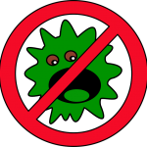
Food safety is a discipline describing the handling, preparation, and storage of food in ways that prevent foodborne illness. This includes a number of routines that should be followed to avoid potentially severe health hazards.

3.3.1 The purpose of food safety
The purpose of food safety regulations in a sugar mill is to ensure that the mill produces and delivers products that meet 3 basic requirements. Namely, products that are:
- Free of contaminants: Products must be free from any foreign matter, substances or micro-organisms which could have quality, disease or safety implications.
- Of enough shelf life: Products must be safe to consume until the “best before” or expiry date.
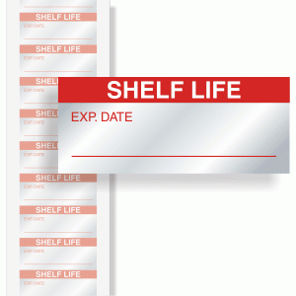
- Safe for consumption: Consumers do not want to be injured or harmed, become ill or die when eating or consuming products.

3.3.2 Food Safety Practices & Procedures
Food safety is the practices and procedures that ensure the following:
- Eliminates food risks or reduces food risks to acceptable levels,
- Ensures food is safe for consumption,
- Ensures food will not cause harm to the consumer when it is prepared or consumed according to its intended use,
- Preserves the quality of food to prevent contamination and food-borne illnesses,
- Are applied throughout the supply chain – from the sugar cane farms to the sugar manufacturing plants until the final product is distributed and sold to the consumer.
Each sugar mill should have a food safety policy which states the company’s commitment and assurance to consumers to produce quality and safe products.

3.3.3 Types of food safety hazards
There are three types of food safety hazards that can occur:
- P - Physical food safety hazards
- C - Chemical food safety hazards
- B - Biological food safety hazards

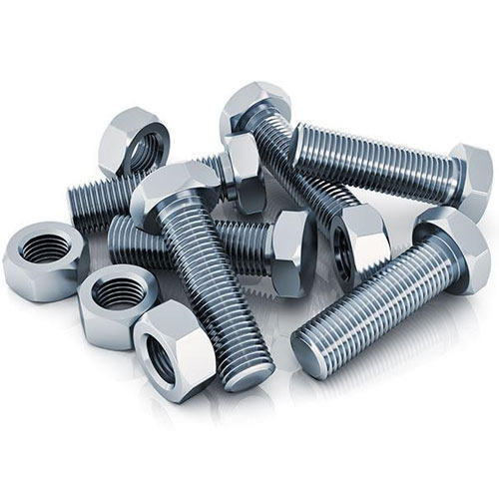
Physical food safety hazards
Physical contamination of the sugar product may be caused by dirt, hair, stones, soil, cigarettes or cigarette butts, nails, nuts and bolts, jewellery, match sticks, bone fragments, feathers, pieces of plastic or foil packaging material, stems, seeds, sticks and leaves, buttons, string and fibres or any other foreign substance.

Chemical food safety hazards
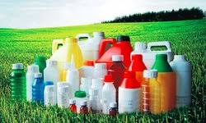
Chemical contaminants of the sugar product may include pesticides, medicines, detergents, disinfectants or any other chemical substance that could find its way into the food chain. Residue monitoring and evaluation programs identify sugar containing harmful residues and remove these from the food chain. These residues include toxins from natural sources, from pesticides, herbicides and fertilisers. A number of agricultural chemicals (pesticides, herbicides, and fertilisers) may leave potentially hazardous residues in raw sugar cane. Chemical contamination during manufacture is also possible. Where compounds that might enter the food chain are known or believed to be hazardous, there are limits on the maximum amount that may be present in foods. This acceptable daily intake is set by determining the highest lifetime level of intake that causes no detectable effect, and dividing it by a safety factor of 100.
Pesticides: At the farm level, all crop protection products must be approved for their intended use. They should only be used in accordance with the manufacturer’s instructions and any relevant codes of good practice should be observed. Compliance with ‘harvest intervals’ should be ensured. Pesticides (including herbicides, fungicides and wood preservatives) should be stored in an appropriate well ventilated and secure area. This area should be constructed in such a manner as to contain spillages in the case of accidents. They should be kept in the original container and not transferred to e.g. unmarked containers such as drink bottles. Appropriate protective clothing and masks should be worn when handling, mixing or using these products, as indicated on the label of the product.

Biological food safety hazards
Biological contamination can be caused by bacteria, yeasts, protozoa, molds and viruses, which can enter the production chain as a result of poor sanitation and poor hygiene practices. Bacteria and fungi are the principal types of micro-organisms that cause sugar spoilage and food-borne illnesses. Sugar may be contaminated by micro-organisms at any time during harvest, processing, handling, storage or distribution. The primary sources of microbial contamination are soil, air, humans, plant surfaces, water, and sugar processing machinery or equipment.
It is the responsibility of each role-player in the chain to ensure that the sugar product remains safe and of a high quality. If each role-player in the chain keeps accurate records of what they did to the product while it was in their care, then it will be easy to trace any problems back to their source and, in so doing, solve the problem. This is called “traceability”.

