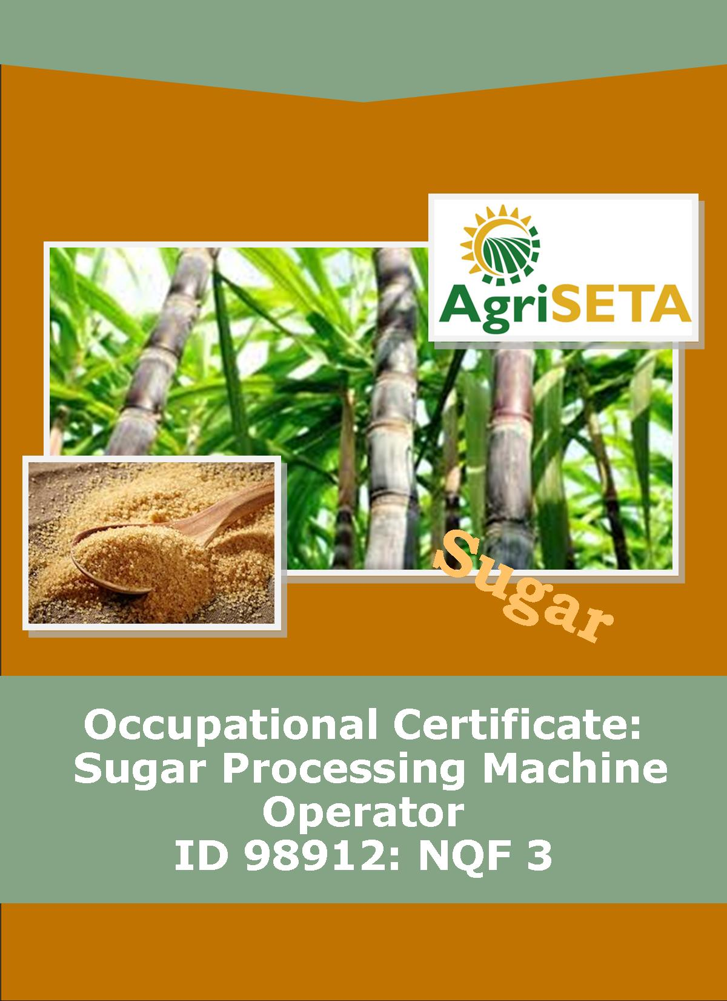
PRACTICAL SKILLS COMPONENT:
LOG BOOK
This Log Book belongs to:
__________________________________
OCCUPATIONAL QUALIFICATION: SUGAR PROCESSING MACHINE OPERATOR

PRACTICAL SKILLS COMPONENT:

LOG BOOK
PRACTICAL SKILLS COMPONENT:
LOG BOOK
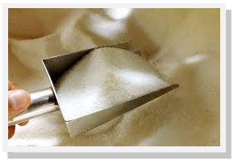
OCCUPATIONAL CERTIFICATE:
SUGAR PROCESSING MACHINE OPERATOR: ID 98912: NQF 3

©Copyright AgriSETA
Telephone: +27 12 301 5600
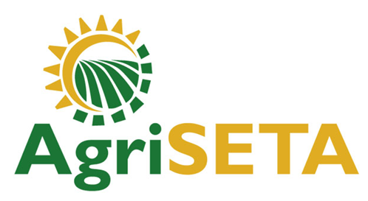

AgriSETA holds the copyright to its publications and Web pages. Proper citation is requested.

TABLE OF CONTENTS
1. AN INTRODUCTION TO THIS LOG BOOK 6
1.1 Practical Skills Module Specifications 6
1.2 Types of Assessment Tools that will be used in the Practical Skills Component 6
1.3 Completing your Log Book 7
1.4 How to use the Competence Checklists 7
1.5 How to use the Preparation Matrices 8

2. PRACTICAL SKILLS MODULE 1 10
2.1 Operate pre-set sugar processing equipment 10
2.2 Preparation Matrix for Practical Skills Module 1 11
2.3 Competence Checklist for Practical Skills Module 1 14

3. PRACTICAL SKILLS MODULE 2 22
3.1 Operate programmable sugar processing equipment 22
3.2 Preparation Matrix for Practical Skills Module 2 23
3.3 Competence Checklist for Practical Skills Module 2 26

4. PRACTICAL SKILLS MODULE 3 37
4.1 Operate a bank of inter linked equipment that functions in sequence in a sugar mill 37
4.2 Preparation Matrix for Practical Skills Module 3 38
4.3 Competence Checklist for Practical Skills Module 3 41

5. PRACTICAL SKILLS MODULE 4 47
5.1 Meet occupational health, safety, environment and quality standards 47
5.2 Preparation Matrix for Practical Skills Module 4 48
5.3 Competence Checklist for Practical Skills Module 4 51

6. SUMMARY LEARNER ASSESSMENT RECORD 56
6.1 Learner Assessment Record 56
6.2 Stakeholder information 57
6.2.1 Learner Details 57
6.2.2 Mill Supervisor Details 57
6.2.3 Programme Assessor Details 58
-O0O-

AN INTRODUCTION TO THIS LOG BOOK

Practical Skills Module Specifications
This Log Book is intended to be used for the Practical Skills Component of the Occupational Qualification: Sugar Processing Machine Operator NQF 3. This Log Book contains the following Practical Skills Module Specifications:
- 716106000-PM-01, Operate pre-set sugar processing equipment, NQF Level 2, Credits 12
- 716106000-PM-02, Operate programmable sugar processing equipment, NQF Level 3, Credits 24
- 716106000-PM-03, Operate a bank of inter linked equipment that functions in sequence in a sugar mill, NQF Level 03, Credits 8
- 716106000-PM-04, Meet occupational health, safety, environment and quality standards, NQF Level 03, Credits 8
Total number of credits for Practical Skill Modules: 52

Types of Assessment Tools that will be used in the Practical Skills Component
Throughout this Occupational Qualification there are three assessment tools or ways of recording knowledge and practical skills. The first method is related to the underpinning knowledge and takes the form of written assessments (as has generally been the case in the Formative Assessment within the Knowledge Component preceding the Practical Skills Component). These have taken the form of multiple choice assessments and short structured questions requiring explanation on the part of the learner. It has also included practical or homework assignments during the formative assessment.
The second and third types of assessment tools are related to the ways in which the assessor can gather and record evidence for the practical skills that you, the learner, must demonstrate. A competence checklist is a list of activities or performance outcomes that you, the learner, must be seen to be able to do in order to be considered competent in the tasks being assessed. The checklist provides a space to state that either “Yes, the learner successfully carried out this activity” or, “No, the learner has not yet achieved this standard”.
Checklists are provided in this Log Book and you, the learner, has to show that the tasks can be performed to the standard stated – The method of assessment is “observation of performance under realistic conditions”. Alternatively performance may be observed under controlled conditions such as a simulated work environment in a training centre workshop or registered Assessment Centre (if the necessary tools and equipment or systems are available for such assessment).
The third method that can be used to assess practical skills is the provision of opportunities for practical assignments. These are tasks that you will be required to complete. In these cases, your supervisor will provide instructions for you to follow in order that you can demonstrate your competence. Practical assignments may ask you to produce a product (e.g. a plan, a report, a design, a drawing, a schematic), or it may require observation by the supervisor of your performance, or a combination of the two.

Completing your Log Book
Once each of these competence checklists are completed and signed off, the Learner Log Book document and all its Supporting Evidence must be handed to the relevant QCTO Assessment Quality Partner for verification.
A summary “Learner Assessment Record” is provided at the back of the Learner Log Book and is a record of your progress over the entire Practical Skills Component. This should be completed by the Mill Supervisor and a certified copy inserted into the Summative Guide (In the Work Experience Component).

How to use the Competence Checklists
The Competence Checklists for each of the Practical Skills Modules contained in this Log Book appear as follows. A few guidelines on how to use these Checklists are shown below:
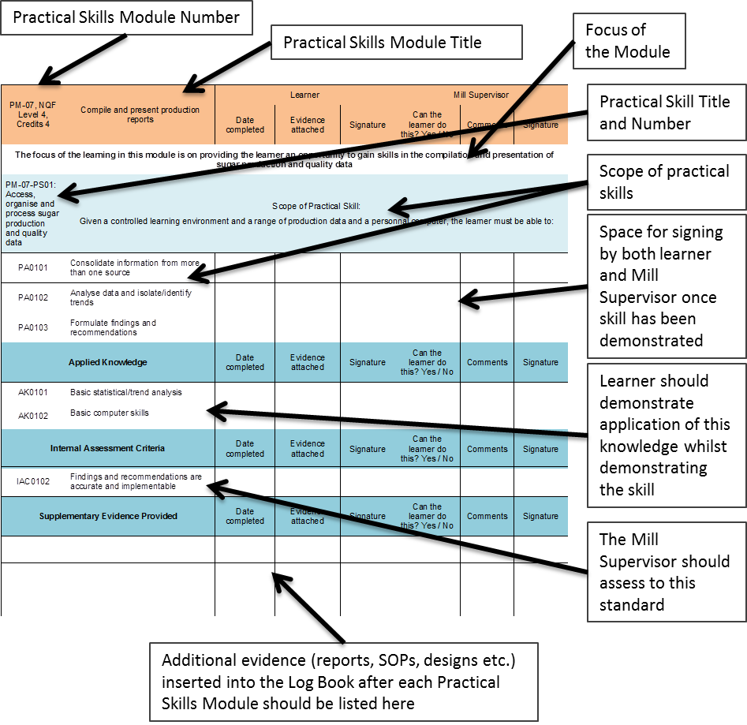

How to use the Preparation Matrices
To prepare for each Practical Skills Module a Preparation Matrix has been provided for your use. Use this to plan your work in collaboration with the Mill Supervisor.
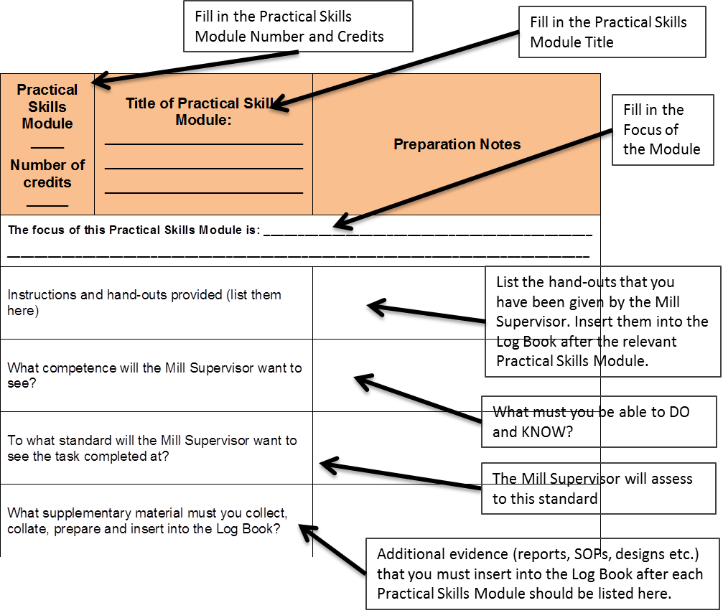
(Note: PM = Practical Skills Module, PA = Practical Skill Assessment Scope, AK = Applied Knowledge)

PRACTICAL SKILLS MODULE 1

Operate pre-set sugar processing equipment
Module number: 716106000-PM-01: NQF Level 2: Credits 12
The focus of the learning in this module is on providing the learner an opportunity to gain practical skills required to attend to pre-set equipment used in uncomplicated processes such as filter presses, juice heater, coolers, Oliver filters, continuous centrifuges in a controlled learning environment.
The learner will be required to:
- PM-01-PS01: Conduct pre start-up procedures of preset sugar processing equipment
- PM-01-PS02: Monitor and operate preset sugar processing equipment
- PM-01-PS03: Shut down and clean preset sugar processing equipment

Preparation Matrix for Practical Skills Module 1
Practical Skills Module ____  Number of credits _____ | Title of Practical Skills Module: ________________________  ________________________  ________________________ | Preparation Notes
The focus of this Practical Skills Module is: ______________________________________________________________________
__________________________________________________________________________________________________________
Instructions and hand-outs provided (list them here)
What competence will the Mill Supervisor want to see?
To what standard will the Mill Supervisor want to see the task completed at?
What supplementary material must you collect, collate, prepare and insert into the Log Book?

Competence Checklist for Practical Skills Module 1
PM01: NQF Level 2: Credits 12 | Operate pre-set sugar processing equipment | Learner |  |  | Mill Supervisor
 |  | Date completed | Evidence attached | Signature | Can the learner do this? Yes / No | Comments | Signature
The focus of the learning in this module is on providing the learner an opportunity to gain practical skills required to attend to pre-set equipment used in uncomplicated processes such as filter presses, juice heater, coolers, Oliver filters, continuous centrifuges in a controlled learning environment.
PM-01-PS01: Conduct pre start-up procedures of preset sugar processing equipment | Scope of Practical Skill:  Given pre-set equipment in a controlled operational environment, operating procedures and instructions, the learner must be able to:
PA0101 | Use a control sheet to inspect the preset equipment for correct settings and mechanical soundness
PA0102 | Inspect and identify feeder material for availability and correctness
PA0103 | Inspect material routing for readiness
Applied Knowledge |  | Date completed | Evidence attached | Signature | Can the learner do this? Yes / No | Comments | Signature
AK0101 | Equipment mechanical inspection procedures and standards
AK0102 | Flow of material
AK0103 | Equipment settings
Internal Assessment Criteria |  | Date completed | Evidence attached | Signature | Can the learner do this? Yes / No | Comments | Signature
IAC0101 | Inspection reports are accurately completed
Supplementary Evidence Provided |  | Date completed | Evidence attached | Signature | Can the learner do this? Yes / No | Comments | Signature
PM-01-PS02: Monitor and operate equipment preset sugar processing equipment | Scope of Practical Skill  Given pre-set processing equipment in a controlled learning environment, the learner must be able to:
PA0201 | Perform specific operational tasks in accordance with equipment operating procedures e.g. start-up, change-over, purging, cleaning, shut down, emergency stop
PA0202 | Monitor preset equipment to maintain operation within output/product requirements and equipment specifications
PA0203 | Recognise and rectify and/or report operating problems related to different scenarios
PA0204 | Achieve required volumes and quality standards
PA0205 | Complete a production report
Applied Knowledge |  | Date completed | Evidence attached | Signature | Can the learner do this? Yes / No | Comments | Signature
AK0201 | Standard operating procedures or instructions
AK0202 | Sensory signs of operating problems
AK0203 | Material specifications
AK0204 | Indicators of the mechanical problems
AK0205 | Product/material standards and specifications
AK0206 | Production reporting requirements
Internal Assessment Criteria |  | Date completed | Evidence attached | Signature | Can the learner do this? Yes / No | Comments | Signature
IAC0201 | The equipment is operated in accordance with standard operating procedures or instructions
IAC0202 | The consequences of wrong practices, neglect and/or misinterpretation of instrument readings, incorrect settings in relation to equipment efficiency and product quality is explained correctly
IAC0203 | Production volumes and quality standards are achieved
Supplementary Evidence Provided |  | Date completed | Evidence attached | Signature | Can the learner do this? Yes / No | Comments | Signature
PM-01-PS03: Shut down and clean preset sugar processing equipment | Scope of Practical Skill  Given cleaning material, equipment, lubricants and the required mechanical tools the learner must be able to:
PA0301 | Perform pre-set equipment shutdown procedures
PA0302 | Clean pre-set sugar processing equipment and perform housekeeping
PA0303 | Lubricate pre-set sugar processing equipment
Applied Knowledge |  | Date completed | Evidence attached | Signature | Can the learner do this? Yes / No | Comments | Signature
AK0301 | Equipment cleaning procedures
AK0302 | Equipment care and maintenance
Internal Assessment Criteria |  | Date completed | Evidence attached | Signature | Can the learner do this? Yes / No | Comments | Signature
IAC0301 | Scheduled cleaning and equipment care procedures are executed in accordance with manufacturer specifications and standard procedures
Supplementary Evidence Provided |  | Date completed | Evidence attached | Signature | Can the learner do this? Yes / No | Comments | Signature

PRACTICAL SKILLS MODULE 2

Operate programmable sugar processing equipment
Module Number 716106000-PM-02, NQF Level 3, Credits 24
The focus of the learning in this module is on providing the learner an opportunity to develop skills to operate programmable equipment or equipment setup and operated in series. The learner will gain the skills by operating equipment used for extraction, clarification, evaporation, sugar melting and refining processes.
The learner will be required to:
- PM-02-PS01: Conduct pre start-up procedures of programmable sugar processing equipment
- PM-02-PS02: Monitor and operate programmable sugar processing equipment
- PM-02-PS03: Shut down and clean programmable sugar processing equipment
- PM-02-PS04: Record data and maintain production records

Preparation Matrix for Practical Skills Module 2
Practical Skills Module ____  Number of credits _____ | Title of Practical Skills Module: ________________________  ________________________  ________________________ | Preparation Notes
The focus of this Practical Skills Module is: ______________________________________________________________________
__________________________________________________________________________________________________________
Instructions and hand-outs provided (list them here)
What competence will the Mill Supervisor want to see?
To what standard will the Mill Supervisor want to see the task completed at?
What supplementary material must you collect, collate, prepare and insert into the Log Book?

Competence Checklist for Practical Skills Module 2
PM-02, NQF Level 3, Credits 24 | Operate programmable sugar processing equipment | Learner |  |  | Mill Supervisor
 |  | Date completed | Evidence attached | Signature | Can the learner do this? Yes / No | Comments | Signature
The focus of the learning in this module is on providing the learner an opportunity to develop skills to operate programmable equipment or equipment setup and operated in series. The learner will gain the skills by operating equipment used for extraction, clarification, evaporation, sugar melting and refining processes.
PM-02-PS01: Conduct pre start-up procedures of programable sugar processing equipment | Scope of Practical Skill:  Given a controlled operational environment, operating procedures and instructions, the learner must be able to:
PA0101 | Use a control sheet to inspect programmable equipment for correct settings and mechanical soundness
PA0102 | Inspect and identify feeder material for availability and correctness
PA0103 | Inspect material routing for readiness
Applied Knowledge |  | Date completed | Evidence attached | Signature | Can the learner do this? Yes / No | Comments | Signature
AK0101 | Programmable equipment mechanical inspection procedures and standards
AK0102 | Flow of material
AK0103 | Programmable equipment settings
Internal Assessment Criteria |  | Date completed | Evidence attached | Signature | Can the learner do this? Yes / No | Comments | Signature
IAC0101 | Inspection reports are accurately completed
Supplementary Evidence Provided |  | Date completed | Evidence attached | Signature | Can the learner do this? Yes / No | Comments | Signature
PM-02-PS02: Monitor and operate programmable sugar processing equipment | Scope of Practical Skill:  Given programmable processing equipment and a controlled learning environment, the learner must be able to:
PA0201 | Set-up and start-up programmable sugar processing equipment manually and achieve normal operating conditions
PA0202 | Control the programmable equipment operation within required output/product specifications
PA0203 | Perform specific procedures related to the process (e.g. change-over, cleaning, emergency stops)
PA0204 | Adjust programmable equipment setting in response to instrument readings and required operating conditions
PA0205 | Use instrumentation readings and sensory cues to anticipate quality problems and make adjustments
PA0206 | Achieve consistent flow of material in terms of required volumes and quality standards
PA0207 | Read and explain a programmable equipment operating diagram
PA0208 | Select and apply appropriate responses to material or process deviations
PA0209 | Control the programmable equipment operation within required output/product specifications
Applied Knowledge |  | Date completed | Evidence attached | Signature | Can the learner do this? Yes / No | Comments | Signature
AK0201 | Standard Operating Procedures
AK0202 | Manual and automatic starting/shut down procedures
AK0203 | Equipment operating procedures and specifications
AK0204 | Product specifications
AK0205 | Standard safety procedures
AK0206 | Standard responses to common problems
AK0207 | Process flow
Internal Assessment Criteria |  | Date completed | Evidence attached | Signature | Can the learner do this? Yes / No | Comments | Signature
IAC0201 | The execution of equipment set-up, start-up, operation and shutdown in accordance with standard procedures
IAC0202 | The execution of adjustments to equipment setting in response to instrument readings and material variations are performed in accordance with standard procedures
IAC0203 | Required product volumes and quality standards are achieved
IAC0204 | The impact and implications of wrong actions in relation to equipment efficiency and product standards can be explained
IAC0205 | Responses to different emergency scenarios, risks and problems can be explained
IAC0206 | Indicators of the mechanical equipment functionality can be explained
Supplementary Evidence Provided |  | Date completed | Evidence attached | Signature | Can the learner do this? Yes / No | Comments | Signature
PM-02-PS03: Shut down and clean programmable sugar processing equipment | Scope of Practical Skill:  Given cleaning and lubricating materials, standard procedures and programmable processing equipment or equipment in series in a controlled learning environment, the learner must be able to:
PA0301 | Perform equipment shutdown procedures of programmable sugar processing equipment
PA0302 | Set-up and run programmable equipment cleaning cycles
Applied Knowledge |  | Date completed | Evidence attached | Signature | Can the learner do this? Yes / No | Comments | Signature
AK0301 | Cleaning and equipment care procedures
AK0302 | Equipment shutdown procedures
Internal Assessment Criteria |  | Date completed | Evidence attached | Signature | Can the learner do this? Yes / No | Comments | Signature
IAC0301 | Equipment cleaning and care procedures are executed in accordance with standard procedures
IAC0302 | Equipment shutdown procedures are executed in accordance with standard procedures
Supplementary Evidence Provided |  | Date completed | Evidence attached | Signature | Can the learner do this? Yes / No | Comments | Signature
PM-02-PS04: Record data and maintain production records | Scope of Practical Skill:  Given production line, quality reports and product specifications, the learner must be able to:
PA0401 | Interpret, collate, calculate, summarise and record production data to ensure availability of accurate and complete production information
PA0402 | Compile production reports to communicate required information accurately
PA0403 | Present information in simple graphical format to analyse and report production data
PA0404 | Read and respond to the essence of written instructions
PA0405 | Organise and capture data
Applied Knowledge |  | Date completed | Evidence attached | Signature | Can the learner do this? Yes / No | Comments | Signature
AK0401 | Data analysis
AK0402 | Reporting and presenting data
AK0403 | Use or purpose of data
Internal Assessment Criteria |  | Date completed | Evidence attached | Signature | Can the learner do this? Yes / No | Comments | Signature
IAC0401 | Data is analysed and reported on accurately
Supplementary Evidence Provided |  | Date completed | Evidence attached | Signature | Can the learner do this? Yes / No | Comments | Signature

PRACTICAL SKILLS MODULE 3

Operate a bank of inter linked equipment that functions in sequence in a sugar mill
Module Number 716106000-PM-03, NQF Level 3, Credits 8
The focus of the learning in this module is on providing the learner an opportunity to develop skills to operate inter linked equipment set up and operated in series such as effluent and waste control and waste product handling systems.
- PM-03-PS01: Conduct pre start-up procedures for a bank of inter linked equipment that functions in sequence in a sugar mill
- PM-03-PS02: Monitor and control a bank of inter linked equipment that functions in sequence in a sugar mill

Preparation Matrix for Practical Skills Module 3
Practical Skills Module ____  Number of credits _____ | Title of Practical Skills Module: ________________________  ________________________  ________________________ | Preparation Notes
The focus of this Practical Skills Module is: ______________________________________________________________________
__________________________________________________________________________________________________________
Instructions and hand-outs provided (list them here)
What competence will the Mill Supervisor want to see?
To what standard will the Mill Supervisor want to see the task completed at?
What supplementary material must you collect, collate, prepare and insert into the Log Book?

Competence Checklist for Practical Skills Module 3
PM-03, NQF Level 3, Credits 8 | Operate a bank of inter linked equipment that functions in sequence in a sugar mill | Learner |  |  | Mill Supervisor
 |  | Date completed | Evidence attached | Signature | Can the learner do this? Yes / No | Comments | Signature
The focus of the learning in this module is on providing the learner an opportunity to develop skills to operate inter linked equipment setup and operated in series such as effluent and waste control, waste product handling systems.
PM-03-PS01: Conduct pre start-up procedures for a bank of inter linked equipment that functions in sequence in a sugar mill | Scope of Practical Skill:  Given a controlled operational environment, operating procedures and instructions the learner must be able to:
PA0101 | Use a control sheet to inspect the bank of equipment for correct settings and mechanical soundness
PA0102 | Use a control sheet to inspect the material transfer pumps, pipes and valves for correct settings and mechanical soundness
PA0103 | Inspect and identify feeder material for availability and correctness
PA0104 | Inspect material routing for readiness
Applied Knowledge |  | Date completed | Evidence attached | Signature | Can the learner do this? Yes / No | Comments | Signature
AK0101 | Operating procedures for the equipment
AK0102 | Equipment inspection procedures
Internal Assessment Criteria |  | Date completed | Evidence attached | Signature | Can the learner do this? Yes / No | Comments | Signature
IAC0101 | Pre start-up procedures are performed in a structured manner in accordance with operating procedures
Supplementary Evidence Provided |  | Date completed | Evidence attached | Signature | Can the learner do this? Yes / No | Comments | Signature
PM-03-PS02: Monitor and control a bank of inter linked equipment that functions in sequence in a sugar mill | Scope of Practical Skill:  Given a bank of equipment in series in a controlled learning environment the learner must be able to:
PA0201 | Set-up and start-up the bank of equipment manually and achieve normal operating conditions
PA0202 | Monitor and control the operation of a bank of equipment working in series within required output specifications
PA0203 | Shut down the bank of equipment
PA0204 | Read and explain a process flow diagram
Applied Knowledge |  | Date completed | Evidence attached | Signature | Can the learner do this? Yes / No | Comments | Signature
AK0201 | Standard Operating Procedures
AK0202 | Standard responses to common problems
AK0203 | Material flow diagrams
Internal Assessment Criteria |  | Date completed | Evidence attached | Signature | Can the learner do this? Yes / No | Comments | Signature
IAC0201 | The operation of the bank of equipment is monitored and controlled in accordance with standard procedures
IAC0202 | Indicators of the mechanical equipment functionality can be explained
Supplementary Evidence Provided |  | Date completed | Evidence attached | Signature | Can the learner do this? Yes / No | Comments | Signature

PRACTICAL SKILLS MODULE 4

Meet occupational health, safety, environment and quality standards
Module Number 716106000-PM-04, NQF Level 3, Credits 8
The focus of the learning in this module is on providing the learner an opportunity to develop skills to comply with occupational safety, health and environmental protection standards and to conduct In-line quality assurance.
The learner will be required to:
- PM-04-PS01: Comply with occupational safety, health and environmental protection standards
- PM-04-PS02: Conduct In-line sugar quality assurance

Preparation Matrix for Practical Skills Module 4
Practical Skills Module ____  Number of credits _____ | Title of Practical Skills Module: ________________________  ________________________  ________________________ | Preparation Notes
The focus of this Practical Skills Module is: ______________________________________________________________________
__________________________________________________________________________________________________________
Instructions and hand-outs provided (list them here)
What competence will the Mill Supervisor want to see?
To what standard will the Mill Supervisor want to see the task completed at?
What supplementary material must you collect, collate, prepare and insert into the Log Book?

Competence Checklist for Practical Skills Module 4
PM-04, NQF Level 3, Credits 8 | Meet occupational health, safety, environment and quality standards | Learner |  |  | Mill Supervisor
 |  | Date completed | Evidence attached | Signature | Can the learner do this? Yes / No | Comments | Signature
The focus of the learning in this module is on providing the learner an opportunity to develop skills to comply with occupational safety, health and environmental protection standards and to conduct In-line quality assurance.
PM-04-PS01: Comply with occupational safety, health and environmental protection standards | Scope of Practical Skill:  Given occupational safety and health procedures, inspection sheets and personal protective equipment the learner must be able to:
PA0101 | Use a control sheet to inspect equipment and protective devices for safe operating conditions
PA0102 | Select, use and care for personal protective equipment
Applied Knowledge |  | Date completed | Evidence attached | Signature | Can the learner do this? Yes / No | Comments | Signature
AK0101 | Safety inspection procedures and standards
AK0102 | Personal protective equipment
Internal Assessment Criteria |  | Date completed | Evidence attached | Signature | Can the learner do this? Yes / No | Comments | Signature
IAC0101 | Safety checks and inspections are performed in accordance with manufacturer specifications and standard procedures
IAC0102 | Personal protective equipment is selected and used correctly
IAC0103 | Operating risks and measures to prevent these can be explained
Supplementary Evidence Provided |  | Date completed | Evidence attached | Signature | Can the learner do this? Yes / No | Comments | Signature
PM-04-PS02: Conduct In-line sugar quality assurance | Scope of Practical Skill:  Given a production line, quality reports and product specifications the learner must be able to:
PA0201 | Integrate various sources of information (instrument/PLC readings, quality reports, sensory cues) to determine quality standards
PA0202 | Conduct in-process sampling and product evaluation to maintain quality control standards
PA0203 | Complete in-process quality reports
Applied Knowledge |  | Date completed | Evidence attached | Signature | Can the learner do this? Yes / No | Comments | Signature
AK0201 | Quality control procedures
AK0202 | Product quality specification
AK0203 | In-process sampling and evaluation techniques
Internal Assessment Criteria |  | Date completed | Evidence attached | Signature | Can the learner do this? Yes / No | Comments | Signature
IAC0201 | In-line quality control procedures are adhered to
IAC0202 | Deviations form required quality standards are recognised and reported
Supplementary Evidence Provided |  | Date completed | Evidence attached | Signature | Can the learner do this? Yes / No | Comments | Signature

SUMMARY LEARNER ASSESSMENT RECORD
As soon as you have completed all the Practical Skills Modules successfully, this form and the stakeholder information below should be completed and the Log Book with all its supplementary information should be handed to the relevant QCTO Assessment Quality Partner for verification.
A certified copy of this entire section (Section 6: Summary Learner Assessment Record) must be inserted into your Summative Guide (In the Work Experience Component).

Learner Assessment Record
Practical Skills Module | Credits | Can the Learner do this? | Signature of Mill Supervisor | Date
716106000-PM-01, Operate pre-set sugar processing equipment, NQF Level 2 | 12
716106000-PM-02, Operate programmable sugar processing equipment, NQF Level 3 | 24
716106000-PM-03, Operate a bank of inter linked equipment that functions in sequence in a sugar mill, NQF Level 03 | 8
716106000-PM-04, Meet occupational health, safety, environment and quality standards, NQF Level 03 | 8

Stakeholder information

Learner Details
First name:
Surname:
ID number:
Telephone number:
Mobile number:
E-mail address:
Postal address:
Start date of workplace experience:
Completion date of workplace experience:
Signature of learner:

Mill Supervisor Details
Organisation / workplace:
Workplace designation (of Mill Supervisor):
First name:
Surname:
ID number:
Telephone number:
Mobile number:
E-mail address:
Postal address:
Date completed:
Signature:

Programme Assessor Details
Company:
First name:
Surname:
ID number:
Telephone number:
Mobile number:
E-mail address:
Postal address:
Date assessed:
Signature:

