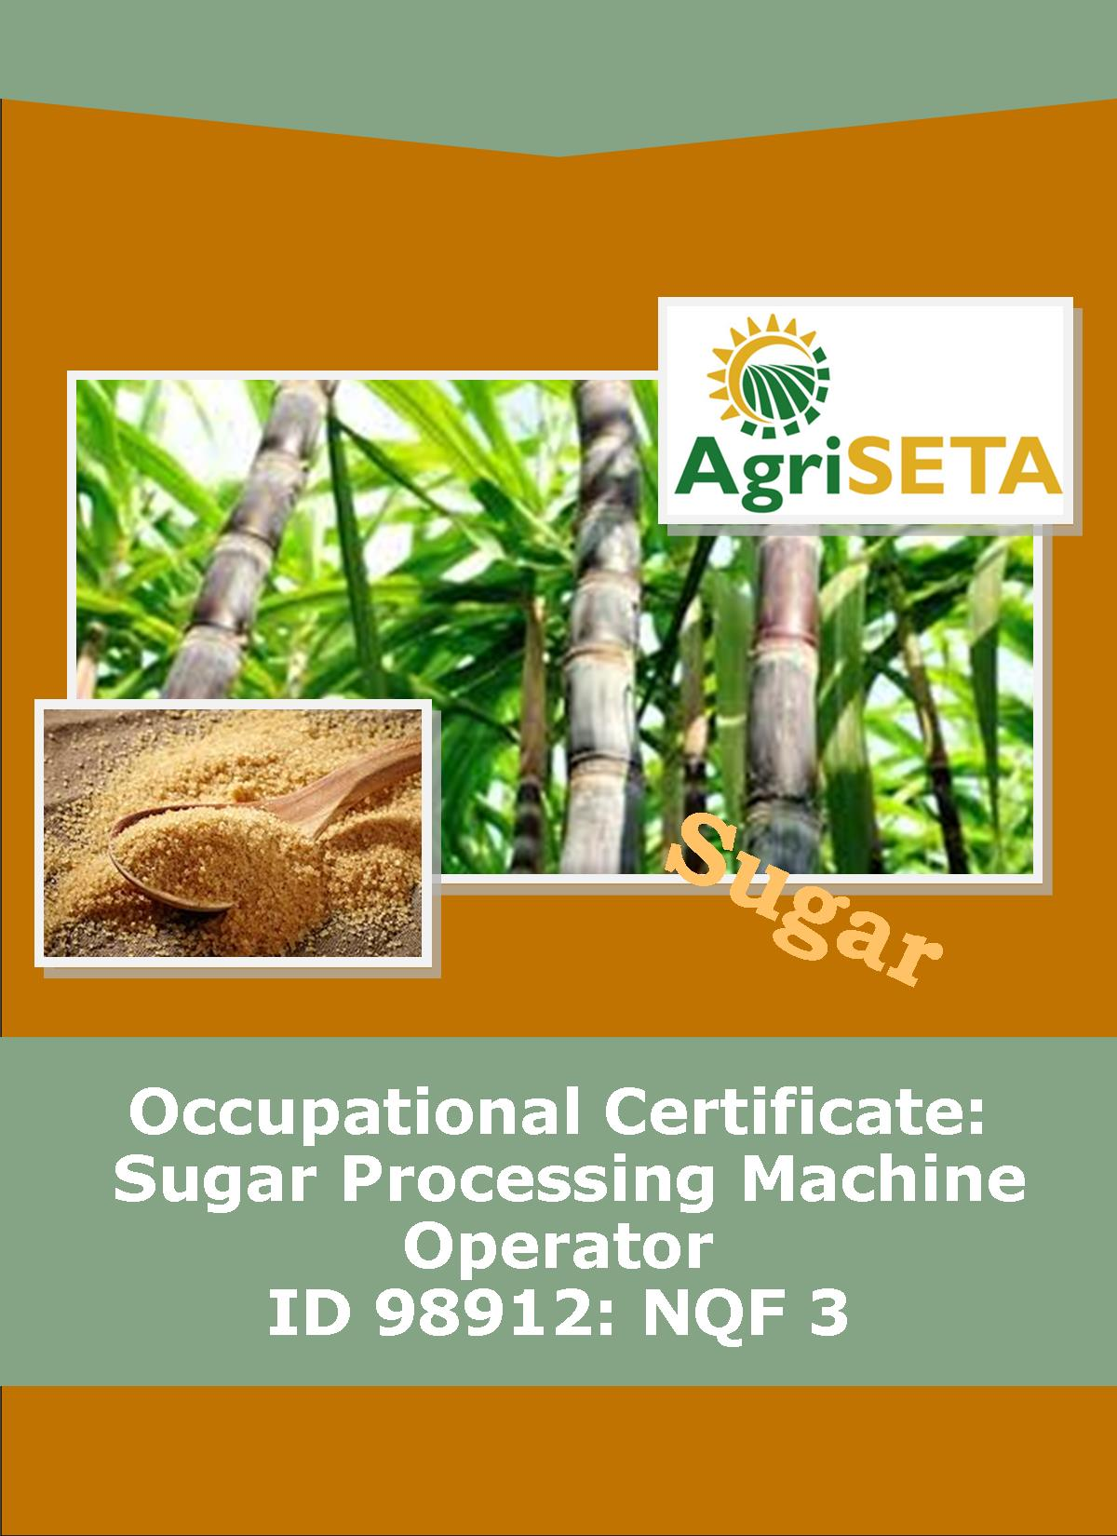
PRACTICAL SKILLS COMPONENT:
MILL SUPERVISOR GUIDE
OCCUPATIONAL QUALIFICATION: SUGAR PROCESSING MACHINE OPERATOR

PRACTICAL SKILLS COMPONENT:

MILL SUPERVISOR GUIDE
PRACTICAL SKILLS COMPONENT:
MILL SUPERVISOR GUIDE
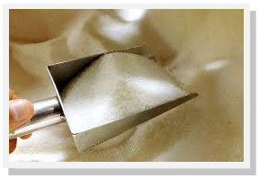
OCCUPATIONAL CERTIFICATE:
SUGAR PROCESSING MACHINE OPERATOR: ID 98912: NQF 3

©Copyright AgriSETA
Telephone: +27 12 301 5600

AgriSETA holds the copyright to its publications and Web pages. Proper citation is requested.

TABLE OF CONTENTS
1. AN INTRODUCTION TO THIS SUPERVISOR GUIDE AND THE PRACTICAL SKILLS MODULES OF THE SUGAR PROCESSING MACHINE OPERATOR OCCUPATIONAL CERTIFICATE 7
1.1 Practical Skills Modules of the Sugar Processing Machine Operator Occupational Certificate 7
1.2 Types of Assessment Tools 7
1.3 Observation of Performance 8
1.4 Creating a Realistic Work Environment at an Assessment Centre VS practicals during a Mill Factory Floor Experience 11
1.5 The Competence Checklist and Practical Assignments 12
1.6 Preparing Assessment Plans 13
1.6.1 Planning 13
1.6.2 Methods to be used 14
1.6.3 Resources required 15
1.7 Conducting the Assessment 15
1.7.1 Brief the learners 15
1.7.2 Observing during Assessment 16
1.7.3 Prepared talks and demonstrations as a means of assessment 16
1.7.4 Written assessments 16
1.7.5 Practical assessments 17
1.8 Giving feedback on performance and completing the assessment records 17
1.8.1 Giving Assessment Feedback 17
1.8.2 Completing Assessment Records 18

2. PRACTICAL SKILLS MODULE 1 21
2.1 Operate pre-set sugar processing equipment 21
2.2 Preparation Matrix for Practical Skills Module 1 22
2.3 Competence Checklist for Practical Skills Module 1 25

3. PRACTICAL SKILLS MODULE 2 33
3.1 Operate programmable sugar processing equipment 33
3.2 Preparation Matrix for Practical Skills Module 2 34
3.3 Competence Checklist for Practical Skills Module 2 37

4. PRACTICAL SKILLS MODULE 3 48
4.1 Operate a bank of inter linked equipment that functions in sequence in a sugar mill 48
4.2 Preparation Matrix for Practical Skills Module 3 49
4.3 Competence Checklist for Practical Skills Module 3 52

5. PRACTICAL SKILLS MODULE 4 57
5.1 Meet occupational health, safety, environment and quality standards 57
5.2 Preparation Matrix for Practical Skills Module 4 58
5.3 Competence Checklist for Practical Skills Module 4 61

6. PROVIDER PROGRAMME ACCREDITATION CRITERIA 66
6.1 Physical Requirements: 66
6.2 Human Resource Requirements: 66
6.3 Legal Requirements: 66
6.4 Exemptions 66

7. SUMMARY LEARNER ASSESSMENT RECORD 67
7.1 Learner Details 67
7.2 Learner Assessment Record 68
7.3 Mill Supervisor Details 68
7.4 Programme Assessor Details 69
-o0o-

AN INTRODUCTION TO THIS SUPERVISOR GUIDE AND THE PRACTICAL SKILLS MODULES OF THE SUGAR PROCESSING MACHINE OPERATOR OCCUPATIONAL CERTIFICATE

Practical Skills Modules of the Sugar Processing Machine Operator Occupational Certificate
This Supervisor Guide is intended to be used by the Supervisor of a learner completing the Practical Skills Component of the Occupational Qualification: Sugar Processing Machine Operator NQF 3. The purpose of this Supervisor Guide is to give advice about the practical supervision and assessment required of Supervisors regarding the following Practical Skills Module Specifications:
- 716106000-PM-01, Operate pre-set sugar processing equipment, NQF Level 2, Credits 12
- 716106000-PM-02, Operate programmable sugar processing equipment, NQF Level 3, Credits 24
- 716106000-PM-03, Operate a bank of inter linked equipment that functions in sequence in a sugar mill, NQF Level 03, Credits 8
- 716106000-PM-04, Meet occupational health, safety, environment and quality standards, NQF Level 03, Credits 8
Total number of credits for Practical Skill Modules: 52

Types of Assessment Tools
Throughout this Occupational Qualification there are three assessment tools or ways of recording knowledge and practical skills. The first method is related to the underpinning knowledge and takes the form of written assessments (as has generally been the case in the Formative Assessment within the Knowledge Component preceding the Practical Skills Component). These have taken the form of multiple choice assessments and short structured questions requiring explanation on the part of the learner. It has also included practical or homework assignments during the formative assessment.
The second and third types of assessment tools are related to the ways in which you can gather and record evidence for the practical skills that a learner must demonstrate. A competence checklist is a list of activities or performance outcomes that a learner must be seen to be able to do in order to be considered competent in the tasks being assessed. The checklist provides a space to state that either “Yes, the learner successfully carried out this activity” or, “No, the learner has not yet achieved this standard”.
Checklists will be provided and the learner has to show that the tasks can be performed to the standard stated – The method of assessment is “observation of performance under realistic conditions”. Alternatively performance can be observed under controlled conditions such as a simulated work environment in a training centre workshop or registered Assessment Centre (if the necessary tools and equipment or systems are available for such assessment).
The third method that can be used to assess practical skills is to provide opportunities for practical assignments. These are required tasks for learners to complete. Practical assignments ensure that all the learners are asked to undertake the same activity in order to demonstrate their practical skills. There are instructions for the learner to follow and there is a marking guide. The marking guide is an alternative to the competence checklist and is a list of the things that the candidate must successfully complete in order to demonstrate competence. The practical assignment may ask the learner to produce a product (e.g. a plan, a report, a design, a drawing, a schematic), or it may require observation of performance, or a combination of the two.
Whether a competence checklist or whether practical assignments are used, these methods are the ways in which you can ensure that the evidence of successful performance is collected and documented in an organised way. This means that everyone can see that the process for assessing practical skills is fair, valid and reliable.

Observation of Performance
Observation of performance is always preferable, as long as they meet the following conditions:
- The assessment (observation) is valid, because it accurately reflects the objectives and content of the syllabus, and does not introduce bias or irrelevant demands.
- The assessment is reliable – It can be checked and confirmed by a second party.
- The assessment is the learner’s own work – it is authentic.
- The assessment is current – It is a reflection of what the learner can do now, not at some time in the past.
- The assessment allows learners equal and frequent opportunity to show competence.
- It is efficient and cost-effective.
- There is sufficient feedback about the result of the assessment.
Although assessment through observation of performance in the real work place as part of work, in actual work placements and in a realistic work environment would be the ideal, there are several disadvantages to the assessment of practical skills in a real work place environment. These disadvantages include:
- The need to involve a workplace supervisor in the assessment which would require training of such a supervisor
- Can be disruptive to normal work procedures of a mill
- Insurance and legal issues may be a problem when “not-yet-competent” learners are allowed onto the factory floor.
- Normal work routine may need to be varied to enable assessment and feedback to take place (placing a further planning burden on the supervisor).
- It may be difficult to arrange placements.
However, the advantages far outweigh the disadvantages. In the case of on-the-job training organised by a company for their own employees, these include:
- Candidate does real job in real environment
- Opportunity for employers to improve quality of workforce through on-the-job training
- Can observe and then promote good workers
- Minimises disruption if learning programme is part of on-the-job training
- Motivates employees
- More cost effective than sending employees on a course off-site
On-the-job training is the approach most likely to be used as part of a training programme organised by a company for its employees.
Sometimes however, candidates are not employees of a company and require work place experience placements.
Advantages of work place experience placements include:
- Popular with new candidates
- Opportunity for candidates to sample real work before making career decisions
- Gives access to real world equipment and facilities (especially up-to-date equipment)
- Opportunity to work alongside more experienced people and to observe
- Work can be carried out within realistic environment and conditions – for example working to realistic times to complete a job
- Opportunity for employers to observe and recruit new employees
- Successful performance is a good predictor of future ability
For those candidates who are not yet employed, special measures to absorb the learner into the work-force may need to be taken. This may include:
- The training centre needs to integrate work placements into the whole programme – No new candidate should be left without the opportunity to complete their Practical Skills Component
- The training centre needs to decide who should provide work placements, when the work placement will take place, where it will take place and how long it needs to be for a thorough assessment to take place
- The prospective employer will need to undertake a “Workplace Experience” contract with the learner
- Providing the learner with orientation to the Health and Safety policies of the work place before moving on to the factory floor
- Providing the learner with the necessary PPE’s to operate safely on the factory floor
- Strong supervision to ensure that the learner is safe and able to undertake tasks according to the work place policies and Standard Operating Procedures

Creating a Realistic Work Environment at an Assessment Centre VS practicals during a Mill Factory Floor Experience
Creating a realistic work environment within an Assessment Centre has several advantages:
- Can be set up within a training centre or assessment centre
- Easy to integrate into training programmes, if on site.
- Available to learners throughout the training programme.
- Good face validity.
- Less pressure to complete observation and practical assessments within time frame of a work placement – Provides opportunities for learners to repeat and practise skills.
- May avoid some insurance and legal issues that make work placements difficult.
However, disadvantages include:
- May be expensive to set up and equip.
- Equipment needs to reflect current work practices – re-equipping can be expensive.
- Can protect learners from real work pressures.
- Benefits may be limited if staff lack recent work experience.
In the case of Sugar Milling, the possibility of creating a simulated work experience will be a difficult and expensive undertaking. It is thus suggested that the Practical Skills Component of the Sugar Processing Machine Operator Qualification presented here should take place through a work experience placement.
For the Practical Skills Component to follow the Knowledge Component seamlessly, the following must be done:
- The Practical Skills Component placements must be arranged by the training centre
- Employers and supervisors need to be familiarised with the requirements of the Practical Skills Component Assessment process and supervisory responsibilities
For the Assessment of the Practical Skills Component an environment and exercises that meet the syllabus outcomes must be found in the work place. As far as possible, employers should use real-world job sheets or Standard Operating Procedures to assist the learner to understand the tasks required of him/her. In this case the learner may be asked to follow the instructions on the job sheet and the assessor uses the exercise to observe the learner performing the tasks. The competence checklist is then used to confirm each of the competencies as they are demonstrated. The aim of each exercise is to make the task as realistic as possible but should also aim to provide carefully controlled situations that ensure the safety of the learner.
The Practical Skills Component Log Book of the learner will help the supervisor to plan exercises that cover all of the assessment and outcome criteria on a particular competence checklist.
Observation of performance and appraisal of products using workshop activities, practical assignments and tasks can also be used as evidence of competency, as relevant. Such “outside of factory floor” assignments have the following advantages:
- The supervisor can structure assignments to match the learner’s development and learning.
- Allows focussing on specific skills.
- Can be used alongside Knowledge Modules and theory lessons to re-enforce learning and put theory into practice.
- Candidate can make mistakes in a “safe” environment.
- Provides an opportunity to practise skills before the Work Place Component.
It should be remembered that:
- The Practical Skills Component does not give experience of real work.
- It is difficult to predict what the learner’s performance will be when faced with the real work environment.

The Competence Checklist and Practical Assignments
For each Skills Module a Competence Checklist must be used to plan a set of activities that will allow the learner to demonstrate competence in the required practical skills. This will involve using equipment in a workshop or factory setting or the application of a skill in a practical assignment (for example, a report, Standard Operating Procedure, a presentation, a design, a schematic, etc.).
With practical assignments:
- All learners can be assessed to the same standard using the same activities.
- Assignments can be designed to ensure that all relevant skills are practised and demonstrated.
- Assignments allow candidates to put theory learning into practice.
- Provide the opportunity to practice and show transferable skills relevant to work.
Planned practical assignments provide a structured approach to the assessment of practical skills. Practical assignments are always structured in the same way – They contain:
- Preparation notes and instructions to the facilitator/assessor – including requirements for the assignment
- Candidate instructions (To be found in the Practical Skills Component Log Book).
- A marking scheme.
- Completion criteria.
- Supplementary material needed to complete the assignment.
Some practical assignment competence can be observed over time (for example: Select and use protective clothing and equipment at all times), or it can be the result of an agreed set of tasks observed on a specific occasion. If the supervisor works with the learner in the workshop, he/she knows, from observation, that the learner consistently wears the appropriate protective clothing in the workshop (not just when a particular task is performed).
Thus, the completion of a competence checklist is a process that takes place over time and is not completed as a last minute effort to meet a deadline nor does the checklist need to be completed in the order provided.

Preparing Assessment Plans

Planning
Be clear about what it is that has to be assessed. What is the learner being asked to do, show, know, produce – to what standard and under what conditions? This information must to translated into the form of a competence checklist or practical assignment marking scheme. In both of these it is stated what has to be seen, produced, observed or explained and under what conditions. This information is presented in the form of “Scope of Practical Skills” (What the learner should be able to do) and “Applied Knowledge” (What the learner is required to know). The “Internal Assessment Criteria” provide the facilitator/assessor with criteria with which to ensure that the objectives or outcomes of the Practical Skills Module are achieved.
Before each Competency Checklist in this Mill Supervisor Guide a Preparation Matrix has been inserted for your use. It looks as follows:
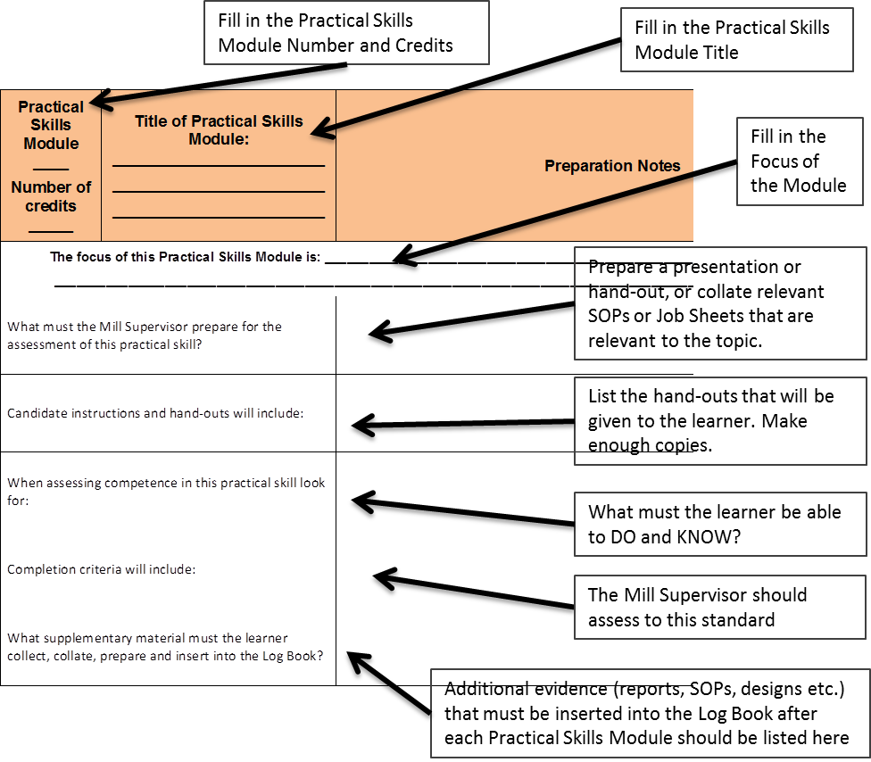

Methods to be used
Assessment of the Practical Skills Component of this course will be formative and summative. Formative assessment, through Competence Checklists, can be used throughout the Practical Skills Component to assess the progress that a student is making towards the final goals. The results are regularly reviewed with the learner – The supervisor will discuss with the learner what has been achieved and what still needs to be learned.
Practical assignments that must be completed within a particular time period, will be used as the summative assessment for the Practical Skills Component and must be inserted into the Log Book once completed.

Resources required
Please note that the Practical Skills Component is planned to take place at an operational Sugar Mill. The ideal Physical, Human Resource and Legal Requirements for each Practical Skills Module are provided at the end of each Practical Skills Module section of this Supervisor Guide. The choice of location and method will depend on the skill being assessed, the time available, and the resources required.
Realistically the supervisor may decide to use a combination of simulated work experience in a workshop as well as observation in a real work setting. Keep in mind that assessment methods should be valid, reliable, cost-effective, and achievable in terms of the time and resources available to you.

Conducting the Assessment

Brief the learners
Before the Practical Skills Component and its assessment takes place, share your planning with the learners either as a group, or individually (especially if the learner has a special need). Stress that the observation of a learner’s performance is not intended to be an examination and that it will take place over time. Explaining the assessment process ensures that assessment is never a surprise or unannounced activity. Explain whether the assessment will be formative (as part of the learning) or summative (part of the final record of evidence of competency). Provide the learners with a description of what you plan to do and what is expected of them to demonstrate competency. These are the items on the competence checklist and “Scope of Practical Skills” list. You should explain what it is you are going to ask the learner to do in order to be given the opportunity to demonstrate the skills. Also be clear as to what physical evidence the learner must collect and place into his/her Log Book for summative assessment of the Practical Skills Component. Make sure that the learner understands what it is you will be looking for.
Hand out the Practical Skills Component Log Book as part of the briefing. Each learner needs to know how the Log Book will be used, when it should be signed, when to present it to the supervisor for signature and what supplementary evidence needs to be inserted.
Each candidate needs to know what you will do with the information that you collect by observation. If you are using the competence checklist to observe performance, you will be looking at the performance outcomes to see which statements can be marked as competent. The competence checklist in the Learner Log Book will be what you submit to the visiting verifier as your evidence for stating that the learner has met the requirements for the Practical Skills Component of the qualification.
The learner also needs to know what will happen if you do not mark him/her as competent during the observation. This means that the candidate has not yet achieved the standard required. An opportunity for the candidate to attempt the activity again should be provided, after you have explained what evidence you are still looking for.
By briefing the learners in this way you are gaining their agreement to your plan and the assessment process. A pre-assessment verification form can be signed by the learners present to provide assurance that the learners understand the assessment process.

Observing during Assessment
You will need to plan your observations with each individual learner. Ensure that you confirm your observation, and the underlying knowledge component of a task, with supplementary questions that start with words such as “Why”, “Where”, “How” and “When”. It is best to develop a set of questions that you are going to ask every learner to answer.

Prepared talks and demonstrations as a means of assessment
A prepared talk with or without a demonstration can also be used to observe competence. Here a topic (or a list of topics) can be prepared and the learners can choose the topic that they would like to prepare a talk and demonstration about. Make it clear to the learners what they should include in the prepared talk and demonstration and how it is relevant to the objectives and outcomes of the Practical Skills Module. The competency checklist can then be marked during the learner’s presentation. Be sure that you know what you are looking for (do you want one or two reasons for a specific decision, for example). Use supplementary questions following the presentation to close any gaps in the competency checklist.

Written assessments
For the Practical Skills Component, written assessment may take the form of essays or reports. Written examinations or tests are rarely used for practical assessment. Written tests could be used during formative assessment to determine the learners’ underpinning level of knowledge about their practical tasks.
Reports are normal in a real work experience context – sometimes at the Machine Operator level – thus, the task to write a report provides evidence that the learner knows where to find the information, how to collect and collate it, and how it needs to be presented in a realistic work context. Using company policy documents and Standard Operating Procedures, and real world reporting sheets can assist to provide realistic context to written reports required of the learner.

Practical assessments
Practical tasks used for assessment purposes should provide learners with a set of instructions to follow in order to complete a specific task, a test of the resulting “product” for functionality and an explanation of the outcomes of, or reasons for, the task. Practical tasks designed for Practical Skills Assessment must be valid and reliable. That is, it must test a skill or skills that are relevant to the syllabus and it must be based on clearly understood criteria that are applied to all the learners in the same way.

Giving feedback on performance and completing the assessment records

Giving Assessment Feedback
Positive feedback on those parts of the assessment that went well should always be given during the one-on-one feedback session following the Practical Skills Assessment. Here you can explain to the learner what you liked and why you felt that the learner achieved the outcomes successfully. If you have done a thorough pre-assessment meeting you can re-iterate the points that you were specifically looking for that the learner was able to demonstrate. A positive approach is also however necessary when providing the learner feedback regarding those aspects that were perhaps not positively achieved. Here you should explain what the learner failed to demonstrate and how he/she can improve on those aspects of the Practical Skills. Again, if you have done a thorough pre-assessment meeting, those aspects that were not demonstrated successfully should come as no surprise to the learner. Provide the learner guidance on how these particular skills can be improved, allow them time in the workshop or on the factory floor to improve those skills and make a future date and time when and where a re-assessment can take place. Give the learner some tips and guidance on what they should specifically concentrate on to improve their performance.
Giving positive feedback will allow the learner to remain comfortable throughout the assessment process. Remember, the aim is to find out what the person can do, not a means to find fault or to catch the candidate out by requiring them to undertake unexpected tasks, or asking deliberately difficult questions.
Always congratulate the learner for those parts of the assessment that went well and then ask them what they thought about their performance. This starts a conversation which will enable the learner to accept the assessment results and feedback positively.
Once the assessment feedback is complete, the supervisor must provide guidance on what the future action must be. This may mean moving onto the next Practical Skills Module, or, if all the Practical Skills Modules are complete, that the candidate may move onto the Work Place Experience Component of the qualification. If the assessment outcome is not yet competent, then a future time and place for re-assessment must be provided. Allow enough time for the learner to practise those Practical Skills that were not successfully completed. This may require that the learner be given access to the workshop and tools outside of normal times, or be allowed to spend more time on the factory floor. This has a time, safety and personnel implication which will need to be considered. Proper planning for such learners will be required so that they do not fall behind the rest of the learning activities.
If the Practical Skills cannot be successfully demonstrated, a learner may re-enter the Practical Skills Component. If the learner is not interested in re-entering the Skills Component, it should be remembered that a “Part Qualification” certificate for the credits of the Knowledge Component would, at this point, already be in the possession of the learner, so they would not be walking away empty handed from the entire programme.

Completing Assessment Records
The following tools need to be completed for every assessment undertaken:

The Competence Checklist
The competence checklist will take the following form:
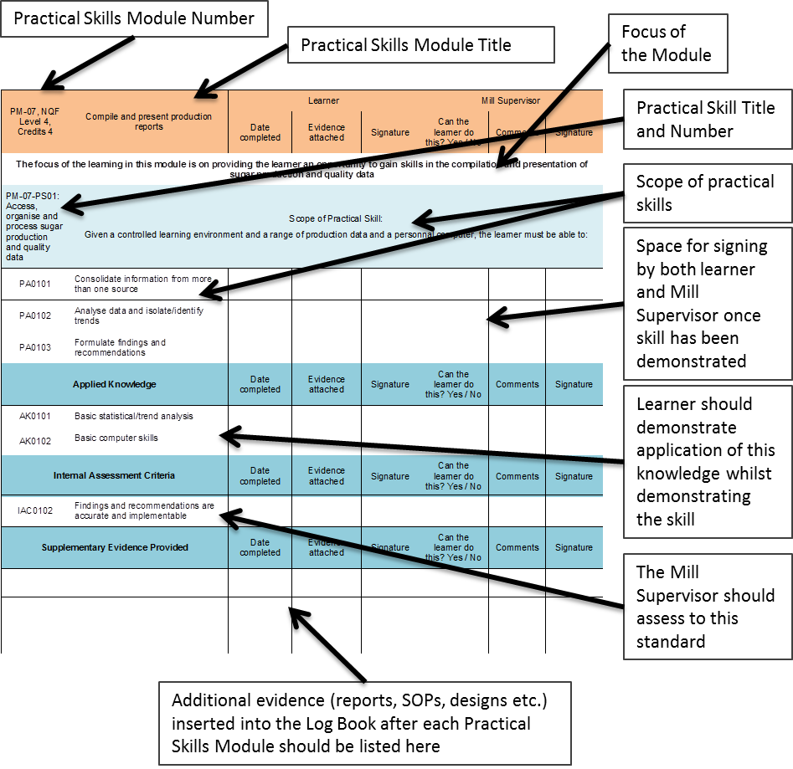
Once each of these competence checklists are completed and signed off, the Learner Log Book document and all its Supporting Evidence must be handed to the relevant QCTO Assessment Quality Partner for verification.
A summary “Learner Assessment Record” is also provided at the back of the Learner Log Book and is a record of the learner’s progress over the entire Practical Skills Component.
Keep in mind that the Practical Skills Component requires either a result of “Yes, the learner has achieved this” or “No, the learner has not yet achieved this”, since you are using assessment to show that a person has successfully acquired and demonstrated all of the competencies necessary for successful performance. There is no need to grade the results (as with a written assessment in the Knowledge Component).
(Note: PM = Practical Skills Module, PA = Practical Skill Assessment Scope, AK = Applied Knowledge)

PRACTICAL SKILLS MODULE 1

Operate pre-set sugar processing equipment
Module number: 716106000-PM-01: NQF Level 2: Credits 12
The focus of the learning in this module is on providing the learner an opportunity to gain practical skills required to attend to pre-set equipment used in uncomplicated processes such as filter presses, juice heater, coolers, Oliver filters, continuous centrifuges in a controlled learning environment.
The learner will be required to:
- PM-01-PS01: Conduct pre start-up procedures of preset sugar processing equipment
- PM-01-PS02: Monitor and operate preset sugar processing equipment
- PM-01-PS03: Shut down and clean preset sugar processing equipment

Preparation Matrix for Practical Skills Module 1
Practical Skills Module ____  Number of credits _____ | Title of Practical Skills Module: ________________________  ________________________  ________________________ | Preparation Notes
The focus of this Practical Skills Module is: ______________________________________________________________________
__________________________________________________________________________________________________________
Instructions and hand-outs provided (list them here)
What competence will the Mill Supervisor want to see?
To what standard will the Mill Supervisor want to see the task completed at?
What supplementary material must you collect, collate, prepare and insert into the Log Book?

Competence Checklist for Practical Skills Module 1
PM01: NQF Level 2: Credits 12 | Operate pre-set sugar processing equipment | Learner |  |  | Mill Supervisor
 |  | Date completed | Evidence attached | Signature | Can the learner do this? Yes / No | Comments | Signature
The focus of the learning in this module is on providing the learner an opportunity to gain practical skills required to attend to pre-set equipment used in uncomplicated processes such as filter presses, juice heater, coolers, Oliver filters, continuous centrifuges in a controlled learning environment.
PM-01-PS01: Conduct pre start-up procedures of preset sugar processing equipment | Scope of Practical Skill:  Given pre-set equipment in a controlled operational environment, operating procedures and instructions, the learner must be able to:
PA0101 | Use a control sheet to inspect the preset equipment for correct settings and mechanical soundness
PA0102 | Inspect and identify feeder material for availability and correctness
PA0103 | Inspect material routing for readiness
Applied Knowledge |  | Date completed | Evidence attached | Signature | Can the learner do this? Yes / No | Comments | Signature
AK0101 | Equipment mechanical inspection procedures and standards
AK0102 | Flow of material
AK0103 | Equipment settings
Internal Assessment Criteria |  | Date completed | Evidence attached | Signature | Can the learner do this? Yes / No | Comments | Signature
IAC0101 | Inspection reports are accurately completed
Supplementary Evidence Provided |  | Date completed | Evidence attached | Signature | Can the learner do this? Yes / No | Comments | Signature
PM-01-PS02: Monitor and operate equipment preset sugar processing equipment | Scope of Practical Skill  Given pre-set processing equipment in a controlled learning environment, the learner must be able to:
PA0201 | Perform specific operational tasks in accordance with equipment operating procedures e.g. start-up, change-over, purging, cleaning, shut down, emergency stop
PA0202 | Monitor preset equipment to maintain operation within output/product requirements and equipment specifications
PA0203 | Recognise and rectify and/or report operating problems related to different scenarios
PA0204 | Achieve required volumes and quality standards
PA0205 | Complete a production report
Applied Knowledge |  | Date completed | Evidence attached | Signature | Can the learner do this? Yes / No | Comments | Signature
AK0201 | Standard operating procedures or instructions
AK0202 | Sensory signs of operating problems
AK0203 | Material specifications
AK0204 | Indicators of the mechanical problems
AK0205 | Product/material standards and specifications
AK0206 | Production reporting requirements
Internal Assessment Criteria |  | Date completed | Evidence attached | Signature | Can the learner do this? Yes / No | Comments | Signature
IAC0201 | The equipment is operated in accordance with standard operating procedures or instructions
IAC0202 | The consequences of wrong practices, neglect and/or misinterpretation of instrument readings, incorrect settings in relation to equipment efficiency and product quality is explained correctly
IAC0203 | Production volumes and quality standards are achieved
Supplementary Evidence Provided |  | Date completed | Evidence attached | Signature | Can the learner do this? Yes / No | Comments | Signature
PM-01-PS03: Shut down and clean preset sugar processing equipment | Scope of Practical Skill  Given cleaning material, equipment, lubricants and the required mechanical tools the learner must be able to:
PA0301 | Perform pre-set equipment shutdown procedures
PA0302 | Clean pre-set sugar processing equipment and perform housekeeping
PA0303 | Lubricate pre-set sugar processing equipment
Applied Knowledge |  | Date completed | Evidence attached | Signature | Can the learner do this? Yes / No | Comments | Signature
AK0301 | Equipment cleaning procedures
AK0302 | Equipment care and maintenance
Internal Assessment Criteria |  | Date completed | Evidence attached | Signature | Can the learner do this? Yes / No | Comments | Signature
IAC0301 | Scheduled cleaning and equipment care procedures are executed in accordance with manufacturer specifications and standard procedures
Supplementary Evidence Provided |  | Date completed | Evidence attached | Signature | Can the learner do this? Yes / No | Comments | Signature

PRACTICAL SKILLS MODULE 2

Operate programmable sugar processing equipment
Module Number 716106000-PM-02, NQF Level 3, Credits 24
The focus of the learning in this module is on providing the learner an opportunity to develop skills to operate programmable equipment or equipment setup and operated in series. The learner will gain the skills by operating equipment used for extraction, clarification, evaporation, sugar melting and refining processes.
The learner will be required to:
- PM-02-PS01: Conduct pre start-up procedures of programmable sugar processing equipment
- PM-02-PS02: Monitor and operate programmable sugar processing equipment
- PM-02-PS03: Shut down and clean programmable sugar processing equipment
- PM-02-PS04: Record data and maintain production records

Preparation Matrix for Practical Skills Module 2
Practical Skills Module ____  Number of credits _____ | Title of Practical Skills Module: ________________________  ________________________  ________________________ | Preparation Notes
The focus of this Practical Skills Module is: ______________________________________________________________________
__________________________________________________________________________________________________________
Instructions and hand-outs provided (list them here)
What competence will the Mill Supervisor want to see?
To what standard will the Mill Supervisor want to see the task completed at?
What supplementary material must you collect, collate, prepare and insert into the Log Book?

Competence Checklist for Practical Skills Module 2
PM-02, NQF Level 3, Credits 24 | Operate programmable sugar processing equipment | Learner |  |  | Mill Supervisor
 |  | Date completed | Evidence attached | Signature | Can the learner do this? Yes / No | Comments | Signature
The focus of the learning in this module is on providing the learner an opportunity to develop skills to operate programmable equipment or equipment setup and operated in series. The learner will gain the skills by operating equipment used for extraction, clarification, evaporation, sugar melting and refining processes.
PM-02-PS01: Conduct pre start-up procedures of programable sugar processing equipment | Scope of Practical Skill:  Given a controlled operational environment, operating procedures and instructions, the learner must be able to:
PA0101 | Use a control sheet to inspect programmable equipment for correct settings and mechanical soundness
PA0102 | Inspect and identify feeder material for availability and correctness
PA0103 | Inspect material routing for readiness
Applied Knowledge |  | Date completed | Evidence attached | Signature | Can the learner do this? Yes / No | Comments | Signature
AK0101 | Programmable equipment mechanical inspection procedures and standards
AK0102 | Flow of material
AK0103 | Programmable equipment settings
Internal Assessment Criteria |  | Date completed | Evidence attached | Signature | Can the learner do this? Yes / No | Comments | Signature
IAC0101 | Inspection reports are accurately completed
Supplementary Evidence Provided |  | Date completed | Evidence attached | Signature | Can the learner do this? Yes / No | Comments | Signature
PM-02-PS02: Monitor and operate programmable sugar processing equipment | Scope of Practical Skill:  Given programmable processing equipment and a controlled learning environment, the learner must be able to:
PA0201 | Set-up and start-up programmable sugar processing equipment manually and achieve normal operating conditions
PA0202 | Control the programmable equipment operation within required output/product specifications
PA0203 | Perform specific procedures related to the process (e.g. change-over, cleaning, emergency stops)
PA0204 | Adjust programmable equipment setting in response to instrument readings and required operating conditions
PA0205 | Use instrumentation readings and sensory cues to anticipate quality problems and make adjustments
PA0206 | Achieve consistent flow of material in terms of required volumes and quality standards
PA0207 | Read and explain a programmable equipment operating diagram
PA0208 | Select and apply appropriate responses to material or process deviations
PA0209 | Control the programmable equipment operation within required output/product specifications
Applied Knowledge |  | Date completed | Evidence attached | Signature | Can the learner do this? Yes / No | Comments | Signature
AK0201 | Standard Operating Procedures
AK0202 | Manual and automatic starting/shut down procedures
AK0203 | Equipment operating procedures and specifications
AK0204 | Product specifications
AK0205 | Standard safety procedures
AK0206 | Standard responses to common problems
AK0207 | Process flow
Internal Assessment Criteria |  | Date completed | Evidence attached | Signature | Can the learner do this? Yes / No | Comments | Signature
IAC0201 | The execution of equipment set-up, start-up, operation and shutdown in accordance with standard procedures
IAC0202 | The execution of adjustments to equipment setting in response to instrument readings and material variations are performed in accordance with standard procedures
IAC0203 | Required product volumes and quality standards are achieved
IAC0204 | The impact and implications of wrong actions in relation to equipment efficiency and product standards can be explained
IAC0205 | Responses to different emergency scenarios, risks and problems can be explained
IAC0206 | Indicators of the mechanical equipment functionality can be explained
Supplementary Evidence Provided |  | Date completed | Evidence attached | Signature | Can the learner do this? Yes / No | Comments | Signature
PM-02-PS03: Shut down and clean programmable sugar processing equipment | Scope of Practical Skill:  Given cleaning and lubricating materials, standard procedures and programmable processing equipment or equipment in series in a controlled learning environment, the learner must be able to:
PA0301 | Perform equipment shutdown procedures of programmable sugar processing equipment
PA0302 | Set-up and run programmable equipment cleaning cycles
Applied Knowledge |  | Date completed | Evidence attached | Signature | Can the learner do this? Yes / No | Comments | Signature
AK0301 | Cleaning and equipment care procedures
AK0302 | Equipment shutdown procedures
Internal Assessment Criteria |  | Date completed | Evidence attached | Signature | Can the learner do this? Yes / No | Comments | Signature
IAC0301 | Equipment cleaning and care procedures are executed in accordance with standard procedures
IAC0302 | Equipment shutdown procedures are executed in accordance with standard procedures
Supplementary Evidence Provided |  | Date completed | Evidence attached | Signature | Can the learner do this? Yes / No | Comments | Signature
PM-02-PS04: Record data and maintain production records | Scope of Practical Skill:  Given production line, quality reports and product specifications, the learner must be able to:
PA0401 | Interpret, collate, calculate, summarise and record production data to ensure availability of accurate and complete production information
PA0402 | Compile production reports to communicate required information accurately
PA0403 | Present information in simple graphical format to analyse and report production data
PA0404 | Read and respond to the essence of written instructions
PA0405 | Organise and capture data
Applied Knowledge |  | Date completed | Evidence attached | Signature | Can the learner do this? Yes / No | Comments | Signature
AK0401 | Data analysis
AK0402 | Reporting and presenting data
AK0403 | Use or purpose of data
Internal Assessment Criteria |  | Date completed | Evidence attached | Signature | Can the learner do this? Yes / No | Comments | Signature
IAC0401 | Data is analysed and reported on accurately
Supplementary Evidence Provided |  | Date completed | Evidence attached | Signature | Can the learner do this? Yes / No | Comments | Signature

PRACTICAL SKILLS MODULE 3

Operate a bank of inter linked equipment that functions in sequence in a sugar mill
Module Number 716106000-PM-03, NQF Level 3, Credits 8
The focus of the learning in this module is on providing the learner an opportunity to develop skills to operate inter linked equipment set up and operated in series such as effluent and waste control and waste product handling systems.
- PM-03-PS01: Conduct pre start-up procedures for a bank of inter linked equipment that functions in sequence in a sugar mill
- PM-03-PS02: Monitor and control a bank of inter linked equipment that functions in sequence in a sugar mill

Preparation Matrix for Practical Skills Module 3
Practical Skills Module ____  Number of credits _____ | Title of Practical Skills Module: ________________________  ________________________  ________________________ | Preparation Notes
The focus of this Practical Skills Module is: ______________________________________________________________________
__________________________________________________________________________________________________________
Instructions and hand-outs provided (list them here)
What competence will the Mill Supervisor want to see?
To what standard will the Mill Supervisor want to see the task completed at?
What supplementary material must you collect, collate, prepare and insert into the Log Book?

Competence Checklist for Practical Skills Module 3
PM-03, NQF Level 3, Credits 8 | Operate a bank of inter linked equipment that functions in sequence in a sugar mill | Learner |  |  | Mill Supervisor
 |  | Date completed | Evidence attached | Signature | Can the learner do this? Yes / No | Comments | Signature
The focus of the learning in this module is on providing the learner an opportunity to develop skills to operate inter linked equipment setup and operated in series such as effluent and waste control, waste product handling systems.
PM-03-PS01: Conduct pre start-up procedures for a bank of inter linked equipment that functions in sequence in a sugar mill | Scope of Practical Skill:  Given a controlled operational environment, operating procedures and instructions the learner must be able to:
PA0101 | Use a control sheet to inspect the bank of equipment for correct settings and mechanical soundness
PA0102 | Use a control sheet to inspect the material transfer pumps, pipes and valves for correct settings and mechanical soundness
PA0103 | Inspect and identify feeder material for availability and correctness
PA0104 | Inspect material routing for readiness
Applied Knowledge |  | Date completed | Evidence attached | Signature | Can the learner do this? Yes / No | Comments | Signature
AK0101 | Operating procedures for the equipment
AK0102 | Equipment inspection procedures
Internal Assessment Criteria |  | Date completed | Evidence attached | Signature | Can the learner do this? Yes / No | Comments | Signature
IAC0101 | Pre start-up procedures are performed in a structured manner in accordance with operating procedures
Supplementary Evidence Provided |  | Date completed | Evidence attached | Signature | Can the learner do this? Yes / No | Comments | Signature
PM-03-PS02: Monitor and control a bank of inter linked equipment that functions in sequence in a sugar mill | Scope of Practical Skill:  Given a bank of equipment in series in a controlled learning environment the learner must be able to:
PA0201 | Set-up and start-up the bank of equipment manually and achieve normal operating conditions
PA0202 | Monitor and control the operation of a bank of equipment working in series within required output specifications
PA0203 | Shut down the bank of equipment
PA0204 | Read and explain a process flow diagram
Applied Knowledge |  | Date completed | Evidence attached | Signature | Can the learner do this? Yes / No | Comments | Signature
AK0201 | Standard Operating Procedures
AK0202 | Standard responses to common problems
AK0203 | Material flow diagrams
Internal Assessment Criteria |  | Date completed | Evidence attached | Signature | Can the learner do this? Yes / No | Comments | Signature
IAC0201 | The operation of the bank of equipment is monitored and controlled in accordance with standard procedures
IAC0202 | Indicators of the mechanical equipment functionality can be explained
Supplementary Evidence Provided |  | Date completed | Evidence attached | Signature | Can the learner do this? Yes / No | Comments | Signature

PRACTICAL SKILLS MODULE 4

Meet occupational health, safety, environment and quality standards
Module Number 716106000-PM-04, NQF Level 3, Credits 8
The focus of the learning in this module is on providing the learner an opportunity to develop skills to comply with occupational safety, health and environmental protection standards and to conduct In-line quality assurance.
The learner will be required to:
- PM-04-PS01: Comply with occupational safety, health and environmental protection standards
- PM-04-PS02: Conduct In-line sugar quality assurance

Preparation Matrix for Practical Skills Module 4
Practical Skills Module ____  Number of credits _____ | Title of Practical Skills Module: ________________________  ________________________  ________________________ | Preparation Notes
The focus of this Practical Skills Module is: ______________________________________________________________________
__________________________________________________________________________________________________________
Instructions and hand-outs provided (list them here)
What competence will the Mill Supervisor want to see?
To what standard will the Mill Supervisor want to see the task completed at?
What supplementary material must you collect, collate, prepare and insert into the Log Book?

Competence Checklist for Practical Skills Module 4
PM-04, NQF Level 3, Credits 8 | Meet occupational health, safety, environment and quality standards | Learner |  |  | Mill Supervisor
 |  | Date completed | Evidence attached | Signature | Can the learner do this? Yes / No | Comments | Signature
The focus of the learning in this module is on providing the learner an opportunity to develop skills to comply with occupational safety, health and environmental protection standards and to conduct In-line quality assurance.
PM-04-PS01: Comply with occupational safety, health and environmental protection standards | Scope of Practical Skill:  Given occupational safety and health procedures, inspection sheets and personal protective equipment the learner must be able to:
PA0101 | Use a control sheet to inspect equipment and protective devices for safe operating conditions
PA0102 | Select, use and care for personal protective equipment
Applied Knowledge |  | Date completed | Evidence attached | Signature | Can the learner do this? Yes / No | Comments | Signature
AK0101 | Safety inspection procedures and standards
AK0102 | Personal protective equipment
Internal Assessment Criteria |  | Date completed | Evidence attached | Signature | Can the learner do this? Yes / No | Comments | Signature
IAC0101 | Safety checks and inspections are performed in accordance with manufacturer specifications and standard procedures
IAC0102 | Personal protective equipment is selected and used correctly
IAC0103 | Operating risks and measures to prevent these can be explained
Supplementary Evidence Provided |  | Date completed | Evidence attached | Signature | Can the learner do this? Yes / No | Comments | Signature
PM-04-PS02: Conduct In-line sugar quality assurance | Scope of Practical Skill:  Given a production line, quality reports and product specifications the learner must be able to:
PA0201 | Integrate various sources of information (instrument/PLC readings, quality reports, sensory cues) to determine quality standards
PA0202 | Conduct in-process sampling and product evaluation to maintain quality control standards
PA0203 | Complete in-process quality reports
Applied Knowledge |  | Date completed | Evidence attached | Signature | Can the learner do this? Yes / No | Comments | Signature
AK0201 | Quality control procedures
AK0202 | Product quality specification
AK0203 | In-process sampling and evaluation techniques
Internal Assessment Criteria |  | Date completed | Evidence attached | Signature | Can the learner do this? Yes / No | Comments | Signature
IAC0201 | In-line quality control procedures are adhered to
IAC0202 | Deviations form required quality standards are recognised and reported
Supplementary Evidence Provided |  | Date completed | Evidence attached | Signature | Can the learner do this? Yes / No | Comments | Signature

PROVIDER PROGRAMME ACCREDITATION CRITERIA

Physical Requirements:
- Pre-set equipment in an sugar processing line
- Programmable equipment or equipment in series in an sugar processing line
- Equipment cleaning material
- Equipment components
- Learning resources approved by the QCTO
- Assessment documentation, instruments and standards approved by the QCTO

Human Resource Requirements:
- Facilitators with subject matter expertise in the content of the module
- A learner facilitator ratio of no more than 1:5
- Assessors with assessment practice training and subject matter expertise on the content of the module

Legal Requirements:
- Compliance with occupational health, safety and environmental protection regulations
- Personal protective equipment

Exemptions
- None recognised

SUMMARY LEARNER ASSESSMENT RECORD
At the back of the Learner Practical Skills Log Book a summary “Learner Assessment Record” is provided (as shown below). As soon as the learner has completed all the Practical Skills Modules successfully, this form and the stakeholder information should be completed and the Log Book with all its supplementary information should be handed to the relevant QCTO Assessment Quality Partner for verification.

Learner Details
First name:
Surname:
ID number:
Telephone number:
Mobile number:
E-mail address:
Postal address:
Start date of workplace experience:
Completion date of workplace experience:
Signature of learner:

Learner Assessment Record
Practical Skills Module | Credits | Can the Learner do this? | Signature of Mill Supervisor | Date
716106000-PM-01, Operate pre-set sugar processing equipment, NQF Level 2 | 12
716106000-PM-02, Operate programmable sugar processing equipment, NQF Level 3 | 24
716106000-PM-03, Operate a bank of inter linked equipment that functions in sequence in a sugar mill, NQF Level 03 | 8
716106000-PM-04, Meet occupational health, safety, environment and quality standards, NQF Level 03 | 8

Mill Supervisor Details
Organisation / workplace:
Workplace designation (of Mill Supervisor):
First name:
Surname:
ID number:
Telephone number:
Mobile number:
E-mail address:
Postal address:
Date completed:
Signature:

Programme Assessor Details
Company:
First name:
Surname:
ID number:
Telephone number:
Mobile number:
E-mail address:
Postal address:
Date assessed:
Signature:

